Risk of Bias Summary Judgement

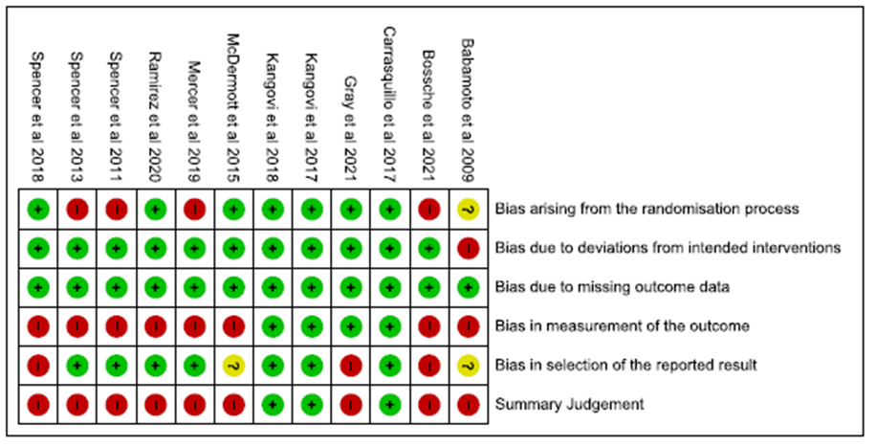

Risk of Bias Judgement on Outcome Domains

