**Supplementary Material**

***Performance evaluation of the fully automated cobas® 6800 CMV PCR for the detection and quantification of cytomegalovirus DNA in neonatal urine and saliva, and adult urine, saliva and vaginal secretion***

Ngee Keong Tan, Cassie F Pope, David Carrington

**Table S1** PCR protocol, workflow and turnaround time for CMV PCR assays.

|  |  |  |  |  |
| --- | --- | --- | --- | --- |
| Protocol | Parameter | PCR Assay | | |
| **cobas® CMV** | **Reference lab M** | **Reference lab R** |
| Extraction | Input volume (µl) | 350 | 200 | 200 |
| Output volume (µl) | 50 | 200 | 90 |
| Instrument | cobas® 6800 | Kingfisher Flex | EZ1 Advanced XL |
| Sample type | Urine in cobas® PCR media | Urine in cobas® PCR media | Saliva swabs (FLOQSwab®) in eNAT® PCR media |
| Vaginal swabs (polyester) in cobas® PCR media | Vaginal swabs (polyester) in cobas® PCR media |  |
| Saliva swabs (FLOQSwab®) in eNAT® PCR media |  |  |
| PCR | Eluate volume (µl) | 27 | 20 | 10 |
| Reaction volume (µl) | 52 | 50 | 20 |
| Instrument | cobas® 6800 | LightCycler® 480 | QuantStudioTM 5 |
| Assay | cobas® CMV | Proprietary laboratory-developed test | Proprietary laboratory-developed test |
| Result (unit) | Quantitative (IU/ml) | Quantitative, urine (copies/ml) | Qualitative |
|  | Qualitative, vaginal swabs |  |
|  | Criteria for test positivity | ≥ limit of detection (LoD). (See Table 1) | Sigmoidal amplification curve with a cycle threshold (Ct) value ≤ 50 | Sigmoidal amplification curve with a Ct value ≤ 40 |
| Workflow (extraction to analysis) | | Fully automated | Semi-automated | Semi-automated |
| Number of user’s intervention | | 1* | 7** | 7** |
| Requirement to remove reagents for storage post processing | | No | Yes | Yes |
| Turnaround time for 30 samples | | ≤ 4 hours† | 24 – 48 hours‡ | 14 – 21 days‡ |

* Load samples (in primary containers) on cobas® 6800. ** Transfer samples to secondary tubes for extraction, load samples for extraction, remove eluates from extractor, prepare PCR mastermix, setup a PCR plate, load PCR plate on a thermocycler, analyse results manually. † Time from receipting samples in our laboratory to reporting test results to clinicians. ‡ Send-away test. Time from receipting samples in our laboratory to reporting test results to clinicians upon receiving test reports from reference laboratory M or laboratory R.

**Table S2** Limit of detection of the cobas® CMV for urine preserved in cobas® PCR media.

|  |  |  |  |
| --- | --- | --- | --- |
| **CMV DNA titre (IU/ml)\*** | **Number of valid replicates** | **Number of positives** | **Hit rate (%)** |
| 90 | 15 | 15 | 100.00 |
| 50 | 15 | 15 | 100.00 |
| 35 | 15 | 15 | 100.00 |
| 24 | 15 | 14 | 93.33 |
| 12 | 15 | 7 | 46.67 |
| 6 | 15 | 5 | 33.33 |
| 3 | 15 | 2 | 13.33 |
| 0 | 15 | 0 | 0.00 |
| **LoD by 95% PROBIT** | 30.87 IU/ml (95% CI 19.86 – 47.98) | | |

* For each concentration, three replicate was tested each day over five days. The PCR test was performed by technician A using reagent lot 1 on day 1 (at 7:15 pm), day 4 (at 1:30 pm), and day 5 (at 10:30 am), technician B using reagent lot 2 on day 2 (at 7:30 pm), and technician C using reagent lot 2 on day 3 (at 11:00 am). Weekly equipment maintenance was performed by technician A on day 1. Daily equipment maintenance was performed by technician A (day 4 and 5), B (day 2) and C (day 3).

**Table S3** Limit of detection of the cobas® CMV for saliva preserved in eNAT® PCR media.

|  |  |  |  |
| --- | --- | --- | --- |
| **CMV DNA titre (IU/ml)\*** | **Number of valid replicates** | **Number of positives** | **Hit rate (%)** |
| 250 | 15 | 15 | 100.00 |
| 210 | 15 | 14 | 93.33 |
| 170 | 15 | 12 | 80.00 |
| 130 | 15 | 8 | 53.33 |
| 90 | 15 | 0 | 0.00 |
| 50 | 15 | 0 | 0.00 |
| 35 | 15 | 0 | 0.00 |
| 0 | 15 | 0 | 0.00 |
| **LoD by 95% PROBIT** | 200 IU/ml (95% CI 172.5 – 237.0) | | |

* For each concentration, three replicate was tested each day over five days. The PCR test was performed by technician A using reagent lot 1 on day 1 (at 2:25 pm), technician B using reagent lot 2 on day 2 (at 1:15 pm) and reagent lot 3 on day 5 (at 11:00 am), technician C using reagent lot 1 on day 3 (at 1:45 pm), and technician D using reagent lot 2 on day 4 (at 10:30 am). Weekly equipment maintenance was performed by technician B on day 2. Daily equipment maintenance was performed by technician A (day 1), B (day 5), C (day 3) and D (day 4).

**Table S4** Limit of detection of the cobas® CMV for vaginal secretion preserved in cobas® PCR media.

|  |  |  |  |
| --- | --- | --- | --- |
| **CMV DNA titre (IU/ml)\*** | **Number of valid replicates** | **Number of positives** | **Hit rate (%)** |
| 90 | 15 | 15 | 100.00 |
| 50 | 15 | 14 | 93.33 |
| 35 | 15 | 10 | 66.67 |
| 24 | 15 | 6 | 40.00 |
| 12 | 15 | 4 | 26.67 |
| 6 | 15 | 2 | 13.33 |
| 3 | 15 | 0 | 0.00 |
| 0 | 15 | 0 | 0.00 |
| **LoD by 95% PROBIT** | 80.58 IU/ml (95% CI 50.04 – 129.80) | | |

* For each concentration, three replicate was tested each day over five days. The PCR test was performed by technician A using reagent lot 1 on day 1 (at 7:15 pm), day 4 (at 1:30 pm), and day 5 (at 10:30 am), technician B using reagent lot 2 on day 2 (at 7:30 pm), and technician C using reagent lot 2 on day 3 (at 11:00 am). Weekly equipment maintenance was performed by technician A on day 1. Daily equipment maintenance was performed by technician A (day 4 and 5), B (day 2) and C (day 3).

**Table S5** Bias, repeatability, intermediate precision and total analytical error of the cobas® CMV for urine preserved in cobas® PCR media.

|  |  |  |  |  |  |  |  |  |  |
| --- | --- | --- | --- | --- | --- | --- | --- | --- | --- |
| **Concentration** | **Day** | **Repeatability** | | | **Intermediate precision (IP)** | | | **Bias (Log10 IU/ml)** | **TAE = │Bias│+ 2 SDIP (Log10 IU/ml)** |
| **(Log10 IU/ml)\*** |  | **Mean** | **SD** | **CV (%)** | **Mean** | **SD** | **CV (%)** |
| 5.40 | 1 | 5.26 | 0.03 | 0.66 | 5.30 | 0.04 | 0.76 | -0.10 | 0.18 |
|  | 2 | 5.33 | 0.03 | 0.62 |  |  |  |  |  |
|  | 3 | 5.29 | 0.02 | 0.33 |  |  |  |  |  |
| 4.40 | 1 | 4.27 | 0.03 | 0.79 | 4.33 | 0.05 | 1.27 | -0.07 | 0.18 |
|  | 2 | 4.37 | 0.03 | 0.68 |  |  |  |  |  |
|  | 3 | 4.34 | 0.04 | 1.01 |  |  |  |  |  |
| 3.40 | 1 | 3.29 | 0.02 | 0.74 | 3.33 | 0.05 | 1.56 | -0.07 | 0.17 |
|  | 2 | 3.36 | 0.07 | 1.96 |  |  |  |  |  |
|  | 3 | 3.32 | 0.05 | 1.44 |  |  |  |  |  |
| 2.40 | 1 | 2.31 | 0.06 | 2.54 | 2.33 | 0.11 | 4.91 | -0.07 | 0.30 |
|  | 2 | 2.31 | 0.21 | 9.00 |  |  |  |  |  |
|  | 3 | 2.37 | 0.05 | 2.08 |  |  |  |  |  |
| 2.00 | 1 | 2.06 | 0.03 | 1.68 | 2.06 | 0.09 | 4.56 | 0.06 | 0.25 |
|  | 2 | 2.11 | 0.04 | 1.90 |  |  |  |  |  |
|  | 3 | 2.01 | 0.15 | 7.68 |  |  |  |  |  |
| 1.70 | 1 | NA | NA | NA | NA | NA | NA | NA | NA |
|  | 2 | 1.85 | 0.19 | 10.12 |  |  |  |  |  |
|  | 3 | 1.75 | 0.18 | 10.42 |  |  |  |  |  |
| 1.54 | 1 | NA | NA | NA | NA | NA | NA | NA | NA |
|  | 2 | NA | NA | NA |  |  |  |  |  |
|  | 3 | NA | NA | NA |  |  |  |  |  |
| 1.30 | 1 | NA | NA | NA | NA | NA | NA | NA | NA |
|  | 2 | NA | NA | NA |  |  |  |  |  |
|  | 3 | NA | NA | NA |  |  |  |  |  |

SD, standard deviation; CV, coefficient of variation; TAE, total analytical error; NA, not available, due to one or more detectable but not quantifiable replicate or not detected result(s). * Each titre was tested in triplicate per day over three days. The test was performed by the same technician using one reagent lot on the first cobas instrument on day 1 and 2, and on the second cobas instrument on day 3.

**Table S6** Bias, repeatability, intermediate precision and total analytical error of the cobas® CMV for saliva preserved in eNAT® PCR media.

|  |  |  |  |  |  |  |  |  |  |
| --- | --- | --- | --- | --- | --- | --- | --- | --- | --- |
| **Concentration** | **Day** | **Repeatability** | | | **Intermediate precision (IP)** | | | **Bias (Log10 IU/ml)** | **TAE = │Bias│+ 2 SDIP** |
| **(Log10 IU/ml)\*** |  | **Mean** | **SD** | **CV (%)** | **Mean** | **SD** | **CV (%)** |  | **(Log10 IU/ml)** |
| 5.40 | 1 | 5.24 | 0.02 | 0.31 | 5.26 | 0.02 | 0.45 | -0.14 | 0.19 |
|  | 2 | 5.27 | 0.03 | 0.57 |  |  |  |  |  |
|  | 3 | 5.27 | 0.01 | 0.18 |  |  |  |  |  |
| 4.40 | 1 | 4.23 | 0.14 | 3.27 | 4.24 | 0.11 | 2.56 | -0.16 | 0.38 |
|  | 2 | 4.30 | 0.07 | 1.57 |  |  |  |  |  |
|  | 3 | 4.19 | 0.12 | 2.77 |  |  |  |  |  |
| 3.40 | 1 | 3.19 | 0.07 | 2.04 | 3.21 | 0.10 | 3.19 | -0.19 | 0.39 |
|  | 2 | 3.26 | 0.07 | 2.06 |  |  |  |  |  |
|  | 3 | 3.16 | 0.16 | 5.10 |  |  |  |  |  |
| 2.40 | 1 | 2.35 | 0.06 | 2.42 | 2.34 | 0.12 | 5.20 | -0.06 | 0.30 |
|  | 2 | 2.25 | 0.16 | 7.03 |  |  |  |  |  |
|  | 3 | 2.44 | 0.07 | 2.84 |  |  |  |  |  |
| 2.00 | 1 | 1.95 | 0.10 | 5.20 | 2.03 | 0.12 | 5.83 | 0.03 | 0.27 |
|  | 2 | 2.06 | 0.15 | 7.44 |  |  |  |  |  |
|  | 3 | 2.08 | 0.08 | 3.84 |  |  |  |  |  |
| 1.70 | 1 | NA | NA | NA | NA | NA | NA | NA | NA |
|  | 2 | NA | NA | NA |  |  |  |  |  |
|  | 3 | 1.87 | 0.09 | 4.78 |  |  |  |  |  |
| 1.54 | 1 | NA | NA | NA | NA | NA | NA | NA | NA |
|  | 2 | 1.66 | 0.11 | 6.45 |  |  |  |  |  |
|  | 3 | 1.76 | 0.13 | 7.49 |  |  |  |  |  |
| 1.30 | 1 | NA | NA | NA | NA | NA | NA | NA | NA |
|  | 2 | NA | NA | NA |  |  |  |  |  |
|  | 3 | NA | NA | NA |  |  |  |  |  |

SD, standard deviation; CV, coefficient of variation; TAE, total analytical error; NA, not available, due to one or more detectable but not quantifiable replicate or not detected result(s). * Each titre was tested in triplicate per day over three days. The test was performed by the same technician using one reagent lot on the first cobas instrument on day 1 and 2, and on the second cobas instrument on day 3.

**Table S7** Bias, repeatability, intermediate precision and total analytical error of the cobas® CMV for vaginal secretion preserved in cobas® PCR media.

|  |  |  |  |  |  |  |  |  |  |  |
| --- | --- | --- | --- | --- | --- | --- | --- | --- | --- | --- |
| **Concentration** | **Day** | **Repeatability** | | | **Intermediate precision (IP)** | | | **Bias (Log10 IU/ml)** | **TAE = │Bias│+ 2 SDIP** | |
| **(Log10 IU/ml)\*** |  | **Mean** | **SD** | **CV (%)** | **Mean** | **SD** | **CV (%)** |  | **(Log10 IU/ml)** | |
| 5.40 | 1 | 5.17 | 0.05 | 0.90 | 5.17 | 0.13 | 2.45 | -0.23 | 0.48 | |
|  | 2 | 5.30 | 0.01 | 0.26 |  |  |  |  |  | |
|  | 3 | 5.03 | 0.07 | 1.34 |  |  |  |  |  | |
| 4.40 | 1 | 4.08 | 0.13 | 3.18 | 4.13 | 0.10 | 2.48 | -0.27 | 0.48 | |
|  | 2 | 4.23 | 0.06 | 1.47 |  |  |  |  |  | |
|  | 3 | 4.09 | 0.02 | 0.59 |  |  |  |  |  | |
| 3.40 | 1 | 3.20 | 0.05 | 1.50 | 3.19 | 0.10 | 3.17 | -0.21 | 0.41 | |
|  | 2 | 3.29 | 0.07 | 2.04 |  |  |  |  |  | |
|  | 3 | 3.10 | 0.08 | 2.62 |  |  |  |  |  | |
| 2.40 | 1 | 2.24 | 0.04 | 1.60 | 2.26 | 0.10 | 4.60 | -0.14 | 0.35 | |
|  | 2 | 2.37 | 0.05 | 2.02 |  |  |  |  |  | |
|  | 3 | 2.17 | 0.08 | 3.91 |  |  |  |  |  | |
| 2.00 | 1 | 1.86 | 0.09 | 4.89 | 1.89 | 0.12 | 6.19 | -0.11 | 0.34 | |
|  | 2 | 1.99 | 0.12 | 5.97 |  |  |  |  |  | |
|  | 3 | 1.80 | 0.04 | 2.22 |  |  |  |  | |  |
| 1.70 | 1 | 1.71 | 0.01 | 0.45 | NA | NA | NA | NA | NA | |
|  | 2 | NA | NA | NA |  |  |  |  |  | |
|  | 3 | NA | NA | NA |  |  |  |  |  | |
| 1.54 | 1 | NA | NA | NA | NA | NA | NA | NA | NA | |
|  | 2 | NA | NA | NA |  |  |  |  |  | |
|  | 3 | NA | NA | NA |  |  |  |  |  | |
| 1.30 | 1 | NA | NA | NA | NA | NA | NA | NA | NA | |
|  | 2 | NA | NA | NA |  |  |  |  |  | |
|  | 3 | NA | NA | NA |  |  |  |  |  | |

SD, standard deviation; CV, coefficient of variation; TAE, total analytical error; NA, not available, due to one or more detectable but not quantifiable replicate or not detected result(s). * Each titre was tested in triplicate per day over three days. The test was performed by the same technician using one reagent lot on the first cobas instrument on day 1 and 2, and on the second cobas instrument on day 3.

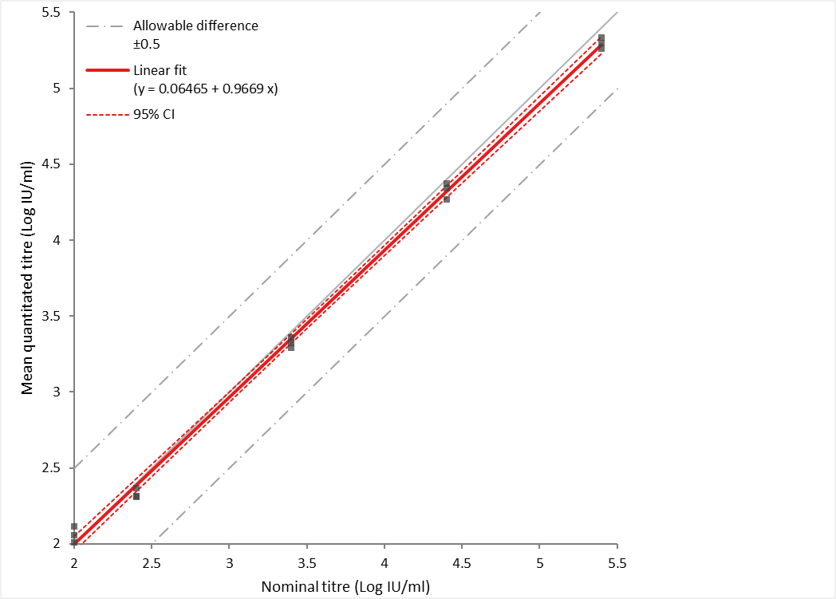

R2 = 0.998 (p = 0.61, KS-CUSUM*)

y-intercept (95% CI) = 0.065 (-0.029 – 0.158)

Slope (95% CI) = 0.967 (0.942 – 0.992)

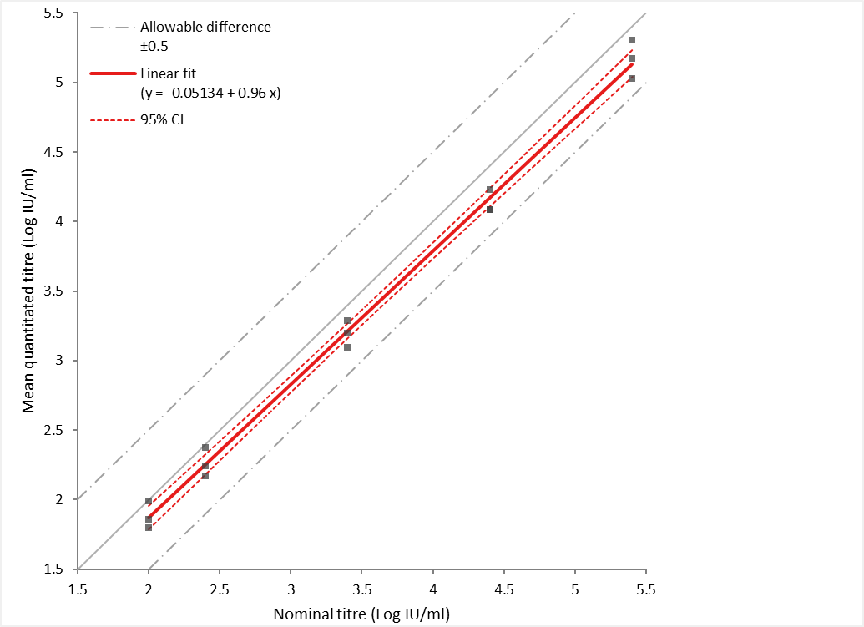

R2 = 0.995 (p = 0.91, KS-CUSUM*)

y-intercept (95% CI) = -0.051 (-0.212 – 0.109)

Slope (95% CI) = 0.960 (0.917 – 1.003)

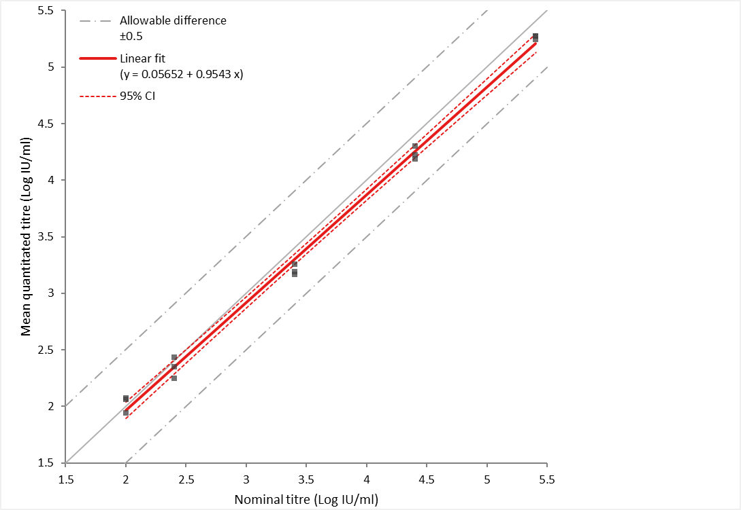

R2 = 0.996 (p = 0.61, KS-CUSUM*)

y-intercept (95% CI) = 0.057 (-0.081 – 0.194)

Slope (95% CI) = 0.954 (0.918 – 0.991)

**Figure S1.** Linearity of the cobas® CMV for urine preserved in cobas® PCR media (regression plot left), saliva preserved in eNAT® PCR media (regression plot middle) and vaginal secretion preserved in cobas® PCR media (regression plot right). The box below each regression plot shows the regression parameters and associated 95% CI. * KS-CUSUM, Kolmogorov-Smirnov-CUSUM test.

**Table S8** Viral targets assessed for cross-reactivity with the cobas® CMV for urine and vaginal secretion preserved in cobas® PCR media and saliva preserved in eNAT® PCR media.

|  |  |
| --- | --- |
| Target | Source |
| Adenovirus type 1α | Zeptometrix NATRPC2.1-BIO (Resp panel) |
| Adenovirus type 2α | 1st WHO international standard, 16/324 |
| Adenovirus type 3α | Zeptometrix NATRPC2.1-BIO (Resp panel) |
| Adenovirus type 31α | Zeptometrix NATRPC2.1-BIO (Resp panel) |
| BK polyomavirusβ | Zeptometrix NATBK-ERCM (calibrated to 1st WHO IS, 14/212) |
| Coronavirus 229Eα | Zeptometrix NATRPC2.1-BIO (Resp panel) |
| Coronavirus HKU-1α | Zeptometrix NATRPC2.1-BIO (Resp panel) |
| Coronavirus NL63α | Zeptometrix NATRPC2.1-BIO (Resp panel) |
| Coronavirus OC43α | Zeptometrix NATRPC2.1-BIO (Resp panel) |
| Coxsackievirus A9α | Zeptometrix NATEVPOS-6MC |
| Epstein-Barr virus, B95-8 strain (type 1)γ | 1st WHO international standard, 09/260 |
| Human Immunodeficiency Virus type 1, subtype Bδ | 3rd WHO international standard, 10/152 |
| Human Immunodeficiency Virus type 2, subtype A | 1st WHO international standard, 08/150 |
| Hepatitis B virus, genotype A2, HBsAg subtype adw2ε | 4th WHO international standard, 10/266 |
| Hepatitis C virus, genotype 1aζ | 5th WHO international standard, 14/150 |
| Herpes simplex virus type 2, strain MSη | Zeptometix NATMEC-BIO (ME panel) |
| Human Metapneumovirus type 8, strain Peru6-2003α | Zeptometrix NATRPC2.1-BIO (Resp panel) |
| Influenza A 2009 H1N1pdm, strain A/NY/02/2009α | Zeptometrix NATRPC2.1-BIO (Resp panel) |
| Influenza A H1N1, strain A/New Caledonia/20/99α | Zeptometrix NATRPC2.1-BIO (Resp panel) |
| Influenza A H3N2, strain A/Brisbane/10/07α | Zeptometrix NATRPC2.1-BIO (Resp panel) |
| Influenza B, strain B/Florida/02/06α | Zeptometrix NATRPC2.1-BIO (Resp panel) |
| Middle East Respiratory Syndrome Coronavirusα | Zeptometrix NATCOV(MR)-BIO (NATtrol MERS-S cerevisiae BioFire) |
| Mumps virus, Isolate 1θ | Zeptometrix Mumps (ref 0831015) |
| Parainfluenza type 1α | Zeptometrix NATRPC2.1-BIO (Resp panel) |
| Parainfluenza type 2α | Zeptometrix NATRPC2.1-BIO (Resp panel) |
| Parainfluenza type 3α | Zeptometrix NATRPC2.1-BIO (Resp panel) |
| Parainfluenza type 4α | Zeptometrix NATRPC2.1-BIO (Resp panel) |
| Parechovirus type 3η | Zeptometix NATMEC-BIO (ME panel) |
| Respiratory Syncytial Virus type A, 2006 isolateα | Zeptometrix NATRPC2.1-BIO (Resp panel) |
| Rhinovirus type 1Aα | Zeptometrix NATRPC2.1-BIO (Resp panel) |
| Severe Acute Respiratory Syndrome Coronavirus-2 (WT, England/02/2020 isolate)κ | 1st WHO international standard, 02/146 |
| Varicella Zoster virus, Ellen strainη | Zeptometix NATMEC-BIO (ME panel) |

Resp panel, respiratory panel; ME panel, meningitis/encephalitis panel.

Target confirmed positive by: **α** FilmArray® Respiratory Panel 2.1 plus assay; **β**cobas® BKV assay; **γ** cobas® EBV assay; **δ** cobas® HIV-1 assay; **ε** cobas® HBV assay; **ζ** cobas® HCV assay; **η** FilmArray® Meningitis/Encephalitis Panel assay; **θ** Fast-Track Diagnostics Viral Meningitis assay; **κ** AusDiagnostics Respiratory Pathogens 24-well assay.

**Table S9** Non-viral targets assessed for cross-reactivity with the cobas® CMV for urine and vaginal secretion preserved in cobas® PCR media and saliva preserved in eNAT® PCR media.

|  |  |
| --- | --- |
| Target | Source |
| *Bordetella pertussis,* strain A639α | Zeptometrix NATRPC2.1-BIO (Resp panel) |
| *Bordetella parapertussis,* strain A747α | Zeptometrix NATRPC2.1-BIO (Resp panel) |
| *Chlamydia pneumoniae,* strain CWL-029α | Zeptometrix NATRPC2.1-BIO (Resp panel) |
| *Chlamydia trachomatisλ* | Seracare AC342 CT/NG Positive control, Cultured CT/NG |
| *Haemophilus influenzae,* strain MinnAη | Zeptometix NATMEC-BIO (ME panel) |
| *Listeria monocytogenes,* serotype 1/2bη | Zeptometix NATMEC-BIO (ME panel) |
| *Mycoplasma genitalium,* strain SEA-1μ | Zeptometrix NATMGN-ERC |
| *Mycoplasma pneumoniae,* strain M129α | Zeptometrix NATRPC2.1-BIO (Resp panel) |
| *Neisseria gonorrhoeaeλ* | Seracare AC342 CT/NG Positive control, Cultured CT/NG |
| *Neisseria meningitidis,* serogroup Aη | Zeptometix NATMEC-BIO (ME panel) |
| *Streptococcus agalactiae,* strain Z019η | Zeptometix NATMEC-BIO (ME panel) |
|  |  |
| *Trichomonas vaginalis,* strain Z070μ | Zeptometrix NATTVPOS-6MC |
|  |  |
| *Pneumocystis jirovecii,* recombinant strain W303-Pji | Zeptometrix *P. jirovecii*-*S.cerevisiae* recombinant (ref 801698) |

Resp panel, respiratory panel; ME panel, meningitis/encephalitis panel.

Target confirmed positive by: **α** FilmArray® Respiratory Panel 2.1 plus assay; **η** FilmArray® Meningitis/Encephalitis Panel assay; **λ** cobas® CT/NG assay; **μ** cobas® TV/MG assay.

|  |  |  |  |
| --- | --- | --- | --- |
| Pathogen (final titre [10x IU/ml] or dilution [1:Y]) | cobas® CMV (mean of two replicate) | | |
| **Urine** | **Saliva** | **Vaginal secretion** |
| AdV (104)α | ND | ND | ND |
| AdV (104)α + CMV (103) | 3.11 | 2.98 | 2.97 |
| BKV (104)β | ND | ND | ND |
| BKV (104)β + CMV (103) | 3.10 | 2.76 | 3.11 |
| Coxsackievirus A9 (1:1)α | ND | ND | ND |
| Coxsackievirus A9 (1:1)α + CMV (103) | 3.20 | 3.11 | 3.04 |
| EBV (104)γ | ND | ND | ND |
| EBV (104)γ + CMV (103) | 3.17 | 3.03 | 3.03 |
| HIV-1 (104)δ | ND | ND | ND |
| HIV-1 (104)δ + CMV (103) | 3.18 | 2.96 | 2.99 |
| HIV-2 (102) | ND | ND | ND |
| HIV-2 (102) + CMV (103) | 3.13 | 3.07 | 3.04 |
| HBV (104)ε | ND | ND | ND |
| HBV (104)ε + CMV (103) | 3.18 | 3.04 | 3.12 |
| HCV (104)ζ | ND | ND | ND |
| HCV (104)ζ + CMV (103) | 3.14 | 3.05 | 3.10 |
| Meningitis/Encephalitis Panel 2 (1:1)η | ND | ND | ND |
| Meningitis/Encephalitis Panel 2 (1:1)η + CMV (103) | 3.08 | 3.00 | 2.97 |
| MERS (1:5)α | ND | ND | ND |
| MERS (1:5)α + CMV (103) | 3.21 | 3.11 | 3.09 |
| Mumps virus (1:1)θ | ND | ND | ND |
| Mumps virus (1:1)θ + CMV (103) | 3.14 | 2.90 | 3.05 |
| Respiratory Panel 1 (1:1)α | ND | ND | ND |
| Respiratory Panel 1 (1:1)α + CMV (103) | 3.20 | 3.02 | 3.03 |
| Respiratory Panel 2 (1:1)α | ND | ND | ND |
| Respiratory Panel 2 (1:1)α + CMV (103) | 3.10 | 3.04 | 3.01 |
| SARS-CoV-2 (104)κ | ND | ND | ND |
| SARS-CoV-2 (104)κ + CMV (103) | 3.11 | 3.05 | 3.10 |
| *C. trachomatis*/*N. gonorrhoeae* (1:1)*λ* | ND | ND | ND |
| *C. trachomatis*/*N. gonorrhoeae* (1:1)*λ* + CMV (103) | 3.03 | 3.02 | 3.01 |
| *M. genitalium* (1:1)μ | ND | ND | ND |
| *M. genitalium* (1:1)μ + CMV (103) | 3.25 | 2.87 | 2.87 |
| *T. vaginalis* (1:1)μ | ND | ND | ND |
| *T. vaginalis* (1:1)μ + CMV (103) | 2.96 | 3.08 | 3.08 |
| *P. jirovecii* (1:1) | ND | ND | ND |
| *P. jirovecii* (1:1) + CMV (103) | 3.08 | 2.99 | 2.97 |

**Table S10** Mean CMV DNA titre recovered by cobas® CMV in the presence of non-CMV pathogens.

Target(s) confirmed positive by: **α** FilmArray® Respiratory Panel 2.1 plus assay; **β**cobas® BKV assay; **γ** cobas® EBV assay; **δ** cobas® HIV-1 assay; **ε** cobas® HBV assay; **ζ** cobas® HCV assay; **η** FilmArray® Meningitis/Encephalitis Panel assay; **θ** Fast-Track Diagnostics Viral Meningitis assay; **κ** AusDiagnostics Respiratory Pathogens 24-well assay; **λ** cobas® CT/NG assay; **μ** cobas® TV/MG assay.

**Table S11** Characteristics of neonatal samples.

|  |  |  |
| --- | --- | --- |
|  | Sample | |
| **Urine** | **Saliva swabs** |
| Neonates investigated (n)  Sample tested (n) | 25  148 | 12  100 |
| *Reason for CMV PCR test request (n)* |  |  |
| Congenital CMV (cCMV) | 11 | 8 |
| Intrauterine growth restriction | 6 | 1 |
| Premature baby | 6 | 0 |
| Suspected sepsis | 5 | 1 |
| Small for gestational age | 3 | 0 |
| Microcephaly | 2 | 1 |
| Raised C-reactive protein | 2 | 1 |
| Conjugated hyperbilirubinemia/jaundice | 2 | 0 |
| Distended abdomen | 2 | 0 |
| Cranial/periventricular/caudothalamic cysts | 2 | 0 |
| Splenomegaly | 1 | 1 |
| Thrombocytopenia | 1 | 1 |
| TORCH screen | 1 | 1 |
| Hydrocephalus | 1 | 0 |
| Ventriculomegaly | 1 | 0 |
| Petechial rash | 1 | 0 |
| Low birth weight | 1 | 0 |
| Necrotising enterocolitis | 1 | 0 |
| Respiratory distress | 1 | 0 |
| Lower respiratory tract infection | 1 | 0 |
| Abnormal movements | 1 | 0 |
| Gastroschisis | 1 | 0 |
| Special Care Baby Unit/Neonatal unit admission | 1 | 0 |
| Failed newborn hearing test, cCMV | 0 | 4 |

**Table S12** Number of spiked and non-spiked adult female urine, saliva swabs and vaginal swabs tested for the performance evaluation of the cobas® CMV with reference laboratory assays.

|  |  |  |  |  |  |  |
| --- | --- | --- | --- | --- | --- | --- |
| **Sample** | **Reference laboratory PCR result\*** | **Pregnant, spiked^ (n)** | **Pregnant, not spiked (n)** | **Not pregnant, spiked^ (n)** | **Not pregnant, not spiked**  **(n)** | **Total**  **(n)** |
| Urine | Detected | 12 | 59 | 18 | 1 | 90 |
| Not detected | 0 | 44 | 0 | 15 | 59 |
| Saliva swabs | Detected | 48 | 0 | 43 | 2 | 93 |
| Not detected | 0 | 26 | 0 | 26 | 52 |
| Vaginal swabs | Detected | 10 | 60 | 28 | 9 | 107 |
| Not detected | 0 | 37 | 0 | 17 | 54 |

* Urine and vaginal swabs were tested by reference laboratory M. Saliva swabs were tested by reference laboratory R.

^ Spiked samples were prepared by spiking 1st WHO international standard for CMV into the appropriate sample type.

**Table S13** Number of adult females investigated in the performance evaluation of the cobas® CMV with reference laboratory assays.

|  |  |  |  |  |  |  |  |
| --- | --- | --- | --- | --- | --- | --- | --- |
| **Source and purpose of samples** | **Pregnancy status** | | | | | | |
| **Pregnant adult female (n)** | | |  | **Not pregnant adult female (n)** | | |
| **Urine** | **Saliva swab** | **Vaginal swab** |  | **Urine** | **Saliva swab** | **Vaginal swab** |
| Submitted by clinicians as part of the clinical investigation of, or follow up for, CMV infection in pregnancy | 2*^ | 1^ | 1^ |  | 2† | 2† | 2† |
| Female volunteers for the purpose of cobas® CMV assay evaluation | 0 | 1 | 0 |  | 5 | 3 | 5 |
| cCHIPS study (see reference 27) | 27 | 53 | 35 |  | 0 | 0 | 0 |

**\*** Adult female 1: Gravida 3, Para 1. Had a miscarriage at gravida 2 due to a primary CMV infection in pregnancy. **^** Adult female 2: Investigated for fetal ventriculomegaly and maternal CMV reinfection/reactivation at 31+4. **†** Follow-up consultation post-delivery (n = 1) and post-miscarriage (n = 1). Both women had laboratory confirmed primary CMV infection in pregnancy.