Table 1: Inclusion and exclusion criteria
Inclusion criteria
- Sickle Cell Disease (all genotypes; HbSS, HbSC…)
- Persistent pain (pain on most days for > 3 months) judged to be leading to significant physical disability and/or distress
- Age ≥ 18 years
- Motivated to attend weekly, group PMP
- Able to communicate within a group setting, with content delivered in English
- Able to attend suggested course dates
Exclusion criteria
- Unable to communicate within a group setting with content delivered in English
- Engagement in group anticipated to be impacted due to active, significant mental health problem (e.g., severe depression with suicidal ideation) or primary addiction problem
- Unable to attend PMP due to other commitment e.g., caring responsibility

Table 2. Core themes introduced within the 8 session SCPMP. All core themes were covered within each programme, however, the programme was designed to allow flexibility around time dedicated to each element depending on the relevance to, and needs of, each group as judged by the group facilitators. Core themes accounted for approximately 50% of the SCPMP per week (see supplementary Table 1). Both facilitators were present throughout all sessions.
Week 1 | Overview of programme, Impact of pain & CBT framework, Introducing Values & Goals.
Week 2 | Pain mechanisms. Goal setting (individual goals).
Week 3 | Activity cycles and pacing. Exercise and movement.
Week 4 | Psychoeducation; thoughts and feelings (1).
Week 5 | Communication (1). Individual review.
Week 6 | Thoughts & Feelings (2). Communication (2).
Week 7 | Managing increases in pain (1). Friends and family session.
Week 8 | Managing increases in pain (2). Review of progress, future goals and maintaining changes.

Table 3. Socio-demographic and clinical characteristics data of patients with sickle cell disease (SCD) participating in the pain management programme (n = 29). Values are frequencies (percentages) unless otherwise stated.
Age (mean years (SD)) | 41.8 (10.6; range 25-72)
Female / Male | 25 (86.2) / 4 (13.8)
Ethnicity
Black or Black British - African | 9 (31.0)
Black – any other Black background | 8 (27.6)
Other – not stated | 6 (20.7)
Black or Black British – Caribbean | 5 (17.2)
White – any other white background | 1 (3.4)
Employment status
Employed/Student | 15 (53.6)
Unemployed | 11 (39.3)
Retired | 2 (7.1)
Sickle cell genotype
HbSS | 19 (65.5)
HbSC | 6 (20.7)
HbS-B+ Thalassemia | 3 (10.3)
HbS-B0 Thalassemia | 1 (3.4)
Exchanges | 17 (58.6)
Transfusions | 3 (10.3)
Hydroxyurea | 3 (10.3)
SCD complications | 13 (44.8)
Other (chronic) pain condition | 9 (31.0)
Previous psychology or physiotherapy input | 12 (41.1)
Medication for pain
Opioids | 28 (96.6%)
Paracetamol | 26 (89.7%)
NSAIDs | 15 (51.7%)
Anti-epileptics | 7 (24.1%)
Most common pain sites
Hips and/or lower limbs | 25 (96.2%)
Upper limbs | 17 (65.4%)
Lower back and/or buttocks | 15 (57.7%)
Chest/Throat | 8 (30.8%)
Painful Crises (n = 27)
6-month frequency
None | 5 (18.5)
1-3 | 7 (25.9)
4-6 | 6 (22.2)
≥ 7 | 9 (33.3)
Pain crisis duration (average in days)
0-2 | 5 (20.8%)
3-7 | 12 (50.0%)
≥ 8 | 7 (29.2%)
Severity of crisis pain (0-10 scale)
≤ 7 | 6 (22.2%)
8-9 | 15 (55.6%)
10 | 6 (22.2%)
Note. HbSS denotes homozygosity for the sickle cell gene (HBB glu6val), sickle cell anemia; HbSC denotes heterozygosity for the sickle cell gene (HBB glu6val) and the haemoglobin C gene (HBB glu6lys), sickle-haemoglobin C disease; HbS-B thalassemia denotes heterozygosity for the sickle cell gene (HBB glu6val) and one of the B-thalassemia gene mutations; SCD complications included (but not limited to) acute chest syndrome, respiratory failure, pulmonary hypertension, splenectomy, cholecystectomy, avascular necrosis, osteomyelitis, and hepatic iron overload. Other (chronic) pain condition included endometriosis, migraine, osteoarthritis and (non-sickle cell-related) joint-related pain problems.

Table 4: Feasibility of delivering a SCPMP within a haemoglobinopathies service, judged against site specific criteria
Feasibility Criteria | Criteria met within study period.  (Yes/No)
- Able to recruit a minimum of eight participants to a minimum of one SCPMP per year | No
- Attendance at a minimum of 5/8 sessions by ≥80% of participants | Yes
- Completion of end of programme questionnaires by ≥80% of programme completers | Yes
- Mean treatment credibility and satisfaction scores > 5 on 0-9 scales (representing the midpoint of the scale or higher) | Yes
- Observed within-group differences from pre-to-post SCPMP of at least moderate magnitude (Hedge’s g ≥0.5), consistent with potentially clinically important changes, seen on at least some treatment outcomes and process measures (excluding pain intensity). | Yes

Table 5. Estimated marginal mean values for SCD patients at pre-PMP, post-PMP, and 1-month and 6-month follow-ups (intention-to-treat analyses).

 | Pre-PMP | Post-PMP | 1-month FU | 6-month FU |  | Pre-Post PMP effect size | Pre-6-month f/u effect size
 | Mean (95% CI) | Mean (95% CI) | Mean (95% CI) | Mean (95% CI) | p | Hedge’s g | Hedge’s g
Brief Pain Inventory
Pain Severity (0-10) | 5.06 (4.47,5.64) | 4.62 (3.95,5.29) | 5.24 (4.53,5.96) | 5.14 (4.37,5.90) | 0.420 | 0.27 | -0.05
Pain Interference (0-10) | 6.76 (6.02,7.50) | 4.88 (4.02,5.74) | 5.30 (4.37,6.23) | 5.53 (4.52,6.55) | 0.005 | 0.93 | 0.60
Pain Self Efficacy (PSEQ; 0-60) | 24.72 (20.80,28.65) | 34.79 (30.28,39.30) | 34.10 (29.29,38.91) | 34.90 (29.71,40.09) | <0.001 | 0.93 | 0.94
Pain Catastrophising (PCS; 0-52) | 31.59 (27.12,36.06) | 23.28 (18.40,28.16) | 22.84 (17.59,28.08) | 23.12 (17.08,29.15) | 0.002 | 0.68 | 0.69
Pain Acceptance (CPAQ; 0-48) | 17.79 (15.53,20.05) | 21.16 (18.66,23.67) | 22.45 (19.75,25.14) | 21.22 (18.26,24.18) | 0.015 | 0.54 | 0.55
Mood
Depression (HADS-D; 0-21) | 10.21 (8.74,11.68) | 6.85 (5.22,8.48) | 6.39 (4.69,8.10) | 7.26 (5.41,9.10) | <0.001 | 0.80 | 0.72
Anxiety (HADS-A; 0-21) | 12.86 (11.54,14.18) | 8.86 (7.34,10.37) | 9.51 (7.90,11.12) | 9.19 (7.41,10.98) | <0.001 | 1.10 | 1.01
Quality of life
EQ Health (-0.285 - 1.000) | 0.487 (0.388,0.586) | 0.596 (0.484,0.707) | 0.585 (0.467,0.702) | 0.588 (0.463,0.713) | 0.167 | 0.40 | 0.37
EQ VAS (0-100) | 55.87 (48.73,63.01) | 64.80 (56.92,72.67) | 59.21 (50.87,67.54) | 64.37 (54.44,73.30) | 0.127 | 0.47 | 0.45
Note. PMP = pain management programme; FU = follow-up; PSEQ = Pain Self-Efficacy Questionnaire; PCS = Pain Catastrophizing Scale; HADS = Hospital Anxiety and Depression Scale; EQ Health = EQ-5D-5L health state evaluation; EQ VAS = current overall health rating; CI = confidence interval. Significant effects are highlighted in bold. Positive effect sizes represent treatment benefit in corresponding measure.

Figure 1. Referrals to Red Cell Pain Management Service during study period
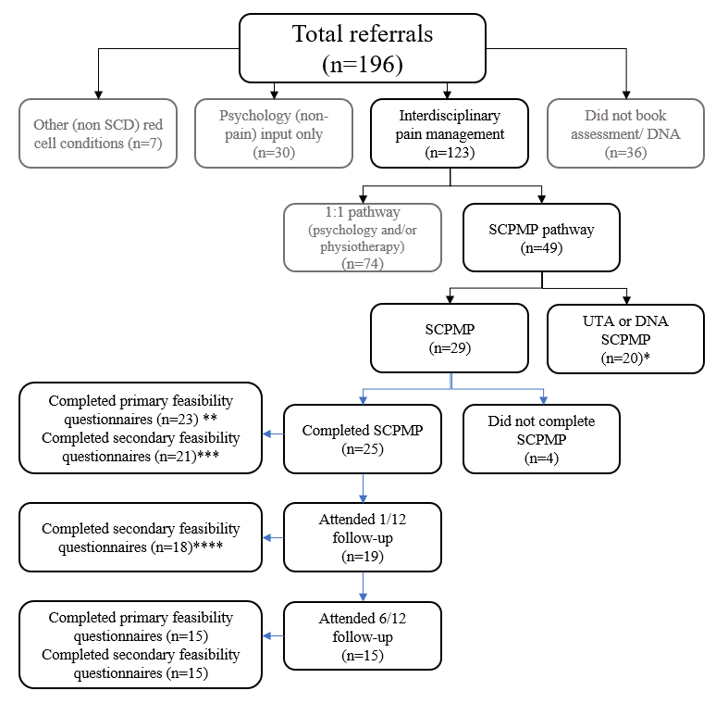
Note: DNA = Did Not Attend; UTA = Unable To Attend; 1/12 = follow-up 1 month after completion of SCPMP; 6/12 = follow-up six months after completion of SCPMP; * UTA/DNA SCPMP n=20 did not start the SCPMP during the study period and may have accessed 1:1 input, ceased involvement with the service or accessed the SCPMP after the study period; ** Primary feasibility questionnaires included credibility, satisfaction and acceptability scales and open-ended treatment experience questions; *** Secondary feasibility questionnaires included Brief Pain Inventory (Cleeland and Ryan, 1994), Hospital Anxiety and Depression Scale (Zigmond and Snaith, 1983), EQ5D5L (Herdman et al., 2011), Pain Self-efficacy Questionnaire (Nicolas, 2007) Pain Catastrophising Scale (Sullivan et al., 1995), Chronic Pain Acceptance Questionnaire) (Fish et al, 2010); **** Nb. Primary feasibility questionnaires were not included at this timepoint.

Figure 2. Recruitment to the SCPMP during the study period.

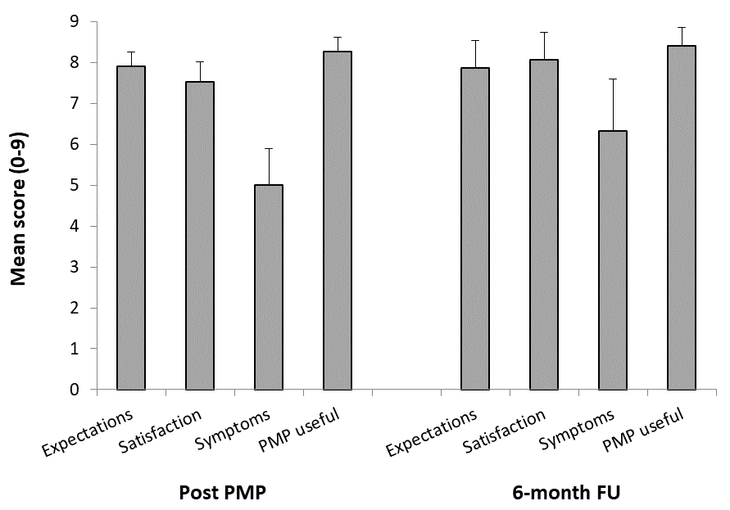

Figure 3. Acceptability, satisfaction and credibility of intervention at post-PMP (n=23) and 6 month follow-up (FU; n=15) according to meeting participants’ expectations of better pain management (‘Expectations’; 0 = ‘Not at all’, 10 = ‘Very much so’), satisfaction that the treatment programme helps manage their pain (‘Satisfaction’; 0 = ‘Not at all’, 10 = ‘Very much so’), feelings about spending the rest of their lives with the present symptoms (‘Symptoms’; 0 = ‘Not at all OK’, 10 = ‘Totally OK’), and agreement that the PMP is useful for someone with sickle cell disease (‘PMP useful’; 0 = ‘Not at all’, 10 = ‘Very much so’). Error bars represent 95% confidence intervals.
Supplementary Table 1. SCPMP session format. Each weekly session comprised two core topics/ themes and additional aspects which were repeated each week including mindfulness practice, for example. Emphasis was placed on experiential learning and reflection, open discussion, and integration of learning into daily life through between session practice. Participants were encouraged to experiment with strategies during the group, for example, integrating movement into periods of sitting.
Approximate time (mins) | Activity
40 | Introduction session (week 1)/ Reflection and review on content from previous session (weeks 2-8)
30 | Mindfulness practice and enquiry
50 | Core topic/ theme (e.g. pain mechanisms)
20 | Break
60 | Core topic/ theme (e.g. goal setting)
30 | Movement practice
40 | Plans for between session practice and personal values-based goal

Supplementary Table 2. Summary data and internal consistency of questionnaires and outcome measures for SCD patients at pre-PMP.

 | Baseline (Pre-PMP)
 | Mean (SD) | Cronbach alpha (95% CI)
Brief Pain Inventory
Pain Interference (0-10) | 6.76 (1.71) | 0.842 (0.735,0.916)
Pain Self Efficacy Questionnaire (PSEQ; 0-60) | 24.72 (11.66) | 0.914 (0.859,0.954)
Pain Catastrophizing Scale (PCS; 0-52) | 31.59 (12.55) | 0.928 (0.881,0.962)
Chronic Pain Acceptance Questionnaire (CPAQ; 0-48) | 17.79 (6.83) | 0.413 (0.015,0.691)
Hospital Anxiety and Depression Scale (HADS)
Depression (HADS-D; 0-21) | 10.21 (4.25) | 0.810 (0.682,0.899)
Anxiety (HADS-A; 0-21) | 12.86 (3.90) | 0.782 (0.634,0.884)
Connor-Davidson Resilience Scale (0-100) | 57.84 (18.03) | 0.935 (0.892,0.966)
Multidimensional Scale of Perceived Social Support (0-7) | 4.63 (1.61) | 0.949 (0.916,0.972)
Note. SCD = sickle cell disease; PMP = pain management programme; SD = standard deviation; CI = confidence interval.

Supplementary Table 5. Mean values for SCD patients at pre-PMP, post-PMP, and 1-month and 6-month follow-ups (treatment completer analyses).

 | Pre-PMP  (n=29) | Post-PMP (n=21) | 1-month FU (n=18) | 6-month FU (n=15) |  | Pre-Post-PMP effect size | Pre-6-month f/u effect size
 | Mean (SD) | Mean (SD) | Mean (SD) | Mean (SD) | p | Hedge’s g | Hedge’s g
Brief Pain Inventory
Pain Average (0-10) | 5.05 (1.26) | 4.68 (1.54) | 5.22 (1.51) | 5.28 (2.21) | 0.574 | 0.34 | 0.05
Pain Interference (0-10) | 6.76 (1.71) | 4.87 (1.93) | 5.25 (2.03) | 5.48 (2.47) | 0.021 | 1.04 | 0.74
Pain Self Efficacy (PSEQ; 0-60) | 24.72 (11.66) | 34.90 (9.30) | 34.22 (11.28) | 35.27 (8.39) | 0.026 | 0.92 | 1.11
Pain Catastrophising (PCS; 0-52) | 31.59 (12.55) | 22.86 (11.73) | 22.00 (10.44) | 21.77 (13.18) | 0.018 | 0.65 | 0.60
Pain Acceptance (CPAQ; 0-48) | 17.79 (6.83) | 21.48 (5.13) | 22.83 (4.63) | 21.33 (6.52) | 0.192 | 0.48 | 0.35
Mood
Depression (HADS-D; 0-21) | 10.21 (4.25) | 6.67 (3.57) | 6.28 (3.59) | 6.57 (3.52) | 0.002 | 0.85 | 0.77
Anxiety (HADS-A; 0-21) | 12.86 (3.90) | 8.86 (3.53) | 9.39 (2.66) | 9.00 (3.70) | 0.040 | 1.07 | 0.85
Quality of life
EQ Health (-0.285 - 1.000) | 0.487 (0.283) | 0.603 (0.269) | 0.585 (0.249) | 0.617 (0.209) | 0.360 | 0.37 | 0.37
EQ VAS (0-100) | 55.78 (18.96) | 62.81 (16.47) | 57.39 (20.14) | 62.47 (18.36) | 0.189 | 0.57 | 0.59
Note. PMP = pain management programme; FU = follow-up; PSEQ = Pain Self-Efficacy Questionnaire; PCS = Pain Catastrophizing Scale; HADS = Hospital Anxiety and Depression Scale; EQ Health = EQ-5D-5L health state evaluation; EQ VAS = current overall health rating; CI = confidence interval. Significant effects are highlighted in bold. Positive effect sizes represent treatment benefit in corresponding measure.

Supplementary Table 3: Content Analysis of open-ended questions on completion of SCPMP (n=23)
Q1. ‘What did you find most useful about the SCPMP?’ | Q2. ‘Was there anything that you would have liked to be different?’ | Q3.‘Is there anything that you will do differently now that the programme has finished?’
Understanding pain (n=10) | Nothing/ No change (n=11) | Pace activity (n=5)
Group aspects (support, discussion, shared experience) (n=4) | Mixing some sessions to have both patients and healthcare professionals present (n=3) | Mindfulness (n=4)
Practical tips/ coping strategies (n=4) | Longer course (n=2) | Work towards goals (n=3)
Understanding/ managing cognitive and emotional aspects (n=3) | Longer friends and family session (n=2) | Notice/manage thoughts (n=3)
Prioritising/ being kind to self (n=3) | Discussion of cultural differences (n=1) | Communicate more about pain (n=3)
Listening to my body (n=3) | Discussion of expectations of a person with SCD from family (n=1) | Exercise or movement (n=3)
Pacing (n=3) | Planning more (n=1) | Look after/ prioritise myself more (n=2)
Communication (n=2) | Dealing with conflicts in hospital procedures and people (n=1) | Breathing exercises (n=2)
Friends and Family session (n=2) | More (physiotherapy) exercise or movement (n=1) | Live my life (despite pain) (n=2)
Exercise (n=2) | More time for mindfulness (n=1) | Try not to stop activity (due to pain) (n=1)
Mindfulness (n=2) |  | Try to worry less (about pain) (n=1)
Insightful topics included (n=1) |  | Delegate more (n=1)
Understanding/ managing stress (n=1) |  | Take time to relax (n=1)
Planning (n=1) |  | Review information given to refresh myself whenever I am feeling low (n=1)
Goal setting (n=1)
Understanding Sickle Cell Disease (n=1)
Having a flare-up box (n=1)
Achieving goals and values (n=1)
Detailed information (n=1)
Breathing exercises (n=1)
Reflection session each week (n=1)

Supplementary Table 4: Content Analysis of open-ended questions at 6/12 follow-up session (n=15)
Q1. ‘What did you find most useful about the SCPMP?’ | Q2. What has the SCPMP led you to think about, or do, differently?
Understanding pain (n=3) | Pace activity (n=6)
Communication skills (n=3) | Exercise (n=5)
Management strategies (n=2) | Communicate more/ more effectively (n=4)
Goal setting (n=2) | Altered perspective/ attitude toward pain (n=4)
Pacing (n=2) | Ask for/ accept help when needed (n=2)
Managing cognitive and emotional aspects (n=2) | Plan more (n=1)
Altered perspective (n=2) | Take time out to care for me (n=1)
Input from facilitators (n=2) | Use medication earlier (n=1)
Weekly sessions (n=1) | Differentiate between acute pain and chronic pain (n=1)
Values (n=1)
Group aspects (n=1)
Learning to be kind to self (n=1)
Exercise (n=1)
SCPMP manual (n=1)
Mindfulness (n=1)
Relaxation techniques (n=1)
Knowing I’m not alone with the feelings that I have (n=1)

