Appendix
Table S1. Detailed description of LGE patterns.
Patient |  |  | Location | Segment
1 | Non ischemic | Junctional | Mid inferior | 10
2 | Non ischemic | Intramyocardial | Basal inferolateral | 5
3 | Non ischemic | Intramyocardial | Basal inferolateral | 5
4 | Non ischemic | Subepicardial | Basal inferolateral | 5
5 | Non ischemic | Junctional | Mid | 7,8,9,10,11,12
6 | Non-ischemic | Subepicardial | Basal inferolateral | 5
7 | Non ischemic | Subepicardial | Basal inferior and inferolateral | 4,5
8 | Non ischemic | Patchy | Basal inferolateral, mid inferolateral | 5,11
9 | Non-ischemic | Intramyocardial | Mid anteroseptal and inferoseptal, apical septal | 8,9,14
10 | Non ischemic | Junctional | Basal inferoseptal, mid inferoseptal | 3,9
11 | Non ischemic | Subendocardial | Septal inferior
12 | Non ischemic |  | Basal inferior | 4
13 | Non ischemic | Intramyocardial | Basal inferior | 4

Table S2. Combination of MVP and MAD and arrhythmogenicity.
 | No inferolateral MAD | Inferolateral MAD only | Inferolateral MAD and MVP | Two sites | Three sites | All sites
High PVC burden, n(%) | 36/158 (23%) | 7/14 (50%) | 9/10 (90%) | 7/34 (21%) | 5/11 (46%) | 8/8 (100%)
Non-sustained VT, n(%) | 62/152 (41%) | 7/14 (50%) | 8/10 (80%) | 12/33 (36%) | 6/11 (55%) | 7/8 (88%)
Appropriate ICD therapy, n(%) | 29/158 (19%) | 2/14 (14%) | 1/10 (10%) | 4/34 (12%) | 0/11 (0%) | 2/8 (25%)
Abbreviations: MAD; mitral annular disjunction, MVP; mitral valve prolapse, PVC; premature ventricular complex, VT; ventricular tachycardia, ICD; implantable cardioverter defibrillator.

Table S3. Proarrhythmic characteristics stratified by the presence of MVP.
 | MVP | No MVP | P-value
High PVC burden, n(%) | 10/13 (77%) | 41/167 (25%) | <0.001
Non-sustained VT, n(%) | 9/13 (69%) | 66/161 (41%) | 0.048
Appropriate ICD therapy, n(%) | 2/13 (15%) | 28/166 (17%) | 1.000
Abbreviations: MVP; mitral valve prolapse, PVC; premature ventricular complex, ICD; implantable cardioverter defibrillator, VT; ventricular tachycardia.

Table S4. Proarrhythmic characteristics stratified by total MAD sum.
 |  | High PVC Burden |  | Non-sustained VT |  | ICD-therapy
≥4mm (mean) | Yes | 31/78  (40%) | 0.004 | 37/77  (48%) | 0.310 | 11/76  (15%) | 0.351
 | No | 21/104 (20%) |  | 40/99 (40%) |  | 21/106 (20%)
≥3mm (median) | Yes | 32/97  (33%) | 0.159 | 44/95  (46%) | 0.457 | 14/94  (15%) | 0.325
 | No | 20/85 (24%) |  | 33/81 (41%) |  | 18/88 (21%)
≥6mm (75th) | Yes | 22/49  (45%) | 0.003 | 24/48  (50%) | 0.306 | 7/49  (14%) | 0.478
 | No | 30/133 (23%) |  | 53/128 (41%) |  | 25/133 (19%)
≥10mm (90th) | Yes | 11/20  (55%) | 0.006 | 11/19  (58%) | 0.188 | 2/20  (10%) | 0.535
 | No | 41/162 (25%) |  | 76/157 (42%) |  | 30/162 (19%)
≥12mm (95th) | Yes | 7/10  (70%) | 0.009 | 7/10  (70%) | 0.107 | 2/10  (20%) | 0.689
 | No | 45/172 (28%) |  | 70/166 (42%) |  | 30/172 (17%)
Abbreviations: MAD; mitral annular disjunction, ICD; implantable cardioverter defibrillator, PVC; premature ventricular complex.

Table S5. Mitral regurgitation in 13 IVF patients with MVP.
 | Mitral regurgitation on echocardiogram or CMR | Bileaflet prolapse | Flail
MVP patient 1 | Mild MR | Yes | No
MVP patient 2 | Mild MR | No | No
MVP patient 3 | No | No | No
MVP patient 4 | No | Yes | No
MVP patient 5 | Mild MR | No | No
MVP patient 6 | Mild MR | Yes | No
MVP patient 7 | Mild MR | Yes | No
MVP patient 8 | No | No | No
MVP patient 9 | No | No | No
MVP patient 10 | Mild MR | Yes | No
MVP patient 11 | Mild MR | Yes | No
MVP patient 12 | No | No | No
MVP patient 13 | No | No | No
Abbreviations: MR; mitral regurgitation, MVP; mitral valve prolapse
Table S6. Anti-arrhythmic medication use of IVF patients with and without inferolateral MAD. Patients using anti-arrhythmic medication for supraventricular tachycardia, hypertension, or non-cardiac causes are not listed as IVF patients using anti-arrhythmic medication.
 | Inferolateral MAD  N = 22 | No inferolateral MAD  N = 144 | P
Anti-arrhythmic medication use at last follow-up | 16 (73%) | 76 (53%) | 0.080
Anti-arrhythmic medication use during follow-up | 18 (82%) | 82 (57%) | 0.026
Abbreviations: MAD; mitral annular disjunction, IVF; idiopathic ventricular fibrillation.

Table S7. Genetic tests results of patients with inferolateral MAD.
ID | Genetic test results
1 | Likely Pathogenic TRDN and PPA2, VUS ANK2 and TTN
2 | Normal (only arrhythmia panel tested)
3 | Normal (only arrhythmia panel tested)
4 | Normal (only arrhythmia panel tested)
5 | Normal (only arrhythmia panel tested)
6 | Normal (only arrhythmia panel tested)
7 | Normal (only arrhythmia panel tested)
8 | Normal (only arrhythmia panel tested)
9 | VUS KCNE1
10 | Normal
11 | Missing
12 | Missing
13 | Normal (only arrhythmia panel tested)
14 | Normal (only arrhythmia panel tested)
15 | VUS CACNB2 and RMB20
16 | Normal
17 | Normal
18 | Pathogenic TTN
19 | VUS DSP and TMEM43
20 | Normal
21 | Missing
22 | Missing
23 | Missing
24 | Missing

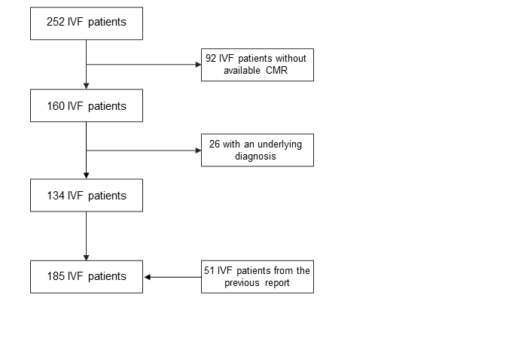
Figure S1. Inclusion flow-chart. IVF patients from 9 collaborating centres (n = 252) were evaluated for inclusion. In total, 51 patients were included from our previous report.

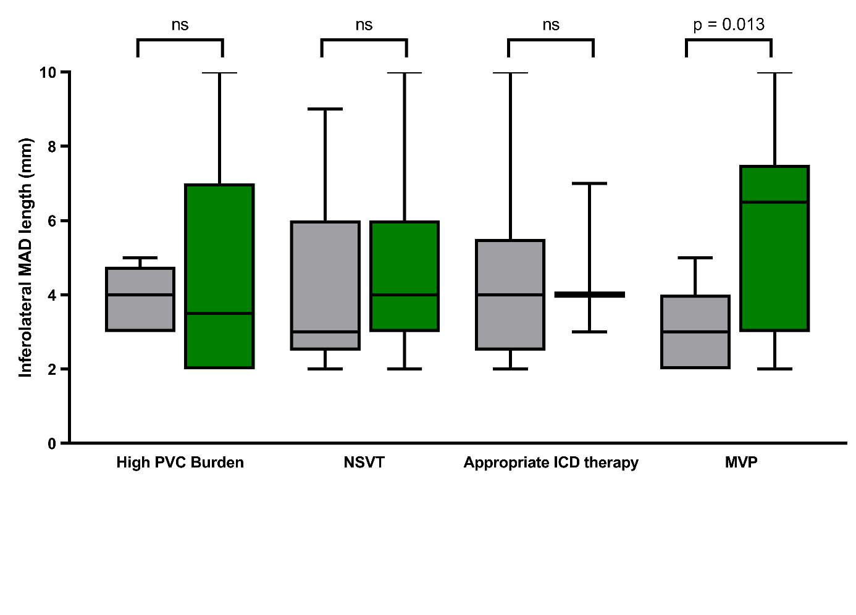
Figure S2. Influence of the length of MAD on PVC burden, non-sustained VT, appropriate ICD therapy or MVP. Green boxes indicate ‘Yes’, grey boxes indicate ‘No’. Abbreviations: PVC; premature ventricular complex, VT; ventricular tachycardia, ICD; implantable cardioverter defibrillator, MAD; mitral annular disjunction, MVP: mitral valve prolapse.

