**SUPPLEMENTAL APPENDIX**

**Association between a hospitalization for heart failure and the initiation/discontinuation of guideline-recommended treatments - An analysis from the Swedish heart failure registry**

Schrage B et al.

*SwedeHF Study cohort*

SwedeHF is an ongoing nationwide registry prospectively enrolling in- and out-patients since May 11th 2000. Until April 2017, clinician-judged HF was the only enrollment criterion. Thereafter, patients were enrolled when a HF diagnosis according to the International Statistical Classification of Diseases, Tenth Revision (ICD-10) codes I50.0, I50.1, I50.9, I42.0, I42.6, I42.7, I25.5, I11.0, I13.0, I13.2 was recorded. Beyond the ~80 variables which are recorded at index date (day of hospital discharge for in-patients and of an out-patient visit for out-patients) in SwedeHF, further data were obtained by linkage with other nationwide registries through the Swedish Personal Identification Number, i.e., to the National Patient Register which provided additional comorbidities and data on hospitalizations, to Statistics Sweden which collects socioeconomic data, to the National Prescribed Drug Register which provided data on the dispensed treatments, and to the Cause of Death Register which reports date and cause of death. Further information on this study, e.g., the definition of comorbidities via ICD-10 codes, is provided at https://kiheartfailure.github.io/shfdb3/.

This study, including the linkage of SwedeHF to other nationwide registries, was approved by the Swedish Ethical Review Authority and was designed and conducted in agreement with the Declaration of Helsinki. Individual patient consent is not requested, but patients are informed about enrollment and can opt out.

*Supplement Table 1.* Association between a heart failure hospitalization and initiation/discontinuation of heart failure treatments stratified by renal function in three strata.

|  |  |  |  |  |  |  |
| --- | --- | --- | --- | --- | --- | --- |
|  | eGFR ≥60  ml/min/1.73m2 | | eGFR 30-59 ml/min/1.73m2 | | eGFR <30  ml/min/1.73m2 | |
| Initiation | | | | | | |
| *MRA initiation* |  | |  | |  | |
| Event rate in out- vs. inpatients | 634 (18.1%) | 1082 (52.2%) | 208 (13.6%) | 794 (36.6%) | 12 (7.5%) | 80 (16.9%) |
| Crude OR (95% CI), p-value | 4.9 (4.4-5.6), <0.001 | | 3.7 (3.1-4.3), <0.001 | | 2.5 (1.3-4.8), 0.004 | |
| *RASi/ARNi initiation* |  | |  | |  | |
| Event rate in out- vs. inpatients | 243 (61.7%) | 524 (80.5%) | 117 (45.0%) | 375 (58.9%) | 10 (21.3%) | 64 (32.2%) |
| Crude OR (95% CI), p-value | 2.6 (1.9-3.4), <0.001 | | 1.7 (1.3-2.3), <0.001 | | 1.8 (0.8-3.7), 0.147 | |
| *Betablocker initiation* |  | |  | |  | |
| Event rate in out- vs. inpatients | 287 (47.2%) | 539 (75.5%) | 92 (36.1%) | 361 (68.0%) | 6 (46.2%) | 59 (66.3%) |
| Crude OR (95% CI), p-value | 3.4 (2.7-4.4), <0.001 | | 3.8 (2.7-5.1), <0.001 | | 2.3 (0.7-7.4), 0.166 | |
| *Loop diuretic initiation* |  | |  | |  | |
| Event rate in out- vs. inpatients | 467 (16.0%) | 814 (76.1%) | 194 (27.4%) | 562 (88.5%) | 13 (43.3%) | 65 (85.5%) |
| Crude OR (95% CI), p-value | 16.7 (14.1-19.8), <0.001 | | 20.4 (15.2-27.3), <0.001 | | 7.7 (2.9-20.3), <0.001 | |
| Discontinuation | | | | | | |
| *MRA discontinuation* |  | |  | |  | |
| Event rate in out- vs. inpatients | 176 (11.3%) | 139 (14.0%) | 156 (19.4%) | 252 (24.8%) | 18 (38.3%) | 49 (36.0%) |
| Crude OR (95% CI), p-value | 1.3 (1.0-1.6), 0.045 | | 1.4 (1.1-1.7), 0.006 | | 0.9 (0.5-1.8), 0.781 | |
| *RASi/ARNi discontinuation* |  | |  | |  | |
| Event rate in out- vs. inpatients | 125 (2.7%) | 117 (4.8%) | 91 (4.4%) | 204 (8.0%) | 31 (19.3%) | 73 (17.8%) |
| Crude OR (95% CI), p-value | 1.8 (1.4-2.4), <0.001 | | 1.9 (1.5-2.4), <0.001 | | 0.9 (0.6-1.5), 0.696 | |
| *Betablocker discontinuation* |  | |  | |  | |
| Event rate in out- vs. inpatients | 147 (3.3%) | 120 (5.1%) | 71 (3.4%) | 118 (4.4%) | 8 (4.1%) | 34 (6.6%) |
| Crude OR (95% CI), p-value | 1.6 (1.2-2.0), <0.001 | | 1.3 (1.0-1.8), 0.076 | | 1.6 (0.7-3.6), 0.219 | |
| *Loop diuretic discontinuation* |  | |  | |  | |
| Event rate in out- vs. inpatients | 492 (23.0%) | 113 (5.7%) | 221 (13.6%) | 86 (3.4%) | 13 (7.3%) | 20 (3.8%) |
| Crude OR (95% CI), p-value | 0.2 (0.2-0.2), <0.001 | | 0.2 (0.2-0.3), <0.001 | | 0.5 (0.2-1.0), 0.056 | |

Initiation/discontinuation of heart failure treatments is compared between patients with a heart failure hospitalization vs. out-patients (i.e., patients without a heart failure hospitalization), stratified by eGFR. For initiation of heart failure treatments, no prior treatment was defined as no dispensed prescription within 8 months to 1 day before the index date, and post treatment was defined as 2 dispensed prescriptions from the index date until 8 months thereafter, and vice versa for discontinuation of heart failure treatments. Crude event rates and crude odds ratios are shown. eGFR: Estimated glomerular filtration rate; OR: Odds ratio; CI: Confidence interval; MRA: Mineralocorticoid receptor antagonist; HFrEF: Heart failure with reduced ejection fraction; HFmrEF: Heart failure with mildly reduced ejection fraction; RASi: Renin-aldosteron-system inhibitors; ARNi: Angiotensin-receptor neprilysin-inhibitors.

*Supplement Figure 1.* Outline of the study design.



HF: Heart failure.

*Supplement Figure 2.* Likelihood of initiation/discontinuation of heart failure treatments in patients with vs. without a heart failure hospitalization, stratified by renal function in two strata.

**

Initiation/discontinuation of heart failure treatments is compared between patients with a heart failure hospitalization vs. out-patients (i.e., patients without a heart failure hospitalization), stratified by eGFR in two strata. For initiation of heart failure treatments (A), no prior treatment was defined as no dispensed prescription within 6 months to 1 day before the index date, and post treatment is defined as 1 dispensed prescription from the index date until 6 months thereafter, and vice versa for discontinuation of heart failure treatments (B). Crude event rates and adjusted odds ratios are shown, and variables used for adjustment in the underlying logistic regression model are reported in *Table 1*. An OR >1 indicates a higher, and an OR <1 indicates a lower likelihood of initiation/discontinuation of heart failure treatments in hospitalized patients. eGFR: Estimated glomerular filtration rate; OR: Odds ratio; CI: Confidence interval; MRA: Mineralocorticoid receptor antagonist; HFrEF: Heart failure with reduced ejection fraction; HFmrEF: Heart failure with mildly reduced ejection fraction; RASi: Renin-aldosteron-system inhibitors; ARNi: Angiotensin-receptor neprilysin-inhibitors.

*Supplement Figure 3.* Initiation/discontinuation of heart failure treatments in relation to recurrent heart failure hospitalizations over time.



Initiation/discontinuation of heart failure treatments in patients after an heart failure hospitalization (x-axis) is displayed in relation to the number of heart failure hospitalizations within a given time period (y-axis). MRA: Mineralocorticoid receptor antagonist; RASi: Renin-aldosteron-system inhibitors; ARNi: Angiotensin-receptor neprilysin-inhibitors; HHF: Heart failure hospitalization

*Supplement Figure 4.* Association between initiation/discontinuation of heart failure treatments and 3-year cardiovascular mortality following a heart failure hospitalization.

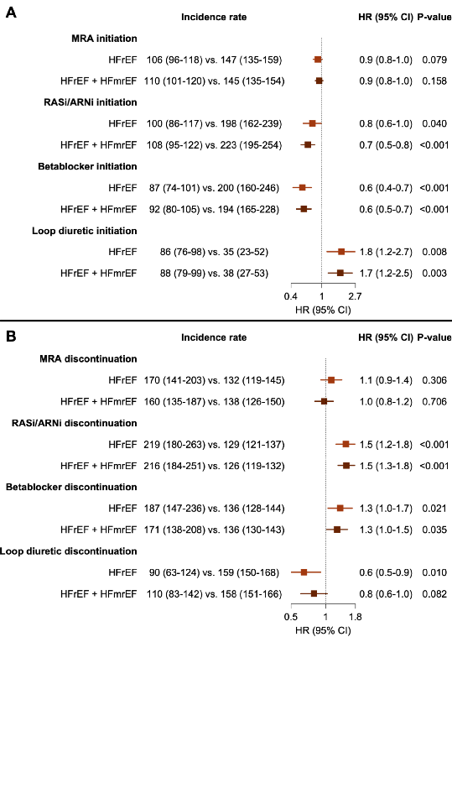

Cox regression models were fitted to evaluate the association between initiation/discontinuation vs. no initiation/no discontinuation (reference) in heart failure treatments and 3-year cardiovascular mortality among patients with a heart failure hospitalization. For initiation of heart failure treatments (A), no prior treatment was defined as no dispensed prescription within 6 months to 1 day before the index date, and post treatment was defined as 1 dispensed prescription from the index date until 6 months thereafter, and vice versa for discontinuation of heart failure treatments (B). Crude event rates and adjusted hazard ratios are shown; and variables used for adjustment in the underlying Cox regression model are reported in *Table 1*. HR: Hazard ratio; CI: Confidence interval; MRA: Mineralocorticoid receptor antagonist; HFrEF: Heart failure with reduced ejection fraction; HFmrEF: Heart failure with mildly reduced ejection fraction; RASi: Renin-aldosterone-system inhibitors; ARNi: Angiotensin-receptor neprilysin-inhibitors.