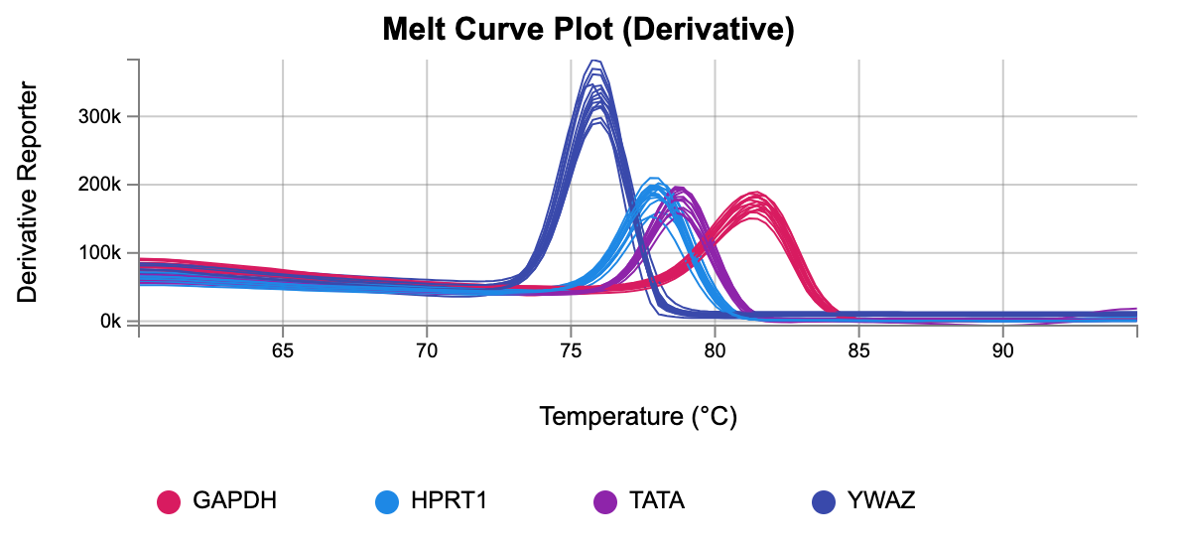
Supplementary Figure 1 | Quality score for the housekeeping genes used as endogenous controls GAPDH, HPRT1, TATA, and YWAZ.

Supplementary Figure 2

A
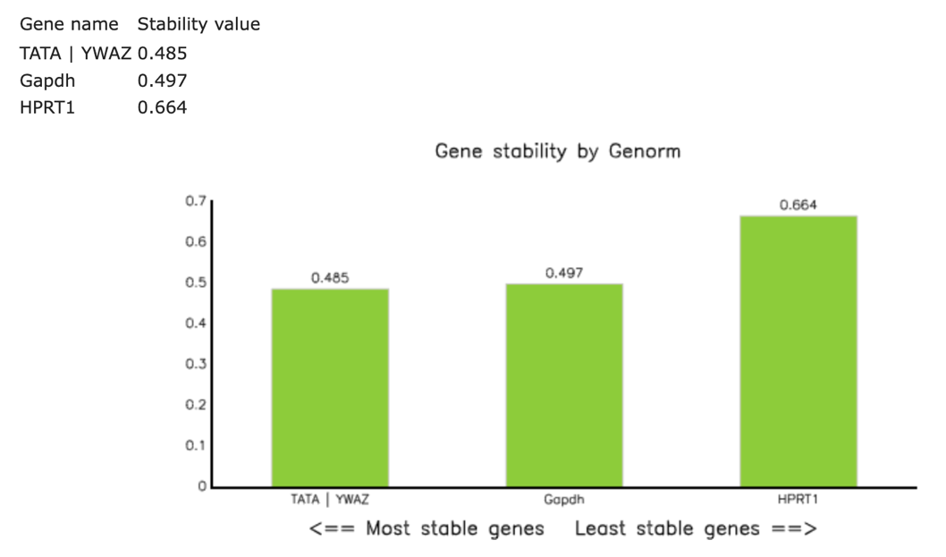

Supplementary Figure 2| Comprehensive gene stability of the housekeeping genes tested for the conditions of our study. All 4 tested genes were stable for the condition of our study. We determined the expression stability of these 4 genes using geNORM qBasePlus software.

