Supplementary information
Supplementary Figure A1 Schematic representation of IPC management plan following a suspicion of HOCI

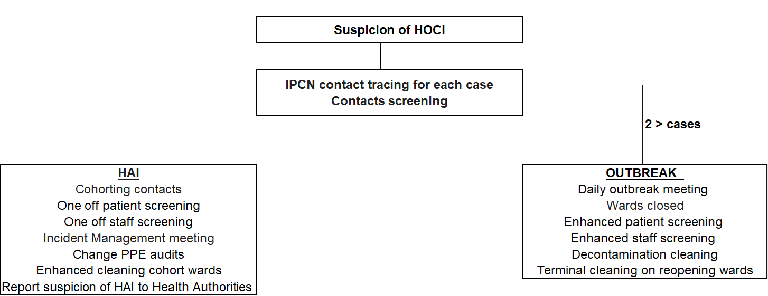

Supplementary Figure A2 Hierarchy of costs (current practice)

Supplementary Table A1 SARS -CoV-2 genome sequencing micro-costing template
Software packages used for bioinformatics
Software packages
Computer operational system LINUX
MinKNOW
RAMPART
Custom Scripts
IQTREE
GLUE SRT Tool

Unit costs applied to staff times
Job title | Employer | Salary

Task list and staff time by stage
Stage | Task | Staff job title | Time required | Unit (e.g. per shipment/batch of up to 24 samples/week etc)
General | Updating rota/schedule
 | Daily quality control of fridges/freezers
 | Stock check and ordering consumables
Sample reception | Checking packaging in MSC II and storing samples
 | Updating and storing sample submission form (SSF)
Purification of viral RNA | Creating extraction spreadsheet
 | Sample preparation
 | Setting up Nimbus/Kingfisher run (2nd person required)
 | Checking run
 | Unloading/storing samples and disposing of waste
 | Comparing IDs from extraction run with extraction spreadsheet
Library preparation - ONT | Creating processing spreadsheet
 | Preparing processing plate
 | Preparation of ARTICv3 primer stock
 | Reverse transcription
 | Incubation
 | PCR set up
 | Running PCR
 | Pooling and bead clean-up
 | Qubit
 | Normalisation
 | End Prep
 | Incubation
 | Barcoding
 | Incubation
 | Pooling and bead clean-up
 | Qubit
 | Normalisation
 | Adapter ligation
 | Incubation
 | Create barcode file
 | Select flowcell
 | Running flowcell check
 | Update processing spreadsheet
 | Bead clean up
 | Qubit
 | Loading flowcell
 | Inform bioinformatician
 | Sequencing run time
 | Washing flowcell
 | Running flowcell check
Bioinformatics | Checking Quality of Run
 | Generating Consensus
Reporting/ delivery of report | Report Generation
 | Tree Building
Data archiving | Upload Sample to COG
 | Metadata Sheet updates
 | Data Backup

Error rates (do activities need to be repeated?)
Stage | Error rate (%)

Consumables used by stage
Stage | Type of consumable | Unit required per shipment
Sample reception | Azowipes
 | Chemgene HLD4H Surface Disinfectant T/Spray
 | PET Sweetie Jar with lid
 | Disposable gloves
 | Wiper roll
Stage | Type of consumable | Units required per 24 samples
Purification of viral RNA | Mag-bind viral DNA/RNA kit (Omega Biotek)
 | Azowipes
 | Chemgene HLD4H Surface Disinfectant T/Spray
 | PET Sweetie Jar with lid
 | Isopropanol (2-Propanol)
 | Phosphate buffered saline
 | 96 tip comb for DW magnets (Nimbus)
 | Elution plates (Nimbus)
 | Deepwell plates
 | 1ml CO-RE tips with filter (Hamilton)
 | 50 µl CO-RE tips with filter (Hamilton)
 | 60 ml reagent reservoirs for NIMBUS (Hamilton)
 | Clear plate seals
 | Foil plate seals
 | 2ml Sarstedt Tubes
 | 1.5ml Eppendorf Tubes
 | Nuclease free water
 | Filter pipette tips – 200ul
 | Filter pipette tips – 1000ul
 | Serological pipettes – 10ml
 | Serological pipettes - 25ml
 | Serological pipettes - 50ml
 | 50 ml falcon tubes
 | DNA-ExitusPlus IF
 | Waste bags
 | Wiper roll
 | Large Bio-bin
 | Small Bio-bin
 | Autoclave bag
 | Disposable gloves
Library preparation - ONT | LunaScript RT SuperMix Kit
 | ARTICv3 primers
 | Q5® Hot Start High-Fidelity 2X Master Mix
 | Qubit ds DNA HS kit
 | Ampure XP beads
 | NEBNext® Ultra8482 II End RepairdA-Tailing Module
 | NEBNext® Ultra™ II Ligation Module
 | NEBNext® Quick Ligation Module
 | Ligation Sequencing Kit
 | Flow Cell Priming Kit
 | Native Barcoding Expansion 1-96
 | SFB Expansion
 | Flow Cell (R9.4.1)
 | Flow Cell Wash Kit
 | Filter pipette tips – 10ul
 | Filter pipette tips – 20ul
 | Filter pipette tips – 200ul
 | Filter pipette tips – 1000ul
 | Inetgra 12.5ul tips
 | 5ml Gilson tips
 | Serological pipettes – 10ml
 | Serological pipettes - 25ml
 | 96 well non-skirted PCR plate
 | 5ml Repetman tips
 | 96 well skirted PCR plate
 | PCR strip tubes
 | Clear plate seals
 | Absolute Ethanol
 | Nuclease free water
 | 0.5mL tubes (Qubit)
 | 2 mL tubes
 | 1.5 mL tubes
 | 1.5 mL conical screw cap tubes
 | White reservoir
 | Bijous
 | RNase Away Spray
 | DNA Away
 | Disposable gloves
 | Waste bags
 | Wiper roll
 | Large Bio-bin
 | Small Bio-bin
 | Sticky printer Cryo labels

Equipment used by stage
Stage | Type of equipment | Quantity used | Percentage of equipment time used for genome sequencing
Sample reception | Laptop
 | MSC class II cabinet
 | -80ºC freezer
 | 4ºC fridge
 | Ice machine
Purification of viral RNA | Pipette – 200ul
 | Pipette – 1000ul
 | Pipetteboy
 | Laptop
 | USB
 | Barcode scanner
 | NimbusPresto with Kingfisher
 | Vortex
 | Benchtop centrifuge
 | -80ºC freezer
 | -20ºC freezer
 | 4ºC fridge
 | Ice machine
Library preparation - ONT | Laptop
 | USB
 | Dymo label printer
 | Single channel pipette – 10ul
 | Single channel pipette – 20ul
 | Single channel pipette – 200ul
 | Single channel pipette – 1000ul
 | Multi-channel pipette – 10ul
 | Multi-channel pipette – 50ul
 | Multi-channel pipette – 200ul
 | Integra 12.5ul electron spacer pipette
 | Gilson Repetman
 | Pipetteboy
 | Pre-PCR hood
 | Vortex
 | Benchtop centrifuge
 | Benchtop plate centrifuge
 | Floor plate centrifuge
 | -80ºC freezer
 | -20ºC freezer
 | 4ºC fridge
 | Ice machine
 | PCR machine
 | Qubit Fluorometer
 | Plate magnet
 | Tube magnet
 | Hula mixer
 | Timer
 | GridION / MinION
Bioinformatics | Custom gaming laptop with 6-8GB GPU memory for data processing.
Reporting/ delivery of report
Data archiving | QNAP TVS-1282T3

Supplementary Table A2 Total cost of provision of training and meetings to read the SRT per site
Sites | Site 1 | Site 2 | Site 3 | Site 4 | Site 5 | Site 6 | Site 7 | Site 8 | Site 9 | Site 10 | Site 11 | Site 12 | Site 13 | Site 14 | TOTAL
SRT tool training
No of sessions
Implementation | 2 | 1 | 2 |  | 1 | 1 | 1 | 1 | 2 | 2 |  | 2 | 1 | 1
Self-directed genomics | 1 | 1 |  | 1 |  |  | 1 |  |  |  |  |  | 2
Bioinformatics |  |  | 1 |  | 1 |  | 2 |  |  | 8 |  | 2
TOTAL COST | £189 | £143 | £194 | £10 | £161 | £64 | £463 | £107 | £249 | £469 | £0 | £542 | £286 | £23 | £2,898.26
SRT report reading
Weekly |  | √
2 times/week |  |  |  |  |  |  |  |  | √ | √
3 times/week |  |  |  |  |  |  | √ | √ |  |  |  | √
4 times/week |  |  | √
When are available | √ |  |  | √ | √ | √ |  |  |  |  | √ |  | √ | √
TOTAL COST | £352 | £226 | £1,369 | £327 | £463 | £675 | £198 | £932 | £1,071 | £254 | £1,752 | £801 | £115 | £307 | £8,839.64
Rapid turnaround | £352 | £125 | £1,369 | £327 | £425 | £675 | £0 | £358 | £849 | £46 | £1,752 | £690 | £19 | £307
Longer turnaround | £0 | £100 | £0 | £0 | £38 | £0 | £198 | £573 | £222 | £207 | £0 | £111 | £95 | £0
More senior-level participants (e.g., consultant virologist, consultant microbiologist, senior virologist) attended the training sessions at site 7, site 9, site 10, and site 12. IPCTs attended the training at site 6 and site 8. Site 11 participated in the development of the SRT and therefore no further training needed. Site 4 also participated in the development of the SRT; however, the sequencing interpretation expert was supported by an academic registrar who was provided with an in-house training.
Most of the sites reviewed SRTs once they were available, with other sites reviewing them from once to several times per week. Each of these meetings lasted 30-60 minutes and were attended by 2 to 8 staff per site. There was a total of 43 (range 0 to 7 per site) meetings in the rapid phase and a total of 96 (range 0 to 10 per site) meetings in the longer turnaround phase.

Supplementary Table A3 Sensitivity analyses
 | Cost of base case | Variation | Cost
SARS-CoV-2 genome sequencing | £86,546 | Lowest per-sample sequencing costs  - £22.48 (Illumina rapid phase)  - £44.34 (Illumina longer turnaround phase)  - £43.43 (Nanopore rapid phase)  - £22.77 (Nanopore longer turnaround phase)  Highest per-sample sequencing costs  - £120.36 (Illumina rapid phase)  - £107.08 (Illumina longer turnaround phase)  - £131.07 (Nanopore rapid phase)  - £111.03 (Nanopore longer turnaround phase) | £49,233  £164,418
SRT tool training | £2,898 | No self-directed genomics/bioinformatics training | £1,606
Patient screening | £3,563 | Daily screening  Twice per week  Once a week | £7,905  £2,430  £1,380

Supplementary Table A4 Isolation costs
 | Number (per day) | Total cost
Gloves per nurse | 20 | £6.2
Gowns per nurse | 4 | £29.4
Cleanser alcohol hand rub Liquid Bottle 151-500ml | 1 | £1.2
Eye protection - face visor | 1 | £0.9
Mask face respirator FFP2 | 4 | £1.4
Cost of isolation/per day |  | £39.06

Supplementary Table A5 Personal protective equipment (PPE) unit costs
 | Price Per Item
1x Apron | £0.03
1x Surgical face mask | £0.12
1x FFP3 mask | £2.50
1x Surgical gown | £2.74
1x Face shield | £1.50
1x Cleaning detergent solution – chlorine based detergent tablets | £0.02
1x Alcohol hand gel | £5.71/L
1x Hand soap | £2.00
1x Detergent wipes – Clinell detergent wipes | £0.01
1x Hand Cream (Based on 500ml price) | £2.00
1x Alginate bags | £1.45
1x Safety goggles | £3.90
1x Clinical waste bags | £0.05
1x Pair of gloves | £0.30

