Supplementary Material

2008
2009
2010
2011
2012
2013
2014
2015
2016
2017
2018
2019
Percentage

Supplementary Figure 1: Bar chart of annual statin and antithrombotic prescription rates among amputees between 2008 and 2019.

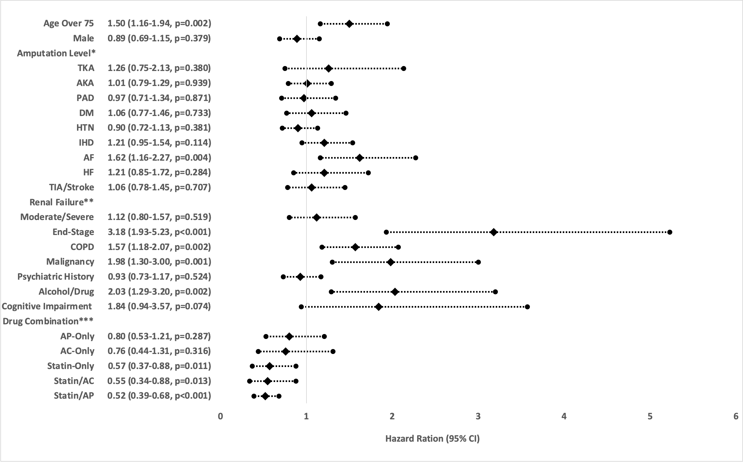

Supplementary Figure 2: Forrest plot of hazard ratios in the sensitivity analysis for Cox-regression for survival excluding non-prosthetic users (85 SIGAM A cases). Reference levels for *=BKA, **=Normal/Moderate Renal Failure, ***=None group.

