Figures

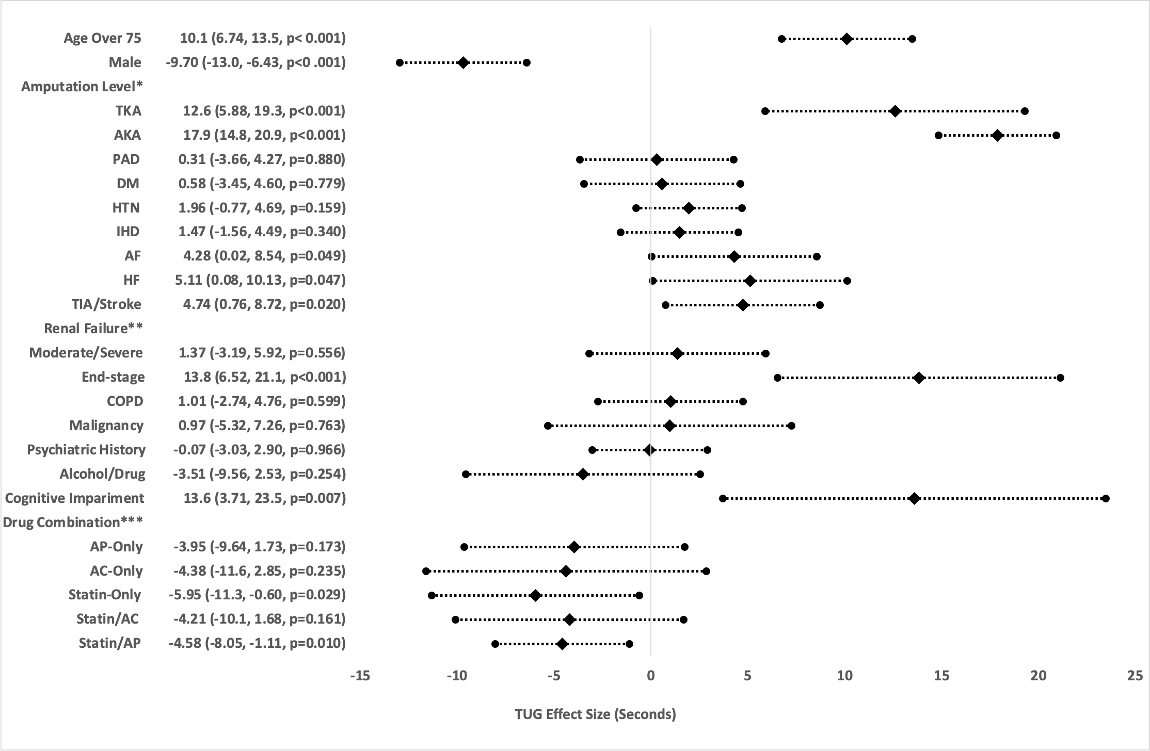
Figure 1a: Forrest plot for effect sizes (seconds) in multivariate linear regression analysis for timed-up-go (TUG) after rehabilitation. Reference levels for *=BKA, **=Normal/Moderate Renal Failure, ***=None group.

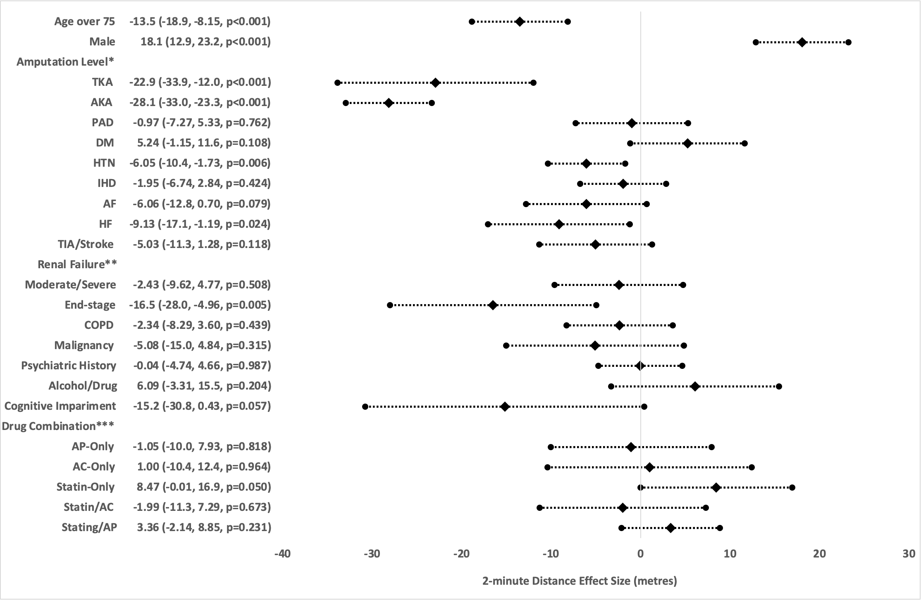
Figure 1b: Forrest plot for effect sizes (meters) in multivariate linear regression analysis for 2-minute walking distance after rehabilitation. Reference levels for *=BKA, **=Normal/Moderate Renal Failure, ***=None group.
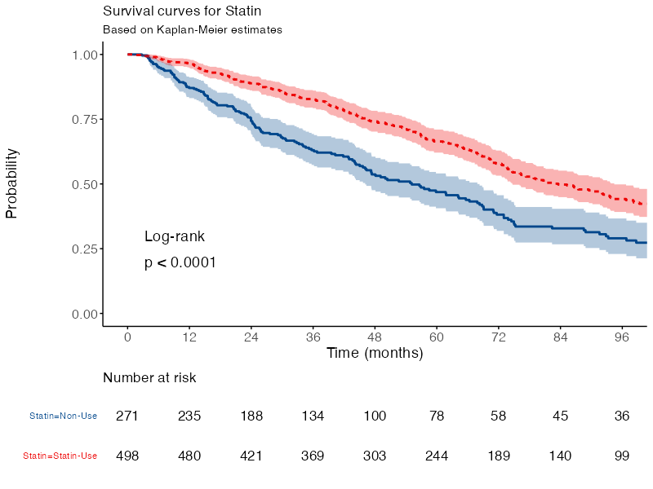
Probability
Non-Use
Statin-Use

Non-Use Reference group

Statin-Use HR 0.59 (0.48-0.72, p<0.001)

Figure 2a: Kaplan-Meier survival analysis comparing amputees using statin with those not using statins.

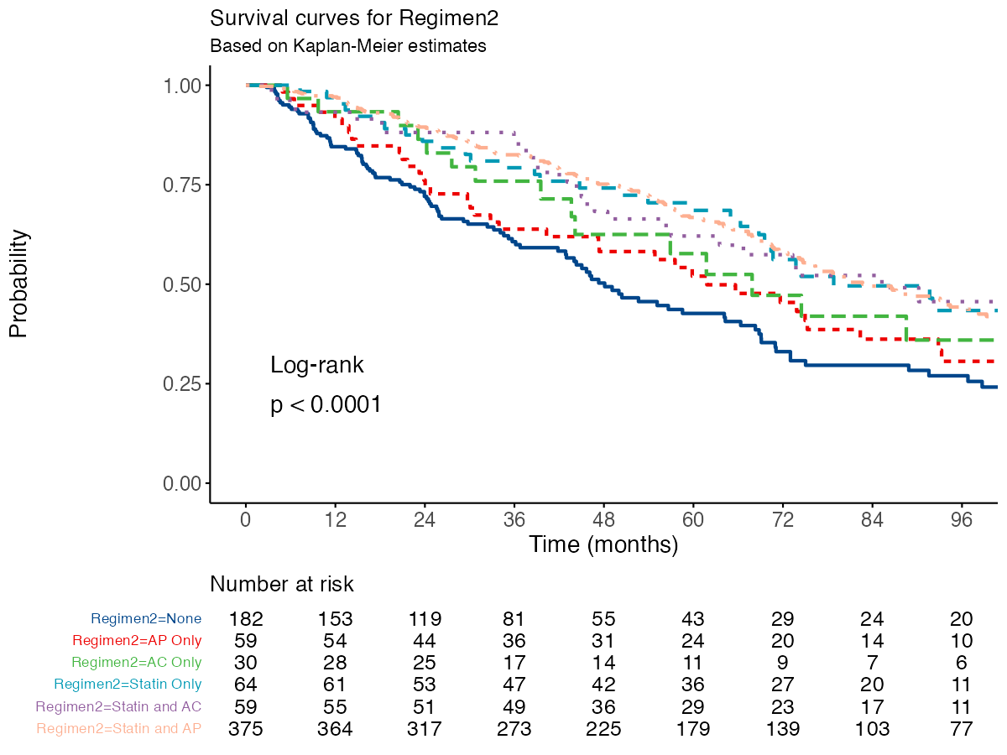
None
AP-Only
AC-Only
Statin-Only
Statin/AC
Statin/AP
Probability
 | None |  |  | Reference group
 | AP-Only |  |  | HR 0.71 (0.49-1.04, p=0.076)
 | AC-Only |  |  | HR 0.76 (0.46-1.25, p=0.273)
 | Statin-Only |  |  | HR 0.53 (0.36-0.78, p=0.001)
 | Statin/AC |  |  | HR 0.58 (0.39-0.87, p=0.008)
 | Statin/AP |  |  | HR 0.51 (0.40-0.65, p<0.001)

Figure 2b: Subgroup Kaplan-Meier survival analysis comparing statin and antithrombotic drug combinations.

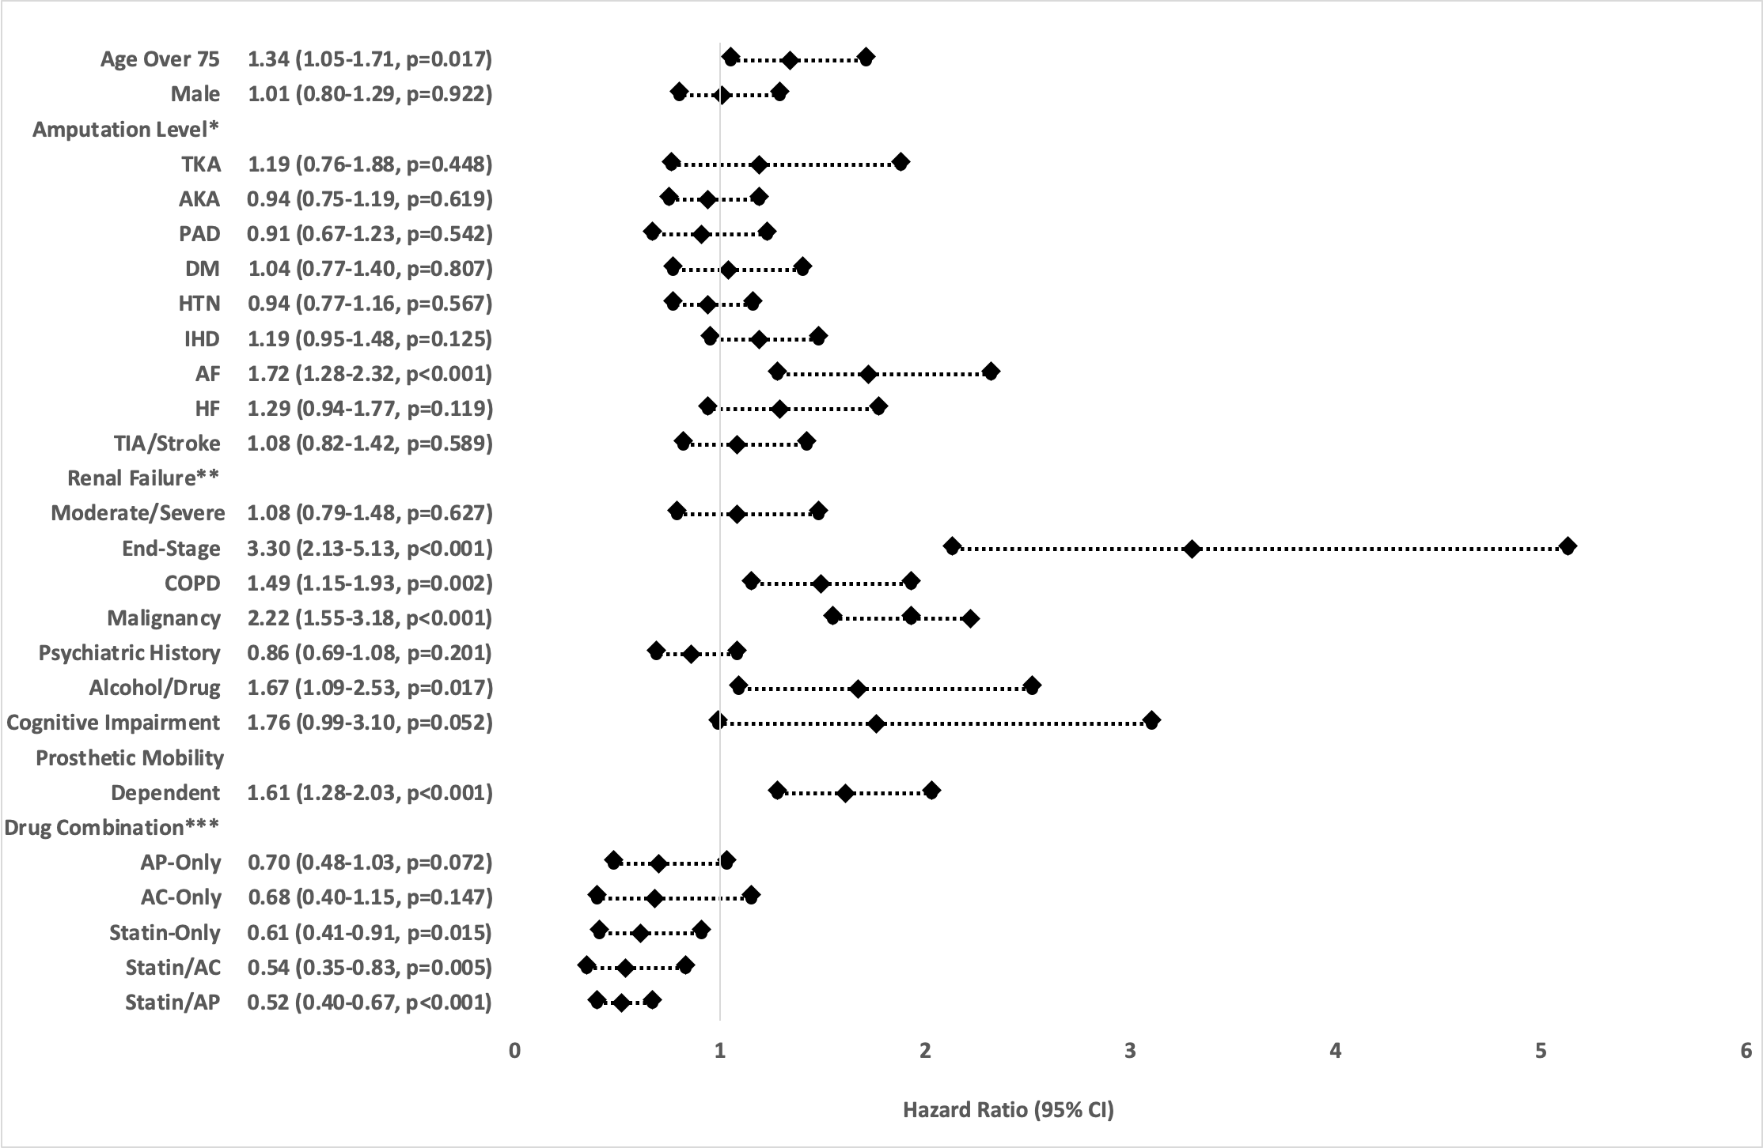

Figure 3: Forrest plot for hazard ratios in Cox-regression analysis for survival. Reference levels for *=BKA, **=Normal/Moderate Renal Failure, ***=None group.

