Appendix 2. Search strategy used for the systematic review
Cochrane Central Register of Controlled Trials (CENTRAL)
Query | Search
#1 | (((induced and (labor or labour)) or induction or (expectant and management))) ti,ab,kw
#2 | full-term or fullterm or post-date or postdate or post-term or postterm or prolonged or protracted or postmature or post-mature or "late term" or "beyond term" or "37* week*" or "38* week*" or "39* week*" or "40* week*" or "41* week*" or "42* week*" or "43* week*" or "44* week*" or "45* week*" or prolonged) NEAR/4 (pregnancy or pregnancies or delivery or deliveries)) ti,ab,kw
#3 | #1 AND #2
#4 | [mh ^"LABOR, INDUCED"]
#5 | (((labor or labour) near/5 induc*)):ti,ab,kw (Word variations have been searched)
#6 | [mh ^"CERVICAL RIPENING"]
#7 | ((cervi* near/3 ripen*)):ti,ab,kw (Word variations have been searched)
#8 | (((unfavorabl* or unfavourabl* or un-favorabl* or un-favourabl* or unripe* or un- ripe*) near/3 cervi*)):ti,ab,kw (Word variations have been searched)
#9 | (((bishop* or cerv*) near/3 scor*)):ti,ab,kw (Word variations have been searched)
#10 | #4or#5or#6or#7or#8or#9
#11 | [mh ^"CONSERVATIVE TREATMENT"]
#12 | ((conservative* near/3 (manag* or treat* or policy or policies))):ti,ab,kw (Word variations have been searched)
#13 | ((expect* near/3 manag*)):ti,ab,kw (Word variations have been searched)
#14 | [mh ^"WATCHFUL WAITING"]
#15 | ((watchful* near/3 wait*)):ti,ab,kw (Word variations have been searched)
#16 | (("no treat*" or "non treat*")):ti,ab,kw (Word variations have been searched)
#17 | (("no interven*" or "non interven*")):ti,ab,kw (Word variations have been searched)
#18 | (("no induc*" or "non induc*")):ti,ab,kw (Word variations have been searched)
#19 | (spontaneous* near/5 (labor or labour or deliver* or onset or "follow* up"))
#20 | (((fetal or foetal or fetus*or foetus) near/5 (test* or monitor*))):ti,ab,kw (Word variations have been searched)
#21 | #11or#12or#13or#14or#15or#16or#17or#18or#19or#20
#22 | [mh ^"PREGNANCY, PROLONGED"]
#23 | (((prolonged or protracted or postmature or post-mature or postterm or post- term or postdate* or post-date*) near/5 pregnanc*)):ti,ab,kw (Word variations have been searched)
#24 | ("full term"):ti,ab,kw (Word variations have been searched)
#25 | #22 or #23 or #24
#26 | ("37* week*"):ti,ab,kw (Word variations have been searched)
#27 | ("38* week*"):ti,ab,kw (Word variations have been searched)
#28 | ("39* week*"):ti,ab,kw (Word variations have been searched)
#29 | ("40* week*"):ti,ab,kw (Word variations have been searched)
#30 | ("41* week*"):ti,ab,kw (Word variations have been searched)
#31 | ("42* week*"):ti,ab,kw (Word variations have been searched)
#32 | ("43* week*"):ti,ab,kw (Word variations have been searched)
#33 | ("44* week*"):ti,ab,kw (Word variations have been searched)
#34 | ("45* week*"):ti,ab,kw (Word variations have been searched)
#35 | #26or#27or#28or#29or#30or#31or#32or#33or#34
#36 | (("37* week*" near/5 ("38* week*" or "39* week*" or "40* week*" or "41* week*" or "42* week*" or "43* week*" or "44* week*" or "45* week*"))):ti,ab,kw (Word variations have been searched)
#37 | (("38* week*" near/5 ("37* week*" or "39* week*" or "40* week*" or "41* week*" or "42* week*" or "43* week*" or "44* week*" or "45* week*"))):ti,ab,kw (Word variations have been searched)
#38 | (("39* week*" near/5 ("37* week*" or "38* week*" or "40* week*" or "41* week*" or "42* week*" or "43* week*" or "44* week*" or "45* week*"))):ti,ab,kw (Word variations have been searched)
#39 | (("40* week*" near/5 ("37* week*" or "38* week*" or "39* week*" or "41* week*" or "42* week*" or "43* week*" or "44* week*" or "45* week*"))):ti,ab,kw (Word variations have been searched)
#40 | (("41* week*" near/5 ("37* week*" or "38* week*" or "39* week*" or "40* week*" or "42* week*" or "43* week*" or "44* week*" or "45* week*"))):ti,ab,kw (Word variations have been searched)
#41 | (("42* week*" near/5 ("37* week*" or "38* week*" or "39* week*" or "40* week*" or "41* week*" or "43* week*" or "44* week*" or "45* week*"))):ti,ab,kw (Word variations have been searched)
#42 | (("43* week*" near/5 ("37* week*" or "38* week*" or "39* week*" or "40* week*" or "41* week*" or "42* week*" or "44* week*" or "45* week*"))):ti,ab,kw (Word variations have been searched)
#43 | (("44* week*" near/5 ("37* week*" or "38* week*" or "39* week*" or "40* week*" or "41* week*" or "42* week*" or "43* week*" or "45* week*"))):ti,ab,kw (Word variations have been searched)
#44 | (("45* week*" near/5 ("37* week*" or "38* week*" or "39* week*" or "40* week*" or "41* week*" or "42* week*" or "43* week*" or "44* week*"))):ti,ab,kw (Word variations have been searched)
#45 | #36or#37or#38or#39or#40or#41or#42or#43or#44
#46 | ((compar* near/10 gestation* near/3 week*)):ti,ab,kw (Word variations have been searched)
#47 | ((compar* near/10 GW*)):ti,ab,kw (Word variations have been searched)
#48 | #46 or #47
#49 | #10 and #21 and #25
#50 | #10 and #21 and #35
#51 | #10 and #45
#52 | #10 and #48
#53 | #49or#50or#51or#52

Appendix 3. Characteristics of the studies included in the systematic review and meta-analysis on the effect of induction of labour on perinatal and maternal outcomes
Study ID | Study date | Country | Inclusion criteria | Exclusion criteria | Intervention | Comparator | Outcomes
Tan 2021 | 2017 - 2019 | Malaysia | Nulliparous women, low- risk and singleton pregnancy, 38- 40 weeks’ gestation, ≥18 years of age. | Previous caesarean section, gestational diabetes, hypertension,  fetal abnormalities. | IOL group: (n=80) induction between 39-40 weeks by amniotomy and oxytocin. | EM group: (n=79) EM until 41 weeks. | Caesarean delivery, operative vaginal delivery, postpartum haemorrhage.  Apgar score <7 in 5 minutes, NICU admission.
Keulen 2019 | 2012-  2016 | Netherlands | Low-risk and singleton pregnancy, 40-41 weeks’ gestation, ≥18 years of age. | Previous caesarean section, hypertension, ruptured membranes, fetal abnormalities. | IOL group: (n=900)  induction at 41 weeks by amniotomy. Cervical ripening and oxytocin if required. | EM group: (n=901) EM until 42 weeks. | Caesarean delivery, operative vaginal delivery, postpartum haemorrhage,  maternal death.  Perinatal death, stillbirth, neonatal death, Apgar score <7 in 5 minutes, NICU admission.
Wennerholm 2019 | 2016-  2018 | Sweden | Low-risk and singleton pregnancy, 40- 41 weeks’ gestation, ≥18 years of age. | Previous caesarean section, gestational diabetes hypertension, oligohydramnios, fetal abnormalities. | IOL: (n=1381) induction at 41 weeks by amniotomy and oxytocin. Cervical ripening if required. | EM: (n=1379) EM until 42 weeks | Caesarean delivery, operative vaginal delivery, postpartum haemorrhage, breastfeeding status, maternal death.  Perinatal death, stillbirth, neonatal death, Apgar score <7 in 5 minutes, NICU admission.
Sargunam  2019 | 2015-  2017 | Malaysia | Low-risk and singleton pregnancy ≥39 weeks' gestation. | Hypertension, previous uterine surgery, fetal abnormalities. | IOL: (n=149) induction at 39 weeks by dinoprostone pessary, amniotomy, or oxytocin. | EM: (n=159). | Caesarean delivery rate, operative vaginal delivery, postpartum haemorrhage.  Apgar score <7 in 5 minutes, NICU admission.
Zandvakili  2019 | 2016-  2018 | Iran | Nulliparous women, low- risk and singleton pregnancy >41 weeks’ gestation. | Gestational diabetes, preeclampsia, fetal abnormalities. | IOL: (n=73) induction from 41 weeks by amniotomy. Oxytocin infusion if required. | EM: (n=78). | Postpartum haemorrhage.
Grobman 2018 | 2014-  2017 | USA | Nulliparous women, low- risk and singleton pregnancy, 34- 38 weeks’ gestation. | Previous caesarean section, hypertension, ruptured membranes, abnormal placenta, vaginal bleeding, fetal abnormalities. | IOL: (n=3059) induction at 39 weeks by oxytocin. Cervical ripening if required. | EM: (n=3037)  EM until 42 weeks. | Caesarean delivery, operative vaginal delivery, postpartum haemorrhage, breastfeeding status,  maternal death.  Perinatal death, stillbirth, neonatal death, NICU admission.
Baev 2017 | 2014-  2015 | Russia | Low-risk and singleton pregnancy ≥40 weeks’ gestation, 18-45 years of age. | Previous caesarean section, gestational diabetes, hypertension, ruptured membranes, preeclampsia. | IOL: (n=74) induction from 40 weeks by dinoprostone gel (Bishop score 6-7) or amniotomy (≥8). Cervical ripening if required. | EM: (n=75) EM until 42 weeks. | Caesarean delivery, operative vaginal delivery.  Apgar score <7 in 5 minutes, NICU admission.
Walker 2016 | 2012-  2015 | UK | Nulliparous women, low- risk and singleton pregnancy, ≥36 weeks’ gestation, ≥35 years of age. | Pregnancy complications, fetal abnormalities, undergone myomectomy, used donor eggs. | IOL: (n=304) induction at 39 weeks by prostaglandin, oxytocin or amniotomy. | EM: (n=314) EM until 42 weeks. | Caesarean delivery, operative vaginal delivery, postpartum haemorrhage.  Perinatal death, stillbirth, neonatal death, Apgar score <7 in 5 minutes, NICU admission.
Miller 2015 | 2010-  2014 | USA | Nulliparous women, low- risk and singleton pregnancy, 38 weeks’ gestation, ≥18 years of age. | Obstetric or medical conditions. | IOL: (n=82) induction from 39 weeks by foley catheter, oxytocin and amniotomy. Cervical ripening if required. | EM: (n=79) EM until 42 weeks. | Caesarean section.  NICU admission.
Brane 2014 | 2007-  2012 | Sweden | Nulliparous women, low- risk and singleton pregnancy, 37- 41 weeks’ gestation. | Complicated pregnancies, such as ruptured membranes. | IOL: (n=65) induction between 37-41 weeks by intravaginal dinoprostone, foley catheter and/or amniotomy depending on Bishop score. Oxytocin if required. | EM: (n=64) | Caesarean delivery, operative vaginal delivery, postpartum haemorrhage.  Apgar score <7 in 5 minutes, NICU admission.
Ugwu 2014 | 2012 | Nigeria | Low-risk and singleton pregnancy, 40- 41 weeks of gestation | Medical conditions, ruptured membranes. | IOL: (n=52) induction between 40-41 weeks by membrane sweeping. | EM: (n=37)  until 41 weeks. | Caesarean delivery, operative vaginal delivery.  Apgar score <7 in 5 minutes, NICU admission.
Benito Reyes  2010 | 2003-  2005 | Canary Islands | Low-risk and singleton pregnancy, ≥41 weeks’ gestation. | Gestational diabetes, hypertension, abnormal placenta. | IOL: (n=102) induction at 42 weeks by prostaglandin gel. | EM: (n=98) | Caesarean delivery, operative vaginal delivery.  Apgar score <7 in 5 minutes, NICU admission.
Yildrim 2010 | 2006-  2007 | Turkey | Low-risk and singleton pregnancy, 38- 40 weeks’ gestation. | Previous caesarean section, fetal abnormalities. | IOL: (n=179) induction between 38-40 weeks by membrane sweeping. | EM: (n=167) EM until 41 weeks. | Caesarean delivery.  Perinatal death, stillbirth, neonatal death, NICU admission.
Heimstad 2007 | 2002-  2004 | Norway | Low-risk and singleton pregnancy. | History of ruptured membranes. | IOL: (n=254) induction at 41 weeks by amniotomy and oxytocin. Cervical ripening if required. | EM: (n=254) EM until 43 weeks. | Caesarean delivery, operative vaginal delivery, postpartum haemorrhage.  Perinatal death, stillbirth, neonatal death, Apgar score <7 in 5 minutes, NICU admission.
De Miranda  2006 | 2000-  2003 | Netherlands | Low-risk and singleton pregnancy, 41 weeks’ gestation. | Pregnancy complications, history of blood loss during pregnancy. | IOL: (n=375) induction at 41 weeks by membrane sweeping every 48 hours, maximum 3 times. | EM: (n=367)  EM until 42 weeks. | Caesarean delivery, operative vaginal delivery.  Perinatal death.
Kashanian  2006 |  | Iran | Low-risk and singleton pregnancy, 39 weeks’ gestation. | Complications such as abnormal placenta, vaginal bleeding, fetal abnormalities. | IOL: (n=50) induction at 39 weeks by membrane sweeping. | EM: (n=51) EM until 41 weeks. | Caesarean delivery.
Gelisen 2005 |  | Turkey | Low-risk and singleton pregnancy, 41 weeks’ gestation. | Previous caesarean section, abnormal placenta, fetal abnormalities, BMI >30, previous induction attempts. | IOL: (n=300) induction at 41 weeks by membrane stripping, intravaginal misoprostol, oxytocin or amniotomy. | EM: (n=300) EM until 42 weeks. | Caesarean delivery.  Apgar score <7 in 5 minutes, NICU admission.
Sahraoui  2005 |  | Tunisia | Low-risk pregnancy, 41 weeks’ gestation. | Gestational diabetes, abnormal placenta, uterine scarring, history of fetal death in utero. | IOL: (n=75) induction at 41 weeks by prostaglandin E2 gel, amniotomy and oxytocin. | EM: (n=75) EM until 42 weeks. | Caesarean section.  Perinatal death, stillbirth, neonatal death.
Nielsen 2005 | 1999-  2002 | USA | Singleton pregnancy, ≥39 weeks', ≥17 years of age. | Multiple pregnancies. | IOL: (n=116) induction between 39-40 weeks by amniotomy and/or oxytocin. | EM: (n=110) EM until 42 weeks. | Caesarean section, operative vaginal delivery.  Apgar score <7 in 5 minutes, NICU admission.
Chanrachakul  2003 | 1998-  2000 | Thailand | Low-risk pregnancy, 40- 41 weeks’ gestation. | Medical or obstetric complications. | IOL: (n=124) induction at 41 weeks by amniotomy. Oxytocin if required. | EM: (n=125) EM until 44 weeks. | Caesarean delivery, postpartum haemorrhage, maternal death.  Perinatal death, Apgar score <7 in 5 minutes, NICU admission.
James 2001 |  | India | Low-risk and singleton pregnancy, 41 weeks’ gestation. | Previous caesarean section, diabetes mellitus, hypertension, ruptured membranes pre- eclampsia, fetal abnormalities. | IOL: (n=37) induction at 41 weeks by amniotomy and oxytocin. Cervical ripening and membrane sweeping if required. | EM: (n=37) | Caesarean delivery, operative vaginal delivery.  Perinatal death, stillbirth, neonatal death, Apgar score <7 in 5 minutes, NICU admission.
Chakravarti 2000 |  | India | Low-risk pregnancy | Pregnancy complications. | IOL: (n=114) induction between 40-41 weeks. Cervical ripening if required. | EM: (n=117) until 42 weeks. | Caesarean delivery.
Gupta 1998 |  | India | Low-risk and singleton pregnancy, 38 weeks’ gestation. | Complications such as ruptured membrane, abnormal placenta, vaginal or cervical infection. | IOL: (n=50) induction at 38 weeks by membrane sweeping. | EM: (n=50). | Caesarean delivery, operative vaginal delivery.  Perinatal death, stillbirth, neonatal death, NICU admission.
Magaan 1998 |  | USA | Low-risk and singleton pregnancy, 39 weeks' gestation. | Pregnancy complications such as abnormal. placenta. | IOL: (n=33) induction at 39 weeks by membrane sweeping. | EM: (n=32) EM until 41 weeks. | Caesarean delivery.  NICU admission.
Roach 1997 |  | China | Low-risk pregnancy, 41 weeks’ gestation. | Pregnancy complications such as gestational diabetes, pre-eclampsia, fetal abnormalities. | IOL: (n=96) induction at 42 weeks by prostaglandin E2 pessary. | EM: (n=105) | Caesarean delivery.  Apgar score <7 in 5 minutes, NICU admission.
Crane 1997 |  | Canada | Low-risk pregnancy, 38- 40 weeks’ gestation. | Ruptured membranes, vaginal bleeding, , , fetal abnormalities, history of perinatal mortality. | IOL: (n=76) induction between 38-40 weeks by membrane sweeping. | EM: (n=74). | Caesarean delivery, operative vaginal delivery.  Apgar score <7 in 5 minutes.
Wiriyasirivaj 1996 | 1994 | Thailand | Low-risk pregnancy, 38 weeks' gestation. | Medical, surgical, or obstetric complications. Previous caesarean section. | IOL: (n=61) induction from 38 weeks by membrane sweeping. | EM: (n=59) EM until 42 weeks. | Caesarean delivery, operative vaginal delivery, postpartum  haemorrh-age.
Frigoletto  1995 | 1991-  1993 | USA | Low-risk pregnancy 40 weeks’ gestation, ≥18 years of age. | Gestational hypertension, cervical incompetence. | IOL: (n=678) induction from 40 weeks by amniotomy. Oxytocin if required. | EM: (n=585). | Caesarean delivery, operative vaginal.
NICHHD 1994 | 1987-1989 | USA | Low-risk pregnancy, 41-43 weeks’ gestation. | Previous caesarean section, fetal abnormalities. | IOL: (n=174) induction from 41 weeks by prostaglandin E2 gel and/or oxytocin. | EM: (n=175) EM until 44 weeks | Caesarean delivery, maternal death.  Perinatal death, stillbirth, neonatal death.
Hannah 1992 | 1985-  1990 | Canada | Low-risk and singleton pregnancy,  ≥41 weeks' gestation. | Previous caesarean section, gestational diabetes, pre- eclampsia, ruptured membranes. | IOL: (n=1701) induction from 41 weeks by intravaginal prostaglandin E2. | EM: (n=1706) EM until 44 weeks. | Caesarean delivery, operative vaginal delivery.  Perinatal death, stillbirth, neonatal death, Apgar score <7 in 5 minutes, NICU admission.
Herabutya  1992 |  | Thailand | Low-risk pregnancy,  >42 weeks’ gestation. | Pregnancy complications, recent oral contraception use. | IOL: (n=57) induction from 42 weeks by prostaglandin gel, amniotomy and oxytocin. | EM: (n=51) EM until 44 weeks. | Caesarean delivery, operative vaginal delivery.  Perinatal death, stillbirth, neonatal death, Apgar score <7 in 5 minutes, NICU admission.
McColgin  1990 | 1988-1989 | USA | Low-risk pregnancy, 38 weeks’ gestation. | Medical complications, vaginal or cervical infection, placenta previa, uncertain dating. | IOL: (n=90) induction at 38 weeks by membrane sweeping. | EM: (n=90) EM until 42 weeks. | Perinatal death, stillbirth, neonatal death.
Martin 1989 | 1987-  1988 | USA | Pregnant women ≥41 weeks’ gestation. | Oligohydramnios, fetal abnormalities | IOL: (n=12) induction at 42 weeks by oxytocin. | EM: (n=10) EM until 43 weeks. | Caesarean delivery, operative vaginal delivery.  Perinatal death, stillbirth, neonatal death.
Bergsjo 1989 | 1982-  1985 | China | Low-risk pregnancy, 42 weeks’ gestation. | Previous caesarean section, pre- eclampsia, fetal abnormalities | IOL: (n=94) induction from 42 weeks by membrane stripping and oxytocin. Amniotomy if cervix was dilated >3cm. | EM: (n=94) EM until 43 weeks. | Caesarean delivery, operative vaginal delivery, breastfeeding status.  Perinatal death, stillbirth, neonatal death.
Egarter 1989 |  | Austria | Low-risk, singleton pregnancy,  >40 weeks’ gestation. | Maternal or fetal complications, such as ruptured membranes. | IOL: (n=180) induction from 40 weeks by intravaginal prostaglandin tablets | EM: (n=165) EM until 42 weeks. | Caesarean delivery, operative vaginal delivery.  Perinatal death, stillbirth, neonatal death.
Augensen 1987 | 1982-  1985 | Norway | Low-risk and singleton pregnancy, 41-42 weeks’ gestation. | Medical and obstetric conditions such as hypertension and fetal abnormalities. | IOL: (n=214) induction at 42 weeks by oxytocin. | EM: (n=195) EM until 43 weeks. | Caesarean delivery, operative vaginal delivery.  Perinatal death, stillbirth, neonatal death, NICU admission.
Witter 1987 |  | USA | Low-risk and singleton pregnancy, 41 weeks’ gestation. | Previous caesarean section, gestational diabetes, hypertension, pre-eclampsia, fetal abnormalities. | IOL: (n=103) induction at 42 weeks by oxytocin and amniotomy. | EM: (n=97) | Caesarean delivery.  Apgar score <7 in 5 minutes.
Dyson 1987 | 1983-  1985 | USA | Low-risk and singleton pregnancy, ≥41 weeks’ gestation. | Previous caesarean section, gestational diabetes, hypertension, pre-eclampsia, previous still birth. | IOL: (n=152) induction from 41 weeks by prostaglandin gel, oxytocin, and amniotomy. | EM: (n=150) | Caesarean delivery.  Perinatal death, stillbirth, neonatal death, Apgar score <7 in 5 minutes.
Suikkari 1983 | 1980-  1981 | Finland | Pregnant women ≥41 weeks’ gestation. |  | IOL: (n=66) induction at 41 weeks by amniotomy and oxytocin infusion or oxytocin if unripe cervix. | EM: (n=53) | Operative vaginal delivery, maternal death.  Perinatal death, stillbirth, neonatal death.
Sande 1983 | 1979-  1980 | Norway | Low-risk and singleton pregnancy, 40-  41 weeks’ gestation. | Pregnancy complications. | IOL: (n=76) induction between 40-41 weeks by oxytocin and amniotomy. | EM: (n=90) EM until 43 weeks. | Caesarean section, operative vaginal delivery.  Perinatal death, stillbirth, neonatal death, Apgar score <7 in 5 minutes, NICU admission.
Tylleskar 1979 |  | Sweden | Low-risk pregnancy, 18- 35 years of age. | Previous caesarean section. | IOL: (n=43) induction at 40 weeks by amniotomy and oxytocin. | EM: (n=41) EM until 42 weeks. | Operative vaginal delivery.
Martin 1978 |  | UK | Low-risk pregnancy, 38 weeks’ gestation. | Past and/or present complicated pregnancy. | IOL: (n=92)  induction at 39 weeks by oxytocin. | EM: (n=92)  EM until 42 weeks. | Caesarean delivery rate.  Perinatal death, stillbirth, neonatal death.
Cole 1975 |  | UK | Low-risk pregnancy, 39- 40 weeks’ gestation, 18-35 years of age. | Complicated pregnancies, such as infection. | IOL: (n=111) induction between 39-40 weeks by amniotomy and oxytocin. | EM: (n=117) EM until 41 weeks. | Caesarean delivery rate, operative vaginal delivery.  Perinatal death, stillbirth, neonatal death.
Henry 1969 |  | UK | Women with a prolonged pregnancy. |  | IOL: (n=55) | EM: (n=57) | Caesarean delivery rate, operative vaginal  Delivery.  Perinatal death, stillbirth, neonatal death.
IOL = induction of labour; EM = expectant management; NICU = neonatal intensive care unit.

Appendix 4. Assessment of the risk of bias of the randomised controlled trials included in the systematic review and meta-analysis on the effects of elective induction of labour on perinatal and maternal outcomes, using the Cochrane Risk of Bias tool 2.0.
Study | Domain 1: the randomisation process | Domain 2: effect of assignment to intervention | Domain 2: effect of adhering to intervention | Domain 3: missing outcome data | Domain 4: measurement of the outcome | Domain 5: selection of the reported data | Overall risk of bias
Tan 2021 | LOW | LOW | LOW | LOW | LOW | LOW | LOW
Keulen 2019 | LOW | LOW | LOW | LOW | LOW | LOW | LOW
Wennerholm 2019 | LOW | LOW | SOME CONCERNS | LOW | LOW | LOW | SOME CONCERNS
Sargunam  2019 | LOW | SOME CONCERNS | LOW | LOW | LOW | SOME CONCERNS | SOME CONCERNS
Zandvakili 2019 | SOME CONCERNS | SOME CONCERNS | LOW | HIGH | LOW | SOME CONCERNS | HIGH
Grobman 2018 | LOW | LOW | LOW | LOW | LOW | LOW | LOW
Baev 2017 | LOW | SOME CONCERNS | LOW | LOW | LOW | LOW | SOME CONCERNS
Walker 2016 | LOW | LOW | LOW | LOW | LOW | LOW | LOW
Miller 2015 | LOW | LOW | LOW | LOW | LOW | LOW | LOW
Brane 2014 | LOW | LOW | LOW | LOW | LOW | SOME CONCERNS | SOME CONCERNS
Ugwu 2014 | LOW | SOME CONCERNS | LOW | HIGH | LOW | LOW | HIGH
Benito Reyes  2010 | LOW | SOME CONCERNS | LOW | LOW | LOW | LOW | SOME CONCERNS
Yildrim 2010 | LOW | LOW | LOW | LOW | LOW | LOW | LOW
Heimstad 2007 | LOW | SOME CONCERNS | LOW | LOW | LOW | LOW | SOME CONCERNS
De Miranda  2006 | LOW | LOW | LOW | LOW | LOW | LOW | LOW
Kashanian  2006 | HIGH | HIGH | LOW | LOW | LOW | SOME CONCERNS | HIGH
Gelisen 2005 | SOME  CONCERNS | SOME  CONCERNS | SOME  CONCERNS | LOW | LOW | LOW | HIGH
Sahraoui 2005 | LOW | SOME CONCERNS | SOME CONCERNS | LOW | LOW | SOME CONCERNS | HIGH
Nielsen 2005 | SOME CONCERNS | LOW | LOW | LOW | LOW | SOME CONCERNS | SOME CONCERNS
Chanrachakul  2003 | LOW | SOME  CONCERNS | LOW | LOW | LOW | LOW | SOME CONCERNS
James 2001 | SOME CONCERNS | SOME CONCERNS | LOW | LOW | LOW | SOME CONCERNS | HIGH
Chakravarti  2000 | SOME CONCERNS | SOME CONCERNS | HIGH | SOME CONCERNS | LOW | SOME CONCERNS | HIGH
Gupta 1998 | LOW | LOW | LOW | LOW | LOW | SOME CONCERNS | SOME CONCERNS
Magann 1998 | LOW | SOME CONCERNS | LOW | LOW | LOW | LOW | SOME CONCERNS
Roach 1997 | SOME CONCERNS | SOME CONCERNS | LOW | LOW | LOW | LOW | SOME CONCERNS
Crane 1997 | LOW | SOME CONCERNS | HIGH | LOW | LOW | LOW | HIGH
Wiriyasirivaj 1996 | LOW | LOW | LOW | LOW | LOW | LOW | LOW
Frigoletto 1995 | SOME CONCERNS | SOME CONCERNS | LOW | LOW | LOW | LOW | SOME CONCERNS
NICHHD 1994 | SOME CONCERNS | LOW | LOW | LOW | LOW | LOW | SOME CONCERNS
Hannah 1992 | SOME CONCERNS | LOW | SOME CONCERNS | LOW | LOW | LOW | SOME CONCERNS
Herabutya 1992 | SOME CONCERNS | SOME CONCERNS | LOW | LOW | LOW | SOME CONCERNS | HIGH
McColgin 1990 | SOME CONCERNS | SOME CONCERNS | LOW | LOW | LOW | SOME CONCERNS | HIGH
Martin 1989 | SOME  CONCERNS | SOME  CONCERNS | LOW | LOW | LOW | HIGH | HIGH
Bergsjo 1989 | SOME CONCERNS | SOME CONCERNS | SOME CONCERNS | LOW | LOW | SOME CONCERNS | HIGH
Egarter 1989 | HIGH | SOME CONCERNS | LOW | LOW | LOW | SOME CONCERNS | HIGH
Augensen 1987 | SOME CONCERNS | SOME CONCERNS | LOW | LOW | LOW | SOME CONCERNS | HIGH
Witter 1987 | SOME  CONCERNS | SOME  CONCERNS | LOW | LOW | LOW | SOME  CONCERNS | HIGH
Dyson 1987 | LOW | SOME CONCERNS | LOW | LOW | LOW | SOME CONCERNS | SOME CONCERNS
Suikkari 1983 | SOME CONCERNS | SOME CONCERNS | SOME CONCERNS | HIGH | LOW | SOME CONCERNS | HIGH
Sande 1983 | HIGH | SOME CONCERNS | SOME CONCERNS | SOME CONCERNS | LOW | HIGH | HIGH
Tylleskar 1979 | SOME  CONCERNS | SOME  CONCERNS | SOME  CONCERNS | SOME  CONCERNS | LOW | SOME  CONCERNS | HIGH
Martin 1978 | SOME CONCERNS | SOME CONCERNS | LOW | SOME CONCERNS | LOW | SOME CONCERNS | HIGH
Cole 1975 | SOME CONCERNS | SOME CONCERNS | LOW | SOME CONCERNS | LOW | SOME CONCERNS | HIGH
Henry 1969 | SOME  CONCERNS | SOME  CONCERNS | LOW | LOW | LOW | SOME  CONCERNS | HIGH

Appendix 5. Effect of induction of labour versus expectant management or delayed induction on perinatal and maternal outcomes
IOL = induction of labour; EM = expectant management.

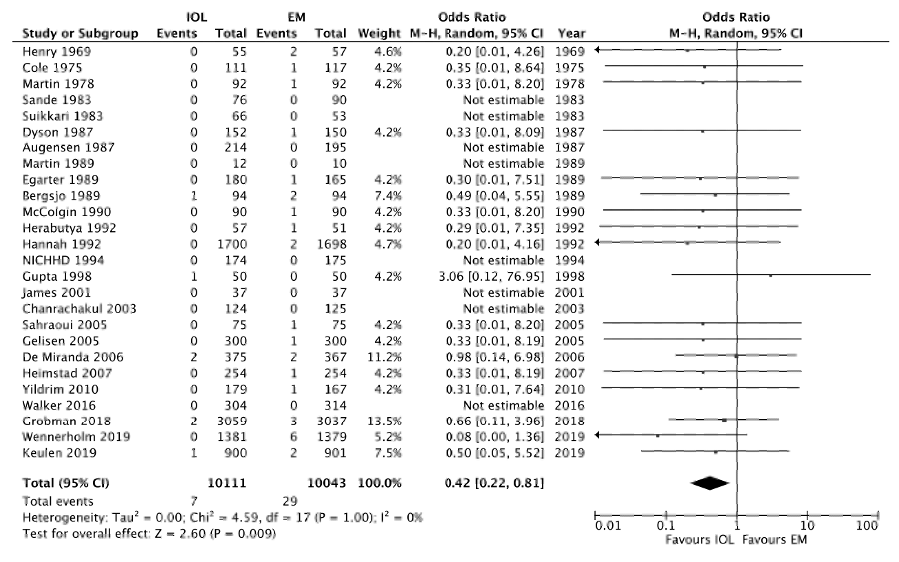
Perinatal death

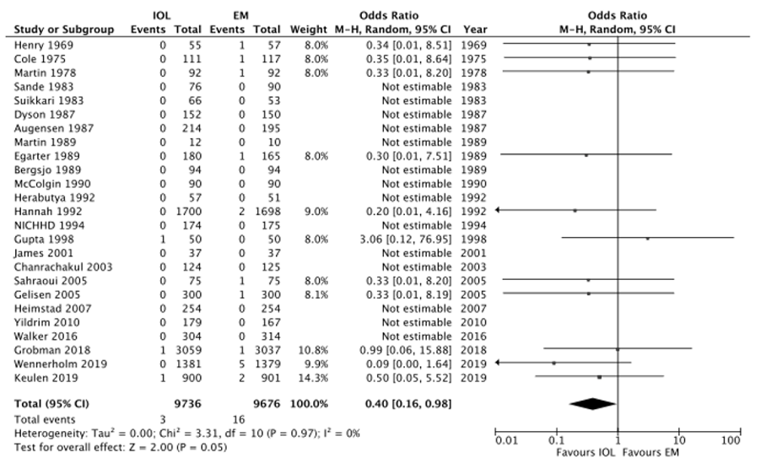
Stillbirth

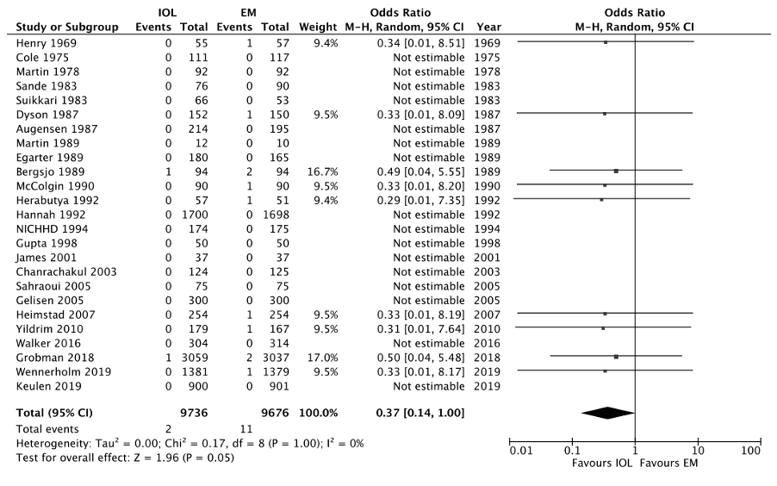
Neonatal death

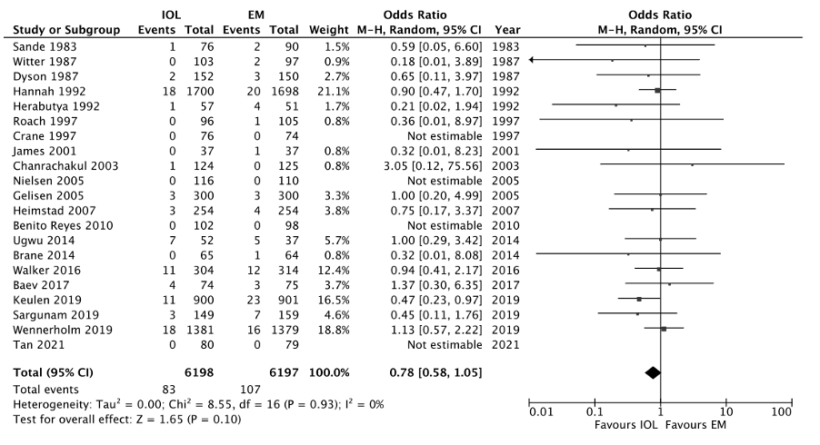
Apgar score <7 in 5 minutes

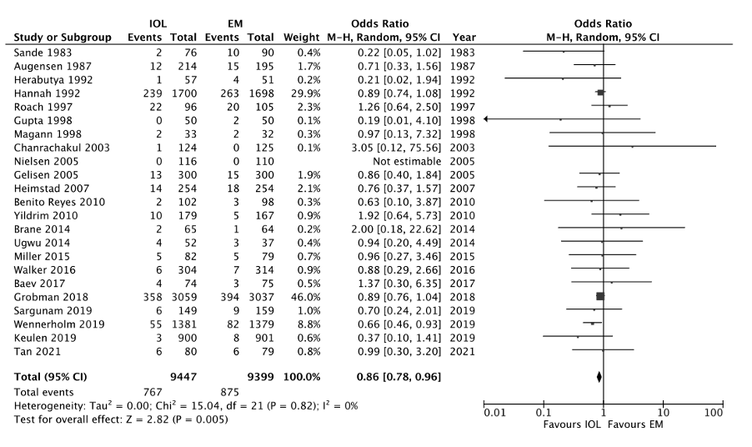
Admissions to neonatal intensive care unit

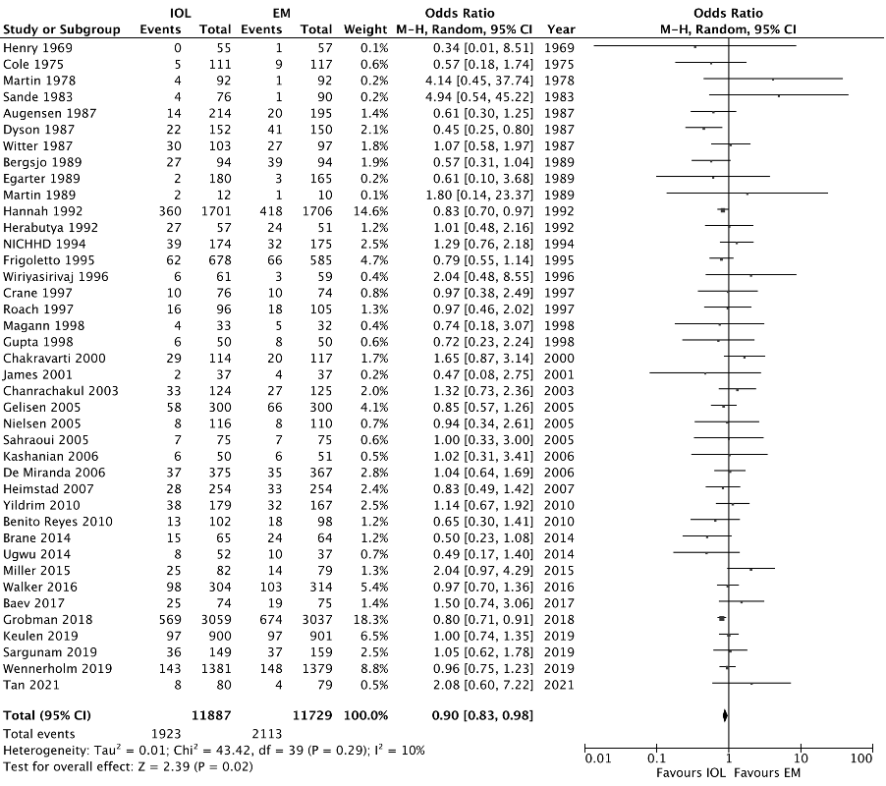
Caesarean delivery

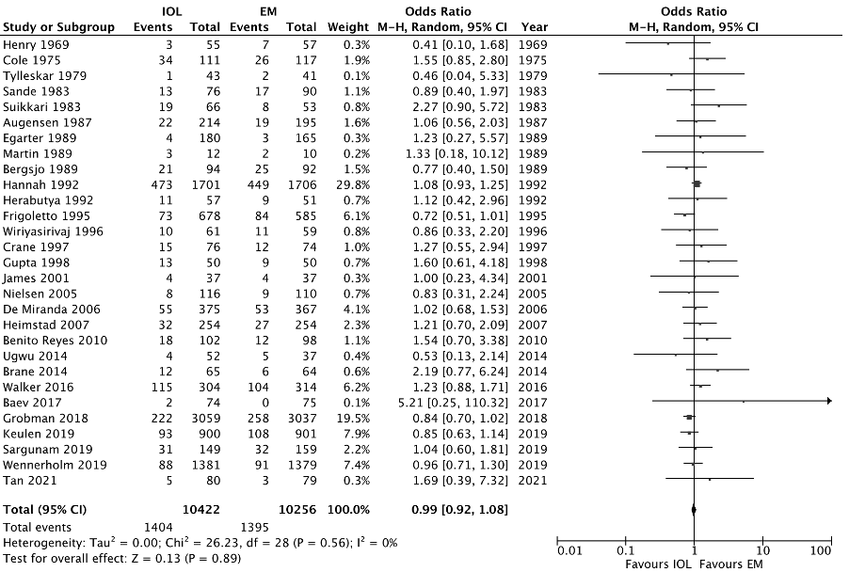
Operative vaginal delivery

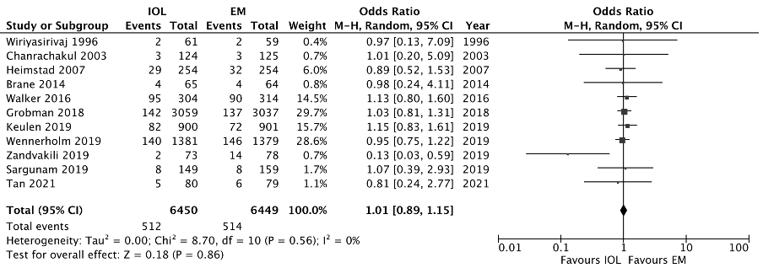
Postpartum haemorrhage

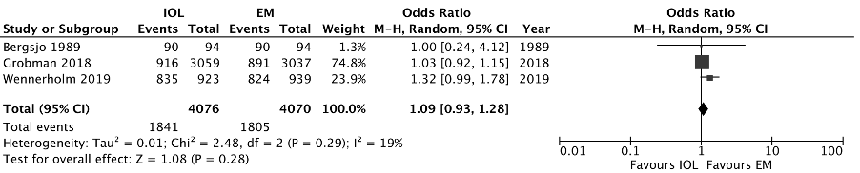
Breastfeeding status

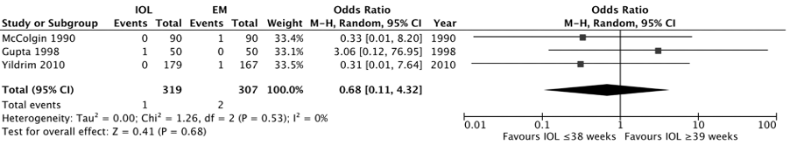
Appendix 6. Effect of induction of labour by week of planned induction on perinatal and maternal outcomes
IOL = induction of labour; EM = expectant management.
Effect of induction ≤38 weeks versus ≥39 weeks on perinatal death

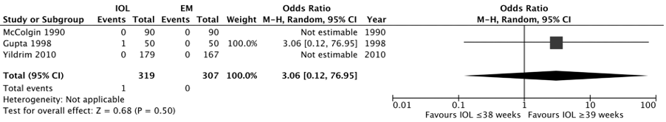
Effect of induction ≤38 weeks versus ≥39 weeks on stillbirth

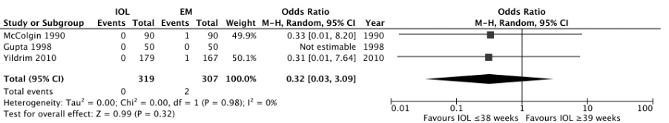
Effect of induction ≤38 weeks versus ≥39 weeks on neonatal death

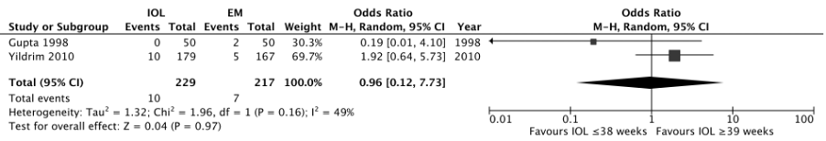
Effect of induction ≤38 weeks versus ≥39 weeks on admissions to neonatal intensive care unit

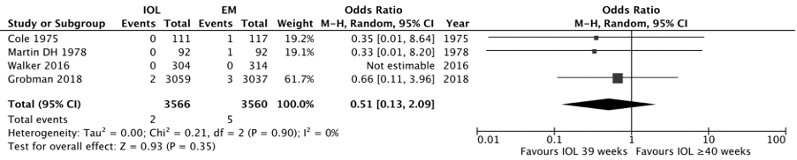
Effect of induction at 39 weeks versus ≥40 weeks on perinatal death

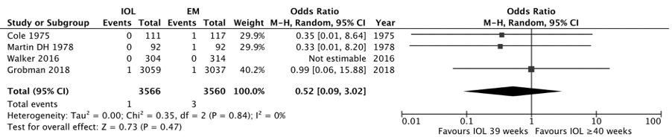
Effect of induction at 39 weeks versus ≥40 weeks on stillbirth

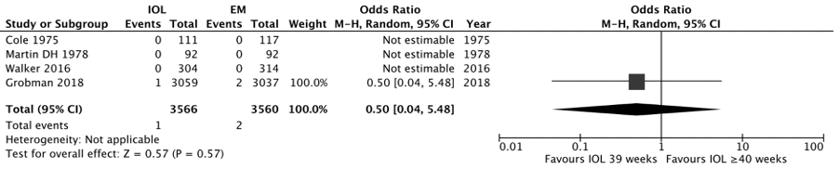
Effect of induction at 39 weeks versus ≥40 weeks on neonatal death

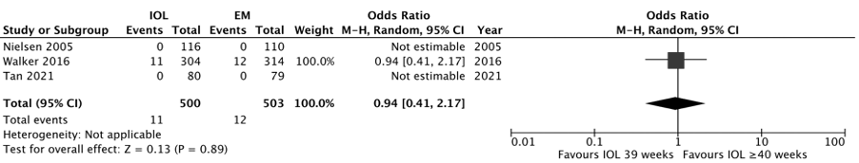
Effect of induction at 39 weeks versus ≥40 weeks on Apgar score <7 in 5 minutes
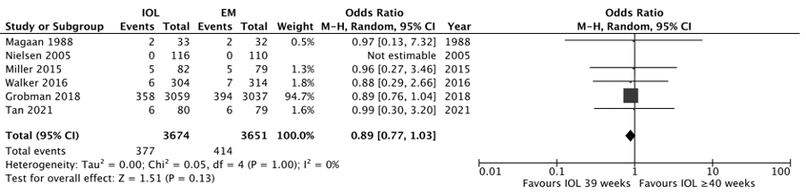
Effect of induction at 39 weeks versus ≥40 weeks on admissions to neonatal intensive care unit
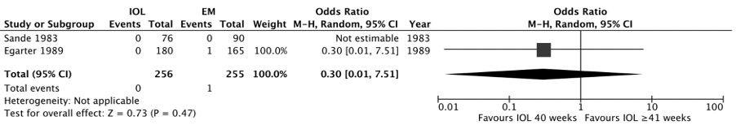
Effect of induction at 40 weeks versus ≥41 weeks on perinatal death

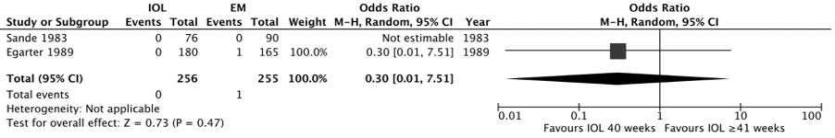
Effect of induction at 40 weeks versus ≥41 weeks on stillbirth

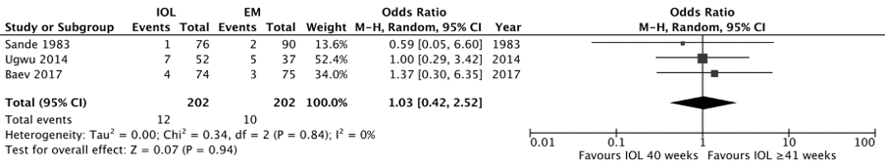
Effect of induction at 40 weeks versus ≥41 weeks on Apgar score <7 in 5 minutes

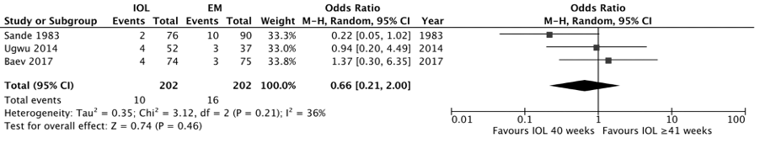
Effect of induction at 40 weeks versus ≥41 weeks on admissions to neonatal intensive care unit

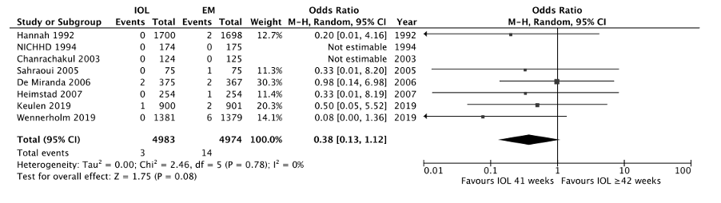
Effect of induction at 41 weeks versus ≥42 weeks on perinatal death
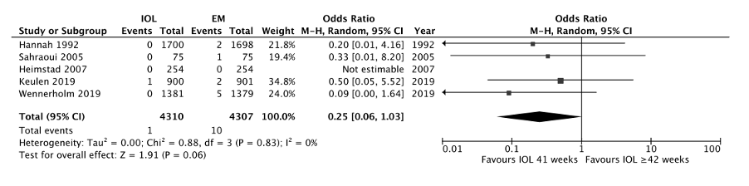
Effect of induction at 41 weeks versus ≥42 weeks on stillbirth
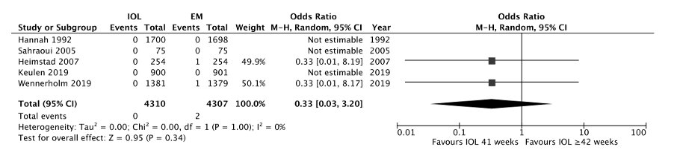
Effect of induction at 41 weeks versus ≥42 weeks on neonatal death
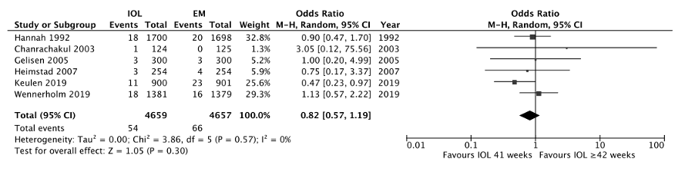
Effect of induction at 41 weeks versus ≥42 weeks on Apgar score <7 in 5 minutes

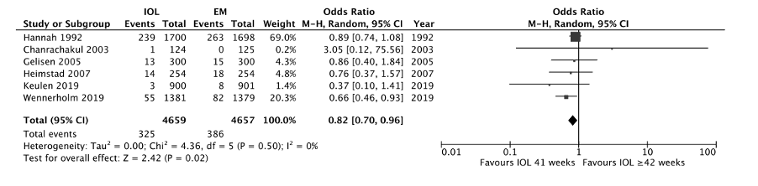
Effect of induction at 41 weeks versus ≥42 weeks on admissions to neonatal intensive care unit

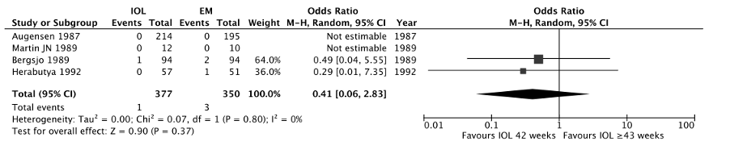
Effect of induction at 42 weeks versus ≥43 weeks on perinatal death

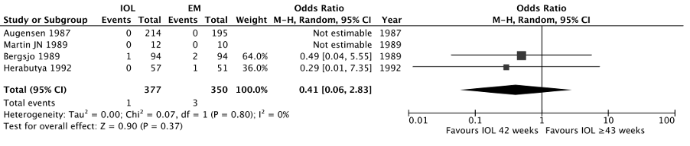
Effect of induction at 42 weeks versus ≥43 weeks on neonatal death

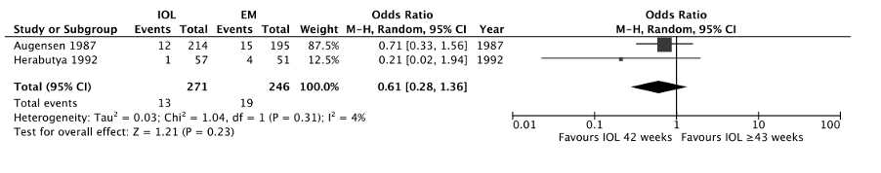
Effect of induction at 42 weeks versus ≥43 weeks on admissions to neonatal intensive care unit

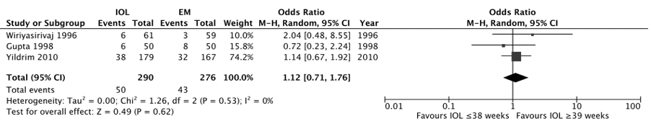
Effect of induction ≤38 weeks versus ≥39 weeks on caesarean delivery

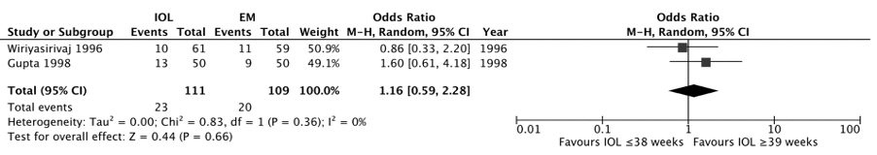
Effect of induction ≤38 weeks versus ≥39 weeks on vaginal operative delivery

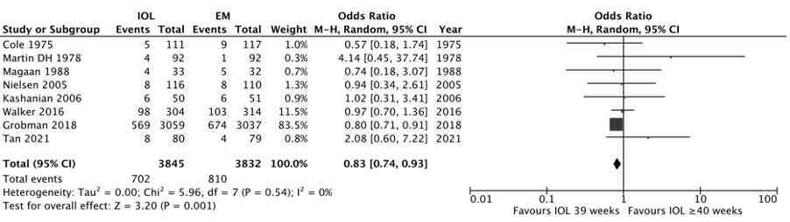
Effect of induction at 39 weeks versus ≥40 weeks on caesarean delivery
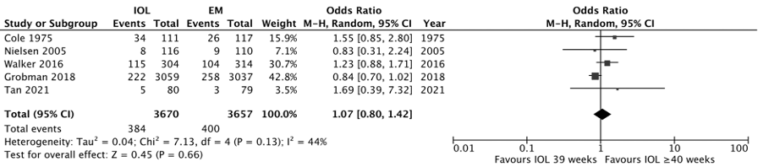
Effect of induction at 39 weeks versus ≥40 weeks on vaginal operative delivery

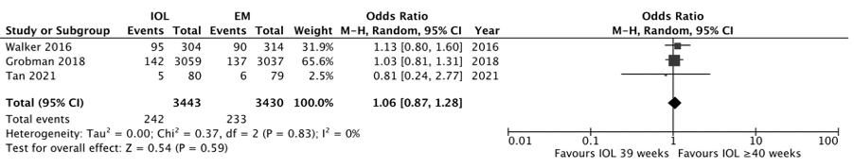
Effect of induction at 39 weeks versus ≥40 weeks on postpartum haemorrhage

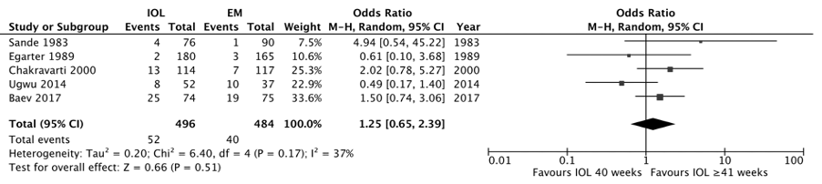
Effect of induction at 40 weeks versus ≥41 weeks on caesarean delivery

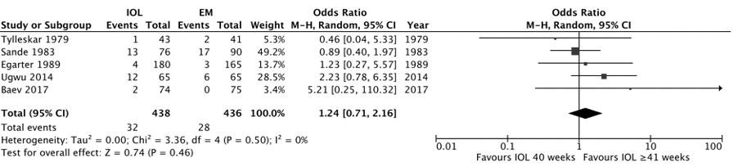
Effect of induction at 40 weeks versus ≥41 weeks on operative vaginal delivery

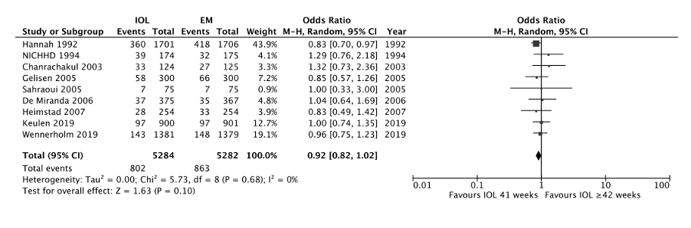
Effect of induction at 41 weeks versus ≥42 weeks on caesarean delivery

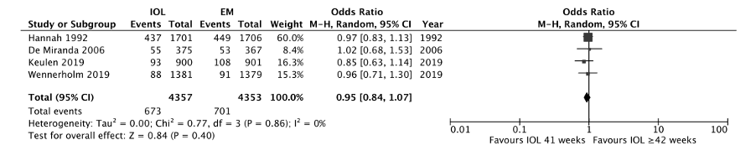
Effect of induction at 41 weeks versus ≥42 weeks on operative vaginal delivery

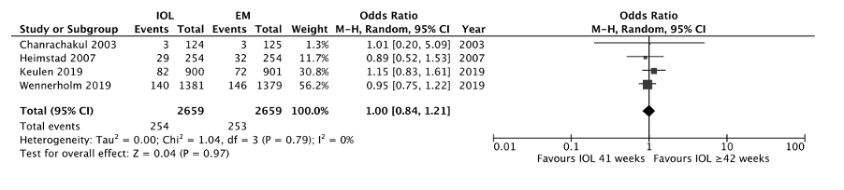
Effect of induction at 41 weeks versus ≥42 weeks on postpartum haemorrhage

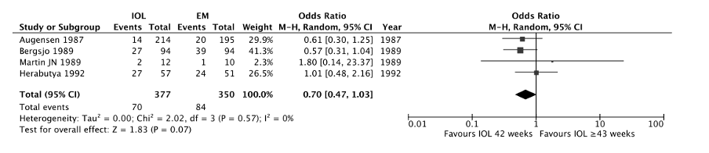
Effect of induction at 42 weeks versus ≥43 weeks on caesarean delivery

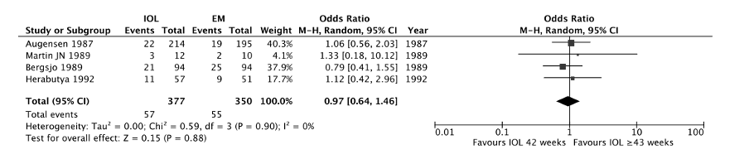
Effect of induction at 42 weeks versus ≥43 weeks on operative vaginal delivery

Appendix 7. Subgroup analysis by method of induction on perinatal and maternal outcomes
IOL = induction of labour; EM = expectant management.

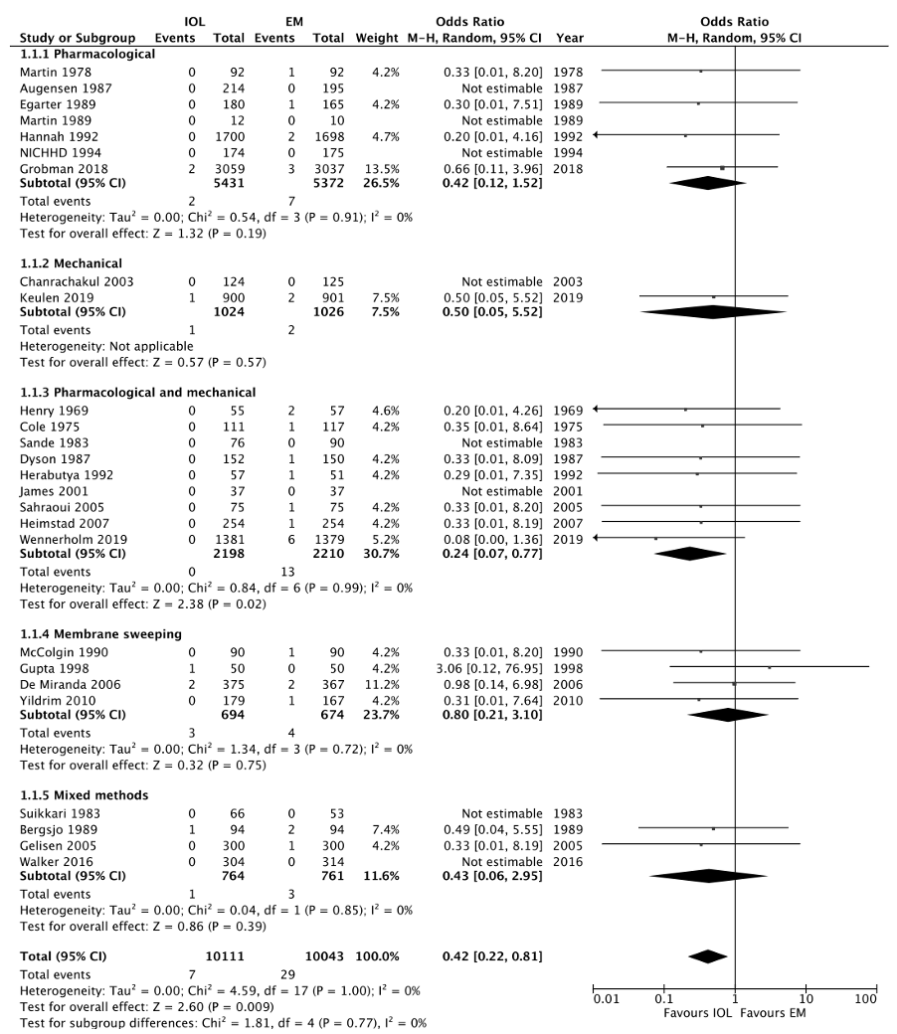
Perinatal death

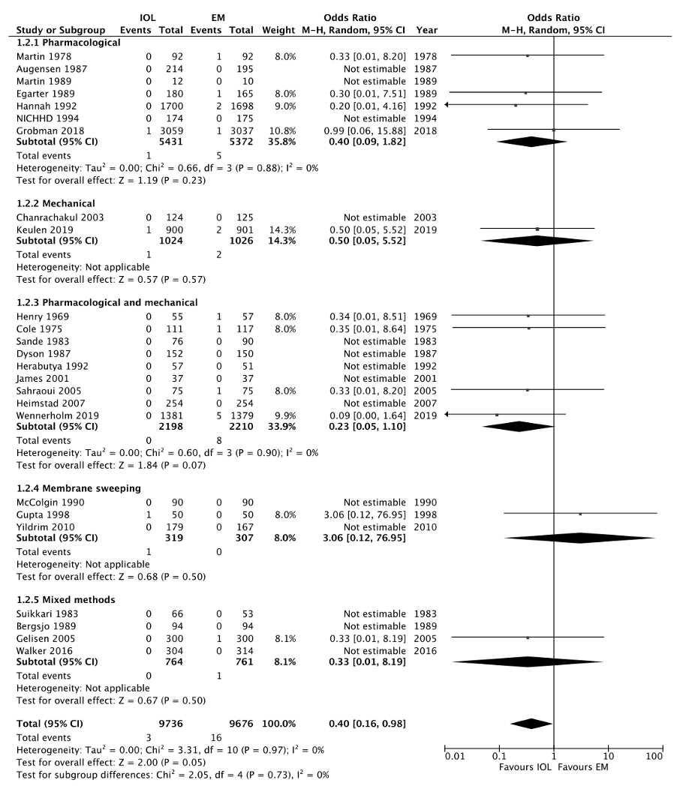
Stillbirth

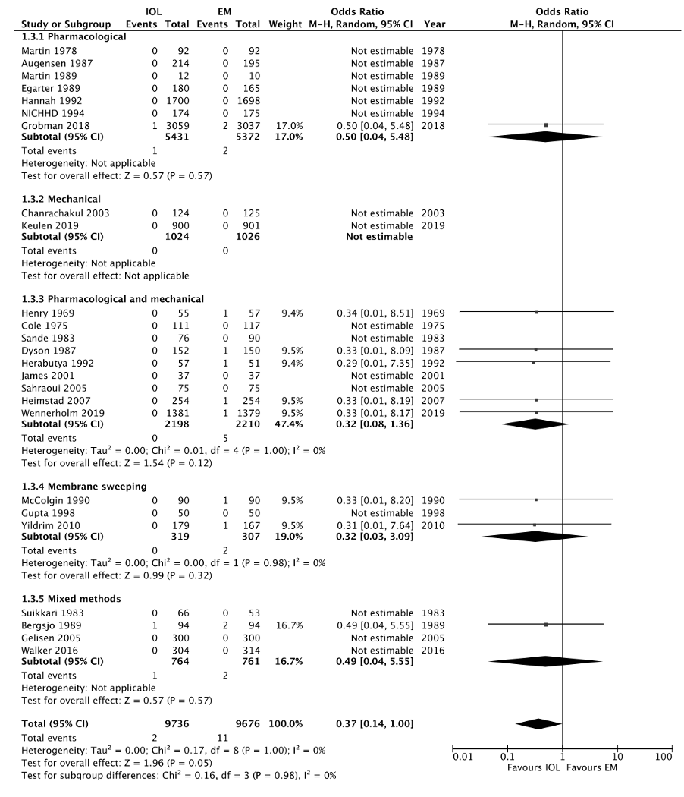
Neonatal death
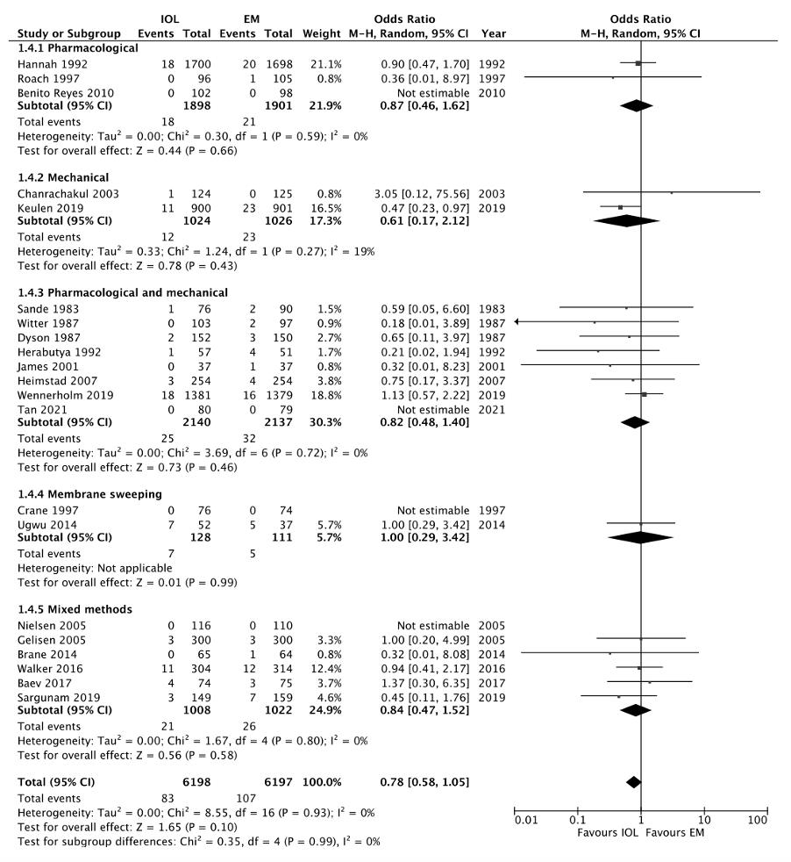
Apgar score <7 in 5 minutes

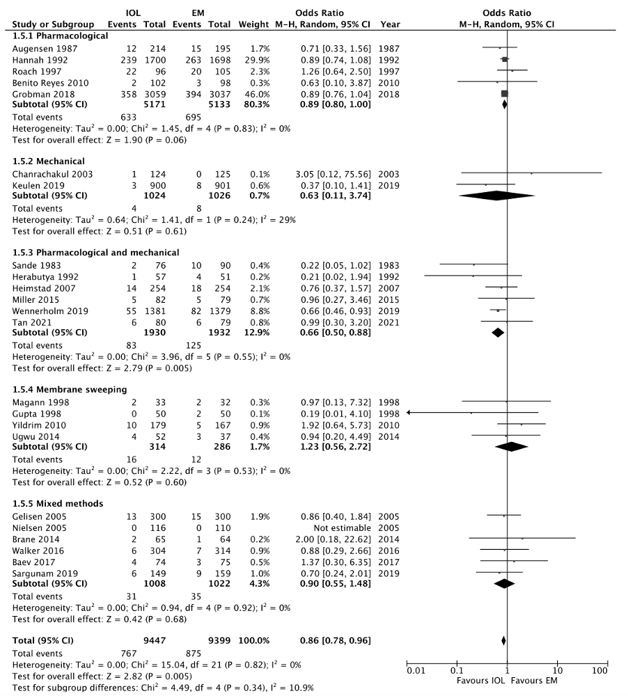
Admissions to neonatal intensive care unit

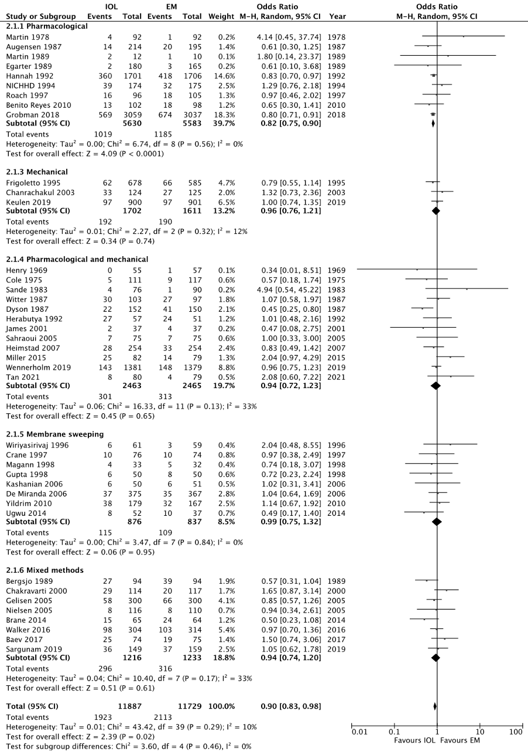
Caesarean delivery
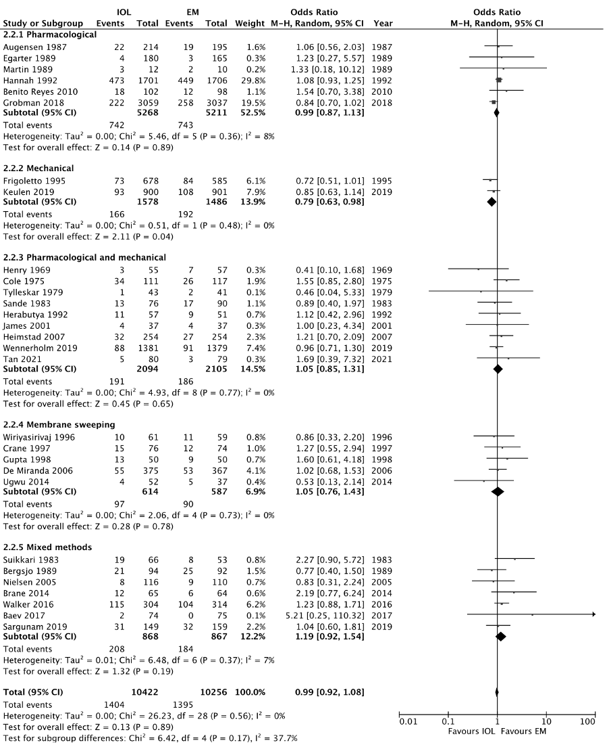
Operative vaginal delivery

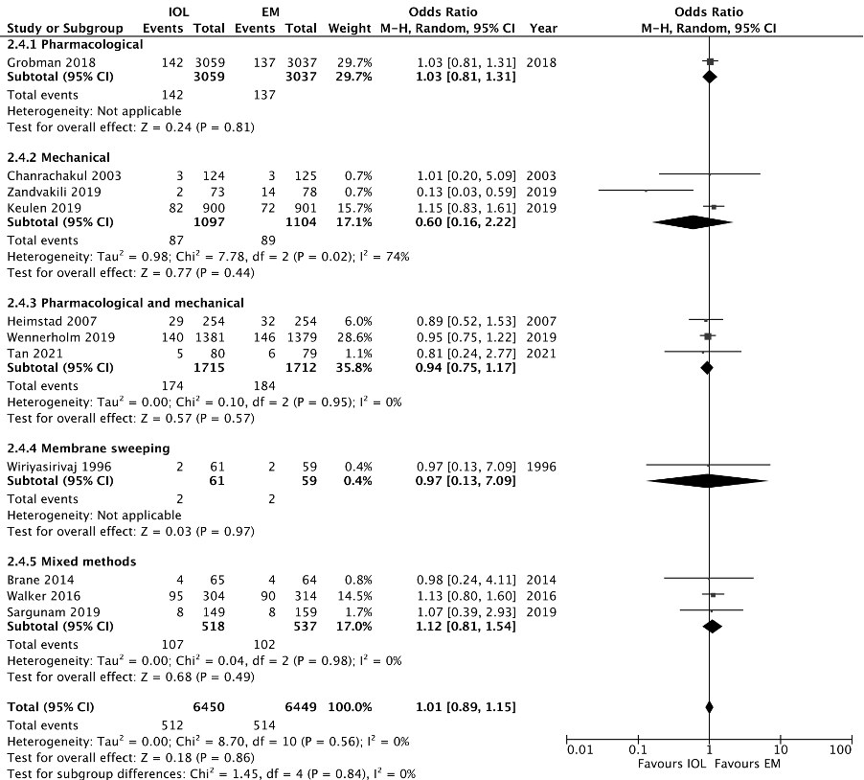
Postpartum haemorrhage

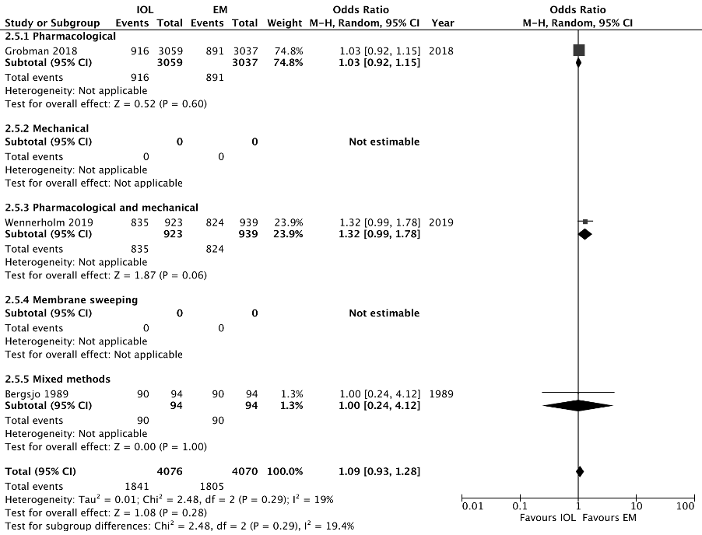
Breastfeeding status

