**S3 Text:** Intervention facts-sheets and educational presentation for the ESTEEM trial

3A: General information

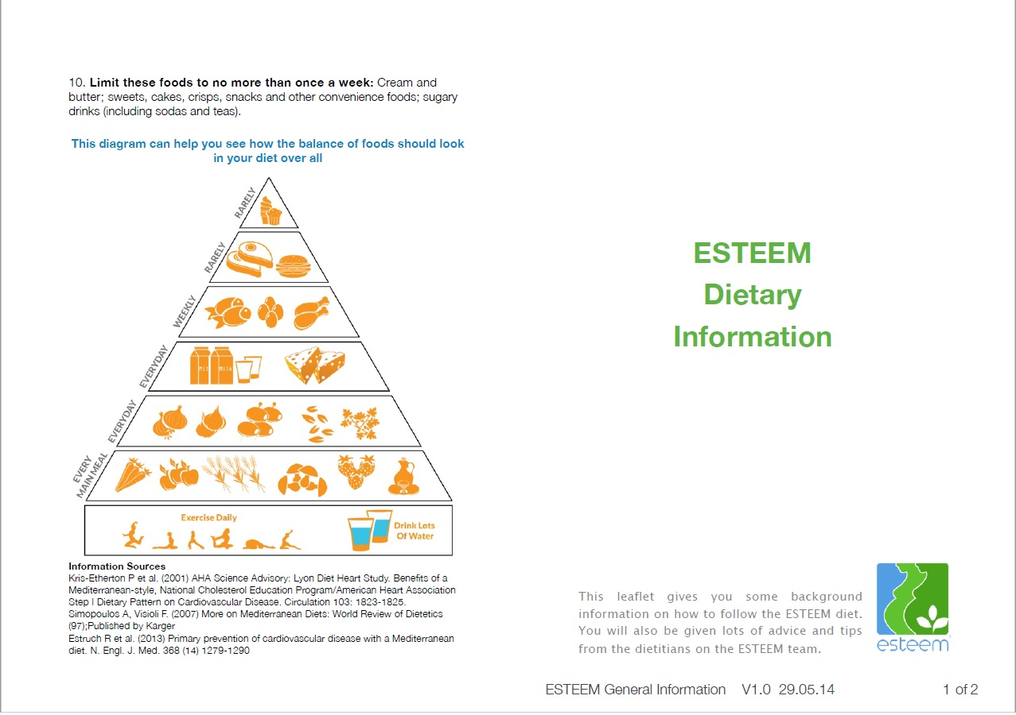

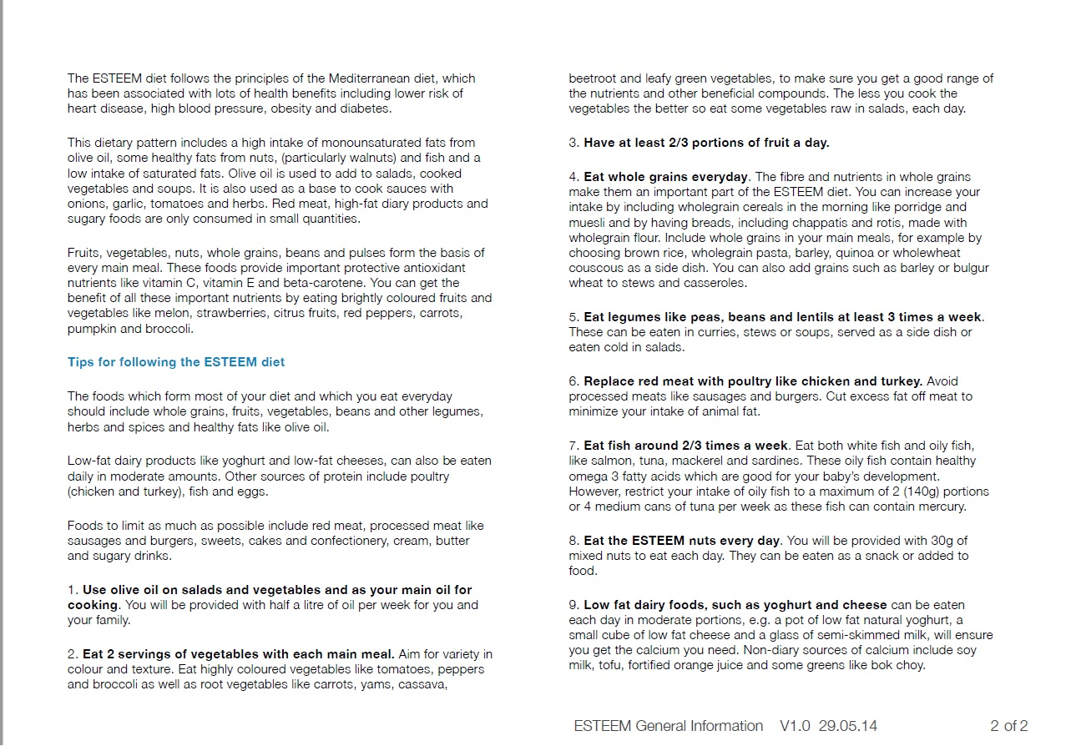

3B: Weekly plan for individual food portion sizes

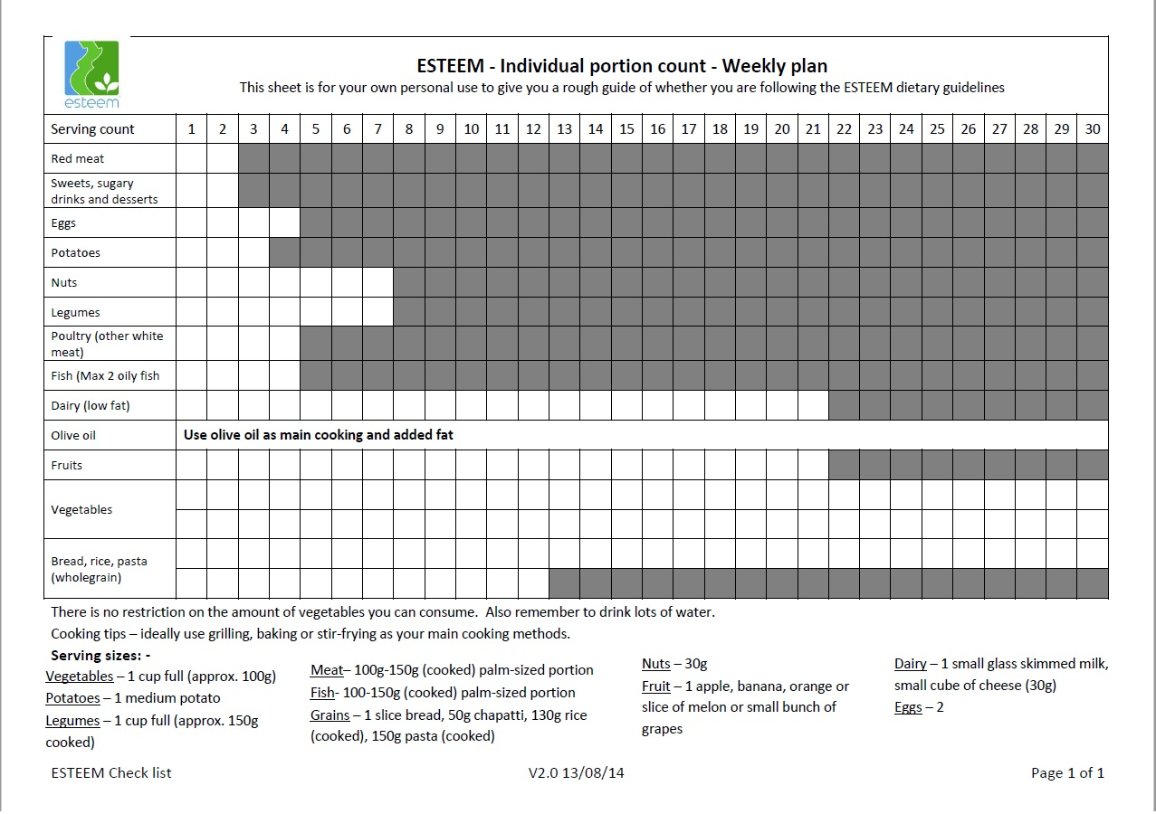

3C: Leaflet on extra virgin olive oil

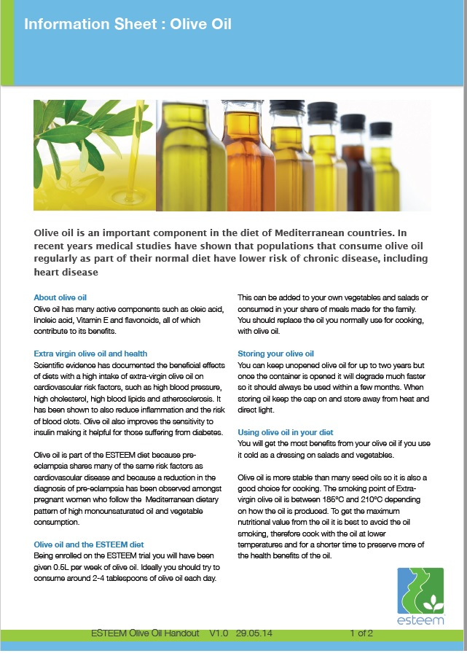 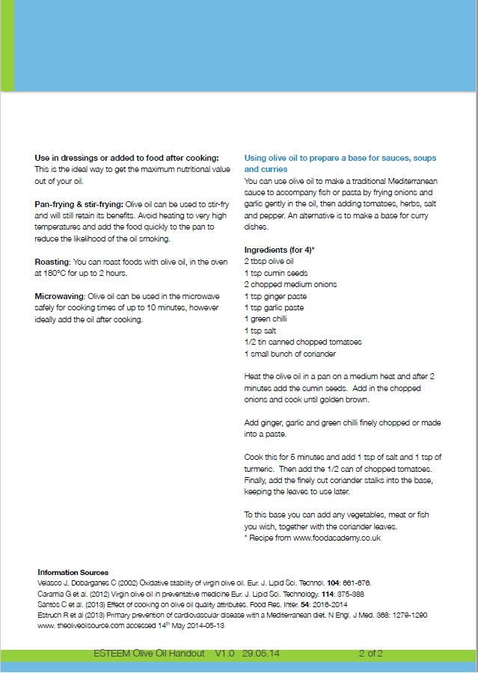

3D: Leaflet on mixed nuts

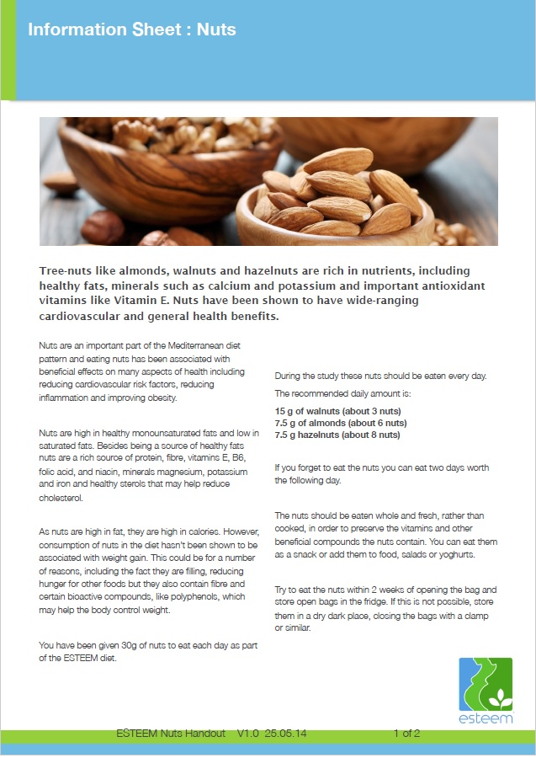 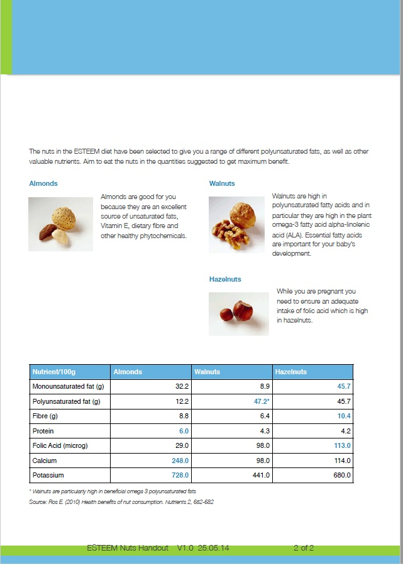

3E: Standardized educational presentation

(i) At 20 weeks’ gestation

|  |  |
| --- | --- |
|  |  |
|  |  |
|  |  |
|  |  |
|  |  |
|  |  |
|  |  |
|  |  |
|  |  |
|  |  |
|  |  |
|  |  |
|  |  |

(ii) At 28 weeks’ gestation

|  |  |
| --- | --- |
|  |  |
|  |  |
|  |  |
|  |  |
|  |  |
|  |  |
|  |  |
|  |  |
|  |  |

3F: Composition of daily nuts and extra virgin oil intake in the intervention

* *0∙5 litre/week extra virgin olive oil:*

Each 100g provides:

|  |  |
| --- | --- |
| Protein | Trace |
| Carbohydrates | 0.0g |
| Fat | 99.9g |
| Saturated fat | 14.0g |
| Mono-unsaturated fat | 69.7g |
| Poly-unsaturated fat | 11.2g |
| Fibre | 0.0g |
| Sodium | Trace |

* *30 g of mixed nuts:*

15 g of walnuts (about 3 nuts)

7.5 g of almonds (about 6 nuts)

7.5 g hazelnuts (about 8 nuts**)**