The fate of patients opportunistically screened for abdominal aortic aneurysms during echocardiogram or arterial duplex scans
Short Title:
The Fate of Opportunistic AAA Screening Patients

Authors and Affiliations:
Kayla Chiew^{1,2}, Iain Roy^{1,2}, James Budge^{1,2}, Fabrizio D’Abate¹, Peter Holt^{1,2}, Ian M Loftus^{1,2}
¹Vascular Institute, St George’s University Hospital NHS Foundation Trust, London, UK
²Molecular and Clinical Sciences Institute, St George’s, University of London, UK
Corresponding Author:
Iain Roy
Molecular and Clinical Sciences Institute,
St George’s, University of London,
Cranmer Terrace,
SW17 0RE
UK
Email: iroy@sgul.ac.uk
Word Count:
WTPA: 98
Abstract: 300
Text body: 2674

Number of Tables: 2
Number of Figures: 3

What this paper adds
With a falling prevalence of AAA in the general population, opportunistic screening of high-risk populations may become a more efficient approach than current population-based screening programs. There is a lack of contemporary data with long-term outcomes evaluating this approach. Our study demonstrates a high yield of AAA identification using opportunistic screening in patients attending for transthoracic echocardiograms or lower limb arterial duplex scans. An evaluation of AAA size progression and clinical outcomes after an eight year follow-up period demonstrate few of these AAAs were treated but those with a AAA were twice as likely to die during follow-up.
Abstract
Objectives
To evaluate the long-term outcomes of individuals who attended for transthoracic echocardiograms (TTE) or lower limb arterial duplex scans (LLADS) and were opportunistically screened for abdominal aortic aneurysms (AAA).
Design
Follow-up of a prospective single-centre pilot cohort study conducted between December 2012 and September 2014 at a tertiary vascular centre in the United Kingdom.
Methods
Males and females aged 65 and over were invited to undergo AAA screening when attending for TTE or LLADS. Screening was performed by ultrasonographic examination of the abdomen at the end of their planned scans. AAA was defined as an abdominal aorta outer wall to outer wall anteroposterior diameter of 30mm or more. Patients were excluded if they had known AAA or previous abdominal aorta intervention. Follow-up outcomes were evaluated in December 2020.
Results
762 patients were enrolled in this study; 486 had TTE and 276 patients had LLADS. The overall incidence of AAA was 54 (7.1%) in the combined cohort, 25 (5.1%) in the TTE group, and 29 (10.5%) in the LLADS group.
After a median 7.6 years, two of the 54 AAAs received intervention in the form of endovascular repair. Three others reached treatment threshold but were conservatively managed. Overall intervention rate was 3.7% of detected AAAs.
Adjusted mortality rates in those with AAA vs without was 64.8% and 36% respectively (HR 2.02, p <.001). Diabetes (HR 1.35, p=.015) and older age (HR 1.18, p=.17) were the other factors associated with mortality.
Conclusions
AAA is associated with significantly increased mortality. Populations attending for TTE or LLADS demonstrate a higher prevalence of AAA compared to population-based screening, however the proportion offered AAA intervention was low. Further research into opportunistic screening should target those more likely to undergo AAA repair, unless other interventions are demonstrated to reduce the general increased mortality in AAA patients.

MeSH Keywords: abdominal aortic aneurysm, mass screening, transthoracic echocardiography, peripheral arterial disease
Introduction
Population-based ultrasound screening for abdominal aortic aneurysm (AAA) in males is undertaken in numerous countries. Randomised controlled trials (RCTs) have demonstrated increased rates of AAA surgery and decreased rates of AAA rupture, which account for a significant reduction in AAA-specific mortality in screened patients¹. Cost analyses in two RCTs demonstrated acceptable cost effectiveness of population screening in men^{2,3}. RCTs of population screening in females have failed to demonstrate even a disease-specific benefit, and subsequent analysis has shown they are unlikely to reach cost-effectiveness even in very favourable conditions⁴.
The National Health Service Abdominal Aortic Aneurysm Screening Program (NHS AAASP) in the United Kingdom (UK) screens men over 65 and is largely based on protocols derived from the largest RCT, The Multicentre Aneurysm Screening Study (MASS), which demonstrated a AAA prevalence of 4.9%. In the year 2019-2020 the NHSAAASP scanned 222 182 males with only 0.9% having an AAA demonstrated⁵. This incidence has slowly fallen since the programme’s first report in 2015⁶. With a decreasing prevalence of AAA found on population screening in males and a lack of cost effectiveness in females, increased attention may be focused on the effectiveness of opportunistic or selective screening to reduce overall AAA-specific mortality.
AAA are known to have a higher prevalence in patients with coronary artery disease and peripheral arterial disease (PAD), likely due to the shared risk factors⁷. Both these populations regularly have ultrasound-based investigations and could have opportunistic screening for AAA at the same time for little additional cost. The risk of screening a population with established co-morbidities is that it will increase the financial costs of AAA treatment and potentially decrease quality of life in individuals who have AAA diagnosed but are not suitable for treatment. This study reports the fate of individuals who had opportunistic screening for AAA as part of a feasibility study and discusses the utility of such screening.
Materials and Methods
Setting and participants
A review of late outcomes was undertaken on a prospective single-centre pilot cohort study conducted at a tertiary vascular centre in the United Kingdom. Between December 2012 and September 2014, male and female patients aged 65 and over who were undergoing transthoracic echocardiography (TTE) by an accredited clinical vascular scientist were invited to participate in the study. Those who agreed had an abdominal aortic measurement taken at the end of their TTE. Qualifying patients having a lower limb arterial duplex scan (LLADS) between January 2013 to August 2015 had their abdominal aortas scanned as part of this investigation and were included in the study. The indication for scan was not a factor determining eligibility. Patients in both groups were excluded on the basis of having had previous abdominal aorta intervention or a known AAA. Consent was sought in all instances. The study received approval by an NHS research governance and ethics committee prior to commencement. It was undertaken prior to a routine requirement for trial registrations.
Outcome measures
An abdominal aorta outer wall to outer wall anteroposterior diameter measured using a transverse view of 30mm or more was defined as a AAA. Those found to have an AAA from our screening were provided with information about the diagnosis and enrolled in the local AAA surveillance program. The patient’s age, sex, smoking status, family history of AAA and comorbidities which included hypertension, diabetes and hypercholesterolaemia, were collected via a questionnaire administered at the time of their scan. Follow-up outcomes were evaluated in December 2020. The central NHS spine was used to ascertain mortality status by evidence of a date of death on the patient’s records. Vascular clinic appointment documentation and the results of repeat AAA scans were reviewed through the institution’s electronic patient records.
Scanning protocol
AAA was assessed by an accredited clinical vascular scientist. Ultrasonographic examination of the abdomen was performed in the supine position at the end of their TTE or LLADS. B-mode ultrasound in a transverse view starting from the epigastric region down to the abdominal aortic bifurcation was undertaken. Once the maximum abdominal aorta diameter was visualised, the image was frozen and a maximum anterior to posterior diameter was obtained using the outer edge of the anterior wall to the outer edge of the posterior wall (Figure 1).
Statistical Analysis
A presumption of non-normal distribution was made for all variables. Continuous variables are presented as median (interquartile range), and categorical variables as total numbers and percentages (%). Comparison between two groups was done using the Wilcoxon rank-sum test. Multiple logistic regression analysis was used to assess for independent association with AAA. A p-value of less than 0.05 were considered statistically significant. Adjusted survival analyses were conducted using a Cox proportional hazard model, using the whole study population as reference when required.
Results
486 patients (316 male, 170 female) and 276 patients (172 male, 104 female) underwent AAA screening during TTE and LLADS respectively. They were followed up for a median duration of 7.6 years (7.1-7.8). Baseline demographic information can be found in Table 1. The overall incidence of AAA was 7.1% (Table 2). The median abdominal aorta size was 20 mm.
Transthoracic Echocardiography Cohort
486 patients were screened for AAA during TTE, the median age of this population was 76 (71-81). The majority of patients attended for evaluation of valvular function (33%) and pre-operative assessment for coronary revascularization (23%). The abdominal aorta was not visualized in 11 patients (2.3%) and AAA was detected in 25 patients, a prevalence of 5.1%. Of these, 19 were male and six were female. The prevalence of AAA in this sample was 6.0% in males, and 3.5% in females (p = .36). Those with AAA were older than those without (p = .038) (Table S1). The median AAA size was 33 mm (31-38) (Figure 2A). The unadjusted mortality rate for those with AAA was 52% compared to 38% in those who did not have a AAA (p = .18).
Males vs Females with AAA
The median AAA size was 36 mm (31-41) in females, and 33 mm (32-38) in males (p = .92). Females with AAA had a median age of 83 (78-81), whilst males had a median age of 78 (73-84) (p = .37). Of the six females found to have AAAs, two reached treatment threshold. One underwent an endovascular aneurysm repair (EVAR) four years after initial screening, and the other developed a 67 mm aneurysm six years after screening which was managed conservatively. Overall five of the six females with AAA did not have any AAA intervention. All 19 males with AAA did not have any AAA intervention. One of them reached treatment threshold with a 63 mm AAA after eight years, however this was managed conservatively. Table S2 lists all the patients identified to have an AAA during TTE and the most recent outcomes of their AAA surveillance.
Risk factor association
Hypertension, being an ex-smoker and hypercholesterolaemia were the most common risk factors identified in the population screened during TTE. Multiple logistic regression analysis identified age (p = .007) and smoking pack years (p < .001) as independent risk factors for AAA (Table S3).

Lower Limb Arterial Duplex Scan Cohort
276 patients were screened for AAA during LLADS, the median age in this population was 77 (70-84) (Table 1). The majority of patients attended due to claudication (37%) and features of chronic limb ischaemia (23%). The abdominal aorta was not visualized in 24 patients (8.7%), AAA was detected in 29 patients, a prevalence of 10.5% (Table 2). Of these, 19 were male and 10 were female. Male and female AAA prevalence is 11.0% and 9.6% respectively (p = .21). The median size of AAA was 36 mm (32-41) (Figure 2B). The unadjusted mortality rate in those with AAA is 76% compared to 35% without AAA (p < .001) (Table S4).
Males vs Females
The median AAA size was 41 mm (34-45) in females, and 34 mm (31-38) in males (p = .046). Females with AAA had a median age of 81 (77-85), whilst males had a median age of 77 (72-84) (p = .21). Of the 10 females found to have AAAs, two reached treatment threshold. One had a AAA size 40 mm at screening which grew to 55 mm 2.5 years later. The second had a 55 mm AAA during screening, which grew to 59 mm three years later. None of the females with AAAs received intervention for their aneurysms. Of the 19 males with AAA, one received an EVAR, and one was found to have a 67 mm AAA during screening which was conservatively managed. Table S5 lists all the patients with AAA identified during LLADS and the most recent outcomes of their AAA surveillance.
Risk factor association
Hypertension, hypercholesterolaemia and diabetes were the most common risk factors identified in the population screened during LLADS . Multiple logistic regression analysis identified being a smoker (p = .006) as an independent risk factor for AAA (Table S6).

Mortality
The overall mortality rate in those with and without a AAA was 64.8% and 36.0% respectively (p < .001). Figure 3 demonstrates the adjusted Kaplan-Meir curves for those with AAA, without AAA, and those with abdominal aortas that were not visualised. Mortality in follow-up was independently associated with having a AAA (HR 2.02, p < .001), a non-visualised aorta (HR 1.96, p = .004), those who were older (HR 1.06 per year, p < .001) and have diabetes (HR 1.36, p = .015) (Figure S1).

Discussion
This study demonstrates a high yield of AAA identification using the approach of opportunistic screening of select high-risk populations. At present, the European Society for Vascular Surgery (ESVS) recommends one-off AAA screening for all men aged 65 years of age⁸. ACC/AHA guidelines take the more targeted recommendation of screening males 65 years of age who have ever smoked.⁹ There has been a dramatic decrease in prevalence of AAA in the UK from 4.7% in the last century, to 0.9% currently¹⁰. This has been mirrored in other Western populations^{11,12}. Targeted screening of high-risk populations is a potential cost-effective alternative to the population-based screening.
A 2018 meta-analysis of 20 observational studies with 43 341 participants demonstrated a prevalence of AAA in those attending for TTE of 3.3%; 4.6% in males, and 1.4% in females ¹³. This study corroborated these findings with a prevalence of 5.5%. A prevalence of 3.5% in women is a almost four-fold higher than that in population-level screening of men in the UK.
Numerous studies have supported the positive correlation between the prevalence of PAD and AAA^{14,15}. Despite this, there are limited studies implementing the opportunistic screening for AAA in those who attend for LLADS. The most contemporary data is from Jones et al which evaluated various targeted screening strategies for AAA¹⁶. Within the group of patients who underwent ultrasound for suspected carotid artery atherosclerosis or PAD, prevalence of AAA was found to be 6% in men and 2.2% in women. This study found a male and female prevalence of 11% and 9.6% respectively.
The increased rate of AAA found in populations attending for TTE or LLADS scans were irrespective of gender and smoking historywas the only consistent risk factor associated with AAA. Difference in prevalence may partially be attributed to the difference in imaging protocols. Gürtelschmid et al. demonstrated a difference in mean aortic diameter measurement of 4.1mm between inter to inner and outer to outer measurements in a known AAA population with a mean aortic diameter of 42mm¹⁷.
The feasibility of opportunistic screening is supported by the convenience of not requiring additional equipment and an acceptable abdominal aorta visualization rate of 95.4%. Whilst the time taken for AAA scanning was not measured in this study, previous reports have suggested a very small additional scan time of 31 seconds to under five minutes, and an 86% success rate for abdominal aorta visualization¹³.
The clinical utility and cost-effectiveness of implementing such a screening program however depends on whether this high pick-up rate translates to a meaningful impact on the patient’s clinical course in the form of identifying large AAAs that are amenable to treatment and reducing AAA mortality. Despite a higher AAA prevalence in our combined cohort compared to the landmark MASS study, the proportion which actually underwent surgical repair is smaller (4% and 3.4% in the TTE and LLADS cohorts respectively). The MASS study demonstrated elective surgery rates as high as 40.2%¹. Furthermore, 2% of MASS’ total screened population received intervention for AAA, whilst 2.9% were found to have AAAs that were not for intervention. These are in contrast to the values observed in this study which showed that only 0.26% of those screened had a AAA that underwent intervention, whilst 6.8% had a AAA that was not for intervention. For one AAA that is amenable to surgery, this study found 26 AAAs that either didn’t grow in size to reach treatment threshold or for whom the risks of surgery outweigh the benefit or the patients declined subsequent surveillance..
Whilst both our cohorts demonstrated a significantly higher mortality rate in those with AAA compared to those without, data sources for this post study analysis preclude comment on what proportion of these were aneurysm-related deaths. It appears unclear whether the risk-benefit of an overall intervention rate of 3.7% as seen in this study is sufficient in justifying this opportunistic screening approach. Although the benefit for screening in men has continued to be shown in meta-analysis, population-based approaches do not seem to show benefit for women^{18,19}. This study however presents a small amount of data that may potentially support targeted opportunistic screening of men and women within the subset of patients who are at higher risk for AAA and who are fit for repair. Targeted screening of those who attend for theses scans but with stable / noncritical co-morbidities and a smoking history may offer a superior strategy.
Finally, these results demonstrated the significance of having a AAA as a poor prognostic marker in this contemporary cohort. The adjusted mortality rate of those with AAA was almost twice as high as those without. With half the AAA population in this study deceased after just six years irrespective of management strategy, the relevance of the general debate on long-term durability of interventional treatments of AAA may be becoming less important. Arguably AAA could be seen as a highly significant predictor of general mortality risk, even in the context of the very co-morbid population of our study. Opportunistic and potentially population based AAA screening could have continued and much greater efficacy if they instigate and demonstrate benefit from aggressive risk factor modification. This looks to have the potential to dwarf the benefits of isolated treatment or surveillance of AAA pathology but is yet to be proven in a randomised setting.
Limitations
This was a pilot study intended to inform a larger study of surveillance, as such it did not anticipate a need for long term follow-up data regarding aneurysm-related outcomes. At the time of initial analysis, it’s low rate of patients requiring repair made a larger study uneconomical. 13 of 54 patients diagnosed with a AAA declined subsequent surveillance. Despite all being ultrasound-based investigations, the adjunct of AAA screening to a transthoracic echocardiogram may require additional training, as cardiac sonographers are not generally qualified in vascular ultrasound. Any future studies into opportunistic screening require a mechanism to collect late aneurysm-related and all-cause deaths to guide the recommendation for targeted opportunistic screening in these high-risk populations.

Conclusion
The mortality rate associated with AAA is almost twice as high compared to those without AAA, in a high-risk cardiovascular population. Opportunistic screening for AAA in patients attending for a TTE or LLADS has demonstrated prevalence rates of up to 10 times higher than that observed in population-based screening in our study. The proportion of those who are candidates for surgical intervention however is small due to patient comorbidities limiting suitability for surgery and little growth in AAA size such that many do not reach treatment threshold. Further research into opportunistic screening should be limited to targeted populations more likely to undergo AAA repair, unless proven interventions to modify general mortality in AAA patients are found.

Funding: No External Funding
Declaration of interest: None to declare
Acknowledgments: This research did not receive any specific grant from funding agencies in the public, commercial, or not-for-profit sectors.
References
1. Scott RAP, Ashton HA, Buxton MJ, Day NE, Kim LG, Marteau TM, et al. The Multicentre Aneurysm Screening Study (MASS) into the effect of abdominal aortic aneurysm screening on mortality in men: A randomised controlled trial. Lancet. 2002;360(9345):1531–9.
2. Thompson SG, Ashton HA, Gao L, Scott R A. P. Screening men for abdominal aortic aneurysm: 10 year mortality and cost effectiveness results from the randomised Multicentre Aneurysm Screening Study. BMJ. 2009;338:b2307.
3. Kim LG, P Scott RA, Ashton HA, Thompson SG, Group MASS. A sustained mortality benefit from screening for abdominal aortic aneurysm. Ann Intern Med. 2007;146(10):699–706.
4. Sweeting MJ, Masconi KL, Jones E, Ulug P, Glover MJ, Michaels JA, et al. Analysis of clinical benefit, harms, and cost-effectiveness of screening women for abdominal aortic aneurysm. The Lancet. 2018;392(10146):487–95.
5. Public Health England. AAA standards report 2019 to 2020. URL: https://www.gov.uk/government/statistics/abdominal-aortic-aneurysm-screening-standards-report-2019-to-2020/aaa-standards-report-2019-to-2020
6. Public Health England. Abdominal aortic aneurysm screening: 2014 to 2015 data. URL: https://www.gov.uk/government/publications/abdominal-aortic-aneurysm-screening-2014-to-2015-data
7. Grenon SM, Vittinghoff E, Owens CD, Conte MS, Whooley M, Cohen BE. Peripheral artery disease and risk of cardiovascular events in patients with coronary artery disease: Insights from the Heart and Soul Study. Vascular Medicine. 2013 Aug 8;18(4):176–84.
8. Wanhainen A, Verzini F, Herzeele I van, Allaire E, Bown M, Cohnert T, et al. Editor’s Choice – European Society for Vascular Surgery (ESVS) 2019 Clinical Practice Guidelines on the Management of Abdominal Aorto-iliac Artery Aneurysms. European Journal of Vascular and Endovascular Surgery. 2019;57(1):8–93.
9. Isselbacher EM, Preventza O, Black JH, Augoustides JG, Beck AW, Bolen MA, et al. 2022 ACC/AHA Guideline for the Diagnosis and Management of Aortic Disease: A Report of the American Heart Association/American College of Cardiology Joint Committee on Clinical Practice Guidelines. Circulation. 2022 Dec 13;146(24):E334–482.
10. Jacomelli J, Summers L, Stevenson A, Lees T, Earnshaw JJ. Impact of the first 5 years of a national abdominal aortic aneurysm screening programme. British Journal of Surgery. 2016;103(9):1125–31.
11. Svensjö S, Björck M, Gürtelschmid M, Djavani Gidlund K, Hellberg A, Wanhainen A. Low Prevalence of Abdominal Aortic Aneurysm Among 65-Year-Old Swedish Men Indicates a Change in the Epidemiology of the Disease. Circulation. 2011;124(10):1118–23.
12. Sandiford P, Mosquera D, Bramley D. Trends in incidence and mortality from abdominal aortic aneurysm in New Zealand. British Journal of Surgery. 2011;98(5):645–51.
13. Argyriou C, Georgiadis GS, Kontopodis N, Pherwani AD, van Herwaarden JA, Hazenberg CEVB, et al. Screening for Abdominal Aortic Aneurysm During Transthoracic Echocardiography: A Systematic Review and Meta-analysis. European Journal of Vascular and Endovascular Surgery. 2018 Apr 1;55(4):475–91.
14. Cornuz J, Pinto CS, Tevaearai H, Egger M. Risk factors for asymptomatic abdominal aortic aneurysmSystematic review and meta-analysis of population-based screening studies. Eur J Public Health. 2004 Dec 1;14(4):343–9.
15. Li X, Zhao G, Zhang J, Duan Z, Xin S. Prevalence and Trends of the Abdominal Aortic Aneurysms Epidemic in General Population - A Meta-Analysis. PLoS One. 2013 Dec 2;8(12):e81260.
16. Jones GT, Hill BG, Curtis N, Kabir TD, Wong LE, Tilyard MW, et al. Comparison of three targeted approaches to screening for abdominal aortic aneurysm based on cardiovascular risk. British Journal of Surgery. 2016;103(9):1139–46.
17. Gürtelschmid M, Björck M, Wanhainen A. Comparison of three ultrasound methods of measuring the diameter of the abdominal aorta. British Journal of Surgery. 2014; 101(6):633–6.
18. Cosford PA, Leng GC, Thomas J. Screening for abdominal aortic aneurysm. Cochrane Database of Systematic Reviews. 2007;(2).
19. Scott RAP, Bridgewater SG, Ashton HA. Randomized clinical trial of screening for abdominal aortic aneurysm in women. British Journal of Surgery. 2002;89(3):283–5.

Legends for Figures
Figure 1. Transverse view B-Mode ultrasound image of abdominal aortic aneurysm, with white callipers demonstrating the outer wall to outer wall anteroposterior diameter measurement.
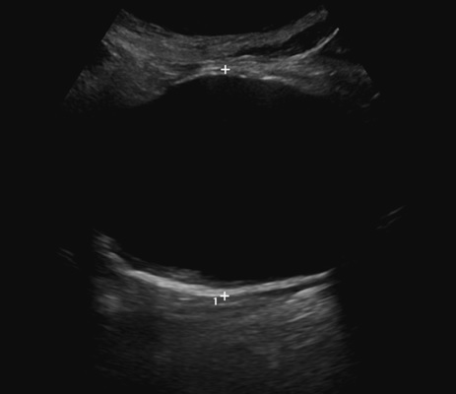

Figure 2. Distribution of abdominal aortic aneurysm (AAA) size identified in those screened during other ultrasound investigations. The dotted lines represent the median values.
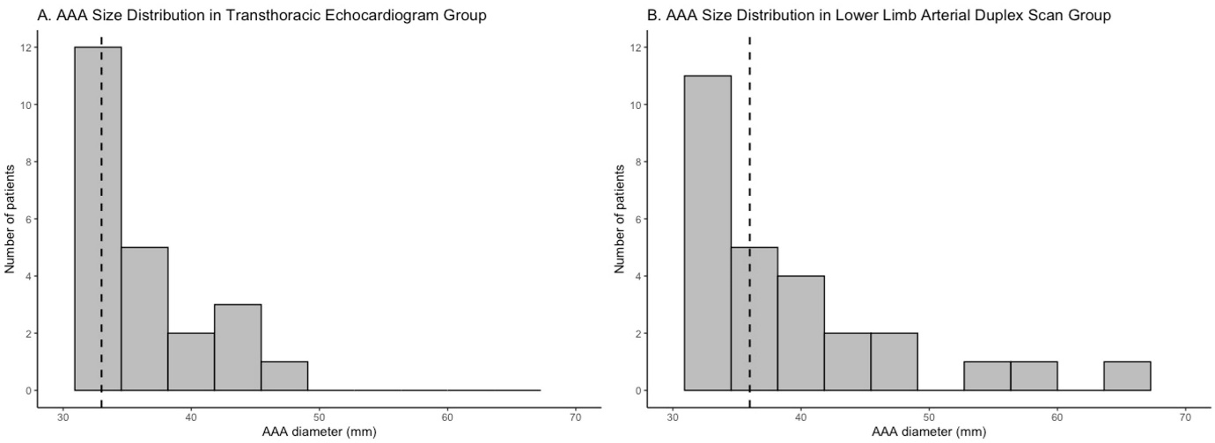

Figure 3. Adjusted Kaplan-Meier curves comparing those with AAA, without AAA, and those with non-visualised abdominal aortas in the combined cohort of patients screened during transthoracic echocardiogram (TTE) and lower limb arterial duplex scan (LLADS).
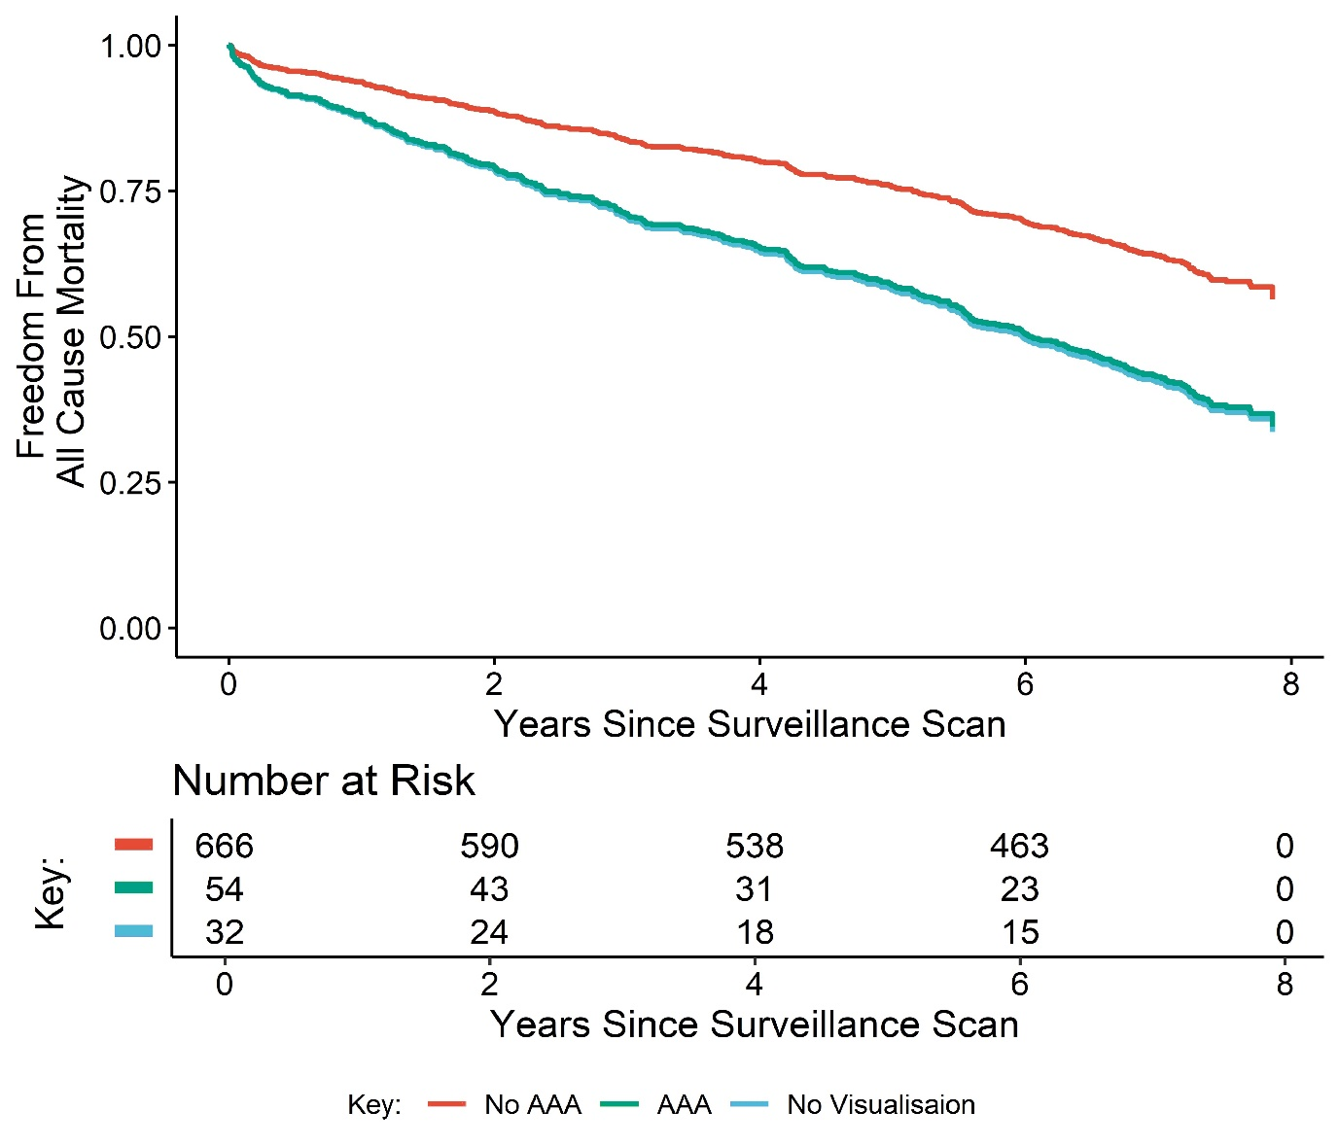
Tables
Table 1. Baseline characteristics for patients screened for abdominal aortic aneurysms during transthoracic echocardiography, lower limb peripheral arterial duplex scans, and the combined group.
 | Transthoracic Echocardiography (n=486) | Lower Limb Peripheral Arterial Duplex (PAD) Scans (n=276) | Combined population  (n=762)
Sex
Male | 316 (65.0) | 172 (62.3) | 488 (64.0)
Female | 170 (35.0) | 104 (37.7) | 274 (36.0)
Age – years | 76 (71-81) | 77 (70-84) | 77 (71-82)
Visit reason | Valvular abnormality, 160 | Claudication, 102
 | Coronary revascularization, 110 | Critical limb ischaemia, 64
 | Arrhythmia or ECG abnormality, 38 | Lower limb ulcer, 38
 | Cardiac symptoms, 33 | Acute limb ischaemia, 34
 | Acute coronary syndrome, 28 | Diabetic foot, 13
 | Ischaemic heart disease, 26 | Other, 22
 | Heart failure, 24
 | Other, 42
Risk factors
Hypertension | 349 (71.8) | 185 (67.0) | 532 (69.8)
Current smoker | 55 (11.3) | 60 (21.7) | 114(15.0)
Ex-smoker | 213 (43.8) | 97 (35.1) | 310 (40.7)
Pack-years | 20 (10-40) | 30 (15-36) | 24 (11-40)
Family history of AAA | 6 (1.2) | 2 (0.7) | 8 (1.0)
Diabetes | 121 (24.9) | 112 (40.6) | 233 (30.6)
Hypercholesterolaemia | 327 (67.3) | 186 (67.4) | 512 (67.2)
Data is represented as n (%), or median (interquartile range)
Table 2. Characteristics of patients with identified abdominal aortic aneurysms after screening during transthoracic echocardiography, lower limb peripheral arterial duplex scans or the combined group.
 | Transthoracic Echocardiography | Lower Limb Peripheral Arterial Duplex Scans | Combined population
Incidence | 25 (5.1) | 29 (10.5) | 54 (7.1)
Male | 19 (6.0) | 19 (11.0) | 38 (7.8)
Female | 6 (3.5) | 10 (9.6) | 16 (5.8)
Age – years | 79 (73-84) | 77 (70-84) | 78 (74-84)
Male | 78 (69-88) | 77 (72-84) | 78 (72-84)
Female | 83 (72-87) | 81 (77-85) | 83 (77-85)
Diameter – mm | 33 (31-38) | 36 (32-41) | 35 (31-40)
Male | 33 (32-38) | 34 (31-38) | 34 (31-38)
Female | 36 (31-41) | 41 (34-45) | 40 (32-43)
Deceased | 188 (38.7) | 123 (44.6) | 311 (40.8)
AAA | 13 (52.0) | 22 (75.9) | 35 (64.8)
No AAA | 168 (36.4) | 87 (35.2) | 255 (36.0)
Data is represented as n (%), or median (interquartile range)

Supplementary Tables
Table S1. Comparison between patients with and without abdominal aortic aneurysms (AAA) in the cohort screened during transthoracic echocardiograms (TTE).
 |  | TTE (n=486)
 | AAA (n=25) | No AAA (n=461) | p-value
Males | 19 (76) | 340 (74) | .24
Age - years | 79 (73-84) | 76 (71-81) | .038
Risk Factors
HTN | 17 (68) | 330 (72) | .65
Current smoker | 6 (24) | 49 (11) | .041
Ex-smoker | 12 (48) | 199 (43) | .67
Pack-years | 20 (0-40) | 1 (0-20) | .017
Family history of AAA | 1 (4) | 8 (2) | .42
Diabetes | 5 (20) | 116 (25) | .56
Hypercholesterolaemia | 20 (80) | 307 (67) | .17
AAA diameter - mm | 33 (31-38) | 20 (18-22) | <2.2e⁻¹⁶
Deceased | 13 (52) | 175 (38) | .18
Data is represented as n (%), or median (interquartile range)
Table S2. All patients identified to have an abdominal aortic aneurysm (AAA) in those screened during transthoracic echocardiography, with outcome of AAA surveillance and mortality status.
Patient | Sex | Age | AAA size (mm) at screening | AAA size (mm) at most recent follow-up | AAA surveillance outcome | Alive or Deceased
1 | F | 72 | 43 | 57 | EVAR 4 years later | Alive
2 | F | 76 | 30 | NA | No surveillance performed– Patient Declined | Alive
3 | F | 82 | 39 | NA | No surveillance performed– Patient Declined | Deceased
4 | F | 84 | 42 | 67 | Decision to conservatively manage after 6 years | Deceased
5 | F | 86 | 30 | NA | No surveillance performed– Patient Declined | Deceased
6 | F | 87 | 33 | 35 | Removed from surveillance program after 7 years | Alive
7 | M | 69 | 31 | 37 | Transfer of care to other service after 7 years | Alive
8 | M | 69 | 37 | 34 | 4-year follow-up | Deceased
9 | M | 71 | 32 | 32 | 3-year follow-up | Alive
10 | M | 72 | 32 | 63 | Decision to conservatively manage after 8 years | Alive
11 | M | 72 | 38 | 49 | 6-year follow-up | Alive
12 | M | 73 | 38 | 46 | 6-year follow-up | Deceased
13 | M | 75 | 31 | 33 | 6-year follow-up | Alive
14 | M | 76 | 31 | 29 | 6-year follow-up | Alive
15 | M | 77 | 36 | 45 | 6-year follow-up | Alive
16 | M | 78 | 31 | 31 | 6-year follow-up | Alive
17 | M | 79 | 34 | 34 | Removed from surveillance program after 1 year - Medically instigated | Deceased
18 | M | 81 | 32 | NA | No surveillance performed– Patient Declined | Deceased
19 | M | 81 | 38 | 38 | 1-year follow-up | Deceased
20 | M | 84 | 44 | NA | No surveillance performed– Patient Declined | Alive
21 | M | 84 | 47 | 51 | Transfer of care to other service after 3 years | Deceased
22 | M | 84 | 31 | 31 | 4-year follow-up | Deceased
23 | M | 87 | 33 | NA | No surveillance performed– Patient Declined | Deceased
24 | M | 87 | 33 | 37 | 1-year follow-up | Deceased
25 | M | 88 | 40 | NA | No surveillance performed– Patient Declined | Deceased

Table S3: Multiple logistic regression analysis of independent risk factors association with abdominal aortic aneurysms (AAA) in the cohort of patients screened during transthoracic echocardiography (TTE).
 | Estimate | Std. Error | T value | Pr(>|t|)
(Intercept) | 11.080322 | 2.902863 | 3.817 | 0.000135
Age | -0.092223 | 0.034215 | -2.695 | 0.007030
HTN | 0.366933 | 0.483912 | 0.758 | 0.448293
Smoker | -0.664539 | 0.608347 | -1.092 | 0.274671
Ex-smoker | 0.216945 | 0.535891 | 0.405 | 0.685602
Pack years | -0.024152 | 0.006826 | -3.538 | 0.000403
Family History | -0.632234 | 1.107996 | -0.571 | 0.568264
Diabetes | 0.312564 | 0.549957 | 0.568 | 0.569802
Hypercholesterolaemia | -1.090644 | 0.570973 | -1.910 | 0.056114

Table S4: Comparison between patients with and without abdominal aortic aneurysms (AAA) in the cohort screened during peripheral arterial duplexes (PAD).
 | PAD (n=276)
 | AAA (n=29) | No AAA (n=247) | p-value
Males | 19 (66) | 153 (62) | .24
Age - years | 77 (70-84) | 78 (75-84) | .19
Risk Factors
HTN | 19 (66) | 166 (67) | .78
Current smoker | 12 (41) | 48 (19) | .007
Ex-smoker | 10 (34) | 88 (36) | .78
Pack-years | 23 (0-45) | 0 (0-24) | .003
Family history of AAA | 0 (0) | 2 (1) | NA
Diabetes | 8 (28) | 104 (42) | .18
Hypercholesterolaemia | 22 (76) | 164 (66) | .39
AAA diameter - mm | 36 (32-41) | 19 (18-22) | <2.2e⁻¹⁶
Deceased | 22 (76) | 87 (35) | .0004

Data is represented as n (%), or median (interquartile range)
Table S5: All patients identified to have an abdominal aortic aneurysm (AAA) in those screened during peripheral arterial duplex, with outcome of AAA surveillance and mortality status.

Patient | Sex | Age | AAA size (mm) at screening | AAA size (mm) at most recent follow-up | AAA surveillance outcome | Alive or Deceased
1 | F | 75 | 46 | 48 | 2-year follow-up | Deceased
2 | F | 75 | 32 | 39 | 5-year follow-up | Deceased
3 | F | 77 | 32 | 32 | 2-year follow-up | Deceased
4 | F | 78 | 43 | 48 | 1-year follow-up | Deceased
5 | F | 78 | 40 | 55 | 3-year follow-up | Deceased
6 | F | 84 | 41 | NA | No surveillance performed– Patient Declined | Alive
7 | F | 84 | 46 | NA | No surveillance performed– Patient Declined | Alive
8 | F | 85 | 40 | NA | No surveillance performed– Patient Declined | Deceased
9 | F | 86 | 55 | 59 | 3-year follow-up | Deceased
10 | F | 91 | 31 | 32 | 1-year follow-up | Alive
11 | M | 66 | 38 | 43 | 5-year follow-up | Alive
12 | M | 66 | 31 | 31 | 8-year follow-up | Alive
13 | M | 70 | 38 | 40 | 1-year follow-up | Deceased
14 | M | 71 | 34 | NA | No surveillance performed– Patient Declined | Deceased
15 | M | 71 | 35 | 34 | 4-year follow-up | Deceased
16 | M | 72 | 38 | 49 | 7-year follow-up | Deceased
17 | M | 74 | 43 | NA | No surveillance performed– Patient Declined | Deceased
18 | M | 75 | 31 | NA | Transfer of care to other service after screening | Alive
19 | M | 76 | 60 | NA | EVAR 3 days after screening | Deceased
20 | M | 77 | 36 | 45 | 6-year follow-up | Alive
21 | M | 78 | 31 | 29 | Patient asked to be removed from surveillance program after 1 year | Deceased
22 | M | 79 | 34 | 34 | Discharged after 1 year- Medically instigated | Deceased
23 | M | 81 | 32 | NA | Deceased shortly after screening | Deceased
24 | M | 83 | 31 | 34 | 1-year follow-up | Deceased
25 | M | 84 | 30 | 33 | 5-year follow-up | Deceased
26 | M | 88 | 30 | NA | No surveillance performed– Patient Declined | Deceased
27 | M | 89 | 40 | NA | Deceased shortly after screening | Deceased
28 | M | 89 | 32 | NA | Deceased shortly after screening | Deceased
29 | M | 94 | 67 | 67 | Medical decision to conservatively manage at screening | Deceased

Table S6: Multiple logistic regression analysis of independent risk factors association with abdominal aortic aneurysms (AAA) in the cohort of patients screened during transthoracic echocardiography (PAD).
 | Estimate | Std. Error | T value | Pr(>|t|)
(Intercept) | 5.098e+00 | 2.541e+00 | 2.007 | 0.04480
Age | - 2.867e-02 | 3.139e-02 | -0.913 | 0.36111
HTN | 0 -2.684e-01 | 5.081e-01 | -0.528 | 0.59736
Smoker | -1.724e+00 | 6.279e-01 | -2.746 | 0.00604
Ex-smoker | -5.815e-01 | 5.977e-01 | -0.973 | 0.33060
Pack years | 1.485e-03 | 8.784e-03 | 0.169 | 0.86571
Family History | 1.457e+01 | 1.696e+03 | 0.009 | 0.99314
Diabetes | 5.970e-01 | 4.886e-01 | 1.222 | 0.22175
Hypercholesterolaemia | -1.140e-01 | 5.213e-01 | -0.219 | 0.82684

Supplementary Figures
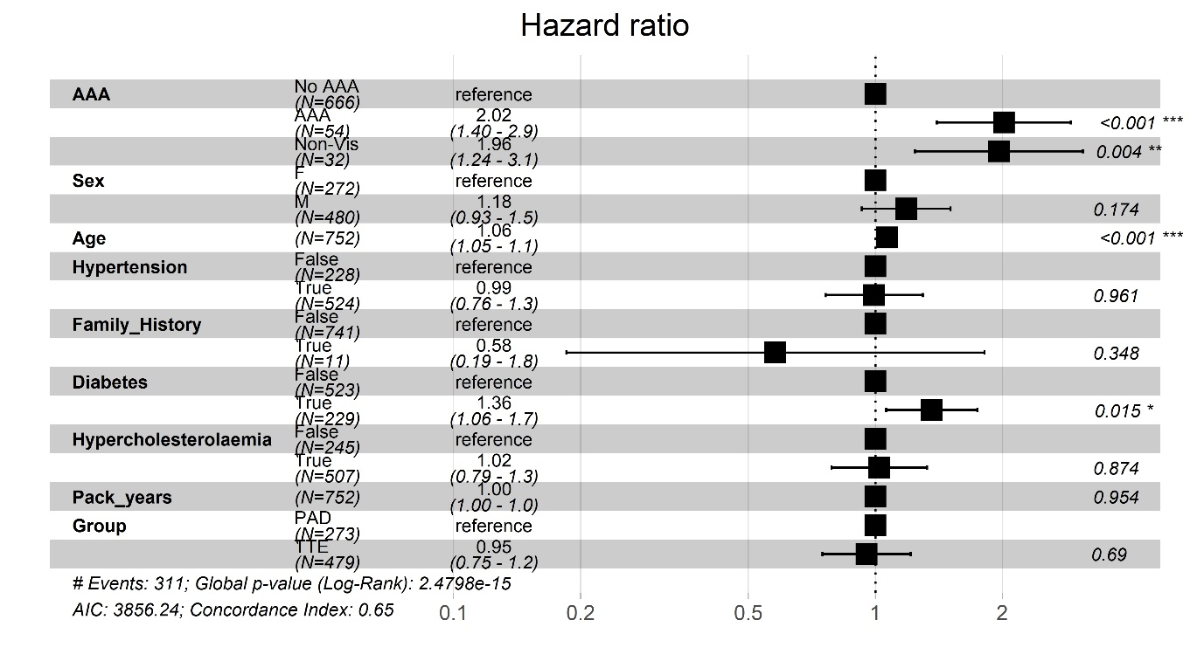
Figure S1. Forest plot for hazard ratios for mortality in the combined cohort of patients screened during transthoracic echocardiogram (TTE) and peripheral arterial duplex (PAD).

