AUTHOR CORRECTION
Volume 7, no. 2, e00135-22, 2022, https://doi.org/10.1128/msystems.00135-22. Following discussions with colleagues and peer-reviewers on further work extending the model introduced in this manuscript, we have identified a technical issue in the way we mathematically phrased the phage-bacteria interaction. This has been corrected with an improved equation which restricts the maximum rate of phage predation at higher phage concentrations, exactly as our original frequency-dependent approach did, but with greater biological and mathematical clarity. Refitting the model with this improved “saturated phage predation” term does not substantially change our parameter values, figures, results, and conclusions.
A summary of the changes can be found below.
- All mentions of “frequency-dependent” phage predation should be replaced by “saturated” phage predation, and all mentions of “density-dependent” phage predation should be replaced by “linear” phage predation.
- Page 6: the two equations used for the frequency-dependent interaction (Equations 2 and 3) should be replaced by this single improved equation for saturated predation:
$$B*P* \frac{β}{\left(1+\frac{P}{P50}\right)}$$
With P50 corresponding to the phage concentration at half saturation, where the adsorption rate is equal to half the maximum.
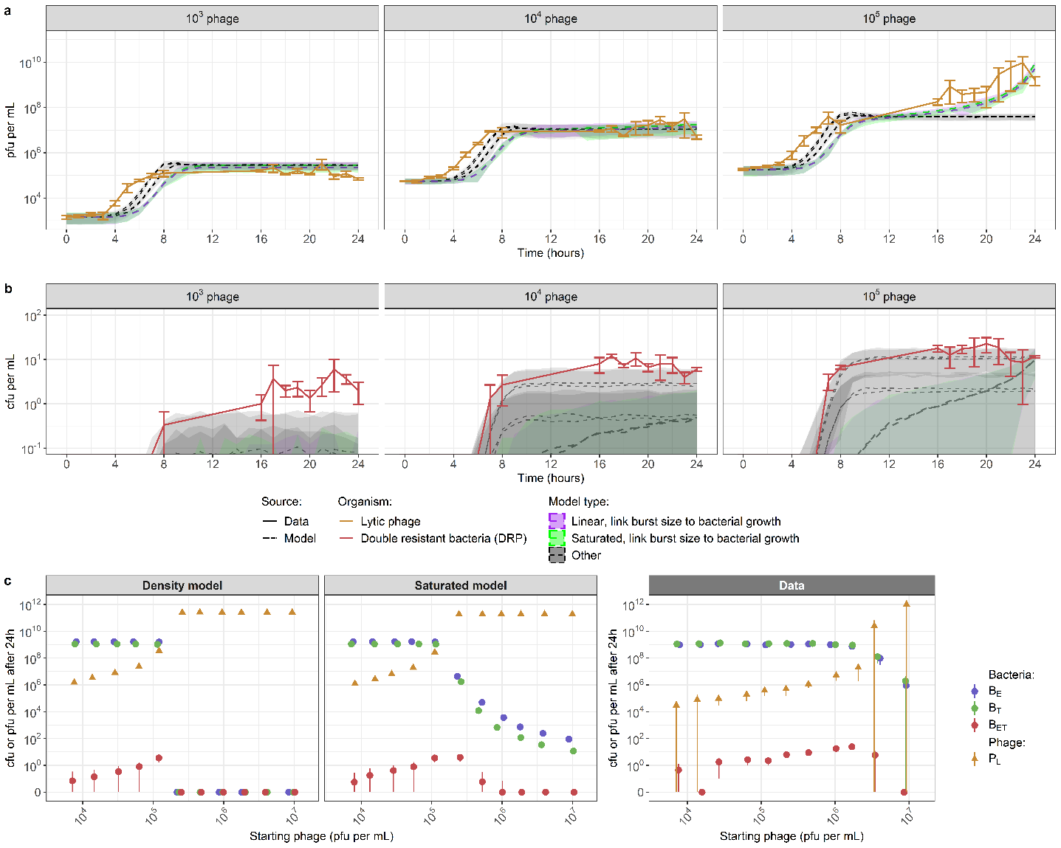
- Page 11: Figure 5 should appear as shown below, with the results from fitting the model with the improved “saturated phage predation” term
Figure 5: Accuracy of the best-fitted models to reproduce in vitro phage-bacteria dynamics.

- Page 12: Table 1 should read:
Interaction type | Adsorption rate linked to growth | Burst size linked to growth | Adsorption rate β (phage⁻¹ bacteria⁻¹ hour⁻¹) | Burst size δ (phage) | Transducing phage proportion α (proportion of burst size) | Phage latent period τ (hour) | Phage concentration at half-saturation P50 (phage) | DIC
Linear | Yes | No | 4.5 x 10⁻⁹ (4.1 x 10⁻⁹ ; 5.0 x 10⁻⁹) | 12 (10 ; 14) | 3.1 x 10⁻⁸ (1.5 x 10⁻⁸ ; 5.8 x 10⁻⁸) | 0.64 (0.55 ; 0.73) | N/A | 610
 | No | Yes | 1.6 x 10⁻¹⁰ (1.5 x 10⁻¹⁰ ; 1.7 x 10⁻¹⁰) | 79 (72 ; 86) | 1.4 x 10⁻⁸ (1.1 x 10⁻⁸ ; 1.7 x 10⁻⁸) | 0.65 (0.62 ; 0.69) | N/A | 63
 | Yes | Yes | 4.3 x 10⁻⁹ (3.9 x 10⁻⁹ ; 4.6 x 10⁻⁹) | 43 (37 ; 49) | 1.2 x 10⁻⁸ (6.4 x 10⁻⁹ ; 2.3 x 10⁻⁸) | 0.93 (0.86 ; 0.99) | N/A | 298
Saturated | Yes | No | 3.3 x 10⁻⁹ (1.8 x 10⁻⁹ ; 5.6 x 10⁻⁹) | 14 (11 ; 21) | 2.5 x 10⁻⁷ (1.2 x 10⁻⁷ ; 5.5 x 10⁻⁷) | 0.67 (0.60 ; 0.78) | 5.1 x 10¹⁰ (2.8 x 10⁹ ; 9.7 x 10¹⁰) | 631
 | No | Yes | 2.3 x 10⁻¹⁰ (2.1 x 10⁻¹⁰ ; 2.7 x 10⁻¹⁰) | 50 (43 ; 54) | 1.2 x 10⁻⁸ (1.1 x 10⁻⁹ ; 1.3 x 10⁻⁸) | 0.60 (0.60 ; 0.61) | 1.2 x 10¹⁰ (1.0 x 10¹⁰ ; 1.3 x 10¹⁰) | 0
 | Yes | Yes | 2.6 x 10⁻⁹ (1.9 x 10⁻⁹ ; 3.4 x 10⁻⁹) | 36 (28 ; 43) | 1.4 x 10⁻⁷ (9.21 x 10⁻⁸ ; 2.2 x 10⁻⁷) | 0.75 (0.63 ; 0.80) | 5.1 x 10¹⁰ (3.6 x 10⁹ ; 9.8 x 10¹⁰) | 385
- Page 18: Equations 34-39 should read:
$$\frac{dB_{E}}{dt}=μ_{E}*B_{E}-B_{E}*{F(P}_{L})- B_{E}* F(P_{T})$$
$$\frac{dB_{T}}{dt}=μ_{T}*B_{T}-B_{T}*F(P_{L})- B_{T}*F(P_{E})$$
$$\frac{dB_{ET}}{dt}=μ_{ET}*B_{ET}-B_{ET}*F(P_{L})+B_{T}*F(P_{E})+B_{E}*F(P_{T})$$
$\frac{dP_{L}}{dt}=\left[\left(B_{E}+B_{T}\right)*F\left(P_{L}\right)\right](t-τ)*δ*\left(1-α\right)+[B_{ET}*F\left(P_{L}\right)]\left(t-τ\right)*δ*\left(1-2*α\right)-N*F(P_{L})$
$$\frac{dP_{E}}{dt}=[\left(B_{E}+B_{ET}\right)*F\left(P_{L}\right)](t-τ)*δ*α-N*F(P_{E})$$
$$\frac{dP_{T}}{dt}=[\left(B_{T}+B_{ET}\right)*F\left(P_{L}\right)](t-τ)*δ*α-N*F(P_{T})$$
- Page 19: the two equations used for the density-dependent interaction (Equations 40 and 41) should be replaced by this single equation, to be consistent with the model equations above:
$$F\left(P_{θ}\right)= P_{θ}*β$$
- Page 19: the two equations used for the frequency-dependent interaction (Equations 42 and 43) should be replaced by this single improved equation for saturated predation:
$F\left(P_{θ}\right)=P_{θ}* \frac{β}{(1+\frac{P_{θ}}{P50})}$
- Page 22: Reference 36 should state: Roach, D. R., Leung, C. Y., Henry, M., Morello, E., Singh, D., Di Santo, J. P., Weitz, J. S. & Debarbieux, L.. Synergy between the host immune system and bacteriophage is essential for successful phage therapy against an acute respiratory pathogen. Cell host & microbe 22, 38–47 (2017).

