SUPPLEMENTARY MATERIALS

Methods

Data sources

SwedeHF, which is a nationwide ongoing health care quality registry founded in 2000, has been previously described in detail (www.SwedenHF.se) (9). Briefly, the inclusion criterion was clinician-diagnosed HF until April 2017, and thereafter a diagnosis of HF according to the International Statistical Classification of Diseases, Tenth Revision (ICD-10) codes I50.0, I50.1, I50.9, I42.0, I42.6, I42.7, I25.5, I11.0, I13.0, and I13.2. Approximately 80 variables are recorded at hospital discharge or after outpatient clinic visits and entered into a web-based database managed by the Uppsala Clinical Research Center (www.UCR.se). Coverage of the registry was 32% of the prevalent HF cases in Sweden according the 2021 annual report. For the current study, SwedeHF was linked to the National Patient Registry which provided additional data on comorbidities and the outcome HF hospitalization; to the Cause of Death Registry which provided data on date and cause-specific death; and to Statistics Sweden which allows examining patients’ socioeconomic characteristics. Linkage across different registries was performed by the personal identification number, which all the residents in Sweden have. Establishment of the HF registry and this analysis with linking of the registries was approved by the Swedish Ethical Review Authority and complies with the Declaration of Helsinki. For SwedeHF, individual patient consent is not required, but all patients in Sweden are informed of entry into national registries and have the opportunity to opt out.

Results
Sensitivity analyses
The study cohort with imputed height counted 22,223 patients, 24% of them was obese. All the clinical/demographics and pharmacological characteristics were consistent with the main analysis as shown in Supplementary Table 4.
As summarized in Supplementary Figure 5 and consistently with the results from the main study population, after adjustments obesity was independently associated with the use of RASi/ARNi (OR [95% CI] 1.16 [1.03-1.30]), beta-blocker (OR [95% CI] 1.32 [1.16-1.50]) and MRA (OR [95% CI] 1.23 [1.15-1.32]), as well as with the achievement of ≥100% TD for each drug (OR [95% CI] 1.26 [1.17-1.35], OR [95% CI] 1.45 [1.36-1.57], OR [95% CI] 1.55 [1.31-1.83], respectively). Obesity was also independently associated with the use of triple therapy (OR [95% CI] 1.24 [1.16-1.34]) and with the achievement of the maximum TD of all the treatments (OR [95% CI] 2.41 [1.82-3.18]).
Results on the association between outcomes and RASi/ARNi use were overall consistent with the main analysis, confirming a lower crude and adjusted risk of outcomes in those receiving the treatment. The association between RASi/ARNi use and all-cause/cardiovascular mortality were similar in obese vs. non-obese patients (Supplementary Figure 6, panel D and E). Conversely, a significant interaction (p for interaction =0.007) was observed between obesity and use of RASi/ARNi for the association with HF hospitalization (Supplementary Figure 6, panel F), with a significant lower risk of HF hospitalization with RASi/ARNi only in the obese group. Models fitted using BMI as a continuous variable showed a non-significant trend for lower HRs for all the associations treatment-outcomes together with increasing BMI (Supplementary Figure 8, panel A-C).
Sensitivity analysis on beta-blockers demonstrated that the association between their use and the study outcomes were consistent with the results from the main analysis. Specifically, a lower crude and adjusted risk of all-cause/cardiovascular mortality was observed with use of beta-blockers in the overall population with no differences in obese vs. non-obese (Supplementary Figure 7, panel A-B and D-E). Use of beta-blockers was not associated with a reduced risk of HF hospitalization, in the overall population as in the obese and non-obese groups (Supplementary Figure 7, panel C and F). Models fitted using BMI as a continuous variable showed a non-significant trend for lower HRs for all the associations treatment-outcomes together with increasing BMI (Supplementary Figure 8, panels D-F).
As in the main analysis on dosages (Supplementary Figure 3 and 4), in the sensitivity analysis higher vs. lower dosages of RASi/ARNi were associated with better prognosis regardless of obesity (Supplementary Figure 9). However, higher vs. lower dosages of beta-blockers were associated with lower cardiovascular mortality in non-obese but not obese patients (p for interaction <0.05; Supplementary Figure 10).
In order to overcome the potential bias deriving from the inclusion of underweight patients in the main study cohort, a sensitivity analysis for outcomes limited to patients with BMI >18.5 kg/m was performed. Underweight patients represented the only 3% of overall population. After the exclusion of these patients, results were consistent with the main analysis (Supplementary Figure 11A and 11B).

Supplementary Table 1. Pharmacological therapies considered for the current study according to the 2021 European Society of Cardiology Guidelines on Heart Failure.
RASi | Dose | TD percentage
Captopril
 | 150 mg | ≥100%
 | 75 – <150 mg | ≥50-99%
 | <75 mg | <50%
Enalapril
 | 20 mg | ≥100%
 | 10 - <20 mg | ≥50-99%
 | <10 mg | <50%
Lisinopril
 | 35 mg | ≥100%
 | 17.5 - <35 mg | ≥50-99%
 | <17.5 mg | <50%
Ramipril
 | 10 mg | ≥100%
 | 5 - <10 mg | ≥50-99%
 | <5 mg | <50%
Trandolapril
 | 4 mg | ≥100%
 | 2 - <4 mg | ≥50-99%
 | <2 mg | <50%
Candesartan
 | 32 mg | ≥100%
 | 16 - <32 mg | ≥50-99%
 | <16 mg | <50%
Valsartan
 | 320 mg | ≥100%
 | 160 - <320 mg | ≥50-99%
 | <160 mg | <50%
Losartan
 | 150 mg | ≥100%
 | 75 - <150 mg | ≥50-99%
 | <75 mg | <50%
ARNi |  | TD percentage
Sacubitril/Valsartan
 | 194/206 mg | ≥100%
 | 97/103 - <194/206 mg | ≥50-99%
 | <97/103 mg | <50%
Beta-blocker |  | TD percentage
Metoprolol
 | 200 mg | ≥100%
 | 100 – <200 mg | ≥50-99%
 | <100 mg | <50%
Bisoprolol
 | 10 mg | ≥100%
 | 5 – <10 mg | ≥50-99%
 | <5 mg | <50%
Carvedilol
 | 50 mg (<85 kg)  100 mg x2 (>85 kg) | ≥100%
 | 25 – <50 mg (<85 kg)  50 – <100 mg (>85 kg) | ≥50-99%
 | <25 mg (<85 kg)  <50 mg (>85 kg) | <50%
MRA |  | TD percentage
Spironolactone
 | 50 mg | ≥100%
 | 25 mg | 50%
Eplerenone | 50 mg | ≥100%
 | 25 mg | 50%

Abbreviations. ARNi: Angiotensin Receptor Neprilysin Inhibitors; MRA: Mineralocorticoid receptor antagonist; RASi: Renin-Angiotensin System Inhibitors; TD: target dose.

Supplementary Table 2. Variables and outcomes definition.

Variables | Definition
Hypertension | Diagnosis in SwedeHF or in NPR (ICD-10 codes:I10-I15)
Diabetes mellitus | Diagnosis in SwedeHF or in NPR (ICD-10 codes: E10-E14)
CAD | Diagnosis in SwedeHF or in NPR (ICD-10 codes: 410-1, 120-5).
Previous Coronary Revascularization | Diagnosis in Swede-HF
History of AF/flutter | Diagnosis in SwedeHF (history of atrial fibrillation/atrial flutter or ECG showing atrial fibrillation/atrial flutter) or in NPR (ICD-10 code: I48).
Valve disease | Diagnosis in SwedeHF or in NPR (ICD-10 codes: A520, I05-I08, I091, I098, I34-I39, Q230-Q233, Z952, Z954)
Anemia | Haemoglobin <120 g/L in females and < 130 g/L in males; ICD:D5;D60-4
Stroke or TIA | Diagnosis in the NPR (ICD-10 codes: 430-4, 438, I60-4, I690-4, G45)
Liver disease | Diagnosis in the NPR (ICD-10 codes: B18, I85, I864, I982, K70, K710, K711, K713-7, K72-4, K760, K762-9)
COPD | Diagnosis in the NPR (ICD-10 codes: J40-4)
Dementia | Diagnosis in the NPR (ICD-10 codes: F00-4)
History of cancer within 3 years | Diagnosis in the NPR (ICD-10 codes: C00-C26, C30-C34, C37-C41, C43, C45-C58, C60-C76, C81-C85, C88, C90-C97)
History of musculoskeletal disease within 3 years | Diagnosis in the NPR (ICD:M)
Outcomes
Cardiovascular mortality | Main diagnosis in Causes of Death register (ICD-10 codes: I00-I99, J81, K761, G45, R57)
HF hospitalization | Main diagnosis in NPR (ICD-10 codes: I50, I42, I43, I255, K761, I110, I130, I132, J81, R57)

Abbreviations. AF: atrial fibrillation; CAD: coronary artery disease; COPD: chronic obstructive pulmonary disease; HF: heart failure; ICD-10: International Classification of Diseases; NPR: National Patient Registry; TIA: transitory ischemic attack.

Supplementary Table 3. Missing data.
 | Total (n. 16,116 pt)
Demographics/Organizational
Sex | 0%
Age (years) | 0%
Caregiver | 0%
Follow-up nurse-led HF clinic | 5%
Location of follow-up | 4%
Education | 2%
Living alone | <1%
Income | <1%
Year of registration* | 0%
Clinical parameters
Systolic BP (mmHg) | <1%
Diastolic BP (mmHg) | <1%
MAP (mmHg) | <1%
Heart Rate (beats/min) | 3%
NYHA functional Class | 21%
Laboratory values
K⁺ (mmol/L) | 18%
eGFR, ml/min/1.73 m² | 3%
NT-proBNP (pg/ml) | 46%
Treatments
Diuretic | <1%
Digoxin | <1%
Antiplatelet | <1%
Anticoagulant | <1%
Statin | <1%
Device | <1%
History and comorbidities
Hypertension | 2%
DM | <1%
Smoking | 15%
CAD | 0%
Coronary Revascularization | 3%
History of AF/flutter | 1%
Valve disease | 2%
Anemia | 4%
Stroke or TIA | 0%
Liver disease | 0%
COPD | 0%
Dementia | 0%
Cancer, past 3 years | 0%
Muscoloskeletal disease, past 3 years | 0%

Abbreviations. BP: Blood Pressure; CAD: Coronary Artery Disease; COPD: Chronic Obstructive Pulmonary Disease; DM: Diabetes Mellitus; eGFR: Estimated Glomerular Filtration Rate; HF: Heart Failure; MAP: Mean Arterial Pressure; NT-proBNP: N-terminal prohormone of Brain Natriuretic Peptide; NYHA: New York Heart Association; pt: patients; TIA: Transitory Ischemic Attack. *in the SwedeHF.

‘

Supplementary Table 4. Baseline characteristics of the study cohort considered for the sensitivity analysis where height was imputed to minimize the amount of missing data for BMI.
 | Overall population  n=22,223 | Non-obese pt  n=16,833 | Obese pt  n=5,303 | p-value
Demographics/Organizational
Male sex ¶ (%) | 16,211 (73) | 12,302 (73) | 3,849 (73) | 0,470
Age (years) ¶, median (IQR) | 76 (68, 83) | 78 (70, 83) | 71 (63, 78) | <0.001
Caregiver at SwedeHF registration ¶, n (%) |  |  |  | <0.001
Inpatient | 9,132 (41) | 7,239 (43) | 1,858 (35)
Outpatient | 13,091 (59) | 9,594 (57) | 3,445 (65)
Follow-up nurse-led HF clinic ¶ (%) | 11,142 (53) | 8,118 (51) | 2,995 (59) | <0.001
Follow-up referral speciality ¶, n (%) |  |  |  | <0.001
Hospital | 14,059 (66) | 10,387 (65) | 3,626 (71)
Primary care | 6,546 (31) | 5,149 (32) | 1,360 (27)
Other | 687 (3) | 544 (3) | 143 (3)
Education¶, |  |  |  | <0.001
Compulsory school | 9,975 (46) | 7,608 (46) | 2,327 (45)
Secondary school | 8,441 (39) | 6,227 (38) | 2,179 (42)
University | 3,316 (15) | 2,621 (16) | 686 (13)
Living alone¶, | 10,503 (47) | 7,865 (47) | 2,593 (49) | 0.006
Income¶, |  |  |  | <0.001
Low | 7,805 (35) | 5,813 (35) | 1,959 (37)
Medium | 8,669 (39) | 6,684 (40) | 1,946 (37)
High | 5,714 (26) | 4309 (26) | 1,391 (26)
Year of registration¶* |  |  |  | <0.001
<2009 | 6,470 (29) | 5,150 (31) | 1,276 (24)
2010-2013 | 5905 (27) | 4,522 (27) | 1,356 (26)
2014-2016 | 3307 (15) | 2,456 (15) | 844 (16)
>2016 | 6541 (29) | 4,705 (28) | 1,827 (35)
MAP ¶ (mmHg) (%) |  |  |  | <0.001
<90 | 12,304 (56) | 9645 (58) | 2618 (50)
≥90 | 9,724 (44) | 7,052 (42) | 2,627 (50)
Heart Rate (beats/min), median (IQR) | 71 (63, 80) | 70 (63, 80) | 72 (64, 80) | 0.038
Heart Rate ¶ (beats/min) (%) |  |  |  | 0.053
<70 | 8,992 (42) | 6,859 (42) | 2,092 (41)
≥70 | 12,413 (58) | 9,338 (58) | 3,033 (59)
NYHA Class ¶ (%) |  |  |  | 0.012
I-II | 8,303 (47) | 6,340 (48) | 1,932 (45)
III-IV | 9,398 (53) | 7,016 (53) | 2,337 (55)
Laboratory values
K⁺ ¶ (mmol/L) |  |  |  | 0.009
<3.5 | 681 (4) | 544 (4) | 137 (3)
3.5-5 | 15,787 (91) | 11,782 (91) | 3,953 (92)
>5 | 797 (5) | 586 (5) | 208 (5)
eGFR category ¶ ˆ, ml/min/1.73 m² (%) |  |  |  | <0.001
<30 | 2,216 (10) | 1,747 (11) | 461 (9)
30-59 | 9,116 (42) | 7,048 (43) | 2,023 (39)
≥60 | 10,309 (48) | 7,603 (46) | 2,673 (52)
NT-proBNP (pg/ml), median (IQR) | 2930 (1161,7080) | 3,490 (1,430, 8,316) | 1,693 (723, 3,940) | <0.001
NT-proBNP ¶ (pg/ml) (%) |  |  |  | <0.001
<2930 | 5,620 (50) | 3,734 (45) | 1,873 (66)
≥2930 | 5,627 (50) | 4651 (56) | 962 (34)
Treatments
ACEi (%) | 11,942 (54) | 9,165 (54) | 2,724 (51) | <0.001
ACEi, drugs (%) |  |  |  | 0.290
Captopril | 164 (1) | 126 (1) | 36 (1)
Enalapril | 5,549 (47) | 4,308 (46) | 1,313 (48)
Lisinopril | 133 (1) | 100 (1) | 32 (1)
Ramipril | 6,093 (51) | 4,729 (52) | 1,342 (49)
Trandolapril | 3 (<1) | 2 (<1) | 1 (<1)
ARB (%) | 6,322 (28) | 4,593 (27) | 1,705 (32) | <0.001
ARB, drugs (%) |  |  |  | 0.027
Candesartan | 3,909 (62) | 2,810 (61) | 1,086 (64)
Losartan | 2,178 (35) | 1,622 (35) | 546 (32)
Valsartan | 235 (4) | 161 (4) | 73 (4)
ARNi (%) | 1,054 (18) | 698 (16) | 356 (21) | <0.001
RASi/ARNi ¶ (%) | 19,318 (87) | 134,456 (86) | 4,785 (90) | <0.001
RASi/ARNi, dosage ¶ (% of TD) |  |  |  | <0.001
0 % | 2,905 (13) | 2,377 (14) | 518 (10)
1-49 % | 5,782 (26) | 4,617 (27) | 1,139 (22)
50-99 % | 5,585 (25) | 4,180 (25) | 1,390 (26)
≥100 % | 7,951 (36) | 5,659 (34) | 2,256 (43)
Beta-blocker ¶ (%) | 20,231 (91) | 15,185 (90) | 4,964 (94) | <0.001
Beta-blocker, drugs (%) |  |  |  | 0.680
Bisoprolol | 8,825 (44) | 6,653 (44) | 2,144 (43)
Carvedilol | 1,202 (6) | 895 (6) | 304 (6)
Metoprolol | 10,204 (50) | 7,637 (50) | 2,516 (51)
Beta-blocker, dosage ¶ (% of TD) |  |  |  | <0.001
0 % | 1,992 (9) | 1,648 (10) | 339 (6)
1-49 % | 6,258 (28) | 5,122 (30) | 1,110 (21)
50-99 % | 7,191 (32) | 5,272 (32) | 1,703 (32)
≥100 % | 6,872 (31) | 4,691 (28) | 2,151 (41)
MRA ¶ (%) | 9,875 (44) | 7,136 (42) | 2,703 (51) | <0.001
Diuretic ¶ (%) | 18,541 (84) | 13,888 (83) | 4,582 (87) | <0.001
Digoxin ¶ (%) | 3,517 (16) | 2,759 (16) | 739 (14) | <0.001
Antiplatelet ¶ (%) | 9,817 (44) | 7,539 (45) | 2,238 (42) | <0.001
Anticoagulant ¶ (%) | 10,796 (49) | 8,037 (48) | 2,718 (51) | <0.001
Statin ¶ (%) | 11,794 (53) | 8,486 (51) | 3,269 (62) | <0.001
Device ¶ (%)
No/PM | 17,989 (82) | 13,770 (83) | 4,139 (79) | <0.001
CRT-P | 974 (4) | 762 (5) | 210 (4)
CRT-D | 1583 (7) | 1,125 (7) | 457 (9)
ICD | 1431 (7) | 995 (6) | 432 (8)
History and comorbidities
Hypertension ¶ (%) | 11,326 (52) | 8,173 (50) | 3,106 (60) | <0.001
Diabetes mellitus ¶ (%) | 6,652 (30) | 4,209 (25) | 2,408 (46)
Smoking ¶ (%) |  |  |  | <0.001
Current | 2,152 (12) | 1,669 (12) | 480 (11)
Former | 8,508 (47) | 6,189 (46) | 2,288 (52)
Never | 7,391 (41) | 5,755 (42) | 1,611 (37)
CAD ¶ (%) | 14,767 (66) | 11,285 (67) | 3,423 (65) | <0.001
Previous Coronary Revascularization ¶ (%) | 8,041 (37) | 6,049 (37) | 1,962 (38) | 0.130
History of AF/flutter ¶ (%) | 13,402 (60) | 10,232 (61) | 3,115 (58) | 0.008
Valve disease ¶ (%) | 5,468 (25) | 4,452 (27) | 999 (19) | <0.001
Anemia ¶ † (%) | 8,047 (38) | 6,477 (40) | 1,540 (31) | <0.001
Stroke or TIA ¶ (%) | 4,333 (20) | 3,439 (20) | 875 (16) | <0.001
Liver disease ¶ (%) | 613 (3) | 488 (3) | 123 (2) | 0.025
COPD ¶ (%) | 3566 (16) | 2,624 (16) | 930 (18) | <0.001
Dementia ¶ (%) | 457 (2) | 395 (2) | 62 (1) | <0.001
Cancer, past 3 years ¶ (%) | 2,820 (13) | 2,314 (14) | 494 (9) | <0.001
Muscoloskeletal disease, past 3 years ¶ (%) | 7,223 (33) | 5,357 (31) | 1,845 (35) | <0.001

Abbreviations. ACEi: Angiotensin-Converting Enzyme Inhibitors; AF: Atrial Fibrillation; ARB: Angiotensin Receptor Blockers; ARNi: Angiotensin Receptor Neprilysin Inhibitors; BP: Blood Pressure; CAD: Coronary Artery Disease; COPD: Chronic Obstructive Pulmonary Disease; CRT-D: Cardiac Resynchronization Therapy-Defibrillator; CRT-P: Cardiac Resynchronization Therapy-Pacemaker; eGFR: Estimated Glomerular Filtration Rate; HF: Heart Failure; ICD: Implantable Cardioverter-Defibrillator; IQR: Interquartile Range; MAP: Mean Arterial Pressure; MRA: Mineralocorticoid Receptor Antagonists; NT-proBNP: N-terminal-pro-hormone Brain Natriuretic Peptide; NYHA: New York Heart Association; pt: patients; RASi: Renin-Angiotensin System Inhibitors; TD: Target Dose; TIA: Transitory Ischemic Attack; PM: Pacemaker; pt: patients.
¶ Variables included in the multiple imputation models and as covariates in the multivariable models (the same of the main analysis, as reported in Table 1). Values are median (IQR Q1,Q3). ˆeGFR was calculated by the Chronic Kidney Disease Epidemiology Collaboration formula. †Anemia, defined as hemoglobin <120 g/l in females and <130 g/l in males. *in the SwedeHF.

Supplementary Figure 1. Flow chart reporting cohort selection.
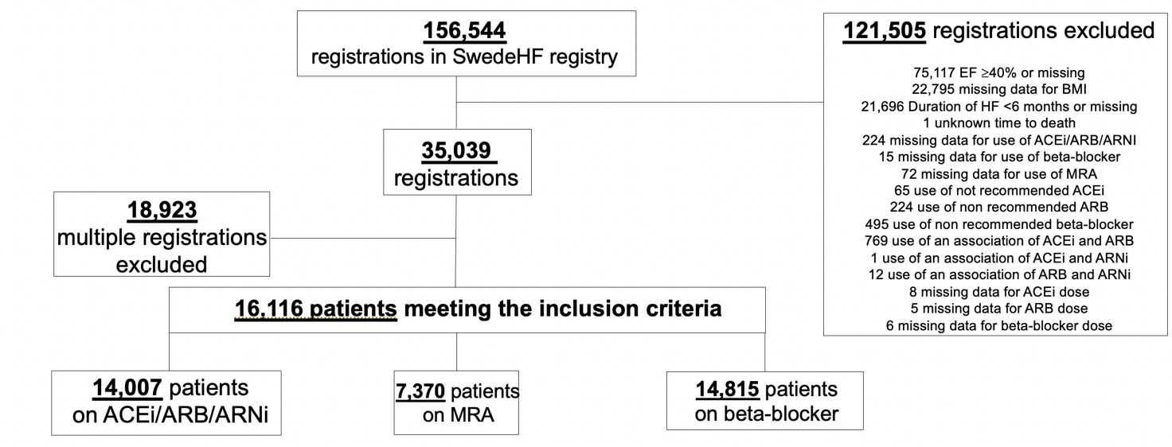

Abbreviations. ACEi: Angiotensin-Converting Enzyme Inhibitor; ARB: Angiotensin Receptor Blocker; ARNi: Angiotensin Receptor Neprilysin Inhibitor; BMI: Body Mass Index; EF: ejection fraction; HF: Heart Failure; MRA: Mineralocorticoid Receptor Antagonist.

Supplementary Figure 2A. Competing risk analysis for cardiovascular mortality and hospitalization for heart failure in the overall population (panel A and C) and obese vs. non-obese patients (panel B and D) receiving/not-receiving renin-angiotensin system inhibitors/angiotensin receptor neprilysin inhibitors.

Abbreviations. Adj: adjusted. ARNi: Angiotensin Receptor Neprilysin Inhibitors; CI: Confidence Interval; CV: Cardiovascular; HF: Heart Failure; HR: Hazard Ratio; RASi: Renin-Angiotensin System Inhibitors.
Variables included as covariates in the multivariable models are labeled with ¶ in Table 1/Supplementary Table 4.
Adjusted sub-HRs and p for interaction are also reported.

Supplementary Figure 2B. Competing risk analysis for cardiovascular mortality and hospitalization for heart failure in the overall population (panel A and C) and obese vs. non-obese patients (panel B and D) receiving/not-receiving beta-blockers.

Abbreviations. Adj: adjusted. BBL: beta-blockers, CI: Confidence Interval; CV: Cardiovascular; HF: Heart Failure; HR: Hazard Ratio.
Variables included as covariates in the multivariable models are labeled with ¶ in Table 1/Supplementary Table 4.
Adjusted sub-HRs and p for interaction are also reported.

Supplementary Figure 3. Forest plots for the outcomes time to all-cause mortality, cardiovascular mortality and hospitalization for heart failure in the overall population and obese vs. non-obese patients treated with renin-angiotensin system inhibitors/angiotensin receptor neprilysin inhibitors, according to target dose achieved.
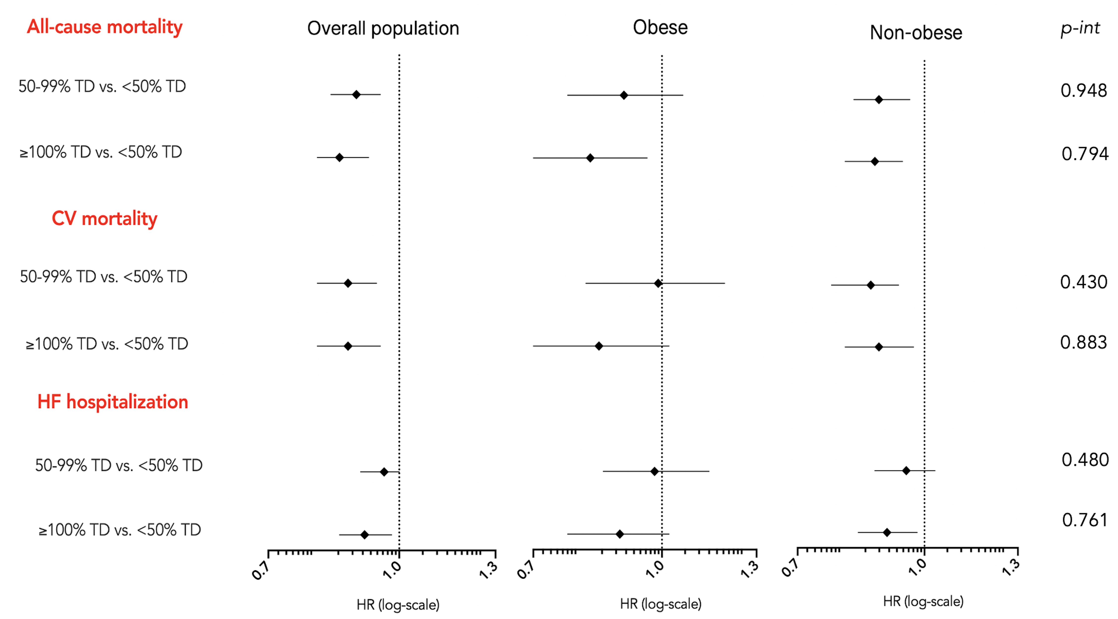
Abbreviations. CV: cardiovascular; HF: Heart Failure; Hazard Ratio; p-int: p-interaction; TD: Target Dose.
Variables included as covariates in the multivariable models are labeled with ¶ in Table 1/Supplementary Table 4.

Supplementary Figure 4. Forest plots for the outcomes time to all-cause mortality, cardiovascular mortality and hospitalization for heart failure in the overall population and obese vs. non-obese patients treated with beta-blockers, according to target dose achieved.
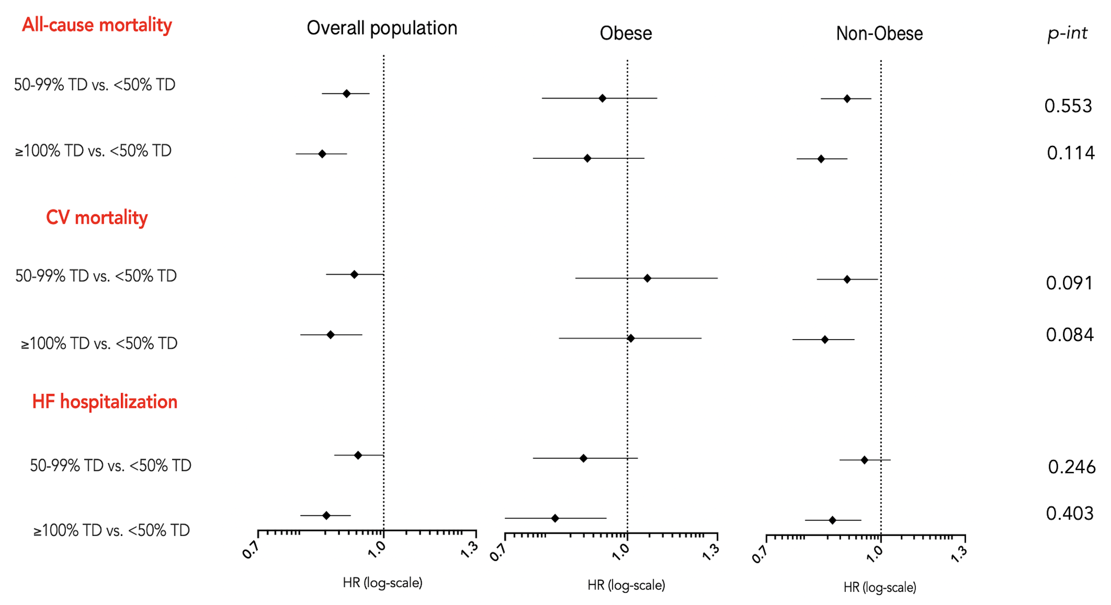

Abbreviations: CV: Cardiovascular; HF: Heart Failure; Hazard Ratio; p-int: p-interaction; TD: Target Dose.
Variables included as covariates in the multivariable models are labeled with ¶ in Table 1/Supplementary Table 4.

Supplementary Figure 5. Sensitivity analysis in the study cohort where height was imputed to minimize the amount of missing data for BMI: independent association between obesity and use of heart failure pharmacological treatments.
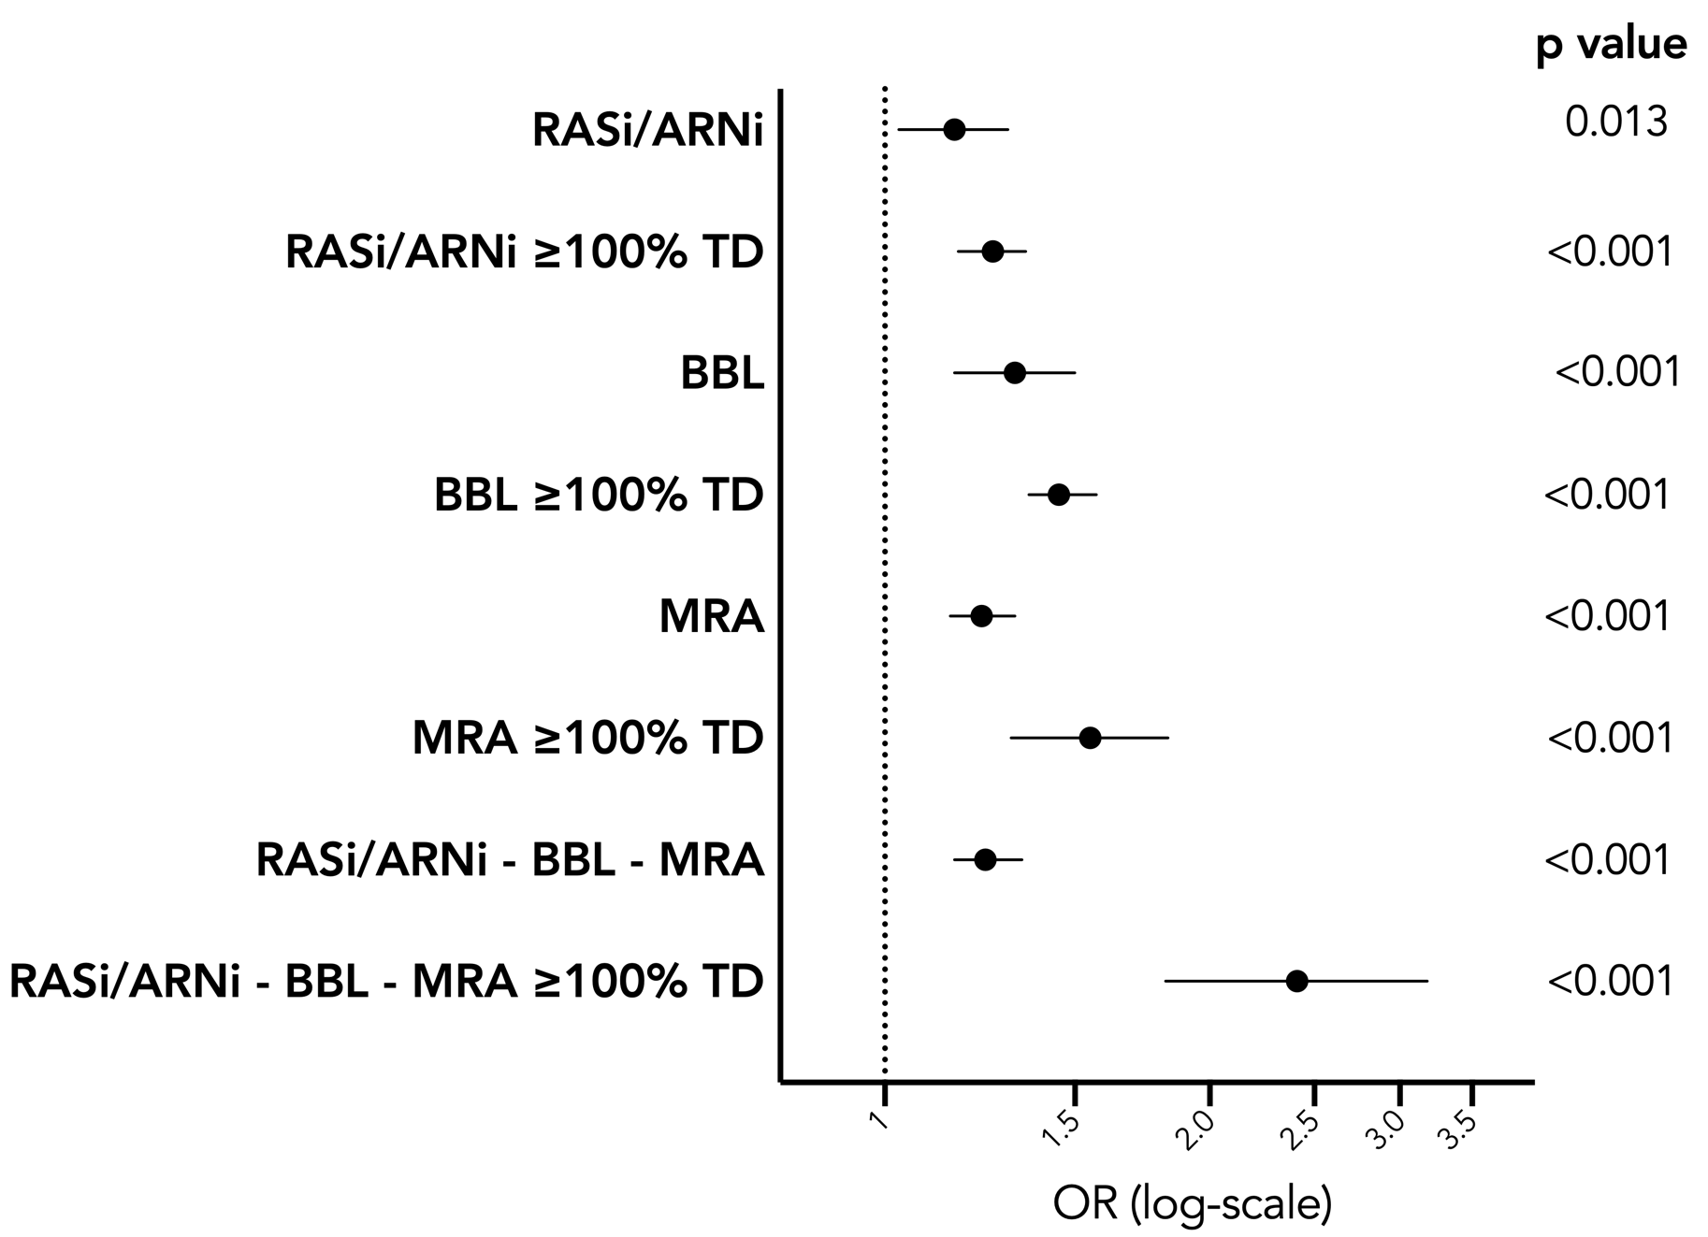
Abbreviations. ARNi: Angiotensin Receptor Neprilysin Inhibitors; BBL: Beta-Blocker; MRA: Mineralocorticoid Receptor Antagonists; RASi: Renin-Angiotensin System Inhibitors; OR: Odd Ratio; TD: Target Dose.
Variables included as covariates in the multivariable models are labeled with ¶ in Table 1/Supplementary Table 4.

Supplementary Figure 6. Sensitivity analysis in the study cohort where height was imputed to minimize the amount of missing data for BMI: Cumulative incidence curves for all-cause mortality, cardiovascular mortality and hospitalization for heart failure in the overall population (panel A, C and E) and in obese/non-obese patients (panel B, D and F) receiving/not receiving renin-angiotensin system inhibitors/angiotensin receptor neprilysin inhibitors.
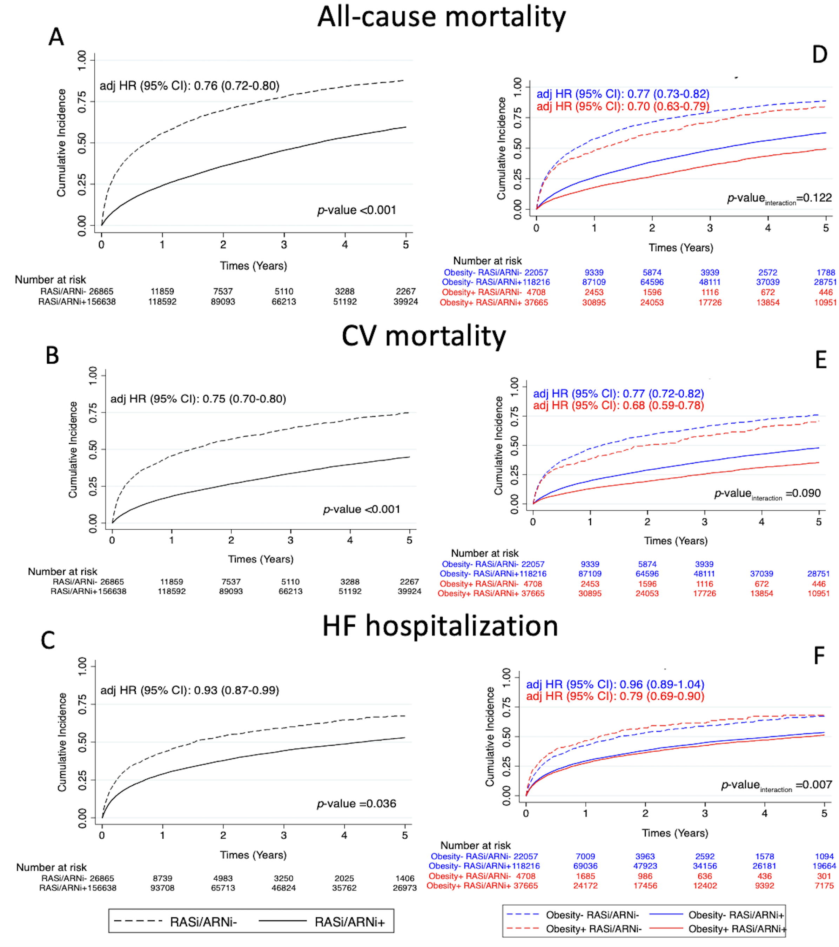

Abbreviations. Adj: adjusted. ARNi: Angiotensin Receptor Neprilysin Inhibitors; CI: Confidence Interval; CV: Cardiovascular; HF: Heart Failure; HR: Hazard Ratio; RASi: Renin-Angiotensin System Inhibitors.
Variables included as covariates in the multivariable models are labeled with ¶ in Table 1/Supplementary Table 4.
Adjusted HRs and p for interaction are also reported.

Supplementary Figure 7. Sensitivity analysis in the study cohort where height was imputed to minimize the amount of missing data for BMI: Cumulative incidence curves for all-cause mortality, cardiovascular mortality and hospitalization for heart failure in the overall population (panel A, C and E) and in obese/non-obese patients (panel B, D and F) receiving/not receiving beta-blockers.
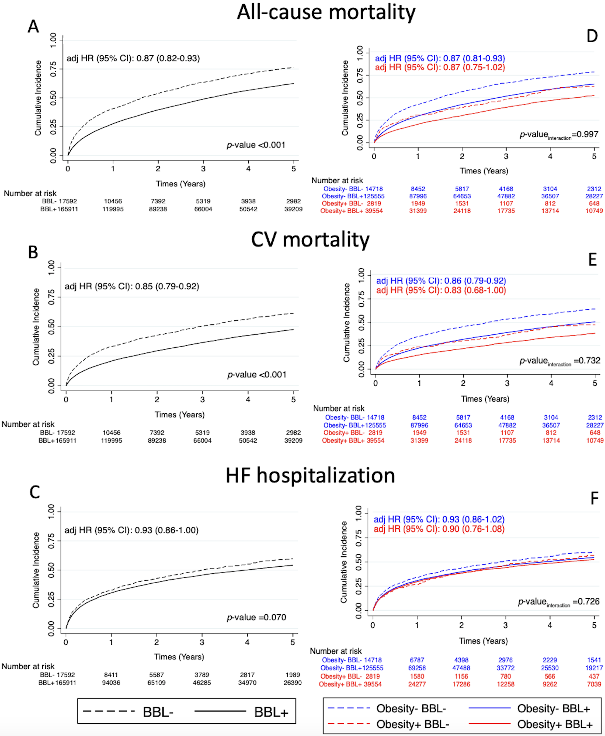
Abbreviations. Adj: adjusted. BBL: beta-blockers, CI: Confidence Interval; CV: Cardiovascular; HF: Heart Failure; HR: Hazard Ratio.
Variables included as covariates in the multivariable models are labeled with ¶ in Table 1/Supplementary Table 4.
Adjusted HRs and p for interaction are also reported.

Supplementary Figure 8. Sensitivity analysis in the study cohort where height was imputed to minimize the amount of missing data for BMI: Splines curves for the association between renin-angiotensin system inhibitor/angiotensin receptor neprilysin inhibitor and beta-blocker use and all-cause mortality (panel A and D), cardiovascular mortality (panel B and E) and hospitalization for heart failure (panel C and F) according to increasing values of body mass index.
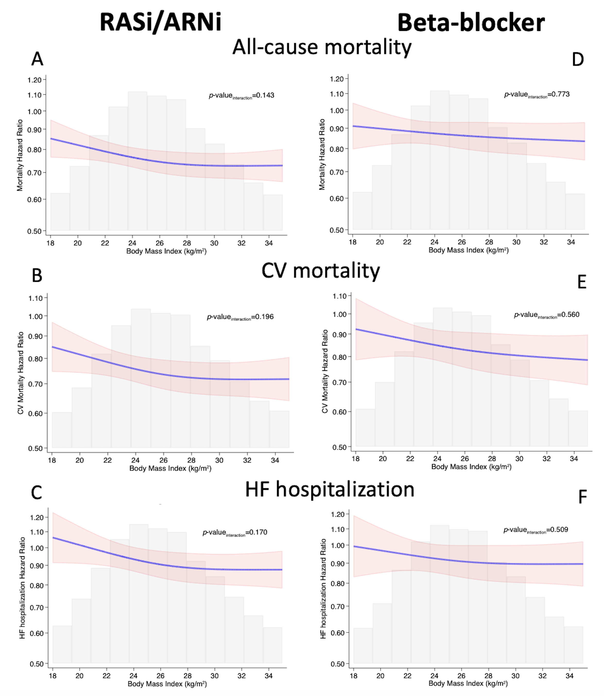
Abbreviations. ARNi: Angiotensin Receptor Neprilysin Inhibitors; CV: Cardiovascular; HF: Heart Failure; RASi: Renin-Angiotensin System Inhibitors.
Variables included as covariates in the multivariable models are labeled with ¶ in Table 1/Supplementary Table 4.

Supplementary Figure 9. Sensitivity analysis in the study cohort where height was imputed to minimize the amount of missing data for BMI: Forest plots for the outcomes time to all-cause mortality, cardiovascular mortality and hospitalization for heart failure in overall population and obese vs. non-obese patients treated with renin-angiotensin system inhibitors/angiotensin receptor neprilysin inhibitors, according to target dose achieved.
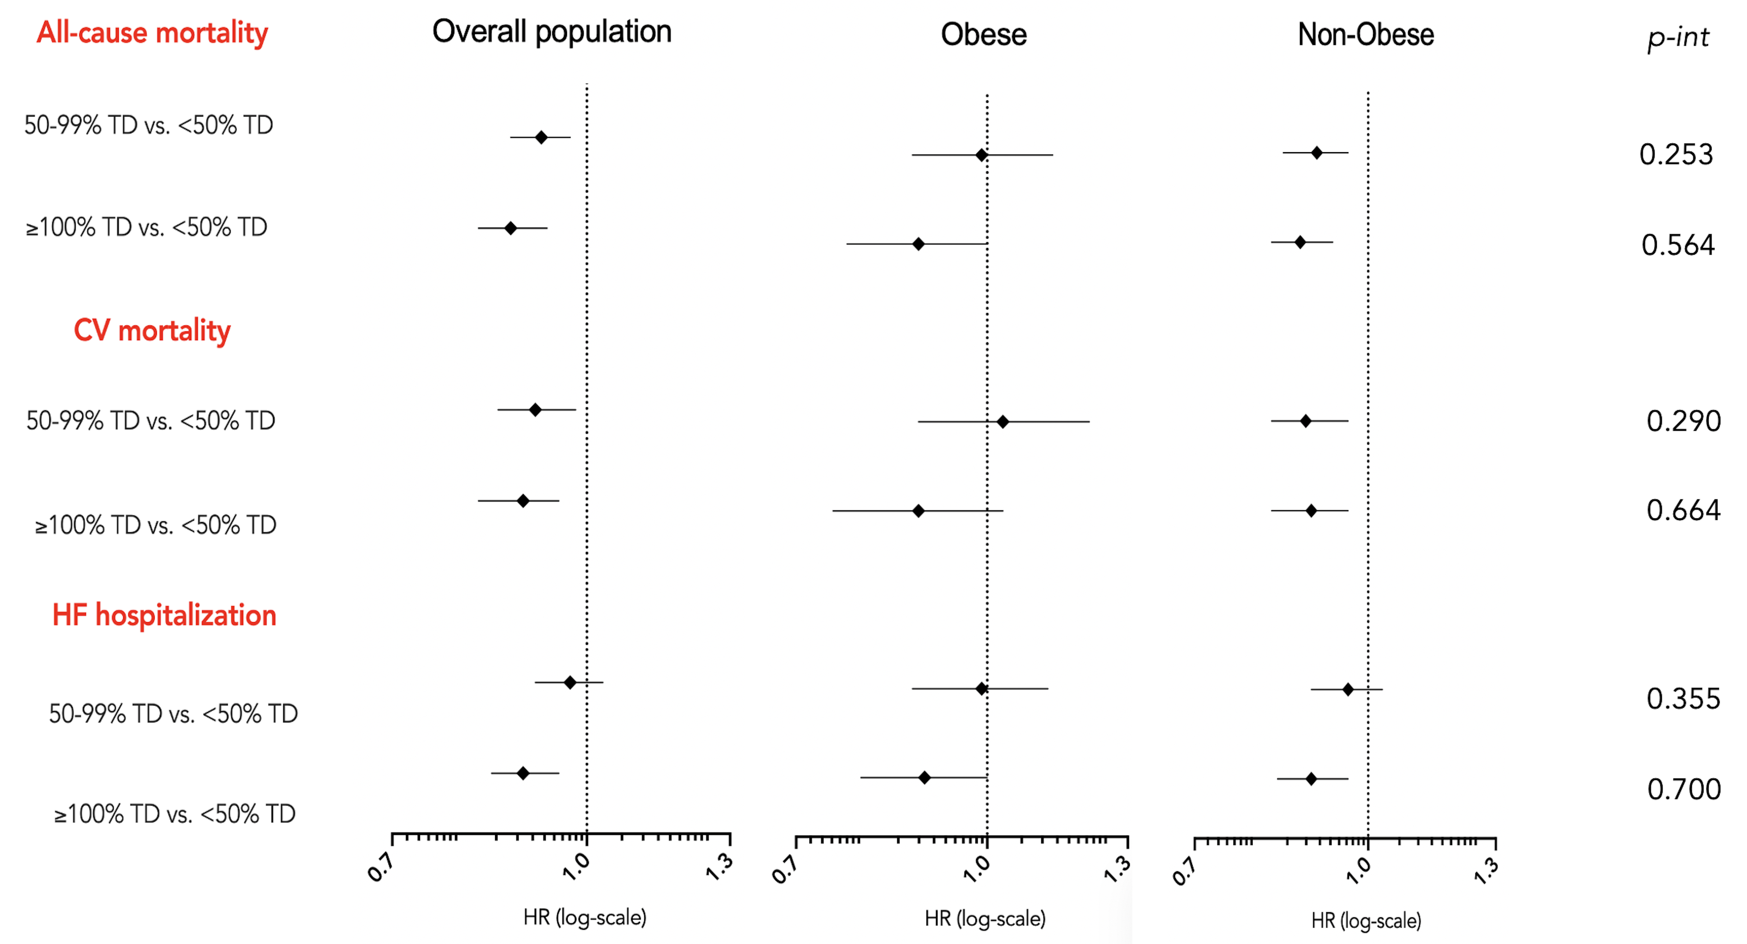
Abbreviations. CV: Cardiovascular; HF: Heart Failure; Hazard Ratio; p-int: p-interaction; TD: Target Dose.
Variables included as covariates in the multivariable models are labeled with ¶ in Table 1/Supplementary Table 4.

Supplementary Figure 10. Sensitivity analysis in the study cohort considered for the sensitivity analysis where height was imputed to minimize the amount of missing data for BMI: Forest plots for the outcomes time to all-cause mortality, cardiovascular mortality and hospitalization for heart failure in overall population and obese vs. non-obese patients treated with beta-blockers, according to target dose achieved.

Abbreviations: CV: Cardiovascular; HF: Heart Failure; Hazard Ratio; p-int: p-interaction; TD: Target Dose.
Variables included as covariates in the multivariable models are labeled with ¶ in Table 1/Supplementary Table 4.

Supplementary Figure 11A. Sensitivity analysis excluding underweight patients: cumulative incidence curves for all-cause mortality, cardiovascular mortality and hospitalization for heart failure in overall population (panel A, B and C) and in obese/non-obese patients (panel D, E and F) receiving/not receiving renin angiotensin system inhibitors/angiotensin receptor neprilysin inhibitors.
Abbreviations. Adj: adjusted. ARNi: Angiotensin Receptor Neprilysin Inhibitors; CI: Confidence Interval; CV: Cardiovascular; HF: Heart Failure; HR: Hazard Ratio; RASi: Renin-Angiotensin System Inhibitors.
Variables included as covariates in the multivariable models are labeled with ¶ in Table 1/Supplementary Table 4.
Adjusted HRs and p for interaction are also reported.

Supplementary Figure 11B. Sensitivity analysis excluding underweight patients: cumulative incidence curves for all-cause mortality, cardiovascular mortality and hospitalization for heart failure in overall population (panel A, B and C) and in obese/non-obese patients (panel D, E and F) receiving/not receiving beta-blockers.
Abbreviations. Adj: adjusted. BBL: Beta-Blockers. CI: Confidence Interval; CV: cardiovascular; HF: Heart Failure; HR: Hazard Ratio.
Variables included as covariates in the multivariable models are labeled with ¶ in Table 1/Supplementary Table 4.
Adjusted HRs and p for interaction are also reported.

