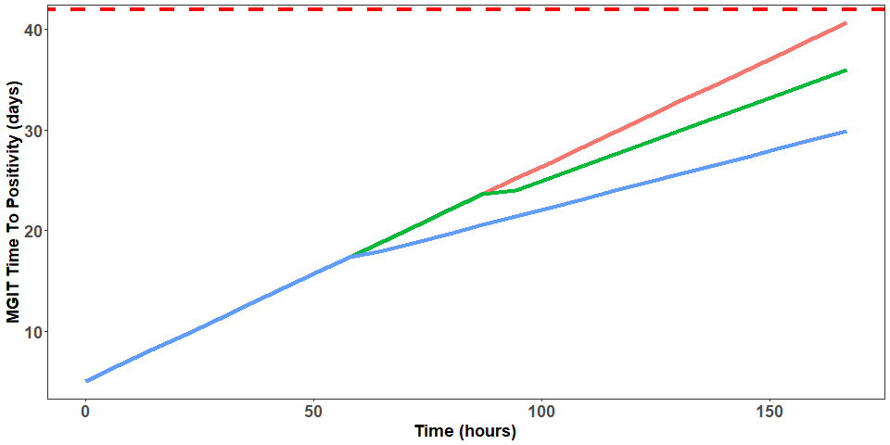
Fig. S1. Visual representation of a mono- (red) and bi-phasic (blue and green) MGIT TTP-time kill series with the horizonal red dashed line representing the upper limit of quantification (i.e. 42 days).

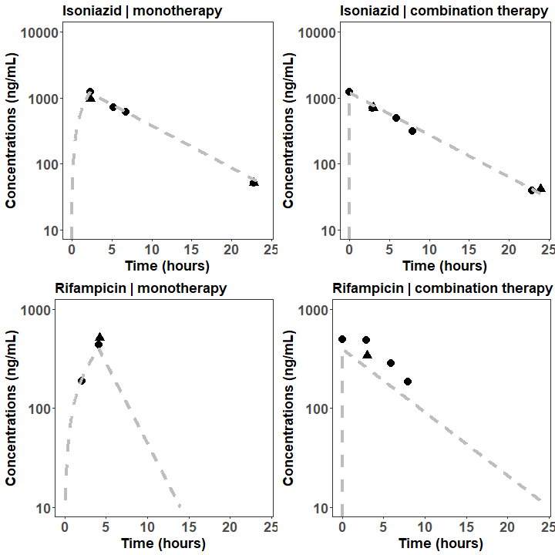
Fig. S2. Simulated (grey dashed line) versus observed pharmacokinetic profile in central reservoir (circles) and extra capillary space (triangles).

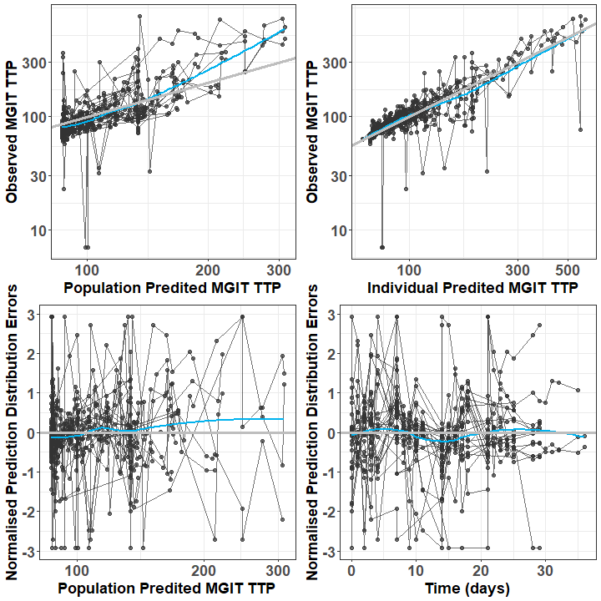
Fig. S3. Basic Goodness of Fitness plots Pharmacodynamic model. Grey and blue lines represent the line of identity and local polynomial regression fitting, respectively.
Table S1. Summary of WGS data.
id | project_title | scientific_name | strain | sample_alias | sample_description
ERS12274705 | PRJEB53040 | Mycobacterium tuberculosis | H37Rv | E1_0-25R-0-25I-2 | 1/4 MIC RIF and 1/4 MIC INH, end of evolution cycle 2, replicate 1
ERS12274706 | PRJEB53040 | Mycobacterium tuberculosis | H37Rv | E1_0-25R-0I-2 | 1/4 MIC RIF and 0 MIC INH, end of evolution cycle 2, replicate 1
ERS12274707 | PRJEB53040 | Mycobacterium tuberculosis | H37Rv | E1_0R-0-25I-2 | 0 MIC RIF and 1/4 MIC INH, end of evolution cycle 2, replicate 1
ERS12274708 | PRJEB53040 | Mycobacterium tuberculosis | H37Rv | E1_0R-0I-2 | 0 MIC RIF and 0 MIC INH, end of evolution cycle 2, replicate 1
ERS12274709 | PRJEB53040 | Mycobacterium tuberculosis | H37Rv | E1_0R-1I-2 | 0 MIC RIF and 1 MIC INH, end of evolution cycle 2, replicate 1
ERS12274710 | PRJEB53040 | Mycobacterium tuberculosis | H37Rv | E1_0R-8I-2 | 0 MIC RIF and 8 MIC INH, end of evolution cycle 2, replicate 1
ERS12274711 | PRJEB53040 | Mycobacterium tuberculosis | H37Rv | E1_1R-0I-2 | 1 MIC RIF and 0 MIC INH, end of evolution cycle 2, replicate 1
ERS12274712 | PRJEB53040 | Mycobacterium tuberculosis | H37Rv | E1_1R-1I-2 | 1 MIC RIF and 1 MIC INH, end of evolution cycle 2, replicate 1
ERS12274713 | PRJEB53040 | Mycobacterium tuberculosis | H37Rv | E1_8R-0I-2 | 8 MIC RIF and 0 MIC INH, end of evolution cycle 2, replicate 1
ERS12274714 | PRJEB53040 | Mycobacterium tuberculosis | H37Rv | E1_8R-8I-2 | 8 MIC RIF and 8 MIC INH, end of evolution cycle 2, replicate 1
ERS12274715 | PRJEB53040 | Mycobacterium tuberculosis | H37Rv | E1_Start-culture-2 | Start culture, replicate 1
ERS12274716 | PRJEB53040 | Mycobacterium tuberculosis | H37Rv | E2_0-25R-0-25I-2 | 1/4 MIC RIF and 1/4 MIC INH, end of evolution cycle 2, replicate 2
ERS12274717 | PRJEB53040 | Mycobacterium tuberculosis | H37Rv | E2_0-25R-0I-2 | 1/4 MIC RIF and 0 MIC INH, end of evolution cycle 2, replicate 2
ERS12274718 | PRJEB53040 | Mycobacterium tuberculosis | H37Rv | E2_0R-0-25I-2 | 0 MIC RIF and 1/4 MIC INH, end of evolution cycle 2, replicate 2
ERS12274719 | PRJEB53040 | Mycobacterium tuberculosis | H37Rv | E2_0R-0I-2 | 0 MIC RIF and 0 MIC INH, end of evolution cycle 2, replicate 2
ERS12274720 | PRJEB53040 | Mycobacterium tuberculosis | H37Rv | E2_0R-1I-2 | 0 MIC RIF and 1 MIC INH, end of evolution cycle 2, replicate 2
ERS12274721 | PRJEB53040 | Mycobacterium tuberculosis | H37Rv | E2_0R-8I-2 | 0 MIC RIF and 8 MIC INH, end of evolution cycle 2, replicate 2
ERS12274722 | PRJEB53040 | Mycobacterium tuberculosis | H37Rv | E2_1R-0I-2 | 1 MIC RIF and 0 MIC INH, end of evolution cycle 2, replicate 2
ERS12274723 | PRJEB53040 | Mycobacterium tuberculosis | H37Rv | E2_1R-1I-2 | 1 MIC RIF and 1 MIC INH, end of evolution cycle 2, replicate 2
ERS12274724 | PRJEB53040 | Mycobacterium tuberculosis | H37Rv | E2_8R-0I-2 | 8 MIC RIF and 0 MIC INH, end of evolution cycle 2, replicate 2
ERS12274725 | PRJEB53040 | Mycobacterium tuberculosis | H37Rv | E2_8R-8I-2 | 8 MIC RIF and 8 MIC INH, end of evolution cycle 2, replicate 2
ERS12274726 | PRJEB53040 | Mycobacterium tuberculosis | H37Rv | E2_Start-culture-2 | Start culture, replicate 2
ERS12274727 | PRJEB53040 | Mycobacterium tuberculosis | H37Rv | 0R-0I-7 | 0 MIC RIF and 0 MIC INH, end of evolution cycle 1, replicate 2
ERS12274728 | PRJEB53040 | Mycobacterium tuberculosis | H37Rv | 0R-1-4I-1 | 0 MIC RIF and 1/4 MIC INH, end of evolution cycle 1, replicate 2
ERS12274729 | PRJEB53040 | Mycobacterium tuberculosis | H37Rv | 0R-1-4I-9 | 0 MIC RIF and 1/4 MIC INH, end of evolution cycle 1, replicate 1
ERS12274730 | PRJEB53040 | Mycobacterium tuberculosis | H37Rv | 0R-1I-5 | 0 MIC RIF and 1 MIC INH, end of evolution cycle 1, replicate 2
ERS12274731 | PRJEB53040 | Mycobacterium tuberculosis | H37Rv | 0R-8I-8 | 0 MIC RIF and 8 MIC INH, end of evolution cycle 1, replicate 1
ERS12274732 | PRJEB53040 | Mycobacterium tuberculosis | H37Rv | 0R-8I-11 | 0 MIC RIF and 8 MIC INH, end of evolution cycle 1, replicate 2
ERS12274733 | PRJEB53040 | Mycobacterium tuberculosis | H37Rv | 1-4R-1-4I-2 | 1/4 MIC RIF and 1/4 MIC INH, end of evolution cycle 1, replicate 2
ERS12274734 | PRJEB53040 | Mycobacterium tuberculosis | H37Rv | 1-4R-1-4I-10 | 1/4 MIC RIF and 1/4 MIC INH, end of evolution cycle 1, replicate 1
ERS12274735 | PRJEB53040 | Mycobacterium tuberculosis | H37Rv | 1R-1I-6 | 1 MIC RIF and 1 MIC INH, end of evolution cycle 1, replicate 2
ERS12274736 | PRJEB53040 | Mycobacterium tuberculosis | H37Rv | 8R-0I-3 | 8 MIC RIF and 0 MIC INH, end of evolution cycle 1, replicate 2
ERS12274737 | PRJEB53040 | Mycobacterium tuberculosis | H37Rv | 8R-8I-4 | 8 MIC RIF and 8 MIC INH, end of evolution cycle 1, replicate 2
ERS12274738 | PRJEB53040 | Mycobacterium tuberculosis | H37Rv | 0R-0I-15 | 0 MIC RIF and 0 MIC INH, end of evolution cycle 1, replicate 1
ERS12274739 | PRJEB53040 | Mycobacterium tuberculosis | H37Rv | 0R-1I-13 | 0 MIC RIF and 1 MIC INH, end of evolution cycle 1, replicate 1
ERS12274740 | PRJEB53040 | Mycobacterium tuberculosis | H37Rv | 1-4R-0I-14 | 1/4 MIC RIF and 0 MIC INH, end of evolution cycle 1, replicate 1
ERS12274741 | PRJEB53040 | Mycobacterium tuberculosis | H37Rv | 1R-0I-16 | 1 MIC RIF and 0 MIC INH, end of evolution cycle 1, replicate 2
ERS12274742 | PRJEB53040 | Mycobacterium tuberculosis | H37Rv | 8R-0I-12 | 8 MIC RIF and 0 MIC INH, end of evolution cycle 1, replicate 1
ERS12274743 | PRJEB53040 | Mycobacterium tuberculosis | H37Rv | Day0-Exp1 | Start 1/3 x standard dose TDS HFIM experiment
ERS12274744 | PRJEB53040 | Mycobacterium tuberculosis | H37Rv | Day0-Exp2 | Start 3 x standard dose OD HFIM experiment
ERS12274745 | PRJEB53040 | Mycobacterium tuberculosis | H37Rv | Day6-Exp1 | End 1/3 x standard dose TDS HFIM experiment
ERS12274746 | PRJEB53040 | Mycobacterium tuberculosis | H37Rv | Day7-Exp2 | End 3 x standard dose OD HFIM experiment
ERS12274747 | PRJEB53040 | Mycobacterium tuberculosis | H37Rv | H37Rv-1 | 1/4 MIC RIF and 0 MIC INH, end of evolution cycle 1, replicate 2
ERS12274748 | PRJEB53040 | Mycobacterium tuberculosis | H37Rv | H37Rv-2 | 1 MIC RIF and 0 MIC INH, end of evolution cycle 1, replicate 1
ERS12274749 | PRJEB53040 | Mycobacterium tuberculosis | H37Rv | H37Rv-3 | 8 MIC RIF and 8 MIC INH, end of evolution cycle 1, replicate 1
ERS12274750 | PRJEB53040 | Mycobacterium tuberculosis | H37Rv | H37Rv-4 | 1 MIC RIF and 1 MIC INH, end of evolution cycle 1, replicate 1
ERS12274751 | PRJEB53040 | Mycobacterium tuberculosis | H37Rv | Frank_HFA_OD_23AUG2019_end-355082158 | End standard dose OD HFIM experiment
ERS12274752 | PRJEB53040 | Mycobacterium tuberculosis | H37Rv | Frank_HFB_TDS_28NOV2019_start-355004492 | Start standard dose TDS HFIM experiment
ERS12274753 | PRJEB53040 | Mycobacterium tuberculosis | H37Rv | Frank_HFC_TDS_10DEC2019_end-355119001 | End standard dose TDS HFIM experiment

