**Supplementary Appendix**

**Table S1: BP Threshold Algorithm (action colours)**

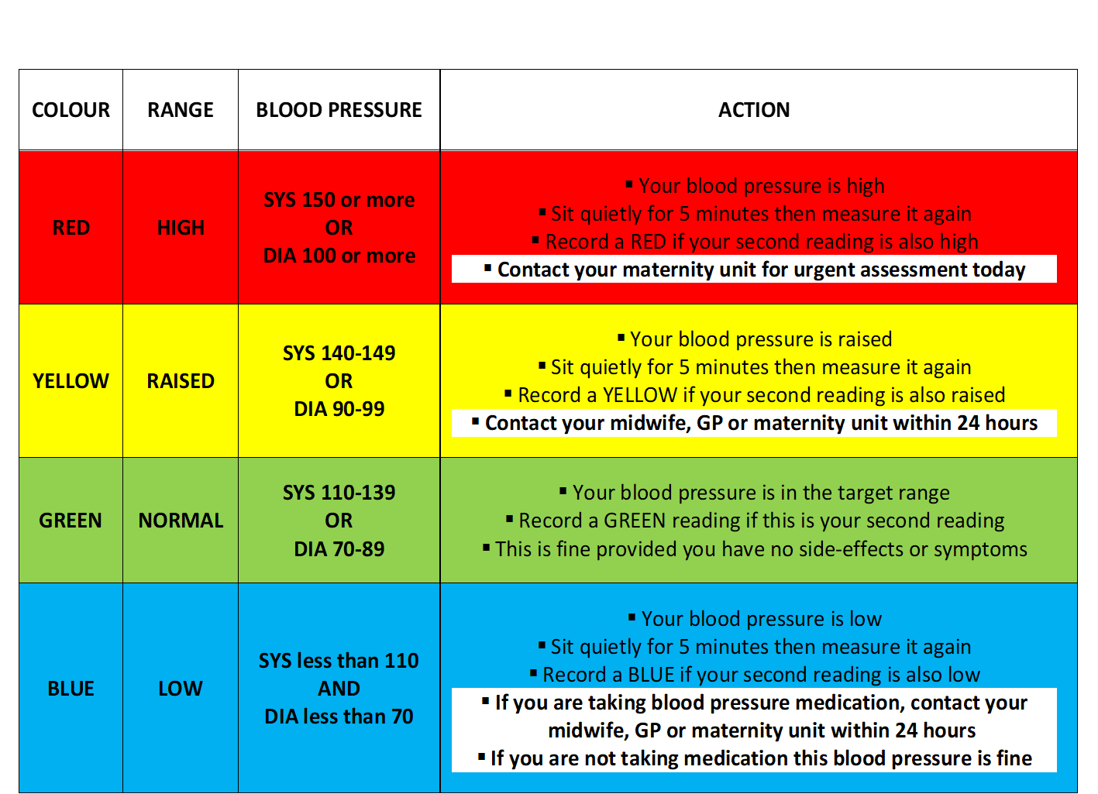

**Figure S1: Histogram of percentage of time that participants submitted SMBP readings (monitor or diary or app) for chronic hypertension and gestational hypertension groups**

     

**Table S2: Average interval between SMBP and clinic blood pressure readings**

|  |  |  |  |  |
| --- | --- | --- | --- | --- |
|  | **Chronic Hypertension** | | **Gestational Hypertension** | |
| Interval between readings (days) | SMBP | Clinic | SMBP | Clinic |
| Median (IQR) | 1 (1,1) | 8 (7,13) | 1 (1, 1) | 4.5 (3.5, 7) |
| Mean (SD) | 2.3 (3.8) | 14.7 (8.6) | 1.3 (0.5) | 6.2 (3.8) |

**Figure S2: Distribution of difference in blood pressure between the clinic and SMBP mean readings (in the 7 days preceding clinic)**

 

 

*Red dashed line represents mean difference; positive numbers represent higher clinic than SMBP readings*

**Table S3: Mean difference between clinic and average SMBP readings (sensitivity analyses looking at a) only SMBP readings from same day as clinic and b) only SMBP readings that were the 2nd reading taken each day)**

|  |  |  |
| --- | --- | --- |
|  | Chronic Hypertension | Gestational Hypertension |
| SMBP reading from same day as clinic |  |  |
| Number of participants included in comparison* | N=41 | N=34 |
| Number of observations included | 143 | 108 |
| Mean (95% CI‡) difference in SBP (mmHg) | -0.47 (-2.97, 2.04) | 2.65 (-0.52, 5.35) |
| Mean (95% CI‡) difference in DBP (mmHg) | 3.02 (0.51, 5.52) | 2.28 (0.25, 4.31) |
| Average SMBP including only 2nd reading of each day † |  |  |
| Number of participants included in comparison** | N=45 | N=29 |
| Number of observations included | 163 | 80 |
| Mean (95% CI‡) difference in SBP (mmHg) | 0.45 (-1.80, 2.69) | 4.47 (0.86, 8.07) |
| Mean (95% CI‡) difference in DBP (mmHg) | 2.72 (0.75, 4.70) | 4.37 (1.23, 7.51) |

* Included where SMBP and clinic readings available from the same day

† Average of the 2nd SMBP readings of each day, from the 7 days prior to clinic

‡ CIs adjusted for clustering by participant

** Included where SMBP and clinic readings available from the same week

**Table S4: Mean difference between clinic and study BP readings**

|  |  |  |
| --- | --- | --- |
|  | **Chronic Hypertension (n=35)** | |
|  | **SBP** | **DBP** |
| Mean (95% CI) difference (mmHg) | -1.84 (-6.18, 2.51) | -2.01 (-4.57, 0.55) |
| Median (IQR) difference (mmHg) | -0.67 (-4.67, 3.00) | -1.33 (-3.67, 1.00) |

**Figure S3: Study and Clinic blood pressure readings at different gestations (Chronic hypertension group, n=15 for 28 week visit, n=20 for 34 week visit)**

 

**Figure S4: Mean number of monitor readings per day**

 