Supplementary figure 2a. Absolute percentage change in the prevelance of current, severe and ever eczema symptoms in adolesents and children by characteristics
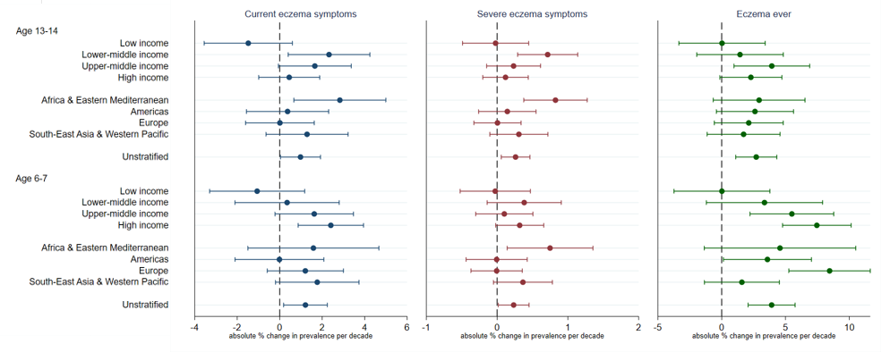

Supplementary figure 2b. Absolute percentage change in the prevelance of current, severe and ever eczema symptoms in adolesents and children derived from models stratifed by age, age and income and age and geographical region

