SUPPLEMENTARY MATERIAL

Title: Non-invasive ventilation in COVID-19 patients aged ≥70 years – a prospective multicentre cohort study.
Authors: Kamil Polok, Jakub Fronczek, Antonio Artigas, Hans Flaatten, Bertrand Guidet, Dylan W. De Lange, Jesper Fjølner, Susannah Leaver, Michael Beil, Sigal Sviri, Raphael Romano Bruno, Bernhard Wernly, Bernardo Bollen Pinto, Joerg C. Schefold, Dorota Studzińska, Michael Joannidis, Sandra Oeyen, Brian Marsh, Finn H. Andersen, Rui Moreno, Maurizio Cecconi, Christian Jung, Wojciech Szczeklik on behalf of COVIP study group

List of content:
Supplementary Figure 1. Missingness maps for each model included in the paper.
Supplementary Figure 2. Histograms showing (A) number of recruited patients (B) proportion of primary NIV (C) proportion of primary IMV and (D) 30-day mortality stratified by study month.
Supplementary Figure 3. Histograms showing distribution of NIV initiation day and NIV duration stratified by group.
Suuplementary Figure 4. Kaplan-Meier curves comparing survival in patients with primary NIV stratified by intubation status
Supplementary Figure 5. Distribution of LST withhold and withdrawal timing.
Supplementary Figure 6. Kaplan-Meier curves for the sensitivity analyses.

Supplementary Table 1. Details concerning ethical approval and patient`s consent
requirements in participating countries.
Supplementary Table 2. Definitions of comorbidities
Supplementary Table 3. Comparison of patients primarily treated with NIV stratified by NIV failure.
Supplementary Table 4. 30-day mortality, NIV failure rate and intubation rate stratified by the duration of primary NIV.

Supplementary Table 5. Comparison of patients primarily treated with NIV and IMV.

Supplementary Figure 1. Missingness maps for each model included in the paper.

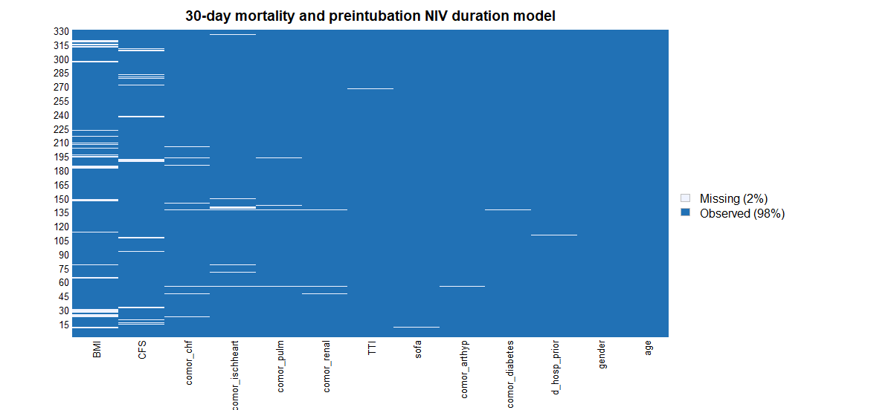

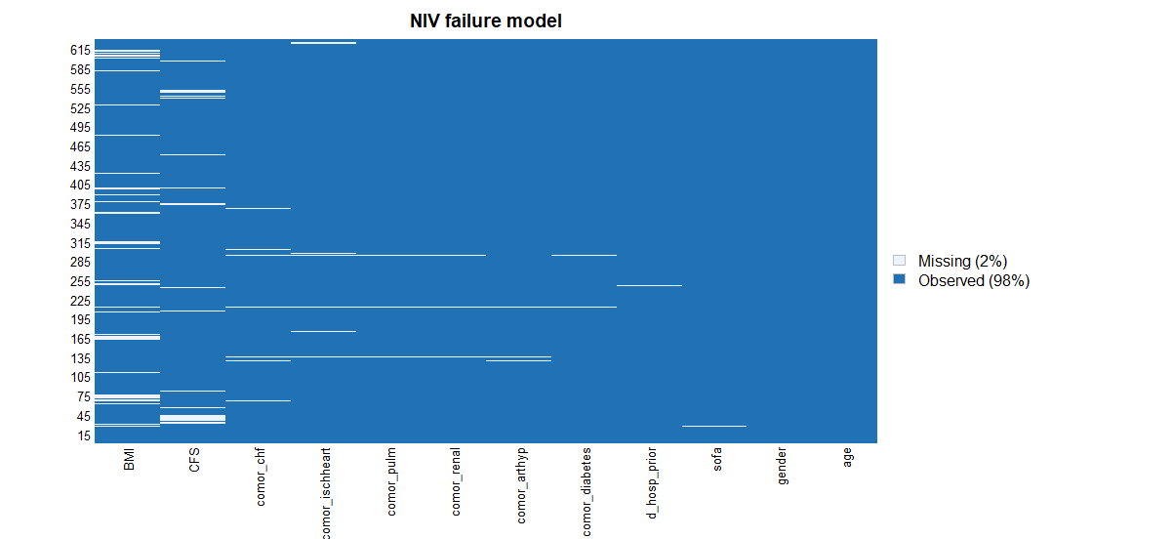

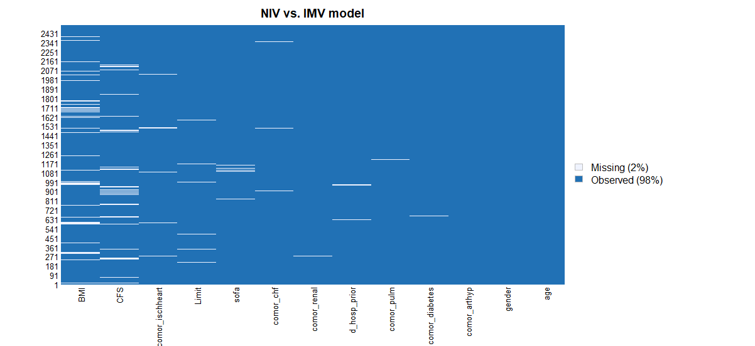

Supplementary Figure 2. Histograms showing (A) number of recruited patients (B) proportion of primary NIV (C) proportion of primary IMV and (D) 30-day mortality stratified by study month.

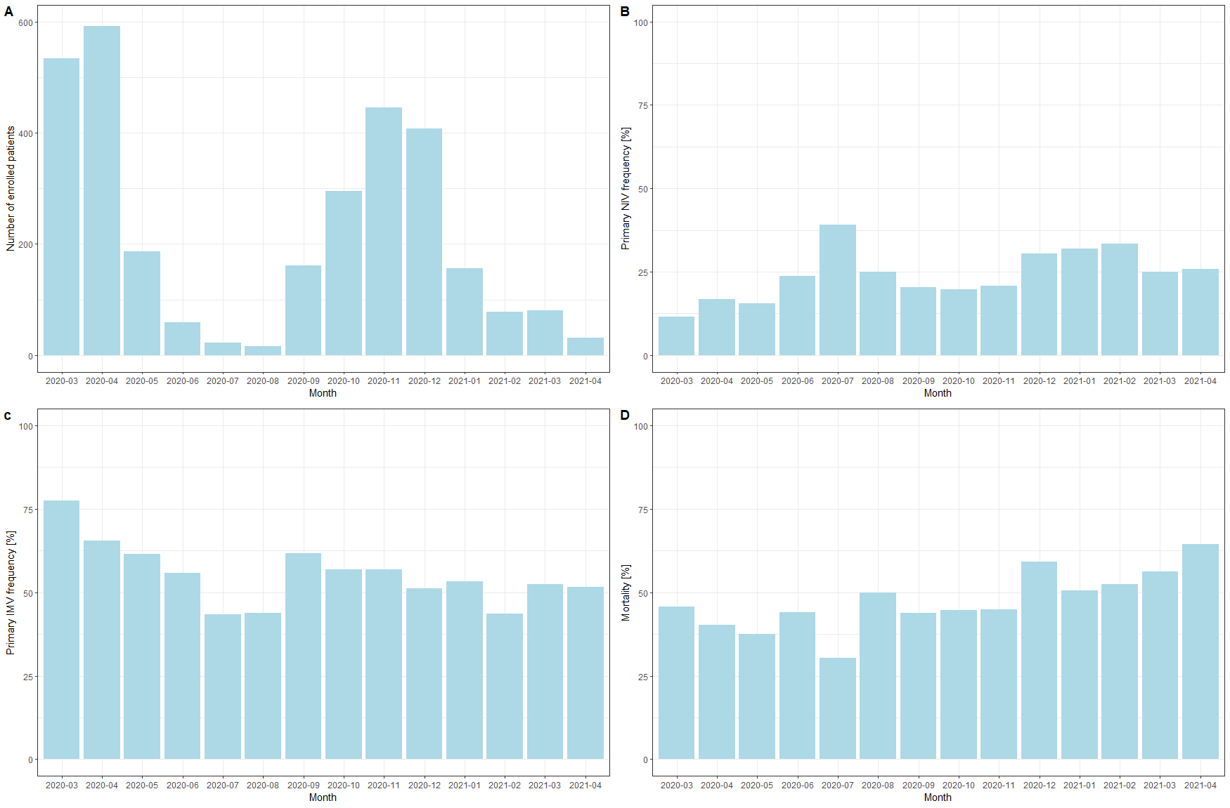

Supplementary Figure 3. Histograms showing distribution of NIV initiation day and NIV duration stratified by group.
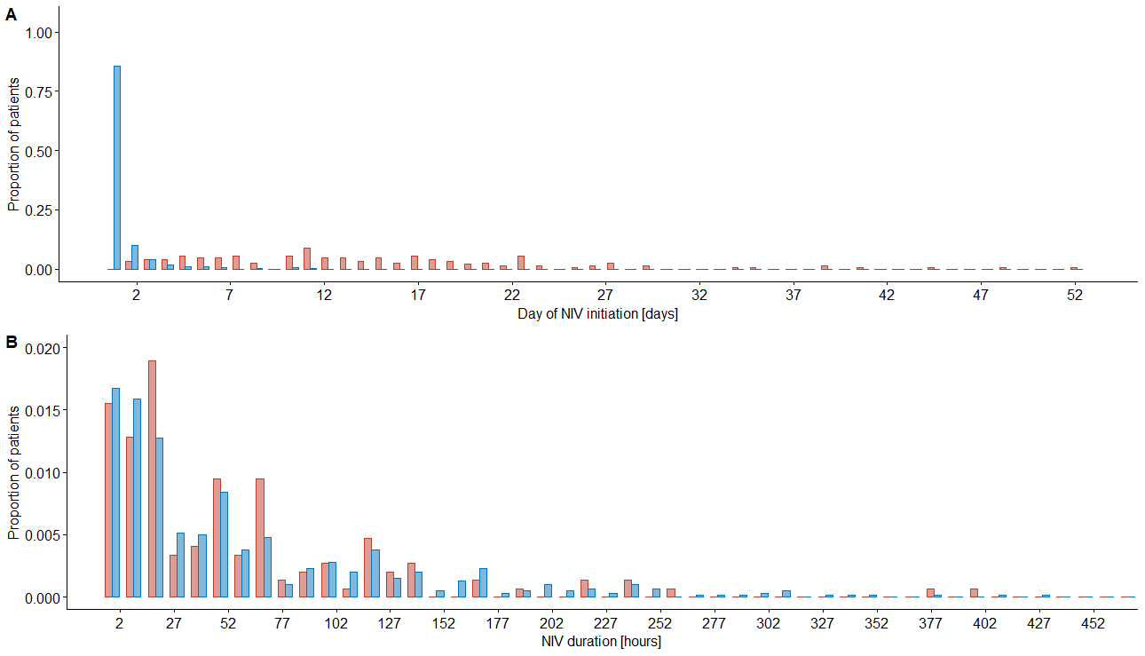

Footnote: Primary NIV is depicted in blue while Post-extubation NIV is presented with pink.

Suplementary Figure 4. Kaplan-Meier curves comparing survival in patients with primary NIV stratified by IMV status.
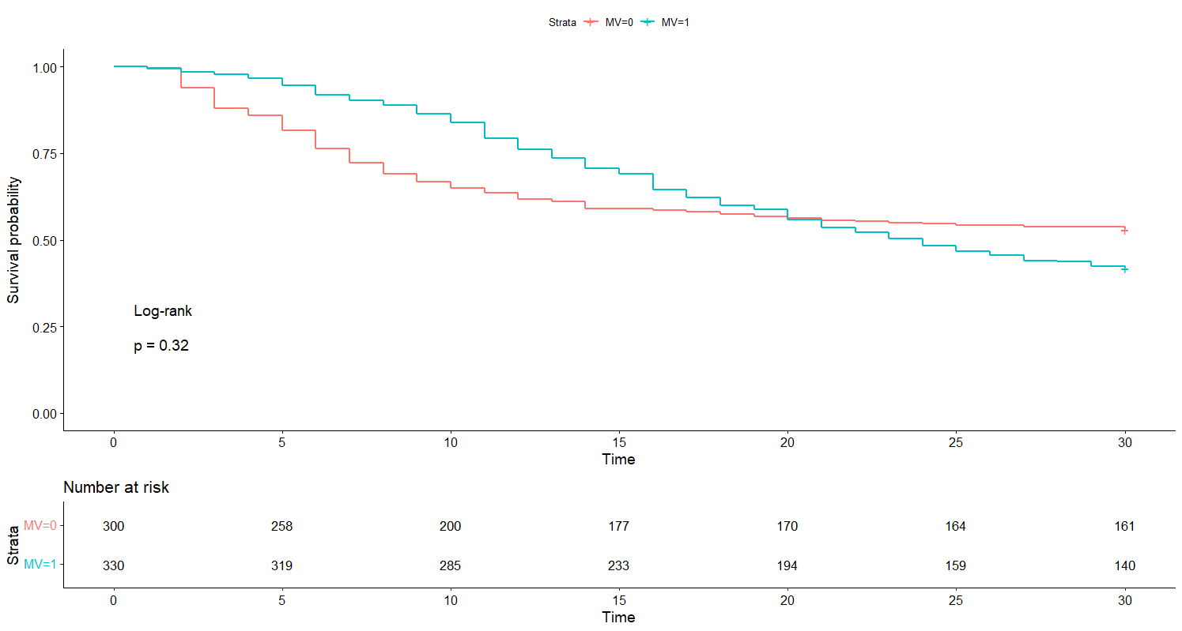

Supplementary Figure 5. Distribution of LST withhold and withdrawal timing.
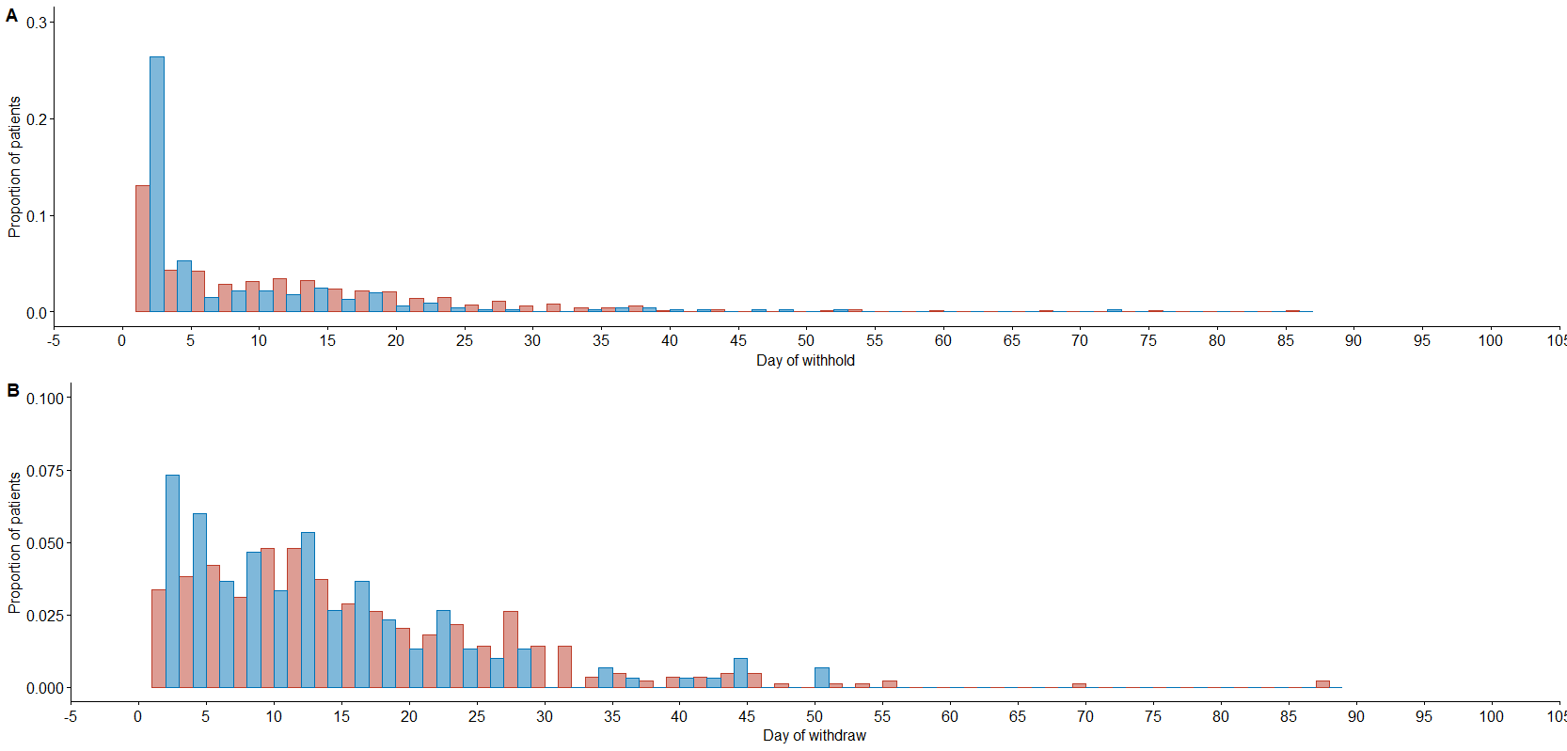

Footnote: Primary NIV is depicted in blue while primary IMV is presented with pink.

Supplementary Figure 6. Kaplan-Meier curves for the sensitivity analyses.

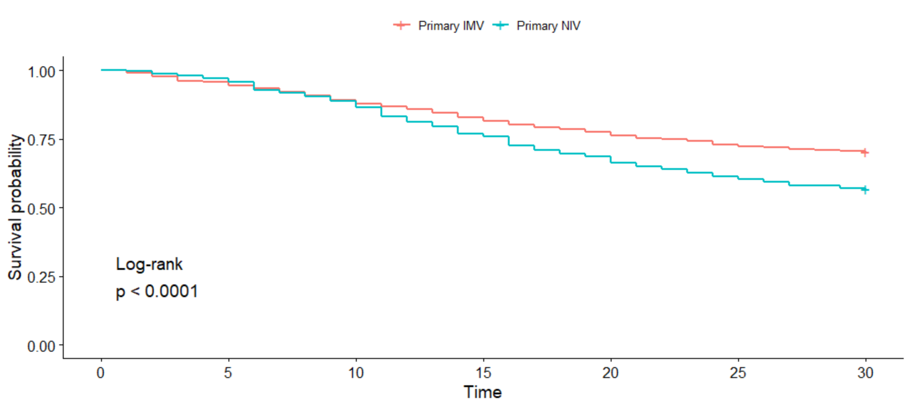
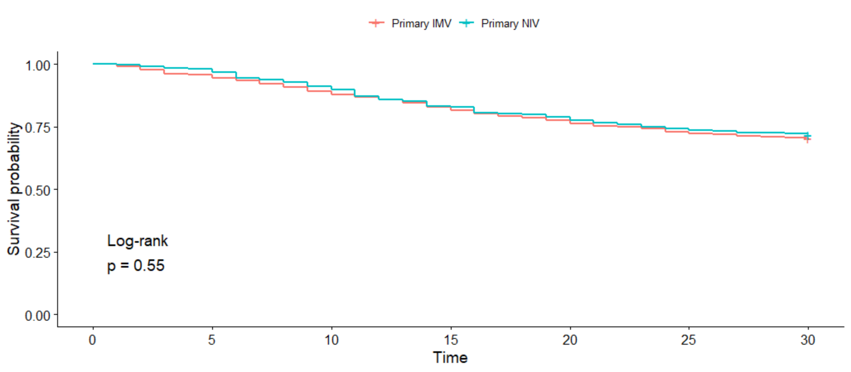
Footnote: The first curve compares the groups after exclusion of patients in whom LST limitation was not introduced during the initial respiratory treatment. The latter presents the comparision of survival probabilty after exclusion of patients in whom LST limitation was introduced within 30 days since the ICU admission.
Supplementary Table 1. Details concerning ethical approval and patient`s consent
requirements in participating countries.

Country | Details on ethical board approval | Details on patient's consent
Austria | Ethical approval was acquired nationally and for each individual hospital. | Required
Belgium | Ethical approval was acquired nationally and for each individual hospital. | Required
Denmark | Ethical approval was acquired nationally. | Waived
England | Ethical approval was acquired nationally and for each individual hospital. | Waived
France | Ethical approval was acquired nationally | Required
Germany | Ethical approval was acquired nationally and for each individual hospital. | Required
Greece | Ethical approval was acquired nationally and for each individual hospital. | Required
Ireland | Ethical approval was acquired for each individual hospital. | Deferred consent
Israel | Ethical approval was acquired for each individual hospital. | Waived
Netherlands | Ethical approval was acquired nationally and for each individual hospital. | Required
Norway | Ethical approval was acquired nationally | Waived. Deferred consent in survivors.
Poland | Ethical approval was acquired for each individual hospital. | Waived
Portugal | Ethical approval was acquired for each individual hospital. | Required in majority of centres
Spain | Ethical approval was acquired for each individual hospital. | Required in majority of centres
Switzerland | Ethical approval was acquired nationally and for each individual hospital. | Waived. Deferred consent at 3-month follow-up in survivors.
Wales | Ethical approval was acquired nationally and for each individual hospital. | Waived

Supplementary Table 2. Definitions of comorbidities

Diabetes mellitus | Documented evidence of diabetes mellitus before Hospital admission, reported by the patient or their relatives or prescription of anti-diabetic medication or insulin on the drug chart.
Ischaemic heart disease | Documented abnormal coronary angiography, known coronary artery disease, previous percutaneous coronary intervention (PCI) or coronary bypass surgery
Chronic renal failure | Documented evidence of chronic renal insufficiency Grade 3 or higher, creatinine clearance <60ml/min or chronic dialysis
Arterial hypertension | Documented evidence of any grade of chronic arterial hypertension and/or prescription of anti-hypertensive medication
Pulmonary disease | Documented evidence of or medication prescribed for chronic pulmonary disease of any aetiology (bronchial asthma, COPD, pulmonary fibrosis), or clinical or radiological signs of chronic pulmonary disease
Chronic heart failure | Documented evidence of or medication prescribed for chronic heart failure of any aetiology or echocardiographic or radiological signs of chronic heart failure.

Supplementary Table 3. Comparison of patients primarily treated with NIV stratified by NIV failure.

Characteristics | NIV success  (n=159) | NIV failure  (n=470) | p-value
Age, mean (SD) [years] | 76.5 (4.8) | 76.9 (5.0) | 0.351
Female gender | 52 (32.7) | 129 (27.4) | 0.244
BMI [kg/m²] | 27.7 (24.6, 32.0) | 27.5 (24.5, 31.1) | 0.496
Prior hospitalization length [days] | 2.0 (1.0, 4.0) | 2.0 (1.0, 5.0) | 0.397
Duration of symptoms before hospitalization [days] | 7.0 (3.0, 10.0) | 6.0 (3.0, 9.0) | 0.628
Diabetes | 60 (37.7) | 181 (38.7) | 0.908
Ischemic heart disease | 36 (22.9) | 122 (26.5) | 0.441
Chronic renal failure | 29 (18.2) | 105 (22.5) | 0.304
Arterial hypertension | 115 (72.8) | 303 (64.7) | 0.079
Pulmonary disease | 41 (25.8) | 118 (25.4) | 1.000
Congestive heart failure | 25 (15.8) | 79 (17.2) | 0.788
Bacterial coinfection | 28 (17.9) | 133 (29.4) | 0.007
SOFA score on admission | 3.0 (2.0, 5.0) | 4.0 (3.0, 7.0) | <0.001
Frailty status |  |  | 0.107
Fit | 99 (66.4) | 257 (57.5)
Frail | 28 (18.8) | 120 (26.8)
Vulnerable | 22 (14.8) | 70 (15.7)
CFS score on admission | 3.0 (2.0, 4.0) | 3.0 (3.0, 5.0) | 0.005
Day of NIV initiation | 1.0 (1.0, 1.0) | 1.0 (1.0, 1.0) | 0.140
Duration of NIV [hours] | 48.0 (17.0, 106.0) | 30.0 (8.0, 82.0) | 0.004
Vasopressors | 17 (10.8) | 334 (71.5) | <0.001
Renal replacement therapy | 2 (1.3) | 92 (19.6) | <0.001
Antibiotics | 123 (77.4) | 433 (92.1) | <0.001
Steroids | 106 (70.7) | 360 (79.5) | 0.034

Supplementary Table 4. 30-day mortality, NIV failure rate and intubation rate stratified by the duration of primary NIV.

Comparison | NIV duration |  |  | p-value
 | <24 hours | 24-72 hours | >72 hours
Primary NIV group (NIV failure = death or intubation within 30 days)
30-mortality | 127/240 (52.9) | 92/180 (51.1) | 106/184 (57.6) | 0.61
NIV failure | 191/239 (79.9) | 132/180 (73.3) | 134/184 (72.8) | 0.16
Primary NIV group without LST limitation
30-mortality | 93/198 (47.0) | 62/145 (42.8) | 51/123 (41.5) | 0.39
Intubation | 153/198 (77.3) | 94/145 (64.8) | 72/123 (58.5) | 0.001

Footnote: Data are presented as n/N (%)

Supplementary Table 5. Comparison of patients primarily treated with NIV and IMV.

Characteristics | Primary IMV  (n=1876) | Primary NIV  (n=630) | p-value
Age, mean (SD) [years] | 75.1 (4.2) | 76.8 (4.9) | <0.001
Female gender | 517 (27.6) | 181 (28.7) | 0.606
BMI [kg/m2] | 27.7 (25.0, 30.9) | 27.65 (24.5, 31.3) | 0.899
Prior hospitalization length [days] | 2.0 (1.0, 5.0) | 2.0 (1.0, 5.0) | 0.390
Duration of symptoms before hospitalization [days] | 7.0 (4.0, 10.0) | 6.0 (3.0, 9.0) | 0.003
Diabetes | 609 (32.5) | 241 (38.4) | 0.009
Ischemic heart disease | 380 (20.5) | 158 (25.5) | 0.010
Chronic renal failure | 249 (13.3) | 134 (21.4) | <0.001
Arterial hypertension | 1229 (65.6) | 418 (66.7) | 0.655
Pulmonary disease | 401 (21.4) | 159 (25.4) | 0.044
Congestive heart failure | 247 (13.3) | 104 (16.8) | 0.034
Bacterial coinfection | 414 (22.5) | 161 (26.4) | 0.053
SOFA score on admission | 7.00 (4.00, 8.00) | 4.00 (3.00, 6.00) | <0.001
Frailty status |  |  | <0.001
Fit | 1222 (71.1) | 356 (59.6)
Frail | 235 (13.7) | 148 (24.8)
Vulnerable | 262 (15.2) | 93 (15.6)
LST limitation | 699 (37.7) | 276 (44.1) | 0.005
Withholding | 547 (29.5) | 227 (36.3) | 0.002
Withdrawal | 417 (22.5) | 150 (24.0) | 0.495
Vasopressors | 1736 (93.0) | 352 (56.3) | <0.001
Renal replacement therapy | 371 (19.8) | 94 (14.9) | 0.007
Antibiotics | 1789 (95.5) | 557 (88.4) | <0.001
Steroids | 1239 (67.6) | 467 (77.3) | <0.001

