Ongoing evidence of the safety and efficacy of the NVX-CoV2373 COVID-19 vaccine in the United Kingdom

Supplementary Material
Ongoing evidence of the safety and efficacy of the NVX-CoV2373 COVID-19 vaccine in the United Kingdom

Table of Contents
2019nCoV-302 Study Group Members……………………………………………………………………….…. 3
Supplemental Methods …………………………………………………………………………………………... 6
Details on the Assays ……………………………………………………………………………………….. 6
Supplemental Tables .……………………………………………………………………………………………. 8
Supplemental Figures……………………………………………………………………………………………. 21

2019nCoV-302 Study Group Members
The NVX-CoV2373-2019nCoV-302 clinical trial was a collective group effort across multiple institutions and locations. Below is a list of sites and staff that significantly contributed to the implementation and conduct of the NVX-CoV2373-2019nCoV-302 clinical trial.
Site | Investigators
Aberdeen Royal Infirmary, NHS Grampian | Roy L. Soiza, Robin Brittain-Long, Chiara Scicluna, Carole Edwards, Lynn Mackay, Mariella D’Allesandro, Amy Nicol, Karen Norris, Sandra Mann, Heather Lawrence, Ruth Valentine
Accelerated Enrollment Solutions | Marianne Elizabeth Viljoen, Carol H. Pretswell, Helen Nicholls, Imrozia Munsoor, Agnieszka Meyrick, Christina Kyriakidou, Shalini Iyengar, Arham Jamal, Nick Richards, Helen Price, Bridie Rowbotham, Danielle Bird, Karen Smith, Olga Littler, Kirsty Fielding, Anna Townsend-Rose, Karen Miller, Jessica Davis, Alison Elliot-Garwood, Lauren Trottier, Paul Edwards
Belfast Health and Trust | Margaret McFarland
Betsi Cadwaladr University Health Board | Thomas Eadsforth, Jonathan Heseltine, Nick Heseltine, Rebecca Andrews, Lynne Grundy, Laura Longshaw, Julia Parton
Blandford Group Practice | Katharine Lucy Broad
Bradford Teaching Hospitals NHS Foundation Trust | Karen Regan, Kim Storton, Declan Ryan-Wakeling, Brad Wilson, Malathy Munisamy, John Wright, Anil Shenoy, Beverley English, Lucy Brear
Centre for Clinical Vaccinology and Tropical Medicine, University of Oxford | Paola Cicconi
Chelsea and Westminster Hospital | Marta Boffito, Ana Milinkovic, Ruth Byrne, Roya Movahedi, Rosalie Housman, Julie Logan, Alfredo Soler-Carracedo, Veronica Canuto, Serge Fedele, Candida Fernandez, Liam Sutcliffe
County Durham & Darlington NHS Foundation Trust | Naveed Kara, Ellen Brown, Andrea Kay
Department of Psychiatry, University of Oxford, NIHR Oxford Health Cognitive Health Clinical Research Facility and NIHR Oxford Health Biomedical Research Centre | Andrea Cipriani, Mary-Jane Attenburrow, Katharine A. Smith
Division of Epidemiology and Public Health, University of Nottingham | Jonathan Packham
Dorset Research Hub, Royal Bournemouth Hospital, University Hospitals Dorset NHS Foundation Trust | Geoff Sparrow
East Suffolk and North Essex NHS Foundation Trust | Richard Smith, Josephine M Rosier, Khalid Saja, Nyasha Nago, Brian Camilleri, Anita Immanuel, Mike Hamblin, Rawlings Osagie, Mahalakshmi Mohan
Epsom and St Helier University Hospitals NHS Trust | Hilary Floyd, Suzanne Goddard, Sanjay Mutgi, John Evans, Sean McKeon, Neringa Vilimiene, Rosavic Chicano, Rachel Hayre, Alice Pandaan
Faculty of Health and Life Sciences, Oxford Brookes University | Catherine Henshall
Guy's and St Thomas' NHS Foundation Trust NIHR BRC | Anna Goodman, Cherry Paice, Naimh Spence, Alice Packham, Movin Abeywickrama, Teona Serafimova, Suhail Aslam, Tanveer Bawa, Sonia Serrano, Moncy Mathew, Karen Bisnauthsing, Samantha Broadhead, Grainne Cullen, Jo Salkeld, Henry Fok, Thurkka Rajeswaran, Andrea Mazzella
Health and Care Research Wales | Nicola Williams, Jayne Goodwin
Highcliffe Medical Centre | Zelda Cheng
Keele University | Toby Helliwell, Adrian Chudyk
Kings College London | Rafaela Giemza, John Lord Villajin, Noah Yogo, Esther Makanju, Pearl Dulawan, Deepak Nagra, April Buazon, Alice Russell, Georgie Bird
Lakeside Healthcare Research, Lakeside Surgery | Amardeep Heer, Rex Sarmiento, Balraj Sanghera, Melanie Mullin, Adam Champion, Aisling Bevan, Kinzah Iqbal, Alshia Johnson
Layton Medical Centre | Rebecca Clark, Sarah Shaw, Steven Shaw, Amanda Chalk, Martin Lovatt, Caroline Lillicrap, Angela Parker, Jan Hansel, Zhi Wong, Galvin Gan, Eyad Tuma
Leeds Teaching Hospitals NHS Trust | Jane Minton, Jennifer Murira, Razan Saman, Alistair Hall, Kyra Holliday, Zara Khan, James Calderwood, George Twigg, Helena Baker, Julie Corrigan, Katy Houseman
Midlands Partnership NHS Foundation Trust | Subhra Raguvanshi, Dominic Heining, Jake Weddell, Liz Glaves, Kim Thompson, Francis Davies, Ruth Lambley Burke
MRC–University of Glasgow Centre for Virus Research, and Queen Elizabeth University Hospital, NHS Greater Glasgow & Clyde, Glasgow, Scotland | Emma C. Thomson
National Institute for Health Research Patient Recruitment Centre and Bradford Teaching Hospitals NHS Foundation Trust, Bradford | Dinesh Saralaya
Newcastle University | Adam Farrier
NIHR Clinical Research Facility, University Hospital Southampton NHS Foundation Trust | Lisa Berry
NIHR Clinical Research Network, Thames Valley and South Midlands, Oxford University Hospitals NHS Foundation Trust | Nancy Hopewell, Leigh Gerdes
NIHR Southampton Clinical Research Facility and NIHR Wessex Local Clinical Research Network, University Hospital Southampton NHS Foundation Trust | Mihaela Pacurar, Saul N Faust
Norfolk and Norwich University Hospital NHS Foundation Trust | Jeremy Turner, Christopher Jeanes, Adele Cooper, Jocelyn Keshet-Price, Lou Coke, Melissa Cambell-Kelly, Ketan Dhatariya, Claire Williams, Georgina Marks, James Sudbury, Lisa Rodolico
Northern Ireland Clinical Research Facility, Queen's University Belfast and Belfast Health and Social Care Trust | Sharon Carr, Roisin Martin, Angelina Madden
Northern Ireland Clinical Research Network | Maurice O’Kane, Paul Biagioni, Sonia McKenna, Alison Clinton
North Tees and Hartlepool NHS Foundation Trust | Justin Carter, Matthew Dewhurst, Bill Wetherill, Rachel Taylor
Oxford Health NHS Foundation Trust, Warneford Hospital | Thandiwe Hoggarth, Katrina Lennon Collins, Marie Chowdhury, Adil Nathoo, Anna Heinen, Jayne E. Starrett, Orla MacDonald, Tokoza Muimo, Claudia Hurducas, Liliana Cifuentes, Sarah McCartney
Quadram Institute | Jane Ewing
Queen Elizabeth University Hospital, NHS Greater Glasgow and Clyde | Guy Mollett, Rachel Blacow, John Haughney, Jonathan MacDonald, John Paul Seenan, Stewart Webb, Colin O'Leary, Scott Muir, Beth White, Neil Ritchie
Queen's University Belfast and Belfast Health and Social Care Trust | Judy Bradley, Daniel F. McAuley, Jonathan Stewart
Research and Development, NHS Grampian | Chiara Scicluna, Mariella D'Alessandro, Carole Edwards, Lynn MacKay, Amy Nicol, Karen Norris, Heather Lawrence, Sandra Mann, Ruth Valentine
Royal Bournemouth Hospital, University Hospitals Dorset NHS Foundation Trust | Nicki Lakeman, Laura Purandare
Royal Cornwall Hospital NHS Trust | Duncan Browne, David Tucker, Peter Luck, Angharad Everden, Lisa Trembath, Michael Visick, Nick Morley, Laura Reid, Helen Chenoweth, Kirsty Maclean
Royal Devon and Exeter Hospital | Ray P. Sheridan, Tom Burden, Craig Francis Lunt, Shirley Todd, Stephanie Estcourt, Jasmine Marie Pearce, Suzanne Wilkins, Cathryn Love-Rouse
Royal Free London NHS Foundation Trust | Eva Torok-Pollok, Mike Youle, Sara Madge, Natalie Hills, Nikesh Devani, Aarti Nandani, Janet North, Nargis Hemat, Suluma Mohamed
Royal Oldham Hospital, Northern Care Alliance, Greater Manchester | Rachel Newport
Salford Royal Hospital, Northern Care Alliance, Greater Manchester | Philip A. Kalra, Chukwuma Chukwu, Olivia Wickens, Vikki O'Loughlin, Hema Mistry, Louise Harrison, Robert Oliver, Anne-Marie Peers, Jess Zadik, Katie Doyle
South Tees Hospitals NHS Foundation Trust | David R. Chadwick, Kerry Colling, Caroline Wroe, Marie Branch, Alison Chilvers, Sarah Essex, Vicky Hanlon, Helen Dunn, Steven Liggett, Jane Greenaway, Tarn Nozedar
Stafford Town Primary Care Network | Mark Stone
Vaccine Institute, St George’s University of London & St George's University Hospitals NHS Foundation Trust | Alberto San Francisco Ramos, Emily Beales, Olivia Bird, Zsofia Danos, Hazel Fofie, Cecilia Hultin, Sabina Ikram, Fran Mabesa, Aoife Mescall, Josyanne Pereira, Jennifer Pearce, Natalina Sutton
St Helens and Knowsley Teaching Hospitals NHS Trust | Emma Snashall
Stockport NHS Foundation Trust, Stepping Hill Hospital | David Neil Baxter, Sara Bennett, Debbie Suggitt, Kerry Hughes, Wiesia Woodyatt, Lynsey Beacon, Alissa Kent, Chris Cooper, Milan Rudic, Simon Tunstall, Matthew Jackson
Swanage Medical Practice | Claire Hombersley
The Adam Practice | Patrick Moore, Rebecca Cutts
University College London | Danielle Solomon, Janet M. North
University Hospitals of Morecambe Bay NHS Foundation Trust | Andrew Higham, Marwan Bukhari, Mohamed Elnaggar, Michelle Glover, Fiona Richardson, Alexandra Dent, Shahzeb Mirza, Rajiv Ark, Jennie Han
University of Exeter Medical School, William Wright House, Royal Devon and Exeter Hospital | Suzy V. Hope, Philip J. Mitchelmore
University of Liverpool | Rostam Osanlou, Thomas Heseltine

Supplemental Methods

Outcomes

Symptomatic COVID-19 was defined per protocol as PCR-confirmed mild, moderate or severe COVID-19 occurring from one week after the second vaccination (i.e., after Day 28). Asymptomatic infection was defined as a positive PCR test result for SARS-CoV-2 or as seroconversion to immunoglobulin G (IgG) against the nucleocapsid protein (N-protein), without any symptoms or with symptoms that did not meet the symptomatic endpoint criteria, occurring in participants from 2 weeks after the second vaccination (i.e., after Day 35). An additional efficacy endpoint included the first occurrence of laboratory-confirmed (by PCR or N-protein serology test) symptomatic or asymptomatic COVID-19 with onset from one week after the second study vaccination in participants with negative serostatus at baseline. Due to these differing definitions, symptomatic and asymptomatic cases are not mutually exclusive, and the sum of these cases do not equal the endpoint of laboratory-confirmed (by PCR or N-protein serology test) symptomatic or asymptomatic disease.

Details on the Assays

SARS-CoV-2 spike (S) protein serum immunoglobulin G (IgG) enzyme-linked immunoassay (ELISA; performed at Novavax Clinical Immunology Laboratory, Gaithersburg, MD, USA)
Recombinant SARS-CoV-2 (rSARS-CoV-2) S protein was immobilised onto the surface of the 96-well microtitre plate wells (100 µL/well) by direct adsorption for 15–72 hours at 2–8°C at a concentration of 1 µg/mL in phosphate-buffered saline (PBS) as per P_SOP_02483 (Validated method). Plates were washed 4 times with 300 µL/well PBST, blocked with 300 µL blocking buffer for 1–1.5 hours at 24°C ±2°C. Diluted reference standard (two-fold dilution series of 12 dilutions starting 1:1000) and human serum samples (three-fold dilution series of 12 dilutions) in assay buffer (1% milk in PBS) starting at 1:100 dilution are then added in duplicate (100 µL/well) to the rSARS-CoV-2 S-protein–coated wells and any specific antibodies are allowed to complex with the coated antigen for 2 hours ±10 minutes at 24°C ±2°C. Plates are washed 4 times with 300 µL/well PBST. Antibodies bound to the rSARS-CoV-2 S protein are then detected using a horseradish peroxidase conjugate goat anti-human IgG antibody diluted 1:2000 (Southern Biotech cat no. 2040-05) incubated for 1 hour ± 10 minutes at 24°C ±2°C, washed 6 times with 300 µL/well PBST, and a colorimetric signal generated by addition of 100 µL/well 3, 3′,5,5′-tetramethylbenzidine (TMB) chromogenic substrate for 10 minutes ± 2 minutes at 24°C ± 2°C. After incubation was complete, the TMB reaction was stopped with 100 µL/well of TMB Stop solution. The absorbance was measured at 450 nm using a Molecular Device 96-well plate reader. When binding reagents (coated antigen and secondary antibody) are in excess, the optical density of the chromogenic substrate at endpoint is proportional to the quantity of anti-rSARS-CoV-2 S-protein IgG present in the serum sample. The total anti-rSARS-CoV-2 S-protein IgG antibody level in a serum sample was quantitated in ELISA unit, EU/mL, by comparison to a reference standard curve. The results were analysed in singleton by SoftMax Pro software using 4-PL curve fit. Assay included control plates comprising positive controls and negative control. This assay was validated for use at Novavax labs, Gaithersburg, MD.
For the Day 35 IgG anti–S-protein assay in all ages, 3 of 178 samples were below the lower limit of quantification (LLOQ) in the active arm, and 164 of 181 samples were below the LLOQ in the placebo arm. For the Day 21 IgG hemagglutination inhibition assay in all ages, 8 of 191, 0 of 191, 49 of 191, and 11 of 191 samples were below the LLOQ in the active arm, and 5 of 190, 0 of 190, 44 of 190, and 6 of 190 samples were below the LLOQ in the placebo arm for H1N1, H3N2, B/Victoria, and B/Yamagata strains, respectively.
N-protein serum IgG (performed by Pharmaceutical Product Development Global Central Labs located in Zaventem, Belgium [PPD GCL-EU])
An analysis similar to the serum IgG antibody levels was performed based on a neutralisation assay subset. All neutralisation assay data were listed for the ITT neutralisation assay subset, with a flag to identify participants included in the per-protocol immunogenicity analysis subset (PP-IMM). PPD GCL-EU performed testing of clinical serum samples for anti-SARS-CoV-2 (anti–N-protein) by electrochemiluminescence using the Elecsys® Anti-SARS-CoV-2 immunoassay kit manufactured by Roche Diagnostics on the Roche Cobas 8000 instruments. This assay was validated for use at PPD GCL-EU.
SARS-CoV-2 Wild type Microneutralization assay (performed by 360Bio labs, Melbourne, Australia)
Neutralizing antibodies specific for SARS CoV-2 virus were measured using a validated wild type virus (Victoria strain) MN50 assay (360biolabs Melbourne Vic Australia).
Neutralizing antibody levels in serologically negative adult participants at Day 35 were increased relative to placebo across all age groups: aged 18–84 years, 18–64 years, and 65–84 years. At Day 0 (baseline), neutralizing antibody geometric mean titres (GMTs) ranged from 10.0–10.3 across all age groups for serologically negative NVX-CoV2373 and placebo recipients (LLOQ was a titre of 20 but documented as a titre of 10). At 2 weeks after second vaccination in all participants (Day 35), neutralizing antibody GMTs in the NVX-CoV2373 group were markedly increased approximately 90- to 120-fold relative to placebo across all age groups (1133.1 vs 10.4, respectively, for participants aged 18–84 years; 1241.2 vs 10.5 for participants aged 18–64 years; and 907.9 vs 10.0 for participants aged 65–84 years), with no evidence of placebo response.
Neutralizing antibody GMTs in the NVX-CoV2373 group were approximately 1.4-fold higher in the younger age cohort (aged 18–64 years) than in the older age cohort (aged 65–84 years). These immune responses equated to neutralizing antibody geometric mean fold rise (GMFRs) relative to baseline (Day 0) of 112.1, 123.5, and 88.6, respectively, across the 3 age groups in the NVX-CoV2373 groups vs 1.0, 1.0, and 1.0, respectively, across the 3 age groups in the placebo groups. Seroconversion rates in the NVX-CoV2373 groups also were markedly increased relative to placebo across all age groups (98.2% vs 0.5% for participants aged 18–84 years; 98.1% vs 0.7% for participants aged 18–64 years; and 98.2% vs 0% for participants aged 65–84 years).
Enzyme-linked immunosorbent spot (ELISpot) measurement of antigen-specific stimulation of cytokine production by peripheral blood mononuclear cells (PBMCs)
T-cell responses, as assessed by ELISpot, were to be examined in approximately 450 participants in the cell-mediated assay subset comprising all consenting participants at a subset of sites. At specified time points, 30 mL of peripheral blood was drawn from members of the subset into lithium heparin tubes and maintained at 15–25°C until delivered to Oxford Immunotec (Milton Park, Abingdon, Oxfordshire, UK). There, PBMCs were separated by density gradient centrifugation on Ficoll, aliquoted, and frozen for storage at −80°C until assay.
ELISpot assays were performed by diluting thawed PBMCs to 2.5×10⁶ cells per mL in serum-free medium, then adding 100 µL of cell suspension to microtitre wells coated with monoclonal antibody to human interferon gamma (IFN-γ). Wells were then treated with different peptide pools representing the N- and C-terminal portions (separately) of the SARS-CoV-2 S protein, the entire S protein, the membrane protein, or the nucleocapsid protein. Control wells received either medium only or medium with phytohemagglutinin as a positive control. After 16-20 hours of incubation at 37°C in a 5% CO₂ atmosphere, the wells were washed, then incubated for 1 hour with a second monoclonal antibody specific for IFN-γ that was conjugated to alkaline phosphatase. After washing, a chromogenic substrate solution was added and allowed to develop for 7 minutes, after which the plate was washed and dried, and the number of spots per well were counted. Results were expressed as spots per 2.5×10⁵ PBMCs after background subtraction.

Statistical analysis: Efficacy
The main event-driven analysis of the primary objective for the current analysis and at the end of the placebo-controlled period was performed at an overall one-sided type I error rate of 0.025 for the primary endpoint. The primary endpoint was analyzed in participants who were seronegative at baseline, received both doses of study vaccine or placebo, had no major protocol deviations affecting the primary endpoint, and had no confirmed cases of symptomatic COVID-19 from the first dose until 7 days after the second dose (per-protocol efficacy population). Vaccine efficacy was defined as VE (%) = (1 – RR) × 100, where RR = relative risk of incidence rates between the two study groups (NVX-CoV2373 or placebo). Mean disease incidence rate was reported as incidence rate per year in 1000 people. The estimated RR and its CI were derived using Poisson regression with robust error variance or, in some cases, the Clopper-Pearson method. Hypothesis testing of the primary endpoint was performed against the null hypothesis: H0: vaccine efficacy ≤ 30%. The success criterion required rejection of the null hypothesis to demonstrate a statistically significant vaccine efficacy.

Supplemental Tables
Table S1. Potential Immune-Mediated Medical Conditions (PIMMCs)
Categories | Diagnoses (as MedDRA Preferred Terms)
Neuro-inflammatory disorders | Acute disseminated encephalomyelitis (including site specific variants: eg, non-infectious encephalitis, encephalomyelitis, myelitis, myeloradiculomyelitis), cranial nerve disorders including paralyses/paresis (eg, Bell’s palsy), generalised convulsion, Guillain-Barre syndrome (including Miller Fisher syndrome and other variants), immune-mediated peripheral neuropathies and plexopathies (including chronic inflammatory demyelinating polyneuropathy, multifocal motor neuropathy and polyneuropathies associated with monoclonal gammopathy), myasthenia gravis, multiple sclerosis, narcolepsy, optic neuritis, transverse myelitis, uveitis
Musculoskeletal and connective tissue disorders | Anti-synthetase syndrome, dermatomyositis, juvenile chronic arthritis (including Still’s disease), mixed connective tissue disorder, polymyalgia rheumatic, polymyositis, psoriatic arthropathy, relapsing polychondritis, rheumatoid arthritis, scleroderma (including diffuse systemic form and CREST syndrome), spondyloarthritis (including ankylosing spondylitis, reactive arthritis [Reiter's syndrome] and undifferentiated spondyloarthritis), systemic lupus erythematosus, systemic sclerosis, Sjogren’s syndrome
Vasculitides | Large vessels vasculitis (including giant cell arteritis such as Takayasu's arteritis and temporal arteritis), medium sized and/or small vessels vasculitis (including polyarteritis nodosa, Kawasaki's disease, microscopic polyangiitis, Wegener's granulomatosis, Churg–Strauss syndrome [allergic granulomatous angiitis], Buerger’s disease [thromboangiitis obliterans], necrotising vasculitis and anti-neutrophil cytoplasmic antibody [ANCA] positive vasculitis [type unspecified], Henoch-Schonlein purpura, Behcet's syndrome, leukocytoclastic vasculitis)
Gastrointestinal disorders | Crohn’s disease, celiac disease, ulcerative colitis, ulcerative proctitis
Hepatic disorders | Autoimmune hepatitis, autoimmune cholangitis, primary sclerosing cholangitis, primary biliary cirrhosis
Renal disorders | Autoimmune glomerulonephritis (including IgA nephropathy, glomerulonephritis rapidly progressive, membranous glomerulonephritis, membranoproliferative glomerulonephritis, and mesangioproliferative glomerulonephritis.
Cardiac disorders | Autoimmune myocarditis/cardiomyopathy
Skin disorders | Alopecia areata, psoriasis, vitiligo, Raynaud’s phenomenon, erythema nodosum, autoimmune bullous skin diseases (including pemphigus, pemphigoid and dermatitis herpetiformis), cutaneous lupus erythematosus, morphoea, lichen planus, Stevens-Johnson syndrome, Sweet’s syndrome
Haematologic disorders | Autoimmune haemolytic anaemia, autoimmune thrombocytopenia, antiphospholipid syndrome, thrombocytopenia
Metabolic disorders | Autoimmune thyroiditis, Grave’s or Basedow’s disease, Hashimoto thyroiditis, diabetes mellitus type 1, Addison’s disease
Other disorders | Goodpasture syndrome, idiopathic pulmonary fibrosis, pernicious anaemia, sarcoidosis
Abbreviations: ANCA=anti-neutrophil cytoplasmic antibody; IgA=immunoglobulin A; MedDRA=Medical Dictionary for Regulatory Activities.

Table S2. Adverse Events of Special Interest Relevant to COVID-19
Body System | Diagnoses
Immunologic | Enhanced disease after immunisation, cytokine release syndrome related to COVID-19, MIS-C
Respiratory | ARDS
Cardiac | Acute cardiac injury including:  - Microangiopathy  - Heart failure and cardiogenic shock  - Stress cardiomyopathy  - Coronary artery disease  - Arrhythmia  - Myocarditis, pericarditis
Haematologic | Coagulation disorder  - Deep vein thrombosis  - Pulmonary embolus  - Cerebrovascular stroke  - Limb ischaemia  - Haemorrhagic disease  - Thrombotic complications
Renal | Acute kidney injury
Gastrointestinal | Liver injury
Neurologic | Guillain-Barré Syndrome, anosmia, ageusia, meningoencephalitis
Dermatologic | Chilblain-like lesions, single organ cutaneous vasculitis, erythema multiforme
To be recorded as AESIs relevant to COVID-19, these complications should be associated with a positive PCR test for SARS-CoV-2.

Abbreviations: AESI=adverse event of special interest; ARDS= acute respiratory distress syndrome; COVID-19=coronavirus disease 2019; DAIDS=Division of AIDS; MIS-C=multisystem inflammatory syndrome in children PCR=polymerase chain reaction; SARS-CoV2=severe acute respiratory syndrome coronavirus 2.
.

Table S3. Demographics for the per protocol immunogenicity cohort

 | NVX-CoV2373  (n=414) | Placebo  (n=417) | Total  (N=831)
Age, y
Mean (SD) | 52.5 (15.34) | 51.5 (15.34) | 52.0 (15.34)
Median | 55.0 | 52.0 | 53.0
Min, max | 19, 80 | 19, 83 | 19, 83
Age group, n (%)
<65 y | 300 (72.5) | 310 (74.3) | 610 (73.4)
≥65 y | 114 (27.5) | 107 (25.7) | 221 (26.6)
Sex, n (%)
Male | 222 (53.6) | 250 (60.0) | 472 (56.8)
Female | 192 (46.4) | 167 (40.0) | 359 (43.2)
Child-bearing potential,* n (%)
Yes | 87 (45.3) | 69 (41.3) | 156 (43.5)
No, sterile | 9 (4.7) | 11 (6.6) | 20 (5.6)
No, post-menopausal | 96 (50.0) | 87 (52.1) | 183 (51.0)
Birth control method,† n (%)
Abstinence | 22 (25.3) | 9 (13.0) | 31 (19.9)
Barrier with spermicide | 17 (19.5) | 9 (13.0) | 26 (16.7)
Barrier with secondary method | 0 | 2 (2.9) | 2 (1.3)
Oral contraceptives | 14 (16.1) | 11 (15.9) | 25 (16.0)
Depot contraceptives | 4 (4.6) | 6 (8.7) | 10 (6.4)
IUD | 26 (29.9) | 24 (34.8) | 50 (32.1)
Other | 0 | 0 | 0
Missing | 6 | 8 | 14
Race, n (%)
White | 355 (85.7) | 363 (87.1) | 718 (86.4)
Black or African American | 3 (0.7) | 2 (0.5) | 5 (0.6)
Asian | 34 (8.2) 1 (0.2) 0 | 32 (7.7) | 66 (7.9)
American Indian or Alaska Native | 4 (1.0) | 0 | 1 (0.1) 0
Native Hawaiian or Other Pacific Islander | 17 (4.1) | 0 | 6 (0.7)
Multiple | 0 | 2 (0.5) | 34 (4.1)
Not reported | 0 | 17 (4.1) | 1 (0.1)
Other | 0 | 1 (0.2) | 718 (86.4)
Ethnicity, n (%)
Hispanic or Latino | 9 (2.2) | 5 (1.2) | 14 (1.7)
Not Hispanic or Latino | 365 (88.2) | 381 (91.4) | 746 (89.8)
Not reported | 34 (8.2) 6 (1.4) | 25 (6.0) | 59 (7.1)
Unknown | 9 (2.2) | 6 (1.4) | 12 (1.4)
Baseline weight, kg
n | 392 | 395 | 787
Mean (SD) | 77.90 (16.383) | 79.28 (16.602) | 78.59 (16.498)
Median | 76.05 | 76.90 | 76.40
Min, Max | 46.4, 144.0 | 48.0, 136.0 | 46.4, 144.0
Baseline height, cm
n | 392 | 396 | 788
Mean (SD) | 171.9 (8.92) | 172.3 (9.71) | 172.1 (9.32)
Median | 172.0 | 172.0 | 172.0
Min, max | 131, 200 | 132, 200 | 131, 200
Mean (SD) baseline BMI, kg/m² | 26.30 (4.948) | 26.70 (5.257) | 26.50 (5.106
Median | 25.50 | 25.60 | 25.50
Min, max | 16.5, 50.3 | 17.6, 57.7 | 16.5, 57.7
Baseline PCR, n (%)
Positive (+) | 45 (0.6) | 44 (0.6) | 89 (0.6)
Negative (−) | 7101 (93.8) | 7089 (93.6) | 14190 (93.7)
Missing | 423 | 437 | 860
Day 0 SARS-CoV-2 serostatus,‡ n (%) | 330 (4.4) | 313 (4.1) | 643 (4.2)
Positive | 7180 (94.9) | 7182 (94.9) | 14,362 (94.9)
Negative | 59 | 75 | 134
Co-morbidity status§
Yes | 3368 (44.5) | 3399 (44.9) | 6767 (44.7)
No | 4201 (55.5) | 4171 (55.1) | 8372 (55.3)
Percentages are based on per-protocol immunogenicity anti-S protein serology subset within each treatment and overall. BMI is calculated as weight (kg) divided by squared height (m).

Abbreviation: BMI=body mass index; SD=standard deviation.
*Includes female participants only.
†Includes female with child-bearing potential age only.
‡Participant serostatus is determined by anti-N.
§Comorbid participants are those identified who have at least one of the comorbid conditions reported as a medical history or have at least one of the comorbid conditions reported as a medical history or have a screening BMI value greater than 30 kg/m².

Table S4. Summary of unsolicited serious treatment-emergent adverse events (safety analysis set)
System Organ Class Preferred Term Severity | NVX-CoV2373  (n=7569),  n (%) | Placebo  (n=7569),  n (%) | Total  (N=15,138),  n (%)
Any serious TEAE | 60 (0.8) | 62 (0.8) | 122 (0.8)
Infections and infestations | 13 (0.2) | 16 (0.2) | 29 (0.2)
Appendicitis | 2 (<0.1) | 2 (<0.1) | 4 (<0.1)
COVID-19 pneumonia | 1 (<0.1) | 3 (<0.1) | 4 (<0.1)
COVID-19 | 2 (<0.1) | 0 | 2 (<0.1)
Gastroenteritis | 1 (<0.1) | 1 (<0.1) | 2 (<0.1)
Peritonsillar abscess | 1 (<0.1) | 1 (<0.1) | 2 (<0.1)
Pneumonia | 0 | 2 (<0.1) | 2 (<0.1)
Wound infection | 1 (<0.1) | 1 (<0.1) | 2 (<0.1)
Appendicitis perforated | 1 (<0.1) | 0 | 1 (<0.1)
Diarrhoea infectious | 1 (<0.1) | 0 | 1 (<0.1)
Diverticulitis | 0 | 1 (<0.1) | 1 (<0.1)
Enterococcal sepsis | 0 | 1 (<0.1) | 1 (<0.1)
Epiglottitis | 0 | 1 (<0.1) | 1 (<0.1)
Herpes zoster oticus | 1 (<0.1) | 0 | 1 (<0.1)
Infected bite | 1 (<0.1) | 0 | 1 (<0.1)
Infection | 1 (<0.1) | 0 | 1 (<0.1)
Intestinal gangrene | 1 (<0.1) | 0 | 1 (<0.1)
Labyrinthitis | 0 | 1 (<0.1) | 1 (<0.1)
Lower respiratory tract infection | 1 (<0.1) | 0 | 1 (<0.1)
Otitis externa | 0 | 1 (<0.1) | 1 (<0.1)
Pharyngeal abscess | 0 | 1 (<0.1) | 1 (<0.1)
Pneumonia mycoplasmal | 0 | 1 (<0.1) | 1 (<0.1)
Postoperative wound infection | 1 (<0.1) | 0 | 1 (<0.1)
Pyelonephritis | 0 | 1 (<0.1) | 1 (<0.1)
Neoplasms benign, malignant and unspecified (including cysts and polyps) | 10 (0.1) | 11 (0.1) | 21 (0.1)
Breast cancer | 2 (<0.1) | 1 (<0.1) | 3 (<0.1)
Intraductal proliferative breast lesion | 1 (<0.1) | 1 (<0.1) | 2 (<0.1)
Prostate cancer | 2 (<0.1) | 0 | 2 (<0.1)
Acoustic neuroma | 1 (<0.1) | 0 | 1 (<0.1)
Adenocarcinoma of appendix | 0 | 1 (<0.1) | 1 (<0.1)
Bladder cancer | 1 (<0.1) | 0 | 1 (<0.1)
Clear cell renal cell carcinoma | 0 | 1 (<0.1) | 1 (<0.1)
Genitourinary melanoma | 0 | 1 (<0.1) | 1 (<0.1)
Glioblastoma | 0 | 1 (<0.1) | 1 (<0.1)
Lung neoplasm malignant | 1 (<0.1) | 0 | 1 (<0.1)
Meningioma benign | 0 | 1 (<0.1) | 1 (<0.1)
Metastases to liver | 1 (<0.1) | 0 | 1 (<0.1)
Myeloproliferative neoplasm | 0 | 1 (<0.1) | 1 (<0.1)
Oesophageal adenocarcinoma | 0 | 1 (<0.1) | 1 (<0.1)
Ovarian cancer | 0 | 1 (<0.1) | 1 (<0.1)
Squamous cell carcinoma of skin | 1 (<0.1) | 0 | 1 (<0.1)
Squamous cell carcinoma of the tongue | 0 | 1 (<0.1) | 1 (<0.1)
Injury, poisoning and  procedural complications | 12 (0.2) | 7 (<0.1) | 19 (0.1)
Ankle fracture | 4 (<0.1) | 0 | 4 (<0.1)
Femoral neck fracture | 0 | 2 (<0.1) | 2 (<0.1)
Forearm fracture | 1 (<0.1) | 1 (<0.1) | 2 (<0.1)
Anaesthetic complication pulmonary | 1 (<0.1) | 0 | 1 (<0.1)
Anaesthetic complication vascular | 1 (<0.1) | 0 | 1 (<0.1)
Cervical vertebral fracture | 1 (<0.1) | 0 | 1 (<0.1)
Facial bones fracture | 0 | 1 (<0.1) | 1 (<0.1)
Femur fracture
Flail chest | 1 (<0.1) | 0 | 1 (<0.1)
Intentional overdose | 1 (<0.1) | 0 | 1 (<0.1)
Lower limb fracture | 0 | 1 (<0.1) | 1 (<0.1)
Multiple fractures | 0 | 1 (<0.1) | 1 (<0.1)
Overdose | 0 | 1 (<0.1) | 1 (<0.1)
Poisoning deliberate | 1 (<0.1) | 0 | 1 (<0.1)
Skin laceration | 1 (<0.1) | 0 | 1 (<0.1)
Skull fracture | 1 (<0.1) | 0 | 1 (<0.1)
Subdural haematoma | 1 (<0.1) | 0 | 1 (<0.1)
Bladder cancer | 1 (<0.1) | 0 | 1 (<0.1)
Clear cell renal cell carcinoma | 0 | 1 (<0.1) | 1 (<0.1)
Genitourinary melanoma | 0 | 1 (<0.1) | 1 (<0.1)
Glioblastoma | 0 | 1 (<0.1) | 1 (<0.1)
Lung neoplasm malignant | 1 (<0.1) | 0 | 1 (<0.1)
Meningioma benign | 0 | 1 (<0.1) | 1 (<0.1)
Cardiac disorders | 7 (<0.1) | 6 (<0.1) | 13 (<0.1)
Acute myocardial infarction | 2 (<0.1) | 0 | 2 (<0.1)
Angina pectoris | 0 | 2 (<0.1) | 2 (<0.1)
Atrioventricular block complete | 1 (<0.1) | 1 (<0.1) | 2 (<0.1)
Arrhythmia | 0 | 1 (<0.1) | 1 (<0.1)
Atrial flutter | 0 | 1 (<0.1) | 1 (<0.1)
Cardiac amyloidosis | 1 (<0.1) | 0 | 1 (<0.1)
Ischaemic cardiomyopathy | 1 (<0.1) | 0 | 1 (<0.1)
Myocardial ischaemia | 0 | 1 (<0.1) | 1 (<0.1)
Myocarditis | 1 (<0.1) | 0 | 1 (<0.1)
Palpitations | 1 (<0.1) | 0 | 1 (<0.1)
Nervous system disorders | 7 (<0.1) | 6 (<0.1) | 13 (<0.1)
Migraine | 3 (<0.1) | 0 | 3 (<0.1)
Cerebrovascular accident | 0 | 2 (<0.1) | 2 (<0.1)
Sciatica | 1 (<0.1) | 1 (<0.1) | 2 (<0.1)
Hemiparaesthesia | 1 (<0.1) | 0 | 1 (<0.1)
Lumbar radiculopathy | 0 | 1 (<0.1) | 1 (<0.1)
Migraine with aura | 0 | 1 (<0.1) | 1 (<0.1)
Presyncope | 1 (<0.1) | 0 | 1 (<0.1)
Retrograde amnesia | 1 (<0.1) | 0 | 1 (<0.1)
Subarachnoid haemorrhage | 1 (<0.1) | 0 | 1 (<0.1)
Transient ischaemic attack | 0 | 1 (<0.1) | 1 (<0.1)
Gastrointestinal disorders | 4 (<0.1) | 3 (<0.1) | 7 (<0.1)
Femoral hernia | 1 (<0.1) | 0 | 1 (<0.1)
Gastritis | 1 (<0.1) | 0 | 1 (<0.1)
Gastrooesophageal reflux disease | 1 (<0.1) | 0 | 1 (<0.1)
Large intestine perforation | 0 | 1 (<0.1) | 1 (<0.1)
Obstructive pancreatitis | 0 | 1 (<0.1) | 1 (<0.1)
Oesophagitis | 1 (<0.1) | 0 | 1 (<0.1)
Small intestinal obstruction | 0 | 1 (<0.1) | 1 (<0.1)
Upper gastrointestinal haemorrhage | 1 (<0.1) | 0 | 1 (<0.1)
Metabolism and nutrition disorders | 1 (<0.1) | 4 (<0.1) | 5 (<0.1)
Dehydration | 1 (<0.1) | 0 | 1 (<0.1)
Diabetic ketosis | 0 | 1 (<0.1) | 1 (<0.1)
Hypoalbuminaemia | 0 | 1 (<0.1) | 1 (<0.1)
Iron deficiency | 0 | 1 (<0.1) | 1 (<0.1)
Type 1 diabetes mellitus | 0 | 1 (<0.1) | 1 (<0.1)
Renal and urinary disorders | 3 (<0.1) | 2 (<0.1) | 5 (<0.1)
Acute kidney injury | 2 (<0.1) | 1 (<0.1) | 3 (<0.1)
Nephrolithiasis | 0 | 1 (<0.1) | 1 (<0.1)
Urinary retention | 1 (<0.1) | 0 | 1 (<0.1)
Respiratory, thoracic and mediastinal disorders | 1 (<0.1) | 4 (<0.1) | 5 (<0.1)
Pulmonary embolism | 1 (<0.1) | 3 (<0.1) | 4 (<0.1)
Epistaxis | 0 | 1 (<0.1) | 1 (<0.1)
Hepatobiliary disorders | 3 (<0.1) | 1 (<0.1) | 4 (<0.1)
Cholecystitis | 1 (<0.1) | 0 | 1 (<0.1)
Cholelithiasis | 1 (<0.1) | 0 | 1 (<0.1)
Hepatic cirrhosis | 1 (<0.1) | 0 | 1 (<0.1)
Liver injury | 0 | 1 (<0.1) | 1 (<0.1)
Pregnancy, puerperium and perinatal conditions | 2 (<0.1) | 2 (<0.1) | 4 (<0.1)
Abortion spontaneous | 2 (<0.1) | 2 (<0.1) | 4 (<0.1)

Musculoskeletal and connective tissue disorders | 1 (<0.1) | 1 (<0.1) | 2 (<0.1)
Muscular weakness | 0 | 1 (<0.1) | 1 (<0.1)
Musculoskeletal chest pain | 1 (<0.1) | 0 | 1 (<0.1)
Psychiatric disorders | 0 | 2 (<0.1) | 2 (<0.1)
Depression | 0 | 1 (<0.1) | 1 (<0.1)
Intentional self-injury | 0 | 1 (<0.1) | 1 (<0.1)
Reproductive system and breast disorders | 2 (<0.1) | 0 | 2 (<0.1)
Endometriosis | 1 (<0.1) | 0 | 1 (<0.1)
Pelvic pain | 1 (<0.1) | 0 | 1 (<0.1)
Vascular disorders | 0 | 2 (<0.1) | 2 (<0.1)
Hypertension | 0 | 1 (<0.1) | 1 (<0.1)
Peripheral ischaemia | 0 | 1 (<0.1) | 1 (<0.1)
Blood and lymphatic system disorders | 0 | 1 (<0.1) | 1 (<0.1)
Autoimmune haemolytic anaemia | 0 | 1 (<0.1) | 1 (<0.1)
Eye disorders | 0 | 1 (<0.1) | 1 (<0.1)
Retinal detachment | 0 | 1 (<0.1) | 1 (<0.1)
General disorders and administration site conditions | 0 | 1 (<0.1) | 1 (<0.1)
Non-cardiac chest pain | 0 | 1 (<0.1) | 1 (<0.1)
Investigations | 1 (<0.1) | 0 | 1 (<0.1)
Oxygen saturation decreased | 1 (<0.1) | 0 | 1 (<0.1)

SAEs were coded using MedDRA, Version 24.0. System organ class is displayed in descending order of frequency for the total column and then alphabetically.
Within class, preferred term is displayed in descending order of frequency for total and then alphabetically. Source Data: Listing 16.2.7.8.
Abbreviations: MedDRA=Medical Dictionary for Regulatory Activities; SAE=serious adverse event.

Table S5. Summary of serum anti-S IgG levels at Day 0 (Baseline) and Day 35 (14 days after second study vaccination) in serologically negative adult participants by age group (PP-IMM anti-S serology subset)
Parameter | Participants 18–84 Years |  | Participants 18–64 Years |  | Participants 65–84 Years
 | NVX-CoV2373  (n=414) | Placebo  (n=417) | NVX-CoV2373  (n=300) | Placebo  (n=310) | NVX-CoV2373  (n=114) | Placebo  (n=107)
Day 0 (baseline)*
n1 | 414 | 417 | 300 | 310 | 114 | 107
Median | 100.0 | 100.0 | 100.0 | 100.0 | 100.0 | 100.0
Min, max | 100, 2222 | 100, 1695 | 100, 2222 | 100, 1107 | 100, 653 | 100, 1695
GMT | 112.2 | 110.3 | 111.9 | 109.7 | 112.8 | 112.1
95% CI† | 107.5, 117.0 | 106.3, 114.5 | 106.2, 117.9 | 105.2, 114.4 | 105.0, 121.2 | 103.4, 121.4
Day 35 (14 days after second study vaccination)
n1 | 414 | 417 | 300 | 310 | 114 | 107
Median | 53277.0 | 100.0 | 56799.5 | 100.0 | 48026.5 | 100.0
Min, max | 100, 656,089 | 100, 125808 | 100, 656,089 | 100, 125,808 | 100, 344,977 | 100, 2092
GMT | 44,678.3 | 113.2 | 47,564.3 | 113.5 | 37,892.8 | 112.3
95% CI† | 40,352.2, 49,468.2 | 106.8, 120.0 | 42,327.3, 53,449.4 | 105.6, 122.0 | 30,833.3, 46,568.5 | 103.1, 122.3
GMFR referencing Day 0 | 398.4 | 1.0 | 425.0 | 1.0 | 335.9 | 1.0
95% CI† | 358.6, 442.6 | 1.0, 1.1 | 375.7, 480.8 | 1.0, 1.1 | 274.4, 411.1 | 1.0, 1.0
SCR ≥ 4-fold increase,‡ n2/n1 (%) | 410/414 (99.0) | 3/417 (0.7) | 297/300 (99.0) | 3/310 (1.0) | 113/114 (99.1) | 0/107 (0.0)
95% CI§ | 97.5, 99.7 | 0.1, 2.1 | 97.1, 99.8 | 0.2, 2.8 | 95.2, 100.0 | 0.0, 3.4
LLOQ=200 EU/mL, with titre values less than LLOQ were replaced by 0.5×LLOQ.
Abbreviations: anti-S=anti-spike (protein); GMFR=geometric mean fold rise; GMT=geometric mean titre; IgG=immunoglobulin G; LLOQ=lower limit of quantification; max=maximum; Min=minimum; n1=number of participants in the PP-IMM anti-S protein serology subset; n2=number of participants who reported ≥4-fold increase, with percentages calculated as (n2/n1)×100; NVX-CoV2373=5 μg SARS-CoV-2 rS with 50 μg Matrix-M1 adjuvant; PP-IMM=per-protocol immunogenicity; SARS-CoV-2 rS=severe acute respiratory syndrome coronavirus 2 recombinant spike protein nanoparticle vaccine; SCR=seroconversion rate.
*Baseline was defined as the last non-missing assessment before first study vaccination.
†The 95% CI for GMT and GMFR were calculated based on the t-distribution of the log-transformed values then back transformed to the original scale for presentation.
‡The SCR was defined as percentage of participants at each post vaccination visit with a titre ≥4-fold rise.
§The 95% CI for SCR was calculated using the exact Clopper-Pearson method.

Table S6. Summary of serum anti-S IgG levels at Day 0 (Baseline) and Day 35 (14 Days after second study vaccination) in adult participants regardless of baseline serostatus by age group (ITT anti-S serology subset)
Parameter | Participants 18–84 Years |  | Participants 18–64 Years |  | Participants 65–84 Years
 | NVX-CoV2373  (n=502) | Placebo  (n=497) | NVX-CoV2373  (n=370) | Placebo  (n=368) | NVX-CoV2373  (n=132) | Placebo  (n=129)
Day 0 (baseline)*
n1 | 445 | 447 | 324 | 331 | 121 | 116
Median | 100.0 | 100.0 | 100.0 | 100.0 | 100.0 | 100.0
Min, max | 100, 45,754 | 100, 31,037 | 100, 45,754 | 100, 5114 | 100, 4438 | 100, 31,037
GMT | 129.1 | 124.7 | 130.1 | 121.2 | 126.4 | 135.2
95% CI† | 119.9, 138.9 | 116.5, 133.5 | 118.9, 142.3 | 113.2, 129.7 | 111.5, 143.3 | 113.1, 161.5
Day 35 (14 days after second study vaccination)
n1 | 445 | 447 | 324 | 331 | 121 | 116
Median | 55,343.0 | 100.0 | 60330.0 | 100.0 | 48,464.0 | 100.0
Min, max | 100, 656,089 | 100, 125,808 | 100, 656,089 | 100, 125,808 | 100, 344,977 | 100, 33,238
GMT | 46,679.3 | 129.5 | 50,659.6 | 127.6 | 37,494.5 | 135.1
95% CI† | 42,206.2, 51,626.4 | 119.5, 140.4 | 45,247.9, 56,718.5 | 116.7, 139.6 | 30,340.9, 46,334.7 | 113.2, 161.2
GMFR referencing Day 0 | 361.6 | 1.0 | 389.4 | 1.1 | 296.6 | 1.0
95% CI† | 324.6, 402.9 | 1.0, 1.1 | 343.8, 441.0 | 1.0, 1.1 | 239.0, 368.2 | 1.0, 1.0
SCR ≥ 4-fold increase,‡ n2/n1 (%) | 440/445 (98.9) | 5/447 (1.1) | 320/324 (98.8) | 5/331 (1.5) | 120/121 (99.2) | 0/116 (0.0)
95% CI§ | 97.4, 99.6 | 0.4, 2.6 | 96.9, 99.7 | 0.5, 3.5 | 95.5, 100.0 | 0.0, 3.1
LLOQ=200 EU/mL, with titre values less than LLOQ were replaced by 0.5×LLOQ.
Abbreviations: anti-S=anti-spike (protein); GMFR=geometric mean fold rise; GMT=geometric mean titre; IgG=immunoglobulin G; ITT=intent-to-treat; LLOQ=lower limit of quantification; max=maximum; Min=minimum; n1=number of participants in the ITT anti-S protein serology subset; n2=number of participants who reported ≥4-fold increase, with percentages calculated as (n2/n1)×100; NVX-CoV2373=5 μg SARS-CoV-2 rS with 50 μg Matrix-M1 adjuvant; SARS-CoV-2 rS=severe acute respiratory syndrome coronavirus 2 recombinant spike protein nanoparticle vaccine; SCR=seroconversion rate.
.*Baseline was defined as the last non-missing assessment before first study vaccination.
†The 95% CI for GMT and GMFR were calculated based on the t-distribution of the log-transformed values then back-transformed to the original scale for presentation.
‡The SCR was defined as percentage of participants at each post vaccination visit with a titre ≥4-fold rise.
§The 95% CI for SCR was calculated using the exact Clopper-Pearson method.

Table S7. Summary of serum anti-S IgG levels at Day 0 (baseline) and Day 35 (14 days after second study vaccination) in adult participants baseline serostatus (ITT anti-S serology subset)
Parameter | Serologically Negative or Positive |  | Serologically Negative |  | Serologically Positive
 | NVX-CoV2373  (n=502) | Placebo  (n=497) | NVX-CoV2373  (n=475) | Placebo  (n=475) | NVX-CoV2373  (n=24) | Placebo  (n=20)
Day 0 (baseline)*
n1 | 445 | 447 | 422 | 427 | 23 | 19
Median | 100.0 | 100.0 | 100.0 | 100.0 | 1926.0 | 1846.0
Min, max | 100, 45,754 | 100, 31,037 | 100, 2222 | 100, 1695 | 100, 45,754 | 100, 31,037
GMT | 129.1 | 124.7 | 112.2 | 110.8 | 1698.8 | 1771.7
95% CI† | 119.9, 138.9 | 116.5, 133.5 | 107.6, 117.0 | 106.8, 115.1 | 994.8, 2900.9 | 915.0, 3430.2
Day 35 (14 days after second study vaccination)
n1 | 445 | 447 | 422 | 427 | 23 | 19
Median | 55,343.0 | 100.0 | 53,077.5 | 100.0 | 135,105.0 | 1582.0
Min, max | 100, 656,089 | 100, 125,808 | 100, 65,6089 | 100, 125,808 | 15,897, 362,001 | 274, 33,238
GMT | 46,679.3 | 129.5 | 44,229.9 | 115.4 | 125,489.8 | 1756.9
95% CI† | 42,206.2, 51,626.4 | 119.5, 140.4 | 39,920.0, 49,005.3 | 108.6, 122.6 | 91,186.3, 172,697.9 | 984.6, 3135.1
GMFR referencing Day 0 | 361.6 | 1.0 | 394.3 | 1.0 | 73.9 | 1.0
95% CI† | 324.6, 402.9 | 1.0, 1.1 | 354.8, 438.3 | 1.0, 1.1 | 46.8, 116.5 | 0.8, 1.2
SCR ≥ 4-fold increase,‡ n2/n1 (%) | 440/445 (98.9) | 5/447 (1.1) | 418/422 (99.1) | 5/427 (1.2) | 22/23 (95.7) | 0/19 (0.0)
95% CI§ | 97.4, 99.6 | 0.4, 2.6 | 97.6, 99.7 | 0.4, 2.7 | 78.1, 99.9 | 0.0, 17.6
LLOQ=200 EU/mL, with titre values less than LLOQ were replaced by 0.5×LLOQ.
Abbreviations: anti-S=anti-spike (protein); CI=confidence interval; GMFR=geometric mean fold rise; GMT=geometric mean titre; IgG=immunoglobulin G; ITT=intent-to-treat; LLOQ=lower limit of quantification; max=maximum; Min=minimum; n1=number of participants in the ITT anti-S protein serology subset; n2=number of participants who reported ≥4-fold increase, with percentages calculated as (n2/n1)×100; NVX-CoV2373=5 μg SARS-CoV-2 rS with 50 μg Matrix-M1 adjuvant; SARS-CoV-2 rS=severe acute respiratory syndrome coronavirus 2 recombinant spike protein nanoparticle vaccine; SCR=seroconversion rate.
*Baseline was defined as the last non-missing assessment before first study vaccination.
†The 95% CI for GMT and GMFR were calculated based on the t-distribution of the log-transformed values then back-transformed to the original scale for presentation.
‡The SCR was defined as percentage of participants at each post vaccination visit with a titre ≥4-fold rise.
§The 95% CI for SCR was calculated using the exact Clopper-Pearson method.

Table S8. Summary of neutralizing antibodies at Day 0 (baseline) and Day 35 (14 days after second study vaccination) in serologically negative adult participants by age group (PP-IMM neutralisation assay subset)
Parameter | Participants 18–84 Years |  | Participants 18–64 Years |  | Participants 65–84 Years
 | NVX-CoV2373  (N=381) | Placebo  (N=380) | NVX-CoV2373  (N=270) | Placebo  (N=284) | NVX-CoV2373  (N=111) | Placebo  (N=96)
Day 0 (baseline)*
n1 | 381 | 380 | 270 | 284 | 111 | 96
Median | 10.0 | 10.0 | 10.0 | 10.0 | 10.0 | 10.0
Min, max | 10, 160 | 10, 40 | 10, 20 | 10, 40 | 10, 160 | 10, 10
GMT | 10.1 | 10.1 | 10.1 | 10.1 | 10.3 | 10.0
95% CI† | 10.0, 10.3 | 10.0, 10.2 | 10.0, 10.1 | 10.0, 10.2 | 9.8, 10.8 | 10.0, 10.0
Day 35 (14 days after second study vaccination)
n1 | 381 | 380 | 270 | 284 | 111 | 96
Median | 1280.0 | 10.0 | 1280.0 | 10.0 | 1280.0 | 10.0
Min, max | 10, 20480 | 10, 5120 | 10, 20480 | 10, 5120 | 10, 10240 | 10, 10
GMT | 1133.1 | 10.4 | 1241.2 | 10.5 | 907.9 | 10.0
95% CI† | 999.4, 1284.7 | 9.9, 10.8 | 1069.4, 1440.5 | 9.9, 11.1 | 720.1, 1144.8 | 10.0, 10.0
GMFR referencing Day 0 | 112.1 | 1.0 | 123.5 | 1.0 | 88.6 | 1.0
95% CI† | 98.7, 127.3 | 1.0, 1.1 | 106.4, 143.3 | 1.0, 1.1 | 69.4, 113.0 | 1.0, 1.0
SCR ≥ 4-fold increase,‡ n2/n1 (%) | 374/381 (98.2) | 2/380 (0.5) | 265/270 (98.1) | 2/284 (0.7) | 109/111 (98.2) | 0/96 (0.0)
95% CI§ | 96.3, 99.3 | 0.1, 1.9 | 95.7, 99.4 | 0.1, 2.5 | 93.6, 99.8 | 0.0, 3.8
LLOQ=titre of 20, with titre values less than LLOQ were replaced by 0.5×LLOQ.
Abbreviations: GMFR=geometric mean fold rise; GMT=geometric mean titre; LLOQ=lower limit of quantification; max=maximum; Min=minimum; n1=number of participants in the PP-IMM neutralisation assay subset; n2=number of participants who reported ≥4-fold increase, with percentages calculated as (n2/n1)×100; NVX-CoV2373=5 μg SARS-CoV-2 rS with 50 μg Matrix-M1 adjuvant; PP-IMM=per-protocol immunogenicity; SARS-CoV-2 rS=severe acute respiratory syndrome coronavirus 2 recombinant spike protein nanoparticle vaccine; SCR=seroconversion rate.
*Baseline was defined as the last non-missing assessment before first study vaccination.
†The 95% CI for GMT and GMFR were calculated based on the t-distribution of the log-transformed values then back-transformed to the original scale for presentation.
‡The SCR was defined as percentage of participants at each post vaccination visit with a titre ≥4-fold rise.
§The 95% CI for SCR was calculated using the exact Clopper-Pearson method.

Table S9. Summary of neutralizing antibody levels at Day 0 (baseline) and Day 35 (14 days after second study vaccination) in adult participants regardless of baseline serostatus by age group (ITT neutralisation assay subset)
Parameter | Participants 18–84 Years |  | Participants 18–64 Years |  | Participants 65–84 Years
 | NVX-CoV2373  (n=500) | Placebo  (n=497) | NVX-CoV2373  (n=369) | Placebo  (n=368) | NVX-CoV2373  (n=131) | Placebo  (n=129)
Day 0 (baseline)*
n1 | 410 | 409 | 293 | 304 | 117 | 105
Median | 10.0 | 10.0 | 10.0 | 10.0 | 10.0 | 10.0
Min, max | 10, 1280 | 10, 1280 | 10, 1280 | 10, 160 | 10, 160 | 10, 1280
GMT | 11.1 | 10.8 | 11.1 | 10.6 | 11.0 | 11.4
95% CI† | 10.6, 11.7 | 10.4, 11.3 | 10.5, 11.8 | 10.3, 11.0 | 10.1, 12.0 | 10.1, 12.9
Day 35 (14 days after second study vaccination)
n1 | 410 | 409 | 293 | 304 | 117 | 105
Median | 1280.0 | 10.0 | 1280.0 | 10.0 | 1280.0 | 10.0
Min, max | 10, 20,480 | 10, 5120 | 10, 20,480 | 10, 5120 | 10, 10,240 | 10, 2560
GMT | 1214.6 | 11.3 | 1345.2 | 11.2 | 940.6 | 11.7
95% CI† | 1074.1, 1373.6 | 10.6, 12.1 | 1165.5, 1552.6 | 10.4, 12.0 | 743.4, 1190.2 | 10.1, 13.6
GMFR referencing Day 0 | 109.4 | 1.0 | 120.6 | 1.1 | 85.6 | 1.0
95% CI† | 96.8, 123.6 | 1.0, 1.1 | 104.7, 139.0 | 1.0, 1.1 | 67.5, 108.5 | 1.0, 1.1
SCR ≥ 4-fold increase,‡ n2/n1 (%) | 403/410 (98.3) | 6/409 (1.5) | 288/293 (98.3) | 5/304 (1.6) | 115/117 (98.3) | 1/105 (1.0)
95% CI§ | 96.5, 99.3 | 0.5, 3.2 | 96.1, 99.4 | 0.5, 3.8 | 94.0, 99.8 | 0.0, 5.2
LLOQ=titre of 20, with titre values less than LLOQ were replaced by 0.5×LLOQ.
Abbreviations: GMFR=geometric mean fold rise; GMT=geometric mean titre; ITT=intent-to-treat; LLOQ=lower limit of quantification; max=maximum; Min=minimum; n1=number of participants in the ITT neutralisation assay subset; n2=number of participants who reported ≥4-fold increase, with percentages calculated as (n2/n1)×100; NVX-CoV2373=5 μg SARS-CoV-2 rS with 50 μg Matrix-M1 adjuvant; SARS-CoV-2 rS=severe acute respiratory syndrome coronavirus 2 recombinant spike protein nanoparticle vaccine; SCR=seroconversion rate.
*Baseline was defined as the last non-missing assessment before first study vaccination.
†The 95% CI for GMT and GMFR were calculated based on the t-distribution of the log-transformed values then back-transformed to the original scale for presentation.
‡The SCR was defined as percentage of participants at each post vaccination visit with a titre ≥4-fold rise.
§The 95% CI for SCR was calculated using the exact Clopper-Pearson method.

Table S10. Summary of neutralizing antibody levels at Day 0 (baseline) and Day 35 (14 days after second study vaccination) in adult participants baseline serostatus (ITT neutralisation assay subset)
Parameter | Serologically Negative or Positive |  | Serologically Negative |  | Serologically Positive
 | NVX-CoV2373  (n=500) | Placebo  (n=497) | NVX-CoV2373  (n=473) | Placebo  (n=475) | NVX-CoV2373  (n=24) | Placebo  (n=20)
Day 0 (baseline)*
n1 | 410 | 409 | 388 | 390 | 22 | 19
Median | 10.0 | 10.0 | 10.0 | 10.0 | 60.0 | 40.0
Min, max | 10, 1280 | 10, 1280 | 10, 160 | 10, 40 | 10, 1280 | 10, 1280
GMT | 11.1 | 10.8 | 10.1 | 10.1 | 58.4 | 48.0
95% CI† | 10.6, 11.7 | 10.4, 11.3 | 10.0, 10.3 | 10.0, 10.2 | 33.7, 101.3 | 28.2, 81.7
Day 35 (14 days after second study vaccination)
n1 | 410 | 409 | 388 | 390 | 22 | 19
Median | 1280.0 | 10.0 | 1280.0 | 10.0 | 5120.0 | 80.0
Min, max | 10, 20,480 | 10, 5120 | 10, 20,480 | 10, 5120 | 640, 10,240 | 10, 2560
GMT | 1214.6 | 11.3 | 1129.5 | 10.4 | 4373.8 | 62.0
95% CI† | 1074.1, 1373.6 | 10.6, 12.1 | 996.9, 1279.8 | 10.0, 10.9 | 3109.8, 6151.4 | 31.4, 122.2
GMFR referencing Day 0 | 109.4 | 1.0 | 111.7 | 1.0 | 74.9 | 1.3
95% CI† | 96.8, 123.6 | 1.0, 1.1 | 98.5, 126.8 | 1.0, 1.1 | 48.1, 116.8 | 0.8, 2.0
SCR ≥ 4-fold increase,‡ n2/n1 (%) | 403/410 (98.3) | 6/409 (1.5) | 381/388 (98.2) | 3/390 (0.8) | 22/22 (100.0) | 3/19 (15.8)
95% CI§ | 96.5, 99.3 | 0.5, 3.2 | 96.3, 99.3 | 0.2, 2.2 | 84.6, 100.0 | 3.4, 39.6
LLOQ=titre of 20, with titre values less than LLOQ were replaced by 0.5×LLOQ.
Abbreviations: GMFR=geometric mean fold rise; GMT=geometric mean titre; ITT=intent-to-treat; LLOQ=lower limit of quantification; max=maximum; Min=minimum; n1=number of participants in the ITT neutralisation assay subset; n2=number of participants who reported ≥4-fold increase, with percentages calculated as (n2/n1)×100; NVX-CoV2373=5 μg SARS-CoV-2 rS with 50 μg Matrix-M1 adjuvant; SARS-CoV-2 rS=severe acute respiratory syndrome coronavirus 2 recombinant spike protein nanoparticle vaccine; SCR=seroconversion rate.
*Baseline was defined as the last non-missing assessment before first study vaccination.
†The 95% CI for GMT and GMFR were calculated based on the t-distribution of the log-transformed values then backtransformed to the original scale for presentation.
‡The SCR was defined as percentage of participants at each post vaccination visit with a titre ≥ 4-fold rise.
§The 95% CI for SCR was calculated using the exact Clopper-Pearson method.

Table S11. Induction of T cells secreting IFN-γ in response to stimulation with overlapping peptide pools representing SARS-CoV-2 proteins after two doses of NVX-CoV2373, evaluated by ELISpot (per-protocol cellular assay subset)

Stimulating Peptide Pools | Group | ELISpot IFN-γ Spot Count per 2.5×10⁵ Peripheral Blood Mononuclear Cells
 |  | All Participants |  |  |  | Participants Aged <65 Years |  |  |  | Participants Aged ≥65 Years
 |  | N | Baseline Mean (SD) | Day 35 Mean (SD) | GMFR* | N | Baseline Mean (SD) | Day 35 Mean (SD) | GMFR* | N | Baseline Mean (SD) | Day 35 Mean (SD) | GMFR*
Spike, full sequence | Placebo | 203 | 1.8 (5.3) | 2.1 (6.7) | 1.1 | 148 | 2.1 (6.1) | 2.4 (7.6) | 1.0 | 55 | 0.8 (1.6) | 1.3 (2.7) | 1.2
 | Active | 204 | 1.4 (3.4) | 55.8 (72.9) | 16.5 | 148 | 1.6 (3.8) | 62.4 (72.7) | 18.4 | 56 | 1.0 (1.7) | 38.4 (71.3) | 11.7
Spike, N-terminus | Placebo | 203 | 1.7 (4.0) | 1.9 (5.8) | 1.1 | 148 | 1.6 (3.5) | 1.7 (2.9) | 1.0 | 55 | 1.7 (5.0) | 2.3 (10.1) | 1.3
 | Active | 204 | 1.5 (3.4) | 47.2 (64.5) | 14.2 | 148 | 1.7 (3.9) | 52.9 (65.0) | 16.1 | 56 | 0.9 (1.1) | 32.0 (61.4) | 9.9
Spike, C-terminus | Placebo | 203 | 1.4 (4.0) | 1.6 (5.3) | 1.2 | 148 | 1.4 (4.4) | 1.8 (5.6) | 1.2 | 55 | 1.2 (3.0) | 1.3 (4.3) | 1.1
 | Active | 204 | 1.3 (3.0) | 25.6 (31.9) | 8.4 | 148 | 1.5 (3.4) | 28.9 (32.9) | 8.8 | 56 | 0.8 (1.2) | 16.9 (27.8) | 7.3
Membrane protein | Placebo | 203 | 1.0 (2.9) | 1.2 (2.1) | 1.2 | 148 | 1.0 (2.1) | 1.1 (1.5) | 1.2 | 55 | 1.2 (4.5) | 1.4 (3.4) | 1.3
 | Active | 204 | 1.0 (2.4) | 1.4 (2.8) | 1.0 | 148 | 1.2 (2.8) | 1.6 (2.1) | 1.0 | 56 | 0.6 (0.9) | 1.1 (1.7) | 1.3
Nucleocapsid protein | Placebo | 203 | 0.6 (2.1) | 0.9 (3.8) | 1.1 | 148 | 0.5 (1.1) | 0.7 (1.4) | 0.9 | 55 | 1.0 (3.6) | 1.5 (7.0) | 1.4
 | Active | 204 | 0.6 (1.3) | 1.2 (1.6) | 1.0 | 148 | 0.6 (1.4) | 1.4 (1.7) | 1.2 | 56 | 0.6 (1.2) | 0.8 (1.0) | 0.8

Abbreviations: ELISpot=enzyme-linked immunosorbent spot; GMFR=geometric mean fold rise; IFN-γ=interferon gamma; NVX-CoV2373=5 μg SARS-CoV-2 rS with 50 μg Matrix-M1 adjuvant; SARS-CoV-2=severe acute respiratory syndrome coronavirus 2.
*GMFR is the geometric mean of within-participant ratios, in a given treatment group with cells stimulated by a given peptide pool, of spot counts in Day 35 samples dived by spot counts in baseline samples.

Supplemental Figures

Figure S1. Box plot of titre for serum anti-S IgG levels at Day 0 and Day 35 in serologically negative adult participants 18–84 years of age (PP-IMM anti-S serology subset)

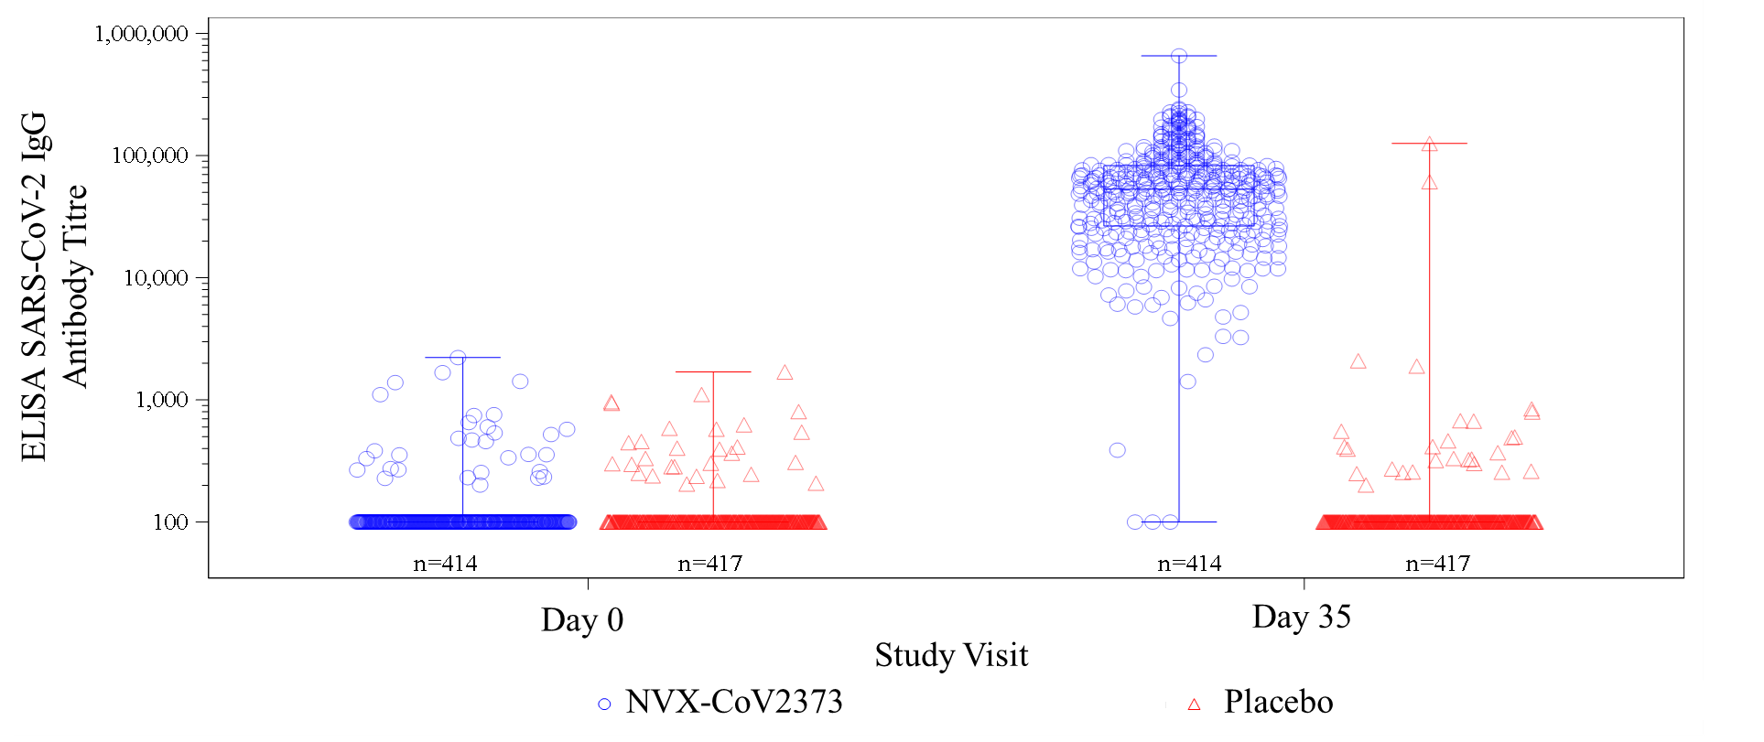
LLOQ=200 EU/mL, with titre values less than LLOQ were replaced by 0.5×LLOQ.
Abbreviations: anti-S=anti-spike (protein); ELISA=enzyme-linked immunosorbent assay; IgG=immunoglobulin G; LLOQ=lower limit of quantification; PP-IMM=per-protocol immunogenicity; SARS-CoV-2=severe acute respiratory syndrome coronavirus 2.

Figure S2. Box plot of titre for serum anti-S IgG levels at Day 0 and Day 35 in serologically negative adult participants 18–64 years of age (PP-IMM anti-S serology subset)
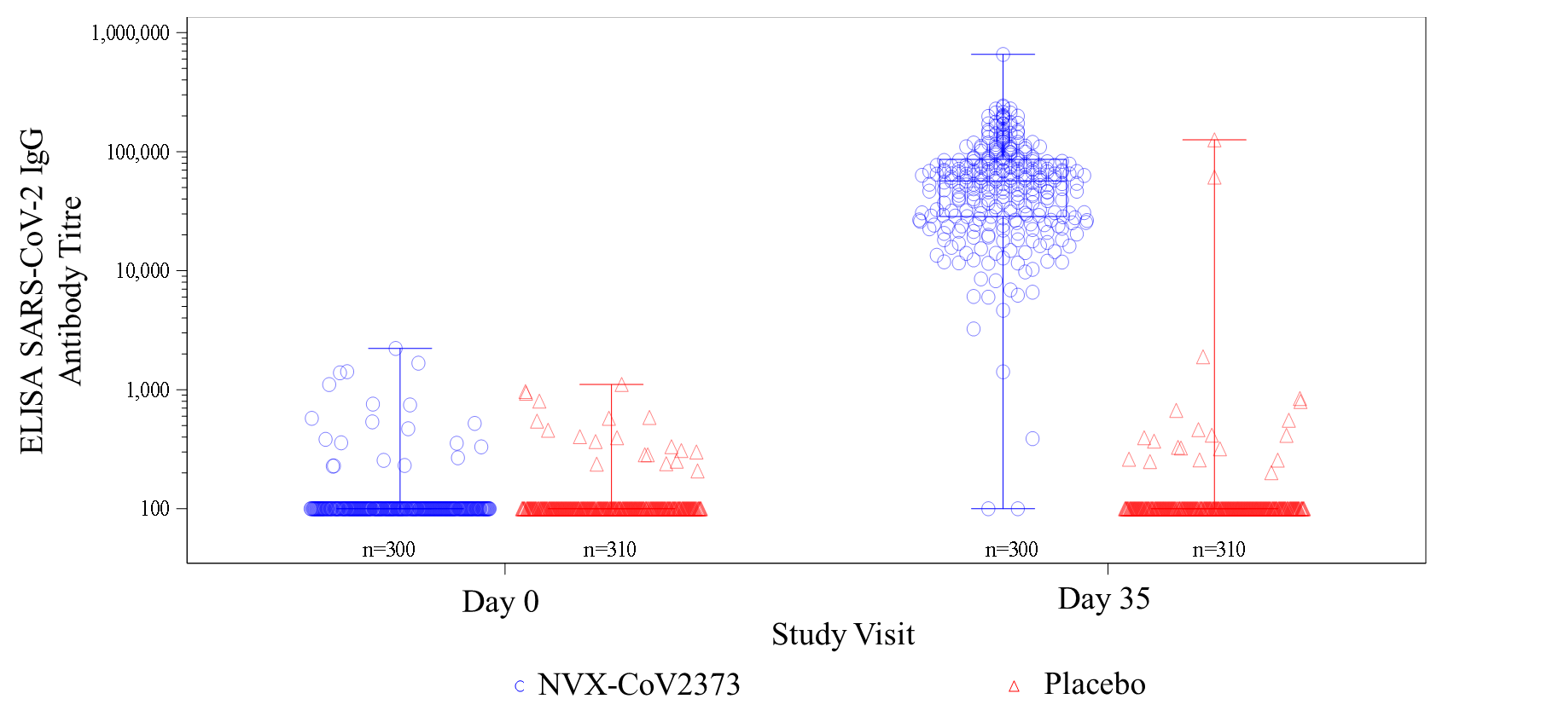
LLOQ=200 EU/mL, with titre values less than LLOQ were replaced by 0.5×LLOQ.
Abbreviations: anti-S=anti-spike (protein); ELISA=enzyme-linked immunosorbent assay; IgG=immunoglobulin G; LLOQ=lower limit of quantification; PP-IMM=per-protocol immunogenicity; SARS-CoV-2=severe acute respiratory syndrome coronavirus 2.

Figure S3. Box plot of titre for serum anti-S IgG levels at Day 0 and Day 35 in serologically negative adult participants 65–84 years of age (PP-IMM anti-S serology subset)
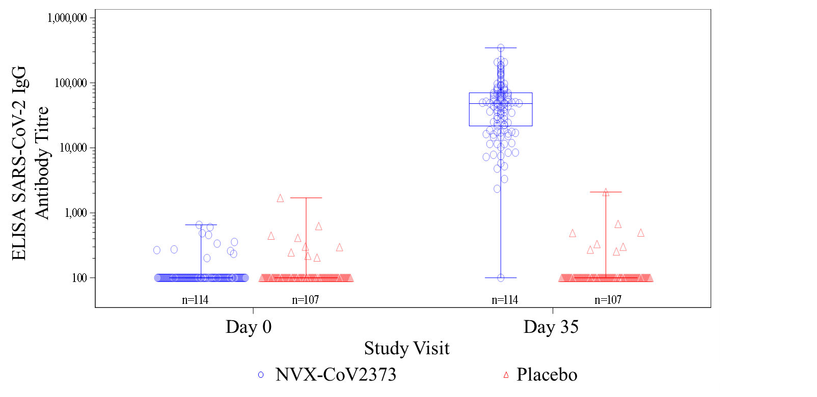
LLOQ=200 EU/mL, with titre values less than LLOQ were replaced by 0.5×LLOQ.
Abbreviations: anti-S=anti-spike (protein); ELISA=enzyme-linked immunosorbent assay; IgG=immunoglobulin G; LLOQ=lower limit of quantification; PP-IMM=per-protocol immunogenicity; SARS-CoV-2=severe acute respiratory syndrome coronavirus 2.

Figure S4. Box plot of titre for serum anti-S IgG levels at Day 0 and Day 35 in serologically positive adult participants (ITT anti-S serology subset)
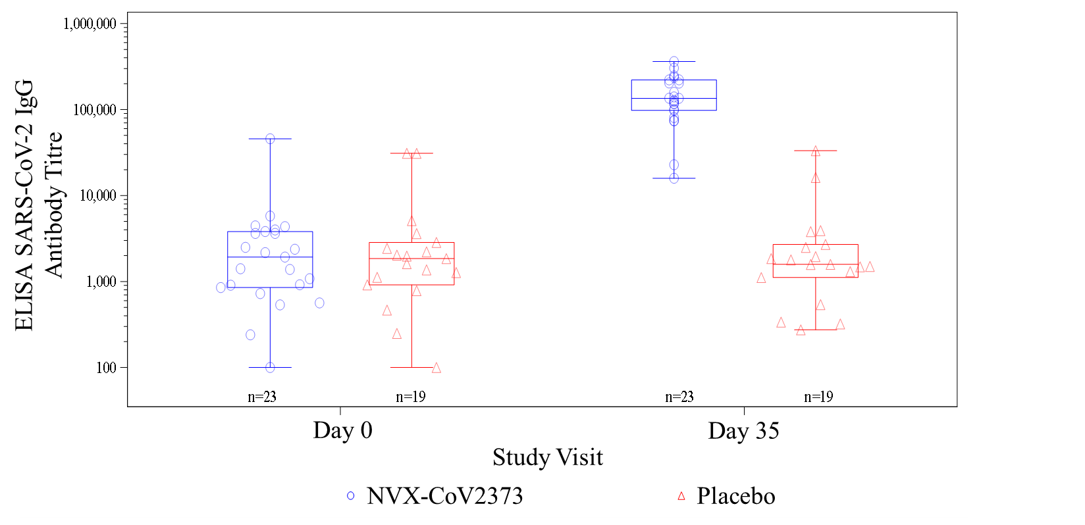
LLOQ=200 EU/mL, with titre values less than LLOQ were replaced by 0.5×LLOQ.
Abbreviations: anti-S=anti-spike (protein); ELISA=enzyme-linked immunosorbent assay; IgG=immunoglobulin G; ITT=intent-to-treat; LLOQ=lower limit of quantification; SARS-CoV-2=severe acute respiratory syndrome coronavirus 2.

Figure S5. Box plot of titre for neutralizing antibody levels at Day 0 and Day 35 in serologically negative adult participants 18–84 years of age (PP-IMM neutralisation assay subset)
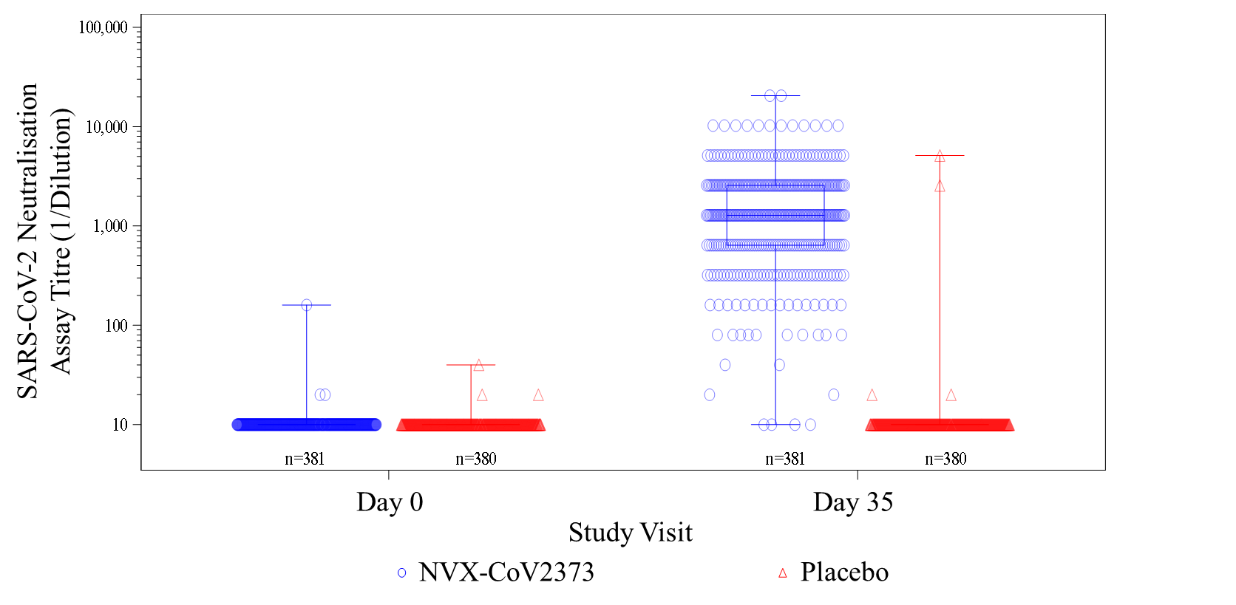
LLOQ=titre of 20, with titre values less than LLOQ were replaced by 0.5×LLOQ.
Abbreviations: LLOQ=lower limit of quantification; PP-IMM=per-protocol immunogenicity; SARS-CoV-2=severe acute respiratory syndrome coronavirus 2.

Figure S6. Box plot of titre for neutralizing antibody levels at Day 0 and Day 35 in serologically negative adult participants 18–64 years of age (PP-IMM neutralisation assay subset)
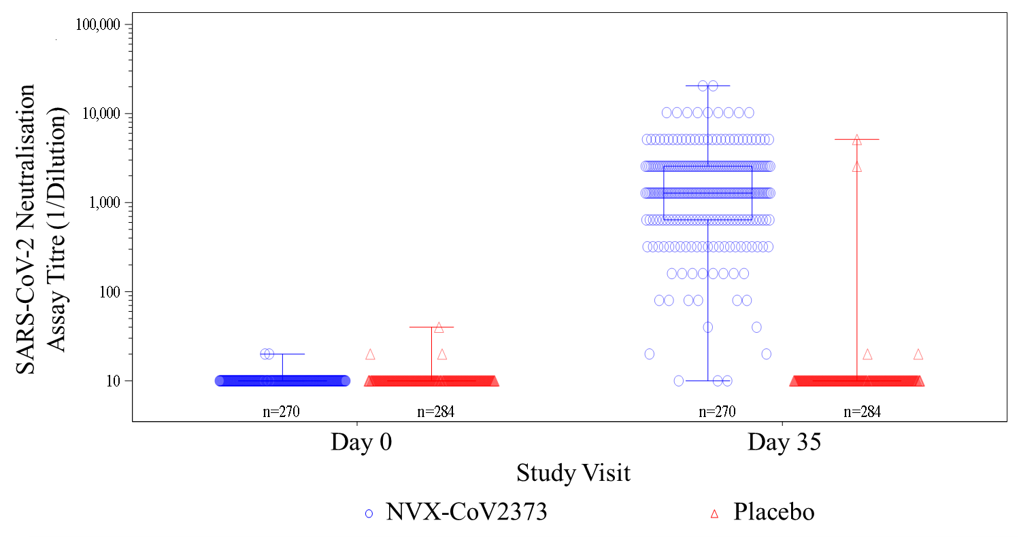
LLOQ=titre of 20, with titre values less than LLOQ were replaced by 0.5×LLOQ.
Abbreviations: LLOQ=lower limit of quantification; PP-IMM=per-protocol immunogenicity; SARS-CoV-2=severe acute respiratory syndrome coronavirus 2.

Figure S7. Box plot of titre for neutralizing antibody levels at Day 0 and Day 35 in serologically negative adult participants 65–84 years of age (PP-IMM neutralisation assay subset)
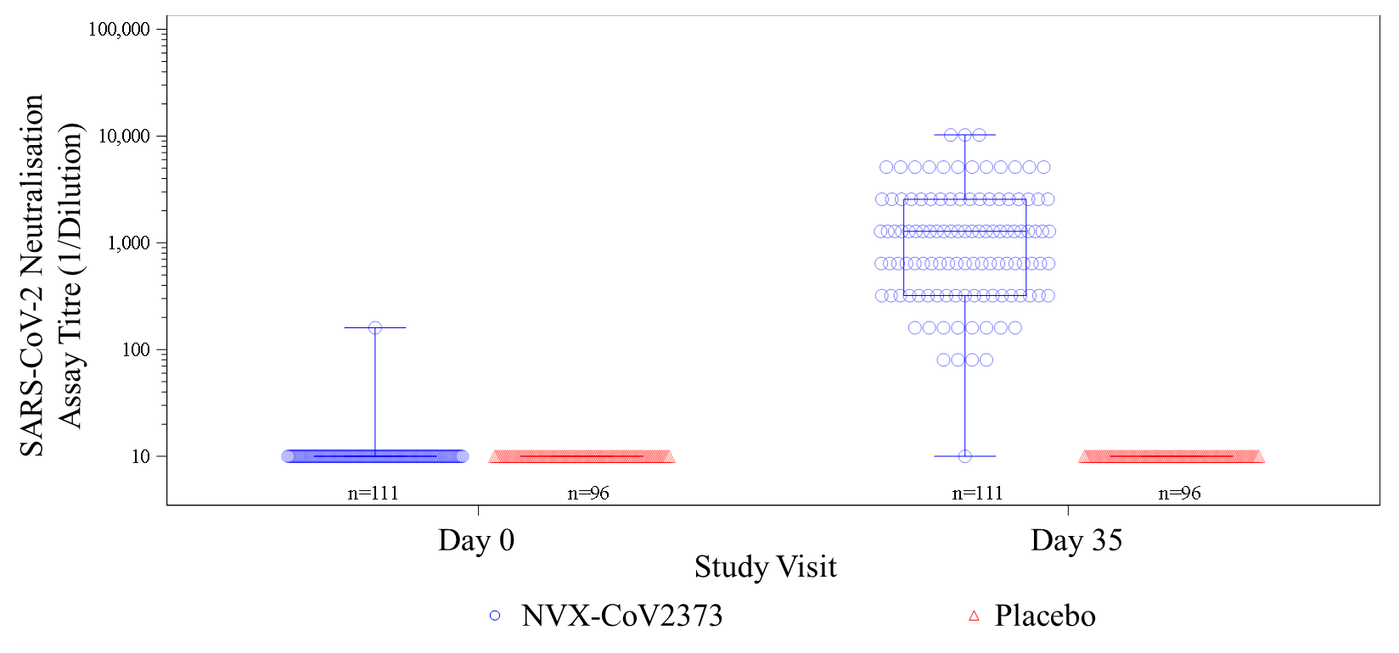
LLOQ=titre of 20, with titre values less than LLOQ were replaced by 0.5×LLOQ.
Abbreviations: LLOQ=lower limit of quantification; PP-IMM=per-protocol immunogenicity; SARS-CoV-2=severe acute respiratory syndrome coronavirus 2.

Figure S8. Box plot of titre for neutralizing antibody levels at Day 0 and Day 35 in adult participants 18–84 years of age regardless of baseline serostatus (ITT neutralisation assay subset)
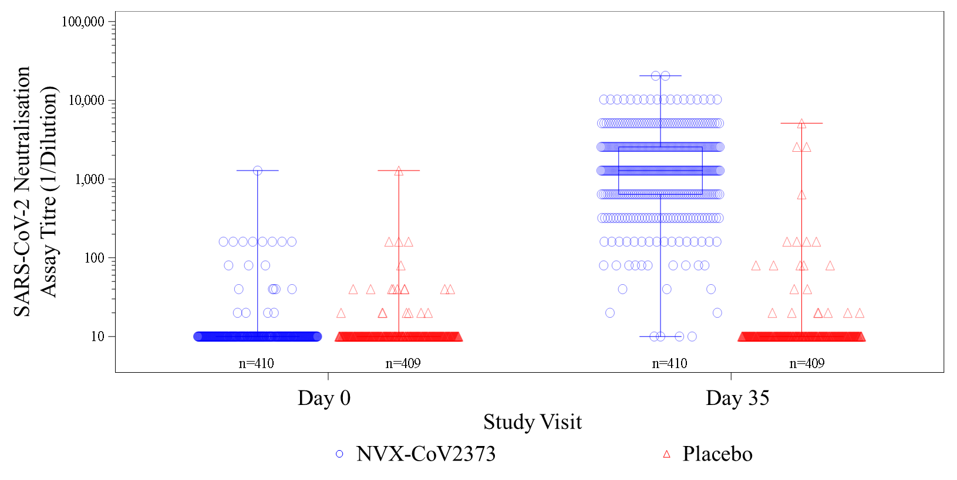
LLOQ=titre of 20, with titre values less than LLOQ were replaced by 0.5×LLOQ.
Abbreviations: ITT=intent-to-treat; LLOQ=lower limit of quantification; SARS-CoV-2=severe acute respiratory syndrome coronavirus 2.

Figure S9. Box plot of titre for neutralizing antibody levels at Day 0 and Day 35 in adult participants 18–64 years of age regardless of baseline serostatus (ITT neutralisation assay subset)
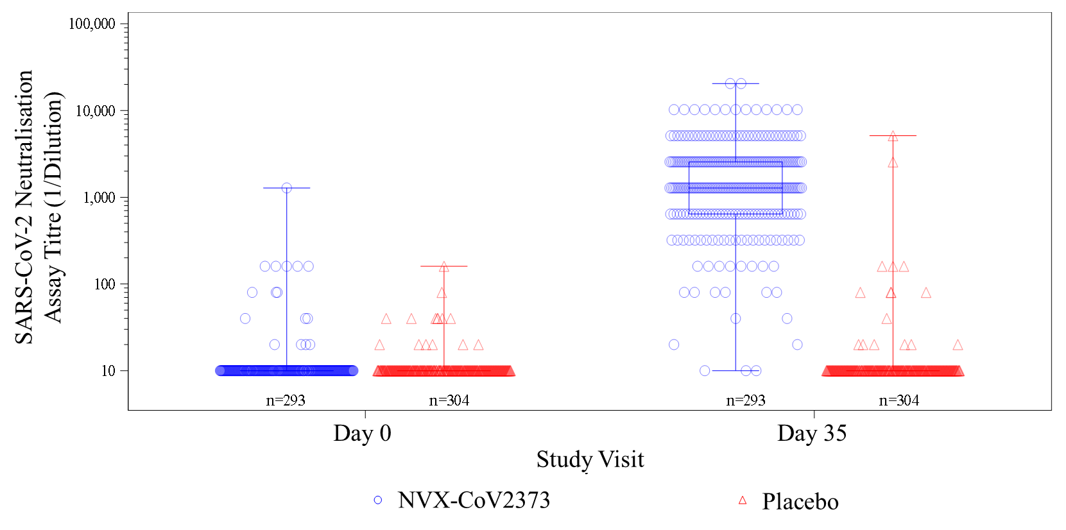
LLOQ=titre of 20, with titre values less than LLOQ were replaced by 0.5×LLOQ.
Abbreviations: ITT=intent-to-treat; LLOQ=lower limit of quantification; SARS-CoV-2=severe acute respiratory syndrome coronavirus 2.

Figure S10. Box plot of titre for neutralizing antibody levels at Day 0 and Day 35 in adult participants 65–84 years of age regardless of baseline serostatus (ITT neutralisation assay subset)
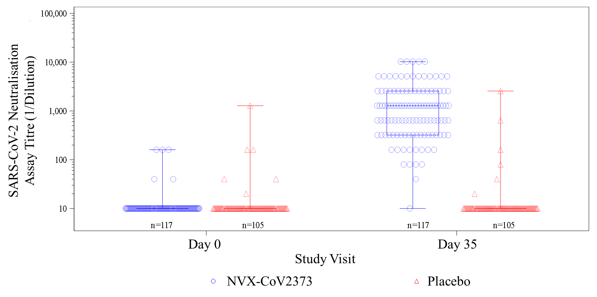
LLOQ=titre of 20, with titre values less than LLOQ were replaced by 0.5×LLOQ.
Abbreviations: ITT=intent-to-treat; LLOQ=lower limit of quantification; SARS-CoV-2=severe acute respiratory syndrome coronavirus 2.

Figure S11. Box plot of titre for neutralizing antibody levels at Day 0 and Day 35 in serologically positive adult participants (ITT neutralisation assay subset)
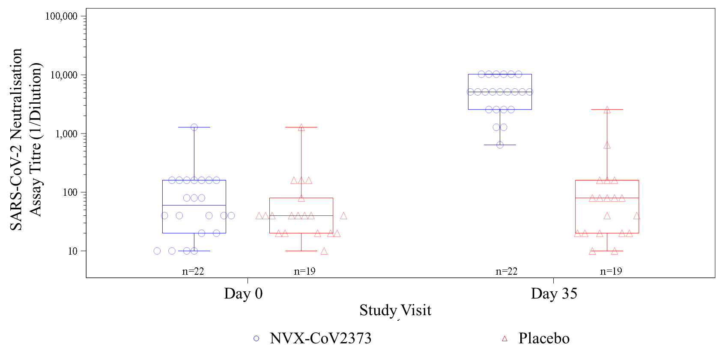
LLOQ=titre of 20, with titre values less than LLOQ were replaced by 0.5×LLOQ.
Abbreviations: ITT=intent-to-treat; LLOQ=lower limit of quantification; SARS-CoV-2=severe acute respiratory syndrome coronavirus 2.

Figure S12. Box plot demonstrating induction of T cells secreting IFN-γ in response to stimulation with overlapping peptide pools representing SARS-CoV-2 proteins after two doses of NVX-CoV2373, evaluated by ELISpot (per-protocol cellular assay subset)

Abbreviations: ELISpot=enzyme-linked immunosorbent spot; IFN-γ=interferon gamma; NVX-CoV2373=5 μg SARS-CoV-2 rS with 50 μg Matrix-M1 adjuvant;

