Supplement

eTable 1. Number of body mass index (BMI) values in children aged 6-15 years, born 1930-1996, from the Copenhagen School Health Records Register.
Number of child BMI values | Boys | Girls
2 | 8,856 | 7,851
3 | 11,087 | 10,172
4 | 12,086 | 10,982
5 | 12,303 | 11,008
6 | 15,531 | 11,770
7 | 49,249 | 32,427
8 | 43,566 | 37,949
9 | 28,699 | 47,968
10 | 8,563 | 15,351
11 | 2,933 | 4,096
12 | 1,687 | 2,044

eTable 2. Number of body mass index values at each age from ages 6 to 15 among individuals who were also examined in adulthood and included in the analytic study population.
Age (years) | Boys | Girls
6 - <7 | 3,036 | 3,258
7 - <8 | 6,558 | 6,754
8 - <9 | 6,393 | 6,930
9 - <10 | 6,423 | 7,053
10 - <11 | 6,673 | 7,390
11 - <12 | 6,526 | 7,263
12 - <13 | 6,258 | 7,220
13 - <14 | 6,381 | 7,188
14 - <15 | 2,706 | 4,363
15 - <16 | 40 | 1,845

eTable 3. Definition of type 2 diabetes from national health registers.
Period | National Health Registers | Codes | Additional requirement
1977-1995 | Danish National Patient Register | ICD-8: 250  ICD-10: E11 | ≥30 years at diagnosis
1996-2016 | Danish National Patient Register  National Prescription Register National Health Service Register (information on foot-therapy)  Danish Adult Diabetes Register (DADR)  Danish Eye-screening Database | ICD-10: E11  ATC: A10  Type 2 diabetes diagnosis in DADR  Foot therapy  Eye screening
2017 | Danish National Patient Register Danish National Prescription Register | ICD-10: E11  ATC code: A10 | ≥30 years at diagnosis; 2 prescriptions or more
Abbreviations: ATC=Anatomical Therapeutic Chemical, ICD=International Classification of Disease

eFigure 1. Flowchart of individuals included in the study from the Copenhagen School Health Records Register (CSHRR) and the Diet, Cancer and Health cohort (DCH).

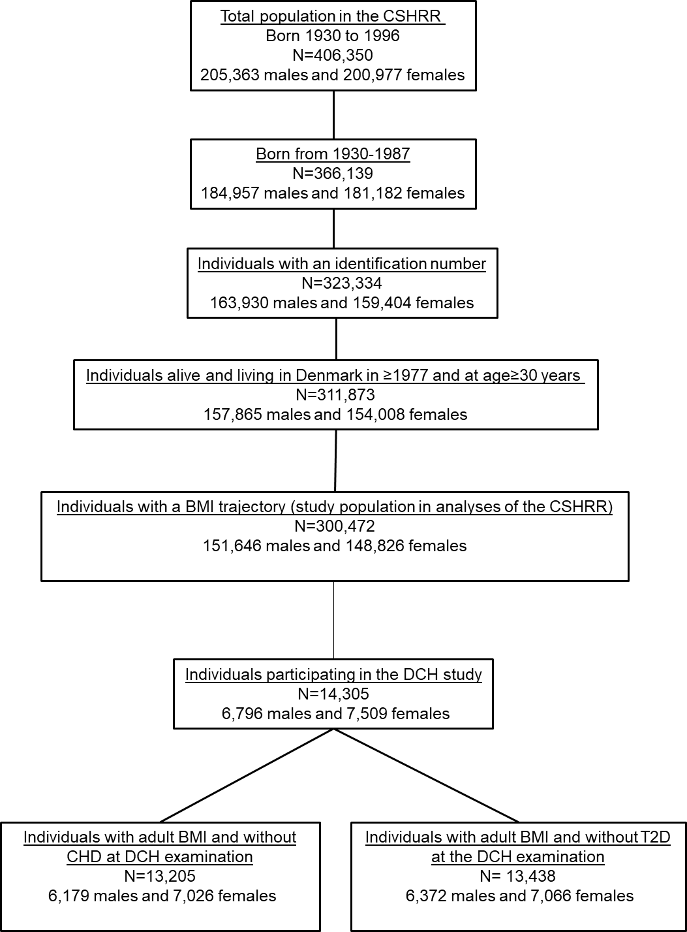

Abbreviations: BMI=body mass index, CHD=coronary heart disease, T2D=type 2 diabetes

eTable 4. Characteristics of the men and women in the analytic study population (n=13,438).
Characteristic | Men | Women
N | 6372 | 7066
Birth year (median, absolute mean difference) | 1940 (5) | 1939 (5)
BMI trajectory, N (%)*
1 | 1,449 (22.7%) | 1,350 (19.1%)
2 | 2,865 (45.0%) | 3,075 (43.5%)
3 | 1,634 (25.6%) | 2,018 (28.6%)
4 | 391 (6.1%) | 537 (7.6%)
5 | 33 (0.5%) | 86 (1.2%)
Age at the adult examination, year, median (absolute mean difference) † | 56 (5) | 56 (5)
Adult BMI, kg/m², mean (SD) † | 26.7 (3.7) | 25.8 (4.4)
Educated beyond basic school, N (%)^{b} | 5,736 (90.0%) | 5,856 (82.9%)
Alcohol drinks per week, median (absolute mean difference) † | 10 (13) | 4 (7)
Never smoked, N (%)† | 1614 (25.3%) | 3113 (44.0%)
Physical activity in MET-hours per week, median (absolute mean difference) † | 64 (53) | 64 (49)
*Childhood characteristics obtained from the Copenhagen School Health Records Register
†Adult characteristics obtained from the Danish Diet, Cancer and Health cohort
Abbreviations: BMI=Body mass index, SD=Standard deviation, MET=metabolic equivalent of task

eTable 5. Characteristics of the analytic study population by child body mass index (BMI) trajectory classes (n=13,438).
Characteristic | All individuals | Child BMI trajectory
 |  | 1 | 2 | 3 | 4 | 5
N (%) | 13,438 | 2799 (20.8%) | 5940 (44.2%) | 3652 (27.2%) | 928 (7.0%) | 119 (0.8%)
Men, N (%) | 6372 (47.4%) | 1449 (51.8%) | 2865 (48.2%) | 1634 (44.7%) | 391 (42.1%) | 33 (27.7%)
Birth year, median (absolute mean difference) | 1940 (5) | 1940 (5) | 1940 (5) | 1940 (5) | 1940 (4) | 1940 (5)
Years of age at adult examination, median (absolute mean difference) | 56 (5) | 56 (5) | 56 (5) | 56 (5) | 56 (4) | 56 (5)
Adult BMI (mean, SD)* | 26.2 (4.1) | 24.3 (3.2) | 25.8 (3.6) | 27.4 (4.2) | 29.2 (4.7) | 32.5 (6.4)
Educated beyond basic school, N (%)* | 11,592 (86.3%) | 2437 (87.1%) | 5124 (86.3%) | 3130 (85.7%) | 804 (86.6%) | 97 (81.5%)
Alcohol drinks per week, no., median (absolute mean difference)* | 7 (11) | 7 (11) | 7 (11) | 7 (10) | 7 (11) | 7 (7)
Never smoked, N (%)* | 4727 (35.2%) | 1104 (39.4%) | 2123 (35.7%) | 1195 (32.7%) | 272 (29.3%) | 33 (27.7%)
Physical activity in MET-hours per week, median (absolute mean difference)* | 64 (51) | 64 (51) | 64 (51) | 64 (51) | 64 (48) | 65 (60)
*Adult characteristics obtained from the Danish Diet, Cancer and Health cohort
Abbreviations: BMI=Body mass index, SD=Standard deviation, MET=metabolic equivalent of task

eTable 6. Proportions of individuals in the analytic study population in different adult body mass index (BMI) categories by child BMI trajectory classes (n=13,438).
Child BMI trajectory class | Adult BMI (kg/m²)
 | <25 | 25 - <30 | ≥30
1 | 63.3% | 31.4% | 5.2%
2 | 43.4% | 44.9% | 11.7%
3 | 29.7% | 47.6% | 22.8%
4 | 18.6% | 42.7% | 38.6%
5 | 11.8% | 24.4% | 63.9%

eFigure 2. Modification of the associations between child body mass index (BMI) trajectories and type 2 diabetes by adult BMI in men. Trajectory 1 is the reference. The shaded regions illustrate the 95% confidence intervals.*
Trajectory 2 Trajectory 3
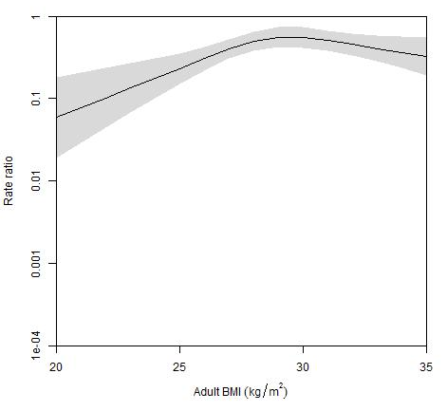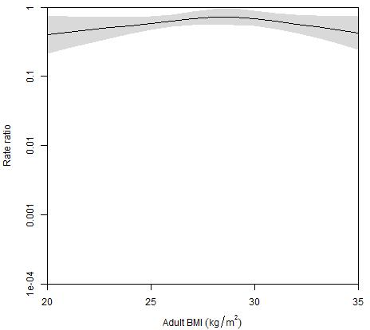
Trajectory 4 Trajectory 5
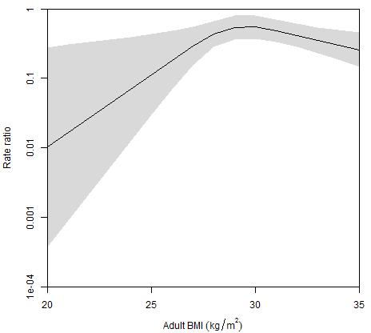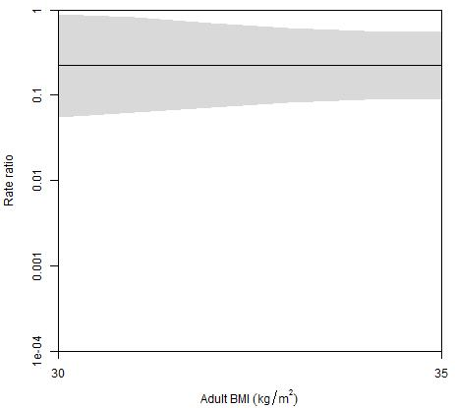

*The lowest point on the x-axis in the plot of association for trajectory 5 is set to 30 kg/m² since few men in trajectory 5 had lower BMI values.

eTable 7. Sensitivity analysis of associations between BMI trajectory and T2D and CHD with follow-up started at age 56 years among individuals born from 1930-1946 in the CSHRR irrespective of having adult information available (92,098 men and 97,862 women in analyses of CHD, and 92,926 men and 97,862 women in analyses of T2D).
 |  | Outcome
 |  | T2D |  | CHD
Sex | BMI trajectory | Number of cases* | Model 1: follow-up starting at 56 years of age†, ‡ | Number of cases* | Model 1: follow-up starting at 56 years of age†, ‡
Men | 1 | 2631 | Ref. | 3403 | Ref.
 | 2 | 5260 | 1.02 (0.97-1.08) | 7025 | 1.04 (1.00-1.09)
 | 3 | 3069 | 1.10 (1.04-1.16) | 4125 | 1.15 (1.10-1.20)
 | 4 | 995 | 1.54 (1.43-1.66) | 979 | 1.17 (1.09-1.26)
 | 5 | 142 | 1.90 (1.60-2.25) | 134 | 1.44 (1.21-1.72)
Women | 1 | 1584 | Ref. | 189 | Ref.
 | 2 | 3252 | 0.97 (0.91-1.04) | 4171 | 1.00 (0.95-1.06)
 | 3 | 2495 | 1.18 (1.11-1.27) | 2884 | 1.10 (1.04-1.17)
 | 4 | 1065 | 1.67 (1.54-1.81) | 1005 | 1.26 (1.16-1.36)
 | 5 | 232 | 2.50 (2.17-2.88) | 181 | 1.48 (1.27-1.73)
* Number of cases are counted by assigning individuals to the trajectory where they have the highest posterior probability
†Adjusted for birth year and age
‡ The median age at the DCH examination

eTable 8. Characteristics of individuals in the CSHRR included in the comparative analyses (n=300,472).
Characteristic | Boys | Girls
N | 151,646 | 148,826
Birth year (median, absolute mean difference) | 1949 (17) | 1949 (17)
BMI trajectory, N (%)*
1 | 34,988 (23.1%) | 31,073 (20.9%)
2 | 64,602 (42.6%) | 59,323 (39.9%)
3 | 37,744 (24.9%) | 39,875 (26.8%)
4 | 11,867 (7.8%) | 15,086 (10.1%)
5 | 2,445 (1.6%) | 3,469 (2.3%)
* Numbers are counted by assigning individuals to the trajectory where they have the highest posterior probability

eTable 9. Comparative analyses of associations between child body mass index (BMI) trajectories in 151,646 men and 148,826 women and type 2 diabetes and coronary heart disease, respectively, relative to trajectory 1. Estimates are incidence rate ratios with 95% confidence intervals.
 |  |  | All CSHRR individuals with a child BMI trajectory available
Outcome | Sex | Child BMI trajectory | Number of cases* | Model 1: no adjustment for adult BMI †
T2D | Men | 1 | 3692 | Ref.
 |  | 2 | 7393 | 1.05 (1.01-1.10)
 |  | 3 | 4908 | 1.27 (1.21-1.32)
 |  | 4 | 1991 | 2.06 (1.94-2.18)
 |  | 5 | 453 | 3.39 (3.07-3.74)
 | Women | 1 | 2065 | Ref.
 |  | 2 | 4403 | 1.06 (1.00-1.12)
 |  | 3 | 3675 | 1.39 (1.32-1.48)
 |  | 4 | 1902 | 2.23 (2.09-2.38)
 |  | 5 | 618 | 4.35 (3.97-4.77)
CHD | Men | 1 | 5125 | Ref.
 |  | 2 | 10671 | 1.08 (1.04-1.12)
 |  | 3 | 6467 | 1.20 (1.16-1.25)
 |  | 4 | 1823 | 1.36 (1.29-1.44)
 |  | 5 | 309 | 1.78 (1.58-2.00)
 | Women | 1 | 2603 | Ref.
 |  | 2 | 5517 | 1.00 (0.95-1.05)
 |  | 3 | 3909 | 1.12 (1.06-1.18)
 |  | 4 | 1420 | 1.26 (1.18-1.35)
 |  | 5 | 277 | 1.48 (1.31-1.68)
Abbreviations: T2D=type 2 diabetes; CHD=coronary heart disease
* Number of cases are counted by assigning individuals to the trajectory where they have the highest posterior probability.
†In analyses of all individuals in the CSHRR, since diabetes or CHD diagnosed before age 30 years may often be due to type 1 diabetes or congenital heart disease, respectively, we excluded these individuals as their childhood BMIs may have been affected by these diseases (517 men and 490 women with diabetes before age 30 years and 98 men and 42 women with CHD before age 30 years were excluded).

eFigure 3. Associations between childhood body mass index (BMI) trajectories and type 2 diabetes by age at risk using trajectory 1 as the reference.*

Men Women
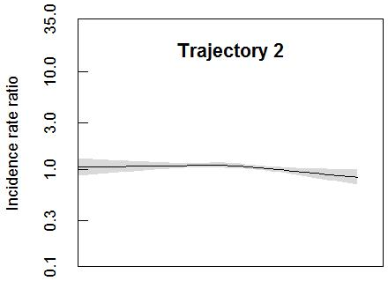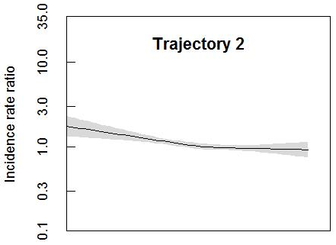
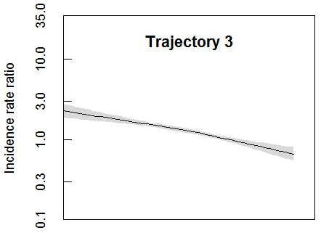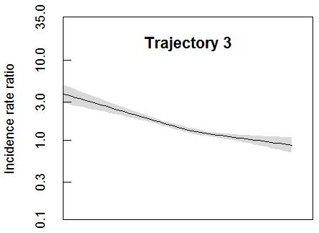
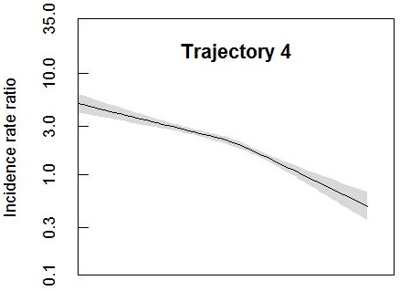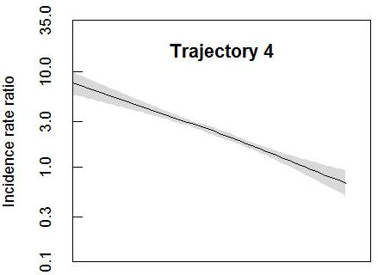
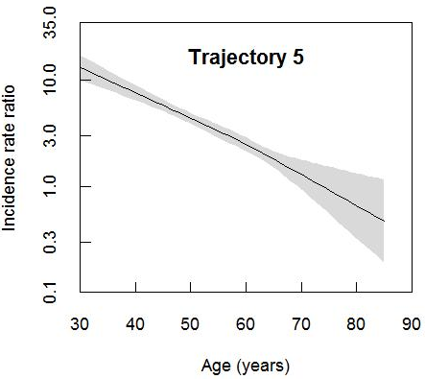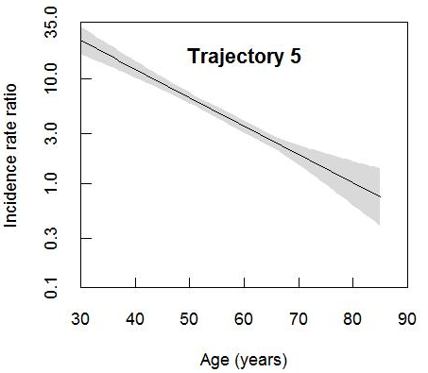

*All plots are based on models including birth year, age, the child BMI trajectories, and interaction terms between all trajectories and age. The shaded regions illustrate the 95% confidence intervals.

eFigure 4. Associations between childhood body mass index (BMI) trajectory and coronary heart disease by age using trajectory 1 is the reference.*

Men Women
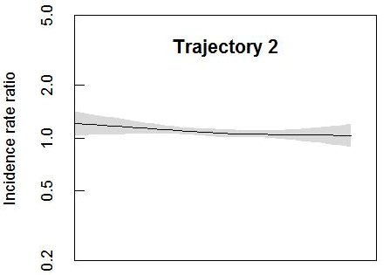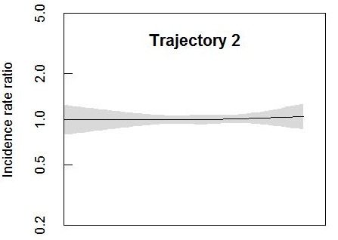
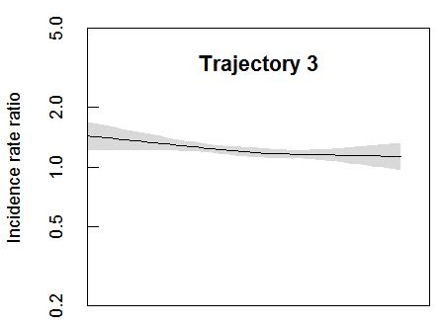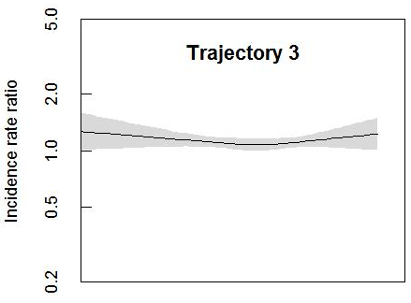
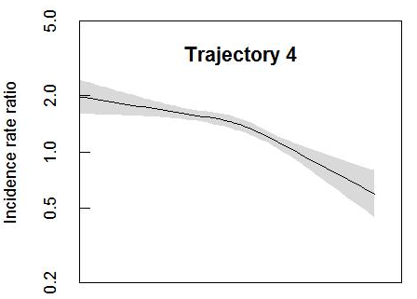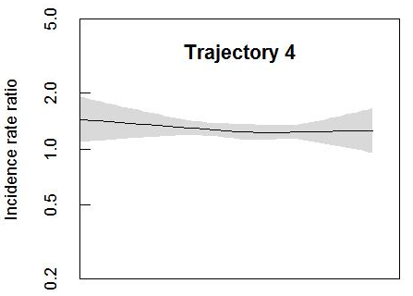
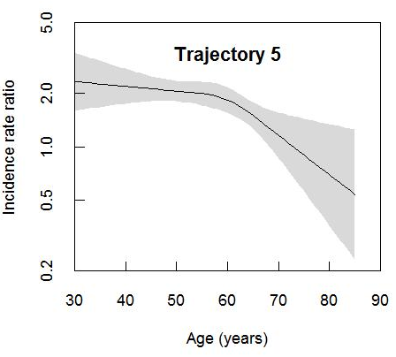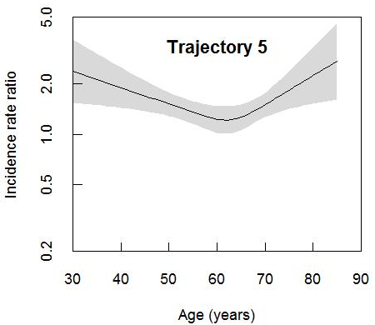

*All plots are based on models including birth year, age, the child BMI trajectories, and interaction terms between all trajectories and age. The shaded regions illustrate the 95% confidence intervals

