Body mass index trajectories in childhood and incidence rates of type 2 diabetes and coronary heart disease in adulthood: a cohort study

Kim Blond PhD ¹, Dorte Vistisen PhD ^{2,3}, Julie Aarestrup PhD ¹, Lise G. Bjerregaard PhD ¹, Mohammed T. Hudda PhD⁴, Anne Tjønneland MD ^{3,5}, Kristine H. Allin MD ⁶, Marit E. Jørgensen MD^{2,7,8}, Britt W. Jensen PhD ¹, Jennifer L. Baker PhD ¹

¹Center for Clinical Research and Prevention, Copenhagen University Hospital – Bispebjerg and Frederiksberg, Copenhagen, Denmark.
²Clinical Epidemiological Research, Steno Diabetes Center Copenhagen, Herlev, Denmark
³Department of Public Health, University of Copenhagen, Copenhagen, Denmark.
⁴Population Health Research Institute, St George's, University of London, Cranmer Terrace, London, United Kingdom.
⁵The Danish Cancer Society Research Center, Copenhagen, Denmark
⁶Center for Molecular Prediction of Inflammatory Bowel Disease (PREDICT), Department of Clinical Medicine, Aalborg University, Copenhagen, Denmark.
⁷Steno Diabetes Center Greenland, Nuuk, Greenland
⁸National Institute of Public Health, University of Southern Denmark, Odense, Denmark.

Corresponding author:
Jennifer L. Baker, Center for Clinical Research and Prevention, Frederiksberg Hospital, Nordre Fasanvej 57, 2000 Frederiksberg, Denmark
Phone: +45 3816 3058, Fax +45 3816 3119, E-mail: Jennifer.Lyn.Baker@regionh.dk

Running title: Childhood BMI trajectories and adult cardiometabolic disease
Abstract
Aims: We examined associations between five body mass index (BMI) trajectories from ages 6-15 years and register-based adult-onset type 2 diabetes mellitus (T2D) and coronary heart disease (CHD) with and without adjustment for adult BMI.
Methods: Child and adult BMI came from two Danish cohorts and 13,205 and 13,438 individuals were included in T2D and CHD analyses, respectively. Trajectories were estimated by latent class modelling. Incidence rate ratios (IRRs) were estimated with Poisson regression.
Results: In models without adult BMI, compared to the lowest trajectory, among men the T2D IRRs were 0.92 (95%CI:0.77-1.09) for the second lowest trajectory and 1.51 (95%CI:0.71-3.20) for the highest trajectory. The corresponding IRRs in women were 0.92 (95%CI:0.74-1.16) and 3.58 (95%CI:2.30-5.57). In models including adult BMI, compared to the lowest trajectory, T2D IRRs in men were 0.57 (95%CI:0.47-0.68) for the second lowest trajectory and 0.26 (95%CI:0.12-0.56) for the highest trajectory. The corresponding IRRs in women were 0.60 (95%CI:0.48-0.75) and 0.59 (95%CI:0.36-0.96). The associations were similar in direction, but not statistically significant, for CHD.
Conclusions: Incidence rates of adult-onset T2D were greater for a high child BMI trajectory than a low child BMI trajectory, but not in models that included adult BMI.
Key words: Body mass index, Cardiovascular diseases, Diabetes Mellitus, Type 2
Introduction
Globally, body mass index (BMI) is increasing in both children and adults¹ and poses a major health challenge due to the associated excess morbidity and mortality. Both early life and adult life body size are positively associated with the incidence of type 2 diabetes mellitus (T2D) and coronary heart disease (CHD).²⁻⁶ The findings from early life, however, have largely been based upon BMI values at single childhood ages rather than the development across a longer period of time as captured by a BMI trajectory. Furthermore, obtaining a healthy adult BMI could potentially mitigate the cardiometabolic risks associated with a high child BMI.
Although several studies examined this for T2D and cardiovascular disease, they typically used single BMI values in childhood and categorical adult BMI values (e.g. normal-weight and overweight).⁷ As a result, they did not examine what happens if individuals who had different patterns of BMI development during childhood obtained the same adult BMI. Thus, it is conceivable that tracking from childhood to adulthood could explain their findings. When conditioning on obtaining the same adult BMI (e.g. including adult BMI as a continuous variable in the model), one study found a positive association between late adolescence BMI and rates of CHD, but not T2D.⁸ Other studies of T2D or CHD may have conditioned on obtaining the same adult BMI, but the studies were not explicit about it.⁹⁻¹¹ Furthermore, only one of these previous studies examined trajectories of childhood and adolescence BMI, and it found an increased T2D risk for trajectories of obesity despite adjustment for adult BMI.¹¹ In addition to the sparse examination of child BMI trajectories in relation to T2D and CHD in studies incorporating adult BMI, it is a limitation that none of these studies required that the assessment of adult BMI preceded the assessment of the outcome.
Thus, evidence is sparse about whether associations between child BMI trajectories and T2D or CHD exist if individuals with different patterns of child BMI development obtain the same adult BMI. Therefore, we examined whether BMI trajectories from 6-15 years of age are associated with incidence rates of T2D and CHD, respectively, with and without including adult BMI.
Subjects, Materials and Methods
Information from two Danish cohorts and national Danish health registers was used. The cohorts were the Copenhagen School Health Records Register (CSHRR) and the Diet, Cancer and Health cohort (DCH). Information on measured childhood weights and heights between 6 and 15 years of age came from the CSHRR, which contains computerized information on 406,350 Copenhagen school children (205,372 boys and 200,978 girls) born 1930-1996.¹² Up to 12 measurements of childhood height and weight were entered in the CSHRR for each child, with the restriction that the measurements needed to be at least three months apart. A median of six BMI values were available per child. The distribution of the number of child BMI values in the CSHRR is provided in eTable 1.
In the DCH, 57,054 individuals (27,179 men and 29,875 women) participated between 1993 and 1997 at ages 50-65 years.¹³ The participants had to be without a diagnosis of cancer and living in the greater Aarhus or Copenhagen area. Nearly all eligible individuals were invited, but those who participated were more likely to have a higher socio-economic position than those who chose not to participate.¹³ We used information on measured adult weights and heights, educational level (basic school, vocational training, 1-2 years of higher education, 3-4 years of higher education, < 4 years of higher education), physical activity (hours of metabolic equivalents of task), alcohol (drinks per week) and smoking (grams per day) from the DCH cohort. The original categories of education were collapsed as follows: basic (basic school or vocational training), middle length education (1-2 years or 3-4 years of higher education), and long education (>4 years of higher education). In eTable 2, we provide the number of BMI values at ages 6 to 15 among those who participated in the CSHRR and the DCH. Among these individuals, the average age span from their earliest to their latest BMI assessment in childhood (in the CSHRR) was 6.4 years in boys and 6.8 years in girls.
Child BMI trajectories were modelled separately for each sex using latent class trajectory modelling (LCTM). Posterior probabilities of belonging to each trajectory were calculated. We tested LCTMs with one to eight trajectories in children with a minimum of two BMI values. A latent class trajectory model of five trajectories without random effects was selected via assessment of fit indices and plots of the estimated versus the observed BMIs. The LCTM was based on a restricted cubic spline of age with knot points at the 25th, 50th and 75th percentiles of the distribution and adjusted for birth cohort (5-year categories). As such, the BMI levels of the trajectories depended on birth year, but there were only minor differences (not shown). Figure 1 shows the estimated mean trajectories for individuals born 1940-1944 and these years closely correspond to years that were eligible for inclusion into the DCH cohort.
Information on T2D was obtained from several national health registers (eTable 3). From 1977-1995, only information from the Danish National Patient Register (DNPR, established in 1977) was available allowing identification of individuals with T2D admitted to a hospital.¹⁴ From 1995-2016 we used an algorithm developed by the Steno Diabetes Center Copenhagen to additionally detect individuals with T2D not admitted to a hospital.¹⁵ In 2017 we used information from the DNPR and the Danish National Prescription Registry as we did not have data from all the registers used in the previously mentioned algorithm.¹⁶ Information on CHD came from the DNPR and the Danish Register of Causes of Death.¹⁷ We used the International Classification of Diseases, Eighth Revision (ICD-8) before 1994 and the Tenth Revision (ICD-10) thereafter. CHD was defined by ICD-8 codes 410.0-414.9 and ICD-10 codes I20.0-I25.9. Vital status and the date of emigration or death were obtained by linkage to the Danish Civil Registration System.
For the main analyses, we required individuals to have at least two available child BMI values, a personal identification number and to be in the DCH study. In the analyses of T2D, we included 6,372 men and 7,066 women who were free of T2D at DCH study entry (we excluded 164 men and 98 women who had T2D prior to DCH study entry) and who had information on adult BMI and other covariates. When analysing CHD, we included 6,179 men and 7,026 women who were free of CHD at DCH study entry (we excluded 366 men and 140 women who had CHD prior to DCH study entry) and who had information on adult BMI and other covariates.
In analyses with and without adult BMI, follow-up started from the age at the DCH examination (median of 56 years). To examine potential selection into the DCH cohort, we additionally conducted analyses starting follow-up at age 56 in the overall CSHRR not conditioning on participating in the DCH and excluding individuals with T2D or CHD, respectively, before age 56. For comparative purposes we also examined these associations in the overall CSHRR where we followed individuals from 30 years of age and after 1 January 1977. Follow-up ended on the date of T2D or CHD, respectively, death, emigration or loss to follow-up or 31 December 2017, whichever came first. A flowchart of individuals included in the main analyses and the other analyses is shown in eFigure 1.
Sex-specific Poisson regression was used to estimate incidence rate ratios for T2D and CHD, respectively. Log-person time was the offset variable. Follow-up time was split into 1-year age bands. The first model included the posterior probability of belonging to each of the child BMI trajectories as the exposure with age at risk (hereafter referred to as age) and year of birth as covariates in the model. The second model also included adult BMI. A third model additionally included level of education, adult smoking, alcohol intake and physical activity to address potential confounding when conditioning on adult BMI. Age, birth year and adult BMI were modelled using restricted cubic splines with knots at the 25th, 50th and 75th percentiles among individuals who had T2D or CHD to have an equal number of cases between the knots. Smoking consumption, alcohol consumption and physical activity were included as linear terms and education was included as a categorical variable. We tested for interactions between child BMI trajectories and birth year, adult BMI, and age, respectively, using likelihood ratio tests of nested models.
The Danish Data Protection Agency approved the data linkages performed in this study. According to Danish law, research based on registers such as the CSHRR does not require ethical approval or written consent. The research including the DCH was approved by the relevant Scientific Committees and the Danish Data Protection Agency. Informed consent was obtained from all individuals participating in the DCH.

Results
Among individuals in the CSHRR and with BMI and other covariates available in adulthood from the DCH, the median birth year was 1940 in men and 1939 in women. Among the five child BMI trajectories examined, trajectory one had the lowest mean BMI values and trajectory five had the highest mean BMI values across ages 6-15 years (Figure 1). Most boys and girls were in trajectory two and the fewest were in trajectory five (eTable 4). The median adult BMI was 26.7 kg/m² in men and 25.8 kg/m² in women (eTable 4). The most notable difference in the covariate distribution across the child BMI trajectories was that adult BMI increased as the BMI level of the childhood trajectory increased (eTables 5-6). Additionally, among individuals with the higher child BMI trajectories, more were women and fewer were never-smokers than among individuals in the lower child BMI trajectories, whereas other covariates showed little variation by child BMI trajectories (eTable5).
During a median of 21 years of follow-up after the adult examination, 1,693 T2D cases (57% men) and 2,535 CHD cases (60% men) were identified among the individuals who were both in the CSHRR and the DCH. In men, the analyses unadjusted for adult BMI showed that when compared with child BMI trajectory one, although trajectories four and five had higher IRRs for T2D, they were not statistically significant. In women, the associations unadjusted for adult BMI showed a different pattern. Compared to trajectory one, all other trajectories with a higher mean BMI level had higher incidence rates of T2D, and the IRRs were statistically significant for trajectories four and five (Table 1). For CHD, when compared with trajectory one, although the IRRs increased with increasing trajectories, they were not statistically significant in men or women (Table 1). In models which included adult BMI, compared with trajectory one, all other trajectories in men and women had lower rates of T2D, irrespective of the inclusion of additional adult factors (Table 1). The corresponding CHD estimates were close to 1 or below 1 with wide confidence intervals regardless of adjustment for additional adult factors (Table 1).
Among men, there was evidence of interactions between child BMI trajectories and adult BMI in the analyses of T2D (p=0.002 in men and p=0.2 in women), but not in analyses of CHD (p=0.2 men and p=0.9 in women). Compared with trajectory one, although the T2D rate ratio remained below 1.00 for all adult BMI values, it increased for men in trajectories two and four as adult BMI increased until a BMI of approximately 29 kg/m², whereafter it decreased (eFigure 2). We did not find evidence of interactions between child BMI trajectories and birth year in models where interactions between child BMI trajectories and age were included (in analyses of T2D, p=0.5 in men and p=0.5 in women, and in analyses of CHD, p=0.5 in men and p=0.6 in women).
To examine if there was potential selection into the DCH, analyses starting follow-up at age 56 (the median age at adult BMI assessment) without conditioning on participating in the DCH were conducted. In these analyses, trajectories three- to five, but not trajectory two, had higher rates of T2D and CHD than trajectory one (eTable 7). For comparative purposes, analyses including all individuals from the CSHRR were conducted (eTables 8 and 9). An interaction with age was found; as adult individuals grew older, the associations with T2D became weaker across all trajectories (eFigure 3). In analyses of CHD, the direction of the age interactions varied across the trajectories (eFigure 4).
Discussion
In both men and women, we found that having a child BMI trajectory with a higher BMI level was associated with higher incidence rates of adult-onset T2D compared to having a child BMI trajectory with the lowest BMI level. However, in adults with the same BMI level, having a high child BMI trajectory was associated with a lower incidence rate of T2D. We did not find statistically significant associations with CHD. Importantly, these results must be interpreted considering that conditioning on adult BMI implies that individuals in trajectory 1 have the largest BMI gain after childhood, and individuals in trajectory 5 have the smallest BMI gain after childhood.
The T2D results from analyses including adult BMI may partly be explained by this differential BMI gain after 15 years of age. Supporting this, a previous study of BMI trajectories from ages 9-25 years concluded that individuals who obtained overweight or obesity in late adolescence had worse cardiometabolic health profiles compared with individuals who had a high and stable BMI throughout childhood and adolescence.¹⁸ Furthermore, the T2D results in analyses including adult BMI may also be explained by BMI development from age 16 onwards as this may be more closely related to body fat development than the child BMI trajectories.¹⁹ Our findings indicate that a healthy BMI development after childhood may play a substantial role in the associations between child BMI trajectories and development of T2D. Our findings additionally illustrate that an individual’s BMI trajectory during childhood is particularly important for T2D development in early adulthood.
Our analyses extend our previous analyses of BMI at single ages in childhood and adulthood in relation to T2D^{21,22} by examining the modifiability of a longer duration of child BMI exposure as captured by our child BMI trajectories. The trajectories spanned an average of 6 years during childhood, however, if they extended for a longer period, the LCTM may have identified trajectories with more variation in their slopes. Few studies of T2D or CHD are comparable with our study in regard to examining child or adolescent BMI conditioned on obtaining the same adult BMI⁸ as several other studies did not explicitly state whether they used adult BMI as a continuous or as a categorical variable and many only examined categories of adult BMI. A recent systematic review found that compared to being in normal-weight categories in both childhood and adulthood, excess weight in childhood was associated with T2D development (odds ratio=1.37, 95% CI: 1.10–1.70) and potentially CVD (odds ratio=1.22, 95% CI: 0.92–1.62) even if obtaining an adult BMI within the normal weight category.⁷ Two studies that may have conditioned on obtaining the same adult BMI also examined childhood or adolescent BMI at single ages, and one of these studies found a T2D odds ratio per BMI z-score of 1.07 (95% CI: 0.95–1.19),²³ whereas the other study reported a CHD HR of 1.8 (95% CI: 0.9–3.9) for overweight compared to normal-weight.¹⁰
A study that explicitly conditioned on obtaining the same adult BMI was performed in male Israeli army personnel (37,674 men).⁸ This study examined a single late-adolescence assessment of BMI at a mean age of 17.4 years in relation to rates of T2D and CHD. In contrast to our findings, it found that a positive association between BMI and CHD rate persisted when adult BMI was accounted for.⁸ Potential explanations for this difference include how CHD was assessed; we used a register-based diagnosis whereas this study identified it through a routine clinical examination. Additionally, we required adult BMI to be measured before a CHD diagnosis, whereas the Israeli study included adult BMI as a time-dependent variable; it was assessed every 3-5 years from age 25 to age 45 years, which was also when CHD was assessed. In relation to T2D, the Israeli study found that compared to adolescents with a mean BMI of 17.3 kg/m², three other groups of adolescents with mean BMIs of 22.8, 24.2, and 27.6 kg/m² had higher rates of T2D. However, when adult BMI was included in the model, they no longer had higher rates of T2D. As such, both the Israeli and our study find that conditioning on obtaining the same adult BMI appears to have differential effects on associations between early life BMI and T2D versus CHD. In another study, higher T2D rates associated with very high late adolescent BMI levels in American Pima Indians (e.g. above 35 kg/m² at age 17 years) persisted even if these individuals obtained the same adult BMI (maximum BMI between ages 20 and 40) as the individuals in the reference trajectory.¹¹ The child BMI levels analysed in this study were well above the BMI levels in our study, which may explain why our study findings differed, whereby the associations with T2D reversed when accounting for adult BMI.
A strength of our study is that the individuals had a median of six BMI values in childhood and heights and weights were measured in both child- and adulthood. We used a methodology (LCTM) that incorporated all BMI values under a missing at random assumption thus allowing the use of all the BMI values instead of restricting to selected BMI values. Furthermore, we used the posterior probabilities of belonging to the trajectories in the analyses to account for uncertainty in the assignment of individuals to the trajectories instead of an all-or-nothing assignment to a trajectory. We used LCTM to reduce the influence of measurement error thereby allowing for the use of robust exposure variables.²⁴ With regards to reducing within-class variability²⁵ and to reduce potential conflict with the consistency assumption²⁶ when relating the trajectories to T2D and CHD, our choice of LCTM was informed by the evidence that adolescent BMI level is closely related to future risks of T2D and CHD.⁸ Therefore, in our choice of LCTM we prioritized good agreement between the BMI levels of the observed individual trajectories and the estimated mean trajectories used as exposure variables.
Additionally, we examined the role of adult BMI in the associations between child BMI trajectories and T2D and CHD incidence rates. As conditioning on obtaining the same adult BMI implies the largest BMI gain after age 15 for trajectory 1 and the smallest BMI gain after age 15 for trajectory 5, the interpretation must also consider that there may be a positive causal relation between child BMI and adult BMI. As such, adult BMI may mediate part of a potential effect of child BMI on the development of T2D and CHD. This potential mediation means that the estimates when conditioning on obtaining the same adult BMI do not reflect the total effect of child BMI on T2D or CHD. Our findings are also limited with regards to understanding a potential direct effect of child adiposity on T2D and CHD (i.e. the effect not mediated through adult adiposity). Examining a direct effect of child adiposity on T2D and CHD requires strong assumptions and potentially a better indicator of adiposity than BMI due to age-dependent associations between BMI and fat mass.¹⁹ Further, this question may be better addressed by using young adult adiposity as it would precede CHD and T2D, and thus a greater proportion of cases would be included in the analyses. Although we used an extensive T2D identification strategy, it differed across time and our T2D findings may be affected by a potential underdiagnosis of T2D.²⁷ The validity of a diagnosis of mortality from CHD can be questioned,²⁸ but a CHD diagnosis from the Danish National Patient Register has been found to have a sensitivity of 88-97%.²⁹
Although our inferences could be influenced by potential selection bias when conditioning on DCH participation, the associations in models without adult BMI included were reassuringly similar between the DCH sub-sample and the overall CSHRR when starting follow-up at 56 years of age. The differences in the associations between the overall CSHRR when starting follow-up at 30 versus 56 years of age likely arose because as individuals grow older, the associations between a childhood BMI trajectory and T2D and CHD led to a differential depletion of individuals susceptible to T2D and CHD across the trajectories. Specifically, those susceptible to T2D for other reasons than their BMI are more likely to remain in the risk set of the trajectory with the lowest BMI than in the risk set of the other trajectories at the age of the adult BMI assessment since the latter, to a greater degree, have been depleted of such individuals. Nonetheless, when we included adult BMI in the models, we had to start follow-up at ≥50-65 years (the age at the DCH examination) to examine incident T2D or CHD. We were unable to assess if differential patterns of BMI change between the CSHRR and the DCH examinations influenced the associations. Furthermore, we were unable to account for pubertal timing which is differentially associated with obesity in boys and girls.^{30,31}
In conclusion, we found that children with higher child BMI trajectories had higher incidence rates of T2D than children with a lower child BMI trajectory, but not after adjustment for adult BMI, i.e. not if they obtained the same adult BMI as the children with the lower child BMI trajectory. In adults with the same BMI level, having a high child BMI trajectory was associated with a lower incidence rate of T2D compared to the lowest BMI trajectory, whereas we did not find an association with CHD. As such, the role of a child’s BMI trajectory in the development of T2D depends on the BMI development after childhood.
Acknowledgements
The CSHRR was initiated and planned by Dr. Thorkild I.A. Sørensen and built by the Institute of Preventive Medicine, The Capital Region of Denmark.
The authors’ responsibilities were as follows – KB, DV, JA, MTH BWJ and JLB designed the research; KB conducted the analyses; KB, DV, MTH and JLB contributed to the specification of the analyses; JLB and AT provided databases; KB wrote the manuscript; all authors contributed to the interpretation of data; KB and JLB are the guarantors and had primary responsibility for the final content; all authors critically read and edited the manuscript; all authors approved the final manuscript.
Declaration of Helsinki: This study complies with the Declaration of Helsinki. The Danish Diet, Cancer and Health Study was approved by the relevant Scientific Committees and the Danish Data Protection Agency. Informed consent was obtained from all participants.
Author disclosures: KB, JA, LGB, MTH, JLB, AT, BWJ and KHA report no conflicts of interest. DV reports shares in Novo Nordisk A/S and has received research grants from Bayer A/S, Sanofi Aventis, Novo Nordisk A/S and Boehringer Ingelheim. MEJ has received research grants from Astra Zeneca, AMGEN, Sanofi Aventis, Novo Nordisk A/S and Boehringer Ingelheim.
Availability of data and material
We will make the data (in de-identified form and to the best of our abilities given legal regulations) used in the manuscript available upon request and pending approval from the steering committee that governs the use of these data. The study protocol and analytic code is also available. Requests may be submitted up to 36 months following article publication
Funding: This project received funding from The Novo Nordisk Foundation NNF17OC0028338. The funders had no role in the study design, data collection, data analyses, interpretation of results, preparation of the manuscript or the publication process.
References
1. N. C. D. Risk Factor Collaboration. Worldwide trends in body-mass index, underweight, overweight, and obesity from 1975 to 2016: a pooled analysis of 2416 population-based measurement studies in 128.9 million children, adolescents, and adults. Lancet. 2017;390:2627-2642. doi: 10.1016/S0140-6736(17)32129-3
2. Llewellyn A, Simmonds M, Owen CG, Woolacott N. Childhood obesity as a predictor of morbidity in adulthood: a systematic review and meta-analysis. Obes Rev. 2016;17:56-67. doi: 10.1111/obr.12316
3. Owen CG, Whincup PH, Orfei L, Chou QA, Rudnicka AR, Wathern AK, Kaye SJ, Eriksson JG, Osmond C, Cook DG. Is body mass index before middle age related to coronary heart disease risk in later life? Evidence from observational studies. Int J Obes (Lond). 2009;33:866-877. doi: 10.1038/ijo.2009.102
4. Mongraw-Chaffin ML, Peters SAE, Huxley RR, Woodward M. The sex-specific association between BMI and coronary heart disease: a systematic review and meta-analysis of 95 cohorts with 1.2 million participants. Lancet Diabetes Endocrinol. 2015;3:437-449. doi: 10.1016/s2213-8587(15)00086-8
5. Geng T, Smith CE, Li C, Huang T. Childhood BMI and Adult Type 2 Diabetes, Coronary Artery Diseases, Chronic Kidney Disease, and Cardiometabolic Traits: A Mendelian Randomization Analysis. Diabetes Care. 2018;41:1089-1096. doi: 10.2337/dc17-2141
6. Richardson TG, Sanderson E, Elsworth B, Tilling K, Davey Smith G. Use of genetic variation to separate the effects of early and later life adiposity on disease risk: mendelian randomisation study. BMJ. 2020;369:m1203. doi: 10.1136/bmj.m1203
7. Sun J, Xi B, Yang L, Zhao M, Juonala M, Magnussen CG. Weight change from childhood to adulthood and cardiovascular risk factors and outcomes in adulthood: A systematic review of the literature. Obes Rev. 2021;22:e13138. doi: 10.1111/obr.13138
8. Tirosh A, Shai I, Afek A, Dubnov-Raz G, Ayalon N, Gordon B, Derazne E, Tzur D, Shamis A, Vinker S, et al. Adolescent BMI trajectory and risk of diabetes versus coronary disease. N Engl J Med. 2011;364:1315-1325. doi: 10.1056/NEJMoa1006992
9. Lawlor DA, Davey Smith G, Clark H, Leon DA. The associations of birthweight, gestational age and childhood BMI with type 2 diabetes: findings from the Aberdeen Children of the 1950s cohort. Diabetologia. 2006;49:2614-2617. doi: 10.1007/s00125-006-0408-z
10. Must A, Jacques PF, Dallal GE, Bajema CJ, Dietz WH. Long-term morbidity and mortality of overweight adolescents. A follow-up of the Harvard Growth Study of 1922 to 1935. N Engl J Med. 1992;327:1350-1355. doi: 10.1056/nejm199211053271904
11. Thearle MS, Votruba SB, Piaggi P, Muller YL, Hanson RL, Baier LJ, Knowler W, Krakoff J. The effect of differing patterns of childhood body mass index gain on adult physiology in American Indians. Obesity (Silver Spring). 2015;23:1872-1880. doi: 10.1002/oby.21162
12. Baker JL, Olsen LW, Andersen I, Pearson S, Hansen B, Sorensen T. Cohort profile: the Copenhagen School Health Records Register. Int J Epidemiol. 2009;38:656-662. doi: 10.1093/ije/dyn164
13. Tjonneland A, Olsen A, Boll K, Stripp C, Christensen J, Engholm G, Overvad K. Study design, exposure variables, and socioeconomic determinants of participation in Diet, Cancer and Health: a population-based prospective cohort study of 57,053 men and women in Denmark. Scand J Public Health. 2007;35:432-441. doi: 10.1080/14034940601047986
14. Schmidt M, Schmidt SA, Sandegaard JL, Ehrenstein V, Pedersen L, Sorensen HT. The Danish National Patient Registry: a review of content, data quality, and research potential. Clin Epidemiol. 2015;7:449-490. doi: 10.2147/CLEP.S91125
15. Carstensen B, Jørgensen ME. A new Danish Diabetes Register. http://bendixcarstensen.com/DMreg/NewReg.pdf. 2018. Accessed 26.06.
16. Kildemoes HW, Sørensen HT, Hallas J. The Danish National Prescription Registry. Scand J Public Health. 2011;39:38-41. doi: 39/7_suppl/38 [pii];10.1177/1403494810394717 [doi]
17. Helweg-Larsen K. The Danish Register of Causes of Death. Scand J Public Health. 2011;39:26-29. doi: 39/7_suppl/26 [pii];10.1177/1403494811399958 [doi]
18. Norris T, Mansukoski L, Gilthorpe MS, Hamer M, Hardy R, Howe LD, Hughes AD, Li L, O’Donnell E, Ong KK, et al. Distinct Body Mass Index Trajectories to Young-Adulthood Obesity and Their Different Cardiometabolic Consequences. Arteriosclerosis, Thrombosis, and Vascular Biology. 2021;41:1580-1593. doi: doi:10.1161/ATVBAHA.120.315782
19. Maynard LM, Wisemandle W, Roche AF, Chumlea WC, Guo SS, Siervogel RM. Childhood body composition in relation to body mass index. Pediatrics. 2001;107:344-350. doi: 10.1542/peds.107.2.344
20. Fall C, Victora C, Eriksson J, Osmond C. Commentary: Disentangling the contributions of childhood and adult weight to cardiovascular disease risk. Int J Epidemiol. 2016;45:1031-1036. doi: 10.1093/ije/dyw157
21. Bjerregaard LG, Jensen BW, Angquist L, Osler M, Sørensen TIA, Baker JL. Change in Overweight from Childhood to Early Adulthood and Risk of Type 2 Diabetes. N Engl J Med. 2018;378:1302-1312. doi: 10.1056/NEJMoa1713231
22. Bjerregaard LG, Wasenius N, Nedelec R, Gjærde LK, Ängquist L, Herzig K-H, Jensen GB, Mortensen EL, Osler M, Overvad K, et al. Possible Modifiers of the Association Between Change in Weight Status From Child Through Adult Ages and Later Risk of Type 2 Diabetes. Diabetes Care. 2020;43:1000-1007. doi: 10.2337/dc19-1726
23. Lawlor DA, Davey Smith G, Clark H, Leon DA. The associations of birthweight, gestational age and childhood BMI with type 2 diabetes: findings from the Aberdeen Children of the 1950s cohort. Diabetologia. 2006;49:2614-2617. doi: 10.1007/s00125-006-0408-z
24. Muthén BO. Latent variable modeling in epidemiology. Alcohol Health & Research World. 1992;16:286-292.
25. Nagin DS, Odgers CL. Group-based trajectory modeling in clinical research. Annu Rev Clin Psychol. 2010;6:109-138. doi: 10.1146/annurev.clinpsy.121208.131413
26. VanderWeele TJ. Concerning the consistency assumption in causal inference. Epidemiology. 2009;20:880-883. doi: 10.1097/EDE.0b013e3181bd5638
27. Jørgensen ME, Ellervik C, Ekholm O, Johansen NB, Carstensen B. Estimates of prediabetes and undiagnosed type 2 diabetes in Denmark: The end of an epidemic or a diagnostic artefact? Scand J Public Health. 2020;48:106-112. doi: 10.1177/1403494818799606
28. Juel K, Sjol A. Decline in mortality from heart disease in Denmark: some methodological problems. J Clin Epidemiol. 1995;48:467-472.
29. Madsen M, Davidsen M, Rasmussen S, Abildstrom SZ, Osler M. The validity of the diagnosis of acute myocardial infarction in routine statistics: a comparison of mortality and hospital discharge data with the Danish MONICA registry. J Clin Epidemiol. 2003;56:124-130.
30. Brix N, Ernst A, Lauridsen LLB, Parner ET, Arah OA, Olsen J, Henriksen TB, Ramlau-Hansen CH. Childhood overweight and obesity and timing of puberty in boys and girls: cohort and sibling-matched analyses. International Journal of Epidemiology. 2020;49:834-844. doi: 10.1093/ije/dyaa056
31. Ahmed ML, Ong KK, Dunger DB. Childhood obesity and the timing of puberty. Trends Endocrinol Metab. 2009;20:237-242. doi: 10.1016/j.tem.2009.02.004

Table 1. Associations between child body mass index (BMI) trajectories and type 2 diabetes (T2D) and coronary heart disease (CHD), respectively, relative to trajectory 1. Estimates are incidence rate ratios with 95% confidence intervals.
 |  |  | Individuals with adult BMI and covariates available (n=13,438)
Outcome | Sex | BMI trajectory | Number of cases* | Model 1: individuals with available adult BMI† | Model 2: includes adult BMI§ | Model 3: includes adult BMI and other covariates||
T2D | Men | 1 | 226 | Ref. | Ref. | Ref.
 |  | 2 | 417 | 0.92 (0.77-1.09) | 0.59 (0.49-0.71) | 0.57 (0.47-0.68)
 |  | 3 | 236 | 0.92 (0.77-1.12) | 0.40 (0.33-0.49) | 0.38 (0.31-0.46)
 |  | 4 | 68 | 1.14 (0.86-1.50) | 0.34 (0.25-0.46) | 0.32 (0.24-0.43)
 |  | 5 | 7 | 1.51 (0.71-3.20) | 0.30 (0.14-0.64) | 0.26 (0.12-0.56)
 | Women | 1 | 128 | Ref. | Ref. | Ref.
 |  | 2 | 280 | 0.92 (0.74-1.16) | 0.62 (0.49-0.78) | 0.60 (0.48-0.75)
 |  | 3 | 218 | 1.15 (0.92-1.45) | 0.53 (0.42-0.68) | 0.51 (0.40-0.64)
 |  | 4 | 79 | 1.60 (1.19-2.14) | 0.52 (0.38-0.71) | 0.48 (0.35-0.65)
 |  | 5 | 24 | 3.58 (2.30-5.57) | 0.68 (0.42-1.10) | 0.59 (0.36-0.96)
CHD | Men | 1 | 315 | Ref. | Ref. | Ref.
 |  | 2 | 678 | 1.10 (0.95-1.27) | 0.98 (0.85-1.14) | 0.96 (0.83-1.11)
 |  | 3 | 407 | 1.18 (1.01-1.38) | 0.98 (0.83-1.15) | 0.93 (0.79-1.09)
 |  | 4 | 88 | 1.06 (0.83-1.35) | 0.81 (0.63-1.05) | 0.77 (0.59-0.99)
 |  | 5 | 10 | 1.42 (0.74-2.74) | 0.96 (0.49-1.88) | 0.91 (0.47-1.78)
 | Women | 1 | 166 | Ref. | Ref. | Ref.
 |  | 2 | 450 | 1.16 (0.96-1.41) | 1.08 (0.89-1.32) | 1.02 (0.84-1.24)
 |  | 3 | 300 | 1.21 (1.00-1.48) | 1.04 (0.85-1.28) | 0.94 (0.77-1.16)
 |  | 4 | 77 | 1.19 (0.90-1.57) | 0.92 (0.69-1.23) | 0.80 (0.60-1.08)
 |  | 5 | 16 | 1.64 (0.97-2.75) | 1.03 (0.60-1.78) | 0.82 (0.47-1.42)
* Cases are counted by assigning individuals to the trajectory where they have the highest posterior probability
†Adjusted for birth year and age
‡ The median age at the DCH examination
§ Adjusted for birth year, age and BMI at the DCH examination
|| Adjusted for birth year, age and the following factors assessed in the DCH: BMI, physical activity, alcohol intake, smoking, and education

Figure 1. Estimated mean child body mass index trajectories among boys (panel A) and girls (panel B) born 1940-1944.
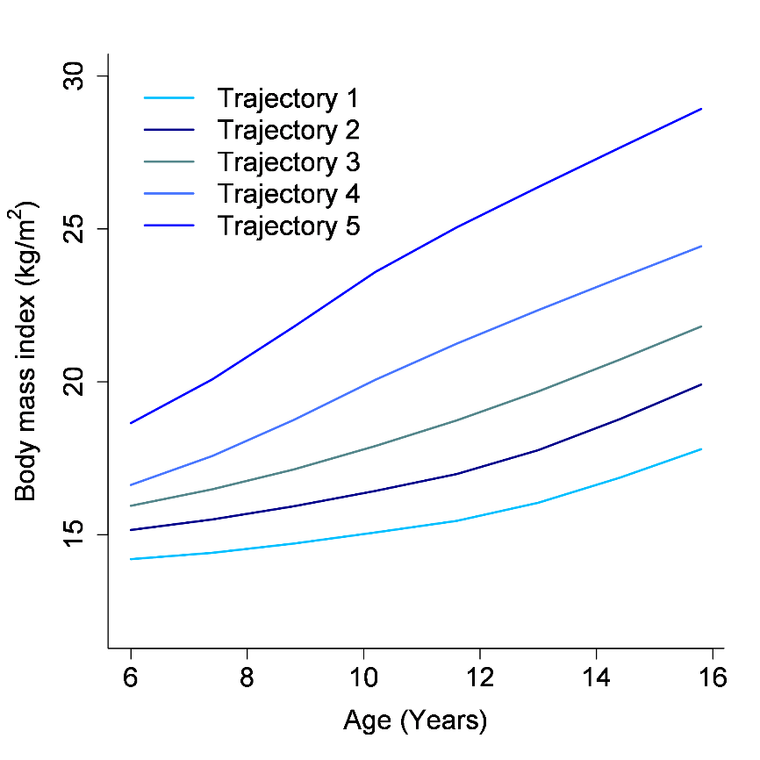
A
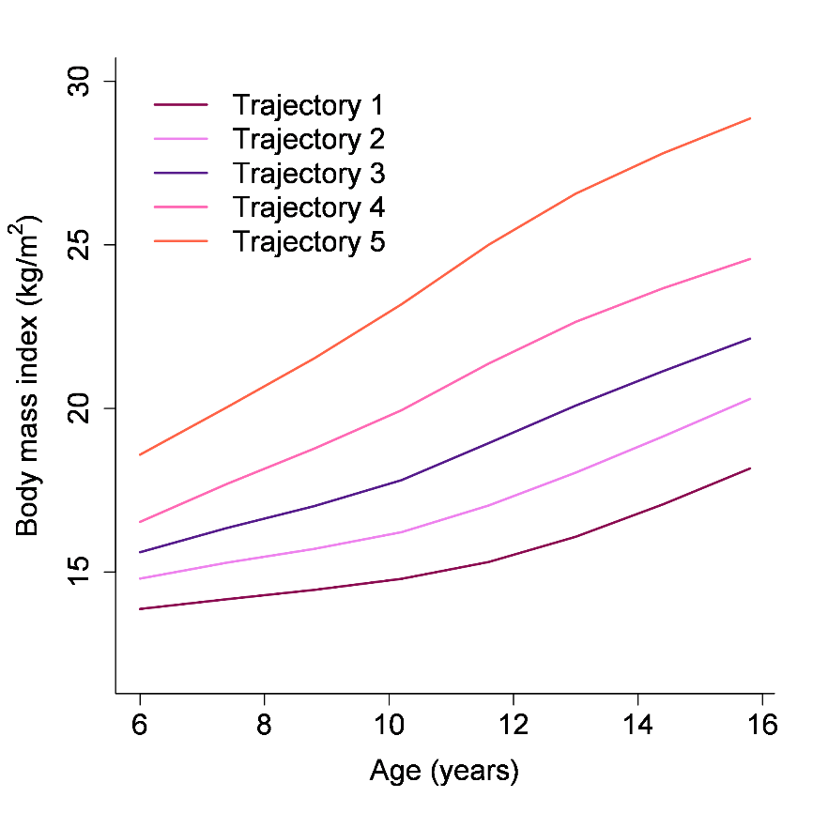
B

