Appendix 1: Biobank participant characteristics by primary care data linkage status

 | Linked  (n=222,121) | Unlinked  (n=280,403)
Age (years): median [IQR] | 58 [50-63] | 58 [50-63]
Male: n (%) | 100,149 (45.1%) | 128,980 (46.0%)
White: n (%) | 210,733 (95.3%) | 261,981 (94.0%)
University/professional education: n (%) | 81,917 (45.7%) | 105,057 (46.1%)
Urban location: n (%) | 186,597 (84.9%) | 242,203 (87.2%)
Disability allowance: n (%) | 13,925 (6.3%) | 16,089 (5.8%)
Median BMI (kg/m²): median [IQR] | 26.8 [24.2-30.0] | 26.6 [24.1-29.8]
Long term illness: n (%) | 72,599 (33.6%) | 87,307 (32.0%)

Appendix 2: Antidepressant prescriptions by outcome

 | Diabetes | Hypertension | CVA | CHD | CVD mortality | ACM
5-year
Antidepressant  N (%) | 11,978 (7.9) | 9,582 (7.9) | 9,709 (7.9) | 9,406 (7.8) | 9,559 (7.9) | 9,546 (7.9)
SSRI  N (% of AD) | 9,574 (79.9) | 7,726 (80.6) | 7,778 (80.1) | 7,627 (81.1) | 7,703 (80.6) | 7,716 (80.8)
Citalopram  N (% of SSRI) | 7,247 (46.3) | 5,924 (46.6) | 5,951 (46.6) | 5,831(46.7) | 5,839 (46.7) | 5,839 (46.7)
Mirtazapine  N (% of Other class) | 1,750 (46.6) | 1,321 (45.0) | 1,334 (45.0) | 1,297 (45.4) | 1,298 (45.5) | 1,298 (45.5)
10-year

Antidepressant  N (%) | 9,126 (6.0) | 7,242 (6.0) | 7,449 (6.1) | 7,124 (6.0) | 7,240 (6.1) | 7,269 (6.1)
SSRI  N (% of AD) | 7,379 (80.9) | 5,941 (82.0) | 6,121 (82.2) | 5,824 (81.2) | 5,941 (82.1) | 5,931 (81.6)
Citalopram  N (% of SSRI) | 7,175 (46.5) | 5,865 (46.7) | 5,892 (46.7) | 5,771 (46.8) | 5,779 (46.8) | 5,779 (46.8)
Mirtazapine  N (% of Other class) | 1,673 (46.2) | 1,258 (44.5) | 1,272 (44.6) | 1,234 (44.9) | 1,234 (44.9) | 1,234 (44.9)

Appendix 3a: List of confounders included in the models looking at the exposure of any antidepressant
Follow-up period | Outcome | Confounders selected by model
5-year
 | Diabetes | Age$, gender, HbA1c$***, BMI***, WHR$***, triglycerides***, long-term illness**, smoking status, parental diabetes history**, benefits status**, urban/rural status***, household income$
 | Hypertension | Age$***, gender**, BMI***, WHR**, triglycerides***, vitamin D$***, parental hypertension history***, alcohol intake status$, urban/rural status***
 | CVA | Age$, gender**, accommodation status$**, benefits status***
 | CHD | Age$***, gender***, apolipoprotein A***, apolipoprotein B***, vitamin D**, long-term illness***, parental CHD history*, education$***
 | CVD mortality | Age$*, gender**, WHR***, employment status$***, physical activity$
 | ACM | Age$*, gender*, BMI$, WHR***, long-term illness***, benefits status***, household income$**
10-year
 | Diabetes | Age$, gender*, apolipoprotein A***, HbA1c$***, BMI***, WHR$***, triglycerides***, vitamin D***, long-term illness**, parental diabetes history***, benefits status***, urban/rural status***, household income$
 | Hypertension | Age$***, gender***, BMI***, WHR***, triglycerides***, vitamin D$***, parental hypertension history***, benefits status, urban/rural status***, household income$*
 | CVA | Age$**, gender***, vitamin D***, long-term illness**, parental CVA history**, number of vehicles per household$***, benefits status***
 | CHD | Age$***, gender***, apolipoprotein A***, apolipoprotein B***, BMI**, vitamin D, long-term illness***, parental CHD history, employment status$*, education$***
 | CVD mortality | Age$*, gender***, HbA1c***, WHR***, long-term illness***, smoking status**, number of vehicles per household$***, employment status$**, benefits status**, physical activity$
 | ACM | Age$***, gender***, HbA1c**, BMI$***, WHR***, vitamin D**, long-term illness***, smoking status***, number of vehicles per household$***, employment status$**, benefits status***, education$*, physical activity$*
$non-linear term
*p<0.05, **p<0.01, ***p<0.001

Appendix 3b: List of confounders included in the models looking at the exposure of SSRI treatment
Follow-up period | Outcome | Confounders selected by model
5-year
SSRI | Diabetes | Age$, gender*, HbA1c$***, BMI***, WHR$***, triglycerides, long-term illness**, parental diabetes history***, benefits status**, urban/rural status***
 | Hypertension | Age$***, gender**, BMI***, WHR**, triglycerides***, vitamin D$***, parental hypertension history***, alcohol intake status, urban/rural status$***
 | CVA | Age$, gender**, long-term illness***, accommodation status$**
 | CHD | Age$**, gender***, apolipoprotein A***, apolipoprotein B***, WHR**, vitamin D*, long-term illness**, parental CHD history, education$***
 | CVD mortality | Age$, gender**, WHR***, employment status$***, physical activity$
 | ACM | Age$*, gender**, WHR***, long-term illness***, number of vehicles per household$***, benefits status***, urban/rural status, household income$
10-year
SSRI | Diabetes | Age$, gender*, apolipoprotein A***, HbA1c$***, BMI$***, WHR$***, triglycerides***, vitamin D***, long-term illness**, smoking status, parental diabetes history***, benefits status***, urban/rural status***, household income$
 | Hypertension | Age$***, gender***, BMI***, WHR***, triglycerides***, vitamin D$***, parental hypertension history***, benefits status, urban/rural status***, household income$
 | CVA | Age$**, gender***, vitamin D***, long-term illness**, parental CVA history**, number of vehicles per household$**, benefits status***
 | CHD | Age$***, gender***, apolipoprotein A***, apolipoprotein B***, BMI**, vitamin D***, long-term illness***, parental CHD history, employment status$*, education$***
 | CVD mortality | Age$*, gender***, HbA1c***, WHR***, long-term illness***, smoking status*, number of vehicles per household$***, employment status$**, benefits status**, physical activity$*
 | ACM | Age$***, gender***, HbA1c***, BMI$***, WHR***, vitamin D**, long-term illness***, smoking status***, number of vehicles per household$***, employment status$, benefits status***, education$, physical activity$*
$non-linear term
*p<0.05, **p<0.01, ***p<0.001

Appendix 3c: List of confounders included in the models looking at the exposure of ‘Other’ class of antidepressants

Follow-up period | Outcome | Confounders selected by model
5-year
Other | Diabetes | Age$, gender**, HbA1c$***, BMI***, WHR$***, triglycerides***, long-term illness**, parental diabetes history***, benefits status**, urban/rural status***
 | Hypertension | Age$***, gender, BMI***, WHR***, triglycerides***, vitamin D***, parental hypertension history***, urban/rural status***
 | CVA | Age$, gender**, accommodation status$**
 | CHD | Age$**, gender***, apolipoprotein A***, apolipoprotein B***, HbA1c***, long-term illness***, parental CHD history, employment status$, education$
 | CVD mortality | Age$*, gender**, WHR***, employment status$**
 | ACM | Age$***, gender*, BMI$***, WHR***, long-term illness***, smoking status***, number of vehicles per household$***, benefits status***
10-year
Other | Diabetes | Age$*, gender, apolipoprotein A***, HbA1c$***, BMI***, WHR$***, triglycerides***, long-term illness**, smoking status, parental diabetes history***, benefits status***, urban/rural status***
 | Hypertension | Age$***, gender***, BMI***, WHR***, triglycerides***, vitamin D***, parental hypertension history***, urban/rural status***, household income$
 | CVA | Age$**, gender***, vitamin D***, long-term illness***, parental CVA history**, accommodation status$, number of vehicles per household$
 | CHD | Age$***, gender***, apolipoprotein A***, apolipoprotein B***, HbA1c**, BMI***, vitamin D***, long-term illness***, parental CHD history, education$
 | CVD mortality | Age$, gender***, HbA1c***, WHR***, long-term illness**, smoking status*, number of vehicles per household$**, employment status$, benefits status***, physical activity$
 | ACM | Age$***, gender***, HbA1c**, BMI$***, WHR***, vitamin D**, long-term illness***, smoking status***, number of vehicles per household$***, employment status$, benefits status***, education$
$non-linear term
*p<0.05, **p<0.01, ***p<0.001

Appendix 4a: Kaplan Meier curves at 5-year follow up

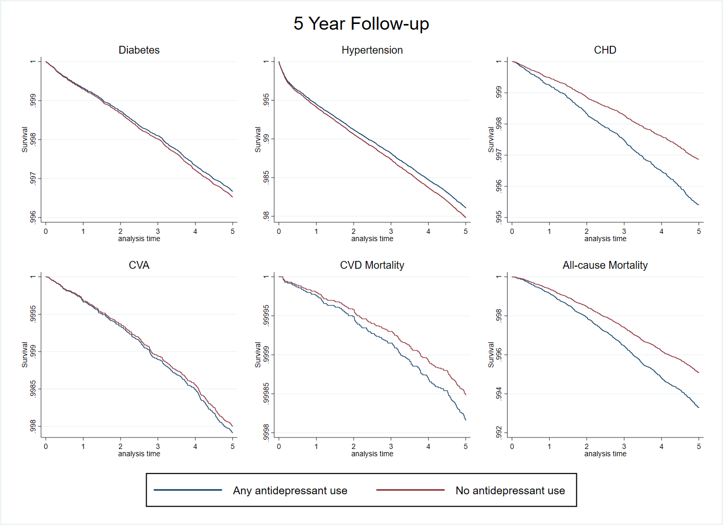

Appendix 4b: Kaplan Meier curves at 10-year follow up
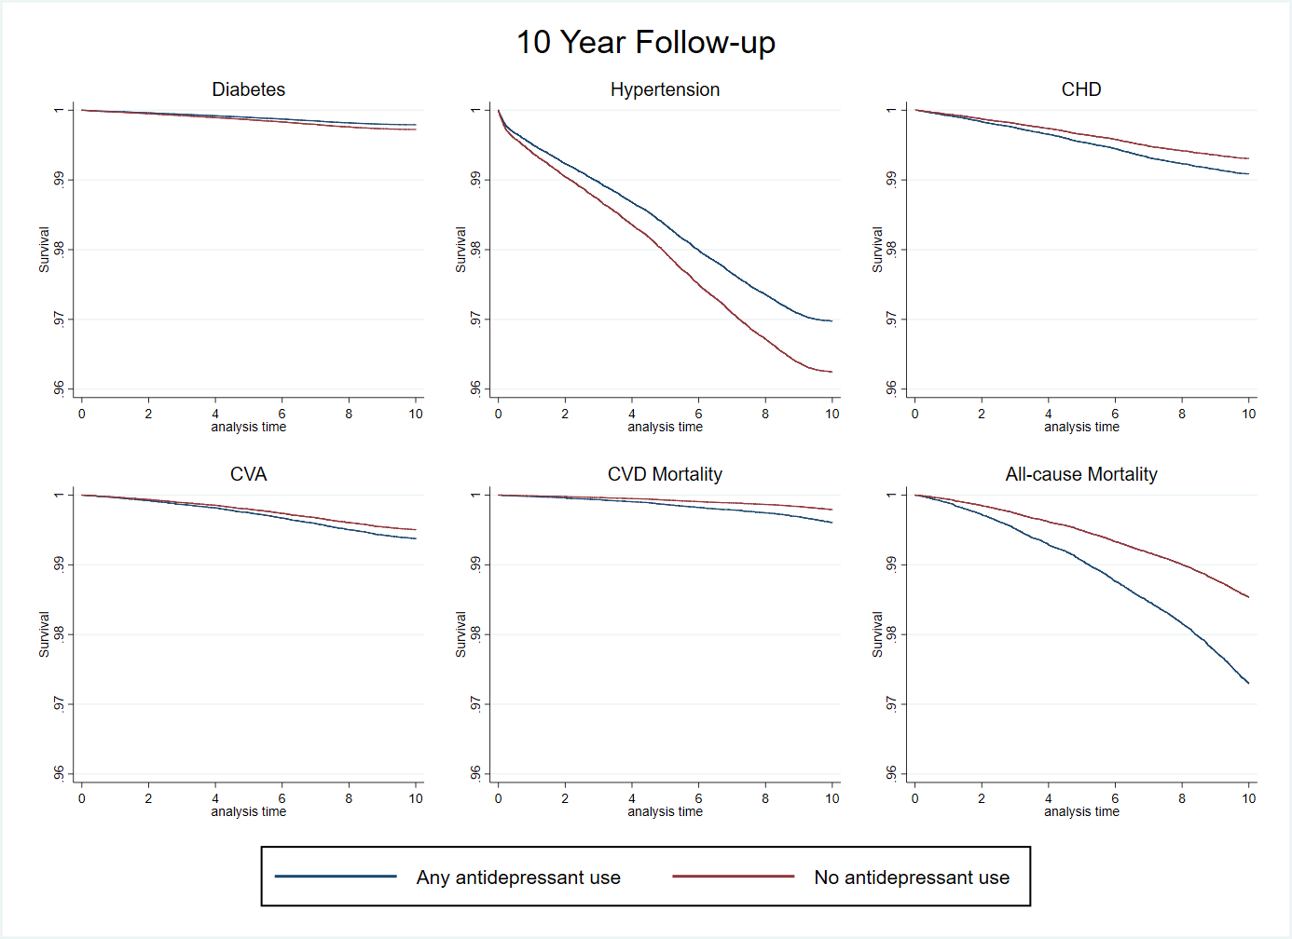

Appendix 5: Sensitivity analysis excluding short term antidepressant use (<90 days)

 | Participants | Observations | Events | Person years | HR | 95% CI
5-year follow-up
Diabetes | 112,207 | 120,582 | 950 | 537,018
No AD |  |  | 865 | 491,174 | 1.00
Any AD |  |  | 85 | 45,843 | 0.83 | (0.67-1.06)
Hypertension | 105,440 | 113,375 | 2,584 | 500,154
No AD |  |  | 2394 | 456,496 | 1.00
Any AD |  |  | 190 | 43,657 | 0.91 | (0.79-1.06)
CVA | 119,069 | 128,165 | 336 | 571,681
No AD |  |  | 306 | 521465 | 1.00
Any AD |  |  | 30 | 50,215 | 1.10 | (0.75-1.60)
CHD | 79,596 | 85,304 | 538 | 382,139
No AD |  |  | 488 | 350,725 | 1.00
Any AD |  |  | 50 | 31,413 | 1.52 | (1.13-2.05)
CVD mortality | 111,840 | 120,250 | 147 | 537,761
No AD |  |  | 135 | 491,290 | 1.00
Any AD |  |  | 12 | 46,471 | 1.04 | (0.57-1.90)
All-cause mortality | 99,894 | 107,426 | 703 | 480,230
No AD |  |  | 645 | 438,834 | 1.00
Any AD |  |  | 58 | 41,396 | 0.87 | (0.66-1.14)
10-year follow-up
Diabetes | 95,576 | 104,342 | 1,422 | 865,671
No AD |  |  | 1,327 | 806,344 | 1.00
Any AD |  |  | 95 | 59,327 | 0.83 | (0.67-1.03)
Hypertension | 89,765 | 98,112 | 3,688 | 800,999
No AD |  |  | 3,497 | 744,779 | 1.00
Any AD |  |  | 191 | 56,220 | 0.79 | (0.68-0.92)
CVA | 102,353 | 111,864 | 674 | 933,859
No AD |  |  | 620 | 869,053 | 1.00
Any AD |  |  | 54 | 64,805 | 1.23 | (0.92-1.63)
CHD | 77,613 | 84,532 | 990 | 707,320
No AD |  |  | 921 | 660,150 | 1.00
Any AD |  |  | 69 | 47,170 | 1.37 | (1.07-1.76)
CVD mortality | 100,533 | 109,845 | 434 | 920,051
No AD |  |  | 388 | 856,516 | 1.00
Any AD |  |  | 46 | 63,534 | 1.61 | (1.17-2.21)
All-cause mortality | 78,953 | 85,995 | 1,671 | 724,214
No AD |  |  | 1505 | 676,204 | 1.00
Any AD |  |  | 166 | 48,009 | 1.54 | (1.31-1.82)

