Ischemia with No Obstructive Coronary Artery Disease (INOCA): A Patient Self-Report Quality of Life Survey from INOCA International

Martha Gulati MD MS¹, Najah Khan MD², Maria George³, Colin Berry MD⁴, Alaide Chieffo MD 5, Paolo G Camici MD⁶, Filippo Crea MD⁷, Juan-Carlos Kaski, DSc, MD⁸, Mario Marzilli MD⁹, C. Noel Bairey Merz MD¹

¹Barbra Streisand Women’s Heart Center, Smidt Heart Institute, Cedars-Sinai Medical Center, Los Angeles, USA
²Houston Methodist Hospital, Houston, TX, USA
³INOCA International, Glasgow, UK
⁴ British Heart Foundation Glasgow Cardiovascular Research Centre, University of Glasgow, Glasgow, UK
⁵ San Raffaele Hospital, Milan, IT
⁶ San Raffaele Hospital and Vita-Salute University, Milan, IT
⁷Catholic University of the Sacred Heart, Rome, IT
⁸Molecular and Clinical Sciences Research Institute, St George’s University of London, London, UK
⁹University of Pisa, Pisa, IT

Disclosures:
MG: None; NK: None; MG2: None; CB: Based on agreements held by the University of Glasgow, CB undertakes research and consultancy work with Abbott Vascular, AstraZeneca, Boehringer Ingelheim, GSK, HeartFlow, Novartis and Valo Health. He is supported by the British Heart Foundation (RE/18/6134217). PGC: nothing to disclose. JCK: Speaker honoraria from Menarini Farmaceutica srl and Servier. CNBM: Caladrius, Abbott Diagnostics, iRhythm

Key Words: ischemic heart disease; ischemia with no obstructive coronary arteries (INOCA); myocardial infarction with no obstructive coronary arteries coronary artery disease (MINOCA); quality of life; disability, functional capacity, mental health, coronary artery disease

Abstract Word Count: 226

Manuscript Word Count: 3139 +3 Figures + Central Figure +3 Tables

Correspondence: Martha Gulati, MD, FAHA, FACC, FASPC, FESC
127 S. San Vicente Blvd, Suite A3600, Los Angeles, CA 90048, Phone: 310-423-9680, Fax: 310-423-9681, Email: Martha.Gulati@cshs.org

The data underlying this article will be shared on reasonable request to the corresponding author.

Twitter Handle @drmarthagulati
Tweet:
Survey of @InocaInternati1 patients demonstrates onset of #INOCA symptoms associated w/ adverse physical, mental & social health QOL
1/3 lived w/ symptoms ≥3y before INOCA dx, 8/10 told symptoms not cardiac
Functional capacity higher prior vs after symptom onset (8.6 vs 5.6METs)

Abbreviations and Acronyms:
CAD = coronary artery disease
DASI= Duke Activity Status Index
INOCA= ischemia with no obstructive coronary arteries
METs= metabolic equivalents

Abstract
Background: There is limited information available regarding evidence of ischemia with no obstructive coronary arteries (INOCA) and quality of life.
Purpose: To determine associations between INOCA and self-reported physical, social, and mental health.
Methods: We conducted a survey of all members (n=1579) of the INOCA International patient support group. Current self-reported diagnosis and health measures were collected. Functional capacity was retrospectively estimated using the Duke Activity Status Index (DASI), assessing levels of activities performed prior and after symptom onset.
Results: A total of 297 (20.8% response rate, 91% women) reported symptoms of chest pain, pressure, or discomfort in 92.9%. Overall, 34.4% were living with symptoms for ≥3 years before an INOCA diagnosis, and 77.8% were told their symptoms were not cardiac. Estimated functional capacity was higher prior to compared to after symptom onset (8.6±1.8 METs vs 5.6±1.8 METs; P<0.0001). Most respondents reported an adverse impact of symptoms on their home life (80.5%), social life (80.1%), mental health (70.4%), outlook on life (69.7%), sex life (55.9%), and their partner/spouse relationship (53.9%), while approximately three-quarters reduced their work hours or stopped work completely, 47.5% retired early, and 38.4% applied for disability.
Conclusions: INOCA symptoms are associated with adverse physical, mental and social health quality of life. Increased patient awareness, physician recognition and diagnosis, and clinical trials are needed to develop evidence-based guidelines for this increasingly recognized cardiovascular disorder.

Introduction:
The diagnosis of coronary artery disease (CAD) has traditionally focused on the presence of obstructive CAD. Nonetheless, it is estimated that at least 2 in every 5 patients with angina referred for elective angiography have nonobstructive coronary arteries, with rates even higher in women.^{1, 2} Ischemia does not require the presence of obstructive coronary arteries,³ and this is recognized in the recent American Heart Association/American College of Cardiology chest pain guidelines expanding the definition of CAD to include both obstructive and nonobstructive CAD.⁴ These same guidelines included a diagnostic pathway for evaluation of chest pain for those with evidence of myocardial ischemia but no obstructive coronary arteries (INOCA).⁴

Patients with INOCA pose both a diagnostic and therapeutic challenge. Most patients with INOCA struggle for years to have an accurate diagnosis made, due to lack of physician awareness and limited availability of diagnostic testing and expertise in INOCA.⁵ In addition, the optimal medical management for INOCA is not well-defined, given that medical therapy should be directed based on the diagnosis of the underlying cause of ischemia, which is best defined by invasive vasoreactive testing but this is not routinely performed.⁶ As a result, patients with INOCA often live with protracted symptoms, undergo repeated diagnostic evaluations, and remain inadequately treated and inadequately diagnosed.²

To date, there is limited literature available on INOCA and quality of life. We sought to determine relations between INOCA symptoms and self-reported physical, social, and mental health. We hypothesized that all aspects of life could be adversely associated with INOCA symptoms.

Methods:
The survey was provided to all members of the patient support group from the United Kingdom (UK)-Based INOCA International, which is an international organization for persons living with INOCA. Awareness of the survey was released by a newsletter, as well as on Twitter and Facebook but only members of the patient support group could access the platform to receive a link for the survey. Participants could fill the survey only once from a single IP address. The survey collection began on October 27, 2021 and was closed on December 27, 2021.The survey questions are included in Appendix 1. All data collected was anonymized and answered directly through SurveyMonkey^{@TM}. Approval for this survey was received from the Cedars-Sinai institutional review board.

Assessment of functional capacity was measured using the Duke Activity Status Index (DASI), previously validated in women with suspected INOCA.⁷ The survey assessed prior to and after the onset of symptoms. Functional capacity was calculated for each participant by converting the sum of DASI questionnaire scores to metabolic equivalents (METs) using the following formula: METs = 0.43 x DASI + 9.6 / 3.5, as previously described.⁸

The statistical analysis included descriptive and frequency distributions, with chi-squared statistics for categorical variable comparisons, and t-tests for continuous variable comparisons. Simple linear regression was performed to determine the association of days lost due to poor physical and mental health, and inability to perform recreational activities per month, related to functional capacity change after onset of symptoms. All statistical analyses were conducted via STATA (College Station, TX) statistical software.

Results:
Three hundred and twenty-eight respondents completed the survey. Given that the established membership of the patient support group of INOCA International is 1579, this represented a response rate of 20.8%. Thirty-one respondents reported not having INOCA, and by default could not answer any further questions in this survey and were excluded. Two hundred and ninety-seven respondents were finally included.
Characteristics of Survey Respondents
Most respondents were women (91.2%), which is slightly higher than the gender representation of the patient support group (83.3% women). The most common forms of diagnosis of INOCA in the responders were coronary microvascular dysfunction (64.3%) and coronary artery spasm (50.5%). Almost two-thirds were diagnosed between the ages of 40 to 60 years. A history of myocardial infarction was reported in 22.6%. A medical history of migraines was common (46.5%), as was a history of any adverse pregnancy outcomes (47.1%), with 25.2% having at least one miscarriage. (Table 1)
Medical Evaluation for INOCA Symptoms
Most respondents (40.4%) had experienced INOCA symptoms for at least 1 to 5 years, with almost half of them experiencing symptoms for anywhere between 1 to 10 years before the diagnosis of INOCA was made, and 77.8% who had been told their symptoms were not cardiac. The symptoms the respondents experienced were numerous, but 92.9% reported symptoms of chest pain, chest pressure, or chest discomfort, and 80.6% reported shortness of breath. Only 8.4% felt the ambulance crew understood the diagnosis of INOCA and 15.3% would not call the ambulance for their INOCA symptoms because they felt their symptoms were not taken seriously. The most common triggers of INOCA reported were stress (79.8%), exercise/exertion (73.4%), and excitement/high emotional state (69%). For the women who had undergone menopause, 37.5% reported that their symptoms changed with menopause. The majority (50.2%) had seen 3 or more cardiologists for the treatment of INOCA. Additionally, 31.6% had been referred to a psychiatrist for their symptoms and 42.1% had been prescribed an anti-depressant. Most respondents (53.9%) had been told their symptoms were due to gastroesophageal reflux disease, with 32% having undergone upper endoscopy for further evaluation. The majority of those surveyed reported that they were told that although their symptoms of INOCA may be unpleasant, they could not die from INOCA or have a heart attack (66.4%). Of the respondents who attended the emergency department for their symptoms, 69.4% were discharged without any treatment. (Table 2)
A minority (6.4%) were diagnosed with INOCA at the first consultation for the onset of symptoms. The majority (93.6%) reported multiple consultations before the diagnosis of INOCA was made. The majority (50.2%) also had consulted 3 or more cardiologists for the treatment of INOCA. All respondents underwent some diagnostic testing with non-invasive imaging performed in 93.3%, and 72.7% underwent invasive imaging but only 32.7% underwent cardiac catheterization with acetylcholine testing. Self-referral to a cardiology specialist familiar with INOCA was reported by 35.7% of individuals, and 38.4% reported never being under the care of an INOCA specialist. Of the respondents, 49.2% were currently under the care of a INOCA specialist (Table 2).
Associations with Health Quality of Life
General Health: At the time of the survey, most of the respondents living with INOCA reported their health as being fair (32.7%) or poor (19.2%). (Table 3)
Physical Health: Prior to the onset of INOCA symptoms, the mean functional capacity for those surveyed was 8.6±1.8 METs, with 69.7% able to perform >8 METs. Following the onset of symptoms, the reported functional capacity was 5.6±1.8 METs, with only 11.4% able to perform >8 METs. (Table 3, Table 4). Those who reported poorer health had a lower functional capacity (data not shown). Those with a prior myocardial infarction had lower post-diagnosis functional capacity when compared with those without a myocardial infarction (5.5±1.8 METs vs 8.5±1.9 METs, respectively; p < 0.0001). Those with self-reported kidney disease had lower symptom onset functional capacity compared with those without kidney disease (4.6±1.0 METs vs. 5.7±1.9 METs; p = 0.031), and those with any co-morbidities had a lower post-symptom onset functional capacity than those with no co-morbidities. (6.1±1.9 METs vs. 5.4±1.8 METs; p = 0.0027).
Social and Mental Health: While living with INOCA, most of the respondents reported an adverse impact on their home life (80.5%), social life (80.1%), mental health (70.4%), outlook on life (69.7%), sex life (55.9%), and their partner/spouse relationship (53.9%). (Table 3) Those who reported an adverse impact of INOCA on specific aspects of their social and mental health had a significantly lower functional capacity compared to those who did not report any adverse impact of INOCA on those factors (Figure 1). Those who reported that their sex life was adversely affected the mean functional capacity level was lower than for those whose sex life was not adversely affected (5.1± 1.5 METs vs. 6.9± 1.9 METs; p<0.0001.
Work and Disability: Most respondents (69.0%) felt that there was an adverse impact on their work life while living with INOCA; and those who reported an adverse impact on their work life had a significantly lower mean functional capacity than those did not report any adverse impact on their work life (5.3±1.5 METs vs. 7.6±2.2 METs, respectively; p < 0.0001). After experiencing INOCA symptoms, approximately 3 of every 4 respondents had either reduced their work hours or had stopped work completely, 47.5% retired early, and 38.4% applied for disability (Table 3). Of those who applied for disability, 22.8% were unsuccessful at receiving disability benefits, with those who were successful having a lower functional capacity than those who were not (4.8±1.4 METs vs. 5.9±2.1 METs, respectively; p < 0.0001). Those who applied for disability, retired early or reduced working hours had a significantly lower functional capacity than those who did not (Figure 2).
Living with INOCA Symptoms and Days of Declining Health: After onset of symptoms, the respondents reported that for every 1 MET decrease in functional capacity, there was a loss of 3.0±0.6 days of physical health per month, 1.8±0.6 days of mental health per month, and 2.9 ±0.7 days of inability to perform recreational activities per month (p<0.0001) (Figure 3).

Discussion:
This study depicts adverse associations with many aspects of quality of life in INOCA patients. Patients reported that their physical, mental and social health were adversely impacted by INOCA symptoms indicative of reduced overall quality of life. Additionally, when compared to prior to the onset of INOCA symptoms, living with INOCA was associated with a significant reduction of approximately 3 METS of functional capacity, comparable to losing the ability to do light housework, activities of daily living (dressing, bathing, use the toilet independently), or being able to walk 1 block on level ground. Those who reported an adverse impact of INOCA on specific aspects of life had a relatively greater reduction in functional capacity, when compared with those who do not. These findings are unique, as there has been very limited data relating the patient experience of living with INOCA.

For the respondents of this survey, functional capacity was significantly reduced while living with INOCA when compared to prior to the onset of INOCA symptoms. Functional capacity is an established independent predictor of mortality,⁹ particularly when functional capacity falls below 5 METs,¹⁰ which in this surveyed population was the case for 5.1% prior to the onset of symptoms, but increased to 41.4% post-symptom onset. In the Women’s Ischemia Syndrome Evaluation (WISE) study, poor functional capacity in women with INOCA was associated with an adverse prognosis.¹¹ A prior evaluation of registry studies demonstrated that patients with INOCA have relatively greater physical limitations and anginal frequency than patients with stable obstructive coronary artery disease and acute myocardial infarction survivors.¹² This conflicts with findings from the WISE study, where functional capacity was demonstrated to be slightly greater in those women with nonobstructive CAD, when compared with obstructive CAD, using the DASI (5.0 METs±4.3 vs 5.6±4.7 METS, respectively; p=0.01).¹³ In this current INOCA survey, following symptom onset functional capacity was similar to what was seen in WISE (5.6 ±1.8 METs).¹³ Further, the survey demonstrates for the first time a decline in functional capacity associated with worsened aspects of physical, mental, and social health. Specifically, for every 1 MET reduction in functional capacity once experiencing INOCA symptoms, there was a self-reported 3-day loss in in physical health and ability to perform recreational physical activities per month, and 2 days per month with suboptimal mental health. The implication of poor functional capacity is important in understanding the impact of this disease and appreciating that the prognosis of INOCA is not benign.

Mental health was adversely impacted in 70.4% of those surveyed, with almost the same number reporting that INOCA had negatively affected their outlook on life. Psychological stress, which includes anxiety, depression, anger and personality disturbances, can be quite common in patients with CAD,¹⁴ including those with INOCA.¹⁵ It is estimated that the prevalence of depression is 15-30% in those with coronary heart disease, and highest post MI and in women,¹⁶ but it is unclear if these estimates included patients with nonobstructive CAD. The WISE study demonstrated that higher anxiety variables predicted more severe cardiac symptoms.¹⁷ In a previously reported study of 66 patients with INOCA, cardiac anxiety levels as assessed using the Cardiac Anxiety Questionnaire were significantly higher in INOCA patients when compared with prior assessments in patients with sudden cardiac death, and quite similar to those documented in patients with hypertrophic cardiomyopathy.¹² Psychological stress can induce endothelial dysfunction and be an underlying cause of INOCA, particularly coronary microvascular dysfunction and vasospasm.¹⁸⁻²⁰

The social health of patients was adversely impacted in those living with INOCA symptoms, with at least 4 of every 5 respondents reporting that their symptoms adversely affected their home life and social life. Sexual activity may often decrease after a myocardial infarction due to fears of inducing another myocardial infarction or anginal symptoms, as was demonstrated in a study of myocardial infarction survivors, where 47% of patient abstained or reduced their sexual activity after their myocardial infarction.²¹ This is comparable to the current survey results, where 1 in 2 patients reported that following onset of INOCA symptoms, their relationship with their partner/spouse and their sex life was adversely impacted. Providing counselling to patients regarding sexual activity after an acute myocardial infarction is far too infrequent,²² but for those with INOCA or myocardial infarction with no obstructive coronary arteries (MINOCA), it remains unknown what counselling is provided, if any. Based on the 2021 AHA Scientific Statement on sexual activity and CVD, “sexual activity is reasonable for patients who can exercise ≥ 3-5 METs without any angina, without angina, excessive dyspnea, ischemic ST-segment changes, cyanosis, hypotension, or arrhythmia.”²³ In the current survey, 41.4% of the INOCA patients reported a functional capacity was <5 METs after onset of symptoms, and those who reported that their sex life was adversely impacted had a significantly lower functional capacity, compared with those whose sex life was not adversely affected.

We observed a significant association of living with INOCA symptoms on the ability to work, with almost 7 out of every 10 patients reporting that INOCA adversely affected their work life, resulting in more than half reducing their work hours or even retiring earlier than expected. Approximately one third of those surveyed changed their job or roles resulting in lower pay. Application for disability was also quite common in those living with INOCA. Our findings are consistent with a study of 66 patients where INOCA was assessed using cardiac magnetic resonance and demonstrated that patients with INOCA frequently missed work (1.1±2.2 full workdays missed in last 2 weeks) and had work limitations, suggestive of a substantial economic impact by work productivity loss.¹² Nonetheless, this study did not address disability or changes in job or roles that also result in lower pay directly for the patient. A study from Denmark examined patients referred for coronary angiography for symptoms of stable angina, and demonstrated no difference in premature exit from the workforce or being on disability in those with obstructive and nonobstructive CAD.²⁴ The national register from Sweden demonstrated that persons of working ages with ischemic heart disease took 83.9 days per year of disability leave in the first post-event year after adjusting for age, sex and education (~6.9 days per month).²⁵ This was six-fold greater than the national average of disability days. Nonetheless, this prior study did not distinguish between those with obstructive versus nonobstructive CAD. Additionally, disability days leveled off within the second year similar to the pre-event year.²⁵

The current results suggest that patients with INOCA often initially live with diagnostic uncertainty despite the presence of symptoms that adversely impact their lives. Most patients reported living with their symptoms for at least 1 year before a diagnosis was made, with almost half experiencing symptoms of INOCA for 1 to 10 years before diagnosis. More than half had seen three or more consultants before their diagnosis of INOCA was made, and three or more cardiologists for the treatment of INOCA. Many reported undergoing endoscopy or psychiatric evaluation of their symptoms. Even for these patients with a diagnosis of INOCA, less than a third had undergone cardiac catheterization with coronary flow reserve testing to determine optimal medical therapies, given that there are many different forms of INOCA. This on top of a lack of understanding of INOCA even within the cardiology community, results in the signs and symptoms of INOCA often being downplayed, dismissed and often untreated and undiagnosed.²⁶

Study Limitations:
There are several limitations in this study. Although most respondents were female, limiting implications somewhat to men, however INOCA is a condition that predominantly affects women. This survey was limited to the patient support group of INOCA International. Accordingly, the survey reflects: (1) participants had an established diagnosis or suspicion of INOCA; (2) they had undergone some evaluation for this diagnosis; (3) they had had time to join a patient-focused support group; and (4) they may have sought out such an organization because of issues related to getting a diagnosis or living with active symptoms of INOCA, and thus may not represent all INOCA patients. A survey-based study will always be limited to a higher literacy audience and may unintentionally exclude those INOCA patients with lower levels of literacy. Because the survey was administered online, there was no interviewer to probe the respondents and ensure understanding of the intention of the questions. There is survival bias in this study, and it remains unknown how large the population of INOCA patient is, but it is likely patients remain undiagnosed and untreated and would not be represented in this study. Reports of applications for disability and successful approval differ from one country to another, and although we do not know where these participants live, this is a UK-based organization. In addition, the survey did not distinguish between short-term or long-term disability. Certainly, recall bias can limit the self-interpretation of quality of life and functional capacity prior to INOCA symptoms. Functional capacity was estimated using the DASI questionnaire, but this has been validated in populations living with ischemic heart disease including those with INOCA from the WISE study.^{7, 8, 11, 27, 28} Information on pharmacological and non-pharmacology therapy was not collected, so we are unable to assess how treatment may influence any of the self-reported measures. Lastly, we have included respondents with a diagnosis of INOCA who also reported being diagnosed with Takotsubo Cardiomyopathy, given that a prevailing hypothesis is that the underlying pathophysiologic process may be due to underlying coronary microvascular ischemia.²⁹

Conclusions
INOCA symptoms are associated with adverse physical, mental and social health quality of life, comparable to patients with symptoms of obstructive CAD. Additionally, functional capacity declines are evident following onset of INOCA symptoms. Increased patient awareness, physician recognition and diagnosis, and clinical trials are needed to develop evidence-based guidelines for this increasingly recognized cardiovascular disorder.

References:

1. Patel MR, Peterson ED, Dai D, Brennan JM, Redberg RF, Anderson HV, Brindis RG and Douglas PS. Low diagnostic yield of elective coronary angiography. N Engl J Med. 2010;362:886-95.
2. Shaw LJ, Merz CN, Pepine CJ, Reis SE, Bittner V, Kip KE, Kelsey SF, Olson M, Johnson BD, Mankad S, Sharaf BL, Rogers WJ, Pohost GM, Sopko G and Women's Ischemia Syndrome Evaluation I. The economic burden of angina in women with suspected ischemic heart disease: results from the National Institutes of Health--National Heart, Lung, and Blood Institute--sponsored Women's Ischemia Syndrome Evaluation. Circulation. 2006;114:894-904.
3. Kaski JC, Crea F, Gersh BJ and Camici PG. Reappraisal of Ischemic Heart Disease. Circulation. 2018;138:1463-1480.
4. Gulati M, Levy PD, Mukherjee D, Amsterdam E, Bhatt DL, Birtcher KK, Blankstein R, Boyd J, Bullock-Palmer RP, Conejo T, Diercks DB, Gentile F, Greenwood JP, Hess EP, Hollenberg SM, Jaber WA, Jneid H, Joglar JA, Morrow DA, O'Connor RE, Ross MA and Shaw LJ. 2021 AHA/ACC/ASE/CHEST/SAEM/SCCT/SCMR Guideline for the Evaluation and Diagnosis of Chest Pain: Executive Summary: A Report of the American College of Cardiology/American Heart Association Joint Committee on Clinical Practice Guidelines. Circulation. 2021;144:e368-e454.
5. Ford TJ, Corcoran D and Berry C. Stable coronary syndromes: pathophysiology, diagnostic advances and therapeutic need. Heart. 2018;104:284-292.
6. Ford TJ, Stanley B, Good R, Rocchiccioli P, McEntegart M, Watkins S, Eteiba H, Shaukat A, Lindsay M, Robertson K, Hood S, McGeoch R, McDade R, Yii E, Sidik N, McCartney P, Corcoran D, Collison D, Rush C, McConnachie A, Touyz RM, Oldroyd KG and Berry C. Stratified Medical Therapy Using Invasive Coronary Function Testing in Angina: The CorMicA Trial. J Am Coll Cardiol. 2018;72:2841-2855.
7. Bairey Merz CN, Olson M, McGorray S, Pakstis DL, Zell K, Rickens CR, Kelsey SF, Bittner V, Sharaf BL and Sopko G. Physical activity and functional capacity measurement in women: a report from the NHLBI-sponsored WISE study. J Womens Health Gend Based Med. 2000;9:769-77.
8. Hlatky MA, Boineau RE, Higginbotham MB, Lee KL, Mark DB, Califf RM, Cobb FR and Pryor DB. A brief self-administered questionnaire to determine functional capacity (the Duke Activity Status Index). Am J Cardiol. 1989;64:651-4.
9. Gulati M, Black HR, Shaw LJ, Arnsdorf MF, Merz CN, Lauer MS, Marwick TH, Pandey DK, Wicklund RH and Thisted RA. The prognostic value of a nomogram for exercise capacity in women. N Engl J Med. 2005;353:468-75.
10. Gulati M, Pandey DK, Arnsdorf MF, Lauderdale DS, Thisted RA, Wicklund RH, Al-Hani AJ and Black HR. Exercise capacity and the risk of death in women: the St James Women Take Heart Project. Circulation. 2003;108:1554-9.
11. Shaw LJ, Olson MB, Kip K, Kelsey SF, Johnson BD, Mark DB, Reis SE, Mankad S, Rogers WJ, Pohost GM, Arant CB, Wessel TR, Chaitman BR, Sopko G, Handberg E, Pepine CJ and Bairey Merz CN. The value of estimated functional capacity in estimating outcome: results from the NHBLI-Sponsored Women's Ischemia Syndrome Evaluation (WISE) Study. J Am Coll Cardiol. 2006;47:S36-43.
12. Schumann CL, Mathew RC, Dean JL, Yang Y, Balfour PC, Jr., Shaw PW, Robinson AA, Salerno M, Kramer CM and Bourque JM. Functional and Economic Impact of INOCA and Influence of Coronary Microvascular Dysfunction. JACC Cardiovasc Imaging. 2021;14:1369-1379.
13. Olson MB, Kelsey SF, Matthews K, Shaw LJ, Sharaf BL, Pohost GM, Cornell CE, McGorray SP, Vido D and Bairey Merz CN. Symptoms, myocardial ischaemia and quality of life in women: results from the NHLBI-sponsored WISE Study. Eur Heart J. 2003;24:1506-14.
14. Lichtman JH, Froelicher ES, Blumenthal JA, Carney RM, Doering LV, Frasure-Smith N, Freedland KE, Jaffe AS, Leifheit-Limson EC, Sheps DS, Vaccarino V, Wulsin L, American Heart Association Statistics Committee of the Council on E, Prevention, the Council on C and Stroke N. Depression as a risk factor for poor prognosis among patients with acute coronary syndrome: systematic review and recommendations: a scientific statement from the American Heart Association. Circulation. 2014;129:1350-69.
15. Gomez MA, Merz NB, Eastwood JA, Pepine CJ, Handberg EM, Bittner V, Mehta PK, Krantz DS, Vaccarino V, Eteiba W and Rutledge T. Psychological stress, cardiac symptoms, and cardiovascular risk in women with suspected ischaemia but no obstructive coronary disease. Stress Health. 2020;36:264-273.
16. Vaccarino V, Badimon L, Bremner JD, Cenko E, Cubedo J, Dorobantu M, Duncker DJ, Koller A, Manfrini O, Milicic D, Padro T, Pries AR, Quyyumi AA, Tousoulis D, Trifunovic D, Vasiljevic Z, de Wit C, Bugiardini R and Reviewers ESCSDG. Depression and coronary heart disease: 2018 position paper of the ESC working group on coronary pathophysiology and microcirculation. Eur Heart J. 2020;41:1687-1696.
17. Handberg EM, Eastwood JA, Eteiba W, Johnson BD, Krantz DS, Thompson DV, Vaccarino V, Bittner V, Sopko G, Pepine CJ, Merz NB and Rutledge TR. Clinical implications of the Women's Ischemia Syndrome Evaluation: inter-relationships between symptoms, psychosocial factors and cardiovascular outcomes. Womens Health (Lond). 2013;9:479-90.
18. van der Meer RE and Maas AH. The Role of Mental Stress in Ischaemia with No Obstructive Coronary Artery Disease and Coronary Vasomotor Disorders. Eur Cardiol. 2021;16:e37.
19. Kop WJ, Krantz DS, Howell RH, Ferguson MA, Papademetriou V, Lu D, Popma JJ, Quigley JF, Vernalis M and Gottdiener JS. Effects of mental stress on coronary epicardial vasomotion and flow velocity in coronary artery disease: relationship with hemodynamic stress responses. J Am Coll Cardiol. 2001;37:1359-66.
20. Mehta PK, Hermel M, Nelson MD, Cook-Wiens G, Martin EA, Alkhoder AA, Wei J, Minissian M, Shufelt CL, Marpuri S, Hermel D, Shah A, Irwin MR, Krantz DS, Lerman A and Noel Bairey Merz C. Mental stress peripheral vascular reactivity is elevated in women with coronary vascular dysfunction: Results from the NHLBI-sponsored Cardiac Autonomic Nervous System (CANS) study. Int J Cardiol. 2018;251:8-13.
21. Cohen G, Nevo D, Hasin T, Benyamini Y, Goldbourt U and Gerber Y. Resumption of sexual activity after acute myocardial infarction and long-term survival. Eur J Prev Cardiol. 2022;29:304-311.
22. Lindau ST, Abramsohn EM, Bueno H, D'Onofrio G, Lichtman JH, Lorenze NP, Mehta Sanghani R, Spatz ES, Spertus JA, Strait K, Wroblewski K, Zhou S and Krumholz HM. Sexual activity and counseling in the first month after acute myocardial infarction among younger adults in the United States and Spain: a prospective, observational study. Circulation. 2014;130:2302-9.
23. Levine GN, Steinke EE, Bakaeen FG, Bozkurt B, Cheitlin MD, Conti JB, Foster E, Jaarsma T, Kloner RA, Lange RA, Lindau ST, Maron BJ, Moser DK, Ohman EM, Seftel AD, Stewart WJ, American Heart Association Council on Clinical C, Council on Cardiovascular N, Council on Cardiovascular S, Anesthesia, Council on Quality of C and Outcomes R. Sexual activity and cardiovascular disease: a scientific statement from the American Heart Association. Circulation. 2012;125:1058-72.
24. Jespersen L, Abildstrom SZ, Hvelplund A, Galatius S, Madsen JK, Pedersen F, Hojberg S and Prescott E. Symptoms of angina pectoris increase the probability of disability pension and premature exit from the workforce even in the absence of obstructive coronary artery disease. Eur Heart J. 2013;34:3294-303.
25. Virtanen M, Ervasti J, Mittendorfer-Rutz E, Lallukka T, Kjeldgard L, Friberg E, Kivimaki M, Lundstrom E and Alexanderson K. Work disability before and after a major cardiovascular event: a ten-year study using nationwide medical and insurance registers. Sci Rep. 2017;7:1142.
26. Kunadian V, Chieffo A, Camici PG, Berry C, Escaned J, Maas A, Prescott E, Karam N, Appelman Y, Fraccaro C, Louise Buchanan G, Manzo-Silberman S, Al-Lamee R, Regar E, Lansky A, Abbott JD, Badimon L, Duncker DJ, Mehran R, Capodanno D and Baumbach A. An EAPCI Expert Consensus Document on Ischaemia with Non-Obstructive Coronary Arteries in Collaboration with European Society of Cardiology Working Group on Coronary Pathophysiology & Microcirculation Endorsed by Coronary Vasomotor Disorders International Study Group. Eur Heart J. 2020;41:3504-3520.
27. Nelson CL, Herndon JE, Mark DB, Pryor DB, Califf RM and Hlatky MA. Relation of clinical and angiographic factors to functional capacity as measured by the Duke Activity Status Index. Am J Cardiol. 1991;68:973-5.
28. Alonso J, Permanyer-Miralda G, Cascant P, Brotons C, Prieto L and Soler-Soler J. Measuring functional status of chronic coronary patients. Reliability, validity and responsiveness to clinical change of the reduced version of the Duke Activity Status Index (DASI). Eur Heart J. 1997;18:414-9.
29. Pelliccia F, Kaski JC, Crea F and Camici PG. Pathophysiology of Takotsubo Syndrome. Circulation. 2017;135:2426-2441.

Table 1. Participant Characteristics

Respondents
(N= 297)
Men | 26 (8.8)
Established Diagnoses  CMD  Coronary Artery Spasm  Nonobstructive atherosclerosis  Heart Failure with Preserved Ejection Fraction  Takotsubo Cardiomyopathy/Stress Cardiomyopathy  Not given any diagnosis aside from INOCA  Unknown  MINOCA | 191 (64.3)  150 (50.5)  18 (6.1)  13 (4.4)  13 (4.4)  24 (8.1)  13 (4.4)  67 (22.6)
Age at Diagnosis of INOCA  <30 Years  30-40  40-50 Years  50-60 Years  >60 Years | 8 (2.7)  29 (9.8)  77 (25.9)  115 (38.7)  54 (18.2)
Comorbidities  Migraines/ frequent headaches  Raynaud's  Thyroid disorder  Rheumatoid Arthritis  Lupus/ systemic lupus erythematosus  Other autoimmune disorder  History of stroke  Kidney disease  None | 138 (46.5)  64 (21.5)  64 (21.5)  16 (5.5)  4 (1.3)  64 (21.5)  10 (3.3)  15 (5.1)  76 (25.6)
Adverse Pregnancy Outcomes  Hypertension During pregnancy  Preeclampsia or Eclampsia  Gestational Diabetes  Preterm Delivery  Miscarriage  Does Not Apply To Me/I have Never Been Pregnant | 140 (47.1)  55 (18.5)  38 (12.8)  24 (8.1)  36 (12.1)  75 (25.2)  139 (46.8)
Legend: INOCA -Ischemia with No Obstructive Coronary Arteries. MINOCA- Myocardial Infarction with No Obstructive Coronary Arteries

Table 2. INOCA Symptoms, Trigger, Referral Patterns & Evaluation

Respondents
(N= 297)
Years With INOCA Symptoms  <1 Year  1-5 Years  5-10 Years  10-20 Years  >20 Years | 34 (11.4)  120 (40.4)  62 (20.9)  46 (15.5)  21 (7.1)
Time From Symptom Onset to Diagnosis of INOCA  <1 Month  1 Month-1Year  1-3 Years  3-10 Years  >10 Years | 26 (8.8)  92 (31.0)  67 (22.6)  73 (24.6)  29 (9.8)
Clinical Assessment of Symptoms  Told that Symptoms were Not Cardiac  Seen in ED for Symptoms+ Discharged without Treatment  Told that although symptoms of INCOA are unpleasant, you cannot die from it or have a heart attack  Had ever called an ambulance for symptoms  Knew when to call an ambulance or go to the hospital for INOCA symptoms | 224 (77.8)  200 (69.4)  188 (66.4)  166 (58.7)  184 (65.5)
Ambulance Response to INOCA Symptoms  Taken to hospital+ ECG+ Monitor  No ambulance dispatched  Assessed by ambulance crew but not taken to hospital  Taken to hospital but no ECG or cardiac monitor performed  Ambulance crew understood the diagnosis of INOCA  Ambulance crew did not understand the diagnosis of INOCA  I never had to call an ambulance  I do not call the ambulance because they do not take my symptoms seriously | 147 (49.4)  9 (3.2)  39 (13.8)  23 (8.2)  25 (8.4)  75 (27.0)  97 (34.4)  43 (15.3)
Symptoms  General: Fatigue/exhaustion, Sweats  Cardiovascular:  Chest pain/chest pressure/chest discomfort  Palpitations  Shortness of breath  Back, shoulder, arm, neck, jaw pain  Neurologic: Confusion, brain fog, vision changes, light headedness, dizziness  Gastrointestinal: Nausea, reflux-like symptoms  Other | 260 (87.5)  276 (92.9)  181 (60.9)  239 (80.5)  242 (81.5)  230 (77.4)  146 (49.2)  45 (15.2)
Triggers  Stress  Exercise/Exertion  Excitement or High Emotional State/Anger  Cold Weather  Change in Temperature or Weather Change  Triggered during Menstruation  Other  No Known Triggers | 237 (79.8)  218 (73.4)  205 (69.0)  178 (59.9)  145 (48.8)  49 (16.5)  70 (23.6)  18 (6.1)
Did Symptoms Change at Menopause?  Yes  No  Unsure  Have Not Undergone Menopause  Male- Does Not Apply  No Response | 75 (25.3)  45 (15.2)  80 (26.9)  53 (17.8)  26 (8.8)  18 (6.1)
Prior to the Diagnosis of INOCA:  Told Symptoms Were Due to GERD  Underwent Endoscopy to Assess for GERD  Told Symptoms Were Not Cardiac  Referred to a Psychiatrist for Symptoms  Recommended to Start Antidepressant/Antianxiety Medication for Symptoms  Seen in the ED For Symptoms of INOCA & Discharged Without Treatment | 160 (53.9)  96 (32.3)  223 (75.1)  94 (31.6)  125 (42.1)  200 (67.3)
Total Consults Seen Prior to INOCA Diagnosis  Diagnosed Right Away  1-2 Additional Consults  3-5 Additional Consults  >5 Additional Consults | 19 (6.4)  86 (28.9)  105 (35.4)  75 (25.3)
Non-invasive Imaging  ECG  Echocardiogram  Exercise Stress Test  Stress Echocardiogram  CT Angiogram  Cardiac MRI  PET Scan  Invasive Imaging  Cardiac Catheterization  Cardiac Catheterization with Acetylcholine Testing | 277 (93.3)  261 (87.9)  242 (81.5)  201 (67.7)  145 (48.8)  134 (45.1)  138 (46.5)  31 (10.4)  216 (72.7)  185 (62.3)  97 (32.7)
Number of Cardiologists Consulted for Treatment of INOCA  1  2  ≥3 | 60 (20.2)  76 (25.6)  149 (50.2)
Finding An INOCA Specialist  Self-Referred  Referred by Cardiologist  Referred by Family Doctor or Other Doctor  Never Under the Care of an INOCA Specialist | 106 (35.7)  45 (15.2)  18 (6.1)  114 (38.4)
Currently Under the Care of an INOCA Specialist | 146 (49.2)
Legend: CT computed tomography; ECG electrocardiogram; GERD Gastroesophageal Reflux Disease; INOCA Ischemia with No Obstructive Coronary Arteries, MRI magnetic resonance imaging; PET positron emission tomography

Table 3. Health Status and Quality of Life
Total Respondents
(N= 297)
Overall Health After Onset of Symptoms  Excellent  Very Good  Good  Fair  Poor  Did not answer | 6 (2.0)  48 (16.3)  87 (29.5)  97 (32.7)  57 (19.2)  2 (0.7)
Functional Capacity Level by DASI (METs) Prior to Onset of INOCA Symptoms  <5 METs  5-8METs  >8 METs  Estimated Exercise Capacity (METs) | 15 (5.1)  63 (21.2)  207 (69.7)  8.6±1.8
Functional Capacity Level by DASI (METs) After Onset of Symptoms  <5 METs  5-8METs  >8 METs  Estimated Exercise Capacity (METs) | 123 (41.4)  128 (43.1)  34 (11.4)  5.6±1.8
Mental Health After Onset of Symptoms  INOCA Adversely affected your Mental Health  INOCA Negatively affected your Outlook on Life | 209 (70.4)  207 (69.7)
Social Health After Onset of Symptoms  INOCA Adversely affected Home Life  INOCA Adversely affected your Relationship with Partner/Spouse  INOCA Adversely affected your Social Life  INOCA Adversely affected your Sex Life | 239 (80.5)  160 (53.9)  238 (80.1)  166 (55.9)
Work & Disability After Onset of Symptoms  INOCA Adversely affecting Work Life  Reduced Work Hours due to INOCA symptoms  Retired Early because of INOCA  Changed Job/Roles for less stressful Position due to INOCA symptoms  Changed Job/Roles resulting in Lower Pay due to INOCA symptoms  Applied for Disability because of INOCA symptoms  Successful Application for Disability Benefits | 205 (69.0)  167 (56.2)  141 (47.5)  111 (37.4)  97 (32.7)  114 (38.4)  88 (77.2)
Legend: DASI Duke Activity Status Index; INOCA Ischemia with No Obstructive Coronary Arteries; METs metabolic equivalents

Table 4. Estimated Functional Capacity Prior and Following Symptom Onset Stratified by Diagnosis
INOCA Forms | Functional Capacity Prior to Symptoms Onset (METS±SD) | Functional Capacity Post Symptom Onset (METS±SD) | P-Value
ALL INOCA (N=297)  CMD (N=191)  Coronary artery spasm (N=150)  Nonobstructive atherosclerosis (N=18)  HFpEF (N=13)  Takutsubo Cardiomyopathy (N=13)  I don't know/I wasn't diagnosed (N=37) | 8.6 ±1.8  8.5 ±1.9  8.7 ±1.9  8.3 ±2.2  8.3 ±2.1  8.3 ±1.7  8.6 ±1.6 | 5.6 ±1.8  5.3 ±1.7  5.6 ±1.8  5.4 ±1.9  4.5 ±0.9  4.7 ±0.8  6.1 ±2.0 | <0.0001  <0.0001  <0.0001  <0.0001  <0.0001  <0.0001  <0.0001
Legend: CMD coronary microvascular dysfunction; HFpEF heart failure with preserved ejection fraction; INOCA Ischemia with No Obstructive Coronary Arteries; METs metabolic equivalents; SD standard deviation

Figures Titles and Legends
Figure 1. Estimated Functional Capacity Based on Impact of INOCA on Specific Aspects of Life
Functional capacity based on impact of INOCA on specific aspects of life
Legend: INOCA= Ischemia with No Obstructive Coronary Arteries; METs= metabolic equivalents
Figure 2. Estimated Functional Capacity Based on Impact of Living with INOCA on Work and Disability
Functional capacity in those living with INOCA based on specific aspects of work and application for disability
Legend: INOCA= Ischemia with No Obstructive Coronary Arteries; METs= metabolic equivalents
Figure 3. Living with INOCA and Days of Declining Health Per Month For Every 1 MET Decrease in Functional Capacity
Number of days per month of declining physical and mental health, and ability to perform recreational activities, for every unit (MET) of decline in functional capacity for those living with INOCA (± Standard Deviation)
Legend: INOCA= Ischemia with No Obstructive Coronary Arteries; METs= metabolic equivalents
Central Figure. Impact of Living with INOCA on Physical, Mental, Social Health & Work-Life
Legend: INOCA= Ischemia with No Obstructive Coronary Arteries; METs= metabolic equivalents

Figure 1.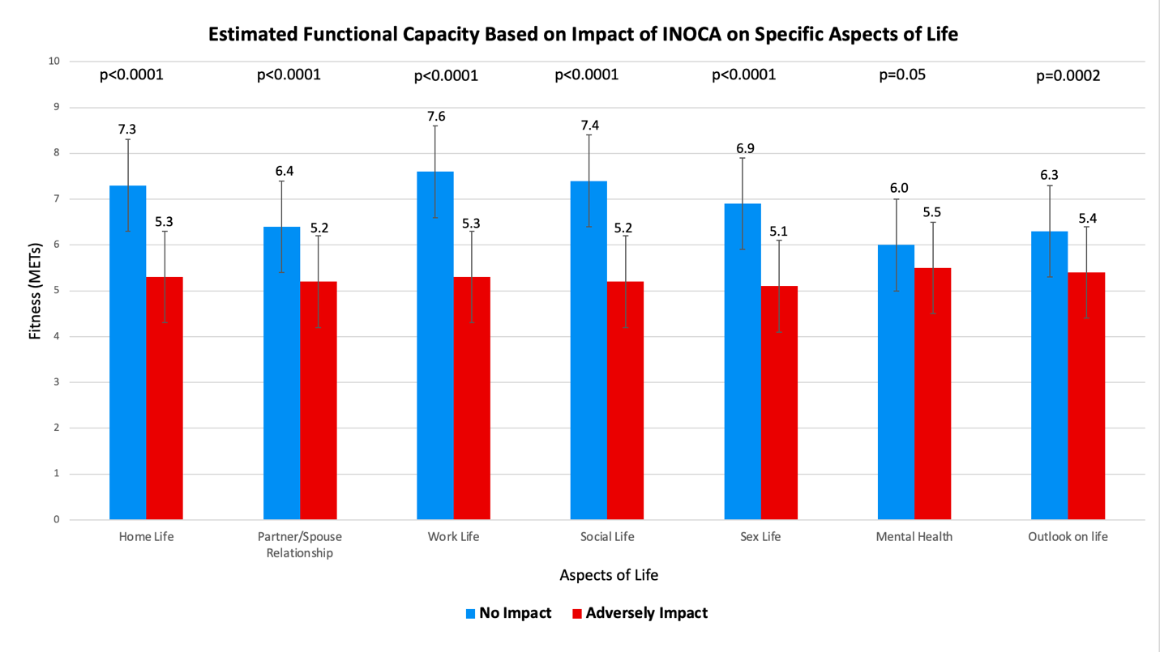

Figure 2.

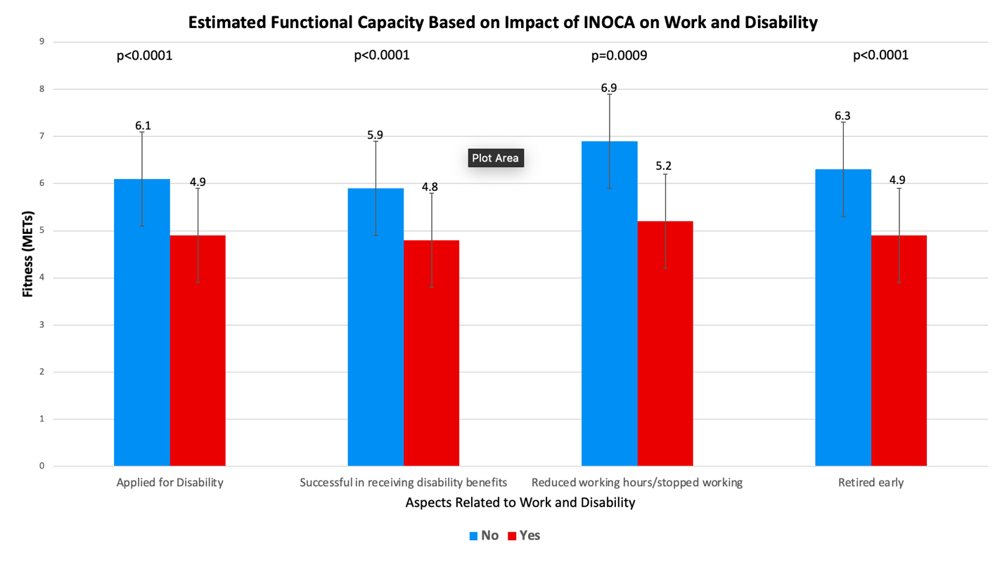

Figure 3.
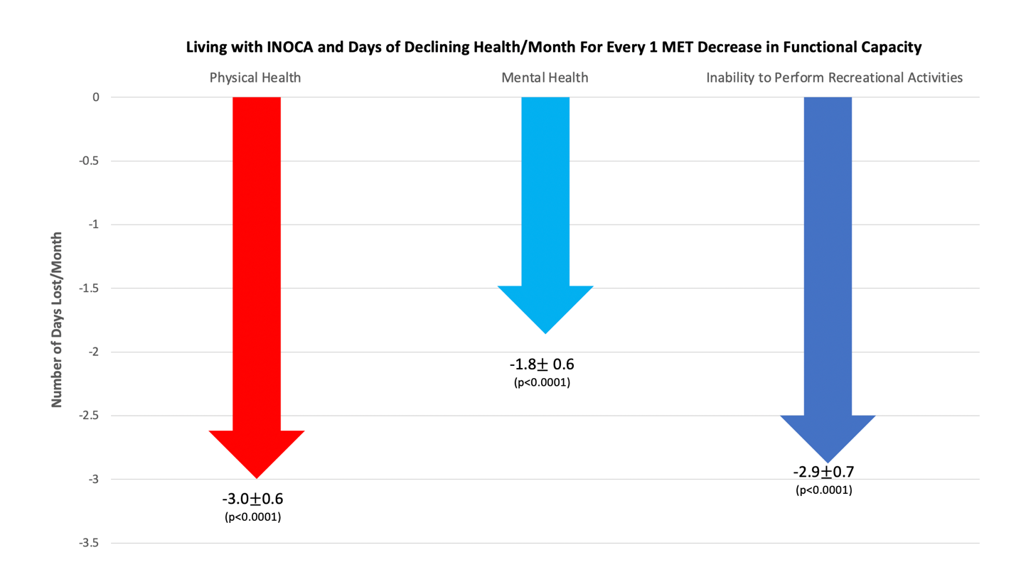

Central Figure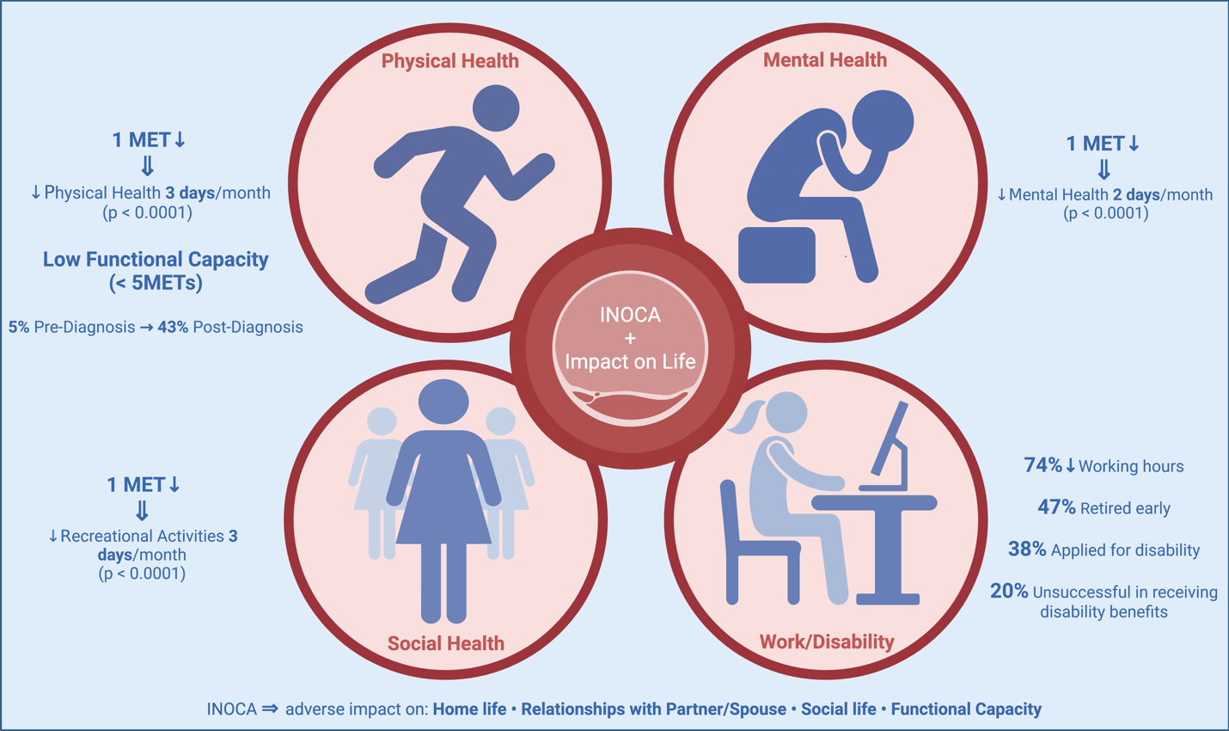

Appendix 1. Survey

INOCA Survey

We are interested in how living with INOCA (Ischemia with No Obstructive Coronary Arteries) has impacted your medical care, health and life. Your responses will remain anonymous. Thank you for your time in responding to our questions.

Question 1

Do you have Ischemia with No Obstructive Coronary Arteries (INOCA)?
Yes
¨ No
(if No, no further questions)

Question 2

Would you say that your general health is:
Excellent
¨ Very Good
¨ Good
¨ Fair
¨ Poor

Question 3

Which of the following forms of INOCA were you diagnosed with? (Check all that apply)
¨ Coronary Microvascular Dysfunction
¨ Coronary Artery Spasm
¨ Nonobstructive Atherosclerosis
¨ Heart Failure with Preserved Ejection Fraction (HFpEF)
¨ Takutsubo’s Syndrome (also known as Stress Cardiomyopathy/”Broken Heart” Syndrome)
¨ I was not given a diagnosis aside from INOCA
¨ I don’t know

Question 4

How long did it take from the onset of your symptoms to getting a diagnosis of INOCA?
¨ Less than 1 months
¨ 1-12 months
¨ 1-3 years
¨ 3-5 years
¨ 5-10 years
¨ >10 years

Question 5

Prior to your diagnosis of INOCA were you ever told your symptoms were due to Reflux or GERD (gastroesophageal reflux disease)?
¨ Yes
¨ No

Question 6

Prior to your diagnosis of INOCA did you undergo an endoscopy to assess for reflux/GERD based on your symptoms?
¨ Yes
¨ No

Question 7

Prior to your diagnosis of INOCA were you ever told your symptoms were not cardiac?
¨ Yes
¨ No

Question 8

Prior to your diagnosis of INOCA were you seen in the Emergency Room/A&E for your symptoms of INOCA and discharged without any treatment?
¨ Yes
¨ No

Question 9

Prior to your onset of symptoms of INOCA, which of the following could you previously do? (Check All That Apply)
¨ Take Care of Yourself (ie. dress, eat, bathe, use toilet)
¨ Walking Indoors
¨ Walk 200 yards (182 meters) on level ground
¨ Climb a flight of stairs or walk up a hill
¨ Run a Short Distance
¨ Do light work around the house (ie. dusting, washing dishes)
¨ Do moderate work around the house (ie. vacuuming, sweeping floors, carrying groceries)
¨ Do heavy work around the house (ie. scrubbing floors, lifting or moving heavy furniture)
¨ Do yardwork (ie. raking leaves, weeding, pushing a lawn mower)
¨ Have Sexual Relations
¨ Participate in Moderate Recreational Activities (ie. golf, bowling, doubles tennis, throwing baseball, kicking football)
¨ Participate in Strenuous Sports (ie. swimming, singles tennis, football, basketball, skiing)

Question 10

With your diagnosis of INOCA, which of the following can you currently do? (Check All That Apply)
¨ Take Care of Yourself (ie. dress, eat, bathe, use toilet)
¨ Walking Indoors
¨ Climb a flight of stairs or walk up a hill
¨ Run a Short Distance
¨ Do light work around the house (ie. dusting, washing dishes)
¨ Do moderate work around the house (ie. vacuuming, sweeping floors, carrying groceries)
¨ Do heavy work around the house (ie. scrubbing floors, lifting or moving heavy furniture)
¨ Do yardwork (ie. raking leaves, weeding, pushing a lawn mower)
¨ Have Sexual Relations
¨ Participate in Moderate Recreational Activities (ie. golf, bowling, doubles tennis, throwing baseball, kicking football)
¨ Participate in Strenous Sports (ie. swimming, singles tennis, football, basketball, skiing)

Question 11

How many consultants/specialists/doctors did you see prior to your diagnosis of INOCA?
¨ 0 (meaning diagnosed right away)
¨ 1-2
¨ 3-5
¨ >5

Question 12

How many cardiologists have you consulted for treatment of your INOCA?
¨ 1
¨ 2
¨ 3-5
¨ >5

Question 13

Prior to your diagnosis of INOCA were you ever referred to a psychiatrist for your symptoms or was such a referral suggested to you by your doctor?
¨ Yes
¨ No

Question 14

Have you ever been started on, or been recommended to start, an antidepressant or antianxiety medication for your INOCA symptoms?
¨ Yes
¨ No

Question 15

Are you under the care of a specialist in INOCA?
¨ Yes
¨ No
¨ Awaiting Initial Appointment
¨ I Don’t Know

Question 16

If you under the care of a specialist in INOCA, how did you get to them?
¨ Self-Referred (I found the specialist myself)
¨ My Family Doctor/GP referred me to the INOCA specialist
¨ Another cardiologists referred me to the INOCA Specialist
¨ Another doctor referred me to the INOCA Specialist
¨ AI have never been under the care of an INOCA Specialist

Question 17

How many years have you had symptoms of INOCA for?
¨ Less than 1 year
¨ 1-5 years
¨ 5-10 years
¨ 10-20 years
¨ >20 years

Question 17

At What Age were you Diagnosed with INOCA?
¨ Less than 30
¨ 30-40
¨ 40-50
¨ 50-60
¨ 60-70
¨ >70 years

Question 18

Have you ever had a Heart Attack?
¨ Yes
¨ No
¨ Unsure

Question 19

Have you ever been told that although your symptoms of INOCA may be unpleasant, you cannot die from it and cannot have a heart attack?
¨ Yes
¨ No

Question 20

Have you ever had to call an Ambulance for your symptoms of INOCA?
¨ Yes
¨ No

Question 21

When you have called an Ambulance for your symptoms of INOCA, have you experienced any of the following? (choose all that apply)
¨ Taken to the Hospital and Cardiac Monitor Attached and ECG performed
¨ No Ambulance dispatched
¨ Assessed by Ambulance Crew but not taken to the hospital
¨ Taken to the Hospital but No Cardiac Monitor or ECG performed despite symptoms
¨ Ambulance Crew Understood the Diagnosis of INOCA
¨ Ambulance Crew DID NOT Understand the Diagnosis of INOCA
¨ I have never had to call an Ambulance
¨ I do not call the Ambulance because they do not take my symptoms seriously

Question 22

As a patient living with INOCA, do you know when to call for an ambulance or go to the hospital for your INOCA symptoms?
Yes
¨ No

Question 23

Which diagnostic tests have you had related to your INOCA symptoms? (Check all that apply)
¨ ECG
¨ Echocardiogram (also called Echo)
¨ Exercise Stress Test
¨ Stress Echocardiogram (Also called Stress Echo)
¨ CT Angiogram
¨ Cardiac MRI
¨ PET Scan
¨ Cardiac Catheterization (Also called Angiogram)
¨ Cardiac Catheterization (Also called Angiogram) with Acetylcholine Testing
¨ None of the Above

Question 24

Which symptoms do you experience related to INOCA? (Check all that apply)
¨ Chest Pain/Chest Pressure/Chest Discomfort
¨ Fatigue/Exhaustion
¨ Shortness of Breath
¨ Back Pain
¨ Shoulder or Arm Pain or Pressure
¨ Neck/Jaw Pain
¨ Palpitations/Racing of the heart
¨ Sweats
¨ Lightheadedness, Dizzyness
¨ Nausea, reflux-like symptoms
¨ Confusion, Brain Fog
¨ Vision Changes
¨ Other

Question 25

Have You Ever Left any Doctor’s Appointment and come away thinking they did not understand INOCA?
All the Time
¨ Often
¨ Occasionally
¨ Never

Question 26

Have You Ever Had to Stop Working because of INOCA?
¨ Yes
¨ No

Question 27

Did You Had to Retire Early because of INOCA?
¨ Yes
¨ No

Question 28

Have You Ever Had to Reduce Working Hours because of INOCA?
¨ Yes
¨ No

Question 29

Have You Ever Had to Change Jobs or Roles for a Less Stressful Position because of your symptoms from INOCA?
¨ Yes
¨ No

Question 30

Have You Ever Had to Change Jobs or Roles that Resulted in Lower Pay Because of your Symptoms with INOCA?
¨ Yes
¨ No

Question 31

Have You Ever Had to Apply for Disability Benefits because of your symptoms with INOCA?
¨ Yes
¨ No

Question 32

If You Had to Apply for Disability Benefits because of your symptoms with INOCA, was your application successful?
¨ Yes
¨ No
¨ I have never applied for disability benefits

Question 33

Do You Ever Worry about being home alone?
¨ Yes
¨ No

Question 34

Do You Ever Worry about going out alone?
¨ Yes
¨ No

Question 35

Do You Drive?
¨ Yes,
¨ No, stopped due to INOCA symptoms
¨ Never Drove

Question 36

Did you have any of the following conditions during pregnancy? (check all that apply)
Hypertension During pregnancy
¨ Preeclampsia or Eclampsia
¨ Gestational Diabetes
Preterm Delivery
¨ Miscarriage
¨ Does Not Apply To Me, I have Never Been Pregnant

Question 37

Do you have any of the following conditions? (check all that apply)
Migraines/ Frequent Headaches
¨ Raynaud’s
¨ Thyroid Disorder
Rheumatoid Arthritis
¨ Lupus/ Systemic Lupus Erythematosus
¨ Other Autoimmune Disorder
¨ History of Stroke
¨ Kidney Disease
¨ None

Question 38

Do You Have Any of the Following Triggers for Your Symptoms of INOCA?
Stress
Exercise/Exertion
¨ Excitement or High Emotional State/Anger
¨ Cold Weather
¨ Change in Temperature or Weather Change
¨ Triggered during Menstruation
¨ Other
¨ No Known Triggers

Question 39

Did Your Symptoms Change at Menopause?
Yes
¨ No
¨ Unsure
¨ Have not Undergone Menopause Yet
¨ Male (Not Applicable)

Question 40

Has INOCA Adversely Affected Your Home Life?
Yes
¨ No

Question 41

Has INOCA Adversely Affected Your Relationship with Your Partner/Spouse?
Yes
¨ No
¨ Not applicable

Question 42

Has INOCA Adversely Affected Your Work Life?
Yes
¨ No

Question 43

Has INOCA Adversely Affected Your Social Life?
Yes
¨ No

Question 44

Has INOCA Adversely Affected Your Sex Life?
Yes
¨ No
¨ Not applicable

Question 45

Has INOCA Adversely Affected Your Mental Health?
Yes
¨ No

Question 46

Has INOCA Negatively Affected Your Outlook on Life?
Yes
¨ No

Question 47

Thinking about your physical health, which includes physical illness and injury, for how many days during the past 30 days was your physical health not good?
__ (no number >30 will be accepted)

Question 48

Thinking about your mental health, which includes stress, depression and problems with emotions, for how many days during the past 30 days was your mental health not good?
__(no number >30 will be accepted)

Question 49

During the past 30 days, for how many days did poor physical health or mental health, keep you from doing your usual activities, such as self-care, work or recreation?
__(no number >30 will be accepted)

IF YOU WOULD LIKE TO SHARE ANY OTHER COMMENTS WITH YOU ABOUT YOUR EXPERIENCE LIVING WITH INOCA, PLEASE FEEL FREE TO WRITE ANY COMMENTS HERE:

