Ai
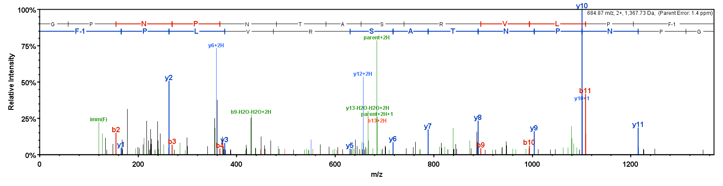
Aii
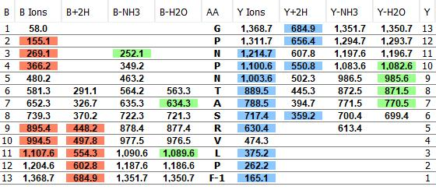

Supplementary Figure 4A (i) Mass spectrum derived from MS/MS analysis of the peptide ArKP1 (GPNPNTASRVLPF-NH₂) present in a methanol acetic acid extract of radial nerve cords from Asterias rubens. (ii) MS/MS data is shown with the b series of fragment ions in red, fragment ions from the y series in blue, and other identified fragment ions in green.

Bi
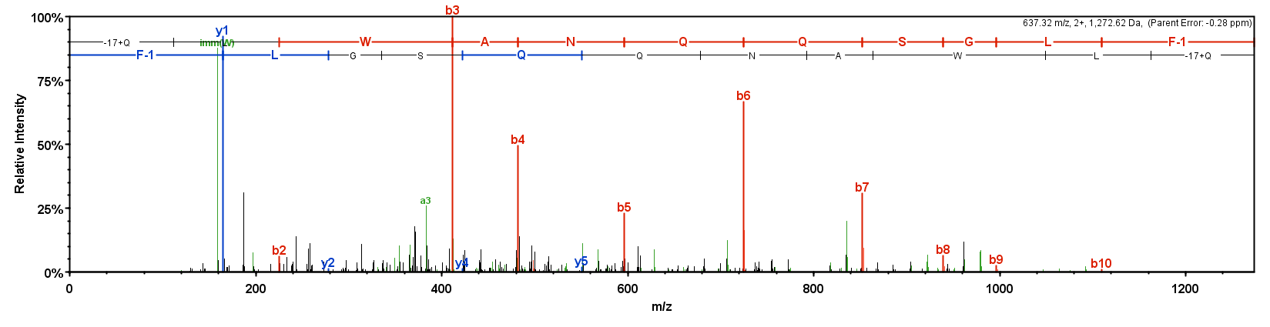
Bii
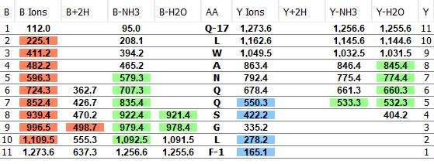

Supplementary Figure 4B (i) Mass spectrum derived from MS/MS analysis of the peptide ArKP2.1 (ArKP2.1; pQLWANQQSGLF-NH₂) present in a methanol acetic acid extract of radial nerve cords from Asterias rubens. (ii) MS/MS data is shown with the b series of fragment ions in red, fragment ions from the y series in blue, and other identified fragment ions in green.

Ci
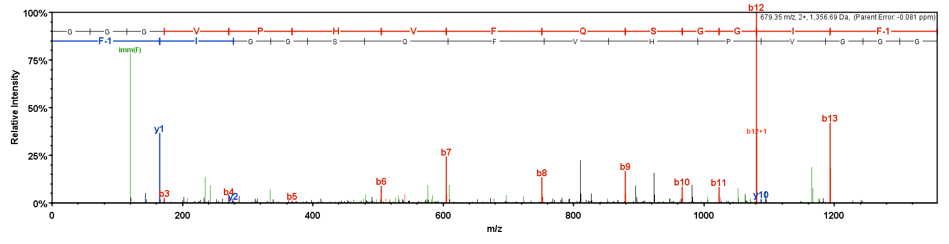
Cii
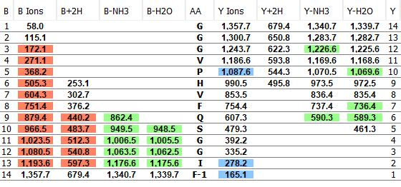

Supplementary Figure 4C (i) Mass spectrum derived from MS/MS analysis of the peptide ArKP2.2 (ArKP2.2; GGGVPHVFQSGGIF-NH₂) present in a methanol acetic acid extract of radial nerve cords from Asterias rubens. (ii) MS/MS data is shown with the b series of fragment ions in red, fragment ions from the y series in blue, and other identified fragment ions in green.

Di
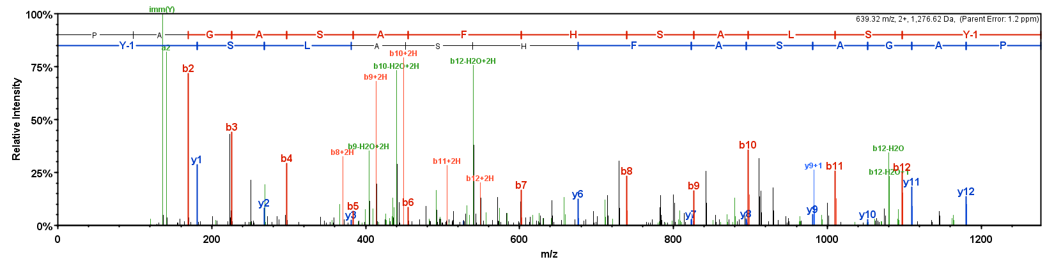
Dii
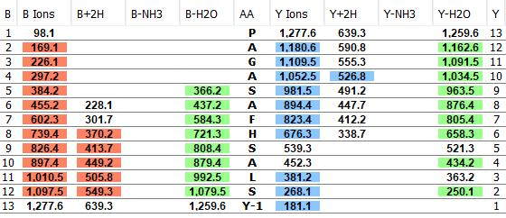

Supplementary Figure 4D (i) Mass spectrum derived from MS/MS analysis of the peptide ArS1.1 (PAGASAFHSALSY-NH₂) present in a methanol acetic acid extract of radial nerve cords from Asterias rubens. (ii) MS/MS data is shown with the b series of fragment ions in red, fragment ions from the y series in blue, and other identified fragment ions in green.

Ei
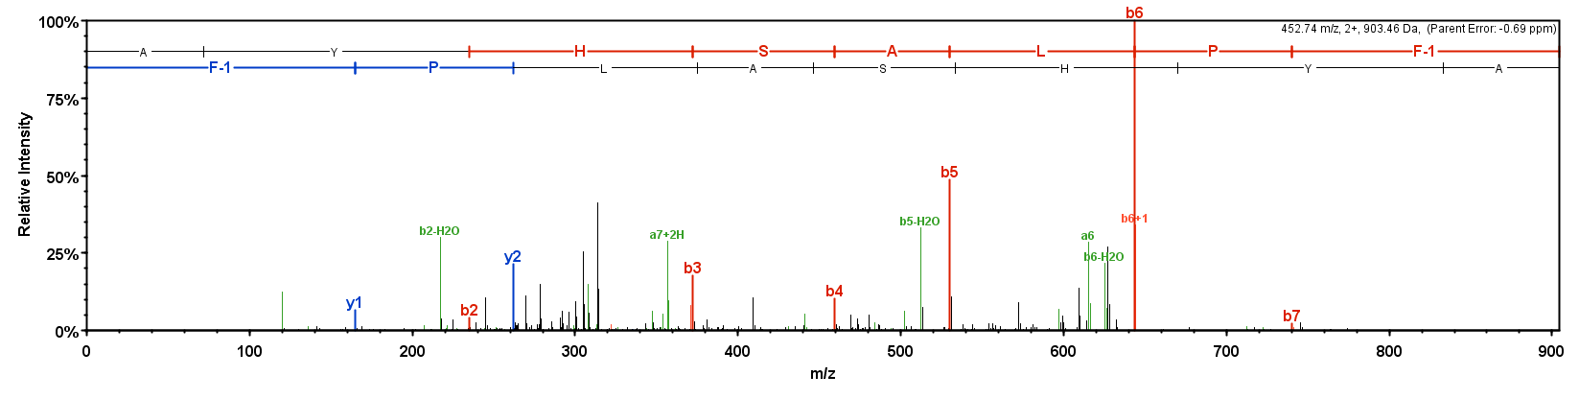
Eii
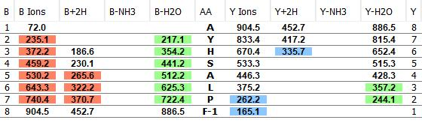

Supplementary Figure 4E (i) Mass spectrum derived from MS/MS analysis of the peptide ArS1.2 (AYHSALPF-NH₂) present in a methanol acetic acid extract of radial nerve cords from Asterias rubens. (ii) MS/MS data is shown with the b series of fragment ions in red, fragment ions from the y series in blue, and other identified fragment ions in green.

Fi
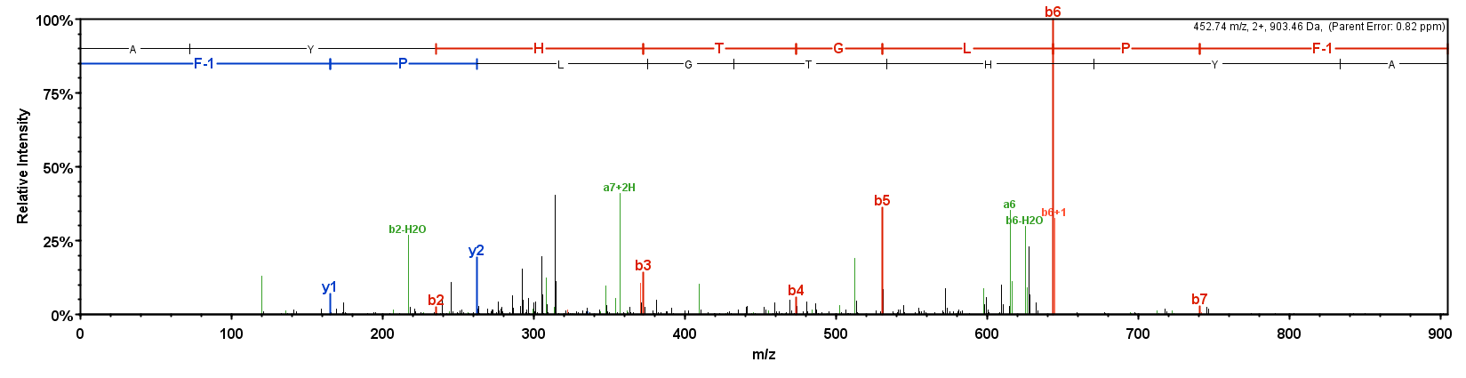
Fii
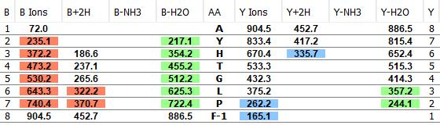

Supplementary Figure 4F (i) Mass spectrum derived from MS/MS analysis of the peptide ArS1.3 (AYHTGLPF-NH₂) present in a methanol acetic acid extract of radial nerve cords from Asterias rubens. (ii) MS/MS data is shown with the b series of fragment ions in red, fragment ions from the y series in blue, and other identified fragment ions in green.

Gi
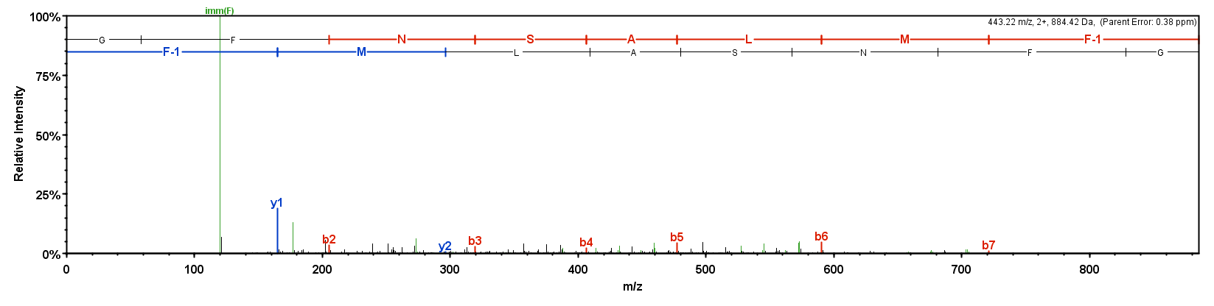
Gii
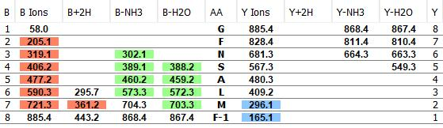

Supplementary Figure 4G (i) Mass spectrum derived from MS/MS analysis of the peptide ArS1.4 (GFNSALMF-NH₂) present in a methanol acetic acid extract of radial nerve cords from Asterias rubens. (ii) MS/MS data is shown with the b series of fragment ions in red, fragment ions from the y series in blue, and other identified fragment ions in green.

Hi
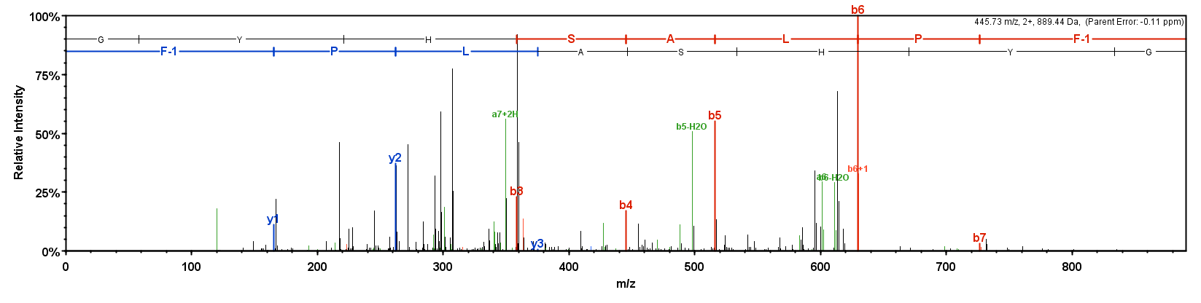
Hii
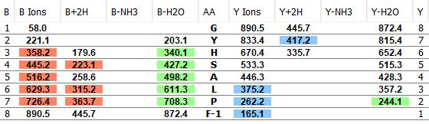

Supplementary Figure 4H (i) Mass spectrum derived from MS/MS analysis of the peptide ArS1.6 (GYHSALPF-NH₂) present in a methanol acetic acid extract of radial nerve cords from Asterias rubens. (ii) MS/MS data is shown with the b series of fragment ions in red, fragment ions from the y series in blue, and other identified fragment ions in green.

Ii
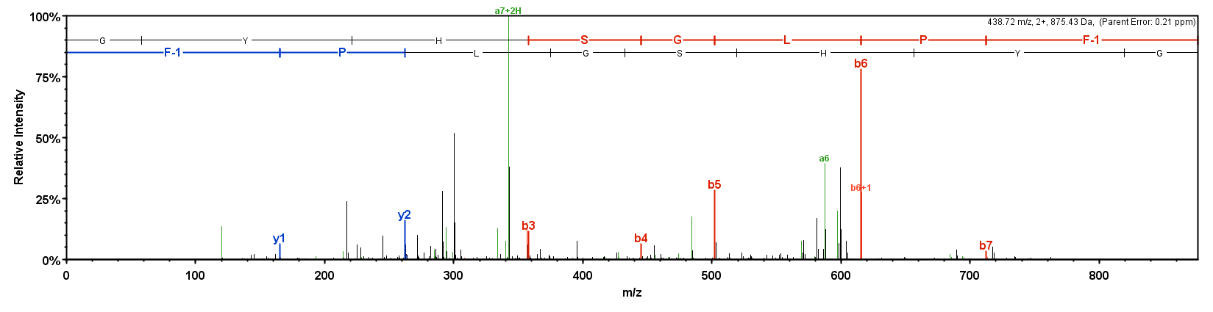
Iii
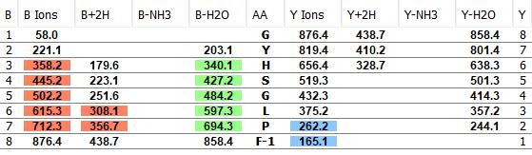

Supplementary Figure 4I (i) Mass spectrum derived from MS/MS analysis of the peptide ArS1.7 (GYHSGLPF-NH₂) present in a methanol acetic acid extract of radial nerve cords from Asterias rubens. (ii) MS/MS data is shown with the b series of fragment ions in red, fragment ions from the y series in blue, and other identified fragment ions in green.

Ji
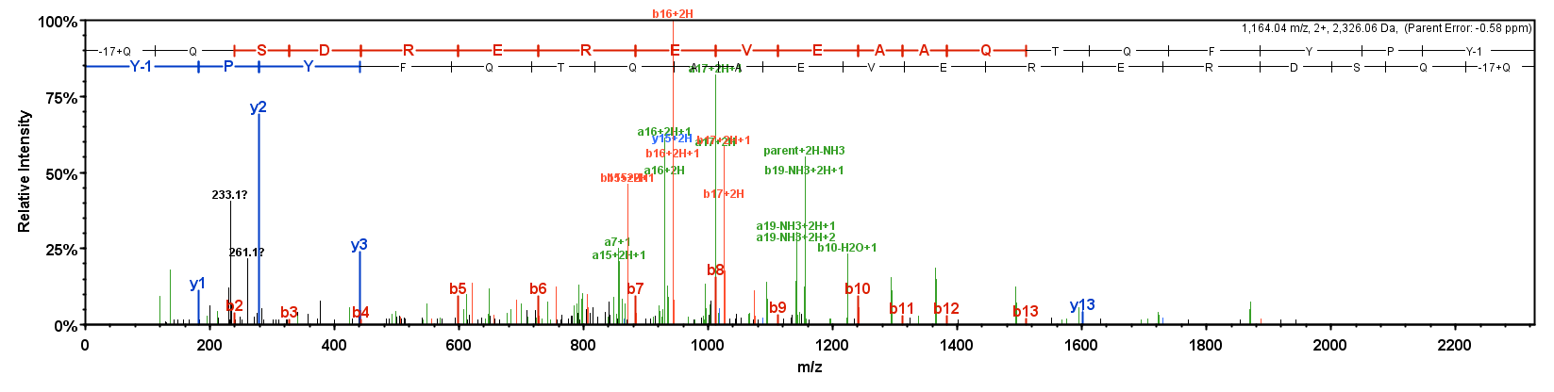
Jii
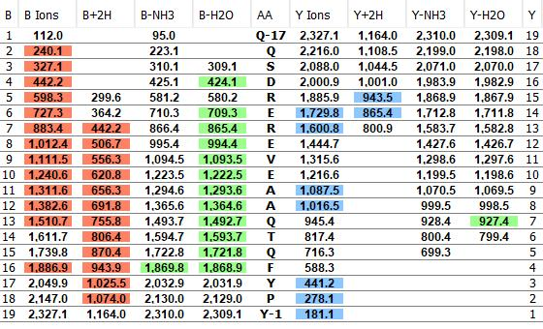

Supplementary Figure 4J (i) Mass spectrum derived from MS/MS analysis of the peptide ArS2.1 (pQQSDREREVEAAQTQFYPY-NH₂) present in a methanol acetic acid extract of radial nerve cords from Asterias rubens. (ii) MS/MS data is shown with the b series of fragment ions in red, fragment ions from the y series in blue, and other identified fragment ions in green.

Ki
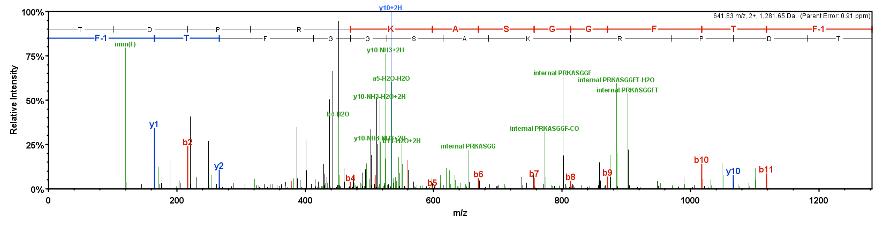
Kii
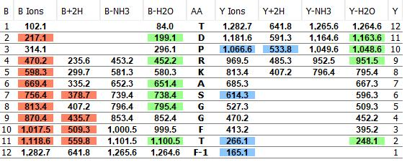

Supplementary Figure 4K (i) Mass spectrum derived from MS/MS analysis of the peptide ArS2.2 (TDPRKASGGFTF-NH₂) present in a methanol acetic acid extract of radial nerve cords from Asterias rubens. (ii) MS/MS data is shown with the b series of fragment ions in red, fragment ions from the y series in blue, and other identified fragment ions in green.

Li
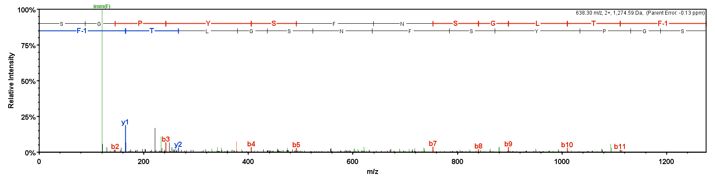
Lii
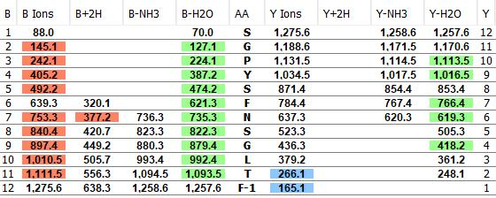

Supplementary Figure 4L (i) Mass spectrum derived from MS/MS analysis of the peptide ArS2.3 (SGPYSFNSGLTF-NH₂) present in a methanol acetic acid extract of radial nerve cords from Asterias rubens. (ii) MS/MS data is shown with the b series of fragment ions in red, fragment ions from the y series in blue, and other identified fragment ions in green.

Mi
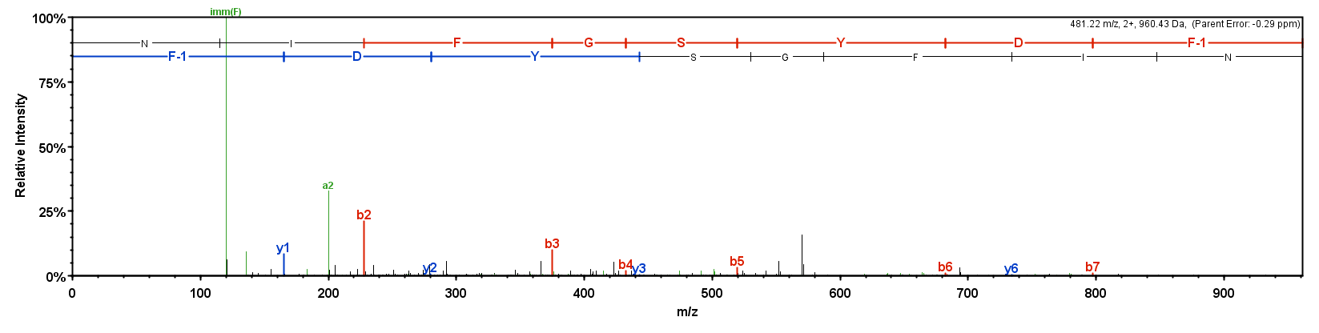
Mii
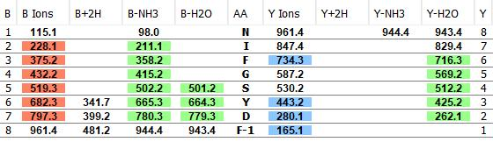

Supplementary Figure 4M (i) Mass spectrum derived from MS/MS analysis of the peptide ArS2.4 (NIFGSYDF-NH₂) present in a methanol acetic acid extract of radial nerve cords from Asterias rubens. (ii) MS/MS data is shown with the b series of fragment ions in red, fragment ions from the y series in blue, and other identified fragment ions in green.

Ni
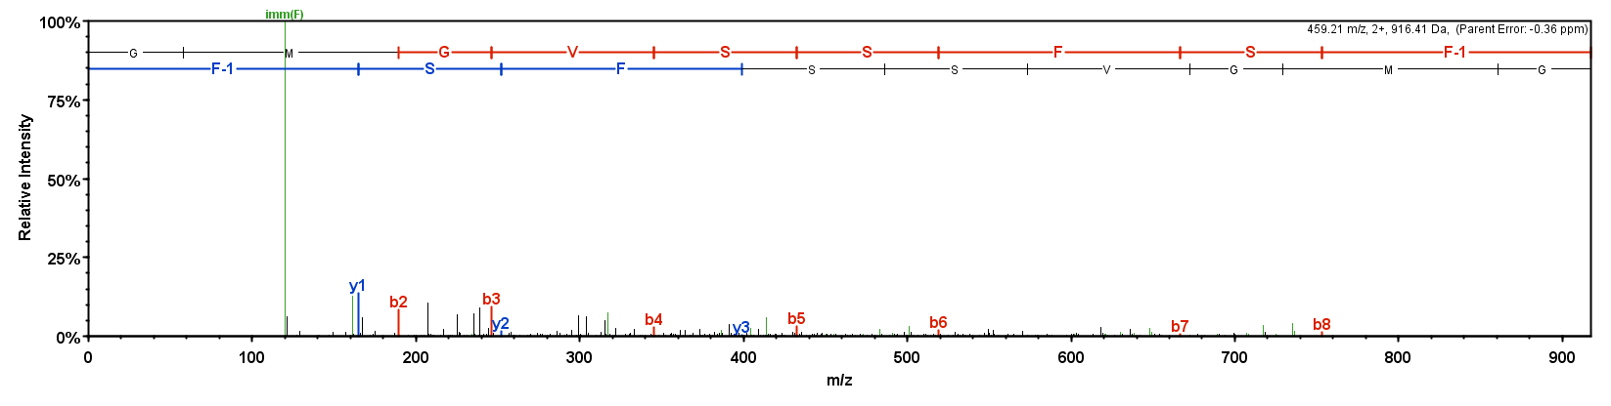
Nii
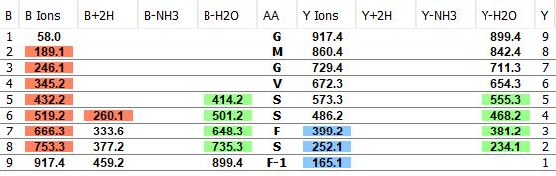

Supplementary Figure 4N (i) Mass spectrum derived from MS/MS analysis of the peptide ArS2.6 (GMGVSSFSF-NH₂) present in a methanol acetic acid extract of radial nerve cords from Asterias rubens. (ii) MS/MS data is shown with the b series of fragment ions in red, fragment ions from the y series in blue, and other identified fragment ions in green.

Oi
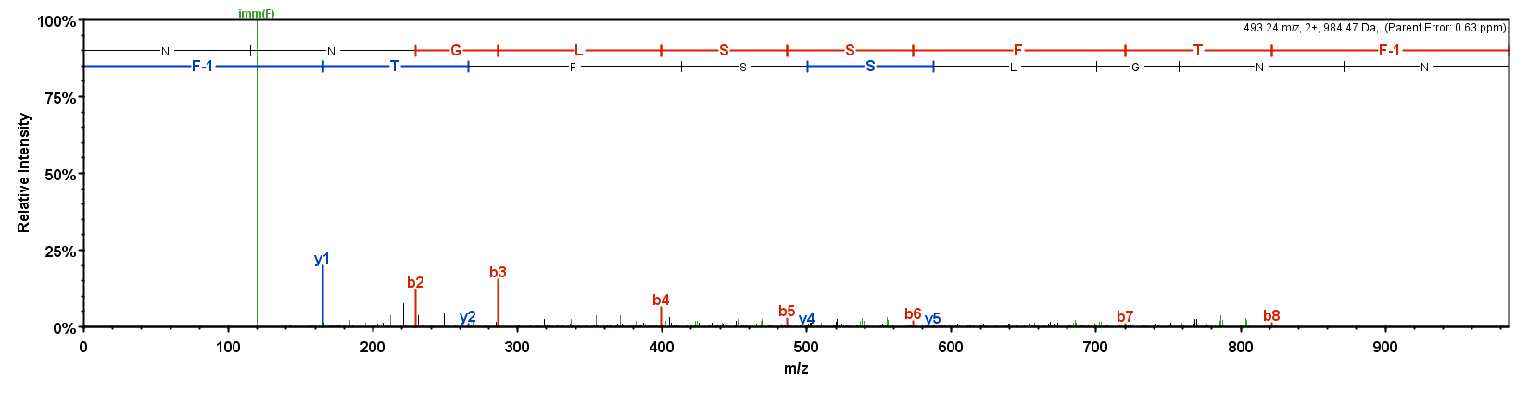
Oii
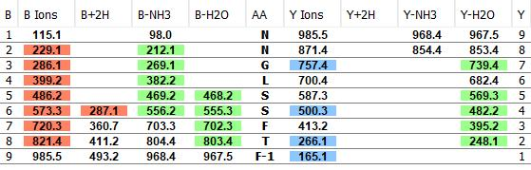

Supplementary Figure 4O (i) Mass spectrum derived from MS/MS analysis of the peptide ArS2.8 (NNGLSSFTF-NH₂) present in a methanol acetic acid extract of radial nerve cords from Asterias rubens. (ii) MS/MS data is shown with the b series of fragment ions in red, fragment ions from the y series in blue, and other identified fragment ions in green.

