SUPPLEMENTARY FILE 2.
Fig S1. Effect of rotavirus UMV introduction on rotavirus incidence per year per region. Time-varying incidence rate ratios for age group of 3-year-olds.
Fig S2. Effect of rotavirus UMV introduction on rotavirus incidence per year per region. Time-varying incidence rate ratios for age group of 4-year-olds
Fig S3. Effect of rotavirus UMV introduction on rotavirus incidence per year per region. Time-varying incidence rate ratios for age group of 5 to 14-year-olds.
Fig S4. Effect of rotavirus UMV introduction on rotavirus incidence per year per region.
Time-varying incidence rate ratios for age group of 15 to 44-year-olds.
Fig S5. Effect of rotavirus UMV introduction on rotavirus incidence per year per region.
Time-varying incidence rate ratios for age group of 45 to 64-year-olds.
Fig S6. Effect of rotavirus UMV introduction on rotavirus incidence per year per region. Time-varying incidence rate ratios for age group above 65-year-olds.

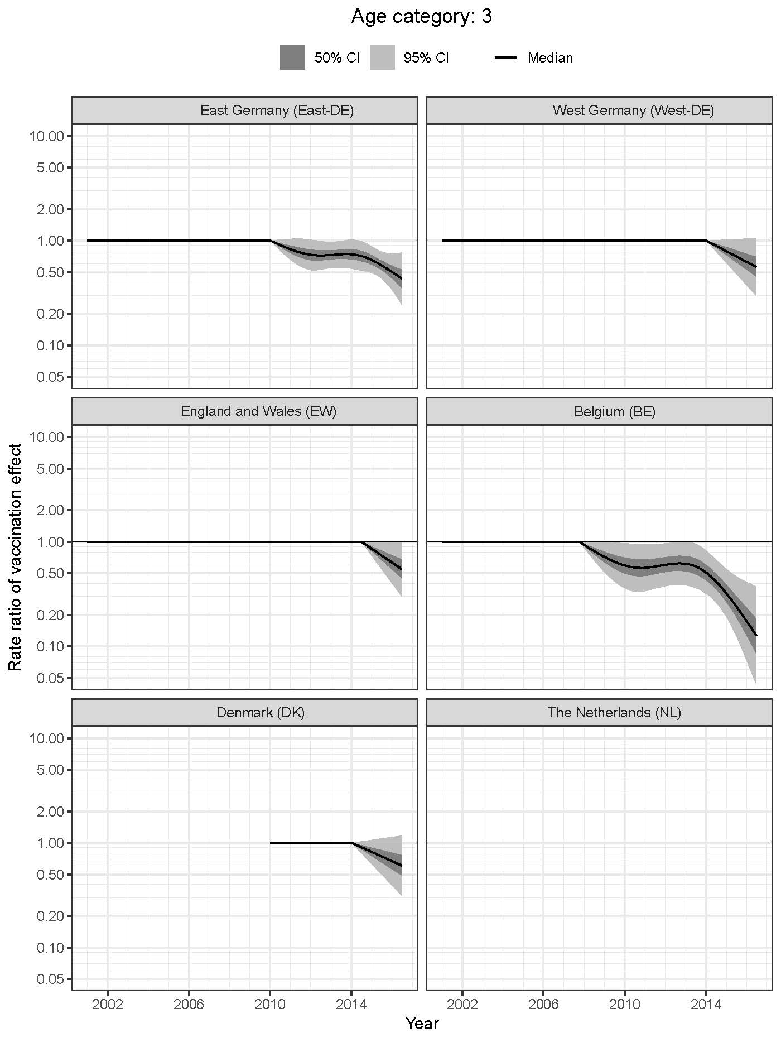
Fig S1. Effect of rotavirus UMV introduction on rotavirus incidence per year per region. Time-varying incidence rate ratios for age group of 3-year-olds.

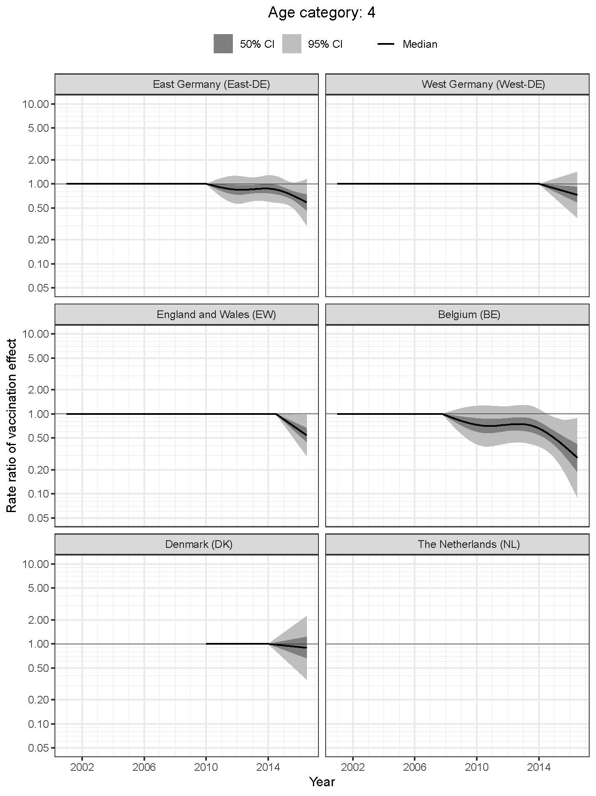

Fig S2. Effect of rotavirus UMV introduction on rotavirus incidence per year per region. Time-varying incidence rate ratios for age group of 4-year-olds.

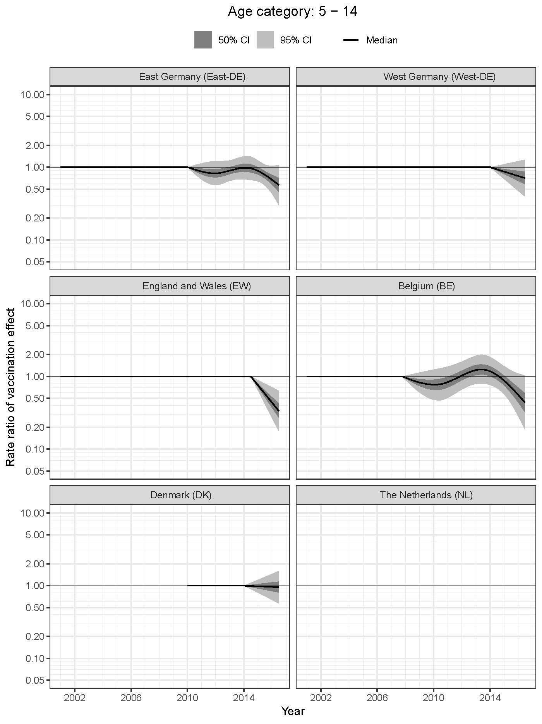

Fig S3. Effect of rotavirus UMV introduction on rotavirus incidence per year per region. Time-varying incidence rate ratios for age group of 5 to 14-year-olds.

Fig S4. Effect of rotavirus UMV introduction on rotavirus incidence per year per region.
Time-varying incidence rate ratios for age group of 15 to 44-year-olds.

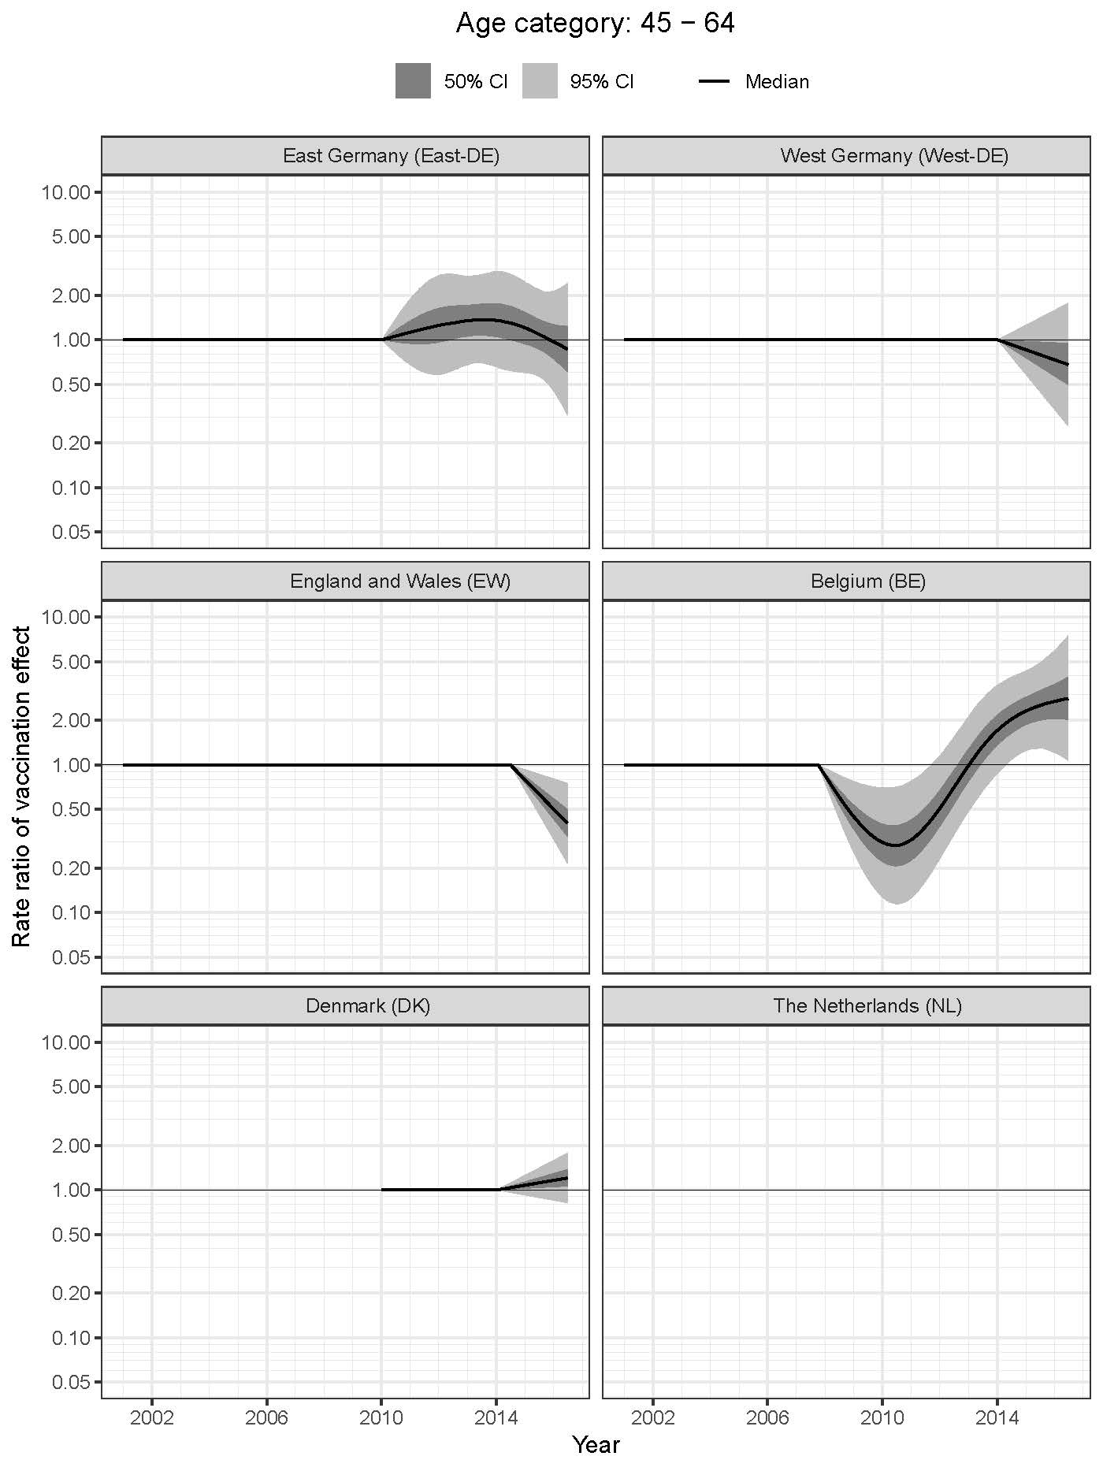
Fig S5. Effect of rotavirus UMV introduction on rotavirus incidence per year per region.
Time-varying incidence rate ratios for age group of 45 to 64-year-olds.

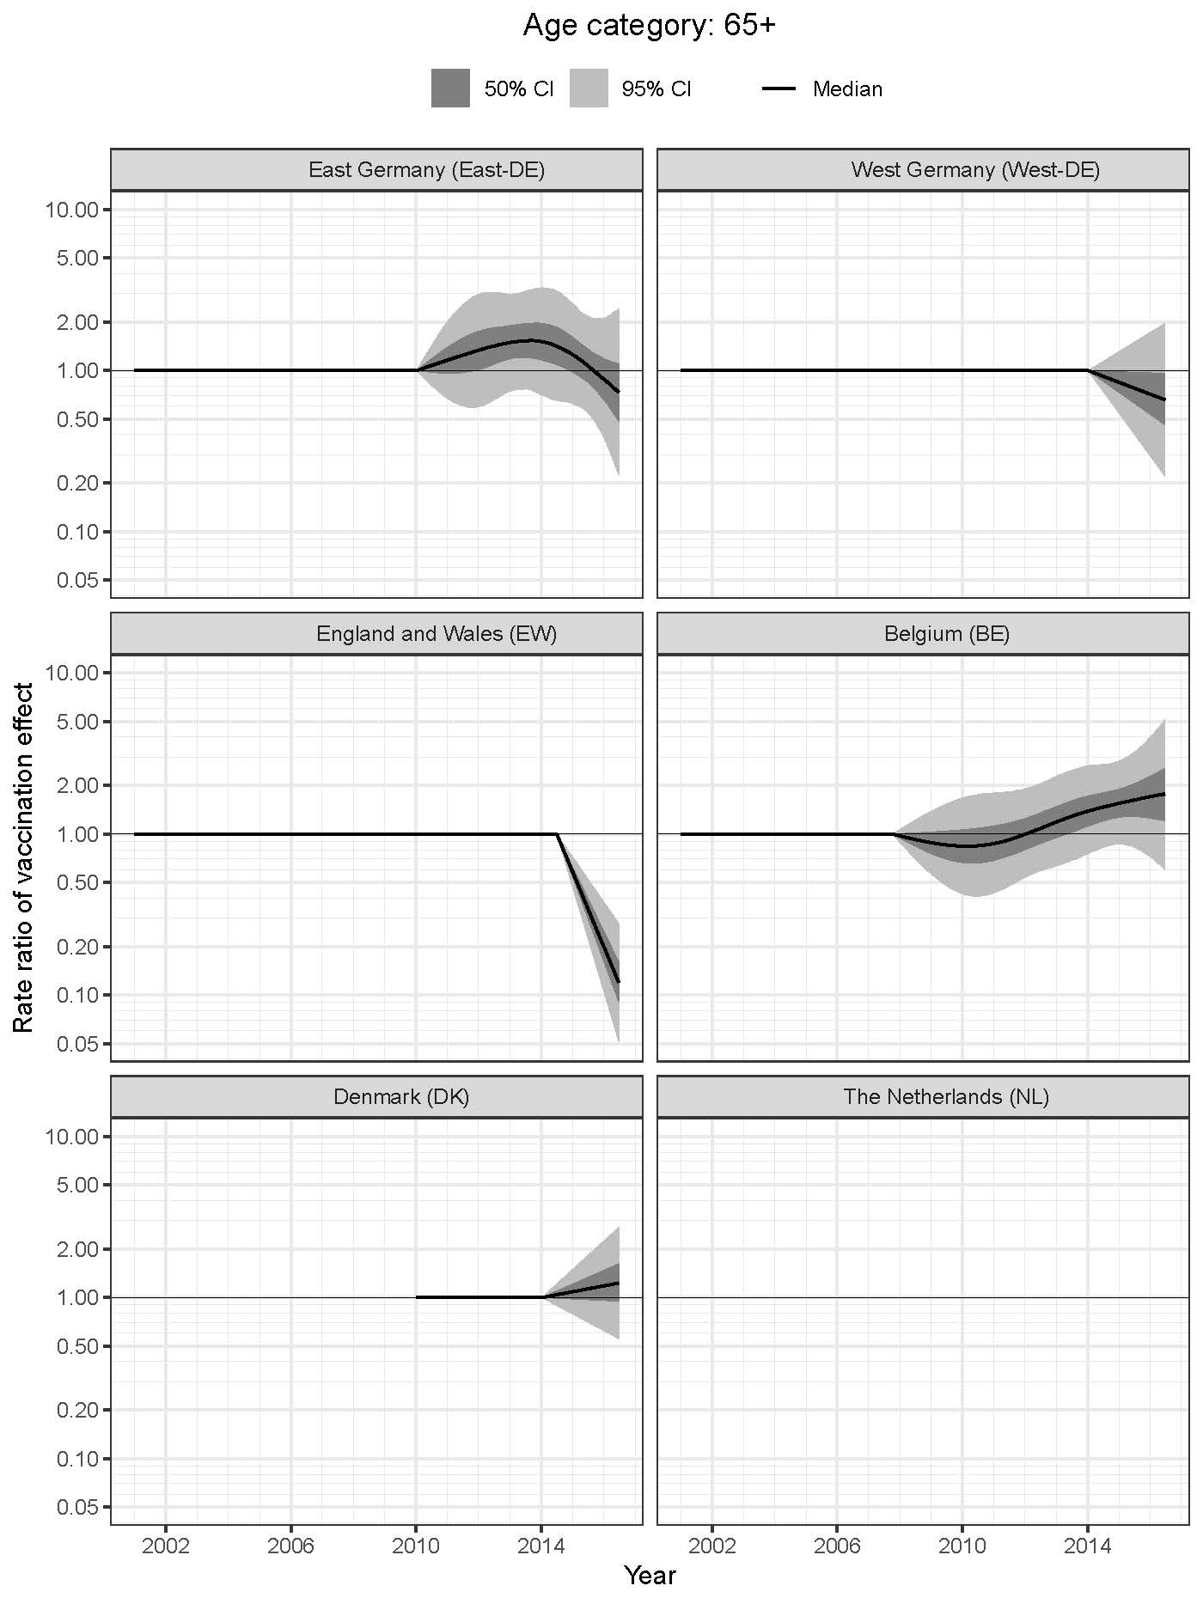
Fig S6. Effect of rotavirus UMV introduction on rotavirus incidence per year per region. Time-varying incidence rate ratios for age group above 65-year-olds.

