Increased Monocyte Distribution Width (MDW) in COVID-19 and sepsis arises from a complex interplay of altered monocyte cellular size and subset frequency.

Tables and Figures

Tables
Table 1: Distribution FBC and monocyte volumetric parameters across groups.
 | Controls (n=11) | Covid (n=15) | Sepsis (n=26) | p value
WCC
Mean (SD) | 5.8 (0.8) | 11.4 (4.2) | 13.6 (8.8) | p¹<0.001
Med. (IQR) | 5.9 (5.2, 6.4) | 10.4 (8.0, 13.6) | 11.3 (8.4, 15.9) | p²=0.745
Missing | 2 | 0 | 0
Neu.
Mean (SD) | 3.3 (0.6) | 8.8 (4.0) | 11.7 (8.3) | p¹<0.001
Med.(IQR) | 3.5 (2.6, 3.7) | 8.0 (5.4, 10.9) | 10.0 (6.1, 13.5) | p²=0.330
Missing | 2 | 0 | 0
Lym.
Mean (SD) | 1.9 (0.5) | 1.6 (0.8) | 1.0 (0.5) | p¹<0.001
Med. (IQR) | 1.7 (1.7, 2.1) | 1.5 (1.0, 2.1) | 1.0 (0.5, 1.2) | p²=0.012
Missing | 2 | 0 | 0
Monocytes
Mean (SD) | 0.4 (0.1) | 0.9 (0.4) | 0.9 (0.6) | p¹<0.001
Med. (IQR) | 0.4 (0.3, 0.4) | 0.8 (0.6, 1.1) | 0.6 (0.5, 1.2) | p²=0.734
Missing | 0 | 0 | 0
MMV
Mean (SD) | 164.9 (5.0) | 178.6 (11.7) | 184.0 (14.1) | p¹<0.001
Med. (IQR) | 163.0 (162.0, 167.0) | 175.0 (171.0, 181.5) | 181.0 (173.0, 190.5) | p²=0.171
Missing | 2 | 0 | 0
FSC-mean
Mean (SD) | 87.7 (3.8) | 90.0 (2.6) | 89.1 (5.1) | p¹=0.145
Med. (IQR) | 87.8 (86.2, 88.0) | 90.3 (88.6, 91.3) | 89.4 (85.7, 92.5) | p²=0.715
MDW
Mean (SD) | 16.0 (1.2) | 23.0 (4.3) | 26.5 (6.4) | p¹<0.001
Med. (IQR) | 16.2 (15.3, 16.3) | 23.8 (20.0, 24.8) | 24.4 (21.3, 30.9) | p²=0.130
FSC-SD
Mean (SD) | 9.1 (0.9) | 8.8 (0.6) | 9.7 (1.2) | p¹=0.021
Med. (IQR) | 9.1 (8.4, 9.8) | 8.7 (8.4, 9.1) | 9.5 (8.8, 10.5) | p²=0.006
The table shows cell counts in 109 cells/L. UniCel DxH 900 parameters (MMV and MDW) in units and CytoFLEX parameters (FSC-mean and FSC-SD) per 10000 Units. p-values correspond to the Kruskal-Wallis test. p1 corresponds to the test assessing differences across all groups. p2 corresponds to the test comparing COVID-19 versus sepsis. WCC: White cell counts. Neu: neutrophils, Lym: Lymphocytes. SD: Standard deviation. IQR: Interquartile range. Med: Median.

Figures
Figure 1: Flow cytometry (CytoFLEX) gating strategy.
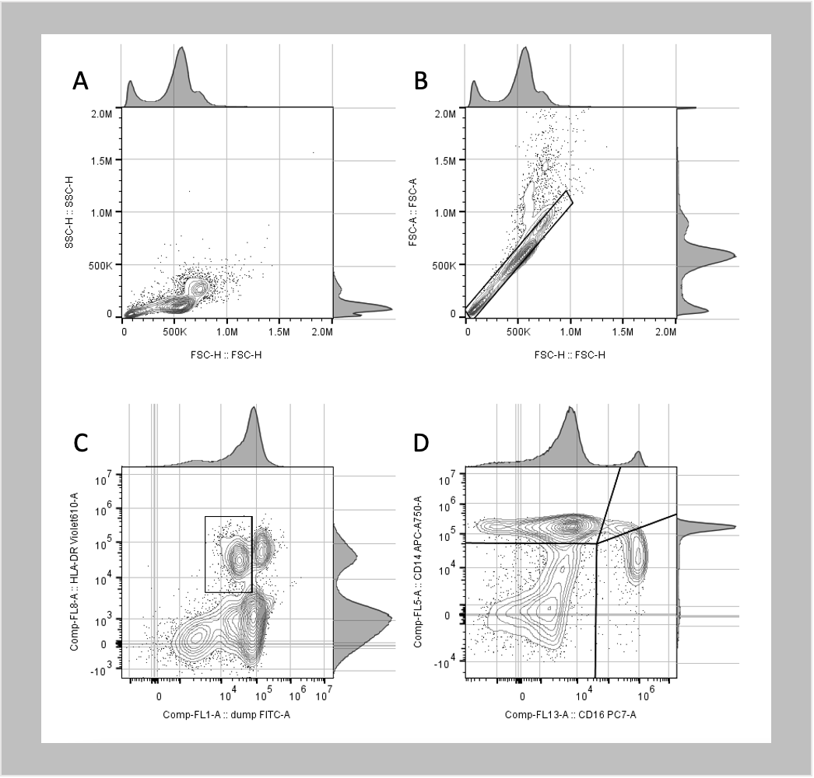
Panel A: forward scatter height (FSC-H) versus side-scatter height (SSC-H). Panel B: forward scatter height (FSC-H) versus forward scatter area (FSC-A). Panel C: fluorescence for HLA-DR positive cells using fluorochrome BV605 versus fluorescence for lineage-negative cells and dead cells using FITC. Panel D: fluorescence for CD14 positive cells using fluorochrome APC-Cy7 versus fluorescence for CD16 positive cells using fluorochrome PE-Cy7.

Figure 2: Panel A: Density plots and boxplots displaying the distribution of the mean monocyte volume (MMV and FSC-mean) and monocyte volume variability (MDW and FSC-SD) across instruments and for each group (controls, COVID-19, sepsis). Panel B: Within instrument scatterplots for both UniCel DxH 900 and CytoFLEX. Panel C: Between instrument scatterplots between for measurements of monocyte mean volume and variability.
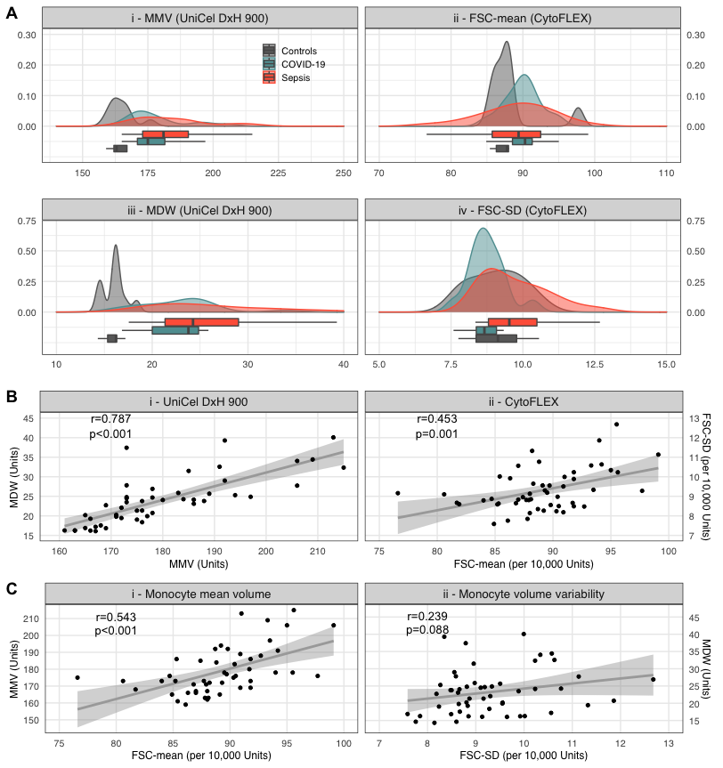
CytoFLEX measures refer to monocytes only (do not include double-negative cells).
For Panel A: There were no missing values for measures of monocyte variability (MDW and FSC-SD), so for plots iii and iv, n=52. There were two controls with missing MMV, so plots i and ii, n=50.
r: Pearson product-moment correlation coefficient. p: p-value. p-values correspond to the test for association between paired samples (using Fisher Z transform). Panel A shows n=50, as two controls had missing MMV values.

Figure 3: Panel A: Scatterplots between UniCel DxH 900 and CytoFLEX measurements of monocyte mean volume (stratified on patient-group). Panel B: Scatterplots between UniCel DxH 900 and CytoFLEX for mean volume variability (stratified on patient-group). Panel C: Boxplots displaying the proportion of cell subtypes identified in the CytoFLEX CD14 versus CD16 density plot (live, lineage-negative cells) across patient-groups. Panel D: CytoFLEX average cell volume (left) and average cell volume variability (right) across cell subtype and patient-groups.
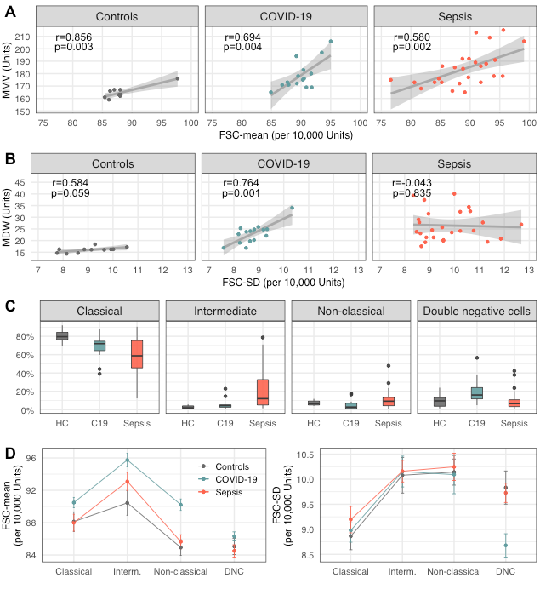
r: Pearson product-moment correlation coefficient. p: p-value. p-values correspond to the test for association between paired samples (using Fisher Z transform). In panel A and B correlation of MMV and FSC-mean on controls shows n=9, as two controls had missing MMV values. For panel C the denominator for the calculation of proportions was HLA-DR⁺ cells, defined as blood mononuclear cells with HLA-DR⁺ expression, and lack of B, T, NK markers. ‘HC’ is Healthy controls, and ‘C19’ is COVID-19. In panel D ‘Interm.’ is Intermediate monocyte and ‘DNC’ is double-negative cells.
Figure 4: Panel A: Boxplots displaying the proportion of cell subtypes identified in the CytoFLEX CD14 versus CD16 density plot (live, lineage-negative cells) expressing either CD192, CD45RA, CX₃CR1 or CD169,, across patient-groups. Panel B: Forest plot displaying the correlation coefficient (and 95% CI) between (top) MDW and different monocyte parameters across patient-groups, and (bottom) between FSC-SD and different monocyte parameters across patient-groups.
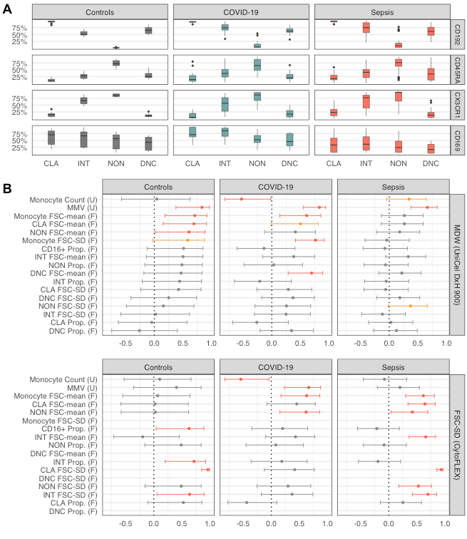
CLA: Classical monocytes. INT: Intermediate monocytes. NON: Non-classical monocytes. DNC: Double-negative cells. CD16⁺: CD16 positive cells, which include intermediate and non-classical cells. Prop: proportion. (F): parameter obtained from CytoFLEX. (U): parameter obtained from UniCel DxH 900. Monocyte parameters obtained from CytoFLEX exclude double-negative cells.
Coefficient corresponds to Pearson product-moment correlation coefficient, and confidence intervals are given based on Fisher Z transform. p<=0.050 are highlighted in red, p>0.050 and p<=0.090 for sepsis group are highlighted in orange. Correlation of MMV and FSC-mean on controls shows n=50, as two controls had missing MMV values.

