**TEXT S1**

*Population growth, immigration and emigration, and mortality rates*

Population growth rate due to births , the rate at which people leave the population through natural mortality and/or emigration (), and the immigration rate  were parametrized with the following functions, providing a good fit for population growth and demographic age structure of each nationality group in Qatar:



and



and



Here, the parameters , , , , , , , , , , , , , , and  were obtained by fitting the model to the demographic data for each nationality group obtained from Qatar’s Planning and Statistics Authority1 2; the Gulf Labour Markets, Migration, and Population Programme3; and the Population Division of the United Nations Department of Economic and Social Affairs4.

**ADDITIONAL TABLES**

**Table S1.** Model assumptions in terms of parameter values.

|  |  |  |  |  |
| --- | --- | --- | --- | --- |
| ***Assumption*** | ***Age group*** | ***Parameter value (95% CI)*** | | ***Reference*** |
| **Male** | **Female** |
| Number of age compartments in the model (each for 5 years; *a*) | - | 20 | 20 | - |
| Relative risk of developing T2DM if obese€ (pooled mean and 95% CI;) | All | 6.48 (5.17–8.13) | 8.38 (5.46–12.85) | 5 |
| Relative risk of developing T2DM if current smoker€ | All | 1.42 (1.34–1.50) | 1.33 (1.26–1.41) | 6 |
| Relative risk of developing T2DM if physically inactive€ | 15–69  70–79  ≥80 | 1.45 (1.37–1.54)  1.32 (1.25–1.40)  1.20 (1.14–1.28) | 1.45 (1.37–1.54)  1.32 (1.25–1.40)  1.20 (1.14–1.28) | 7 |
| Relative risk of developing T2DM if obese and smoker€ | All | 9.20 (6.93–12.20) | 11.15 (6.88–18.12) | Multiplicative effect calculated based on 5 6 |
| Relative risk of developing T2DM if obese and physically inactive€ | 15–69  70–79  ≥80 | 9.40 (7.08–12.52)  8.55 (6.46–11.38)  7.78 (5.89–10.41) | 12.15 (7.48–19.79)  11.06 (6.83–18.12)  10.06 (6.22–16.45) | Multiplicative effect calculated based on 5 7 |
| Relative risk of developing T2DM if smoker and physically inactive€ | 15–69  70–79  ≥80 | 2.06 (1.84–2.37)  1.87 (1.68–2.17)  1.70 (1.53–1.97) | 1.93(1.73–2.17)  1.76 (1.58–1.99)  1.60 (1.44–1.80) | Multiplicative effect calculated based on 6 7 |
| Relative risk of developing T2DM if obese, smoker, and physically inactive€ | 15–69  70–79  ≥80 | 13.34 (9.49–19.28)  12.15 (8.66–17.65)  11.04 (7.90–16.03) | 16.16 (9.43–27.90)  14.71 (8.60–25.55)  13.37 (7.84–23.19) | Multiplicative effect calculated based on 5-7 |
| RR of mortality in T2DM as compared to the general population¥ | 20–29  30–39  40–49  50–59  60–69  70–79+ | 3.70  3.30  1.95  1.65  1.62  1.40 | 5.95  5.61  3.41  2.73  2.08  1.78 | 8 9 |

**T2DM:** type 2 diabetes mellitus

€All relative risks are with respect to healthy individuals as the reference group.

¥The highest RRM was for age group 20-29 as other reasons for mortality in that age group are minimal.

**Table S2.** Characteristics of the expatriate resident population in Qatar based on Qatar’s Planning and Statistics Authority1 2.

|  |  |  |  |
| --- | --- | --- | --- |
| **Nationality** | **Proportion** | **Proportion of males (%)** | **Mean age (years)** |
| Bangladeshi | 14.0% | 96.6% | 35 |
| Egyptian | 6.9% | 66.8% | 30 |
| Filipino | 9.0% | 37.1% | 36 |
| Indian | 26.9% | 81.7% | 35 |
| Nepalese | 12.2% | 96.6% | 34 |
| Pakistani | 5.6% | 76.2% | 32 |
| Other nationalities | 25.5% | 62.4% | 32 |

**Table S3.** Projected prevalence of type 2 diabetes mellitus by sex and nationality group.

|  |  |  |  |  |  |  |  |  |  |  |  |  |  |  |  |  |  |  |  |  |  |  |  |  |
| --- | --- | --- | --- | --- | --- | --- | --- | --- | --- | --- | --- | --- | --- | --- | --- | --- | --- | --- | --- | --- | --- | --- | --- | --- |
|  | **Qatari** | | | **Bangladeshi** | | | **Egyptian** | | | **Indian** | | | **Nepalese** | | | **Pakistani** | | | **Filipino** | | | **Others** | | |
|  | **T** | **F** | **M** | **T** | **F** | **M** | **T** | **F** | **M** | **T** | **F** | **M** | **T** | **F** | **M** | **T** | **F** | **M** | **T** | **F** | **M** | **T** | **F** | **M** |
| **2021** | 17.1 | 16.7 | 17.5 | 4.9 | 8.6 | 4.9 | 12.8 | 14.2 | 12.4 | 6.4 | 7.7 | 6.2 | 1.9 | 3.4 | 1.9 | 6.8 | 5.6 | 7.0 | 4.8 | 4.1 | 5.7 | 7.2 | 17.8 | 2.0 |
| **2025** | 18.6 | 18.3 | 18.9 | 5.6 | 8.8 | 5.5 | 13.8 | 14.6 | 13.5 | 7.2 | 8.1 | 7.0 | 2.3 | 3.8 | 2.2 | 7.6 | 6.4 | 7.8 | 5.0 | 4.4 | 6.0 | 7.8 | 17.4 | 2.2 |
| **2030** | 20.5 | 20.3 | 20.8 | 6.7 | 9.2 | 6.6 | 15.3 | 15.2 | 15.4 | 8.5 | 8.9 | 8.4 | 2.9 | 4.3 | 2.9 | 8.9 | 7.9 | 9.0 | 5.5 | 4.9 | 6.5 | 8.4 | 17.1 | 2.7 |
| **2035** | 22.7 | 22.5 | 22.8 | 8.1 | 9.6 | 8.1 | 17.3 | 16.2 | 17.8 | 10.2 | 10.0 | 10.2 | 3.8 | 4.9 | 3.8 | 10.6 | 10.0 | 10.7 | 6.3 | 5.7 | 7.2 | 9.2 | 17.1 | 3.4 |
| **2040** | 24.9 | 24.9 | 24.9 | 10.1 | 10.2 | 10.1 | 19.9 | 17.7 | 20.9 | 12.3 | 11.4 | 12.5 | 5.0 | 5.4 | 5.0 | 12.7 | 12.8 | 12.7 | 7.2 | 6.7 | 8.1 | 10.0 | 17.6 | 4.3 |
| **2045** | 27.2 | 27.3 | 27.1 | 12.7 | 10.8 | 12.8 | 23.2 | 19.7 | 24.7 | 15.0 | 13.1 | 15.5 | 6.8 | 6.0 | 6.8 | 15.3 | 16.7 | 15.0 | 8.5 | 8.1 | 9.4 | 11.1 | 18.4 | 5.6 |
| **2050** | 29.5 | 29.8 | 29.3 | 15.9 | 11.4 | 16.1 | 27.1 | 22.2 | 29.2 | 18.3 | 15.0 | 19.1 | 9.1 | 6.5 | 9.2 | 18.4 | 21.6 | 17.8 | 10.2 | 9.8 | 10.9 | 12.5 | 19.5 | 7.3 |

**T:** Totalpopulation; **F:** Female population; **M:** Male population

**ADDITIONAL FIGURES**

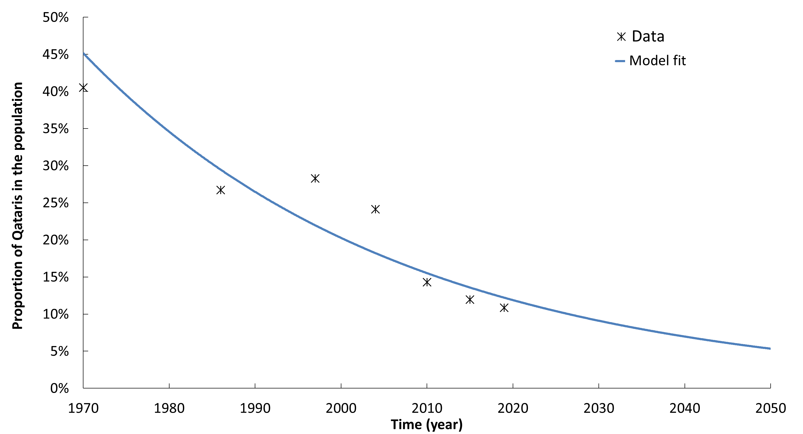**Figure S1.** Proportion of the total population that are Qatari nationals. Data were obtained from the Gulf Labour Markets, Migration, and Population Programme3 and Qatar’s Planning and Statistics Authority1 2.

**Figure S2.** Model predictions for the population age-distribution of each nationality group in Qatar. Data were obtained from Qatar’s Planning and Statistics Authority1 2.

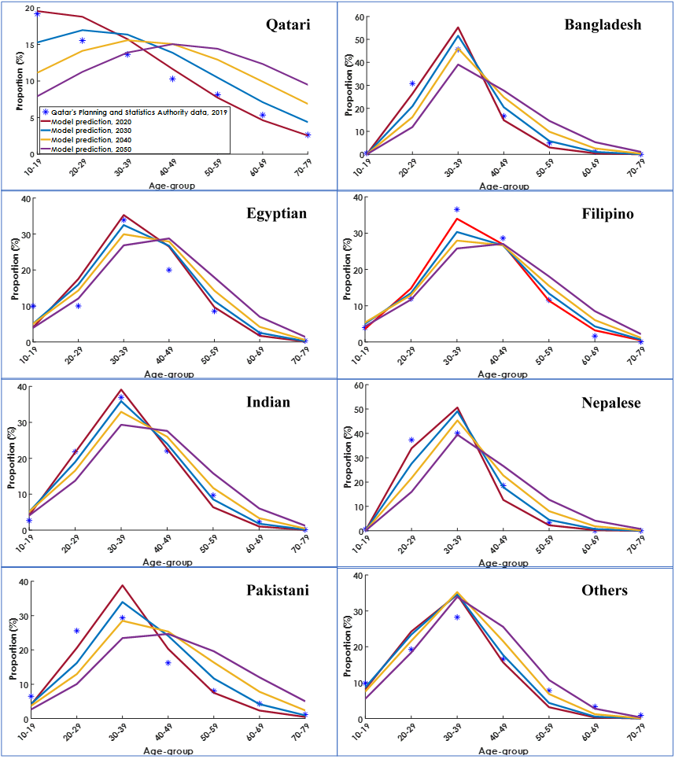**Figure S3.** Model fitting for data on Qataris. **A)** The population size; **B)** the proportion of the population in each age-group in 2019; **C)** age-specific prevalence of diabetes, obesity, smoking, and physical inactivity in females in 2012; and **D)** age-specific prevalence of diabetes, obesity, smoking, and physical inactivity in males in 2012. Model predictions were compared to estimates from the Population Division of the United Nations Department of Economic and Social Affairs4, Qatar’s Planning and Statistics Authority1 2, and the 2012 Qatar STEPwise Survey10 11.



**Figure S4.** Model fitting for Indians residing in Qatar. **A)** The population size; **B)** the proportion of the population in each age-group in 2019, 2030, 2040, and 2050; **C)** age-specific prevalence of type 2 diabetes mellitus in females and males in 2019; **D)** prevalence of obesity between 1990–2050; **E)** prevalence of smoking between 1990–2050; and **F)** prevalence of physical inactivity between 1990–2050. Model predictions were compared to estimates from the Population Division of the United Nations Department of Economic and Social Affairs4, Qatar’s Planning and Statistics Authority1 2, the International Diabetes Federation data, and the Global Health Observatory data repository12-14.

**A.**

**B.**

**C.**

**D.**

**E.**

**F.**

**Smoking**

**Physical inactivity**

**Obesity**

**Diabetes**



**Figure S5.** Model prediction for the mean age of each nationality group in Qatar.

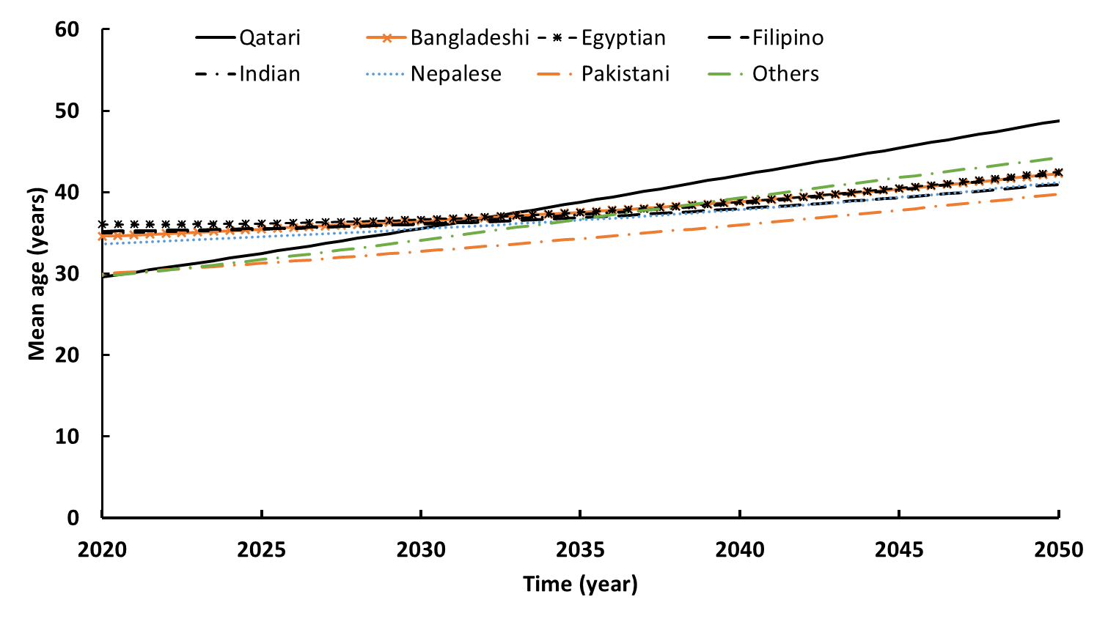

**Figure S6.** Two sensitivity analyses to investigate the impact of population aging on T2DM burden. **A**)T2DM prevalence in the two sensitivity analyses compared to the base-case scenario. First sensitivity analysis assumes that T2DM incidence rate after 2020 is independent of age to control the effect of aging. The second sensitivity analysis assumes a stable constant obesity prevalence to control the effect of obesity (obesity prevalence is shown in Panel **B**).

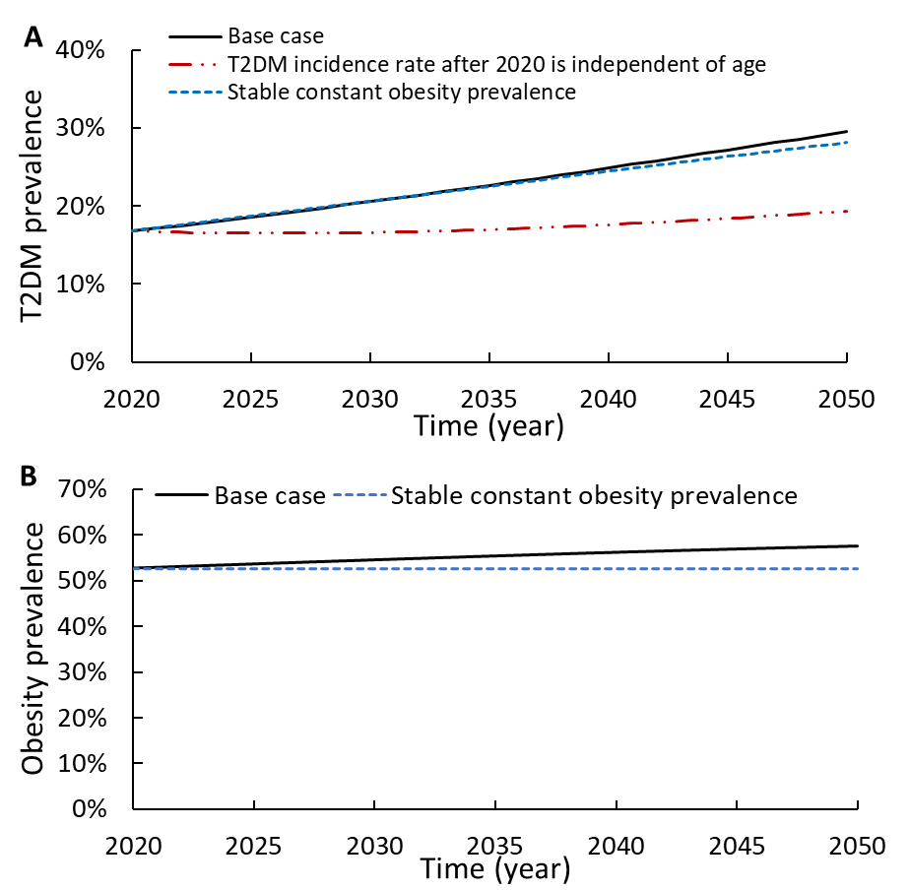

**Figure S7.** Uncertainty analysis for the prevalence of type 2 diabetes mellitus (T2DM) in Qatar between 2020-2050. The solid line represents the mean, while the dashed lines bracket the 95% uncertainty interval.

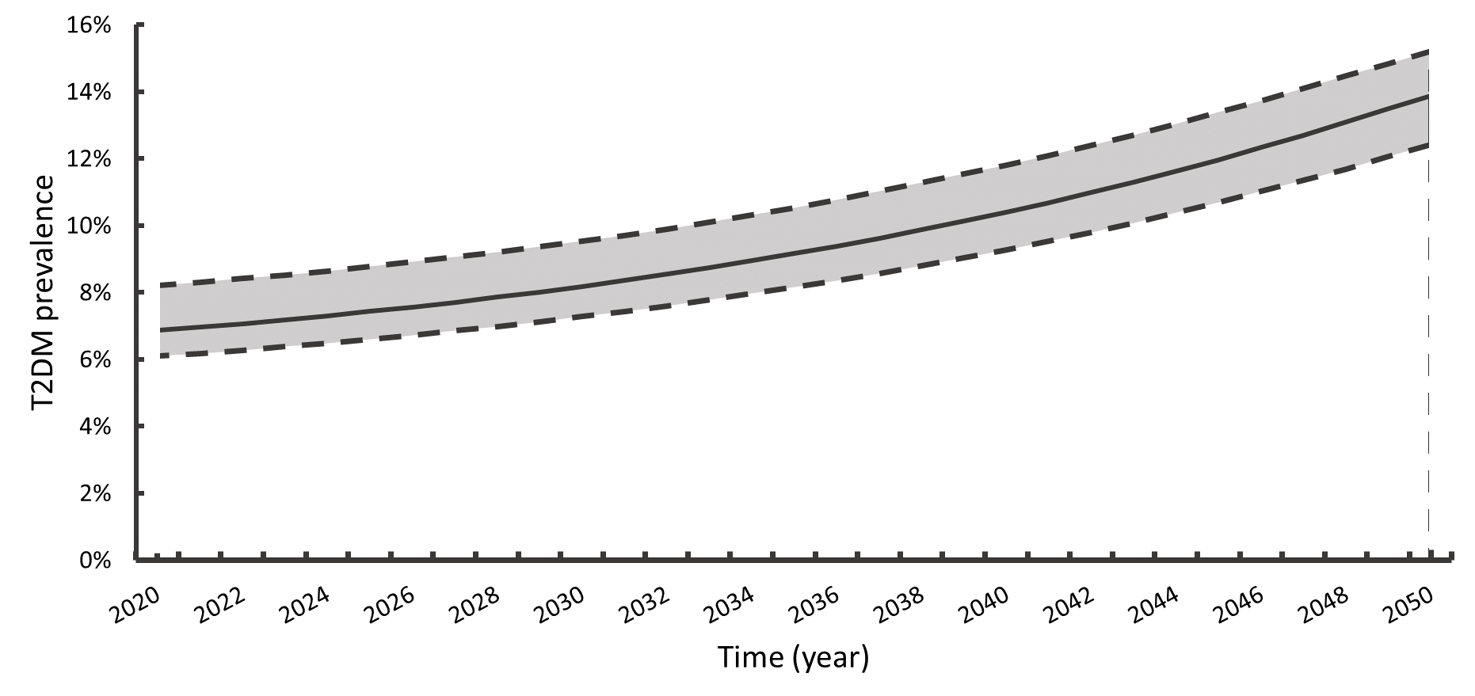

**References**

1. Planning and Statistics Authority- State of Qatar. Qatar Monthly Statistics. Available from: <https://www.psa.gov.qa/en/pages/default.aspx>. Accessed on: May 26, 2020. 2020.

2. Planning and Statistics Authority-State of Qatar. The Simplified Census of Population, Housing & Establishments. Available from: <https://www.psa.gov.qa/en/statistics/Statistical%20Releases/Population/Population/2018/Population_social_1_2018_AE.pdf> Accessed on: April 2, 2020. 2019.

3. Gulf Labour Markets M, and Population (GLMM) Programme;. Demographic and economic module for Qatar (available at: <https://gulfmigration.org/glmm-database/demographic-and-economic-module/?search=1&cmct=Qatar>; accessed May, 06, 2021).

4. United Nations, Department of Economic and Social Affairs, Population Division. World Population Prospects: The 2019 Revision, DVD Edition. (Available at: <https://esa.un.org/unpd/wpp/Download/Standard/Population/>) 2019 [

5. Abdullah A, Peeters A, de Courten M, et al. The magnitude of association between overweight and obesity and the risk of diabetes: a meta-analysis of prospective cohort studies. *Diabetes research and clinical practice* 2010;89(3):309-19. doi: 10.1016/j.diabres.2010.04.012

6. Pan A, Wang Y, Talaei M, et al. Relation of active, passive, and quitting smoking with incident type 2 diabetes: a systematic review and meta-analysis. *Lancet Diabetes Endocrinol* 2015;3(12):958-67. doi: 10.1016/S2213-8587(15)00316-2

7. Fiona C. Bull, Timothy P. Armstrong, Tracy Dixon SH, et al. Comparative Quantification of Health Risks. Global and Regional Burden of Disease Attribution to Selected Major Risk Factors. Chapter 10: Physical Inactivity. (available at: <http://www.who.int/publications/cra/chapters/volume1/0729-0882.pdf?ua=1>): World Health Organization, 2004.

8. Nakagami T, Group DS. Hyperglycaemia and mortality from all causes and from cardiovascular disease in five populations of Asian origin. *Diabetologia* 2004;47(3):385-94. doi: 10.1007/s00125-004-1334-6

9. International Diabetes Federation. IDF Diabetes Atlas. 3th edition. Brussels, Belgium (available at: <https://www.idf.org/sites/default/files/Diabetes-Atlas-3rd-edition.pdf>. Accessed on 10 Dec. 2015), 2006.

10. Mohammed H. Al-Thani, Kholood A. Al-Mutawa, Salah A. Alyafei, et al. Characterizing epidemiology of prediabetes, diabetes, and hypertension in Qataris: a cross-sectional study (Under Review). 2021

11. Supreme Council of Health. Qatar STEPwise report 2012: Chronic disease risk factor surveillance (available at: <http://www.who.int/chp/steps/qatar/en/>), 2013.

12. World Health Organization. Prevalence of obesity among adults, BMI ≥ 30, age-standardized Estimates by WHO region. Global Health Observatory data repository (Available at: <https://appswhoint/gho/data/viewmainREGION2480A?lang=en>).

13. Organization WH. Prevalence of smokingy among adults; Data by country Global Health Observatory data repository (Available at: <https://www.who.int/gho/tobacco/use/en/>).

14. World Health Organization. Prevalence of insufficient physical activity among adults Data by country. Global Health Observatory data repository (Available at: <https://appswhoint/gho/data/viewmain2463>).