Supplemental Material

Patient profile and outcomes associated with follow-up in specialty vs. primary care in heart failure

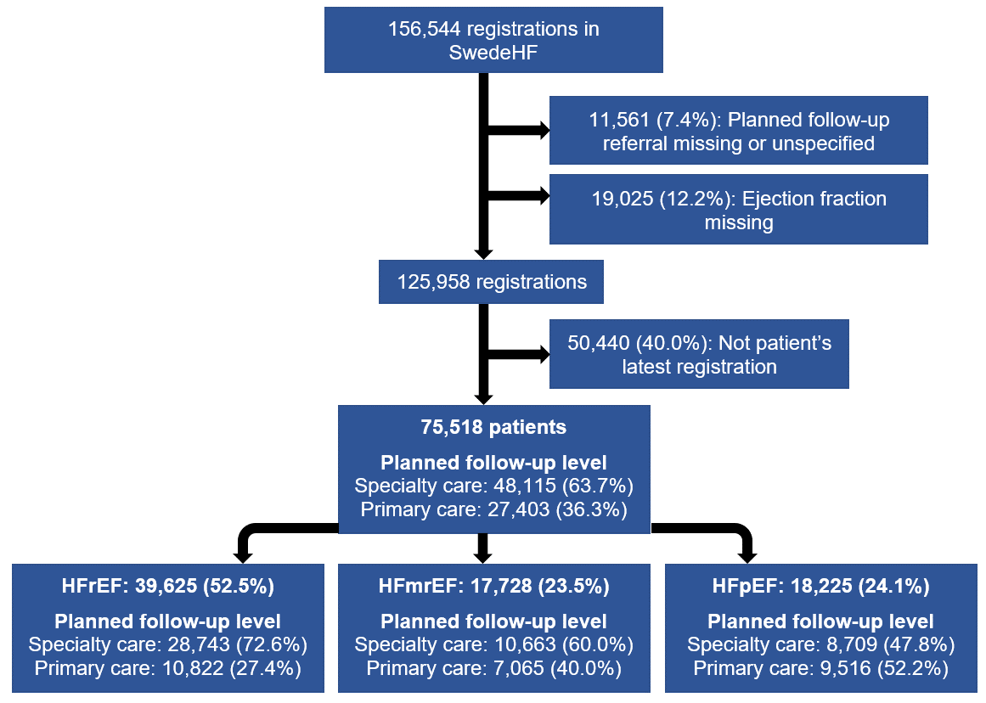
Figure 1. Flowchart depicting patient selection.
Abbreviations: EF, ejection fraction; HFmrEF, heart failure with mildly reduced ejection fraction; HFpEF, heart failure with preserved ejection fraction; HFrEF, heart failure with reduced ejection fraction; SwedeHF, Swedish Heart Failure Registry

Table 1. Variable definitions, sources, and use in analyses.
Variable | Definition | Categorisation used in multiple imputation and/or subsequent regression models
All-cause death | Death from any cause in the Cause of Death registry. Censored at emigration, 5 years after the index date, or at the end of the study follow-up, i.e. 31st December 2019, whichever came first. | In imputations: No; Yes (event indicator), and Nelson-Aalen estimate. In Cox regression models: No; Yes (event indicator), and time until event
CV death | Underlying CV cause of death in the Cause of Death registry within 5 years after index date (ICD-10 codes: I, J81, K761, R57, G45). Censored at non-CV death/emigration, 5 years after the index date, or at the end of the study follow-up, i.e. 31st December 2019, whichever came first. | Not used in imputations. In Cox regression models: No; Yes (event indicator), and time until event
First HF hospitalisation | Hospitalisation diagnosis in the NPR within 5 years after index date (ICD-10 codes: ICD:I110, I130, I132, I255, I420, I423, I425-I429, I43, I50, J81, K761, R57). Censored at death/emigration, 5 years after the index date, or at the end of the study follow-up, i.e. 31st December 2019, whichever came first. | Not used in imputations. In Cox regression models: No; Yes (event indicator), and time until event
Follow-up type | Planned follow-up in specialty or primary care in SwedeHF at the index date. | Specialty care; Primary care
Index year | Year of entry into SwedeHF recorded at hospital discharge for in-patients and admission for out-patients. | 2000-2011; 2012-2018
Sex | Variable in SwedeHF. | Male; Female
Age | Variable in SwedeHF. | <75 years; ≥75 years
Income level | Disposable income from LISA (Statistics Sweden). Tertiles were calculated stratified by year of registration. | Highest two income tertiles; Lowest income tertile
Education level | Education from LISA (Statistics Sweden). | University; Secondary or compulsory school
Cohabitation status | Variable in SwedeHF. | Married or cohabitating; Living alone
Children | Variable in SwedeHF. | Yes; No
EF phenotype | Categorised according to 2016 ESC Guidelines definitions (HFrEF <40%, HFmrEF 40-49%, HFpEF ≥50%) based on EF measurements in SwedeHF categorised as <30%, 30-40%, 40-49%, ≥50%. | HFrEF; HFmrEF; HFpEF
Follow-up in nurse-led HF unit | Variable in SwedeHF. | Yes; No
Caregiver | Variable in SwedeHF. | Out-patient; In-patient
HF duration | Variable in SwedeHF. | <6 months; ≥6 months
NYHA class | Variable in SwedeHF. | NYHA I-II; NYHA III-IV
Body mass index | Variable in SwedeHF. | <30 kg/m²; ≥30 kg/m²
Mean arterial pressure | Variable in SwedeHF. | ≥90 mmHg; <90 mmHg
Heart rate | Variable in SwedeHF. | <70 b.p.m.; ≥70 b.p.m.
eGFR | Variable in SwedeHF. | Not used, but represented in the kidney disease variable
Hemoglobin | Variable in SwedeHF. | Not used, but represented in the anaemia variable
Potassium | Variable in SwedeHF. | Not used
NT-proBNP | Variable in SwedeHF. For the multiple imputation and subsequent analyses, | ≥median by EF phenotype; <median by EF phenotype
Peripheral artery disease | Diagnosis in the NPR (ICD-10 codes: I70-I73). | No; Yes
Stroke/transitory ischaemic attack | Diagnosis in the NPR (ICD-10 codes: 430-434, 438, I60-I64, I690-I694, G45) | No; Yes
Anaemia | Hemoglobin <120 g/L in women and <130 g/L in men. | No; Yes
Depression | Diagnosis in the NPR (ICD-10 codes: F32-34) | No; Yes
Cancer past 3 years | Diagnosis in the NPR within 3 years prior to the registrations in SwedeHF (ICD-10 codes: C) | No; Yes
Liver disease | Diagnosis in the NPR (ICD-10 codes: B18, I85, I864, I982, K70, K710, K711, K713-K717, K72-4, K760, K762-9) | No; Yes
Major bleeding | Diagnosis in the NPR (ICD-10 codes: S064, S065, S066, I850, I983, K226, K250, K252, K254, K256, K260, K262, K264, K266, K270, K272, K274, K276, K280, K284, K286, K290, K625, K661, K920, K921, K922, H431, N02, R04, R58, T810, D629; Procedure code: DR029) | No; Yes
Kidney disease | eGFR <60 mL/min/1.73m² | No; Yes
Diabetes mellitus | Diagnosis in SwedeHF or in the NPR (ICD-10 codes: E10-E14). | No; Yes
Atrial fibrillation | Atrial fibrillation on ECG or as diagnosis in SwedeHF or in the NPR (ICD-10 code: I48). | No; Yes
Hypertension | Diagnosis in SwedeHF or in the NPR (ICD-10 codes: I10-I15) | No; Yes
Chronic obstructive pulmonary disease | Diagnosis in the NPR (ICD-10 codes: J40-J44) | No; Yes
Ischaemic heart disease | Previous coronary revascularisation in SwedeHF, previous myocardial infarction in the NPR, or previous coronary revascularisation in the NPR (ICD-10 codes: 410-414, I20-I25, I252; Procedure codes: FNG, FNA, FNB, FNC, FND, FNE, FNF, FNH). | No; Yes
Valvular disease | Diagnosis in the NPR (ICD-10 codes: I05-I08, I34-I39, Q22, Q230-Q233, Z952-Z954) | No; Yes
Charlson comorbidity index | Calculated from NPR. | Not used
Beta-blockers | Variable in SwedeHF. | No; Yes
RASi/ARNi | Variable in SwedeHF. | No; Yes
MRA | Variable in SwedeHF. | No; Yes
Diuretics | Variable in SwedeHF. | No; Yes
Digoxin | Variable in SwedeHF. | No; Yes
Nitrates | Variable in SwedeHF. | No; Yes
Anticoagulants | Variable in SwedeHF. | No; Yes
Antiplatelets | Variable in SwedeHF. | No; Yes
Statins | Variable in SwedeHF. | No; Yes
HF device | Device treatment with ICD or CRT in SwedeHF. | No; Yes
Abbreviations: ARNi, angiotensin-receptor-neprilysin inhibitor; CRT, cardiac resynchronisation therapy; CV, cardiovascular; EF, ejection fraction; eGFR, estimated glomerular filtration rate (calculated by Chronic Kidney Disease Epidemiology Collaboration formula); HF, heart failure; HFmrEF, HF with mildly reduced EF; HFpEF, HF with preserved EF; HFrEF, HF with reduced EF; ICD, implantable cardioverter-defibrillator device; ICD-10, International Statistical Classification of Diseases and Related Health Problems - Tenth Revision; LISA, Longitudinal Integrated Database For Health Insurance And Labour Market Studies; MRA, mineralocorticoid receptor antagonist; NPR, National Patient registry; NT-proBNP, N-terminal pro-B-type natriuretic peptide; NYHA, New York Heart Association functional class; RASi, renin-angiotensin-system inhibitor; SwedeHF, Swedish Heart Failure registry (RiksSvikt).
Table 2. Patient characteristics at baseline stratified by follow-up type in patients with HFrEF.
 | Specialty care | Primary care | p | Missing
 | 28,743 (72.6%) | 10,822 (27.4%)
Sociodemographic data
Index year |  |  | <0.001 | 0.0%
2000-2011 | 10,073 (35.0%) | 5,607 (51.8%)
2012-2018 | 18,670 (65.0%) | 5,215 (48.2%)
Female | 7,453 (25.9%) | 3,914 (36.2%) | <0.001 | 0.0%
Age, years | 70 (±12) | 80 (±9) | <0.001 | 0.0%
≥75 years | 11,376 (39.6%) | 8,350 (77.2%) | <0.001 | 0.0%
Income level |  |  | <0.001 | 0.2%
Lowest tertile | 9,097 (31.7%) | 4,558 (42.2%)
Medium tertile | 9,886 (34.5%) | 4,389 (40.6%)
Highest tertile | 9,679 (33.8%) | 1,866 (17.3%)
Education level |  |  | <0.001 | 2.0%
Compulsory school | 11,277 (39.9%) | 5,919 (56.2%)
Secondary school | 11,901 (42.1%) | 3,443 (32.7%)
University | 5,065 (17.9%) | 1,162 (11.0%)
Education level: Secondary school or less | 23,178 (82.1%) | 9,362 (89.0%) | <0.001 | 2.0%
Living alone | 12,459 (43.5%) | 6,005 (55.5%) | <0.001 | 0.2%
Children | 23,682 (82.4%) | 8,973 (82.9%) | 0.228 | 0.0%
Clinical data
Follow-up in nurse-led HF unit | 19,502 (69.1%) | 2,440 (23.0%) | <0.001 | 1.7%
Caregiver: In-patient | 8,880 (30.9%) | 6,113 (56.5%) | <0.001 | 0.0%
HF duration ≥6 months | 15,112 (53.6%) | 7,199 (67.6%) | <0.001 | 1.8%
NYHA III-IV | 9,924 (43.0%) | 3,912 (52.7%) | <0.001 | 22.9%
Body mass index, kg/m² | 27 (±5) | 26 (±5) | <0.001 | 40.7%
≥30 kg/m² | 4,247 (24.3%) | 1,146 (19.1%) | <0.001 | 40.7%
Mean arterial pressure, mmHg | 89 (±13) | 89 (±13) | 0.785 | 1.5%
<90 mmHg | 14,565 (51.5%) | 5,425 (50.9%) | 0.286 | 1.5%
Heart rate, b.p.m. | 73 (±16) | 75 (±16) | <0.001 | 4.0%
≥70 b.p.m. | 15,642 (56.5%) | 6,352 (61.6%) | <0.001 | 4.0%
eGFR, mL/min/1.73m² | 64 [47, 83] | 51 [37, 68] | <0.001 | 1.4%
Hemoglobin, g/L | 135 (±17) | 130 (±17) | <0.001 | 5.1%
Potassium, mmol/L | 4 (±0) | 4 (±0) | <0.001 | 20.7%
NT-proBNP, pg/L | 2,553 [1,073, 5,816] | 4,004 [1,614, 9,860] | <0.001 | 48.9%
≥median | 7,428 (47.0%) | 2,682 (60.8%) | <0.001 | 48.9%
Comorbidities
Peripheral artery disease | 2,581 (9.0%) | 1,155 (10.7%) | <0.001 | 0.0%
Stroke/transitory ischaemic attack | 4,285 (14.9%) | 2,351 (21.7%) | <0.001 | 0.0%
Anaemia | 8,280 (30.7%) | 4,382 (41.5%) | <0.001 | 5.1%
Depression | 1,070 (3.7%) | 448 (4.1%) | 0.058 | 0.0%
Cancer past 3 years | 3,773 (13.1%) | 1,653 (15.3%) | <0.001 | 0.0%
Liver disease | 684 (2.4%) | 217 (2.0%) | 0.029 | 0.0%
Major bleeding | 4,538 (15.8%) | 2,112 (19.5%) | <0.001 | 0.0%
Kidney disease | 12,293 (43.4%) | 6,930 (64.9%) | <0.001 | 1.4%
Diabetes mellitus | 7,735 (26.9%) | 3,394 (31.4%) | <0.001 | 0.0%
Atrial fibrillation | 15,043 (52.3%) | 6,501 (60.1%) | <0.001 | 0.0%
Hypertension | 16,926 (58.9%) | 6,972 (64.4%) | <0.001 | 0.0%
Chronic obstructive pulmonary disease | 3,465 (12.1%) | 1,623 (15.0%) | <0.001 | 0.0%
Ischaemic heart disease | 16,170 (56.3%) | 6,873 (63.5%) | <0.001 | 0.0%
Valvular disease | 5,301 (18.4%) | 2,012 (18.6%) | 0.745 | 0.0%
Charlson comorbidity index | 2 [1, 4] | 3 [2, 5] | <0.001 | 0.0%
Treatments
Beta-blockers | 26,980 (94.0%) | 9,416 (87.2%) | <0.001 | 0.2%
RASi/ARNi | 26,501 (92.9%) | 8,729 (81.7%) | <0.001 | 0.9%
MRA | 12,575 (43.9%) | 3,486 (32.4%) | <0.001 | 0.4%
Diuretics | 21,648 (75.6%) | 9,295 (86.2%) | <0.001 | 0.4%
Digoxin | 4,106 (14.3%) | 1,723 (16.0%) | <0.001 | 0.3%
Nitrates | 3,200 (11.2%) | 2,188 (20.3%) | <0.001 | 0.3%
Anticoagulants | 13,818 (48.2%) | 4,233 (39.2%) | <0.001 | 0.3%
Antiplatelets | 12,237 (42.7%) | 5,370 (49.8%) | <0.001 | 0.4%
Statins | 15,195 (53.0%) | 4,676 (43.3%) | <0.001 | 0.2%
HF device | 4,491 (15.7%) | 425 (4.0%) | <0.001 | 1.0%
Summary statistics based on unimputed data. Categorical, continuous normally distributed, and continuous non-normally distributed variables are presented as absolute (relative) frequencies, mean (±standard deviations), and median [interquartile range], respectively, and compared by χ2-test, analysis of variance, and Kruskal-Wallis test, respectively.
Abbreviations: ARNi, angiotensin-receptor-neprilysin inhibitor; b.p.m, beats per minutes; eGFR, estimated glomerular filtration rate (calculated by Chronic Kidney Disease Epidemiology Collaboration formula); HF, heart failure; HF device, heart failure device (cardiac resynchronisation therapy or implantable cardioverter-defibrillator); HFrEF, heart failure with reduced ejection fraction; MRA, mineralocorticoid receptor antagonist; NT-proBNP, N-terminal pro-B-type natriuretic peptide; NYHA, New York Heart Association functional class; RASi, renin-angiotensin-system inhibitor.

Table 3. Patient characteristics at baseline stratified by follow-up type in patients with HFmrEF.
 | Specialty care | Primary care | p | Missing
 | 10,663 (60.0%) | 7,065 (40.0%)
Sociodemographic data
Index year |  |  | <0.001 | 0.0%
2000-2011 | 3,541 (33.2%) | 2,819 (39.9%)
2012-2018 | 7,121 (66.8%) | 4,246 (60.1%)
Female | 3,530 (33.1%) | 3,132 (44.3%) | <0.001 | 0.0%
Age, years | 71 (±12) | 80 (±9) | <0.001 | 0.0%
≥75 years | 4,538 (42.6%) | 5,299 (75.0%) | <0.001 | 0.0%
Income level |  |  | <0.001 | 0.1%
Lowest tertile | 3,304 (31.0%) | 2,920 (41.4%)
Medium tertile | 3,715 (34.9%) | 2,801 (39.7%)
Highest tertile | 3,629 (34.1%) | 1,339 (19.0%)
Education level |  |  | <0.001 | 2.0%
Compulsory school | 3,980 (37.9%) | 3,647 (53.0%)
Secondary school | 4,444 (42.3%) | 2,368 (34.4%)
University | 2,081 (19.8%) | 861 (12.5%)
Education level: Secondary school or less | 8,424 (80.2%) | 6,015 (87.5%) | <0.001 | 2.0%
Living alone | 4,476 (42.0%) | 3,919 (55.5%) | <0.001 | 0.1%
Children | 8,951 (83.9%) | 6,030 (85.4%) | 0.012 | 0.0%
Clinical data
Follow-up in nurse-led HF unit | 6,602 (63.2%) | 2,192 (31.7%) | <0.001 | 2.1%
Caregiver: In-patient | 2,997 (28.1%) | 3,255 (46.1%) | <0.001 | 0.0%
HF duration ≥6 months | 5,523 (53.0%) | 4,720 (68.7%) | <0.001 | 2.5%
NYHA III-IV | 2,378 (29.0%) | 1,724 (35.4%) | <0.001 | 26.3%
Body mass index, kg/m² | 28 (±6) | 27 (±6) | <0.001 | 43.1%
≥30 kg/m² | 1,689 (27.7%) | 1,071 (26.8%) | 0.292 | 43.1%
Mean arterial pressure, mmHg | 92 (±13) | 92 (±13) | <0.001 | 1.8%
<90 mmHg | 4,572 (43.8%) | 2,842 (40.8%) | <0.001 | 1.8%
Heart rate, b.p.m. | 72 (±15) | 74 (±15) | <0.001 | 4.7%
≥70 b.p.m. | 5,377 (52.8%) | 3,896 (58.1%) | <0.001 | 4.7%
eGFR, mL/min/1.73m² | 66 [48, 83] | 55 [40, 72] | <0.001 | 1.9%
Hemoglobin, g/L | 133 (18) | 129 (±17) | <0.001 | 6.0%
Potassium, mmol/L | 4 (±0) | 4 (±0) | <0.001 | 19.0%
NT-proBNP, pg/L | 1,534 [583, 3,530] | 2,030 [850, 4,620] | <0.001 | 47.3%
≥median | 2,749 (46.9%) | 1,921 (55.3%) | <0.001 | 47.3%
Comorbidities
Peripheral artery disease | 995 (9.3%) | 678 (9.6%) | 0.572 | 0.0%
Stroke/transitory ischaemic attack | 1,458 (13.7%) | 1,491 (21.1%) | <0.001 | 0.0%
Anaemia | 3,276 (33.1%) | 2,588 (38.4%) | <0.001 | 6.0%
Depression | 398 (3.7%) | 270 (3.8%) | 0.791 | 0.0%
Cancer past 3 years | 1,569 (14.7%) | 1,086 (15.4%) | 0.238 | 0.0%
Liver disease | 231 (2.2%) | 104 (1.5%) | 0.001 | 0.0%
Major bleeding | 1,909 (17.9%) | 1,516 (21.5%) | <0.001 | 0.0%
Kidney disease | 4,326 (41.3%) | 4,007 (57.9%) | <0.001 | 1.9%
Diabetes mellitus | 2,684 (25.2%) | 2,018 (28.6%) | <0.001 | 0.0%
Atrial fibrillation | 5,871 (55.1%) | 4,507 (63.8%) | <0.001 | 0.0%
Hypertension | 6,740 (63.2%) | 5,198 (73.6%) | <0.001 | 0.0%
Chronic obstructive pulmonary disease | 1,310 (12.3%) | 1,131 (16.0%) | <0.001 | 0.0%
Ischaemic heart disease | 5,896 (55.3%) | 4,114 (58.2%) | <0.001 | 0.0%
Valvular disease | 2,516 (23.6%) | 1,345 (19.0%) | <0.001 | 0.0%
Charlson comorbidity index | 2 [1, 4] | 3 [2, 4] | <0.001 | 0.0%
Treatments
Beta-blockers | 9,555 (89.8%) | 5,994 (84.9%) | <0.001 | 0.2%
RASi/ARNi | 9,345 (88.2%) | 5,513 (78.7%) | <0.001 | 0.7%
MRA | 3,407 (32.0%) | 1,885 (26.9%) | <0.001 | 0.4%
Diuretics | 6,946 (65.3%) | 5,582 (79.3%) | <0.001 | 0.3%
Digoxin | 1,259 (11.8%) | 1,019 (14.5%) | <0.001 | 0.2%
Nitrates | 1,197 (11.3%) | 1,251 (17.8%) | <0.001 | 0.4%
Anticoagulants | 4,980 (46.8%) | 3,187 (45.3%) | 0.056 | 0.3%
Antiplatelets | 4,490 (42.2%) | 3,092 (44.0%) | 0.018 | 0.4%
Statins | 5,673 (53.3%) | 3,191 (45.3%) | <0.001 | 0.2%
HF device | 692 (6.5%) | 85 (1.3%) | <0.001 | 1.7%
Summary statistics based on unimputed data. Categorical, continuous normally distributed, and continuous non-normally distributed variables are presented as absolute (relative) frequencies, mean (±standard deviations), and median [interquartile range], respectively, and compared by χ2-test, analysis of variance, and Kruskal-Wallis test, respectively.
Abbreviations: ARNi, angiotensin-receptor-neprilysin inhibitor; b.p.m, beats per minutes; eGFR, estimated glomerular filtration rate (calculated by Chronic Kidney Disease Epidemiology Collaboration formula); HF, heart failure; HF device, heart failure device (cardiac resynchronisation therapy or implantable cardioverter-defibrillator); HFmrEF, heart failure with mildly reduced ejection fraction; MRA, mineralocorticoid receptor antagonist; NT-proBNP, N-terminal pro-B-type natriuretic peptide; NYHA, New York Heart Association functional class; RASi, renin-angiotensin-system inhibitor.

Table 4. Patient characteristics at baseline stratified by follow-up type in patients with HFpEF.
 | Specialty care | Primary care | p | Missing
 | 8,709 (47.8%) | 9,516 (52.2%)
Sociodemographic data
Index year |  |  | <0.001 | 0.0%
2000-2011 | 2,940 (33.8%) | 3,898 (41.0%)
2012-2018 | 5,769 (66.2%) | 5,618 (59.0%)
Female | 4,012 (46.1%) | 5,505 (57.8%) | <0.001 | 0.0%
Age, years | 73 (±12) | 81 (±9) | <0.001 | 0.0%
≥75 years | 4,608 (52.9%) | 7,610 (80.0%) | <0.001 | 0.0%
Income level |  |  | <0.001 | 0.1%
Lowest tertile | 3,132 (36.0%) | 4,295 (45.2%)
Medium tertile | 3,041 (35.0%) | 3,714 (39.1%)
Highest tertile | 2,522 (29.0%) | 1,501 (15.8%)
Education level |  |  | <0.001 | 2.6%
Compulsory school | 3,542 (41.6%) | 5,067 (54.9%)
Secondary school | 3,335 (39.1%) | 3,038 (32.9%)
University | 1,645 (19.3%) | 1,125 (12.2%)
Education level: Secondary school or less | 6,877 (80.7%) | 8,105 (87.8%) | <0.001 | 2.6%
Living alone | 4,129 (47.5%) | 5,750 (60.5%) | <0.001 | 0.1%
Children | 7,350 (84.4%) | 8,084 (85.0%) | 0.307 | 0.0%
Clinical data
Follow-up in nurse-led HF unit | 4,734 (55.9%) | 2,371 (25.6%) | <0.001 | 2.7%
Caregiver: In-patient | 3,660 (42.0%) | 5,328 (56.0%) | <0.001 | 0.0%
HF duration ≥6 months | 4,850 (57.7%) | 6,073 (65.9%) | <0.001 | 3.3%
NYHA III-IV | 2,269 (39.3%) | 2,096 (37.4%) | 0.035 | 37.6%
Body mass index, kg/m² | 28 (±6) | 28 (±6) | 0.004 | 44.0%
≥30 kg/m² | 1,567 (31.7%) | 1,535 (29.2%) | 0.007 | 44.0%
Mean arterial pressure, mmHg | 92 (±13) | 93 (±13) | <0.001 | 2.3%
<90 mmHg | 3,775 (44.4%) | 3,671 (39.5%) | <0.001 | 2.3%
Heart rate, b.p.m. | 73 (±16) | 74 (±15) | <0.001 | 5.2%
≥70 b.p.m. | 4,442 (53.9%) | 5,352 (59.3%) | <0.001 | 5.2%
eGFR, mL/min/1.73m² | 59 [42, 79] | 53 [39, 70] | <0.001 | 2.5%
Hemoglobin, g/L | 128 (±18) | 127 (±17) | <0.001 | 5.3%
Potassium, mmol/L | 4 (±0) | 4 (±0) | <0.001 | 20.6%
NT-proBNP, pg/L | 1,700 [661, 3,812] | 1,915 [840, 4,151] | <0.001 | 46.0%
≥median | 2,352 (48.0%) | 2,572 (52.0%) | <0.001 | 46.0%
Comorbidities
Peripheral artery disease | 852 (9.8%) | 860 (9.0%) | 0.090 | 0.0%
Stroke/transitory ischaemic attack | 1,384 (15.9%) | 2,041 (21.4%) | <0.001 | 0.0%
Anaemia | 3,301 (40.7%) | 3,819 (41.8%) | 0.132 | 5.3%
Depression | 331 (3.8%) | 450 (4.7%) | 0.002 | 0.0%
Cancer past 3 years | 1,428 (16.4%) | 1,520 (16.0%) | 0.450 | 0.0%
Liver disease | 265 (3.0%) | 163 (1.7%) | <0.001 | 0.0%
Major bleeding | 2,054 (23.6%) | 2,188 (23.0%) | 0.354 | 0.0%
Kidney disease | 4,319 (50.9%) | 5,642 (60.8%) | <0.001 | 2.5%
Diabetes mellitus | 2,505 (28.8%) | 2,729 (28.7%) | 0.912 | 0.0%
Atrial fibrillation | 5,445 (62.5%) | 6,351 (66.7%) | <0.001 | 0.0%
Hypertension | 6,285 (72.2%) | 7,437 (78.2%) | <0.001 | 0.0%
Chronic obstructive pulmonary disease | 1,356 (15.6%) | 1,699 (17.9%) | <0.001 | 0.0%
Ischaemic heart disease | 4,046 (46.5%) | 4,551 (47.8%) | 0.067 | 0.0%
Valvular disease | 2,930 (33.6) | 2,045 (21.5) | <0.001 | 0.0%
Charlson comorbidity index | 3 [1, 4] | 3 [1, 4] | 0.064 | 0.0%
Treatments
Beta-blockers | 7,353 (84.7%) | 7,481 (78.9%) | <0.001 | 0.3%
RASi/ARNi | 6,492 (75.2%) | 6,533 (69.4%) | <0.001 | 1.0%
MRA | 2,962 (34.2%) | 2,610 (27.6%) | <0.001 | 0.6%
Diuretics | 6,736 (77.7%) | 8,068 (85.0%) | <0.001 | 0.4%
Digoxin | 1,174 (13.5%) | 1,398 (14.7%) | 0.021 | 0.4%
Nitrates | 1,137 (13.1%) | 1,669 (17.6%) | <0.001 | 0.5%
Anticoagulants | 4,481 (51.7%) | 4,257 (45.0%) | <0.001 | 0.4%
Antiplatelets | 2,852 (32.9%) | 3,597 (38.0%) | <0.001 | 0.4%
Statins | 3,973 (45.8%) | 3,562 (37.6%) | <0.001 | 0.3%
HF device | 354 (4.1%) | 52 (0.6%) | <0.001 | 2.3%
Summary statistics based on unimputed data. Categorical, continuous normally distributed, and continuous non-normally distributed variables are presented as absolute (relative) frequencies, mean (±standard deviations), and median [interquartile range], respectively, and compared by χ2-test, analysis of variance, and Kruskal-Wallis test, respectively.
Abbreviations: ARNi, angiotensin-receptor-neprilysin inhibitor; b.p.m, beats per minutes; eGFR, estimated glomerular filtration rate (calculated by Chronic Kidney Disease Epidemiology Collaboration formula); HF, heart failure; HF device, heart failure device (cardiac resynchronisation therapy or implantable cardioverter-defibrillator); HFpEF, heart failure with preserved ejection fraction; MRA, mineralocorticoid receptor antagonist; NT-proBNP, N-terminal pro-B-type natriuretic peptide; NYHA, New York Heart Association functional class; RASi, renin-angiotensin-system inhibitor.
Figure 2. Independent predictors of follow-up type in patients with HFrEF.
Multivariable logistic regression model with follow-up in specialty vs. primary care as dependent variable.
Abbreviations: ARNi, angiotensin-receptor-neprilysin inhibitor; b.p.m, beats per minutes; CI, confidence interval; HF, heart failure; HF device, heart failure device (cardiac resynchronisation therapy or implantable cardioverter-defibrillator); HFrEF, heart failure with reduced ejection fraction; MRA, mineralocorticoid receptor antagonist; NT-proBNP, N-terminal pro-B-type natriuretic peptide; NYHA, New York Heart Association functional class; OR, odds ratio; RASi, renin-angiotensin-system inhibitor.
Figure 3. Independent predictors of follow-up type in patients with HFmrEF.
Multivariable logistic regression model with follow-up in specialty vs. primary care as dependent variable.
Abbreviations: ARNi, angiotensin-receptor-neprilysin inhibitor; b.p.m, beats per minutes; CI, confidence interval; HF, heart failure; HF device, heart failure device (cardiac resynchronisation therapy or implantable cardioverter-defibrillator); HFmrEF, heart failure with mildly reduced ejection fraction; MRA, mineralocorticoid receptor antagonist; NT-proBNP, N-terminal pro-B-type natriuretic peptide; NYHA, New York Heart Association functional class; OR, odds ratio; RASi, renin-angiotensin-system inhibitor.
Figure 4. Independent predictors of follow-up type in patients with HFpEF.
Multivariable logistic regression model with follow-up in specialty vs. primary care as dependent variable.
Abbreviations: ARNi, angiotensin-receptor-neprilysin inhibitor; b.p.m, beats per minutes; CI, confidence interval; HF, heart failure; HF device, heart failure device (cardiac resynchronisation therapy or implantable cardioverter-defibrillator); HFpEF, heart failure with preserved ejection fraction; MRA, mineralocorticoid receptor antagonist; NT-proBNP, N-terminal pro-B-type natriuretic peptide; NYHA, New York Heart Association functional class; OR, odds ratio; RASi, renin-angiotensin-system inhibitor.

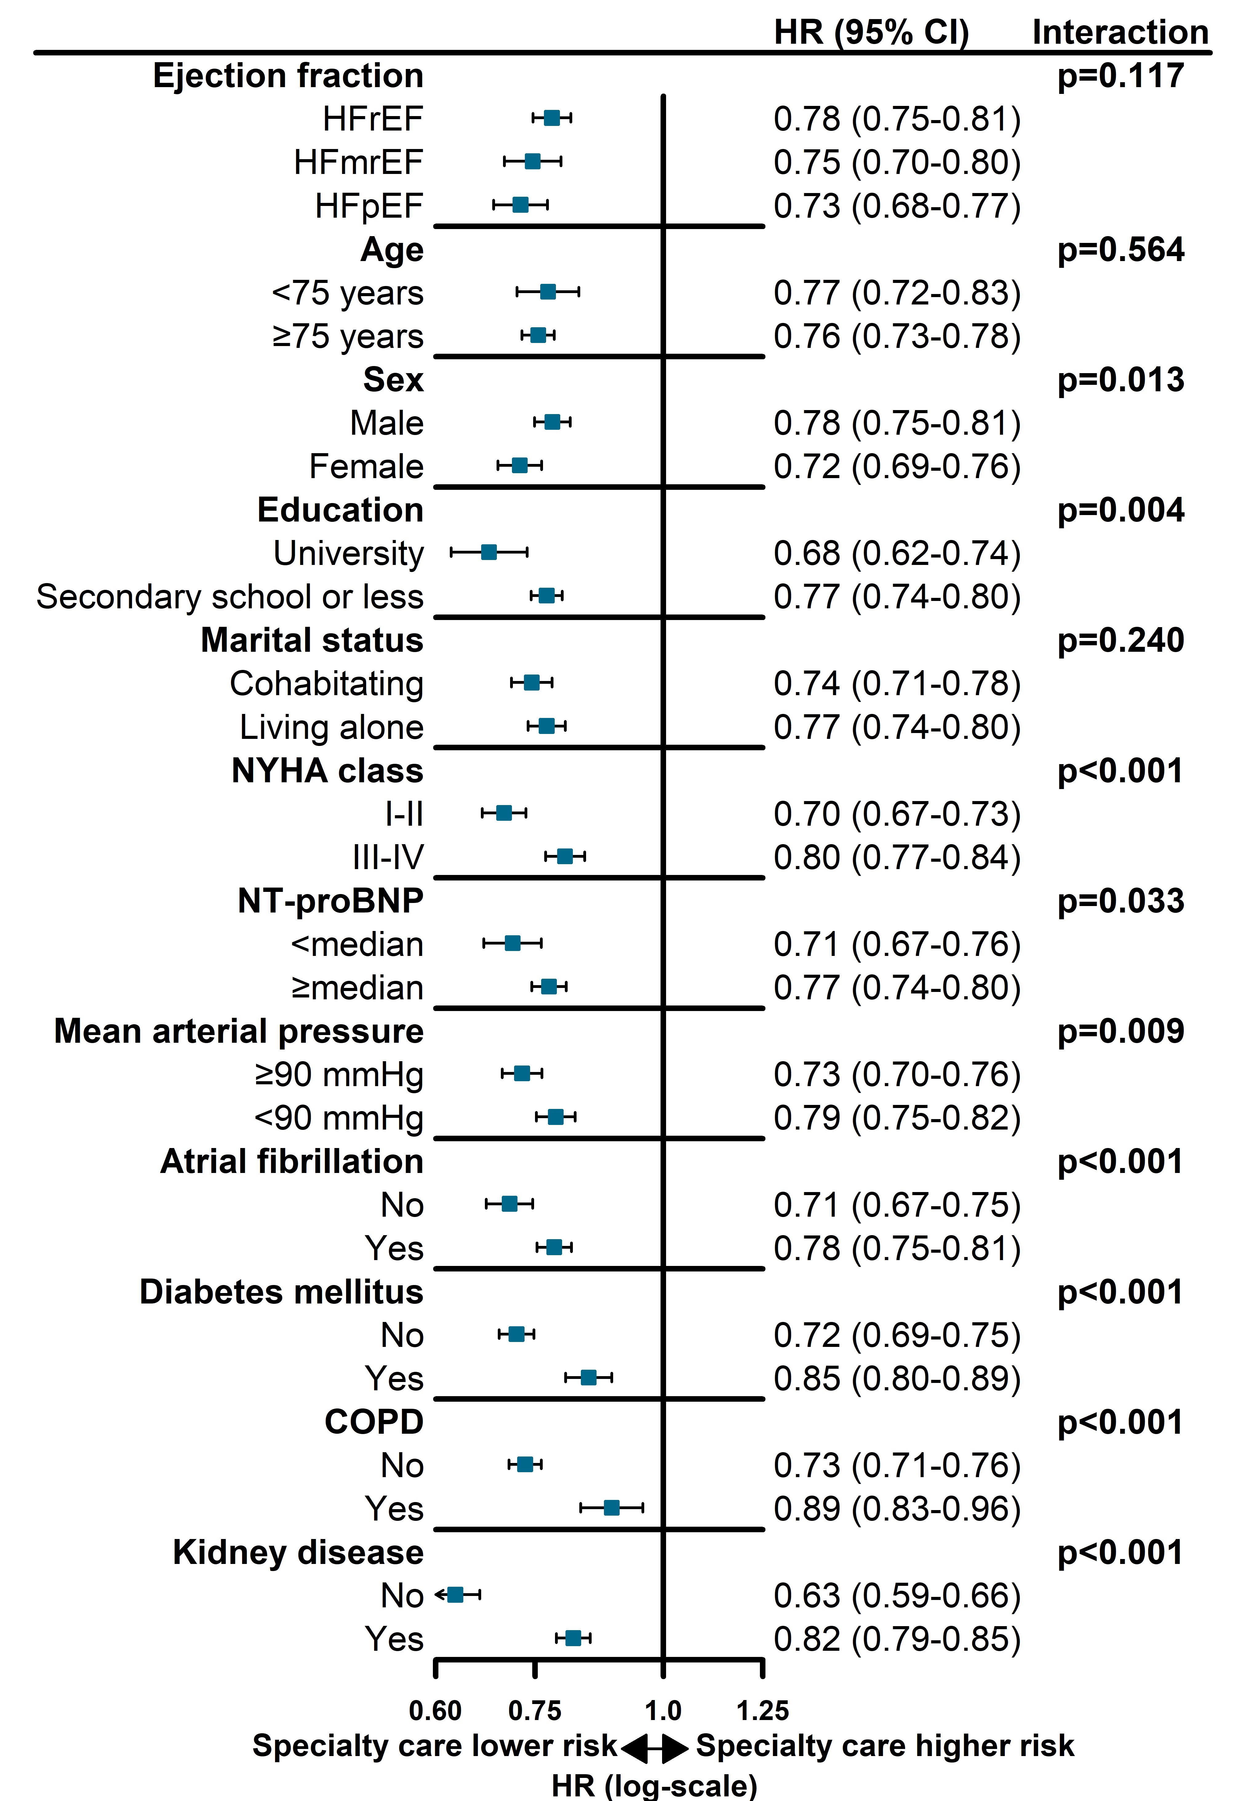
Figure 5. Association between follow-up type and risk of cardiovascular death in clinically relevant subgroups
Cox proportional hazards regression models adjusted for variables labeled with a dagger (†) in Table 1, including an interaction term between the subgroup variable and follow-up type.
Abbreviations: CI, confidence interval; HFmrEF, heart failure with mildly reduced ejection fraction; HFpEF, heart failure with preserved ejection fraction; HFrEF, heart failure with reduced ejection fraction; HR, hazard ratio; NT-proBNP, N-terminal pro-B-type natriuretic peptide.

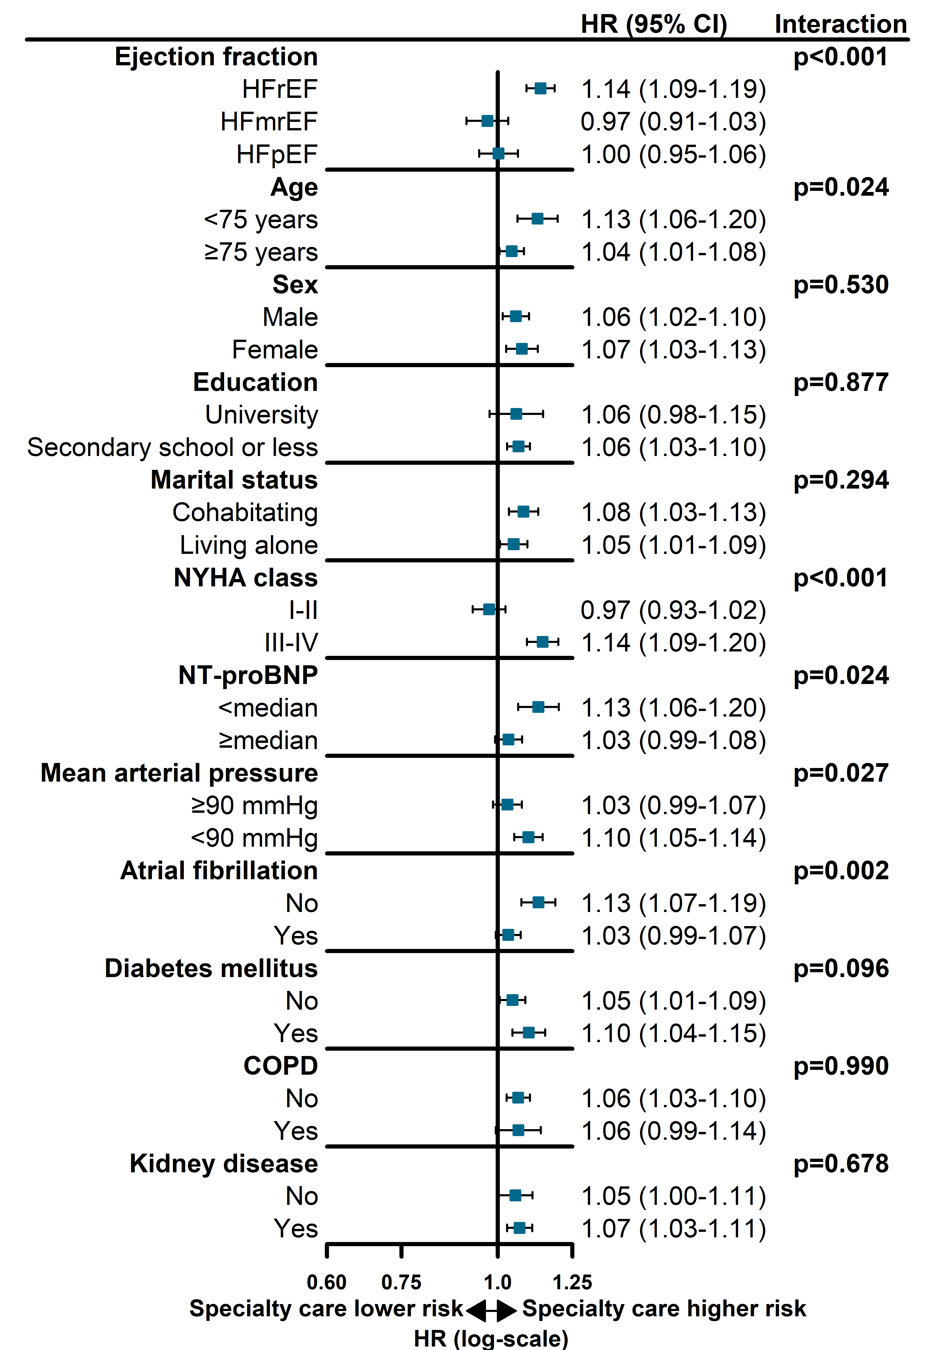
Figure 6. Association between follow-up type and risk of first heart failure hospitalisation in clinically relevant subgroups
Cox proportional hazards regression models adjusted for variables labeled with a dagger (†) in Table 1, including an interaction term between the subgroup variable and follow-up type.
Abbreviations: CI, confidence interval; HFmrEF, heart failure with mildly reduced ejection fraction; HFpEF, heart failure with preserved ejection fraction; HFrEF, heart failure with reduced ejection fraction; HR, hazard ratio; NT-proBNP, N-terminal pro-B-type natriuretic peptide.

