**Impact of Diabetes Mellitus on Tuberculosis Epidemiology in Indonesia: A Mathematical Modeling Analysis**

Word count: Abstract: 200 words, Text: 2,693 words.

**Number of figures:** 4

**Number of Tables:** 1

Conflict of interest: There are no conflicts of interest

**Disclose funding received for this work:** Qatar National Research Fund (QNRF)

**Running head:** Impact of diabetes on tuberculosis

**ABSTRACT**

We investigated and forecasted the impact of diabetes mellitus (DM) on tuberculosis (TB) epidemiology in Indonesia between 2020-2050. A recently-developed age-structured TB-DM dynamic mathematical model was utilized to assess the impact of DM on TB epidemiology. Model parameters were informed by systematic reviews and meta-analyses. Sensitivity and uncertainty analyses were conducted to assess robustness of predictions. The proportion of TB incident cases attributed to DM increased from 18.8% (95% uncertainty interval (UI): 12.6%-24.3%) in 2020, to 20.9% (95% UI: 14.7%-27.1%) in 2030, and 25.8% (95% UI: 17.7%-32.2%) in 2050. The proportion of TB-related deaths attributed to DM increased from 24.3% (95% UI: 18.7%-29.1%) in 2020, to 27.7% (95% UI: 22.4%-32.4%) in 2030, and 34.3% (95% UI: 27.6%-38.0%) in 2050. Most of the impact of DM on TB transmission has risen because of faster progression to TB disease, increased risk of reinfection, and increased infectiousness, with higher bacterial loads. Sensitivity and uncertainty analyses affirmed the predictions. TB-DM synergy is projected to increase in Indonesia over the next three decades with DM becoming a major driver of TB incidence and deaths. Joint TB-DM management and programs could offer significant reductions in TB incidence and mortality, making post-2015 End TB targets more feasible.

**Keywords:** Infectious disease; chronic disease; population attributable fraction; epidemiological synergy; mathematical modeling; Asian Pacific

1. **INTRODUCTION**

Tuberculosis (TB) and diabetes mellitus (DM) comorbidity is a global health threat to the control and prevention of TB disease1. People living with DM (PLWD) are more susceptible to acquire TB2, develop TB disease and/or TB reactivation and reinfection3-5, are more infectious while having TB disease6, and have an increased risk of TB recurrence and mortality5-10. A recent comprehensive study revealed the potentially large impact that DM can have on TB incidence, arising from both *direct effects* (e.g., increased risk of TB disease onset) and *indirect* *effects* (e.g., increased transmission of TB)6.

In low and middle-income countries where TB incidence is high and DM prevalence is increasing11, TB-DM synergy may present a challenge for attainment of the post-2015 End TB Strategy global goals of reducing TB disease incidence by 90% and TB mortality by 95% between 2015-203512. Indonesia has one of the largest TB burdens globally, with an estimated 845,000 new active TB cases and 98,300 TB-related deaths in 201813. TB incidence was estimated at 316 per 100,000 population, one of the highest globally13. In 2019, the International Diabetes Federation’s (IDF) Diabetes Atlas reported that Indonesia is and will remain one of the countries most affected by diabetes, with an estimated 10.7 million PLWD in 2019 (age-adjusted prevalence of 6.3%) and 16.6 million PLWD by 2045 (age-adjusted prevalence of 7.1%)14.

Since Indonesia is burdened by both TB and DM, their synergetic interactions are a public health concern. Against this background, we investigated and forecasted the impact of DM on TB epidemiology in this country between 2020-2050.

1. **METHODS**

**2.1 Mathematical model, data sources, and model fitting**

A deterministic compartmental mathematical model was used to investigate and forecast the impact of DM on TB epidemiology in Indonesia, based on adaptation and extension of a recently developed modeling approach6, 15. In contrast to earlier approaches16-23, this approach accounts for 1) different pathways in which DM affects TB natural history and treatment outcomes, 2) TB-DM bi-directionality, 3) the projected rise of the DM epidemic over coming decades, and importantly 4) both direct and indirect population-level impacts of DM effects on TB.

The implemented model captured the full dynamics of TB natural history, DM natural history, TB-DM interactions, and demography. Description of the conceptual framework, model structure, data sources, model fitting, and model analyses are presented in Table 1. Briefly, the model is described by a system of coupled, nonlinear, ordinary differential equations listed in the Appendix of Awad et al.15 and codded in MATLAB 2019a24. The model stratify the population of Indonesia by five-year age group, DM status (those with and without DM), and TB progression states. TB progression states are described by TB infection status and stage (latent slow [LSI] and latent fast [LFI]), TB disease status and form (smear-positive pulmonary [SP-PTB], smear-negative pulmonary [SN-PTB], and extra-pulmonary [EP-TB]), TB treatment status, and TB recovery status (Table 1).The proportion of individuals going into each of the infection and disease states differed between children (<15 years old) and adults (≥15 years old) 25.

TB natural history for PLWD was modulated by specific effects of having DM. Informed by empirical evidence6, 15, DM affected TB natural history via six different pathways: *Effect 1-Susceptibility* (increased susceptibility to TB infection), *Effect 2-Fast progression* (increased proportion of TB infections entering LFI versus LSI states), *Effect 3-Reactivation* (increased susceptibility to develop TB disease among those with LSI), *Effect 4-Primary reinfection* (increased susceptibility to TB reinfection among those with LSI), *Effect 5-Smear positivity* (increased proportion of those developing SP-PTB versus SN-PTB for those with pulmonary TB), and *Effect 6-Disease infectiousness* (increased TB infectiousness among those with pulmonary TB; Table 1).

Furthermore, DM affected TB treatment outcomes through four additional pathways6: *Effect 7-TB mortality* (increased risk of TB-related mortality), *Effect 8-Treatment failure* (reduced proportion of successful treatment among those undergoing TB treatment), *Effect 9-Recovery* (delayed resolution of TB disease), and *Effect 10-Recurrence* (increased susceptibility to TB reinfection after recovery; Table 1).

In the baseline analysis, *Effect 3-Reactivation* was set at null effect size (no effect), as the impact of this pathway could have been implicitly captured by *Effect 2*–*Fast progression* (pooled studies did not differentiate whether DM is associated with *Effect 2-Fast progression* and/or *Effect 3-Reactivation*3). Moreover, *Effect 8-Treatment failure* was set at null effect size given the conflicting evidence10. Definitions of the different DM-on-TB effects and their effect sizes are summarized in Table S1.

Evidence also suggests an effect of TB on DM (in addition to DM effects on TB)26-31. However, current evidence is not conclusive; thus, this bidirectionality was not accounted for in the baseline analysis, but was incorporated only in a sensitivity analysis.

Further details on this modeling approach can be found in Awad et al.6, 15.

Parametrization of TB natural history and treatment outcomes as well as DM natural history were informed by available empirical evidence25 (Table S2), or by fitting TB incidence and mortality32, DM prevalence33-38, and Indonesian demography39. TB contact and case-detection rates, DM incidence rate, and birth and natural mortality rates were derived by model fitting.

**2.2 Projecting the TB-DM burden**

Using the best fit parameters, TB disease incidence (annual number of new TB disease cases), TB disease incidence rate (ratio of the total annual number of new TB disease cases over the total population), the annual number of TB-related deaths, TB mortality rate (ratio of total annual number of TB-related deaths over total population), and DM prevalence were estimated between 1995-2050 for the total population of Indonesia.

Through a population attributable fraction (*PAF*) approach6, the impact of DM on TB disease incidence and mortality was also estimated between 1995-2050. The impact of DM on TB epidemiology was assessed for each of the DM-on-TB effects individually and in combinations.

**2.3 Uncertainty analysis**

The uncertainty range in the impact of DM on TB was estimated through a multivariable uncertainty analysis of 500 runs. In each uncertainty run, the DM-on-TB effect sizes and key TB and DM natural history parameters (listed in Tables S1 and S2) were varied simultaneously using either their confidence intervals (CI), or assuming ±25% uncertainty around the point estimates. Latin Hypercube sampling was applied to generate random samples of input parameter values for each uncertainty run40. Consequently, the means and 95% uncertainty intervals (UI) of the *PAF*s were estimated.

**2.4 Sensitivity analyses**

Given heterogeneities and uncertainties surrounding the exact effect sizes of some of the DM-on-TB effects6, 15, several sensitivity analyses were conducted to accommodate different parametrizations of these effects, as informed by the application to India6. First, the TB-DM association effect size was based on pooling only prospective cohort studies, as opposed to all observational studies3. Second, the effect size of *Effect 7-TB mortality* was based on pooling only studies that appropriately adjusted for confounders, as opposed to all studies assessing this effect10. Third, an effect size for *Effect 3-Reactivation* was incorporated and assumed equal in magnitude to *Effect 2-Fast progression*, out of biological plausibility. Fourth, age-dependence of the TB-DM association was factored as informed by a key cohort study41. Fifth, the TB-DM synergy implications were explored accommodating for the TB-DM bi-directionality. In this analysis, the risk of DM onset among those with TB disease compared to those without TB disease was assumed to be 1.79 based on a recent assessment (in the baseline scenario this effect was not incorporated)29. Sixth, the proportion of individuals with SN-PTB as oppose to SP-PTB was assumed to be larger in elderly (≥60 year old) compared to younger individuals as informed by various studies42-44. Seventh, 10 different future trajectories (by 2050) were assumed for each of TB incidence rate and DM prevalence that ranged between ±50% of the baselines for these indicators. Last, the impact of variation of each effect size within its confidence interval, or if not available by ±25% uncertainty around the point estimate, was assessed.

The model was coded and the fitting and all analyses were conducted in MATLAB R2019a45.

1. **RESULTS**

Figures 1 and S1 show the best-fits and predictions of Indonesia’s demographics, TB incidence rate, TB mortality rate, and DM prevalence and its age distribution. Between 2020-2050, the TB disease incidence rate and the annual number of new cases (absolute incidence) were estimated to decrease from 260.0 to 195.6 per 100,000 persons per year and from 768,213 to 700,176, respectively (Figures 1B and S2A). Similarly, the TB mortality rate and TB deaths were estimated to decrease from 39.4 to 30.6 per 100,000 persons per year and from 114,937 to 107,332, respectively (Figures 1C and S2B). Between 2020-2050, DM prevalence and the total number of PLWD were projected to increase from 6.4% to 9.4% and from 11.0 million to 20.4 million, respectively (Figures 1D and S2C).

The proportion of TB incident cases and the proportion of TB-related deaths attributed to DM increased between 2020-2050 (Figure 2A). In 2020, these proportions were 18.8% (95% UI: 12.6%-24.3%) and 24.3% (95% UI: 18.7%-29.1%), respectively, but they are projected to increase to 20.9% (95% UI: 14.7%-27.1%) and 27.7% (95% UI: 22.4%-32.4%) in 2030, and to 25.8% (95% UI: 17.7%-32.2%) and 34.3% (95% UI: 27.6%-38.0%) in 2050, respectively. The uncertainty interval for the predicted impact of DM on TB was relatively narrow overall, but wider closer to 2050 (Figure S3).

Figures 2B and 2C show the impact of each DM-on-TB effect in 2020 and 2050. Most effects resulted in larger TB disease incidence and mortality and the impact grow larger with time. *Effect 2-Fast progression, Effect 4-Reinfection,* and *Effect 6-Infectiousness* each had a large impact on TB incidence (Figure 2A). Between 2020-2050, the proportion of TB incidence attributed to *Effect 2-Fast progression* increased from 8.9% to 12.5%, while that attributed to *Effect 4-Reinfection* increased from 10.1% to 12.5% and that to *Effect 6-Disease infectiousness* increased from 8.1% to 11.7% (Figure 2B). Due to premature death of individuals with smear-positive pulmonary TB disease before transmitting the infection, *Effect 5-Smear positivity* and *Effect 7-TB mortality* actually reduced TB disease incidence (i.e., negative attributable fraction; Figure 2B).

*Effect 2-Fast progression, Effect 4-Reinfection,* and *Effect 6-Infectiousness* had the largest impact on TB mortality (Figure 2C). Between 2020-2050, the proportion of TB-related deaths attributed to *Effect 2-Fast progression* increased from 10.3% to 14.6%, while that attributed to *Effect 4-Reinfection* increased from 11.7% to 14.7% and that to *Effect 6-Disease infectiousness* increased from 7.9% to 11.7% (Figure 2C).

**3.1 Sensitivity analyses**

Figure 3 shows the predicted proportion of TB disease incident cases and the proportion of TB-related deaths attributed to DM in 2020 and 2050 in the different sensitivity analyses related to parametrization of some of the DM-on-TB effect sizes. Nearly all sensitivity analyses resulted in a larger impact of DM on both TB disease cases and deaths.

Figure 4 shows a sensitivity analysis factoring 10 different future trajectories for TB incidence rate and DM prevalence. For the 10 trajectories of TB incidence rate, by 2050, the proportion of TB disease incident cases and the proportion of TB-related deaths attributed to DM ranged between 16.9%-30.0% and 26.7%-38.1%, respectively. For the 10 trajectories of DM prevalence, by 2050, the proportion of TB disease incident cases and the proportion of TB-related deaths attributed to DM ranged between 15.0%-36.9% and 21.3%-46.5%, respectively.

Figure S4 shows the sensitivity of the proportion of TB disease incident and mortality cases attributed to DM in 2050, to variations in the key parameters in the model. The figure affirmed the predictions and suggested that *Effect 2-Fast progression* and *Effect 6-Infectiousness* had the largest impact on TB incidence and mortality.

1. **DISCUSSION**

With the large pool of people living with DM in Indonesia who have a higher risk of developing TB disease and of having poor TB treatment outcomes, the role of DM in TB epidemiology is already substantial and will grow further in coming decades. In 2020, one in five TB cases and one in four TB-related deaths were attributed to DM, and these proportions are projected to increase to one in 4 and one in 3, respectively, by 2050 (Figure 2). Accounting for both direct and indirect impacts and factoring the different DM-on-TB effects based on a foundation of systematic and pooled empirical evidence, our estimates are higher than earlier estimates16-21 where typically only one or several effects are factored and the focus is only on the direct impact.

As supported by evidence, uncontrolled DM worsen TB disease and treatment outcome3, 46-48. Therefore, having a large population of undiagnosed/uncontrolled DM in Indonesia14, 49 can substantially worsen TB incidence and mortality (potentially more than predicted in this study).

These findings highlight the urgency for implementation of joint multifactorial TB-DM intervention strategies targeting PLWD before TB disease onset and/or during TB treatment. A recent modeling study in India highlighted the importance of such an approach50, possibly through improved DM management and/or implementation of TB vaccination using novel TB vaccines as they become available51-53. Moving in this direction is essential if we are to accomplish the post-2015 End TB Strategy targets, as has been emphasized elsewhere5, 54.

The above results demonstrate that the impact of DM on TB transmission is mostly driven by the effects of DM on TB natural history, specifically *Effect 2-Fast progression*, *Effect 4-Reinfection,* and *Effect 6-Disease infectiousness* (Figures 2B-C and S4). Although other DM-on-TB effects also contribute, those contributions are minimal compared to these three effects. DM also had a significant impact on TB mortality through *Effect 7-TB mortality* (Figure 2C).

Our study has several limitations. While we included various DM-on-TB effects based on empirical evidence, some of these effects were provided only as summary measures with no age stratification, though heterogeneities in the age effect could be important in driving the population level impact. Also, the summary measures were not stratified by controlled and uncontrolled DM though evidence suggest that uncontrolled DM further worsen TB disease and treatment outcome. The effect of intermediate hyperglycemia (pre-DM) on TB was not incorporated, although it may enhance the impact of DM on TB3, 55. Therefore, more studies are required to evaluate the impact of targeted interventions for the full spectrum of glucose intolerance. Also, the modelling framework can in the future be extended to include more stratification for DM: pre-DM, controlled DM, and uncontrolled DM.

Some co-factors that may influence the epidemiology of TB and/or DM or their interactions were not included in the model, mainly HIV, smoking, and obesity56-58. However, the prevalence of HIV is relatively low in Indonesia at <1.0%59; thus, its public health implications on TB-DM synergy are perhaps minimal. Moreover, the TB-DM-obesity interaction seems paradoxical, i.e., obesity increases the risk of DM60, but obesity seems to be a protective factor against TB disease61; thus, the obesity effect may be difficult to disentangle62.

The complex natural history of TB infection remains insufficiently understood63. For instance, in recent years, there has been evidence that latent TB infection may not refer to only two entities (i.e., LSI and LFI), but may represent an array of microbiological and pathological states giving rise to a clinical spectrum spanning latent TB infection64. Evidence suggests that young adults are at a higher risk of fast progression to TB disease compared to older individuals63, but in our model we assumed that the risk only differed between children (0-14 years old) and adults (+15 years old; Table S2).

Despite these limitations, our model accounts for ten pathways by which DM affects TB natural history and treatment outcomes, includes TB-DM bidirectionality, and factors the projected rise of the DM epidemic in Indonesia over coming decades. The model also incorporates both direct and indirect DM-on-TB population impacts and is based on comprehensive investigation of empirical evidence for DM-on-TB effects6, 15. Extensive sensitivity analyses and an uncertainty analysis were further conducted to ensure robustness of the predictions, and these have confirmed the results and suggested that the DM-on-TB impact could perhaps be underestimated (Figures 3 and S3-S4).

1. **CONCLUSION**

At present one in five TB disease cases and one in four TB-related deaths are attributed to DM in Indonesia. By 2050, these will increase to one in four and one in three, respectively. These findings demonstrate the criticality of addressing TB-DM synergy and they provide scientific evidence necessary to inform TB control policy, programming, and resource allocation in a country with one of the world’s highest TB burdens.

**ACKNOWLEDGEMENTS**

This publication was made possible by NPRP grant number 7-627-3-167 from the Qatar National Research Fund, a member of the Qatar Foundation. The findings herein are solely the responsibility of the authors. The authors are grateful for direct and infrastructure support provided by the Biomedical Research Program and the Biostatistics, Epidemiology, and Biomathematics Research Core, at Weill Cornell Medicine-Qatar. We acknowledge Bachti Alisjahbana for his valuable insights and useful comments on an earlier draft of this manuscript.

**CONFLICTS OF INTEREST**

We declare that we have no conflict of interest to disclose.

**PATIENT CONSENT STATEMENT**

All data used in this study are aggregated, de-identified, and anonymized.

**REFERENCES**

1. Lin Y, Harries AD, Kumar AMV, Critchley JA, Crevel Rv, Owiti P, Dlodlo RA, Dejgaard A. Management of diabetes mellitus-tuberculosis. A guide to the essential practice. (Available at: <https://www.theunion.org/what-we-do/publications/technical/english/TheUnion_DMTB_Guide_October2018_Text_AW_02.pdf>, Accessed Jan. 2019). 2019.

2. Martinez L, Zhu L, Castellanos ME, Liu Q, Chen C, Hallowell BD, Whalen CC. Glycemic Control and the Prevalence of Tuberculosis Infection: A Population-based Observational Study. *Clinical infectious diseases : an official publication of the Infectious Diseases Society of America* 2017 doi: 10.1093/cid/cix632

3. Al-Rifai RH, Pearson F, Critchley JA, Abu-Raddad LJ. Association between diabetes mellitus and active tuberculosis: A systematic review and meta-analysis. *PLoS One* 2017;**12**:e0187967. doi: 10.1371/journal.pone.0187967

4. Jeon CY, Murray MB. Diabetes mellitus increases the risk of active tuberculosis: a systematic review of 13 observational studies. *PLoS medicine* 2008;**5**:e152. doi: 10.1371/journal.pmed.0050152

5. World Health Organization, International Union Against Tuberculosis and Lung Disease. Collaborative framework for care and control of tuberculosis and diabetes. Switzerland: World Health Organization, 2011.

6. Awad SF, Dargham SR, Omori R, Pearson F, Critchley JA, Abu-Raddad LJ. Analytical Exploration of Potential Pathways by which Diabetes Mellitus Impacts Tuberculosis Epidemiology. *Sci Rep* 2019;**9**:8494. doi: 10.1038/s41598-019-44916-7

7. Baker MA, Harries AD, Jeon CY, Hart JE, Kapur A, Lönnroth K, Ottmani S-E, Goonesekera SD, Murray MB. The impact of diabetes on tuberculosis treatment outcomes: A systematic review. *BMC Medicine* 2011;**9**:81-81. doi: 10.1186/1741-7015-9-81

8. Stevenson CR, Critchley JA, Forouhi NG, Roglic G, Williams BG, Dye C, Unwin NC. Diabetes and the risk of tuberculosis: a neglected threat to public health? *Chronic illness* 2007;**3**:228-245. doi: 10.1177/1742395307081502

9. Faurholt-Jepsen D, Range N, Praygod G, Kidola J, Faurholt-Jepsen M, Aabye MG, Changalucha J, Christensen DL, Martinussen T, Krarup H, Witte DR, Andersen AB, Friis H. The role of diabetes co-morbidity for tuberculosis treatment outcomes: a prospective cohort study from Mwanza, Tanzania. *BMC infectious diseases* 2012;**12**:165. doi: 10.1186/1471-2334-12-165

10. Huangfu P, Ugarte-Gil C, Golub J, Pearson F, Critchley J. The effects of diabetes on tuberculosis treatment outcomes: an updated systematic review and meta-analysis. *The international journal of tuberculosis and lung disease : the official journal of the International Union against Tuberculosis and Lung Disease* 2019;**23**:783-796. doi: 10.5588/ijtld.18.0433

11. McAllister SM, Koesoemadinata RC, Santoso P, Soetedjo NNM, Kamil A, Permana H, Ruslami R, Critchley JA, van Crevel R, Hill PC, Alisjahbana B. High tuberculosis incidence among people living with diabetes in Indonesia. *Transactions of The Royal Society of Tropical Medicine and Hygiene* 2019;**114**:79-85. doi: 10.1093/trstmh/trz100

12. World Health Organization. Global strategy and targets for tuberculosis prevention, care and control after 2015 (Available from: <http://apps.who.int/gb/ebwha/pdf_files/EB134/B134_12-en.pdf?ua=1>; accessed on July 2018). 2013.

13. World Health Organization. Global tuberculosis report 2018 (Available from: <http://apps.who.int/iris/bitstream/handle/10665/274453/9789241565646-eng.pdf?ua=1>, accessed Sept. 2018). 2018.

14. International Diabetes Federation. IDF Diabetes Atlas. Ninth edition 2019. (Available at: <https://www.diabetesatlas.org/upload/resources/2019/IDF_Atlas_9th_Edition_2019.pdf>. Accessed: 24 Nov. 2019). 2019.

15. Awad SF, Huangfu P, Ayoub HH, Pearson F, Dargham SR, Critchley JA, Abu-Raddad LJ. Forecasting the impact of diabetes mellitus on tuberculosis disease incidence and mortality in India. *Journal of global health* 2019;**9**:020415. doi: 10.7189/jogh.09.020415

16. Ruslami R, Aarnoutse RE, Alisjahbana B, van der Ven AJ, van Crevel R. Implications of the global increase of diabetes for tuberculosis control and patient care. *Tropical medicine & international health : TM & IH* 2010;**15**:1289-1299. doi: 10.1111/j.1365-3156.2010.02625.x

17. Harries AD, Satyanarayana S, Kumar AMV, Nagaraja SB, Isaakidis P, Malhotra S, Achanta S, Naik B, Wilson N, Zachariah R, Lönnroth K, Kapur A. Epidemiology and interaction of diabetes mellitus and tuberculosis and challenges for care: a review [Review article]. *Public Health Action* 2013;**3**:3-9. doi: 10.5588/pha.13.0024

18. Stevenson CR, Forouhi NG, Roglic G, Williams BG, Lauer JA, Dye C, Unwin N. Diabetes and tuberculosis: the impact of the diabetes epidemic on tuberculosis incidence. *BMC public health* 2007;**7**:234.

19. Lonnroth K, Castro KG, Chakaya JM, Chauhan LS, Floyd K, Glaziou P, Raviglione MC. Tuberculosis control and elimination 2010-50: cure, care, and social development. *Lancet* 2010;**375**:1814-1829. doi: 10.1016/S0140-6736(10)60483-7

20. Odone A, Houben RM, White RG, Lonnroth K. The effect of diabetes and undernutrition trends on reaching 2035 global tuberculosis targets. *The lancet Diabetes & endocrinology* 2014;**2**:754-764. doi: 10.1016/S2213-8587(14)70164-0

21. Pan SC, Ku CC, Kao D, Ezzati M, Fang CT, Lin HH. Effect of diabetes on tuberculosis control in 13 countries with high tuberculosis: a modelling study. *The lancet Diabetes & endocrinology* 2015;**3**:323-330. doi: 10.1016/S2213-8587(15)00042-X

22. Moualeu DP, Bowong S, Tewa JJ, Emvudu Y. Analysis of The Impact of Diabetes on The Dynamical Transmission of Tuberculosis. *Math Model Nat Phenom* 2012;**7** 117-146. doi: 10.1051/mmnp/20127309

23. Walker C, Unwin N. Estimates of the impact of diabetes on the incidence of pulmonary tuberculosis in different ethnic groups in England. *Thorax* 2010;**65**:578-581. doi: 10.1136/thx.2009.128223

24. The MathWorks, Inc. MATLAB. The language of technical computing. The MathWorks, Inc., 2020.

25. Abu-Raddad LJ, Sabatelli L, Achterberg JT, Sugimoto JD, Longini IM, Jr., Dye C, Halloran ME. Epidemiological benefits of more-effective tuberculosis vaccines, drugs, and diagnostics. *Proceedings of the National Academy of Sciences of the United States of America* 2009;**106**:13980-13985. doi: 10.1073/pnas.0901720106

26. Nathan DM, Davidson MB, DeFronzo RA, Heine RJ, Henry RR, Pratley R, Zinman B. Impaired fasting glucose and impaired glucose tolerance: implications for care. *Diabetes care* 2007;**30**:753-759. doi: 10.2337/dc07-9920

27. Forouhi NG, Luan J, Hennings S, Wareham NJ. Incidence of Type 2 diabetes in England and its association with baseline impaired fasting glucose: the Ely study 1990-2000. *Diabet Med* 2007;**24**:200-207. doi: 10.1111/j.1464-5491.2007.02068.x

28. Harries AD, Murray MB, Jeon CY, Ottmani S-E, Lonnroth K, Barreto ML, Billo N, Brostrom R, Bygbjerg IC, Fisher-Hoch S, Mori T, Ramaiya K, Roglic G, Strandgaard H, Unwin N, Viswanathan V, Whiting D, Kapur A. Defining the research agenda to reduce the joint burden of disease from Diabetes mellitus and Tuberculosis. *Tropical Medicine & International Health* 2010;**15**:659-663. doi: 10.1111/j.1365-3156.2010.02523.x

29. Young F, Wotton CJ, Critchley JA, Unwin NC, Goldacre MJ. Increased risk of tuberculosis disease in people with diabetes mellitus: record-linkage study in a UK population. *Journal of epidemiology and community health* 2012;**66**:519-523. doi: 10.1136/jech.2010.114595

30. Pearson F, Huangfu P, McNally R, Pearce M, Unwin N, Critchley JA. Tuberculosis and diabetes: bidirectional association in a UK primary care data set. *Journal of epidemiology and community health* 2018 doi: 10.1136/jech-2018-211231

31. F. Pearson, M. Pearce, R. Mcnally, N. Unwin, Critchley J. OA-434-05 Exploring the association betweenTB and diabetes. *The Interbnational Journal of Tuberculosis and Lung Disease* 2015;**19**:S299.

32. World Health Organization. WHO Global Health Observatory Data Repository, (available at: <http://apps.who.int/gho/data/node.main>). 2017.

33. International Diabetes Federation. IDF Diabetes Atlas. 3th edition. Brussels, Belgium (available at: <https://www.idf.org/sites/default/files/Diabetes-Atlas-3rd-edition.pdf>; accessed on December 2015). 2006.

34. International Diabetes Federation. IDF diabetes atlas, sixth edition (available at: <www.idf.org/diabetesatlas>). International Diabetes Federation, 2013.

35. International Diabetes Federation. IDF Diabetes Atlas. 7th edition. Brussels, Belgium (Available at:<http://www.diabetesatlas.org>; accessed on September 2016). 2016.

36. International Diabetes Federation. IDF Diabetes Atlas. Eighth edition. Brussels, Belgium (Available at:<http://www.diabetesatlas.org>; accessed on December 2017). 2017.

37. Guariguata L, Whiting DR, Hambleton I, Beagley J, Linnenkamp U, Shaw JE. Global estimates of diabetes prevalence for 2013 and projections for 2035. *Diabetes research and clinical practice* 2014;**103**:137-149. doi: <http://dx.doi.org/10.1016/j.diabres.2013.11.002>

38. Whiting DR, Guariguata L, Weil C, Shaw J. IDF diabetes atlas: global estimates of the prevalence of diabetes for 2011 and 2030. *Diabetes research and clinical practice* 2011;**94**:311-321. doi: 10.1016/j.diabres.2011.10.029

39. United Nations Department of Economic and Social Affairs, Population Division, Population Estimates and Projections Section. World population prospects, the 2012 revision. 2012. available: <http://esa.un.org/wpp/Excel-Data/population.htm>

40. Stein M. Large Sample Properties of Simulations Using Latin Hypercube Sampling. *Technometrics* 1987;**29**:143-151. doi: 10.1080/00401706.1987.10488205

41. Kim SJ, Hong YP, Lew WJ, Yang SC, Lee EG. Incidence of pulmonary tuberculosis among diabetics. *Tubercle and Lung Disease* 1995;**76**:529-533. doi: <http://dx.doi.org/10.1016/0962-8479(95)90529-4>

42. Negin J, Abimbola S, Marais BJ. Tuberculosis among older adults – time to take notice. *International Journal of Infectious Diseases* 2015;**32**:135-137. doi: <https://doi.org/10.1016/j.ijid.2014.11.018>

43. Nagu T, Ray R, Munseri P, Moshiro C, Shayo G, Kazema R, Mugusi F, Pallangyo K. Tuberculosis among the elderly in Tanzania: disease presentation and initial response to treatment. *The international journal of tuberculosis and lung disease : the official journal of the International Union against Tuberculosis and Lung Disease* 2017;**21**:1251-1257. doi: 10.5588/ijtld.17.0161

44. Borgdorff MW, Nagelkerke NJ, de Haas PE, van Soolingen D. Transmission of Mycobacterium tuberculosis depending on the age and sex of source cases. *Am J Epidemiol* 2001;**154**:934-943. doi: 10.1093/aje/154.10.934

45. The MathWorks, Inc. MATLAB. The language of technical computing. The MathWorks, Inc., 2015.

46. Julia A. Critchley, Iain M. Carey, Tess Harris, Stephen DeWilde, Fay J. Hosking, Derek G. Cook. Glycemic Control and Risk of Infections Among People With Type 1 or Type 2 Diabetes in a Large Primary Care Cohort Study (Under Review). *Diabetes Care* 2018;**41**:1–9

47. Mahishale V, Avuthu S, Patil B, Lolly M, Eti A, Khan S. Effect of Poor Glycemic Control in Newly Diagnosed Patients with Smear-Positive Pulmonary Tuberculosis and Type-2 Diabetes Mellitus. *Iran J Med Sci* 2017;**42**:144-151.

48. Shewade HD, Jeyashree K, Mahajan P, Shah AN, Kirubakaran R, Rao R, Kumar AMV. Effect of glycemic control and type of diabetes treatment on unsuccessful TB treatment outcomes among people with TB-Diabetes: A systematic review. *PLoS One* 2017;**12**:e0186697. doi: 10.1371/journal.pone.0186697

49. Soewondo P, Ferrario A, Tahapary DL. Challenges in diabetes management in Indonesia: a literature review. *Globalization and health* 2013;**9**:63-63. doi: 10.1186/1744-8603-9-63

50. Awad SF, Critchley JA, Abu-Raddad LJ. Epidemiological impact of targeted interventions for people with diabetes mellitus on tuberculosis transmission in India: Modelling based predictions. *Epidemics* 2019;**30**:100381. doi: 10.1016/j.epidem.2019.100381

51. Nemes E, Geldenhuys H, Rozot V, Rutkowski KT, Ratangee F, Bilek N, Mabwe S, Makhethe L, Erasmus M, Toefy A, Mulenga H, Hanekom WA, Self SG, Bekker L-G, Ryall R, Gurunathan S, DiazGranados CA, Andersen P, Kromann I, Evans T, Ellis RD, Landry B, Hokey DA, Hopkins R, Ginsberg AM, Scriba TJ, Hatherill M, Team CS. Prevention of M. tuberculosis Infection with H4:IC31 Vaccine or BCG Revaccination. *The New England journal of medicine* 2018;**379**:138-149. doi: 10.1056/NEJMoa1714021

52. Bill & Melinda Gates Medical Research Institute. A Randomized, Placebo Controlled, Observer-Blind, Phase IIb Study to Evaluate the Efficacy, Safety, and Immunogenicity of BCG Revaccination in Healthy Adolescents for the Prevention of Sustained Infection With Mycobacterium Tuberculosis. <https://clinicaltrials.gov/ct2/show/NCT04152161> 2020

53. Van Der Meeren O, Hatherill M, Nduba V, Wilkinson RJ, Muyoyeta M, Van Brakel E, Ayles HM, Henostroza G, Thienemann F, Scriba TJ, Diacon A, Blatner GL, Demoitié M-A, Tameris M, Malahleha M, Innes JC, Hellström E, Martinson N, Singh T, Akite EJ, Khatoon Azam A, Bollaerts A, Ginsberg AM, Evans TG, Gillard P, Tait DR. Phase 2b Controlled Trial of M72/AS01(E) Vaccine to Prevent Tuberculosis. *The New England journal of medicine* 2018;**379**:1621-1634. doi: 10.1056/NEJMoa1803484

54. International Union Against Tuberculosis and Lung Disease, World Diabetes Foundation. The Looming Co-epidemic of TB-Diabetes: A Call to Action (Available at: <https://www.theunion.org/what-we-do/publications/technical/low-resolution/25383_TCB_Report_LR.pdf>; accessed April 2018). 2014.

55. Owiti P, Keter A, Harries AD, Pastakia S, Wambugu C, Kirui N, Kasera G, Momanyi R, Masini E, Some F, Gardner A. Diabetes and pre-diabetes in tuberculosis patients in western Kenya using point-of-care glycated haemoglobin. *Public Health Action* 2017;**7**:147-154. doi: 10.5588/pha.16.0114

56. Faurholt-Jepsen D, Range N, PrayGod G, Jeremiah K, Faurholt-Jepsen M, Aabye MG, Changalucha J, Christensen DL, Grewal HMS, Martinussen T, Krarup H, Witte DR, Andersen AB, Friis H. Diabetes is a strong predictor of mortality during tuberculosis treatment: a prospective cohort study among tuberculosis patients from Mwanza, Tanzania. *Tropical Medicine & International Health* 2013;**18**:822-829. doi: 10.1111/tmi.12120

57. Levitt NS, Bradshaw D. The impact of HIV/AIDS on Type 2 diabetes prevalence and diabetes healthcare needs in South Africa: projections for 2010. *Diabet Med* 2006;**23**:103-104. doi: 10.1111/j.1464-5491.2006.01768.x

58. Young F, Critchley JA, Johnstone LK, Unwin NC. A review of co-morbidity between infectious and chronic disease in Sub Saharan Africa: TB and diabetes mellitus, HIV and metabolic syndrome, and the impact of globalization. *Globalization and health* 2009;**5**:9. doi: 10.1186/1744-8603-5-9

59. UNAIDS. HIV in Indonesia, 2018 (Available at: <https://www.unaids.org/en/regionscountries/countries/indonesia#:~:text=In%20Indonesia%20in%202018%3A,49%20years)%20was%200.4%25>.; Accessed 2020). 2020.

60. Guh DP, Zhang W, Bansback N, Amarsi Z, Birmingham CL, Anis AH. The incidence of co-morbidities related to obesity and overweight: a systematic review and meta-analysis. *BMC public health* 2009;**9**:88. doi: 10.1186/1471-2458-9-88

61. Lonnroth K, Williams BG, Cegielski P, Dye C. A consistent log-linear relationship between tuberculosis incidence and body mass index. *Int J Epidemiol* 2010;**39**:149-155. doi: 10.1093/ije/dyp308

62. Lin HH, Wu CY, Wang CH, Fu H, Lonnroth K, Chang YC, Huang YT. Association of Obesity, Diabetes, and Risk of Tuberculosis: Two Population-Based Cohorts. *Clinical infectious diseases : an official publication of the Infectious Diseases Society of America* 2018;**66**:699-705. doi: 10.1093/cid/cix852

63. Nico J.D. Nagelkerke. *Courtesans and consumption. How sexually transmitted infections drive tuberculosis epidemics*. The Netherlands (<www.eburon.nl>). Eburon, Delft. ISBN: 978-90-5972-603-1 (paperback), ISBN: 978-90-5972-604-8 (ebook), 2012.

64. Dutta NK, Karakousis PC. Latent tuberculosis infection: myths, models, and molecular mechanisms. *Microbiol Mol Biol Rev* 2014;**78**:343-371. doi: 10.1128/MMBR.00010-14

65. Lagarias JC, J. A. Reeds, M. H. Wright,and P. E. Wright. Convergence Properties of the Nelder-MeadSimplex Method in Low Dimensions. *SIAM Journal of Optimization* 1998;**9**:112-147.

**Table 1.** Description of the mathematical modeling methodology employed in this study.

|  |  |  |
| --- | --- | --- |
| **Methodology** | | **Description** |
| **Schematic diagrama** | |  |
| **TB-DM model** | | * Expressed in terms of a set of 400 coupled non-linear ordinary differential equations. * Disaggregated the population into: * Twenty five-year age bands (0–4, 5–9… 95–99 years old) * Two TB susceptible classes: individuals living with or without DM * Four TB latent infection stages: TB latent fast and latent slow progression for each individual living with or without DM * Six TB disease states: smear-positive pulmonary, smear-negative pulmonary, and extra-pulmonary TB disease for each individual living with or without DM * Six TB disease treatment states: treated TB disease (characterized according to the three TB disease types) for each individual living with or without DM |
| **Data Sources and parameters** | **TB natural history and TB and DM mortality** | Age-specific parameters for TB natural history (in the absence of DM) were obtained from empirical data of multiple sources listed in Table S2:   * proportion of TB infections entering latent-fast state * proportions of new TB disease cases in each of the three clinical disease categoriesb * fractional reduction in the susceptibility to TB reinfection due to prior exposure to TB * progression rate from latency to TB disease for latent-fast progressors * progression rate from latency to TB disease for latent-slow progressors * TB disease mortality rate per TB disease category for untreated and treated cases * proportion of TB disease cases that are effectively treated * spontaneous recovery rate * rate of successful completion of treatment * transmission probability per respiratory contact * relative risk of mortality in people with DM compared to the general population |
| **Effects of DM on TB** | DM was assumed to affect TB natural history and treatment outcomes via 10 different pathways. Effect sizes of the 10 DM-on-TB effects were based mostly on pooled evidence from systematic reviews and/or meta-analyses, or derived from specific observational studies. DM:   * increases susceptibility to TB infection (*Effect 1-Susceptibility*) * increases the proportion of TB infections entering latent-fast state as opposed to latent-slow state (*Effect 2-Fast progression*) * increases the rate of developing TB disease among those with latent TB infection (*Effect 3-Reactivation*) * increases the susceptibility to TB reinfection among those with latent-slow TB infection (*Effect 4-Latent reinfection*) * increases proportion of those developing SP-PTB (versus SN-PTB) for those with pulmonary TB disease (*Effect 5-Smear positivity*) * increases TB infectiousness among those with pulmonary TB disease for untreated and treated TB disease cases (*Effect 6-Disease infectiousness*) * increases the risk of TB-related mortality for untreated and treated TB disease cases (*Effect 7-TB mortality*) * reduces the proportion of successful treatment among those undergoing TB treatment (through increased risk of treatment failure and MDR-TB; *Effect 8-Treatment failure*) * reduces the rate of TB recovery (i.e. prolongs the recovery time) for those who recover naturally or due to treatment (*Effect 9-Recovery*) * increases susceptibility to TB reinfection among those treated or recovered from TB disease (*Effect 10-Cured reinfection*) |
| **Incidence and prevalence** | * Data on TB incidence and mortality rates were obtained from the World Health Organization Global Health Observatory data repository 32. * National and age-specific (by 5-year age band) DM prevalence was obtained from the International Diabetes Federation’s diabetes Atlas [3,21-25]. |
| **Demography** | Demographic data were obtained from the database of the Population Division of the United Nations Department of Economic and Social Affairs. Demographic data included:   * total and sex-specific population size * age-specific population size and distribution |
| **Fitting method** | | * The model was fitted to all available country-specific data using a nonlinear least-square fitting method 65. * Parameters quantified through best fit included: * TB respiratory contact rate * TB case-detection rates * DM incidence rate * birth rate * natural mortality rate |
| **Sensitivity-analyses** | | Several univariable sensitivity analyses were conducted to assess robustness of model predictions to:   * variations in effect sizes of DM-on-TB effects * an effect for TB on DM (i.e., accounting for bidirectionality) * variation in TB incidence rate trajectory up to 2050 * variation in DM prevalence trajectory up to 2050 |
| **Uncertainty-analysis** | | * Multivariable uncertainty analysis was conducted using Latin Hypercube sampling to specify ranges of uncertainty in projected TB-DM outcomes with respect to variations in key model parameters. * 500 model uncertainty runs were generated. * Parameters varied in the uncertainty analysis were: * all DM-on-TB effect sizes * all TB natural history parameters |

**a** Black and red lines indicate different TB natural histories depending on DM status. The blue dashed line indicates the potential TB effect on DM.

**b**Three clinical categories are smear-positive pulmonary, smear-negative pulmonary, and extra-pulmonary TB.

Abbreviation—TB: Tuberculosis; DM: Diabetes mellitus; MDR-TB: Multi-drug resistance TB SP-TB: Smear-positive pulmonary; SN-TB: Smear-negative pulmonary.

**Figure 1.** Model projections forIndonesia’s **(A)** population between 1980-2050, **(B)** tuberculosis (TB) disease incidence rate between 1995-2050, **(C)** TB mortality rate between 1995-2050, and **(D)** diabetes mellitus (DM) prevalence between 1995-2050. Measures in red asterisks are provided by the Population Division of the United Nations Department of Economic and Social Affairs 39 (panel A), by the World Health Organization’s Global Health Observatory data repository 32 (panel B and C), and by the International Diabetes Federation 35 (panel D).

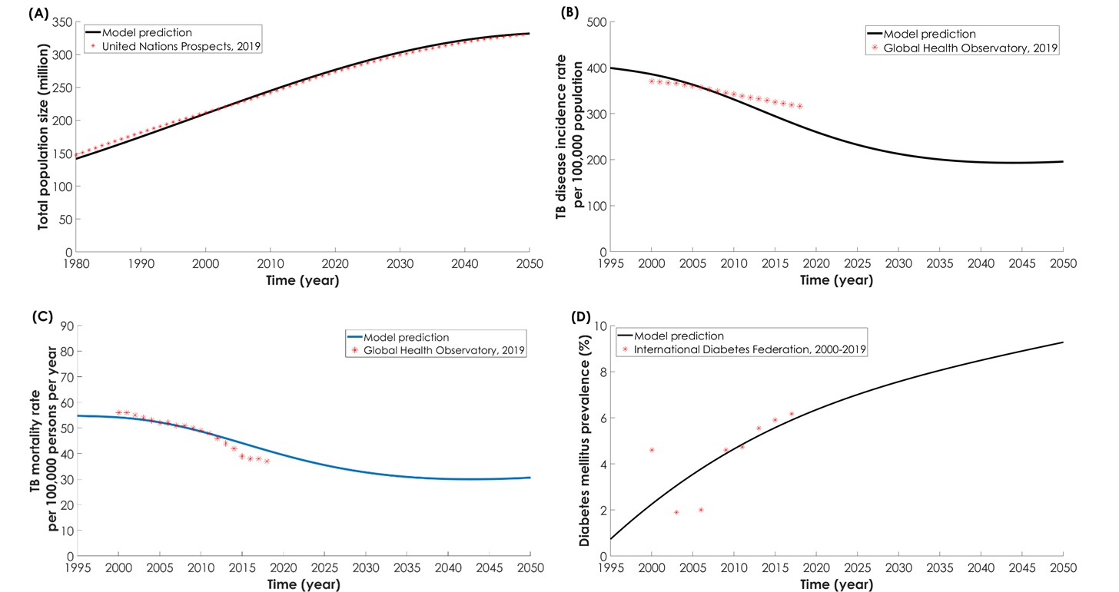

**Figure 2. (A)** Model predictions for the proportion of tuberculosis (TB) disease incident (solid black line) and mortality (dashes blue line) cases attributed to diabetes mellitus (DM) in Indonesia between 2010-2050. The epidemiologic impact in 2020 and in 2050 of each individual DM effect on TB natural history and treatment outcomes as measured by the proportion of **(B)** TB disease incident cases attributed to DM and **(C)** TB-related mortality cases attributed to DM.

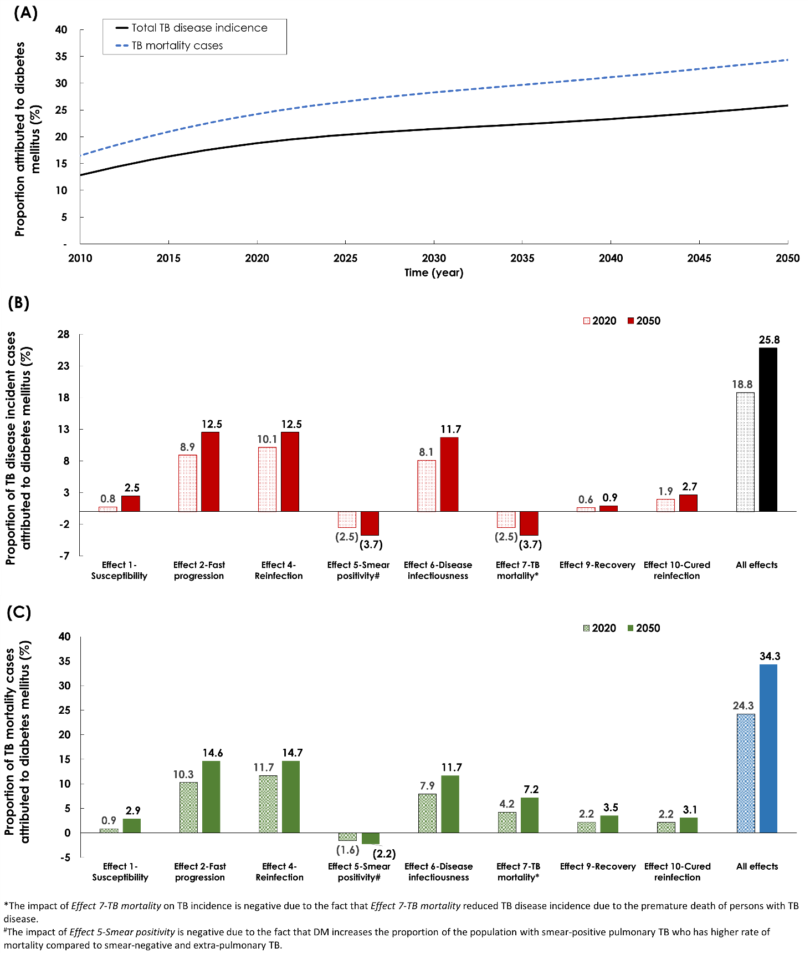

**Figure 3.** Sensitivity analyses. Model predictions for the proportion of tuberculosis (TB) disease **(A)** incident and **(B)** mortality cases attributed to diabetes mellitus (DM) in Indonesia in 2020 and 2050 in five different sensitivity analyses compared to the baseline analysis.

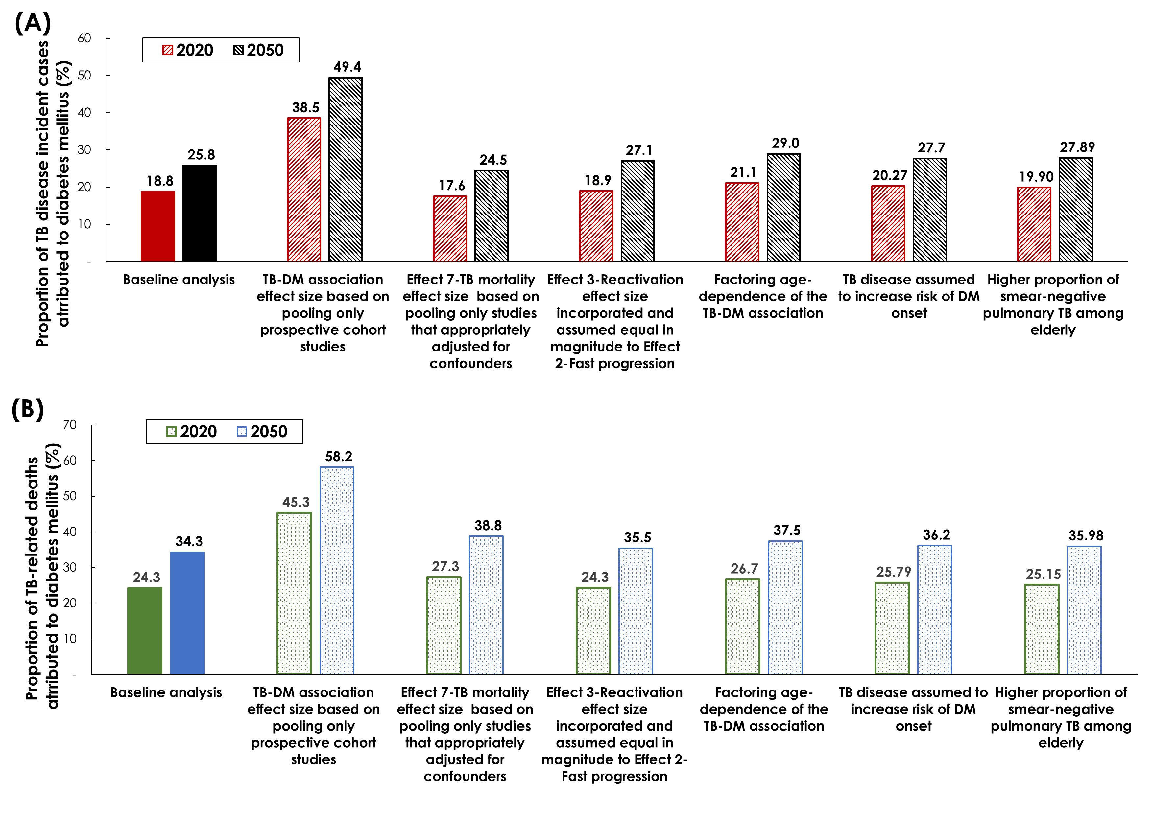

**Figure 4.** Model projections for the proportion of tuberculosis (TB) disease incident and mortality cases attributed to diabetes mellitus (DM) in Indonesia in ten different **(A)** TB disease incidence rate trajectories, and in ten **(B)** DM prevalence trajectories. The variation in TB incidence rate and DM prevalence at 2050, relative to the baseline model scenario, was assumed to range between -50% to +50%.

