Original article
Ancient and recent differences in the intrinsic susceptibility of Mycobacterium tuberculosis complex to pretomanid
Running title: Intrinsic MTBC susceptibility to pretomanid

Anna BATESON¹, Julio ORTIZ CANSECO¹, Timothy D. McHUGH¹, Adam A. WITNEY², Silke FEUERRIEGEL³, Matthias MERKER^{3,4,5}, Thomas A. KOHL^{3,5}, Christian UTPATEL^{3,5}, Stefan NIEMANN^{3,5}, Sönke ANDRES⁶, Katharina KRANZER⁷⁻⁹, Florian P. MAURER^{5,6,10}, Arash GHODOUSI^{11,12}, Emanuele BORRONI¹¹, Daniela M. CIRILLO^{11,12}, Maria WIJKANDER¹³, Juan C. TORO¹³, Ramona GROENHEIT¹³, Jim WERNGREN¹³, Diana MACHADO¹⁴, Miguel VIVEIROS¹⁴, Robin M. WARREN¹⁵, Frederick SIRGEL¹⁵, Anzaan DIPPENAAR^{15,16,17}, Claudio U. KÖSER¹⁸, Eugene SUN¹⁹, Juliano TIMM¹⁹*
Affiliations
¹ Centre for Clinical Microbiology, University College London, Royal Free Campus, London, UK.
² Institute of Infection and Immunity, St George’s, University of London, London, UK.
³ Molecular and Experimental Mycobacteriology, Research Center Borstel, Germany.
⁴Evolution of the Resistome, Research Center Borstel, Germany.
⁵German Center for Infection Research, Partner site Hamburg-Lübeck-Borstel-Riems, Germany.
⁶National and WHO Supranational Reference Laboratory for Tuberculosis, Research Center Borstel, Borstel, Germany.
⁷Department of Clinical Research, Faculty of Infectious & Tropical Diseases, London School of Hygiene & Tropical Medicine, UK.
⁸Biomedical Research & Training Institute, Harare, Zimbabwe.
⁹Division of Infectious & Tropical Medicine, Medical Centre of the University of Munich, Munich, Germany.
¹⁰Institute for Medical Microbiology, Virology and Hygiene, University Medical Center Hamburg-Eppendorf, Hamburg, Germany.
¹¹IRCCS San Raffaele Scientific Institute, Milan, Italy.
¹²Vita-Salute San Raffaele University, Milan, Italy.
¹³Supranational Reference Laboratory for Tuberculosis, Public Health Agency of Sweden, Solna, Sweden.
¹⁴Unidade de Microbiologia Médica, Global Health and Tropical Medicine, Instituto de Higiene e Medicina Tropical, Universidade Nova de Lisboa, Lisbon, Portugal.
¹⁵DSI-NRF Centre of Excellence for Biomedical Tuberculosis Research/South African Medical Research Council Centre for Tuberculosis Research, Division of Molecular Biology and Human Genetics, Faculty of Medicine and Health Sciences, Stellenbosch University, Cape Town, South Africa.
¹⁶Tuberculosis Omics Research Consortium, Family Medicine and Population Health, Institute of Global Health, Faculty of Medicine and Health Sciences, University of Antwerp, Antwerp, Belgium.
¹⁷Unit of Mycobacteriology, Institute of Tropical Medicine, Antwerp, Belgium.
¹⁸Department of Genetics, University of Cambridge, Cambridge, UK.
¹⁹TB Alliance, New York City, NY, USA.

*Corresponding author: Juliano.Timm@tballiance.org

Word count: 3474
Abstract
Objectives
To develop a robust phenotypic AST method with a correctly set breakpoint for pretomanid (Pa), the most recently approved anti-tuberculosis drug.
Methods
The Becton Dickinson Mycobacterial Growth Indicator Tube™ (MGIT) system was used at six laboratories to determine the MICs of a phylogenetically diverse collection of 356 Mycobacterium tuberculosis complex (MTBC) strains to establish the epidemiological cut-off value for pretomanid. MICs were correlated with WGS data to study the genetic basis of differences in the susceptibility to pretomanid.
Results
We observed ancient differences in the susceptibility to pretomanid among various members of MTBC. Most notably, lineage 1 of M. tuberculosis, which is estimated to account for 28% of tuberculosis cases globally, was less susceptible than lineages 2, 3, 4, and 7 of M. tuberculosis, resulting in a 99th percentile of 2 mg/L for lineage 1 compared with 0.5 mg/L for the remaining M. tuberculosis lineages. Moreover, we observed that higher MICs (≥8 mg/L), which probably confer resistance, had recently evolved independently in six different M. tuberculosis strains. Unlike the aforementioned ancient differences in susceptibility, these recent differences were likely caused by mutations in the known pretomanid resistance genes.
Conclusions
In light of these findings, the provisional critical concentration of 1 mg/L for MGIT set by EMA must be re-evaluated. More broadly, these findings underline the importance of considering the global diversity of MTBC during clinical development of drugs and when defining breakpoints for AST.
Introduction
Shorter, more effective and less toxic regimens are urgently required to treat the nearly half a million people who develop rifampicin-resistant TB annually.¹ To this end, EMA and FDA have approved pretomanid (Pa), in combination with bedaquiline (B) and linezolid (L) for the treatment of pulmonary XDR TB, based on the pre-2021 WHO definition, or treatment-intolerant or nonresponsive MDR TB.^{2, 3} This oral 26-week once-daily regimen cured 90% of patients enrolled in the Nix-TB trial in South Africa.⁴ More recently, similar results were obtained in ZeNix, a follow-up randomized trial examining varying doses and durations of linezolid in combination with bedaquiline and pretomanid in South Africa, Russia, Georgia, and Moldova.⁵ Pretomanid is now also being studied in combination with other anti-TB drugs for the treatment of drug-susceptible (DS) and drug-resistant (DR) TB in other trials (SimpliciTB and TB-PRACTECAL).⁶

Loss-of-function mutations in the ddn, fbiA, fbiB, fbiC, fbiD, and fgd1 genes, the products of which are responsible for the activation of the nitroimidazoles pretomanid and delamanid, typically result in large MIC increases and, consequently, probably clinical resistance.^{7, 8} Importantly, intrinsic resistance to delamanid (i.e. resistance not due to selection by nitroimidazole treatment) is known to have evolved recently and independently in individual strains due to mutations in at least five of these resistance genes.^{9, 10} The role of ndh, the seventh delamanid resistance gene, in pretomanid susceptibility is not yet established.¹¹ Even though not all mutations in these genes affect pretomanid and delamanid susceptibility equally, this means that some intrinsic resistance to pretomanid likely also exists in treatment-naïve patients.¹² This highlights the need for widely available, robust AST for treatment optimisation/follow-up and surveillance purposes.¹³

Phenotypic AST of Mycobacterium tuberculosis for pretomanid has been the subject of several previous studies, using various liquid and solid media methodologies.¹⁴⁻¹⁷ In most studies, only the reference strain H37Rv or H37Rv-derived mutants were tested. The few analyses which included strains of other members of the M. tuberculosis complex (MTBC) were not aimed at setting an epidemiological cut-off value (ECOFF).^{16, 18} More recently, pretomanid MIC testing from 56 baseline isolates from Nix-TB (the data from which are included in this study) showed MICs between 0.03 and 1 mg/L using the BACTEC™ Mycobacterial Growth Indicator Tube™ (MGIT) system by Becton Dickinson. These results informed the provisional critical concentration (CC; see supplement for an overview of the different terminology used for breakpoints in the TB field) of 1 mg/L included in the Summary of Product Characteristics by EMA.²

In this study, we developed a standardised protocol for routine phenotypic AST of MTBC to pretomanid, using MGIT with the EpiCenter™/TB eXiST™ software.¹⁹ We defined a quality control (QC) range for this assay and determined the pretomanid MICs for a phylogenetically diverse collection of 356 MTBC strains from pretomanid-naïve and likely delamanid-naïve patients to re-evaluate the provisional CC of 1 mg/L.²

Methods
Study design and strains
This study was designed to establish the pretomanid MIC range and the inter-laboratory variability for the M. tuberculosis reference strain H37Rv (ATCC 27294); and to determine the phenotypically wild-type (pWT) MIC distribution, using the MGIT method, to provide the data required to define an ECOFF. As per the EUCAST SOP 10.2, MICs for at least 100 strains from five laboratories, each contributing at least 15 strains, are needed to set an ECOFF.²⁰ Phylogenetically diverse MTBC strains (Table 1) were tested at six laboratories: University College London Centre for Clinical Microbiology, London; Emerging Bacterial Pathogens Unit, IRCCS San Raffaele Scientific Institute, Milan; Research Center, Borstel; Supranational Reference Laboratory for TB, Stockholm; Instituto de Higiene e Medicina Tropical, Universidade Nova de Lisboa, Lisbon; and Stellenbosch University, Cape Town. At the London laboratory, a preliminary pretomanid MIC validation included the testing of 11 known pretomanid resistant strains (Table S1). For the main study, the London laboratory tested a total of 148 strains including those from baseline cultures of patients participating in TB Alliance trials for pretomanid-containing regimens for which it was serving as the central microbiology laboratory: Nix-TB (n=56); ZeNix (n=11), STAND (n=35) and SimpliciTB (n=15).^{4-6, 21} These were supplemented with additional strains provided by B. Kreiswirth, Centre for Discovery and Innovation, Hackensack Meriden Health (n=24), and strains obtained from BCCM/ITM (n=7).²² For the first part of the study, the Borstel, Lisbon, Milan, and Stockholm laboratories, each tested a minimum of 20 strains (15 DS-TB and 5 DR-TB) from their own collections, including at least five H37Rv replicates. Analysis of these data suggested lower pretomanid susceptibility for lineage 1 (L1) strains, and thus a further round of testing was carried out in Borstel (n=24), Cape Town (n=22), Milan (n=18), and Stockholm (n=26), focussing on L1 strains to ensure the study included MICs for at least 20 L1 strains from five laboratories.

Antimicrobial agents
Pretomanid powder was provided by the TB Alliance to all participating laboratories. Stock solutions of 4 mg/mL were prepared in DMSO, and frozen at -20°C in aliquots for up to 6 months in either glass or polypropylene tubes. Frozen stock solutions were thawed once and discarded afterwards; working solutions were not stored. For routine pretomanid MIC testing a range of serial 2-fold drug dilutions were prepared in DMSO from 0.03 to 1 mg/L. If the MIC obtained was outside of this range, the test was repeated at higher (0.5-8 mg/L) or lower (0.004-0.06 mg/L) concentrations to avoid truncating the pWT MIC distribution. In some cases, higher range repeats were performed up to 64 mg/L. For H37Rv, the concentrations tested were serial 2-fold dilutions from 0.03-0.5 mg/L, based on validation data obtained from the London laboratory.

MIC in MGIT
MICs were determined in all laboratories using MGIT 960 connected to an EpiCenter™ equipped with TBeXIST module (BD), according to the manufacturer’s instructions.²³ Preparation of seed cultures (from liquid or solid media) and inocula, and the inoculation of MGIT tubes for MIC testing were performed as described previously.²⁴ The drug-free growth control tube was inoculated with a 1:100 dilution of the bacterial suspension used for the drug-containing tubes (no DMSO was added to the drug-free control tube). The pretomanid MIC was defined as the lowest drug concentration for which the growth units (GU) were <100, at the point when the drug free growth control reached 400 GU and therefore the test was completed. H37Rv was included as a control in each batch of clinical strains. For any tests where the MIC result was ≥1 mg/L, a blood agar culture and acid-fast stain was prepared to confirm the absence of contamination, and the test was repeated for confirmation of the result. In addition, MGIT tubes and supplement batches were subjected to QC as outlined in the MGIT 960 System User’s Manual.²⁵

DNA extraction and WGS analysis
Genomic DNA was extracted using the CTAB or phenol chloroform methods, and prior to sequencing DNA was quantified using Qubit dsDNA kits (Life Technologies).^{26, 27} WGS was performed using different sequencing platforms (Illumina; MiSeq, HiSeq or NextSeq; Ion Torrent) according to manufacturer’s instructions and local validated protocols in participating laboratories. All sequences have been deposited (Table S2).

Analysis of the WGS data was performed as described previously.²⁸ Only strains showing coverage of at least 20x (mean read depth) were included in the analysis. All variant calls relative to the H37Rv reference genome were determined for the six (ddn, fbiA, fbiB, fbiC, fbiD and fgd1) known pretomanid resistance genes. Site statistics were generated using SAMtools mpileup and gene annotation generated using snpEff software. In addition, lineages based on Coll et al.²⁹ and key resistance determining genes for first and second-line drugs were determined using MTBseq (v1.0.3).³⁰ To standardise drug resistance data across laboratories, strains were classified as DS-TB, MDR-TB, XDR-TB (using the pre-2021 WHO definition), or DR-TB (i.e. resistant to at least one agent without meeting the definition for MDR-TB or XDR-TB) according to the genotypic resistance data generated by MTBseq, taking the intrinsic resistance of M. canettii to pyrazinamide into consideration (Table S2).^{3, 31} All sequences were also used to reconstruct a study-wide, maximum likelihood phylogenetic tree using IQ-TREE (v2.0.3) with a General Time Reversible model of nucleotide substitution (model selection restricted to those supported by RAxML); branch support values were determined using 1000 bootstrap replicates (Figure 2C).²⁸

Results
H37Rv QC range and in vitro control mutants
H37Rv was included in every batch of clinical strains tested in the MGIT system throughout this study. Based on 117 replicates of H37Rv from 6 laboratories, testing was found to be reproducible with 99% (95% confidence interval 95-100) of replicates falling in a three-dilution range (0.06-0.25 mg/L; Figure 1). In addition, 11 in vitro resistant control strains all had MICs of at least 16 mg/L (Table S1), consistent with previous results obtained when testing these mutants with delamanid or pretomanid.^{8, 16, 32, 33}

Clinical strains
We conducted a multicentre study based on the EUCAST standard operating procedures for setting ECOFFs (SOP 10.2).²⁰ Each of the six laboratories tested between 20 and 148 strains. A total of 356 strains were tested that featured all major lineages of MTBC and key animal-adapted members, as well as M. canettii (Table 1). Only lineages 8 and 9, which are exceptionally rare and had not been described when this study started, and some uncommon animal-adapted variants were not represented.³⁴ 46% of strains were DS, 13% DR, 30% MDR, and 10% XDR. We found that MTBC can be divided in four groups with respect to pretomanid susceptibility, from more to less susceptible: Group A = M. africanum lineages L5 and L6, and the animal-adapted members (M. bovis, M. bovis BCG, M. caprae, M. microti, and M. pinnipedii); Group B = M. tuberculosis lineages L2, L3, L4 and L7; Group C = M. tuberculosis lineage L1; Group D = M. canettii (Figure 2 and Table S2); with modal MICs of 0.03, 0.125, 1 and 2 mg/L, respectively. The mechanism(s) for these ancient MIC differences could not be explained by polymorphisms in the six canonical resistance genes (Table S3) and did not follow an obvious evolutionary trend (Figure 2C). Interestingly, this pattern, at least with respect to L1, is not shared by delamanid.³⁵ By contrast, the higher pretomanid MICs (≥8 mg/L), which we assume to probably confer clinical resistance, arose more recently on six independent occasions in four L1 and two L2 strains (Figure 2C), likely due to different mutations in three of the known resistance genes, of which one mutation has not been described in the literature before (Table 2).

Based on ECOFFinder analyses of re-weighed distributions, the 99th percentile of the MIC distribution for Group B was 0.5 mg/L compared with 2 mg/L for Group C (Figure 2B). Our study was not powered to define 99th percentile for Groups A and D, both in terms of the number of strains tested and contributing laboratories. Based on these limited data, the upper end by visual inspection of Group A was 0.125 mg/L and for Group D was 4 mg/L (Figure 2A). However, given that Group A appeared to be most susceptible and Group D (M. canettii) is exceptionally rare globally neither group were our focus.³⁶ Feuerriegel et al. had previously reported that M. canettii is less susceptible to pretomanid.¹⁶ Here, we tested a total of 21 M. canettii strains across two laboratories and consistently obtained MICs of 2-4 mg/L. This included the two strains tested in Feuerriegel et al., which were found to have MICs of 8 mg/L using MGIT in the 2011 study using a less rigorous testing procedure than the one employed in the present study (e.g. H37Rv was not included in every batch and testing could not be repeated at the time because of the limited amounts of pretomanid available).¹⁶ Retesting of these strains in two laboratories as part of this study consistently yielded MICs of 2 mg/L, suggesting that the results from 2011 were incorrect (i.e. M. canettii still has intrinsically elevated MICs but to a lesser degree than previously reported).¹⁶
Discussion
In 2020, EUCAST announced that, in line with its approach to AST for fungi and other bacteria, it would transition to setting clinical breakpoints (CBs) for MTBC using its non-commercial broth microdilution reference method against which other methods would have to be calibrated.³⁷ This will ensure that MIC, pharmacokinetics/pharmacodynamics (PK/PD), and clinical outcome data from different studies can be compared directly or using a conversion factor when systematic MIC differences exist between media, as is the case with bedaquiline and delamanid.⁹ However, it is accepted that this reference method will not be implemented routinely in most settings because of the advantages offered by other methods (e.g. biosafety and labour requirements).³⁷ For this study, which started before the endorsement of the EUCAST method, we conducted a multicentre study modelled on EUCAST SOP 10.2 and adopted the MGIT methodology given that it is semi-automated and widely used for routine AST of MTBC globally.²⁰ A QC range spanning four dilutions was obtained, of which 92% of replicates spanned just two concentrations (0.125-0.25 mg/L; Figure 1). Moreover, approximately 95% of samples reached the cut-off for reading the MIC within the standard 13 days (i.e. few samples required an extended incubation using the EpiCenter/TB eXIST software; London laboratory, data not shown). Taken together, these results underline the need for developing a quality-assured, lyophilised pretomanid product given that preparing antibiotic solutions, as required by our procedure, is a known source of error during routine AST. In the meantime, interested laboratories can order pretomanid powder from TB Alliance and a lyophilised panel of control strains with known MGIT pretomanid MICs is available from the BCCM/ITM collection (Table S2).²²

To interpret the MICs obtained from the current MGIT method, a CB has to be set to distinguish susceptible strains with a high likelihood of treatment success using the standard dosing regimen from resistant strains that are likely to fail (the susceptible, increased exposure [I] category does not apply to BPaL given that dosing is fixed).³⁸ In this context, the ECOFF plays a key role. When the MICs to a novel agent that does not share any resistance mechanism with an existing antibiotic are measured, a unimodal distribution spanning between 3-5 two-fold dilutions is typically obtained, provided that the technical variability of testing is minimised.²⁰ This MIC distribution is referred to as pWT because it is devoid of phenotypically detectable resistance to the agent in question. This does not mean that there is no biological variability in this pWT distribution but, rather, that this is masked by the intra- and inter-laboratory variability inherent in MIC testing under routine conditions (at least if the MIC is measured only once as is usually the case).^{39, 40} As a result, any CB that divides the pWT distribution (i.e. is set below the ECOFF that corresponds to the upper end of this distribution) will result in a poor reproducibility of phenotypic AST for pWT strains. Nevertheless, this does not mean that an ECOFF automatically becomes the CB. Instead, PK/PD and clinical evidence is required to demonstrate that the proposed dosing regimen is sufficient to treat pWT strains successfully, in which case the ECOFF can be used as the CB and pWT strains become clinically susceptible.¹⁸ In this scenario, the ECOFF represents a conservative CB until sufficient evidence becomes available that phenotypically non-wild-type strains with MICs>ECOFF are treatable (i.e. during the first trials of novel agents, such strains are usually too rare to investigate this question).

Unlike the classical paradigm of a unimodal pWT MIC distribution, we observed marked and ancient differences in the susceptibility of MTBC to pretomanid, which fell into four groups from more to less susceptible: Group A = M. africanum and the animal-adapted members; Group B = M. tuberculosis L2, L3, L4 and L7; Group C = M. tuberculosis L1; Group D = M. canettii (Figure 2). Most notably, we report an 8-fold increase in the modal MIC and a 4-fold increase in the ECOFF of Group C compared to Group B. Therefore, taking into consideration these new data, regulators need to reassess for which groups sufficient PK/PD and/or clinical evidence exists to classify them as susceptible and to set a single interim MGIT CB accordingly. Considering the 99th percentiles of the groups, an interim CB of 0.5 mg/L would be suitable for Groups A-B, 2 mg/L for Groups A-C, and 4 mg/L for Groups A-D. The provisional CC of 1 mg/L set by EMA is too high for Groups A-B and too low for Groups C and D.² Fewer than 200 cases of M. canettii infection (Group D) have been described to date, mostly from patients with links to the Horn of Africa.³⁶ Consequently, it is unlikely that robust clinical evidence for pretomanid treatment in this group will ever become available. In contrast, L1 strains (Group C) are estimated to account for 28% of the global TB burden.⁴¹ 80% of those strains are in India, the Philippines, Indonesia and Bangladesh, which are amongst the top seven countries with the highest absolute number of MDR/RR-TB globally.^{41, 42} As such, it is essential that data from L1 strains is now considered to re-evaluate the provisional CC by EMA.

In terms of clinical data, consistent with L1 strains being rare in South Africa, among the 56 Nix-TB patients for which baseline isolates were tested, only one belonged to Group C (the remaining were from Group B); the patient had a favourable outcome. Now, data are available for 38 additional patients known to be infected with L1 strains and receiving pretomanid-containing regimens in other TB Alliance trials – ZeNix (regimen BPaL; one patient); SimpliciTB (regimen BPa plus moxifloxacin [M] plus pyrazinamide [Z]; 30 patients); and STAND (regimen PaMZ; seven patients).^{5, 6, 21} Regardless of the regimen, 29 of the 30 patients who completed treatment (excluding cases of early withdrawals, early death due to hepatotoxicity, and late exclusions) culture converted and had a favourable outcome (J. Timm, unpublished data), suggesting infection with L1 strains has not led to worse outcomes. More data on effectiveness of pretomanid-containing regimens in the treatment of patients with L1 strains will be collected in the various operational studies underway in Asia (LIFT-TB).⁴³

Target attainment analysis for pretomanid is still preliminary, but several studies in animal models and humans provided insights into its PK.¹⁵ The most important studies with human data are a population PK model developed using data from 14 studies in the pretomanid development programme and 1,054 patients⁴⁴, and PK data from the Nix-TB trial (J. Nedelman, unpublished data). The first analysis revealed that the median C_{avg}, C_{max}, and C_{24h} values in plasma for a reference subject administered 200 mg once daily of pretomanid alone in a fed condition to steady state were 2.4, 3.2, and 1.6 mg/L, respectively. For a subset of 27 Nix-TB patients with full PK profiles at week 16 (i.e. at steady state), who received 200 mg daily in a fed condition, the geometric means of trough C_{min} and C_{max} were 1.4 and 2.9 mg/L, respectively. Given that the primary site of MTBC infection is lung tissue, the blood exposure is less important than the exposure achieved at the sites of infection, particularly at the centre of granulomas.⁴⁵ Studies in mice showed that efficacy of pretomanid in vivo correlated better with lung PK than with plasma PK, thanks to a 3-fold accumulation of pretomanid in the lung.⁴⁶ Similar pretomanid penetration levels (4-fold increases) have been reported in lungs or lung lesions of rabbits.⁴⁷ However, the precise PK/PD target of efficacy of pretomanid is not known to date, which means that regulators will have to primarily rely on the above trial data to set an interim CB. When making this decision, regulators will have to take into consideration that pretomanid has been approved as part of a three-drug regimen, which complicates the assessment of the impact of an individual component compared with agents that are used in monotherapy (although for core drugs in regimens, this is possible).⁴⁸⁻⁵⁰

Differences in the intrinsic susceptibility linked to particular genotypes has been reported previously, with intrinsic resistance of M. bovis and M. canettii to pyrazinamide, M. bovis BCG to cycloserine, and a subgroup of M. tuberculosis lineage 4 to capreomycin.^{51, 52} More recently, it has been reported that L1 has intrinsically higher pyrazinamide MICs compared with other M. tuberculosis lineages, which may require the current MGIT CC of 100 mg/L to be raised.⁵³ Conversely, it is also possible for some genotypes to be more susceptible than other MTBC members (e.g. the more recently derived variants of M. bovis BCG are susceptible to macrolides).⁵² Taken together, these results and our data on pretomanid support the requirement by EUCAST to test phylogenetically diverse MTBC strains to set ECOFFs, and highlight the importance of testing globally representative strain panels during pre-clinical development.^{37, 52} This should not be regarded as an additional expense but an insurance policy as it may prompt an agent to be abandoned or inform additional pre-clinical testing and the trial design to ensure that intrinsically less susceptible genotypes are sampled adequately.³⁷

Acknowledgements
We thank B. Kreiswirth, E. Nuermberger and L. Rigouts for contributing strains; the Centre for Disease Control and Prevention (J. Posey) and King Abdullah University of Science and Technology (A. Pain) for sequencing the South African strains; and C. Mendel, J. Nedelman, D. Summers and A. Upton for helpful discussions.

Funding
This work was supported by TB Alliance with funding from Australia’s Department of Foreign Affairs and Trade, the Bill & Melinda Gates Foundation, Germany’s Federal Ministry of Education and Research through KfW, Irish Aid, Netherlands Ministry of Foreign Affairs, United Kingdom Department of Health, United Kingdom Foreign, Commonwealth and Development Office, and the United States Agency for International Development. RMW was supported by South African Medical Research Council baseline funding. RMW and AD acknowledge the support from the Tuberculosis Omics Research Consortium headed by A. Van Rie (Research Foundation Flanders [FWO], under grant No. G0F8316N [FWO Odysseus]). CUK is a visiting scientist at the Department of Genetics, University of Cambridge, and a research associate at Wolfson College, University of Cambridge. CUK received an observership by the European Society of Clinical Microbiology and Infectious Diseases.

Transparency declarations
CUK is a consultant for the TB Alliance and the Foundation for Innovative New Diagnostics. CUK’s consulting work for Becton Dickinson involves a collaboration with Janssen and Thermo Fisher Scientific. CUK is collaborating with PZA Innovation. CUK worked as a consultant for QuantuMDx, the Stop TB Partnership, the WHO Global TB Programme, and the WHO Regional Office for Europe. CUK gave a paid educational talk for Oxford Immunotec. Hain Lifescience covered CUK’s travel and accommodation to present at a meeting. CUK is an unpaid advisor to BioVersys and GenoScreen. Other authors: nothing to declare.
References
Figure 1. Pretomanid (Pa) MIC distribution for the M. tuberculosis H37Rv laboratory reference strain (n=117).
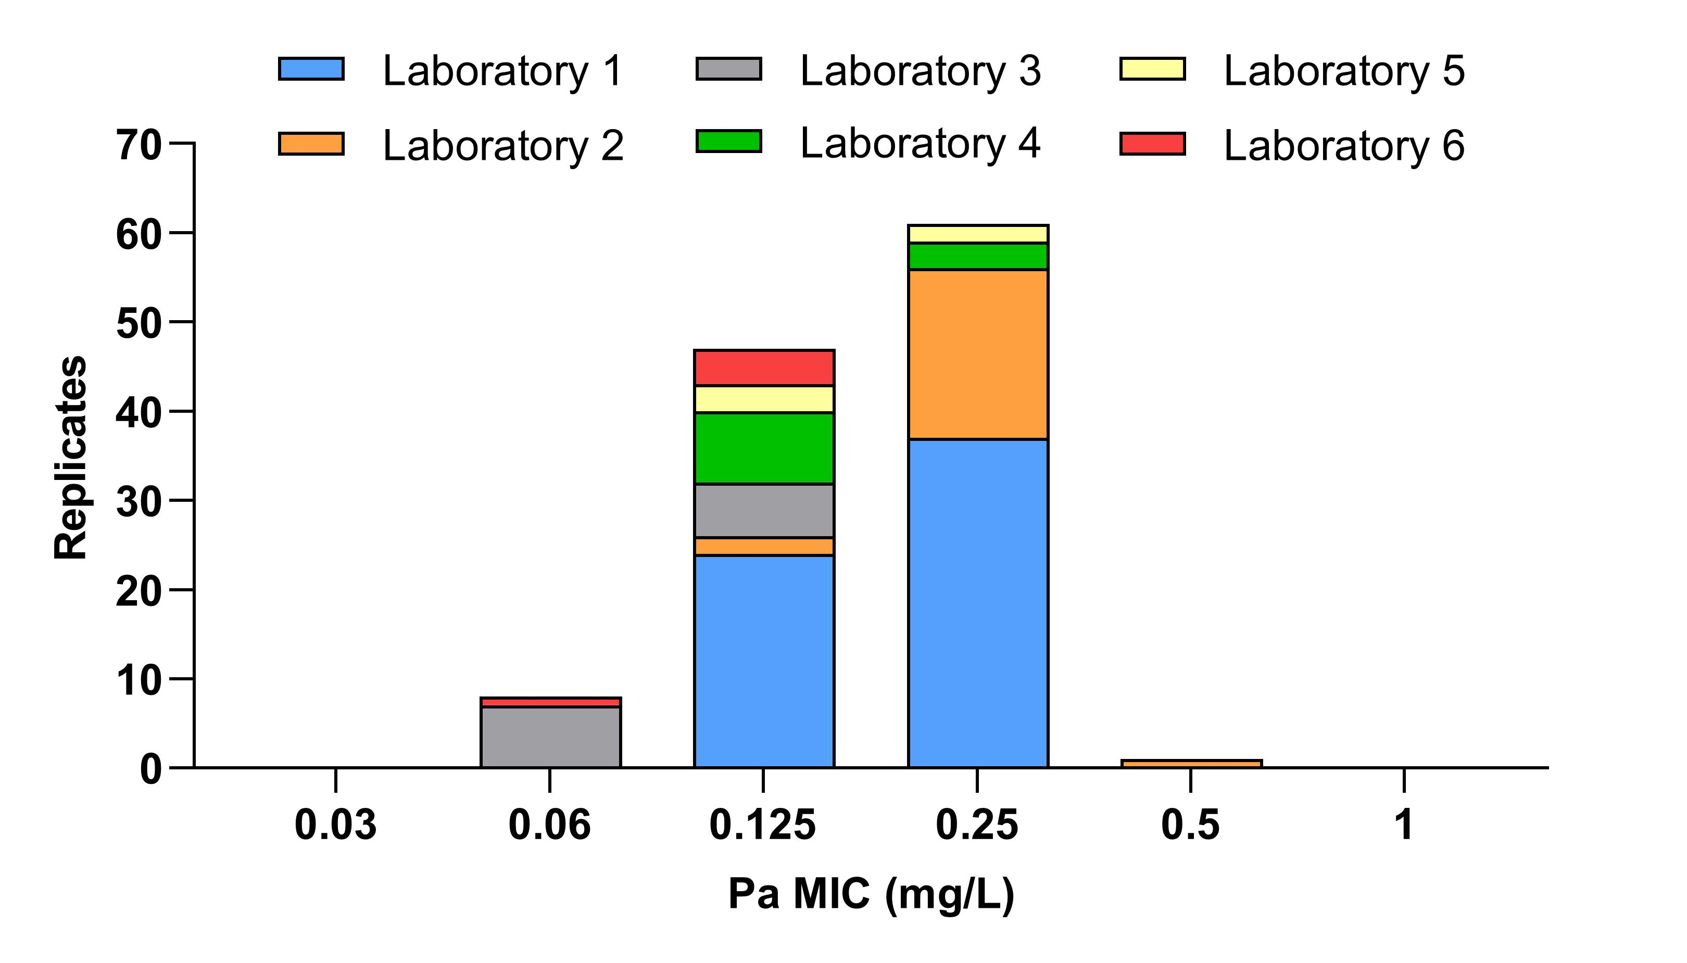
Figure 2. Pretomanid (Pa) MIC distributions for A) Groups A and D, B) Groups B and C (excluding H37Rv). The 99th percentile for Groups B and C based on ECOFFinder and visual estimation for group A and D are shown by arrows. C) The relationship between these MICs, represented by the heat map on the outer circle, and the underlying MTBC phylogeny (BCG is shown as part of M. bovis). The phylogenetic tree was rooted at the midpoint. The M. canettii branch lengths (dotted lines) were scaled to be 5x shorter for the purpose of visualisation. An unscaled tree is shown in Figure S1.
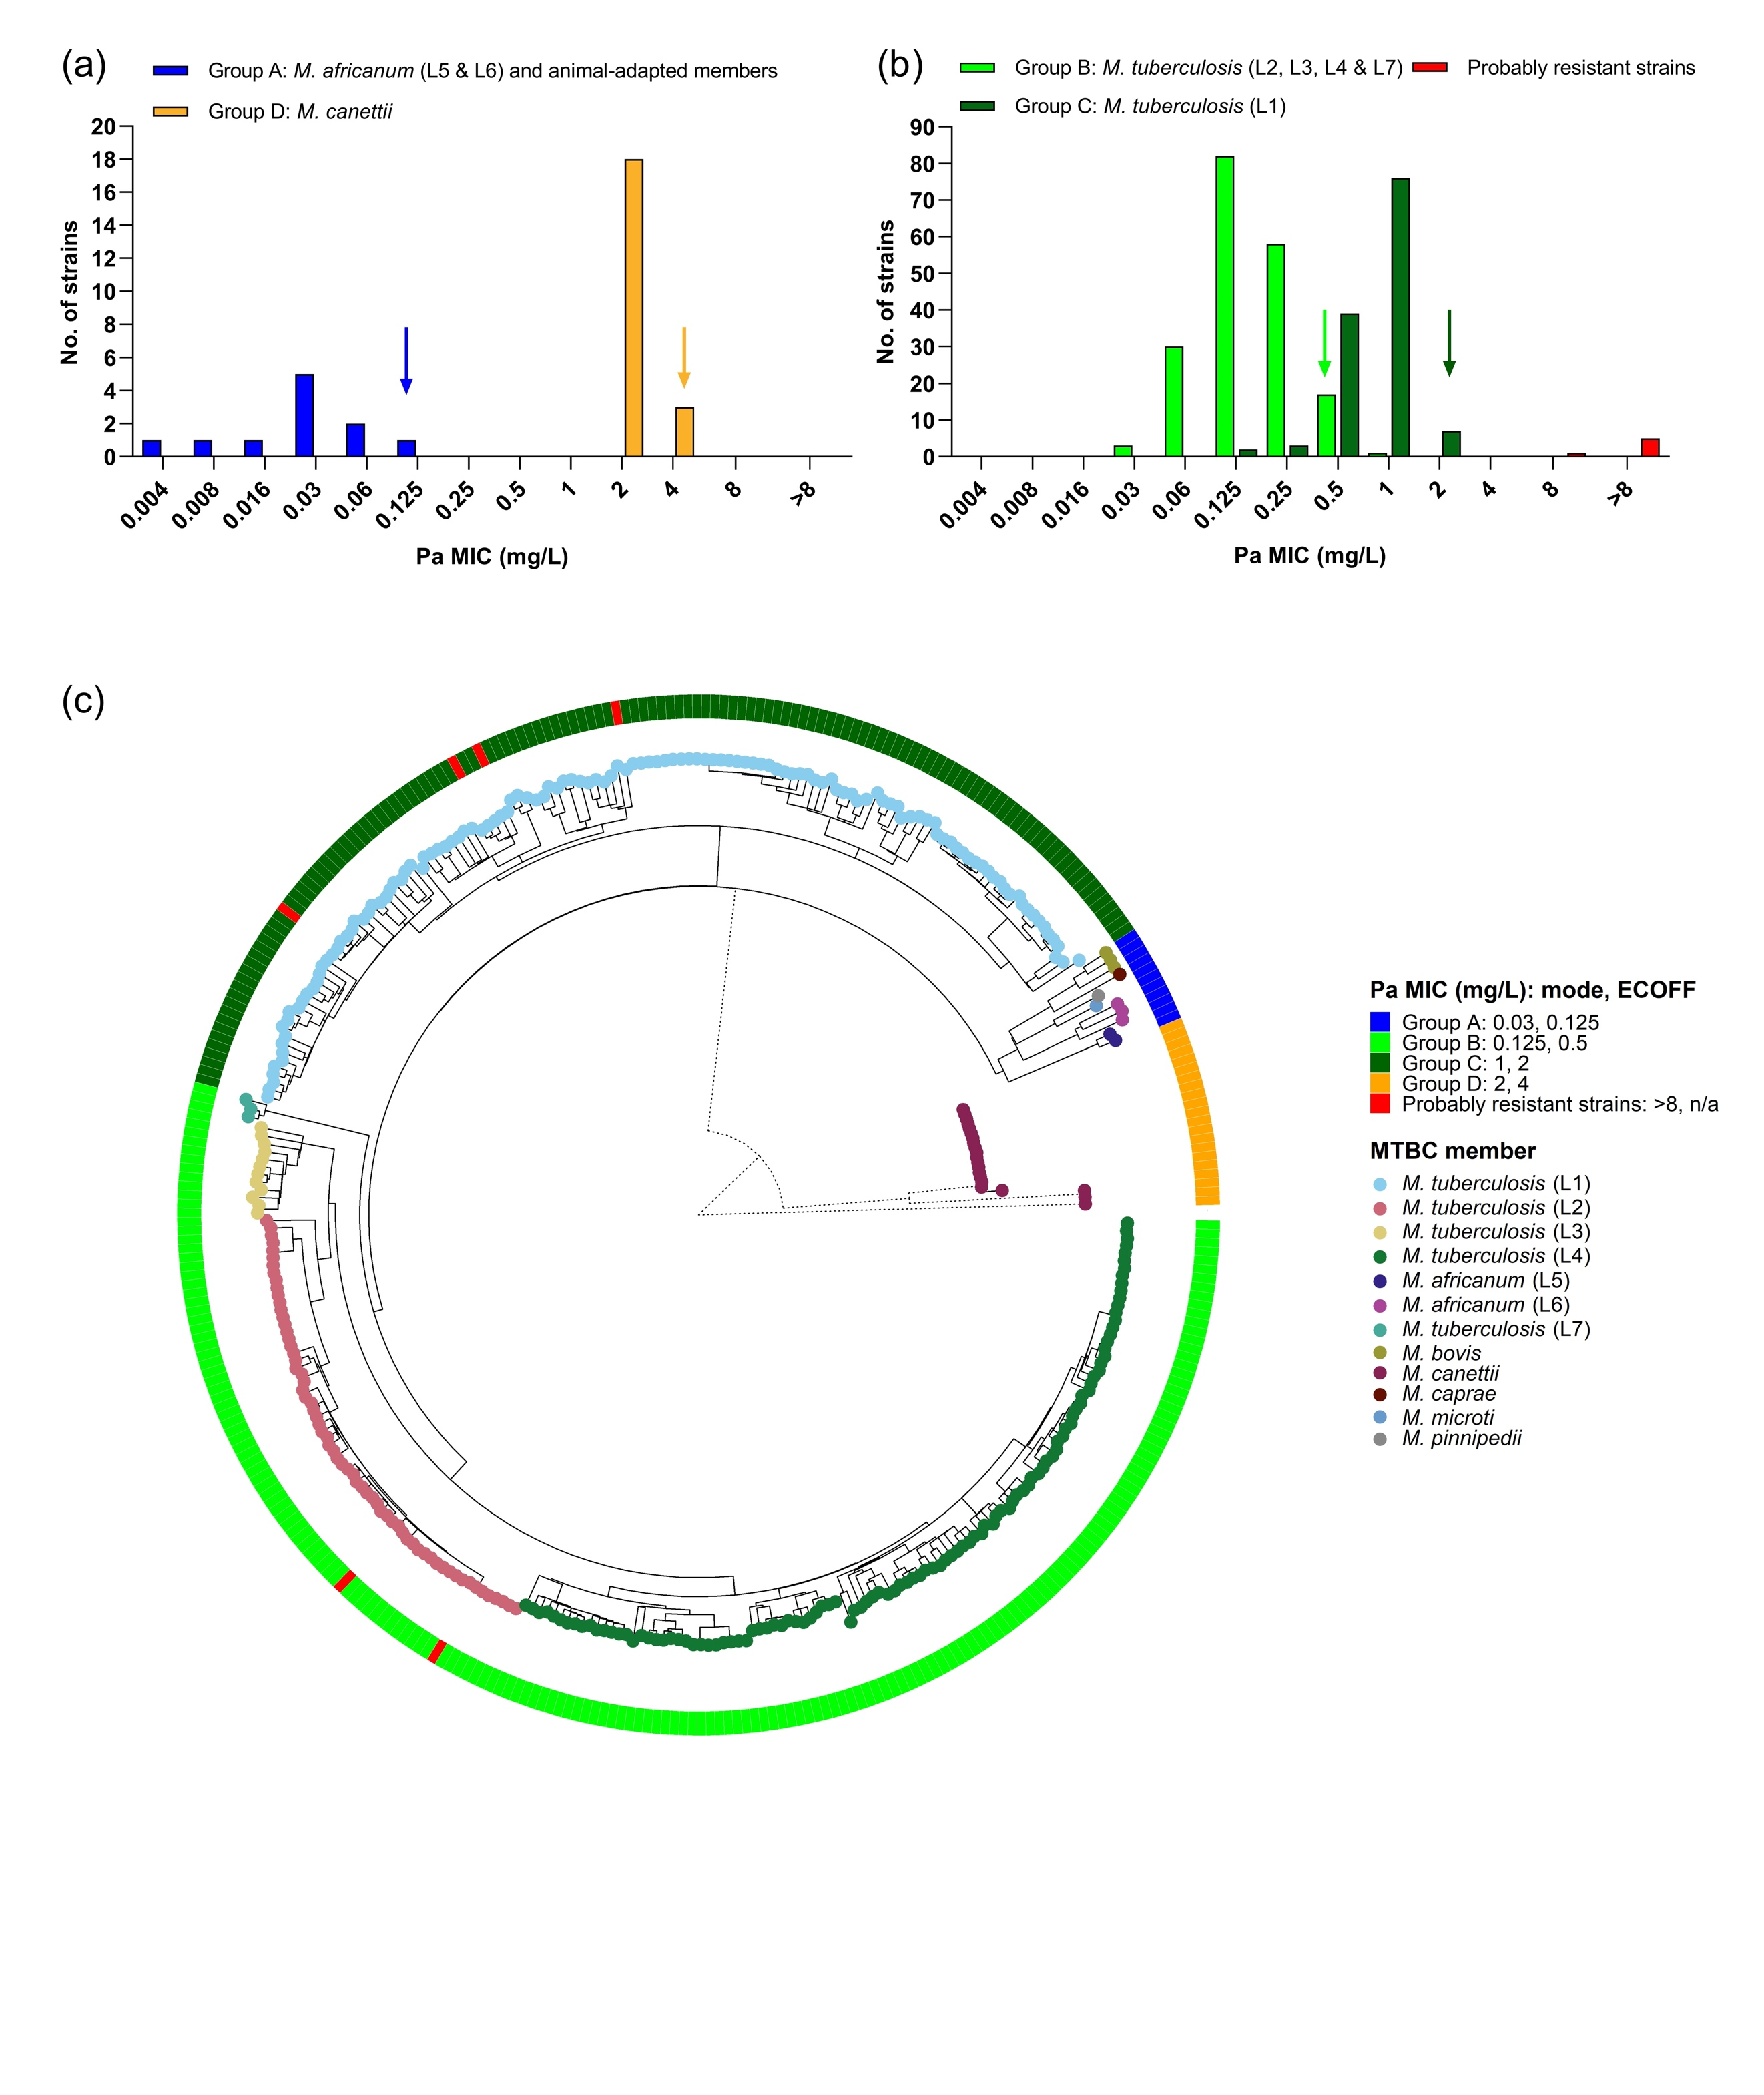
Table 1: Overview of MTBC members included in this study.
Group | MTBC memberª | Lineage^{b} | Lineage synonym^{c} | Major spoligotype(s)^{c} | No. | Resistance type (percentage)
 |  |  |  |  |  | DS-TB | DR-TB | MDR-TB | XDR-TB
A | M. africanum | 5 | West African I | AFRI2 | 2 | 100 | 0 | 0 | 0
A | M. africanum | 6 | West African II | AFRI1 | 3 | 100 | 0 | 0 | 0
A | M. bovis^{d} |  |  |  | 2 | 0 | 100 | 0 | 0
A | M. bovis BCG^{e} |  |  |  | 1 | 0 | 100 | 0 | 0
A | M. caprae |  |  |  | 1 | 100 | 0 | 0 | 0
A | M. microti |  |  |  | 1 | 100 | 0 | 0 | 0
A | M. pinnipedii |  |  |  | 1 | 100 | 0 | 0 | 0
B | M. tuberculosis | 2 | East Asian | Beijing | 63 | 17 | 2 | 51 | 31
B | M. tuberculosis | 3 | East African-Indian | CAS | 12 | 92 | 0 | 8 | 0
B | M. tuberculosis | 4 | Euro-American | Haarlem, LAM, T, X | 113 | 42 | 9 | 36 | 13
B | M. tuberculosis | 7 |  |  | 3 | 100 | 0 | 0 | 0
C | M. tuberculosis | 1 | Indo-Oceanic | EAI | 127 | 64 | 10 | 24 | 2
D | M. canettii^{f} |  |  |  | 21 | 0 | 100 | 0 | 0
Probably resistant^{g} | M. tuberculosis | 1 | Indo-Oceanic | EAI | 4 | 100 | 0 | 0 | 0
Probably resistant^{g} | M. tuberculosis | 2 | East Asian | Beijing | 2 | 50 | 0 | 50 | 0
ª In accordance with current CLSI guidelines, we considered M. canettii to be part of MTBC, although this classification is disputed.^{54, 55}
^{b} Based on Coll et al.²⁹
^{c} Based on Gagneux & Small.⁵⁶
^{b} Largely intrinsically resistant to pyrazinamide.³¹
^{e} Intrinsically resistant to pyrazinamide and cycloserine.⁵²
^{f} Intrinsically resistant to pyrazinamide.³¹
^{g} See Table 2 for more details.
Table 2 Likely mechanisms of pretomanid resistance in six clinical M. tuberculosis strains (shown as probably resistant strains in red in Fig. 2B and in outer ring of Fig. 2C).
ID | Year and country isolation | Resistance type | Pa MIC (mg/L) | Lineage | Gene |  |  | Previous reports describing mutation, if available
 |  |  |  |  | ddn | fbiC | fgd1 | Previous reports describing mutation, if available
295/08⁵⁷ | 2008, Portugal^{b} | MDR-TB | 64 | 2.2.1 | Trp88Stop |  |  | Selected in vitro with Pa⁵⁸; observed in three DLM-resistant clinical strains³⁵; DLM-resistant control strain³³
PRE_007; ITM 501095ª | 2015, Ukraine | DS-TB | >16 | 2.2.1 | Gln58Stop |  |  | Observed in three DLM-resistant L2.2.1 MDR-TB strains from Ukraine¹⁰
TBA_067 | 2019, Tanzania | DS-TB | 16 | 1.1.2 | Lys19Glu |  |  | Novel mutation
PRE_004 (TN34503); ITM 501092ª | 2015, USA^{c} | DS-TB | >8 | 1.1.3 | Trp27Stop |  |  | Observed in DLM-resistant L1.1.3 MDR-TB strain from Bangladesh¹⁰
10213-12⁵⁹ | 2012, Germany | DS-TB | 8 | 1.1.1.1 |  | Ala349Val |  | Mutation observed in seven L1.1.1 strains and predicted to be functionally significant⁶⁰
8844-10⁵⁹ | 2010, Germany | DS-TB | >32 | 1.1.1.1 |  |  | Glu230Lys | Selected in vitro with Pa¹⁷
ª Lyophilised strain available from BCCM/ITM.²² ^{b} Patient from Moldova. ^{c} Patient from Myanmar.
DLM=delamanid; Pa=pretomanid.

