Supplementary Data

Supplementary Table 1. Osteoarthritis Bone Score Rasch analysis individual item fit statistics
Item | Item descriptor | Location | Standard Error | Fit Residual | Chi² | Probability
1 | Cysts | 2.211 | 0.202 | -0.399 | 1.562 | 0.458
2 | Fibrosis | 0.094 | 0.187 | -1.663 | 14.351 | 0.001
3 | Blood vessels | -0.499 | 0.202 | 1.291 | 4.763 | 0.092
4 | Cartilage | 0.825 | 0.180 | 0.121 | 1.966 | 0.374
5 | Trabeculae thickened | -1.575 | 0.253 | -0.255 | 8.892 | 0.012
6 | Tidemark integrity | -1.037 | 0.223 | -0.166 | 0.409 | 0.815
7 | Inflammation | -0.010 | 0.189 | -2.061 | 10.587 | 0.005

Item descriptor key: Fibrosis; fibrotic connective tissue within bone marrow space, Blood vessels; number of blood vessels within the subchondral region of interest, Cartilage islands; new cartilage within bone, Inflammation; cellular infiltrates.

Supplementary Table 2. Osteoarthritis Bone Score Rasch analysis overall item and person fit statistics
 | Item |  | Person
 | Location | Fit residual | Location | Fit residual
Mean | 0.000 | -0.445 | 1.196 | -0.225
SD | 1.250 | 1.121 | 1.430 | 0.679
Skewness | 0.742 | -0.054 | -0.401 | 0.765
Kurtosis | 0.655 | -1.355 | -0.620 | 0.058
N | 7 |  | 203

Supplementary Table 3: Osteoarthritis Bone Score polychoric correlation matrix

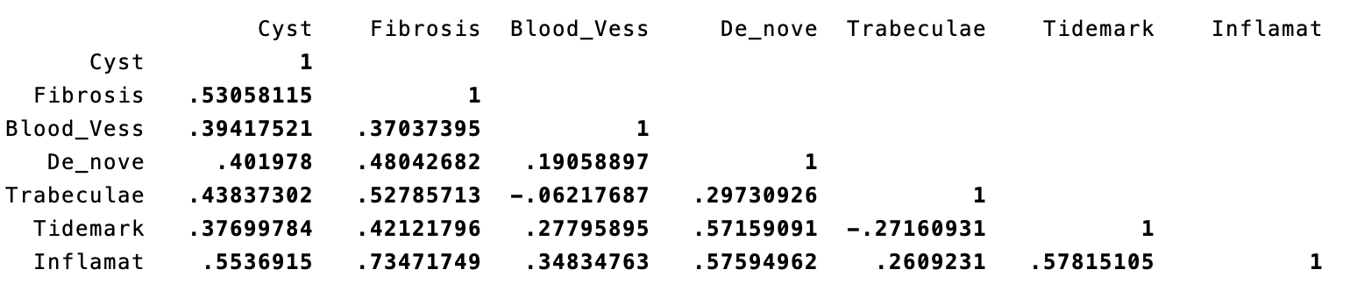

Item descriptor key: Fibrosis; fibrotic connective tissue within bone marrow space, Blood vess; number of blood vessels within the subchondral region of interest, De-nove; cartilage islands (new cartilage within bone), Trabeculae; trabeculae thickened, Tidemark: tidemark integrity, Inflammat; cellular infiltrates.

Supplementary Table 4: Osteoarthritis Bone Score factor analysis
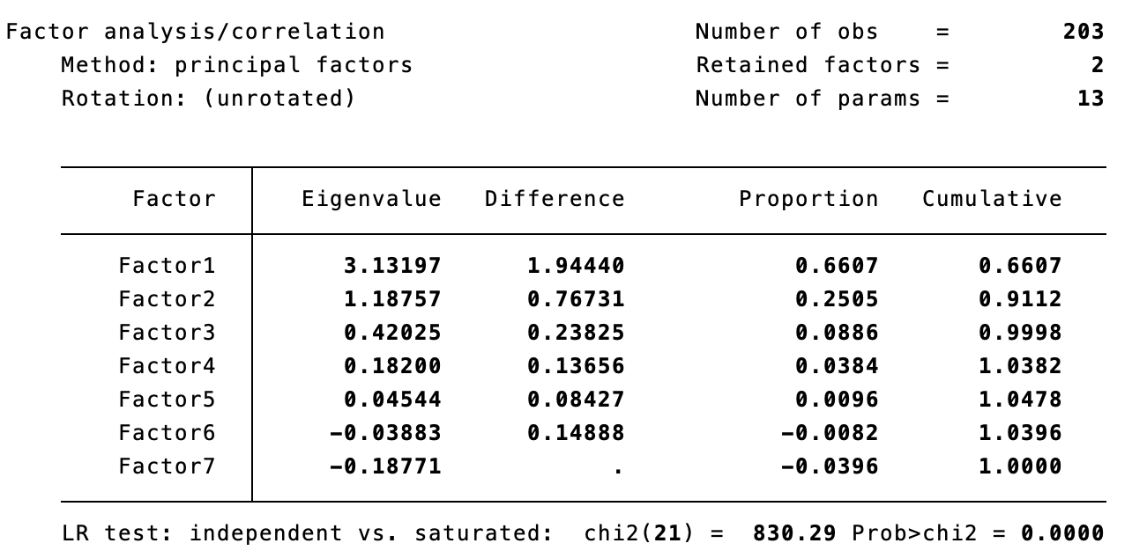

Supplementary Table 5: Osteoarthritis Bone Score rotated factor loadings (pattern matrix) and unique variances sorted

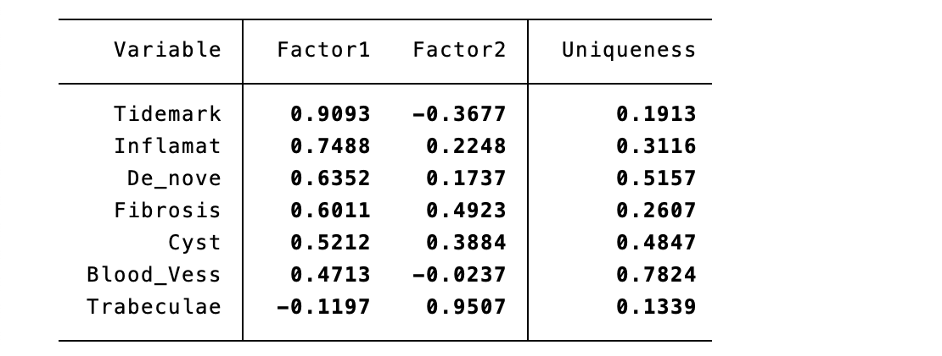
Item descriptor key: Fibrosis; fibrotic connective tissue within bone marrow space, Blood vess; number of blood vessels within the subchondral region of interest, De-nove; Cartilage islands, new cartilage within bone, Trabeculae; trabeculae thickened, Tidemark: tidemark integrity, Inflammat; cellular infiltrates.

Supplementary Table 6: Osteoarthritis Bone Score factor rotation matrix

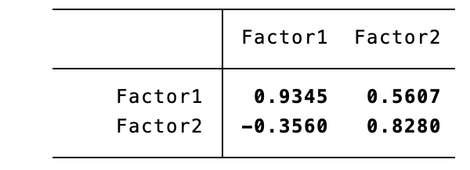

Inter-observer reliability results between independent scorers
ICC for inter-observer reliability (SK, NS) for OABS within Groups 1 and 2 of the development set was 0.95 (0.88 to 0.97), p<0.001.
ICC for inter-observer reliability (SK, MS) for OABS within Group 3 of the development set was 0.81 (0.38 to 0.94), p<0.001

Supplementary Table 7: Individual case frequency data for MOAKS scores and OABS scores for each BML sample in the developmental set (Group 1)
Eff/Syn_MOAKS | 0 | 1 | 2 | 3
PA044 | 0 | 1 | 0 | 0
PA069 | 0 | 1 | 0 | 0
PA081 | 0 | 1 | 0 | 0
PA083 | 0 | 0 | 1 | 0
PA116 | 0 | 0 | 1 | 0
PA123 | 0 | 0 | 1 | 0
PA124 | 0 | 1 | 0 | 0
PA125 | 0 | 1 | 0 | 0
PA126 | 0 | 1 | 0 | 0
PA129 | 0 | 0 | 1 | 0
Mean | 0 | 0.6 | 0.4 | 0
% | 0 | 60 | 40 | 0

BML_MOAKS | 0 | 1 | 2 | 3 | Cartilage_MOAKS | 0 | 1 | 2 | 3
PA044 | 6 | 5 | 3 | 1 | PA044 | 0 | 5 | 4 | 5
PA069 | 4 | 6 | 3 | 2 | PA069 | 2 | 1 | 3 | 8
PA081 | 9 | 2 | 2 | 2 | PA081 | 3 | 0 | 3 | 8
PA083 | 12 | 2 | 1 | 0 | PA083 | 4 | 1 | 3 | 6
PA116 | 8 | 6 | 1 | 0 | PA116 | 1 | 0 | 4 | 9
PA123 | 1 | 10 | 4 | 0 | PA123 | 0 | 0 | 3 | 11
PA124 | 8 | 5 | 1 | 1 | PA124 | 0 | 1 | 6 | 7
PA125 | 10 | 3 | 2 | 0 | PA125 | 8 | 1 | 2 | 3
PA126 | 11 | 4 | 0 | 0 | PA126 | 0 | 2 | 5 | 7
PA129 | 8 | 3 | 2 | 2 | PA129 | 1 | 3 | 5 | 5
Mean | 7.7 | 4.6 | 1.9 | 0.8 | Mean | 1.9 | 1.4 | 3.8 | 6.9
% | 51.333 | 30.667 | 12.667 | 5.3333 | % | 13.571 | 10 | 27.143 | 49.286
OABS | 0 | 1 | 2 | 3 | 4 | 5 | 6 | 7
PA044 | 0 | 1 | 1 | 1 | 1 | 1 | 1 | 1
PA069 | 0 | 1 | 1 | 1 | 1 | 1 | 1 | 1
PA081 | 1 | 1 | 1 | 1 | 0 | 1 | 1 | 1
PA083 | 5 | 0 | 0 | 1 | 0 | 1 | 0 | 0
PA116 | 0 | 1 | 1 | 1 | 1 | 1 | 1 | 1
PA123 | 0 | 1 | 1 | 1 | 1 | 1 | 1 | 1
PA124 | 0 | 1 | 1 | 1 | 1 | 1 | 1 | 1
PA125 | 1 | 1 | 1 | 1 | 0 | 1 | 1 | 1
PA126 | 1 | 1 | 1 | 1 | 0 | 1 | 1 | 1
PA129 | 0 | 1 | 1 | 1 | 1 | 1 | 1 | 1
Mean | 0.8 | 0.9 | 0.9 | 1 | 0.6 | 1 | 0.9 | 0.9
% | 11.429 | 12.857 | 12.857 | 14.286 | 8.571 | 14.286 | 12.857 | 12.857

Table legend: the columns on the left represent participants’ ID and the numbers 0-3 correspond to MOAKS scores for each sample. The number 0-7 correspond to OABS scores for each sample.
Abbreviations: Effusion/Synovitis (Eff/Syn), Bone marrow lesions (BML), Osteoarthritis Bone Score (OABS), MRI Osteoarthritis Knee Score (MOAKS)

