Supplementary Information

Title: Bioaccumulation and Tolerance Indices of Cadmium in Wheat Plants Grown in Cadmium- spiked Soil: Health Risk Assessment

Md Abdul Halim^{1, 2, 3}, Mohammad Mahmudur Rahman^{1, 2*}, Debapriya Mondal⁴, Mallavarapu Megharaj ^{1, 2}, Ravi Naidu^{1, 2*}

¹Global Centre for Environmental Remediation (GCER), College of Science, Engineering and Environment, The University of Newcastle, Callaghan, NSW 2308, Australia.

²Cooperative Research Centre for Contamination Assessment and Remediation of the Environment (CRC CARE), ATC Building, The University of Newcastle, Callaghan NSW 2308, Australia.

³Department of Biotechnology, Sher-e-Bangla Agricultural University, Dhaka-1207, Bangladesh.
⁴Institite of Medical and Biomedical Education, St George’s University of London, London SW17 0RE, UK.
*Corresponding author: mahmud.rahman@newcastle.edu.au and ravi.naidu@newcastle.edu.au

TABLE S1 ⎟ Aqua regia and DTPA extractable Cd from different levels of spiking Cd in soil after 120 days of incubation
Treatment | Spiking  Cd (mg kg⁻¹ soil) | Total  Cd (mg kg⁻¹ soil) | DTPA Extracted  Cd (mg kg⁻¹ soil)
CK | 0 | 0.084±0.093 | 0.0486±0.053
Cd1 | 1 | 0.903±0.032 | 0.382±0.049
Cd2 | 2 | 1.655±0.044 | 0.742±0.024
Cd4 | 4 | 3.839±0.108 | 2.361±0.087
Cd8 | 8 | 8.120±0.081 | 6.521±0.093

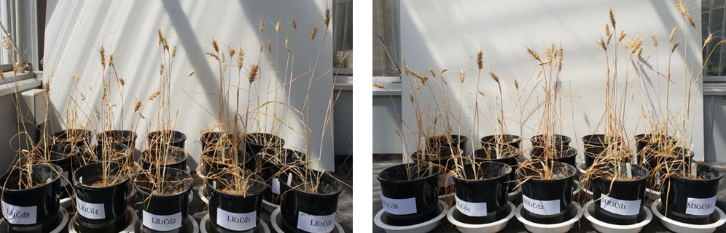

FIGURE S1 ⎟ Plant growth experiment on two spring wheat varieties Mustang (M) and Lancer (L) in pots under different levels of Cd-spiked soil in greenhouse conditions.
FIGURE S2 ⎟ Total biomass dry weight and Tolerance index under different levels of soil cadmium (Cd) concentrations in two wheat cultivars (Mustang and Lancer). Data are mean ± standard error of three replicates. Different letters indicate the significant differences by letters (a, b, c, d, e for Mustang and z, y, x, w, v for Lancer) among treatments at p < 0.05 as per Duncan’s multiple range test.

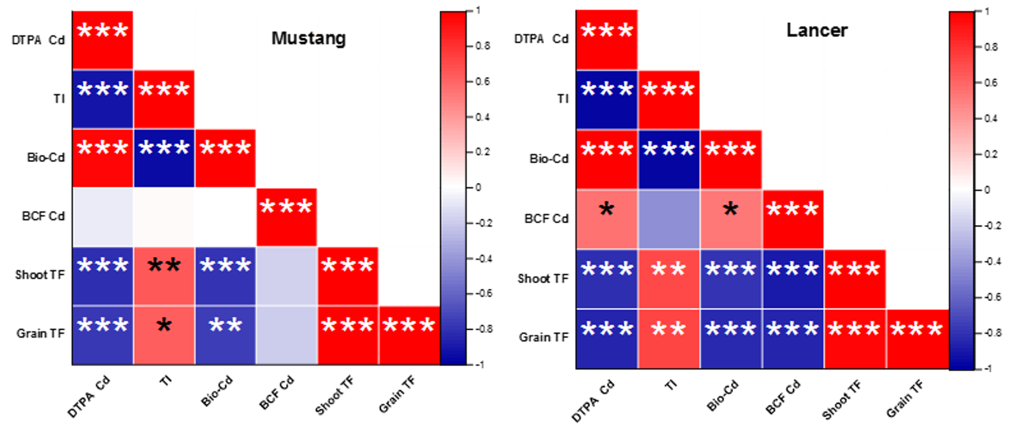FIGURE S3⎟ The Correlation co-efficient (n=15) among soil DTPA Cd, Bio Cd (Bioaccumulation Cd), BCF Cd, Shoot TF, Root TF, TI in two spring wheat cultivars which are grown under Cd spiked soil. (Red to Blue +ve to -ve correlation, * p<0.05, ** p<0.01, *** p<0.001).

