Supplementary material
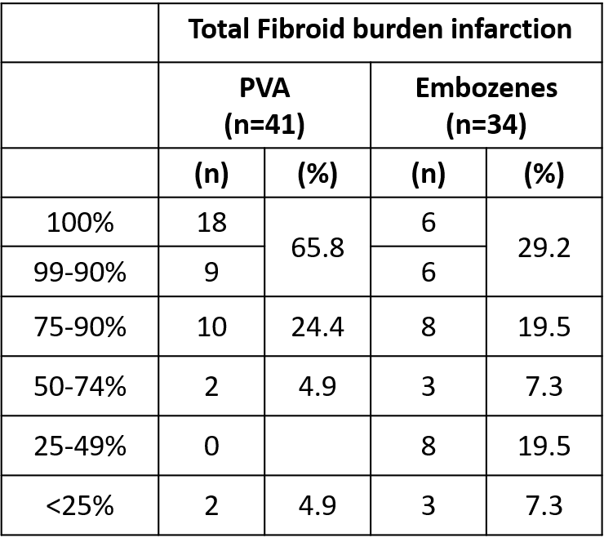
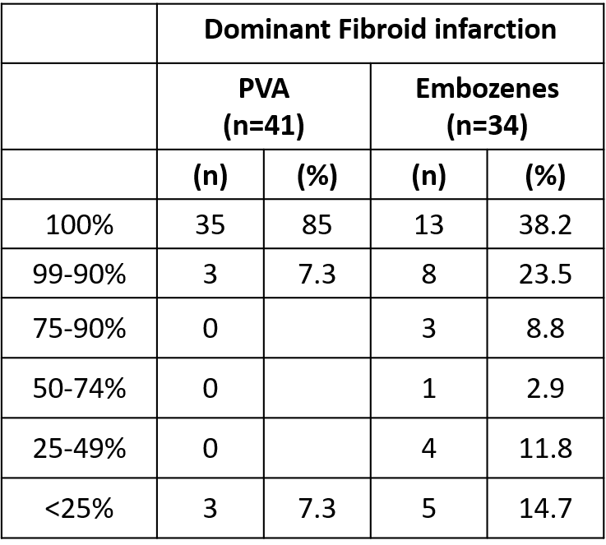

Table 5: Percentage dominant fibroid infarction and total fibroid burden infarction between PVA and Embozenes.

 | Dominant Fibroid Infarction |  |  |  |  | Total Fibroid burden infarction
 | PVA (n=41) |  | Embozenes (n=34) |  |  | PVA (n=41) |  | Embozenes (n=34)
 | (n) | (%) | (n) | (%) |  | (n) | (%) | (n) | (%)
100% | 35 | 85 | 13 | 38.2 | 100% | 18 | 65.8 | 6 | 29.2
90-99% | 3 | 7.3 | 8 | 23.5 | 90-99% | 9 |  | 6
75-90% | 0 |  | 3 | 8.8 | 75-90% | 10 | 24.4 | 8 | 19.5
50-74% | 0 |  | 1 | 2.9 | 50-74% | 2 | 4.9 | 3 | 7.3
25-49% | 0 |  | 4 | 11.8 | 25-49% | 0 |  | 8 | 19.5
<25% | 3 | 7.3 | 5 | 14.7 | <25% | 2 | 4.9 | 3 | 7.3
Fischer’s Exact test | p < 0.0001 |  |  |  |  | p= 0.02

Table 6: Fischer’s exact test of dominant fibroid percentage infarction and total fibroid percentage infarction in both PVA and Embozenes groups.

