Appendix S3 – Complete data meta-analysis
(results presented with forest-plots and their respective funnel-plots for each specific analysis)

Content index:
 | page
Summary of main findings of all meta-analysis……………………………………………………………  1. Meta-analysis for the outcome ASTHMA………………………………………………………………..  2. Meta-analysis for the outcome WHEEZING…………………………………………………………….  3. Meta-analysis for the outcome ECZEMA ………………………………………………………………..  4. Meta-analysis for the outcome ATOPY……………………………………………………………………  5. Meta-analysis for the outcome ALLERGIC RHINITIS………………………………………………..  6. Meta-analysis for the outcome BRONCHIAL HYPERREACTIVITY……………………………… | 2  8  24  49  64  93  107

Summary of main findings of all meta-analysis
(measures of associations reported for all outcomes and subgroup analysis. Statistically significant results highlighted as: positive effects on green shadow and negative effects on yellow shadow)

OUTCOME OR SUBGROUP | PAX | STUDIES | RISK RATIO (IV, RANDOM, 95% CI) | I² | I²  P value
1.ASTHMA
1.1 Asthma - subanalysis on helminth species
1.1.1 Asthma - A.Lumbricoides | 17724 | 18 | 1.08 [0.95, 1.23] | 80 | <0.0001
1.1.2 Asthma - T.Trichiura | 8532 | 10 | 0.98 [0.79, 1.22] | 85 | <0.0001
1.1.3 Asthma – Hookworm or A. Duodenalis | 1865 | 3 | 0.95 [0.41, 2.20] | 94 | <0.0001
1.1.4 Asthma - S.Mansoni | 1812 | 2 | 1.25 [0.90, 1.73] | 0 | 0.50
1.1.5 Asthma - E.Vermicularis | 5136 | 3 | 0.83 [0.58, 1.19] | 77 | 0.01
1.2 Asthma - subanalysis on bias quality
1.2.1 Low Risk of Bias | 16252 | 15 | 1.02 [0.87, 1.20] | 81 | <0.0001
1.2.2 Moderate Risk of Bias | 8923 | 8 | 0.91 [0.67, 1.23] | 81 | <0.0001
1.2.3 High Risk of Bias | 2164 | 1 | 1.28 [1.09, 1.49] | -- | --
1.3 Asthma - subanalysis on study dimension
1.3.1 Small studies (<1000 pax) | 5569 | 13 | 0.97 [0.75, 1.25] | 78 | <0.0001
1.3.2 Large studies (≥1000 pax) | 21770 | 12 | 1.04 [0.89, 1.21] | 84 | <0.0001
1.4 Asthma - subanalysis on publication year
1.4.1 Old studies (<2010) | 9434 | 10 | 0.92 [0.72, 1.17] | 84 | <0.0001
1.4.2 Recent studies (≥2010) | 17905 | 15 | 1.06 [0.91, 1.24] | 78 | <0.0001
1.5 Asthma - subanalysis on participants age
1.5.1 Children | 21705 | 18 | 1.10 [0.97, 1.25] | 78 | <0.0001
1.5.2 Adults | 5634 | 7 | 0.72 [0.47, 1.09] | 84 | <0.0001
1.6 Asthma - subanalysis on country income level
1.6.1 Low income countries | 20562 | 20 | 0.98 [0.85, 1.13] | 82 | <0.0001
1.6.2 High income countries | 6777 | 5 | 1.07 [0.71, 1.62] | 81 | <0.0001
1.7 Asthma - subanalysis on continental region
1.7.1 Africa | 3435 | 5 | 0.84 [0.55, 1.27] | 78 | 0.001
1.7.2 Asia | 6485 | 5 | 0.99 [0.68, 1.46] | 78 | 0.001
1.7.3 Europe | 2524 | 4 | 1.16 [0.76, 1.77] | 73 | 0.01
1.7.4 South America | 14895 | 11 | 1.02 [0.86, 1.21] | 86 | <0.0001
1.8 Asthma - subanalysis on study design
1.8.1 Cross-sectional | 21259 | 21 | 0.98 [0.84, 1.15] | 82 | <0.0001
1.8.2 Cohort | 6080 | 4 | 1.03 [0.82, 1.30] | 71 | 0.02
1.9 Asthma – subanalysis on type of Helminth detection:
1.9.1 One stool sample | 9033 | 5 | 1.05 [0.80, 1.39] | 90 | <0.0001
1.9.2 ≥2 stool samples | 14118 | 10 | 0.97 [0.84, 1.11] | 58 | 0.01
1.9.3 Serologic IgE | 2422 | 7 | 0.88 [0.61, 1.28] | 88 | <0.0001
1.9.4 Serologic IgG | 1766 | 4 | 1.44 [0.97, 2.13] | 49 | 0.12
1.10 Asthma - subanalysis on helminth detection method sensitivity:
1.10.1 Low (direct microscopy) | 227 | 1 | 0.66 [0.49, 0.90] | -- | --
1.10.2 Moderate (concentration/sedimentation methods with or without direct microscopy) | 21142 | 16 | 1.05 [0.92, 1.19] | 76 | <0.0001
1.10.2 High (PCR and other molecular-based methods) | 264 | 1 | 0.69 [0.31, 1.49] | -- | --
1.11 Asthma - subanalysis on endemic prevalence:
1.11.1 A. Lumbricoides prevalence High | 4699 | 2 | 0.84 [0.45, 1.56] | 83 | 0.02
1.11.1 A. Lumbricoides prevalence Moderate | 5611 | 4 | 0.90 [0.78, 1.05] | 0 | 0.89
1.11.1 A. Lumbricoides prevalence Low | 6794 | 7 | 1.10 [0.91, 1.34] | 88 | <0.0001
1.11.2 T. Trichiura prevalence High | 359 | 1 | 1.24 [0.86, 1.79] | -- | --
1.11.2 T. Trichiura prevalence Moderate | 654 | 2 | 0.69 [0.52, 0.91] | 0 | 0.37
1.11.2 T. Trichiura prevalence Low | 9609 | 7 | 1.03 [0.82, 1.30] | 85 | <0.0001
1.11.2 Hookworm prevalence Moderate | 427 | 1 | 0.97 [0.44, 2.15] | -- | --
1.11.2 Hookworm prevalence Low | 1285 | 1 | 1.61 [1.43, 1.81] | -- | --
OUTCOME OR SUBGROUP | PAX | STUDIES | RISK RATIO (IV, RANDOM, 95% CI) | I² | I²  P value
2.WHEEZING
2.1 Wheezing - subanalysis on helminth species
2.1.1 Wheezing - A.Lumbricoides | 40542 | 22 | 1.07 [0.99, 1.16] | 53 | 0.002
2.1.2 Wheezing - T.Trichiura | 28269 | 16 | 1.00 [0.90, 1.11] | 64 | 0.0002
2.1.3 Wheezing – Hookworm or A. Duodenalis | 24135 | 8 | 0.96 [0.79, 1.18] | 53 | 0.04
2.1.4 Wheezing - S.Mansoni | 1989 | 2 | 1.08 [0.78, 1.48] | 59 | 0.12
2.1.5 Wheezing - S.Stercoralis | 1240 | 2 | 0.99 [0.84, 1.17] | 0 | 0.71
2.2 Wheezing - subanalysis on bias quality
2.2.1 Low Risk of Bias | 45286 | 24 | 1.02 [0.95, 1.09] | 54 | 0.001
2.2.2 Moderate Risk of Bias | 30382 | 14 | 1.08 [0.90, 1.28] | 62 | 0.001
2.3 Wheezing - subanalysis on study dimension
2.3.1 Small studies (<1000 pax) | 9887 | 19 | 1.06 [0.94, 1.20] | 61 | 0.0003
2.3.2 Large studies (≥1000 pax) | 65781 | 19 | 1.01 [0.94, 1.09] | 52 | 0.005
2.4 Wheezing - subanalysis on publication year
2.4.1 Old studies (<2010) | 46997 | 14 | 0.97 [0.87, 1.07] | 57 | 0.004
2.4.2 Recent studies (≥2010) | 28671 | 24 | 1.09 [1.00, 1.19] | 53 | 0.001
2.5 Wheezing - subanalysis on participants age
2.5.1 Children | 68503 | 30 | 1.04 [0.97, 1.12] | 53 | 0.0003
2.5.2 Adults | 7165 | 8 | 1.02 [0.80, 1.30] | 70 | <0.0001
2.6 Wheezing - subanalysis on country income level
2.6.1 Low income countries | 73125 | 34 | 1.02 [0.95, 1.10] | 58 | <0.0001
2.6.2 High income countries | 2543 | 4 | 1.19 [0.97, 1.46] | 20 | 0.29
2.7 Wheezing - subanalysis on continental region
2.7.1 Africa | 46040 | 14 | 0.94 [0.84, 1.04] | 43 | 0.04
2.7.2 Asia | 5734 | 8 | 1.11 [0.91, 1.35] | 54 | 0.03
2.7.3 Europe | 1506 | 3 | 1.34 [1.07, 1.69] | 0 | 0.77
2.7.4 South America | 22388 | 13 | 1.07 [0.96, 1.19] | 66 | 0.0005
2.8 Wheezing - subanalysis on study design
2.8.1 Cross-sectional | 63766 | 29 | 1.03 [0.96, 1.12] | 60 | <0.0001
2.8.2 Cohort | 11902 | 9 | 1.06 [0.90, 1.25] | 45 | 0.07
2.9 Wheezing – subanalysis on type of Helminth detection:
2.9.1 One stool sample | 13276 | 7 | 1.16 [0.99, 1.37] | 33 | 0.18
2.9.2 ≥2 stool samples | 56114 | 18 | 1.02 [0.93, 1.11] | 58 | 0.001
2.9.3 Serologic IgE | 4396 | 9 | 0.95 [0.79, 1.13] | 68 | 0.002
2.9.4 Serologic IgG | 1882 | 4 | 1.18 [0.95, 1.47] | 35 | 0.20
2.10 Wheezing - subanalysis on helminth detection method sensitivity:
2.10.1 Low (direct microscopy) | 557 | 3 | 1.09 [0.71, 1.67] | 71 | 0.03
2.10.2 Moderate (concentration/sedimentation methods with or without direct microscopy) | 69928 | 29 | 1.00 [0.94, 1.07] | 53 | 0.0005
2.10.3 High (PCR and other molecular-based methods) | 2809 | 3 | 1.36 [0.82, 2.23] | 43 | 0.17
2.11 Wheezing - subanalysis on endemic prevalence:
2.11.1 A. Lumbricoides prevalence High | 5343 | 4 | 1.10 [0.85, 1.41] | 70 | 0.02
2.11.1 A. Lumbricoides prevalence Moderate | 20850 | 6 | 0.93 [0.82, 1.05] | 54 | 0.05
2.11.1 A. Lumbricoides prevalence Low | 15209 | 9 | 1.07 [0.96, 1.18] | 20 | 0.26
2.11.2 T. Trichiura prevalence High | 19547 | 6 | 0.94 [0.84, 1.06] | 39 | 0.14
2.11.2 T. Trichiura prevalence Moderate | 2557 | 2 | 1.68 [1.13, 2.51] | 4 | 0.31
2.11.2 T. Trichiura prevalence Low | 10847 | 8 | 0.95 [0.86, 1.04] | 0 | 0.92
2.11.2 Hookworm prevalence Moderate | 604 | 1 | 0.55 [0.33, 0.90] | -- | --
2.11.2 Hookworm prevalence Low | 17008 | 5 | 1.07 [0.81, 1.42] | 54 | 0.07
OUTCOME OR SUBGROUP | PAX | STUDIES | RISK RATIO (IV, RANDOM, 95% CI) | I² | I²  P value
3.ECZEMA
3.1 Eczema - subanalysis on helminth species
3.1.1 Eczema - A.Lumbricoides | 20860 | 11 | 1.04 [0.87, 1.25] | 81 | <0.0001
3.1.2 Eczema - T.Trichiura | 13091 | 5 | 1.03 [0.87, 1.21] | 57 | 0.05
3.1.3 Eczema – Hookworm or A. duodenalis | 6293 | 4 | 1.15 [0.94, 1.41] | 45 | 0.14
3.2 Eczema - subanalysis on bias quality
3.2.1 Low Risk of Bias | 19389 | 8 | 1.07 [0.85, 1.34] | 86 | <0.0001
3.2.2 Moderate Risk of Bias | 4358 | 4 | 1.08 [0.82, 1.41] | 62 | <0.0001
3.3 Eczema - subanalysis on study dimension
3.3.1 Small studies (<1000 pax) | 4242 | 7 | 1.12 [0.91, 1.37] | 56 | 0.03
3.3.2 Large studies (≥1000 pax) | 19505 | 5 | 1.03 [0.79, 1.34] | 89 | <0.0001
3.4 Eczema - subanalysis on publication year
3.4.1 Old studies (<2010) | 10576 | 5 | 0.94 [0.71, 1.26] | 89 | <0.0001
3.4.2 Recent studies (≥2010) | 13171 | 7 | 1.21 [0.97, 1.49] | 63 | 0.01
3.5 Eczema - subanalysis on participants age
3.5.1 Children | 23483 | 11 | 1.05 [0.88, 1.25] | 82 | <0.0001
3.5.2 Adults | 264 | 1 | 1.44 [0.88, 2.34] | -- | --
3.6 Eczema - subanalysis on country income level
3.6.1 Low income countries | 15185 | 7 | 1.12 [0.94, 1.34] | 65 | 0.009
3.6.2 High income countries | 8562 | 5 | 1.02 [0.73, 1.43] | 87 | <0.0001
3.7 Eczema - subanalysis on continental region
3.7.1 Africa | 2507 | 3 | 1.19 [0.85, 1.67] | 53 | 0.12
3.7.2 Europe | 8562 | 5 | 1.02 [0.73, 1.43] | 87 | <0.0001
3.7.3 South America | 12674 | 4 | 1.07 [0.86, 1.33] | 58 | 0.07
3.8 Eczema - subanalysis on study design
3.8.1 Cross-sectional | 17174 | 8 | 1.12 [0.96, 1.30] | 67 | 0.003
3.8.2 Cohort | 6573 | 4 | 0.95 [0.60, 1.51] | 84 | 0.0003
3.9 Eczema – subanalysis on type of Helminth detection:
3.9.1 One stool sample | 9876 | 5 | 1.22 [0.99, 1.50] | 70 | 0.01
3.9.2 ≥2 stool samples | 5309 | 2 | 0.88 [0.69, 1.14] | 1 | 0.31
3.9.3 Serologic IgG | 1506 | 3 | 1.09 [0.75, 1.57] | 67 | 0.05
3.10 Eczema - subanalysis on helminth detection method sensitivity:
3.10.2 Moderate (concentration/sedimentation methods with or without direct microscopy) | 14956 | 6 | 1.13 [0.94, 1.38] | 71 | 0.004
3.10.3 High (PCR and other molecular-based methods) | 493 | 2 | 1.22 [0.85, 1.77] | 0 | 0.33
3.11 Eczema - subanalysis on endemic prevalence:
3.11.1 A. Lumbricoides prevalence High | 8602 | 2 | 0.77 [0.56, 1.06] | 78 | 0.03
3.11.1 A. Lumbricoides prevalence Moderate | 8748 | 3 | 1.21 [0.94, 1.56] | 82 | 0.004
3.11.1 A. Lumbricoides prevalence Low | 2004 | 3 | 1.04 [0.64, 1.70] | 55 | 0.11
3.11.2 T. Trichiura prevalence High | 11254 | 2 | 0.98 [0.88, 1.08] | 0 | 0.68
3.11.2 T. Trichiura prevalence Moderate | 732 | 1 | 1.23 [1.08, 1.47] | -- | --
3.11.2 T. Trichiura prevalence Low | 1105 | 2 | 0.83 [0.54, 1.30] | 0 | 0.32
3.11.2 Hookworm prevalence Low | 1860 | 3 | 1.26 [1.09, 1.45] | 0 | 0.51
OUTCOME OR SUBGROUP | PAX | STUDIES | RISK RATIO (IV, RANDOM, 95% CI) | I² | I²  P value
4.ATOPY
4.1 Atopy - subanalysis on helminth species
4.1.1 Atopy - A.Lumbricoides | 60880 | 33 | 0.97 [0.91, 1.04] | 82 | <0.0001
4.1.2 Atopy - T.Trichiura | 44776 | 24 | 0.98 [0.90, 1.06] | 81 | <0.0001
4.1.3 Atopy – Hookworm or A. duodenalis | 31012 | 12 | 0.96 [0.85, 1.09] | 79 | <0.0001
4.1.4 Atopy - S.Mansoni | 4480 | 4 | 1.12 [0.58, 2.17] | 87 | <0.0001
4.1.5 Atopy - E.Vermicularis | 8520 | 5 | 0.93 [0.75, 1.16] | 87 | <0.0001
4.1.6 Atopy – S. Stercoralis | 2013 | 2 | 0.79 [0.68, 0.93] | 0 | 0.46
4.1.7 Atopy – H. Hana | 2013 | 2 | 0.79 [0.68, 0.93] | 0 | 0.46
4.2 Atopy - subanalysis on bias quality
4.2.1 Low Risk of Bias | 82783 | 49 | 1.00 [0.94, 1.07] | 83 | <0.0001
4.2.2 Moderate Risk of Bias | 29624 | 11 | 1.04 [0.91, 1.18] | 72 | <0.0001
4.3 Atopy - subanalysis on study dimension
4.3.1 Small studies (<1000 pax) | 14583 | 26 | 1.09 [0.96, 1.23] | 70 | <0.0001
4.3.2 Large studies (≥1000 pax) | 97824 | 34 | 0.97 [0.91, 1.04] | 85 | <0.0001
4.4 Atopy - subanalysis on publication year
4.4.1 Old studies (<2010) | 64247 | 28 | 1.00 [0.90,1.10] | 87 | <0.0001
4.4.2 Recent studies (≥2010) | 48160 | 32 | 1.02 [0.94, 1.11] | 79 | <0.0001
4.5 Atopy - subanalysis on participants age
4.5.1 Children | 100564 | 48 | 0.96 [0.90, 1.01] | 80 | <0.0001
4.5.2 Adults | 11843 | 12 | 1.37 [1.18, 1.61] | 52 | 0.02
4.6 Atopy - subanalysis on country income level
4.6.1 Low income countries | 105695 | 55 | 1.00 [0.93, 1.07] | 82 | <0.0001
4.6.2 High income countries | 6712 | 5 | 1.11 [0.91, 1.35] | 89 | <0.0001
4.7 Atopy - subanalysis on continental region
4.7.1 Africa | 56300 | 22 | 1.12 [1.01, 1.24] | 70 | <0.0001
4.7.2 Asia | 8910 | 10 | 1.01 [0.86, 1.20] | 49 | 0.04
4.7.3 Europe | 6693 | 5 | 1.03 [0.86, 1.22] | 84 | <0.0001
4.7.4 South America | 40504 | 23 | 0.91 [0.84, 0.98] | 80 | <0.0001
4.8 Atopy - subanalysis on study design
4.8.1 Cross-sectional | 96027 | 50 | 1.02 [0.95, 1.10] | 82 | <0.0001
4.8.2 Cohort | 16380 | 10 | 0.95 [0.85, 1.06] | 76 | <0.0001
4.9 Atopy – subanalysis on type of Helminth detection:
4.9.1 One stool sample | 28117 | 11 | 1.00 [0.84, 1.19] | 92 | <0.0001
4.9.2 ≥2 stool samples | 69584 | 33 | 0.97 [0.90, 1.04] | 73 | <0.0001
4.9.3 Serologic IgE | 5790 | 10 | 1.28 [1.00, 1.65] | 75 | <0.0001
4.9.4 Serologic IgG | 4747 | 5 | 1.00 [0.83, 1.20] | 85 | <0.0001
4.10 Atopy - subanalysis on helminth detection method sensitivity:
4.10.1 Low (direct microscopy) | 1013 | 2 | 1.66 [0.89, 3.11] | 78 | 0.03
4.10.2 Moderate (concentration/sedimentation methods with or without direct microscopy) | 97097 | 50 | 0.96 [0.90, 1.02] | 79 | <0.0001
4.10.3 High (PCR and other molecular-based methods) | 8886 | 5 | 1.33 [1.21, 1.47] | 0 | 0.82
4.11 Atopy - subanalysis on endemic prevalence:
4.11.1 A. Lumbricoides prevalence High | 17804 | 8 | 0.85 [0.80, 0.90] | 56 | 0.03
4.11.1 A. Lumbricoides prevalence Moderate | 22197 | 11 | 0.98 [0.88, 1.08] | 76 | <0.0001
4.11.1 A. Lumbricoides prevalence Low | 20329 | 12 | 1.04 [0.90, 1.21] | 77 | <0.0001
4.11.2 T. Trichiura prevalence High | 27575 | 9 | 0.88 [0.80, 0.96] | 81 | <0.0001
4.11.2 T. Trichiura prevalence Moderate | 7571 | 4 | 1.29 [1.08, 1.54] | 49 | 0.11
4.11.2 T. Trichiura prevalence Low | 15313 | 12 | 0.97 [0.88, 1.06] | 32 | 0.14
4.11.2 Hookworm prevalence High | 1674 | 1 | 1.27 [0.98, 1.66] | -- | --
4.11.2 Hookworm prevalence Moderate | 1178 | 2 | 1.40 [0.93, 2.10] | 18 | 0.27
4.11.2 Hookworm prevalence Low | 17341 | 4 | 1.04 [0.95, 1.15] | 0 | 0.62
4.12 Atopy – type of measure:
4.12.1 IgE detection | 28575 | 28 | 1.04 [0.94, 1.15] | 78 | <0.0001
4.12.1 Skin Prick Test | 104414 | 52 | 1.01 [0.94, 1.08] | 84 | <0.0001
OUTCOME OR SUBGROUP | PAX | STUDIES | RISK RATIO (IV, RANDOM, 95% CI) | I² | I²  P value
5.ALLERGIC RHINITIS
5.1 Allergic Rhinitis - subanalysis on helminth species
5.1.1 Allergic Rhinitis - A.Lumbricoides | 14335 | 8 | 1.02 [0.90, 1.16] | 28 | 0.20
5.1.2 Allergic Rhinitis - T.Trichiura | 12829 | 5 | 0.94 [0.78, 1.12] | 58 | 0.05
5.1.3 Allergic Rhinitis - Hookworm or A. duodenalis | 5753 | 2 | 1.23 [0.70, 2.14] | 82 | 0.02
5.1.4 Allergic Rhinitis - E.Vermicularis | 5445 | 3 | 0.95 [0.69, 1.31] | 85 | 0.001
5.2 Allergic Rhinitis - subanalysis on bias quality
5.2.1 Low Risk of Bias | 19412 | 13 | 1.04 [0.91, 1.18] | 61 | 0.002
5.2.2 Moderate Risk of Bias | 4685 | 4 | 0.93 [0.70, 1.23] | 49 | 0.12
5.3 Allergic Rhinitis - subanalysis on study dimension
5.3.1 Small studies (<1000 pax) | 5041 | 10 | 1.03 [0.83, 1.28] | 59 | 0.009
5.3.2 Large studies (≥1000 pax) | 19056 | 7 | 0.99 [0.87, 1.14] | 70 | 0.003
5.4 Allergic Rhinitis - subanalysis on publication year
5.4.1 Old studies (<2010) | 13135 | 9 | 1.08 [0.90, 1.29] | 67 | 0.002
5.4.2 Recent studies (≥2010) | 11226 | 8 | 0.95 [0.81, 1.13] | 59 | 0.02
5.5 Allergic Rhinitis - subanalysis on participants age
5.5.1 Children | 18139 | 11 | 1.11 [0.97, 1.26] | 51 | 0.03
5.5.2 Adults | 6222 | 6 | 0.85 [0.71, 1.02] | 49 | 0.08
5.6 Allergic Rhinitis - subanalysis on country income level
5.6.1 Low income countries | 18039 | 11 | 0.99 [0.87, 1.13] | 56 | 0.01
5.6.2 High income countries | 6322 | 6 | 1.09 [0.85, 1.40] | 73 | 0.002
5.7 Allergic Rhinitis - subanalysis on continental region
5.7.1 Africa | 695 | 2 | 1.27 [0.91, 1.78] | 2 | 0.31
5.7.2 Asia | 5770 | 5 | 0.94 [0.75, 1.18] | 66 | 0.02
5.7.3 Europe | 2524 | 4 | 1.19 [0.94, 1.51] | 0 | 0.57
5.7.4 South America | 15372 | 6 | 0.99 [0.83, 1.17] | 73 | 0.003
5.8 Allergic Rhinitis - subanalysis on study design
5.8.1 Cross-sectional | 23732 | 16 | 1.02 [0.90, 1.14] | 65 | 0.0002
5.8.2 Cohort | 629 | 1 | 0.92 [0.49, 1.73] | -- | --
1.9 Allergic Rhinitis – subanalysis on type of Helminth detection:
5.9.1 One stool sample | 10479 | 4 | 1.12 [0.92, 1.35] | 68 | 0.02
5.9.2 ≥2 stool samples | 9867 | 6 | 0.86 [0.77, 0.95] | 0 | 0.74
5.9.3 Serologic IgE | 1837 | 3 | 0.87 [0.54, 1.40] | 79 | 0.008
5.9.4 Serologic IgG | 1506 | 3 | 1.25 [0.96, 1.62] | 0 | 0.53
5.10 Allergic Rhinitis - subanalysis on helminth detection method sensitivity:
5.10.1 Moderate (concentration/sedimentation methods with or without direct microscopy) | 19076 | 12 | 0.99 [0.88, 1.11] | 52 | 0.02
5.10.2 High (PCR and other molecular-based methods) | 264 | 1 | 1.45 [0.91, 2.33] | -- | --
5.11 Allergic Rhinitis - subanalysis on endemic prevalence:
5.11.1 A. Lumbricoides prevalence High | 5172 | 2 | 0.89 [0.74, 1.09] | 0 | 0.40
5.11.1 A. Lumbricoides prevalence Moderate | 6821 | 1 | 0.97 [0.88, 1.07] | -- | --
5.11.1 A. Lumbricoides prevalence Low | 836 | 2 | 1.15 [0.71, 1.85] | 46 | 0.17
5.11.2 T. Trichiura prevalence High | 11613 | 3 | 1.02 [0.87, 1.19] | 43 | 0.17
5.11.2 T. Trichiura prevalence Moderate | 739 | 1 | 0.59 [0.39, 0.90] | -- | --
5.11.2 T. Trichiura prevalence Low | 477 | 1 | 0.85 [0.61, 1.20] | -- | --
OUTCOME OR SUBGROUP | PAX | STUDIES | RISK RATIO (IV, RANDOM, 95% CI) | I² | I²  P value
6.BRONCHIAL HYPERREACTIVITY
6.1 Bronchial Hyperreactivity - subanalysis on helminth species
6.1.1 Bronchial Hyperreactivity - A.Lumbricoides | 1829 | 5 | 1.41 [1.17, 1.70] | 50 | 0.09
6.1.2 Bronchial Hyperreactivity - T.Trichiura | 1132 | 2 | 1.10 [0.86, 1.41] | 59 | 0.12
6.2 Bronchial Hyperreactivity - subanalysis on bias quality
6.2.1 Low Risk of Bias | 798 | 2 | 1.30 [1.09, 1.55] | 0 | 0.96
6.2.2 Moderate Risk of Bias | 1804 | 4 | 1.41 [1.04, 1.92] | 82 | 0.0008
6.3 Bronchial Hyperreactivity - subanalysis on publication year
6.3.1 Old studies (<2010) | 898 | 3 | 1.34 [1.13, 1.58] | 0 | 0.38
6.3.2 Recent studies (≥2010) | 1704 | 3 | 1.32 [0.96, 1.81] | 86 | 0.0009
6.4 Bronchial Hyperreactivity - subanalysis on participants age
6.4.1 Children | 2602 | 6 | 1.32 [1.09, 1.60] | 72 | 0.003
6.5 Bronchial Hyperreactivity - subanalysis on country income level
6.5.1 Low income countries | 2602 | 6 | 1.32 [1.09, 1.60] | 72 | 0.003
6.6 Bronchial Hyperreactivity - subanalysis on continental region
6.6.1 Africa | 1905 | 3 | 1.16 [0.97, 1.40] | 68 | 0.04
6.6.2 Asia | 158 | 1 | 2.70 [1.51, 4.83] | NA | NA
6.6.4 South America | 539 | 2 | 1.51 [0.94, 2.42] | 47 | 0.17
6.7 Bronchial Hyperreactivity - subanalysis on study design
6.7.1 Cross-sectional | 2502 | 5 | 1.28 [1.06, 1.54] | 73 | 0.005
6.7.2 Cohort | 100 | 1 | 2.24 [1.07, 4.69] | -- | --
6.8 Bronchial Hyperreactivity – subanalysis on type of Helminth detection:
6.8.1 ≥2 stool samples | 1646 | 3 | 1.21 [0.93, 1.57] | 77 | 0.01
6.8.2 Serologic IgE | 956 | 3 | 1.50 [1.09, 2.05] | 64 | 0.06
6.9 Bronchial Hyperreactivity - subanalysis on helminth detection method sensitivity:
6.9.1 Low (direct microscopy) | 597 | 2 | 1.78 [0.88, 3.61] | 81 | 0.02
6.9.2 Moderate (concentration/sedimentation methods with or without direct microscopy) | 2005 | 4 | 1.21 [0.99, 1.49] | 68 | 0.03
6.10 Bronchial Hyperreactivity - subanalysis on endemic prevalence:
6.10.1 A. Lumbricoides prevalence High | 258 | 2 | 2.51 [1.59, 3.97] | 0 | 0.69
6.10.1 A. Lumbricoides prevalence Moderate | 773 | 1 | 1.27 [1.11, 1.46] | -- | --
6.10.1 A. Lumbricoides prevalence Low | 359 | 1 | 1.29 [0.96, 1.73] | -- | --

1. Meta-analysis for the outcome ASTHMA

DISAGGREGATED ANALISYS ACCORDING TO:
- 1.1 - Helminth type of infection:
A. Lumbricoides
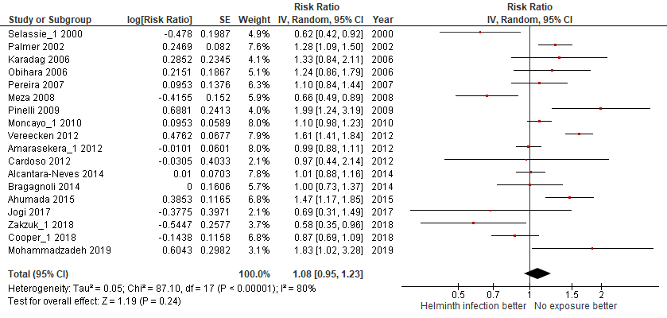
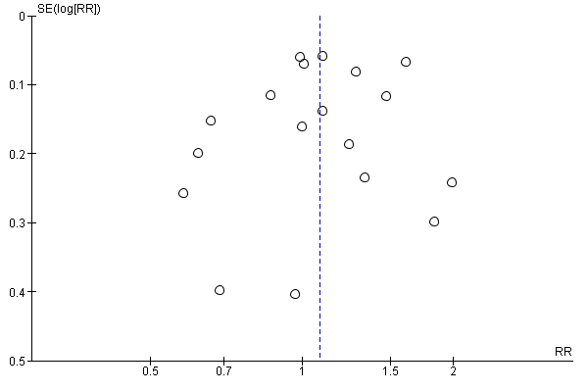

T. Trichiura
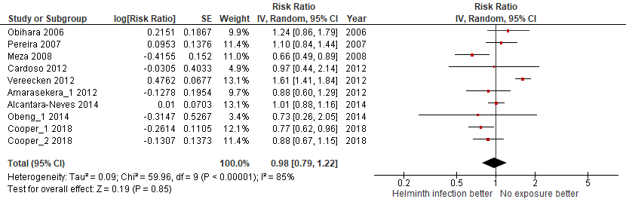
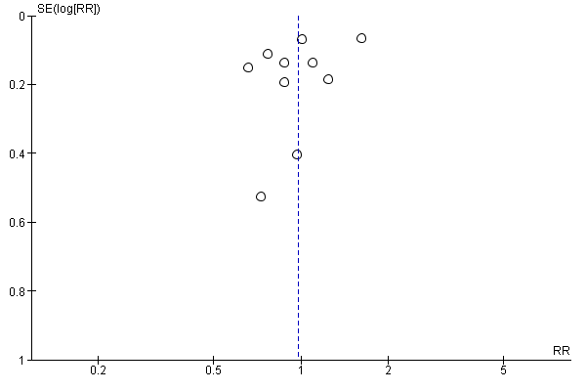

Hookworm or A. duodenalis
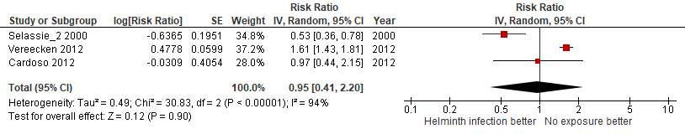
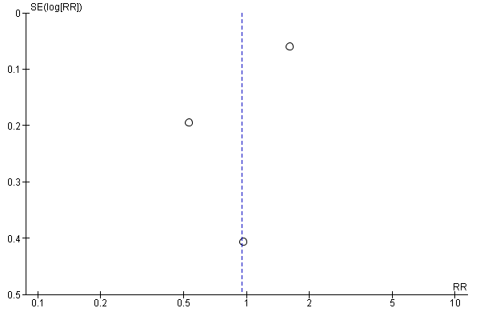
S.mansoni
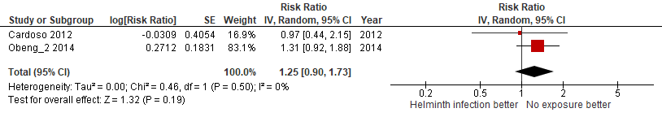
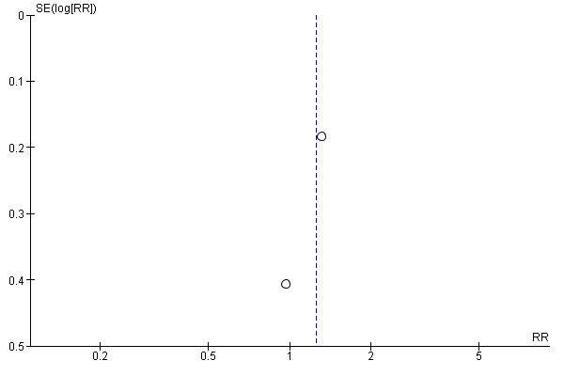

E.vermicularis
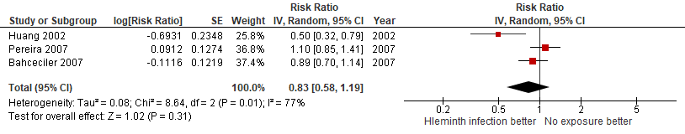
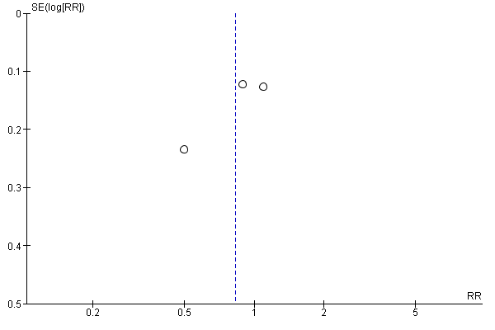

Clonorchis sinensis
Not performed because there were no studies available.

S.stercoralis
Not performed because there was only one study available.

H.nana
Not performed because there was only one study available.

S.hematobium
Not performed because there were no studies available.
- 1.2 - Bias quality assessment, high VS moderate VS low:
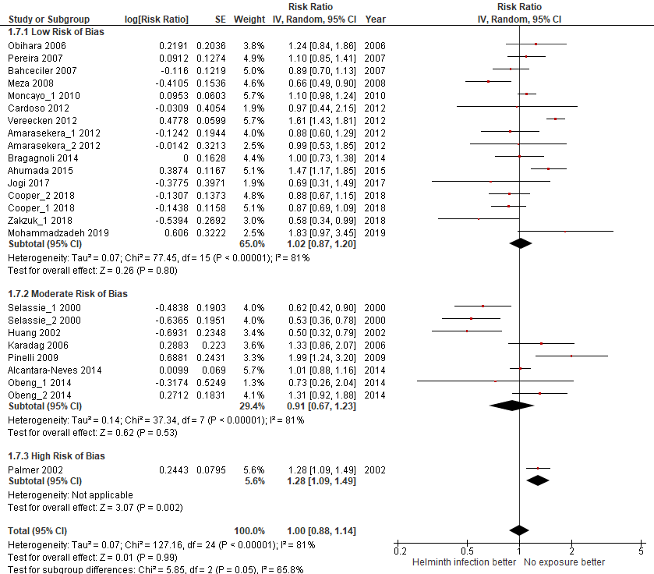

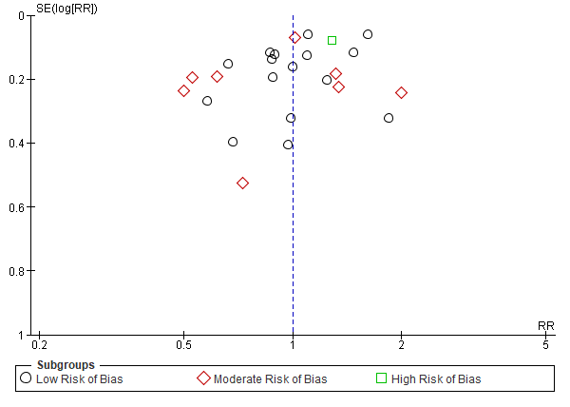

- 1.3 - Sample size, large (≥1000 pax) VS small (<1000 pax):
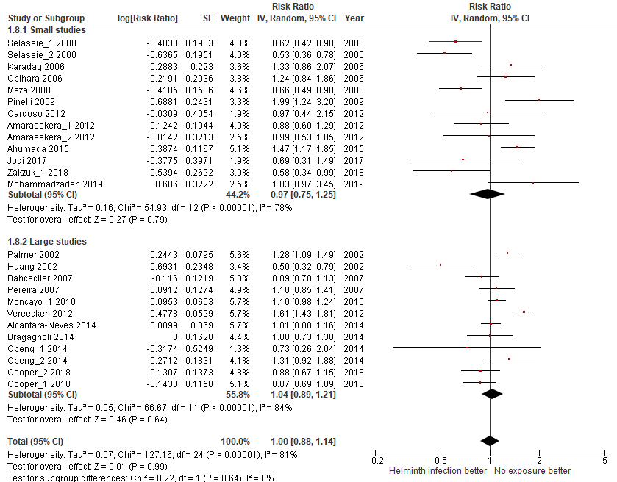
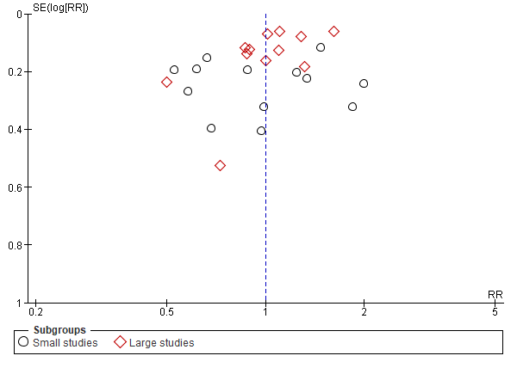

- 1.4 - Year of publication, old (<2010) VS recent (≥2010):
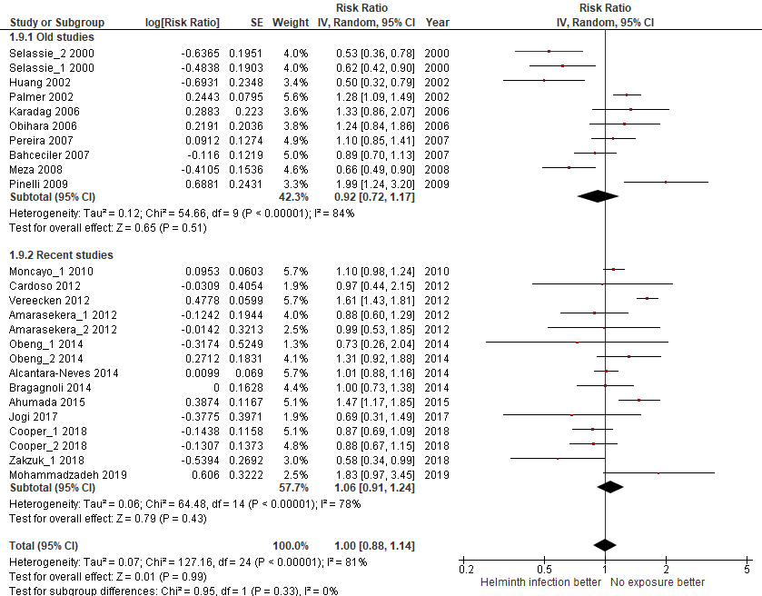
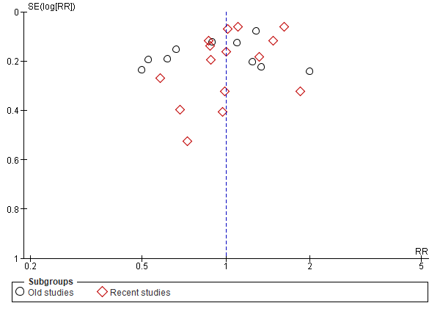

- 1.5 - Participants age, children VS adults:
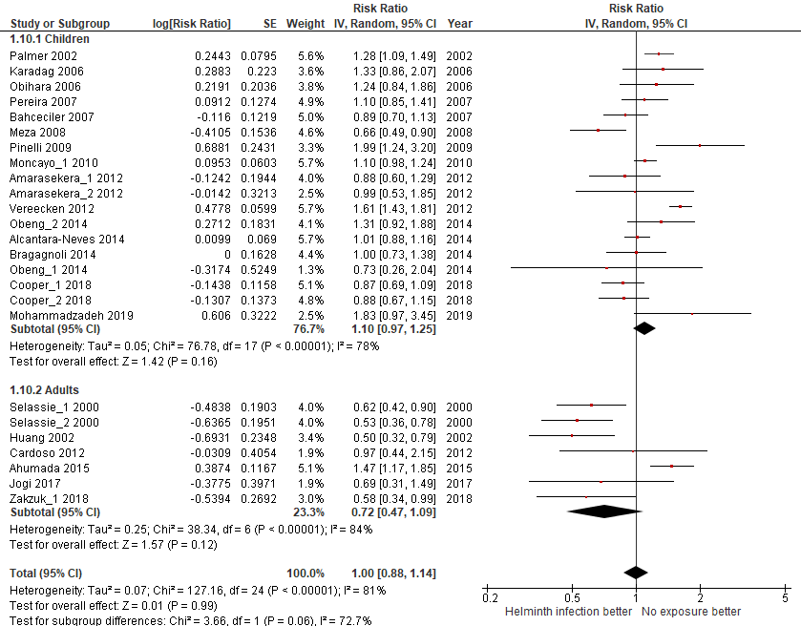
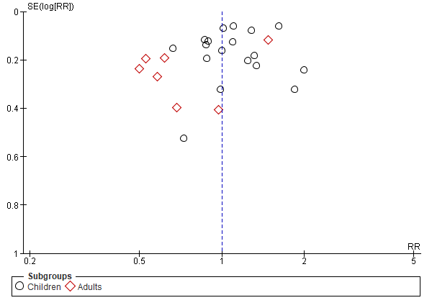

- 1.6 - Country Income level, high VS low:
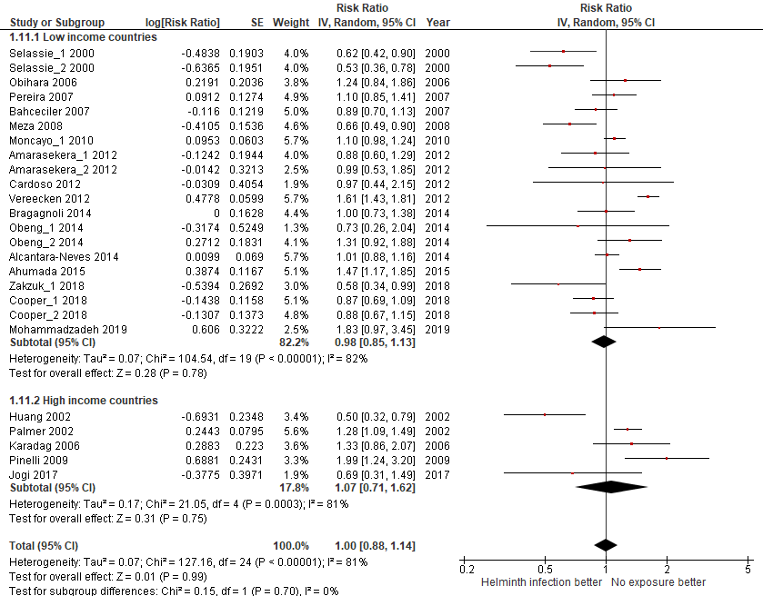
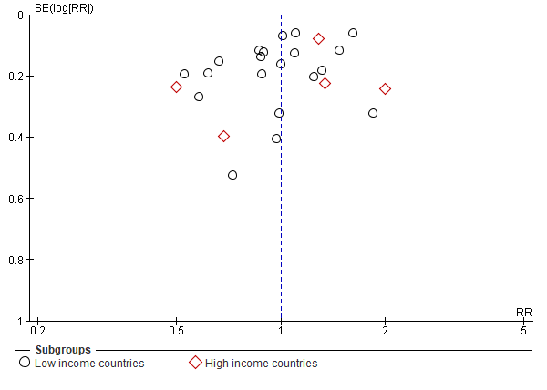

- 1.7 - Country continental region:
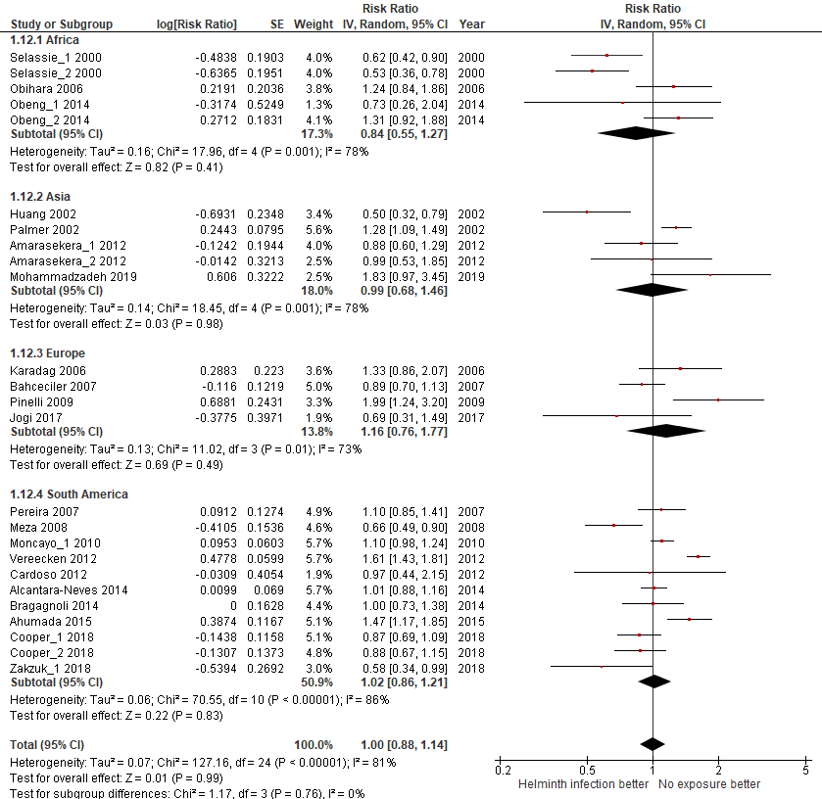

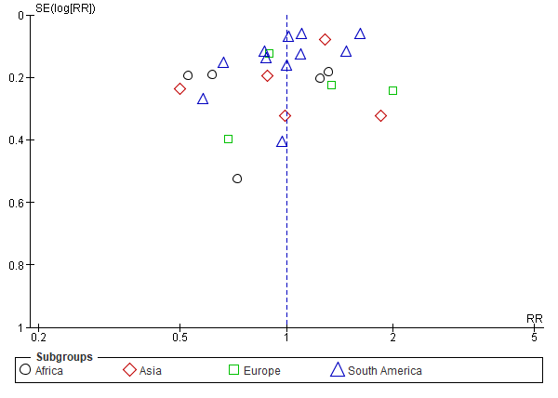

- 1.8 - Design, cross-sectional VS cohort:
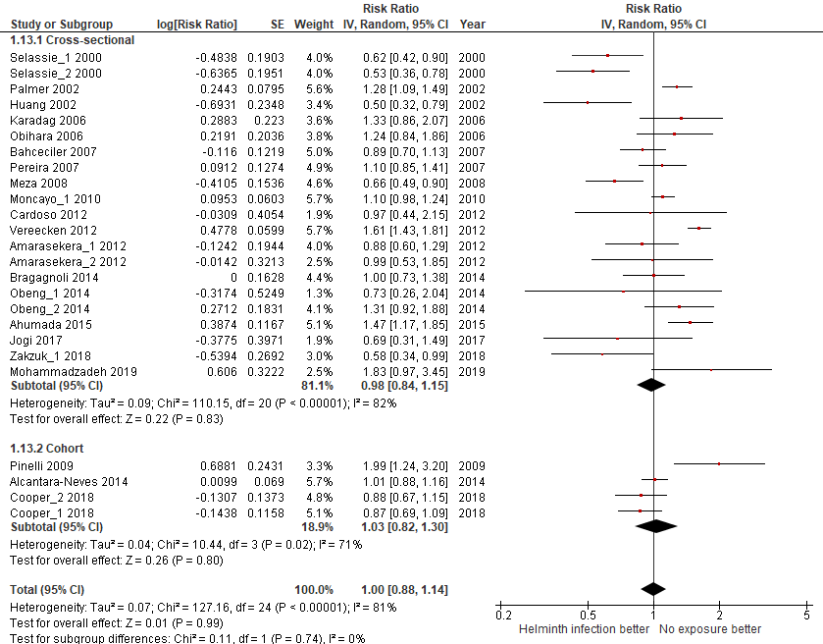
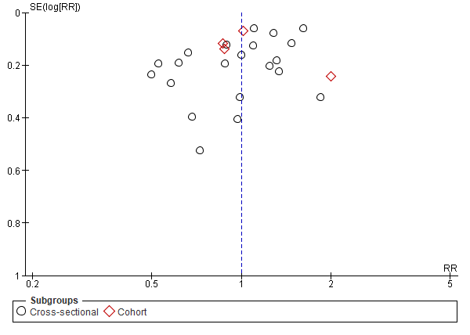

- 1.9 - Type of helminth detection:

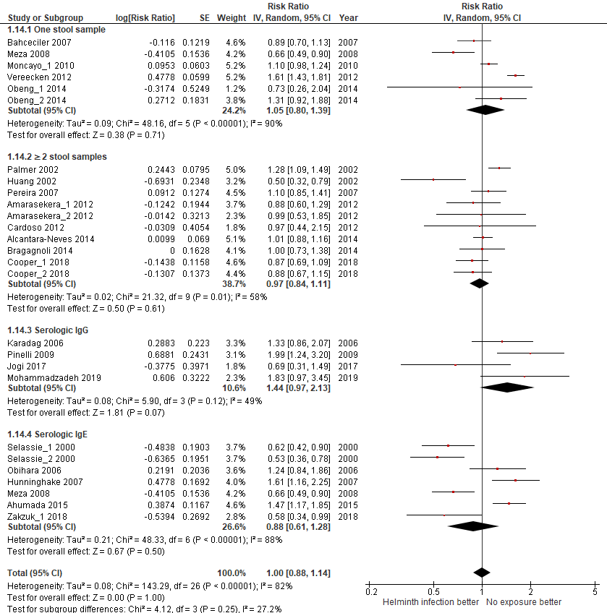

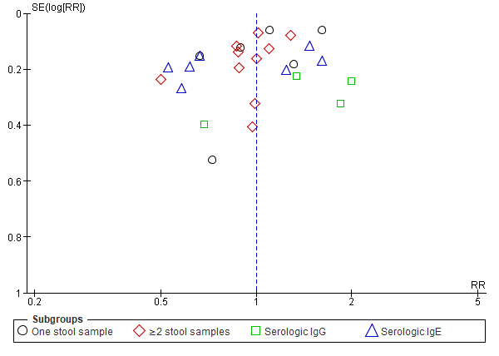
- 1.10 - Helminth detection method sensitivity:
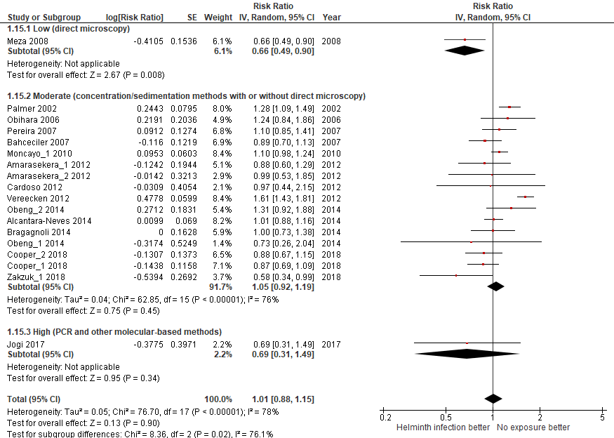

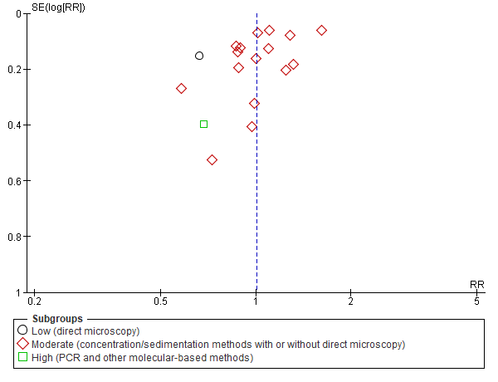

- 1.11 – Endemic prevalence:
A. Lumbricoides prevalece
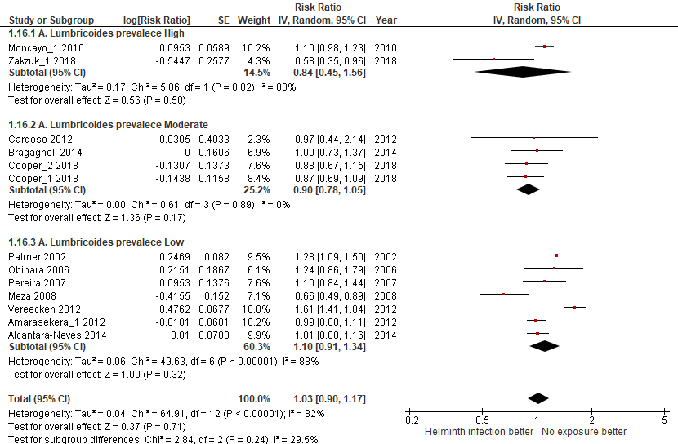
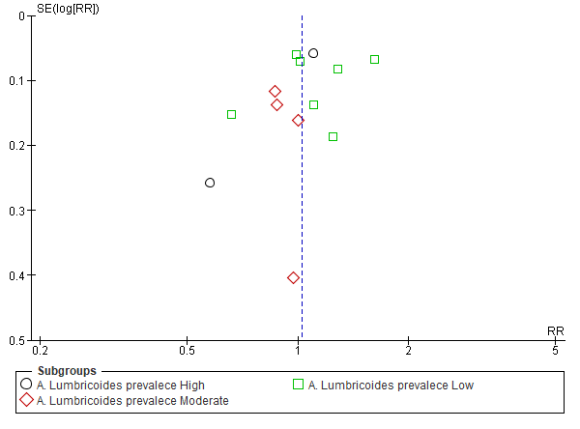

T. Trichiura prevalece
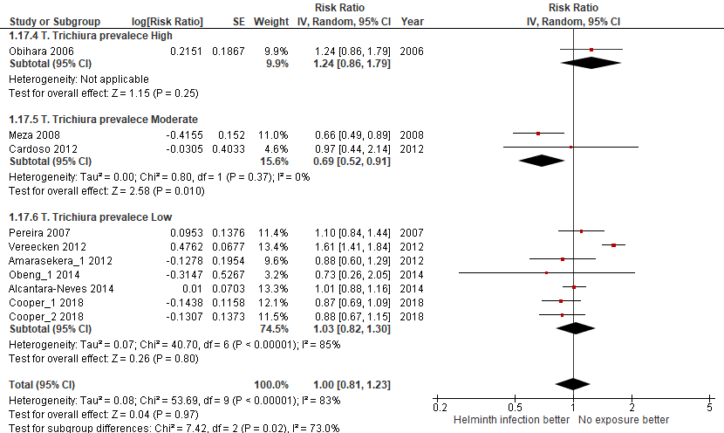
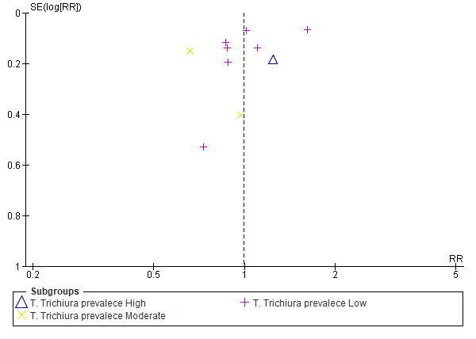

Hookworm prevalece
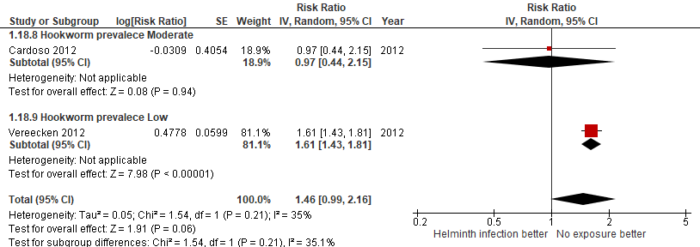
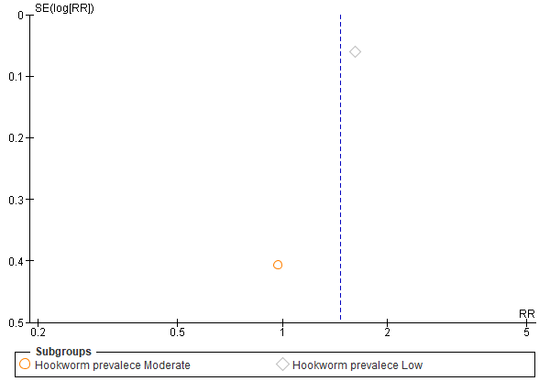

2. Meta-analysis for the outcome WHEEZING

DISAGGREGATED ANALISYS ACCORDING TO:
- 2.1 - Helminth type of infection
A. Lumbricoides
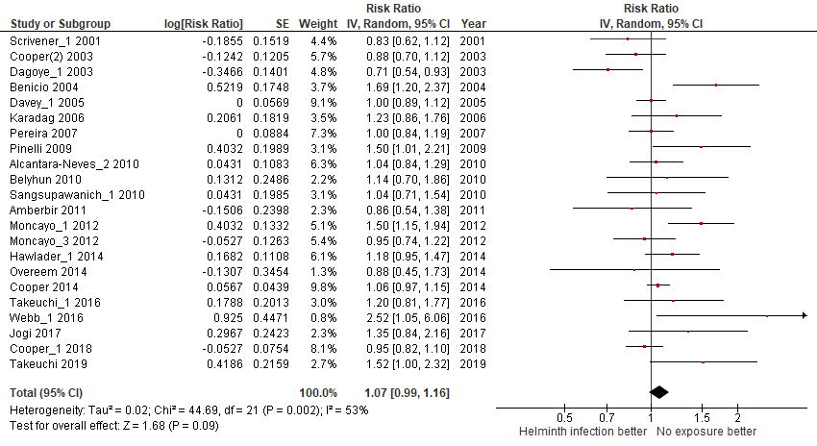
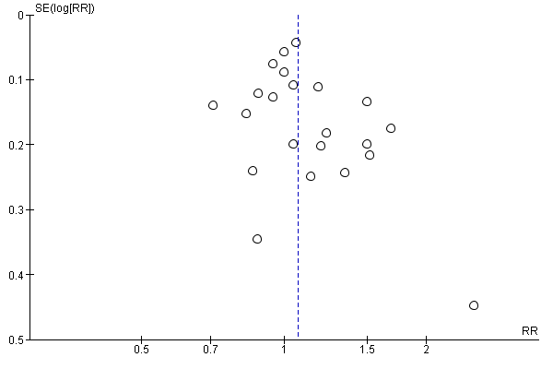

T. Trichiura
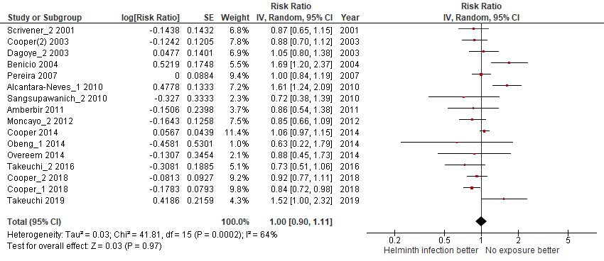
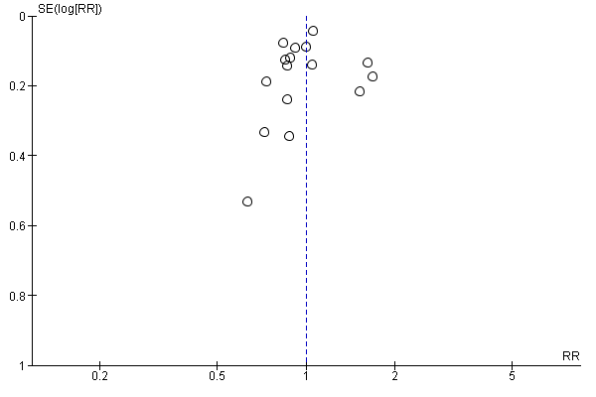

Hookworm or A. duodenalis
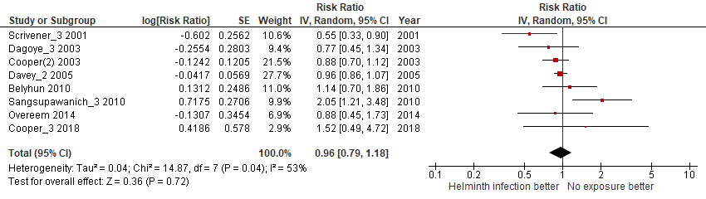
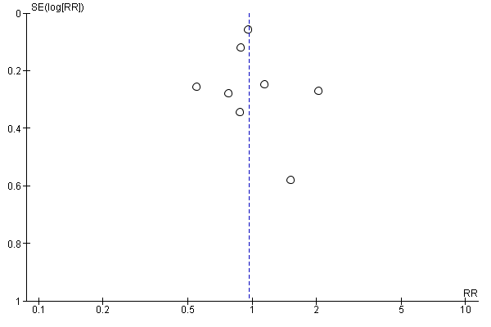

S.mansoni
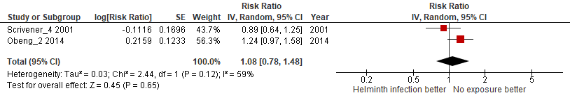
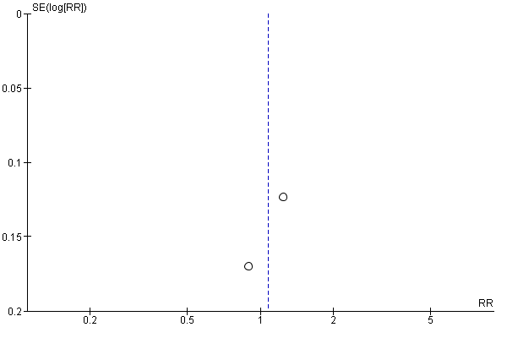

E.vermicularis
Not performed because there was only one study available.

Clonorchis sinensis
Not performed because there was only one study available.

S.stercoralis
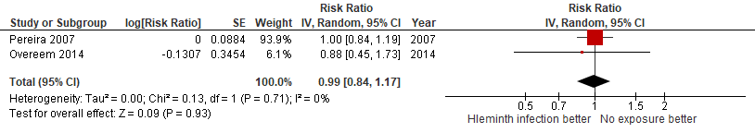
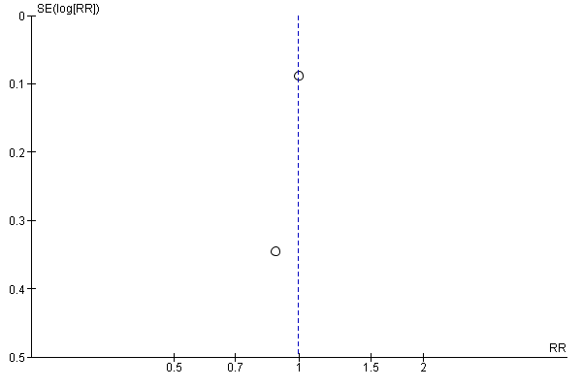

H.nana
Not performed because there was only one study available.

S.hematobium
Not performed because there were no studies available.

- 2.2 - Bias quality assessment, high VS moderate VS low:
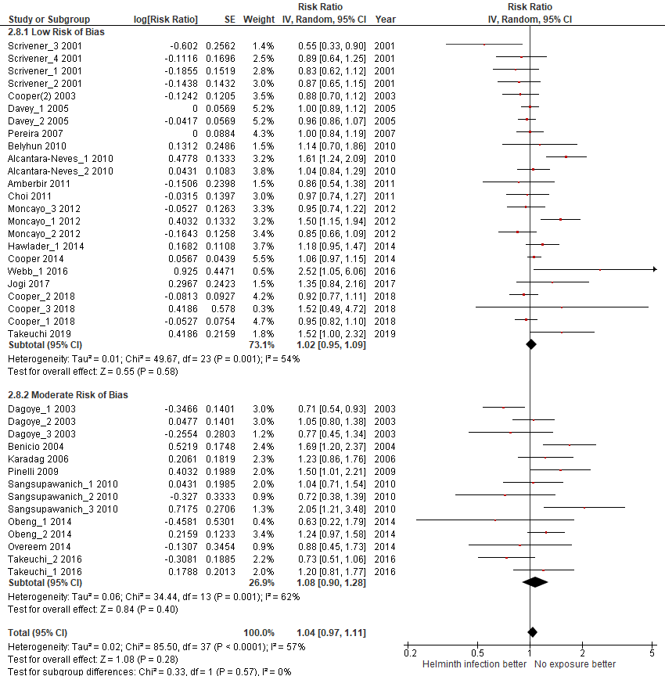
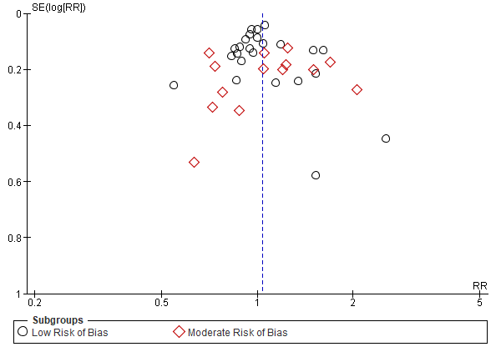

- 2.3 - Sample size, large (≥1000 pax) VS small (<1000 pax):
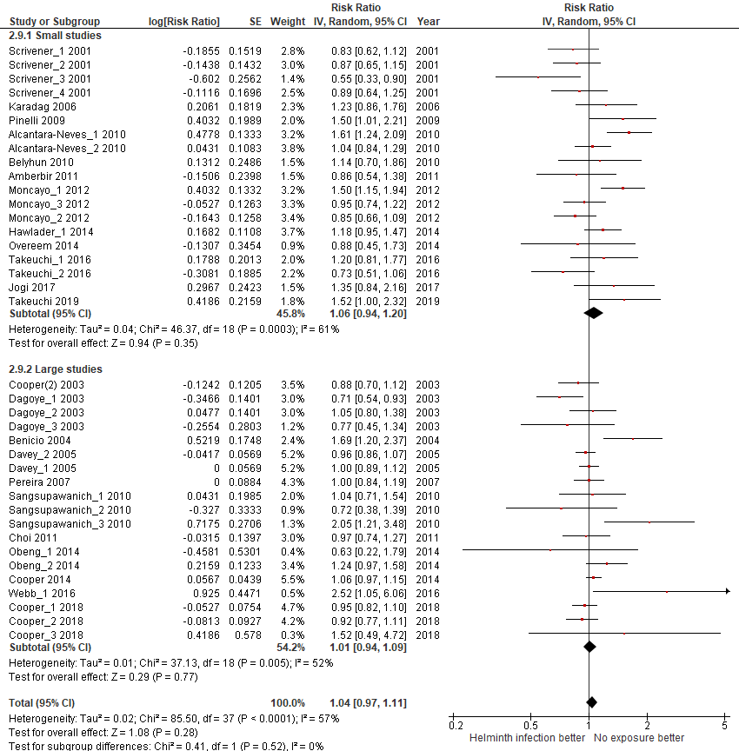
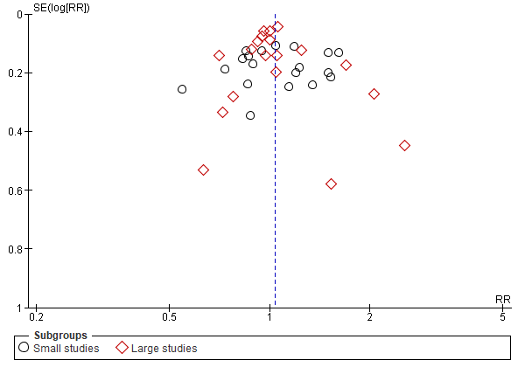

- 2.4 - Year of publication, old (<2010) VS recent (≥2010):
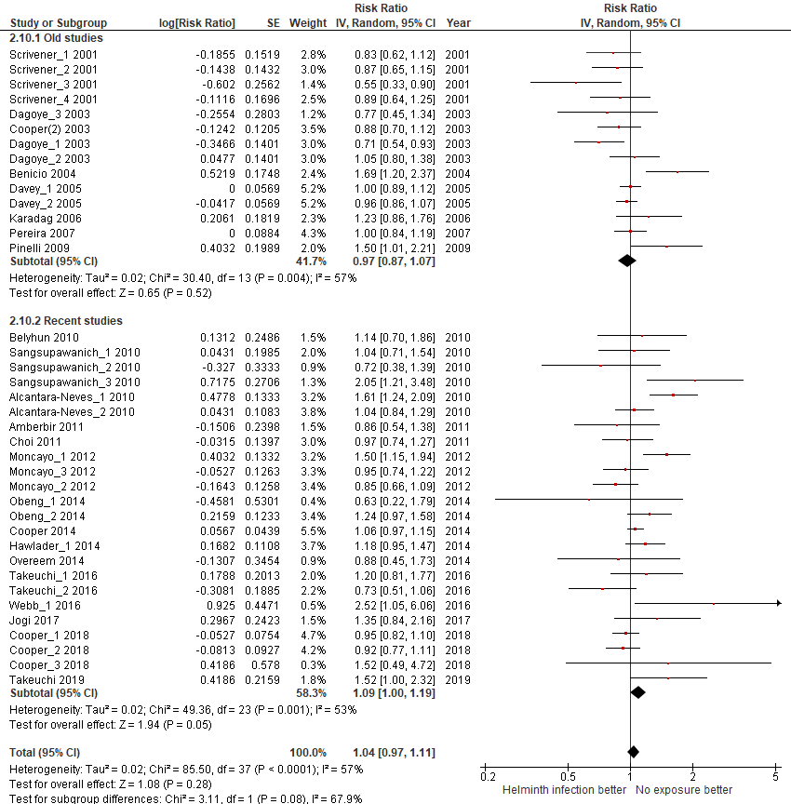
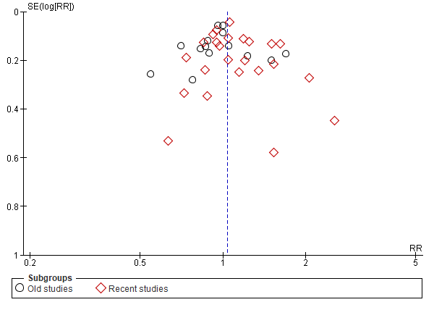

- 2.5 - Participants age, children VS adults:
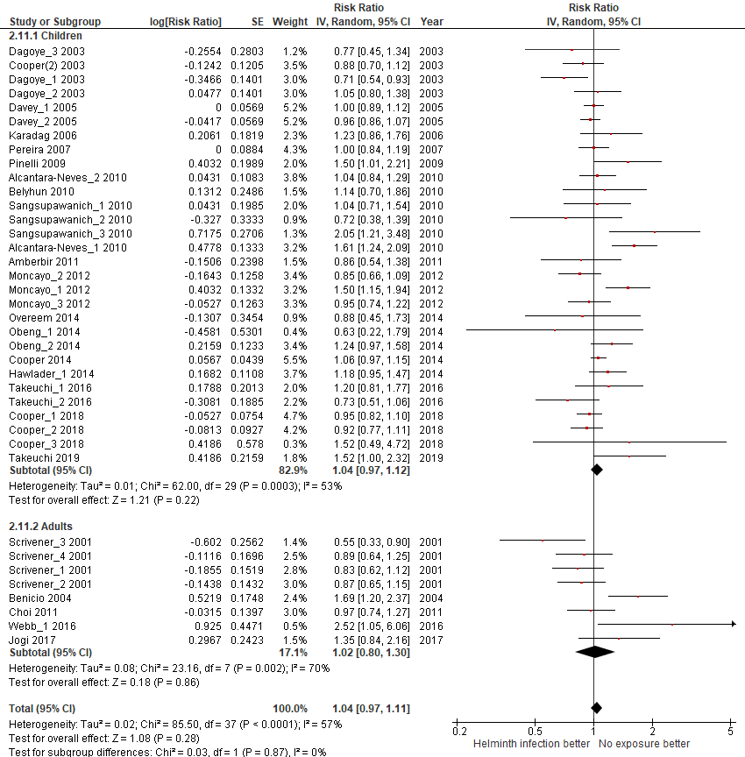
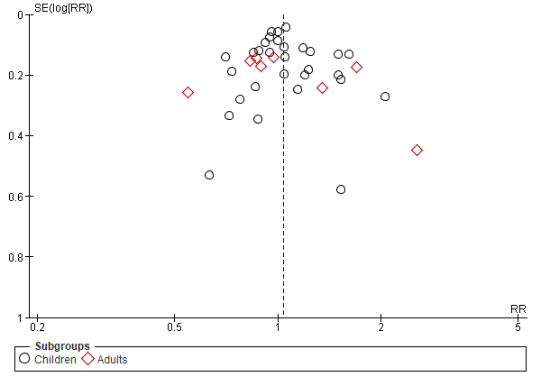

- 2.6 - Country Income level, moderate VS low:
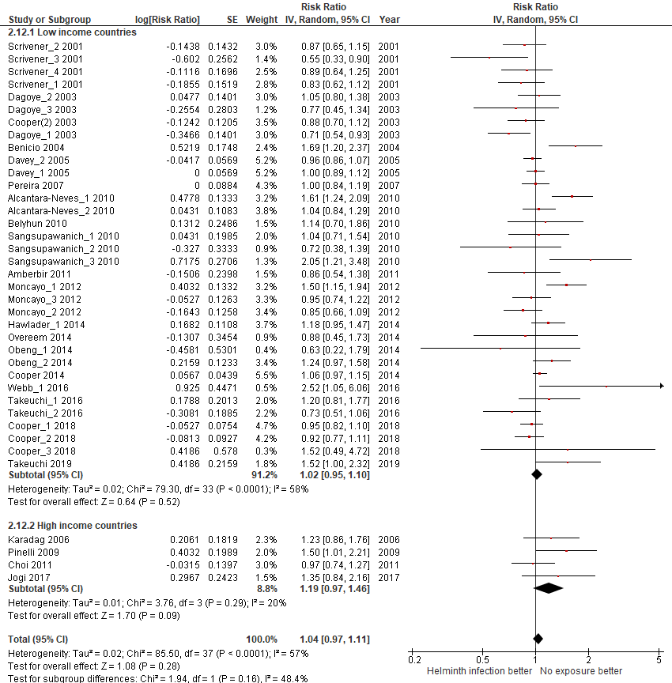
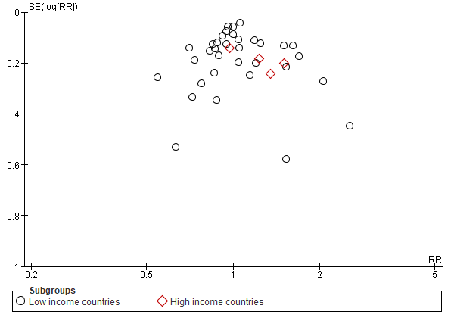

- 2.7 - Country continental region:
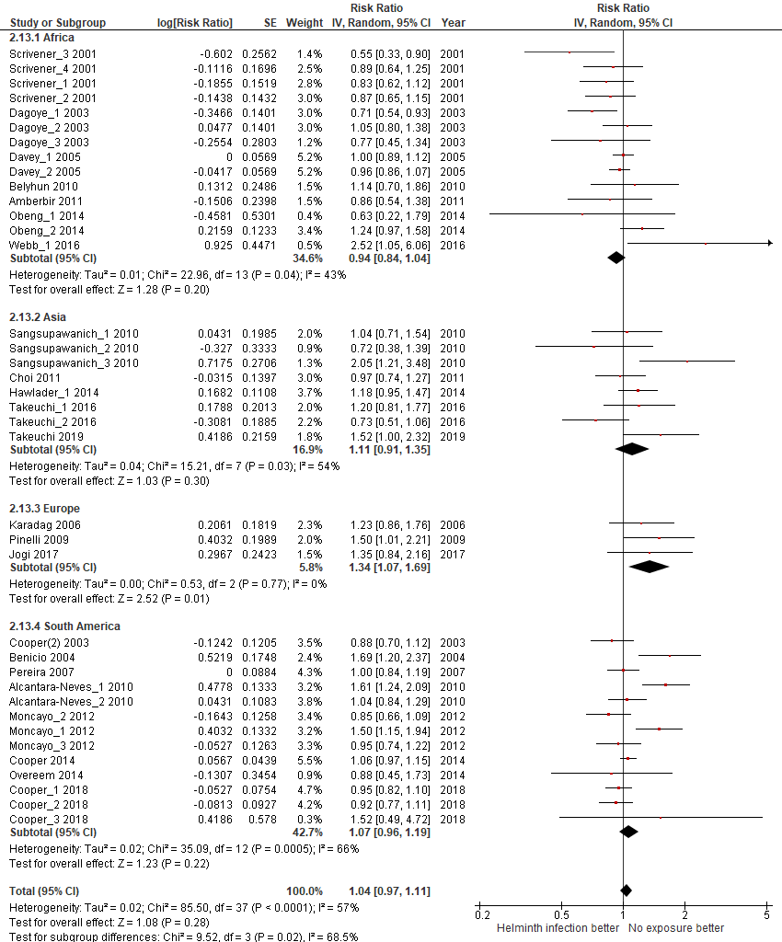
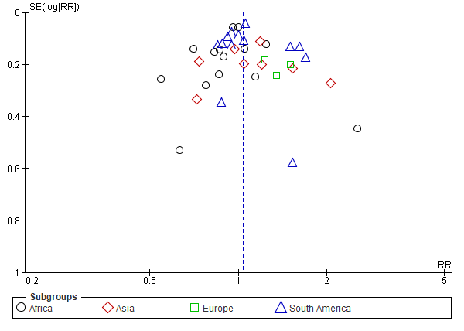

- 2.8 - Design, cross-sectional VS cohort:
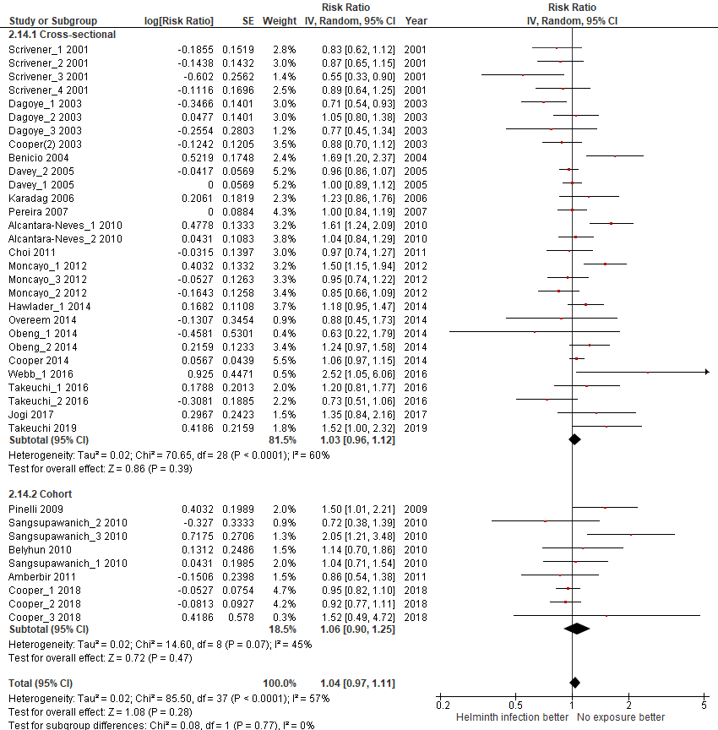
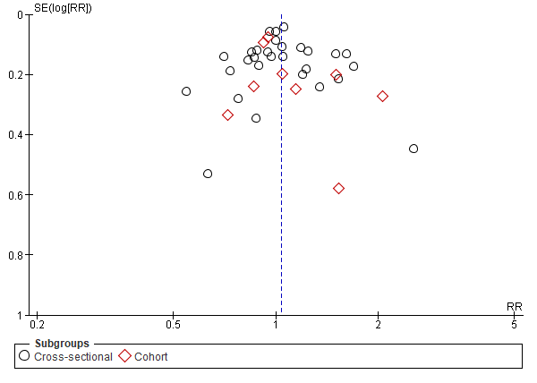

- 2.9 - Type of helminth detection:

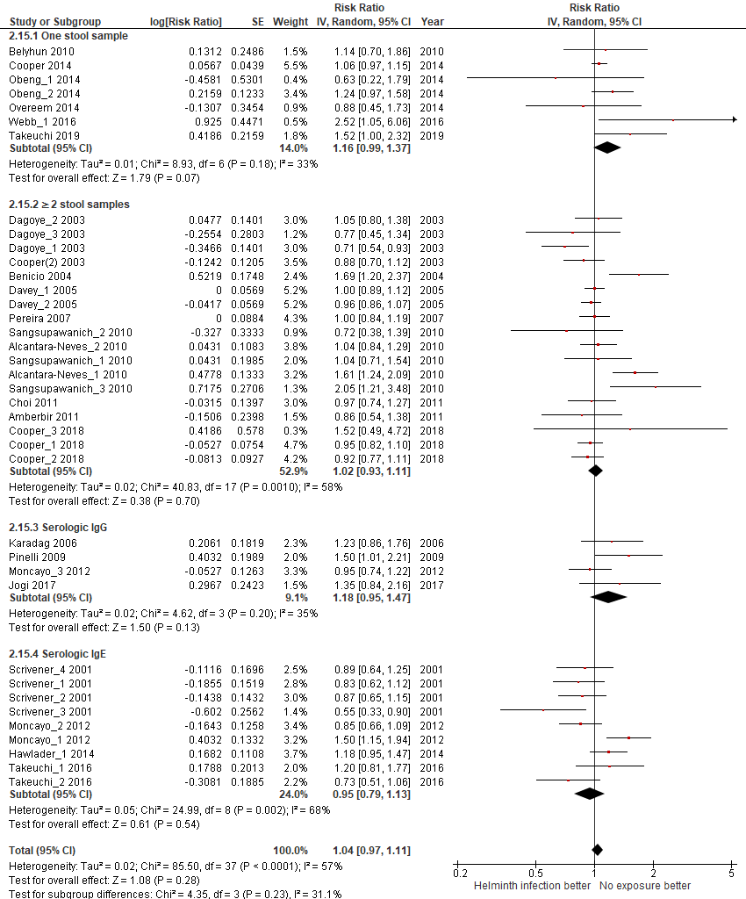

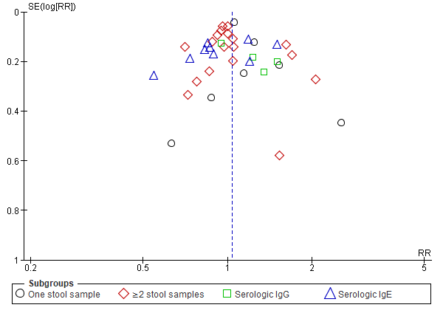

- 2.10 - Helminth detection method sensitivity:
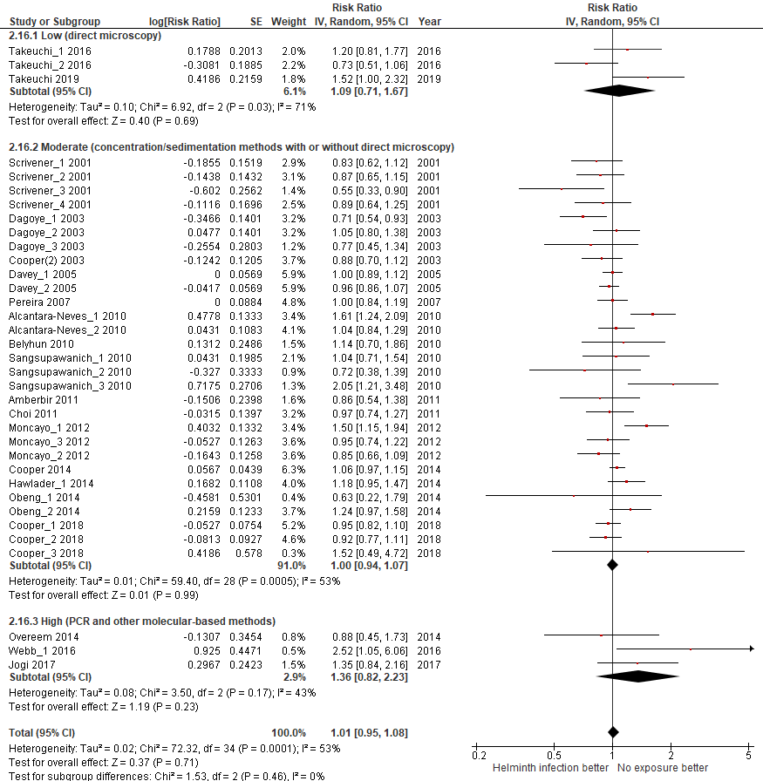
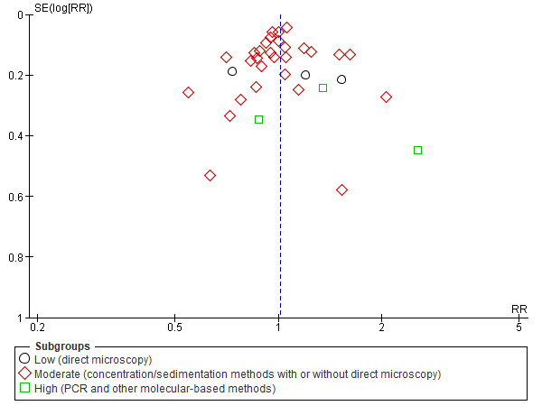

- 2.11 – Endemic prevalence:
A. Lumbricoides prevalece
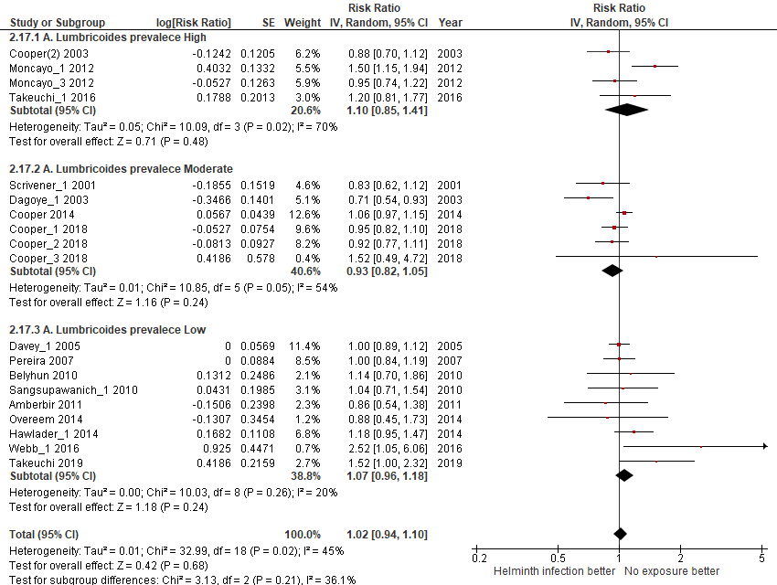
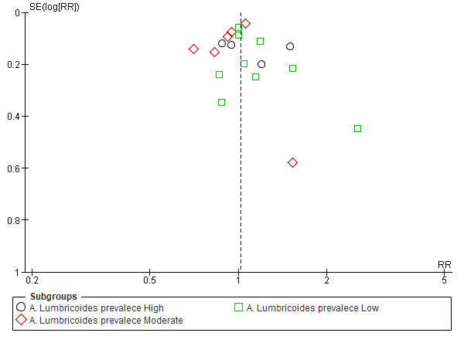

T. Trichiura prevalece
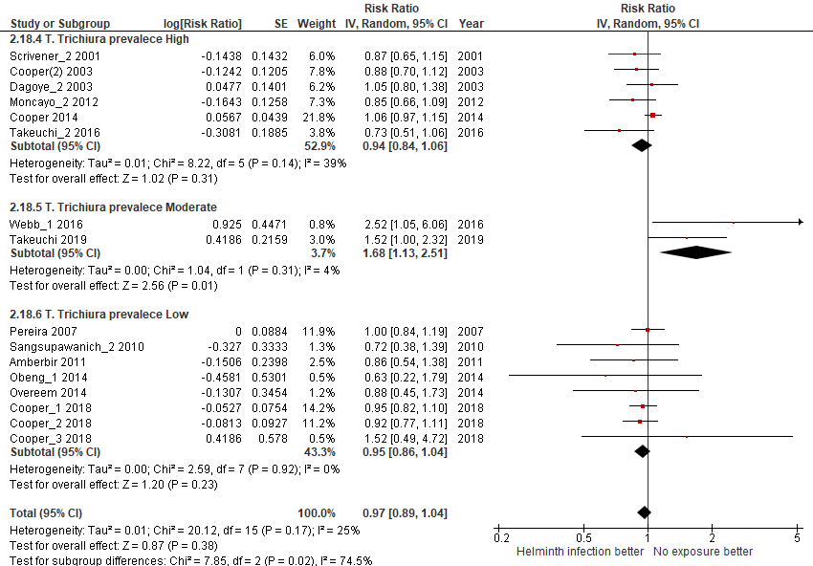
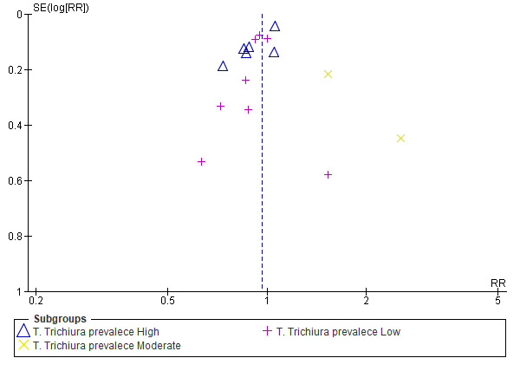

Hookworm prevalece
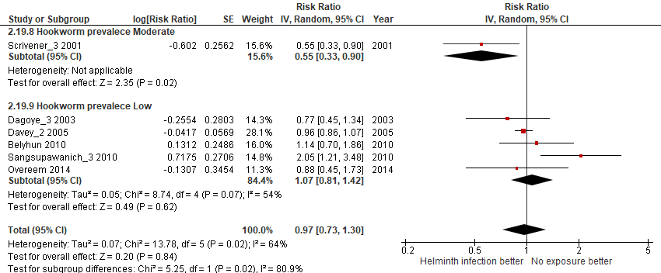

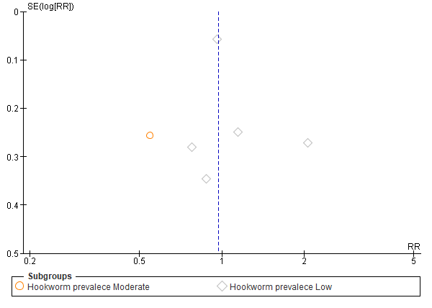

3. Meta-analysis for the outcome ECZEMA

DISAGGREGATED ANALISYS ACCORDING TO:
- 3.1 - Helminth type of infection
A. Lumbricoides
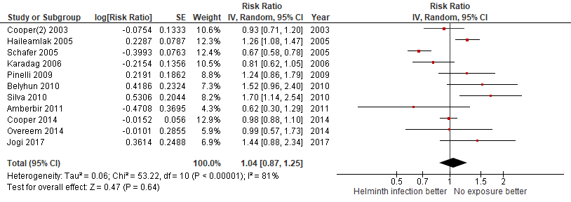
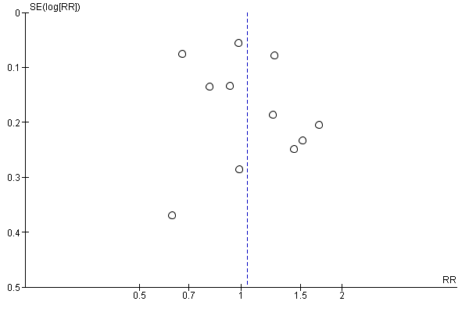

T. Trichiura
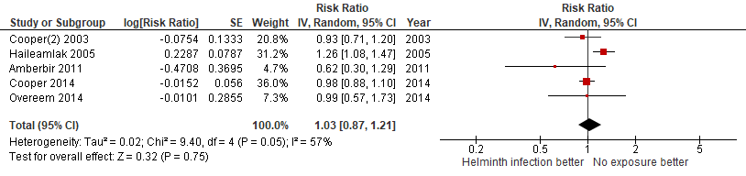
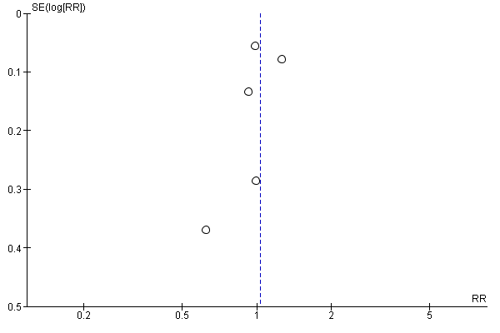

Hookworm or A. duodenalis
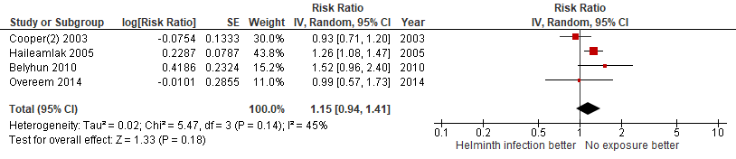
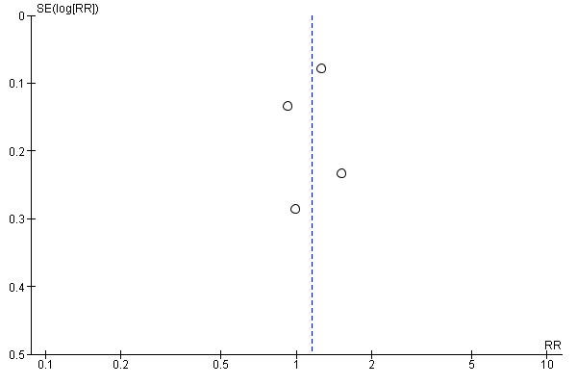

S.mansoni
Not performed because there were no studies available.

E.vermicularis
Not performed because there was only one study available.

Clonorchis sinensis
Not performed because there were no studies available.

S.stercoralis
Not performed because there was only one study available.

H.nana
Not performed because there were no studies available.

S.hematobium
Not performed because there were no studies available.

- 3.2 - Bias quality assessment, high VS moderate VS low:
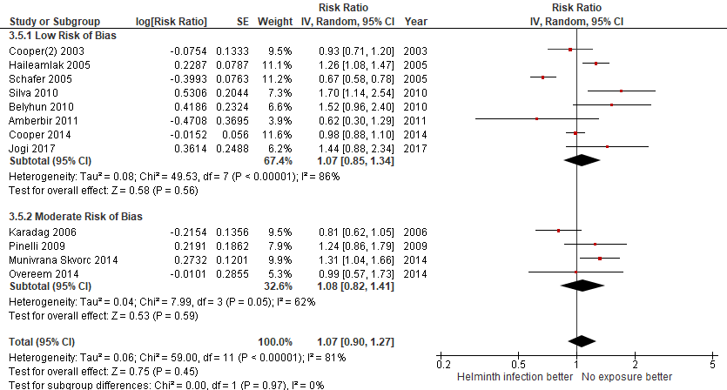
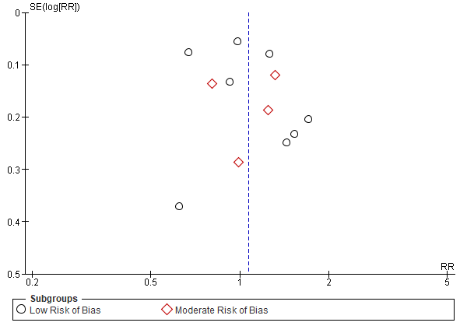

- 3.3 - Sample size, large (≥1000 pax) VS small (<1000 pax):
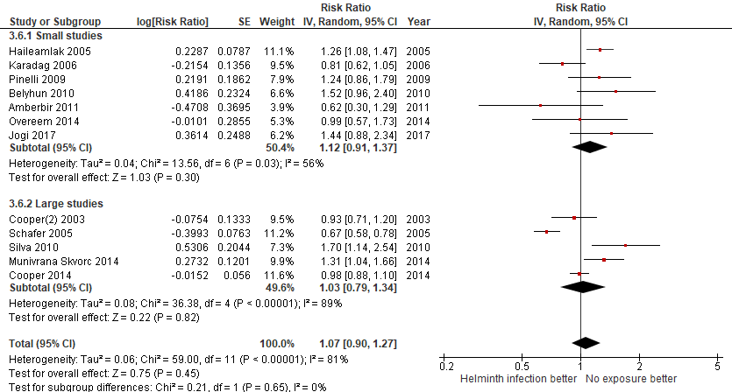
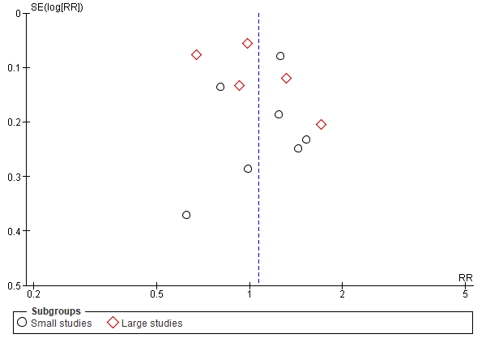

- 3.4 - Year of publication, old (<2010) VS recent (≥2010):
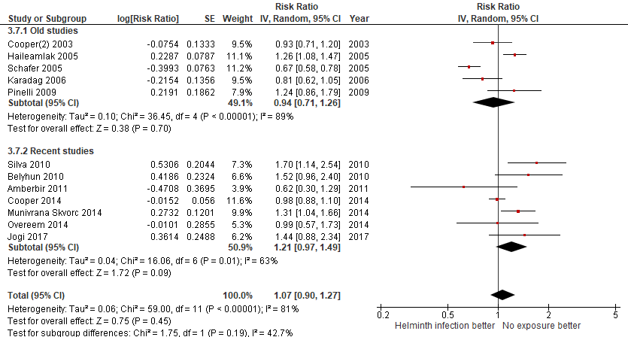
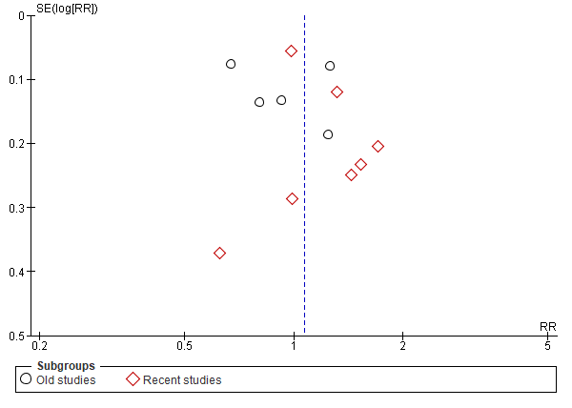

- 3.5 - Participants age (children vs adults):
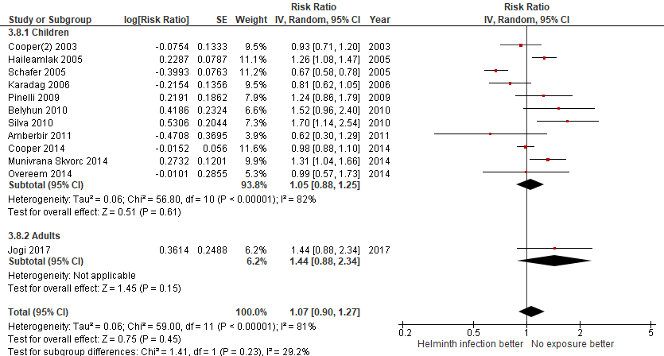
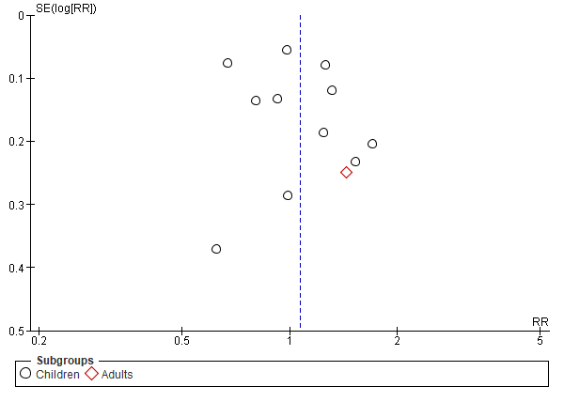

- 3.6 - Country Income level, high VS low:
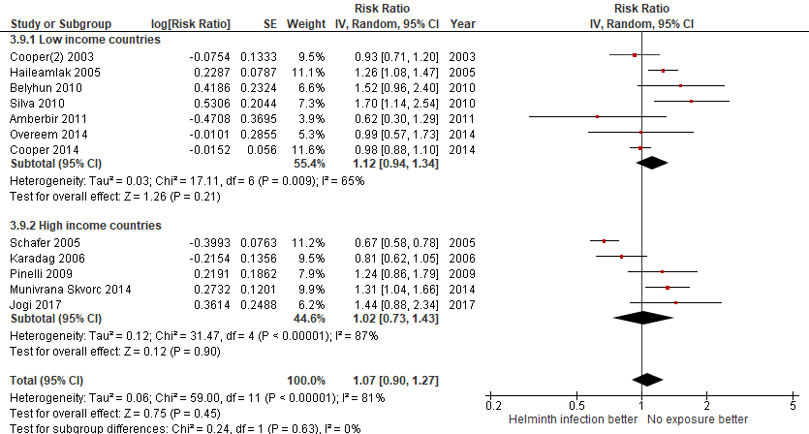
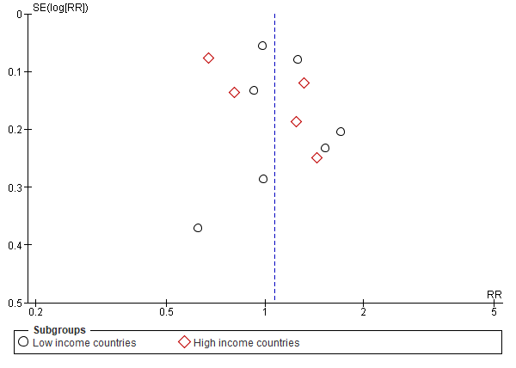

- 3.7 - Country continental region:
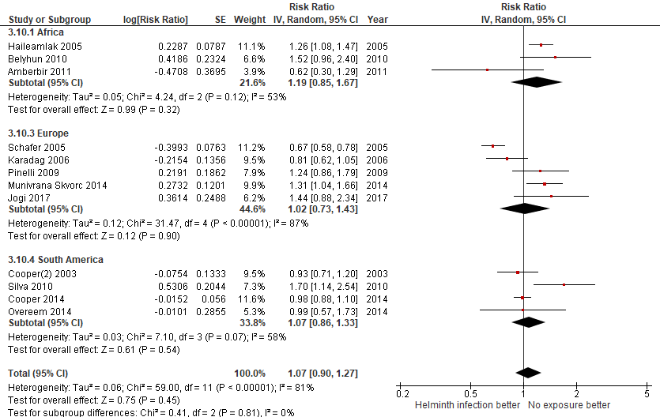
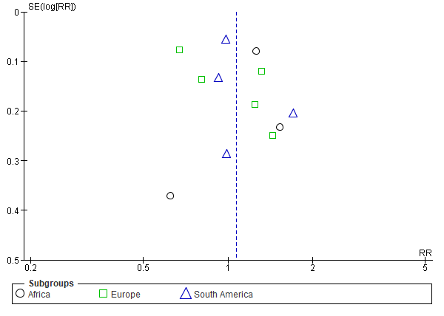

- 3.8 - Design, cross-sectional VS cohort:
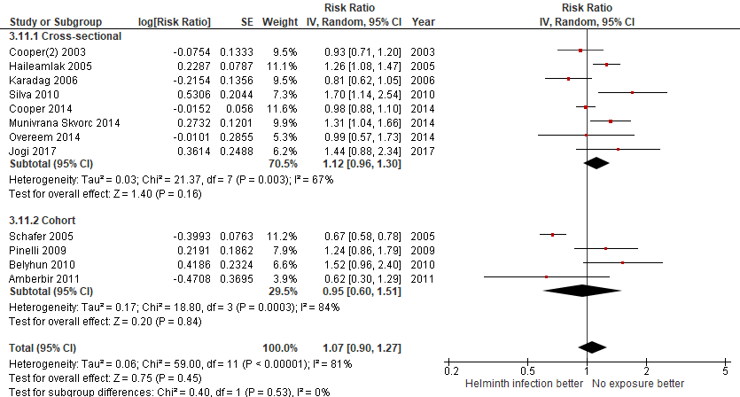
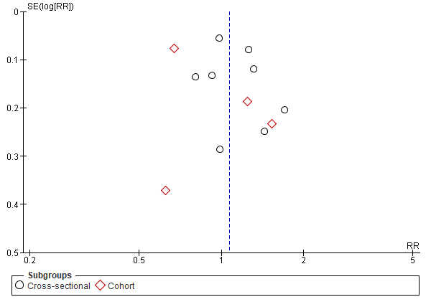

- 3.9 - Type of helminth detection:

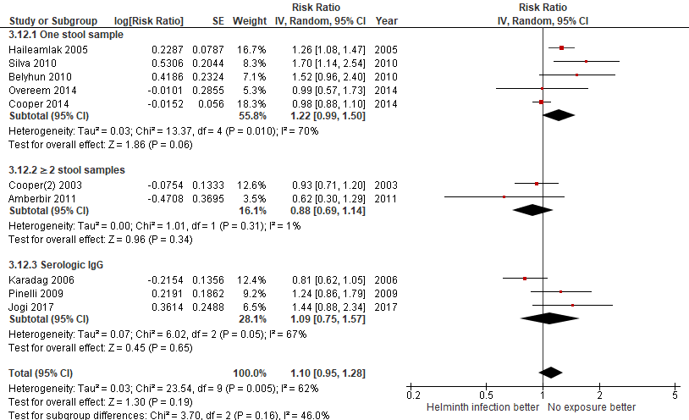

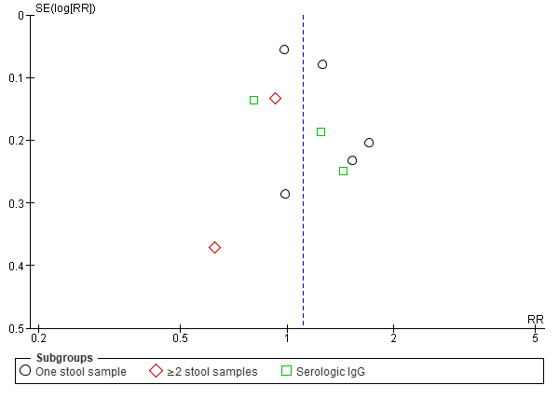

- 3.10 - Helminth detection method sensitivity:

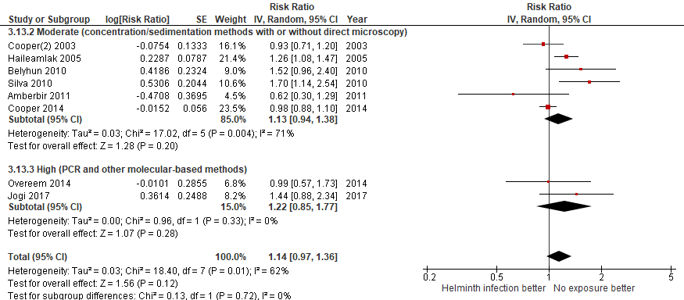
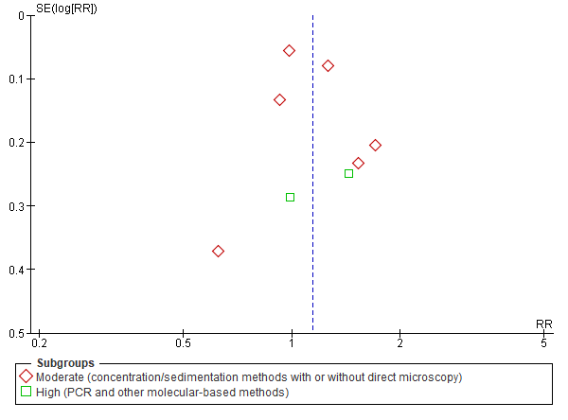

- 3.11 – Endemic prevalence:
A. Lumbricoides prevalence
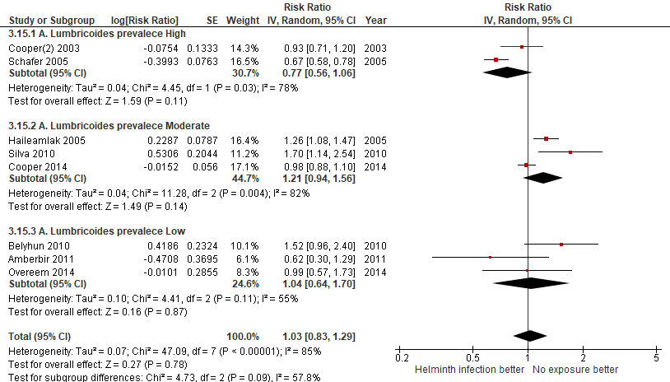

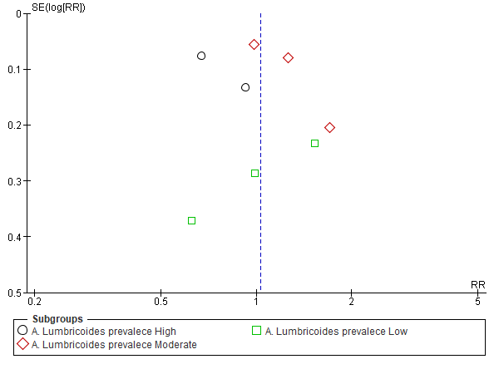

T. Trichiura prevalence
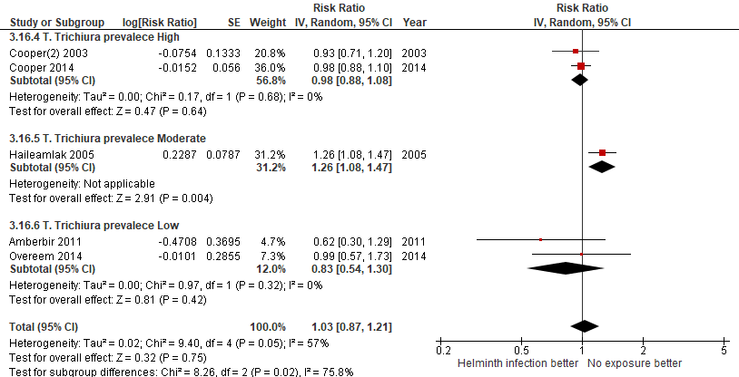

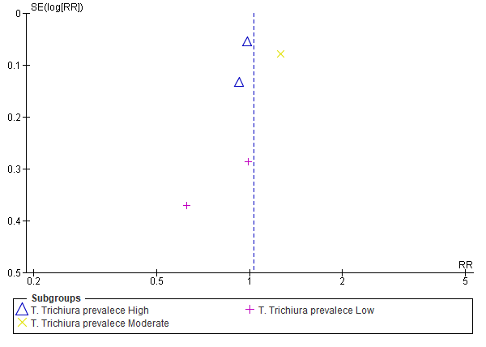

Hookworm prevalence (Low prevalence only)
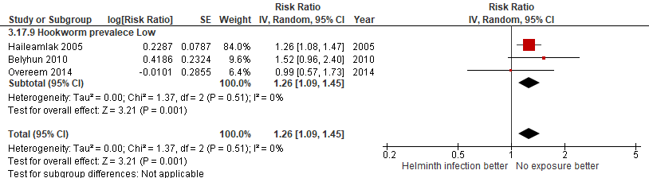
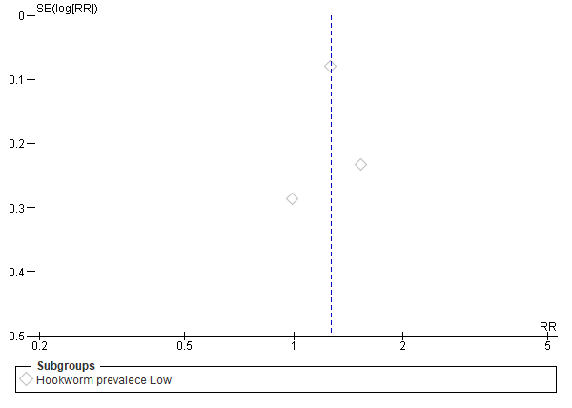

4. Meta-analysis for the outcome ATOPY

DISAGGREGATED ANALISYS ACCORDING TO:
- 4.1 - Helminth type of infection
A. Lumbricoides
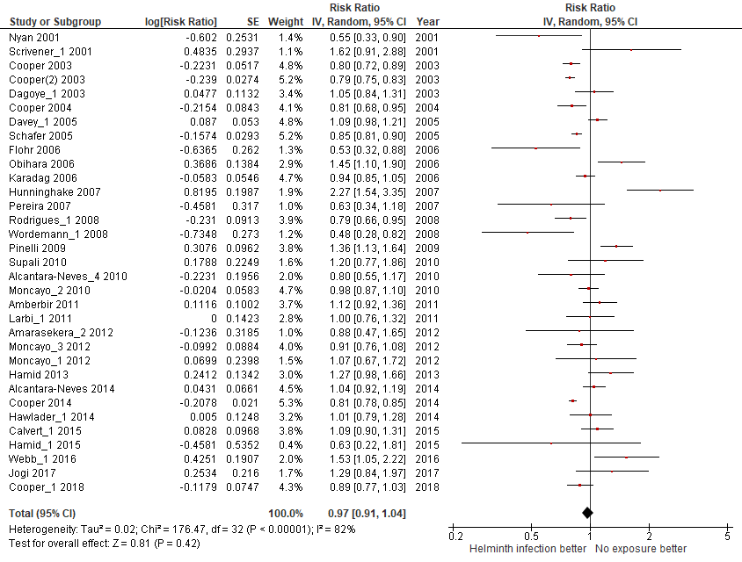
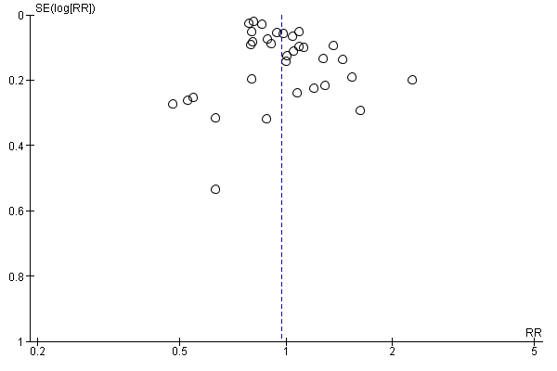

T. Trichiura
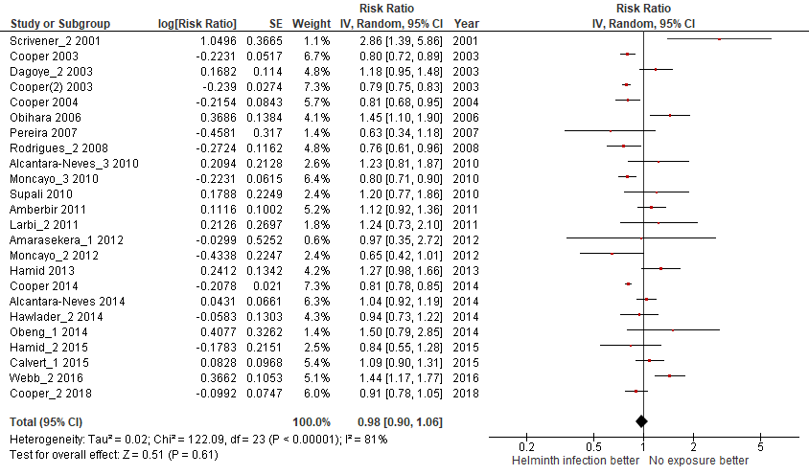
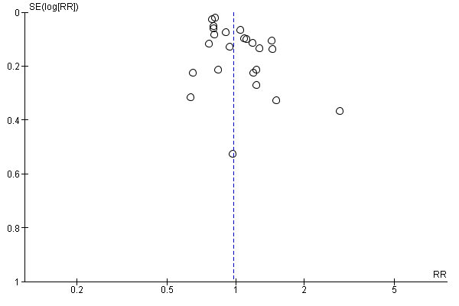

Hookworm or A. duodenalis
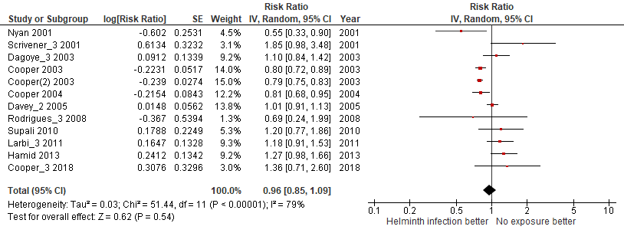
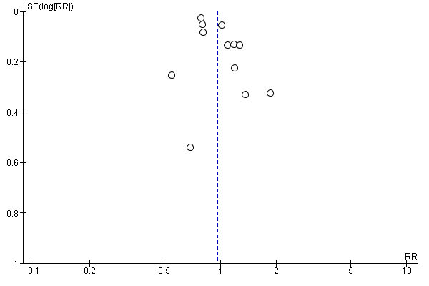

S.mansoni
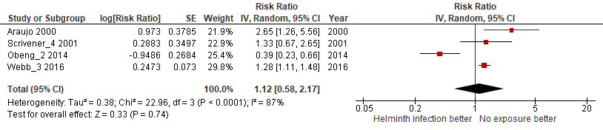
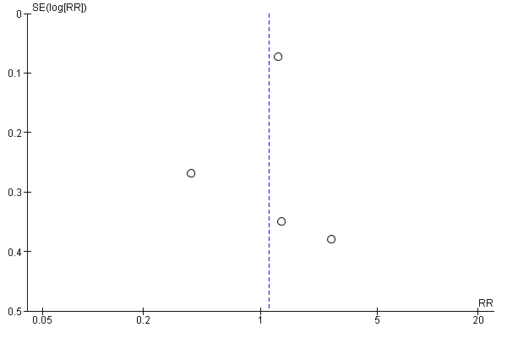

E.vermicularis
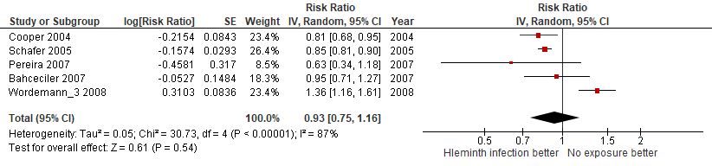
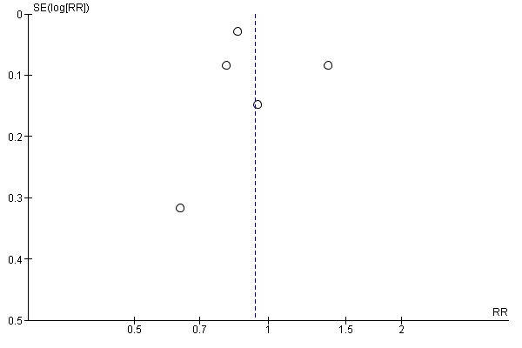

Clonorchis sinensis
Not performed because there was only one study available.

S.stercoralis
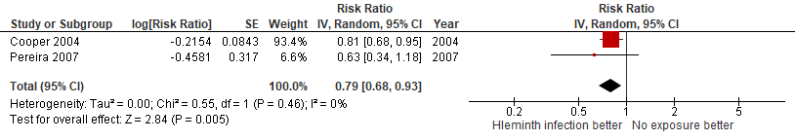
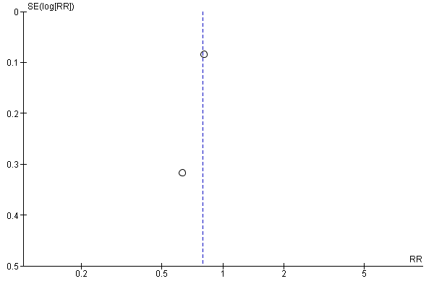

H.nana
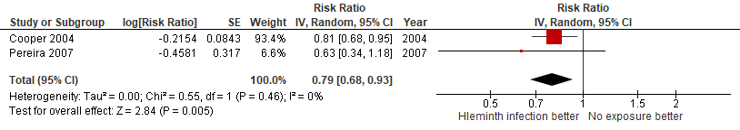
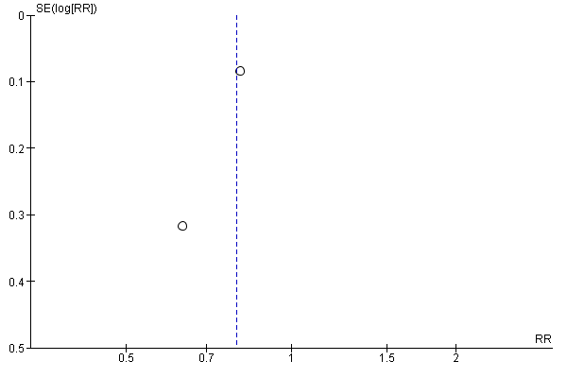
S.hematobium
Not performed because there was only one study available.

- 4.2 - Bias quality assessment, high VS moderate VS low:
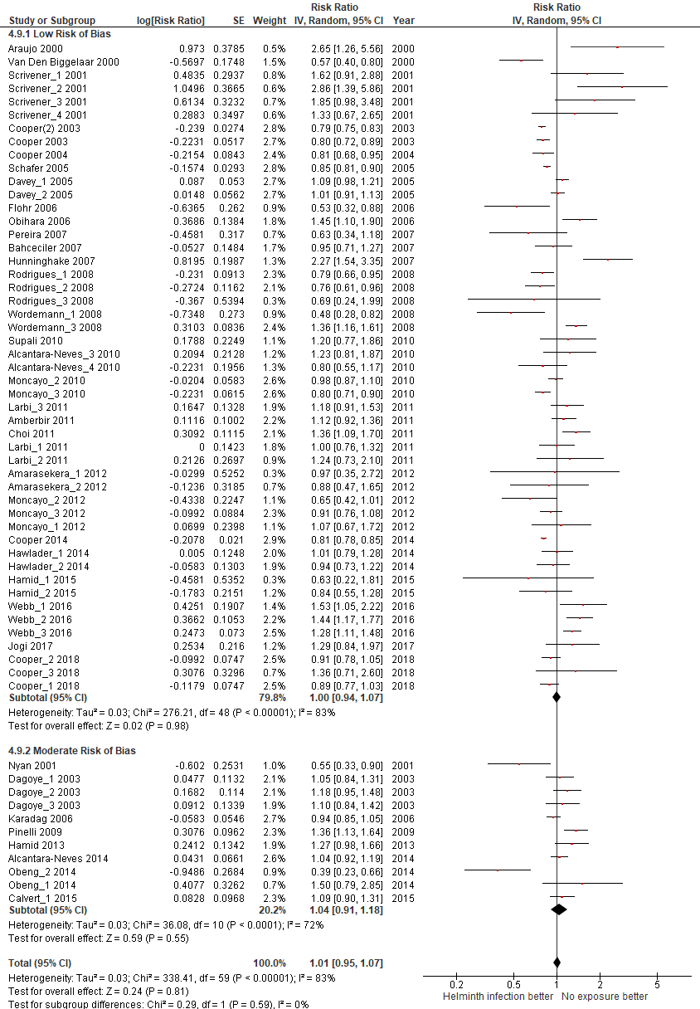
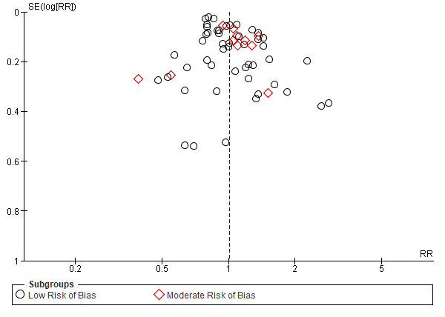

- 4.3 - Sample size, large (≥1000 pax) VS small (<1000 pax):
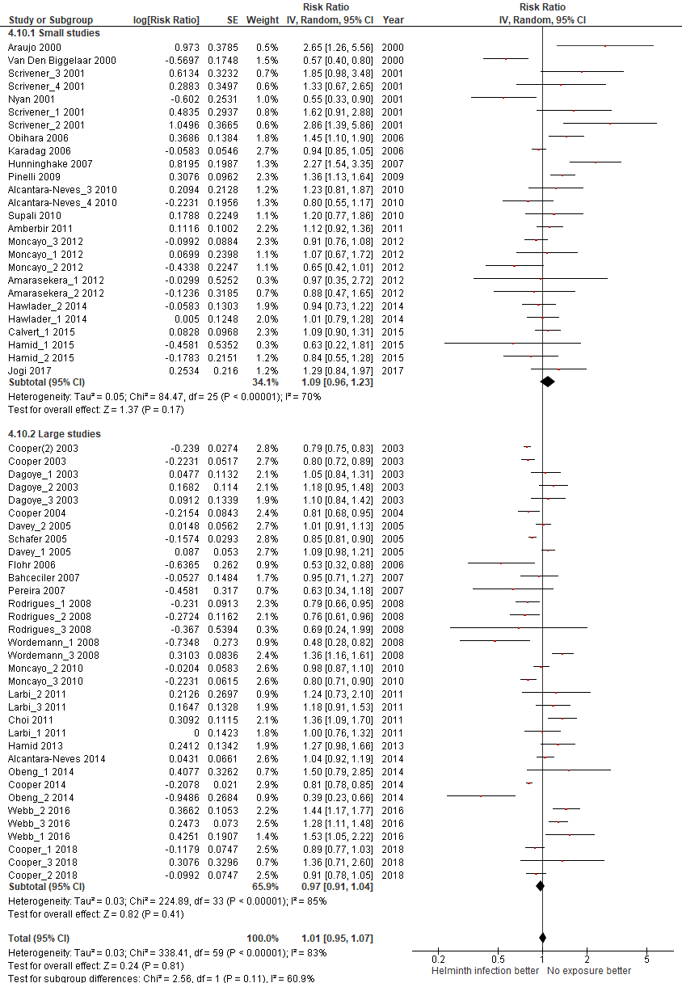
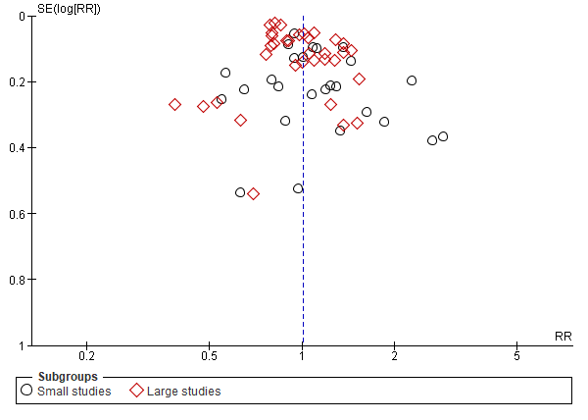

- 4.4 - Year of publication, old (<2010) VS recent (≥2010):
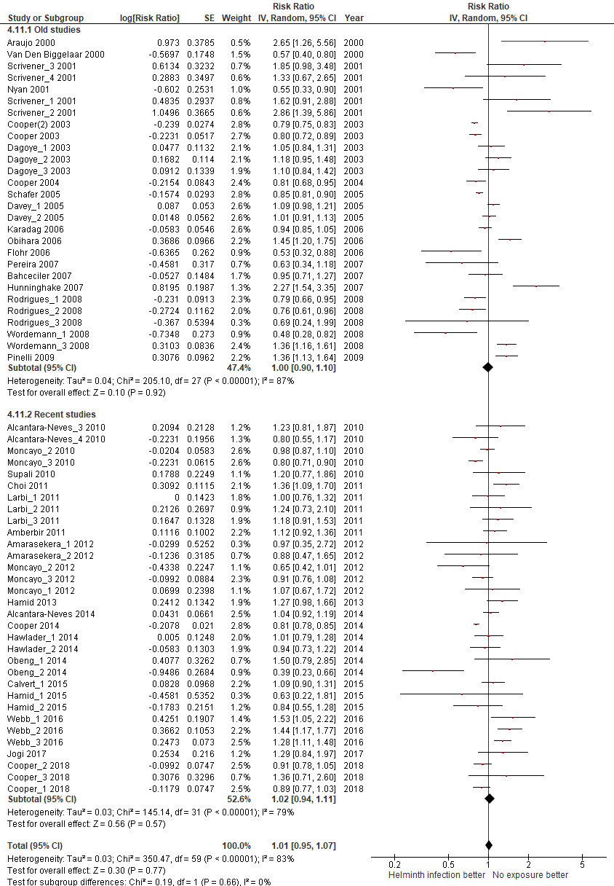
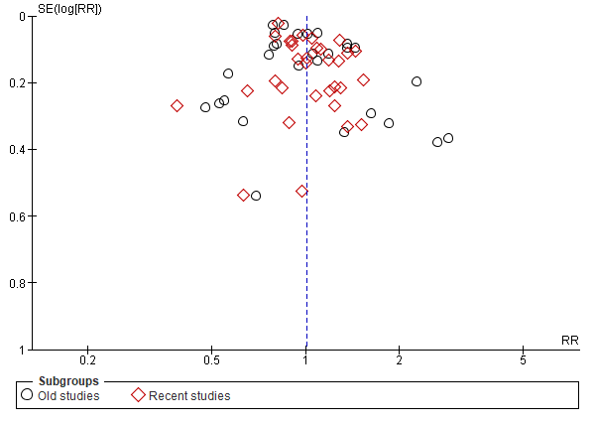

- 4.5 - Participants age, children VS adults:
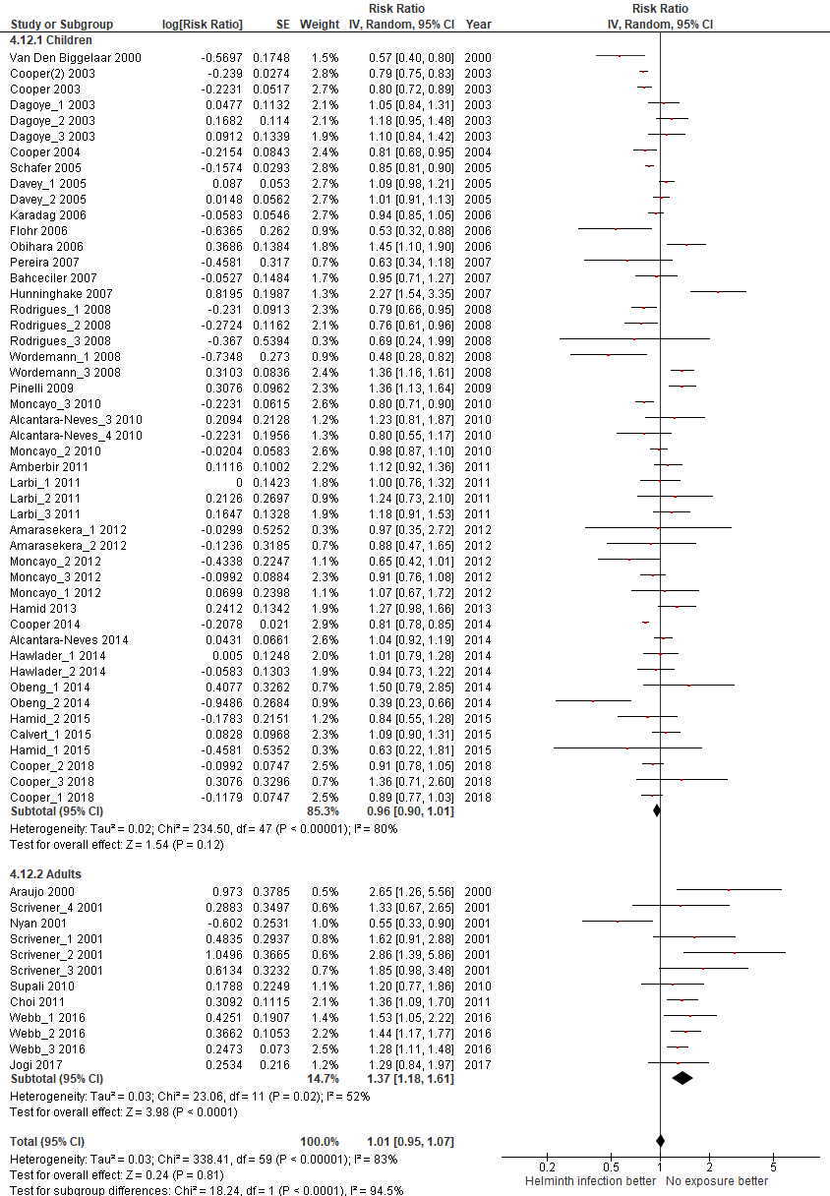
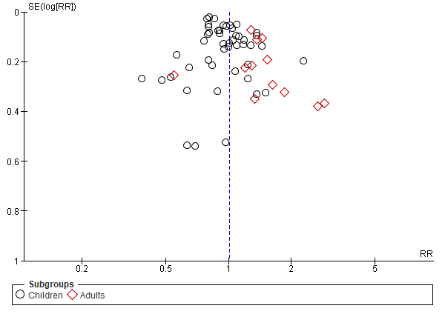

- 4.6 - Country Income level, high VS low:
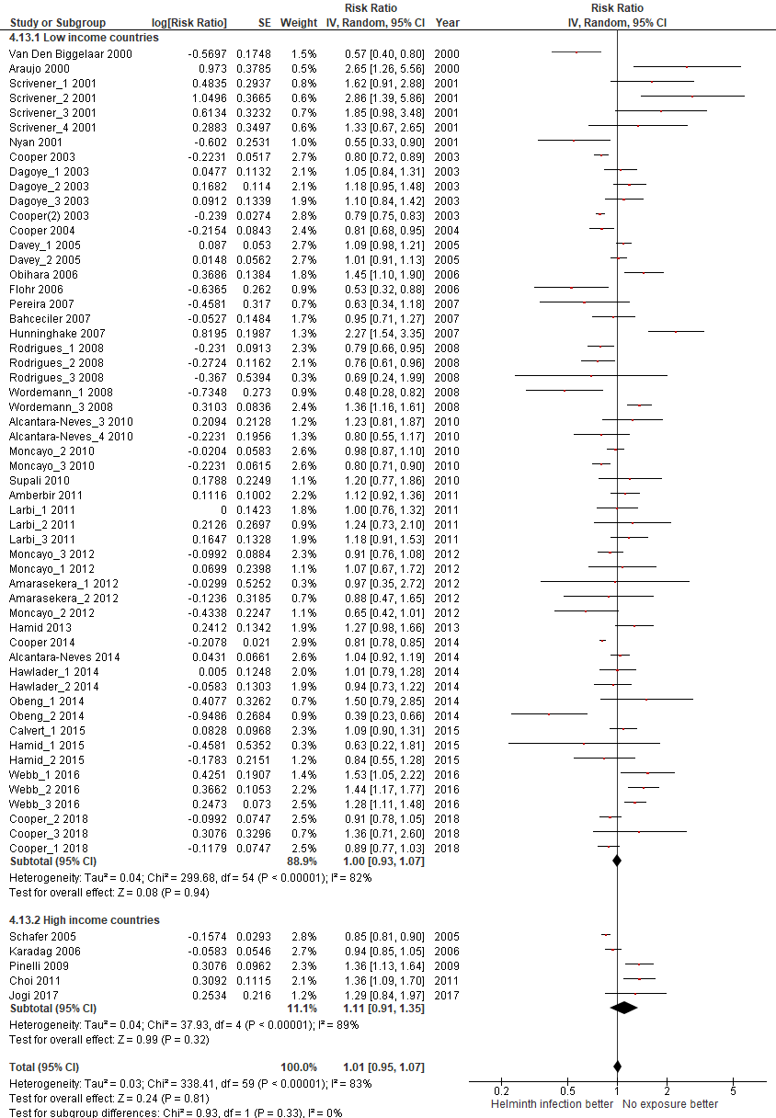
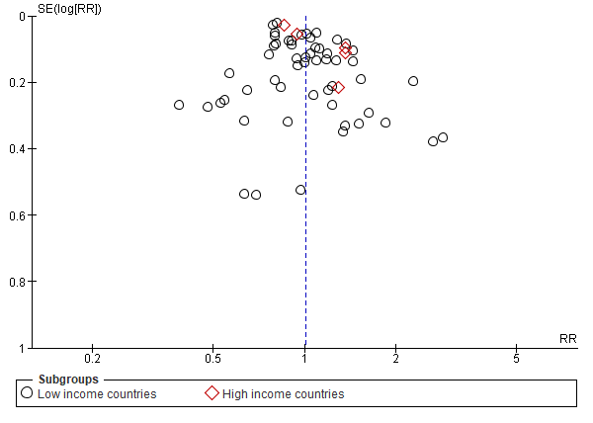

- 4.7 - Country continental region:
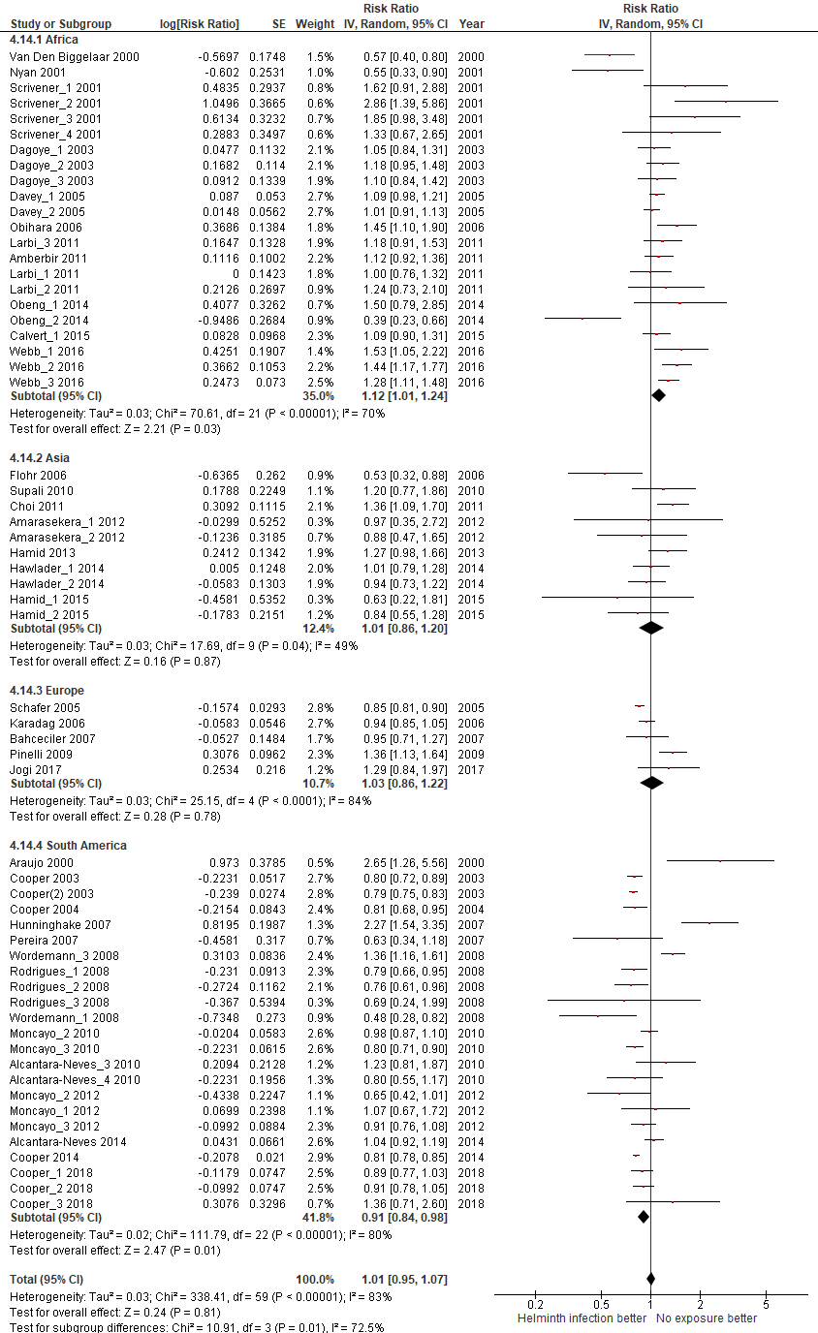
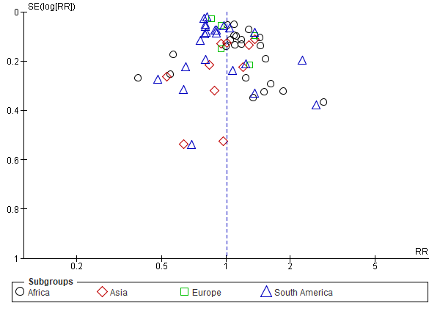

- 4.8 - Design, cross-sectional VS cohort:
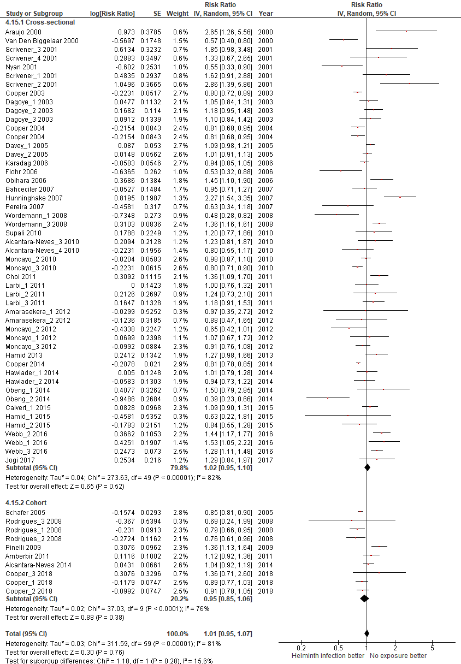
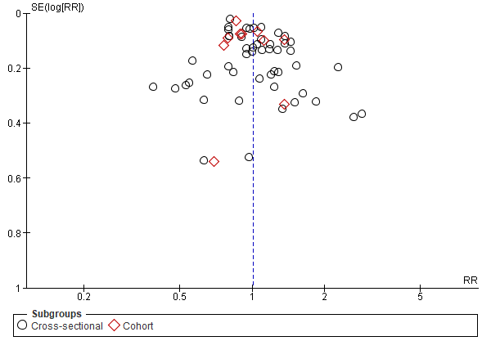

- 4.9 - Type of helminth detection:

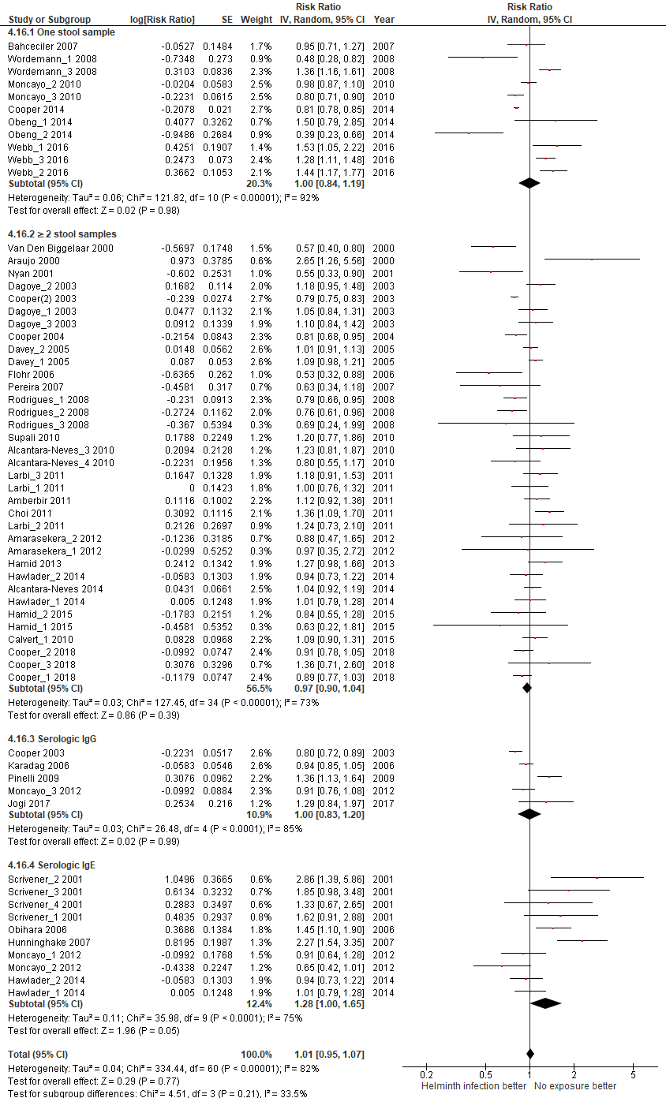

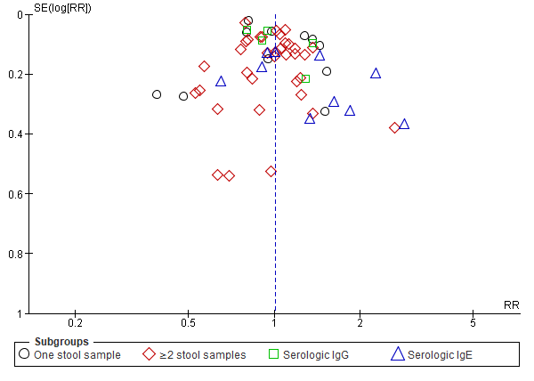

- 4.10 - Helminth detection method sensitivity:
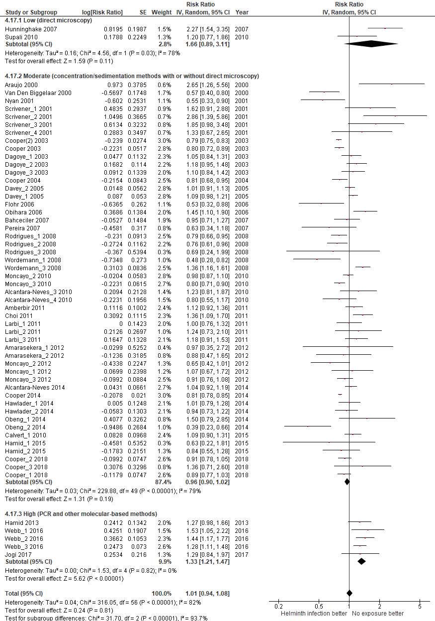
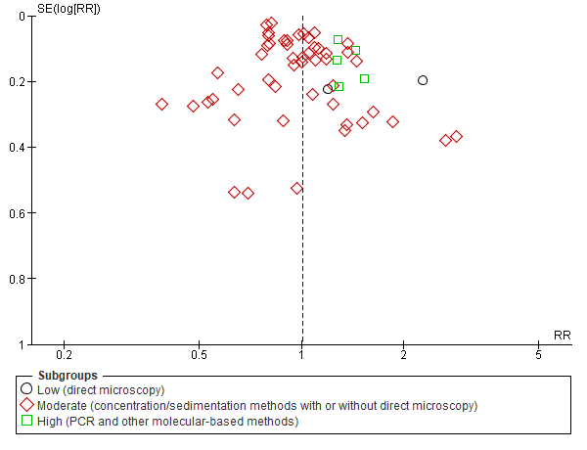

- 4.11 – Endemic prevalence:
A. Lumbricoides prevalence
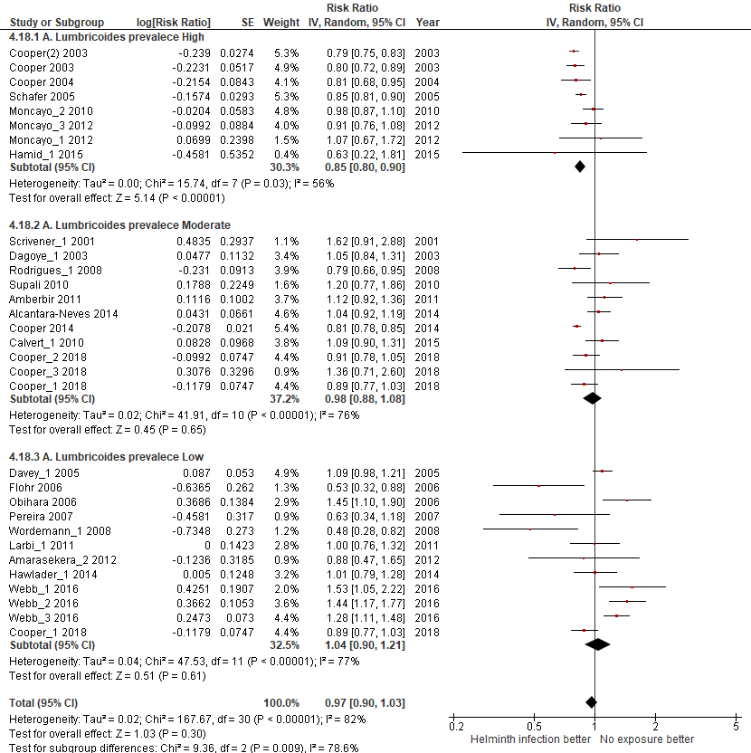
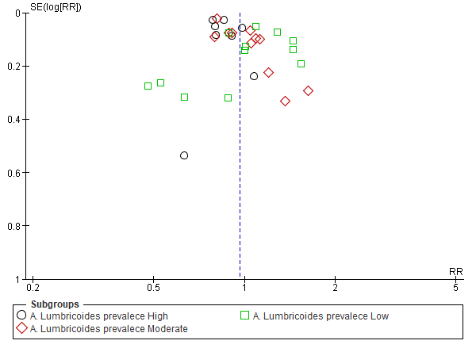

T. Trichiura prevalence
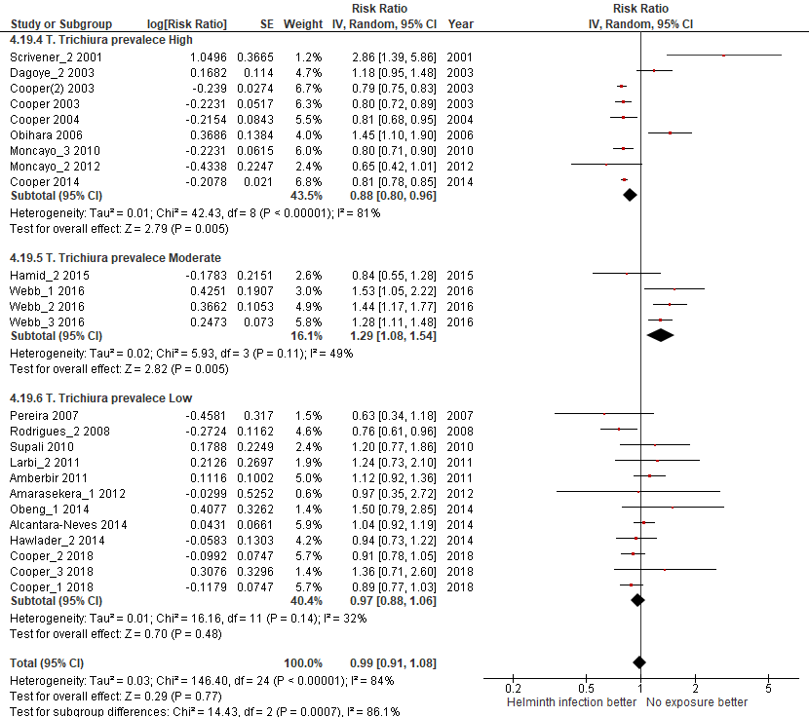
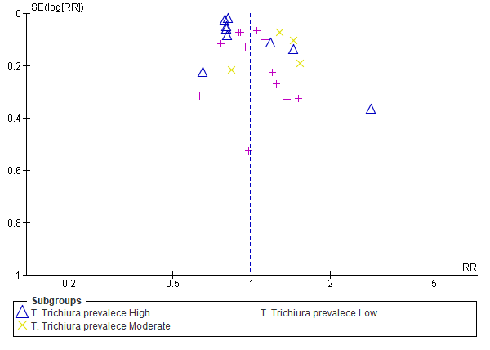

Hookworm prevalence
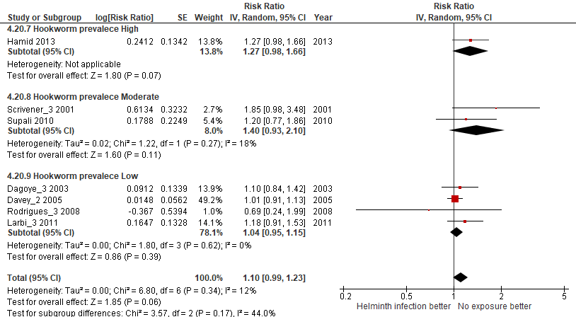

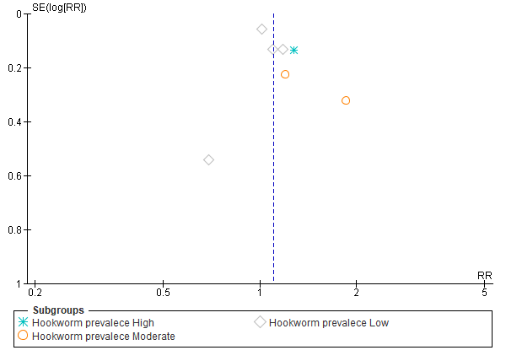

- 4.12 – Type of measure (IgE VS SPT):
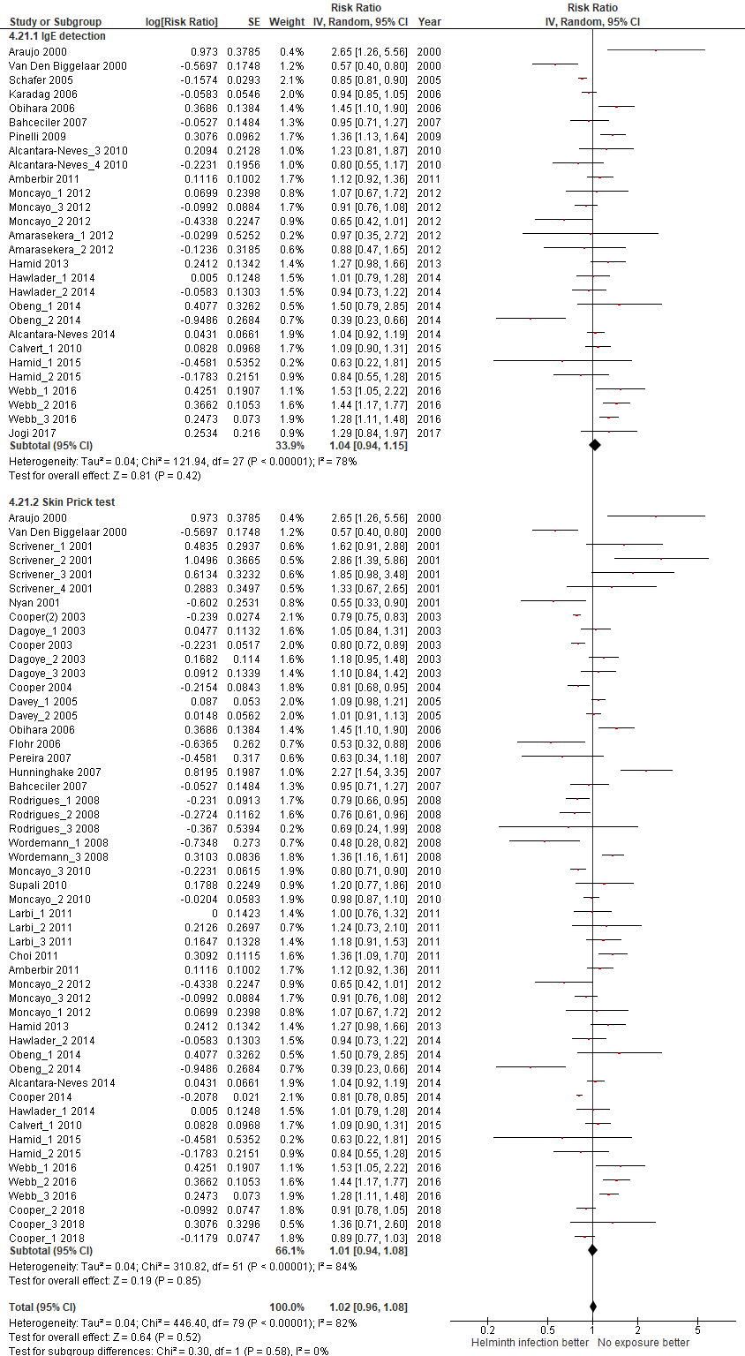
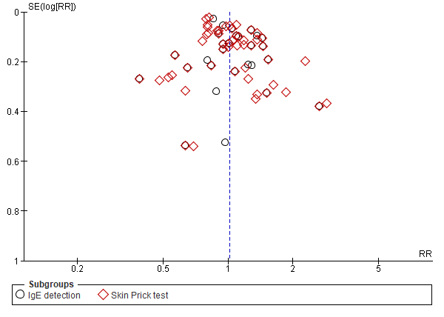

5. Meta-analysis for the outcome ALLERGIC RHINITIS

DISAGGREGATED ANALISYS ACCORDING TO:
- 5.1 - Helminth type of infection
A. Lumbricoides
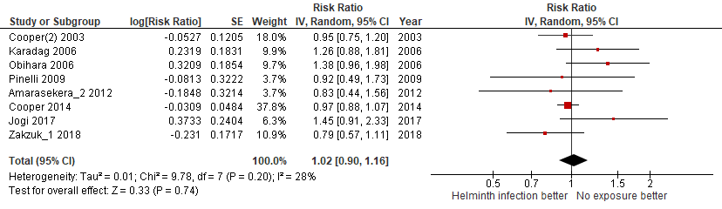
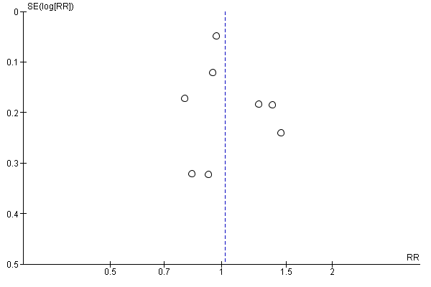

T. Trichiura
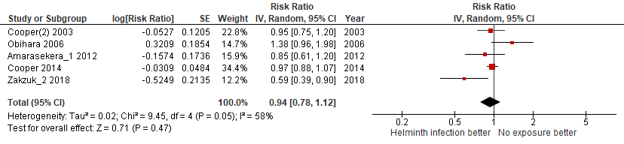
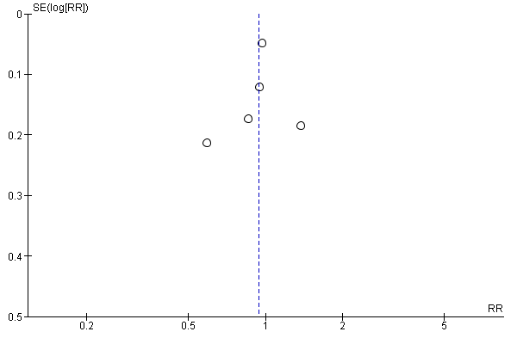

Hookworm or A. duodenalis
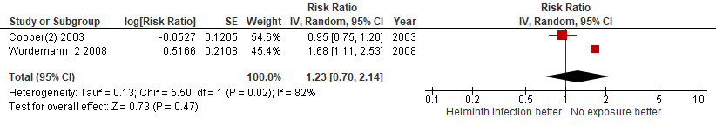
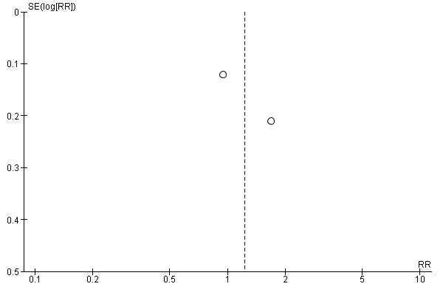

S.mansoni
Not performed because there were no studies available.

E.vermicularis
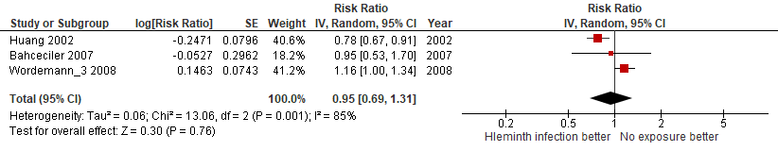
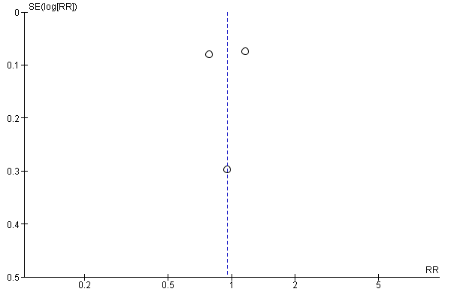

Clonorchis sinensis
Not performed because there was only one study available.

S.stercoralis
Not performed because there were no studies available.

H.nana
Not performed because there were no studies available.

S.hematobium
Not performed because there were no studies available.

- 5.2 - Bias quality assessment, high VS moderate VS low:
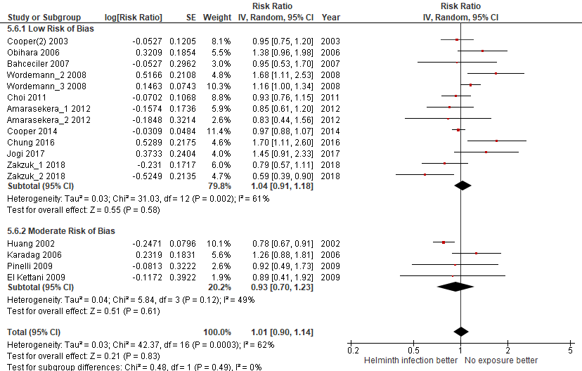
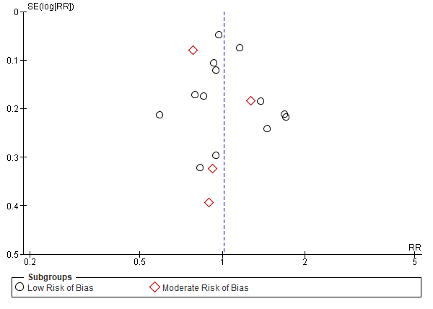

- 5.3 - Sample size, large (≥1000 pax) VS small (<1000 pax):
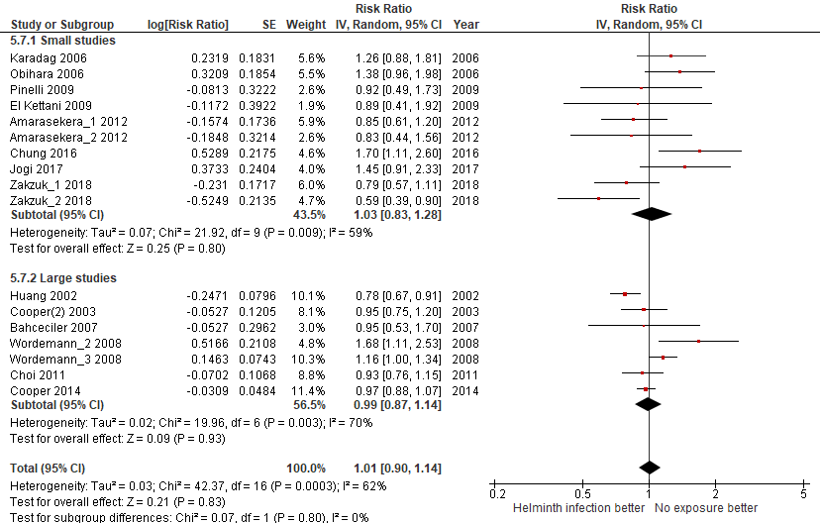
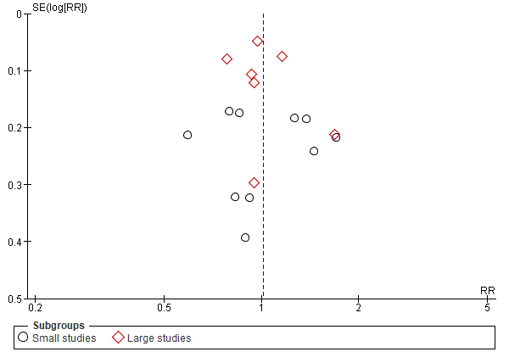

- 5.4 - Year of publication, old (<2010) VS recent (≥2010):
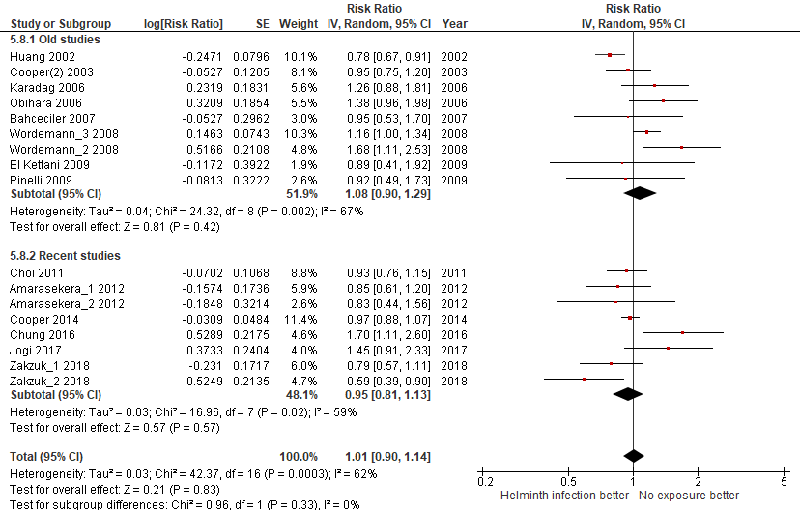
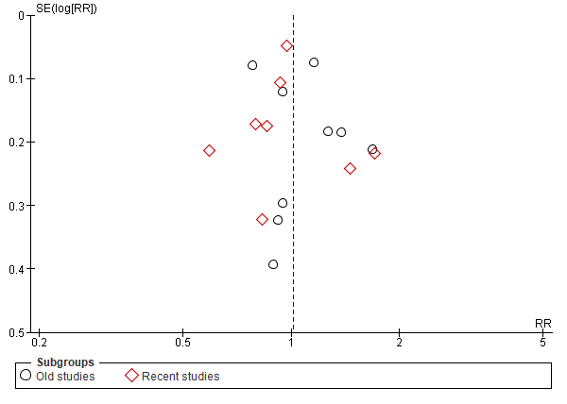

- 5.5 - Participants age, children VS adults:
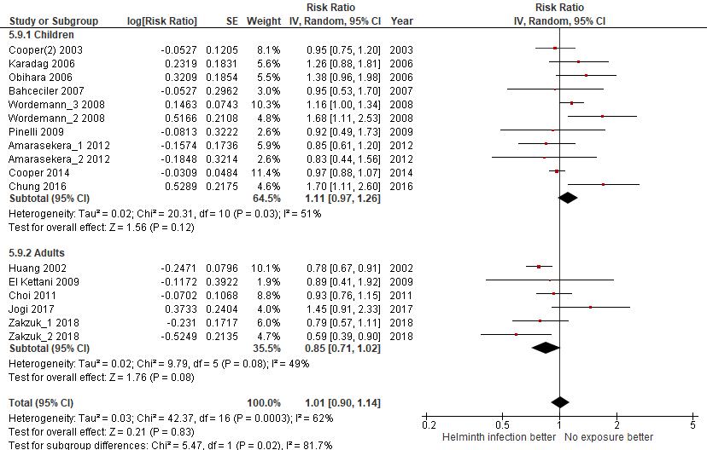
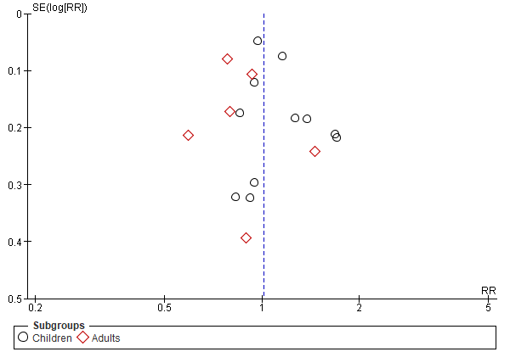

- 5.6 - Country Income level, high VS low:
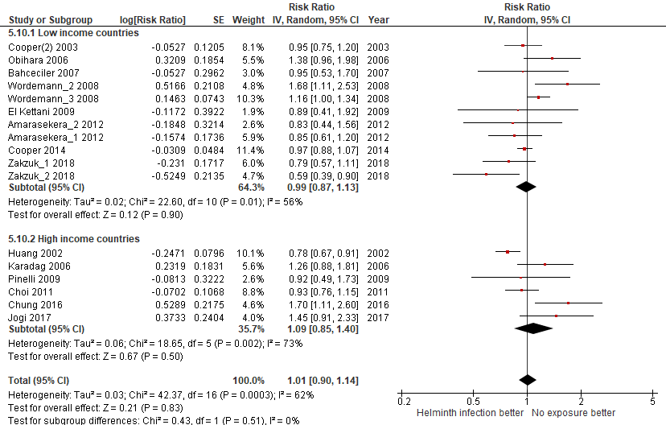
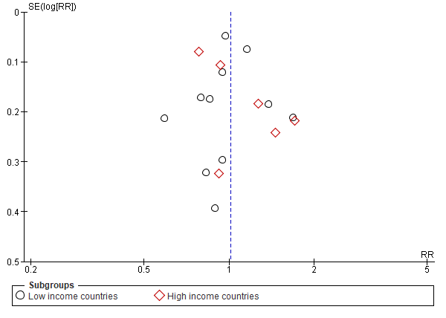

- 5.7 - Country continental region:
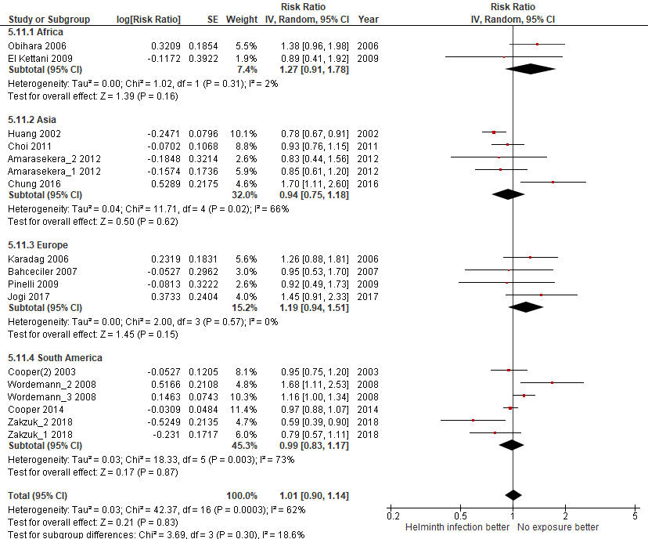
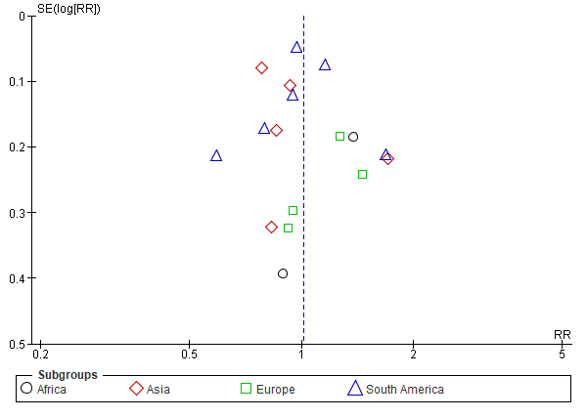

- 5.8 - Design, cross-sectional VS cohort:
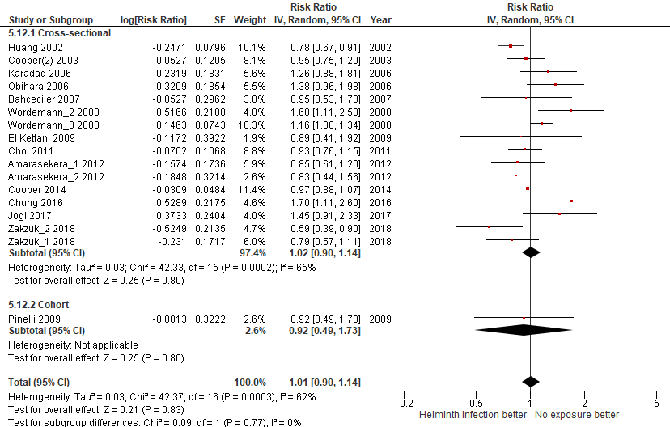
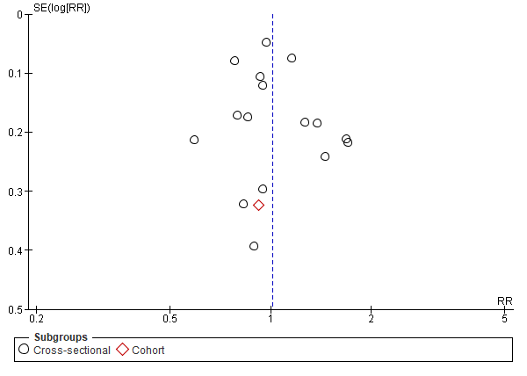

- 5.9 - Type of helminth detection:

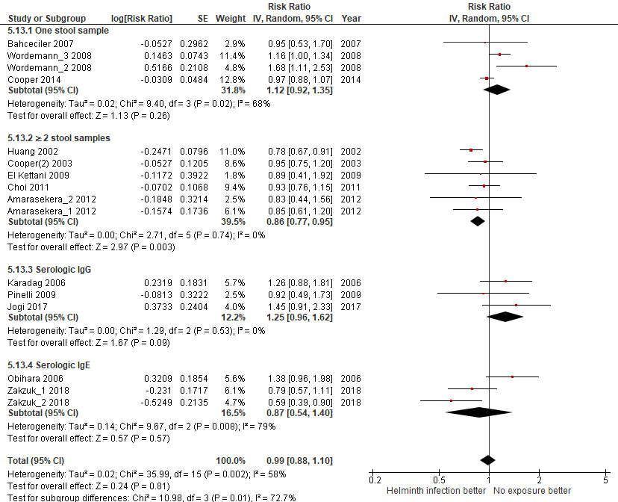

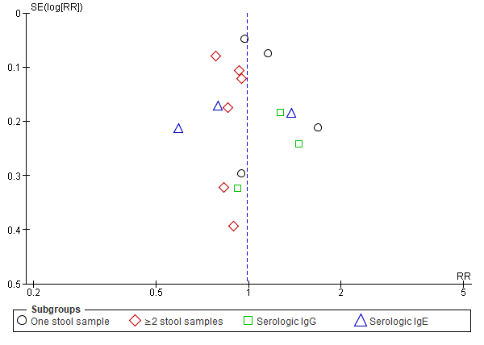

- 5.10 - Helminth detection method sensitivity (moderate vs high):
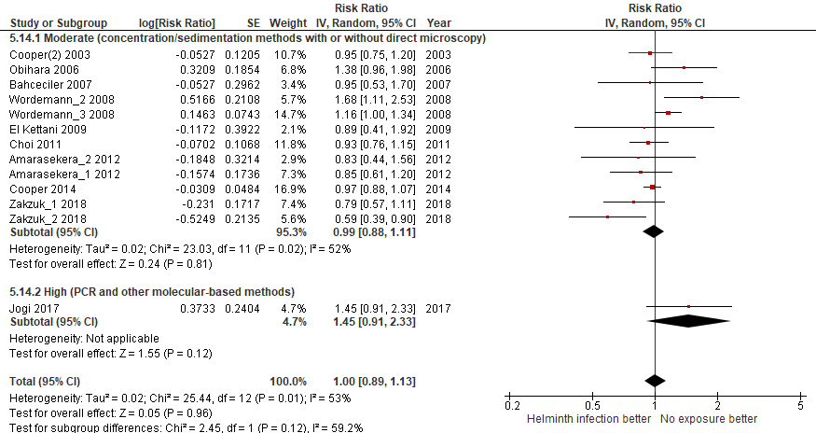
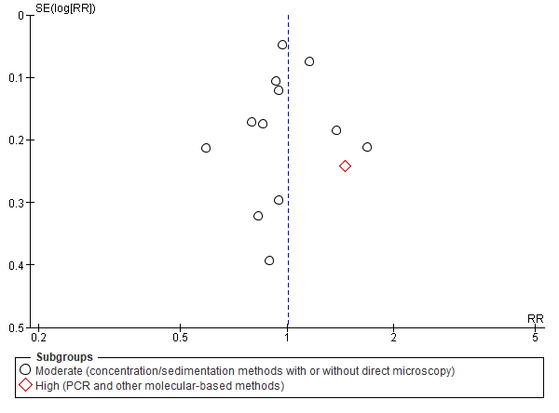

- 5.11 – Endemic prevalence:
A. Lumbricoides prevalence
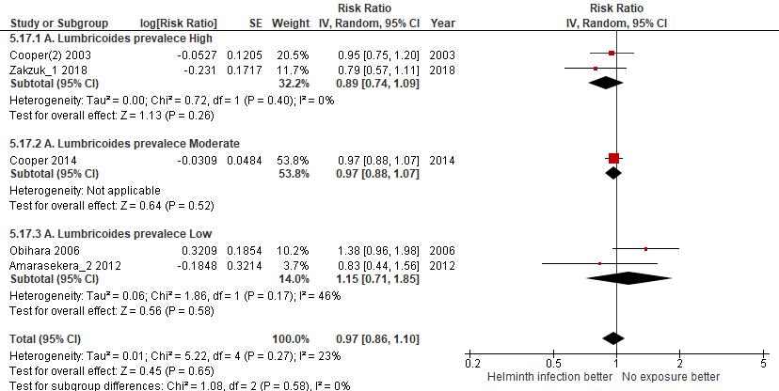

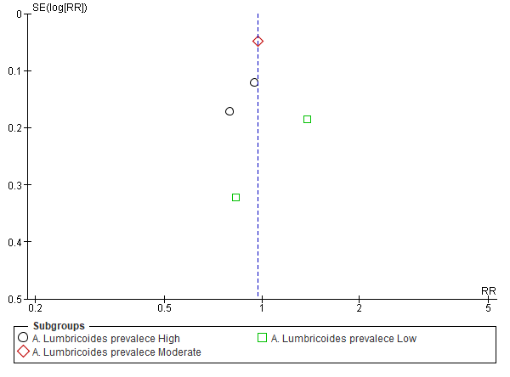

T. Trichiura prevalence
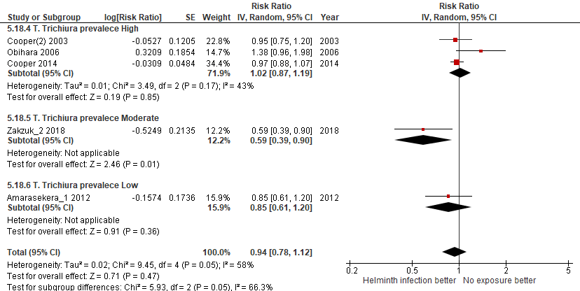

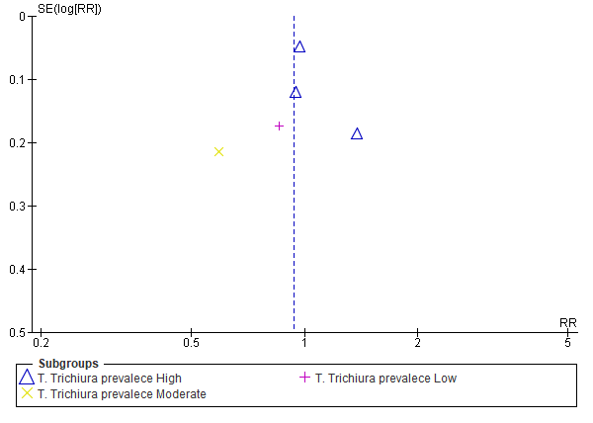

Hookworm prevalence
Not performed because there was only one study available.

6. Meta-analysis for the outcome BRONCHIAL HYPERREACTIVITY

DISAGGREGATED ANALISYS ACCORDING TO:
- 6.1 - Helminth type of infection
A. Lumbricoides
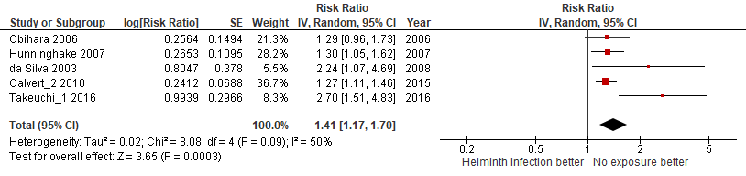
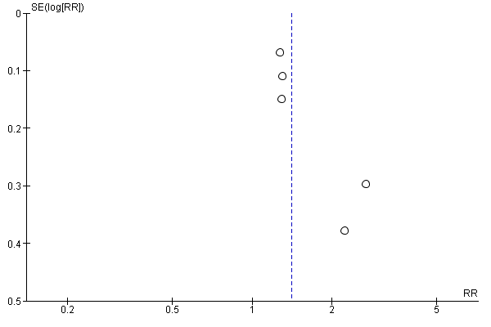

T. Trichiura
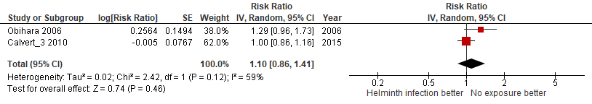
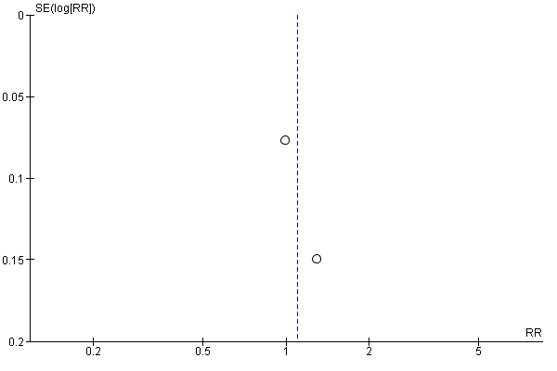

Hookworm or A. duodenalis
Not performed because there were no studies available.

S.mansoni
Not performed because there were no studies available.

E.vermicularis
Not performed because there were no studies available.

Clonorchis sinensis
Not performed because there were no studies available.

S.stercoralis
Not performed because there were no studies available.

H.nana
Not performed because there were no studies available.

S.hematobium
Not performed because there were no studies available.

- 6.2 - Bias quality assessment, moderate VS low:
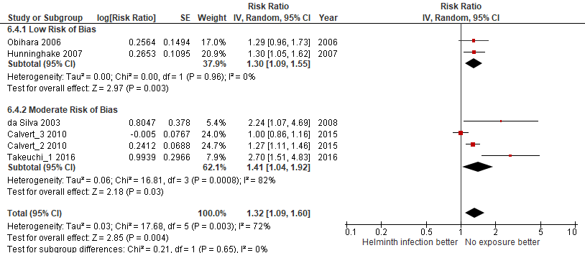
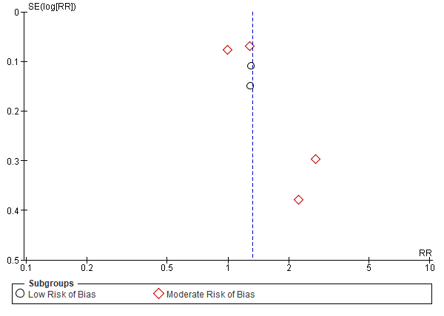

- 6.3 - Year of publication, old (<2010) VS recent (≥2010):
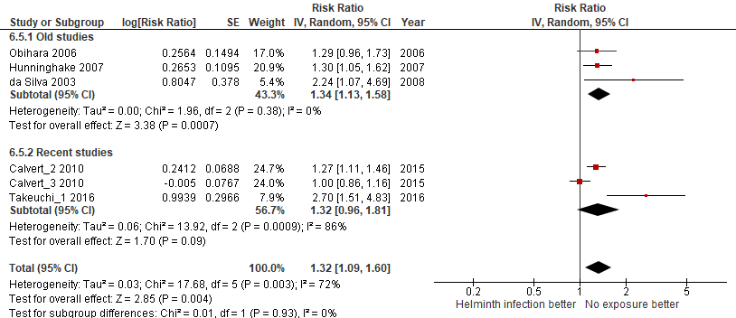
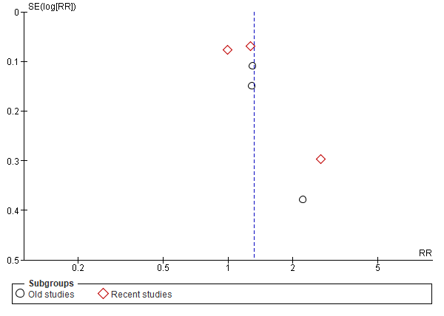

- 6.4 – Participant age (only children):
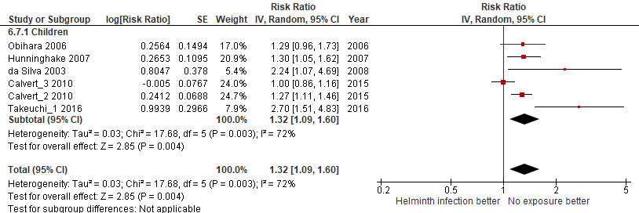
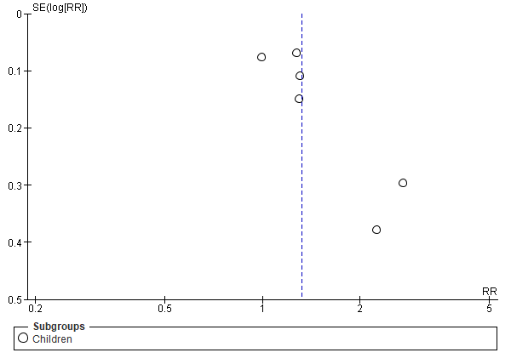

- 6.5 - Country Income level (only low):
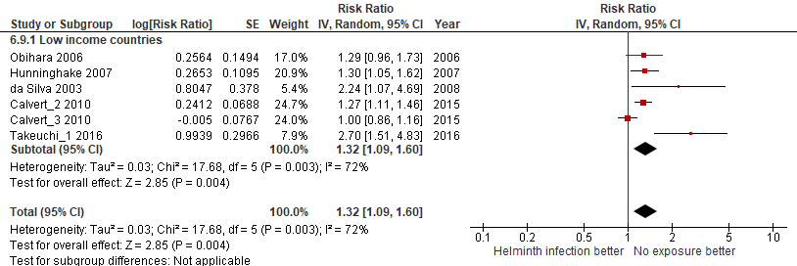
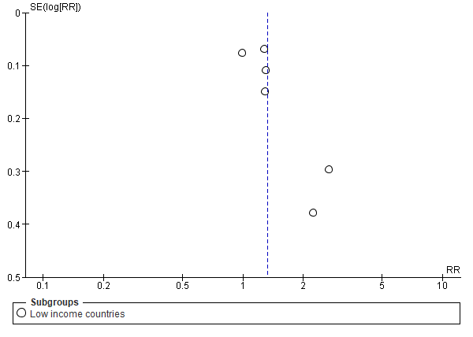
- 6.6 - Country continental region:
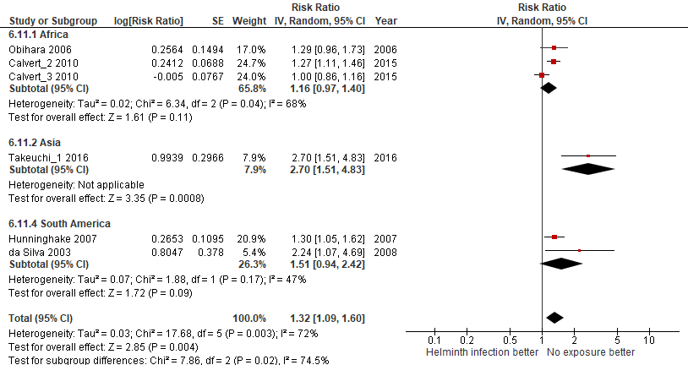
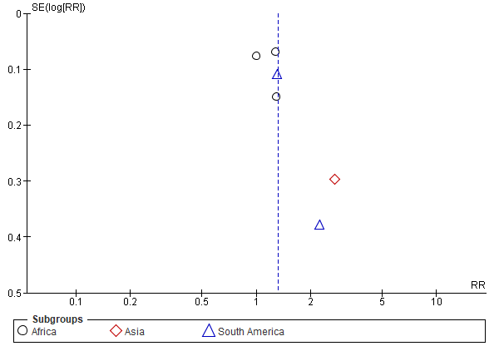

- 6.7 - Design, cross-sectional VS cohort:
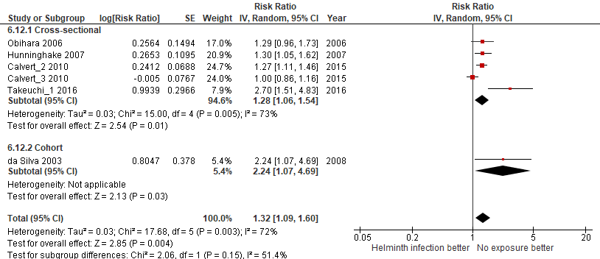
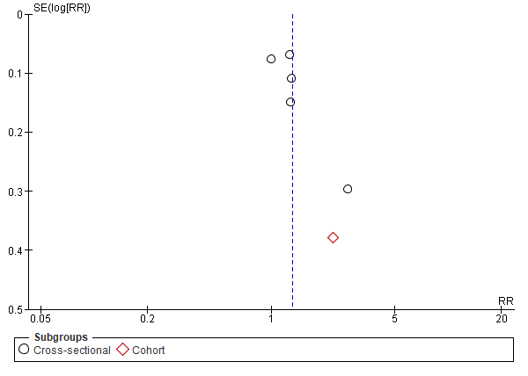

- 6.8 - Type of helminth detection:

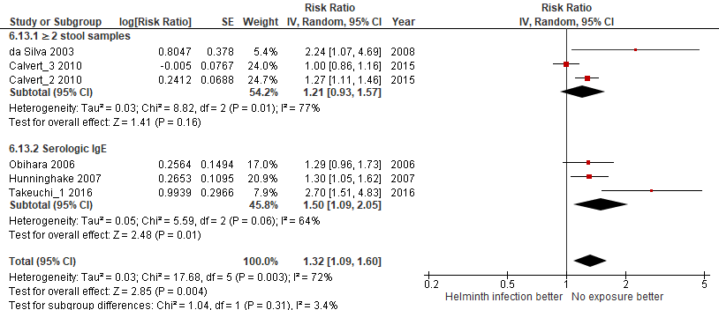

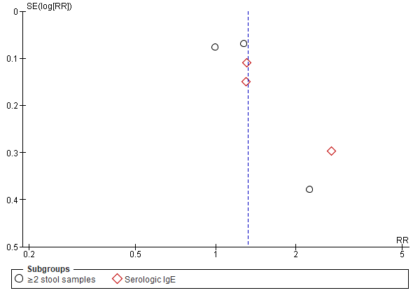

- 6.9 - Helminth detection method sensitivity:
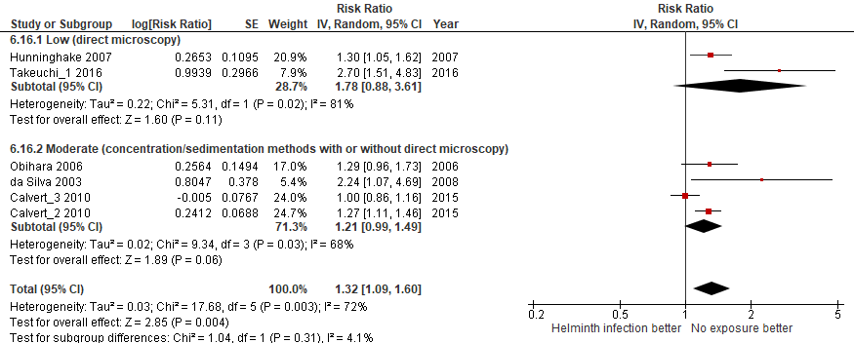
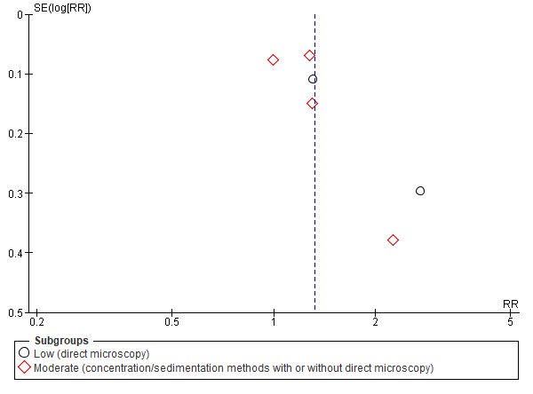

- 6.10 – Endemic prevalence:
A. Lumbricoides prevalence
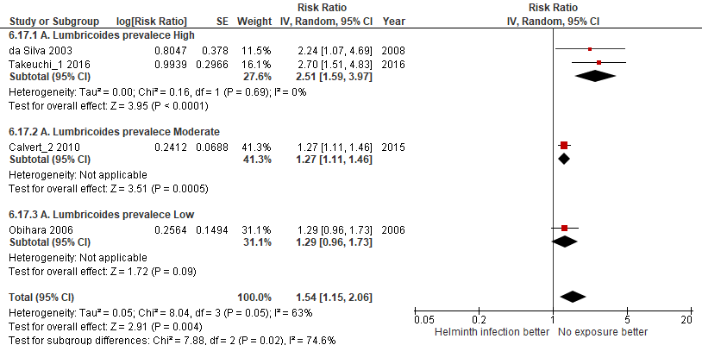
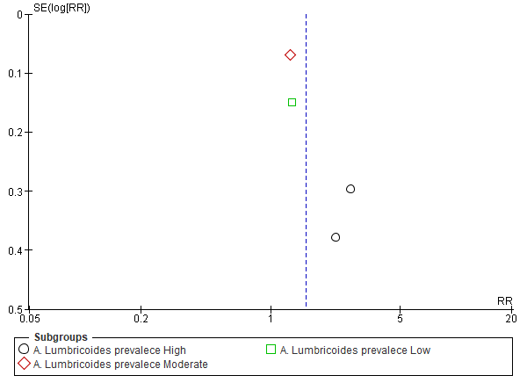

T. Trichiura prevalence
Not performed because there was only one study available.

Hookworm prevalence
Not performed because there were no studies available.

