Thalamic Deep Brain Stimulation for Post-Traumatic Neuropathic Limb Pain: Efficacy at Five Years’ Follow-Up and Effective Volume of Activated Brain Tissue Reviewed

Vasco Abreu M.D.^{1,2}, Rui Vaz M.D. Ph.D.^{2,3,4}, Clara Chamadoira M.D.³, Virgínia Rebelo M.Psy.⁵, Carina Reis M.D. ⁶, Francisca Costa ⁶, João Martins ⁷, Martin J. Gillies ⁸, Tipu Z. Aziz F.Med.Sci.^{2,8} and Erlick A. C. Pereira D.M.^{2,9}

1 Dept. of Neuroradiology. Centro Hospitalar Universitário do Porto. Portugal
2 Faculdade de Medicina da Universidade do Porto. Portugal
3 Dept. of Neurosurgery. Centro Hospitalar Universitário São João. Porto. Portugal
4 Neurociences Unity Hospital Cuf Porto. Portugal
5 Pain Unit. Centro Hospitalar Universitário São João. Porto. Portugal
6 Dept. of Neuroradiology. Centro Hospitalar Universitário São João. Porto. Portugal
7 Medtronic Portugal
8 Nuffield Department of Surgery, University of Oxford, Oxford, United Kingdom
9 Neurosciences Research Centre, Institute of Molecular and Clinical Neurosciences, St. George’s, University of London, London, United Kingdom

Abstract:

Chronic neuropathic pain affects 7%-10% of the population. Deep brain stimulation (DBS) has shown variable but promising results in its treatment. This study prospectively assesses long-term effectiveness of DBS in a series of patients with chronic neuropathic pain correlating clinical results with neuroimaging.

Sixteen patients received 5 years post-surgical follow-up in a single-center. Six had phantom limb pain after amputation and ten deafferentation pain after traumatic brachial plexus injury. Patient-reported outcome measures were completed before and after surgery, using VAS, UWNPS, BPI and SF-36 scores. Neuroimaging evaluated electrode location and respective volume of activated tissue (VAT). Two subgroups were created based on the percentage of VAT superimposed upon the ventroposterolateral thalamic nucleus (eVAT) and clinical outcomes were compared.

Analgesic effect was assessed after 5 years and compared to before surgery, with an improvement in VAS of 76.4% (p = 0.0001), in UW-NPS of 35.2% (p = 0.3582), in BPI of 65.1% (p = 0.0505) and in SF-36 of 5% (p = 0.7406). Eight patients with higher eVAT had an improvement in VAS of 67.5% (p=0,0017) while the remaining patients, with lower eVAT, improved 50.6% (p=0,03607).

DBS remains effective after 5 years in improving chronic neuropathic pain. While VPL-targeting contributes to success, analgesia is also obtained by stimulating surrounding posterior ventrobasal thalamic structures and related spinothalamocortical tracts.

Introduction

Chronic neuropathic pain is caused by a lesion or disease affecting the somatosensory system [1]. It has been recently estimated to affect 7-10% of the population with its incidence likely to increase [2]. It poses a serious burden to society, related to the complexity of neuropathic symptoms, impairment of quality of life, difficult treatment decisions and clinical outcomes. Many cases are refractory to pharmacologic approaches, leading clinicians to consider neurosurgery as a therapeutic option [3].

Both phantom limb pain after amputation and deafferentation pain after brachial plexus injury are forms of chronic neuropathic pain. Phantom limb pain affects 85% of amputees, usually arising two to three years after amputation [4]. Brachial plexus injury commonly proceeds to deafferentation pain within a few months of injury, with 25% of sufferers experiencing severe neuropathic pain years later [5]. Despite pathophysiology that is not clearly defined, there are numerous empirical treatments for both aetiologies with little clinical evidence supporting any particular therapy [6].

At Hospital de São João in Porto, Portugal, there is a pain unit with a national referral base, reviewing a great number of patients, many of them refractory to medical treatment. This fact, coupled with our previous experience with deep brain stimulation (DBS) for movement disorders since 2002, led us to begin sensory thalamic stimulation for the treatment of neuropathic pain in 2009. These factors together with the available evidence and expert opinion motivated trial of DBS before recourse to other available surgical techniques [7-9].

DBS has established itself as a transformative treatment option for essential tremor, Parkinson’s disease, idiopathic dystonia, with good evidence emerging in non-motor indications such as severe obsessive-compulsive disorder and a long history of case series with variable outcomes in chronic pain [10,11]. There are several targets for DBS for pain [12], one being ventroposterolateral nucleus (VPL) of the sensory thalamus, with supporting evidence coming from ablative surgery [13].

We describe a prospective, open-label, consecutive case series study of patients receiving VPL-DBS for chronic neuropathic pain after amputation or brachial plexus injury, treated at a single Portuguese center by an experienced multidisciplinary functional neurosurgery team. Our previous results after one- and three years follow-up have shown favorable clinical outcomes for this group of patients [14,15], most marked in pain amelioration and with significant improvement in quality of life also at longer-term follow-up. This study therefore is to understand whether this therapeutic efficacy is maintained after five years. We also review relevant neuroimaging to evaluate implanted DBS electrode positions, and estimate volumes of brain tissue activation.

Methods

Study Population
Patients with chronic neuropathic pain were referred to a single-center multidisciplinary team at Hospital de S. João in Porto, Portugal. Patients with neuropathic pain due to brachial plexus injury or phantom limb pain, refractory to pharmacological treatment for at least two years with no surgical contraindications were selected. Diagnosis of psychiatric disorder was a major exclusion criterion. The study received local ethical approval and informed consent was obtained.

Sixteen patients were selected for surgery (Table 1). Fourteen were male (87.5%) and two female (12.5%). The average age was 53 ± 69.1 years old. The mean duration of symptoms before surgery was 20 ± 12.6 years and all surgeries were performed between January 2009 and May 2012. All suffered traumatic injuries as the cause for neuropathic pain. Six had phantom limb pain after amputation and ten had deafferentation pain after brachial plexus avulsion. One patient did not report any pain relief during the trial period and was not fully implanted. Thus, from the original sample of 16 patients, 15 proceeded to full DBS implantation after successful intraoperative and postoperative trials. One patient with phantom limb pain after amputation was lost to follow-up after 12 months, leaving 14 patients with 5 years’ follow-up.

Deep Brain Stimulation Procedure
Under local anesthesia, a Leksell stereotactic frame (Elekta Instruments, Stockholm, Sweden) was applied to the patient’s shaved head. A stereotactic head CT scan with 1-mm slice thickness was fused with preoperative T1- and T2-weighted MR images of 2-mm slice thickness from a 1.5-T scanner using FrameLink software (Medtronic, Dublin, Ireland). The Leksell stereotactic arc was then fixed to its frame on the awake patient. The contralateral ventroposterolateral nucleus of the sensory thalamus was targeted for limb pain and found 10–13 mm lateral to the posterior commissure and the effects of macrostimulation assessed from 2 mm above to 5 mm below the calculated target to elicit paraesthesia or analgesia in the area of pain. No microelectrode recordings were made. Final electrode position was determined by intraoperative clinical assessment that relied upon subjective reporting by the awake patient of paresthesias at pain areas, after stimulation of 5–50 Hz, with a pulse width of 200–450 µs and amplitude of 0.5–5 V, the wide range of parameters being accounted for by the great individual variation in patient response seen intraoperatively in DBS for pain. Once satisfactory targeting had been achieved by Microdrive adjustment, a Medtronic Model 3387 quadripolar electrode was secured in place with a Stimloc skull fixation device (Medtronic). Electrode leads were externalized. Typical surgery duration was 2–3 hours, including stereotactic planning.

Bedside DBS programming was undertaken during the postoperative period both morning and afternoon, in sessions lasting approximately 30 min per patient. Different frequencies from 5 to 50 Hz were used alongside varied bipolar stimulation over different contacts at increasing pulse widths and amplitudes to optimize analgesia and minimize unpleasant sensations in the painful body part. After one week with of postoperative clinical assessment under external stimulation, a decision was made whether to permanently implant the electrodes under general anaesthesia if there was evidence of clinical benefit. The electrodes were connected to a pulse generator (Medtronic Kinetra or Activa PC) implanted in the chest via new extension leads. Patients usually left the hospital a day after implantation of the pulse generator. Continuous rather than on-demand stimulation was encouraged, but in addition to the ability to switch the DBS on and off at will, patients were usually given control over its voltage only, which was typically limited by the clinician to a maximum amplitude of 4V.

Clinical Outcome Assessment
Quantitative assessment of pain and health-related quality of life was performed 1 month before surgery and 3 month, 6 month then annual timepoints. Here we report the post-operative results at 36 and 60 months compared to before surgery (detailed results up to and including 36 months are published elsewhere [15]). Clinical evaluation was accomplished by independent assessors trained in pain medicine, not involved in caring for the patient and unaware of the details of the treatment given. The Visual Analog Scale (VAS), the University of Washington Neuropathic Pain Score (UWNPS), and Brief Pain Inventory (BPI) were used to rate pain intensity and to evaluate pain characteristics. Patients also completed a 36-Item Short-Form HealthSurvey (SF-36) on quality of life. Norm-based scores allowed comparison between studies.

Neuroimaging Evaluation
Electrode position was determined retrospectively using SureTune® software (Medtronic, Dublin, Ireland) by co-registering the individual preoperative MRI used for stereotactic planning with each immediately postoperative CT scan. The accuracy of the fusion was carefully evaluated and the process iterated whenever necessary. All volumes were co-registered in planes parallel to the AC-PC line.

The contour of the thalamic nuclei was adapted using a semi-automatic algorithm on T1-weighted MRI sequences (both conventional and inversion recovery) with manual fitting to the Yelnick atlas [16]. Electrodes were visualized by CT-generated artifact (Hemm et al., 2009) before representation in the 3D thalamic segmentation. These methods are part of the workflow of the Suretune software.

Based on patients’ therapeutic stimulation parameters (contacts, amplitude, frequency, pulse width and impedance) volume of tissue activated (VTA) was predicted for each patient analysis, based on spatial voltage distribution in brain [17], again using Suretune workflow.

Finally, the volume of VPL (and other thalamic nuclei) was geometrically measured and superimposed upon calculated VTA for each patient using Suretune, with the aim of measuring VTA inside VPL, termed here effective volume of tissue activated (eVAT).

Statistical Analysis
Clinical outcome data was first normalised by dividing the test score at each time point by the preoperative score for that test. A Kruskal Wallis test (non-parametric one-way ANOVA) was then performed on the normalized data for each test score of interest. The null hypothesis of the Kruskal Wallis test was that the group median of the tested score at each time point came from the same distribution. In tests where p was less than 0.05, multiple comparison tests using a Tukey-Kramer method were performed to compare individual group medians at each time point to assess which scores at which time points differed significantly from the preoperative score, with a p-value <0.05 considered statistically significant and p<0.01 considered highly significant. All data is presented as median + interquartile range.

Results

The demographic characteristics of the fourteen patients are summarized in Table 1. Most patients were male and mean age at surgery was 53 ± 9.1 years. Neither surgical complications nor side effects from stimulation emerged. No patients required electrode or implanted pulse generator revisions in the post-operative period up to five years.

Table 2 lists the stimulation parameters at different timepoints. All patients received continuous bipolar DBS with patient control of amplitude up to a clinician-set maximum. Initial mean stimulation parameters were 2.1 ± 1.1V, 23.3 ± 13.5 Hz and 186.7 ± 76.5 µs. During the 5 years’ follow-up all patients were regularly re-evaluated and parameters were adjusted according to the clinical status. The average stimulation parameters after 5 years’ were 3.86 ± 1.03V, 16.4 ± 8.6 Hz and 201.4 ± 55.7 µs, notably showing mean increases in amplitude and pulse width with time.

Table 3 lists changes in patient reported outcomes of the 15 patients who proceeded to full DBS implantation after successful intraoperative and postoperative trials, at different time points: preoperative and 3 and 5 years’ follow-up. Figure 1 shows bar graphs of overall baseline scores and postoperative improvements in outcomes across the entire cohort. Analyzing these last two, we observe continued improvement in pain with follow-up in this series of patients, showing that five years after implantation, mean pain relief was improved from three years, and at 60 months the median (+interquartile range) of the improvement of VAS score from before surgery was 76.4% (62.5%) (p=0.0001). Regarding the remaining scales, there is an improvement in UWNPS of 35.2% (58.3%) (p=0.3582), in BPI of 65.1% (48.2%) (p=0.0505) and in SF-36 of 5% (58.4%) (p=0.7406).

The UWNPS subscores, as we have found previously, remain significant in improvement (p<0.05) in most domains including intensity, sharp, hot, dull, deep and unpleasant pain, but not in cold, sensitive, itchy and superficial pain. The considerable reductions in hot, sharp, deep and dull subscores suggest that DBS still relieves both the paroxysmal and continuous components of neuropathic pain. In addition, when comparing the 5 years’ subscores analysis with the 3 years’ one, despite it not being statistically significant, there is a trend towards improvement both in cold and hot pain, and an exacerbation of sensitive, itchy and superficial pain.

A comparison of results was made between brachial plexus injury and phantom limb pain subgroups. Although both subgroups showed improvements with DBS, we reported in 2017 that amputation pain improved more, with significant benefits sustained across all pain outcome measures. This trend continues after 5 years (Table 3). VAS improvement was 90% (56.6%) (p=0.0442) in the amputation subgroup compared with 75% (55.9%) (p=0.0015) in the brachial plexus injury subgroup. No statistical significance was found in the other subgroup score analyses, despite the higher VAS pain score improvement in amputation subgroup.
Patient reported outcome measure improvements were marked after five years in this cohort. To evaluate the development of tolerance, we compared all outcome scores at 60 months with the previous annual assessments. There were no statistically significant differences found among any scores between all post-surgery timepoints, namely between 3 and 5 years’ results.

Retrospective neuroimaging analysis was performed in thirteen patients, as one patient did not have postoperative CT images. The VTA generated by each patient’s stimulation parameters was measured and its overlap with surrounding anatomy was defined. Some examples of axial and three dimensional (3D) reconstructed images are represented below (figure 3,4,5,6). Table 4 summarizes VTA, effective VTA (percentage of VTA inside VPL nucleus) and clinical outcome improvements individually by patient. In 5/13 patients there was almost no intersection between VTA and VPL whereas in 8/13 there was some. Two subgroups were therefore created based on the recruitment of VPL fibers, subgroup 1 having high recruitment and subgroup 2 little recruitment (20% nucleus intersection cut-off). We estimated a mean VTA of ~93.3mm3 (89.3 mm3 in subgroup 1 and 97.3 mm3 in subgroup 2). The average eVAT was estimated to be 36.5% (35.7 % in subgroup 1 and 0.8% in subgroup 2), depending on the 3D brain atlas fitting.

Clinical outcome measures at five years after surgery were analyzed in each subgroup and are represented in Figure 2. The first subgroup showed an improvement of 67.5% (34.3) (p=0,00176) in VAS, in relation to the second group, whom VPL fibers were not directed stimulated, with a VAS improvement of 50.6% (33.4) (p=0,036076). Remaining scores’ analysis are seen in Table 4. Comparing improvements between both subgroups there was statistical significance only in UW-NPS (p=0.032), and not others: VAS (p=0.200), BPI (p=0.392) and SF-36 (p=0.080).

Figure 3 shows direct stimulation of the VPL nucleus in a patient with good clinical outcomes (100% and 80% improvement in VAS and BPI, respectively). In figure 4, conversely, the lead is located anterior and superiorly to VPM in a patient with poor clinical outcomes (0% and 26% improvement in the same scores). Figure 5 shows the lead centered in the VPM nucleus, with slight stimulation of VPL fibers, in a patient with relatively good clinical outcomes (80% and 77% improvement). Figure 6 shows the lead anterior to both VPM and VPL, with no direct recruitment of VPL fibers, in a patient with relatively good clinical outcomes (67% and 65%)

Discussion

Chronic neuropathic pain is a serious and prevalent clinical syndrome. Interest in DBS continues for patients who become refractory to medical treatment, and has paralleled advances in DBS technology, neuroimaging, and the publication of more rigorous case series regarding its long-term efficacy [18].

Neuromodulation for the treatment for this condition has been undertaken for seven decades. Despite satisfied efficacy criteria of at least half of the patients reporting at least 50% pain relief one year after surgery, further multicenter trials of DBS for pain have not been conducted to seek US FDA approval [19]. Although being considered an “off-label” procedure in the USA, the European Federation of Neurological Societies and the United Kingdom National Institute for Health and Clinical Excellence support the procedure [20,21] and consequently, more case series DBS for pain are undertaken in Europe than in the USA.

We update long-term clinical outcomes on our recent, open-label, prospective study of DBS for neuropathic pain which is the largest contemporary single-center experience of DBS for limb injury pain. Our experience supports an argument for only undertaking DBS for pain in centers with access to appropriate expertise and experience, and willing to audit outcomes. Moreover, we describe a study with a refined patient selection of neuropathic pain secondary to limb trauma, unlike other heterogeneous case series [22-24]. We maintain that DBS can consistently deliver analgesia to patients with chronic neuropathic pain after amputation and brachial plexus injury, with significant sustained improvements five years later.

Since our published article suggesting benefit after 3 years’ follow-up, no new case series related to this theme have been published to our knowledge. Published peer reviewed clinical outcomes data in DBS for pain case series comprising at least 6 patients are summarized elsewhere, with only about 20 groups worldwide reporting long-term efficacy with follow-ups of up to 6 years [6], and only six centers, publishing case series of >6 patients in the last decade [18,22,25-30], including our own [15]. Nevertheless, the heterogeneous selection of patients due to the great variability of etiologies of neuropathic pain that characterize these studies remains a problem which may lead to a great variability of results. Central neuropathic mechanisms may differ between brachial plexus injury and amputation, but both are forms of traumatic limb injury and we selected these patients in Porto drawing upon the experience in Oxford of relative success with those particular patient groups [18].

The usual shortcomings of other case series have not affected this study, namely variable deep brain stimulation targets and parameters, underspecified patient selection criteria or loss to follow-up. Here, we focus upon the long-term assessment, the relatively large sample evaluated and refined inclusion criteria [35]. We also undertook a week of postoperative clinical trialing of externalized DBS, with only one brachial plexus injury patient failing that trial and not proceeding to full implantation.

Other neuromodulation related therapies such as Motor Cortex Stimulation (MCS), Spinal Cord Stimulation (SCS) and Dorsal Root Entry Zone (DREZ) lesioning have been reported as alternative surgical procedures. No new trials have been performed comparing their efficacy to each other for neuropathic pain since our 2017 publication which summarizes our justification for offering DBS as a primary surgical treatment. Some cases from more recent series show some probable success of SCS in some modalities of pain, such as post-herpetic neuralgia, intercostal neuralgia or diabetic neuropathy [36]. However, none of these studies addressed patients with traumatic etiology. Taking into account our experience in DBS, and the lack of it with SCS in our centrs, as well as the little evidence of its applicability in cases of traumatic neuropathic pain published in the literature, led us to favour DBS as an option with greater potential.

VPL stimulation shows benefit at five years suggesting that this therapeutic approach may have a role in these difficult to treat conditions. There is considerable and significant improvement after five years in VAS score. BPI and UW-NPS, despite the considerable improvement, show no statistically significant benefit, perhaps because of insufficient case series size. BPI 3-years’ results showed a statistically significant improvement compared to before surgery. This can be explained by the fact that the BPI scale as a whole, in addition to assessing the intensity of the pain felt, also allows assessing the way it interferes with patients' daily activities. A confounding factor may arise here, as each patient may report a greater restriction in their daily activities, not only because of their own pain, but also because of the functional limitations caused by their bodily injury (avulsion of the brachial plexus or amputation of a limb). Moreover, meaningful and sustained improvements were not noted in SF-36 quality of life score and, comparing to 3 years’ results, a decreasing pattern may be noticed. It is difficult to explain these results without undertaking further qualitative research by interviewing the patients, caregivers, and blinded pain physicians who undertook assessments. In our opinion, as we postulated before, this can be due not only to the motor deficit but also to its psychological sequelae, both limiting daily routine despite pain improvement. The inferior overall SF-36 results after 5 years, comparing to previous years, might follow the natural tendency of aging, leading to a decrease in the physical capacities of the patients, with greater limitations in their daily life. The trend towards cumulative improvements in pain scores from 3 years to 5 years is heartening, suggesting long-term efficacy over time, rather than tolerance.

Although we have been restrictive in the etiological selection of our cases, in order to have a more homogeneous group, we know that the nature of this type of pain is quite variable, and its characteristics and manifestations may vary over time, which may be reflected in the UWNPS subscores analysis. In addition to the fact that pain characteristics may vary widely from patient to patient, we also noticed that, comparing to 3 years’ results, there is an improvement both in cold and hot pain subscores, and a worsening of the sensitive, itchy and superficial ones. This may reflect not only the behavioral variability of pain, but also it could partly address the main areas of pain where DBS can have greater impact. Awareness of such descriptive, characteristic components of pain therefore has a role in history taking and patient reported questionnaire analysis towards patient selection for DBS for pain.

Tolerance phenomenon is described in literature as responsible for the decrease in the efficacy of DBS, motivating the adjustment of the stimulation parameters (either pulse width, frequency, or both) [18,31,32]. Our five years’ results suggest these patients are still experiencing long-term benefit from this procedure, with no statistically significant differences found between 1, 2, 3 and 5 years’ time periods. However, it should be borne in mind that stimulation parameters were constantly adjusted individually and were increased to a mean average of 3.86 V, 16.4 Hz and 201.4 µs across the group.

The clinical success of DBS for movement disorders has prompted the development of techniques attempting to quantify its effects on the central nervous system and also aiming to provide clinical guidance on the most efficacious neuroanatomical structures for electrode implantation and the most suitable stimulation parameters. The second goal of this study was to integrate detailed computer modeling with clinical outcomes analysis to enhance our understanding of the neuromodulation effects. In many case-series in which DBS was not effective for the treatment of neuropathic pain, there has been little neuroimaging analysis.

Clinical outcome improvements were generally higher in the subgroup with major recruitment of VPL fibers. Nevertheless, we also reported clinical benefit in patients with little VPL stimulation: two cases had clinical VAS and BPI improvements higher than 50%, with the centromedian and VPM nucleus of thalamus being the main targets stimulated. Furthermore, stimulation of VPL in the successful cases shared a mixed stimulation with the VPM nucleus, leading us to believe that DBS efficacy possibly relies on a broad thalamocortical network stimulation neighboring VPL nucleus. However limitations in sequential algorithms or neuroplasticity may also explain these results
There are several limitations to this study. Firstly, the atlas fitting to MRI for each patient creates assumptions about the location of VPL. To limit inexpert error, manual fitting was performed simultaneously by two neuroradiologists. Future studies using diffusion tractography to fiber track from VPL to the primary somatosensory cortex corresponding to the affected limb area would be desirable, although ultimately histological analysis is the only way to provide true confirmation. Generated VTA predictions using the Suretune model were derived from the activation of axons with small diameter (2.0µm) and may not be representative of the response of other types of neurons. Figures 2-5 illustrate the utility of intra-operative macroelectrode stimulation with awake patient assessment rather than image-guided surgery alone towards optimizing clinical outcomes in DBS for pain.

Other limitations of this study include the absence of randomization, no comparable control group and no on-off trialling. Aside from RCT issues of funding, recruitment, and follow-up, the power such studies have to detect a difference between groups relies upon setting a meaningful threshold of clinical improvement with a ratified outcome score. Alternative thresholds and approaches to study design are therefore desirable alongside the holy grail of an objectively measurable biomarker for chronic pain.

DBS for the treatment of chronic pain is moderately supported in the literature (level II evidence) [35]. Nevertheless, continued RCTs evaluating DBS both on and off are needed. The “optimal” implantation location of DBS electrodes will be undoubtedly become increasingly debated, as new techniques enable more detailed analysis of the anatomical, electrical and behavioral variables of DBS.

This contribution to the literature is both the confirmation of good long-term outcomes over half a decade for DBS for refractory neuropathic pain after traumatic limb injury and the integration of neuroanatomical and stimulation field modelling. Although still at an early stage, such techniques may make powerful contributions towards optimizing the clinical efficacy of DBS for the treatment of refractory pain syndromes. Recent advances in DBS electrode technology (both directional leads which enable VAT to be directed to optimize efficacy and minimize side-effects, and octopolar electrodes enabling dual targeting of pain structures such as VPM and periaqueductal gray) may improve outcomes, as would identification of an electrophysiological marker for pain applied to sensing DBS. More detailed imaging analysis including MR tractography and connectomic mapping may in future help select patients, targets and guide programming.

References:

[1] Ashburn MA, Staats PS. Management of chronic pain. Lancet 1999;353:1865–1869. DOI: 10.1016/S0140-6736(99)04088-X

[2] van Hecke O, Austin SK, Khan RA, Smith BH, Torrance N. Neuropathic pain in the general population: a systematic review of epidemiological studies. Pain. 2014; 155:654–662. DOI: 10.1016/j.pain.2013.11.013.

[3] Torrance N, Smith BH, Bennett MI, Lee AJ. The epidemiology of chronic pain of predominantly neuropathic origin. Results from a general population survey. J Pain. 2006;7:281–289. DOI:10.1016/j.jpain.2005.11.008

[4] Hall GC, Carroll D, Parry D, McQuay HJ. Epidemiology and treatment of neuropathic pain: the UK primary care perspective. Pain 2006;122:156–162. DOI:10.1016/j.pain.2006.01.030

[5] Narakas A. Surgical treatment of traction injuries of the brachial plexus. Clin Orthop Relat Res 1978;133:71–90.

[6] Pereira EA, Aziz TZ. Neuropathic pain and deep brain stimulation. Neurotherapeutics 2014;11:496–507. Doi: 10.1007/s13311-014-0278-x.

[7] Papuc´ E, Rejdak K. The role of neurostimulation in the treatment of neuropathic pain. Ann Agric Environ Med 2013;1:14–17.

[8] . Rokyta R, Fricov_a J. Neurostimulation methods in the treatment of chronic pain. Physiol Res 2012; 61(Suppl.2):S23–S31.

[9] Nizard J, Raoul S, Nguyen JP, Lefaucheur JP. Invasive stimulation therapies for the treatment of refractory pain. Discov Med 2012;14:237–246.

[10] Pereira EA, Green AL, Nandi D, Aziz TZ. Deep brain stimulation: indications and evidence. Expert Rev Med Devices 2007;4:591–603. DOI: 10.1586/17434440.4.5.591

[11] Heath R, Studies in schizophrenia: a multidisciplinary approach to mind-brain relationships. Cambridge, MA: Harvard University Press, 1954;

[12] Frizon LA, Yamamoto EA, Nagel SJ, Simonson MT, Hogue O, Machado AG. Deep Brain Stimulation for Pain in the Modern Era: A Systematic Review. Neurosurgery. 2020. 1;86(2):191-202. DOI: 10.1093/neuros/nyy552.

[13] Mark VH, Ervin FR. Role of thalamotomy in treatment of chronic severe pain. Postgrad Med 1965;37:563–571.

[14] Pereira EA, Boccard SG, Linhares P et al. Thalamic deep brain stimulation relieves neuropathic pain after amputation or brachial plexus avulsion. Neurosurg Focus 2013;35:1–11. DOI: 10.3171/2013.7.FOCUS1346.

[15] Abreu, V, Vaz R, rebelo, V, Rosas, MJ, Chamadoira, C, Gillies, MJ, Aziz, TZ, Pereira, EA. Thalamic Deep Brain Stimulation for Neuropathic Pain: Efficacy at Three Years' Follow-Up. Neuromodulation. 2017. DOI: 10.1111/ner.12620. Epub 2017 Jun 20.

[16] Yelnik J, Bardinet E, Dormont D, Malandain G, Ourselin S, Tandé D, Karachi C, Ayache N, Cornu P, Agid Y. A three-dimensional, histological and deformable atlas of the human basal ganglia. Atlas construction based on immunohistochemical and MRI data. Neuroimage. 2007. 15;34(2):618-38. DOI: 10.1016/j.neuroimage.2006.09.026

[17] Franz Hell, Carla Palleis, Jan H. Mehrkens, Thomas Koeglsperger, Kai Bötzel. Deep Brain Stimulation Programming 2.0: Future Perspectives for Target Identification and Adaptive Closed Loop Stimulation. Front Neurol. 2019. 10: 314. DOI: 10.3389/fneur.2019.00314

[18] Boccard SG, Pereira EA, Moir L, Aziz TZ, Green AL. Long-term outcomes of deep brain stimulation for neuropathic pain. Neurosurgery 2013;72:221–231. DOI: 10.1227/NEU.0b013e31827b97d6.

[19] Coffey RJ. Deep brain stimulation for chronic pain: results of two multicenter trials and a structured review. Pain Med 2001; 2:183–192. DOI: 10.1046/j.1526-4637.2001.01029.x

[20] Cruccu G, Aziz TZ, Garcia-Larrea L et al. EFNS guidelines on neurostimulation therapy for neuropathic pain. Eur J Neurol 2007;14:952–970. DOI: 10.1111/j.1468-1331.2007.01916.x

[21] National Institute for Health and Care Excellence: IPG382. Deep Brain Stimulation for Chronic Pain Syndromes (Excluding Headache). http://publications.nice.org.uk/deep-brain-stimulation-for-refractory-chronic-pain -syndromes-excluding-headacheipg38 [Accessed July 25, 2013].

[22] Levy RM. Deep brain stimulation for the treatment of intractable pain. Neurosurg Clin N Am 2003;14:389–399. DOI: 10.1016/j.nec.2014.07.009

[23] Pereira EAC, Aziz TZ, Deep brain stimulation. In: Hayek S, Levy RM, Deer TR, eds. Neurostimulation for the treatment of chronic pain. Interventional and neuromodulatory techniques for pain management, Vol. 1. Philadelphia: Elsevier Saunders, 2011: 187–201.

[24] Pereira EAC, Moir L, Green AL, Aziz TZ, Deep brain stimulation for chronic pain. In: Krames E, Peckham PH, Rezai AR, eds. Neuromodulation, Vol. 1. London: Elsevier, 2009: 499–507.

[25] Yamamoto T, Katayama Y, Obuchi T et al. Thalamic sensory relay nucleus stimulation for the treatment of peripheral deafferentation pain. Stereotact Funct Neurosurg 2006;84:180–183. DOI: 10.1159/000094958

[26] Hamani C, Schwalb JM, Rezai AR, Dostrovsky JO, Davis KD, Lozano AM. Deep brain stimulation for chronic neuropathic pain: Long-term outcome and the incidence of insertional effect. Pain 2006;125:188–196. DOI: 10.1016/j.pain.2006.05.019

[27] Marchand S, Kupers RC, Bushnell MC, Duncan GH. Analgesic and placebo effects of thalamic stimulation. Pain 2003;105:481–488. DOI: 10.1016/s0304-3959(03)00265-3
[28] Rasche D, Rinaldi PC, Young RF, Tronnier VM. Deep brain stimulation for the treatment of various chronic pain syndromes. Neurosurg Focus 2006;21:E8. DOI: 10.3171/foc.2006.21.6.10

[29] Green AL, Owen SL, Davies P, Moir L, Aziz TZ. Deep brain stimulation for neuropathic cephalalgia. Cephalalgia 2006;26:561–567. DOI: 10.1111/j.1468-2982.2005.01068.x

[30] Owen SL, Green AL, Stein JF, Aziz TZ. Deep brain stimulation for the alleviation of post-stroke neuropathic pain. Pain 2006;120:202–206. DOI: 10.1016/j.pain.2005.09.035

[31] Young RF, Rinaldi PC, Brain stimulation. In North RB, Levy RM, eds. Neurosurgical management of pain. New York: Springer 1997:283–301

[32] Gybels JM, Sweet WH. Neurosurgical treatment of persis-tent pain. Physiological and
pathological mechanisms of human pain, Vol. 11, Basel: Karger 1989.

[33] Coffey RJ, Lozano AM. Neurostimulation for chronic noncancer pain: an evaluation of the clinical evidence and recommendations for future trial designs. J Neurosurg 2006;105:175–189. DOI: 10.3171/jns.2006.105.2.175

[34] Levy R, Deer TR, Henderson J. Intracranial neurostimulation for pain control: a review. Pain Physician 2011;13:157–165.

[35] Deer, TR, Falowski S, Arle JE, Vesper J, Pilitsis, J, Slavin, KV, Hancu M, Grider JS, Mogilner, AY. A Systematic Literature Review of Brain Neurostimulation Therapies for the Treatment of Pain. Pain medicine 2020, 1–6. doi: 10.1093/pm/pnz371

[36] Dones, I, Levi, Vicenzo. Spinal Cord Stimulation for Neuropathic Pain: Current Trends and Future Applications. Brain Sci. 2018; Aug; 8(8): 138.

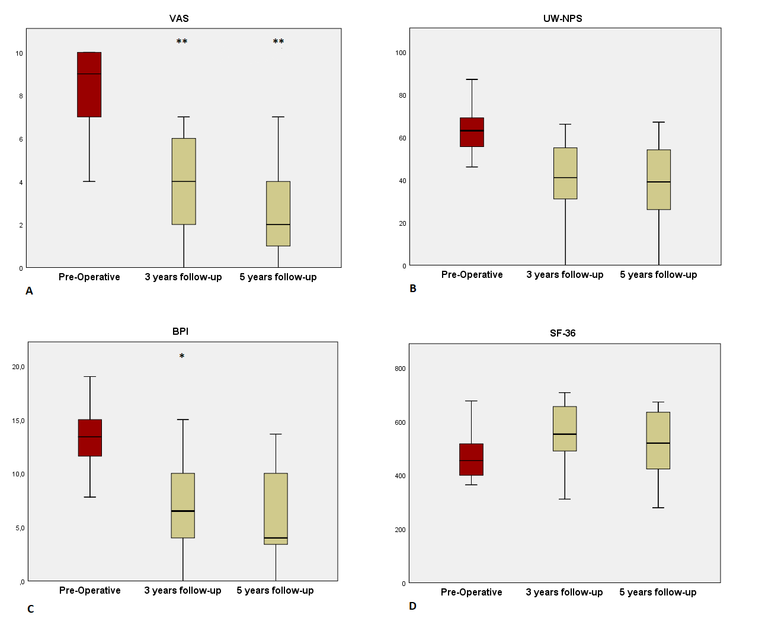
Figure 1. Bar graphs showing overall outcomes according to the VAS (A), UW-NPS (B), BPI (C), and SF-36 (D), preoperatively and at 3 and 5 years after surgery. The median is indicated by the horizontal line inside the boxes, which represent two quartiles, and the whiskers show minimum and maximum values. Asterisks indicate the statistical significance of the difference between the postsurgery and presurgery scores. **p<0.01 (highly statistically significant). *p<0.05 (statistically significant).

Figure 2. Clinical outcome improvements after five years in each subgroup (higher eVTA versus lower eVTA)

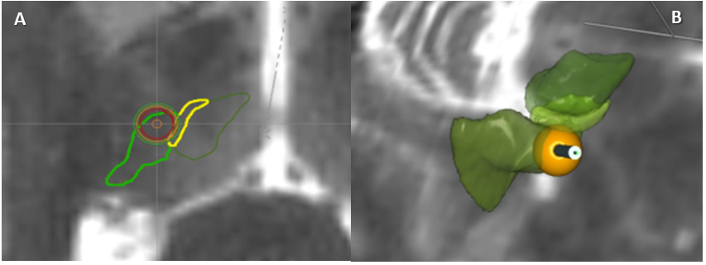
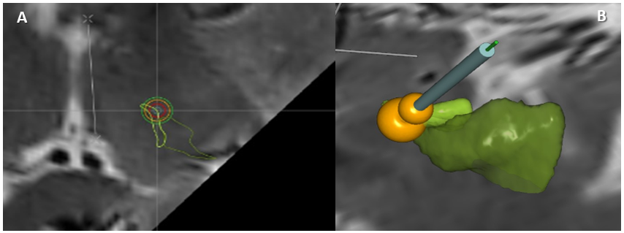
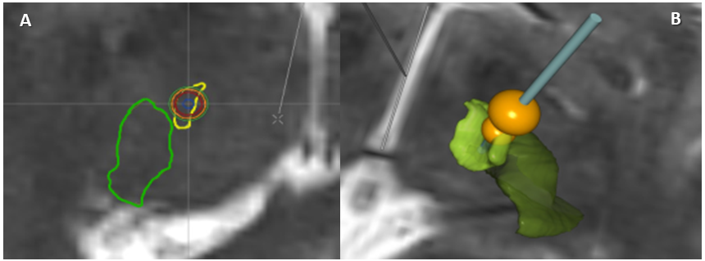
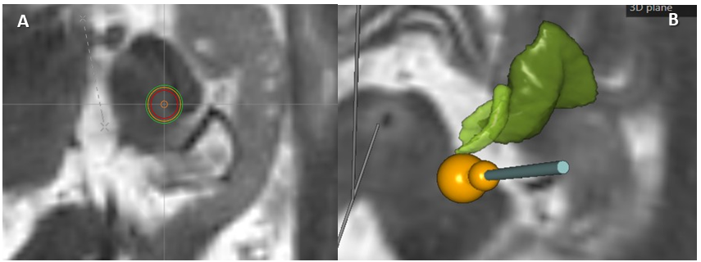
Patient ID 10

Good clinical outcomes (100% and 80% improvement in VAS and BPI, respectively) with associated eVAT o 51.3%

Poor clinical outcomes (0% and 26% improvement in VAS and BPI, respectively) with associated eVAT of 0.9%

Good clinical outcomes (80% and 77% improvement in VAS and BPI, respectively) with associated eVAT of 58.5%

Relatively good clinical outcomes (67% and 65% improvement in VAS and BPI, respectively) with associated eVAT of 0%

Patient ID 13

Patient ID 15

Patient ID 16

Figure 3-6: axial and three dimensional (3D) reconstructed images of thalamic nucleus and of the stimulation lead and its VAT (eVAT corresponds to superimposition of the previous). A – Axial MRI; circumferences represent area stimulated by the electrode; green line represents VPL; yellow line represents VPM; B - 3D reconstruction; orange spheres represent electrode stimulation volume (VTA); VPL shown in dark green and VPM in light green/ yellow.

Case No. | Age at Op (yrs), Sex | Pathology |  |  | Symptom  duration (yrs) | Pre-op Medications |  |  | Year of surgery
1 | 63, M |  | It brachial plexus injury | 4 |  |  | PGB | 2009
2 | 45, M |  | It brachial plexus injury | 28 |  |  | PGB | 2009
3 | 71, F |  | rt AKA | 13 |  |  | PGB | 2009
4 | 64, M |  | It brachial plexus injury | 50 |  |  | PGB | 2009
5 | 45, M |  | It AEA | 25 |  |  | PGB | 2009
6†² | 57, F |  | It AKA | 24 |  |  | PGB, GBP | 2010
7 | 40, M |  | It brachial plexus injury | 14 |  |  | PGB, GBP | 2010
8 | 48, M |  | rt AEA | 16 |  |  | PGB | 2010
9†¹ | 45, M |  | It brachial plexus injury | 12 |  |  | PGB, TMD, AMT | 2010
10 | 50, M |  | It BKA | 20 |  |  | GBP, TMD | 2011
11 | 56, M |  | rt brachial plexus injury | 2 |  |  | TMD, DZP | 2011
12 | 52, M |  | It brachial plexus injury | 32 |  |  | PGB, GBP, TMD, AMT | 2011
13 | 59, M |  | rt brachial plexus injury | 12 |  |  | TMD, VLX | 2011
14 | 48, M |  | rt brachial plexus injury | 20 |  |  | PGB, AMT, VLX | 2012
15 | 42, M |  | lt brachial plexus injury | 11 |  |  | PGB. AMT | 2012
16 | 63, M |  | Rt AEA | 40 |  |  | PGB, AMT | 2012
Mean ± SD | 53 ± 9.1 |  |  | 20.2 ± 12.8
Table 1. Patient demographics
Legend:
*AEA = above elbow amputation; AKA = above knee amputation; AMT = amitriptyline; BKA = below knee amputation; DZP = diazepam; GBP = gabapentin; NA = not applicable/ not available; PGB = pregrabalin; TMD = tramadol; VLX= venlafaxine; lt = left; rt = right.
†1 Failed Trial of DBS;
†2 Lost in the follow-up

Table 2. Stimulation parameters
Case No. | Initial Stimulation Parameters |  |  | 3 years’ Stimulation Parameters |  |  | 5 years’ Stimulation Parameters |  |  | Active Contacts
 | Amplitude (V) | Frequency (Hz) | Pulse Width (µs) | Amplitude (V) | Frequency (Hz) | Pulse Width (µs) | Amplitude (V) | Frequency (Hz) | Pulse Width (µs)
1 | 1.5 | 50 | 150 | 4 | 20 | 210 | 4 | 10 | 300 | 0-, 3+
2 | 0.8 | 50 | 150 | 4 | 10 | 210 | 4.2 | 10 | 240 | 2-, 3+
3 | 2 | 10 | 300 | 5 | 10 | 210 | 5 | 10 | 210 | 2-, 1+
4 | 1.5 | 10 | 300 | 4.5 | 20 | 300 | 1.8 | 30 | 210 | 1-, 3+
5 | 1.5 | 10 | 90 | 3.4 | 10 | 180 | 3.4 | 10 | 210 | 1-, 0+
7 | 2.5 | 20 | 210 | 4.5 | 25 | 210 | 5 | 25 | 210 | 1-, 3+
8 | 0.8 | 20 | 90 | 3.5 | 10 | 210 | 3.5 | 10 | 210 | 1-, 3+
10 | 3 | 30 | 90 | 4.3 | 15 | 120 | 4.3 | 15 | 120 | 2-, 0+
11 | 1 | 30 | 130 | 1.5 | 10 | 90 | 2 | 30 | 90 | 4-, 7+
12 | 1.5 | 30 | 210 | 4.5 | 10 | 210 | 3.5 | 10 | 240 | 2-, 1+
13 | 3.5 | 20 | 210 | 5 | 20 | 120 | 3.4 | 20 | 120 | 1-, 3+
14 | 4.5 | 10 | 300 | 5 | 10 | 240 | 5.2 | 10 | 240 | 1-, 3+
15 | 3 | 30 | 210 | 4.5 | 30 | 210 | 4.5 | 30 | 210 | 3-, 2+
16 | 3 | 10 | 120 | 4 | 10 | 210 | 4.3 | 10 | 210 | 0-, 3+
Mean ± SD | 2.1 ± 1.1 | 23.3 ± 13.5 | 186.7 ± 76.5 | 4.1 ± 0.9 | 15.3 ± 6.7 | 196 ± 51.8 | 3.86 ± 1.03 | 16.4 ± 8.6 | 201.4 ± 55.7

Table 3: Baseline scores and percentage of improvement for amputation and BPI cohorts
 |  |  | VAS |  |  | UWNPS |  |  | BPI |  |  | SF-36
 |  |  | Amputation | Brachial plexus injury | Overall | Amputation | Brachial plexus injury | Overall | Amputation | Brachial plexus injury | Overall | Amputation | Brachial plexus injury | Overall
Pre - Operative | Outcome Score | Min | 4 | 8 | 4 | 47 | 46 | 46 | 9 | 8 | 8 | 187 | 364 |  | 187
 |  | Max | 10 | 10 | 10 | 99 | 87 | 99 | 19 | 19 | 19 | 606 | 676 |  | 676
 |  | Median | 6 | 9 | 9 | 63 | 60 | 61.5 | 11.5 | 13.4 | 13.1 | 462 | 454 |  | 458
 |  | Interquartile Range | 4 | 2 | 4 | 35 | 12 | 16 | 7 | 4 | 4 | 248 | 161 |  | 163
3 year follow-Up | Outcome Score | Min | 0 | 0 | 0 | 2 | 0 | 0 | 0 | 0 | 0 | 539 | 311 |  | 311
 |  | Max | 4 | 7 | 7 | 46 | 66 | 66 | 5 | 15 | 15 | 659 | 707 |  | 707
 |  | Median | 2 | 5 | 4 | 31 | 51 | 41 | 4 | 7 | 6.5 | 655 | 494 |  | 552.5
 |  | Interquartile Range | 3 | 3 | 4 | 28 | 27 | 29 | 2 | 5 | 6 | 106 | 136 |  | 169
 | % Improvment | Median | 66.7 | 40 | 52.8 | 50.8 | 22.7 | 30.7 | 65.2 | 47.8 | 55.0 | 16.7 | 16 |  | 16.3
 |  | Interquartile Range | 51.7 | 31.9 | 45.4 | 62.9 | 37.1 | 49.2 | 31.6 | 62.8 | 32 | 140.2 | 42.7 |  | 30.3
 | P Value † |  | 0.0494 | 0.01298 | 0.00021 | 0.3225 | 0.4632 | 0.0590 | 0.1623 | 0.189 | 0.00737 | 0.2406 | 0.9953 |  | 0.4754
5 years follow-Up | Outcome Score | Min | 0 | 0 | 0 | 2 | 0 | 0 | 0 | 0 | 0 | 416 | 279 |  | 279
 |  | Max | 4 | 10 | 10 | 56 | 67 | 67 | 6 | 13.7 | 13.7 | 657 | 672 |  | 672
 |  | Median | 1 | 2 | 2 | 30 | 44 | 39 | 3.75 | 7 | 4 | 539 | 499 |  | 519
 |  | Interquartile Range | 3 | 5 | 4 | 36 | 33 | 29 | 3.5 | 8.3 | 7 | 206 | 264 |  | 215
 | % Improvment | Median | 90 | 75 | 76.4 | 55.5 | 26.7 | 35.2 | 65.2 | 50 | 65.1 | 16.6 | - 6.62 |  | 5
 |  | Interquartile Range | 56.6 | 55.9 | 62.5 | 79.3 | 57.5 | 58.3 | 42 | 66.2 | 48.2 | 167.8 | 54.1 |  | 58.4
 | P Value † |  | 0.0442 | 0.0015 | 0.0001 | 0.0923 | 0.2705 | 0.3582 | 0.0654 | 0.2523 | 0.0505 | 0.7966 | 0.9159 |  | 0.7406

Legend:
*Min = minimum patient outcome score within subgroup and overall population; Max = maximum patient outcome score within subgroup and overall population; † p value calculated on the difference between postsurgical and baseline scores. Statistically significant improvements (p<0,05) in bold.

Table 4: Volume of tissue activated related to five years’ clinical outcomes
Patients ID | Group 1  (Major recruitment of VPL fibers) |  |  |  |  |  | Group 2  (Minor recruitment of VPL fibers)
 | Therapeutic VAT (mm3) | eVAT (%) | VAS improvement (%) | BPI improvement (%) | UW-NPS improvement (%) | SF-36 improvement (%) | Therapeutic VAT (mm³) | eVAT (%) | VAS improvement (%) | BPI improvement (%) | UW-NPS improvement (%) | SF-36 improvement (%)
1 |  |  |  |  |  |  | 45.5 | 1.1 | 75 | 70.1 | -3.8 | 20.9
2 | 148.4 | 45.8 | 60 | -11.1 | -1.6 | -33.3
4 |  |  |  |  |  |  | 216.3 | 1.2 | 77.8 | 68.8 | 26.1 | -18.8
5 | 74.3 | 20.2 | 20 | 31 | -5.7 | -10.6
7 |  |  |  |  |  |  | 125.6 | 0.6 | 33.3 | 39.8 | 43.7 | -13.4
8 | 71.2 | 60.7 | 90 | 100 | 98 | 251.3
10 | 79.3 | 51.3 | 100 | 80 | 55.6 | 42.4
11 | 10.7 | 1.14 | 100 | 100 | 100 | 37.1
12 | 118.5 | 30.5 | 77.8 | 50 | 55.2 | 28.3
13 |  |  |  |  |  |  | 68.7 | 0.97 | 0 | 26.2 | -1.5 | -24
14 | 71.4 | 17.5 | 12.5 | -41 | 26.7 | -6.6
15 | 140.5 | 58.5 | 80 | 77.3 | 56.7 | 66
16 |  |  |  |  |  |  | 30.3 | 0 | 66.7 | 65.2 | 2.1 | 16.7
Median ± Interquartile range | 89.3 ± 44.9 | 35.7 ± 19.6 | 67.5 ± 34.3 | 48.3± 52.1 | 48.1± 40 | 46.2 ± 88.8 | 97.3 ± 75.7 | 0.8 ± 0.49 | 50.6 ±33.4 | 54 ± 19.9 | 13.3 ± 20.8 | -3.7 ± 20.9
P value |  |  | 0.032 | 0.026 | 0.008 | 0.134 |  |  | 0.03 | 0.007 | 0.00073 | 0.0004

Legend:
* There were no neuroimaging data from patients ID number 3,6 and 9

