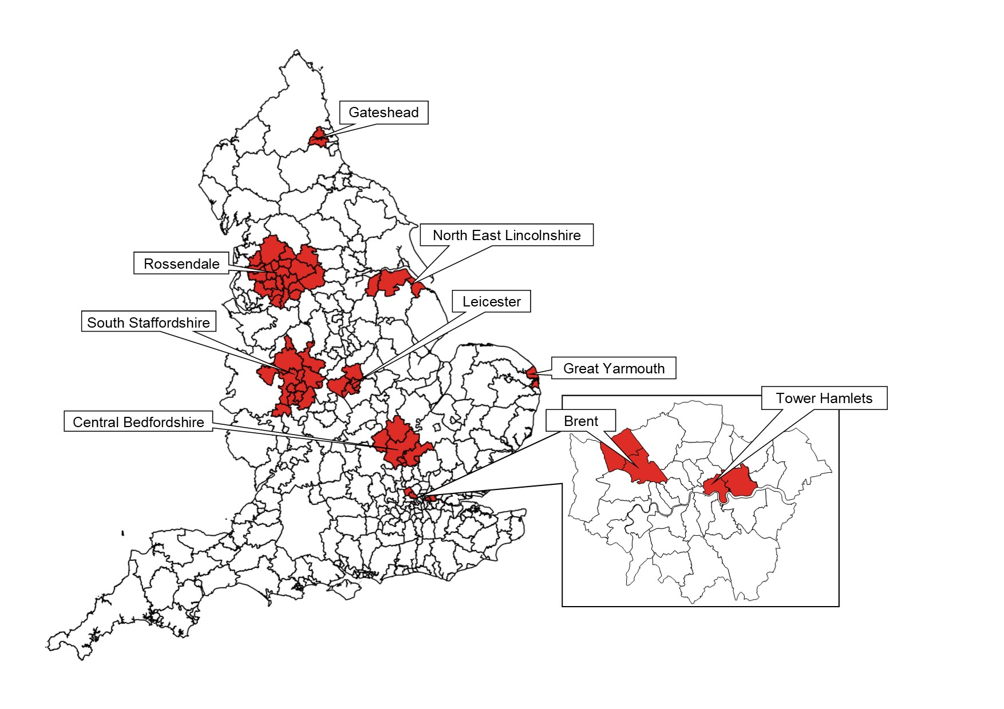
S2 Fig. Short stature clusters in England (London inset) 2006-07 to 2018-19, adjusted for ethnicity and IMD.

Note: Short stature clusters are in red. Map base layer is shapefile Local Authority Districts (December 2017) Full Clipped Boundaries in Great Britain, published by the Office for National Statistics and available at https://geoportal.statistics.gov.uk/datasets/local-authority-districts-december-2017-full-clipped-boundaries-in-great-britain/explore?location=55.450000%2C-2.950000%2C5.64&showTable=true.

