Supplementary Tables
Table S1. IEC/IRB committees that approved the EMAX trial
Comité de Ética en Investigación. INAER, Arenales 3146 1° B, Ciudad Autónoma de Buenos Aires, C1425BEN, Argentina
CEICI, Italia 424, Rosario, Santa Fe, 2000, Argentina
CEMER, Esmeralda 1550, Florida, Buenos Aires, 1602, Argentina
CECIC Comité de Ética de CER Investigaciones Clínicas, Vicente Lopez 1441, Quilmes, Buenos Aires, 1878, Argentina
Comite Independiente de etica Fundacion Rusculleda, Avenida Colon 2057, Cordoba, Córdova, X5003DCE, Argentina
Framingham Centro Médico, Calle 9 Numero 431, La Plata, Buenos Aires, B1902COS, Argentina
Comité Independiente de ética para ensayos en Farmacología Clinica del centro Medico Dra. De Salvo, Avenida Cabildo 1536 5° B, Ciudad Autonoma de Buenos Aires, Buenos Aires, C1426ABP, Argentina
Instituto Argentino de Investigacion Neurologica, Uruguay 824 1st floor, Ciudad Autonoma de Buenis Aires, C1015ABR, Argentina
FUMELIT, Av. Gdor. Freyre 3074, Santa Fe, 3000, Argentina
CIDEA, 3er Cuerpo - 2do Subsuelo, Paraguay 2035, Ciudad Autónoma de Buenos Aires, C1121ABE, Argentina
Comite de Etica de San Isidro-CESI, Avenue Libertador 169581, San Isidro, Buenos Aires, CP 1643, Argentina
Comite de etica para la investigación Clinica Fundación Dr. J.R. Villavicencio, Alvear 854, Rosario, Santa Fe, 2000QGB, Argentina
Comite de Etica Iniciativa y Refelexion Bioetica Rosario, Rioja 2926, Rosario, S2002OJN, Argentina
CESIM, Urquiza 646, Santa Rosa, 6300, Argentina
Instituto de Investigacion Clinica de Mar del Plata, Av. Colon 3364 PB, Mar del Plata, Buenos Aires, B7600FZN, Argentina
Centro de Osteopatias Medicas, Azcuenaga 1860, Buenos Aires, C1128AAF, Argentina
Comite de Etica en Investigacion Clinica - CEIC, Larrea 1381, Ciudad Autonoma de Buenos Aires, Buenos Aires, C1117ABK, Argentina
Comite de Etica en Investigacion, Instituto Ave Pulmo, Carlos M. Alvear 3345, Mar del Plata,
Buenos Aires, B7602DCK, Argentina
Bellberry Limited, 129 Glen Osmond Rd, Eastwood, South Australia, 5063, Australia
INSTITUTIONAL REVIEW BOARD Services, Suite 300, 372 Hollandview Trail, Aurora, Ontario, L4G 0A5, Canada
Comité d'éthique de la recherche de l'Institut universitaire de cardiologie et de pneumologie de Qué, 2725 Chemin Ste-Foy, Quebec, G1V 4G5, Canada
CHU Pontachaillou, Comité de Protection des Personnes, 9 Avenue de la Bataille Flandres-Dunkerque Mai 1940, Rennes, 35000, France
Ethik-Kommission der Landesaerztekammer Hessen, Im Vogelsgesang 3, Frankfurt, Hessen, 60488, Germany
Comitato Etico IRCCS Istituto Tumori "G.Paolo II", V.le Orazio Flacco 65, Bari, Puglia, 70124, Italy
Comitato Etico Campania Nord c/o A.O. San Giuseppe Moscati di Avellino, Segreteria Scientifico- Amministrativa, Città Ospedaliera -Pal. Uffici, Contrada Amoretta, Avellino, Campania, Italy
Com. Etico Reg. Toscano "Area Vasta Nord Ovest", Segreteria Scientifico-Amministrativa -Azienda Ospedaliero-Universitaria Pisana, Via Roma, 67, Pisa, Toscana, 56126, Italy
Comitato Etico Palermo 1, c/o Azienda Ospedaliera Universitaria Policlinico "Paolo Giaccone", Segreteria Scientifico-Amministrativa, Via del Vespro 129, Palermo, Sicilia, 90127, Italy
Comitato Etico Univ. Studi Campania L.Vanvitelli – AOU L.Vanvitelli - AORN Osp. dei Colli, Sede AORN Ospedali dei Colli, Via Leonardo Bianchi snc, Napoli, Campania, 80131, Italy
C.E.ROM. Comitato Etico della Romagna, c/o Ist. Scientifico Romagnolo per lo Studio e la Cura dei Tumori, IRST - IRCCS Srl, Via Piero Maroncelli 40, Meldola (FC), Emilia-Romagna, 47014, Italy
Comitato Etico Unico Regionale del Friuli Venezia Giulia, Segreteria Tecnico-Scientifica c/o Dir. Scientifica, IRCCS CRO di Aviano, Via Gallini, 2, Aviano (PN), Friuli-Venezia-Giulia, 33081, Italy
Comitato Etico dell'Area Vasta Emilia Nord, Via Vertoiba, 10A, Reggio Emilia, Emilia-Romagna, 42124, Italy
Comitato Etico Aziende Sanitarie dell'Umbria, Segreteria Scientifico-Amministrativa, Via della Rivoluzione, 16, Ellera di Corciano (PG), Umbria, 6070, Italy
Comitato Etico Area 4 – ASL Brindisi, Segreteria Scientificoamministrativa, Via Napoli, 8, Brindisi, Puglia, 72100, Italy
Comitato Etico Univ. Studi Campania L.Vanvitelli – AOU L.Vanvitelli - AORN Osp. dei Colli, Sede AORN Ospedali dei Colli, Via Leonardo Bianchi snc, Napoli, Campania, 80131, Italy
Comitato Etico degli Istituti Clinici Scientifici Maugeri SpA – SB, Via Salvatore Maugeri 4, Pavia, Lombardia, 27100, Italy
Comitato Etico Campania Sud c/o ASL Napoli 3 Sud, Segreteria Scientifico-Amministrativa, Piazza San Giovanni, 7, Brusciano (NA), Campania, 80031, Italy
Hospital Real San Jose, Av Lázaro Cárdenas 4149 Colonia Jardines de San Ignacio, Zapopan, Jalisco, 45040, Mexico
Instituto Jalisciense de Investigación Clínica, S.A. de C.V., Penitenciaria 20, Guadalajara, Jalisco, 44100, Mexico
St. Antonius Ziekenhuis, Koekoekslaan 1, NIEUWEGEIN, 3435 CM, Netherlands
Pharma Ethics, 123 Amcor Road, Lyttelton Manor, 157, South Africa
University of Cape Town, Human Research Ethics Committee, Room E52.24, Old Main Building, Groote Schuur Hospital, Main Road, Observatory, 7925, South Africa
Fundació Unió Catalana d’Hospitals, 1ºA, C/Bruc 72-74, Barcelona, 8009, Spain
Regionala Etikprövningsnämnden I Göteborg, Guldhedsgatan 5A, GÖTEBORG, SE-413 20, Sweden
Advarra Institutional Review Board, Suite 110, 6940 Columbia Gateway Drive, Columbia, Maryland, 21046, USA
Saint Luke’s Hospital Institutional Review Board, 232 South Woods Mill Road, Chesterfield, Missouri, 63017, USA
South Carolina Pharmaceutical Research, 141 Harold Fleming Court, Spartanburg, South Carolina, 29303, USA

Supplementary Table S2. Patient demographics and baseline characteristics by smoking status and treatment
Characteristic | Current smokers (N=1203) |  |  | Former smokers (N=1221)
 | UMEC/VI (n=394) | UMEC  (n=396) | SAL  (n=413) | UMEC/VI (n=418) | UMEC  (n=407) | SAL  (n=396)
Age, years, mean (SD) | 61.9 (7.4) | 62.0 (7.7) | 61.3 (8.0) | 67.2 (8.4) | 67.7 (8.3) | 67.5 (7.9)
Female, n (%) | 180 (46) | 180 (45) | 201 (49) | 139 (33) | 147 (36) | 141 (36)
Smoking pack-years, mean (SD) | 50.6 (28.6) | 46.0 (22.7) | 47.5 (24.6) | 48.3 (26.9) | 49.3 (28.7) | 48.8 (27.0)
No prior maintenance medication (from 30 days prior to Screening) , n (%) | 161 (41) | 169 (43) | 163 (39) | 89 (21) | 80 (20) | 86 (22)
Patients with a moderate COPD exacerbation history in prior yearª, n (%) | 46 (12) | 55 (14) | 63 (15) | 77 (18) | 68 (17) | 83 (21)
Duration of COPD, years, mean (SD) | 8.3 (7.2) | 7.3 (5.8) | 7.6 (5.8) | 9.2 (6.7) | 8.3 (6.1) | 9.0 (7.5)
Post-salbutamol FEV₁, mL, mean (SD) | 1635 (512) | 1653 (493) | 1652 (539) | 1523 (495) | 1567 (511) | 1545 (500)
Post-salbutamol % predicted FEV₁, mean (SD) | 55.7 (12.6) | 56.3 (12.4) | 56.0 (12.6) | 54.1 (12.9) | 55.5 (12.9) | 55.2 (13.0)
Post-salbutamol FEV₁/FVC, mean (SD) | 0.52 (0.11) | 0.53 (0.10) | 0.52 (0.09) | 0.51 (0.10) | 0.52 (0.10) | 0.51 (0.10)
% reversibility to salbutamol, mean (SD) | 10.2 (11.4) | 11.2 (13.3) | 11.0 (12.6) | 10.7 (14.1) | 9.2 (13.2) | 10.5 (13.9)
GOLD spirometric grade^{b}, n (%)
2 | 260 (66) | 269 (68) | 267 (65) | 258 (62) | 260 (64) | 255 (64)
3 | 134 (34) | 124 (31) | 145 (35) | 160 (38) | 146 (36) | 141 (36)
FEV₁, mL, mean (SD) | 1527 (511) | 1553 (485) | 1554 (546) | 1423 (509) | 1454 (520) | 1434 (513)
BDI score, mean (SD) | 7.0 (1.9) | 7.0 (2.1) | 7.1 (1.9) | 7.0 (1.8) | 7.0 (1.8) | 7.1 (1.8)
E-RS total score | 11.5 (5.5) | 11.7 (6.0) | 11.2 (5.8) | 9.9 (5.7) | 9.8 (5.6) | 9.5 (5.4)
SGRQ score, mean (SD) | 45.6 (16.1) | 47.4 (17.3) | 46.7 (17.1) | 43.4 (16.1) | 42.7 (14.5) | 42.3 (15.1)
CAT score, mean (SD) | 19.9 (6.2) | 20.4 (6.5) | 20.4 (6.6) | 18.3 (5.5) | 18.2 (5.7) | 18.1 (5.8)
Rescue salbutamol, puffs/day, mean (SD) | 2.4 (2.8) | 2.5 (2.6) | 2.5 (2.6) | 2.0 (2.2) | 1.8 (2.0) | 1.8 (2.3)

ªNumber of exacerbations requiring oral or systemic corticosteroids and/or antibiotics (moderate) in 12 months prior to screening (patients with >1 moderate exacerbation or with a severe exacerbation [requiring hospitalization] were excluded); ^{b}an additional 4 (<1%) current smokers with GOLD grade 1 were randomized (UMEC n=3; SAL n=1).

BDI, Baseline Dyspnoea Index; CAT, COPD Assessment Test; COPD, chronic obstructive pulmonary disease; E-RS, Evaluating Respiratory Symptoms–COPD; FEV₁, forced expiratory volume in 1 second; FVC, forced vital capacity; GOLD, Global Initiative for Chronic Obstructive Lung Disease; SAL, salmeterol; SD, standard deviation; SGRQ, St George’s Respiratory Questionnaire; UMEC, umeclidinium; VI, vilanterol.

Supplementary Figure Legends

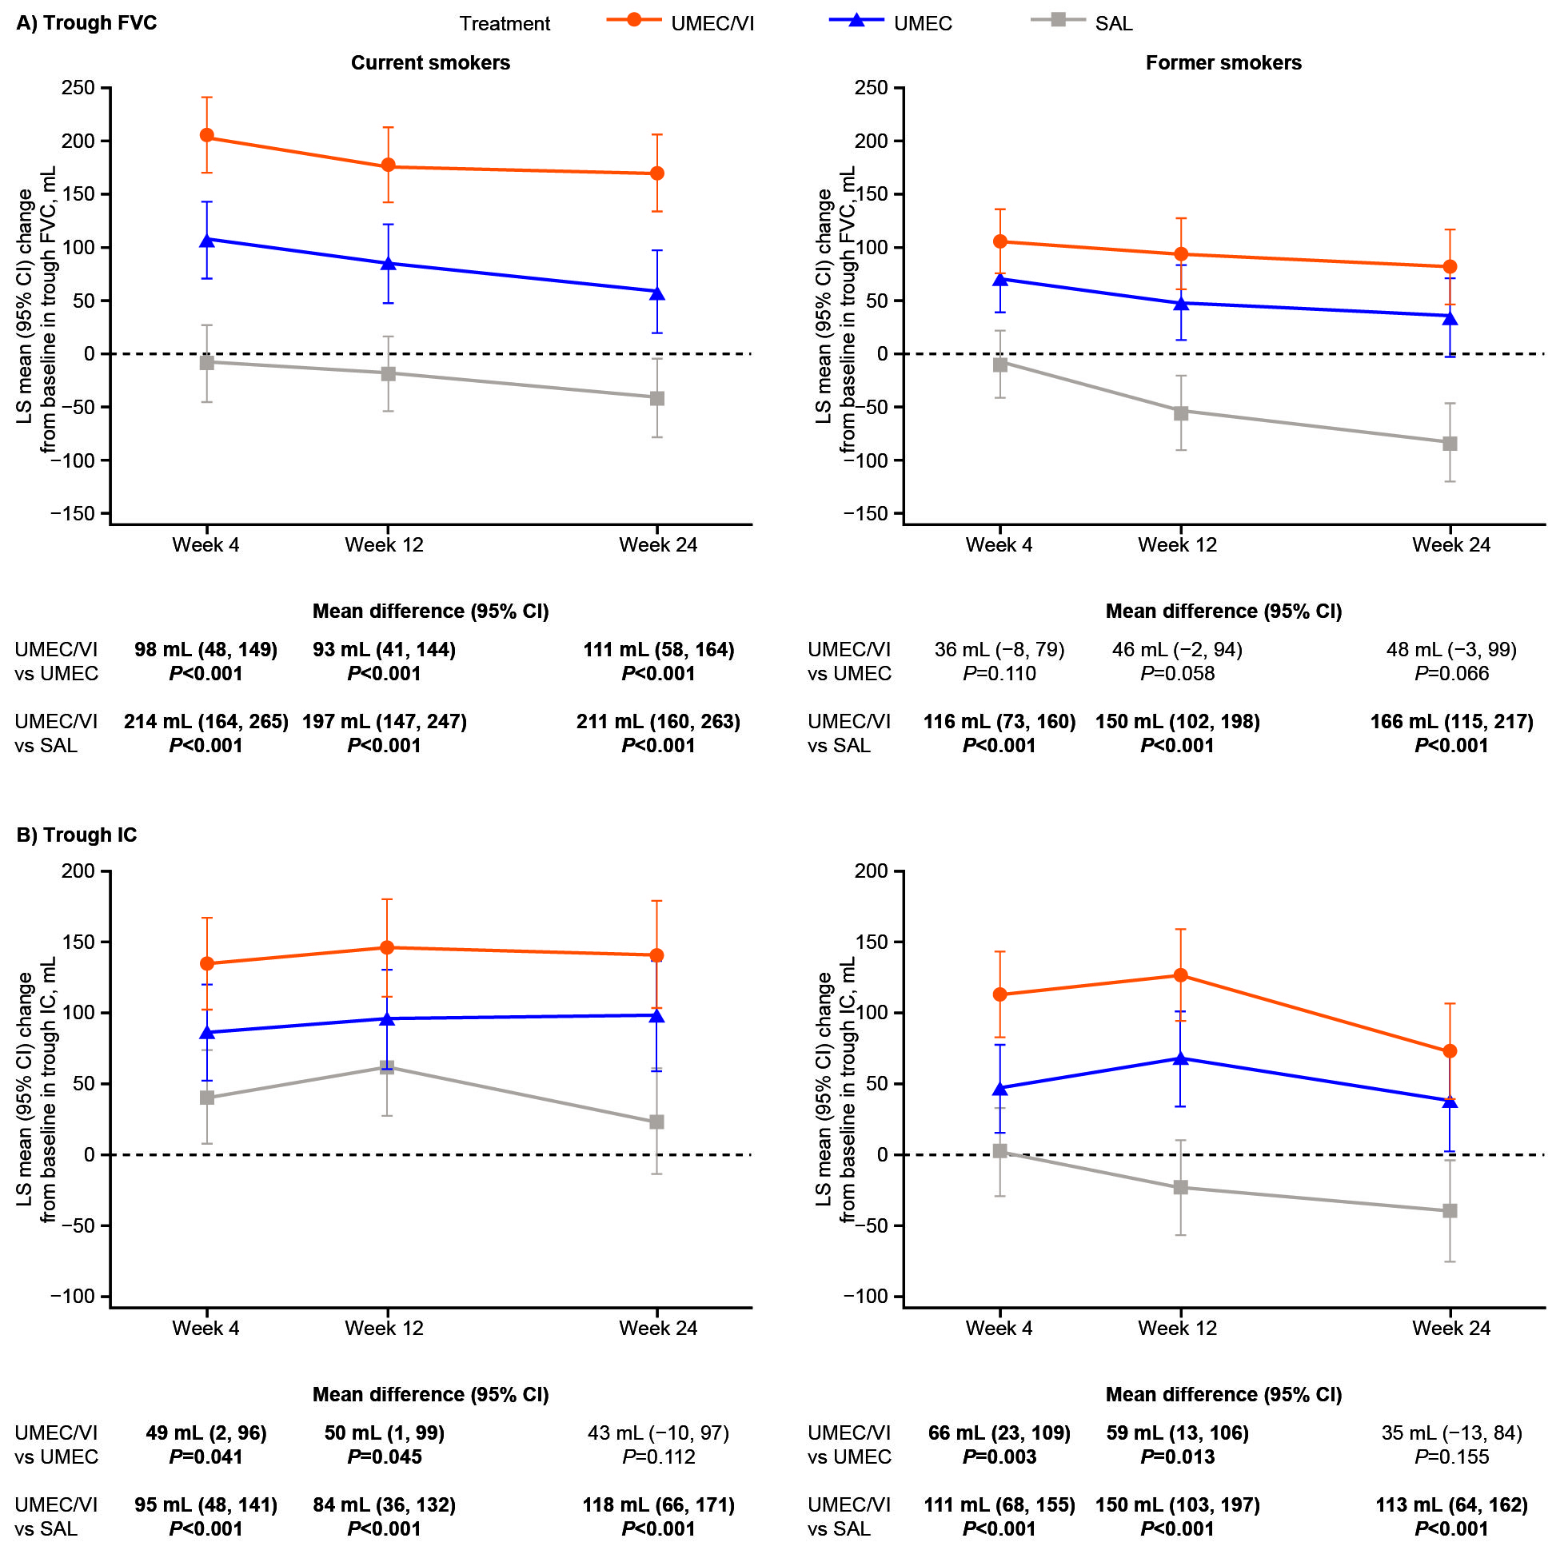Supplementary Figure S1. Change from baseline in (A) trough FVC and (B) trough IC at Weeks 4, 12, and 24 in current smokers and former smokers

CI, confidence interval; FVC, forced vital capacity; IC, inspiratory capacity; LS, least squares; SAL, salmeterol; UMEC, umeclidinium; VI, vilanterol.
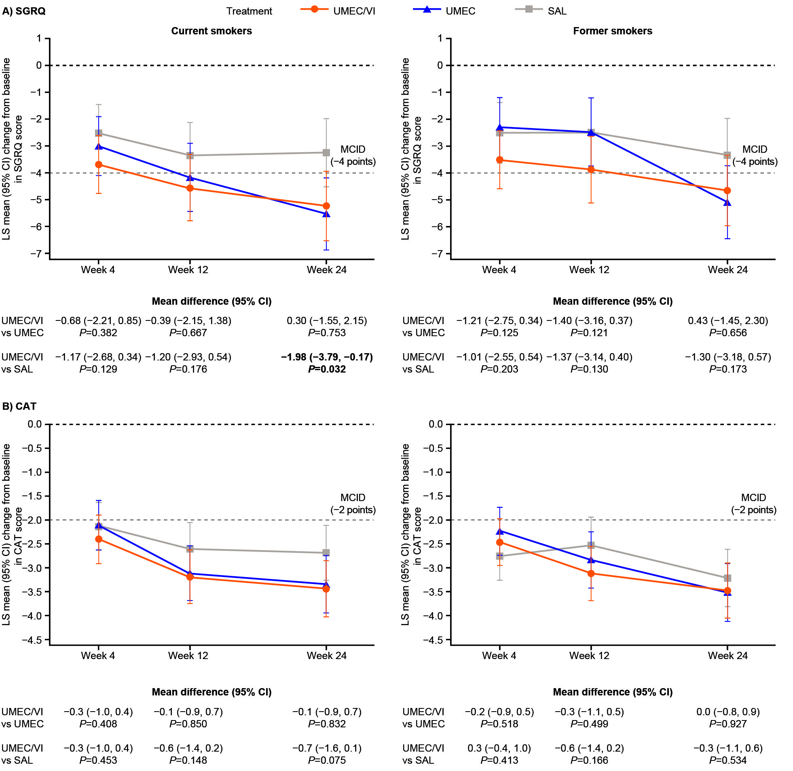
Supplementary Figure S2. Change from baseline in (A) SGRQ score and (B) CAT score at Weeks 4, 12, and 24 in current smokers and former smokers

CAT, COPD Assessment Test; COPD, chronic obstructive pulmonary disease; CI, confidence interval; LS, least squares; MCID, minimum clinically important difference; SAL, salmeterol; SGRQ, St George’s Respiratory Questionnaire; UMEC, umeclidinium; VI, vilanterol.

