International Urogynecology Journal
Early secondary repair of obstetric anal sphincter injuries (OASIs): Experience and a review of the literature
- Nicola Adanna Okeahialam, MBChB
Urogynaecology Clinical Research Fellow
Croydon University Hospital
nicola.okeahialam@nhs.net

- Ranee Thakar, MD, FRCOG
Consultant Obstetrician and Urogynaecologist
Croydon University Hospital
Honorary Senior Lecturer, St George’s University of London
ranee.thakar@nhs.net

- Abdul H Sultan, MD, FRCOG
Consultant Obstetrician and Urogynaecologist
Croydon University Hospital
Honorary Reader, St. George’s University of London
abdulsultan@nhs.net

Corresponding Author:
Mr Abdul H Sultan, MD, FRCOG
Consultant Obstetrician and Urogynaecologist
Croydon University Hospital
530 London Rd, Thornton Heath CR7 7YE
02084014395
abdulsultan@nhs.net

Financial Disclaimers/Conflicts of Interest:
Nicola Adanna Okeahialam: None
Miss Ranee Thakar: Miss Thakar is the past president of the International Urogynecological Association.
Mr Abdul H Sultan: None

Each authors' contribution to the Manuscript
NAO- Project development, Data Collection, Data analysis, Manuscript writing
RT- Project development, Manuscript editing
AS- Project development, Manuscript editing

Abstract Word Count: 237
Manuscript Body Word Count: 4288
References: 38
Figures: 4
Tables: 6

Abstract:
Introduction and Hypothesis:
Secondary anal sphincter repair for a dehisced obstetric anal sphincter injury (OASI) is required following 2.6% of primary repairs. There is growing evidence that instead of delaying repair for 3-6 months, early secondary repair of the anal sphincter can be completed within 14 days. Our aims were to review the literature and to describe experiences in our unit.

Methods:
This is a narrative review of all published cases reporting outcomes of early secondary repair of dehisced OASIs. In addition, we report a series from Croydon University Hospital (CUH) between 2010-2019.

Results:
Ninety patients from five studies were identified on literature search. Six patients from CUH were included in the case series. Overall, the most common complications included skin dehiscence (10.3% (n=10)), infection (5.2% (n=5)) and fistula formation (8.2% (n=8)). In our case series, normal manometric incremental squeeze pressure was found in five women (83%). Also, on endoanal ultrasound, internal anal sphincter (IAS) defects were found in 75% with a history of IAS injury (n=4). There were no full thickness external anal sphincter defects. In comparison to those requiring primary repair alone, residual defects were significantly larger in those undergoing secondary repair (Starck score 2.1 vs 5.7, p=0.01).

Conclusion:
Early secondary repair is a feasible surgical procedure for the reconstruction of dehisced OASIs. This case series and review of the literature can be used to support clinicians in the management of primary OASI repair dehiscence.

Keywords:
Obstetric Anal Sphincter Injury, Anal sphincter repair, Early secondary sphincter repair, Anal incontinence

Brief summary:
Early secondary repair is a feasible surgical procedure for the reconstruction of dehisced OASIs with satisfactory postoperative outcomes.

Main Text
Introduction:
Complications following primary repair of obstetric anal sphincter injuries (OASIs) occur in approximately 7% of women. These include wound infection, wound dehiscence, hospital readmission and re-operation [1]. Wound infection and dehiscence in OASI has been shown to most often occur concurrently [2] Complete dehiscence of a primary OASI repair is uncommon, with secondary anal sphincter repair being required in 2.6% of women following primary repair [1].

Early secondary repair of the anal sphincter is defined as repeat repair within 14 days following vaginal delivery [3]. Traditionally, it is recommended that repeat repair of a primary anal sphincter dehiscence should be delayed for three to six months. This is done to ensure tissues have adequate vascular supply and that inflammation has completely resolved [4, 5] thereby, reducing the risk of wound complications such as infection, abscess and fistula formation [6]. However, this delayed approach is associated with an increase in maternal morbidity and reduction in quality of life due to persistent anal incontinence, pain and sexual dysfunction whilst awaiting secondary repair [7]. The optimal timing of the management of a dehisced OASI is unclear. This is due to the growing body of evidence in the literature describing early secondary repair and its comparable short and long- term post-operative outcomes [3, 4, 6, 8].

The aims of this review were firstly, to perform a narrative review of the literature regarding early secondary repair of OASIs following wound dehiscence. Secondly, we aimed to demonstrate our experience in the management of dehisced primary OASIs repair with reference to wound healing outcomes, anorectal symptoms and sphincter integrity, comparing these outcomes to a control group of primary repairs without wound breakdown.

Methods:
Firstly, we performed a narrative review of all published cases reporting outcomes of early secondary repair of the anal sphincter following complete OASI dehiscence. A literature search of Medline, Cinahl and Emcare Cochrane Library, Trip database, BMJ Best Practice, BMJ Case Reports and Up-To-Date was conducted, using the MeSH terms; obstetric, anal sphincter, vaginal delivery, faecal incontinence. In addition, a hand search of the references in these papers was completed. All titles and abstracts were screened, and relevant articles reviewed. Conference proceedings were not included. Authors of included studies were contacted if the full text was not available or if data reported was published in a manner that was unclear and not extractable.

Secondly, a retrospective analysis of all women who underwent early secondary OASI repair or primary repair alone at Croydon University Hospital between July 2010 to October 2019 was performed. Croydon University Hospital is a district general hospital, with a tertiary referral specialist perineal trauma and pelvic floor reconstruction unit [9]. All women with dehiscence of their primarily repaired OASI were reviewed in a dedicated perineal clinic led by a urogynaecology consultant. Dehiscence was defined as complete or near-complete separation of the primary anal sphincter repair on clinical examination. Prior to surgery, women were examined clinically and endoanal ultrasound was performed to confirm the diagnosis and demarcate the extent of sphincter disruption. In cases of superficial wound infection, broad-spectrum oral antibiotics were given. In the presence of deep wound infection, intravenous antibiotics were commenced (Cefuroxime 1.5 g and Metronidazole 500 mg or in cases of penicillin allergy: Clindamycin 900mg and Ciprofloxacin 400mg). The wound was irrigated regularly until the wound was deemed clean. No bowel preparation was given prior to surgery. All procedures were completed on an emergency or elective operating list by the urogynaecology consultant (AHS or RT).

2.1 Surgical technique
All secondary wound closures were performed using a standard surgical procedure protocol under general anaesthetic, which is described below.

Women were given a prophylactic broad-spectrum antibiotic perioperatively. A per rectal examination was performed to review the extent of dehiscence and old sutures were removed (Figure 1). The wound was irrigated with a 50:50 dilution of 3% hydrogen peroxide and 0.9% sodium chloride. Wound debridement was then completed using a brush and curette and bleeding points were cauterised. If the anal epithelium had broken down, it was repaired separately with a continuous, non-locking 3-0 Vicryl (polyglactin) suture. The torn ends of the external anal sphincter (EAS) were mobilised by dissection of EAS away from the ischioanal fat laterally to release tension (Figure 2). If the internal anal sphincter (IAS) repair was broken down, it was repaired separately by end-to-end approximation using horizontal mattress sutures. If the full length of the EAS was identified it was repaired using an overlap technique (Figure 3). If this was not possible, an end-to-end repair was performed similar to the technique of internal sphincter repair. The edges of the vaginal skin were then freshened with excision of devitalised tissue.
Perineal repair was completed in three layers using 2-0 Vicryl (polyglactin) suture material. First, the vaginal mucosa was closed with a continuous, non-locking suture. The perineal muscles were then dissected away from the skin as necessary to release tension and sutured continuously in one or two layers, ensuring closure of dead space. Following this, skin closure was completed with interrupted mattress sutures (Figure 4). At the end of the procedure, the vaginal and rectal examinations were repeated, to ensure the vaginal introitus admitted at least two fingerbreadths. Also, in cases where the rectal mucosa was intact; to confirm that no sutures had penetrated the rectal mucosa (Figure 4).
All women were discharged with oral broad-spectrum antibiotics for five days, stool softeners for ten days and followed up in the perineal clinic one week after the procedure. Women were also reviewed three months postpartum using the validated St Mark’s Incontinence Score (SMIS) to assess anorectal symptoms. This score grades the severity of anal incontinence on a scale of 0-24 with 24 being severe incontinence [10]. Endoanal ultrasound (EAUS) was performed using the Pro-focus 2202 or Flex-focus 500 ultrasound system (BK Medical, Herlev, Denmark, Type 2052; 360◦ rotational probe). A residual anal sphincter defect was defined as a full-thickness discontinuity of >1-hour size (30° angle). A discontinuity of ≤1-hour was classified as a scar; a normal finding following sphincter repair [11]. The modified Starck score was used to evaluate the extent of an abnormal anal sphincter defect diagnosed on EAUS based on the length, depth and size of defect, using a scale of 0 (no defect) to 16 (> 180⁰ size defect which affects the entire length and depth of the anal sphincter) [12]. Anal manometry was performed using a validated Stryker 295-1 Intra-Compartmental Pressure Monitor [13] or the portable Anopress device (THD Worldwide, Correggio (RE), Italy) [14] . Maximum resting pressure (Normal = 40-103 mmHg) and maximum squeeze pressure (Normal =41-121 mmHg) were measured. The difference between these two measurements, the incremental maximum squeeze pressure (iMSP) (Normal= >20mmHg) was then calculated.
Data was analysed using SPSS version 26.0.0.0. Nominal data is expressed as number and percentage. For continuous data, the mean (SD) was calculated. In order to evaluate outcomes following primary and early secondary OASI repair, continuous variables were compared using Student’s t test, whereas the Fisher’s exact test was used for categorical variables. A corresponding p value of < 0.05 was considered statistically significant.

Results:
Review of the literature:
The search identified a total of 86 papers of which five relevant papers were reviewed after removal of duplicates and screening of both title and abstract. A narrative overview of the studies was then conducted. Table 1 and 2 show a summarised description of papers included in this review.

From the five papers identified, a total of 90 patients had undergone early secondary re-suturing of a dehisced OASI [3, 4, 6, 8, 15]. Although the total number of patients from the five studies was 121, 22 of the patients from the prospective study by Soerensen et al [3] were also included in the retrospective analysis by Barbosa el al [6]. Barbosa et al [6] provided the unpublished data for 29 patients from their cohort. However, nine patients were excluded due to incomplete data sets. Pre-operatively, daily perineal wound irrigation was completed in two studies, to ensure the wound was clean, free of exudate with healthy granulation tissue prior to repair [4, 8]. During pre-operative wound preparation, oral [4, 15] or intravenous [8] antibiotics were given if there was concurrent wound infection. Most studies reported that women received intravenous broad spectrum antibiotics at the time of repair [3, 4, 6, 8]. However, one-study did not report using any peri-operative antibiotics [15]. In two studies, the EAS and IAS were repaired separately with end to end approximation using 2-0 Vicryl (polyglactin) sutures [3, 6]. One study, reported repairing the EAS and IAS separately using an overlapping and continuous technique respectively with 2-0/3-0 polydioxanone sutures [15]. Two studies repaired the EAS with interrupted sutures [4, 8]. Hauth et al reported repairing the EAS using a ‘figure of eight’ technique with chromic surgical gut sutures, but this study was more than 35 years old [8]. In all studies, if the rectal mucosa was disrupted, it was repaired separately with the continuous [3, 4, 6, 8, 15] or interrupted [4] technique. Sutures used included; 3-0/4-0 polyglactin/ polyglycolic acid [4], 2-0, polyglactin [3] or chromic surgical gut [8]. One study did not specify the absorbable suture type used [6].

Post-operative wound care included regular perineal toileting in four studies [3, 4, 8, 15]. However, antibiotic provision differed across all studies. In one study, all women were given three doses of intravenous antibiotics [4], whilst in one, oral broad spectrum antibiotics were only given post-operatively in cases of obvious infection; this was for a total of five days [3]. However, Lewicky-Gaupp et al discharged all women with a seven day course of broad-spectrum antibiotics [15]. Laxatives were given post-operatively in all studies [3, 4, 6, 8, 15]. The duration of laxative use was only documented in one study; this was advised for six weeks [8].

Four studies reported short-term follow up of wound healing outcomes and anorectal symptoms: up to three [4, 15] and six months [3, 8]. One study reported an average follow-up period of four years [6]. Wound healing complications following early secondary repair were reported in all studies. Out of 90 patients, superficial skin dehiscence occurred in seven women (7.8%) [4, 15]. Five women (5.6%) developed wound infection (two had concurrent dehiscence of the perineal muscles and one of the sphincter repair) [6, 8, 15]. Overall, four women (4.4%) required a repeat sphincter operation [6]. Seven women (7.8%) developed a fistula [4, 6, 8], and 57.1% of these required surgical repair [rectovaginal (n=1) [6, 8], anovaginal (n=3) [6]. The rest closed spontaneously without intervention (rectoperineal (n=1), anovaginal (n=2)) [4, 6].

Anorectal symptoms were reported to occur following early secondary sphincter repair in four studies [3, 4, 6, 15]. In all studies, flatal incontinence was the most commonly reported symptom, with 100% of women reporting this at long term follow up (mean= 4 years) [6]. However, studies with shorter follow-up reported flatal incontinence occurring in 5% at six weeks [4], in 22% at three months [15] and 40.9% at six months[3]. Faecal incontinence was reported in two studies with 14.3% experiencing involuntary leakage of liquid stool at six months [3] and 50.0% at four years [6]. With solid stool, 9.5% experienced symptoms at six months [3] and 40.0% at four years [6]. In addition, mean SMIS was also lower at six months (6.0) [3] in comparison to four years follow up (8.5) [6].
Croydon University Hospital Cases:
Between July 2010 to October 2019, 510 patients underwent primary repair of OASIs and were subsequently seen three-months postpartum in our perineal clinic. Six (1.2%) of these women experienced dehiscence of their primary repair and underwent early secondary repair. Table 3 describes the delivery details and characteristics of these women. Misdiagnosed perineal tears were found in three women (case 2, 4 and 6). Repeat repair of the anal sphincter was completed between 5 to 15 days following vaginal delivery and primary anal sphincter repair. All women underwent daily perineal irrigation prior to repair. Two patients (case 3 and 6) required pre-operative intravenous antibiotics due to evidence of deep perineal infection. The remaining four women were managed with oral antibiotics. An end-to-end repair technique of the EAS was used in the majority of cases (cases 2-5). In the patient (case 2) with a missed buttonhole tear the anal mucosa was accessed by division of the IAS. In the two women (case 3 and 5) with a history of grade 3c tears, the IAS appeared intact at the time of secondary repair. All patients were discharged the following day with advice regarding perineal hygiene and performing pelvic floor muscle exercises when they found it comfortable. A five-day course of broad-spectrum oral antibiotics and Lactulose for ten days were prescribed (Table 3).

In comparison to women who underwent primary repair alone, those who had a secondary repair had a significantly higher number of women with major tears (3c, 4th, buttonhole) (p= 0.001). In addition, the mean infant birthweight was significantly higher (p=0.03) in the secondary repair group (3846.3 g [SD 538.2]) in comparison to those who only had a primary repair (3415.9 g [SD 467.7]). There was no significant difference in other variables including mode of delivery, age or body mass index (BMI) (Table 4).

The average wound healing time ranged between 17 to 42 days. Wound healing was defined as complete closure of the perineal muscle and skin, with absence of exudate or inflammation. Complications following secondary suturing included skin dehiscence in three patients; managed expectantly (healing by secondary intention). Other complications included, granulation tissue formation in four women; requiring cauterisation with silver nitrate and haematoma formation which was managed conservatively with antibiotic prophylaxis. Also, two women (case 1 and 2) developed asymptomatic perineal sinus tracts. On surgical exploration, case 1 was confirmed to be blind-ending and was laid open, with no further surgical intervention required. Case 2 was found to be complex in nature and shown to communicate with the anal canal on magnetic resonance imaging. However, this patient was lost to follow-up (Table 4).

Table 5 highlights findings from follow up at three months; review of anorectal symptoms, anal manometry and EAUS. Four women did not report any symptoms, with case 4 reporting occasional faecal urgency and case 5 reporting faecal urgency and flatal incontinence (Total SMIS of 2 and 8 respectively). Normal IMSP was found in five out of six patients. Residual defects of the IAS were found in three of four patients with a history of IAS injury (case 2, 3 and 5). There were no full thickness residual EAS defects present in any of the women following secondary sphincter repair. In comparison to women who underwent primary OASI repair alone, there was no significant difference in SMIS or iMSP. However, the Starck score was significantly higher (p=0.01) in women who had a secondary OASI repair (5.7 [SD 4.7]) in comparison to those who had a single repair (2.1 [SD 3.1]) (Table 6).

Discussion:
This case series and review of the literature of 96 women undergoing early secondary sphincter repair has demonstrated that most have a satisfactory post-operative recovery with few complications. Potential wound healing complications following include superficial skin dehiscence in 10.3% (n=10) [4, 15], infection in 5.2% (n=5) [6, 8, 15] and fistula formation in 8.2% (n=8) [4, 6, 8]. These risks can potentially be minimised with pre-operative perineal irrigation, antibiotics and laxatives. However, the risk of complications, particularly the development of a fistula must be considered by clinicians when counselling women regarding the management of a dehisced OASI.

Our case series is strengthened by the use of the validated SMIS score in the reporting of anorectal symptoms [10]. In addition, we used EAUS to evaluate sphincter integrity, the gold standard imaging investigation for the evaluation of anal sphincter defects [16]. We are not aware of any study that has reported anal manometry and EAUS findings following early secondary repair. Moreover, by contacting corresponding authors we were able to include unpublished data, which strengthens our findings. Limitations of our case series included its retrospective nature and the relatively small number of women experiencing dehiscence of their primary repair but this is to be expected due to its infrequent occurrence [1, 17]. We acknowledge that another limitation of this review is that it is not a systematic review but unfortunately only lower quality studies with inconsistent outcome measures have been published with respect to early secondary sphincter repair. However, due to the nature of OASI dehiscence, completion of a prospective study comparing re-suturing with healing by secondary intention would prove difficult. A randomised control trial comparing the two management options with dehisced perineal wounds (with an intact anal sphincter) has previously been performed, but due to patient and clinician preferences, the study faced recruitment challenges and was terminated prematurely. However despite this, the study showed a significant increase in wound healing by two weeks and patient satisfaction at three months [18].

The incidence of women requiring secondary repair in our case series was lower than the incidence reported by Stock et al in their retrospective analysis of 909 women with OASIs (1.2% vs 2.6%) [1]. However, the average BMI of their cohort was much higher than the BMI of the 510 women undergoing primary repair of OASI at Croydon University Hospital (28.8 kg/m² vs 24.7 kg/m²). In their study they found that the risk of wound complications increased by 6% for every unit increase in BMI [1]. Operative delivery and fourth degree tears were also additional risk factors [1]. Although we found that compared to the primary repair group, more women who had an early secondary sphincter repair had undergone operative delivery and had a higher mean BMI, it was not statistically significant. However, women requiring a secondary repair had significantly higher grades of tear in comparison to those who had a primary OASI repair alone.

As women undergoing an early secondary repair of a broken-down wound have potentially poor-quality tissue, all women in our case series received antibiotics if there were concurrent signs of wound infection, prior to microbiological confirmation. Also, all underwent daily perineal irrigation until the signs of infection had resolved. This concurred with the approach adopted in two studies included in the literature review, in which pre-operative wound preparation also incorporated daily perineal irrigation and sharp debridement of devitalised wound edges [4, 8]. Of the 37 women included in these studies and our case series, one (2.7%) experienced wound infection [8] and three (8.1%) developed a fistula [4, 8]. By contrast, of the 59 women in the remaining studies where wound irrigation and sharp debridement was not performed, a greater proportion developed a wound infection (6.8%, n=4) [6, 15] and fistula (8.5%, n=5) [6]

Obstetric trauma is the most common cause of rectovaginal fistula, which tends to form at two time points: immediately after delivery, or 7-14 days following delivery due to wound infection [19]. A large prospective population-based study of 116,389 vaginal deliveries in Norway showed that the incidence of obstetric related rectovaginal fistula was 13.7/100000 women. 50% of cases were following OASI, 20% after a first- or second-degree perineal tear and in 30% of cases the perineum appeared intact at delivery [17]. Fourth-degree perineal tears or buttonhole tears that are missed, infected, dehisced or are repaired inadequately, have been described to be at an increased risk of developing a fistula [19–21]. Fistula formation occurred mostly in women who had secondary repair of a fourth-degree perineal tear [6, 8]. In our case series, a complex recto-vaginal fistula developed in one patient following repair of a dehisced 3b perineal tear and an undiagnosed buttonhole tear. Repair technique for buttonhole tears has been described previously by Roper et al [22].

When a traditional approach of delaying repair for three to six months was adopted, wound infection has been reported to occur in 20% of patients and fistulae in 9% [23]. It is important to note that, at the time of diagnosis of OASI dehiscence, 41.2% of the women included in the study by Lewicky- Gaupp et al had developed concomitant rectovaginal fistulae which were repaired at the time of secondary sphincter repair [15]. This could be a reflection of the referral pattern to their service, which is a tertiary unit. It is believed that up to 50% of acute small rectovaginal fistulae will spontaneously heal without intervention [24]. This phenomenon of spontaneous healing or healing following a diverting stoma has also been reported in other referral centres. However, surgical repair of a rectovaginal fistula can be challenging and is associated with a high recurrence rate and the need for a diverting stoma [17, 25].

The description of re-suturing techniques in the cases series in our unit was consistent with the literature, with suturing of the EAS and IAS separately using an end to end technique being the most common approach [3, 4, 6, 8]. The previous conventional approach to sphincter repair was to directly oppose the EAS and due to difficulty with identifying the IAS, suturing the IAS together with the rectal mucosa [26]. This would account for two studies [4, 8] description of repairing the rectal mucosa followed by the EAS alone with interrupted sutures. Moreover, the case series including eight patients by Hauth et al [8] used figure-of-eight haemostatic chromic surgical gut sutures for the EAS. However, it is important to note that these patients were recruited between 1980-1985. This technique should not be used for OASI repair due to the risk of ischaemia and subsequent necrosis [27–29].

Most patients included in the literature review and our case series received intra-operative broad-spectrum antibiotics, in line with recommended practice following OASI [27, 29, 30]. It has been shown that the use of prophylactic antibiotics at the time of primary repair significantly reduces the risk of perineal wound complications such as wound dehiscence or purulent discharge [31]. In addition, OASI has been described to increase the risk of wound breakdown following vaginal delivery four-fold [32]. Although all patients in our case series received a five-day course of broad-spectrum antibiotics, antibiotics were not routinely given in the studies included in this review. In two studies antibiotics were given post-operatively; either routinely [15] or in the presence of obvious concurrent infection [3]. Although the evidence surrounding the use of post-operative antibiotics following OASI repair is limited, antibiotic use may potentially reduce the risk of infection, breakdown and development of fistulae [27, 33]. With regards to other post-operative management, all patients in this review also received laxatives. Laxatives are recommended as the passage of hard stool and faecal impaction requiring manual evacuation can result in disruption of the sphincter repair [28, 29].

In keeping with the literature, the most common anorectal symptoms reported in our case series following early secondary sphincter repair was faecal urgency (n=2) and flatal incontinence (n=1). This was reported in the literature review both in the short and long-term [3, 4, 6, 15]. In addition, the SMIS at three-months follow-up for the majority of women in our case series was 0. Whilst at long-term follow up, Barbosa et al showed that the mean SMIS reported was 8.5 [6]. The SMIS in women with a history of OASIs undergoing late secondary sphincter repair has also been reported to be higher at long-term follow up [34, 35]. Berg et al completed a retrospective analysis of 94 women with a history of OASI undergoing late sphincter repair for anal incontinence, and found that median SMIS improved from 13 pre-operatively to 2.5 six weeks post-operatively; however at long term follow-up (median 44.5 months) this had increased to 6.5 [35]. Moreover, in a prospective study of 40 women by Johnson et al, the median SMIS improved from 12.0 pre-operatively to 7.0 at seven months post-operatively, however at long term follow up (median 103 months) this had increased to 9.0 [34].

With regards to anal manometry, in our series, the majority of women had a normal iMSP, which directly correlates with EAS function [16]. However, residual defects of the IAS following early secondary sphincter repair were found on EAUS in 75% of patients with a history of IAS injury. In addition, although there were no full thickness residual EAS defects detected, two women had partial thickness defects. It has been postulated that repairing healthy sphincter muscle at primary repair would lead to a better result than secondary repair of scarred sphincter muscle [36]. This would explain why in our series the Starck score was significantly higher in women who had required a secondary repair in comparison to those who had undergone a primary repair alone, highlighting the importance of optimal primary sphincter repair. Identifying and re-suturing the IAS is often difficult and the general opinion amongst colorectal surgeons is that injuries to the IAS cannot be surgically repaired [7]. In our series, despite the IAS clinically appearing intact, two women subsequently had an IAS defect on EAUS. Persistent IAS defects following primary OASI repair have been shown to be associated with anal incontinence [37]. However, persistent IAS and EAS defects on EAUS also occur following late secondary sphincter repair. Berg et al have shown that when separate repair of the IAS and EAS is performed, an IAS defect persists in 39% of cases and an EAS defect in 18% [35]. However, those with a persistent IAS defect are more likely to have poorer functional outcome following repair [35]. Therefore, if a dehisced OASI involves the IAS and the IAS can be identified, it should be repaired using the techniques described by Sultan et al [28, 29].

Conclusion:
Early secondary repair is a feasible surgical procedure for the reconstruction of dehisced OASIs. This case series and review of the literature can be used to by clinicians to understand management options and counsel women presenting with wound dehiscence following primary OASI repair.

Acknowledgements:
We thank M Barbosa (Aarhus University Hospital) for providing her unpublished crude data.
References: 38/100
1. Stock L, Basham E, Gossett DR, Lewicky-Gaupp C (2013) Factors associated with wound complications in women with obstetric anal sphincter injuries (OASIS). American Journal of Obstetrics and Gynecology 208:327.e1-327.e6. https://doi.org/10.1016/j.ajog.2012.12.025
2. Goldaber KG, Wendel PJ, McIntire DD, Wendel GD (1993) Postpartum perineal morbidity after fourth-degree perineal repair. American Journal of Obstetrics and Gynecology 168:489–493. https://doi.org/10.1016/0002-9378(93)90478-2
3. Soerensen MM, Bek KM, Buntzen S, et al (2008) Long-Term Outcome of Delayed Primary or Early Secondary Reconstruction of the Anal Sphincter after Obstetrical Injury: Dis Colon Rectum 51:312–317. https://doi.org/10.1007/s10350-007-9084-4
4. Arona AJ, al-Marayati L, Grimes DA, Ballard CA (1995) Early secondary repair of third- and fourth-degree perineal lacerations after outpatient wound preparation. Obstet Gynecol 86:294–296. https://doi.org/10.1016/0029-7844(95)00128-e
5. Hankins GD, Hauth JC, Gilstrap LC, et al (1990) Early repair of episiotomy dehiscence. Obstet Gynecol 75:48–51
6. Barbosa M, Glavind-Kristensen M, Christensen P (2020) Early secondary repair of obstetric anal sphincter injury: postoperative complications, long-term functional outcomes, and impact on quality of life. Tech Coloproctol 24:221–229. https://doi.org/10.1007/s10151-019-02146-z
7. Phillips R, Brown T (2007) Surgical Management of Anal Incontinence Part A. Secondary Anal Sphincter Repair. In: Sultan AH, Thakar R, Fenner DE (eds) Perineal and anal sphincter trauma: diagnosis and clinical management. Springer, London, pp 144–153
8. Hauth JC, Gilstrap LC, Ward SC, Hankins GDV (1986) Early Repair of an External Sphincter Ani Muscle and Rectal Mucosal Dehiscence: Obstetrics & Gynecology 67:806–809. https://doi.org/10.1097/00006250-198606000-00011
9. Wan OYK, Taithongchai A, Veiga SI, et al (2020) A one-stop perineal clinic: our eleven-year experience. Int Urogynecol J 31:2317–2326. https://doi.org/10.1007/s00192-020-04405-2
10. Vaizey CJ, Carapeti E, Cahill JA, Kamm MA (1999) Prospective comparison of faecal incontinence grading systems. Gut 44:77–80. https://doi.org/10.1136/gut.44.1.77
11. Jordan PA, Naidu M, Thakar R, Sultan AH (2018) Effect of subsequent vaginal delivery on bowel symptoms and anorectal function in women who sustained a previous obstetric anal sphincter injury. Int Urogynecol J 29:1579–1588. https://doi.org/10.1007/s00192-018-3601-y
12. Starck M, Bohe M, Valentin L (2003) Results of endosonographic imaging of the anal sphincter 2-7 days after primary repair of third- or fourth-degree obstetric sphincter tears: Endosonographic imaging after anal sphincter tear repair. Ultrasound Obstet Gynecol 22:609–615. https://doi.org/10.1002/uog.920
13. Sultan AH, Kamm MA, Hudson CN, et al (1993) Anal-Sphincter Disruption during Vaginal Delivery. N Engl J Med 329:1905–1911. https://doi.org/10.1056/NEJM199312233292601
14. Leo CA, Cavazzoni E, Leeuwenburgh MMN, et al (2020) Comparison between high‐resolution water‐perfused anorectal manometry and THD ® Anopress anal manometry: a prospective observational study. Colorectal Dis codi.14992. https://doi.org/10.1111/codi.14992
15. Lewicky-Gaupp C, Mueller MG, Collins SA, et al (2020) Early Secondary Repair of Obstetric Anal Sphincter Injury Breakdown: Contemporary Surgical Techniques and Experiences From a Peripartum Subspecialty Clinic. Female Pelvic Medicine & Reconstructive Surgery Publish Ahead of Print: https://doi.org/10.1097/SPV.0000000000000921
16. Sultan AH, Monga A, Lee J, et al (2017) An International Urogynecological Association (IUGA)/International Continence Society (ICS) joint report on the terminology for female anorectal dysfunction. Int Urogynecol J 28:5–31. https://doi.org/10.1007/s00192-016-3140-3
17. Trovik J, Thornhill HF, Kiserud T (2016) Incidence of obstetric fistula in Norway: a population-based prospective cohort study. Acta Obstetricia et Gynecologica Scandinavica 95:405–410. https://doi.org/10.1111/aogs.12845
18. Dudley L, Kettle C, Thomas PW, Ismail KMK (2017) Perineal resuturing versus expectant management following vaginal delivery complicated by a dehisced wound (PREVIEW): a pilot and feasibility randomised controlled trial. BMJ Open 7:e012766. https://doi.org/10.1136/bmjopen-2016-012766
19. Abulafi AM, Sultan AH (2021) Rectovaginal Fistulae. In: Santoro GA, Wieczorek AP, Sultan AH (eds) Pelvic Floor Disorders: A Multidisciplinary Textbook. Springer International Publishing, Cham, pp 975–994
20. Rogers R, Fenner DE (2007) Rectovaginal Fistula. In: Sultan AH, Thakar R, Fenner DE (eds) Perineal and anal sphincter trauma: diagnosis and clinical management. Springer, London, pp 166–177
21. Keighley MRB, Bick D, Frohlich J, et al (2017) Mothers with Anal Sphincter Injuries In Childbirth. Information Document: Anal incontinence following Obstetric Anal Sphincter Injuries at Birth
22. Roper JC, Thakar R, Sultan AH (2020) Isolated rectal buttonhole tears in obstetrics: case series and review of the literature. Int Urogynecol J. https://doi.org/10.1007/s00192-020-04502-2
23. Oom DMJ, Gosselink MP, Schouten WR (2009) Anterior Sphincteroplasty for Fecal Incontinence: A Single Center Experience in the Era of Sacral Neuromodulation: Diseases of the Colon & Rectum 52:1681–1687. https://doi.org/10.1007/DCR.0b013e3181b13862
24. Homsi R, Daikoku NH, Littlejohn J, Wheeless CR (1994) Episiotomy: Risks of Dehiscence and Rectovaginal Fistula. Obstetrical & Gynecological Survey 49:803–808. https://doi.org/10.1097/00006254-199412000-00002
25. Fu J, Liang Z, Zhu Y, et al (2019) Surgical repair of rectovaginal fistulas: predictors of fistula closure. Int Urogynecol J 30:1659–1665. https://doi.org/10.1007/s00192-019-04082-w
26. Knowles CH, Laurberg S, Lehur P-A, et al (2017) Surgery for adult faecal incontinence. In: Abrams P, Cardozo L, Wagg A, Wein A (eds) Incontinence, 6th ed. International Continence Society, pp 2090–2117
27. Royal College of Obstetrics and Gynaecology (2015) Management of third and fourth degree perineal tears. Greentop guideline number 29
28. Sultan AH, Monga AK, Kumar D, Stanton SL (1999) Primary repair of obstetric anal sphincter rupture using the overlap technique. BJOG:An international journal of O&G 106:318–323. https://doi.org/10.1111/j.1471-0528.1999.tb08268.x
29. Sultan AH, Thakar R (2007) Third and Fourth Degree Tears. In: Sultan AH, Thakar R, Fenner DE (eds) Perineal and Anal Sphincter Trauma. Springer, London, pp 33–51
30. Buppasiri P, Lumbiganon P, Thinkhamrop J, Thinkhamrop B (2014) Antibiotic prophylaxis for third- and fourth-degree perineal tear during vaginal birth. Cochrane Database of Systematic Reviews. https://doi.org/10.1002/14651858.CD005125.pub4
31. Duggal N, Mercado C, Daniels K, et al (2008) Antibiotic Prophylaxis for Prevention of Postpartum Perineal Wound Complications: A Randomized Controlled Trial. Obstetrics & Gynecology 111:1268–1273. https://doi.org/10.1097/AOG.0b013e31816de8ad
32. Williams MK, Chames MC (2006) Risk factors for the breakdown of perineal laceration repair after vaginal delivery. Am J Obstet Gynecol 195:755–759. https://doi.org/10.1016/j.ajog.2006.06.085
33. Sultan AH, Thakar R (2002) Lower genital tract and anal sphincter trauma. Best Practice & Research Clinical Obstetrics & Gynaecology 16:99–115. https://doi.org/10.1053/beog.2002.0258
34. Johnson E, Carlsen E, Steen TB, et al (2010) Short- and long-term results of secondary anterior sphincteroplasty in 33 patients with obstetric injury. Acta Obstet Gynecol Scand 89:1466–1472. https://doi.org/10.3109/00016349.2010.519019
35. Berg MR, Gregussen H, Sahlin Y (2019) Long-term outcome of sphincteroplasty with separate suturing of the internal and the external anal sphincter. Tech Coloproctol 23:1163–1172. https://doi.org/10.1007/s10151-019-02122-7
36. Edozien L (2005) Primary versus secondary repair of obstetric anal sphincter injury. Clinical Risk 11:51–52. https://doi.org/10.1258/1356262053429697
37. Mahony R, Behan M, Daly L, et al (2007) Internal anal sphincter defect influences continence outcome following obstetric anal sphincter injury. American Journal of Obstetrics and Gynecology 196:217.e1-217.e5. https://doi.org/10.1016/j.ajog.2006.09.012

Figure Legend:

Figure 1: A. 3b perineal laceration with dehiscence of primary repair. B. A rectal examination is being performed demonstrating disruption of the anal sphincter

Figure 2: A. The torn ends of the external anal sphincter (EAS) are identified and grasped with Allis forceps. B. The EAS is dissected laterally away from the ischioanal fat (arrow)

Figure 3: A. Reconstruction of the external anal sphincter (EAS) with overlap repair using 3-0 PDS (polydioxanone) dyed sutures. B. Completed overlap repair of the EAS, the edges of the vaginal skin are freshened by excision of devitalised tissue before re-suturing
Figure 4: Closure of the perineal skin with interrupted mattress sutures using a 2-0 Vicryl rapide. A per rectal examination is being performed to confirm that no sutures have penetrated the rectal mucosa.

Figure 1:
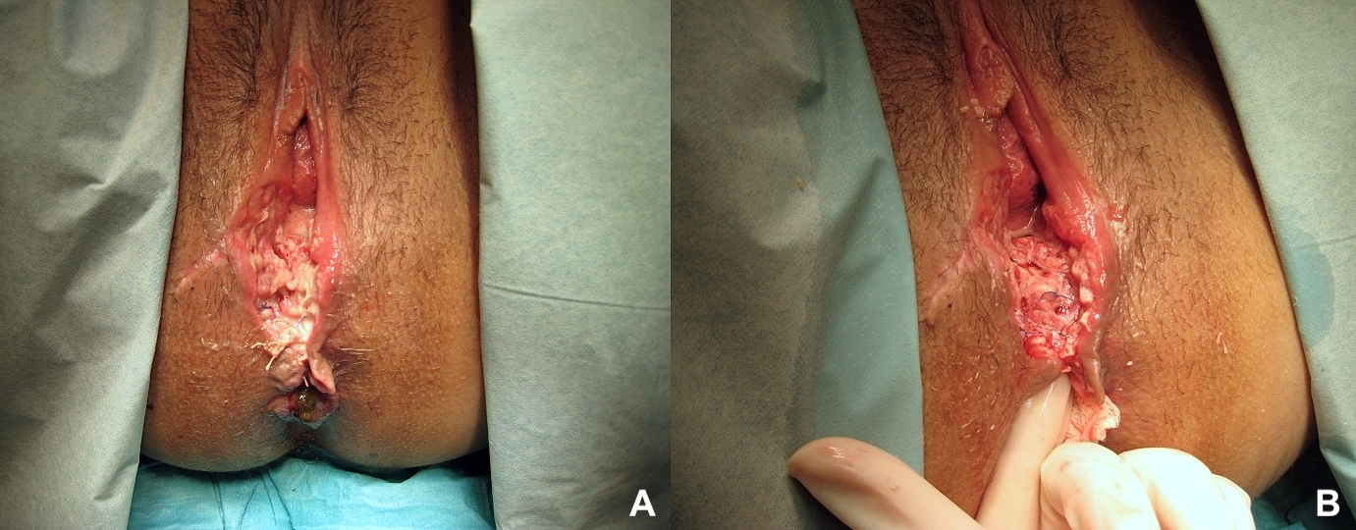

Figure 2:

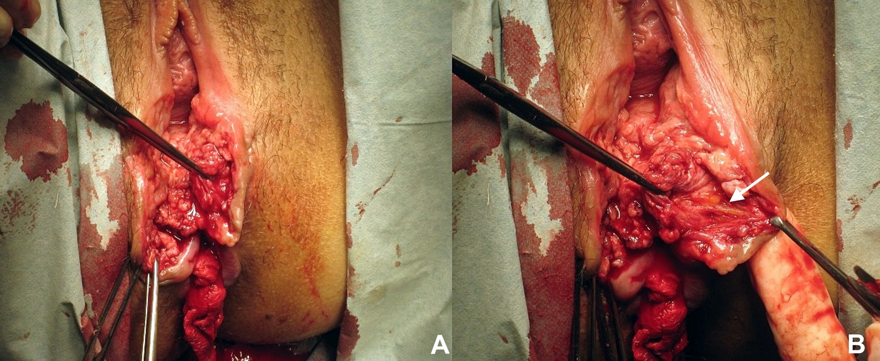
Figure 3:

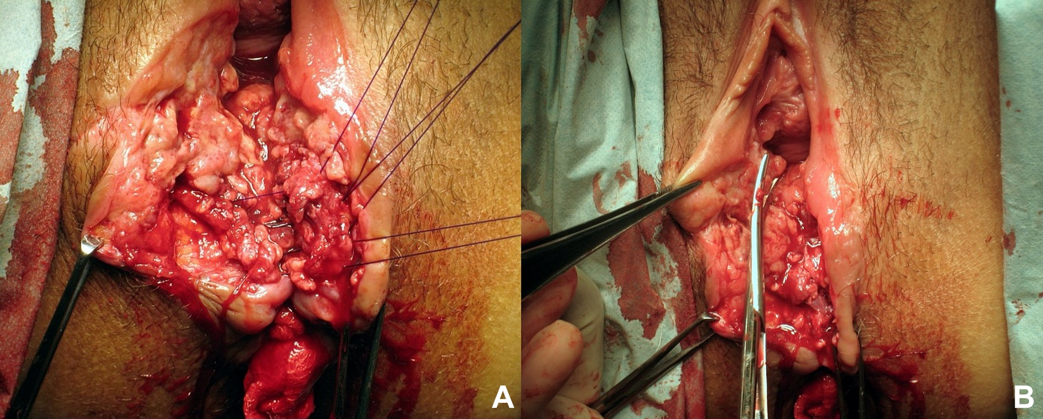

Figure 4:
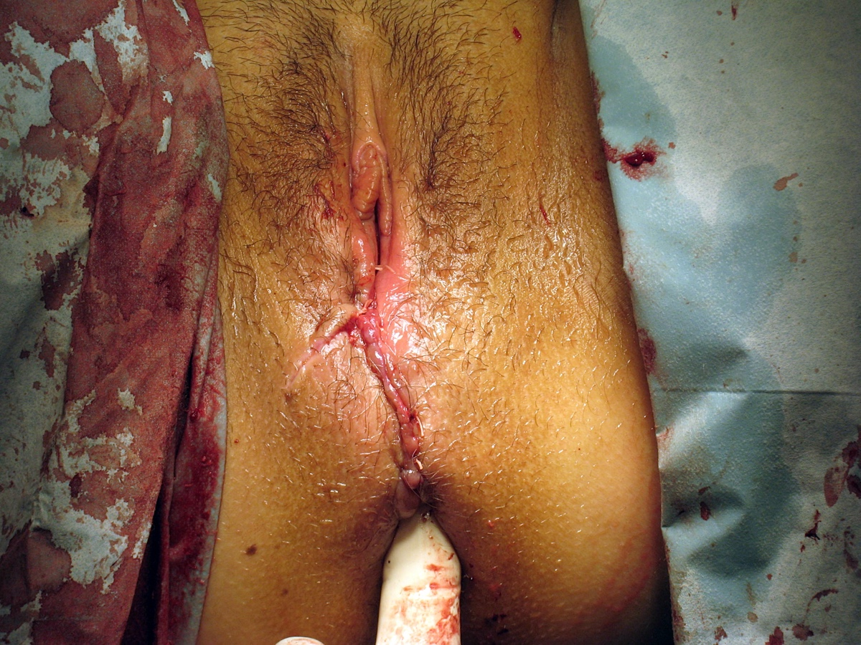

Table 1: Perioperative management described in the literature
 | Barbosa et al [6] | Arona et al [4] | Soerensen et al [3] | Hauth et al [8] | Lewicky-Gaupp et al[15]
Number of patients | 20† | 23 | 22 | 8 | 17
Tear Grade (%) | -3b (45.0)  -3c (15.0)  -4th (40.0) | 3rd/4th degree tears (not specified) | -3rd (81.8)  -4th (18.2) | 4th (100) | -3rd (55.6)  -4th (27.8)  -Misdiagnosed 2nd degree tear (16.6)
Days from delivery to diagnosis/ diagnosis to re-suturing | 3-18 | 2-60/4-10 | 1-15 | 0-10/1-16 | Median=10 (IQR 5.3-52.5)/ 19.5 (IQR 12-26.8)
Preoperative management | -EAUS  -Perioperative broad-spectrum IV antibiotics | -Daily perineal irrigation and sharp debridement (+/- antibiotics if infection present)  -Mechanical bowel preparation  -Perioperative broad-spectrum IV antibiotics | -EAUS  -Perioperative broad-spectrum IV antibiotics | -Daily perineal irrigation (+/- antibiotics if infection present)  -Mechanical bowel preparation  -Perioperative broad-spectrum IV antibiotics | - Daily antibiotics if infection present  - Avoidance of opiod based analgesia
Anaesthesia | General or regional anaesthesia | General or regional anaesthesia | General anaesthesia | Not specified | Not specified
Repair technique in all patients | -EAS- end to end  -IAS- end to end  -Rectal mucosa- continuous | -EAS- end to end  -Rectal mucosa-interrupted/continuous | -EAS- end to end  -IAS- end to end  -Rectal mucosa- continuous | -EAS- interrupted figure of eight  -Rectal mucosa- continuous | -EAS- overlapping  -IAS-continuous  -Rectal mucosa- continuous  §
Suture material for sphincter | -2.0 polyglactin *  -absorbable suture** | -0 polyglactin/ polyglycolic acid*  -3-0/4-0 polyglactin/ polyglycolic acid** | -2-0 polyglactin | -Chromic surgical gut or 00-poldioxanone *  - Chromic surgical gut** | -2.0 poldioxanone/3.0 poldioxanone*  -3.0 poldioxanone
Repair conducted by | Senior urogynaecologist or colorectal surgeon | Obstetric trainee (supervised by obstetric consultant) | Senior obstetrician alone/and colorectal surgeon | Senior obstetrician | Senior urogynaecologist
Post-operative management | -Laxatives  -PFMT | -3 doses of IV antibiotics  - Bowel rest; clear fluids followed by low-residue diet for 3 days  -Daily perineal toileting (soak in bath three times daily and after defecation)  - Laxatives | - 5-day course of broad-spectrum antibiotics in cases of obvious infection  -Daily perineal toileting (soak in a bath twice daily and after defecation)  -Laxatives  -PFMT | - Bowel rest; nil by mouth for 72 hours and low-residue diet following for 10 days  -Daily perineal toileting  -Laxatives | -7-day course of broad-spectrum antibiotics  -Laxatives  -Daily perineal toileting (soak in a bath twice daily)  -PFMT
IQR- Interquartile range
EAUS- Endoanal ultrasound
EAS- External anal sphincter
IAS- Internal anal sphincter
IV- Intravenous
PFMT- Pelvic floor muscle training
* Sutures used for repair of anal sphincter muscle
**Sutures used for repair of rectal mucosa
¶- The study by Soerensen et al also included outcomes following delayed primary reconstruction and early secondary repair
§ 41.2% of women also had a rectovaginal fistula which was repaired at the time of sphincter re-suturing

Table 2: Complications following early secondary repair described in the literature
 | Barbosa et al [6] | Arona et al [4] | Soerensen et al [3] | Hauth et al [8] | Lewicky-Gaupp et al [15]
Follow up | Mean 4.3years (± 2.55) | 1 week, 6 weeks and 3 months | 1 week, 5 months and 6 months | 6 months | At weekly intervals for at least 1 month
Complications (%) | 4 years: (n=20)  Anal fissure 1(5.0)  Infection 1(5.0)  Wound dehiscence + infection 2(10.0)  Fistula 5(25.0)  Repeat sphincter repair 4(20.0)  Temporary stoma 4(20.0) | 1 week: (n=23)  Skin dehiscence 5 (21.7)  6 weeks: (n=20)  Fistula 1(5.0)  Skin dehiscence 2(10.0)  Dyspareunia 1(5.0)  3 months: (n=17)  Dyspareunia 1(6.0) | 5 months: (n=22)  Anal fissure 2(9.1)  Dyspareunia 2(9.1) | 6 months: (n=8)  Fistula 1(12.5)  Abscess 1(12.5) | 1 week: (n=17)  Skin dehiscence 2(11.8)  Wound infection + dehiscence 1(5.9)  3 months: (n=17)  Dyspareunia 1(5.8)
Anorectal symptoms (%) | 4 years: (n=20)  Flatal incontinence 20(100.0)  Faecal incontinence-solid 8(40.0)  Faecal incontinence-liquid 10(50.0)  Faecal urgency 8 (60.0)  SMIS mean 8.5 (SD ± 5.8)  Wexner mean 6.3 (SD ±5.8) | 1 week: (n=23)  Dyschezia 10 (43.4)  6 weeks: (n=20)  Flatal incontinence 1(5)  Dyschezia 1(5.0)  3 months: (n=17)  Dyschezia 1(11.8) | 5 months: (n=22)  Flatal incontinence 9(40.9)  Faecal incontinence-liquid 1(4.5)  Faecal urgency 1(4.5)  6 months: (n=21)  Flatal incontinence 14(66.7)  Faecal incontinence-solid 2(9.5)  Faecal incontinence-liquid 3(14.3)  Faecal urgency 11(52.4)  SMIS mean 6 (range 0-16)  Wexner mean 4.1 (range 0-13) | 6 months: (n=8)  No symptoms 8(100) | 1 month: (n=17)  No symptoms 17(100.0)  3 months: (n=17)  Flatal incontinence  4(22.0)
IQR- interquartile range
SMIS- St Mark’s Score

Table 3: Patient Characteristics, delivery and secondary repair details of women who underwent early secondary OASI repair at Croydon University Hospital
 | Patient 1 | Patient 2 | Patient 3 | Patient 4 | Patient 5 | Patient 6
Age | 32 | 19 | 28 | 43 | 29 | 25
BMI (kg/m²) | 20.6 | 32.8 | 26.2 | 37.4 | 28 | 22
Ethnicity | White British | White British | Asian Indian | Asian Pakistani | White British | White British
Co-morbidities | None | None | GDM | GDM | None | None
Mode of Delivery | Ventouse + Forceps | Forceps | Forceps | Forceps | Ventouse + Forceps | SVD
Primary repair tear grade | 3b | 3b* | 3c | Second degree* | 3c | Intact*
Secondary repair tear grade | 3b | 3b + buttonhole tear | 3c | 3a | 3c | 4th
Time from delivery to re-suturing (days) | 10 | 10 | 13 | 10 | 15 | 5
IAS repair technique | N/A | End to end | N/A† | N/A | N/A† | End to End
EAS repair  technique | Overlap | End to end | End to end | End to end | End to end | Overlap
Preoperative antibiotics course (hours) | 24** | 48** | 72*** | 24** | 24** | 18***
Post-operative antibiotics (oral) | Co-amoxiclav | Cefalexin and Metronidazole | Cefalexin and Metronidazole | Cefalexin and Metronidazole | Cefalexin and Metronidazole | Cefalexin and Metronidazole
GDM- Gestational Diabetes
SVD- Spontaneous vaginal delivery
IAS- Internal anal sphincter
EAS- external anal sphincter
*Misdiagnosed tears
†Internal anal sphincter appeared intact at time of repair
**Oral antibiotics
***Intravenous antibiotics

Table 4: Comparison of patient and delivery details of women undergoing early secondary OASI repair or primary repair alone

 | Primary repair  Mean (SD)/ n(%)  N=504 | Secondary repair  Mean (SD)/ n(%)  N=6 | p- value
Age | 29.1 (5.4) | 29.3 (8.0) | 0.92*
BMI (kg/m²) | 24.6 (4.5) | 27.8 (6.4) | 0.08*
Birthweight (g) | 3415.9 (467.7) | 3846.3 (538.2) | 0.03*
Mode of delivery
SVD | 294(51.8) | 1 (16.7) | 0.09**
Operative vaginal delivery | 209 (41.7) | 5 (83.3)
Tear grade
Minor (3a, 3b) | 438 (86.9) | 2 (33.3) | 0.001**
Major (3c, 4th, buttonhole) | 66 (13.1) | 4 (66.7)†

*= Student’s t-test
**= Fishers Exact
† One of the women had a 3b and buttonhole tear. A 4th degree tear was created to repair the buttonhole tear because the distal extent could not be identified.

Table 5: Post-operative outcomes following secondary anal sphincter repair
 | Patient 1 | Patient 2 | Patient 3 | Patient 4 | Patient 5 | Patient 6
Time from re-suturing to wound healed (days) | 20 | 37 | 37 | 42 | 17 | 21
Complications | - Haematoma  - Granulation tissue  -Sinus | - Granulation tissue  - Fistula | - Skin dehiscence | - Skin dehiscence  - Granulation tissue | - Skin dehiscence | -Granulation tissue  -Dyspareunia
Anorectal symptoms | None | None | None | Faecal urgency | Flatal incontinence and faecal urgency | None
SMIS | 0 | 0 | 0 | 2 | 8 | 0
iMSP (Normal >20 mmHg) | 18 | 22 | 25 | 31 | 49 | 60
Endoanal Ultrasound Findings
IAS | Intact | 2-hour defect | 4- hour defect | Intact | 4-hour defect | Scar
EAS Proximal | 3- hour partial thickness defect | 2- hour partial thickness defect | Scar | Scar | 2- hour partial thickness defect | Scar
EAS Distal | 3- hour partial thickness defect | 2- hour partial thickness defect | Scar | Scar | Scar | Scar
SMIS- St Mark’ Score
iMSP- Incremental maximum squeeze pressure
IAS- Internal Anal Sphincter
EAS- External Anal Sphincter

Table 6: Comparison of anorectal symptoms, anal manometry pressures and endoanal ultrasound findings in women undergoing early secondary OASI repair or primary repair alone

 | Primary repair  Mean (SD) | Secondary repair  Mean (SD) | p- value
SMIS | 1.4 (3.2) | 1.6 (3.2) | 0.84
iMSP | 37.2 (22.6) | 34.2 (16.7) | 0.74
Starck Score | 2.1(3.1) | 5.7(4.7) | 0.01*
SMIS- St Mark’ Score
iMSP- Incremental maximum squeeze pressure

