Supplementary materials
Supplementary Methods
Randomization
Randomization was stratified by maintenance bronchodilator use during the run-in period (0 or 1 long-acting bronchodilator per day).
Statistical analyses
For the MMRM analysis of the primary endpoint, the model included covariates of baseline FEV₁, geographical region, visit, treatment, visit by baseline FEV₁ and visit by treatment interactions, where visit is nominal. For the responder analyses of the primary endpoint, the generalized linear mixed model included treatment as an explanatory variable and covariates of visit, baseline trough FEV₁, geographical region, visit by baseline FEV₁ and visit by treatment interactions. Unless stated otherwise, other efficacy endpoints were analyzed in a similar manner using the relevant baseline values for outcomes; for analyses of E-RS score and rescue medication use, the 4-weekly period was included as a covariate instead of visit.
Time to first exacerbation HRs and 95% CIs were based on Cox proportional hazards model with covariates of treatment and geographical region. Time to first CID HRs and 95% CIs were based on a Cox proportional hazards model with covariates of treatment, geographical region, trough FEV₁ at baseline, and SGRQ score at baseline.
For the post hoc analysis of an interaction between change from baseline in trough FEV₁ and maintenance therapy status, the MMRM model included covariates of baseline FEV₁, geographical region, number of bronchodilators received during run-in (0 or 1), visit, treatment, MN status, visit by baseline FEV₁, visit by treatment, visit by MN status, treatment by MN status, and visit by treatment by MN status interactions (where visit is nominal). The interaction test for SAC-TDI focal score was conducted in a similar manner, with SAC-baseline dyspnea index score as the baseline value.

Supplementary Table S1 IEC/IRB committees that approved the EMAX trial
Comité de Ética en Investigación. INAER, Arenales 3146 1° B, Ciudad Autónoma de Buenos Aires, C1425BEN, Argentina
CEICI, Italia 424, Rosario, Santa Fe, 2000, Argentina
CEMER, Esmeralda 1550, Florida, Buenos Aires, 1602, Argentina
CECIC Comité de Ética de CER Investigaciones Clínicas, Vicente Lopez 1441, Quilmes, Buenos Aires, 1878, Argentina
Comite Independiente de etica Fundacion Rusculleda, Avenida Colon 2057, Cordoba, Córdova, X5003DCE, Argentina
Framingham Centro Médico, Calle 9 Numero 431, La Plata, Buenos Aires, B1902COS, Argentina
Comité Independiente de ética para ensayos en Farmacología Clinica del centro Medico Dra. De Salvo, Avenida Cabildo 1536 5° B, Ciudad Autonoma de Buenos Aires, Buenos Aires, C1426ABP, Argentina
Instituto Argentino de Investigacion Neurologica, Uruguay 824 1st floor, Ciudad Autonoma de Buenis Aires, C1015ABR, Argentina
FUMELIT, Av. Gdor. Freyre 3074, Santa Fe, 3000, Argentina
CIDEA, 3er Cuerpo - 2do Subsuelo, Paraguay 2035, Ciudad Autónoma de Buenos Aires, C1121ABE, Argentina
Comite de Etica de San Isidro-CESI, Avenue Libertador 169581, San Isidro, Buenos Aires, CP 1643, Argentina
Comite de etica para la investigación Clinica Fundación Dr. J.R. Villavicencio, Alvear 854, Rosario, Santa Fe, 2000QGB, Argentina
Comite de Etica Iniciativa y Refelexion Bioetica Rosario, Rioja 2926, Rosario, S2002OJN, Argentina
CESIM, Urquiza 646, Santa Rosa, 6300, Argentina
Instituto de Investigacion Clinica de Mar del Plata, Av. Colon 3364 PB, Mar del Plata, Buenos Aires, B7600FZN, Argentina
Centro de Osteopatias Medicas, Azcuenaga 1860, Buenos Aires, C1128AAF, Argentina
Comite de Etica en Investigacion Clinica - CEIC, Larrea 1381, Ciudad Autonoma de Buenos Aires, Buenos Aires, C1117ABK, Argentina
Comite de Etica en Investigacion, Instituto Ave Pulmo, Carlos M. Alvear 3345, Mar del Plata,
Buenos Aires, B7602DCK, Argentina
Bellberry Limited, 129 Glen Osmond Rd, Eastwood, South Australia, 5063, Australia
INSTITUTIONAL REVIEW BOARD Services, Suite 300, 372 Hollandview Trail, Aurora, Ontario, L4G 0A5, Canada
Comité d'éthique de la recherche de l'Institut universitaire de cardiologie et de pneumologie de Qué, 2725 Chemin Ste-Foy, Quebec, G1V 4G5, Canada
CHU Pontachaillou, Comité de Protection des Personnes, 9 Avenue de la Bataille Flandres-Dunkerque Mai 1940, Rennes, 35000, France
Ethik-Kommission der Landesaerztekammer Hessen, Im Vogelsgesang 3, Frankfurt, Hessen, 60488, Germany
Comitato Etico IRCCS Istituto Tumori "G.Paolo II", V.le Orazio Flacco 65, Bari, Puglia, 70124, Italy
Comitato Etico Campania Nord c/o A.O. San Giuseppe Moscati di Avellino, Segreteria Scientifico- Amministrativa, Città Ospedaliera -Pal. Uffici, Contrada Amoretta, Avellino, Campania, Italy
Com. Etico Reg. Toscano "Area Vasta Nord Ovest", Segreteria Scientifico-Amministrativa -Azienda Ospedaliero-Universitaria Pisana, Via Roma, 67, Pisa, Toscana, 56126, Italy
Comitato Etico Palermo 1, c/o Azienda Ospedaliera Universitaria Policlinico "Paolo Giaccone", Segreteria Scientifico-Amministrativa, Via del Vespro 129, Palermo, Sicilia, 90127, Italy
Comitato Etico Univ. Studi Campania L.Vanvitelli – AOU L.Vanvitelli - AORN Osp. dei Colli, Sede AORN Ospedali dei Colli, Via Leonardo Bianchi snc, Napoli, Campania, 80131, Italy
C.E.ROM. Comitato Etico della Romagna, c/o Ist. Scientifico Romagnolo per lo Studio e la Cura dei Tumori, IRST - IRCCS Srl, Via Piero Maroncelli 40, Meldola (FC), Emilia-Romagna, 47014, Italy
Comitato Etico Unico Regionale del Friuli Venezia Giulia, Segreteria Tecnico-Scientifica c/o Dir. Scientifica, IRCCS CRO di Aviano, Via Gallini, 2, Aviano (PN), Friuli-Venezia-Giulia, 33081, Italy
Comitato Etico dell'Area Vasta Emilia Nord, Via Vertoiba, 10A, Reggio Emilia, Emilia-Romagna,
42124, Italy
Comitato Etico Aziende Sanitarie dell'Umbria, Segreteria Scientifico-Amministrativa, Via della Rivoluzione, 16, Ellera di Corciano (PG), Umbria, 6070, Italy
Comitato Etico Area 4 – ASL Brindisi, Segreteria Scientificoamministrativa, Via Napoli, 8, Brindisi, Puglia, 72100, Italy
Comitato Etico Univ. Studi Campania L.Vanvitelli – AOU L.Vanvitelli - AORN Osp. dei Colli, Sede AORN Ospedali dei Colli, Via Leonardo Bianchi snc, Napoli, Campania, 80131, Italy
Comitato Etico degli Istituti Clinici Scientifici Maugeri SpA – SB, Via Salvatore Maugeri 4, Pavia, Lombardia, 27100, Italy
Comitato Etico Campania Sud c/o ASL Napoli 3 Sud, Segreteria Scientifico-Amministrativa, Piazza San Giovanni, 7, Brusciano (NA), Campania, 80031, Italy
Hospital Real San Jose, Av Lázaro Cárdenas 4149 Colonia Jardines de San Ignacio, Zapopan, Jalisco, 45040, Mexico
Instituto Jalisciense de Investigación Clínica, S.A. de C.V., Penitenciaria 20, Guadalajara, Jalisco, 44100, Mexico
St. Antonius Ziekenhuis, Koekoekslaan 1, NIEUWEGEIN, 3435 CM, Netherlands
Pharma Ethics, 123 Amcor Road, Lyttelton Manor, 157, South Africa
University of Cape Town, Human Research Ethics Committee, Room E52.24, Old Main Building, Groote Schuur Hospital, Main Road, Observatory, 7925, South Africa
Fundació Unió Catalana d’Hospitals, 1ºA, C/Bruc 72-74, Barcelona, 8009, Spain
Regionala Etikprövningsnämnden I Göteborg, Guldhedsgatan 5A, GÖTEBORG, SE-413 20, Sweden
Advarra Institutional Review Board, Suite 110, 6940 Columbia Gateway Drive, Columbia, Maryland, 21046, United States
Saint Luke’s Hospital Institutional Review Board, 232 South Woods Mill Road, Chesterfield, Missouri, 63017, United States
South Carolina Pharmaceutical Research, 141 Harold Fleming Court, Spartanburg, South Carolina, 29303, United States

Supplementary Table S2 Baseline demographics and clinical characteristics by treatment arm
 | MN  (N=749) |  |  | MT  (N=1676)
 | UMEC/VI  N=250 | UMEC  N=250 | SAL  N=249 | UMEC/VI  N=562 | UMEC  N=554 | SAL  N=560
Age, years, mean (SD) | 63.3 (8.0) | 63.4 (8.2) | 62.2 (8.8) | 65.2 (8.5) | 65.5 (8.5) | 65.3 (8.2)
Female, n (%) | 112 (45) | 121 (48) | 110 (44) | 207 (37) | 206 (37) | 232 (41)
Current smoker, n (%) | 161 (64) | 169 (68) | 163 (65) | 233 (41) | 227 (41) | 250 (45)
Smoking pack-years, mean (SD) | 53.2 (25.9) | 46.6 (24.1) | 49.8 (25.3) | 47.7 (28.4) | 48.1 (26.7) | 47.3 (26.0)
Duration of COPD, years, mean (SD) | 8.7 (7.4) | 7.8 (5.9) | 8.4 (6.9) | 8.8 (6.8) | 7.8 (6.0) | 8.2 (6.6)
Moderate COPD exacerbation in past 12 monthsª, n (%) | 27 (11) | 24 (10) | 26 (10) | 96 (17) | 100 (18) | 120 (21)
Post-albuterol percent predicted FEV₁, mean (SD) | 57.7 (12.1) | 57.7 (12.0) | 55.7 (12.6) | 53.6 (12.9) | 55.1 (12.8) | 55.5 (12.9)
Post-albuterol FEV₁/FVC, mean (SD) | 0.55 (0.09) | 0.54 (0.09) | 0.53 (0.10) | 0.50 (0.11) | 0.51 (0.10) | 0.51 (0.10)
Percent reversibility to albuterol, mean (SD) | 12.6 (13.2) | 13.0 (13.4) | 12.9 (12.0) | 9.4 (12.6) | 8.9 (13.0) | 9.8 (13.7)
GOLD grade^{b}, n (%)
2 | 187 (75) | 177 (71) | 162 (65) | 331 (59) | 352 (64) | 360 (64)
3 | 63 (25) | 72 (29) | 87 (35) | 231 (41) | 199 (36) | 199 (36)
Baseline FEV₁, mL, mean (SD) | 1559 (511) | 1528 (513) | 1536 (569) | 1436 (509) | 1491 (501) | 1477 (516)
BDI focal score, mean (SD) | 7.2 (2.0) | 7.1 (2.1) | 7.1 (2.0) | 6.9 (1.8) | 7.0 (1.9) | 7.0 (1.8)
E-RS total score, mean (SD) | 11.4 (5.7) | 11.9 (6.4) | 11.5 (6.0) | 10.4 (5.6) | 10.2 (5.5) | 9.9 (5.5)
SGRQ score, mean (SD) | 47.2 (16.5) | 48.1 (17.8) | 49.0 (17.1) | 43.3 (15.8) | 43.7 (15.1) | 42.6 (15.6)
CAT score, mean (SD) | 20.7 (6.2) | 21.4 (6.7) | 21.2 (6.7) | 18.4 (5.6) | 18.3 (5.7) | 18.4 (5.9)
Rescue medication use^{c}, puffs/day, mean (SD) | 2.8 (3.1) | 2.7 (2.8) | 2.9 (3.0) | 1.9 (2.2) | 1.9 (2.1) | 1.8 (2.1)
Rescue-free days^{c}, % (SD) | 35.7 (41.4) | 37.9 (42.5) | 33.2 (40.4) | 40.5 (42.1) | 41.0 (41.3) | 41.6 (41.5)
ªNumber of patients with an exacerbation requiring oral or systemic corticosteroids and/or antibiotics (moderate) in 12 months prior to screening (patients with >1 moderate exacerbation or with a severe exacerbation [requiring hospitalization] were excluded from the study); ^{b}an additional 4 (<1%) patients with GOLD grade 1 (MN n=1; MT n=3) were randomized; ^{c}during the 4-week run-in period.
BDI, Baseline Dyspnea Index; CAT, COPD Assessment Test; COPD, chronic obstructive pulmonary disease; E-RS, Evaluating Respiratory Symptoms–COPD; FEV₁; forced expiratory volume in 1 second; FVC, forced vital capacity; GOLD, Global initiative for chronic Obstructive Lung Disease; ITT, intent-to-treat;
MN, maintenance-naïve; MT, maintenance-treated; SD, standard deviation; SGRQ, St George’s Respiratory Questionnaire.

Supplementary Table S3 Change from baseline in lung function and symptoms outcomes with UMEC versus SAL in MN and MT patients
 | MN |  |  | MT
 | UMEC  (N=250) | SAL  (N=249) | UMEC  (N=554) |  | SAL  (N=560)
Lung function outcomes
Trough FEV₁ at Week 24, mL
LS mean CFB (95% CI) | 150 (120, 181) | 66 (36, 97) | 12 (-8, 32) |  | -56 (-75, -37)
UMEC vs SAL mean difference (95% CI) | - | 84 (41, 127)  P<0.001 | - |  | 68 (40, 95)  P<0.001
Trough FVC at Week 24, mL
LS mean CFB (95% CI) | 161 (114, 209) | 66 (19, 114) | -8 (-40, 24) |  | -120 (-151, -89)
UMEC vs SAL mean difference (95% CI) | - | 95 (28, 162)  P=0.006 | - |  | 112 (68, 157)  P<0.001
Trough IC at Week 24, mL
LS mean CFB (95% CI) | 127 (80, 174) | 85 (38, 131) | 39 (7, 70) |  | -50 (-81, -20)
UMEC vs SAL mean difference (95% CI) | - | 42 (-23, 108)  P=0.207 | - |  | 89 (45, 133)  P<0.001
Symptom outcomes/severity changes
SAC-TDI focal score at Week 24
LS mean CFB (95% CI) | 1.65 (1.24, 2.07) | 1.55 (1.14, 1.96) | 1.13 (0.87, 1.39) |  | 1.08 (0.83, 1.34)
UMEC vs SAL mean difference (95% CI) |  | 0.10 (-0.48, 0.69)  P=0.735 |  |  | 0.05 (-0.32, 0.41)  P=0.808
E-RS total score at Weeks 21–24
LS mean CFB (95% CI) | -2.02 (-2.58, -1.46) | -1.70 (-2.25, -1.14) | -0.52 (-0.88, -0.17) |  | -0.24 (-0.59, 0.11)
UMEC vs SAL mean difference (95% CI) |  | -0.32 (-1.11, 0.46)  P=0.421 |  |  | -0.28 (-0.78, 0.21)  P=0.265
Rescue medication use over Weeks 1–24
Mean inhalations/day
LS mean CFB (95% CI) | -0.82 (-1.02, -0.62) | -0.89 (-1.09, -0.69) | -0.03 (-0.15, 0.09) |  | -0.06 (-0.18, 0.05)
UMEC vs SAL mean difference (95% CI) | - | 0.07 (-0.22, 0.35)  P=0.634 | - |  | 0.03 (-0.13, 0.20)  P=0.686
% rescue medication-free days
LS mean CFB (95% CI) | 11.3 (7.2, 15.3) | 13.6 (9.5, 17.6) | 4.5 (2.0, 6.9) |  | 5.0 (2.5, 7.4)
UMEC vs SAL mean difference (95% CI) | - | -2.3 (-8.0, 3.4)  P=0.425 | - |  | -0.5 (-4.0, 3.0)  P=0.772
GADSª at Week 24
Proportion of patients reporting improvement from baseline at Week 24, n/N (%) | 128/196 (65) | 129/206 (63) | 265/442 (60) |  | 284/468 (61)
UMEC vs SAL ordered odds ratio for improvement in response category (95% CI) | - | 1.13 (0.80, 1.62)  P=0.482 | - |  | 0.94 (0.74, 1.19)  P=0.584
Bold text indicates statistically significant treatment differences with UMEC/VI versus UMEC or SAL. ªOverall assessment of change in COPD severity was rated using a seven-point Likert scale (‘Much Better’, ‘Slightly Better’, ‘Better’, ‘No Change’, ‘Slightly Worse’, ‘Worse’, ‘Much Worse’); ordered response ratios were reported as odds of better response category;
CFB, change from baseline; CI, confidence interval; COPD, chronic obstructive pulmonary disease; E-RS, Evaluating Respiratory Symptoms-COPD; FEV₁, forced expiratory volume in 1 second; FVC, forced vital capacity; GADS, global assessment of disease severity; IC, inspiratory capacity; LS, least squares; MN, maintenance-naïve; MT, maintenance-treated; SAC-TDI, self-administered computerized Transition Dyspnea Index; SAL, salmeterol; UMEC, umeclidinium; VI, vilanterol.

Supplementary Figure S1 LS mean change from baseline in trough FEV₁ at Week 4, SAC-TDI focal score at Week 4, rescue medication inhalations/day over Weeks 1–4, and SGRQ score at Week 4 with UMEC/VI, UMEC, and SAL in (A) MN and (B) MT patients
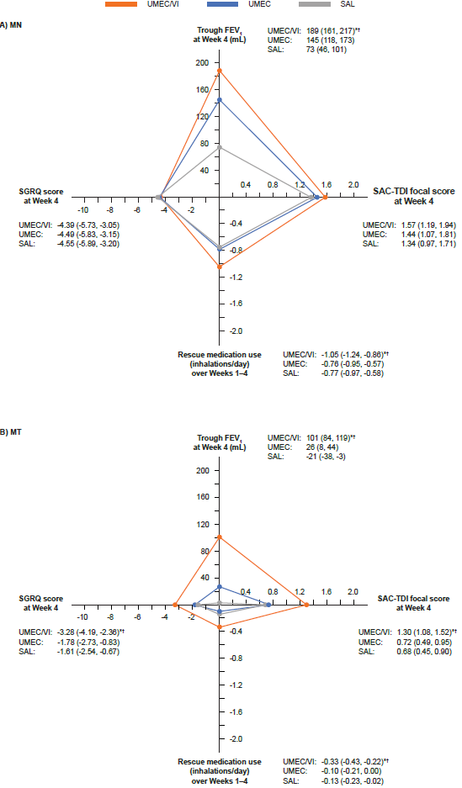
All values are LS mean (95% CI). Negative changes from baseline are not shown; change from baseline in in trough FEV₁ at Week 4 of -21 mL with SAL in the MT subgroup is presented as zero.
*P<0.05 vs UMEC and †vs SAL;
CI, confidence interval; FEV₁, forced expiratory volume in 1 second; LS, least squares; MN, maintenance-naïve; MT, maintenance-treated; SAC-TDI, self-administered computerized Transition Dyspnea Index; SAL, salmeterol; SGRQ, St George’s Respiratory Questionnaire; UMEC, umeclidinium; VI, vilanterol.
Supplementary Figure S2 LS mean trough FEV₁ at Week 24, SAC-TDI focal score at Week 24, rescue medication inhalations/day over Weeks 1–24, and SGRQ score at Week 24 with UMEC/VI, UMEC, and SAL in (A) MN and (B) MT patients
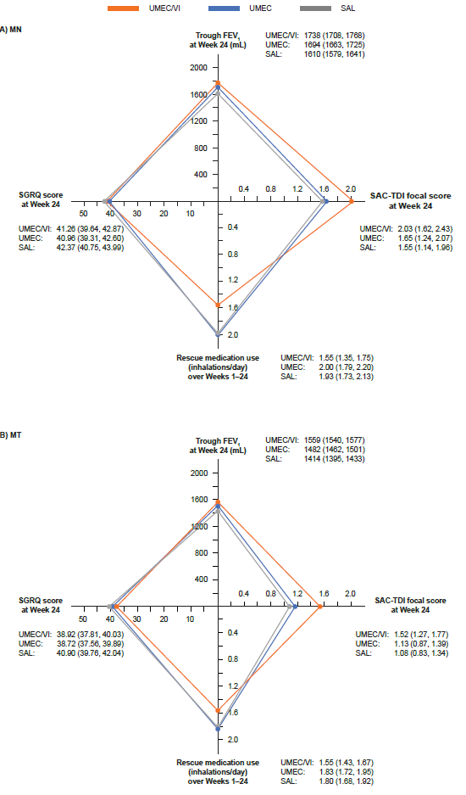

All values are LS mean (95% CI).
CI, confidence interval; FEV₁, forced expiratory volume in 1 second; LS, least squares; MN, maintenance-naïve; MT, maintenance-treated; SAC-TDI, self-administered computerized Transition Dyspnea Index; SAL, salmeterol; SGRQ, St George’s Respiratory Questionnaire; UMEC, umeclidinium; VI, vilanterol.

