SUPPORTING INFORMATION

Discovery and Optimization of DNA Gyrase and Topoisomerase IV Inhibitors
with Potent Activity Against Fluoroquinolone-Resistant Gram-positive Bacteria

Guillaume Lapointe,†* Colin K. Skepper,†* Lauren M. Holder,† Duncan Armstrong,§ Cornelia Bellamacina,† Johanne Blais,† Dirksen Bussiere,† Jianwei Bian,¶ Cody Cepura,† Helen Chan,† Charles R. Dean,† Gianfranco De Pascale,† Bhavesh Dhumale,⊥ L. Mark Fisher,# Mangesh Fulsunder,⊥ Bhavin Kantariya,⊥ Julie Kim,† Sean King,† Lauren Kossy,† Upendra Kulkarni,† Jay Lakshman,‡ Jennifer A. Leeds,† Xiaolan Ling,¶ Anatoli Lvov,§ Sylvia Ma,† Swapnil Malekar,† David McKenney,† Wosenu Mergo,† Louis Metzger,† Keshav Mhaske,⊥ Heinz E. Moser,† Mina Mostafavi,† Sunil Namballa,⊥ Jonas Noeske,† Colin Osborne,† Ashish Patel,⊥ Darshit Patel,⊥ Tushar Patel,⊥ Philippe Piechon,∞ Valery Polyakov,† Krunal Prajapati,⊥ Katherine R. Prosen,† Folkert Reck,† Daryl L. Richie,† Mark R. Sanderson,‖ Shailesh Satasia,⊥ Bhautik Savani,⊥ Jogitha Selvarajah,# Vijay Sethuraman,† Wei Shu,† Kyuto Tashiro,† Katherine V. Thompson,† Krishniah Vaarla,⊥ Lakhan Vala,⊥ Dennis A. Veselkov,‖ Jason Vo,† Bhavesh Vora,⊥ Trixie Wagner,∞ Laura Wedel,† Sarah L. Williams,† Satya Yendluri,† Qin Yue,† Aregahegn Yifru,† Yong Zhang,¶ and Alexey Rivkin†

†Novartis Institutes for Biomedical Research, Emeryville, California 94608, United States
§Novartis Institutes for Biomedical Research, Cambridge, Massachusetts 02139, United States
¶ Novartis Global Drug Development, Pudong, Shanghai 201203, China
‡ Novartis Global Drug Development, East Hanover, New Jersey 07936, United States
⊥ Piramal Discovery Solutions, Pharmaceutical Special Economic Zone, Sarkhej Bavla Highway, Ahmedabad, Gujarat 382213, India
# Molecular and Clinical Sciences Research Institute, St George’s, University of London, London SW17 0RE, UK
‖ Randall Centre for Cell and Molecular Biophysics, King's College, Guy's Campus, London Bridge, London SE1 1UL, UK

Corresponding Authors
E-mail: guillaume.lapointe@novartis.com. Phone: +41 613245818
E-mail: colin.skepper@novartis.com. Phone: +1 510 879 9317

Table of Contents | Page #
Supplementary Table 1. Crystallographic data table for the structure of K. pneumoniae topoisomerase IV bound to compound 25..................................................... | 5
Supplementary Figure 1. Chemical structure of 25 and unbiased electron-density difference map (F_{obs}-F_{calc}) around the compound contoured at 3.0σ................................. | 6
Supplementary Figure 2. Interaction diagram of compound 25 bound to topoisomerase IV from K. pneumoniae............................................................................. | 7
Supplementary Figure 3. Sequence alignment of ParC and ParE from K. pneumoniae, S. aureus, E. faecalis and S. pneumoniae........................................................................... | 8
Supplementary Figure 4. Structure of compound 24 in the crystal................................. | 9
Supplementary Table 2. Crystal data and structure refinement for compound 24.......... | 10
Supplementary Figure 5. Structure of compound 25 in the crystal................................. | 11
Supplementary Table 3. Crystal data and structure refinement for compound 25.......... | 12
Supplementary Figure 6. Structure of compound 48 in the crystal................................. | 13
Supplementary Table 4. Crystal data and structure refinement for compound 48.......... | 14
Supplementary Figure 7. Structure of compound 49 in the crystal................................. | 15
Supplementary Table 5. Crystal data and structure refinement for compound 49.......... | 16
Supplementary Figure 8. Structure of compound 50 in the crystal................................. | 17
Supplementary Table 6. Crystal data and structure refinement for compound 50.......... | 18
Supplementary Figure 9. Structure of compound 52 in the crystal................................. | 19
Supplementary Table 7. Crystal data and structure refinement for compound 52.......... | 20
Supplementary Figure 10. Crystal structure of compound 54........................................ | 21
Supplementary Table 8. Crystal data and structure refinement for compound 54.......... | 22
Supplementary Figure 11. Overlay of crystal structures of compound 24 and compound 48 ..................................................................................................................... | 23
Supplementary Figure 12. Overlay of crystal structures of compound 48 and compound 49 ..................................................................................................................... | 23
References.......................................................................................................................... | 23
Synthesis and Characterization of Final Compounds and Intermediates............................ | 24
LC/MS Data for Final Compounds | Page #
LC/MS chromatogram of compound 6........................................................................... | 161
LC/MS chromatogram of compound (–)-8..................................................................... | 162
LC/MS chromatogram of compound 9........................................................................... | 163
LC/MS chromatogram of compound 10......................................................................... | 164
LC/MS chromatogram of compound 11......................................................................... | 165
LC/MS chromatogram of compound 12......................................................................... | 166
LC/MS chromatogram of compound 13......................................................................... | 167
LC/MS chromatogram of compound 14......................................................................... | 168
LC/MS chromatogram of compound 15......................................................................... | 169
LC/MS chromatogram of compound 16......................................................................... | 170
LC/MS chromatogram of compound 17......................................................................... | 171
LC/MS chromatogram of compound 18......................................................................... | 172
LC/MS chromatogram of compound 19......................................................................... | 173
LC/MS chromatogram of compound 20......................................................................... | 174
LC/MS chromatogram of compound 21......................................................................... | 175
LC/MS chromatogram of compound 22......................................................................... | 176
LC/MS chromatogram of compound 23......................................................................... | 177
LC/MS chromatogram of compound 24......................................................................... | 178
LC/MS chromatogram of compound 25......................................................................... | 179
LC/MS chromatogram of compound 26......................................................................... | 180
LC/MS chromatogram of compound 27......................................................................... | 181
LC/MS chromatogram of compound 28......................................................................... | 182
LC/MS chromatogram of compound 29......................................................................... | 183
LC/MS chromatogram of compound 30......................................................................... | 184
LC/MS chromatogram of compound 31......................................................................... | 185
LC/MS chromatogram of compound 32......................................................................... | 186
LC/MS chromatogram of compound 33......................................................................... | 187
LC/MS chromatogram of compound 34......................................................................... | 188
LC/MS chromatogram of compound 35......................................................................... | 189
LC/MS chromatogram of compound 36......................................................................... | 190
LC/MS chromatogram of compound 37......................................................................... | 191
LC/MS chromatogram of compound 38......................................................................... | 192
LC/MS chromatogram of compound 39......................................................................... | 193
LC/MS chromatogram of compound 40......................................................................... | 194
LC/MS chromatogram of compound 41......................................................................... | 195
LC/MS chromatogram of compound 42......................................................................... | 196
LC/MS chromatogram of compound 43......................................................................... | 197
LC/MS chromatogram of compound 44......................................................................... | 198
LC/MS chromatogram of compound 45......................................................................... | 199
LC/MS chromatogram of compound 46......................................................................... | 200
LC/MS chromatogram of compound 47......................................................................... | 201
LC/MS chromatogram of compound 48......................................................................... | 202
LC/MS chromatogram of compound 49......................................................................... | 203
LC/MS chromatogram of compound 50......................................................................... | 204
LC/MS chromatogram of compound 51......................................................................... | 205
LC/MS chromatogram of compound 52......................................................................... | 206
LC/MS chromatogram of compound 53......................................................................... | 207
LC/MS chromatogram of compound 54......................................................................... | 208
LC/MS chromatogram of compound 55......................................................................... | 209
LC/MS chromatogram of compound 56......................................................................... | 210
LC/MS chromatogram of compound 57......................................................................... | 211

Supplementary Table 1. Crystallographic data table for the structure of K. pneumoniae topoisomerase IV bound to compound 25.
Data collection statistics
Data set | Native
X‐ray source | IMCA-CAT
Space group | P21 (two molecules per asymmetric unit)
Unit cell parameters | a = 94.185 Å, b = 159.818 Å, c = 144.059 Å, β = 94.94°
Wavelength (Å) | 1.0000
Resolution (Å) | 46.92 - 3.30 (3.42 - 3.30)
Observations | 211597 (20003)
Unique reflections | 63764 (6310)
Completeness (%) | 99.46 (98.30)
Multiplicity | 3.3 (3.2)
R-merge | 0.2446 (1.603)
I/σ (I) | 3.30 (0.56)
CC(1/2) | 0.98 (0.334)
Refinement statistics
Resolution range (Å) | 46.92-3.30 (3.35-3.30)
Reflections used in refinement | 63590 (6247)
Reflections used for R-free | 3285 (332)
R‐work (%) | 0.2831 (0.3753)
R‐free (%) | 0.3086 (0.4252)
Number of non-hydrogen atoms | 21018
macromolecules | 20882
ligands | 132
solvent | 4
Ramachandran favored/allowed/outliers (%) | 97.15/2.85/0.00
Rotamer outliers (%) | 0.06
RMS (bonds) (Å) | 0.003
RMS (angles) (°) | 0.51
Average B‐factor (Å²) | 90.63
macromolecules | 90.65
ligands | 87.41
solvent | 56.03
PDB ID | 7LHZ

Data for the last resolution shell are in parentheses.
Supplementary Figure 1. Chemical structure of 25 and unbiased electron-density difference map (F_{obs}-F_{calc}) around the compound contoured at 3.0σ.

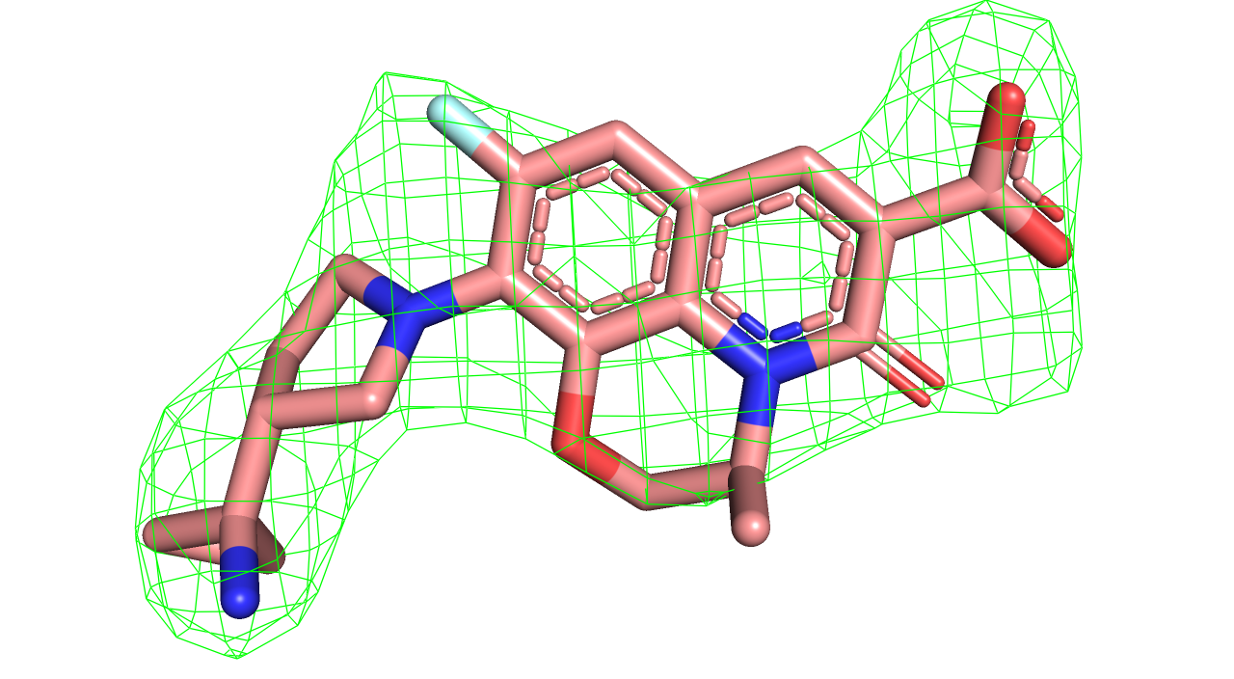

Supplementary Figure 2. Interaction diagram of compound 25 bound to topoisomerase IV from K. pneumoniae.
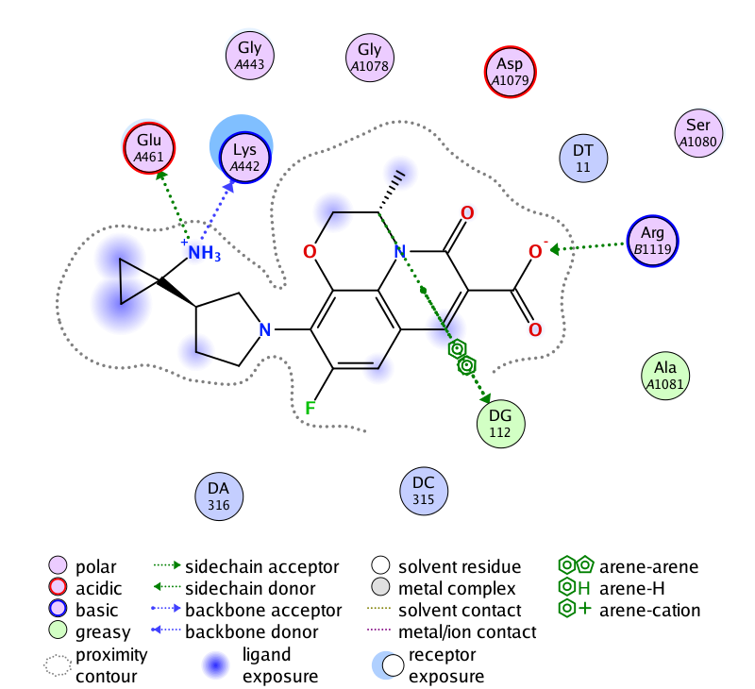
The interaction diagram was drawn with Molecular Operating Environment (MOE): Molecular Operating Environment (MOE), 2019.01; Chemical Computing Group ULC, 1010 Sherbrooke St. West, Suite #910, Montreal, QC, Canada, H3A 2R7, 2019

Supplementary Figure 3. Sequence alignment of ParC and ParE from K. pneumoniae, S. aureus, E. faecalis and S. pneumoniae. Residue coloring corresponds to the coloring used in Figure 2.
Alignment for ParC:
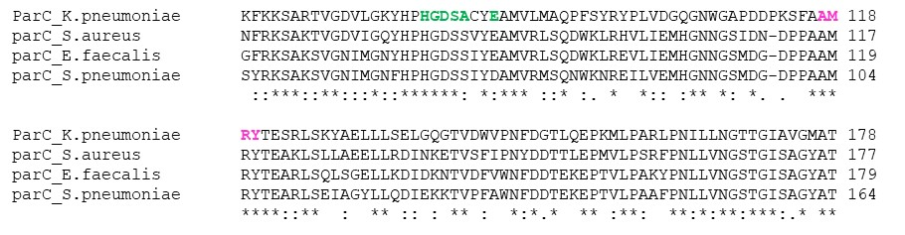
Alignment for ParE:
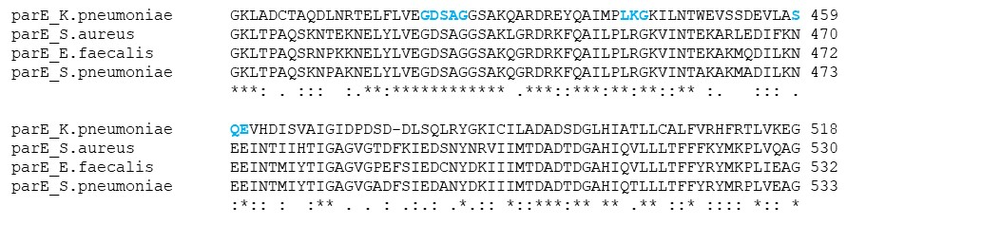

Supplementary Figure 4. Structure of compound 24 in the crystal.
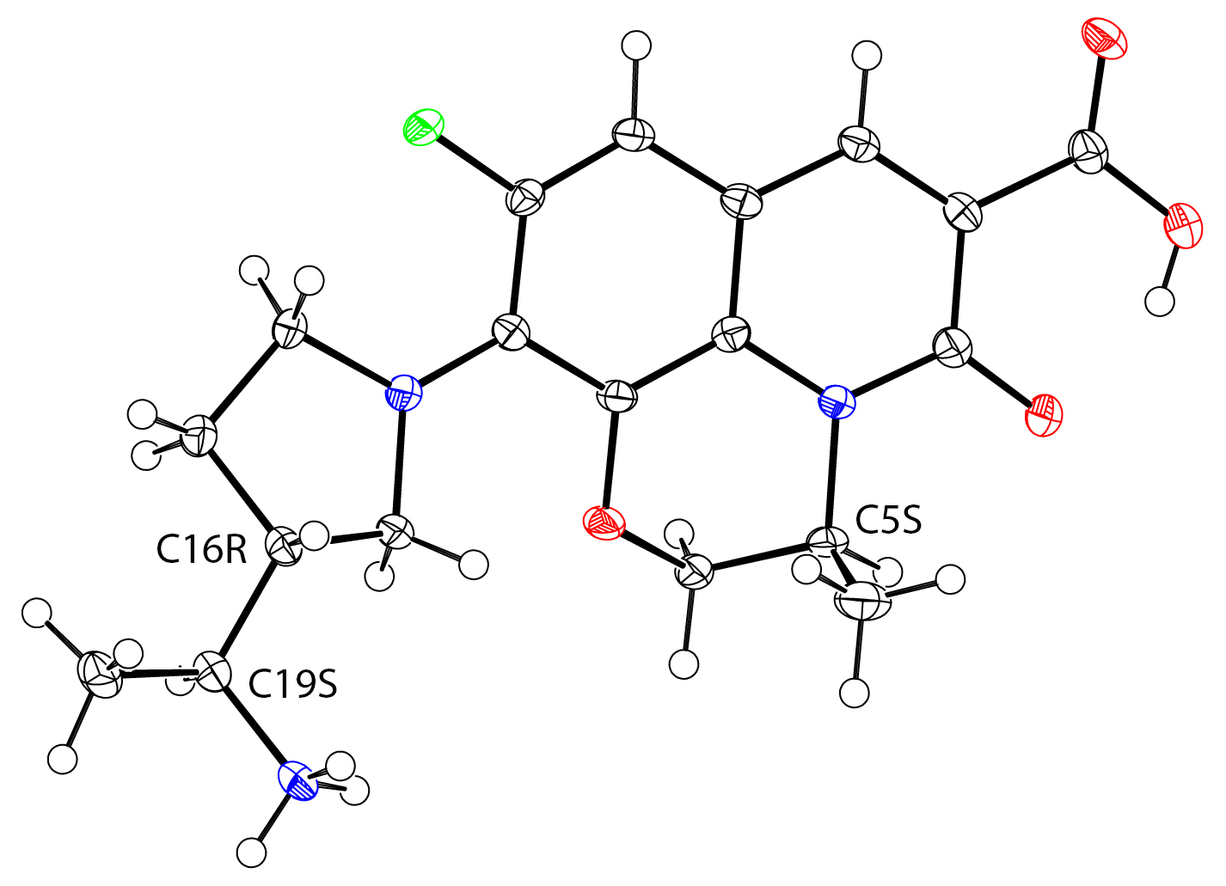
Representation created with PLATON.¹ Ellipsoids shown at 50% probability, radii of hydrogen atoms arbitrary. Disordered counterion (chloride) and solvent (water) omitted for clarity.

Supplementary Table 2. Crystal data and structure refinement for compound 24.

Crystallization solvent mixture MeOH/IBMK
Empirical formula C19 H25 Cl F N3 O5
Formula weight 429.87
Temperature 100(2) K
Wavelength 1.54178 Å
Crystal system Monoclinic
Space group P21
Unit cell dimensions a = 11.591(4) Å α= 90°
b = 7.111(2) Å β= 102.389(19)°
c = 12.069(4) Å γ = 90°
Volume 971.6(5) Å3
Z 2
Density (calculated) 1.469 g/cm3
Absorption coefficient 2.162 mm-1
F(000) 452
Crystal size 0.23 x 0.05 x 0.02 mm3
Theta range for data collection 3.75 to 68.29°
Index ranges -13<=h<=13, -8<=k<=8, -13<=l<=14
Reflections collected 21324
Independent reflections 3540 [R(int) = 0.0470]
Completeness to theta = 68.29° 99.8 %
Absorption correction Semi-empirical from equivalents
Max. and min. transmission 0.9580 and 0.6362
Refinement method Full-matrix least-squares on F2
Data / restraints / parameters 3540 / 1 / 271
Goodness-of-fit on F2 1.034
Final R indices [I>2sigma(I)] R1 = 0.0307, wR2 = 0.0770
R indices (all data) R1 = 0.0343, wR2 = 0.0791
Absolute structure parameter -0.001(13)
Largest diff. peak and hole 0.28 and -0.23 e·Å-3

Supplementary Figure 5. Structure of compound 25 in the crystal.

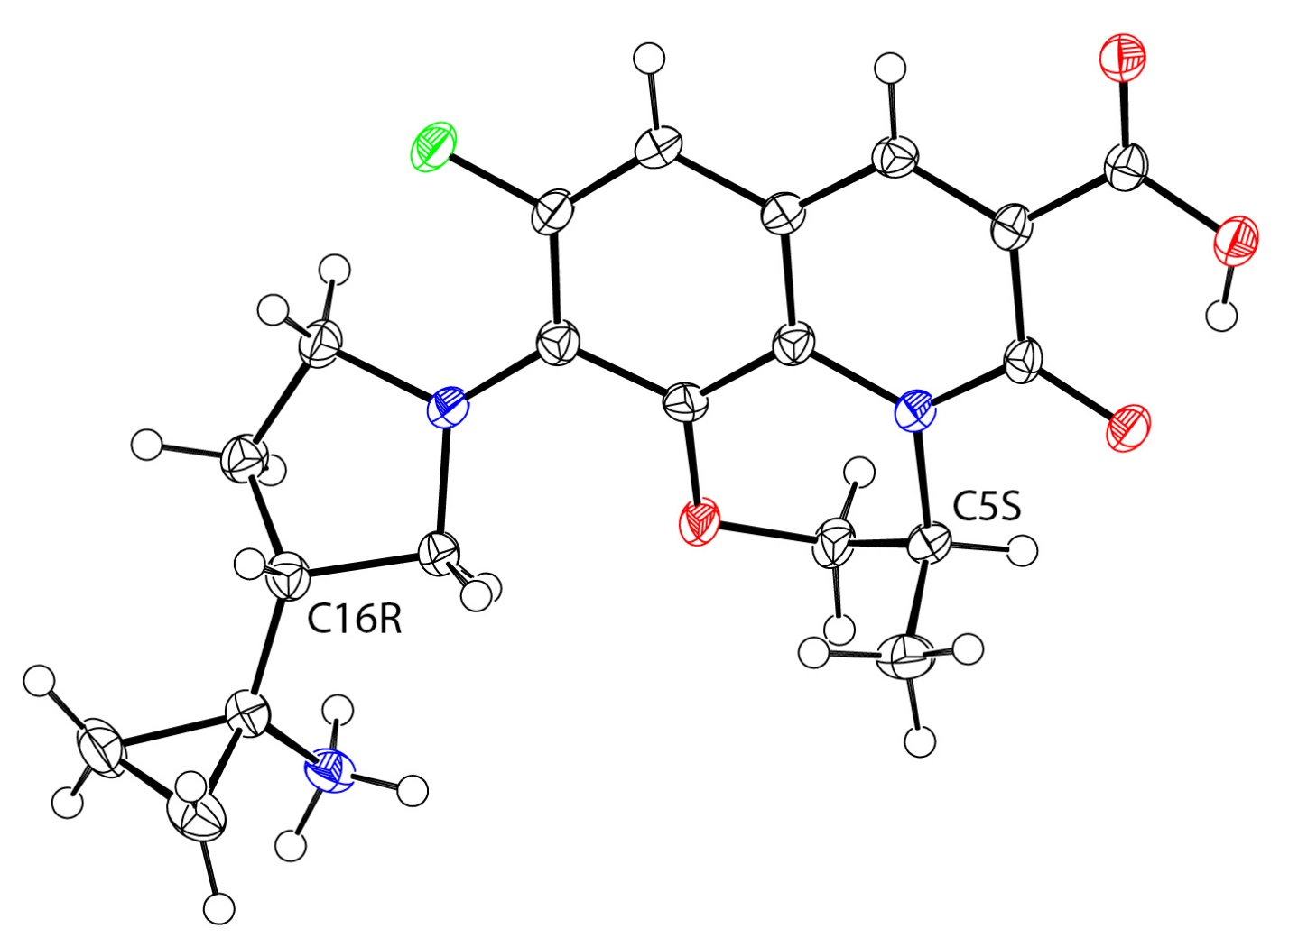

Representation created with PLATON.¹ Ellipsoids shown at 50% probability, radii of hydrogen atoms arbitrary. Counterion (cloride) and second independent molecule omitted for clarity.

Supplementary Table 3. Crystal data and structure refinement for compound 25.

Crystallization solvent mixture PYR/DIPE/MEOH
Empirical formula C20 H23 Cl F N3 O4
Formula weight 423.86
Temperature 100(2) K
Wavelength 1.54178 Å
Crystal system Monoclinic
Space group P21
Unit cell dimensions a = 9.525(2) Å α= 90°
b = 21.604(5) Å β= 97.131(14)°
c = 9.652(2) Å γ = 90°
Volume 1970.8(7) Å3
Z 4
Density (calculated) 1.429 g/cm3
Absorption coefficient 2.088 mm-1
F(000) 888
Crystal size 0.18 x 0.07 x 0.02 mm3
Theta range for data collection 4.09 to 68.28°
Index ranges -11<=h<=11, -26<=k<=26, -11<=l<=11
Reflections collected 40957
Independent reflections 7231 [R(int) = 0.0548]
Completeness to theta = 68.28° 99.9 %
Absorption correction Semi-empirical from equivalents
Max. and min. transmission 0.9594 and 0.7050
Refinement method Full-matrix least-squares on F2
Data / restraints / parameters 7231 / 1 / 529
Goodness-of-fit on F2 1.034
Final R indices [I>2sigma(I)] R1 = 0.0356, wR2 = 0.0910
R indices (all data) R1 = 0.0396, wR2 = 0.0940
Absolute structure parameter 0.008(10)
Largest diff. peak and hole 0.24 and -0.22 e·Å-3

Supplementary Figure 6. Structure of compound 48 in the crystal.
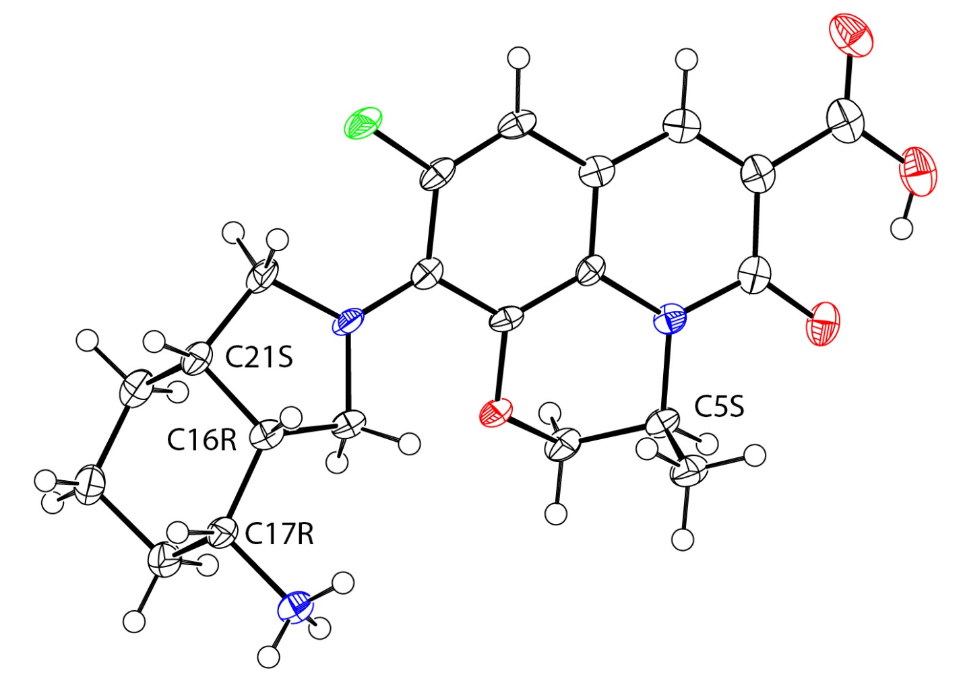
Representation created with PLATON.¹ Ellipsoids shown at 50% probability, radii of hydrogen atoms arbitrary. Counterion (chloride) and solvent (water, methanol) omitted for clarity.

Supplementary Table 4. Crystal data and structure refinement for compound 48.
Identification code MeOH
Empirical formula C22 H31 Cl F N3 O6
Formula weight 487.95
Temperature 100(2) K
Wavelength 1.54178 Å
Crystal system monoclinic
Space group P21
Unit cell dimensions a = 9.245(5) Å α= 90°
b = 6.578(4) Å β= 102.10(4)°
c = 18.960(11) Å γ = 90°
Volume 1127.4(11) Å3
Z 2
Density (calculated) 1.437 g/cm3
Absorption coefficient 1.965 mm-1
F(000) 516
Crystal size 0.06 x 0.04 x 0.02 mm3
Theta range for data collection 2.38 to 68.65°
Index ranges -11<=h<=11, -7<=k<=7, -22<=l<=22
Reflections collected 24658
Independent reflections 4136 [R(int) = 0.0851]
Completeness to theta = 68.65° 99.4 %
Absorption correction semi-empirical from equivalents
Max. and min. transmission 0.9617 and 0.8912
Refinement method full-matrix least-squares on F2
Data / restraints / parameters 4136 / 1 / 303
Goodness-of-fit on F2 1.032
Final R indices [I>2sigma(I)] R1 = 0.0490, wR2 = 0.1164
R indices (all data) R1 = 0.0704, wR2 = 0.1274
Absolute structure parameter 0.00(2)
Largest diff. peak and hole 0.41 and -0.46 e·Å-3

Supplementary Figure 7. Structure of compound 49 in the crystal.

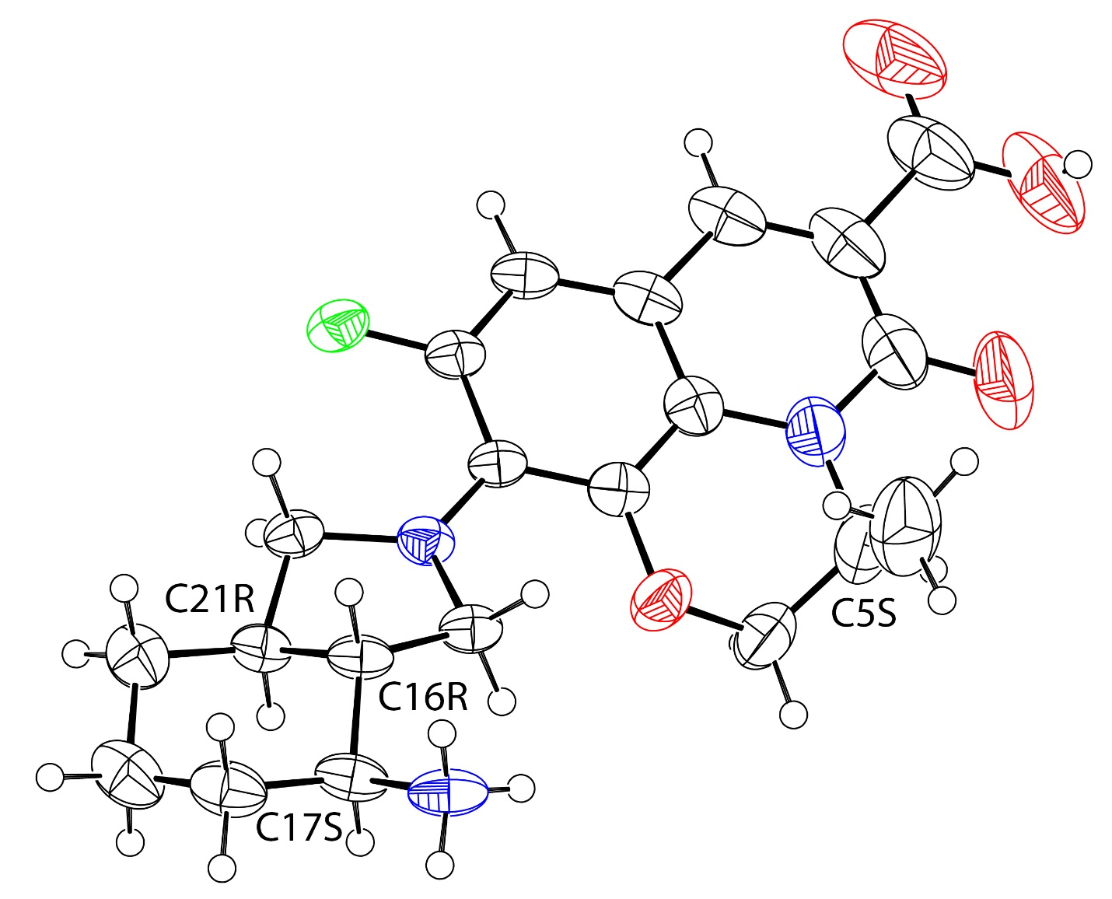

Representation created with PLATON.¹ Ellipsoids shown at 50% probability, radii of hydrogen atoms arbitrary. Counterion (cloride) omitted for clarity.

Supplementary Table 5. Crystal data and structure refinement for compound 49.

Crystallization solvent mixture ETOH/THF
Empirical formula C21 H25 Cl F N3 O4
Formula weight 437.89
Temperature 100(2) K
Wavelength 1.54178 Å
Crystal system monoclininc
Space group P21
Unit cell dimensions a = 13.2524(9) Å α = 90 °
b = 7.4185(4) Å β = 110.970(4) °
c = 14.5019(8) Å γ = 90 °
Volume 1331.30(14) Å3
Z 2
Density (calculajed) 1.092 g/cm3
Absorption coefficient 1.559 mm-1
F(000) 460
Crystal size 0.54 x 0.15 x 0.03 mm3
Theta range for data collection 3.26 to 68.30°.
Index ranges -15<=h<=15, -8<=k<=8, -17<=l<=17
Reflections collected 27573
Independent reflections 4813 [R(int) = 0.0733]
Completeness to theta = 68.30° 99.9 %
Max. and min. transmission 0.9547 and 0.4865
Refinement method Full-matrix least-squares on F2
Data / restraints / parameters 4813 / 1 / 274
Goodness-of-fit on F2 1.070
Final R indices [I>2sigma(I)] R1 = 0.0522, wR2 = 0.1250
R indices (all data) R1 = 0.0599, wR2 = 0.1309
Absolute structure parameter 0.054(18)
Largest diff. peak and hole 0.43 and -0.29 e·Å-3

Supplementary Figure 8. Structure of compound 50 in the crystal.

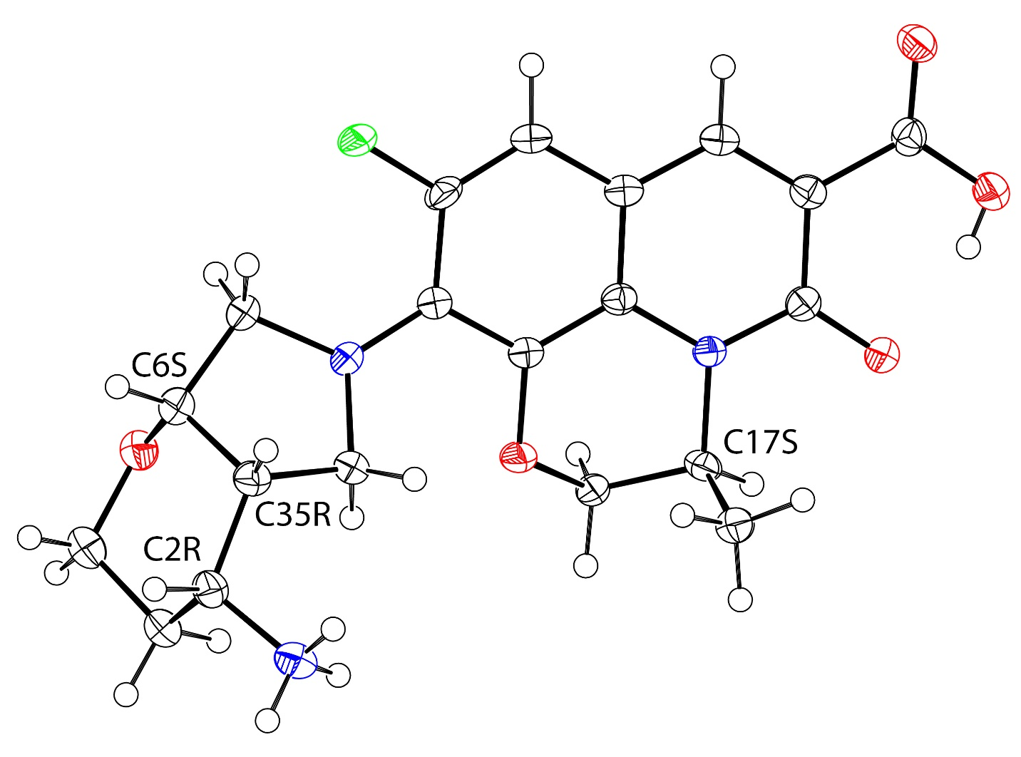
Representation created with PLATON.¹ Ellipsoids shown at 50% probability, radii of hydrogen atoms arbitrary. Counterion (chloride) and solvent (water) omitted for clarity.

Supplementary Table 6. Crystal data and structure refinement for compound 50.

Crystallization solvent mixture DCM/MeOH
Empirical formula C20 H33 Cl F N3 O10
Formula weight 529.94
Temperature 100(2) K
Wavelength 1.54178 Å
Crystal system monoclinic
Space group P21
Unit cell dimensions a = 11.2731(18) Å α = 90 °
b = 7.0444(11) Å β = 102.536(9) °
c = 15.858(2) Å γ = 90 °
Volume 1229.3(3) Å3
Z 2
Density (calculated) 1.432 g/cm3
Absorption coefficient 1.971 mm-1
F(000) 560
Crystal size 0.11 x 0.08 x 0.02 mm3
Theta range for data collection 2.85 to 67.99°.
Index ranges -13<=h<=13, -8<=k<=8, -19<=l<=19
Reflections collected 21873
Independent reflections 4463 [R(int) = 0.0614]
Completeness to theta = 67.99° 99.8 %
Absorption correction semi-empirical from equivalents
Max. and min. transmission 0.9616 and 0.8123
Refinement method full-matrix least-squares on F2
Data / restraints / parameters 4463 / 4 / 322
Goodness-of-fit on F2 1.090
Final R indices [I>2sigma(I)] R1 = 0.0542, wR2 = 0.1351
R indices (all data) R1 = 0.0632, wR2 = 0.1438
Absolute structure parameter -0.01(2)
Largest diff. peak and hole 0.59 and -0.29 e·Å-3

Supplementary Figure 9. Structure of compound 52 in the crystal.

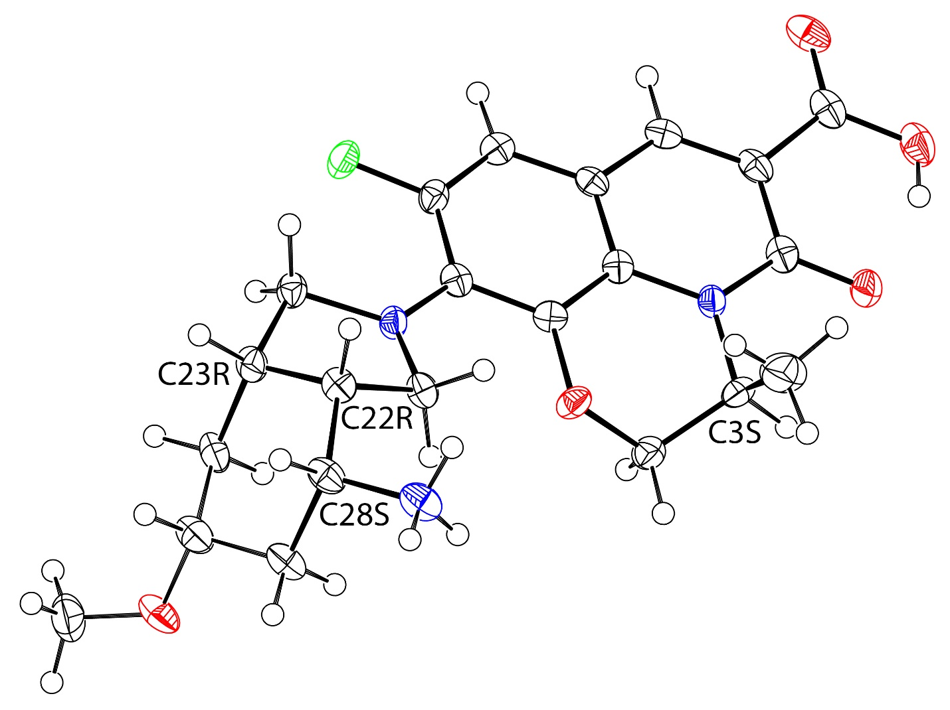
Representation created with PLATON.¹ Ellipsoids shown at 50% probability, radii of hydrogen atoms arbitrary. Counterion (chloride), solvent (water) and disorder in OMe group omitted for clarity.

Supplementary Table 7. Crystal data and structure refinement for compound 52.

Crystallization solvent mixture ETOH/HCl
Empirical formula C22 H29 Cl F N3 O6
Formula weight 485.93
Temperature 100(2) K
Wavelength 1.54178 Å
Crystal system monoclinic
Space group P21
Unit cell dimensions a = 12.6524(7) Å α = 90 °
b = 6.5019(3) Å β = 99.676(3) °
c = 15.4151(8) Å γ = 90 °
Volume 1250.08(11) Å3
Z 2
Density (calculated) 1.291 g/cm3
Absorption coefficient 1.772 mm-1
F(000) 512
Crystal size 0.53 x 0.03 x 0.02 mm3
Theta range for data collection 3.54 to 68.28°.
Index ranges -15<=h<=15, -7<=k<=7, -18<=l<=18
Reflections collected 18008
Independent reflections 4377 [R(int) = 0.0791]
Completeness to theta = 68.28° 99.1 %
Absorption corrections semi-empirical from equivalents
Max. and min. transmission 0.9654 and 0.4535
Refinement method full-matrix least-squares on F2
Data / restraints / parameters 4377 / 65 / 312
Goodness-of-fit on F2 1.092
Final R indices [I>2sigma(I)] R1 = 0.0491, wR2 = 0.1177
R indices (all data) R1 = 0.0597, wR2 = 0.1245
Absolute structure parameter 0.050(19)
Largest diff. peak and hole 0.33 and -0.31 e·Å-3

Supplementary Figure 10. Crystal structure of compound 54.
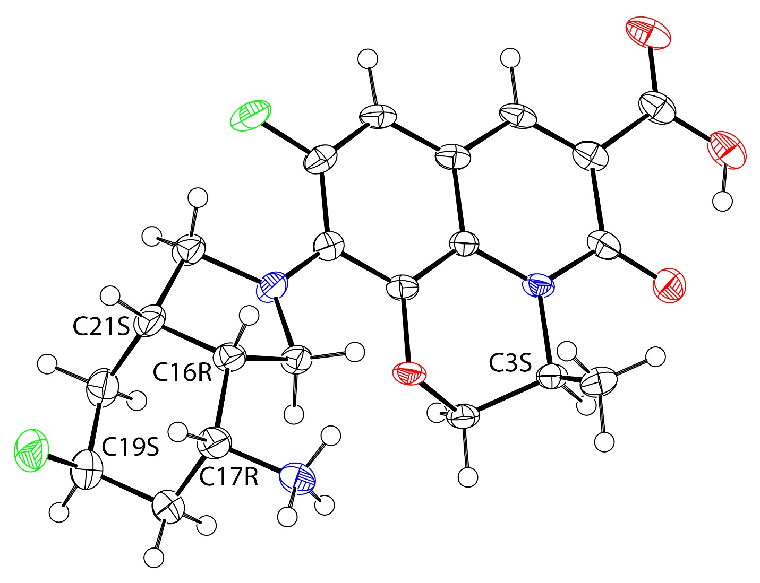

Representation created with PLATON.¹ Ellipsoids shown at 50% probability, radii of hydrogen atoms arbitrary. Counterion (chloride) and solvent (water, isopropanol) omitted for clarity.

Supplementary Table 8. Crystal data and structure refinement for compound 54
Crystallization solvent mixture isopropanol/HCl
Empirical formula C22.50 H28 Cl F2 N3 O6
Formula weight 509.93
Temperature 100(2) K
Wavelength 1.54178 Å
Crystal system triclinic
Space group P1
Unit cell dimensions a = 6.6384(5) Å α = 76.408(4) °
b = 11.8760(9) Å β = 78.976(4) °
c = 16.1825(10) Å γ = 78.507(5) °
Volume 1201.15(15) Å3
Z 2
Density (calculated) 1.410 g/cm3
Absorption coefficient 1.935 mm-1
F(000) 534
Crystal size 0.17 x 0.04 x 0.02 mm3
Theta range for data collection 2.84 to 68.39°.
Index ranges -7<=h<=7, -14<=k<=14, -19<=l<=19
Reflections collected 23816
Independent reflections 7947 [R(int) = 0.0488]
Completeness to theta = 68.39° 98.5 %
Absorption correction semi-empirical from equivalents
Max. and min. transmission 0.9623 and 0.7345
Refinement method full-matrix least-squares on F2
Data / restraints / parameters 7947 / 9 / 641
Goodness-of-fit on F2 1.016
Final R indices [I>2sigma(I)] R1 = 0.0599, wR2 = 0.1544
R indices (all data) R1 = 0.0674, wR2 = 0.1608
Absolute structure parameter 0.041(16)
Largest diff. peak and hole 0.76 and -0.32 e·Å-3

Supplementary Figure 11. Overlay of crystal structures of compound 24 (purple) and compound 48 (yellow).

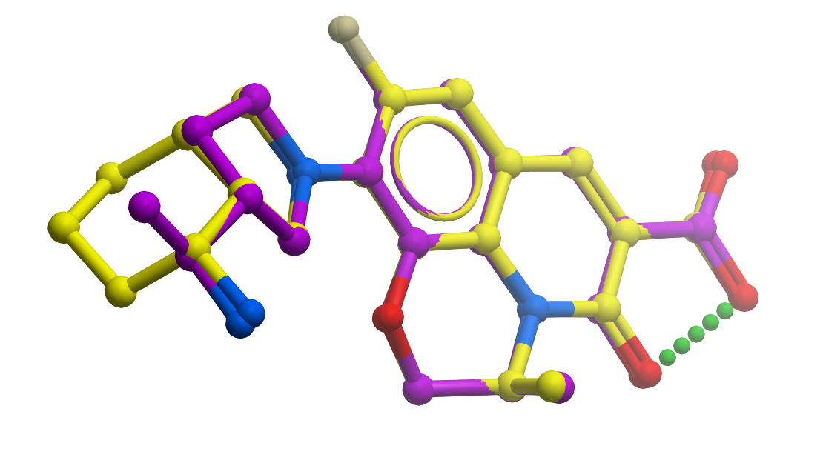
Supplementary Figure 12. Overlay of crystal structures of compound 48 (yellow) and compound 49 (green).

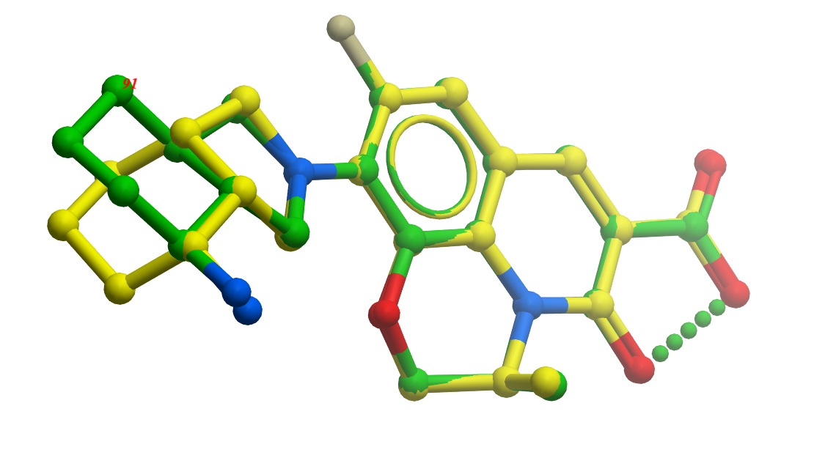
References
- Spek, A. L. Single-crystal structure validation with the program PLATON. J. Appl. Crystallogr. 2003, 36, 7-13.

Synthesis and Characterization of Final Compounds and Intermediates
General Experimental Conditions
Conditions for analytical HPLC: Final compounds and/or intermediates were characterized by high performance liquid chromatography (HPLC) using a Waters UPLC instrument. HPLC solvent A was 100% MilliQ water (Millipore) with 0.05% formic acid (Fluka) and solvent B was 100% methanol (EMD OmniSolvent) with 0.04% formic acid. The instrument was a Waters ACQUITY UPLC system with 1 mL/min flow rate; column BEH C18, 2.1 x 30 mm, column temperature: 60 °C; gradient: 2-80% solvent B over 0.50 min, then 80-95%B over 0.1 min and holding at 95% solvent B for 0.2 min. Compounds were detected by ultraviolet light (UV) absorption at 214 nm and evaporative light scattering (ELSD). Purity of all final compounds was determined to be ≥95% unless otherwise noted.
Typical conditions for LC/MS analysis (compounds 10-23, 26, 45): LCMS solvent A was 5 mM ammonium acetate and 0.1 % formic acid in water and solvent B was 0.1 % formic acid in acetonitrile. The instrument was a Waters ACQUITY H class UPLC system with 0.55 mL/min flow rate; column BEH-C18, 1.7 um, 2.1 x 50 mm from Waters or HSS C18, 1.8 µm, 2.1 x 50 mm; column temperature: ambient; gradient: 5% solvent B held for 0.4 min, 5-40 % solvent B over 0.2 min, 40-60% solvent B over 0.6 min, 60-100% solvent B over 1.1 min then held at 100% solvent B for 0.7 min. Compounds were detected by ultraviolet light (UV) absorption and electrospray ionization (ESI) mass spectrometry (MS) in positive ion mode. For select bromine-containing intermediates, MS data is reported as [M+2]⁺, reflecting the mass of the heavier isotope [M+H]⁺.
Alternate conditions for LC/MS analysis (compounds 24, 27, 30-42, 44, 48, 50, 52-57): LCMS solvent A was 2 mM ammonium acetate and 0.1 % formic acid in water and solvent B was 0.1 % formic acid in acetonitrile. The instrument was a Waters ACQUITY H class UPLC system with 0.55 mL/min flow rate; column BEH-C18, 1.7 um, 2.1 x 50 mm from Waters; column temperature: ambient; gradient: 2% solvent B held for 0.3 min with 0.55 mL/min flow rate, 2-50 % solvent B over 0.3 min, 50-75% solvent B over 0.5 min, 75-100% solvent B over 0.9 min with 0.6 mL/min flow rate then held at 100% solvent B for 0.7 min with 0.6 mL/min flow rate. Compounds were detected by ultraviolet light (UV) absorption and electrospray ionization (ESI) mass spectrometry (MS) in positive ion mode. For select bromine-containing intermediates, MS data is reported as [M+2]⁺, reflecting the mass of the heavier isotope [M+H]⁺.
Alternate conditions for LC/MS analysis (compounds 6, 8, 9, 25, 28, 29, 43, 46, 47, 49, 51): HPLC solvent A was 100% Water with 0.1% trifluoroacetic acid (TFA) and solvent B was 100% acetonitrile with 0.1% TFA. HPLC/mass spectrometric analysis (LC/MS) Waters ACQUITY UPLC system and equipped with a ZQ 2000 or SQD MS system; Column: Kinetex by Phenomenex, 2.6 um, 2.1 x 50 mm, column temperature: 50 °C; gradient: 2-88% (or 0-45%, or 65-95%) solvent B over a 1.29 min or 9.79 min period (1.5 min or 10 min run time, respectively); flow rate 1.2 mL/min. Compounds were detected by a Waters Photodiode Array Detector. Unless otherwise noted, all masses were reported as those of the protonated parent ions, molecular weight range 150-850; cone voltage 20V.
NMR spectra were run on Varian 400 or Bruker 400 and 500 MHz NMR spectrometers. Spectra were measured at 298K and were referenced using the solvent peak.
High resolution ESI-MS data were recorded using a LTQ Orbitrap mass spectrometer (Thermo Fisher Scientific) with electrospray ionization source. The resolution of the MS system was approximately 30000. The analyte compound was infused into the mass spectrometer by UPLC (Acquity, Waters) from sample probe. The separation was performed on Acquity UPLC BEH C18 1x50 mm column at 0.15 mL/min flow rate with the gradient from 5% to 95% in 2.8 min. Solvent A was Water with 0.1% Trifluoroacetic acid and solvent B was 75% Methanol and 25% Isopropyl alcohol with 0.1% Trifluoroacetic acid. The mass accuracy of the system was found to be <5 ppm.
Preparative separations are carried out using a Combiflash Rf system (Teledyne Isco, Lincoln, NE) with RediSep silica gel cartridges (Teledyne Isco, Lincoln, NE) or SiliaSep silica gel cartridges (Silicycle Inc., Quebec City, Canada) or by flash column chromatography using silica gel (230-400 mesh) packing material, or by HPLC using a Waters 2767 Sample Manager, C-18 reversed phase Sunfire column, 30X50 mm, flow 75 mL/min. Typical solvents employed for the Combiflash Rf system and flash column chromatography are dichloromethane, methanol, ethyl acetate, hexane, heptane, acetone, aqueous ammonia (or ammonium hydroxide), and triethyl amine. Typical solvents employed for the reverse phase HPLC are varying concentrations of acetonitrile and water with 0.1% trifluoroacetic acid.

Synthesis of iso-fluoroquinolone 6.

7-Bromo-1-cyclopropyl-6-fluoro-3-methoxy-8-methylquinolin-2(1H)-one (59)
To a solution of LiHMDS (1M in THF, 14.0 mL, 14.0 mmol) in THF (7 mL) at –78 °C was added ethyl 2-methoxyacetate (1.65 mL, 14.0 mmol). The reaction mixture was stirred for 20 min, after which a solution of 4-bromo-2-(cyclopropylamino)-5-fluoro-3-methylbenzaldehyde (58) (380 mg, 1.40 mmol) in THF (7 mL) was added. The reaction mixture was stirred at room temperature for 16 h. The reaction was quenched with 6N HCl (4 mL, pH = 3), and the resulting mixture was refluxed at 110 °C for 2 h. The solution was diluted with ethyl acetate, washed with water, brine, dried over sodium sulfate, and concentrated. The residue was purified by silica gel chromatography (0-100% EtOAc/heptane) to give the title compound (300 mg, 40% yield) as a light yellow oil. LCMS (m/z): 328.0 [M+2]⁺.

tert-Butyl ((S)-1-((R)-1-(1-cyclopropyl-6-fluoro-3-methoxy-8-methyl-2-oxo-1,2-dihydroquinolin-7-yl)pyrrolidin-3-yl)ethyl)carbamate (61)
To a solution of 7-bromo-1-cyclopropyl-6-fluoro-3-methoxy-8-methylquinolin-2(1H)-one (59) (95.0 mg, 0.29 mmol) in dioxane (3 mL) were added tert-butyl ((S)-1-((R)-pyrrolidin-3-yl)ethyl)carbamate (60) (112 mg, 0.52 mmol), Cs₂CO₃ (285 mg, 0.87 mmol), xantphos (33.7 mg, 0.06 mmol) and Pd₂(dba)₃ (26.7 mg, 0.03 mmol). The resulting mixture was heated at 110 °C for 18 h. The reaction was diluted with water and the solution was extracted with ethyl acetate. The combined organic phase was dried over sodium sulfate and concentrated. The residue was purified by silica gel chromatography (0-100% EtOAc/heptane) providing the desired product (40.0 mg, 30% yield). LCMS (m/z): 460.3 [M+H]⁺.

7-((R)-3-((S)-1-Aminoethyl)pyrrolidin-1-yl)-1-cyclopropyl-6-fluoro-3-hydroxy-8-methylquinolin-2(1H)-one trifluoroacetic acid (6)
To an ice cold solution of tert-butyl ((S)-1-((R)-1-(1-cyclopropyl-6-fluoro-3-methoxy-8-methyl-2-oxo-1,2-dihydroquinolin-7-yl)pyrrolidin-3-yl)ethyl)carbamate (61) (20.0 mg, 0.04 mmol) in DCM (2 mL) was added boron tribromide (1M in DCM, 0.22 mL, 0.22 mmol). The resulting mixture was stirred at room temperature for 2 h. The reaction mixture was quenched with ice water and extracted with ethyl acetate. The combined organic phase was washed with brine, dried over sodium sulfate and concentrated. The resulting residue was purified by HPLC to provide the product (4.20 mg, 20% yield). HRMS (ESI) calc’d for C₁₉H₂₄FN₃O₂ [M+H]⁺ 346.1925, found 346.1920. ¹H NMR (400 MHz, CD₃OD) δ 6.94 (d, J = 12.5 Hz, 1H), 6.78 (s, 1H), 3.47 (qd, J = 7.1, 3.5 Hz, 1H), 3.43–3.32 (m, 2H), 3.31–3.24 (m, 3H), 2.53 (s, 3H), 2.47–2.32 (m, 1H), 2.12 (tdd, J = 11.7, 7.7, 3.6 Hz, 1H), 1.83–1.63 (m, 1H), 1.30 (d, J = 6.6 Hz, 3H), 1.18–1.03 (m, 2H), 0.42 (q, J = 3.9 Hz, 2H).

Synthesis of iso-fluoroquinolone 8.

(R)-methyl 7-(3-(1-((tert-butoxycarbonyl)amino)cyclopropyl)pyrrolidin-1-yl)-1-cyclopropyl-6-fluoro-8-methyl-2-oxo-1,2-dihydroquinoline-3-carboxylate (64)
Eighteen 20 mL microwave vials were each charged with methyl 7-bromo-1-cyclopropyl-6-fluoro-8-methyl-2-oxo-1,2-dihydroquinoline-3-carboxylate (62) (1.00 g, 2.82 mmol), RuPhos (0.132 g, 0.282 mmol), RuPhos Pd G3 (0.236 g, 0.282 mmol) and cesium carbonate (2.76 g, 8.47 mmol). The vial was sealed, evacuated and back-filled with N₂, then (R)-tert-butyl (1-(pyrrolidin-3-yl)cyclopropyl)carbamate (63) (0.958 g, 4.24 mmol) was added as a solution in dioxane (10 ml, previously degassed by sparging with argon). The mixture was heated to 90 °C for 2 hours, then cooled to rt. The 18 reactions were then split into two batches of nine. Each group of nine were combined, filtered through celite, and concentrated under reduced pressure. The two crude batches were purified separately via SiO₂ flash chromatography (0-100% EtOAc/heptane) to provide (R)-methyl 7-(3-(1-((tert-butoxycarbonyl)amino)cyclopropyl)pyrrolidin-1-yl)-1-cyclopropyl-6-fluoro-8-methyl-2-oxo-1,2-dihydroquinoline-3-carboxylate as a yellow foam (18.5 g, 73% yield). LCMS m/z: 500.3 [M+H]⁺. ¹H NMR (400 MHz, CDCl₃) δ 8.19 (s, 1H), 7.00 (d, J = 12.7 Hz, 1H), 4.95 (s, 0.69H, Boc rotamer), 4.73 (s, 0.22H, Boc rotamer), 3.92 (s, 3H), 3.70 (br q, J = 8.6 Hz, 1H), 3.57 (td, J = 9.3, 2.7 Hz, 1H), 3.52 – 3.35 (m, 3H), 2.48 – 2.29 (m, 4H), 2.09 – 1.98 (m, 1H), 1.78 (p, J = 10.0 Hz, 1H), 1.50 (s, 2H, Boc rotamer), 1.42 (s, 7H, Boc rotamer), 1.33 – 1.24 (m, 1H), 1.19 – 1.08 (m, 1H), 0.92 – 0.71 (m, 4H), 0.64 – 0.49 (m, 2H).

(R)-7-(3-(1-((tert-butoxycarbonyl)amino)cyclopropyl)pyrrolidin-1-yl)-1-cyclopropyl-6-fluoro-8-methyl-2-oxo-1,2-dihydroquinoline-3-carboxylic acid (65)
(R)-methyl 7-(3-(1-((tert-butoxycarbonyl)amino)cyclopropyl)pyrrolidin-1-yl)-1-cyclopropyl-6-fluoro-8-methyl-2-oxo-1,2-dihydroquinoline-3-carboxylate (64) (9.87 g, 19.76 mmol) was dissolved in MeOH (148 ml) and water (49.4 ml) and lithium hydroxide (1M in water, 59.3 ml, 59.3 mmol) was added dropwise at room temperature using a dropping funnel. After 3 hours, LCMS showed complete reaction. Most of the MeOH was evaporated from the mixture under reduced pressure. The mixture was diluted with water (200 mL) then 100 mL of 1M HCl was added. The mixture was extracted with EtOAc (3 x 100 mL), then the combined organic extracts were washed with brine, dried over MgSO₄, filtered and concentrated under reduced pressure. The crude material was purified by SiO₂ flash chromatography (0-100% EtOAc/heptane with 0.5% acetic acid) to give (R)-7-(3-(1-((tert-butoxycarbonyl)amino)cyclopropyl)pyrrolidin-1-yl)-1-cyclopropyl-6-fluoro-8-methyl-2-oxo-1,2-dihydroquinoline-3-carboxylic acid (8.56 g, 89% yield) as a yellow solid following evaporation from toluene to remove residual acetic acid. LCMS m/z: 486.3 [M+H]⁺.

(R)-7-(3-(1-aminocyclopropyl)pyrrolidin-1-yl)-1-cyclopropyl-6-fluoro-8-methyl-2-oxo-1,2-dihydroquinoline-3-carboxylic acid ((–)-8)
A mixture of (R)-7-(3-(1-((tert-butoxycarbonyl)amino)cyclopropyl)pyrrolidin-1-yl)-1-cyclopropyl-6-fluoro-8-methyl-2-oxo-1,2-dihydroquinoline-3-carboxylic acid (65) (8.36 g, 17.2 mmol) in DCM (43.0 ml) was treated with 4M HCl in dioxane (43.0 mL) at rt. The reaction was stirred for 3 hours during which time a yellow precipitate formed. The reaction mixture was filtered and the yellow solid was washed multiple times with Et₂O and then pentane before drying at the frit overnight. The solid was lyophilized from 1:1 MeCN/water to give (R)-7-(3-(1-aminocyclopropyl)pyrrolidin-1-yl)-1-cyclopropyl-6-fluoro-8-methyl-2-oxo-1,2-dihydroquinoline-3-carboxylic acid (6.26 g, 86% yield) as a fluffy yellow solid. HRMS (ESI) calc’d for C₂₁H₂₄FN₃O₃ [M+H]⁺ 386.1874, found 386.1868. ¹H NMR (400 MHz, CD₃OD) δ 8.63 (s, 1H), 7.42 (d, J = 12.9 Hz, 1H), 3.87 – 3.77 (m, 1H), 3.70 – 3.61 (m, 2H), 3.59 – 3.49 (m, 2H), 2.75 (p, J = 7.7 Hz, 1H), 2.55 (s, 3H), 2.23 – 2.14 (m, 1H), 1.78 (p, J = 9.4 Hz, 1H), 1.39 – 1.21 (m, 2H), 1.07 – 0.91 (m, 4H), 0.72 – 0.55 (m, 2H). [α]_{D}²⁰ = –62.0 (c = 10 mg/mL, MeOH).

Synthesis of iso-fluoroquinolone 9.

tert-Butyl (R)-(1-(1-(3-carbamoyl-1-cyclopropyl-6-fluoro-8-methyl-2-oxo-1,2-dihydroquinolin-7-yl)pyrrolidin-3-yl)cyclopropyl)carbamate (S1)
To a solution of (R)-7-(3-(1-((tert-butoxycarbonyl)amino)cyclopropyl)pyrrolidin-1-yl)-1-cyclopropyl-6-fluoro-8-methyl-2-oxo-1,2-dihydroquinoline-3-carboxylic acid (65) (350 mg, 0.72 mmol) in DCM (4 mL) were added HATU (548 mg, 1.44 mmol), TEA (1.00 mL, 7.21 mmol) and ammonium chloride (193 mg, 3.60 mmol). The resulting suspension was stirred at rt for 2 h. The reaction was concentrated and the crude residue was purified by silica gel column chromatography (0-100% EtOAc/heptane), providing the desired product (350 mg, quantitative yield). LCMS (m/z): 485.3 [M+H]⁺.

(R)-7-(3-(1-Aminocyclopropyl)pyrrolidin-1-yl)-1-cyclopropyl-6-fluoro-8-methyl-2-oxo-1,2-dihydroquinoline-3-carboxamide hydrochloride (9)
To a solution of tert-butyl (R)-(1-(1-(3-carbamoyl-1-cyclopropyl-6-fluoro-8-methyl-2-oxo-1,2-dihydroquinolin-7-yl)pyrrolidin-3-yl)cyclopropyl)carbamate (S1) (350 mg, 0.72 mmol) in DCM (4.5 mL) was added HCl (4M in dioxane, 4.5 mL) at rt. The reaction mixture was stirred for 1 h. The reaction mixture was concentrated and the residue was triturated with acetonitrile to give the desired product (158 mg, 51% yield). HRMS (ESI) calc’d for C₂₁H₂₅FN₄O₂ [M+H]⁺ 385.2034, found 385.2029. ¹H NMR (400 MHz, CD₃OD) δ 8.55 (s, 1H), 7.32 (d, J = 12.7 Hz, 1H), 3.71 (q, J = 8.6 Hz, 1H), 3.62–3.51 (m, 2H), 3.51–3.40 (m, 2H), 2.73 (p, J = 8.0 Hz, 1H), 2.52 (s, 3H), 2.15 (ddt, J = 9.4, 6.8, 3.4 Hz, 1H), 1.91 (s, 2H), 1.75 (p, J = 9.3 Hz, 1H), 1.32–1.18 (m, 2H), 1.04–0.91 (m, 4H), 0.61–0.46 (m, 2H).

Synthesis of iso-fluoroquinolone 10.

7-Bromo-1-cyclopropyl-6-fluoro-8-methyl-2-oxo-1,2-dihydroquinoline-3-carboxamide (S2)
To 7-bromo-1-cyclopropyl-6-fluoro-8-methyl-2-oxo-1,2-dihydroquinoline-3-carboxylic acid (67) (0.90 g, 2.65 mmol) in DMF (10 mL) were added N-methyl morpholine (1.34 g, 13.2 mmol), HOBt (0.54 g, 3.97 mmol) and EDC•HCl (0.61 g, 3.17 mmol) at room temperature followed by stirring for 10 minutes. Ammonium chloride (0.42 g, 7.92 mmol) was added and the reaction mixture was stirred at room temperature for 2 hours. The reaction mixture was quenched with cold water and extracted with EtOAc. The combined organic layer was washed with brine, dried over sodium sulfate and concentrated, affording the desired product (0.87 g, 97% yield). LCMS (m/z): 341.2 [M+2]⁺. ¹H NMR (400 MHz, DMSO-d₆) δ 8.88 (s, 1H), 8.68 (s, 1H), 7.89–7.83 (m, 2H), 3.65–3.60 (m, 1H), 2.77 (s, 3H), 1.19 (q, J = 6.6 Hz, 2H), 0.49 (d, J = 9.1 Hz, 2H).

7-Bromo-1-cyclopropyl-6-fluoro-8-methyl-2-oxo-1,2-dihydroquinoline-3-carbonitrile (68)
Trifluoroacetic anhydride (2.70 g, 12.8 mmol) was added dropwise to a solution of 7-bromo-1-cyclopropyl-6-fluoro-8-methyl-2-oxo-1,2-dihydroquinoline-3-carboxamide (S2) (0.87 g, 2.57 mmol) in pyridine (20 mL) at 0 °C followed by stirring for 2 h. The reaction mixture was poured into cold water, acidified with 1N HCl and extracted with EtOAc. The combined organic layer was washed with water, brine, dried over sodium sulfate and concentrated to afford a crude residue, which was purified by silica gel chromatography (0-100% EtOAc/heptane), providing the desired product (0.75 g, 91% yield). LCMS (m/z): 323.4 [M+2]⁺. ¹H NMR (400 MHz, CDCl₃) δ 8.01 (s, 1H), 7.19 (d, J = 7.0 Hz, 1H), 3.58 (td, J = 6.9, 3.5 Hz, 1H), 2.82 (s, 3H), 0.89 (dd, J = 11.8, 4.9 Hz, 2H), 0.62 (q, J = 7.0 Hz, 2H).

tert-Butyl (1-(1-(3-cyano-1-cyclopropyl-6-fluoro-8-methyl-2-oxo-1,2-dihydroquinolin-7-yl)pyrrolidin-3-yl)cyclopropyl)carbamate (69)

To a solution of 7-bromo-1-cyclopropyl-6-fluoro-8-methyl-2-oxo-1,2-dihydroquinoline-3-carbonitrile (68) (300 mg, 0.93 mmol) in toluene (5 mL) was added tert-butyl (1-(pyrrolidin-3-yl)cyclopropyl)carbamate (63) (316 mg, 1.40 mmol), Cs₂CO₃ (911 mg, 2.80 mmol), RuPhos (90.0 mg, 0.19 mmol) and RuPhosPd G3 (156 mg, 0.19 mmol). The reaction mixture was stirred at 90 °C for 4 h. After completion the mixture was dissolved in water and extracted with EtOAc. The organic layer was dried over Na₂SO₄ and concentrated to give a crude product which was purified by column chromatography on silica gel (0-60% EtOAc/PE), affording the desired product (310 mg, 71% yield). LCMS (m/z): 467.7 [M+H]⁺.

7-(3-(1-Aminocyclopropyl)pyrrolidin-1-yl)-1-cyclopropyl-6-fluoro-8-methyl-2-oxo-1,2-dihydroquinoline-3-carbonitrile trifluoroacetic acid (10)
tert-Butyl (1-(1-(3-cyano-1-cyclopropyl-6-fluoro-8-methyl-2-oxo-1,2-dihydroquinolin-7-yl)pyrrolidin-3-yl)cyclopropyl)carbamate (69) (50.0 mg, 0.11 mmol) was dissolved in DCM (3 mL) and cooled to 0 °C. Trifluoroacetic acid (1.5 mL) was added and the reaction mixture was stirred at room temperature for 2 hours. The reaction mixture was concentrated to afford a crude residue, which was purified by trituration with diethyl ether, providing the desired product (37.0 mg, 95% yield). HRMS (ESI) calc’d for C₂₁H₂₃FN₄O [M+H]⁺ 367.1929, found 367.1921. ¹H NMR (400 MHz, CD₃OD) δ 8.29 (s, 1H), 7.30 (d, J = 12.9 Hz, 1H), 3.81 (d, J = 8.6 Hz, 1H), 3.69–3.62 (m, 1H), 3.54 (dd, J = 17.7, 9.9 Hz, 3H), 2.76 (d, J = 8.4 Hz, 1H), 2.53 (s, 3H), 2.18 (s, 1H), 1.82–1.75 (m, 1H), 1.29–1.20 (m, 2H), 1.06–0.99 (m, 4H), 0.65–0.55 (m, 2H).

Synthesis of iso-fluoroquinolone 11.

tert-Butyl (R,Z)-(1-(1-(1-cyclopropyl-6-fluoro-3-(N'-hydroxycarbamimidoyl)-8-methyl-2-oxo-1,2-dihydroquinolin-7-yl)pyrrolidin-3-yl)cyclopropyl)carbamate (70)
tert-Butyl (R)-(1-(1-(3-cyano-1-cyclopropyl-6-fluoro-8-methyl-2-oxo-1,2-dihydroquinolin-7-yl)pyrrolidin-3-yl)cyclopropyl)carbamate (69) (obtained using the (R)-tert-butyl (1-(pyrrolidin-3-yl)cyclopropyl)carbamate during the Buchwald coupling step in the synthesis of iso-fluoroquinolone 10) (0.43 g, 0.92 mmol) was dissolved in ethanol (10 mL) at room temperature. Hydroxylamine (50% in water, 2.5 mL) was added and the reaction mixture was stirred at 50 °C for 2 h. The reaction mixture was quenched with cold water and extracted with EtOAc. The combined organic layer was washed with brine, dried over sodium sulfate and concentrated to providing the desired product (0.40 g). LCMS (m/z): 500.6 [M+H]⁺.

tert-Butyl (R)-(1-(1-(1-cyclopropyl-6-fluoro-8-methyl-2-oxo-3-(5-oxo-4,5-dihydro-1,2,4-oxadiazol-3-yl)-1,2-dihydroquinolin-7-yl)pyrrolidin-3-yl)cyclopropyl)carbamate (S3)
tert-Butyl (R,Z)-(1-(1-(1-cyclopropyl-6-fluoro-3-(N'-hydroxycarbamimidoyl)-8-methyl-2-oxo-1,2-dihydroquinolin-7-yl)pyrrolidin-3-yl)cyclopropyl)carbamate (70) (0.10 g, 0.02 mmol) was dissolved in dioxane (5 mL). CDI (0.05 g, 0.03 mmol) was added and the reaction mixture was heated to 80 °C for 2 h. The reaction mixture was concentrated to afford a crude residue (0.10 g crude), which was directly used in the next step without any further purification. LCMS (m/z): 526.5 [M+H]⁺.

(R)-3-(7-(3-(1-Aminocyclopropyl)pyrrolidin-1-yl)-1-cyclopropyl-6-fluoro-8-methyl-2-oxo-1,2-dihydroquinolin-3-yl)-1,2,4-oxadiazol-5(4H)-one hydrochloride (11)
tert-Butyl (R)-(1-(1-(1-cyclopropyl-6-fluoro-8-methyl-2-oxo-3-(5-oxo-4,5-dihydro-1,2,4-oxadiazol-3-yl)-1,2-dihydroquinolin-7-yl)pyrrolidin-3-yl)cyclopropyl)carbamate (S3) (0.10 g, 0.19 mmol) was dissolved in DCM (5 mL) and cooled to at 0 °C. HCl (4 M in dioxane, 2 mL) was added and the reaction mixture was stirred at room temperature for 2 h. The reaction mixture was concentrated to afford a crude residue, which was purified by preparative HPLC, providing the desired product (23.0 mg, 6% yield, 3 steps). HRMS (ESI) calc’d for C₂₂H₂₄FN₅O₃ [M+H]⁺ 426.1936, found 426.1931. ¹H NMR (400 MHz, CD₃OD) δ 8.50 (s, 1H), 8.20 (s, 1H), 8.26 (d, J = 12.8 Hz ,1H), 3.70–3.50 (m, 5H), 2.69–2.65 (t, J = 8.4 Hz, 1H), 2.50 (s, 3H), 2.18–2.14 (m, 1H), 1.80 (t, J = 10.4 Hz, 1H), 1.25–1.21 (m, 2H), 1.00 (s, 4H), 0.57–0.54 (m, 2H).

Synthesis of iso-fluoroquinolone 12.

tert-Butyl (R)-(1-(1-(1-cyclopropyl-6-fluoro-3-(hydrazinecarbonyl)-8-methyl-2-oxo-1,2-dihydroquinolin-7-yl)pyrrolidin-3-yl)cyclopropyl)carbamate (66)
To methyl (R)-7-(3-(1-((tert-butoxycarbonyl)amino)cyclopropyl)pyrrolidin-1-yl)-1-cyclopropyl-6-fluoro-8-methyl-2-oxo-1,2-dihydroquinoline-3-carboxylate (64) (0.45 g, 0.90 mmol) in EtOH (5 mL) was added hydrazine monohydrate (0.45 g, 9.00 mmol) followed by stirring at 80 °C for 5 h. The reaction mixture was quenched with cold water and extracted with EtOAc. The combined organic layer was washed with brine, dried over sodium sulfate and concentrated to afford the desired product (0.46 g, quantitative yield). LCMS (m/z): 500.8 [M+H]⁺.

(R)-5-(7-(3-(1-Aminocyclopropyl)pyrrolidin-1-yl)-1-cyclopropyl-6-fluoro-8-methyl-2-oxo-1,2-dihydroquinolin-3-yl)-1,3,4-oxadiazol-2(3H)-one hydrochloride (12)
tert-Butyl (R)-(1-(1-(1-cyclopropyl-6-fluoro-3-(hydrazinecarbonyl)-8-methyl-2-oxo-1,2-dihydroquinolin-7-yl)pyrrolidin-3-yl)cyclopropyl)carbamate (66) (450 mg, 0.90 mmol) was dissolved in DCM (3 mL) and cooled to 0 °C. Triphosgene (134 mg 0.45 mmol) in DCM (1 mL) was added and the solution was stirred for 10 minutes. The reaction mixture was quenched with cold water and extracted with EtOAc. The combined organic layer was washed with brine, dried over sodium sulfate and concentrated to afford the heterocycle. The crude Boc-protected amine (460 mg, 0.22 mmol) was dissolved in DCM (10 mL) and HCl (4M in dioxane, 4.0 mL) was added, followed by stirring at room temperature for 2 hours. The reaction mixture was concentrated to afford a crude residue, which was purified by trituration with EtOAc, providing the desired product (205 mg, 51% yield). HRMS (ESI) calc’d for C₂₂H₂₄FN₅O₃ [M+H]⁺ 426.1936, found 426.1931. ¹H NMR (400 MHz, CD₃OD) δ 8.19 (s, 1H), 7.31 (d, J = 12.8 Hz, 1H), 3.71 (d, J = 8.0 Hz, 2H), 3.61 (dd, J = 18.7, 10.4 Hz, 2H), 3.49 (d, J = 8.2 Hz, 1H), 2.80–2.70 (m, 1H), 2.54 (s, 3H), 2.18 (d, J = 4.8 Hz, 1H), 1.79 (dd, J = 19.7, 10.2 Hz, 1H), 1.25 (dd, J = 13.4, 6.8 Hz, 2H), 0.97 (t, J = 26.3 Hz, 4H), 0.55 (d, J = 8.9 Hz, 2H).

Synthesis of iso-fluoroquinolone 13.

tert-Butyl (1-(1-(1-cyclopropyl-6-fluoro-8-methyl-3-(1,2,4-oxadiazol-3-yl)-2-oxo-1,2-dihydroquinolin-7-yl)pyrrolidin-3-yl)cyclopropyl)carbamate (71)
tert-Butyl (Z)-(1-(1-(1-cyclopropyl-6-fluoro-3-(N'-hydroxycarbamimidoyl)-8-methyl-2-oxo-1,2-dihydroquinolin-7-yl)pyrrolidin-3-yl)cyclopropyl)carbamate (70) (0.20 g, 0.40 mmol) was dissolved in trimethylorthoformate (20 mL) at room temperature. p-TsOH (0.02 g) was added and the reaction mixture was stirred at 90 °C for 2 hours. The reaction mixture was quenched with cold water and extracted with EtOAc. The combined organic layer was washed with brine, dried over sodium sulfate and concentrated to afford a crude residue, which was purified by silica gel column chromatography (50-70% EtOAc/hexanes), providing the desired product (0.15 g, 74% yield). LCMS (m/z): 510.7 [M+H]⁺.

7-(3-(1-Aminocyclopropyl)pyrrolidin-1-yl)-1-cyclopropyl-6-fluoro-8-methyl-3-(1,2,4-oxadiazol-3-yl)quinolin-2(1H)-one formic acid (13)
tert-Butyl (1-(1-(1-cyclopropyl-6-fluoro-8-methyl-3-(1,2,4-oxadiazol-3-yl)-2-oxo-1,2-dihydroquinolin-7-yl)pyrrolidin-3-yl)cyclopropyl)carbamate (71) (0.15 g, 0.29 mmol) was dissolved in DCM (4 mL) and cooled to 0 °C. TFA (3.0 mL) was added and the reaction mixture was stirred at room temperature for 2 hours. The reaction mixture was concentrated to afford a crude residue, which was purified by reverse phase prep HPLC, providing the desired product (0.07 g, 58% yield). HRMS (ESI) calc’d for C₂₂H₂₄FN₅O₂ [M+H]⁺ 410.1987, found 410.1980. ¹H NMR (400 MHz, CD₃OD) δ 9.31 (s, 1H), 8.56 (s, 1H), 7.35 (d, J = 12.8 Hz, 1H), 3.73 (d, J = 8.5 Hz, 1H), 3.62 (dd, J = 9.2, 5.9 Hz, 2H), 3.52 (d, J = 8.8 Hz, 2H), 2.73–2.67 (m, 1H), 2.59 (s, 3H), 2.18 (s, 1H), 1.86–1.79 (m, 1H), 1.29 (dt, J = 12.7, 6.6 Hz, 2H), 0.99–0.93 (m, 4H), 0.64–0.55 (m, 2H).

Synthesis of iso-fluoroquinolone 14.

tert-Butyl (R)-(1-(1-(1-cyclopropyl-6-fluoro-3-(2-formylhydrazine-1-carbonyl)-8-methyl-2-oxo-1,2-dihydroquinolin-7-yl)pyrrolidin-3-yl)cyclopropyl)carbamate (S4)
(R)-7-(3-(1-((tert-Butoxycarbonyl)amino)cyclopropyl)pyrrolidin-1-yl)-1-cyclopropyl-6-fluoro-8-methyl-2-oxo-1,2-dihydroquinoline-3-carboxylic acid (65) (0.35 g, 0.72 mmol) was dissolved in DMF (5.0 mL). N-Methyl morpholine (0.22 g, 2.16 mmol) and HATU (0.33 g, 0.86 mmol) were added at room temperature and the mixture was stirred for 45 minutes. Formylhydrazine (0.05 g, 0.79 mmol) was added at 30 °C and the resulting mixture was stirred for another 45 minutes. After completion, the reaction mixture was quenched with water and extracted with EtOAc. The combined organic layer was washed with brine, dried over sodium sulfate and concentrated to afford a residue, which was purified by trituration with pentane, providing the desired product (0.35 g, 92% yield). LCMS (m/z): 528.6 [M+H]⁺.

tert-Butyl (R)-(1-(1-(1-cyclopropyl-6-fluoro-8-methyl-3-(1,3,4-oxadiazol-2-yl)-2-oxo-1,2-dihydroquinolin-7-yl)pyrrolidin-3-yl)cyclopropyl)carbamate (S5)
tert-Butyl (R)-(1-(1-(1-cyclopropyl-6-fluoro-3-(2-formylhydrazine-1-carbonyl)-8-methyl-2-oxo-1,2-dihydroquinolin-7-yl)pyrrolidin-3-yl)cyclopropyl)carbamate (S4) (0.12 g, 0.22 mmol) was dissolved in DCM (6.0 mL) and triethylamine (0.07 g, 0.68 mmol) was added. p-Toluene sulfonylchloride (0.05 g, 0.25 mmol) in DCM (0.2 mL) was added dropwise at 0 °C followed by stirring for 1 h. The reaction mixture was quenched with saturated sodium bicarbonate solution and extracted with EtOAc. The combined organic layer was washed with water, brine, dried over sodium sulfate and concentrated to afford a crude residue, which was triturated with pentane, providing the desired product (0.11 g, 96% yield). LCMS (m/z): 510.6 [M+H]⁺.

(R)-7-(3-(1-Aminocyclopropyl)pyrrolidin-1-yl)-1-cyclopropyl-6-fluoro-8-methyl-3-(1,3,4-oxadiazol-2-yl)quinolin-2(1H)-one trifluoroacetic acid (14)
To tert-Butyl (R)-(1-(1-(1-cyclopropyl-6-fluoro-8-methyl-3-(1,3,4-oxadiazol-2-yl)-2-oxo-1,2-dihydroquinolin-7-yl)pyrrolidin-3-yl)cyclopropyl)carbamate (S5) (0.100 g, 0.19 mmol) in DCM (3 mL) was added TFA (1 mL) followed by stirring at 10 °C for 1 hour. The reaction mixture was concentrated to afford a crude residue, which was triturated with 3:2 EtOAc/Et₂O, providing the desired product (0.07 g, 87% yield). LCMS (m/z): 410.6 [M+H]⁺. ¹H NMR (400 MHz, MeOD) δ 9.08 (s, 1H), 8.45 (s, 1H), 7.35 (d, J = .12.8 Hz, 1H), 3.70 (dd, J = 28.5, 8.4 Hz, 1H), 3.69–3.36 (m, 4H), 2.85–2.69 (m, 1H), 2.53 (s, 3H), 2.17 (t, J = 22.7 Hz, 1H), 1.83 (dd, J = 20.2, 10.0 Hz, 1H), 1.40–1.20 (m, 2H), 1.03 (dd, J = 13.0, 5.0 Hz, 4H), 0.60 (d, J = 5.2 Hz, 2H).

Synthesis of iso-fluoroquinolone 15.

7-Bromo-1-cyclopropyl-6-fluoro-3-iodo-8-methylquinolin-2(1H)-one (S6)
To 7-bromo-1-cyclopropyl-6-fluoro-8-methyl-2-oxo-1,2-dihydroquinoline-3-carboxylic acid (67) (1.50 g, 4.40 mmol) in DMF:H₂O (9:1, 60 mL) were added N-iodosuccinimide (3.97 g, 17.6 mmol) and lithium acetate (0.54 g, 5.29 mmol), followed by heating at 110 °C for 15 minutes under microwave irradiation. The reaction mixture was quenched with cold water and extracted with EtOAc. The combined organic layer was washed with cold water, saturated sodium thiosulfate, brine, dried over sodium sulfate and concentrated to afford a crude residue, which was purified by trituration with pentane, providing the desired product (1.60 g, 86% yield). LCMS (m/z): 424.3 [M+2]⁺.

Diethyl 2-(7-bromo-1-cyclopropyl-6-fluoro-8-methyl-2-oxo-1,2-dihydroquinolin-3-yl)malonate (72)
A mixture of diethyl malonate (0.82 g, 5.11 mmol), Cs₂CO₃ (3.06 g, 9.38 mmol) in DMF (2.5 mL) was heated at 70 °C for 30 minutes. 7-Bromo-1-cyclopropyl-6-fluoro-3-iodo-8-methylquinolin-2(1H)-one (S6) (1.80 g, 4.26 mmol) was added slowly at and the reaction mixture was stirred at 70 °C for 2 hours. The reaction mixture was quenched with cold water and extracted with EtOAc. The organic layer was washed with water, brine, dried over sodium sulfate and concentrated to afford a crude residue, which was purified by silica gel colum chromatography (0-100% EtOAc/heptane), providing the desired product (1.10 g, 57% yield). LCMS (m/z): 456.5 [M+2]⁺.

2-(7-Bromo-1-cyclopropyl-6-fluoro-8-methyl-2-oxo-1,2-dihydroquinolin-3-yl)acetic acid (S7)
To a solution of diethyl 2-(7-bromo-1-cyclopropyl-6-fluoro-8-methyl-2-oxo-1,2-dihydroquinolin-3-yl)malonate (72) (1.10 g, 2.42 mmol) in MeOH (15 mL)/water (5 mL) was added LiOH.H₂O (0.31 g, 7.26 mmol) followed by stirring at 70 °C for 10 hours. The reaction mixture was quenched with cold water, acidified with dilute HCl to pH 4 and extracted with EtOAc. The combined organic layer was washed with brine, dried over sodium sulfate and concentrated to afford the desired product (0.68 g, 79% yield). LCMS (m/z): 356.3 [M+2]⁺.

Methyl 2-(7-bromo-1-cyclopropyl-6-fluoro-8-methyl-2-oxo-1,2-dihydroquinolin-3-yl)acetate (73)
2-(7-Bromo-1-cyclopropyl-6-fluoro-8-methyl-2-oxo-1,2-dihydroquinolin-3-yl)acetic acid (S7) (0.68 g, 1.92 mmol) was dissolved in MeOH (10 mL) and cooled to 0 °C. Concentrated H₂SO₄ (0.7 mL) was added dropwise and the reaction mixture was stirred at 80 °C for 3 hours. The reaction mixture was quenched with water and extracted with EtOAc. The organic layer was washed with saturated sodium bicarbonate, brine, dried over sodium sulfate and concentrated to afford the desired product (0.67 g, 95% yield). LCMS (m/z): 370.3 [M+2]⁺. ¹H NMR (400 MHz, CDCl₃) δ 7.20 (d, J = 8.8 Hz, 1H), 6.60 (s, 1H), 3.74 (s, 3H), 3.70 (s, 2H), 3.54–3.52 (m,1H), 1.27–1.23 (m, 2H), 0.61–0.57 (m, 2H).

Methyl (R)-2-(7-(3-(1-((tert-butoxycarbonyl)amino)cyclopropyl)pyrrolidin-1-yl)-1-cyclopropyl-6-fluoro-8-methyl-2-oxo-1,2-dihydroquinolin-3-yl)acetate (S8)
To a suspension of methyl 2-(7-bromo-1-cyclopropyl-6-fluoro-8-methyl-2-oxo-1,2-dihydroquinolin-3-yl)acetate (73) (0.65 g, 1.76 mmol), Cs₂CO₃ (1.73 g, 5.29 mmol), tert-butyl (R)-(1-(pyrrolidin-3-yl)cyclopropyl)carbamate (0.60 g, 2.65 mmol) in degassed toluene (10 mL) were added Pd₂(dba)₃ (0.81 g, 0.09 mmol) and BINAP (165 mg, 0.26 mmol), followed by stirring at 100 °C for 16 hours. The reaction mixture was filtered through Celite and washed with EtOAc. The filtrate was concentrated to afford a crude residue, which was purified by silica gel column chromatography (40-50% EtOAc/hexanes), providing the desired product (0.80 g, 88% yield). LCMS (m/z): 514.8 [M+H]⁺.

tert-Butyl (R)-(1-(1-(1-cyclopropyl-6-fluoro-3-(2-hydrazinyl-2-oxoethyl)-8-methyl-2-oxo-1,2-dihydroquinolin-7-yl)pyrrolidin-3-yl)cyclopropyl)carbamate (74)
A solution of methyl (R)-2-(7-(3-(1-((tert-butoxycarbonyl)amino)cyclopropyl)pyrrolidin-1-yl)-1-cyclopropyl-6-fluoro-8-methyl-2-oxo-1,2-dihydroquinolin-3-yl)acetate (S8) (0.14 g, 0.27 mmol) and hydrazine monohydrate (0.27 g, 5.46 mmol) in EtOH (6 mL) was stirred at 80 °C for 3 hours. The reaction mixture was concentrated, cold water was added and the slurry was extracted with EtOAc. The combined organic layer was washed with brine, dried over sodium sulfate and concentrated to afford the desired product (0.12 g, 85% yield). LCMS (m/z): 514.2 [M+H]⁺.

(R)-5-((7-(3-(1-Aminocyclopropyl)pyrrolidin-1-yl)-1-cyclopropyl-6-fluoro-8-methyl-2-oxo-1,2-dihydroquinolin-3-yl)methyl)-1,3,4-oxadiazol-2(3H)-one hydrochloride (15)
To a solution of tert-butyl (R)-(1-(1-(1-cyclopropyl-6-fluoro-3-(2-hydrazinyl-2-oxoethyl)-8-methyl-2-oxo-1,2-dihydroquinolin-7-yl)pyrrolidin-3-yl)cyclopropyl)carbamate (74) (0.12 g, 0.23 mmol) in DCM (5 mL) at 0 ºC was added dropwise a solution of triphosgene (0.07 g, 0.23 mmol) in DCM (1 mL) followed by stirring for 10 minutes. The reaction mixture was quenched with cold water and extracted with EtOAc. The organic layer was washed with brine, dried over sodium sulfate and concentrated to afford the desired intermediate. To the protected amine (0.11 g, 0.20 mmol) in DCM (2 mL) at 0 ºC was added HCl (4M in dioxane, 1.2 mL) and the reaction mixture was stirred at room temperature for 2 hours. The reaction mixture was concentrated to afford a crude residue, which was purified by trituration with ethyl acetate, providing the desired product (75.0 mg, 67% yield). HRMS (ESI) calc’d for C₂₃H₂₆FN₅O₃ [M+H]⁺ 440.2092, found 440.2085. ¹H NMR (400 MHz, CD₃OD) δ 7.42 (d, J = 13.8 Hz, 1H), 6.51 (s, 1H), 4.13 (s, 2H), 3.51 (dddd, J = 31.1, 22.7, 13.8, 6.6 Hz, 5H), 2.84–2.72 (m, 1H), 2.59 (s, 3H), 2.19 (s, 1H), 1.86–1.74 (m, 1H), 1.29–1.14 (m, 2H), 1.07–0.91 (m, 4H), 0.55 (dd, J = 10.3, 5.4 Hz, 2H).

Synthesis of iso-fluoroquinolone 16.

Ethyl 3-(7-bromo-1-cyclopropyl-6-fluoro-8-methyl-2-oxo-1,2-dihydroquinolin-4-yl)propiolate (76)
To 7-bromo-1-cyclopropyl-6-fluoro-8-methyl-2-oxo-1,2-dihydroquinolin-4-yl trifluoromethanesulfonate (75) (2.40 g, 5.40 mmol) in THF (15 mL) were added K₂CO₃ (1.47 g, 10.8 mmol), CuI (0.41 g, 2.16 mmol), Pd(PPh₃)₂Cl₂ (0.76 g, 1.08 mmol) and the suspension was degassed for 5 minutes with nitrogen. Ethyl propiolate (1.32 g, 13.5 mmol) was added and the reaction mixture was stirred at 60 °C for 3 hours. The reaction mixture was quenched with cold water and extracted with EtOAc. The combined organic layer was washed with brine, dried over sodium sulfate and concentrated to afford a crude which was purified by silica gel chromatography (0-20% EtOAc/hexanes), providing the product (1.10 g, 50% yield) as a brown solid. LCMS (m/z): 394.5 [M+2]⁺.

7-Bromo-1-cyclopropyl-6-fluoro-4-(3-hydroxyisoxazol-5-yl)-8-methylquinolin-2(1H)-one (77)
NH₂OH (50% in water, 2.86 mL) and NaOH (76.0 mg, 1.91 mmol) were added to a solution of ethyl 3-(7-bromo-1-cyclopropyl-6-fluoro-8-methyl-2-oxo-1,2-dihydroquinolin-4-yl)propiolate (76) (0.75 g, 1.91 mmol) in ethanol (24 mL) at 0 °C followed by stirring for 10 minutes. The reaction mixture was quenched with cold water, acidified with 1N HCl to pH 4 and extracted with EtOAc. The combined organic layer was washed with water, brine, dried over sodium sulfate and concentrated to afford the desired product (0.75 g, 92% yield). LCMS (m/z): 381.5 [M+2]⁺.

7-Bromo-1-cyclopropyl-6-fluoro-4-(3-(methoxymethoxy)isoxazol-5-yl)-8-methylquinolin-2(1H)-one (S9)
To 7-bromo-1-cyclopropyl-6-fluoro-4-(3-hydroxyisoxazol-5-yl)-8-methylquinolin-2(1H)-one (77) (0.75 g, 1.98 mmol) in DMF (5 mL) at 0 ºC was added sodium hydride (50% in oil, 0.19 g, 3.95 mmol) and the reaction was stirred for 10 minutes. A solution of chloromethylmethyl ether (0.30 g, 2.96 mmol) in DMF (5 mL) was added dropwise at 0 °C followed by stirring for 10 minutes. The reaction mixture was quenched with ammonium chloride solution and extracted with EtOAc. The combined organic layer was washed with water, brine, dried over sodium sulfate and concentrated to afford a crude residue, which was purified by silica gel chromatography (0-20% EtOAc/hexanes), providing the desired product (0.18 g, 20% yield). LCMS (m/z): 425.0 [M+2]⁺.

tert-Butyl (R)-(1-(1-(1-cyclopropyl-6-fluoro-4-(3-(methoxymethoxy)isoxazol-5-yl)-8-methyl-2-oxo-1,2-dihydroquinolin-7-yl)pyrrolidin-3-yl)cyclopropyl)carbamate (S10)
To a suspension of 7-bromo-1-cyclopropyl-6-fluoro-4-(3-(methoxymethoxy)isoxazol-5-yl)-8-methylquinolin-2(1H)-one (S9) (180 mg, 0.43 mmol), Cs₂CO₃ (416 mg, 1.27 mmol), tert-butyl (R)-(1-(pyrrolidin-3-yl)cyclopropyl)carbamate (126 mg, 0.55 mmol) in degassed toluene (5 mL) were added Pd₂(dba)₃ (80.0 mg, 0.17 mmol) and BINAP (105 mg, 0.17 mmol) followed by stirring at 130 °C for 16 hours. The reaction mixture was filtered through Celite and washed with EtOAc. The filtrate was concentrated to afford a crude residue, which was purified by silica gel column chromatography (40% EtOAc/hexanes) providing the desired product (40.0 mg, 16% yield). LCMS (m/z): 570.3 [M+H]⁺.

(R)-7-(3-(1-Aminocyclopropyl)pyrrolidin-1-yl)-1-cyclopropyl-6-fluoro-4-(3-hydroxyisoxazol-5-yl)-8-methylquinolin-2(1H)-one hydrochloride (16)
To tert-butyl (R)-(1-(1-(1-cyclopropyl-6-fluoro-4-(3-(methoxymethoxy)isoxazol-5-yl)-8-methyl-2-oxo-1,2-dihydroquinolin-7-yl)pyrrolidin-3-yl)cyclopropyl)carbamate (S10) (40.0 mg, 0.07 mmol) in DCM (2.5 mL) at 0 ºC was added HCl (4M in dioxane, 0.2 mL) and the reaction mixture was stirred at room temperature for 2 hours. The reaction mixture was concentrated to afford a crude residue, which was purified by trituration with ethyl acetate, providing the desired product (20.0 mg, 64% yield). HRMS (ESI) calc’d for C₂₃H₂₅FN₄O₃ [M+H]⁺ 425.1983, found 425.1975. ¹H NMR (400 MHz, CD₃OD) δ 7.51 (d, J = 14.1 Hz, 1H), 6.74 (s, 1H), 6.48 (s, 1H), 3.71–3.43 (m, 5H), 2.81–2.77 (m, 1H), 2.59 (s, 3H), 2.20–2.17 (m, 1H), 1.82–1.77 (m, 1H), 1.28–1.24 (m, 2H), 1.07–0.92 (m, 4H), 0.62–0.55 (m, 2H).

Preparation of iso-fluoroquinolone 17.

7-Bromo-1-cyclopropyl-6-fluoro-8-methyl-2-oxo-1,2-dihydroquinoline-4-carbonitrile (78)

A solution of 7-bromo-1-cyclopropyl-6-fluoro-8-methyl-2-oxo-1,2-dihydroquinolin-4-yl trifluoromethanesulfonate (75) (238 mg, 0.54 mmol), tetrakis(triphenylphosphine)palladium (31.0 mg, 0.03 mmol), and dicyanozinc (33.0 mg, 0.28 mmol) in DMF (1.8 mL) was heated at 80 °C for 18 hours. The reaction was treated with water and extracted with ethyl acetate. The organic phase was collected, washed with brine, dried over MgSO4, filtered, concentrated, and purified by silica gel column chromatography (0-100% EtOAc/heptane) to afford the desired material (125 mg, 72% yield). LCMS (m/z): 322.9 [M+H]⁺.

tert-Butyl (1-(1-(4-cyano-1-cyclopropyl-6-fluoro-8-methyl-2-oxo-1,2-dihydroquinolin-7-yl)pyrrolidin-3-yl)cyclopropyl)carbamate (79)
To 7-bromo-1-cyclopropyl-6-fluoro-8-methyl-2-oxo-1,2-dihydroquinoline-4-carbonitrile (78) (1.00 g, 3.12 mmol) in toluene (20 mL) were added tert-butyl 1-(pyrrolidin-3-yl)cyclopropyl)carbamate (0.85 g, 3.74 mmol), RuPhos (0.29 g, 0.62 mmol), RuPhos Pd G3 (0.52 g, 0.62 mmol) and cesium carbonate (3.04 g, 9.35 mmol). The mixture was heated to 90 °C for 4 h. The crude mixture was filtered through a disposable filter funnel and volatiles were evaporated under reduced pressure. Silica gel chromatography (25% EtOAc/heptane) provided the product (0.50 g, 34% yield) as a yellow gum. LCMS (m/z): 467.7 [M+H]⁺.

tert-Butyl (1-(1-(1-cyclopropyl-6-fluoro-4-(N-hydroxycarbamimidoyl)-8-methyl-2-oxo-1,2-dihydroquinolin-7-yl)pyrrolidin-3-yl)cyclopropyl)carbamate (S11)
NH₂OH (50% in water, 2.30 mL) was added to a solution of tert-butyl (1-(1-(4-cyano-1-cyclopropyl-6-fluoro-8-methyl-2-oxo-1,2-dihydroquinolin-7-yl)pyrrolidin-3-yl)cyclopropyl)carbamate (79) (0.46 g, 0.99 mmol) in ethanol (10 mL) followed by stirring at 60 °C for 2 hours. The reaction mixture was quenched with cold water and extracted with EtOAc. The combined organic layer was washed with water, brine, dried over sodium sulfate and concentrated. Preparative TLC (100% EtOAc) provided the product (0.20 g, 40% yield) as a yellow solid. LCMS (m/z): 500.7 [M+H]⁺.

tert-Butyl (1-(1-(1-cyclopropyl-6-fluoro-8-methyl-2-oxo-4-(5-thioxo-4,5-dihydro-1,2,4-oxadiazol-3-yl)-1,2-dihydroquinolin-7-yl)pyrrolidin-3-yl)cyclopropyl)carbamate (80)
To tert-butyl (1-(1-(1-cyclopropyl-6-fluoro-4-(N-hydroxycarbamimidoyl)-8-methyl-2-oxo-1,2-dihydroquinolin-7-yl)pyrrolidin-3-yl)cyclopropyl)carbamate (S11) (0.18 g, 0.36 mmol) in THF (18 mL) was added thioCDI (0.19 g, 1.08 mmol), followed by stirring at room temperature for 45 minutes. The reaction mixture was poured into cold water and extracted with EtOAc. The combined organic layer was washed with brine, dried over sodium sulfate and concentrated to afford the thiocarboimidazole adduct. The intermediate was dissolved in MeCN (11 mL) and DBU (0.05 mL, 0.33 mmol) was added, followed by stirring at rt for 2 hours. The reaction mixture was lyophilized and the crude residue was triturated with pentane to remove excess DBU, affording the product (0.12 g, 62% yield). LCMS (m/z): 542.8 [M+H]⁺.

7-(3-(1-Aminocyclopropyl)pyrrolidin-1-yl)-1-cyclopropyl-6-fluoro-8-methyl-4-(5-thioxo-4,5-dihydro-1,2,4-oxadiazol-3-yl)quinolin-2(1H)-one hydrochloride (17)
To tert-butyl (1-(1-(1-cyclopropyl-6-fluoro-8-methyl-2-oxo-4-(5-thioxo-4,5-dihydro-1,2,4-oxadiazol-3-yl)-1,2-dihydroquinolin-7-yl)pyrrolidin-3-yl)cyclopropyl)carbamate (80) (100 mg, 0.18 mmol) in DCM (3 mL) at 0 ºC was added HCl (4M in dioxane, 1.5 mL) and the reaction mixture was stirred at room temperature for 2 hours. The reaction mixture was concentrated to afford a crude residue, which was purified by reverse phase HPLC, providing the desired product (27.0 mg, 30% yield). HRMS (ESI) calc’d for C₂₂H₂₄FN₅O₂S [M+H]⁺ 442.1708, found 442.1698. ¹H NMR (400 MHz, DMSO-d₆) δ 8.12 (d, J = 15.0 Hz, 1H), 6.80 (s, 1H), 3.68–3.41 (m, 4H), 2.63 (dd, J = 23.6, 15.2 Hz, 1H), 2.46 (s, 3H), 2.04 (s, 1H), 1.68 (d, J = 10.3 Hz, 1H), 1.15 (d, J = 9.7 Hz, 2H), 0.89 (d, J = 8.1 Hz, 4H), 0.45–0.41 (m, 2H).

Preparation of iso-fluoroquinolone 18.

Ethyl 7-bromo-1-cyclopropyl-6-fluoro-8-methyl-2-oxo-1,2-dihydroquinoline-4-carboxylate (81)
A solution of 7-bromo-1-cyclopropyl-6-fluoro-8-methyl-2-oxo-1,2-dihydroquinolin-4-yl trifluoromethanesulfonate (75) (6.00 g, 13.5 mmol), palladium acetate (0.30 g, 1.35 mmol), DPPF (0.75 g, 1.35 mmol), molybdenum hexacarbonyl (1.80 g, 6.75 mmol), ethanol (60 mL) and pyridine (30 mL) was heated at 90 °C for 18 hours. The reaction was concentrated, diluted with ethyl acetate and washed with water. The organic phase was collected, dried over MgSO4, filtered, concentrated, and purified by silica gel column chromatography (0-100% EtOAc/heptane) to afford the desired product (2.10 g, 43% yield). LCMS (m/z): 368.3 [M+H]⁺. ¹H NMR (400 MHz, CDCl₃) δ 8.02 (d, J = 9.4 Hz, 1H), 7.17 (s, 1H), 4.44 (q, J = 7.1 Hz, 2H), 3.60–3.54 (m, 1H), 2.79 (s, 3H), 1.43 (t, J = 7.1 Hz, 3H), 1.28–1.22 (m, 2H), 0.58–0.53 (m, 2H).

Ethyl 7-(3-(1-((tert-butoxycarbonyl)amino)cyclopropyl)pyrrolidin-1-yl)-1-cyclopropyl-6-fluoro-8-methyl-2-oxo-1,2-dihydroquinoline-4-carboxylate (82)
To a suspension of ethyl 7-bromo-1-cyclopropyl-6-fluoro-8-methyl-2-oxo-1,2-dihydroquinoline-4-carboxylate (81) (500 mg, 1.30 mmol), Cs₂CO₃ (1.32 g, 4.07 mmol), tert-butyl (1-(pyrrolidin-3-yl)cyclopropyl)carbamate (368 mg, 1.63 mmol) in degassed toluene (10 mL) were added Pd₂(dba)₃ (248 mg, 0.27 mmol) and BINAP (168 mg, 0.27 mmol) followed by stirring at 90 °C for 15 hours. The reaction mixture was filtered through Celite and washed with EtOAc. The filtrate was concentrated to afford a crude residue, which was purified by silica gel column chromatography (40-60% EtOAc/hexanes), providing the desired product (250 mg, 35% yield). LCMS (m/z): 514.6 [M+H]⁺.

tert-Butyl (1-(1-(1-cyclopropyl-6-fluoro-4-(hydrazinecarbonyl)-8-methyl-2-oxo-1,2-dihydroquinolin-7-yl)pyrrolidin-3-yl)cyclopropyl)carbamate (S12)
Hydrazine monohydrate (0.49 mL, 9.75 mmol) was added to a solution of ethyl 7-(3-(1-((tert-butoxycarbonyl)amino)cyclopropyl)pyrrolidin-1-yl)-1-cyclopropyl-6-fluoro-8-methyl-2-oxo-1,2-dihydroquinoline-4-carboxylate (82) (250 mg, 0.49 mmol) in ethanol (3 mL) followed by stirring at 80 °C overnight. The reaction mixture was quenched with cold water and extracted with EtOAc. The combined organic layer was washed with water, brine, dried over sodium sulfate and concentrated. Preparative TLC (100% EtOAc) provided the product (120 mg, 49% yield) as a yellow solid. LCMS (m/z): 500.8 [M+H]⁺.

5-(7-(3-(1-Aminocyclopropyl)pyrrolidin-1-yl)-1-cyclopropyl-6-fluoro-8-methyl-2-oxo-1,2-dihydroquinolin-4-yl)-1,3,4-oxadiazol-2(3H)-one hydrochloride (18)
To tert-butyl (1-(1-(1-cyclopropyl-6-fluoro-4-(hydrazinecarbonyl)-8-methyl-2-oxo-1,2-dihydroquinolin-7-yl)pyrrolidin-3-yl)cyclopropyl)carbamate (S12) (120 mg, 0.24 mmol) in DCM (4 mL) at 0 °C was added triphosgene (71.0 mg, 0.24 mmol) followed by stirring for 15 minutes. The reaction mixture was poured into cold water and extracted with EtOAc. The combined organic layer was washed with brine, dried over sodium sulfate and concentrated to afford the heterocycle. To the protected amine in DCM (2 mL) at 0 ºC was added HCl (4M in dioxane, 1.5 mL) and the reaction mixture was stirred at room temperature for 2 hours. The reaction mixture was concentrated to afford a crude residue, which was purified by trituration with EtOAc, providing the desired product (38.0 mg, 34% yield). HRMS (ESI) calc’d for C₂₂H₂₄FN₅O₃ [M+H]⁺ 426.1936, found 426.1931. ¹H NMR (400 MHz, CD₃OD) δ 8.28 (d, J = 14.9 Hz, 1H), 6.92 (s, 1H), 3.72–3.63 (m, 1H), 3.63–3.52 (m, 2H), 3.44 (dd, J = 17.3, 8.3 Hz, 2H), 2.85–2.70 (m, 1H), 2.56 (s, 3H), 2.18 (s, 1H), 1.87–1.64 (m, 1H), 1.24 (dd, J = 18.7, 9.7 Hz, 2H), 0.98 (dd, J = 33.2, 18.6 Hz, 4H), 0.53–0.50 (m, 2H).

Synthesis of iso-fluoroquinolone 19.

(Z)-7-Bromo-1-cyclopropyl-4-(2-ethoxyvinyl)-6-fluoro-8-methylquinolin-2(1H)-one (85)
A solution of 7-bromo-1-cyclopropyl-6-fluoro-8-methyl-2-oxo-1,2-dihydroquinolin-4-yl trifluoromethanesulfonate (75) (15.0 g, 33.0 mmol), (Z)-tributyl(2-ethoxyvinyl)stannane (14.6 g, 40.0 mmol) in toluene (150 mL) was degassed for 5 minutes. Pd(PPh₃)₄ (1.90 g, 1.60 mmol) was added and the reaction mixture was stirred at 80 °C for 3 hours. The reaction mixture was quenched with cold water and extracted with EtOAc. The combined organic layer was washed with brine, dried over sodium sulfate and concentrated to afford a crude residue, which was purified by silica gel column chromatography (0-20% EtOAc/hexanes), providing the desired product (13.0 g, 84% yield). LCMS (m/z): 368.2 [M+2]⁺.

2-(7-Bromo-1-cyclopropyl-6-fluoro-8-methyl-2-oxo-1,2-dihydroquinolin-4-yl)acetic acid (S13)
To (Z)-7-bromo-1-cyclopropyl-4-(2-ethoxyvinyl)-6-fluoro-8-methylquinolin-2(1H)-one (85) (6.00 g, 16.0 mmol) in DCM (60 mL) at 0 ºC was added TFA (25 mL), followed by stirring at room temperature for 5 hours. The reaction mixture was concentrated and co-distilled with DCM, providing the corresponding aldehyde. The aldehyde was dissolved in MeCN:H₂O (1:1, 80 mL). Sodium chlorite (2.60 g, 28.0 mmol) and H₂O₂ (3.1 mL, 21.0 mmol) were added and the pH was maintained at 4.5 with sodium dihydrogenphosphate buffer. The reaction mixture was stirred at room temperature for 3 hours. The reaction mixture was quenched with cold water and extracted with EtOAc. The combined organic layer was washed with brine, dried over sodium sulfate and concentrated to afford the desired product (7.00 g, 97% yield). LCMS (m/z): 356.3 [M+2]⁺. ¹H NMR (400 MHz, DMSO-d₆) δ 7.48 (d, J = 9.2 Hz, 1H), 6.55 (s, 1H), 3.80 (s, 2H), 3.63–3.48 (m, 1H), 2.72 (s, 3H), 1.18–1.10 (m, 2H), 0.38–0.32 (m, 2H).

Methyl 2-(7-bromo-1-cyclopropyl-6-fluoro-8-methyl-2-oxo-1,2-dihydroquinolin-4-yl)acetate (86)
To 2-(7-bromo-1-cyclopropyl-6-fluoro-8-methyl-2-oxo-1,2-dihydroquinolin-4-yl)acetic acid (S13) (7.00 g, 19.0 mmol) in MeOH (70 mL) at 0 ºC was added sulfuric acid (7 mL) dropwise followed by stirring at 60 ºC for 12 hours. The reaction mixture was quenched with NaHCO₃ solution and extracted with EtOAc. The combined organic layer was washed with brine, dried over sodium sulfate and concentrated to afford a crude residue, which was purified by silica gel column chromatography (0-30% EtOAc/hexanes), providing the desired product (6.00 g, 60% yield). LCMS (m/z): 370.3 [M+2]⁺. ¹H NMR (400 MHz, CD₃OD) δ 7.22 (d, J = 8.8 Hz, 1H), 6,59 (s, 1H), 3.74 (s, 3H), 3.70 (s, 2H), 3.55–3.49 (m, 1H), 2.79 (s, 3H), 1.30–1.21 (m, 2H), 0.59–0.54 (m, 2H).

Methyl 2-(7-(3-(1-((tert-butoxycarbonyl)amino)cyclopropyl)pyrrolidin-1-yl)-1-cyclopropyl-6-fluoro-8-methyl-2-oxo-1,2-dihydroquinolin-4-yl)acetate (87)
To a suspension of methyl 2-(7-bromo-1-cyclopropyl-6-fluoro-8-methyl-2-oxo-1,2-dihydroquinolin-4-yl)acetate (86) (200 mg, 0.54 mmol), Cs₂CO₃ (530 mg, 1.60 mmol), tert-butyl (1-(pyrrolidin-3-yl)cyclopropyl)carbamate (180 mg, 0.81 mmol) in degassed toluene (5 mL) were added Pd₂(dba)₃ (25.0 mg, 0.03 mmol) and BINAP (50.0 mg, 0.08 mmol) followed by stirring at 90 °C for 12 hours. The reaction mixture was filtered through Celite and washed with EtOAc. The filtrate was concentrated to afford a crude residue, which was purified by silica gel column chromatography (0-100% EtOAc/hexanes), providing the desired product (90.0 mg, 31% yield). LCMS (m/z): 514.8 [M+H]⁺.

2-(7-(3-(1-((tert-Butoxycarbonyl)amino)cyclopropyl)pyrrolidin-1-yl)-1-cyclopropyl-6-fluoro-8-methyl-2-oxo-1,2-dihydroquinolin-4-yl)acetic acid (88)
Methyl 2-(7-(3-(1-((tert-butoxycarbonyl)amino)cyclopropyl)pyrrolidin-1-yl)-1-cyclopropyl-6-fluoro-8-methyl-2-oxo-1,2-dihydroquinolin-4-yl)acetate (87) (90.0 mg, 0.17 mmol) was dissolved in MeOH (3 mL), THF (2 mL) and water (1 mL). Lithium hydroxide hydrate (20.0 mg, 0.52 mmol) was added at rt. After stirring at rt for 4 h, the mixture was diluted with water and treated with 1 M HCl. The resulting mixture was extracted with EtOAc, and the combined organic extract was washed with brine, dried over Na₂SO₄, filtered and concentrated, affording the product (60.0 mg, 75% yield). LCMS (m/z): 500.6 [M+H]⁺.

Ethyl 4-(7-(3-(1-((tert-butoxycarbonyl)amino)cyclopropyl)pyrrolidin-1-yl)-1-cyclopropyl-6-fluoro-8-methyl-2-oxo-1,2-dihydroquinolin-4-yl)-3-oxobutanoate (89)
To 2-(7-(3-(1-((tert-butoxycarbonyl)amino)cyclopropyl)pyrrolidin-1-yl)-1-cyclopropyl-6-fluoro-8-methyl-2-oxo-1,2-dihydroquinolin-4-yl)acetic acid (88) (300 mg, 0.60 mmol) in DCM (15 mL) was added CDI (194 mg, 1.20 mmol) and the reaction mixture was stirred for 2 hours at room temperature. The mixture was concentrated, the crude material was dissolved in THF (12 mL) and MgCl₂ (228 mg, 2.40 mmol) was added followed by monoethyl potassium malonate (409 mg, 2.40 mmol). The reaction mixture was heated at 60 °C for 1 hour. The slurry was filtered through Celite and washed with excess of EtOAc. The organic layer was washed with saturated NaHCO₃ solution, brine, dried over sodium sulfate and concentrated to afford a crude residue, which was purified by silica gel column chromatography (0-55% EtOAc/hexanes), providing the desired product (200 mg, 58% yield) as a pale orange oil. LCMS (m/z): 570.8 [M+H]⁺.

tert-Butyl (1-(1-(1-cyclopropyl-6-fluoro-4-((3-hydroxyisoxazol-5-yl)methyl)-8-methyl-2-oxo-1,2-dihydroquinolin-7-yl)pyrrolidin-3-yl)cyclopropyl)carbamate (90)
NH₂OH hydrochloride (91.0 mg, 0.26 mmol) and NaOH (53.0 mg, 1.32 mmol) were added to a solution of ethyl 4-(7-(3-(1-((tert-butoxycarbonyl)amino)cyclopropyl)pyrrolidin-1-yl)-1-cyclopropyl-6-fluoro-8-methyl-2-oxo-1,2-dihydroquinolin-4-yl)-3-oxobutanoate (89) (150 mg, 0.26 mmol) in water (6 mL)/THF (3mL)/MeOH (3 mL) at 0 °C followed by stirring at rt 16 hours. The reaction mixture was quenched with cold water, acidified with 1N HCl to pH 4 and extracted with EtOAc. The combined organic layer was washed with water, brine, dried over sodium sulfate and concentrated to afford the desired product (120 mg, 85% yield). LCMS (m/z): 539.8 [M+H]⁺.

7-(3-(1-Aminocyclopropyl)pyrrolidin-1-yl)-1-cyclopropyl-6-fluoro-4-((3-hydroxyisoxazol-5-yl)methyl)-8-methylquinolin-2(1H)-one formic acid (19)
To tert-butyl (1-(1-(1-cyclopropyl-6-fluoro-4-((3-hydroxyisoxazol-5-yl)methyl)-8-methyl-2-oxo-1,2-dihydroquinolin-7-yl)pyrrolidin-3-yl)cyclopropyl)carbamate (90) (120 mg, 0.22 mmol) in DCM (4 mL) at 0 ºC was added HCl (4M in dioxane, 1.5 mL) and the reaction mixture was stirred at room temperature for 2 hours. The reaction mixture was concentrated to afford a crude residue, which was purified by preparative HPLC, providing the desired product (38.0 mg, 34% yield, 92% purity). HRMS (ESI) calc’d for C₂₄H₂₇FN₄O₃ [M+H]⁺ 439.2140, found 439.2130. ¹H NMR (400 MHz, CD₃OD) δ 8.40 (s, 1H), 7.41 (d, J = 13.9 Hz, 1H), 6.50 (s, 1H), 3.84 (s, 2H), 3.52 (dd, J = 39.1, 17.6 Hz, 5H), 2.76–2.66 (m, 1H), 2.57 (s, 3H), 2.18 (s, 1H), 1.84–1.77 (m, 1H), 1.23–1.16 (m, 2H), 1.03–0.91 (m, 4H), 0.53–0.50 (m, 2H).

Synthesis of iso-fluoroquinolone 20.

7-Bromo-1-cyclopropyl-6-fluoro-8-methyl-4-vinylquinolin-2(1H)-one (91)
A solution of 7-bromo-1-cyclopropyl-6-fluoro-8-methyl-2-oxo-1,2-dihydroquinolin-4-yl trifluoromethanesulfonate (75) (10.0 g, 22.5 mmol) in i-PrOH/THF (3:1, 100 mL) were added vinyl boronic acid pinacol ester (5.20 g, 33.8 mmol) and TEA (6.20 mL, 45.0 mmol). The reaction mixture was degassed with nitrogen for 5 minutes. PdCl₂(dppf) DCM adduct (1.84 g, 2.25 mmol) was added and the reaction mixture was heated to 80 ºC for 4 hours. The reaction mixture was poured into water and extracted with EtOAc. The combined organic layer was washed with brine, dried over sodium sulfate and concentrated to afford a crude residue, which was purified by silica gel column chromatography (25% EtOAc/hexanes), providing the desired product (6.50 g, 90% yield). LCMS (m/z): 324.2 [M+2]⁺.

7-Bromo-1-cyclopropyl-6-fluoro-8-methyl-2-oxo-1,2-dihydroquinoline-4-carbaldehyde (S14)
To 7-Bromo-1-cyclopropyl-6-fluoro-8-methyl-4-vinylquinolin-2(1H)-one (91) (8.70 g, 27.0 mmol) in dioxane/H₂O (4:1, 100 mL) at 0 ºC were added osmium tetroxide (1g in t-BuOH solution, 13.7 mL, 1.10 mmol) and NaIO₄ (23.1 g, 108 mmol), followed by stirring at room temperature for 6 hours. The reaction mixture was poured into ice-cold water and extracted with EtOAc. The combined organic layer was dried over sodium sulfate and concentrated to afford a crude residue, which was purified by silica gel column chromatography (0-25% EtOAc/hexanes), providing the desired product (4.50 g, 52% yield). LCMS (m/z): 326.3 [M+2]⁺.

7-Bromo-1-cyclopropyl-6-fluoro-4-(hydroxymethyl)-8-methylquinolin-2(1H)-one (S15)
Sodium borohydride (0.13 g, 3.60 mmol) was added to a solution of 7-bromo-1-cyclopropyl-6-fluoro-8-methyl-2-oxo-1,2-dihydroquinoline-4-carbaldehyde (S14) (1.20 g, 3.60 mmol) in methanol (10 mL) at 0 °C followed by stirring at room temperature 30 minutes. The reaction mixture was quenched with cold water and extracted with EtOAc. The organic layer was washed with brine, dried over sodium sulfate and concentrated to afford the desired product (0.40 g, 33% yield). LCMS (m/z): 328.2 [M+2]⁺. ¹H NMR (400 MHz, DMSO-d₆) δ 7.50 (d, J = 9.2 Hz, 1H), 6.58 (s, 1H), 5.54 (d, J = 4.8 Hz, 2H), 3.51–3.46 (m, 1H), 2.67 (s, 3H), 1.20–1.18 (m, 2H), 0.37–0.35 (m, 2H).

7-Bromo-4-(((tert-butyldimethylsilyl)oxy)methyl)-1-cyclopropyl-6-fluoro-8-methylquinolin-2(1H)-one (92)
TBDMS-Cl (0.27 g, 0.18 mmol) and imidazole (0.16 g, 0.24 mmol) were added to a solution of 7-bromo-1-cyclopropyl-6-fluoro-4-(hydroxymethyl)-8-methylquinolin-2(1H)-one (S15) (0.40 g, 0.12 mmol) in DCM (10 mL) followed by stirring at room temperature for 24 hours. The reaction mixture was quenched with cold water and extracted with DCM. The organic layer was washed with brine, dried over sodium sulfate, concentrated and purified by silica gel column chromatography (0-25% EtOAc/hexanes), providing the desired product (0.40 g, 75% yield). LCMS (m/z): 442.4 [M+2]⁺. ¹H NMR (400 MHz, CDCl₃) δ 7.16 (d, J = 8.8 Hz, 1H), 6.79 (s, 1H), 4.78 (d, J = 1.2 Hz, 2H), 3.53–3.51 (m, 1H), 2.79 (s, 3H), 1.25–1.19 (m, 2H), 0.96 (s, 9H), 0.89–0.84 (m, 2H), 0.15 (s, 6H).

tert-Butyl (1-(1-(4-(((tert-butyldimethylsilyl)oxy)methyl)-1-cyclopropyl-6-fluoro-8-methyl-2-oxo-1,2-dihydroquinolin-7-yl)pyrrolidin-3-yl)cyclopropyl)carbamate (93)
To a suspension of 7-bromo-4-(((tert-butyldimethylsilyl)oxy)methyl)-1-cyclopropyl-6-fluoro-8-methylquinolin-2(1H)-one (92) (400 mg, 0.12 mmol), Cs₂CO₃ (1.17 g, 0.36 mmol), tert-butyl (1-(pyrrolidin-3-yl)cyclopropyl)carbamate (420 mg, 0.19 mmol) in degassed toluene (10 mL) were added Pd₂(dba)₃ (219 mg, 0.02 mmol) and BINAP (298 mg, 0.05 mmol) followed by stirring at 110 °C for 16 hours. The reaction mixture was filtered through Celite and washed with EtOAc. The filtrate was concentrated to afford a crude residue, which was purified by silica gel column chromatography (0-100% EtOAc/hexanes), providing the desired product (350 mg, 45% yield). LCMS (m/z): 586.8 [M+H]⁺.

tert-Butyl (1-(1-(1-cyclopropyl-6-fluoro-4-(hydroxymethyl)-8-methyl-2-oxo-1,2-dihydroquinolin-7-yl)pyrrolidin-3-yl)cyclopropyl)carbamate (S16)
To tert-butyl (1-(1-(4-(((tert-butyldimethylsilyl)oxy)methyl)-1-cyclopropyl-6-fluoro-8-methyl-2-oxo-1,2-dihydroquinolin-7-yl)pyrrolidin-3-yl)cyclopropyl)carbamate (93) (0.39 g, 0.07 mmol) in THF (2 mL) at 0 °C was added TBAF (1M in THF, 1.30 mL, 0.13 mmol) and the reaction mixture was stirred at room temperature for 30 minutes. The reaction mixture was quenched with cold water and extracted with EtOAc. The organic layer was washed with brine, dried over sodium sulfate, concentrated and purified by silica gel column chromatography (0-100% EtOAc/hexanes), providing the desired product (0.18 g, 55% yield). LCMS (m/z): 472.7 [M+H]⁺. ¹H NMR (400 MHz, CDCl₃) δ 7.12 (d, J = 13.6 Hz, 1H), 6.63 (s, 1H), 4.79 (s, 2H), 3.60–3.58 (m, 1H), 3.49–3.35 (m, 4H), 3.44–3.40 (m, 2H), 2.47 (s, 3H), 2.10–2.04 (m, 1H), 1.82–1.63 (m, 1H), 1.44 (s, 9H), 1.29–1.26 (m, 2H), 0.88–0.69 (m, 4H), 0.54–0.46 (m, 2H).
(7-(3-(1-((tert-Butoxycarbonyl)amino)cyclopropyl)pyrrolidin-1-yl)-1-cyclopropyl-6-fluoro-8-methyl-2-oxo-1,2-dihydroquinolin-4-yl)methyl methanesulfonate (94)
To tert-butyl (1-(1-(1-cyclopropyl-6-fluoro-4-(hydroxymethyl)-8-methyl-2-oxo-1,2-dihydroquinolin-7-yl)pyrrolidin-3-yl)cyclopropyl)carbamate (S16) (1.00 g, 2.12 mmol) in DCM (20.0 mL) were added triethylamine (1.07 g, 10.6 mmol) and methanesulfonyl chloride (0.73 g, 6.36 mmol) at 0 ºC followed by stirring for 30 minutes. The reaction mixture was quenched with water and extracted with EtOAc. The organic layer was washed with brine, dried over sodium sulfate, concentrated and purified by trituration with pentane providing the desired product as a yellow solid (1.10 g, 94% yield). LCMS (m/z): 555.7 [M+H]⁺.

tert-Butyl (1-(1-(4-(cyanomethyl)-1-cyclopropyl-6-fluoro-8-methyl-2-oxo-1,2-dihydroquinolin-7-yl)pyrrolidin-3-yl)cyclopropyl)carbamate (S17)
To (7-(3-(1-((tert-butoxycarbonyl)amino)cyclopropyl)pyrrolidin-1-yl)-1-cyclopropyl-6-fluoro-8-methyl-2-oxo-1,2-dihydroquinolin-4-yl)methyl methanesulfonate (94) (1.00 g, 1.82 mmol) in acetonitrile (15 mL) were added TBAF (1M in THF, 3.64 ml, 3.64 mmol) and trimethylsilyl cyanide (0.36 g, 3.64 mmol) at rt followed by stirring for 2 h. The reaction mixture was quenched with cold water and extracted with EtOAc. The organic layer was washed with brine, dried over sodium sulfate and concentrated to afford a crude residue, which was purified by silica gel chromatography (50-60% EtOAc/hexanes), providing the desired product (0.60 g, 69% yield). LCMS (m/z): 480.6 [M+H]⁺.

tert-Butyl (1-(1-(1-cyclopropyl-6-fluoro-4-(2-(hydroxyamino)-2-iminoethyl)-8-methyl-2-oxo-1,2-dihydroquinolin-7-yl)pyrrolidin-3-yl)cyclopropyl)carbamate (95)
To tert-butyl (1-(1-(4-(cyanomethyl)-1-cyclopropyl-6-fluoro-8-methyl-2-oxo-1,2-dihydroquinolin-7-yl)pyrrolidin-3-yl)cyclopropyl)carbamate (S17) (0.60 g, 1.25 mmol) in ethanol (60 mL) were added hydroxylamine hydrochloride (0.69 g, 10.0 mmol) and triethylamine (1.26 g, 12.5 mmol) and the resulting mixture was stirred at rt for 15 h. The slurry was quenched with water and extracted with EtOAc. The organic layer was washed with brine, dried over sodium sulfate and concentrated to afford a crude residue, which was purified by by trituration with pentane, providing the desired product as a yellow solid (0.45 g, 70% yield). LCMS (m/z): 514.6 [M+H]⁺.

tert-Butyl (1-(1-(1-cyclopropyl-6-fluoro-8-methyl-2-oxo-4-((5-thioxo-4,5-dihydro-1,2,4-oxadiazol-3-yl)methyl)-1,2-dihydroquinolin-7-yl)pyrrolidin-3-yl)cyclopropyl)carbamate (96)
To tert-butyl (1-(1-(1-cyclopropyl-6-fluoro-4-(2-(hydroxyamino)-2-iminoethyl)-8-methyl-2-oxo-1,2-dihydroquinolin-7-yl)pyrrolidin-3-yl)cyclopropyl)carbamate (95) (0.25 g, 4.86 mmol) in DCM (4 mL) were added triethylamine (50.0 g, 4.86 mmol) and acetic anhydride (44.0 mg, 4.38 mmol) followed by stirring at at rt for 1 hour. The reaction mixture was quenched with water and extracted with EtOAc. The combined organic layer was washed with brine, dried over sodium sulfate and concentrated to afford the activated hydroxy imidate. To the adduct in DMF (6 mL) was added carbon disulphide (356 mg, 46.8 mmol) and the mixture was cooled to 0 °C. NaH (60% in oil, 56.0 mg, 1.40 mmol) was added and the reaction mixture was stirred at 0 ºC for 2 hours. The slurry was diluted with EtOAc and washed with brine. The combined organic layer was dried over sodium sulfate and concentrated to afford a crude residue, which was purified by trituration with pentane, providing the desired product as a brown solid (220 mg, 82% yield). LCMS (m/z): 556.7 [M+H]⁺.

7-(3-(1-Aminocyclopropyl)pyrrolidin-1-yl)-1-cyclopropyl-6-fluoro-8-methyl-4-((5-thioxo-4,5-dihydro-1,2,4-oxadiazol-3-yl)methyl)quinolin-2(1H)-one formic acid (20)
To tert-butyl (1-(1-(1-cyclopropyl-6-fluoro-8-methyl-2-oxo-4-((5-thioxo-4,5-dihydro-1,2,4-oxadiazol-3-yl)methyl)-1,2-dihydroquinolin-7-yl)pyrrolidin-3-yl)cyclopropyl)carbamate (96) (220 mg, 0.40 mmol) in DCM (4 mL) at 0 ºC was added HCl (4M in dioxane, 2 mL) and the reaction mixture was stirred at room temperature for 1 hour. The reaction mixture was concentrated to afford a crude residue, which was purified by preparative HPLC, providing the desired product (21.0 mg, 12% yield). HRMS (ESI) calc’d for C₂₃H₂₆FN₅O₂S [M+H]⁺ 456.1864, found 456.1855. ¹H NMR (400 MHz, DMSO-d₆) δ 8.52 (s, 1H), 7.33 (d, J = 13.5 Hz, 1H), 6.39 (s, 1H), 3.97 (s, 2H), 3.66–3.40 (m, 3H), 3.44–3.31 (m, 2H), 2.66 (s, 1H), 2.53 (s, 3H), 2.14 (s, 1H), 1.84–1.77 (m, 1H), 1.23–1.16 (m, 2H), 0.92 (d, J = 9.2 Hz, 4H), 0.53–0.50 (m, 2H).

Synthesis of iso-fluoroquinolone 21.

tert-Butyl (1-(1-(1-cyclopropyl-6-fluoro-8-methyl-2-oxo-4-((5-oxo-4,5-dihydro-1,2,4-oxadiazol-3-yl)methyl)-1,2-dihydroquinolin-7-yl)pyrrolidin-3-yl)cyclopropyl)carbamate (97)
To tert-butyl (1-(1-(1-cyclopropyl-6-fluoro-8-methyl-2-oxo-4-((5-oxo-4,5-dihydro-1,2,4-oxadiazol-3-yl)methyl)-1,2-dihydroquinolin-7-yl)pyrrolidin-3-yl)cyclopropyl)carbamate (95) (0.10 g, 0.19 mmol) in dioxane (2 mL) was added CDI (0.05 g, 0.29 mmol) followed by stirring at 100 °C for 6 hours. The reaction mixture was quenched with cold water and extracted with EtOAc. The organic layer was washed with brine, dried over sodium sulfate and concentrated to afford a crude residue, which was purified by preparative TLC (70% EtOAc/hexanes), providing the desired product (35.0 mg, 33% yield). LCMS (m/z): 540.7 [M+H]⁺.

3-((7-(3-(1-Aminocyclopropyl)pyrrolidin-1-yl)-1-cyclopropyl-6-fluoro-8-methyl-2-oxo-1,2-dihydroquinolin-4-yl)methyl)-1,2,4-oxadiazol-5(4H)-one (21)
To tert-butyl (1-(1-(1-cyclopropyl-6-fluoro-8-methyl-2-oxo-4-((5-oxo-4,5-dihydro-1,2,4-oxadiazol-3-yl)methyl)-1,2-dihydroquinolin-7-yl)pyrrolidin-3-yl)cyclopropyl)carbamate (97) (35.0 mg, 65.0 μmol) in dichloromethane (1 mL) was added TFA (0.5 mL) and the resulting solution was stirred at room temperature for 1 hours. The reaction mixture was concentrated to afford a crude residue, which was purified by reverse phase prep HPLC, providing the desired product (11.0 mg, 38% yield). HRMS (ESI) calc’d for C₂₃H₂₆FN₅O₃ [M+H]⁺ 440.2092, found 440.2084. ¹H NMR (400 MHz, CD₃OD) δ 7.33 (d, J = 14.0 Hz, 1H), 6.42 (d, J = 36.0 Hz, 1H), 3.99–3.81 (m, 2H), 3.63–3.51 (m, 2H), 3.52–3.38 (m, 3H), 2.74–2.66 (m, 1H), 2.54 (s, 3H), 2.15 (s, 1H), 1.74 (d, J = 15.9 Hz, 1H), 1.23–1.16 (m, 2H), 0.95 (d, J = 19.1 Hz, 4H), 0.53–0.50 (m, 2H).

5-((7-(3-(1-Aminocyclopropyl)pyrrolidin-1-yl)-1-cyclopropyl-6-fluoro-8-methyl-2-oxo-1,2-dihydroquinolin-4-yl)methyl)-1,3,4-oxadiazol-2(3H)-one (22)
(22) (96.0 mg, 43% yield, 3 steps) was prepared from methyl 2-(7-(3-(1-((tert-butoxycarbonyl)amino)cyclopropyl)pyrrolidin-1-yl)-1-cyclopropyl-6-fluoro-8-methyl-2-oxo-1,2-dihydroquinolin-4-yl)acetate (87) (300.0 mg, 0.58 mmol) according to the procedure used for compound (18). HRMS (ESI) calc’d for C₂₃H₂₆FN₅O₃ [M+H]⁺ 440.2092, found 440.2084. ¹H NMR (400 MHz, CD₃OD) δ 7.43 (d, J = 13.8 Hz, 1H), 6.52 (s, 1H), 4.14 (s, 2H), 3.71–3.39 (m, 5H), 2.86–2.75 (m, 1H), 2.60 (s, 3H), 2.20 (s, 1H), 1.89–1.75 (m, 1H), 1.26 (dd, J = 19.0, 12.5 Hz, 2H), 1.09–0.97 (m, 4H), 0.55 (dd, J = 10.1, 5.7 Hz, 2H).

Synthesis of iso-fluoroquinolone 23.

2-(7-(3-(1-Aminocyclopropyl)pyrrolidin-1-yl)-1-cyclopropyl-6-fluoro-8-methyl-2-oxo-1,2-dihydroquinolin-4-yl)-N,N-dimethylacetamide hydrochloride (23)
To 2-(7-(3-(1-((tert-butoxycarbonyl)amino)cyclopropyl)pyrrolidin-1-yl)-1-cyclopropyl-6-fluoro-8-methyl-2-oxo-1,2-dihydroquinolin-4-yl)acetic acid (88) (60.0 mg, 0.18 mmol) in DMF (2 mL) were added N-methyl morpholine (0.13 mL, 0.90 mmol), HOBt (29.0 mg, 0.21 mmol) and EDC hydrochloride (51.0 mg, 0.27 mmol) followed by stirring for 10 minutes at room temperature. Dimethylamine hydrochloride (29.0 mg, 0.13 mmol) was added and the reaction mixture was heated at 60 °C for 2 hours. The slurry was quenched with water and extracted with EtOAc. The organic layer was washed with brine, dried over sodium sulfate and concentrated to afford the desired amide. To the protected amine in DCM (2 mL) at 0 ºC was added HCl (4M in dioxane, 2 mL) and the reaction mixture was stirred at room temperature for 1 hour. The reaction mixture was concentrated to afford a crude residue, which was purified by trituration with diethyl ether, providing the desired product (25.0 mg, 35% yield). HRMS (ESI) calc’d for C₂₄H₃₁FN₄O₂ [M+H]⁺ 427.2504, found 427.2494. LCMS (m/z): 427.6 [M+H]⁺. ¹H NMR (400 MHz, CD₃OD) δ 7.20 (d, J = 13.7 Hz, 1H), 6.38 (s, 1H), 3.93 (s, 2H), 3.68–3.35 (m, 5H), 3.17 (s, 3H), 2.99 (s, 3H), 2.82–2.68 (m, 1H), 2.57 (s, 3H), 2.23–2.13 (m, 1H), 1.85–1.70 (m, 1H), 1.28–1.13 (m 2H), 1.06–0.91 (m, 4H), 0.58–0.49 (m, 2H).

Synthesis of iso-fluoroquinolone 24.

Methyl 4-bromo-3-fluorobenzoate (S18)
A solution of 4-bromo-3-fluorobenzoic acid (98) (350 g, 1.60 mol) in HCl (4M in MeOH, 2 L) was stirred at 50 °C for 3 h. The reaction mixture was concentrated to give the title compound (372 g, quantitative yield) as a gray solid. ¹H NMR (400 MHz, CDCl₃) δ 7.78–7.64 (m, 3H), 3.93 (s, 3H).

Methyl 4-bromo-5-fluoro-2-nitrobenzoate (S19)
To a solution of methyl 4-bromo-3-fluorobenzoate (S18) (372 g, 1.60 mol) in H₂SO₄ (1000 mL) was added KNO₃ (170 g, 1.68 mol) at 0 °C. The mixture was stirred at rt for 2 h. The reaction mixture was quenched with ice water and extracted with EtOAc. The organic layer was dried over anhydrous Na₂SO₄ and concentrated to give the crude product, which was purified by column chromatography on silica gel (5% EtOAc/PE) affording the title compound (380 g, 86% yield) as a yellow solid. ¹H NMR (400 MHz, CDCl₃) δ 8.21 (d, J = 5.6 Hz, 1H), 7.45 (d, J = 7.6 Hz, 1H), 3.94 (s, 3H).

Methyl 2-amino-4-bromo-5-fluorobenzoate (S20)
To a solution of methyl 4-bromo-5-fluoro-2-nitrobenzoate (S19) (95.0 g, 0.34 mol) in MeOH (1000 mL) was added AcOH (102 g, 1.70 mol). Fe powder (95.4 g, 1.70 mol) was added slowly at 0 °C. After stirring at rt for 1 h, the reaction mixture was filtered, the filtrate was concentrated, and the residue was purified by column chromatography on silica gel (5% EtOAc/PE) to give the title compound (62.5 g, 74% yield) as a white solid. ¹H NMR (400 MHz, CDCl₃) δ 7.59 (d, J = 9.6 Hz, 1H), 6.88 (d, J = 5.6 Hz, 1H), 5.62 (br s, 2H), 3.88 (s, 3H).

Methyl 2-amino-4-bromo-5-fluoro-3-iodobenzoate (99)
To a solution of methyl 2-amino-4-bromo-5-fluorobenzoate (S20) (50.0 g, 0.20 mol) in MeOH (480 mL) was added water (400 mL) and Ag₂SO₄ (100 g, 0.32 mol). A solution of I₂ (81.2 g, 0.32 mol) in THF (480 mL) was added at rt. After stirring at rt for 30 min, the solvent was evaporated and the resulting suspension was filtered. The filtrate was extracted with EtOAc, the organic phase was dried over anhydrous Na₂SO₄ and concentrated to give a crude residue, which was purified by column chromatography on silica gel (5% EtOAc/PE), affording the title compound (68.0 g, 90% yield) as a yellow solid. ¹H NMR (400 MHz, CDCl₃) δ 7.75 (d, J = 9.6 Hz, 1H), 6.55 (br s, 2H), 3.90 (s, 3H).

Methyl 2-amino-4-bromo-5-fluoro-3-methoxybenzoate (101)
Methyl 2-amino-4-bromo-5-fluoro-3-iodobenzoate (99) (195 g, 521 mmol) was dissolved in methanol (2.9 L) and CuI (9.44 g, 52.1 mmol) was added, followed by stirring for 5 minutes. NaOMe (281 g, 5.21 mol), pyridine (390 mL) were added and the reaction mixture was stirred at 120 °C for 2 hours. The reaction mixture was quenched with cold water, acidified to pH 2 by the addition of 1N HCl and the suspension was extracted with EtOAc. The organic layer was washed with brine, dried over sodium sulfate and concentrated to afford the corresponding acid (100) which was triturated with pentane:diethyl ether (1:1). The acid was dissolved in methanol (2 L), concentrated H₂SO₄ (260 mL) was added and the reaction mixture was stirred at 85 °C for 24 hours. The reaction mixture was quenched with ice-water and extracted with DCM. The organic layer was washed with brine, dried over sodium sulfate and concentrated to give a crude residue, which was purified by column chromatography (0-20% EtOAc/hexanes), affording the desired product (59.0 g, 47% yield). LCMS (m/z): 279.9 [M+H]⁺. ¹H NMR (400 MHz, DMSO-d₆) δ 7.41 (d, J = 9.7 Hz, 1H), 6.69 (s, 2H), 3.82 (s, 3H), 3.75 (s, 3H).

Methyl 4-bromo-5-fluoro-2-iodo-3-methoxybenzoate (102)
Methyl 2-amino-4-bromo-5-fluoro-3-methoxybenzoate (101) (55.0 g, 197 mmol) was dissolved in acetonitrile (350 mL), 6M HCl (1.1 L) was added and the reaction mixture was stirred at room temperature for 10 minutes. The reaction mixture was cooled to 0 °C and NaNO₂ (15.0 g, 218 mmol) in water (220 mL) was added followed by stirring at 0 °C for 1 hour. KI (22.7 g, 395 mmol) in water (440 mL) was added dropwise and the reaction mixture was stirred at 0 °C for 30 minutes and at room temperature for 4 hours. The reaction mixture was quenched with cold water and extracted with EtOAc. The organic layer was washed with saturated aqueous sodium thiosulfate solution, dried over sodium sulfate and concentrated to afford a crude residue. The crude residue was purified by silica gel column chromatography (10% EtOAc/hexanes) to afford the desired product (37.0 g, 48% yield). ¹H NMR (400 MHz, DMSO-d₆) δ 7.55 (d, J = 8.5 Hz, 1H), 3.87 (s, 3H), 3.83 (s, 3H).

Methyl 4-bromo-5-fluoro-3-hydroxy-2-iodobenzoate (103)
Methyl 4-bromo-5-fluoro-2-iodo-3-methoxybenzoate (102) (18.5 g, 47.6 mmol) was dissolved in DCM (222 mL) at –78 °C. BBr₃ (19.4 mL, 19.1 mmol) was added and the reaction mixture was stirred at room temperature for 16 h. The reaction mixture was cooled to –10 °C and MeOH (200 mL) was added dropwise. The reaction mixture was concentrated and co-evaporated 3 times with methanol. The crude residue was purified by silica gel column chromatography (0-10% EtOAc/hexanes) to afford the desired product (13.6 g, 76% yield). LCMS (m/z): 375.0 [M+H]⁺. ¹H NMR (400 MHz, DMSO-d₆) δ 7.10 (d, J = 8.4 Hz, 1H), 3.85 (s, 3H).

Methyl (S)-3-(2-aminopropoxy)-4-bromo-5-fluoro-2-iodobenzoate hydrochloride (105)
To a solution of methyl 4-bromo-5-fluoro-3-hydroxy-2-iodobenzoate (103) (3.50 g, 9.34 mmol) in DMF (10 mL) was added sodium hydride (50% in oil, 0.41 g, 10.3 mmol) and the resulting mixture was stirred at rt for 5 minutes. tert-Butyl (S)-4-methyl-1,2,3-oxathiazolidine-3-carboxylate 2,2-dioxide (104) (2.44 g, 10.3 mmol) in DMF (5 mL) was added and the mixture was stirred at rt for 2 h. EtOAc was added, followed by HCl 0.2N. The phase were separated and the aqueous layer was extracted with EtOAc. The combined organic layer was washed with water and brine. The organic phase was dried on Na₂SO₄, filtered and concentrated. Dioxane (10 ml) and water (1.2 mL) were added, followed by concentrated sulfuric acid (3.6 mL). The solution was stirred at rt for 30 minutes. The mixture was quenched with saturated aqueous NaHCO₃ and with DCM. The combined organic extract was concentrated and HCl (4N in dioxane, 5 mL) was added. The solvent was evaporated to give the product (4.33 g, 99% yield) as a beige solid. LCMS (m/z): 434.2 [M+2]⁺. ¹H NMR (400 MHz, DMSO-d₆) δ 8.39 (s, 2H), 7.61 (d, J = 8.4 Hz, 1H), 4.15–4.05 (m, 2H), 3.89 (s, 3H), 3.69 (s, 1H), 1.42 (d, J = 6.8 Hz, 3H).

Methyl (S)-8-bromo-7-fluoro-3-methyl-3,4-dihydro-2H-benzo[b][1,4]oxazine-5-carboxylate (106)
To a solution of methyl (S)-3-(2-aminopropoxy)-4-bromo-5-fluoro-2-iodobenzoate hydrochloride (105) (4.70 g, 10.0 mmol) in dioxane (45 ml) were added Pd₂(dba)₃ (0.92 g, 1.00 mmol), xantphos (1.74 g, 3.01 mmol) and cesium carbonate (9.81 g, 30.1 mmol). The mixture was stirred at 80 °C overnight. Water was added and the slurry was extracted with DCM. The combined organic extract was dried on Na₂SO₄, filtered and concentrated. The crude material was purified by silica gel chromatography (0-100% EtOAc/heptane), affording a yellow solid (1.82 g, 60% yield). LCMS (m/z): 304.3 [M]⁺.
Methyl (S)-8-bromo-7-fluoro-4-(3-methoxy-3-oxopropanoyl)-3-methyl-3,4-dihydro-2H-benzo[b][1,4]oxazine-5-carboxylate (107)
To a solution of methyl (S)-8-bromo-7-fluoro-3-methyl-3,4-dihydro-2H-benzo[b][1,4]oxazine-5-carboxylate (106) (1.82 g, 5.97 mmol) in toluene (30 mL) was added methyl 3-chloro-3-oxo-propionate (3.26 g, 23.9 mmol). The solution was stirred at 60 °C for 1 h. The solvent was evaporated and the crude material was purified by silica gel chromatography (0-100% EtOAc/heptane) to provide an orange oil (1.75 g, 73% yield). LCMS (m/z): 406.3 [M+2]⁺.

Methyl (S)-10-bromo-9-fluoro-7-hydroxy-3-methyl-5-oxo-2,3-dihydro-5H-[1,4]oxazino[2,3,4-ij]quinoline-6-carboxylate (108)
To a solution of methyl (S)-8-bromo-7-fluoro-4-(3-methoxy-3-oxopropanoyl)-3-methyl-3,4-dihydro-2H-benzo[b][1,4]oxazine-5-carboxylate (107) (1.75 g, 4.33 mmol) in acetonitrile (40 mL) was added cesium carbonate (4.23 g, 13.0 mmol). The slurry was stirred at 60 °C for 3 h. The reaction mixture was diluted with water and acidified with 1N HCl solution to pH 2. EtOAc was added, and the phases were separated. The aqueous layer was extracted with EtOAc, and the organic phase was dried on Na₂SO₄, filtered and concentrated. The crude material was purified by silica gel chromatography (0-80% EtOAc/heptane), affording a light yellow solid (1.16 g, 72% yield). LCMS (m/z): 372.3 [M+2]⁺. ¹H NMR (400 MHz, DMSO-d₆) δ 12.93 (s, 1H), 7.54 (d, J = 9.2 Hz, 1H), 4.93–4.89 (m, 1H), 4.64–4.60 (m, 1H), 4.25–4.22 (m, 1H), 3.88 (s, 3H), 1.21 (d, J = 8.8 Hz, 3H).

Methyl (S)-10-bromo-9-fluoro-3-methyl-5-oxo-2,3-dihydro-5H-[1,4]oxazino[2,3,4-ij]quinoline-6-carboxylate (110)
To a solution of methyl (S)-10-bromo-9-fluoro-7-hydroxy-3-methyl-5-oxo-2,3-dihydro-5H-[1,4]oxazino[2,3,4-ij]quinoline-6-carboxylate (108) (1.16 g, 3.13 mmol) in anhydrous DCM (25 mL) was added triethylamine (1.31 mL, 9.38 mmol) and triflic anhydride (2.65 g, 9.38 mmol) at 0 °C. The reaction was complete after 15 minutes. The solvent was evaporated to give the water-sensitive triflate. The crude triflate was dissolved in DMF (20 mL). DPPP (0.39 g, 0.94 mmol), palladium(II) acetate (0.11 g, 0.47 mmol) and triethylsilane (908 mg, 7.81 mmol) were added sequentially under N₂ purging, followed by stirring at 60 °C for 4 h. The crude mixture was diluted with EtOAc and extracted with water. The organic layer was washed with water, dried on Na₂SO₄ and filtered. The solvent was evaporated, and the crude residue was purified by silica gel chromatography (0-60 % EtOAc/heptane) to afford the desired product (797 mg, 72 % yield) as a yellow solid with some amount (ca. 10%) of des-bromo product present. LCMS (m/z): 358.2 [M+2]⁺. ¹H NMR (400 MHz, CDCl₃) δ 8.40 (s, 1H), 7.10 (d, J = 7.6 Hz, 1H), 5.21–5.19 (m, 1H), 4.62–4.59 (m, 1H), 4.23–4.19 (m, 1H), 3.99 (s, 3H), 1.45 (d, J = 6.8 Hz, 3H).

Methyl (S)-10-((R)-3-((S)-1-((tert-butoxycarbonyl)amino)ethyl)pyrrolidin-1-yl)-9-fluoro-3-methyl-5-oxo-2,3-dihydro-5H-[1,4]oxazino[2,3,4-ij]quinoline-6-carboxylate (111)
To methyl (S)-10-bromo-9-fluoro-3-methyl-5-oxo-2,3-dihydro-5H-[1,4]oxazino[2,3,4-ij]quinoline-6-carboxylate (110) (60.0 mg, 0.17 mmol) in toluene (1 mL) were added tert-butyl ((S)-1-((R)-pyrrolidin-3-yl)ethyl)carbamate (60) (54.0 mg, 0.25 mmol), RuPhos (16.0 mg, 0.03 mmol), RuPhos Pd G3 (28.0 mg, 0.03 mmol) and cesium carbonate (165 mg, 0.51 mmol). The mixture was heated at 90 °C for 4 h. The crude mixture was filtered through a disposable filter funnel and volatiles were evaporated under reduced pressure. Silica gel chromatography (0-100% EtOAc/heptane) provided the product (32.0 mg, 39% yield) as a yellow solid. LCMS (m/z): 490.3 [M+H]⁺.

(S)-10-((R)-3-((S)-1-Aminoethyl)pyrrolidin-1-yl)-9-fluoro-3-methyl-5-oxo-2,3-dihydro-5H-[1,4]oxazino[2,3,4-ij]quinoline-6-carboxylic acid trifluoroacetic acid (24)
Methyl (S)-10-((R)-3-((S)-1-((tert-butoxycarbonyl)amino)ethyl)pyrrolidin-1-yl)-9-fluoro-3-methyl-5-oxo-2,3-dihydro-5H-[1,4]oxazino[2,3,4-ij]quinoline-6-carboxylate (111) (32.0 mg, 0.07 mmol) was dissolved in MeOH (1 mL) and water (0.25 mL). Lithium hydroxide hydrate (8.25 mg, 0.20 mmol) was added at rt. After stirring for 4 h, the mixture was diluted with water and treated with 1 M HCl. The resulting mixture was extracted with EtOAc, and the combined organic extract was washed with brine, dried over Na₂SO₄, filtered and concentrated. The crude acid (112) was dissolved in DCM (0.5 mL) and TFA (0.5 mL) was added. The solution was stirred at rt for 2 h. The solvent was evaporated and the crude material was purified by reverse phase HPLC to afford the product (20.0 mg, 47% yield) as a yellow solid. HRMS (ESI) calc’d for C₁₉H₂₂FN₃O₄ [M+H]⁺ 376.1667, found 376.1661. ¹H NMR (400 MHz, CDCl₃) δ 8.63 (d, J = 21.4 Hz, 1H), 7.38–7.10 (m, 1H), 5.09 (dt, J = 13.6, 6.4 Hz, 1H), 4.55–4.39 (m, 1H), 4.13–3.90 (m, 2H), 3.90–3.60 (m, 3H), 3.39–3.31 (m, 1H), 2.33 (dt, J = 16.5, 8.2 Hz, 1H), 2.23–2.03 (m, 1H), 1.79–1.59 (m, 1H), 1.38 (tt, J = 12.2, 6.6 Hz, 6H).

(S)-10-((R)-3-(1-Aminocyclopropyl)pyrrolidin-1-yl)-9-fluoro-3-methyl-5-oxo-2,3-dihydro-5H-[1,4]oxazino[2,3,4-ij]quinoline-6-carboxylic acid (25)
(25) (153 mg, 45% yield, 3 steps) was prepared from methyl (S)-10-bromo-9-fluoro-3-methyl-5-oxo-2,3-dihydro-5H-[1,4]oxazino[2,3,4-ij]quinoline-6-carboxylate (110) (300 mg, 0.84 mmol) and tert-butyl (R)-(1-(pyrrolidin-3-yl)cyclopropyl)carbamate (286 mg, 1.26 mmol) according to the procedure used for compound (24). HRMS (ESI) calc’d for C₂₀H₂₂FN₃O₄ [M+H]⁺ 388.1667, found 388.1660. ¹H NMR (400 MHz, CD₃OD) δ 8.70 (s, 1H), 7.31 (d, J = 13.5 Hz, 1H), 5.13 (q, J = 6.1 Hz, 1H), 4.53 (d, J = 11.3 Hz, 1H), 4.08 (d, J = 9.6 Hz, 1H), 3.99 (dt, J = 9.9, 6.9 Hz, 1H), 3.77 (dq, J = 18.2, 10.0, 8.8 Hz, 4H), 2.59 (dt, J = 16.7, 7.6 Hz, 1H), 2.17–2.06 (m, 1H), 1.70 (dt, J = 20.2, 10.1 Hz, 1H), 1.43 (d, J = 6.7 Hz, 3H), 1.04–0.93 (m, 4H). ¹³C NMR (125 MHz, CDCl₃) δ 168.1 (C=O), 162.9 (C=O), 153.1 (d, J = 254 Hz, C-F), 145.5 (CH), 135.2 (C), 133.0 (C), 126.5 (C), 113.8 (C), 113.1 (C), 110.5 (CH), 69.5 (CH₂), 55.0 (CH₂), 52.7 (CH₂), 47.9 (CH), 42.9 (CH), 36.3 (C), 28.6 (CH₂), 16.2 (CH₃), 9.64 (CH₂), 8.98 (CH₂).

Optimized process route for scale-up of compound 25.

6-Bromo-2,3-difluorophenol (116)
To a solution of t-BuNH₂ (3.37 kg, 46.1 mol) in toluene (36 L) was added dropwise Br₂ (3.69 kg, 23.0 mol) at –30 °C. The mixture was cooled to –78°C, and a solution of 2,3-difluorophenol (115) (3.00 kg, 23.0 mol) in DCM (6 L) was added dropwise. The mixture was allowed to warm slowly to rt and was then stirred for 2 hours. The mixture was diluted with EtOAc (30 L), washed with 1M HCl (2 x 30 L), concentrated in vacuo to give the crude product as a brown oil (7.75 kg). The crude product was purified by silica gel chromatography with n-heptane/EtOAc (200:1) to give the product (2.63 kg, qNMR assay 90%, 49% yield) as a yellow oil.

(S)-1-(6-Bromo-2,3-difluorophenoxy)propan-2-amine (117)
To a mixture of (116) (2.78 kg, qNMR assay 90%, 12.0 mol) in DMF (15 L) was added t-BuOK (2.02 kg, 18.0 mol), followed by stirring at 20 °C. tert-Butyl (4S)-4-methyl-2,2-dioxo-oxathiazolidine-3-carboxylate (4.15 kg, qNMR assay 95%, 16.6 mol) was added and the mixture was stirred at 40 °C for 16 hours. The mixture was diluted with MTBE (50 L) and 7.5% citric acid (10 L) was added. The organic layer was separated and washed with brine (3 x 10 L). The organic layer was dried over Na₂SO₄, concentrated in vacuum to give tert-butyl N-[(1S)-2-(6-bromo-2,3-difluoro-phenoxy)-1-methyl-ethyl]carbamate (4.71 kg) as a yellow oil, which was directly used for next step without further purification.
To a solution of tert-butyl N-[(1S)-2-(6-bromo-2,3-difluoro-phenoxy)-1-methyl-ethyl]carbamate (4.71 kg) in EtOAc (25 L) was added 4N HCl/i-PrOH (12 L, 48 mol) at 25°C. The mixture was allowed to warm slowly to 50 °C and was then stirred for 5 hours. The mixture was concentrated then MTBE (25 L) was added and stirred for 2 hours at 25 ºC. The mixture was filtered and washed with MTBE (10 L). The solid was dissolved in H₂O (20 L) and basified with aqueous 4N NaOH until pH = 10 and extracted with EtOAc (3 x 10 L).The organic phase was dried over Na₂SO₄ and concentrated in vacuo to give (117) (2.52 kg, qNMR assay 94%, 75% yield over two steps) as a yellow oil.

(S)-7,8-Difluoro-3-methyl-3,4-dihydro-2H-benzo[b][1,4]oxazine (118)
Under N₂, a mixture of (117) (3.54 kg, qNMR assay 94%, 12.5 mol), Pd(OAc)₂ (168.46 g, 0.75 mol), Xantphos (434 g, 0.75 mol) , NaOt-Bu (2.46 kg, 25.6 mol) in toluene (35 L) was stirred at 100 °C for 3 hours. The reaction was cooled to 25 ºC and quenched with H₂O (15 L).The mixture was separated, then the aqueous phase was extracted with EtOAc (3 x 10 L). The organic phase was concentrated in vacuo to give the crude product, which was purified by silica gel chromatography with n-heptane/EtOAc (10:1), affording compound (118) (2.19 kg, qNMR assay 73%, 69% yield) as a yellow oil.

(S)-5-Bromo-7,8-difluoro-3-methyl-3,4-dihydro-2H-benzo[b][1,4]oxazine (119)
Under N₂, to a mixture of compound (118) (2.19 kg, qNMR assay 73%, 8.78 mol) in CH₃CN (15 L) was added NBS (2.03 kg, 11.4 mol) at rt and the resulting mixture was stirred for 6 hours. The mixture was diluted with i-PrOAc (30 L) and Na₂CO₃ aqueous solution (30 L). The organic layer was separated, then the aqueous phase was extracted with i-PrOAc (3 x 10 L). The combined organic phase was washed with Na₂CO₃ aqueous solution (10 L) and brine (10 L), then concentrated in vacuo to give the crude product as a brown oil. The crude product was purified by silica gel chromatography eluting with n-heptane/EtOAc (20:1) to give (119) (1.28 kg, qNMR assay 88%, 49% yield) as a yellow oil.

(S)-7,8-Difluoro-3-methyl-3,4-dihydro-2H-benzo[b][1,4]oxazine-5-carbaldehyde (120)
Under N_{2,} to a solution of (119) (455 g, qNMR assay 88%, 1.61 mol) in THF (4 L) was added n-BuLi (2.25 L, 5.62 mol) at –40 °C. After addition, the mixture was stirred for 10 minutes at –40 °C. Morpholine-4-carbaldehyde (730 g, 6.74 mol) was added dropwise at –40 °C. After addition, the mixture was stirred for 10 minutes at –40 °C. After completion of the reaction, the mixture was poured into aqueous NH₄Cl (3 L) and stirred for 10 min at 25 °C. The two phases were separated, the aqueous phase was extracted with EtOAc (2 x 1 L), and the organic phase was washed with brine (1 L), dried over anhydrous sodium sulfate and filtered. Concentration of the filtrate in vacuo provided a residue which was purified by column chromatography with 20:1 (heptane/EtOAc), providing (120) (182 g, qNMR assay 96%, 51% yield) as light yellow solid.

Methyl (S)-9,10-difluoro-3-methyl-5-oxo-2,3-dihydro-5H-[1,4]oxazino[2,3,4-ij]quinoline-6-carboxylate (121)
Compound (120) (300 g, 1.41 mol) was dissolved in toluene (5 L). Dimethyl malonate (558 g, 4.23 mol), piperidine (240 g, 2.82 mol), and acetic acid (169 g, 2.82 mol) were added and the mixture was heated to 110 °C for 5 hours. The reaction mixture was cooled to 0-5 ºC, NaHCO₃ aqueous solution (6 L) was added. Phases were separated. The aqueous phase was extracted with EtOAc (2 x 3 L), the organic phase was washed with brine (3 L) then concentrated under reduced pressure to provide a residue (452 g). MTBE (1.2 L) was added and the mixture was stirred for 30 min. The mixture was then filtered and washed with MTBE (1.2 L). The cake was dried to offer a yellow solid (295 g, 96% ee). The solid was added into EtOAc (600 mL) and stirred for 2 h at 60 °C, then cooled down to 20-25 °C, filtered and washed with EtOAc (120 mL). The solid was collected and dried under vacuum to give (121) (240 g, qNMR assay 99%, 58% yield, 98% ee) as a yellow solid.

Methyl (S)-10-((R)-3-(1-((tert-Butoxycarbonyl)amino)cyclopropyl)pyrrolidin-1-yl)-9-fluoro-3-methyl-5-oxo-2,3-dihydro-5H-[1,4]oxazino[2,3,4-ij]quinoline-6-carboxylate (113)
(R)-tert-butyl (1-(pyrrolidin-3-yl)cyclopropyl)carbamate (63) (617.8 g, 2.73 mol) was dissolved in DMSO (9000 mL) under N₂. Compound (121) (620 g, 2.10 mol) and DIPEA (1.07 kg, 8.27 mol) were added and the mixture was heated and stirred at 90 °C for 4 hours. The reaction solution was cooled to 40 °C, and a yellow solid precipitated. To the mixture was slowly added water (18 L, exothermic), the slurry was stirred at rt for 16 hours. The solid was filtered and washed with water (1 L) to afford (113) as wet solid (1.79 kg, qNMR assay 59%, quantitative yield). LCMS: m/z = 502.21 [M+H]⁺. ¹H NMR (400 MHz, DMSO-d₆) δ 8.36 (s, 1 H), 7.13 - 7.38 (m, 1 H), 4.90 (br d, J=6.24 Hz, 1 H), 4.40 (br d, J=11.13 Hz, 1 H), 3.98 (br d, J=9.54 Hz, 1 H), 3.74 - 3.87 (m, 4 H), 3.63 - 3.73 (m, 1 H), 3.55 (q, J=8.68 Hz, 2 H), 2.03 - 2.17 (m, 1 H), 1.85 (br s, 1 H), 1.64 (quin, J=9.78 Hz, 1 H), 1.33 - 1.45 (m, 9 H), 1.25 (d, J=6.60 Hz, 3 H), 0.64 (br d, J=3.06 Hz, 4 H).

(S)-10-((R)-3-(1-((tert-Butoxycarbonyl)amino)cyclopropyl)pyrrolidin-1-yl)-9-fluoro-3-methyl-5-oxo-2,3-dihydro-5H-[1,4]oxazino[2,3,4-ij]quinoline-6-carboxylic acid (114)
To compound (113) (1.71 kg, qNMR assay 59%, 2.01 mol) in 2-MeTHF (5000 mL) and water (2000 mL) was added lithium hydroxide hydrate (169 g, 4.02 mol). The mixture was heated and stirred at 50 °C for 4 h. The solvent was removed (5000 mL) and water (3000 mL) was added. The solution was cooled to rt, and a solution of citric acid (1.27 kg, 6.03 mol) in water (2000 mL) was added. The mixture was stirred for 4 hours and water (5000 mL × 2) was added. The solid was filtered and washed with deionized water (2000 mL) to afford (114) as a wet yellow solid (1.62 kg, qNMR assay 59%, 98% yield). LCMS: m/z = 488.22 [M+H]⁺. ¹H NMR (400 MHz, DMSO-d₆) δ 14.53 (s, 1 H), 8.71 (s, 1 H), 7.53 (d, J=14.31 Hz, 1 H), 7.29 (s, 1 H), 5.01 (br d, J=6.48 Hz, 1 H), 4.45 (br d, J=11.25 Hz, 1 H), 4.02 - 4.14 (m, 1 H), 3.55 -3.95 (m, 4 H), 2.00 - 2.17 (m, 1 H), 1.79 - 1.94 (m, 1 H), 1.58 - 1.73 (m, 1 H), 1.25 - 1.46 (m, 12 H), 0.65 (br d, J=2.69 Hz, 4 H).

(S)-10-((R)-3-(1-Aminocyclopropyl)pyrrolidin-1-yl)-9-fluoro-3-methyl-5-oxo-2,3-dihydro-5H-[1,4]oxazino[2,3,4-ij]quinoline-6-carboxylic acid (25)
Compound (114) (1.62 kg, qNMR assay 59%, 1.96 mol) was dissolved in 2-MeTHF (3000 mL). 2M HCl in EtOAc (5000 mL) was added to the stirred mixture, which was heated to 40 °C and stirred for 16 hours. The mixture was cooled to 20 °C, and the precipitate was filtered and washed with acetone (2000 mL). The wet solid was dried under vacuum at 40 °C to afford 1.03 kg crude (25) as the HCl salt, a light yellow solid. Compound (25) was recrystallized from acetone (9000 mL) and deionized water (1000 mL). The mixture was stirred and heated at 55 °C for 18 hours, then cooled to 10 °C. The solid was filtered, washed with acetone (1000 mL), and dried under vacuum at 40 °C for 24 hours to afford (25) as the HCl monohydrate salt, an orange-yellow solid (780 g, 90% yield).

Alternative process chemistry route to intermediate 121 for the synthesis of 25.

(S)-7,8-Difluoro-3-methyl-3,4-dihydro-2H-benzo[b][1,4]oxazine (118) (10.0 g, 90% qNMR assay, 49.0 mmol) in 100 mL toluene was cooled to 0 °C. Methyl malonylchloride (11.5 g, 84.2 mmol) was slowly added, followed by dropwise addition of triethylamine (8.20 g, 81.0 mmol). The reaction mixture was heated to 60 °C and stirred for 5 hours. 250 mL EtOAc was added to the reaction mixture and the precipitate was filtered off. The filtrate was washed with 250 mL 10% NH₄Cl, brine, dried and concentrated over MgSO₄ to afford 19.5 g of a dark yellow oil. The crude product was used directly in the next step.
Diisopropylamine (4.70 g, 6.5 mL, 46.0 mmol) was dissolved in 30 mL dry THF and cooled to 0 °C. TFA (5.29 g, 46.4 mmol) was added dropwise and the solution was stirred for 30 minutes. (S)-Methyl 3-(7,8-difluoro-3-methyl-2H-benzo[b][1,4]oxazin-4(3H)-yl)-3-oxopropanoate (122) (19.5 g, 68% qNMR assay, 46.0 mmol) was dissolved in 60 mL dry THF and added to the above mixture at 0°C, followed by the addition of paraformaldehyde (4.18 g, 139 mmol). The reaction mixture was warmed to 60 °C and stirred for 20 h. The mixture was filtered through microcrystalline cellulose, washed with 5% NaHCO₃, and extracted with EtOAc. The organic layers were combined and washed with NH₄Cl and brine. The resulting solution was dried over MgSO_{4,} concentrated in vacuo to afford 17.2 g crude product as a brown oil.
(S)-Methyl 2-(7,8-difluoro-3-methyl-3,4-dihydro-2H-benzo[b][1,4]oxazine-4-carbonyl)acrylate (123) (17.2 g, crude) was dissolved in 250 mL DCM. AlCl₃ (19.3 g, 144 mmol) was added and the reaction mixture turned black. The mixture was stirred at rt for 24 hours. The resulting reaction mixture was diluted with DCM and washed with brine 2x. The organic layer was concentrated to afford the crude product, which was used directly in the final step.
(3S)-Methyl 9,10-difluoro-3-methyl-5-oxo-3,5,6,7-tetrahydro-2H-[1,4]oxazino[2,3,4-ij]quinoline-6-carboxylate was dissolved in 200 mL chlorobenzene, followed by the addition of DDQ (9.81g, 43.2 mmol). The mixture was heated at 50 °C and stirred for 4 hours. EtOAc and 5% aq. NaHCO₃ solution were added, the phases were separated and the aqueous layer was extracted with EtOAc. The combined organic layers were washed with brine, dried over MgSO₄ and the solvent removed in vacuo to afford the product as a dark brown oil (22.52 g, qNMR assay 26%, 19.8 mmol, 40% yield over 4 steps).

(R)-10-((R)-3-(1-Aminocyclopropyl)pyrrolidin-1-yl)-9-fluoro-3-methyl-5-oxo-2,3-dihydro-5H-[1,4]oxazino[2,3,4-ij]quinoline-6-carboxylic acid hydrochloride (26)
(26) (70.0 mg, 9% yield, 9 steps) was prepared from methyl 4-bromo-5-fluoro-3-hydroxy-2-iodobenzoate (113) and tert-butyl (R)-4-methyl-1,2,3-oxathiazolidine-3-carboxylate 2,2-dioxide ((R)-114) according to the procedures described for compound (24). HRMS (ESI) calc’d for C₂₀H₂₂FN₃O₄ [M+H]⁺ 388.1667, found 388.1662. ¹H NMR (400 MHz, CD₃OD) δ 8.71 (s, 1H), 7.35–7.31 (d, J = 13.6 Hz, 1H), 5.16–5.14 (m, 1H), 4.57–4.55 (m, 1H), 4.12–4.01 (m, 2H), 3.84–3.76 (m, 2H), 2.64–2.60 (m, 1H), 2.16–2.13 (m, 1H), 1.76–1.71 (m, 1H), 1.47–1.44 (m, 3H), 1.04–0.98 (m, 4H).

(S)-11-((R)-3-(1-Aminocyclopropyl)pyrrolidin-1-yl)-10-fluoro-4-methyl-6-oxo-3,4-dihydro-2H,6H-[1,4]oxazepino[2,3,4-ij]quinoline-7-carboxylic acid hydrochloride (27)
(27) (20.0 mg, 3% yield, 9 steps) was prepared from methyl 4-bromo-5-fluoro-3-hydroxy-2-iodobenzoate (113) and tert-butyl (S)-4-methyl-1,2,3-oxathiazinane-3-carboxylate 2,2-dioxide according to the procedures described for compound (24). HRMS (ESI) calc’d for C₂₁H₂₄FN₃O₄ [M+H]⁺ 402.1824, found 402.1821. ¹H NMR (400 MHz, CD₃OD) δ 8.66 (s, 1H), 7.41 (d, J = 13.3 Hz, 1H), 5.52–5.50 (s, 1H), 4.62–4.50 (m, 1H), 4.24–4.16 (m, 1H), 3.99 (d, J = 8.8 Hz, 1H), 3.81 (d, J = 9.0 Hz, 1H), 3.75 (s, 2H), 2.65 (d, J = 17.1 Hz, 1H), 2.40 (s, 1H), 2.16 (s, 2H), 1.83–1.68 (m, 4H), 1.03 (dd, J = 15.3, 5.3 Hz, 4H).

Synthesis of iso-fluoroquinolone 28.

Methyl 2-amino-4-bromo-3-(3-((tert-butoxycarbonyl)amino)but-1-yn-1-yl)-5-fluorobenzoate (125)
A mixture of methyl 2-amino-4-bromo-5-fluoro-3-iodobenzoate (99) (3.30 g, 8.82 mmol), tert-butyl but-3-yn-2-ylcarbamate (1.87 g, 11.0 mmol), copper(I) iodide (0.08 g, 0.44 mmol) and bis(triphenylphosphine)palladium(II) chloride (0.62 g, 0.88 mmol) in Et₃N (30 mL) was stirred at 65 °C for 2 h. The mixture was cooled down, diluted with ethyl acetate, filtered, concentrated and purified by silica gel chromatography (0-100% EtOAc/heptane), yielding the desired product (2.95 g, 85% yield). LCMS (m/z): 417.4 [M+2]⁺.

Methyl 2-amino-3-(3-aminobut-1-yn-1-yl)-4-bromo-5-fluorobenzoate hydrochloride (126)
To methyl 2-amino-4-bromo-3-(3-((tert-butoxycarbonyl)amino)but-1-yn-1-yl)-5-fluorobenzoate (125) (2.90 g, 6.98 mmol) in MeOH ( 20 mL) was added HCl (4N in dioxane,17.5 mL, 69.8 mmol) and the resulting solution was stirred at rt for 3 h. The solvent was evaporated, affording the crude product. LCMS (m/z): 318.3 [M+2]⁺.

Methyl 2-amino-4-bromo-3-(3-((tert-butoxycarbonyl)amino)butyl)-5-fluorobenzoate (127)
To a degassed solution of methyl 2-amino-3-(3-aminobut-1-yn-1-yl)-4-bromo-5-fluorobenzoate (126) (2.46 g, 6.98 mmol) in EtOH (20 mL) was added Platinum(IV) oxide (0.32 g, 1.40 mmol). The reaction vessel was stirred under an hydrogen atmosphere for 1.5 h. After completion, the solvent was evaporated and THF (20 mL) was added, followed by Et₃N (3.18 g, 4.38 mL, 31.4 mmol) and Boc anhydride (2.75 g, 12.6 mmol). The resulting suspension was stirred at rt for 1 h. The slurry was filtered, the solvent evaporated and the crude material purified by silica gel chromatography (0-100% EtOAc/heptane), affording the desired product (1.72 g, 65% yield). LCMS (m/z): 421.3 [M+2]⁺.

Methyl 3-(3-aminobutyl)-4-bromo-5-fluoro-2-iodobenzoate hydrochloride (128)
Methyl 2-amino-4-bromo-3-(3-((tert-butoxycarbonyl)amino)butyl)-5-fluorobenzoate (127) (500 mg, 1.19 mmol) in DCM (6 mL) was added to a stirred suspension of nitrosonium tetrafluoroborate (279 mg, 2.39 mmol) in DCM (6 mL) at –20 °C. The mixture was stirred at this temperature for 1 h. The DCM was evaporated and the resulting diazonium salt was immediately dissolved in acetonitrile (12 mL). To this solution was added dibenzo-18-crown-6 (43.0 mg, 0.12 mmol) and potassium iodide (990 mg, 5.96 mmol). The suspension was stirred at rt for 30 minutes and then at 65 °C for 14 h. The reaction mixture was filtered and the solvent removed. The crude mixture was purified by silica gel chromatography (0-100% EtOAc/heptane). The protected amine was dissolved in DCM/MeOH (4:4 mL) and HCl (4N in dioxane, 1.42 mL, 5.66 mmol) was added. The resulting solution was stirred at rt for 2 h. The solvent was evaporated to afford the desired product (251 mg, 45% yield). LCMS (m/z): 432.2 [M+2]⁺.

Methyl 5-bromo-6-fluoro-2-methyl-1,2,3,4-tetrahydroquinoline-8-carboxylate (129)
To a solution of methyl 3-(3-aminobutyl)-4-bromo-5-fluoro-2-iodobenzoate hydrochloride (128) (251 mg, 0.54 mmol) in dioxane (2 ml) was added Pd₂(dba)₃ (49.0 mg, 0.05 mmol), xantphos (93.0 mg, 0.16 mmol) and cesium carbonate (701 mg, 2.15 mmol). The mixture was stirred at 90 °C overnight. The suspension was filtered and concentrated. The crude material was purified by silica gel chromatography (0-40% EtOAc/heptane), affording the product (130 mg, 80% yield). LCMS (m/z): 304.3 [M+2]⁺.

Methyl 5-bromo-6-fluoro-1-(3-methoxy-3-oxopropanoyl)-2-methyl-1,2,3,4-tetrahydroquinoline-8-carboxylate (130)
To a solution of methyl 5-bromo-6-fluoro-2-methyl-1,2,3,4-tetrahydroquinoline-8-carboxylate (129) (300 mg, 0.99 mmol) in toluene (4 mL) was added methyl 3-chloro-3-oxo-propionate (542 mg, 3.97 mmol), followed by stirring at 60 °C for 1 h. The solvent was evaporated and the crude material was purified by silica gel chromatography (0-100% EtOAc/heptane), providing the desired product (399 mg, 99 % yield). LCMS (m/z): 404.0 [M+2]⁺.

Methyl 10-bromo-9-fluoro-7-hydroxy-3-methyl-5-oxo-2,3-dihydro-1H,5H-pyrido[3,2,1-ij]quinoline-6-carboxylate (131)
To a solution of methyl 5-bromo-6-fluoro-1-(3-methoxy-3-oxopropanoyl)-2-methyl-1,2,3,4-tetrahydroquinoline-8-carboxylate (130) (310 mg, 0.77 mmol) in acetonitrile (6 mL) was added cesium carbonate (753 mg, 2.31 mmol). The mixture was stirred at 60 °C for 1 h. The reaction mixture was quenched with water and acidified with 1N HCl to pH 2. EtOAc was added, and the phases were separated. The aqueous layer was extracted with EtOAc, and the organic layer was dried on Na₂SO₄, filtered and concentrated. The crude material was purified by silica gel chromatography (0-100% EtOAc/heptane), affording the desired product (285 mg, 99% yield). LCMS (m/z): 372.2 [M+2]⁺. ¹H NMR (400 MHz, CD₃OD) δ 7.79 (d, J = 8.6 Hz, 1H), 5.28–5.19 (m, 1H), 3.97 (s, 3H), 3.36–3.29 (m, 1H), 3.15 (dd, J = 17.8, 4.9 Hz, 1H), 2.98 (ddd, J = 18.1, 13.8, 5.8 Hz, 1H), 2.24–2.14 (m, 1H), 1.96 (tt, J = 13.8, 5.0 Hz, 1H), 1.23 (d, J = 6.7 Hz, 3H).

Methyl 10-bromo-9-fluoro-3-methyl-5-oxo-2,3-dihydro-1H,5H-pyrido[3,2,1-ij]quinoline-6-carboxylate (132)
To a solution of methyl 10-bromo-9-fluoro-7-hydroxy-3-methyl-5-oxo-2,3-dihydro-1H,5H-pyrido[3,2,1-ij]quinoline-6-carboxylate (131) (300 mg, 0.81 mmol) in DCM (6 mL) was added triethylamine (0.34 mL, 2.43 mmol) and triflic anhydride (686 mg, 2.43 mmol) at 0 °C. The reaction was completed after 15 minutes. The solvent was evaporated, affording the product as a dark brown oil. The crude triflate was dissolved in dry DMF (4 mL). DPPP (99.0 mg, 0.24 mmol), palladium(II) acetate (27.0 mg, 0.12 mmol) and triethylsilane (0.32 mL, 1.99 mmol) were added sequentially under N₂ purging. The reaction mixture was stirred at 60 °C for 4 h. The crude mixture was diluted with EtOAc and extracted with water. The organic layer was washed with water, dried on Na₂SO₄ and filtered. The solvent was evaporated, and the crude residue was purified by silica gel chromatography (0-100 % EtOAc/heptane) to afford a yellow solid as the desired product (141 mg, 50% yield) with some amount of des-bromo product present. LCMS (m/z): 356.2 [M+2]⁺. ¹H NMR (500 MHz, CD₃OD) δ 8.52 (s, 1H), 7.59 (d, J = 8.1 Hz, 1H), 5.40–5.23 (m, 1H), 3.93 (s, 3H), 3.21 (dd, J = 17.8, 4.9 Hz, 1H), 3.04 (ddd, J = 18.2, 13.8, 5.7 Hz, 1H), 2.30–2.23 (m, 1H), 2.11–1.97 (m, 1H), 1.30 (d, J = 6.7 Hz, 3H).

Methyl (S)-10-((R)-3-(1-((tert-butoxycarbonyl)amino)cyclopropyl)pyrrolidin-1-yl)-9-fluoro-3-methyl-5-oxo-2,3-dihydro-1H,5H-pyrido[3,2,1-ij]quinoline-6-carboxylate (133)
To methyl 10-bromo-9-fluoro-3-methyl-5-oxo-2,3-dihydro-1H,5H-pyrido[3,2,1-ij]quinoline-6-carboxylate (132) (138 mg, 0.39 mmol) in toluene (4 mL) were added tert-butyl (S)-(1-(pyrrolidin-3-yl)cyclopropyl)carbamate (176 mg, 0.78 mmol), RuPhos (18.0 mg, 0.04 mmol), RuPhos Pd G3 (33.0 mg, 0.04 mmol) and cesium carbonate (381 mg, 1.17 mmol). The mixture was heated at 100 °C for 1.5 h. The crude mixture was filtered through a disposable filter funnel and volatiles were evaporated under reduced pressure. Silica gel chromatography (0-100% EtOAc/heptane) provided the diastereomeric mixture (117 mg) as a yellow solid. The mixture was further separated by SFC (Column: AS 21x250 mm, CO₂/EtOH=85/15, flow rate 100ml/min) to afford the desired diastereoisomer (55.0 mg, 28% yield). Stereochemistry was arbitrary assigned and confirmed based on analogous potency of (28) with respect to compound (25). LCMS (m/z): 500.3 [M+H]⁺.

(S)-10-((R)-3-(1-Aminocyclopropyl)pyrrolidin-1-yl)-9-fluoro-3-methyl-5-oxo-2,3-dihydro-1H,5H-pyrido[3,2,1-ij]quinoline-6-carboxylic acid hydrochloride (28)
Methyl 10-((R)-3-(1-((tert-butoxycarbonyl)amino)cyclopropyl)pyrrolidin-1-yl)-9-fluoro-3-methyl-5-oxo-2,3-dihydro-1H,5H-pyrido[3,2,1-ij]quinoline-6-carboxylate (133) (55.0 mg, 0.11 mmol) was dissolved in MeOH (1 mL) and water (1 mL). Lithium hydroxide hydrate (18.5 mg, 0.44 mmol) was added at rt. After stirring for 3 h the mixture was diluted with water and treated with 1 M HCl. The aqueous layer was extracted with EtOAc, the organic extract was washed with brine, dried over Na₂SO₄, filtered and concentrated under reduced pressure to afford the desired product. The crude acid was dissolved in DCM (1 mL) and HCl (4N in dioxane, 1 mL) was added. The resulting mixture was stirred at rt for 2 h. The solvent was evaporated, and the crude residue was purified by reverse phase prep HPLC affording the desired product (4.50 mg, 36% yield). HRMS (ESI) calc’d for C₂₁H₂₄FN₃O₃ [M+H]⁺ 386.1874, found 386.1868. ¹H NMR (400 MHz, CD₃OD) δ 8.78 (s, 1H), 7.58 (d, J = 12.5 Hz, 1H), 5.36–5.20 (m, 1H), 3.91–3.84 (m, 1H), 3.76 (td, J = 8.8, 3.6 Hz, 1H), 3.19 (q, J = 7.7 Hz, 1H), 3.09–2.94 (m, 3H), 2.84–2.72 (m, 1H), 2.27–2.15 (m, 2H), 1.99–1.82 (m, 2H), 1.37 (d, J = 6.7 Hz, 3H), 0.97 (dd, J = 11.2, 4.3 Hz, 4H).

Synthesis of iso-fluoroquinolone 29.

Methyl 2-amino-4-bromo-5-fluoro-3-(prop-1-yn-1-yl)benzoate (134)
To a mixture of methyl 2-amino-4-bromo-5-fluoro-3-iodobenzoate (99) (4.00 g, 10.7 mmol), copper(I) iodide (0.21 g, 1.07 mmol), (dppf)palladium(II) chloride DCM adduct (0.44 g, 0.54 mmol) in Et₃N (30 mL)/DMF (20 mL) was bubbled propyne gas (excess, not quantified) for 10 minutes at 0 °C. The reaction was tightly sealed and stirred at 70 °C for 24 h. The mixture was cooled down to rt, filtered through Celite, concentrated and purified by silica gel chromatography (0-30% EtOAc/heptane), yielding the desired product (2.00 g, 65% yield). LCMS (m/z): 288.2 [M+2]⁺. ¹H NMR (400 MHz, CDCl₃) δ 7.56 (d, J = 9.4 Hz, 1H), 6.36 (br s, 2H), 3.87 (s, 3H), 2.22 (s, 3H).

Methyl 4-bromo-5-fluoro-2-methyl-1H-indole-7-carboxylate (135)
To methyl 2-amino-4-bromo-5-fluoro-3-(prop-1-yn-1-yl)benzoate (134) (2.50 g, 8.74 mmol) in acetonitrile (20 mL) was added palladium(II) chloride (0.04 g, 0.22 mmol) followed by stirring at reflux for 3 h. The reaction mixture was cooled down to rt, the solvent was evaporated, and the crude product was purified by silica gel chromatography (0-100% EtOAc/heptane), yielding the desired product (2.35 g, 94% yield). LCMS (m/z): 288.1 [M+2]⁺. ¹H NMR (500 MHz, DMSO-d₆) δ 11.33 (s, 1H), 7.51 (d, J = 9.7 Hz, 1H), 6.30 (s, 1H), 3.95 (s, 3H), 2.47 (s, 3H).

Methyl 4-bromo-5-fluoro-2-methylindoline-7-carboxylate (136)
To a suspension of methyl 4-bromo-5-fluoro-2-methyl-1H-indole-7-carboxylate (135) (1.10 g, 3.84 mmol) in TFA (8 mL) was added triethylsilane (6.14 mL, 38.4 mmol). The resulting mixture was stirred at 65 °C for 1 h. The reaction mixture was cooled down to rt, the solvent was evaporated, and the crude product was diluted with EtOAc and extracted with NaHCO₃ saturated solution. The organic layer was washed with water, dried on MgSO₄ and filtered. The solvent was evaporated, delivering the desired product (1.10 g, 99% yield). LCMS (m/z): 290.2 [M+2]⁺.

(S)-9-((R)-3-(1-Aminocyclopropyl)pyrrolidin-1-yl)-8-fluoro-2-methyl-4-oxo-1,2-dihydro-4H-pyrrolo[3,2,1-ij]quinoline-5-carboxylic acid hydrochloride (29)
(29) (29.0 mg, 6% yield, 7 steps) was prepared from methyl 4-bromo-5-fluoro-2-methylindoline-7-carboxylate (136) (1.10 g, 3.85 mmol) according to the procedure used for compound (28). Stereochemistry was arbitrary assigned and confirmed based on analogous potency to compound (25). HRMS (ESI) calc’d for C₂₀H₂₂FN₃O₃ [M+H]⁺ 372.1718, found 372.1713. ¹H NMR (400 MHz, CD₃OD) δ 8.59 (s, 1H), 7.35 (d, J = 14.3 Hz, 1H), 5.07–5.01 (m, 1H), 3.96–3.85 (m, 4H), 3.68 (dt, J = 9.8, 5.0 Hz, 1H), 3.49–3.42 (m, 1H), 2.66–2.61 (m, 1H), 2.13 (dt, J = 11.7, 5.9 Hz, 1H), 1.79–1.66 (m, 1H), 1.61 (d, J = 6.4 Hz, 3H), 1.04–0.97 (m, 4H).

Synthesis of iso-fluoroquinolone 30.

Methyl (S)-10-bromo-9-fluoro-3-methyl-8-nitro-5-oxo-2,3-dihydro-5H-[1,4]oxazino[2,3,4-ij]quinoline-6-carboxylate (137)
Methyl (S)-10-bromo-9-fluoro-3-methyl-5-oxo-2,3-dihydro-5H-[1,4]oxazino[2,3,4-ij]quinoline-6-carboxylate (110) (3.50 g, 9.85 mmol) was dissolved in concentrated H₂SO₄ (35 mL) at 0 °C. KNO₃ (1.04 g, 10.4 mmol) was added and the reaction mixture was stirred at rt for 1 h. The reaction mixture was poured into ice and extracted with EtOAc. The combined organic layer was washed with saturated NaHCO₃, brine, dried over sodium sulfate and concentrated to afford the desired product (3.40 g, 86% yield) as a yellow solid. LCMS (m/z): 403.2 [M+2]⁺.

Methyl (S)-10-bromo-8,9-difluoro-3-methyl-5-oxo-2,3-dihydro-5H-[1,4]oxazino[2,3,4-ij]quinoline-6-carboxylate (138)
Methyl (S)-10-bromo-9-fluoro-3-methyl-8-nitro-5-oxo-2,3-dihydro-5H-[1,4]oxazino[2,3,4-ij]quinoline-6-carboxylate (137) (3.40 g, 8.47 mmol) was dissolved in DMF (15 mL). Tetramethylammonium fluoride (1.18 g, 12.7 mmol) was added slowly at 0 °C and the mixture was stirred at rt for 16 h. The reaction mixture was poured into ice cold water and extracted with EtOAc. The combined organic layer was washed with water, brine, dried over sodium sulfate and concentrated to afford the desired product (1.93 g, 61% yield). LCMS (m/z): 376.2 [M+2]⁺. ¹H NMR (400 MHz, CDCl₃) δ 8.68 (s, 1H), 5.19 (d, J = 7.0 Hz, 1H), 4.60 (dd, J = 11.4, 1.2 Hz, 1H), 4.34–4.12 (m, 1H), 4.02 (s, 3H), 1.46 (d, J = 6.6 Hz, 3H).

(S)-10-((R)-3-(1-Aminocyclopropyl)pyrrolidin-1-yl)-8,9-difluoro-3-methyl-5-oxo-2,3-dihydro-5H-[1,4]oxazino[2,3,4-ij]quinoline-6-carboxylic acid hydrochloride (30)
(30) (137 mg, 48% yield, 3 steps) was prepared from methyl (S)-10-bromo-8,9-difluoro-3-methyl-5-oxo-2,3-dihydro-5H-[1,4]oxazino[2,3,4-ij]quinoline-6-carboxylate (138) (250 mg, 1.33 mmol) and tert-butyl (R)-(1-(pyrrolidin-3-yl)cyclopropyl)carbamate (63) (302 mg, 1.33 mmol) according to the procedures described for compound (24). HRMS (ESI) calc’d for C₂₀H₂₁F₂N₃O₄ [M+H]⁺ 406.1573, found 406.1566. ¹H NMR (400 MHz, CD₃OD) δ 8.83 (s, 1H), 5.14 (d, J = 6.7 Hz, 1H), 4.54 (d, J = 11.4 Hz, 1H), 4.07 (d, J = 11.5 Hz, 2H), 3.97–3.79 (m, 3H), 2.70–2.61 (m, 1H), 2.20–2.12 (m, 1H), 1.76 (q, J = 10.4 Hz, 1H), 1.47 (d, J = 6.7 Hz, 3H), 1.08–0.99 (m, 4H).

Synthesis of iso-fluoroquinolone 31.

Methyl (S)-10-bromo-8-chloro-9-fluoro-3-methyl-5-oxo-2,3-dihydro-5H-[1,4] oxaz ino[2,3,4-ij]quinoline-6-carboxylate (141)
Methyl (S)-10-bromo-9-fluoro-3-methyl-5-oxo-2,3-dihydro-5H-[1,4]oxazino[2,3,4-ij]quinoline-6-carboxylate (110) (0.20 g, 0.56 mmol) was dissolved in DMF (5 mL). N-Chlorosuccinimide (0.22 g, 1.68 mmol) was added and the resulting suspension was stirred at rt for 24 h. The reaction mixture was diluted with cold water and extracted with EtOAc. The combined organic layer was washed with water, brine, dried over sodium sulfate and concentrated to afford the desired product (0.18 g, 81% yield) as a yellow solid. LCMS (m/z): 392.6 [M+H]⁺. ¹H NMR (400 MHz, CD₃OD) δ 8.81 (s, 1H), 5.25–5.21 (m, 1H), 4.63 (d, J = 11.2 Hz, 1H), 4.23–4.20 (m, 1H), 4.01 (s, 3H), 1.47 (d, J = 6.8 Hz, 3H).

(S)-10-((R)-3-(1-Aminocyclopropyl)pyrrolidin-1-yl)-8-chloro-9-fluoro-3-methyl-5-oxo-2,3-dihydro-5H-[1,4]oxazino[2,3,4-ij]quinoline-6-carboxylic acid formic acid (31)
(31) (20.0 mg, 16% yield, 3 steps) was prepared from methyl (S)-10-bromo-8-chloro-9-fluoro-3-methyl-5-oxo-2,3-dihydro-5H-[1,4]oxazino[2,3,4-ij]quinoline-6-carboxylate (141) (150 mg, 0.38 mmol) and tert-butyl (R)-(1-(pyrrolidin-3-yl)cyclopropyl)carbamate (63) (130 mg, 0.58 mmol) according to the procedures described for compound (24). HRMS (ESI) calc’d for C₂₀H₂₁ClFN₃O₄ [M+H]⁺ 422.1277, found 422.1271. ¹H NMR (400 MHz, CD₃OD) δ 8.66 (s, 1H), 8.56 (s, 1H), 5.15–5.11 (m, 1H), 4.53 (d, J = 11.4 Hz, 1H), 4.09 (d, J = 11.1 Hz, 1H), 3.96 (d, J = 9.0 Hz, 1H), 3.76–3.70 (m, 3H), 2.47–2.43 (m, 1H), 2.12–2.09 (m, 1H), 1.78–1.75 (m, 1H), 1.40–1.31 (m, 3H), 0.91–0.88 (m, 4H).

Synthesis of iso-fluoroquinolone 32.

Methyl (S)-8-amino-10-bromo-9-fluoro-3-methyl-5-oxo-2,3-dihydro-5H-[1,4]oxazino[2,3,4-ij]quinoline-6-carboxylate (139)
Methyl (S)-10-bromo-9-fluoro-3-methyl-8-nitro-5-oxo-2,3-dihydro-5H-[1,4]oxazino[2,3,4-ij]quinoline-6-carboxylate (137) (0.12 g, 0.30 mmol) was dissolved in THF (5 mL) and cooled to 0 °C. Tin (36.0 mg, 0.30 mmol) and 4M HCl (0.5 ml) were added and the reaction mixture was heated at 45 °C for 30 minutes. The reaction mixture was quenched with cold water, acidified with diluted HCl to pH 4 and extracted with EtOAc. The organic layer was dried over sodium sulfate and concentrated to afford the desired product (0.11 g, 98% yield) as a beige solid. LCMS (m/z): 359.1 [M+2]⁺.

Methyl (S)-8-amino-10-bromo-9-fluoro-3-methyl-5-oxo-2,3-dihydro-5H-[1,4]oxazino[2,3,4-ij]quinoline-6-carboxylate (140)
(S)-8-Amino-10-bromo-9-fluoro-3-methyl-5-oxo-2,3-dihydro-5H-[1,4]oxazino[2,3,4-ij]quinoline-6-carboxylate (139) (0.11 g, 0.31 mmol) was dissolved in methanol (12 mL) and cooled to 0 °C. H₂SO₄ (3 drops) was added and the reaction mixture was heated to reflux for 6 h. The reaction mixture was quenched with cold water and extracted with EtOAc. The organic layer was dried over sodium sulfate and concentrated to afford the desired product (0.10 g, 87% yield) as a beige solid. LCMS (m/z): 373.3 [M+2]⁺.
(S)-8-Amino-10-((R)-3-(1-aminocyclopropyl)pyrrolidin-1-yl)-9-fluoro-3-methyl-5-oxo-2,3-dihydro-5H-[1,4]oxazino[2,3,4-ij]quinoline-6-carboxylic acid formic acid (32)
(32) (12.0 mg, 14% yield, 3 steps) was prepared from methyl (S)-8-amino-10-bromo-9-fluoro-3-methyl-5-oxo-2,3-dihydro-5H-[1,4]oxazino[2,3,4-ij]quinoline-6-carboxylate (150) (80.0 mg, 0.22 mmol) and tert-butyl (R)-(1-(pyrrolidin-3-yl)cyclopropyl)carbamate (63) (58.0 mg, 0.26 mmol) according to the procedures described for compound (24). HRMS (ESI) calc’d for C₂₀H₂₃FN₄O₄ [M+H]⁺ 403.1776, found 403.1768. ¹H NMR (400 MHz, CD₃OD) δ 8.92 (s, 1H), 5.08 (d, J = 6.4 Hz, 1H), 5.04–5.00 (m, 1H), 4.41 (d, J = 10.6 Hz, 1H), 4.03–4.00 (m, 1H), 3.95–3.92 (m, 1H), 3.77–3.74 (m, 2H), 2.36–2.34 (m, 1H), 2.07–2.04 (m, 1H), 1.77–1.75 (m, 1H), 1.42 (d, J = 6.6 Hz, 3H), 0.81–0.75 (m, 4H).

Synthesis of iso-fluoroquinolone 33.

Methyl (S)-10-bromo-9-fluoro-8-iodo-3-methyl-5-oxo-2,3-dihydro-5H-[1,4]oxazino[2,3,4-ij]quinoline-6-carboxylate (142)
Methyl (S)-10-bromo-9-fluoro-3-methyl-5-oxo-2,3-dihydro-5H-[1,4]oxazino[2,3,4-ij]quinoline-6-carboxylate (110) (1.50 g, 4.21 mmol) was dissolved in DCM (7 mL) and NIS (1.90 g, 8.46 mmol) was added. The reaction mixture was cooled to 0 °C, and H₂SO₄ (7 mL) was slowly added followed by stirring at rt for 1 h. The reaction mixture was diluted with ice cold water and extracted with EtOAc. The combined organic layer was washed with brine, dried over sodium sulfate and concentrated to afford the desired product (1.50 g, 74% yield). LCMS (m/z): 484.2 [M+2]⁺. ¹H NMR (400 MHz, CDCl₃) δ 8.73 (s, 1H), 5.30–5.19 (m, 1H), 4.63 (dd, J = 11.4, 1.2 Hz, 1H), 4.23 (dd, J = 11.4, 2.5 Hz, 1H), 4.03 (s, 3H), 1.46 (d, J = 6.7 Hz, 3H).

Methyl (S)-10-bromo-8-cyano-9-fluoro-3-methyl-5-oxo-2,3-dihydro-5H-[1,4]oxazino[2,3,4-ij]quinoline-6-carboxylate (143)
Methyl (S)-10-bromo-9-fluoro-8-iodo-3-methyl-5-oxo-2,3-dihydro-5H-[1,4]oxazino[2,3,4-ij]quinoline-6-carboxylate (142) (200 mg, 0.41 mmol), zinc cyanide (100 mg, 0.82 mmol) and Zn dust (6.00 mg, 0.10 mmol) were suspended in DMA (5 mL) and degassed with nitrogen for 5 minutes. 1,1'-Bis(diphenylphosphanyl)ferrocene (18.0 mg, 0.03 mmol), Pd₂(dba)₃ (15.0 mg, 0.02 mmol) were added and the reaction mixture was heated under microwave irradiation at 130 °C for 2 h. The reaction mixture was quenched with cold water and extracted with EtOAc. The organic layer was washed with brine, dried over sodium sulfate and concentrated to afford a crude residue, which was purified by silica gel chromatography (10-20% EtOAc/hexanes), providing the desired product (60.0 mg, 38% yield). LCMS (m/z): 383.3 [M+2]⁺. ¹H NMR (400 MHz, CDCl₃) δ 8.65 (s, 1H), 5.27 (d, J = 6.2 Hz, 1H), 4.72 (d, J = 11.6 Hz, 1H), 4.31 (dd, J = 11.5, 2.5 Hz, 1H), 4.03 (s, 3H), 1.47 (d, J = 6.8 Hz, 3H).

(S)-10-((R)-3-(1-Aminocyclopropyl)pyrrolidin-1-yl)-8-cyano-9-fluoro-3-methyl-5-oxo-2,3-dihydro-5H-[1,4]oxazino[2,3,4-ij]quinoline-6-carboxylic acid trifluoroacetic acid (33)
(33) (32.0 mg, 53% yield, 3 steps) was prepared from methyl (S)-10-bromo-8-cyano-9-fluoro-3-methyl-5-oxo-2,3-dihydro-5H-[1,4]oxazino[2,3,4-ij]quinoline-6-carboxylate (143) (60.0 mg, 0.15 mmol) and tert-butyl (R)-(1-(pyrrolidin-3-yl)cyclopropyl)carbamate (63) (46.0 mg, 0.20 mmol) according to the procedures described for compound (24). HRMS (ESI) calc’d for C₂₁H₂₁FN₄O₄ [M+H]⁺ 413.1620, found 413.1615. ¹H NMR (400 MHz, CD₃OD) δ 8.78 (s, 1H), 5.23–5.21 (m, 1H), 4.66 (d, J = 11.1 Hz, 1H), 4.22 (d, J = 11.3 Hz, 1H), 4.07–4.05 (m, 1H), 3.83–3.81 (m, 3H), 2.66–2.64 (m, 1H), 2.17–2.15 (m, 1H), 1.76–1.74 (m, 1H), 1.47 (d, J = 6.7 Hz, 3H), 1.04 (d, J = 15.6 Hz, 4H).

Synthesis of iso-fluoroquinolone 34.

Methyl (S)-4-bromo-3-(2-((tert-butoxycarbonyl)amino)propoxy)-2-fluorobenzoate (145)
To methyl 4-bromo-2-fluoro-3-hydroxybenzoate (144) (1.00 g, 4.01 mmol) in DMF (20 mL) at 0 °C was added portionwise NaH (60% in oil, 0.18 g, 4.41 mmol) followed by stirring at room temperature for 45 minutes. tert-Butyl (S)-4-methyl-1,2,3-oxathiazolidine-3-carboxylate 2,2-dioxide (1.15 g, 4.81 mmol) in DMF (10 mL) was added at 0 °C followed by stirring at room temperature for 45 minutes. The reaction mixture was quenched with water and extracted with EtOAc. The combined organic layer was washed with brine, dried over sodium sulfate and concentrated, affording the desired product (1.30 g, 80% yield). LCMS (m/z): 408.3 [M+2]⁺. ¹H NMR (400 MHz, CDCl₃) δ 7.58 (dd, J = 8.7, 6.8 Hz, 1H), 7.48–7.38 (m, 1H), 7.31 (s, 1H), 5.02 (s, 1H), 4.14 (dd, J = 13.4, 5.5 Hz, 2H), 3.97 (s, 3H), 1.49 (s, 9H), 1.41 (d, J = 6.8 Hz, 3H).

Methyl (S)-8-bromo-3-methyl-3,4-dihydro-2H-benzo[b][1,4]oxazine-5-carboxylate (146)
To methyl (S)-4-bromo-3-(2-((tert-butoxycarbonyl)amino)propoxy)-2-fluorobenzoate (145) (1.30 g, 0.32 mmol) in DCM (10 mL) at 0 ºC was added HCl (4M in dioxane, 5.0 mL) followed by stirring at room temperature for 2 hours. The reaction mixture was concentrated, poured into sat. NaHCO₃ solution and extracted with EtOAc. The combined organic layer was dried with sodium sulfate and concentrated to afford the deprotected amine. The amine was dissolved in DMF (15 mL). TEA (0.94 g, 9.31 mmol) was added and the reaction mixture was heated at 60 ºC for 30 minutes. The slurry was poured into water and extracted with EtOAc. The combined organic layer was washed with water, brine, dried over sodium sulfate and concentrated to afford the desired product (0.85 g, 95% yield). LCMS (m/z): 288.2 [M+2]⁺. ¹H NMR (400 MHz, CDCl₃) δ 7.38 (d, J = 8.8 Hz, 1H), 6.78 (d, J = 8.7 Hz, 1H), 4.35 (dd, J = 10.4, 3.1 Hz, 1H), 3.89 (s, 3H), 4.00–3.80 (m, 1H), 3.79–3.68 (m, 1H), 1.31 (d, J = 6.6 Hz, 3H).

(S)-(8-Bromo-3-methyl-3,4-dihydro-2H-benzo[b][1,4]oxazin-5-yl)methanol (147)
To methyl (S)-8-bromo-3-methyl-3,4-dihydro-2H-benzo[b][1,4]oxazine-5-carboxylate (146) (0.85 g, 2.97 mmol) in toluene (10 mL) at –78 ºC was added DIBAL (1M in toluene, 5.94 mL, 5.94 mmol) and the reaction mixture was stirred for 2 hours while slowly warming to room temperature. The reaction mixture was cooled to –30 ºC, EtOAc (1 mL) was added and the suspension was poured onto a wet sodium sulfate slurry. The reaction mixture was filtered through Celite and concentrated to afford the desired product (0.71 g, 92% yield). LCMS (m/z): 260.2 [M+2]⁺. ¹H NMR (400 MHz, CDCl₃) δ 7.30 (s, 1H), 7.22 (d, J = 7.6 Hz, 1H), 6.89 (d, J = 8.1 Hz, 1H), 6.61 (d, J = 8.1 Hz, 1H), 4.65 (p, J = 11.9 Hz, 2H), 4.35 (dd, J = 10.5, 3.0 Hz, 1H), 3.86 (dd, J = 10.5, 8.0 Hz, 1H), 3.71–3.59 (m, 1H), 1.35–1.25 (m, 3H).

(S)-8-Bromo-3-methyl-3,4-dihydro-2H-benzo[b][1,4]oxazine-5-carbaldehyde (148)
(S)-(8-Bromo-3-methyl-3,4-dihydro-2H-benzo[b][1,4]oxazin-5-yl)methanol (147) (0.71 g, 2.75 mmol) was dissolved in DMF (5 mL) and cooled to 0 ºC. MnO₂ (3.59 g, 41.3 mmol) was added and the reaction mixture was stirred at room temperature for 2 hours. The reaction mixture was filtered through Celite and washed with excess of EtOAc. The filtrate was washed with cold water, brine, dried over sodium sulfate and concentrated to afford the desired product (0.70 g, 99% yield) as a yellow solid. LCMS (m/z): 258.2 [M+H]⁺. ¹H NMR (400 MHz, CDCl₃) δ 9.83 (s, 1H), 8.21 (s, 1H), 7.02 (d, J = 8.5 Hz, 1H), 6.89 (d, J = 8.4 Hz, 1H), 4.36 (ddd, J = 10.5, 3.2, 1.2 Hz, 1H), 3.87 (dd, J = 10.5, 7.4 Hz, 1H), 3.82–3.70 (m, 1H), 1.41–1.25 (m, 3H).

Methyl (S)-10-bromo-3-methyl-5-oxo-2,3-dihydro-5H-[1,4]oxazino[2,3,4-ij]quinoline-6-carboxylate (149)
(S)-8-Bromo-3-methyl-3,4-dihydro-2H-benzo[b][1,4]oxazine-5-carbaldehyde (148) (0.70 g, 2.73 mmol) was dissolved in toluene (15mL). K₂CO₃ (0.70 g, 1.36 mmol), dimethyl malonate (0.72 g, 5.46 mmol), piperidine (0.5 mL) and acetic acid (0.5mL) were added and the suspension was heated at 100 ºC for 16 hours. The reaction mixture was quenched with water and extracted with EtOAc. The combined organic layer was washed with water, brine, dried over sodium sulfate and concentrated to give a crude residue, which was purified by trituration with diethyl ether, providing the desired product (0.65 g, 70% yield) as a yellow solid. LCMS (m/z): 340.2 [M+2]⁺. ¹H NMR (400 MHz, CDCl₃) δ 8.48 (s, 1H), 7.45 (d, J = 8.5 Hz, 1H), 7.21 (d, J = 8.5 Hz, 1H), 5.21 (dddd, J = 9.0, 7.6, 6.4, 2.3 Hz, 1H), 4.58 (dd, J = 11.4, 1.2 Hz, 1H), 4.25–4.11 (m, 1H), 4.00 (s, 3H), 1.48 (d, J = 6.7 Hz, 3H).

(S)-10-((R)-3-(1-Aminocyclopropyl)pyrrolidin-1-yl)-3-methyl-5-oxo-2,3-dihydro-5H-[1,4]oxazino[2,3,4-ij]quinoline-6-carboxylic acid hydrochloride (34)
(34) (310 mg, 60% yield, 3 steps) was prepared from methyl (S)-10-bromo-3-methyl-5-oxo-2,3-dihydro-5H-[1,4]oxazino[2,3,4-ij]quinoline-6-carboxylate (149) (300 mg, 0.89 mmol) and tert-butyl (R)-(1-(pyrrolidin-3-yl)cyclopropyl)carbamate (63) (401 mg, 1.77 mmol) according to the procedures described for compound (24). HRMS (ESI) calc’d for C₂₀H₂₃N₃O₄ [M+H]⁺ 370.1761, found 370.1753. ¹H NMR (400 MHz, CD₃OD) δ 8.66 (s, 1H), 7.45 (d, J = 8.9 Hz, 1H), 6.90 (d, J = 8.9 Hz, 1H), 5.14 (d, J = 6.8 Hz, 1H), 4.52 (d, J = 11.2 Hz, 1H), 4.06 (d, J = 10.1 Hz, 1H), 3.97–3.73 (m, 1H), 3.81 (s, 1H), 3.62–3.59 (m, 2H), 2.71 (s, 1H), 2.23–2.15 (m, 1H), 1.83–1.73 (m, 1H), 1.48 (d, J = 6.6 Hz, 3H), 1.09–0.98 (m, 4H).

Synthesis of iso-fluoroquinolone 35.

Methyl 4-bromo-2,6-difluoro-3-hydroxybenzoate (151)
To 2,6-difluoro-3-benzoic acid methyl ester (150) (750 mg, 3.99 mmol) in AcOH (20 mL) was added sodium acetate (360 mg, 4.39 mmol) and Br₂ (956 mg, 5.98 mmol). The mixture was stirred at rt for 4 h. After completion, a saturated solution of sodium thiosulfate was added followed by water and EtOAc. The phases were separated, and the organic layer was washed with water, brine, dried over Na₂SO₄, filtered and concentrated. The crude residue was purified by silica gel chromatography (0-50% EtOAc/heptane), affording the product (915 mg, 86% yield) as a white solid. ¹H NMR (400 MHz, CDCl₃) δ 7.16 (dd, J = 8.8, 2.3 Hz, 1H), 5.45 (br s, 1H), 3.96 (s, 3H).

(S)-10-((R)-3-(1-Aminocyclopropyl)pyrrolidin-1-yl)-8-fluoro-3-methyl-5-oxo-2,3-dihydro-5H-[1,4]oxazino[2,3,4-ij]quinoline-6-carboxylic acid trifluoroacetic acid (35)
(35) (46.0 mg, 6% yield, 8 steps) was prepared from methyl 4-bromo-2,6-difluoro-3-hydroxybenzoate (151) (910 mg, 3.41 mmol) according to the procedure used for compound (34). HRMS (ESI) calc’d for C₂₀H₂₂FN₃O₄ [M+H]⁺ 388.1667, found 388.1660. ¹H NMR (400 MHz, CD₃OD) δ 8.64 (s, 1H), 6.59 (d, J = 12.1 Hz, 1H), 5.07 (q, J = 6.4 Hz, 1H), 4.44 (d, J = 11.3 Hz, 1H), 4.01–3.87 (m, 2H), 3.76 (dd, J = 26.1, 7.3 Hz, 2H), 3.55–3.50 (m, 1H), 2.68–2.63 (m, 1H), 2.18–2.09 (m, 1H), 1.85–1.66 (m, 1H), 1.43 (d, J = 6.6 Hz, 3H), 1.00 (d, J = 16.5 Hz, 4H).

(S)-10-((R)-3-(1-Aminocyclopropyl)pyrrolidin-1-yl)-8-chloro-3-methyl-5-oxo-2,3-dihydro-5H-[1,4]oxazino[2,3,4-ij]quinoline-6-carboxylic acid hydrochloride (36)
(36) (28.0 mg, 10% yield, 4 steps) was prepared from methyl (S)-10-bromo-3-methyl-5-oxo-2,3-dihydro-5H-[1,4]oxazino[2,3,4-ij]quinoline-6-carboxylate (149) (200 mg, 0.59 mmol) according to the procedures described for compound (31). HRMS (ESI) calc’d for C₂₀H₂₂ClN₃O₄ [M+H]⁺ 404.1372, found 404.1365. LCMS (m/z): 404.5 [M+H]⁺. ¹H NMR (400 MHz, CD₃OD) δ 8.91 (s, 1H), 6.97 (s, 1H), 5.16 (d, J = 7.1 Hz, 1H), 4.51 (d, J = 11.4 Hz, 1H), 4.05 (d, J = 10.8 Hz, 1H), 3.99–3.89 (m, 1H), 3.80–3.58 (m, 2H), 3.48–3.29 (m, 1H), 2.70 (br s, 1H), 2.18 (br s, 1H), 1.82–1.72 (m, 1H), 1.48 (d, J = 6.6 Hz, 3H), 1.09–0.95 (m, 4H).

(S)-10-((R)-3-(1-Aminocyclopropyl)pyrrolidin-1-yl)-8-cyano-3-methyl-5-oxo-2,3-dihydro-5H-[1,4]oxazino[2,3,4-ij]quinoline-6-carboxylic acid hydrochloride (37)
(37) (45.0 mg, 9% yield, 5 steps) was prepared from methyl (S)-10-bromo-3-methyl-5-oxo-2,3-dihydro-5H-[1,4]oxazino[2,3,4-ij]quinoline-6-carboxylate (149) (650 mg, 1.92 mmol) according to the procedures described for compound (33). HRMS (ESI) calc’d for C₂₁H₂₂N₄O₄ [M+H]⁺ 395.1714, found 395.1707. ¹H NMR (400 MHz, CD₃OD) δ 8.74 (s, 1H), 7.44–7.12 (m, 1H), 5.24–5.07 (m, 1H), 4.67–4.50 (m, 1H), 4.23–4.07 (m, 1H), 4.00–3.67 (m, 4H), 2.81–2.59 (m, 1H), 2.30–2.08 (m, 1H), 1.88–1.67 (m, 1H), 1.55–1.38 (m, 3H), 1.17–0.91 (m, 4H).

Synthesis of iso-fluoroquinolone 38.

Methyl (S)-9-amino-10-bromo-3-methyl-8-nitro-5-oxo-2,3-dihydro-5H-[1,4]oxazino[2,3,4-ij]quinoline-6-carboxylate (152)
Methyl (S)-10-bromo-9-fluoro-3-methyl-8-nitro-5-oxo-2,3-dihydro-5H-[1,4]oxazino[2,3,4-ij]quinoline-6-carboxylate (137) (0.60 g, 1.50 mmol) was dissolved in DMF (15 mL). Ammonium carbonate (1.44 g, 15.0 mmol) was added and the reaction mixture was stirred at 90 °C for 5 h. The reaction mixture was poured on ice cold water, the yellow precipitate was filtered and concentrated to afford the desired product (0.55 g, 93% yield). LCMS (m/z): 400.2 [M+2]⁺.

(S)-10-Bromo-6-(methoxycarbonyl)-3-methyl-8-nitro-5-oxo-2,3-dihydro-5H-[1,4]oxazino[2,3,4-ij]quinoline-9-diazonium tetrafluoroborate (153)
BF₃•Et₂O (0.40 g, 2.83 mmol) was dissolved in DCM (15 mL) at –10 °C. Methyl (S)-9-amino-10-bromo-3-methyl-8-nitro-5-oxo-2,3-dihydro-5H-[1,4]oxazino[2,3,4-ij]quinoline-6-carboxylate (152) (0.75 g, 1.88 mmol) in DCM (15 mL) was added and the reaction mixture was stirred at –10 °C for 5 minutes. t-Butyl nitrite (0.23 g, 1.80 mmol) was added and the reaction mixture was stirred at –10 °C for 30 minutes and 0 °C for 20 minutes. After completion of the reaction, the DCM was decanted and the residue was triturated with pentane/diethyl ether to afford the desired product (0.98 g, 93% yield).

Methyl (S)-10-bromo-9-cyano-3-methyl-8-nitro-5-oxo-2,3-dihydro-5H-[1,4]oxazino[2,3,4-ij]quinoline-6-carboxylate (154)
(S)-10-Bromo-6-(methoxycarbonyl)-3-methyl-8-nitro-5-oxo-2,3-dihydro-5H-[1,4]oxazino[2,3,4-ij]quinoline-9-diazonium tetrafluoroborate (153) (0.98 g, 1.99 mmol), CuCN (0.18 g, 3.97 mmol) were dissolved in MeCN (20 mL) and the reaction mixture was stirred at 50 °C for 10 minutes. The reaction mixture was quenched with water and extracted with EtOAc. The combined organic layer was washed with brine, dried over sodium sulfate and concentrated to afford a crude residue, which was purified by silica gel chromatography (20-30% EtOAc/hexanes), affording the desired product (0.44 g, 54% yield). LCMS (m/z): 410.3 [M+2]⁺. ¹H NMR (400 MHz, CDCl₃) δ 8.52 (s, 1H), 5.34–5.29 (m, 1H), 4.73 (dd, J = 11.5, 1.0 Hz, 1H), 4.34–4.26 (m, 1H), 4.02 (s, 3H), 1.50 (d, J = 6.7 Hz, 3H).

Methyl (S)-8-amino-10-bromo-9-cyano-3-methyl-5-oxo-2,3-dihydro-5H-[1,4]oxazino[2,3,4-ij]quinoline-6-carboxylate (155)
Methyl-(S)-10-bromo-9-cyano-3-methyl-8-nitro-5-oxo-2,3-dihydro-5H-[1,4]oxazino[2,3,4-ij]quinoline-6-carboxylate (154) (0.40 g, 0.98 mmol) was dissolved in EtOH (20 mL) and the reaction mixture was heated at 90 °C. Na₂S₂O₄ (0.51 g, 2.94 mmol) in water (2 mL) was added dropwise and the reaction mixture was stirred at 90 °C for 10 minutes. The reaction mixture was concentrated, diluted with water and extracted with EtOAc. The combined organic layer was washed with brine, dried over sodium sulfate and concentrated to afford a crude residue, which was triturated with pentane, affording the desired product (0.15 g, 36% yield). LCMS (m/z): 380.2 [M+2]⁺. ¹H NMR (400 MHz, DMSO-d₆) δ 8.93 (s, 1H), 6.99 (s, 2H), 4.92 (d, J = 7.1 Hz, 1H), 4.45 (d, J = 11.3 Hz, 1H), 4.07 (dd, J = 11.5, 2.5 Hz, 1H), 3.83 (s, 3H), 1.26 (d, J = 6.6 Hz, 3H).

(S)-10-Bromo-9-cyano-6-(methoxycarbonyl)-3-methyl-5-oxo-2,3-dihydro-5H-[1,4]oxazino[2,3,4-ij]quinoline-8-diazonium tetrafluoroborate (156)
BF₃•Et₂O (84.0 mg, 0.59 mmol) was dissolved in DCM (3 mL) at –10 °C. Methyl-(S)-8-amino-10-bromo-9-cyano-3-methyl-5-oxo-2,3-dihydro-5H-[1,4]oxazino[2,3,4-ij]quinoline-6-carboxylate (155) (150 mg, 0.40 mmol) in DCM (2 mL) was added and the reaction mixture was stirred at –10 °C for 5 minutes. t-Butyl nitrite (62.0 mg, 0.59 mmol) was added and the reaction mixture was stirred at –10 °C for 30 minutes and then at 0 °C for 20 minutes. After completion of the reaction the DCM was decanted and the residue triturated with pentane/diethyl ether, affording the desired product (110 mg, 90% yield).

Methyl (S)-10-bromo-9-cyano-3-methyl-5-oxo-2,3-dihydro-5H-[1,4]oxazino[2,3,4-ij] quinoline-6-carboxylate (157)
(S)-10-Bromo-9-cyano-6-(methoxycarbonyl)-3-methyl-5-oxo-2,3-dihydro-5H[1,4]oxazino[2,3,4-ij]quinoline-8-diazonium tetrafluoroborate (156) (188 mg, 0.39 mmol), FeSO₄•7H₂O (131 mg, 0.47 mmol) were suspended in DMF (2 mL) at 0 °C and stirred at rt for 10 minutes. The reaction mixture was quenched with water and extracted with EtOAc. The combined organic layer was washed with brine, dried over sodium sulfate and concentrated to afford a crude residue, which was purified by silica gel chromatography (20-30% EtOAc/hexanes), affording the desired product (50.0 mg, 35% yield). LCMS (m/z): 365.2 [M+2]⁺. ¹H NMR (400 MHz, CDCl₃) δ 8.46 (s, 1H), 7.69 (s, 1H), 5.22 (d, J = 6.7 Hz, 1H), 4.65 (d, J = 11.6 Hz, 1H), 4.23 (d, J = 10.8 Hz, 1H), 4.00 (s, 3H), 1.49 (d, J = 6.7 Hz, 3H).

(S)-10-((R)-3-(1-Aminocyclopropyl)pyrrolidin-1-yl)-9-cyano-3-methyl-5-oxo-2,3-dihydro-5H-[1,4]oxazino[2,3,4-ij]quinoline-6-carboxylic acid trifluoroacetic acid (38)
(38) (32.0 mg, 44% yield, 3 steps) was prepared from methyl (S)-10-bromo-9-cyano-3-methyl-5-oxo-2,3-dihydro-5H-[1,4]oxazino[2,3,4-ij] quinoline-6-carboxylate (157) (50.0 mg, 0.14 mmol) and tert-butyl (R)-(1-(pyrrolidin-3-yl)cyclopropyl)carbamate (63) (62.0 mg, 0.23 mmol) according to the procedures described for compound (24). HRMS (ESI) calc’d for C₂₁H₂₂N₄O₄ [M+H]⁺ 395.1714, found 395.1707. LCMS (m/z): 395.6 [M+H]⁺. ¹H NMR (400 MHz, CD₃OD) δ 8.79 (s, 1H), 7.94 (s, 1H), 5.15 (d, J = 7.3 Hz, 1H), 4.58 (d, J = 11.3 Hz, 1H), 4.26–4.07 (m, 2H), 3.95–3.84 (m, 3H), 2.70–2.68 (m, 1H), 2.21–2.05 (m, 1H), 1.82–1.77 (m, 1H), 1.47 (d, J = 6.6 Hz, 3H), 1.04–0.93 (m, 4H).

Synthesis of iso-fluoroquinolone 39.

Methyl (S)-10-bromo-9-chloro-3-methyl-8-nitro-5-oxo-2,3-dihydro-5H-[1,4]oxazino[2,3,4-ij]quinoline-6-carboxylate (158)
(S)-10-Bromo-6-(methoxycarbonyl)-3-methyl-8-nitro-5-oxo-2,3-dihydro-5H-[1,4]oxazino[2,3,4-ij]quinoline-9-diazonium tetrafluoroborate (153) (450 mg, 0.91 mmol), CuCl (108 mg, 1.10 mmol) were dissolved in MeCN (10 mL) and the reaction mixture was stirred at 70 °C for 10 minutes. The reaction mixture was quenched with water and extracted with EtOAc. The organic layer was washed with brine, dried over sodium sulfate and concentrated to afford a crude residue, which was purified by silica gel chromatography (20-30% EtOAc/hexanes), providing the desired product (280 mg, 59% yield). LCMS (m/z): 418.6 [M+2]⁺. ¹H NMR (400 MHz, DMSO-d₆) δ 8.81 (s, 1H), 4.92 (d, J = 7.1 Hz, 1H), 4.46 (d, J = 11.3 Hz, 1H), 4.07 (d, J = 11.0 Hz, 1H), 4.00 (s, 3H), 1.49 (d, J = 6.7 Hz , 3H).

(S)-10-((R)-3-(1-Aminocyclopropyl)pyrrolidin-1-yl)-9-chloro-3-methyl-5-oxo-2,3-dihydro-5H-[1,4]oxazino[2,3,4-ij]quinoline-6-carboxylic acid hydrochloride (39)
(39) (8.00 mg, 3% yield, 6 steps) was prepared from methyl (S)-10-bromo-9-chloro-3-methyl-8-nitro-5-oxo-2,3-dihydro-5H-[1,4]oxazino[2,3,4-ij]quinoline-6-carboxylate (158) (200 mg, 0.52 mmol) according to the procedures described for compound (38). LCMS (m/z): 404.6 [M+H]⁺. ¹H NMR (400 MHz, CD₃OD) δ 8.84 (s, 1H), 7.72 (s, 1H), 5.18 (d, J = 6.5 Hz, 1H), 4.63 (d, J = 11.6 Hz, 1H), 4.22–4.19 (m, 1H), 3.67 (d, J = 8.3 Hz, 1H), 3.62–3.58 (m, 2H), 3.51–3.42 (m, 1H), 2.68–2.59 (m, 1H), 2.25 (s, 1H), 1.90 (dd, J = 12.6, 8.0 Hz, 1H), 1.47 (d, J = 6.7 Hz, 3H), 1.07–0.97 (m, 4H).

Synthesis of iso-fluoroquinolone 40.

Methyl (S)-10-bromo-9-methoxy-3-methyl-8-nitro-5-oxo-2,3-dihydro-5H-[1,4]oxazino[2,3,4-ij]quinoline-6-carboxylate (159)
Methyl (S)-10-bromo-9-fluoro-3-methyl-8-nitro-5-oxo-2,3-dihydro-5H-[1,4]oxazino[2,3,4-ij]quinoline-6-carboxylate (137) (0.20 g, 0.50 mmol) was dissolved in methanol (4 mL) and cooled to 0 °C. NaOMe (0.03 g, 055 mmol) was added at 0 °C and the reaction mixture was stirred at rt for 16 h. The reaction mixture was concentrated to afford a crude residue, which was diluted with EtOAc and washed with water. The organic layer was dried over sodium sulfate and concentrated to afford the desired product (0.18 g, 86% yield) as a beige solid. LCMS (m/z): 415.2 [M+2]⁺.

(S)-10-((R)-3-(1-Aminocyclopropyl)pyrrolidin-1-yl)-9-methoxy-3-methyl-5-oxo-2,3-dihydro-5H-[1,4]oxazino[2,3,4-ij]quinoline-6-carboxylic acid formic acid (40)
(40) (5.00 mg, 2% yield, 6 steps) was prepared from methyl (S)-10-bromo-9-methoxy-3-methyl-8-nitro-5-oxo-2,3-dihydro-5H-[1,4]oxazino[2,3,4-ij]quinoline-6-carboxylate (159) (200 mg, 0.48 mmol) according to the procedures described for compound (38). LCMS (m/z): 400.5 [M+H]⁺. ¹H NMR (400 MHz, CD₃OD) δ 8.44 (s, 1H), 7.03 (s, 1H), 5.10 (s, 1H), 4.51 (d, J = 11.3 Hz, 1H), 4.10 (d, J = 11.1 Hz, 1H), 3.92 (s, 3H), 3.78–3.58 (m, 4H), 2.19 (d, J = 7.9 Hz, 2H), 1.93 (s, 1H), 1.40 (d, J = 6.6 Hz, 3H), 0.96–0.86 (m, 4H).

(S)-10-((R)-3-(1-Aminocyclobutyl)pyrrolidin-1-yl)-9-fluoro-3-methyl-5-oxo-2,3-dihydro-5H-[1,4]oxazino[2,3,4-ij]quinoline-6-carboxylic acid hydrochloride (41)
(41) (170 mg, 52% yield, 3 steps) was prepared from methyl (S)-10-bromo-9-fluoro-3-methyl-5-oxo-2,3-dihydro-5H-[1,4]oxazino[2,3,4-ij]quinoline-6-carboxylate (110) (325 mg, 0.92 mmol) and tert-butyl (R)-(1-(pyrrolidin-3-yl)cyclobutyl)carbamate (307 mg, 1.28 mmol) according to the procedures described for compound (24). HRMS (ESI) calc’d for C₂₁H₂₄FN₃O₄ [M+H]⁺ 402.1824, found 402.1817. ¹H NMR (400 MHz, CD₃OD) δ 8.71 (s, 1H), 7.34 (d, J = 13.4 Hz, 1H), 5.17 (d, J = 6.9 Hz, 1H), 4.58 (d, J = 11.4 Hz, 1H), 4.14 (dd, J = 11.5, 2.4 Hz, 1H), 4.06–3.97 (m, 1H), 3.92 (t, J = 8.8 Hz, 1H), 3.88–3.75 (m, 2H), 2.69 (p, J = 8.1 Hz, 1H), 2.50–2.42 (m, 2H), 2.43–2.11 (m, 3H), 2.09–1.97 (m, 2H), 2.02–1.84 (m, 1H), 1.48 (d, J = 6.6 Hz, 3H).

(3S)-10-(8-(Aminomethyl)-6-azaspiro[3.4]octan-6-yl)-9-fluoro-3-methyl-5-oxo-2,3-dihydro-5H-[1,4]oxazino[2,3,4-ij]quinoline-6-carboxylic acid hydrochloride (42)
(42) (60.0 mg, 27% yield, 3 steps) was prepared from methyl (S)-10-bromo-9-fluoro-3-methyl-5-oxo-2,3-dihydro-5H-[1,4]oxazino[2,3,4-ij]quinoline-6-carboxylate (110) (80.0 mg, 0.23 mmol) and tert-butyl ((6-azaspiro[3.4]octan-8-yl)methyl)carbamate (65.0 mg, 0.27 mmol, single enantiomer of unknown configuration) according to the procedures described for compound (24). HRMS (ESI) calc’d for C₂₁H₂₄FN₃O₄ [M+H]⁺ 402.1824, found 402.1817. ¹H NMR (400 MHz, CD₃OD) δ 8.66 (s, 1H), 7.30 (d, J = 13.4 Hz, 1H), 5.11 (q, J = 6.6 Hz, 1H), 4.53 (d, J = 11.2 Hz, 1H), 4.10 (d, J = 11.2 Hz, 1H), 4.05–4.00 (m, 1H), 3.96 (d, J = 10.5 Hz, 1H), 3.85 (d, J = 10.2 Hz, 1H), 3.82–3.72 (m, 1H), 3.40–3.18 (m, 2H), 2.94 (t, J = 13.3 Hz, 1H), 2.32–1.94 (m, 6H), 1.43 (d, J = 6.6 Hz, 3H).

(S)-9-Fluoro-3-methyl-10-(4-methylpiperazin-1-yl)-5-oxo-2,3-dihydro-5H-[1,4]oxazino[2,3,4-ij]quinoline-6-carboxylic acid trifluoroacetic acid (43)
(43) (14.0 mg, 18% yield, 2 steps) was prepared from methyl (S)-10-bromo-9-fluoro-3-methyl-5-oxo-2,3-dihydro-5H-[1,4]oxazino[2,3,4-ij]quinoline-6-carboxylate (110) (58.0 mg, 0.16 mmol) and 1-methylpiperazine (25.0 mg, 0.24 mmol) according to the procedures described for compound (24). HRMS (ESI) calc’d for C₁₈H₂₀FN₃O₄ [M+H]⁺ 362.1511, found 362.1505. ¹H NMR (400 MHz, CD₃OD) δ 8.79 (s, 1H), 7.40 (d, J = 11.6 Hz, 1H), 5.15 (q, J = 6.6 Hz, 1H), 4.60 (d, J = 11.5 Hz, 1H), 4.21 (dd, J = 11.5, 2.1 Hz, 1H), 3.63 (dt, J = 40.5, 12.4 Hz, 6H), 2.98 (s, 3H), 1.43 (d, J = 6.7 Hz, 3H).

(S)-9-Fluoro-3-methyl-10-((4aS,7aS)-octahydro-6H-pyrrolo[3,4-b]pyridin-6-yl)-5-oxo-2,3-dihydro-5H-[1,4]oxazino[2,3,4-ij]quinoline-6-carboxylic acid hydrochloride (44)
(44) (100 mg, 82% yield, 3 steps) was prepared from methyl (S)-10-bromo-9-fluoro-3-methyl-5-oxo-2,3-dihydro-5H-[1,4]oxazino[2,3,4-ij]quinoline-6-carboxylate (110) (100 mg, 0.29 mmol) and tert-butyl (4aS,7aS)-octahydro-1H-pyrrolo[3,4-b]pyridine-1-carboxylate (96.0 mg, 0.42 mmol) according to the procedures described for compound (24). HRMS (ESI) calc’d for C₂₀H₂₂FN₃O₄ [M+H]⁺ 388.1667, found 388.1664. ¹H NMR (400 MHz, CD₃OD) δ 8.73 (s, 1H), 7.37 (d, J = 13.7 Hz, 1H), 5.17 (d, J = 6.9 Hz, 1H), 4.60 (d, J = 11.4 Hz, 1H), 4.59 (d, J = 11.2 Hz, 1H), 4.42 (d, J = 12.1 Hz, 1H), 4.12 (dd, J = 16.9, 6.9 Hz, 2H), 3.94–3.80 (m, 3H), 3.41 (d, J = 12.7 Hz, 1H), 3.12 (t, J = 11.7 Hz, 1H), 2.83–2.80 (m, 1H), 1.93 (d, J = 28.9 Hz, 4H), 1.48 (d, J = 6.7 Hz, 3H).

Synthesis of iso-fluoroquinolone 45

4-(2-((tert-Butyldiphenylsilyl)oxy)-1-chloroethylidene)piperidine (161)
To tert-butyl 4-(1-chloro-2-hydroxyethylidene)piperidine-1-carboxylate (160) (2.20 g, 8.40 mmol) in DCM (25 mL) were added imidazole (1.95 g, 25.2 mmol) and tert-butyldiphenylsilyl chloride (2.78 g, 10.1 mmol), followed by stirring at room temperature overnight. The reaction mixture was quenched with water and extracted with EtOAc. The organic layer was washed with cold water, brine, dried over sodium sulfate and concentrated to afford the protected alcohol. The protected alcohol was dissolved in DCM (25 mL) and cooled to 0 ºC. HCl (4M in dioxane, 25 mL) was added and the mixture was stirred at room temperature for 2 hours. The slurry was quenched with water, neutralized with solid sodium bicarbonate and extracted with EtOAc. The organic layer was dried over sodium sulfate and concentrated to afford a crude residue, which was purified by silica gel chromatography (0-8% MeOH/DCM), providing the desired product (1.70 g, 53% yield). LCMS (m/z): 401.1 [M+H]⁺.

Methyl (S)-10-(4-(2-((tert-butyldiphenylsilyl)oxy)-1-chloroethylidene)piperidin-1-yl)-9-fluoro-3-methyl-5-oxo-2,3-dihydro-5H-[1,4]oxazino[2,3,4-ij]quinoline-6-carboxylate (162)
To methyl (S)-10-bromo-9-fluoro-3-methyl-5-oxo-2,3-dihydro-5H-[1,4]oxazino[2,3,4-ij]quinoline-6-carboxylate (110) (250 mg, 0.70 mmol) in toluene (12.5 mL) were added 4-(2-((tert-butyldiphenylsilyl)oxy)-1-chloroethylidene)piperidine (310 mg, 0.77 mmol), RuPhos (49.0 mg, 0.11 mmol), RuPhos Pd G3 (88.0 mg, 0.11 mmol) and cesium carbonate (689 mg, 2.11 mmol). The mixture was heated at 80 °C for 4 h. The crude mixture was filtered through a disposable filter funnel and volatiles were evaporated under reduced pressure. Silica gel chromatography (40-60% EtOAc/hexanes) provided the product (400 mg, 84% yield) as a yellow gum. LCMS (m/z): 676.3 [M+H]⁺.

Methyl (S)-10-(4-(1-chloro-2-hydroxyethylidene)piperidin-1-yl)-9-fluoro-3-methyl-5-oxo-2,3-dihydro-5H-[1,4]oxazino[2,3,4-ij]quinoline-6-carboxylate (163)
To methyl (S)-10-(4-(2-((tert-butyldiphenylsilyl)oxy)-1-chloroethylidene)piperidin-1-yl)-9-fluoro-3-methyl-5-oxo-2,3-dihydro-5H-[1,4]oxazino[2,3,4-ij]quinoline-6-carboxylate (162) (0.40 g, 0.59 mmol) in THF (12 mL) was added TBAF (1M in THF, 0.89 mL, 0.89 mmol) at 0 °C and the reaction mixture was stirred at room temperature for 30 minutes. The reaction mixture was quenched with cold water and extracted with EtOAc. The organic layer was washed with brine, dried over sodium sulfate and concentrated to afford a crude residue, which was purified by silica gel column chromatography (0-4% MeOH/DCM), providing the desired product (0.19 g, 73% yield). LCMS (m/z): 437.3 [M+H]⁺. ¹H NMR (400 MHz, CDCl₃) δ 8.40 (s, 1H), 7.02 (d, J = 11.2 Hz, 1H), 5.20–5.17 (m, 1H), 4.49–4.42 (m, 3H), 4.17–4.13 (m, 1H), 4.00 (s, 3H), 3.68–3.40 (m, 4H), 2.76–2.55 (m, 4H), 1.45 (d, J = 6.8 Hz, 3H).

Methyl (S)-10-(4-(2-azido-1-chloroethylidene)piperidin-1-yl)-9-fluoro-3-methyl-5-oxo-2,3-dihydro-5H-[1,4]oxazino[2,3,4-ij]quinoline-6-carboxylate (164)
To methyl (S)-10-(4-(1-chloro-2-hydroxyethylidene)piperidin-1-yl)-9-fluoro-3-methyl-5-oxo-2,3-dihydro-5H-[1,4]oxazino[2,3,4-ij]quinoline-6-carboxylate (163) (0.14 g, 0.32 mmol) in DCM (10 mL) were added triethylamine (0.16 g, 1.60 mmol) and methanesulfonyl chloride (0.11 g, 0.96 mmol) at 0 °C followed by stirring at room temperature for 4 hours. The reaction mixture was quenched with saturated solution of NaHCO₃ and extracted with EtOAc. The organic layer was washed with water, brine, dried over sodium sulfate and concentrated to afford the desired product. To the activated alcohol (0.14 g, 0.31 mmol) in DMSO (5 mL) was added sodium azide (0.08 g, 1.23 mmol) and the reaction mixture was stirred at 60 °C for 4 hours. The reaction mixture was quenched with cold water and extracted with EtOAc. The organic layer was washed with water, brine, dried over sodium sulfate and concentrated to afford the desired product (0.11 g, 77% yield). LCMS (m/z): 462.3 [M+H]⁺.

Methyl (S)-10-(4-(2-amino-1-chloroethylidene)piperidin-1-yl)-9-fluoro-3-methyl-5-oxo-2,3-dihydro-5H-[1,4]oxazino[2,3,4-ij]quinoline-6-carboxylate (165)
To methyl (S)-10-(4-(2-azido-1-chloroethylidene)piperidin-1-yl)-9-fluoro-3-methyl-5-oxo-2,3-dihydro-5H-[1,4]oxazino[2,3,4-ij]quinoline-6-carboxylate (164) (0.11 g, 0.24 mmol) in THF/water (2:1, 6 mL) was added triphenylphosphine (187 mg, 0.72 mmol) and the reaction mixture was stirred at 80 °C for 4 hours. The reaction mixture was concentrated, quenched with cold water, acidified to pH = 2 by the addition of 1N HCl and extracted with EtOAc to remove the phosphine oxide impurity. The aqueous layer was basified with the addition of sodium bicarbonate and extracted with EtOAc. The organic layer was washed with water, brine, dried over sodium sulfate and concentrated to afford the desired product (45.0 mg, 43% yield). LCMS (m/z): 436.3 [M+H]⁺.

(S)-10-(4-(2-Amino-1-chloroethylidene)piperidin-1-yl)-9-fluoro-3-methyl-5-oxo-2,3-dihydro-5H-[1,4]oxazino[2,3,4-ij]quinoline-6-carboxylic acid formic acid (45)
Methyl (S)-10-(4-(2-amino-1-chloroethylidene)piperidin-1-yl)-9-fluoro-3-methyl-5-oxo-2,3-dihydro-5H-[1,4]oxazino[2,3,4-ij]quinoline-6-carboxylate (165) (45.0 mg, 0.10 mmol) was dissolved in MeOH/H₂O (3:1 mL) and LiOH (1M in water, 0.31 mL, 0.31 mmol) was added, followed by stirring at room temperature for 2 hours. The reaction mixture was concentrated to afford a crude residue, which was purified by reverse phase Prep HPLC, providing the desired product (12.0 mg, 27% yield) as a yellow solid. HRMS (ESI) calc’d for C₂₀H₂₁ClFN₃O₄ [M+H]⁺ 422.1277, found 422.1270. LCMS: m/z = 422.3 [M+H]⁺. ¹H NMR (400 MHz, CD₃OD) δ 8.44 (s, 1H), 7.27 (d, J = 12.0 Hz, 1H), 5.14–5.12 (m, 1H), 4.57 (d, J = 11.2 Hz, 1H), 4.17 (d, J = 10.0 Hz, 2H), 3.95 (s, 2H), 3.51–3.34 (m, 4H), 2.70–2.65 (m, 4H), 1.43 (d, J = 6.8 Hz, 3H).

(S)-10-((S)-3-Aminopyrrolidin-1-yl)-9-fluoro-3-methyl-5-oxo-2,3-dihydro-5H-[1,4]oxazino[2,3,4-ij]quinoline-6-carboxylic acid trifluoroacetic acid (46)
(46) (17.0 mg, 22% yield, 3 steps) was prepared from methyl (S)-10-bromo-9-fluoro-3-methyl-5-oxo-2,3-dihydro-5H-[1,4]oxazino[2,3,4-ij]quinoline-6-carboxylate (110) (58.0 mg, 0.16 mmol) and tert-butyl (S)-pyrrolidin-3-ylcarbamate (96.0 mg, 0.42 mmol) according to the procedures described for compound (24). LCMS: m/z = 348.2 [M+H]⁺. ¹H NMR (400 MHz, CD₃OD) δ 8.70 (s, 1H), 7.33 (d, J = 13.3 Hz, 1H), 5.12 (q, J = 6.0 Hz, 1H), 4.55 (d, J = 11.4 Hz, 1H), 4.22–3.69 (m, 6H), 2.40 (dq, J = 14.8, 6.8 Hz, 1H), 2.07 (td, J = 12.8, 5.1 Hz, 1H), 1.43 (d, J = 6.7 Hz, 3H).

Synthesis of iso-fluoroquinolone 47.

Methyl (S)-10-((S)-3-((tert-butyldimethylsilyl)oxy)pyrrolidin-1-yl)-9-fluoro-3-methyl-5-oxo-2,3-dihydro-5H-[1,4]oxazino[2,3,4-ij]quinoline-6-carboxylate (S22)
To methyl (S)-10-bromo-9-fluoro-3-methyl-5-oxo-2,3-dihydro-5H-[1,4]oxazino[2,3,4-ij]quinoline-6-carboxylate (110) (60.0 mg, 0.17 mmol) in toluene (1.5 mL) were added (S)-3-((tert-butyldimethylsilyl)oxy)pyrrolidine (51.0 mg, 0.25 mmol), RuPhos (16.0 mg, 0.03 mmol), RuPhos Pd G3 (28.0 mg, 0.03 mmol) and cesium carbonate (165 mg, 0.51 mmol). The mixture was heated at 90 °C for 12 h. The crude mixture was filtered through a disposable filter funnel and volatiles were evaporated under reduced pressure. Silica gel chromatography (0-100% EtOAc/heptane) provided the product (32.0 mg, 40% yield) as a yellow oil. LCMS (m/z): 477.3 [M+H]⁺.

(S)-9-Fluoro-10-((S)-3-hydroxypyrrolidin-1-yl)-3-methyl-5-oxo-2,3-dihydro-5H-[1,4]oxazino[2,3,4-ij]quinoline-6-carboxylic acid (47)
Methyl (S)-10-((S)-3-((tert-butyldimethylsilyl)oxy)pyrrolidin-1-yl)-9-fluoro-3-methyl-5-oxo-2,3-dihydro-5H-[1,4]oxazino[2,3,4-ij]quinoline-6-carboxylate (S22) (32.0 mg, 0.07 mmol) was dissolved in THF (1 mL) and TBAF (1M in THF, 0.10 mL, 0.10 mmol) was added. The mixture was stirred at rt for 30 minutes. The solution was diluted with water, and extracted with EtOAc. The organic extract was washed with brine, dried over MgSO4, filtered and concentrated, giving the deprotected alcohol. The alcohol was dissolved in MeOH (1 mL) and LiOH (1M in water, 0.25 mL, 0.25 mmol) was added, followed by stirring at room temperature for 4 hours. The reaction mixture was concentrated to afford a crude residue, which was purified by reverse phase prep HPLC, providing the desired product (12.0 mg, 52% yield) as a yellow solid. HRMS (ESI) calc’d for C₁₇H₁₇FN₂O₅ [M+H]⁺ 349.1194, found 349.1189. ¹H NMR (400 MHz, CD₃OD) δ 8.63 (d, J = 22.8 Hz, 1H), 7.25 (dd, J = 22.9, 13.9 Hz, 1H), 5.15–5.01 (m, 1H), 4.46 (dt, J = 23.1, 12.0 Hz, 2H), 4.21–3.95 (m, 3H), 3.78–3.65 (m, 1H), 3.62–3.47 (m, 1H), 2.05–1.86 (m, 2H), 1.69–1.56 (m, 1H), 1.45–1.32 (m, 3H), 0.99 (dq, J = 14.8, 7.2 Hz, 1H).

Synthesis of iso-fluoroquinolone 48.
Absolute stereochemistry was assigned by small molecule x-ray crystallography.

(3aR*, 7aS*)-2-Benzyloctahydro-4H-isoindol-4-one (167)
Cyclohex-2-en-1-one (166) (4.00 g, 41.6 mmol) and N-benzyl-1-methoxy-N-((trimethylsilyl)methyl)methanamine (11.9 g, 49.9 mmol) were dissolved in DCM (60.0 mL) under nitrogen and cooled to 0 ºC. TFA (1.00 M in DCM, 4.10 mL, 4.10 mmol) was added dropwise and the reaction was stirred at room temperature for 16 hours. The reaction was quenched with ice-cold water and extracted with ethyl acetate. The combined organic layers were washed with saturated aqueous NaHCO₃ solution and brine then dried over sodium sulfate and concentrated under vacuum to afford a crude residue, which was purified by silica gel column chromatography (0-35% EtOAc in hexane) to obtain the desired product (3.10 g, 30% yield) as a pale orange gum. LCMS (m/z): 230.37 [M+H]⁺.

tert-Butyl ((3aR,4R,7aS)-2-benzyloctahydro-1H-isoindol-4-yl) carbamate (168)
(3aR*, 7aS*)-2-Benzyloctahydro-4H-isoindol-4-one (167) (3.10 g, 13.5 mmol), ammonium acetate (15.6 g, 203 mmol) and NaBH₃CN (1.70 g, 27.0 mmol) were suspended in methanol (40.0 mL) and the reaction was heated to 60 ºC for 2 hours. The reaction mixture was concentrated under vaccum, the residue was diluted with cold water, basified with K₂CO₃ and extracted with EtOAc. The combined organic layers were dried over sodium sulfate and concentrated under vacuum to afford the desired crude amine (2.60 g) as a pale orange oil, which was used in the next step without any further purification. LCMS (m/z): 231.18 [M+H]⁺.
The amine (2.60 g, 11.3 mmol) was dissolved in DCM (30.0 mL) and cooled to 0 ºC. Triethylamine (3.42 g, 33.9 mmol) and Boc anhydride (3.69 g, 17.0 mmol) were added and the reaction mixture was stirred at room temperature for 16 hours. The reaction was quenched with water and extracted with ethyl acetate. The combined organic layers were washed with water and brine then dried over sodium sulfate and concentrated under vacuum to afford a crude residue, which was purified by silica gel column chromatography (0-10% EtOAc in hexane) to afford diastereomers:
tert-Butyl ((3aR*,4R*,7aS*)-2-benzyloctahydro-1H-isoindol-4-yl) carbamate (rac-168) (1.60 g, 44% yield): LCMS (m/z): 331.52 [M+H]⁺. ¹H NMR (400 MHz, CDCl₃) δ 7.40 – 7.31 (m, 5H), 5.34 (s, 1H), 3.92 (q, J = 13.3 Hz, 3H), 2.88 – 2.70 (m, 2H), 2.70 – 2.48 (m, 3H), 2.24 – 2.20 (m, 1H), 1.77 – 1.70 (m, 1H), 1.60 – 1.20 (m, 5H), 1.48 (s, 9H).
tert-Butyl ((3aR*,4S*,7aS*)-2-benzyloctahydro-1H-isoindol-4-yl) carbamate (rac-169) (0.370 g, 14% yield): LCMS (m/z): 331.52 [M+H]⁺. ¹H NMR (400 MHz, CDCl₃) δ 7.43 – 7.35 (m, 5H), 4.44 (s, 1H), 3.95 – 3.90 (m, 2H), 3.53 – 3.42 (m, 1H), 3.14 – 3.09 (m, 1H), 2.97 (t, J = 8.4 Hz, 1H), 2.74 (t, J = 10.0 Hz, 2H), 2.01 – 1.12 (m, 8H), 1.44 (s, 9H).
Purification of the first diastereomer by preparative chiral SFC afforded the enantiomers as follows:
tert-Butyl ((3aR,4R,7aS)-2-benzyloctahydro-1H-isoindol-4-yl)carbamate (168) (0.218 g): LCMS (m/z): 331.52 [M+H]⁺. ¹H NMR (400 MHz, CDCl₃) δ 7.40 – 7.31 (m, 5H), 5.34 (s, 1H), 3.92 (q, J = 13.3 Hz, 3H), 2.88 – 2.70 (m, 2H), 2.70 – 2.48 (m, 3H), 2.24 – 2.20 (m, 1H), 1.76 – 1.71 (m, 1H), 1.60 – 1.20 (m, 5H), 1.48 (s, 9H).
tert-Butyl ((3aS,4S,7aR)-2-benzyloctahydro-1H-isoindol-4-yl)carbamate (0.216 g): LCMS (m/z): 331.52 [M+H]⁺. ¹H NMR (400 MHz, CDCl₃) δ 7.40 – 7.31 (m, 5H), 5.34 (s, 1H), 3.92 (q, J = 13.3 Hz, 3H), 2.88 – 2.70 (m, 2H), 2.70 – 2.48 (m, 3H), 2.24 – 2.20 (m, 1H), 1.76 – 1.71 (m, 1H), 1.60 – 1.20 (m, 5H), 1.48 (s, 9H).

tert-Butyl ((3aR,4R,7aS)-octahydro-1H-isoindol-4-yl)carbamate (170)
tert-Butyl ((3aR,4R,7aS)-2-benzyloctahydro-1H-isoindol-4-yl)carbamate (168) (0.218 g, 0.650 mmol) was dissolved in MeOH (10.0 mL). 10% Pd/C (50% water by weight, 0.200 g) and ammonium formate (0.210 g, 3.20 mmol) were added and the reaction mixture was stirred at 80 ºC for 2 hours. After completion, the reaction mixture was filtered through a celite pad and concentrated under vacuum to afford the desired product (0.151 g, 95% yield), which was used in the next step without any further purification. LCMS (m/z): 241.40 [M+H]⁺. ¹H NMR (400 MHz, CDCl₃) δ 8.56 (s 1H), 5.34 (s, 1H) 3.83 – 3.70 (m, 1H), 3.77 (q, J = 13.3 Hz, 1H), 2.80 (dt, J = 26.4, 7.6 Hz, 2H), 2.70 – 2.48 (m, 2H), 2.22 (s, 2H), 1.61 – 1.57 (m, 1H), 1.48 (s, 9H), 1.25 (d, J = 6.1 Hz, 2H).

Methyl (S)-10-((3aR,4R,7aS)-4-((tert-butoxycarbonyl)amino)octahydro-2H-isoindol-2-yl)-9-fluoro-3-methyl-5-oxo-2,3-dihydro-5H-[1,4]oxazino[2,3,4-ij]quinoline-6-carboxylate (171)
Methyl (S)-10-bromo-9-fluoro-3-methyl-5-oxo-2,3-dihydro-5H-[1,4]oxazino[2,3,4-ij]quinoline-6-carboxylate (110) (0.150 g, 0.420 mmol), tert-butyl ((3aR,4R,7aS)-octahydro-1H-isoindol-4-yl)carbamate (170) (0.151 g, 0.634 mmol) and Cs₂CO₃ (0.412 g, 1.20 mmol) were suspended in toluene (12.0 mL) and degassed with nitrogen for 5 minutes. Ruphos (0.030 g, 0.064 mmol) and Ruphos Pd G₃ (0.052 g, 0.064 mmol) were added and the reaction mixture was heated to 80 ºC for 5 hours. The reaction mixture was filtered through a celite pad and the pad was washed with EtOAc. The filtrate was concentrated under vacuum to afford a crude residue, which was purified by SiO₂ column chromatography to obtain the desired product (0.140 g, 66% yield) as a pale yellow gum. LCMS (m/z): 516.58 [M+H]⁺.

(S)-10-((3aR,4R,7aS)-4-Aminooctahydro-2H-isoindol-2-yl)-9-fluoro-3-methyl-5-oxo-2,3-dihydro-5H-[1,4]oxazino[2,3,4-ij]quinoline-6-carboxylic acid hydrochloride (48)
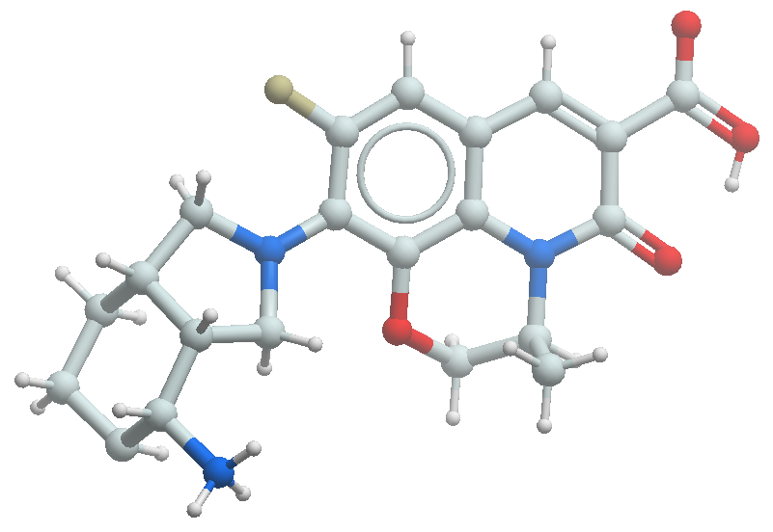
Methyl (S)-10-((3aR,4R,7aS)-4-((tert-butoxycarbonyl)amino)octahydro-2H-isoindol-2-yl)-9-fluoro-3-methyl-5-oxo-2,3-dihydro-5H-[1,4]oxazino[2,3,4-ij]quinoline-6-carboxylate (171) (0.140 g, 0.270 mmol) was dissolved in 3:1 MeOH:H₂O (6.00 mL). 1M LiOH·H₂O (0.800 mL, 1.20 mmol) was added and the reaction was stirred at room temperature for 2-3 hours. The reaction was quenched with cold water, acidified with dilute HCl to pH 4 and extracted with ethyl acetate. The organic layer was dried over sodium sulfate and concentrated under vacuum to afford the desired product (0.114 g, 85% yield) as an off-white solid, which was used in the next step without any further purification. LCMS (m/z): 502.71 [M+H]⁺.
The corresponding acid (0.120 g, 0.223 mmol) was dissolved in DCM (4.00 mL) and cooled to 0 ºC. 4M HCl in dioxane (1.50 mL) was added and the reaction was stirred at room temperature for 2 hours. The reaction mixture was concentrated under vacuum and triturated with ethyl acetate to afford the title compound (0.062 g, 64% yield). LCMS (m/z): 402.5 [M+H]⁺. ¹H NMR (400 MHz, CD₃OD) δ 8.71 (s, 1H), 7.33 (d, J = 13.7 Hz, 1H), 5.17 (d, J = 7.0 Hz, 1H), 4.57 (d, J = 11.4 Hz, 1H), 4.30 (dt, J = 14.6, 8.1 Hz, 2H), 4.16 – 4.08 (m, 1H), 3.67 – 3.52 (m, 2H), 3.48 – 3.36 (m, 1H), 2.79 (s, 1H), 2.40 (dd, J = 11.8, 5.6 Hz, 1H), 1.93 (d, J = 10.9 Hz, 2H), 1.70 (t, J = 12.3 Hz, 2H), 1.59 – 1.37 (m, 5H).

Synthesis of iso-fluoroquinolone 49.
Absolute stereochemistry was assigned by small molecule x-ray crystallography.

(3R*,4R*)-Methyl 1-benzyl-4-vinylpyrrolidine-3-carboxylate (173)
TFA (8.71 mL, 113 mmol) was added to a solution of (E)-methyl penta-2,4-dienoate (172) (5.76 g, 51.4 mmol) and N-benzyl-N-(methoxymethyl)-N-[(trimethylsilyl)methyl]amine (18.29 g, 77 mmol) in DCM (30.0 mL) at 0 ºC. The reaction was stirred at room temperature for 16 hours, then quenched with saturated aqueous NaHCO₃. The layers were separated and the aqueous layer extracted 2x with DCM. The combined organics were dried over MgSO₄, filtered, and concentrated. The crude residue was purified by silica gel chromatography with 20-60% EtOAc/heptane to afford the desired product (1.80 g, 14% yield) as an oil. LCMS (m/z): 246.2 [M+H]⁺. ¹H NMR (400 MHz, CDCl₃) δ 7.51 – 7.17 (m, 5H), 5.87 – 5.82 (m, 1H), 5.08 (d, J = 17.1 Hz, 1H), 5.04 – 4.96 (d, J = 10.2 Hz, 1H), 3.76 – 3.54 (m, 5H), 3.16 – 3.02 (m, 1H), 2.95 – 2.75 (m, 4H), 2.44 (dd, J = 9.3, 6.9 Hz, 1H).

(3R*,4R*)-1-Benzyl 3-methyl 4-vinylpyrrolidine-1,3-dicarboxylate (174)
To a solution of (3R*,4R*)-methyl 1-benzyl-4-vinylpyrrolidine-3-carboxylate (173) (1.50 g, 6.11 mmol) in DCM (25.0 mL) was added benzyl chloroformate (30% in toluene, 5.82 mL, 12.2 mmol) dropwise. The reaction was stirred at rt for 16 hours and quenched with NaHCO₃. The layers were separated and the aqueous layer was extracted with DCM. The combined organics were dried over MgSO₄, filtered, and concentrated. The crude residue was purified using silica gel chromatography with 0-100% EtOAc/heptane to afford the desired product (1.25 g, 71% yield). LCMS (m/z): 290.1 [M+H]⁺.

(3R*,4R*)-Benzyl 3-formyl-4-vinylpyrrolidine-1-carboxylate (175)
To a solution of (3R*,4R*)-1-benzyl 3-methyl 4-vinylpyrrolidine-1,3-dicarboxylate (174) (1.25 g, 4.32 mmol) in THF (10.0 mL) was added lithium tetrahydroborate (0.471 g, 21.6 mmol), followed by addition of MeOH (2.00 mL) and the resulting suspension was stirred at rt for 30 min. The reaction was then quenched with water and extracted with DCM. The organic layer was dried over MgSO₄, filtered, and concentrated in vacuo to afford the desired product (1.13 g), which was used in the next step without any further purification. LCMS (m/z): 262.1 [M+H]⁺. ¹H NMR (400 MHz, CDCl₃) δ 7.42 – 7.28 (m, 5H), 5.81 – 5.57 (m, 1H), 5.26 – 5.02 (m, 4H), 3.74 – 3.68 (m, 3H), 3.60 – 3.55 (m, 1H), 3.33 – 3.08 (m, 2H), 2.63 – 2.58 (m, 1H), 2.27 – 2.06 (m, 1H).
The alcohol (1.07 g, 4.09 mmol) was added to a stirred solution of Dess–Martin periodinane (2.08 g, 4.91 mmol) in anhydrous DCM (20.0 mL). The white suspension was stirred for 3 hours at room temperature under nitrogen. The reaction mixture was then diluted with DCM and 1N sodium hydroxide (10.0 mL) was added and stirred for 10 minutes. The layers were separated and the aqueous layer was extracted with DCM. The combined organic layers were washed with 1N sodium hydroxide (25.0 mL), dried over MgSO₄, filtered, and concentrated in vacuo to afford the desired product (0.733 g, 69% yield). LCMS (m/z): 260.2 [M+H]⁺.

(3R*,4R*)-Benzyl 3-((E)-((tert-butylsulfinyl)imino)methyl)-4-vinylpyrrolidine-1-carboxylate (176)
To a solution of (3R*,4R*)-benzyl 3-formyl-4-vinylpyrrolidine-1-carboxylate (175) (840 mg, 3.24 mmol) and tert-butanesulfinamide (393 mg, 3.24 mmol) in CHCl₃ (15 mL) was added pyridinium p-toluenesulfonate (1.63 g, 6.48 mmol), MgSO₄ (1.95 g, 16.2 mmol) and copper(II) sulfate (517 mg, 3.24 mmol). The mixture was heated to reflux for 2 hours. The reaction mixture was filtered, concentrated in vacuo and the crude product was used in the next step without any further purification. LCMS (m/z): 363.2 [M+H]⁺.

Benzyl (3R*,4R*)-3-((S*)-1-((tert-butoxycarbonyl)amino)but-3-en-1-yl)-4-vinylpyrrolidine-1-carboxylate (179)
To a solution of rac-(3R,4R)-benzyl 3-((E)-((tert-butylsulfinyl)imino)methyl)-4-vinylpyrrolidine-1-carboxylate (176) (845 mg, 2.33 mmol) in DCM (16.0 mL) at –78 ºC was added a solution of allylmagnesium bromide (1M, 6.99 mL, 6.99 mmol) dropwise. The reaction was stirred while slowly warming to 0 ºC over 2 hours. LCMS analysis revealed that the reaction was ~90% complete. Further reaction time did not improve the conversion, instead a side product began to form along with deprotection of the amine. The reaction mixture was then diluted with DCM, quenched with sat. NH₄Cl, and extracted with DCM. The combined organic layers were concentrated and the crude residue was purified by flash chromatography on silica gel 0-100% EtOAc/heptane, followed by 20% EtOH/EtOAc in 80% heptane to collect some of the deprotected free amine.
Complete deprotection was achieved with addition of DCM (4.00 mL) and 4M HCl (0.657 mL, 21.6 mmol), followed by stirring at room temperature for 2.5 hours. The solvent was removed in vacuo affording the crude product. LCMS (m/z): 301.9 [M+H]⁺.
The free amine was dissolved in DCM (12.0 mL) and Boc-anhydride (1.03 mL, 4.45 mmol) and triethylamine (1.034 mL, 7.42 mmol) were added at 0 ºC. The reaction mixture was allowed to stir for 16 hours at room temperature, then solvent was removed in vacuo. The resulting crude residue was dissolved in DCM and purified by flash chromatography on SiO₂ using 0-100% EtOAc/heptane as eluent to afford the desired product (500 mg) as a mixture of diastereomers. Further purification by silica gel using 30-40% EtOAc/Heptane afforded the pure isomers as follows:
Benzyl (3R*,4R*)-3-((S*)-1-((tert-butoxycarbonyl)amino)but-3-en-1-yl)-4-vinylpyrrolidine-1-carboxylate (179) (210 mg, 35% yield): LCMS (m/z): 401.9 [M+H]⁺. ¹H NMR (500 MHz, CDCl₃) δ 7.46 – 7.30 (m, 5H), 5.86 – 5.57 (m, 2H), 5.33 – 5.02 (m, 6H), 4.38 – 4.35 (m, 1H), 3.92 – 3.89 (m, 1H), 3.75 – 3.72 (m, 1H), 3.63 – 3.60 (m, 1H), 3.18 – 3.15 (m, 2H), 2.66 – 2.64 (m, 1H), 2.32 – 2.10 (m, 3H), 1.45 (s, 9H).
Benzyl (3R*,4R*)-3-((R*)-1-((tert-butoxycarbonyl)amino)but-3-en-1-yl)-4-vinylpyrrolidine-1-carboxylate (178) (260 mg, 44% yield): LCMS (m/z): 401.9 [M+H]⁺. ¹H NMR (500 MHz, CDCl₃) δ 7.44 – 7.32 (m, 5H), 5.72 – 5.69 (m, 2H), 5.26 – 4.96 (m, 6H), 4.40 (br s, 1H), 3.84 – 3.56 (m, 3H), 3.18 – 3.15 (m, 2H), 2.88 – 2.68 (m, 1H), 2.33 – 2.30 (m, 1H), 2.26 – 2.08 (m, 2H), 1.44 (s, 9H).

Benzyl (3aR*,4S*,7aR*)-4-((tert-butoxycarbonyl)amino)-1,3,3a,4,5,7a-hexahydro-2H-isoindole-2-carboxylate (180)
To a 5-mL microwave vial containing benzyl (3R*,4R*)-3-((S*)-1-((tert-butoxycarbonyl)amino)but-3-en-1-yl)-4-vinylpyrrolidine-1-carboxylate (179) (210 mg, 0.524 mmol) and CuI (15.0 mg, 0.079 mmol) in anhydrous DCM (2.00 mL) and Toluene (6.00 mL) was added Grubbs-II (22.3 mg, 0.026 mmol). The vial was sealed and irradiated in the microwave at 150 ºC for 1 hour. The reaction mixture was filtered through a pad of celite, the filtrate concentrated in vacuo, and purified by flash chromatography on SiO₂ using 0-50% EtOAc/heptane to afford the desired product (170 mg, 87% yield). LCMS (m/z): 273.6 [M–Boc+H]⁺.

tert-Butyl ((3aR*,4S*,7aR*)-octahydro-1H-isoindol-4-yl)carbamate (181)
To a solution of benzyl (3aR*,4S*,7aR*)-4-((tert-butoxycarbonyl)amino)-1,3,3a,4,5,7a-hexahydro-2H-isoindole-2-carboxylate (180) (170 mg, 0.456 mmol) in EtOAc (8.00 mL) was added Pd/C (10%, 48.6 mg, 0.046 mmol) and the resulting suspension was stirred at rt under an atmosphere of hydrogen for 2 hours. The reaction mixture was then filtered through celite, solvent removed in vacuo and the crude dried under high vacuum for 30 min to afford the desired product (110 mg, quant. yield), which was used in the next step without any further purification. LCMS (m/z): 241.7 [M+H]⁺.

Methyl (S)-10-((3aR*,4S*,7aR*)-4-((tert-butoxycarbonyl)amino)octahydro-2H-isoindol-2-yl)-9-fluoro-3-methyl-5-oxo-2,3-dihydro-5H-[1,4]oxazino[2,3,4-ij]quinoline-6-carboxylate (182)
(S)-Methyl 9,10-difluoro-3-methyl-5-oxo-3,5-dihydro-2H-[1,4]oxazino[2,3,4-ij]quinoline-6-carboxylate (121) (110 mg, 0.373 mmol) was dissolved in DMSO (2.00 mL). tert-Butyl ((3aR*,4S*,7aR*)-octahydro-1H-isoindol-4-yl)carbamate (181) (90.0 mg, 0.373 mmol) and DIPEA (0.260 mL, 1.49 mmol) were added to the solution. The reaction was heated to 95 ºC for 4 hours. The reaction was then cooled to ambient temperature, diluted with EtOAc, washed with saturated NH₄Cl, and then with brine. The organic layer was then dried, filtered, and solvent evaporated in vacuo. The crude residue was purified by flash chromatography on SiO₂ using EtOAc/heptane to afford a mixture of diastereomers (150 mg, 78% yield), as a yellow solid. LCMS (m/z): 517.0 [M+H]⁺. ¹H NMR (500 MHz, CDCl₃) δ 8.34 (s, 1H), 6.93 (d, J = 13.3 Hz, 1H), 5.12 (dd, J = 29.9, 7.1 Hz, 1H), 4.39 (d, J = 11.2 Hz, 1H), 3.98 – 3.90 (m, 5H), 3.79 – 3.58 (m, 3H), 2.21 – 2.08 (m, 1H), 1.93 (d, J = 13.4 Hz, 2H), 1.75 (br s, 1H), 1.48 (s, 9H), 1.41 (t, J = 6.1 Hz, 3H), 1.35 – 1.05 (m, 5H).
(S)-10-((3aR,4S,7aR)-4-Aminooctahydro-2H-isoindol-2-yl)-9-fluoro-3-methyl-5-oxo-2,3-dihydro-5H-[1,4]oxazino[2,3,4-ij]quinoline-6-carboxylic acid hydrochloride (49)
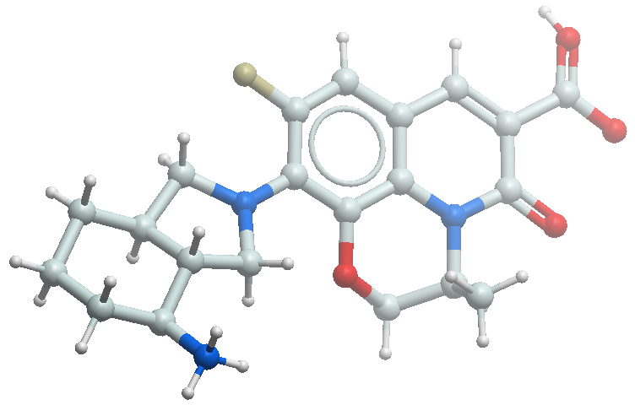
LiOH (1M, 0.786 mL, 0.786 mmol) was added to a solution of methyl (S)-10-(-4-((tert-butoxycarbonyl)amino)octahydro-2H-isoindol-2-yl)-9-fluoro-3-methyl-5-oxo-2,3-dihydro-5H-[1,4]oxazino[2,3,4-ij]quinoline-6-carboxylate diastereoisomers (182) (135 mg, 0.262 mmol) in 1:1 MeOH/THF (8.00 mL) and the resulting suspension was stirred at rt for 2 hours. The reaction mixture was then diluted with EtOAc, acifidifed with 1N HCl, and extracted with EtOAc. The organic layer was then dried over MgSO₄, filtered and solvent removed in vacuo. The diastereomers were separated by preparative chiral SFC purification to afford (S)-10-((3aS,4R,7aS)-4-((tert-butoxycarbonyl)amino)octahydro-2H-isoindol-2-yl)-9-fluoro-3-methyl-5-oxo-2,3-dihydro-5H-[1,4]oxazino[2,3,4-ij]quinoline-6-carboxylic acid (54.0 mg, 41% yield) and (S)-10-((3aR,4S,7aR)-4-((tert-butoxycarbonyl)amino)octahydro-2H-isoindol-2-yl)-9-fluoro-3-methyl-5-oxo-2,3-dihydro-5H-[1,4]oxazino[2,3,4-ij]quinoline-6-carboxylic acid (54.0 mg, 41% yield). LCMS (m/z): 502.2 [M+H]⁺.
(S)-10-((3aR,4S,7aR)-4-((tert-Butoxycarbonyl)amino)octahydro-2H-isoindol-2-yl)-9-fluoro-3-methyl-5-oxo-2,3-dihydro-5H-[1,4]oxazino[2,3,4-ij]quinoline-6-carboxylic acid (54.0 mg, 0.108 mmol) was dissolved in DCM (5.00 mL), 4M HCl in dioxane (1.00 mL, 4.00 mmol) was added and the resulting suspension was stirred at rt for 2 hours. The reaction mixture was concentrated in vacuo and dried under high vacuum. The crude product was suspended in MeCN and filtered to afford a yellow solid (27.0 mg, 57% yield). HRMS (ESI) calc’d for C₂₁H₂₄FN₃O₄ [M+H]⁺ 402.1824, found 402.1823. ¹H NMR (500 MHz, CD₃OD) δ 8.70 (s, 1H), 7.32 (d, J = 13.6 Hz, 1H), 5.16 (br s, 1H), 4.53 (d, J = 11.4 Hz, 1H), 4.08 (d, J = 11.3 Hz, 1H), 4.01 – 3.99 (m, 1H), 3.88 – 3.84 (m, 2H), 3.78 – 3.74 (m, 1H), 3.23 – 3.20 (m, 1H), 2.16 (d, J = 12.2 Hz, 1H), 2.03 (t, J = 13.1 Hz, 2H), 1.85 – 1.79 (m, 2H), 1.62 – 1.58 (m, 1H), 1.50 – 1.43 (m, 4H), 1.26 – 1.23 (m, 1H).

Synthesis of iso-fluoroquinolone 50.
Relative and absolute stereochemistry was assigned by small molecule x-ray crystallography.

(Z)-3-((tert-Butyldiphenylsilyl)oxy)-N-hydroxypropanimidoyl chloride (184)
3-((tert-Butyldiphenylsilyl)oxy)propanal (183) (82.1 g, 263 mmol) was dissolved in MeOH (1.60 L) under nitrogen and cooled to 0 ºC. Pyridine (80.5 g, 1.01 mol) was added dropwise followed by the addition of hydroxylamine hydrochloride (27.4 g, 395 mmol) at 0 ºC. The mixture was stirred at room temperature for 16 hours, then concentrated under vacuum to afford a crude residue, which was dissolved in water and extracted with ethyl acetate. The combined organic layers were washed with brine, dried over sodium sulfate and concentrated under vacuum to afford the desired product (86 g), which was used in the next step without any further purification. LCMS (m/z): 328.4 [M+H]⁺. ¹H NMR (400 MHz, CDCl₃) δ 7.79 – 7.69 (m, 4H), 7.56 – 7.30 (m, 7H), 4.19 – 4.14 (m, 1H), 3.87 – 3.84 (m, 2H), 2.69 – 2.65 (m, 1H), 2.51 – 2.46 (m, 1H), 1.16 (s, 9H).
The oxime (86.0 g, 263 mmol) was dissolved in DMF (860 mL) under nitrogen and cooled to 0 ºC. N-Chlorosuccinimide (38.6 g, 289 mmol) was added portionwise at 0 ºC and the resulting mixture was stirred at room temperature for 2 hours. Upon completion, the mixture was quenched with ice cold water and extracted with ethyl acetate. The combined organic layers were thoroughly washed with cold water and brine then dried over sodium sulfate and concentrated under vacuum to afford the desired product (95.0 g), which was used in the next step immediately without any further purification. Note: (Z)-3-((tert-butyldiphenylsilyl)oxy)-N-hydroxypropanimidoyl chloride degrades on standing over 1 week at –20 °C. LCMS (m/z): 362.4 [M+H]⁺. ¹H NMR (400 MHz, CDCl₃) δ 7.79 – 7.69 (m, 4H), 7.56 – 7.30 (m, 7H), 4.19 – 4.14 (m, 1H), 3.87 – 3.84 (m, 2H), 2.69 – 2.65 (m, 1H), 2.51– 2.46 (m, 1H), 1.16 (s, 9H).

Benzyl (3aR*,6aS*)-3-(2-((tert-butyldiphenylsilyl)oxy)ethyl)-3a,4,6,6a-tetrahydro-5H-pyrrolo[3,4-d]isoxazole-5-carboxylate (186)
(Z)-3-((tert-Butyldiphenylsilyl)oxy)-N-hydroxypropanimidoyl chloride (184) (47.0 g, 130 mmol) and benzyl 2,5-dihydro-1H-pyrrole-1-carboxylate (185) (24.0 g, 118 mmol) were dissolved in i-PrOH (500 mL) at room temperature. Sodium bicarbonate (56.0 g, 667 mmol) was added and the mixture was heated to 50 ºC with stirring for 16 hours. Upon completion of the reaction, the mixture was quenched with ice cold water and extracted with ethyl acetate. The combined organic layers were washed with cold water and brine then dried over sodium sulfate and concentrated under vacuum to afford a crude residue, which was purified by silica gel column chromatography (35-45% EtOAc in hexane) to obtain the desired product (11.5 g, 18% yield). LCMS (m/z): 546.6 [M+H₂O]⁺. ¹H NMR (400 MHz, CDCl₃) δ 7.68 – 7.67 (m, 4H), 7.47 – 7.30 (m, 11H), 5.16 – 5.12 (m, 2H), 3.96 – 3.86 (m, 5H), 3.60 – 3.50 (m, 2H), 2.76 – 2.73 (m, 2H), 2.10 – 2.08 (m, 1H), 1.10 (s, 9H).

Benzyl (3S*,4R*)-3-hydroxy-4-((R*)-2,2,11,11-tetramethyl-9-oxo-3,3-diphenyl-4,10-dioxa-8-aza-3-siladodecan-7-yl)pyrrolidine-1-carboxylate (188)
Benzyl (3aR*,6aS*)-3-(2-((tert-butyldiphenylsilyl)oxy)ethyl)-3a,4,6,6a-tetrahydro-5H-pyrrolo[3,4-d]isoxazole-5-carboxylate (186) (11.5 g, 21.8 mmol) was dissolved in 3:1 MeOH/THF (560 mL) under nitrogen and cooled to –30 ºC. NiCl₂·6H₂O (15.5 g, 65.3 mmol) was added and the resulting mixture was treated with NaBH₄ (8.27 g, 218 mmol) portionwise at –30 ºC and allowed to stir for 2 hours. Triethylamine (7.00 mL) was added and the mixture was filtered through a celite pad, which was subsequently washed with MeOH. The filtrate was concentrated under vacuum, dissolved in ethyl acetate and washed with brine, dried over sodium sulfate and concentrated under vacuum to afford the desired product (187) (10.4 g), which was used in the next step without any further purification. LCMS (m/z): 533.6 [M+H]⁺.
The diastereoisomeric amines (10.4 g, 19.6 mmol) were dissolved in DCM (160 mL) and cooled to 0 ºC. Triethylamine (5.94 g, 58.8 mmol) and Boc anhydride (6.41 g, 29.4 mmol) were added and the mixture was stirred at room temperature for 16 hours. The reaction was quenched with water and extracted with ethyl acetate. The combined organic layers were washed with water and brine then dried over sodium sulfate and concentrated under vacuum to afford a crude residue, which was purified by SiO₂ flash column chromatography (30-65% EtOAc in hexane) to give two diastereomeric products (70% combined yield) as follows:
rac-Benzyl (3S*,4R*)-3-hydroxy-4-((R*)-2,2,11,11-tetramethyl-9-oxo-3,3-diphenyl-4,10-dioxa-8-aza-3-siladodecan-7-yl)pyrrolidine-1-carboxylate (188) (3.60 g, 29% yield): LCMS (m/z): 533.63 [M–Boc+H]⁺. ¹H NMR (400 MHz, CDCl₃) δ 7.68 – 7.67 (m, 4H), 7.47 – 7.30 (m, 11H), 6.20 – 6.10 (m, 1H), 5.16 – 5.12 (m, 2H), 4.20 (s, 1H), 4.05 – 3.75 (m, 3H), 3.70 – 3.60 (m, 1H), 3.36 – 3.34 (m, 1H), 3.21 – 3.19 (m, 1H), 2.10 – 2.08 (m, 2H), 1.45 (s, 9H), 1.10 (s, 9H).
Benzyl (3S*,4R*)-3-hydroxy-4-((S*)-2,2,11,11-tetramethyl-9-oxo-3,3-diphenyl-4,10-dioxa-8-aza-3-siladodecan-7-yl)pyrrolidine-1-carboxylate (189) (5.10 g, 41% yield): LCMS (m/z): 533.58 [M–Boc+H]⁺. ¹H NMR (400 MHz, CD₃OD) δ 7.69 – 7.66 (m, 4H), 7.47 – 7.30 (m, 11H), 5.17 (s, 2H), 4.20 (s, 1H), 4.00 – 3.70 (m, 3H), 3.60 – 3.45 (m, 2H), 3.31 – 3.29 (m, 2H), 2.21 – 2.19 (m, 1H), 2.11 – 2.09 (m, 1H), 1.77 – 1.75 (m, 1H), 1.47 (s, 9H), 1.08 (s, 9H).

Benzyl (3R*,4S*)-3-((R*)-1-((tert-butoxycarbonyl)amino)-3-hydroxypropyl)-4-hydroxypyrrolidine-1-carboxylate (190)
Benzyl (3S*,4R*)-3-hydroxy-4-((R*)-2,2,11,11-tetramethyl-9-oxo-3,3-diphenyl-4,10-dioxa-8-aza-3-siladodecan-7-yl)pyrrolidine-1-carboxylate (189) (3.60 g, 5.69 mmol) was dissolved in THF (50.0 mL) and cooled to 0 ºC. TBAF (1 M in THF, 1.78 g, 6.83 mmol) was added at 0 ºC and the mixture was stirred at room temperature for 30 minutes. Upon completion of the reaction, the mixture was quenched with water and extracted with ethyl acetate. The combined organic layers were washed with water and brine then dried over sodium sulfate and concentrated under vacuum to afford a crude residue, which was purified by trituration with n-pentane to obtain the desired product (2.20 g, 98% yield). LCMS m/z: 295.2 [M–Boc+H]⁺. ¹H NMR (400 MHz, CD₃OD) δ 7.39 – 7.35 (m, 5H), 5.12 (s, 2H), 4.30 – 4.21 (m, 1H), 3.95 – 3.82 (m, 1H), 3.78 – 3.50 (m, 6H), 2.35 – 2.15 (m, 1H), 2.15 – 1.95 (m, 1H), 1.35 (br s, 9H).

Benzyl (4R*,4aR*,7aS*)-4-((tert-butoxycarbonyl)amino)hexahydropyrano[2,3-c]pyrrole-6(2H)-carboxylate (191)
Benzyl (3R*,4S*)-3-((R*)-1-((tert-butoxycarbonyl)amino)-3-hydroxypropyl)-4-hydroxypyrrolidine-1-carboxylate (190) (2.20 g, 5.58 mmol) was dissolved in DCM (50.0 mL) and cooled to 0 ºC. Triethylamine (0.560 g, 5.58 mmol) was added followed by dropwise addition of mesyl chloride (0.630 g, 5.58 mmol) in DCM (5.00 mL) at 0 ºC. The mixture was stirred for 2 hours then concentrated under vacuum to afford the desired product (2.60 g), which was used in the next step without any further purification. LCMS (m/z): 373.1 [M–Boc+H]⁺. ¹H NMR (400 MHz, CDCl₃) δ 7.75 – 7.46 (m, 5H), 5.30 – 5.10 (m, 2H), 4.73 – 4.71 (m, 1H), 4.35 – 4.34 (m, 1H), 4.05 – 3.99 (m, 1H), 3.84 – 3.45 (m, 3H), 3.44 – 3.14 (m, 1H), 3.14 (s, 3H), 2.95 – 2.71 (m, 1H), 2.35 – 2.15 (m, 1H), 2.15 – 1.95 (m, 1H), 1.35 (br s, 9H).
The mesylate (2.60 g, 5.51 mmol) was dissolved in THF (80.0 mL) and cooled to 0 ºC. Cs₂CO₃ (5.38 g, 16.5 mmol) was added and the mixture was heated to reflux for 16 hours. Upon completion of the reaction, the mixture was filtered through a celite pad and the pad was washed with THF. The filtrate was concentrated under vacuum to afford a crude residue, which was purified by basic alumina column chromatography (30-45% EtOAc in hexane) to obtain the desired product (1.10 g, 63% yield). LCMS (m/z): 377.5 [M+H]⁺. ¹H NMR (400 MHz, CD₃OD) δ 7.41 – 7.30 (m, 5H), 5.15 – 5.13 (m, 2H), 4.05 – 4.03 (m, 1H), 3.97 – 3.94 (m, 2H), 3.54 – 3.47 (m, 3H), 3.45 – 3.33 (m, 3H), 2.72 – 2.70 (m, 1H), 1.77 – 1.70 (m, 1H), 1.63 – 1.60 (m, 1H), 1.46 (s, 9H).

tert-Butyl ((4R*,4aR*,7aS*)-octahydropyrano[2,3-c]pyrrol-4-yl)carbamate (192)
Benzyl (4R*,4aR*,7aS*)-4-((tert-butoxycarbonyl)amino)hexahydropyrano[2,3-c]pyrrole-6(2H)-carboxylate (191) (0.400 g, 1.06 mmol) was dissolved in t-BuOH (60.0 mL). Pd/C (10% dry wt, 0.200 g) and Pd(OH)₂ (20% dry wt, 0.200 g) were added and the mixture was stirred at room temperature for 45 minutes under 10 kg/cm² hydrogen pressure. Upon completion of the reaction, the mixture was filtered through a celite pad and the pad was washed with DCM. The filtrate was concentrated under vacuum to afford the desired product (0.257 g), which was used in the next step without any further purification. LCMS (m/z): 243.2 [M+H]⁺. ¹H NMR (400 MHz, CDCl₃) δ 4.53 – 4.51 (m, 1H), 4.14 – 4.12 (m, 1H), 4.01 – 3.99 (m, 2H), 3.20 – 3.00 (m, 3H), 2.70 – 2.30 (m, 4H), 1.80 – 1.60 (m, 2H), 1.49 (s, 9H).

Methyl (S)-10-((4R,4aR,7aS)-4-((tert-butoxycarbonyl)amino)hexahydropyrano[2,3-c]pyrrol-6(2H)-yl)-9-fluoro-3-methyl-5-oxo-2,3-dihydro-5H-[1,4]oxazino[2,3,4-ij]quinoline-6-carboxylate (193)
tert-Butyl ((4R*,4aR*,7aS*)-octahydropyrano[2,3-c]pyrrol-4-yl)carbamate (192) (0.130 g, 0.439 mmol) and methyl (S)-9,10-difluoro-3-methyl-5-oxo-2,3-dihydro-5H-[1,4]oxazino[2,3,4-ij]quinoline-6-carboxylate (121) (0.116 g, 0.483 mmol) were dissolved in DMSO (6.00 mL). Triethylamine (0.260 g, 2.63 mmol) was added and the reaction mixture was heated to 85 ºC for 16 hours. Upon completion of the reaction, the mixture was poured into water and extracted with EtOAc. The combined organic layers were washed with cold water and brine then dried over sodium sulfate and concentrated under vacuum to afford a crude residue, which was purified by automated reverse phase flash chromatography (30-35% MeOH in water) to obtain the desired product (0.130 g). This material was further purified by chiral SFC to obtain the two constituent diastereomers as follows:
Methyl (S)-10-((4R,4aR,7aS)-4-((tert-butoxycarbonyl)amino)hexahydropyrano[2,3-c]pyrrol-6(2H)-yl)-9-fluoro-3-methyl-5-oxo-2,3-dihydro-5H-[1,4]oxazino[2,3,4-ij]quinoline-6-carboxylate (193) (0.06 g, 33% yield). LCMS (m/z): 518.47 [M+H]⁺. ¹H NMR (400 MHz, CDCl₃) δ 8.37 (s, 1H), 6.98 – 6.65 (m, 1H), 5.19 – 5.17 (m, 1H), 4.61 – 4.59 (m, 1H), 4.51 – 4.49 (m, 1H), 4.41 – 4.39 (m, 1H), 4.25 – 4.00 (m, 5H), 3.98 (s, 3H), 3.61 – 3.56 (m, 3H), 3.11 – 3.10 (m, 1H), 2.80 – 2.78 (m, 1H), 1.84 – 1.79 (m, 2H), 1.49 (s, 9H), 1.46 (d, J = 6.6 Hz, 3H).
Methyl (S)-10-((4S,4aS,7aR)-4-((tert-butoxycarbonyl)amino)hexahydropyrano[2,3-c]pyrrol-6(2H)-yl)-9-fluoro-3-methyl-5-oxo-2,3-dihydro-5H-[1,4]oxazino[2,3,4-ij]quinoline-6-carboxylate (0.06 g, 33% yield). LCMS (m/z): 518.28 [M+H]⁺. ¹H NMR (400 MHz, CDCl₃) δ 8.37 (s, 1H), 6.98 – 6.65 (m, 1H), 5.14 – 5.12 (m, 1H), 4.63 – 4.61 (m, 1H), 4.51 – 4.49 (m, 1H), 4.41 – 4.39 (m, 1H), 4.25 – 4.00 (m, 5H), 3.98 (s, 3H), 3.61 – 3.56 (m, 3H), 3.11 – 3.09 (m, 1H), 2.80 – 2.78 (m, 1H), 1.84 – 1.79 (m, 2H), 1.49 (s, 9H), 1.46 (d, J = 6.6 Hz, 3H).

(S)-10-((4R,4aR,7aS)-4-Aminohexahydropyrano[2,3-c]pyrrol-6(2H)-yl)-9-fluoro-3-methyl-5-oxo-2,3-dihydro-5H-[1,4]oxazino[2,3,4-ij]quinoline-6-carboxylic acid trifluoroacetic acid (50)
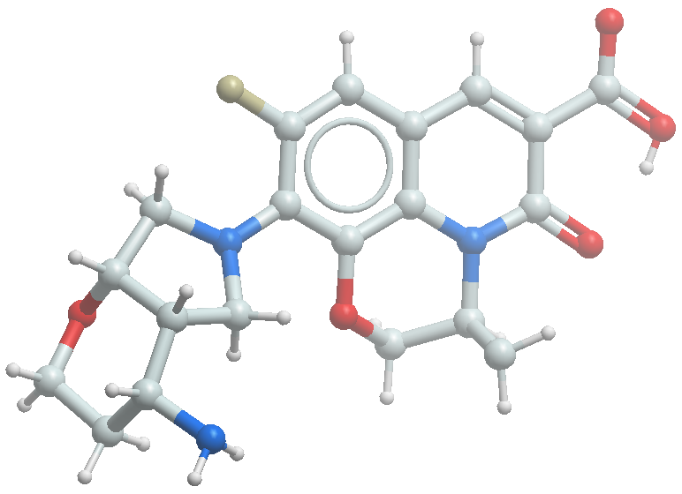
Methyl (S)-10-((4R,4aR,7aS)-4-((tert-butoxycarbonyl)amino)hexahydropyrano[2,3-c]pyrrol-6(2H)-yl)-9-fluoro-3-methyl-5-oxo-2,3-dihydro-5H-[1,4]oxazino[2,3,4-ij]quinoline-6-carboxylate (193) (0.060 g, 0.116 mmol) was dissolved in 3:1 MeOH/H₂O (8.00 mL). 1M LiOH·H₂O (0.348 mL, 0.348 mmol) was added and the mixture was stirred at room temperature for 2-3 hours. The reaction was quenched with cold water, acidified with dilute HCl to pH 4 and extracted with ethyl acetate. The combined organic layers were dried over sodium sulfate and concentrated under vacuum to afford the desired product (0.055 g, 95% yield) as a yellow solid, which was used in the next step without any further purification. LCMS (m/z): 504.5 [M+H]⁺. ¹H NMR (400 MHz, CDCl₃) δ 14.45 (s, 1H), 8.68 (s, 1H), 7.09 (d, J = 13.4 Hz, 1H), 5.18 – 5.17 (m, 1H), 4.55 – 4.54 (m, 1H), 4.54 – 4.46 (m, 1H), 4.39 – 4.22 (m, 1H), 4.19 – 4.17 (m, 1H), 4.15 – 4.05 (m, 4H), 3.69 – 3.66 (m, 1H), 3.59 – 3.53 (m, 2H), 2.84 – 2.82 (m, 1H), 1.86 – 1.85 (m, 2H), 1.31 (s, 9H), 1.29 (d, J = 6.6 Hz, 3H).
The acid was dissolved in DCM (4.00 mL) and cooled to 0 ºC. TFA (0.500 mL) was added and the reaction mixture was stirred at room temperature for 2 hours. The mixture was concentrated under vacuum to afford a crude residue which was purified by trituration with diethyl ether to afford the title compound (0.020 g, 80% yield). C₂₀H₂₂FN₃O₅ [M+H]⁺ 404.1616, found 404.1617. ¹H NMR (400 MHz, CD₃OD) δ 8.73 (s, 1H), 7.35 (d, J = 13.4 Hz, 1H), 5.18 – 5.16 (m, 1H), 4.58 – 4.55 (m, 1H), 4.43 – 4.32 (m, 2H), 4.23 – 4.21 (m, 1H), 4.12 – 4.09 (m, 2H), 3.88 – 3.85 (m, 1H), 3.68 – 3.57 (m, 3H), 2.70 – 2.68 (m, 1H), 2.03 – 1.97 (m, 1H), 1.88 – 1.86 (m, 1H) 1.47 (d, J = 6.6 Hz, 3H).

Synthesis of iso-fluoroquinolone 51.
Absolute stereochemistry of the octahydropyranopyrrole moiety was assigned by comparison of bioactivity to 49.

tert-Butyl (3R*,4S*)-3-hydroxy-4-vinylpyrrolidine-1-carboxylate (195)
tert-Butyl 6-oxa-3-azabicyclo[3.1.0]hexane-3-carboxylate (194) (6.00 g, 32.4 mmol) was combined with copper(I) bromide-dimethyl sulfide complex (6.66 g, 32.4 mmol) in a dry, 1L round bottom flask. THF (162 mL) was added and the mixture was cooled to –40 ºC. Vinylmagnesium chloride (1.6M in THF, 81.0 mL, 130 mmol) was added dropwise over 15 minutes. The mixture was allowed to warm to –10 ºC over 4.5 hours, then quenched carefully by the addition of saturated aqueous NH₄Cl. The reaction mixture was diluted with 400 mL of saturated aqueous NH₄Cl and 200 mL water and stirred vigorously. The mixture was then extracted with EtOAc (3 x 100 mL) and the combined organic extracts were washed with saturated aqueous NH₄Cl and brine, dried over MgSO₄, filtered and concentrated under reduced pressure. SiO₂ flash chromatography (0-100% EtOAc/heptane) provided the desired product (6.50 g, 94% yield) as a light yellow/brown oil. LCMS (m/z): 158.1 [M–^{t}Bu+H]⁺. ¹H NMR (500 MHz, CDCl₃) δ 5.70 (ddd, J = 17.7, 10.3, 7.9 Hz, 1H), 5.23 – 5.12 (m, 2H), 4.09 (q, J = 5.9 Hz, 1H), 3.73 – 3.60 (m, 2H), 3.28 – 3.16 (m, 2H), 2.73 – 2.63 (m, 1H), 1.46 (s, 9H).

tert-Butyl (3R*,4S*)-3-(allyloxy)-4-vinylpyrrolidine-1-carboxylate (196)
Sodium hydride (60% in mineral oil, 0.844 g, 21.1 mmol) was added to a mixture of tert-butyl (3R*,4S*)-3-hydroxy-4-vinylpyrrolidine-1-carboxylate (195) (3.00 g, 14.1 mmol) in DMF (56.3 mL) at 0 ºC. After 20 minutes allyl bromide (2.43 mL, 28.1 mmol) was added dropwise. The reaction mixture was stirred for 3.5 hours, during which time the temperature increased to 6 ºC. The reaction was quenched by the addition of saturated aqueous NH₄Cl (100 mL). The mixture was diluted with water (200 mL) and extracted with EtOAc (3 x 50 mL). The combined organic extracts were washed with brine, dried over MgSO₄ and concentrated under reduced pressure. SiO₂ flash chromatography (0-50% EtOAc/heptane) provided the desired product (3.25 g, 91% yield) as a pale yellow oil. LCMS (m/z): 198.2 [M–^{t}Bu+H]⁺. ¹H NMR (400 MHz, CDCl₃) δ 5.89 (ddt, J = 17.2, 10.3, 5.6 Hz, 1H), 5.73 (ddd, J = 17.6, 10.4, 7.5 Hz, 1H), 5.28 (dd, J = 17.2, 1.7 Hz, 1H), 5.21 – 5.08 (m, 3H), 4.02 (d, J = 5.6 Hz, 2H), 3.80 (q, J = 5.1 Hz, 1H), 3.67 – 3.52 (br m, 2H), 3.36 – 3.16 (br m, 2H), 2.87 – 2.77 (m, 1H), 1.46 (s, 9H).

tert-Butyl (4aS*,7aR*)-4a,5,7,7a-tetrahydropyrano[2,3-c]pyrrole-6(2H)-carboxylate (197)
tert-Butyl (3R*,4S*)-3-(allyloxy)-4-vinylpyrrolidine-1-carboxylate (196) (1.93 g, 7.62 mmol) was dissolved in DCM (152 mL) under N₂. Copper(I) iodide (0.073 g, 0.381 mmol) and Grubbs II (0.485 g, 0.571 mmol) were added. The reaction was stirred overnight. The following morning TLC indicated consumption of starting material. The mixture was concentrated under reduced pressure. SiO₂ flash chromatography (0-50% EtOAc/heptane) provided the desired product (934 mg, 54% yield) as a clear, tan oil. LCMS (m/z): 170.1 [M–^{t}Bu+H]⁺. ¹H NMR (400 MHz, CDCl₃) δ 6.01 – 5.91 (m, 1H), 5.69 (dq, J = 10.1, 2.6 Hz, 1H), 4.39 (br s, 2H), 3.72 (q, J = 7.3 Hz, 1H), 3.68 – 3.58 (m, 2H), 3.16 – 3.04 (m, 1H), 2.88 (t, J = 11.1 Hz, 1H), 2.60 – 2.42 (m, 1H), 1.46 (s, 9H).

tert-Butyl (1aR*,3aR*,6aS*,6bS*)-hexahydrooxireno[2',3':4,5]pyrano[2,3-c]pyrrole-5(2H)-carboxylate (198)
A mixture of tert-butyl (4aS*,7aR*)-4a,5,7,7a-tetrahydropyrano[2,3-c]pyrrole-6(2H)-carboxylate (197) (2.75 g, 12.2 mmol) in DCM (122 mL) at 0 ºC was treated with m-CPBA (6.32 g, 36.6 mmol) portionwise. The mixture was allowed to warm to rt slowly and stirred overnight. The mixture was cooled to 0 ºC, then poured into pre-cooled saturated aqueous sodium thiosulfate (150 mL) solution. The mixture was stirred at this temperature for 1.5 hours. The mixture was then further diluted with DCM and water and the layers were separated. The aqueous layer was extracted once with DCM (100 mL) and the combined organic layers were washed with saturated aqueous NaHCO₃ and brine, then dried over MgSO₄, filtered and concentrated under reduced pressure. SiO₂ flash chromatography (0-100% EtOAc/heptane) provided two products:
tert-Butyl (1aR*,3aR*,6aS*,6bS*)-hexahydrooxireno[2',3':4,5]pyrano[2,3-c]pyrrole-5(2H)-carboxylate (198), (911 mg, 31% yield). LCMS (m/z): 186.1 [M–^{t}Bu+H]⁺. ¹H NMR (400 MHz, CDCl₃) δ 4.26 (dt, J = 13.6, 3.0 Hz, 1H), 4.11 (dd, J = 13.6, 2.2 Hz, 1H), 3.75 – 3.55 (m, 3H), 3.49 (dd, J = 15.4, 4.5 Hz, 1H), 3.23 (dd, J = 4.5, 3.5 Hz, 1H), 3.11 (ddd, J = 11.9, 10.2, 8.2 Hz, 1H), 3.03 – 2.91 (m, 1H), 2.35 – 2.20 (m, 1H), 1.46 (s, 4.5H), 1.45 (s, 4.5H).

tert-Butyl (1aS*,3aR*,6aS*,6bR*)-hexahydrooxireno[2',3':4,5]pyrano[2,3-c]pyrrole-5(2H)-carboxylate, 475 mg (16% yield). LCMS (m/z): 186.1 [M-^{t}Bu+H]⁺. ¹H NMR (400 MHz, CDCl₃) δ 4.34 (dd, J = 13.8, 2.0 Hz, 1H), 3.99 (ddd, J = 13.8, 5.0, 1.7 Hz, 1H), 3.78 (ddd, J = 26.2, 10.2, 8.3 Hz, 1H), 3.67 (dd, J = 9.9, 7.0 Hz, 0.5H), 3.58 (dd, J = 9.7, 6.9 Hz, 0.5H), 3.42 (dd, J = 16.0, 4.0 Hz, 1H), 3.26 (td, J = 10.5, 6.9 Hz, 1H), 3.14 – 3.05 (m, 2H), 3.01 (q, J = 10.1 Hz, 1H), 2.05 – 1.89 (m, 1H), 1.46 (s, 4.5H), 1.45 (s, 4.5H).

tert-Butyl (4R*,4aR*,7aR*)-4-hydroxyhexahydropyrano[2,3-c]pyrrole-6(2H)-carboxylate (199)
DIBAL (1M in toluene, 2.22 mL, 2.22 mmol) was added dropwise to a mixture of tert-butyl (1aR*,3aR*,6aS*,6bS*)-hexahydrooxireno[2',3':4,5]pyrano[2,3-c]pyrrole-5(2H)-carboxylate (198) (268 mg, 1.11 mmol) in DCM (11.1 mL) at –78 ºC. The mixture was allowed to warm slowly to 0 ºC over 4 hours. The reaction was quenched with MeOH (1.00 mL), then 1:1 water/Rochelle's salt was added (15.0 mL). The mixture was stirred vigorously for 1 hour before being diluted with water and DCM. The layers were separated and the aqueous layer was extracted twice more with DCM (25.0 mL). The combined organic extracts were washed with brine, dried over MgSO₄ and concentrated under reduced pressure. SiO₂ flash chromatography (0-100% EtOAc/heptane) provided the desired product (150 mg, 56% yield) as a colorless foam. ¹H NMR indicated a mixture of rotamers. LCMS (m/z): 188.1 [M–^{t}Bu+H]⁺. ¹H NMR (400 MHz, CDCl₃) δ 4.36 – 4.25 (br m, 1H), 4.00 – 3.83 (m, 3H), 3.76 (dd, J = 9.7, 7.3 Hz, 0.5H), 3.66 (dd, J = 9.7, 7.3 Hz, 0.5H), 3.44 (ddd, J = 22.9, 10.3, 7.7 Hz, 1H), 3.15 (t, J = 11.3 Hz, 1H), 3.02 (dt, J = 12.8, 9.8 Hz, 1H), 2.03 – 1.80 (m, 2H), 1.71 – 1.63 (m, 1H), 1.45 (s, 9H).
A sample of compound 199 was deprotected (1:3 TFA/CH₂Cl₂, rt, 1 h) to give the amine 199a. Relative stereochemistry was assigned by 2D NOESY and 1D nOe analysis as shown below.
¹H NMR (500 MHz, DMSO-d6) δ 9.04 (s, 1H), 8.80 (s, 1H), 5.10 (s, 1H), 4.13 (d, J = 2.8 Hz, 1H), 3.85 – 3.68 (m, 3H), 3.38 (m, 1H), 3.27 (dd, J = 11.0, 7.5 Hz, 1H), 2.89 (t, J = 11.9 Hz, 1H), 2.78 (t, J = 10.7 Hz, 1H), 1.86 – 1.78 (m, 1H), 1.70 (dddd, J = 14.1, 12.6, 5.9, 2.7 Hz, 1H), 1.56 (dtd, J = 14.1, 2.8, 1.3 Hz, 1H).

tert-Butyl (4S*,4aR*,7aR*)-4-azidohexahydropyrano[2,3-c]pyrrole-6(2H)-carboxylate (200)
Methanesulfonyl chloride (0.072 mL, 0.925 mmol) was added to a mixture of tert-butyl (4R*,4aR*,7aR*)-4-hydroxyhexahydropyrano[2,3-c]pyrrole-6(2H)-carboxylate (199) (150 mg, 0.62 mmol) and triethylamine (0.258 mL, 1.85 mmol) in DCM (6.2 mL) at 0 ºC. The mixture was allowed to warm to rt and stirred overnight. More Et₃N (0.86 mL) and MsCl (0.24 mL) were added and stirring continued for 45 minutes. At this time the reaction mixture was added into saturated aqueous NH₄Cl and extracted with DCM. The combined organic extracts were washed with saturated aqueous NaHCO₃ and brine, then dried over Na₂SO₄ and concentrated under reduced pressure. SiO₂ flash chromatography (0-100% EtOAc/heptane) provided the desired product (96.0 mg, 48% yield) as a colorless foam. ¹H NMR indicated a mixture of rotamers. LCMS (m/z): 266.1 [M–^{t}Bu+H]⁺. ¹H NMR (400 MHz, CDCl₃) δ 5.19 (br s, 1H), 4.03 – 3.83 (m, 3H), 3.76 (dd, J = 9.8, 7.4 Hz, 0.5H), 3.69 (dd, J = 9.8, 7.4 Hz, 0.5H), 3.55 (ddd, J = 22.0, 10.5, 7.6 Hz, 1H), 3.15 – 2.99 (m, 5H), 2.15 – 1.92 (m, 3H), 1.45 (s, 9H).
Sodium azide (199 mg, 3.07 mmol) was added to a solution of mesylate (493 mg, 1.53 mmol) in DMF (15.3 mL) and the resulting mixture was heated to 85 ºC for 1.5 hours. The mixture was diluted with water (50.0 mL) and extracted with EtOAc (3 x 25 mL). The combined organic extracts were washed with saturated aqueous NaHCO₃ and brine, then dried over MgSO₄ and concentrated under reduced pressure. SiO₂ flash chromatography (0-100% EtOAc/heptane) provided the desired product (284 mg, 69% yield) as a clear, colorless oil. LCMS (m/z): 213.2 [M–^{t}Bu+H]⁺. ¹H NMR (400 MHz, CDCl₃) δ 4.16 (dt, J = 11.7, 5.6 Hz, 1H), 3.88 – 3.66 (m, 2H), 3.65 – 3.55 (m, 1H), 3.45 – 3.35 (m, 2H), 3.12 (q, J = 10.0 Hz, 1H), 3.01 (t, J = 11.0 Hz, 1H), 2.05 – 1.95 (m, 1H), 1.92 – 1.78 (m, 1H), 1.78 – 1.65 (m, 1H), 1.46 (s, 9H).

tert-Butyl (4S*,4aR*,7aR*)-4-aminohexahydropyrano[2,3-c]pyrrole-6(2H)-carboxylate (201)
A mixture of tert-butyl (4S*,4aR*,7aR*)-4-azidohexahydropyrano[2,3-c]pyrrole-6(2H)-carboxylate (200) (284 mg, 1.058 mmol) and palladium on carbon (10%, 225 mg, 0.106 mmol) in EtOH (10.6 mL) was stirred under a balloon of hydrogen for 30 minutes. The mixture was filtered and concentrated and the residue was re-subjected to hydrogenation under the conditions described above for 1 hour. The reaction mixture was filtered through celite and concentrated under reduced pressure to give the desired product as a dark oil (256 mg).

tert-Butyl (4S*,4aR*,7aR*)-4-(((allyloxy)carbonyl)amino)hexahydropyrano[2,3-c]pyrrole-6(2H)-carboxylate (202)
Allyl chloroformate (169 µl, 1.59 mmol) was added to a mixture of tert-butyl (4S*,4aR*,7aR*)-4-aminohexahydropyrano[2,3-c]pyrrole-6(2H)-carboxylate (201) (256 mg, 1.06 mmol) and triethylamine (442 µl, 3.17 mmol) in DCM (10.6 mL) at 0 ºC. The mixture was allowed to warm to rt over 3.5 hours. The mixture was diluted with saturated aqueous NH₄Cl (50.0 mL) and the mixture was extracted with DCM (3 x 25 mL). The combined organic extracts were washed with brine, dried over MgSO₄ and concentrated under reduced pressure. SiO₂ chromatography (0-100% EtOAc/heptane) provided the desired product (121 mg, 35% yield) as a colorless foam. LCMS (m/z): 271.2 [M–^{t}Bu+H]⁺. ¹H NMR (400 MHz, CDCl₃) δ 5.99 – 5.83 (m, 1H), 5.36 – 5.25 (m, 1H), 5.23 (dd, J = 10.3, 5.7 Hz, 1H), 4.71 – 4.47 (m, 3H), 4.14 – 4.05 (m, 1H), 3.82 – 3.57 (m, 4H), 3.51 – 3.40 (m, 1H), 3.16 – 3.00 (m, 2H), 2.00 (d, J = 13.2 Hz, 1H), 1.78 – 1.63 (m, 1H), 1.55 – 1.47 (m, 1H), 1.45 (s, 9H).
Allyl ((4S*,4aR*,7aR*)-octahydropyrano[2,3-c]pyrrol-4-yl)carbamate (203)
A mixture of tert-butyl (4S*,4aR*,7aR*)-4-(((allyloxy)carbonyl)amino)hexahydropyrano[2,3-c]pyrrole-6(2H)-carboxylate (202) (120 mg, 0.368 mmol) in DCM (2.76 mL) and TFA (919 µl) was stirred for 2 hours. Volatiles were evaporated under reduced pressure and the residue was concentrated from DCM-MeOH three times before being dried under vacuum. The crude amine was used in the next step without purification (83 mg). LCMS (m/z): 227.2 [M+H]⁺.

Methyl (S)-10-((4S,4aR,7aR)-4-((tert-butoxycarbonyl)amino)hexahydropyrano[2,3-c]pyrrol-6(2H)-yl)-9-fluoro-3-methyl-5-oxo-2,3-dihydro-5H-[1,4]oxazino[2,3,4-ij]quinoline-6-carboxylate (204)
A mixture of allyl ((4S*,4aR*,7aR*)-octahydropyrano[2,3-c]pyrrol-4-yl)carbamate (203) (83 mg, 0.368 mmol), methyl (S)-9,10-difluoro-3-methyl-5-oxo-2,3-dihydro-5H-[1,4]oxazino[2,3,4-ij]quinoline-6-carboxylate (121) (141 mg, 0.478 mmol) and DIPEA (0.257 mL, 1.47 mmol) in DMSO (3.68 mL) was heated to 100 ºC overnight (16 hours). The reaction mixture was diluted with water (30 mL) and extracted with EtOAc (3 x 25 mL). The combined organic extracts were washed with brine, dried over MgSO₄ and concentrated under reduced pressure. SiO₂ flash chromatography (0-100% EtOAc/heptane) provided the desired product as a yellow foam. This mixture of diastereomers was further purified by chiral SFC to afford the two constituent diastereomers as follows. In both cases, a residual water peak appeared to partially obscure one peak of the spectrum.
Methyl (S)-10-((4R,4aS,7aS)-4-((tert-butoxycarbonyl)amino)hexahydropyrano[2,3-c]pyrrol-6(2H)-yl)-9-fluoro-3-methyl-5-oxo-2,3-dihydro-5H-[1,4]oxazino[2,3,4-ij]quinoline-6-carboxylate (73.0 mg, 40% yield): LCMS (m/z): 502.2 [M+H]⁺. ¹H NMR (400 MHz, CDCl₃) δ 8.33 (s, 1H), 6.93 (d, J = 12.9 Hz, 1H), 6.00 – 5.86 (m, 1H), 5.32 (d, J = 15.1 Hz, 1H), 5.23 (d, J = 10.5 Hz, 1H), 5.12 – 5.04 (m, 1H), 4.66 (br d, J = 8.3 Hz, 1H), 4.57 (br d, J = 5.7 Hz, 2H), 4.38 (d, J = 11.3 Hz, 1H), 4.15 (dd, J = 12.0, 4.9 Hz, 1H), 4.00 – 3.91 (m, 5H), 3.90 – 3.75 (m, 2H), 3.73 – 3.55 (m, 4H), 2.10 – 2.01 (m, 1H), 1.91 – 1.78 (m, 1H), 1.39 (d, J = 6.6 Hz, 3H).
Methyl (S)-10-((4S,4aR,7aR)-4-((tert-butoxycarbonyl)amino)hexahydropyrano[2,3-c]pyrrol-6(2H)-yl)-9-fluoro-3-methyl-5-oxo-2,3-dihydro-5H-[1,4]oxazino[2,3,4-ij]quinoline-6-carboxylate (204) (70.0 mg, 38% yield): LCMS (m/z): 502.2 [M+H]⁺. ¹H NMR (400 MHz, CDCl₃) δ 8.33 (s, 1H), 6.93 (d, J = 13.0 Hz, 1H), 5.99 – 5.87 (m, 1H), 5.32 (d, J = 16.8 Hz, 1H), 5.24 (d, J = 10.4 Hz, 1H), 5.17 – 5.09 (m, 1H), 4.67 (br d, J = 8.6 Hz, 1H), 4.58 (br d, J = 5.7 Hz, 2H), 4.38 (d, J = 10.8 Hz, 1H), 4.15 (dd, J = 11.9, 4.9 Hz, 1H), 4.01 – 3.84 (m, 6H), 3.84 – 3.76 (m, 1H), 3.75 – 3.64 (m, 3H), 3.62 – 3.53 (m, 1H), 2.06 (br d, J = 13.2 Hz, 1H), 1.90 – 1.77 (m, 1H), 1.39 (d, J = 6.7 Hz, 3H).

(S)-10-((4S,4aR,7aR)-4-Aminohexahydropyrano[2,3-c]pyrrol-6(2H)-yl)-9-fluoro-3-methyl-5-oxo-2,3-dihydro-5H-[1,4]oxazino[2,3,4-ij]quinoline-6-carboxylic acid trifluoroacetic acid (51)
1M LiOH (419 µL, 0.419 mmol) was added to a mixture of methyl (S)-10-((4S,4aR,7aR)-4-((tert-butoxycarbonyl)amino)hexahydropyrano[2,3-c]pyrrol-6(2H)-yl)-9-fluoro-3-methyl-5-oxo-2,3-dihydro-5H-[1,4]oxazino[2,3,4-ij]quinoline-6-carboxylate (204) (70.0 mg, 0.140 mmol) in MeOH (3 mL) and water (0.7 mL). The mixture was stirred for 3 hours then MeOH was evaporated under reduced pressure. The aqueous mixture was then diluted with water, made acidic with 1M HCl and extracted with EtOAc (3X). The combined organic extracts were washed with brine, dried over Na₂SO₄ and concentrated under reduced pressure to give the desired product (65.0 mg, 96% yield) as a yellow solid. LCMS (m/z): 488.2 [M+H]⁺.
The acid (65.0 mg, 0.133 mmol) was dissolved in THF (1.33 mL) under N₂. Morpholine (0.058 mL, 0.667 mmol) was added, followed by tetrakis(triphenylphosphine)palladium(0) (7.70 mg, 6.67 µmol). After 45 minutes the reaction mixture were diluted with Et₂O and the resulting yellow solid was collected by filtration and washed thorougly with Et₂O. The solid was then dissolved/suspended in DCM and treated with TFA (20.0 μL) and concentrated under reduced pressure. The residue was dissolved in 4.00 mL of DMSO. Purification was carried out by preparative HPLC (5-45% MeCN in water + 0.1% TFA, 75 mL/min) to give the title compound (37.3 mg, 54% yield). C₂₀H₂₂FN₃O₅ [M+H]⁺ 404.1616, found 404.1616. ¹H NMR (400 MHz, CD₃OD) δ 8.62 (s, 1H), 7.26 (d, J = 13.3 Hz, 1H), 5.13 (q, J = 6.7 Hz, 1H), 4.52 (d, J = 11.0 Hz, 1H), 4.20 (dd, J = 12.1, 4.9 Hz, 1H), 4.07 (d, J = 11.0 Hz, 1H), 4.04 – 3.87 (m, 3H), 3.85 – 3.63 (m, 3H), 3.55 – 3.43 (br m, 1H), 2.07 (d, J = 12.9 Hz, 1H), 1.99 (br s, 1H), 1.84 – 1.69 (m, 1H), 1.44 (d, J = 6.6 Hz, 3H).

Synthesis of iso-fluoroquinolone 52.
Relative and absolute stereochemistry was assigned by small molecule x-ray crystallography.

(E)-N,N-Dibenzyl-3-((tert-butyldimethylsilyl)oxy)buta-1,3-dien-1-amine (206)
(Z)-4-Methoxybut-3-en-2-one (205) (5.00 g, 50.0 mmol) was dissolved in dry THF (25.0 mL). Dibenzylamine (19.7 g, 100 mmol) in dry THF (40.0 mL) was added dropwise and the reaction mixture was allowed to stir at room temperature for 16 hours. Upon completion of the reaction, the mixture was quenched with water and extracted with EtOAc. The combined organic layers were dried over sodium sulfate and concentrated under reduced pressure to afford a crude residue, which was purified by silica gel column chromatography (20%-45% EtOAc in hexane) to obtain the desired product (10.0 g, 75% yield) as pale orange gum. LCMS (m/z): 266.42 [M+H]⁺. ¹H NMR (400 MHz, CDCl₃) δ 7.89 (d, J = 12.8 Hz, 1H), 7.41 – 7.20 (m, 10H), 5.37 (d, J = 12.8 Hz, 1H), 4.37 (br s, 4H), 2.15 (s, 3H).
KHMDS (0.5 M in toluene, 9.01 g, 27.2 mL, 45.3 mmol) was added to dry THF (95.0 mL) at –78 ºC under a nitrogen atmosphere. The ketone (10.0 g, 37.7 mmol) was added to the mixture as a solution in dry THF (100 mL) over a period of 15 minutes. The reaction was allowed to slowly warm to –50 ºC and stirred for 2 hours. The reaction was re-cooled to –78 ºC and a solution of TBSCl (7.40 g, 49.1 mmol) in dry THF (75.0 mL) was added dropwise via addition funnel over a period of 10 minutes. The resulting mixture was allowed to warm to 0 ºC over 2.5 hours, then poured into diethyl ether and filtered through a celite pad. The filtrate was concentrated under reduced pressure to afford the desired product (11.8 g), which was immediately used in the next step without any further purification.

(3aS*,4R*,7aS*)-2-Benzyl-6-((tert-butyldimethylsilyl)oxy)-4-(dibenzylamino)-3a,4,7,7a-tetrahydro-1H-isoindole-1,3(2H)-dione (208)
(E)-N,N-Dibenzyl-3-((tert-butyldimethylsilyl)oxy)buta-1,3-dien-1-amine (206) (11.8 g, 31.1 mmol) was dissolved in dry toluene (100 mL) and cooled to –78 ºC under nitrogen. N-benzyl maleimide (207) (5.24 g, 28.0 mmol) in dry toluene (75.0 mL) was added dropwise and the reaction was allowed to warm to room temperature slowly and stirred for 16 hours. Upon completion of the reaction, the mixture was quenched with water and extracted with EtOAc. The combined organic layers were dried over sodium sulfate and concentrated under reduced pressure to afford a crude residue, which was purified using basic alumina column chromatography (3-12% EtOAc in hexane) to give the desired product (5.00 g, 24% yield over 2 steps). LCMS (m/z): 567.45 [M+H]⁺. ¹H NMR (400 MHz, CDCl₃) δ 7.43 – 7.25 (m, 15H), 4.92 – 4.91 (m, 1H), 4.72 – 4.63 (m, 1H), 4.48 – 4.44 (m, 1H), 3.95 – 3.92 (m, 1H), 3.86 – 3.76 (m, 2H), 3.67 – 3.61 (m, 2H), 3.30 – 3.25 (m, 1H), 3.15 – 3.10 (m, 1H), 2.72 – 2.67 (m, 1H), 2.32 – 2.25 (m, 1H), 0.89 (s, 9H), 0.14 – 0.10 (m, 6H).

tert-Butyl ((3aS*,4R*,6R*,7aS*)-2-benzyl-6-((tert-butyldimethylsilyl)oxy)-1,3-dioxooctahydro-1H-isoindol-4-yl)carbamate (209)
(3aS*,4R*,7aS*)-2-Benzyl-6-((tert-butyldimethylsilyl)oxy)-4-(dibenzylamino)-3a,4,7,7a-tetrahydro-1H-isoindole-1,3(2H)-dione (208) (5.00 g, 8.84 mmol) was dissolved in i-PrOH (50.0 mL). 10% Pd/C (2.50 g) was added and the reaction was stirred at room temperature under 1 atmosphere of hydrogen for 30 hours. Upon completion of the reaction, the mixture was filtered through a celite pad and the pad was washed with EtOAc. The filtrate was concentrated under vacuum to afford the desired product (3.03 g, 88% yield), which was used in the next step without any further purification. LCMS (m/z): 389.25 [M+H]⁺.
The amine (3.03 g, 7.73 mmol) was dissolved in DCM (30.0 mL). Triethylamine (2.34 g, 23.2 mmol) was added and the reaction was allowed stir at room temperature for 15 minutes. Boc₂O (1.87 g, 8.59 mmol) in DCM (5.00 mL) was then added dropwise at 0 ºC. Upon completion of the reaction, the mixture was concentrated under reduced pressure to afford a crude residue, which was diluted with EtOAc and washed successively with water, 5% citric acid solution and saturated aqueous sodium bicarbonate. The organic layer was dried over anhydrous sodium sulfate and concentrated under reduced pressure to afford a crude residue, which was purified by basic alumina column chromatography (8-22% EtOAc in hexane) to obtain the desired product (1.20 g, 31% yield). LCMS (m/z): 487.35 [M–H]–. ¹H NMR (400 MHz, CDCl₃) δ 7.41 – 7.32 (m, 5H), 6.19 (d, J = 9.2Hz, 1H), 4.70 – 4.59 (m, 1H), 4.08– 4.03 (m, 1H), 3.10 – 3.01 (m, 1H), 2.33 – 2.26 (m, 1H), 2.09 – 1.99 (m, 1H), 1.83 – 1.77 (m, 1H), 1.43 (s, 9H), 1.30 –1.26 (m, 1H), 0.89 (s, 9H), 0.14 – 0.10 (m, 6H).

tert-Butyl ((3aR*,4R*,6R*,7aS*)-6-((tert-butyldimethylsilyl)oxy)octahydro-1H-isoindol-4-yl)carbamate (210)
tert-Butyl ((3aS*,4R*,6R*,7aS*)-2-benzyl-6-((tert-butyldimethylsilyl)oxy)-1,3-dioxooctahydro-1H-isoindol-4-yl)carbamate (209) (0.690 g, 1.41 mmol) was dissolved in dry toluene (15.0 mL) and cooled to –78 °C. Red-Al (5.71 g, 28.5 mmol, 70% in toluene) was added and the reaction mixture was allowed to stir at room temperature for 1 hour. Upon completion of the reaction, the mixture was cooled to 0 ºC and water (2.75 mL) was added followed by 1N NaOH (3.00 mL) and water (3.00 mL). The mixture was then diluted with EtOAc (25.0 mL) and filtered through a celite pad. The filtrate was dried over anhydrous Na₂SO₄ and concentrated under reduced pressure to afford the desired product (0.730 g), which was used in the next step without any further purification. LCMS (m/z): 461.61 [M+H]⁺.
The benzyl amine (0.730 g, 1.58 mmol) was dissolved in i-PrOH (15.0 mL). 10% Pd/C (0.350 g) was added and the reaction mixture was stirred at room temperature under 1 atmosphere of hydrogen for 16 hours. Upon completion of reaction, the mixture was filtered through a celite pad and concentrated under vacuum to afford the desired product (0.550 g), which was used in the next step without any further purification. LCMS (m/z): 371.49 [M+H]⁺.

Methyl (S)-10-((3aR*,4R*,6R*,7aS*)-4-((tert-butoxycarbonyl)amino)-6-hydroxyoctahydro-2H-isoindol-2-yl)-9-fluoro-3-methyl-5-oxo-2,3-dihydro-5H-[1,4]oxazino[2,3,4-ij]quinoline-6-carboxylate (211)
Methyl (S)-9,10-difluoro-3-methyl-5-oxo-2,3-dihydro-5H-[1,4]oxazino[2,3,4-ij]quinoline-6-carboxylate (121) (0.150 g, 0.508 mmol) and tert-butyl ((3aR*,4R*,6R*,7aS*)-6-((tert-butyldimethylsilyl)oxy)octahydro-1H-isoindol-4-yl)carbamate (210) (0.250 g, 0.675 mmol) were dissolved in DMSO (5.00 mL). Triethylamine (0.409 g, 3.05 mmol) was added at room temperature and the reaction was heated to 85 ºC for 4 hours. Upon completion of the reaction, the mixture was poured into ice cold water and extracted with EtOAc. The combined organic layers were washed with ice cold water and brine then dried over sodium sulfate and concentrated under vacuum to afford the desired product (mixture of diastereoisomers, 0.350 g) as a yellow gum, which was used in the next step without any further purification. LCMS (m/z): 646.33 [M+H]⁺.
The ester (0.350 g, 0.541 mmol) was dissolved in THF (10.0 mL) and cooled to 0 ºC. TBAF (1M in THF, 0.327 g, 1.35 mmol) was added dropwise and the reaction was allowed to stir at room temperature for 4 hours. Upon completion of the reaction, the mixture was poured into ice cold water and extracted with EtOAc. The combined organic layers were washed with brine, dried over sodium sulfate and concentrated under vacuum to afford a crude residue which was purified by reverse phase flash chromatography (85-100% MeOH/water) to give the desired product as a mixture of diastereomers (0.220 g, 82% yield over 2 steps). LCMS (m/z): 532.34 [M+H]⁺. ¹H NMR (400 MHz, CD₃OD) δ 8.42 (s, 1H), 6.97 (d, J = 13.2 Hz, 1H), 5.19 – 5.13 (m, 1H), 4.45 – 4.44 (m, 1H), 4.27 –4.25 (m, 1H), 4.22 – 4.12 (m, 2H), 4.09 – 4.00 (m, 5H), 3.81 (br s, 1H), 3.44 – 3.38 (m, 2H), 2.84 (br s, 1H), 2.34 – 2.31 (m, 1H), 2.12 –2.09 (m, 1H), 1.93 –1.90 (m, 1H), 1.48 – 1.45 (m, 11H).

Methyl (S)-10-((3aR*,4R*,6R*,7aS*)-4-((tert-butoxycarbonyl)amino)-6-methoxyoctahydro-2H-isoindol-2-yl)-9-fluoro-3-methyl-5-oxo-2,3-dihydro-5H-[1,4]oxazino[2,3,4-ij]quinoline-6-carboxylate (212)
Methyl (S)-10-((3aR*,4R*,6R*,7aS*)-4-((tert-butoxycarbonyl)amino)-6-hydroxyoctahydro-2H-isoindol-2-yl)-9-fluoro-3-methyl-5-oxo-2,3-dihydro-5H-[1,4]oxazino[2,3,4-ij]quinoline-6-carboxylate (211) (0.300 g, 0.564 mmol) was dissolved in DCM (9.00 mL). Silver oxide (1.30 g, 5.60 mmol) was added followed by dropwise addition of methyl iodide (2.40 g, 16.9 mmol) at room temperature. The reaction was then heated at 40 ºC in a sealed tube for 40 hours. Upon completion of the reaction, the mixture was diluted with DCM, filtered through a celite pad and the pad was washed with DCM. The filtrate was concentrated under vacuum to afford a crude residue, which was purified by reverse phase flash chromatography (75-80% MeOH/water) to obtain the desired product (0.240 g, 78% combined yield) as a yellow solid. This material was further purified by chiral SFC to obtain the diastereomers as follows:
Methyl (S)-10-((3aR,4R,6R,7aS)-4-((tert-butoxycarbonyl)amino)-6-methoxyoctahydro-2H-isoindol-2-yl)-9-fluoro-3-methyl-5-oxo-2,3-dihydro-5H-[1,4]oxazino[2,3,4-ij]quinoline-6-carboxylate (212) (0.085 g, 28% yield): LCMS (m/z): 546.39 [M+H]⁺. ¹H NMR (400 MHz, CD₃OD) δ 8.38 (s, 1H), 6.97 (d, J = 13.2 Hz, 1H), 5.19 – 5.17 (m, 1H), 4.57 (s, 1H), 4.43 – 4.40 (m, 1H), 4.28 – 4.24 (m, 1H), 4.09 – 4.01 (m, 2H), 3.98 (s, 3H), 3.42 – 3.31 (m, 5H), 2.84 – 2.81 (m, 1H), 2.30 – 2.21 (m, 2H), 2.00 – 1.97 (m, 1H), 1.46 – 1.42 (m, 12H).
Methyl (S)-10-((3aS,4S,6S,7aR)-4-((tert-butoxycarbonyl)amino)-6-methoxyoctahydro-2H-isoindol-2-yl)-9-fluoro-3-methyl-5-oxo-2,3-dihydro-5H-[1,4]oxazino[2,3,4-ij]quinoline-6-carboxylate (0.100 g, 33% yield): LCMS (m/z): 546.39 [M+H]⁺. ¹H NMR (400 MHz, CD₃OD) δ 8.37 (s, 1H), 6.97 (d, J = 13.2 Hz, 1H), 5.14 – 5.12 (m, 1H), 4.57 (s, 1H), 4.44 – 4.41 (m, 1H), 4.23 – 4.21 (m, 1H), 4.07 – 4.02 (m, 3H), 3.98 (s, 3H), 3.42 (s, 3H), 3.38 – 3.29 (m, 2H), 2.82 (s, 1H), 2.34 – 2.20 (m, 2H), 2.00 – 1.97 (m, 1H), 1.66 – 1.59 (m, 2H), 1.48 (s, 9H).

(S)-10-((3aR,4R,6R,7aS)-4-amino-6-methoxyoctahydro-2H-isoindol-2-yl)-9-fluoro-3-methyl-5-oxo-2,3-dihydro-5H-[1,4]oxazino[2,3,4-ij]quinoline-6-carboxylic acid (52)
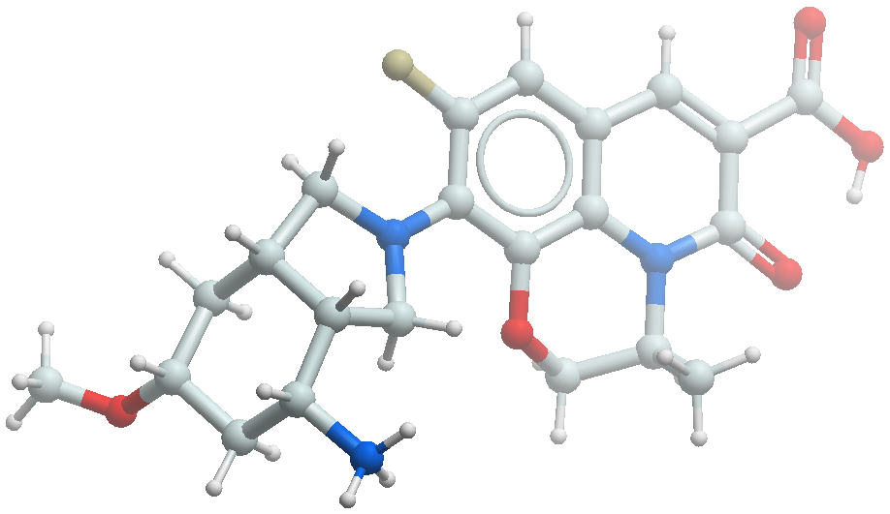
Methyl (S)-10-((3aR,4R,6R,7aS)-4-((tert-butoxycarbonyl)amino)-6-methoxyoctahydro-2H-isoindol-2-yl)-9-fluoro-3-methyl-5-oxo-2,3-dihydro-5H-[1,4]oxazino[2,3,4-ij]quinoline-6-carboxylate (212) (0.085 g, 0.155 mmol) was dissolved in 3:1 MeOH:H₂O (4.00 mL). 1M LiOH·H₂O (0.467 mL, 0.467 mmol) was added and the reaction was stirred at room temperature for 3 hours. The reaction mixture was concentrated under reduced pressure to give a residue, which was diluted with ice cold water, acidified with dilute HCl to pH 4 and extracted with ethyl acetate. The combined organic layers were dried over sodium sulfate and concentrated under vacuum to afford the desired product (0.080 g, 97% yield) as a yellow solid, which was used in the next step without any further purification. LCMS (m/z): 532.49 [M+H]⁺.
The acid (0.080 g, 0.150 mmol) was dissolved in DCM (4.00 mL) and cooled to 0 ºC. TFA (0.800 mL) was added and the reaction mixture was stirred at room temperature for 2 hours. The reaction mixture was concentrated under vacuum to afford a crude residue, which was purified by trituration with ethyl acetate to afford the title compound (0.070 g, 64% yield). C₂₂H₂₆FN₃O₅ [M+H]⁺ 432.1929, found 432.1929. ¹H NMR (400 MHz, CD₃OD) δ 8.71 (s, 1H), 7.32 (d, J = 13.6 Hz, 1H), 5.20 – 5.10 (m, 1H), 4.54 (d, J = 11.4 Hz, 1H), 4.35 – 4.21 (m, 2H), 4.10 (d, J = 11.2 Hz, 1H), 3.73 – 3.61 (m, 1H), 3.55 – 3.48 (m, 1H), 3.47 – 3.35 (m, 5H), 2.79 – 2.65 (m, 1H), 2.48 – 2.36 (m, 1H), 2.32 – 2.21 (m, 1H), 2.14 – 2.00 (m, 1H), 1.58 (q, J = 11.9 Hz, 1H), 1.44 (d, J = 6.7 Hz, 3H), 1.29 (q, J = 12.6 Hz, 1H).

Synthesis of iso-fluoroquinolone 53.
Relative and absolute stereochemistry was assigned by comparison of bioactivity to 52.

Methyl (S)-10-((3aR,4R,6R,7aS)-4-((tert-butoxycarbonyl)amino)-6-(difluoromethoxy)octahydro-2H-isoindol-2-yl)-9-fluoro-3-methyl-5-oxo-2,3-dihydro-5H-[1,4]oxazino[2,3,4-ij]quinoline-6-carboxylate (213)
Methyl (S)-10-((3aR*,4R*,6R*,7aS*)-4-((tert-butoxycarbonyl)amino)-6-hydroxyoctahydro-2H-isoindol-2-yl)-9-fluoro-3-methyl-5-oxo-2,3-dihydro-5H-[1,4]oxazino[2,3,4-ij]quinoline-6-carboxylate (211) (0.450 g , 0.847 mmol) was dissolved in MeCN (8.00 mL) and copper (I) iodide (0.032 g , 0.169 mmol) was added under N₂. A solution of 2,2-difluoro-2-(fluorosulfonyl)acetic acid (0.301 g, 1.690 mmol) in MeCN (2 mL) was added dropwise at room temperature and the reaction was heated to 60 ºC for 3 hours. After completion, the reaction was quenched with ice cold water and extracted with EtOAc. The combined organic layers were dried over sodium sulfate and concentrated in vacuo. The crude residue was purified by reverse phase combiflash to obtain a mixture of diastereomers (0.250 g, 52% yield). The diastereomers were separated by chiral preparative SFC to afford each as yellow solids as follows:
Methyl (S)-10-((3aR,4R,6R,7aS)-4-((tert-butoxycarbonyl)amino)-6-(difluoromethoxy)octahydro-2H-isoindol-2-yl)-9-fluoro-3-methyl-5-oxo-2,3-dihydro-5H-[1,4]oxazino[2,3,4-ij]quinoline-6-carboxylate (0.125 g, 26% yield): LCMS (m/z): 582.33 [M+H]⁺. ¹H NMR (400 MHz, CDCl₃) δ 8.39 (s, 1H), 6.98 (d, J = 13.1 Hz, 1H), 6.47 (t, J = 7.4 Hz, 1H), 5.19 (br s, 1H), 4.55 – 4.44 (m, 2H), 4.25 – 4.15 (m, 2H), 4.10 – 4.07 (m, 2H), 3.98 (s, 3H), 3.45 – 3.34 (m, 2H), 2.85 (br s, 1H), 2.22 (d, J = 11.5 Hz, 2H), 1.99 (d, J = 12.2 Hz, 1H), 1.67 – 1.60 (m, 2H), 1.47 (s, 9H), 1.29 (d, J = 9.5 Hz, 3H).
Methyl (S)-10-((3aS,4S,6S,7aR)-4-((tert-butoxycarbonyl)amino)-6-(difluoromethoxy)octahydro-2H-isoindol-2-yl)-9-fluoro-3-methyl-5-oxo-2,3-dihydro-5H-[1,4]oxazino[2,3,4-ij]quinoline-6-carboxylate (0.125 g, 26% yield): LCMS (m/z): 582.33 [M+H]⁺. ¹H NMR (400 MHz, CDCl₃) δ 8.38 (s, 1H), 6.98 (d, J = 13.2 Hz, 1H), 6.47 (t, J = 7.4 Hz, 1H), 5.14 (d, J = 7.0 Hz, 1H), 4.53 (br s, 1H), 4.44 (d, J = 11.2 Hz, 1H), 4.26 – 4.21 (m, 2H), 4.02 – 4.00 (m, 2H), 3.98 (s, 3H), 3.48 – 3.35 (m, 2H), 2.85 (br s, 1H), 2.33 (dd, J = 12.3, 5.7 Hz, 1H), 2.22 (d, J = 12.3 Hz, 1H), 2.00 (d, J = 13.3 Hz, 1H), 1.74 – 1.56 (m, 2H), 1.51 (s, 9H), 1.30 (d, J = 12.8 Hz, 3H).

(S)-10-((3aR,4R,6R,7aS)-4-Amino-6-(difluoromethoxy)octahydro-2H-isoindol-2-yl)-9-fluoro-3-methyl-5-oxo-2,3-dihydro-5H-[1,4]oxazino[2,3,4-ij]quinoline-6-carboxylic acid trifluoroacetic acid (53)
Methyl (S)-10-((3aR,4R,6R,7aS)-4-((tert-butoxycarbonyl)amino)-6-(difluoromethoxy)octahydro-2H-isoindol-2-yl)-9-fluoro-3-methyl-5-oxo-2,3-dihydro-5H-[1,4]oxazino[2,3,4-ij]quinoline-6-carboxylate (213) (0.120 g, 0.206 mmol) was dissolved in 3:1 MeOH:H₂O (2.50 mL). 1M LiOH·H₂O (0.618 mL, 0.244 mmol) was added and the reaction was stirred at room temperature for 7 hours. The reaction was quenched with ice cold water, acidified with dilute HCl to pH 4 and extracted with EtOAc. The combined organic layers were washed with brine, dried over sodium sulfate and concentrated in vacuo to afford the desired product (0.110 g, 94% yield) which was used in the next step without further purification. LCMS (m/z): 568.73 [M+H]⁺. ¹H NMR (400 MHz, CDCl₃) δ 14.42 (s, 1H), 8.70 (s, 1H), 7.10 (d, J = 13.3 Hz, 1H), 6.29 (t, J = 7.4 Hz, 1H), 5.19 (d, J = 7.2 Hz, 1H), 4.56 (br s, 1H), 4.49 (d, J = 11.3 Hz, 1H), 4.35 – 4.20 (m, 2H), 4.20 – 4.04 (m, 3H), 3.56 – 3.42 (m, 2H), 2.87 (br s, 1H), 2.35 (dd, J = 12.4, 5.6 Hz, 1H), 2.23 (d, J = 11.8 Hz, 1H), 2.01 (d, J = 12.7 Hz, 1H), 1.70 (d, J = 12.4 Hz, 2H), 1.50 (s, 9H), 1.36 (d, J = 9.4 Hz, 3H).
The acid (0.110 g, 0.197 mmol) was dissolved in DCM (2.00 mL) and cooled to 0 ºC. TFA (0.500 mL) was added and the reaction was stirred at room temperature for 4 hours. Upon completion, the reaction mixture was concentrated in vacuo to afford a crude residue, which was purified by trituration with diethyl ether to obtain the title compound (0.085 g, 77 % yield) as a yellow solid. C₂₂H₂₄F₃N₃O₅ [M+H]⁺ 468.1741, found 468.1740. ¹H NMR (400 MHz, CD₃OD) δ 8.72 (s, 1H), 7.35 (d, J = 13.5 Hz, 1H), 6.50 (t, J = 7.2 Hz, 1H), 5.18 (d, J = 7.0 Hz, 1H), 4.59 (d, J = 11.5 Hz, 1H), 4.34 (d, J = 10.6 Hz, 3H), 4.14 (d, J = 11.3 Hz, 1H), 3.79 (d, J = 12.8 Hz, 1H), 3.57 (br s, 1H), 3.49 (d, J = 10.3 Hz, 1H), 2.77 (br s, 1H), 2.55 – 2.47 (m, 1H), 2.30 (d, J = 12.1 Hz, 1H), 2.08 (d, J = 12.8 Hz, 1H), 1.87 (q, J = 12.2 Hz, 1H), 1.44 (d, J = 9.8 Hz, 3H).

Synthesis of iso-fluoroquinolone 54.
Relative and absolute stereochemistry was assigned by small molecule X-ray crystallography.

Methyl (S)-10-((3aR,4R,6S,7aS)-4-((tert-butoxycarbonyl)amino)-6-fluorooctahydro-2H-isoindol-2-yl)-9-fluoro-3-methyl-5-oxo-2,3-dihydro-5H-[1,4]oxazino[2,3,4-ij]quinoline-6-carboxylate (S23)
Methyl (S)-10-((3aR*,4R*,6R*,7aS*)-4-((tert-butoxycarbonyl)amino)-6-hydroxyoctahydro-2H-isoindol-2-yl)-9-fluoro-3-methyl-5-oxo-2,3-dihydro-5H-[1,4]oxazino[2,3,4-ij]quinoline-6-carboxylate (211) (0.300 g, 0.564 mmol) was dissolved in dry DCM (45.0 mL) and cooled to –78 ºC under nitrogen. DAST (0.272 g, 1.69 mmol) was added dropwise as a solution in DCM (15.0 mL) over a period of 25 minutes. The resulting mixture was stirred for a further 30 minutes at the same temperature. Upon completion of the reaction, the mixture was quenched with water and extracted with EtOAc. The combined organic layers were dried over anhydrous Na₂SO₄ and concentrated under reduced pressure to afford a crude residue, which was purified by reverse phase preparative HPLC to obtain the following products:
Methyl (S)-10-((3aR,4R,6S,7aS)-4-((tert-butoxycarbonyl)amino)-6-fluorooctahydro-2H-isoindol-2-yl)-9-fluoro-3-methyl-5-oxo-2,3-dihydro-5H-[1,4]oxazino[2,3,4-ij]quinoline-6-carboxylate (S23) (0.050 g, 17% yield) as a yellow solid. LCMS (m/z): 534.5 [M+H] ⁺. ¹H NMR (400 MHz, CDCl₃) δ 8.39 (s, 1H), 6.98 (d, J = 13.2 Hz, 1H), 5.20 – 5.17 (m, 2H), 5.04 – 5.01 (m, 1H), 4.43 – 4.41 (m, 3H), 4.26 (m, 2H), 4.05 – 3.94 (m, 4H), 3.46 – 3.43 (m, 1H), 3.36 – 3.33 (m, 1H), 2.98 – 2.96 (m, 1H), 2.64 – 2.62 (m, 1H), 2.25 – 2.23 (m, 1H), 2.04 – 2.02 (m, 1H), 1.71 – 1.69 (m 1H), 1.48 (s, 9H), 1.30 (s, 3H).
Methyl (S)-10-((3aS,4S,6R,7aR)-4-((tert-butoxycarbonyl)amino)-6-fluorooctahydro-2H-isoindol-2-yl)-9-fluoro-3-methyl-5-oxo-2,3-dihydro-5H-[1,4]oxazino[2,3,4-ij]quinoline-6-carboxylate (0.025 g, 8% yield) as a yellow solid. LCMS (m/z): 534.5 [M+H] ⁺. ¹H NMR (400 MHz, CDCl₃) δ 8.38 (s, 1H), 6.98 (d, J = 13.3 Hz, 1H), 5.15 – 5.13 (m, 2H), 5.03 – 5.00 (m, 1H), 4.44 – 4.35 (m, 3H), 4.20 – 4.14 (m, 2H), 3.98 (s, 3H), 3.46 (t, J = 9.1 Hz, 1H), 3.36 – 3.33 (m, 1H), 2.99 – 2.96 (m, 1H), 2.67 – 2.60 (m, 1H), 2.24 – 2.21 (m, 1H), 2.04 – 2.01 (m, 1H), 1.71 – 1.69 (m 1H), 1.46 (s, 9H), 1.31 – 1.30 (m, 3H).

(S)-10-((3aR,4R,6S,7aS)-4-Amino-6-fluorooctahydro-2H-isoindol-2-yl)-9-fluoro-3-methyl-5-oxo-2,3-dihydro-5H-[1,4]oxazino[2,3,4-ij]quinoline-6-carboxylic acid trifluoroacetic acid (54)
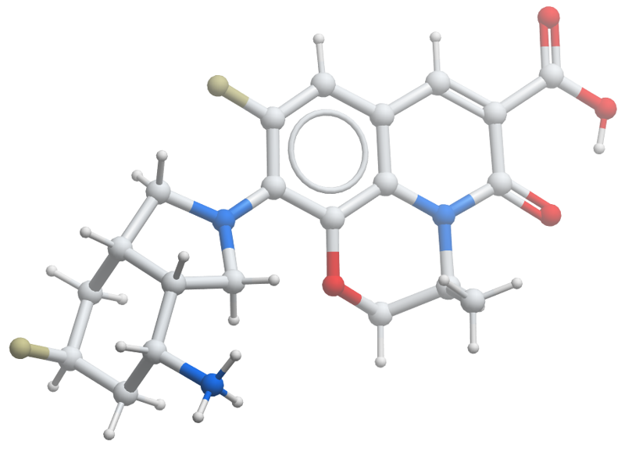
Methyl (S)-10-((3aR,4R,6S,7aS)-4-((tert-butoxycarbonyl)amino)-6-fluorooctahydro-2H-isoindol-2-yl)-9-fluoro-3-methyl-5-oxo-2,3-dihydro-5H-[1,4]oxazino[2,3,4-ij]quinoline-6-carboxylate (S23) (0.050 g, 0.094 mmol) was dissolved in 3:1 MeOH:H₂O (1.00 mL). 1M LiOH·H₂O (0.375 mL, 0.375 mmol) was added and the reaction mixture was stirred at room temperature for 2-3 hours. The reaction mixture was quenched with ice cold water, acidified with dilute HCl to pH 4 and extracted with EtOAc. The organic layer was washed with brine, dried over sodium sulfate and concentrated under vacuum to afford the desired product (0.045 g, 94% yield) which was used in the next step without any further purification. LCMS (m/z): 520.5 [M+H]⁺.
The carboxylic acid (0.040 g, 0.077 mmol) was dissolved in DCM (10.0 mL) and cooled to 0 ºC. TFA (0.400 mL) was added and the reaction mixture was stirred at room temperature for 2 hours. The reaction mixture was concentrated under vacuum to afford a crude residue, which was purified by trituration with diethyl ether to obtain the title compound (0.025 g, 61% yield) as a yellow solid. C₂₁H₂₃F₂N₃O₄ [M+H]⁺ 420.1729, found 420.1731. ¹H NMR (400 MHz, CD₃OD) δ 8.67 (s, 1H), 7.30 (d, J = 13.6 Hz, 1H), 5.20 – 5.03 (m, 2H), 4.55 (d, J = 11.4 Hz, 1H), 4.35 – 4.21 (m, 2H), 4.09 (d, J = 11.3 Hz, 1H), 3.99 – 3.88 (m, 1H), 3.58 (t, J = 9.3 Hz, 1H), 3.45 (d, J = 10.5 Hz, 1H), 2.93 – 2.78 (m, 1H), 2.74 – 2.61 (m, 1H), 2.34 – 2.21 (m, 1H), 2.13 – 1.86 (m, 2H), 1.65 (dt, J = 46.5, 13.9 Hz, 1H), 1.44 (d, J = 6.6 Hz, 3H).

Synthesis of iso-fluoroquinolone 55.
Relative and absolute stereochemistry was assigned by comparison of bioactivity to Example 48.

Methyl (S)-10-((3aR*,4R*,7aS*)-4-((tert-butoxycarbonyl)amino)-6-oxooctahydro-2H-isoindol-2-yl)-9-fluoro-3-methyl-5-oxo-2,3-dihydro-5H-[1,4]oxazino[2,3,4-ij]quinoline-6-carboxylate (214)
Methyl (S)-10-((3aR*,4R*,6R*,7aS*)-4-((tert-butoxycarbonyl)amino)-6-hydroxyoctahydro-2H-isoindol-2-yl)-9-fluoro-3-methyl-5-oxo-2,3-dihydro-5H-[1,4]oxazino[2,3,4-ij]quinoline-6-carboxylate (211) (0.600 g, 1.12 mmol) was dissolved in DCM (60.0 mL) and cooled to 0 ºC under nitrogen. Dess–Martin periodinane (1.48 g, 3.38 mmol) was added portionwise over a period of 45 minutes and the mixture was stirred at room temperature for 6 hours. The reaction mixture was filtered through a celite pad and the pad was washed with EtOAc. The filtrate was washed with sodium thiosulfate and sodium bicarbonate (50:50) followed by brine, then dried over sodium sulfate and concentrated under vacuum to afford the desired product (0.540 g, 91% yield), which was used in the next step without any further purification. LCMS (m/z): 530.57 [M+H]⁺. ¹H NMR (400 MHz, CD₃OD) δ 8.79 (s, 1H), 7.01 (d, J = 12.8 Hz, 1H), 5.19 – 5.16 (m, 1H), 4.84 (br s, 1H), 4.51 – 4.49 (m, 3H), 4.48 –4.36 (m, 1H), 4.10 – 4.00 (m, 2H), 3.99 (s, 3H), 3.68 – 3.35 (m, 4H), 3.03 – 3.01 (m, 1H), 2.77 – 2.48 (m, 3H), 1.51 – 1.48 (m, 12H).

Methyl (S)-10-((3aR*,4R*,7aS*)-4-((tert-butoxycarbonyl)amino)-6,6-difluorooctahydro-2H-isoindol-2-yl)-9-fluoro-3-methyl-5-oxo-2,3-dihydro-5H-[1,4]oxazino[2,3,4-ij]quinoline-6-carboxylate (215)
Methyl (S)-10-((3aR*,4R*,7aS*)-4-((tert-butoxycarbonyl)amino)-6-oxooctahydro-2H-isoindol-2-yl)-9-fluoro-3-methyl-5-oxo-2,3-dihydro-5H-[1,4]oxazino[2,3,4-ij]quinoline-6-carboxylate (214) (0.250 g, 0.472 mmol) was dissolved in DCM (8.00 mL) under nitrogen. DAST (0.304 g, 1.89 mmol) was added dropwise at room temperature and the reaction mixture was stirred at room temperature for 8 hours. Upon completion of the reaction, the mixture was quenched with ice cold water and extracted with EtOAc. The combined organic layers were dried over sodium sulfate and concentrated under vacuum to afford a crude residue, which was purified by chiral SFC to obtain the individual diastereomers as follows:
Methyl (S)-10-((3aR,4R,7aS)-4-((tert-butoxycarbonyl)amino)-6,6-difluorooctahydro-2H-isoindol-2-yl)-9-fluoro-3-methyl-5-oxo-2,3-dihydro-5H-[1,4]oxazino[2,3,4-ij]quinoline-6-carboxylate (215) (0.024 g, 9% yield). LCMS (m/z): 552.35 [M+H]⁺. ¹H NMR (400 MHz, CD₃OD) δ 8.51 (s, 1H), 7.20 (d, J = 13.6 Hz, 1H), 5.12 – 5.11 (m, 1H), 4.55 – 4.53 (m, 1H), 4.28 – 4.05 (m, 4H), 3.90 (s, 3H), 3.45 – 3.42 (m, 2H), 2.85 – 2.82 (m, 1H), 2.51 – 2.49 (m, 1H), 2.20 – 2.05 (m, 2H), 2.00 – 1.98 (m, 1H), 1.90 – 1.70 (m, 2H), 1.474 (s, 9H), 1.42 (d, J = 6.4 Hz, 3H).
Methyl (S)-10-((3aS,4S,7aR)-4-((tert-butoxycarbonyl)amino)-6,6-difluorooctahydro-2H-isoindol-2-yl)-9-fluoro-3-methyl-5-oxo-2,3-dihydro-5H-[1,4]oxazino[2,3,4-ij]quinoline-6-carboxylate (0.024 g, 9% yield). LCMS (m/z): 552.49 [M+H]⁺. ¹H NMR (400 MHz, CD₃OD) δ 8.51 (s, 1H), 7.20 (d, J = 13.2 Hz, 1H), 5.08 – 5.06 (m, 1H), 4.56 – 4.53 (m, 1H), 4.22 – 4.09 (m, 3H), 3.90 (s, 3H), 3.45 – 3.42 (m, 2H), 2.83 (s, 1H), 2.51 – 2.49 (m, 1H), 2.18 – 2.01 (m, 3H), 2.01 – 1.99 (m, 1H), 1.87 – 1.78 (m, 2H), 1.47 – 1.40 (m, 12H).

(S)-10-((3aR,4R,7aS)-4-Amino-6,6-difluorooctahydro-2H-isoindol-2-yl)-9-fluoro-3-methyl-5-oxo-2,3-dihydro-5H-[1,4]oxazino[2,3,4-ij]quinoline-6-carboxylic acid trifluoroacetatic acid (55)
Methyl (S)-10-((3aR,4R,7aS)-4-((tert-butoxycarbonyl)amino)-6,6-difluorooctahydro-2H-isoindol-2-yl)-9-fluoro-3-methyl-5-oxo-2,3-dihydro-5H-[1,4]oxazino[2,3,4-ij]quinoline-6-carboxylate (215) (0.024 g, 0.044 mmol) was dissolved in 3:1 MeOH/H₂O (1.00 mL). 1M LiOH·H₂O (0.130 mL, 0.130 mmol) was added and the reaction mixture was stirred at room temperature for 2-3 hours. The reaction was quenched with ice cold water, acidified with dilute HCl to pH 4 and extracted with EtOAc. The combined organic layers were washed with brine, dried over sodium sulfate and concentrated under vacuum to afford the desired product (0.021 g, 91% yield), which was used in the next step without any further purification. LCMS (m/z): 538.48 [M+H]⁺.
The acid (0.021 g, 0.039 mmol) was dissolved in DCM (2.00 mL) and cooled to 0 ºC. TFA (0.200 mL) was added and the reaction mixture was stirred at room temperature for 2 hours. The mixture was concentrated under vacuum to afford a crude residue, which was purified by trituration with diethyl ether to obtain the title compound (0.017 g, 85% yield) as a yellow solid. C₂₁H₂₂F₃N₃O₄ [M+H]⁺ 438.1635, found 438.1636. ¹H NMR (400 MHz, CD₃OD) δ 8.75 (s, 1H), 7.37 (d, J = 13.2 Hz, 1H), 5.19 – 5.17 (m, 1H), 4.60 – 4.57 (m, 1H), 4.34 – 4.30 (m, 2H), 4.15 – 4.12 (m, 1H), 3.93 – 3.89 (m, 1H), 3.62 – 3.52 (m, 2H), 2.88 (br s, 1H), 2.66 (br s, 1H), 2.42 – 2.23 (m, 3H), 2.00 – 1.91 (m, 1H), 1.47 (d, J = 6.8 Hz, 3H).

Synthesis of iso-fluoroquinolone 56.
Relative and absolute stereochemistry of C2′, 3′, and 7′ was assigned by comparing bioactivity with compound 48. Stereochemistry at C6′ was assigned by NOESY.

4-Methoxycyclohex-2-en-1-one (217)
1,4-Dioxaspiro[4.5]dec-6-en-8-one (216) (10.0 g, 64.9 mmol) was dissolved in dry methanol (150 mL). Anhydrous CeCl₃ (16.0 g, 64.9 mmol) was added and the reaction mixture was cooled to 0 ºC under nitrogen. NaBH₄ (1.20 g, 32.4 mmol) was added portionwise and the reaction was stirred at 0 ºC for 30 minutes. The reaction was quenched with ice water (100 mL) and stirred for 5 minutes. Thereafter, 5% oxalic acid (66.0 mL) was added and stirred for 1 hour. The reaction mixture was filtered through a celite pad, diluted with water and extracted with ethyl acetate. The combined organic layers were dried over Na₂SO₄ and concentrated under reduced pressure to afford the desired product (7.00 g, 96% yield), which was used in the next step without any further purification. LCMS (m/z): 113.13 [M+H]⁺. ¹H NMR (400 MHz, CDCl₃) δ 7.03 – 7.00 (d, J = 10.3 Hz, 1H), 6.05 – 6.03 (d, J = 9.6 Hz, 1H), 4.14 – 4.10 (m, 1H), 2.67 – 2.62 (m, 1H), 2.43 – 2.35 (m, 2H), 2.06 – 2.03 (m, 1H).
The hydroxyketone (7.00 g, 62.5 mmol) was dissolved in dry DCM (150 mL) and silver oxide (72.1 g, 31.2 mmol) was added. Methyl iodide (88.1 g, 62.5 mmol) was added and the reaction was stirred at room temperature for 16 hours in a sealed vessel. The reaction mixture was filtered through a celite pad, diluted with water and extracted with ethyl acetate. The combined organic layers were dried over Na₂SO₄ and concentrated under reduced pressure to afford a crude residue, which was purified by silica gel column chromatography (0-15% ethyl acetate in hexane) to afford the desired product (3.50 g, 44% yield). LCMS (m/z): 127.16 [M+H]⁺. ¹H NMR (400 MHz, CDCl₃) δ 7.03 – 7.00 (d, J = 10.3 Hz, 1H), 6.05 – 6.03 (d, J = 9.6 Hz, 1H), 3.51 (s, 3H), 4.14 – 4.11 (m, 1H), 2.67 – 2.62 (m, 1H), 2.43 – 2.35 (m, 2H), 2.06 – 2.03 (m, 1H).

(3aR*,7R*,7aS*)-2-Benzyl-7-methoxyoctahydro-4H-isoindol-4-one (219)
Methoxycyclohex-2-en-1-one (217) (3.50 g, 27.0 mmol) and N-(methoxy methyl)-N-(trimethylsilyl benzylamine) (6.50 g, 27.0 mmol) were dissolved in dry 1,4-dioxane (32.0 mL) and the reaction mixture was heated to 120 ºC for 16 hours in a sealed vessel. After completion, the reaction mixture was diluted with water and extracted with ethyl acetate. The combined organic layers were dried over Na₂SO₄ and concentrated under reduced pressure to afford a crude residue, which was purified by silica gel column chromatography (0-100% ethyl acetate in hexane) to afford two diastereomers as follows:
(3aR*,7R*,7aS*)-2-benzyl-7-methoxyoctahydro-4H-isoindol-4-one (219) (1.50 g, 20% yield): LCMS (m/z): 260.35 [M+H]⁺. ¹H NMR (400 MHz, CDCl₃) δ 7.33 – 7.27 (m, 5H), 3.68 – 3.59 (m, 2H), 3.34 (s, 3H), 3.02 – 2.87 (m, 2H), 2.81 – 2.76 (m, 3H), 2.58 – 2.52 (m, 1H), 2.46 – 2.44 (m ,1H), 2.44 – 2.39 (m, 1H), 2.19 – 2.16 (m, 1H), 2.10 – 2.00 (m, 1H).
(3aR*,7S*,7aS*)-2-Benzyl-7-methoxyoctahydro-4H-isoindol-4-one (218) (0.500 g, 7% yield): LCMS (m/z): 260.35 [M+H]⁺. ¹H NMR (400 MHz, CDCl₃) δ 7.34 – 7.26 (m, 5H), 3.65 (s, 2H), 3.26 (s, 3H), 3.01 – 2.90 (m, 2H), 2.88 – 2.82 (m, 1H), 2.76 – 2.70 (m, 2H), 2.66 – 2.63 (m, 1H), 2.49 – 2.46 (m, 1H), 2.36 – 2.30 (m, 1H), 2. 19 – 2.16 (m, 1H), 1.99 – 1.96 (m, 1H).

(3aR*,4R*,7R*,7aS*)-2-Benzyl-7-methoxyoctahydro-1H-isoindol-4-amine (220)
(3aR*,7R*,7aS*)-2-Benzyl-7-methoxyoctahydro-4H-isoindol-4-one (219) (1.09 g, 3.86 mmol) was dissolved in dry methanol (15.0 mL). Ammonium acetate (4.45 g, 57.9 mmol) and sodium cyanoborohydride (0.48 g, 7.72 mmol) were added and the reaction was heated at 80 ºC for 2 hours in a sealed tube. The reaction mixture was concentrated under vacuum, diluted with saturated K₂CO₃ solution and extracted with ethyl acetate. The combined organic layers were dried over sodium sulfate and concentrated under reduced pressure to afford the desired product (1.00 g), which was used in next step without any further purification. LCMS (m/z): 261.38 [M+H]⁺.

tert-Butyl ((3aR*,4R*,7R*,7aS*)-2-benzyl-7-methoxyoctahydro-1H-isoindol-4-yl)carbamate (221)
(3aR*,4R*,7R*,7aS*)-2-Benzyl-7-methoxyoctahydro-1H-isoindol-4-amine (220) (1.05 g, 4.18 mmol) was dissolved in dry DCM (12.0 mL). Triethylamine (1.74 mL, 12.5 mmol) and Boc anhydride (1.36 g, 6.26 mmol) were added and the reaction mixture was stirred at room temperature for 16 hours. The reaction was quenched with water and extracted with ethyl acetate. The combined organic layers were dried over Na₂SO₄ and concentrated under vacuum to afford a crude residue, which was purified by silica gel column chromatography (0-2 % methanol in DCM), followed by reverse phase prep HPLC to obtain the desired product (0.10 g, 7% yield). LCMS (m/z): 361.50 [M+H]⁺. ¹H NMR (400 MHz, CDCl₃) δ 7.76 (br s, 1H), 7.41 – 7.237 (m, 5H), 3.75 – 3.73 (m, 3H), 3.46 – 3.44 (m, 1H), 3.35 (s, 3H), 3.04 – 3.01 (m, 1H), 2.99 – 2.87 (m, 2H), 2.59 – 2.53 (m, 1H), 2.50 – 2.48 (m, 1H), 2.37 – 2.36 (m, 1H), 2.21 – 2.16 (m, 1H), 1.70 – 1.68 (m, 1H), 1.63 – 1.61 (m, 1H), 1.50 (s, 9H).

tert-Butyl ((3aR*,4R*,7R*,7aS*)-7-methoxyoctahydro-1H-isoindol-4-yl)carbamate (222)
tert-Butyl ((3aR*,4R*,7R*,7aS*)-2-benzyl-7-methoxyoctahydro-1H-isoindol-4-yl)carbamate (221) (0.170 g, 0.470 mmol) was dissolved in i-PrOH (1.50 mL). 10% Pd/C (Dry basis, 0.085 g) was added and the reaction mixture was stirred under 1 atmosphere of hydrogen at room temperature for 16 hours. After completion, the reaction mixture was filtered through a celite pad and concentrated under vacuum to afford the desired product (0.125 g), which was used in the next step without any further purification. LCMS (m/z): 271.37 [M+H]⁺.

Methyl (S)-10-((3aR*,4R*,7R*,7aS*)-4-((tert-butoxycarbonyl)amino)-7-methoxyoctahydro-2H-isoindol-2-yl)-9-fluoro-3-methyl-5-oxo-2,3-dihydro-5H-[1,4]oxazino[2,3,4-ij]quinoline-6-carboxylate (223)
tert-Butyl ((3aR*,4R*,7R*,7aS*)-7-methoxyoctahydro-1H-isoindol-4-yl)carbamate (222) (0.070 g, 0.259 mmol) and methyl (S)-9,10-difluoro-3-methyl-5-oxo-2,3-dihydro-5H-[1,4]oxazino[2,3,4-ij]quinoline-6-carboxylate (121) (0.061 g, 0.207 mmol) were dissolved in DMSO (3.00 mL). Triethylamine (0.200 mL, 1.55 mmol) was added at room temperature and the reaction mixture was heated to 85 ºC for 16 hours. After completion, the reaction mixture was poured in to ice cold water and extracted with EtOAc. The combined organic layers were washed with cold water, brine, dried over sodium sulfate and concentrated under vacuum to afford a crude residue, which was purified by reverse phase combi-flash (100 % Methanol) to afford a mixture of diastereomers. The diastereomers were separated by chiral SFC purification to give:
Methyl (S)-10-((3aR,4R,7R,7aS)-4-((tert-butoxycarbonyl)amino)-7-methoxyoctahydro-2H-isoindol-2-yl)-9-fluoro-3-methyl-5-oxo-2,3-dihydro-5H-[1,4]oxazino[2,3,4-ij]quinoline-6-carboxylate (223) (0.035 g, 25%): LCMS (m/z): 546.61 [M+H]⁺. ¹H NMR (400 MHz, CDCl₃) δ 8.41 (s, 1H), 6.99 (d, J = 12.7 Hz, 1H), 5.19 (s, 1H), 4.48 (s, 1H), 4.10 (s, 1H), 3.99 (s, 3H), 3.88 (s, 2H), 3.67 (s, 2H), 3.54 (s, 1H), 3.38 (s, 3H), 2.78 (s, 1H), 2.60 (s, 1H), 1.98 – 1.95 (m, 1H), 1.45 (s, 3H), 1.31 (s, 9H).
Methyl (S)-10-((3aS,4S,7S,7aR)-4-((tert-butoxycarbonyl)amino)-7-methoxyoctahydro-2H-isoindol-2-yl)-9-fluoro-3-methyl-5-oxo-2,3-dihydro-5H-[1,4]oxazino[2,3,4-ij]quinoline-6-carboxylate (0.035 g, 25%): LCMS (m/z): 546.61 [M+H]⁺. ¹H NMR (400 MHz, CDCl₃) δ 8.41 (s,1H), 6.99 (d, J = 12.7 Hz, 1H), 5.19 (s, 2H), 4.48 (s, 1H), 4.10 (s, 1H), 3.99 (s, 3H), 3.88 (s, 2H), 3.67 (s, 2H), 3.54 (s, 1H), 3.38 (s, 3H), 2.78 (s, 1H), 2.60 (s, 1H), 1.96 (m, 1H), 1.452 (s, 3H), 1.310 (s, 9H).

(S)-10-((3aR,4R,7R,7aS)-4-Amino-7-methoxyoctahydro-2H-isoindol-2-yl)-9-fluoro-3-methyl-5-oxo-2,3-dihydro-5H-[1,4]oxazino[2,3,4-ij]quinoline-6-carboxylic acid trifluoroacetic acid (56)
Methyl (S)-10-((3aR,4R,7R,7aS)-4-((tert-butoxycarbonyl)amino)-7-methoxyoctahydro-2H-isoindol-2-yl)-9-fluoro-3-methyl-5-oxo-2,3-dihydro-5H-[1,4]oxazino[2,3,4-ij]quinoline-6-carboxylate (223) (0.075 g, 0.138 mmol) was dissolved in 3:1 MeOH:H₂O (3.00 mL). 1M LiOH·H₂O (0.400 mL, 0.412 mmol) was added and the reaction mixture was stirred at room temperature for 2-3 hours. The reaction mixture was quenched with ice cold water, acidified with dilute HCl to pH 4 and extracted with ethyl acetate. The combined organic layers were dried over sodium sulfate and concentrated under vacuum to afford the desired product (0.070 g) as a yellow solid, which was used in the next step without any further purification. LCMS (m/z): 532.5 [M+H]⁺. ¹H NMR (400 MHz, DMSO-d₆) δ 14.58 (s, 1H), 8.72 (s, 1H), 7.53 (d, J = 14.3 Hz, 1H), 6.89 (d, J = 7.8 Hz, 1H), 5.02 (d, J = 7.5 Hz, 1H), 4.50 (d, J = 11.3 Hz, 1H), 4.13 – 4.11 (m, 1H), 4.06 – 3.92 (m, 1H), 3.74 – 3.72 (m, 1H), 3.60 (d, J = 10.8 Hz, 1H), 3.50 – 3.40 (m, 2H), 3.18 (s, 3H), 2.62 – 2.30 (m, 2H), 2.08 – 1.98 (m, 1H), 1.72 – 1.61 (m, 1H), 1.43 – 1.27 (m, 3H), 1.32 (s, 9H), 1.25 (s, 3H).
The acid (0.070 g, 0.131 mmol) was dissolved in DCM (3.00 mL) and cooled to 0 ºC. TFA (0.600 mL) was added slowly and the reaction mixture was stirred at room temperature for 2 hours. The reaction mixture was concentrated under vacuum to afford a crude residue, which was purified by trituration with diethyl ether to afford the title compound (0.053 g, 88% yield) as a yellow solid. C₂₂H₂₆FN₃O₅ [M+H]⁺ 432.1929, found 432.1930. ¹H NMR (400 MHz, CD₃OD) δ 8.71 (s, 1H), 7.32 (d, J = 14.0 Hz, 1H), 5.17 – 5.15 (m, 1H), 4.55 (d, J = 11.2 Hz, 1H), 4.39 (t, J = 8.6 Hz, 1H), 4.32 – 4.30 (m, 1H), 4.08 (d, J = 11.2 Hz, 1H), 3.65 – 3.60 (m, 3H), 3.50 – 3.47 (m, 1H), 3.29 (s, 3H), 2.77 – 2.75 (m, 1H), 2.55 – 2.53 (m, 1H), 2.30 (d, J = 14.7 Hz, 1H), 1.97 (d, J = 12.5 Hz, 1H), 1.77 – 1.74 (m, 1H), 1.58 – 1.44 (m, 4H).

Synthesis of iso-fluoroquinolone 57.
Relative and absolute stereochemistry assigned by comparing bioactivity with 48.

(3aS*,7aR*)-2-Benzylhexahydrospiro[isoindole-4,2'-[1,3]dioxolan]-7(1H)-one (224)
1,4-dioxaspiro[4.5]dec-6-en-8-one (206) (10.0 g, 64.9 mmol) and N-(methoxy methyl)-N-(trimethylsilyl benzylamine) (15.4.g, 64.9 mmol) were dissolved in dry DCM (250 mL) and the reaction mixture was cooled to 0 ºC under nitrogen. TFA (1.00 mL) was added dropwise to the mixture and the reaction was heated to 40 ºC for 24 hours. The reaction mixture was concentrated under vacuum to afford a crude residue, which was purified by basic alumina column chromatography (0-20 % EtOAc in hexane) to afford the desired product (3.20 g, 17% yield) as a yellow oil. LCMS (m/z): 288.3 [M+H]⁺. ¹H NMR (400 MHz, CDCl₃) δ 7.40 – 7.23 (m, 5H), 4.09 – 3.93 (m, 4H), 3.68 – 3.60 (m, 2H), 3.03 – 2.89 (m, 2H), 2.91 – 2.50 (m, 6H), 2.23 (ddd, J = 13.6, 9.7, 6.7 Hz, 1H), 1.95 (dddd, J = 13.9, 7.2, 5.1, 2.0 Hz, 1H).

(3aS*,7R*,7aR*)-7-Amino-2-benzyloctahydro-4H-isoindol-4-one (225)
(3aS*,7aR*)-2-benzylhexahydrospiro[isoindole-4,2'-[1,3]dioxolan]-7(1H)-one (224) (1.80 g, 6.25 mmol) was dissolved in dry methanol (50.0 mL). Ammonium acetate (7.20 g, 93.7 mmol) and NaCNBH₃ (0.785 g, 12.5 mmol) were added and the reaction mixture was heated to 60 ºC for 2 hours in a sealed tube. The reaction mixture was concentrated under vacuum, quenched with water, basified using a saturated K₂CO₃ solution, and extracted with EtOAc. The combined organic layers were dried over sodium sulfate and concentrated under reduced pressure to afford the desired product (1.50 g), which was used in the next step without any further purification. LCMS (m/z): 289.3 [M+H]⁺.
The ketal (2.10 g, 7.29 mmol) was dissolved in THF (30.0 mL). HCl (1N, 29.0 mL, 29.1 mmol) was added and the reaction mixture was heated to 80 ºC for 16 hours in a sealed tube. The reaction mixture was concentrated under reduced pressure to afford the desired product (1.60 g) as a yellow gum, which was used in the next step without any further purification. LCMS (m/z): 245.34 [M+H]⁺.

tert-Butyl ((3aR*,4R*,7aS*)-2-benzyl-7-oxooctahydro-1H-isoindol-4-yl)carbamate (226)
(3aS*,7R*,7aR*)-7-Amino-2-benzyloctahydro-4H-isoindol-4-one (225) (1.60 g, 6.50 mmol) was dissolved in dry DCM (50.0 mL). Triethylamine (1.99 g, 19.6 mmol) and Boc anhydride (2.14 g, 9.83 mmol) were added and the reaction mixture was stirred at room temperature for 16 hours. The reaction mixture was quenched with water and extracted with EtOAc. The combined organic layers were dried over sodium sulfate and concentrated under vacuum to afford a crude residue, which was purified using basic alumina column chromatography (0-2 % methanol in DCM) to give the desired product (0.55 g, 32% yield) as a pale yellow gum. LCMS (m/z): 345.34 [M+H]⁺. ¹H NMR (400 MHz, CDCl₃) δ 7.37 – 7.30 (m, 5H), 3.98 – 3.94 (m, 2H), 3.56 – 3.54 (m, 1H), 3.43 – 3.41 (m, 1H), 2.90 – 2.88 (m, 2H), 2.71 – 2.69 (m, 1H), 2.54 – 2.34 (m, 5H), 1.91 – 1.89 (m, 1H), 1.48 (s, 9H).

tert-Butyl ((3aR*,4R*,7aS*)-2-benzyl-7-hydroxyoctahydro-1H-isoindol-4-yl)carbamate (227)
tert-Butyl ((3aR*,4R*,7aS*)-2-benzyl-7-oxooctahydro-1H-isoindol-4-yl)carbamate (226) (0.540 g, 1.570 mmol) was dissolved in ethanol (20 mL) and cooled to 0 ºC. Sodium borohydride (0.059 g, 1.570 mmol) was added portionwise and the reaction mixture was stirred at 0 ºC for 1 hour. The reaction was quenched with ice water and extracted with EtOAc. The combined organic layers were dried over sodium sulfate and concentrated under vacuum to afford a mixture of diastereomers (0.500 g, 90% yield) as a pale yellow gum. LCMS (m/z): 347.23 [M+H]⁺.

tert-Butyl ((3aR*,4R*,7aS*)-7-hydroxyoctahydro-1H-isoindol-4-yl)carbamate (228)
A mixture of tert-butyl ((3aR*,4R*,7aS*)-2-benzyl-7-hydroxyoctahydro-1H-isoindol-4-yl)carbamate (227) (0.250 g, 0.722 mmol) was dissolved in methanol (20.0 mL). 10% Pd/C (dry basis, 0.125 g) was added and the reaction mixture was stirred under 1 atmosphere of hydrogen at room temperature for 16 hours. After completion, the reaction mixture was filtered through a celite pad and washed with excess MeOH. The filtrate was concentrated under vacuum to afford the desired product (0.150 g, 81% yield) which was used in the next step without any further purification. LCMS (m/z): 257.5 [M+H]⁺.

Methyl (S)-10-((3aR*,4R*,7aS*)-4-((tert-butoxycarbonyl)amino)-7-oxooctahydro-2H-isoindol-2-yl)-9-fluoro-3-methyl-5-oxo-2,3-dihydro-5H-[1,4]oxazino[2,3,4-ij]quinoline-6-carboxylate (229)
Methyl (S)-9,10-difluoro-3-methyl-5-oxo-2,3-dihydro-5H-[1,4]oxazino[2,3,4-ij]quinoline-6-carboxylate (121) (0.270 g, 0.912 mmol) and tert-butyl ((3aR*,4R*,7aS*)-7-hydroxyoctahydro-1H-isoindol-4-yl)carbamate (228) (0.347 g, 1.370 mmol) were dissolved in DMSO (5.00 mL). Triethylamine (0.276 g, 2.740 mmol) was added at room temperature and the reaction mixture heated to 85 ºC for 16 hours. After completion, the reaction mixture was poured into ice cold water and extracted with EtOAc. The combined organic layers were washed with cold water, brine, dried over sodium sulfate and concentrated under vacuum to afford a crude residue, which was purified by reverse phase combi-flash (70-90% methanol:water) to afford a mixture of four diastereomers. While the mixture was used directly in the subsequent step, the diastereomers could be separated by chiral preparative SFC to afford the pure products as follows (40% total yield):
Methyl (S)-10-((3aR,4R,7S,7aS)-4-((tert-butoxycarbonyl)amino)-7-hydroxyoctahydro-2H-isoindol-2-yl)-9-fluoro-3-methyl-5-oxo-2,3-dihydro-5H-[1,4]oxazino[2,3,4-ij]quinoline-6-carboxylate (0.080 g): LCMS (m/z): 532.2 [M+H]⁺. ¹H NMR (400 MHz, CDCl₃): δ 8.38 (s, 1H), 6.98 (d, J = 13.1 Hz, 1H), 5.14 (s, 1H), 4.66 – 4.64 (m, 1H), 4.44 (d, J = 11.4 Hz, 2H), 4.20 – 4.04 (m, 4H), 3.98 (s, 3H), 3.93 – 3.91 (m, 1H), 3.78 (d, J = 10.3 Hz, 1H), 3.44 – 3.41 (m, 1H), 3.04 – 3.01 (m, 1H), 2.41 – 2.39 (m, 1H), 2.00 – 1.92 (m, 2H), 1.70 – 1.30 (m, 13H).
Methyl (S)-10-((3aS,4S,7R,7aR)-4-((tert-butoxycarbonyl)amino)-7-hydroxyoctahydro-2H-isoindol-2-yl)-9-fluoro-3-methyl-5-oxo-2,3-dihydro-5H-[1,4]oxazino[2,3,4-ij]quinoline-6-carboxylate (0.070 g): LCMS (m/z): 532.2 [M+H]⁺. ¹H NMR (400 MHz, CDCl₃): δ 8.38 (s, 1H), 6.98 (d, J = 13.1 Hz, 1H), 5.14 (s, 1H), 4.44 (d, J = 11.4 Hz, 2H), 4.15 – 4.04 (m, 3H), 3.98 (s, 3H), 3.93 – 3.91 (m, 1H), 3.78 (d, J = 10.3 Hz, 1H), 3.67 – 3.65 (m, 1H), 3.44 – 3.42 (m, 1H), 3.04 – 3.01 (m, 1H), 2.07 (d, J = 14.1 Hz, 3H), 1.93 – 1.91 (m, 1H), 1.70 – 1.42 (m, 13H).
Methyl (S)-10-((3aR,4R,7R,7aS)-4-((tert-butoxycarbonyl)amino)-7-hydroxyoctahydro-2H-isoindol-2-yl)-9-fluoro-3-methyl-5-oxo-2,3-dihydro-5H-[1,4]oxazino[2,3,4-ij]quinoline-6-carboxylate (0.023 g): LCMS (m/z): 532.2 [M+H]⁺. ¹H NMR (400 MHz, CDCl₃): δ 8.38 (s, 1H), 6.99 (d, J = 13.1 Hz, 1H), 5.20 – 5.18 (m, 1H), 4.44 – 4.14 (d, J = 11.4 Hz, 2H), 4.15 – 4.14 (m, 1H), 3.90 – 4.05 (m, 2H), 4.00 (s, 3H), 3.78 (d, J = 10.3 Hz, 1H), 3.67 – 3.66 (m, 1H), 3.44 – 3.43 (m, 1H), 3.03 – 3.01 (m, 1H), 2.09 – 1.90 (m, 3H), 1.60 1.40 (m, 11H).
Methyl (S)-10-((3aS,4S,7S,7aR)-4-((tert-butoxycarbonyl)amino)-7-hydroxyoctahydro-2H-isoindol-2-yl)-9-fluoro-3-methyl-5-oxo-2,3-dihydro-5H-[1,4]oxazino[2,3,4-ij]quinoline-6-carboxylate (0.023 g): LCMS (m/z): 532.2 [M+H]⁺. ¹H NMR (400 MHz, CDCl₃): δ 8.39 (s, 1H), 7.05 (d, J = 13.1 Hz, 1H), 5.17 (s, 1H), 4.80 (s, 1H), 4.56 (d, J = 11.4 Hz, 2H), 4.18 – 4.14 (m, 2H), 3.97 (s, 3H), 3.88 – 3.57 (m, 3H), 3.03 – 3.00 (m, 1H), 2.47 (d, J = 14.1 Hz, 3H), 1.93 – 1.90 (m, 2H), 1.43 (s, 9H).
The mixture of diastereomeric alcohols (0.65 g , 1.22 mmol) was dissolved in DCM (60 mL) and cooled to 0 ºC. Dess–Martin periodinane (1.03 g , 2.45 mmol) was added portionwise over a period of 15 minutes and the reaction mixture was stirred at room temperature for 6 hours. The reaction mixture was filtered through a celite pad and washed with excess EtOAc. The filtrate was washed with a solution of 1:1 sodium thiosulfate:sodium bicarbonate, brine, dried over sodium sulfate and concentrated under vacuum. The crude residue was purified by reverse phase combi-flash to obtain a mixture of two diastereomers (0.48 g, 4:1 dr, 74% yield). While the mixture was used directly in the subsequent step, the diastereomers could be separated by chiral preparative SFC to afford diastereomerically pure products as follows:
Methyl (S)-10-((3aR,4R,7aS)-4-((tert-butoxycarbonyl)amino)-7-oxooctahydro-2H-isoindol-2-yl)-9-fluoro-3-methyl-5-oxo-2,3-dihydro-5H-[1,4]oxazino[2,3,4-ij]quinoline-6-carboxylate (229) (0.13 g, 19% yield): LCMS (m/z): 530.7 [M+H]⁺. ¹H NMR (400 MHz, CDCl₃) δ 8.39 (s, 1H), 6.99 (d, J = 13.6 Hz, 1H), 5.17 (d, J = 7.4 Hz, 1H), 4.75 – 4.73 (m, 1H), 4.56 – 4.48 (m, 2H), 4.00 – 3.97 (m, 4H), 3.89 – 3.84 (m, 1H), 3.50 – 3.45 (m, 1H), 3.30 (br s, 1H), 3.09 – 3.07 (m, 1H), 3.03 – 3.01 (m, 1H), 2.60 – 2.58 (m, 1H), 2.25 – 2.20 (m, 3H), 1.43 (s, 9H), 1.30 (t, J = 7.2 Hz, 3H).
Methyl (S)-10-((3aS,4S,7aR)-4-((tert-butoxycarbonyl)amino)-7-oxooctahydro-2H-isoindol-2-yl)-9-fluoro-3-methyl-5-oxo-2,3-dihydro-5H-[1,4]oxazino[2,3,4-ij]quinoline-6-carboxylate (0.17 g, 24% yield): LCMS (m/z): 530.7 [M+H]⁺. ¹H NMR (400 MHz, CDCl₃) δ 8.39 (s, 1H), 7.13 (d, J = 13.6 Hz, 1H), 5.16 (d, J = 7.4 Hz, 1H), 4.75 – 4.73 (m, 1H), 4.56 – 4.48 (m, 2H), 4.00 – 3.97 (m, 4H), 3.89 – 3.84 (m, 1H), 3.50 – 3.45 (m, 1H), 3.30 (br s, 1H), 3.09 – 3.07 (m, 1H), 3.03 – 3.01 (m, 1H), 2.60 – 2.58 (m, 1H), 2.25 – 2.20 (m, 3H), 1.43 (s, 9H), 1.30 (t, J = 7.2 Hz, 3H).

Methyl (S)-10-((3aS,7R,7aR)-7-((tert-butoxycarbonyl)amino)-4,4-difluorooctahydro-2H-isoindol-2-yl)-9-fluoro-3-methyl-5-oxo-2,3-dihydro-5H-[1,4]oxazino[2,3,4-ij]quinoline-6-carboxylate (230)
A mixture of methyl (S)-10-((3aR*,4R*,7aS*)-4-((tert-butoxycarbonyl)amino)-7-oxooctahydro-2H-isoindol-2-yl)-9-fluoro-3-methyl-5-oxo-2,3-dihydro-5H-[1,4]oxazino[2,3,4-ij]quinoline-6-carboxylate (229) (0.420 g, 0.792 mmol) was dissolved in DCM (10.0 mL) under nitrogen. DAST (0.766 g, 47.50 mmol) was added dropwise at room temperature and the reaction was stirred at room temperature for 24 hours. After completion, the reaction was quenched with ice cold water and extracted with EtOAc. The combined organic layers were dried over sodium sulfate and concentrated in vacuo. The crude residue was purified by reverse phase combiflash to obtain a mixture of diastereomers and alkenyl fluoride resulting from F elimination. The diastereoisomers and alkenes were separated by prep HPLC purification, followed by preparative chiral SFC purification to obtain the following products, each as yellow solids (23% total difluoro yield):
Methyl (S)-10-((3aS,7R,7aR)-7-((tert-butoxycarbonyl)amino)-4,4-difluorooctahydro-2H-isoindol-2-yl)-9-fluoro-3-methyl-5-oxo-2,3-dihydro-5H-[1,4]oxazino[2,3,4-ij]quinoline-6-carboxylate (230) (0.050 g): LCMS (m/z): 552.38 [M+H]⁺. ¹H NMR (400 MHz, CDCl₃) δ 8.39 (s, 1H), 6.99 (d, J = 13.2 Hz, 1H), 5.18 (d, J = 7.3 Hz, 1H), 4.72 (d, J = 7.6 Hz, 1H), 4.45 (d, J = 11.0 Hz, 1H), 4.24 (t, J = 9.3 Hz, 1H), 4.03 – 3.98 (m, 6H), 3.81 (d, J = 11.3 Hz, 1H), 3.57 (br s, 1H), 3.06 (br s, 1H), 2.71 – 2.60 (m, 1H), 2.30 – 2.25 (m, 1H), 1.94 (d, J = 8.9 Hz, 3H), 1.47 – 1.45 (m, 9H), 1.36 (d, J = 9.2 Hz, 3H).
Methyl (S)-10-((3aR,7S,7aS)-7-((tert-butoxycarbonyl)amino)-4,4-difluorooctahydro-2H-isoindol-2-yl)-9-fluoro-3-methyl-5-oxo-2,3-dihydro-5H-[1,4]oxazino[2,3,4-ij]quinoline-6-carboxylate (0.050 g): LCMS (m/z): 552.38 [M+H]⁺. ¹H NMR (400 MHz, CDCl₃) δ 8.39 (s, 1H), 7.00 (d, J = 13.1 Hz, 1H), 5.16 (s, 1H), 4.87 (s, 1H), 4.47 (d, J = 11.1 Hz, 1H), 4.08 (d, J = 10.5 Hz, 3H), 3.98 (s, 3H), 3.84 (d, J = 10.5 Hz, 2H), 3.66 (s, 1H), 3.01 (br s, 1H), 2.72 (br s, 1H), 2.25 (br s, 1H), 1.99 – 1.92 (m, 3H), 1.45 (s, 9H), 1.29 (d, J = 8.9 Hz, 3H).

Fluoro alkene side-products:
Methyl (S)-10-((3aR,4R,7aS)-4-((tert-butoxycarbonyl)amino)-7-fluoro-1,3,3a,4,5,7a-hexahydro-2H-isoindol-2-yl)-9-fluoro-3-methyl-5-oxo-2,3-dihydro-5H-[1,4]oxazino[2,3,4-ij]quinoline-6-carboxylate (0.050 g): LCMS (m/z): 532.33 [M+H]⁺. ¹H NMR (400 MHz, CDCl₃) δ 8.47 (s, 1H), 7.02 (d, J = 13.3 Hz Hz, 1H), 5.28 – 5.20 (m, 2H), 4.61 – 4.51 (m, 2H), 4.15 – 3.97 (m, 7H), 3.81 – 3.78 (m, 1H), 3.62 – 3.57 (m, 1H), 3.17 – 3.05 (m, 2H), 2.27 (br s, 3H), 1.46 (s, 9H), 1.30 (d, J = 8.4 Hz, 3H).
Methyl (S)-10-((3aS,4S,7aR)-4-((tert-butoxycarbonyl)amino)-7-fluoro-1,3,3a,4,5,7a-hexahydro-2H-isoindol-2-yl)-9-fluoro-3-methyl-5-oxo-2,3-dihydro-5H-[1,4]oxazino[2,3,4-ij]quinoline-6-carboxylate (0.050 g): LCMS (m/z): 532.33 [M+H]⁺. ¹H NMR (400 MHz, CDCl₃) δ 8.51 (s, 1H), 7.02 (d, J = 13.3 Hz Hz, 1H), 5.27 (d, J = 16.0 Hz, 1H), 5.18 – 5.12 (m, 1H), 4.88 – 4.68 (m, 1H), 4.46 (br s, 1H), 4.14 – 3.97 (m, 5H), 3.98 (d, J = 7.2 Hz, 2H), 3.69 (br s, 1H), 3.29 – 3.05 (m, 2H), 2.25 (br s, 3H), 1.46 (s, 9H), 1.30 (d, J = 8.4 Hz, 3H).

(S)-10-((3aS,7R,7aR)-7-Amino-4,4-difluorooctahydro-2H-isoindol-2-yl)-9-fluoro-3-methyl-5-oxo-2,3-dihydro-5H-[1,4]oxazino[2,3,4-ij]quinoline-6-carboxylic acid trifluoroacetic acid (57)
Methyl (S)-10-((3aS,7R,7aR)-7-((tert-butoxycarbonyl)amino)-4,4-difluorooctahydro-2H-isoindol-2-yl)-9-fluoro-3-methyl-5-oxo-2,3-dihydro-5H-[1,4]oxazino[2,3,4-ij]quinoline-6-carboxylate (230) (0.045 g, 0.082 mmol) was dissolved in 3:1 MeOH:H₂O (1 mL). 1M LiOH·H₂O (0.244 mL, 0.244 mmol) was added and the reaction was stirred at room temperature for 7 hours. The reaction was quenched with ice cold water, acidified with dilute HCl to pH 4 and extracted with EtOAc. The combined organic layers were washed with brine, dried over sodium sulfate and concentrated in vacuo to afford the desired product (0.040 g), which was used in the next step without any further purification. LCMS (m/z): 538.48 [M+H]⁺. ¹H NMR (400 MHz, CDCl₃) δ 14.44 (s, 1H), 8.71 (s, 1H), 7.11 (d, J = 13.3 Hz, 1H), 5.19 (d, J = 7.3 Hz, 1H), 4.61 (br s, 1H), 4.49 (d, J = 11.2 Hz, 1H), 4.32 – 4.29 (m, 1H), 4.08 (d, J = 11.0 Hz, 1H), 4.00 – 3.93 (m, 1H), 3.90 (d, J = 11.6 Hz, 1H), 3.61 (br s, 1H), 3.11 (br s, 1H), 2.72 – 2.61 (m, 2H), 2.27 (br s, 1H), 1.93 (d, J = 18.3 Hz, 2H), 1.48 (s, 9H), 1.30 (d, J = 9.2 Hz, 3H).
The acid (0.040 g, 0.061 mmol) was dissolved in DCM (2.00 mL) and cooled to 0 ºC. TFA (0.400 mL) was added and the reaction was stirred at room temperature for 4 hours. The reaction mixture was concentrated in vacuo to afford a crude residue, which was purified by trituration with diethyl ether to obtain the title compound (0.035 g, 99 % yield) as a yellow solid. C₂₁H₂₂F₃N₃O₄ [M+H]⁺ 438.1635, found 438.1638. ¹H NMR (400 MHz, CD₃OD) δ 8.75 (s, 1H), 7.37 (d, J = 13.7 Hz, 1H), 5.18 (d, J = 7.0 Hz, 1H), 4.58 (d, J = 11.4 Hz, 1H), 4.42 – 4.38 (m, 1H), 4.20 – 4.08 (m, 2H), 3.84 (d, J = 11.1 Hz, 2H), 3.66 (br s, 1H), 3.03 (br s, 1H), 2.92 – 2.85 (m, 1H), 2.32 (br s, 1H), 1.49 – 1.47 (m, 3H), 1.31 (d, J = 9.2 Hz, 3H).

LCMS data for compound 6
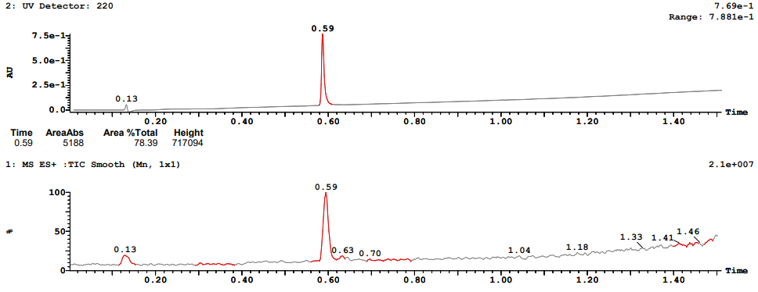
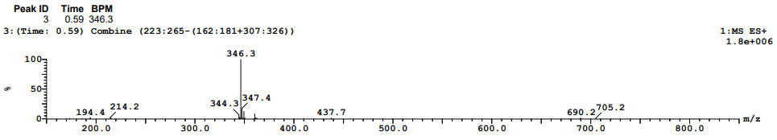

LCMS data for compound (–)-8
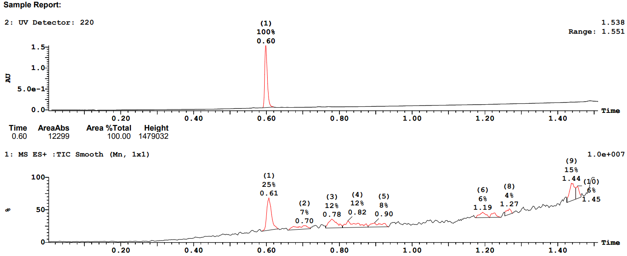
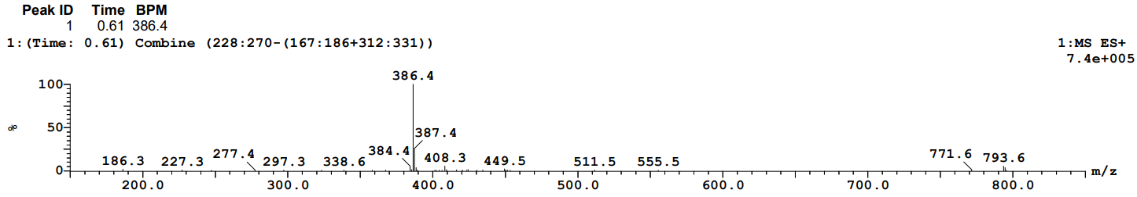

LCMS data for compound 9
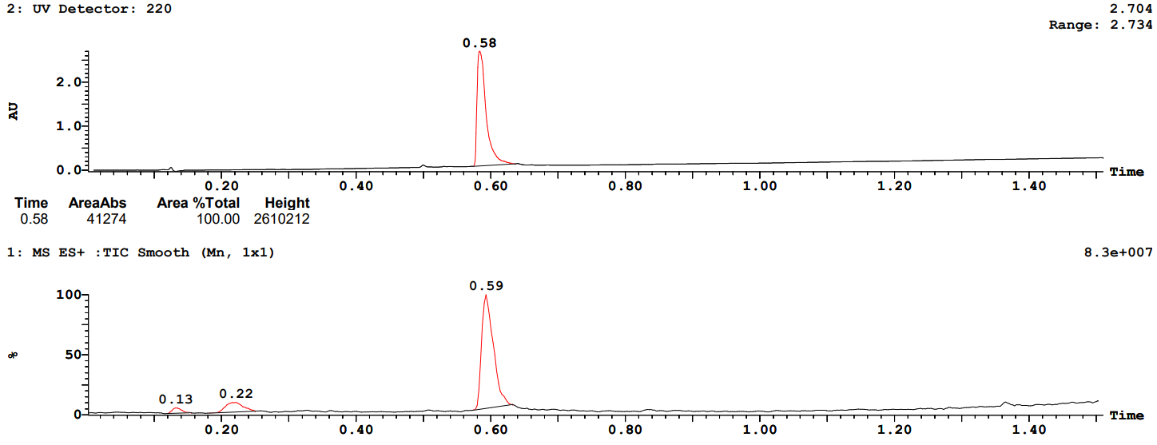
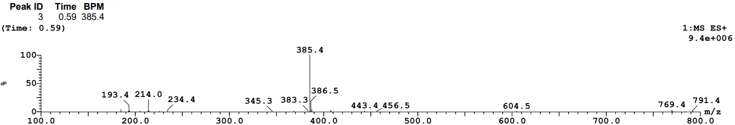

LCMS data for compound 10
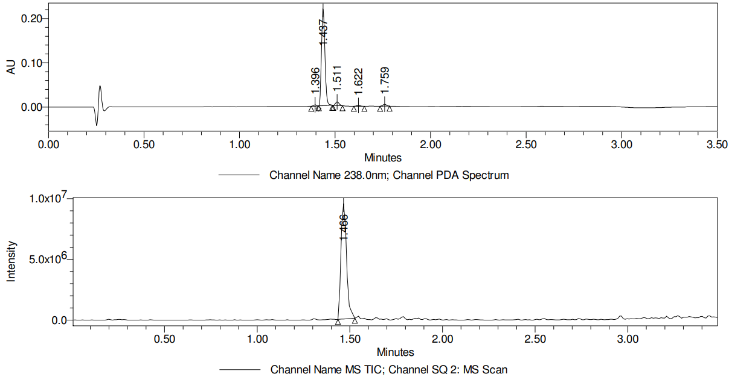
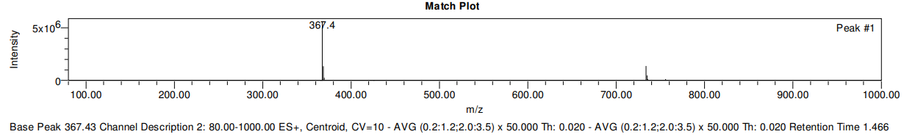

LCMS data for compound 11
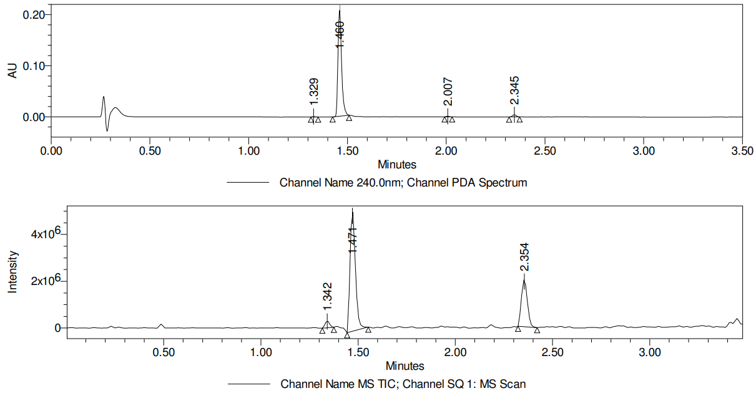
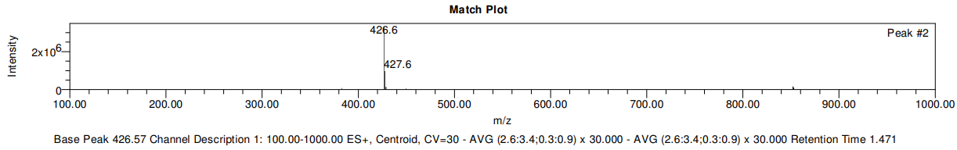

LCMS data for compound 12
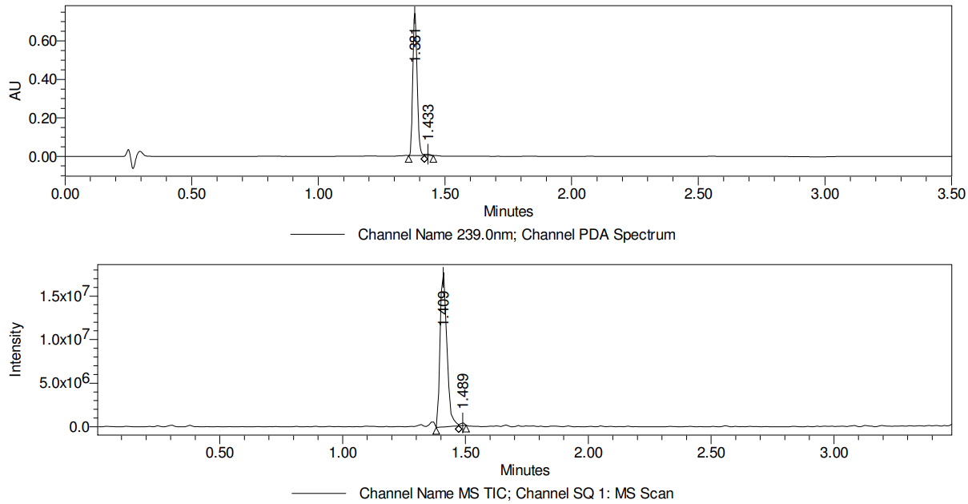
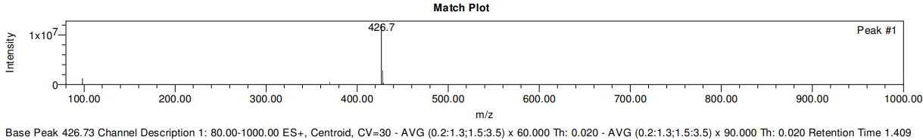

LCMS data for compound 13
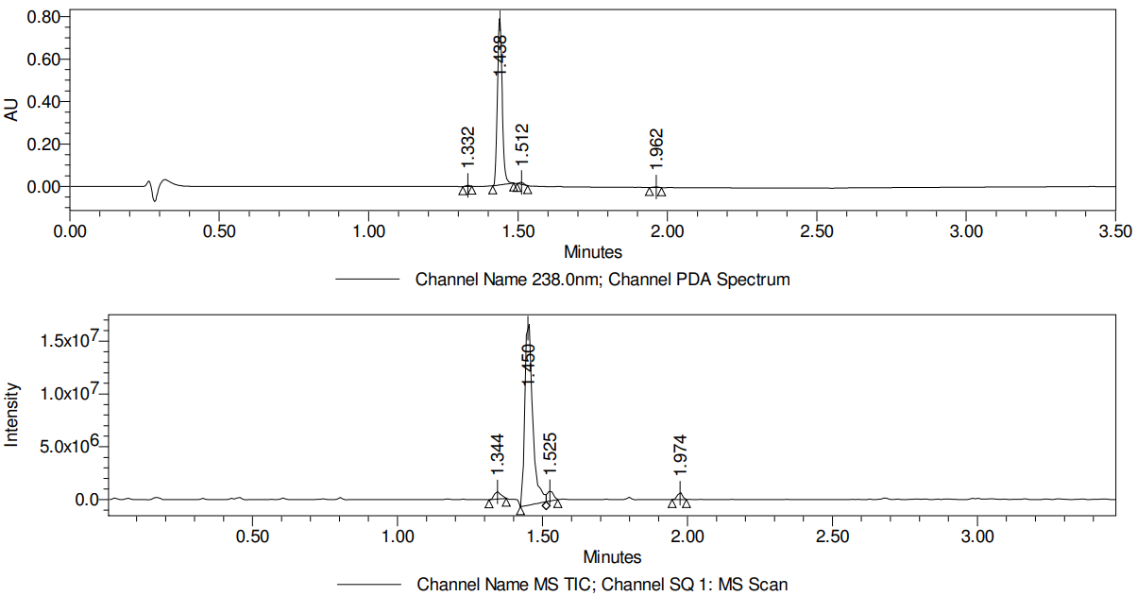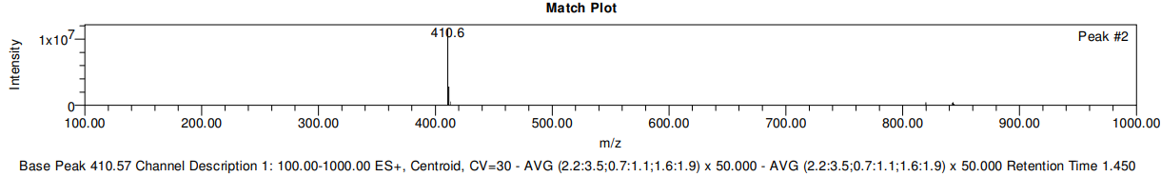

LCMS data for compound 14
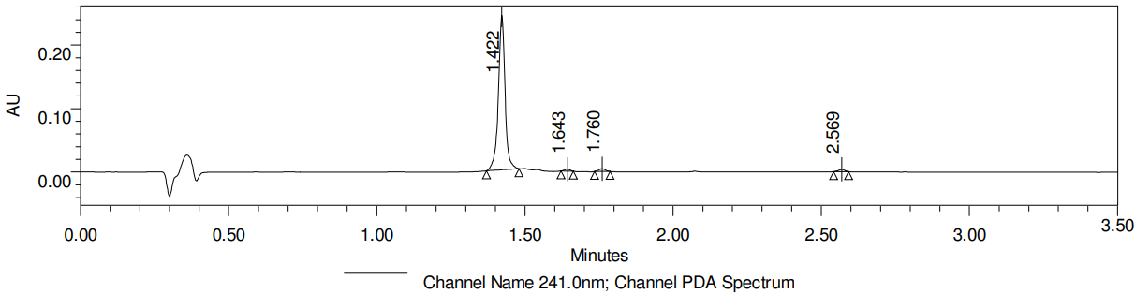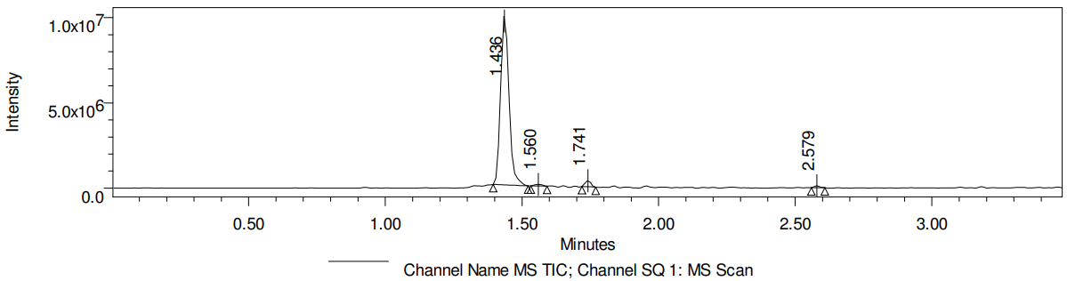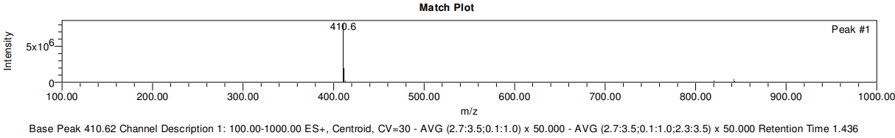

LCMS data for compound 15
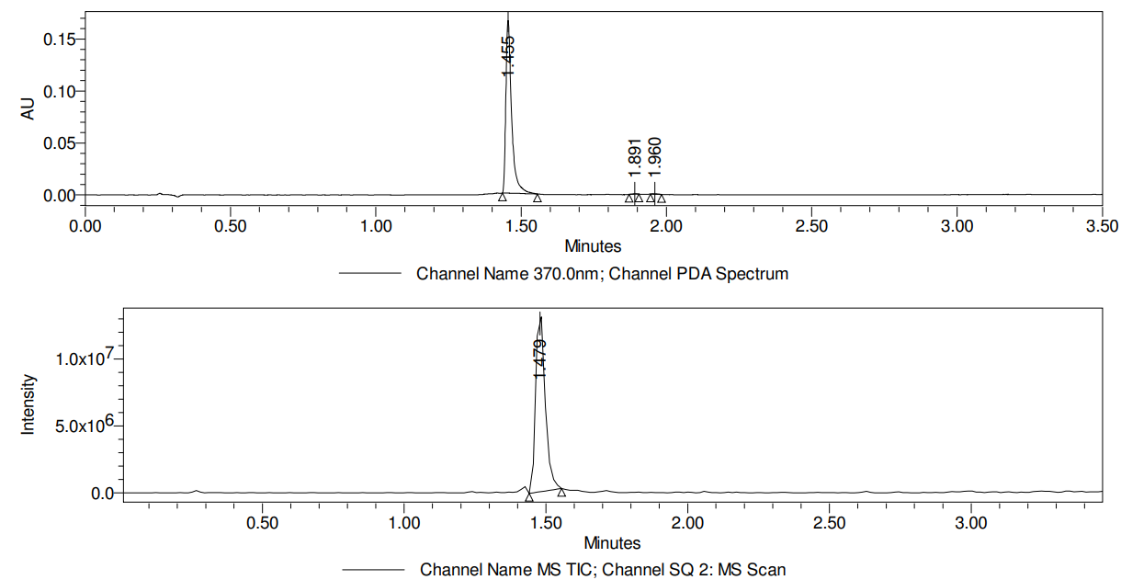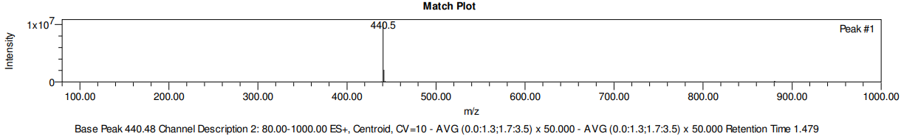

LCMS data for compound 16
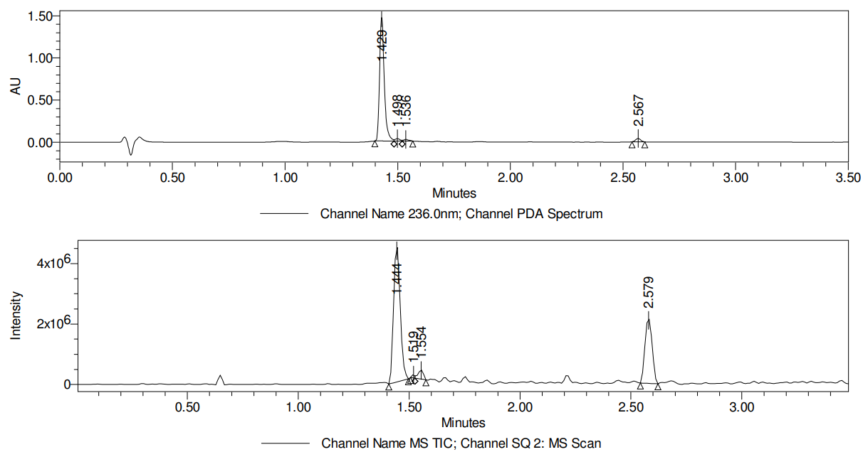
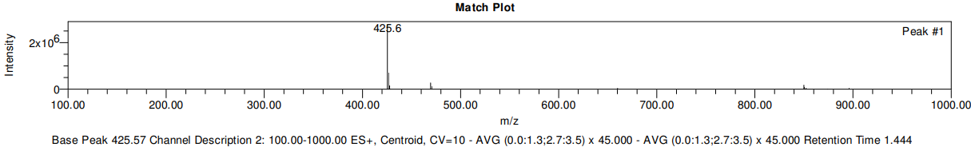

LCMS data for compound 17
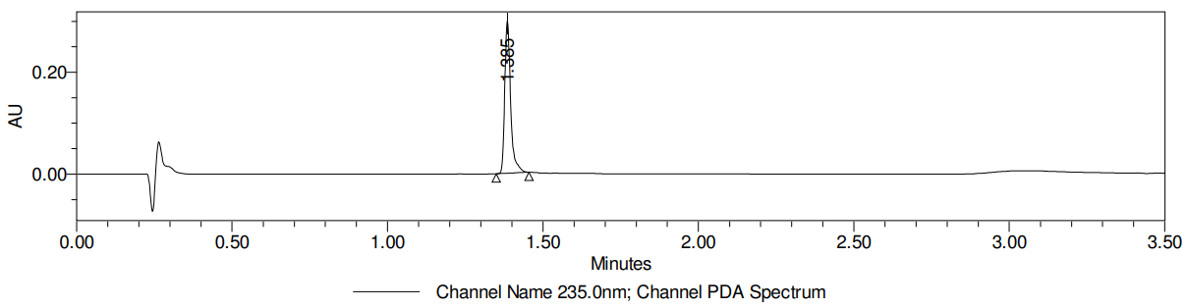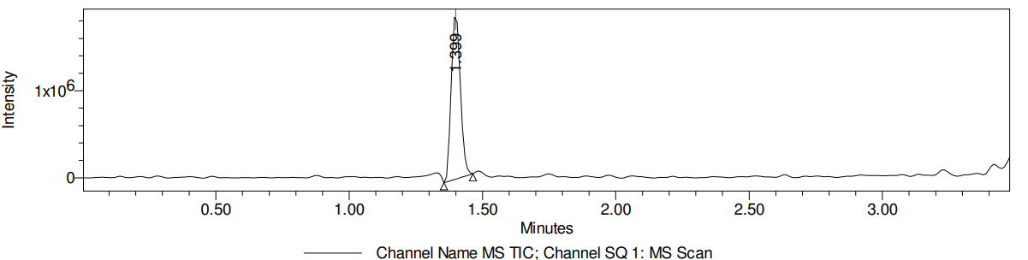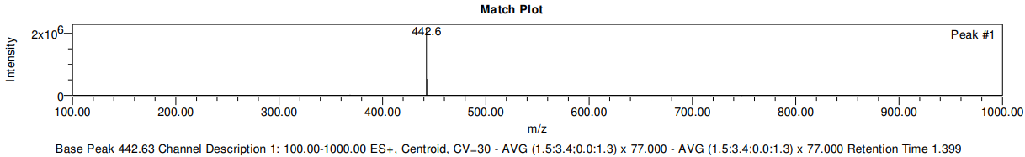

LCMS data for compound 18
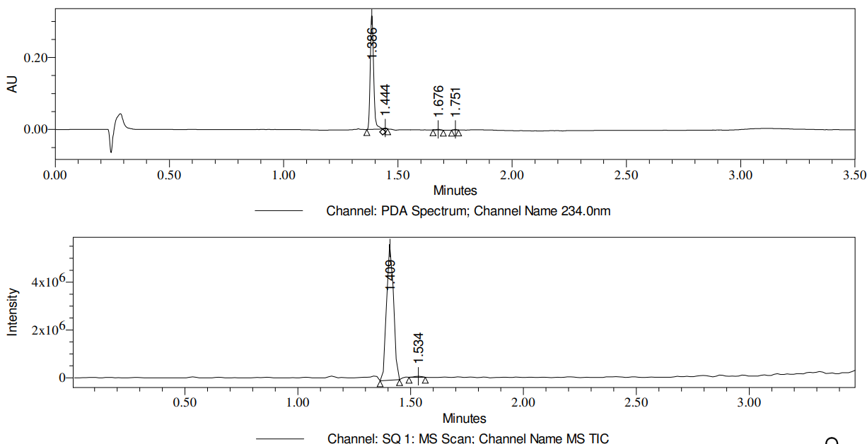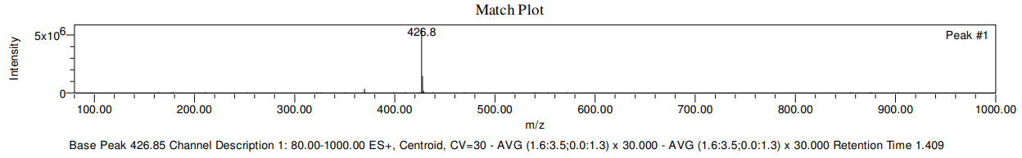

LCMS data for compound 19
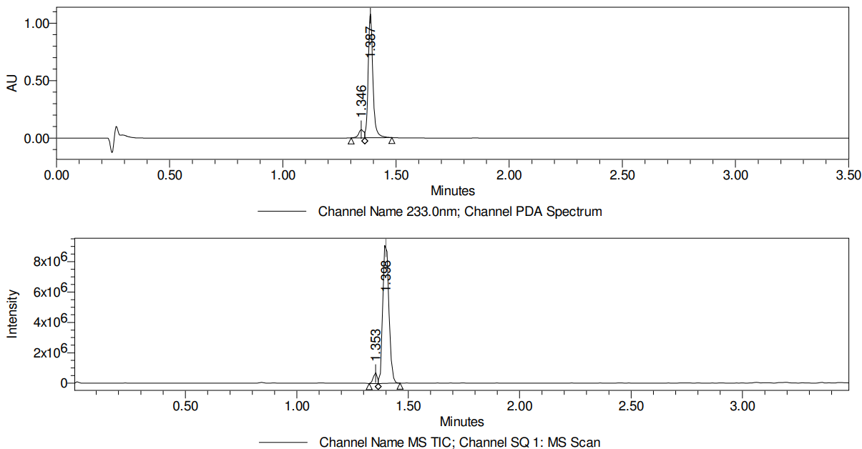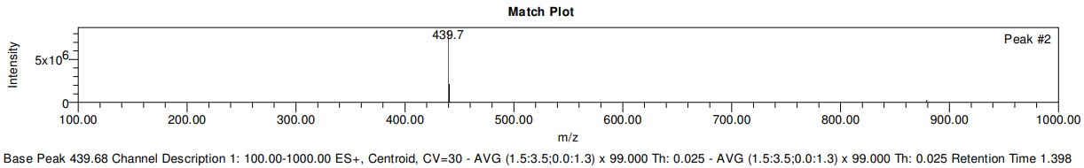

LCMS data for compound 20
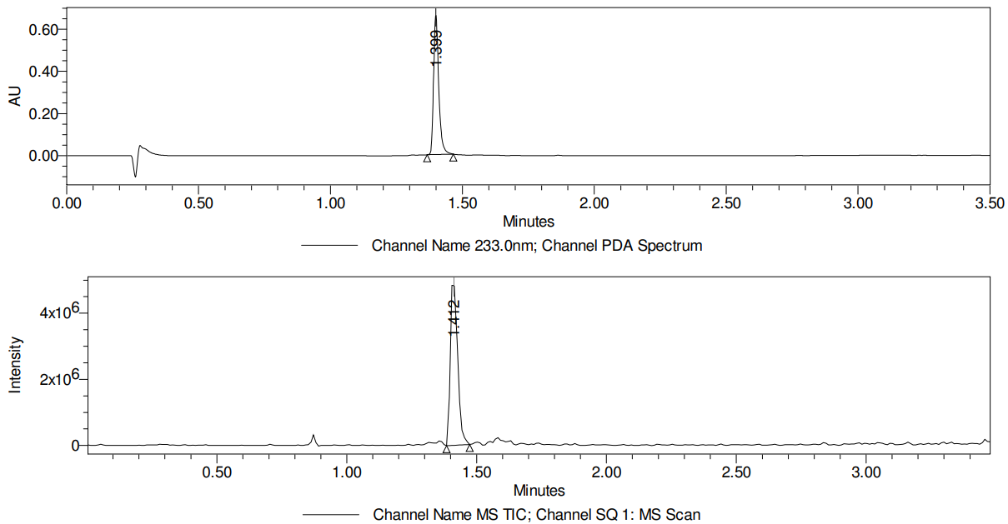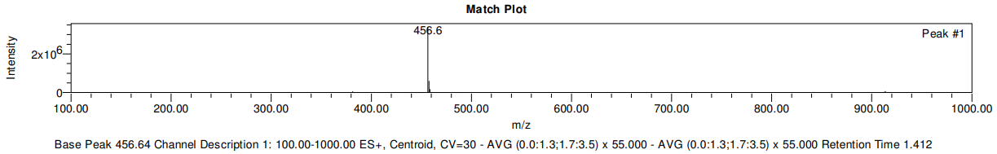

LCMS data for compound 21
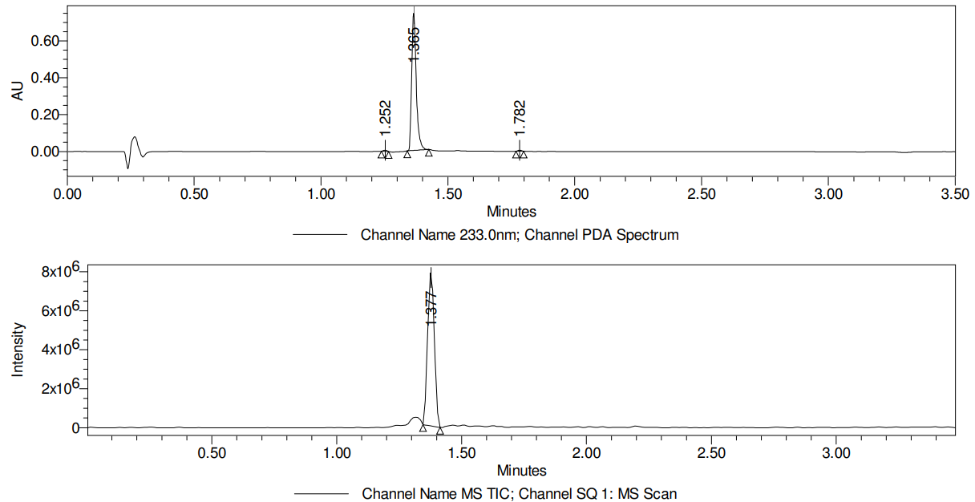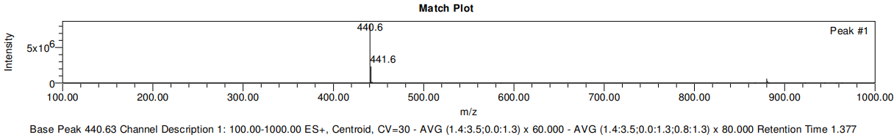

LCMS data for compound 22
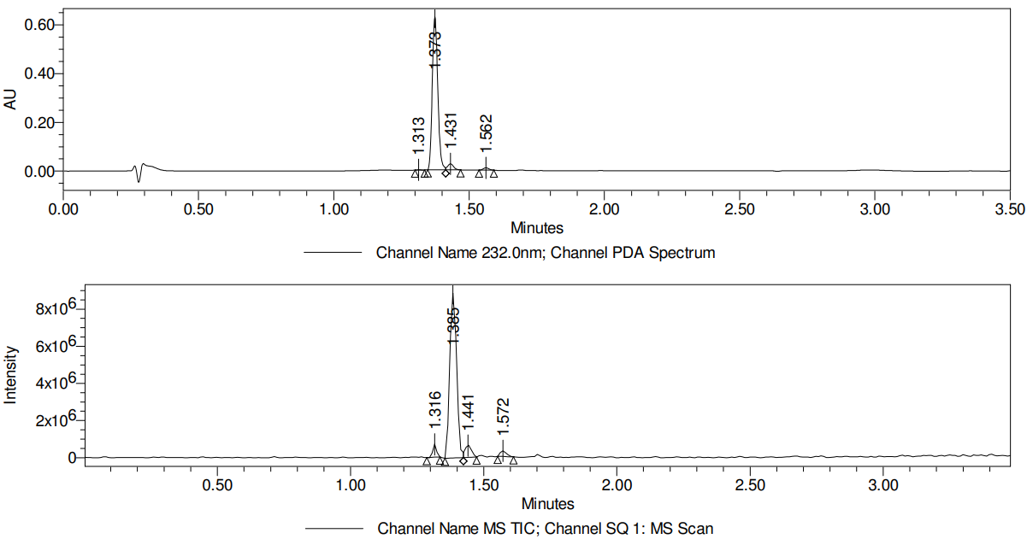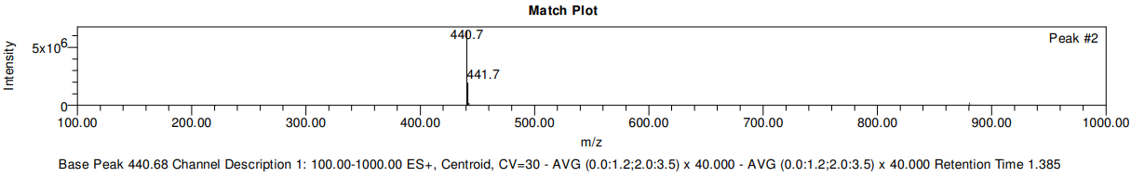

LCMS data for compound 23
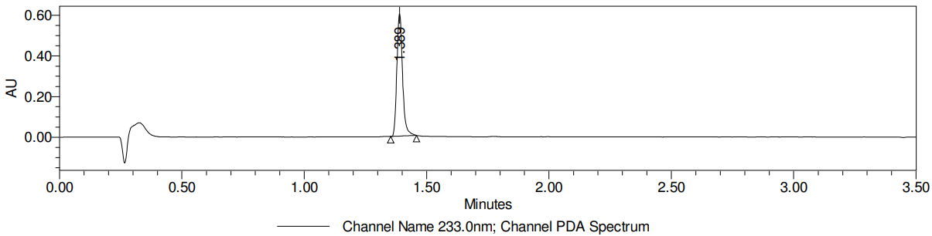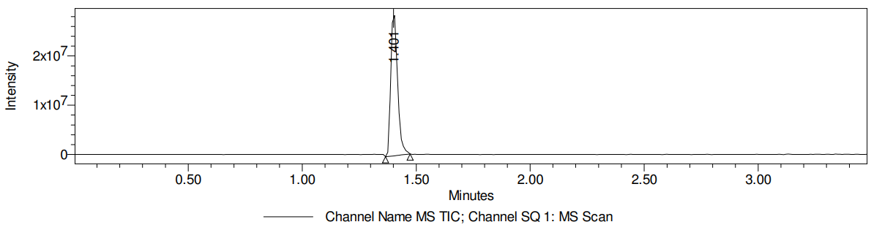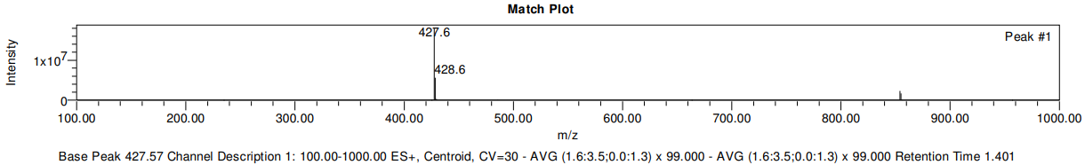

LCMS data for compound 24
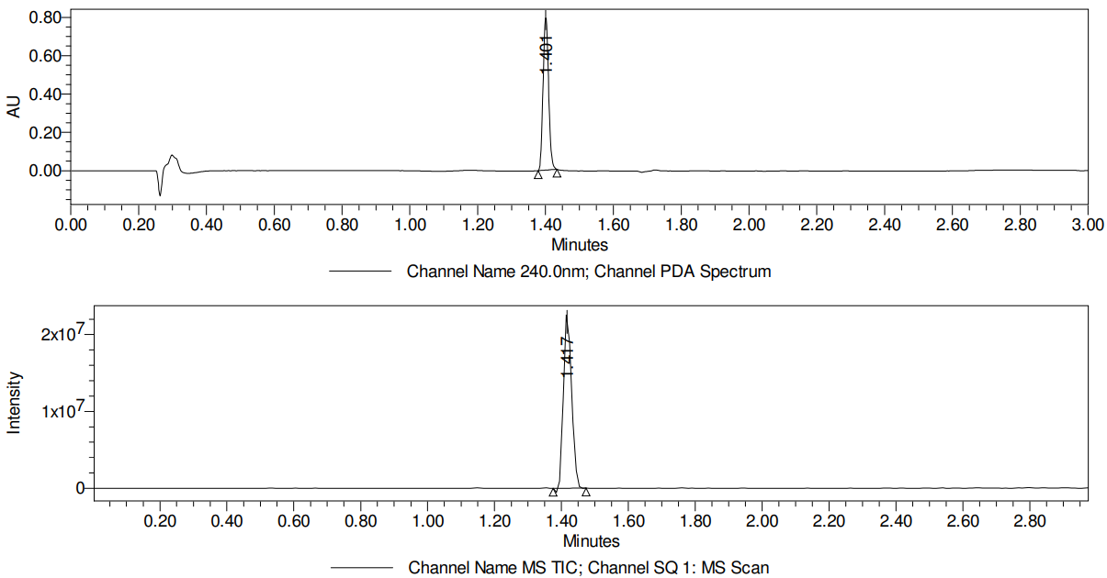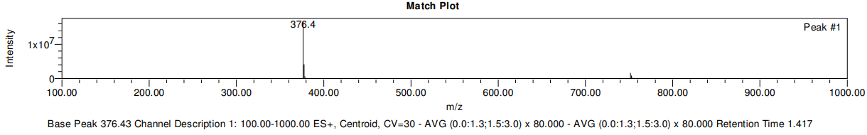

LCMS data for compound 25
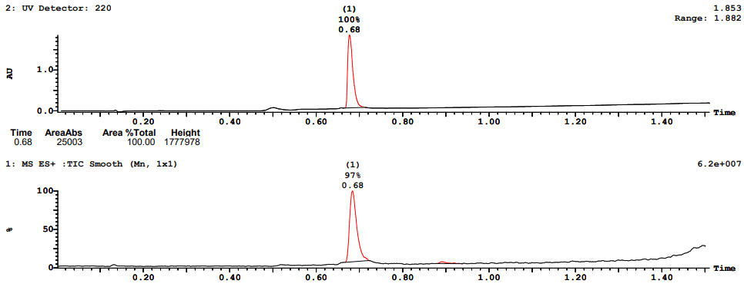
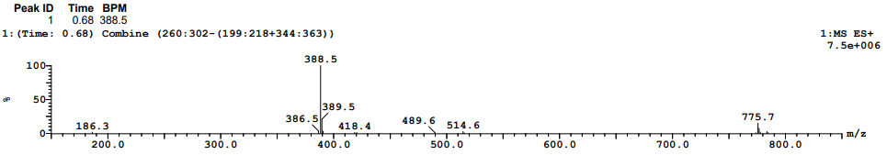

LCMS data for compound 26
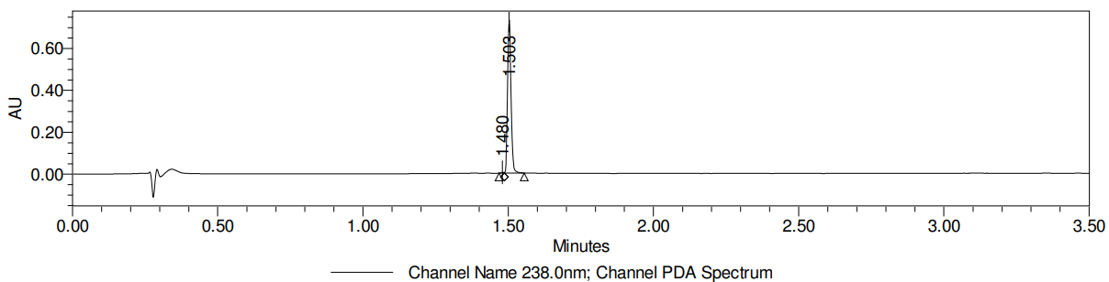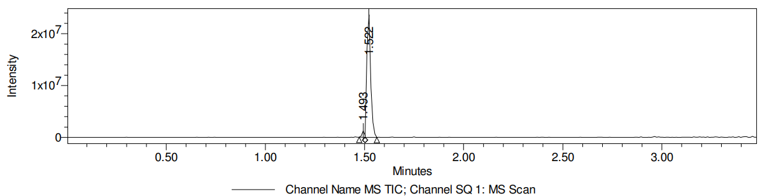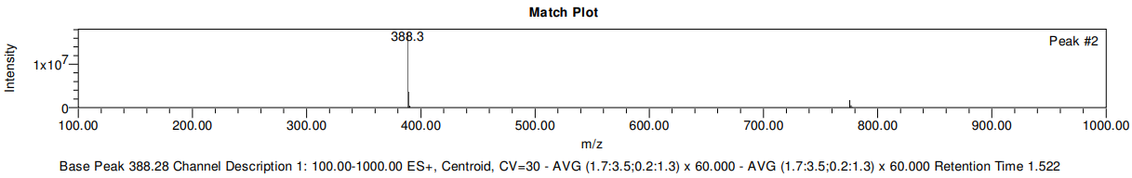

LCMS data for compound 27
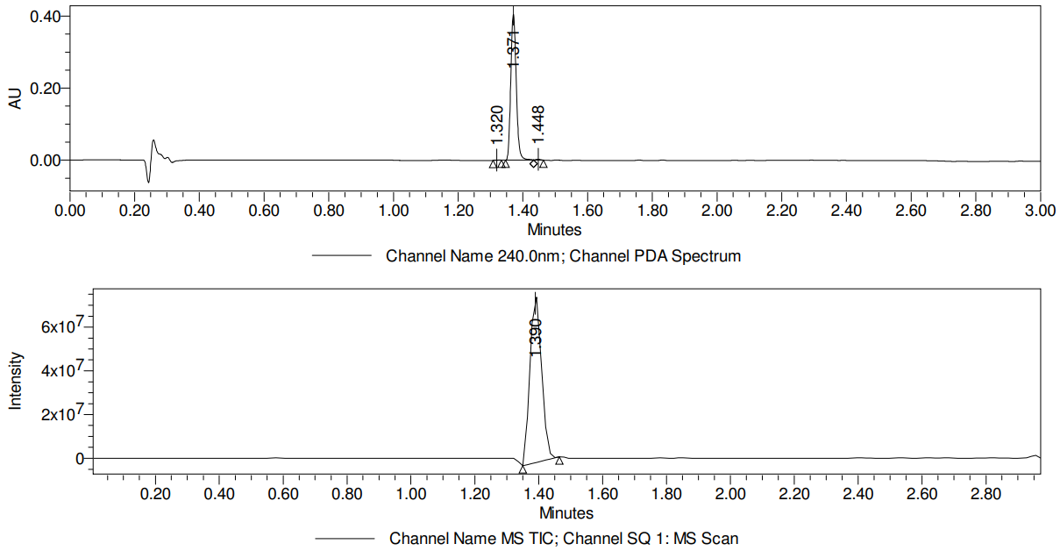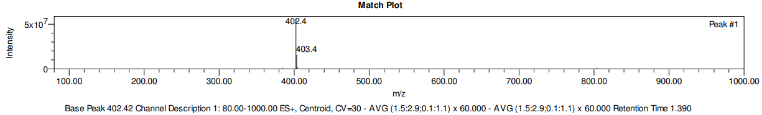

LCMS data for compound 28
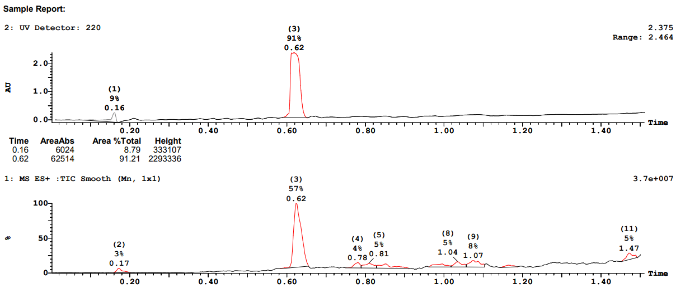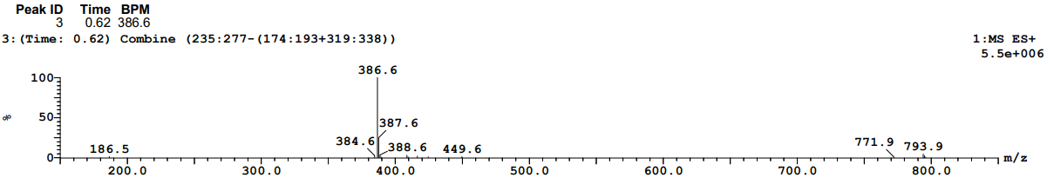

LCMS data for compound 29
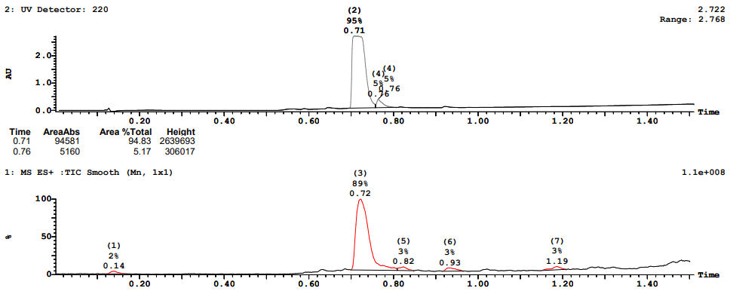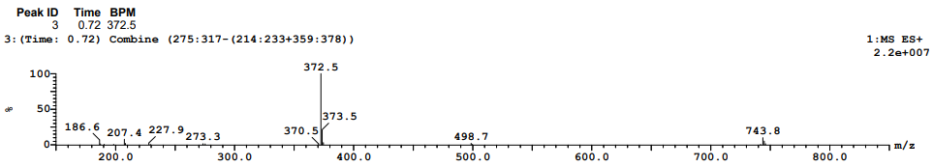

LCMS data for compound 30
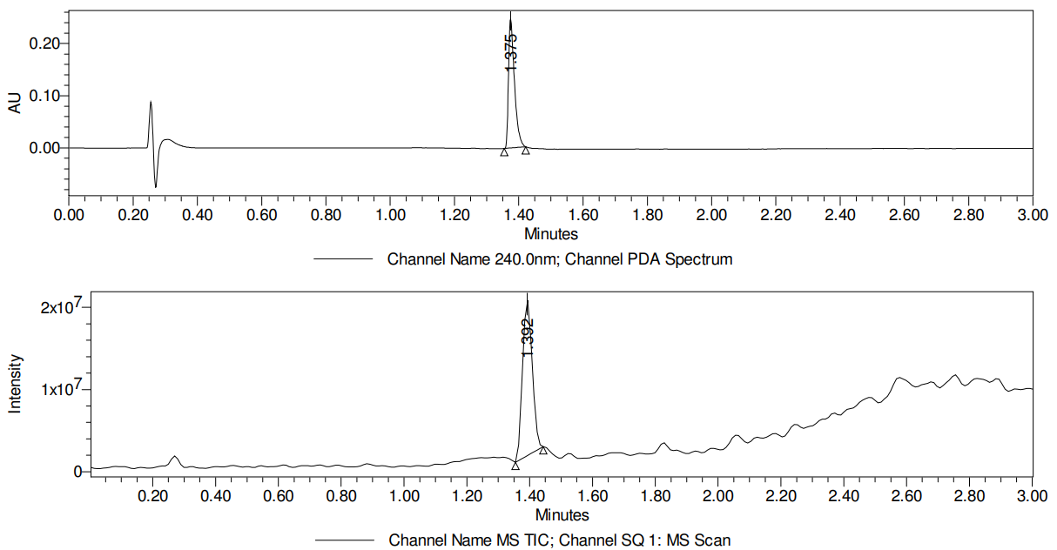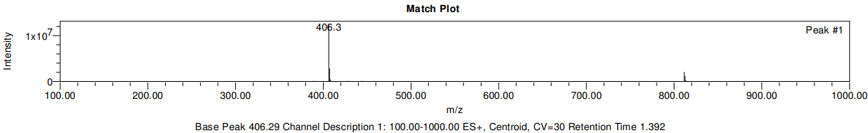

LCMS data for compound 31
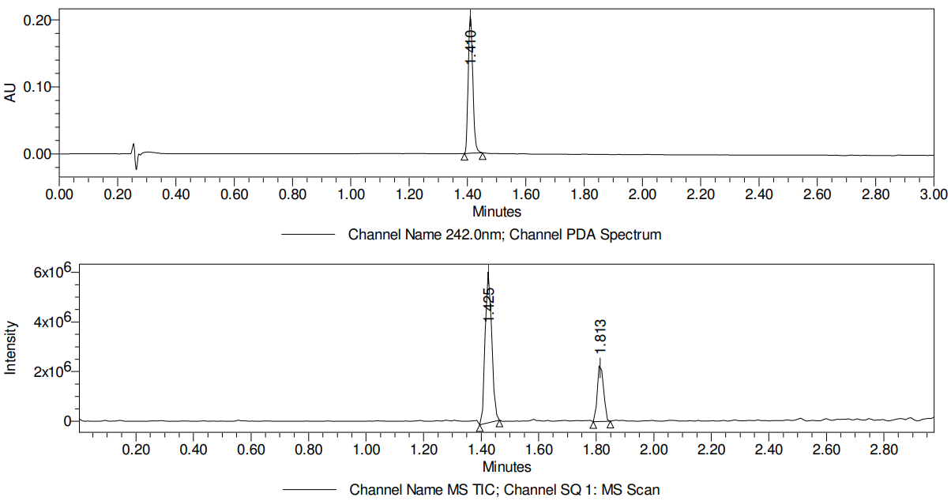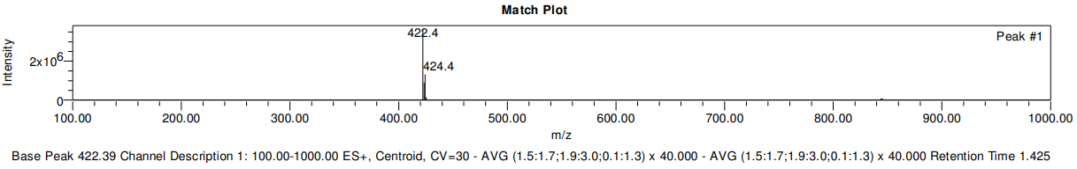

LCMS data for compound 32
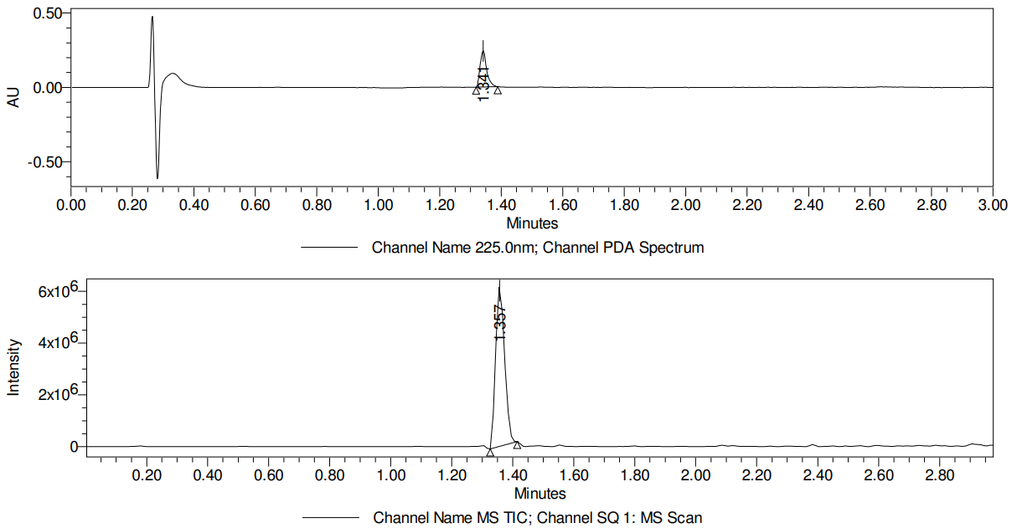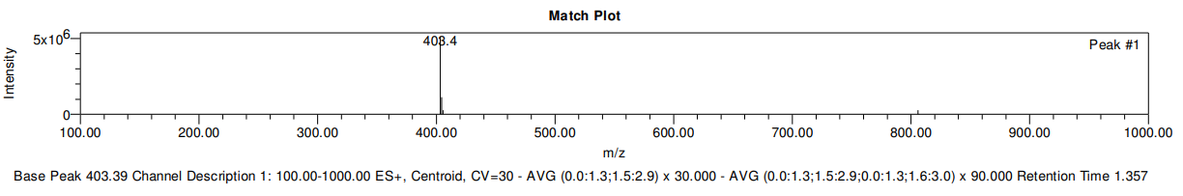

LCMS data for compound 33
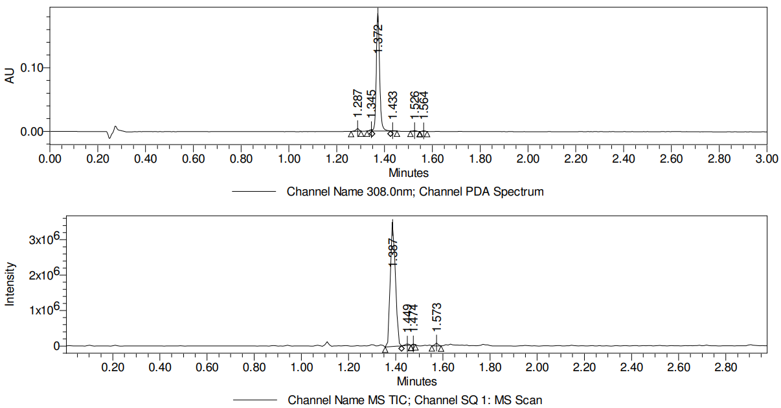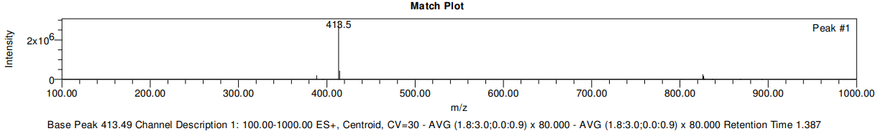

LCMS data for compound 34
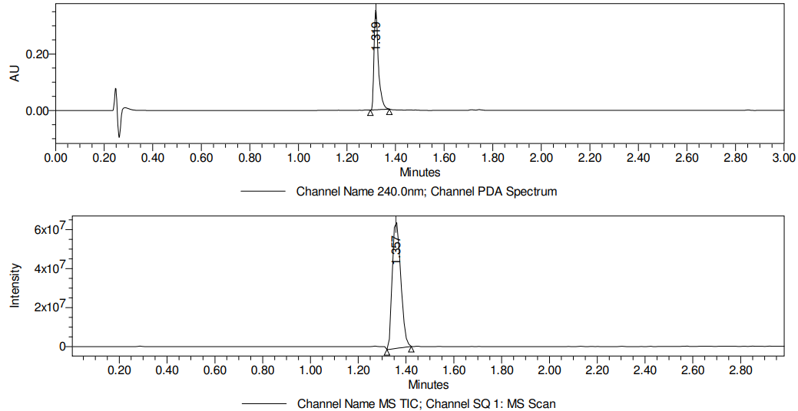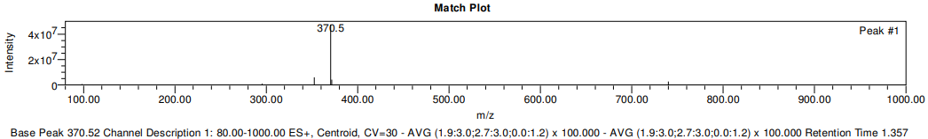

LCMS data for compound 35
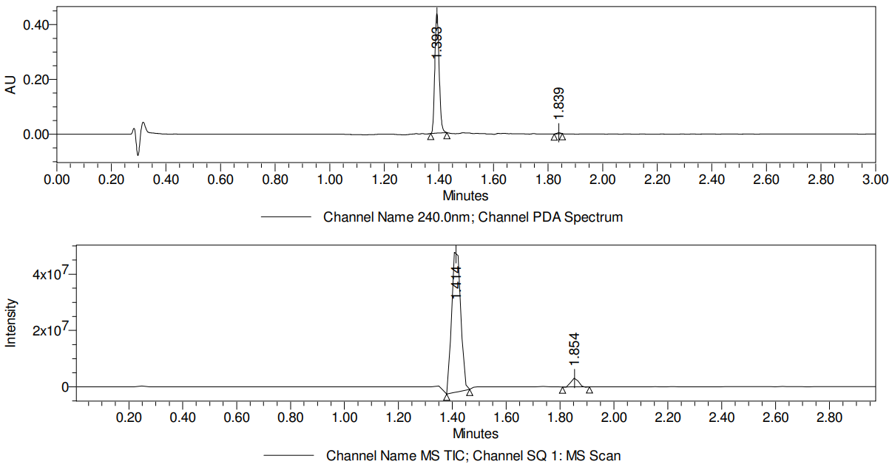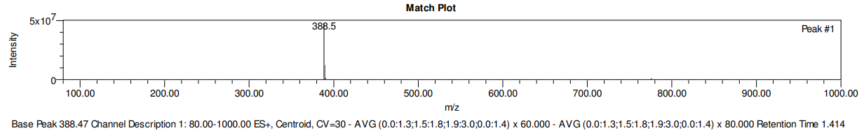

LCMS data for compound 36
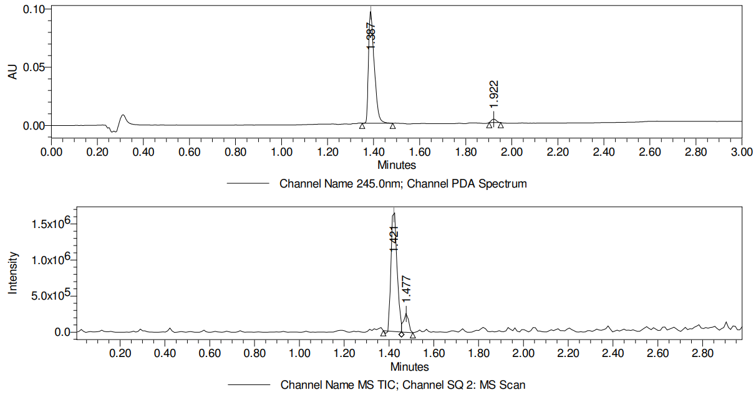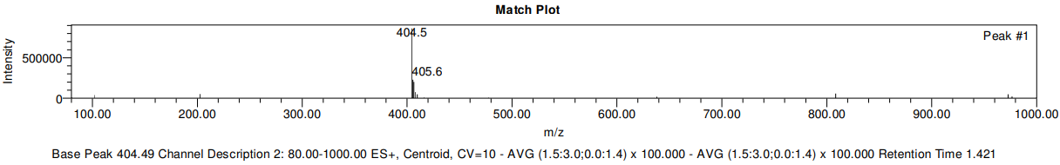

LCMS data for compound 37
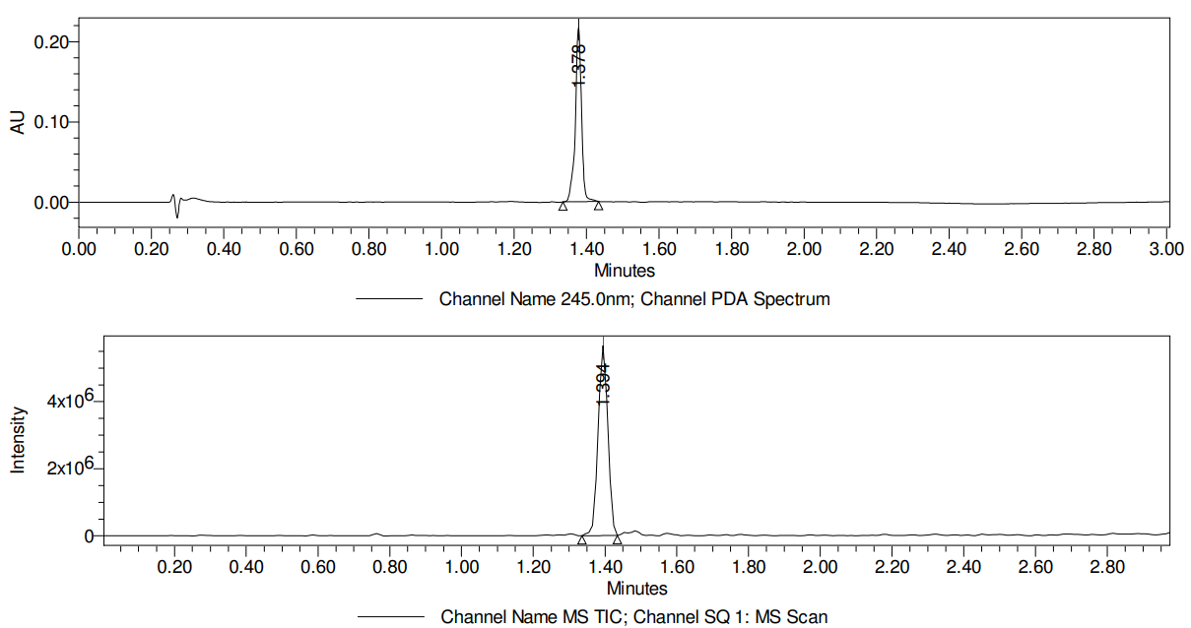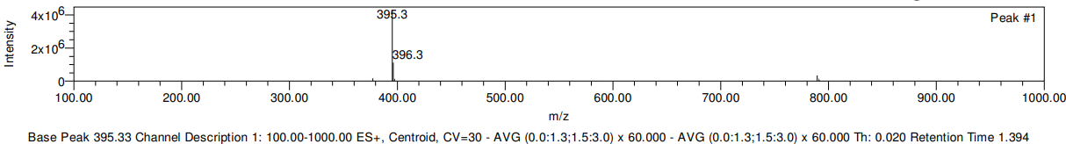

LCMS data for compound 38
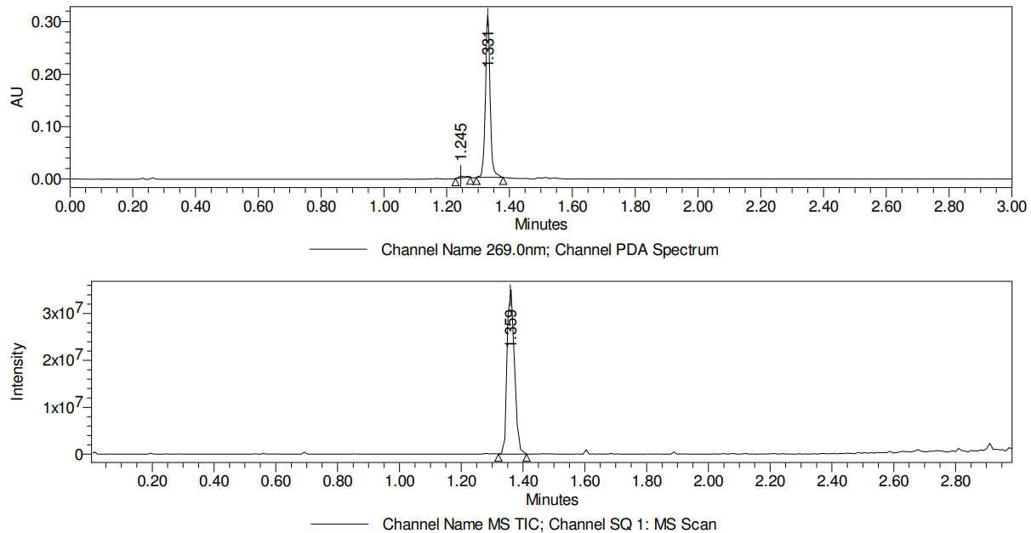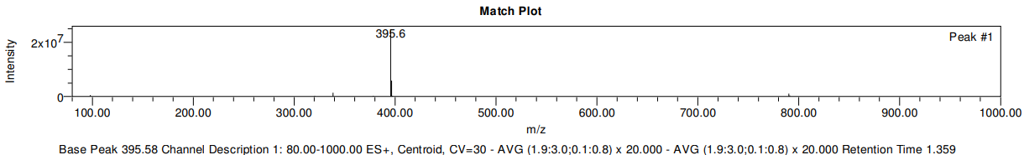

LCMS data for compound 39
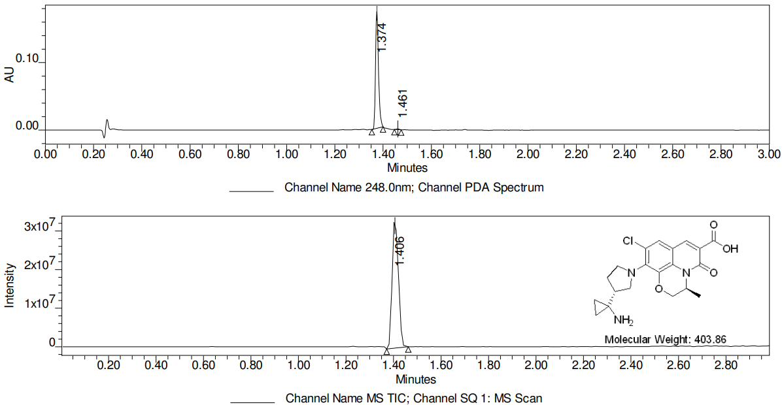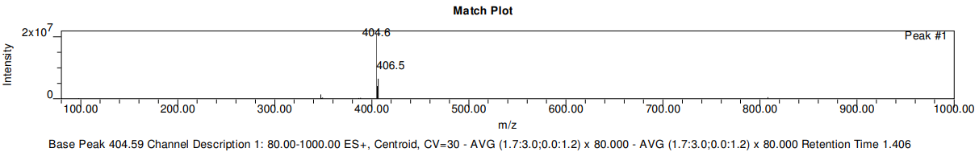

LCMS data for compound 40
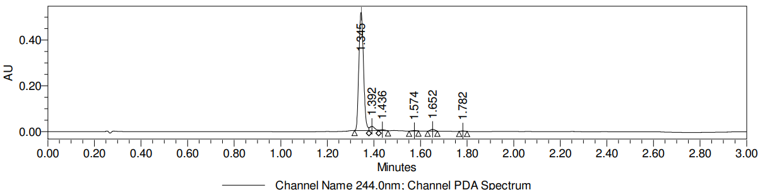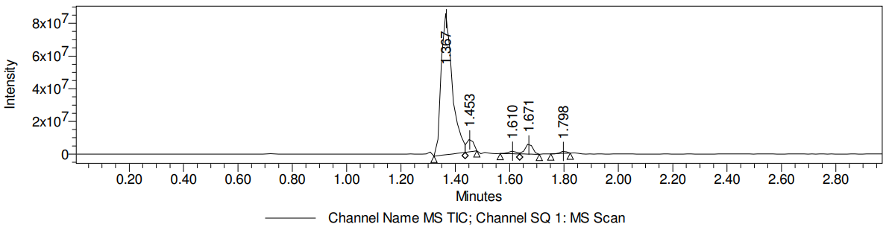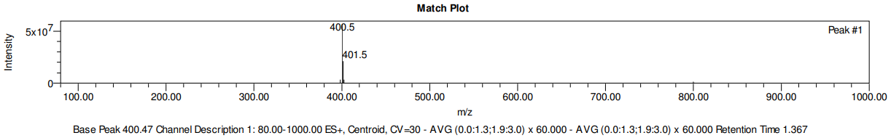

LCMS data for compound 41
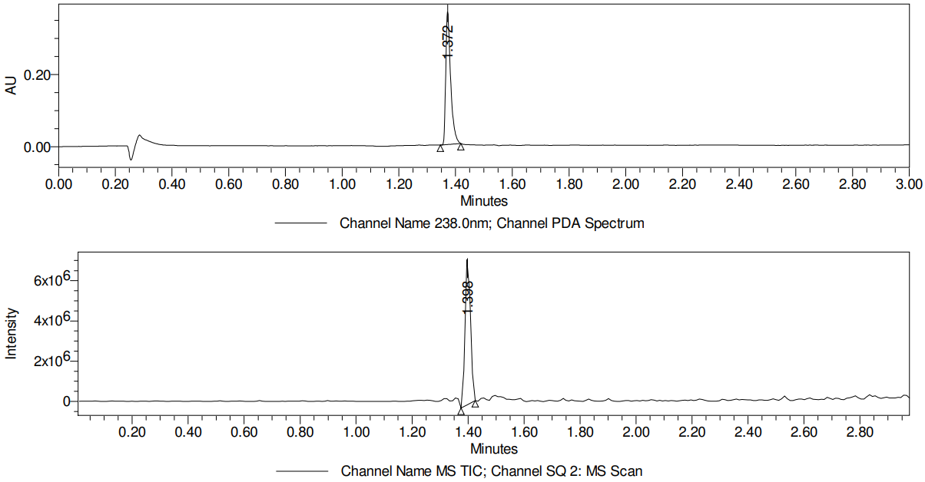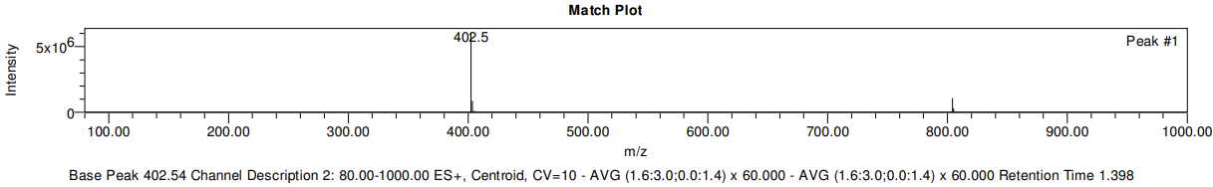

LCMS data for compound 42
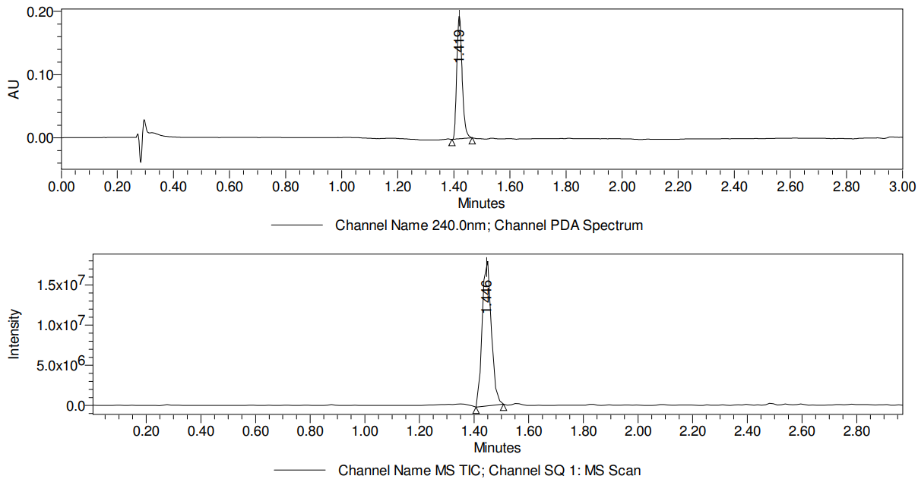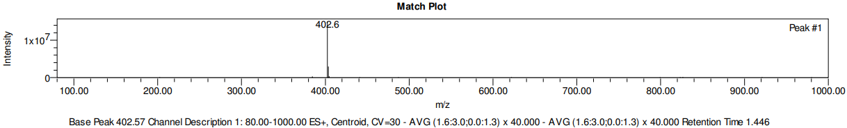

LCMS data for compound 43
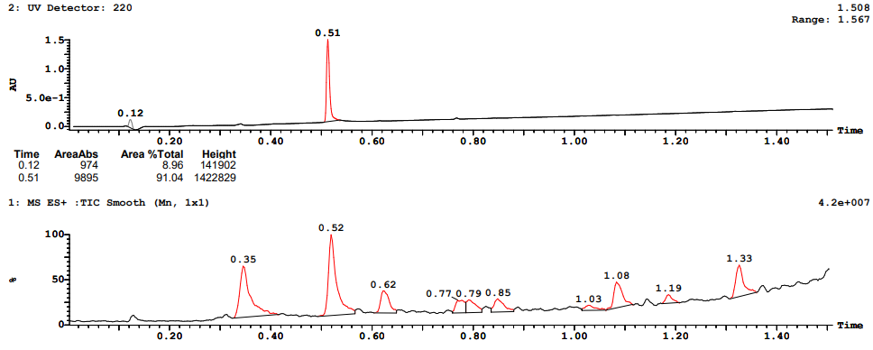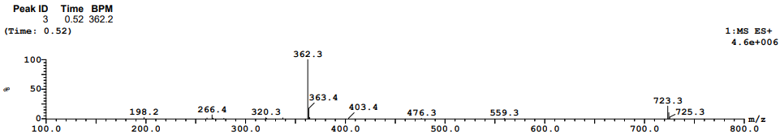

LCMS data for compound 44
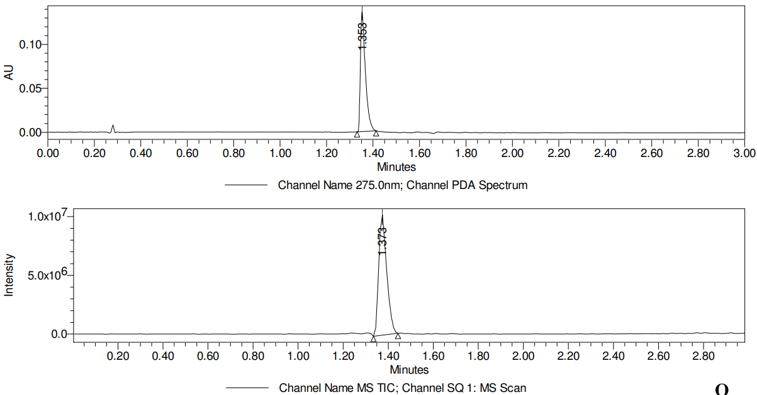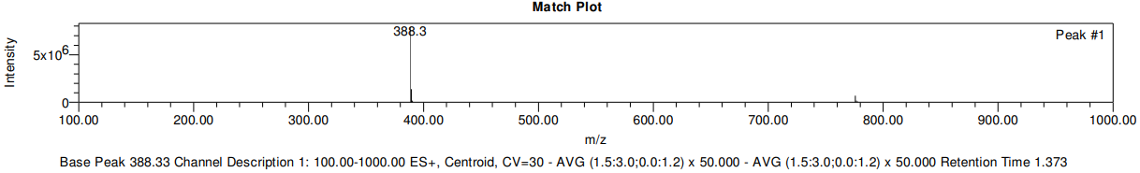

LCMS data for compound 45
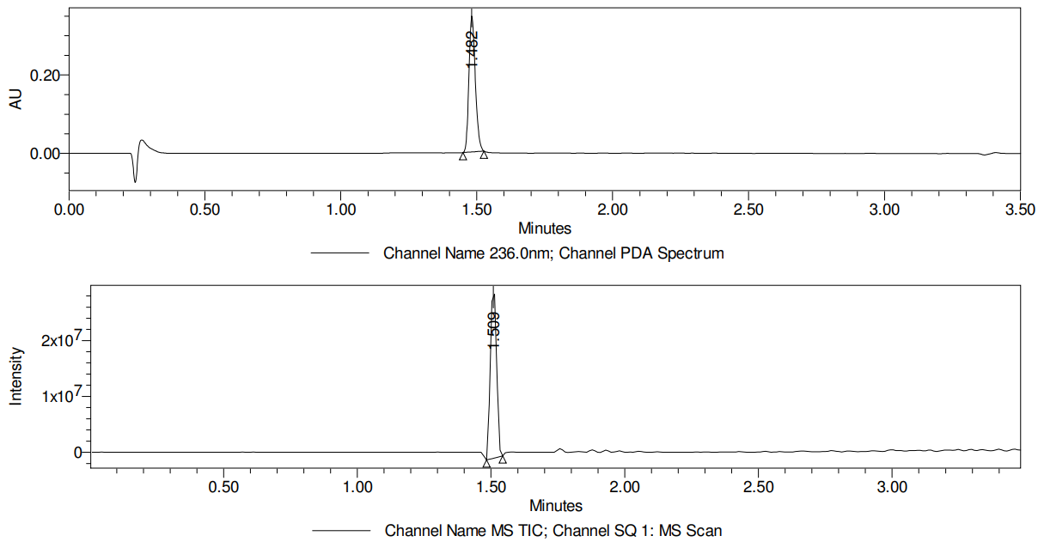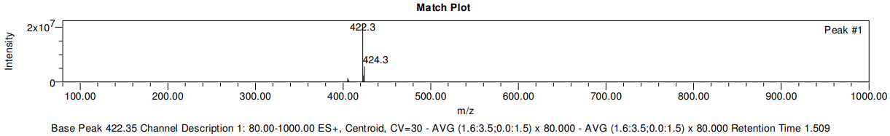

LCMS data for compound 46
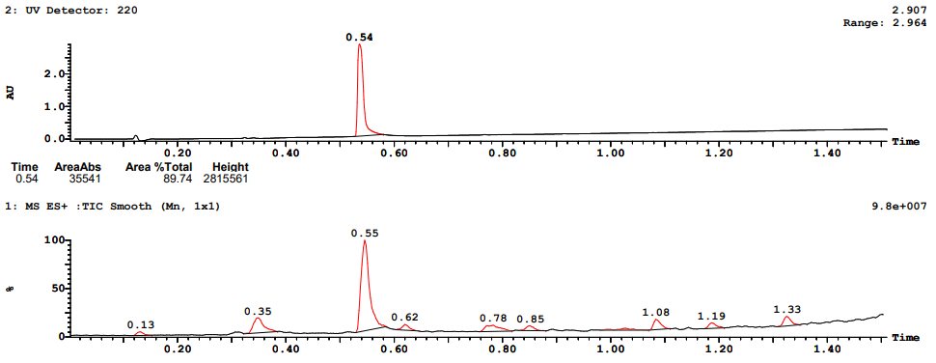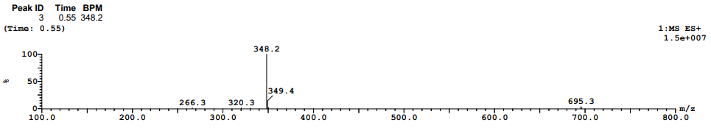

LCMS data for compound 47
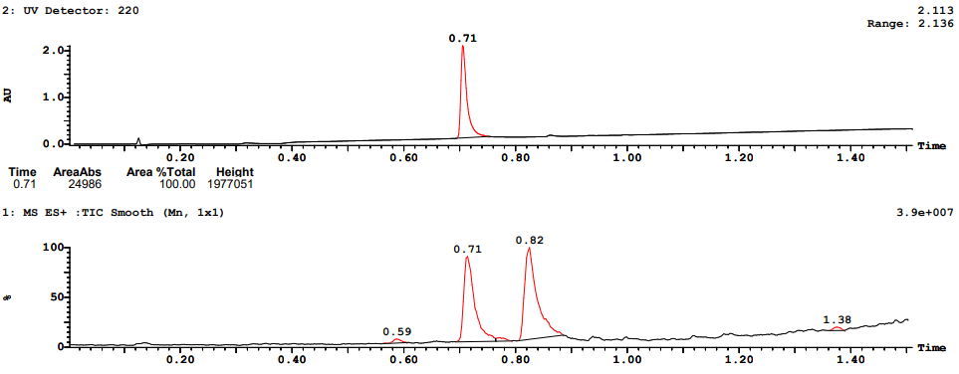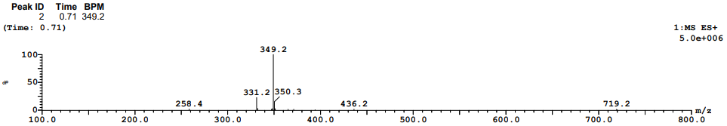

LCMS data for compound 48
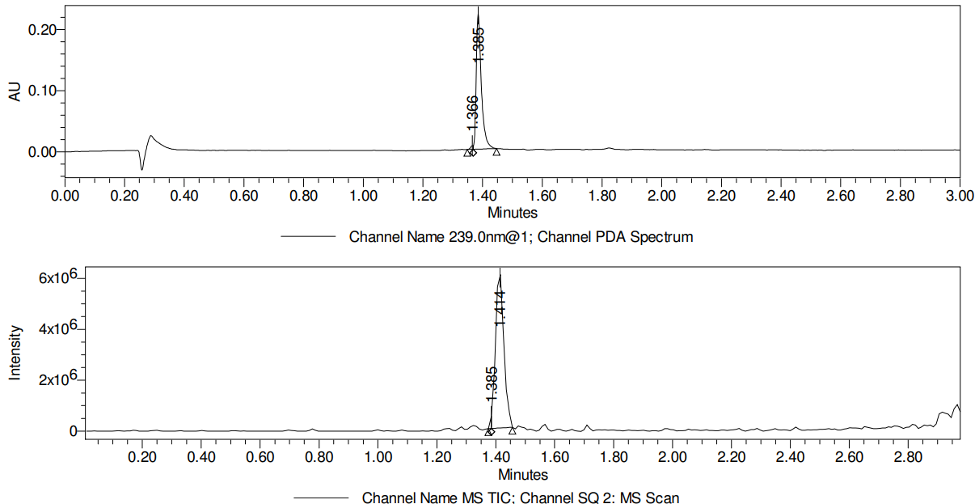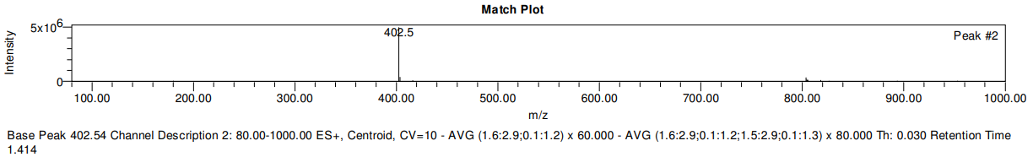

LCMS data for compound 49
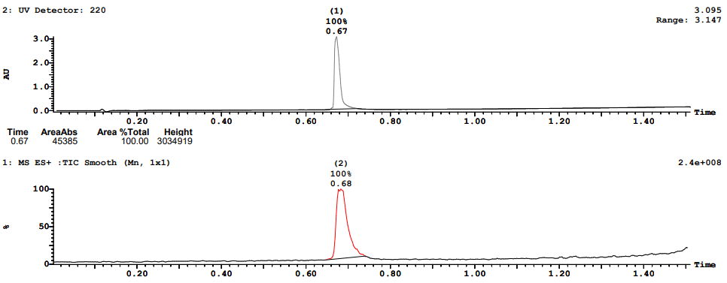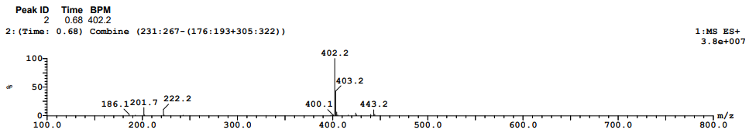

LCMS data for compound 50
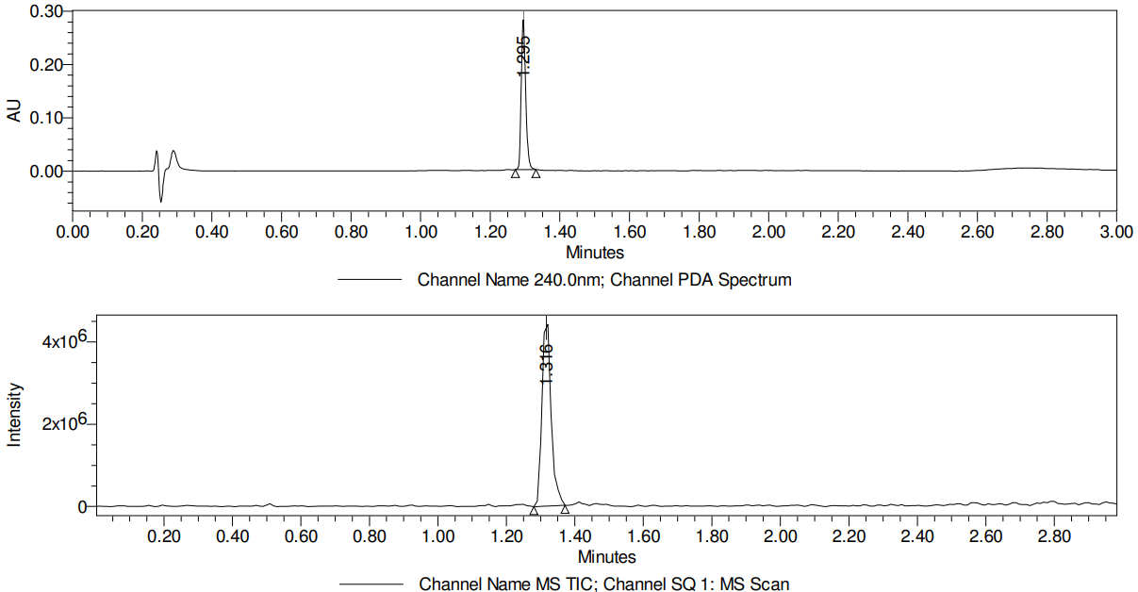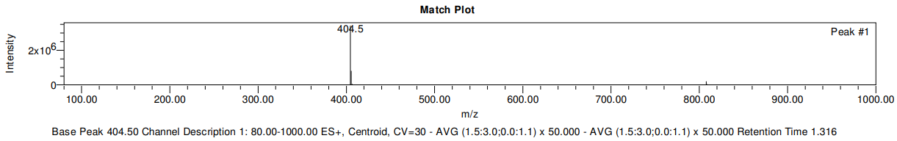

LCMS data for compound 51
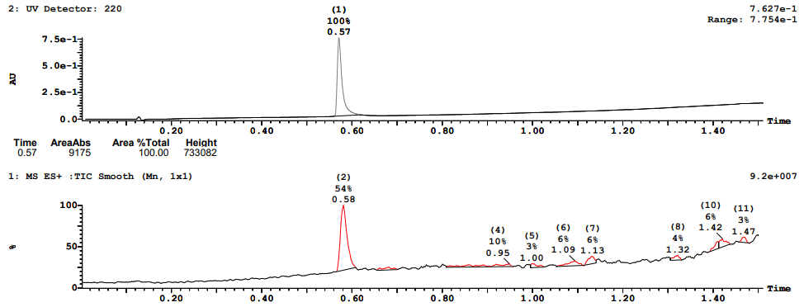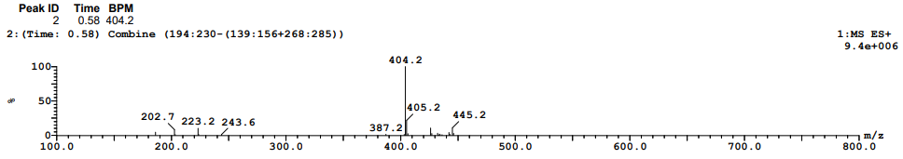

LCMS data for compound 52
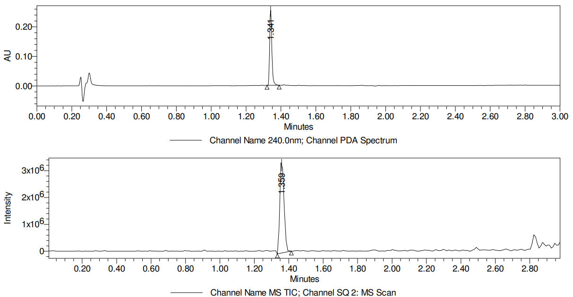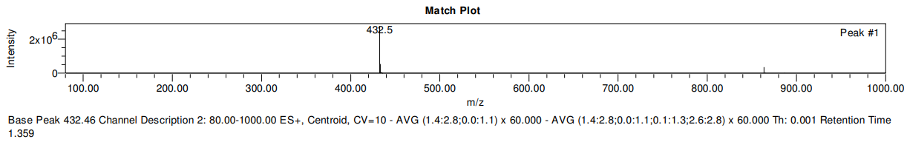

LCMS data for compound 53
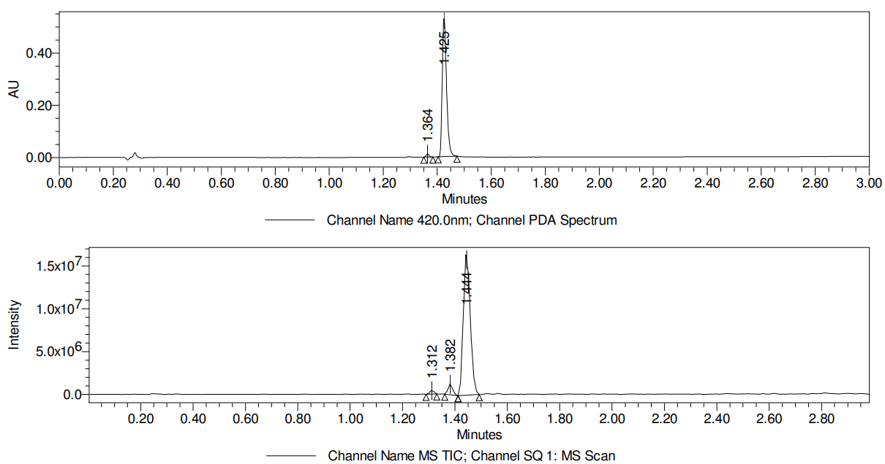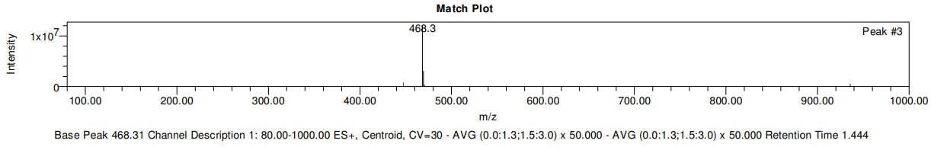

LCMS data for compound 54
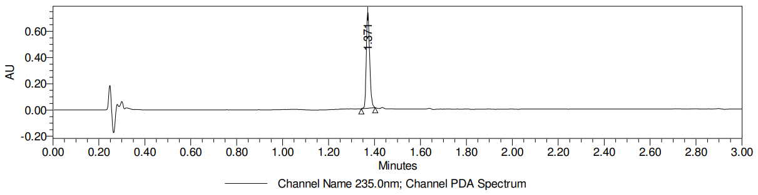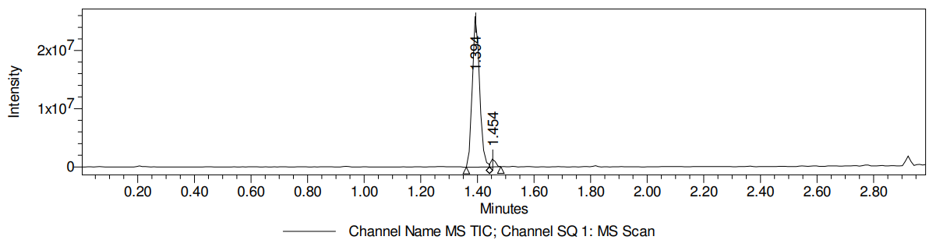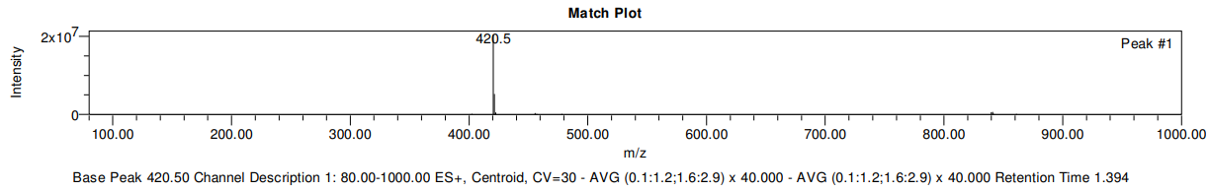

LCMS data for compound 55
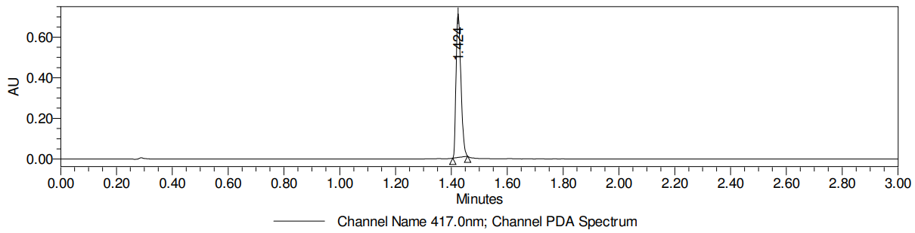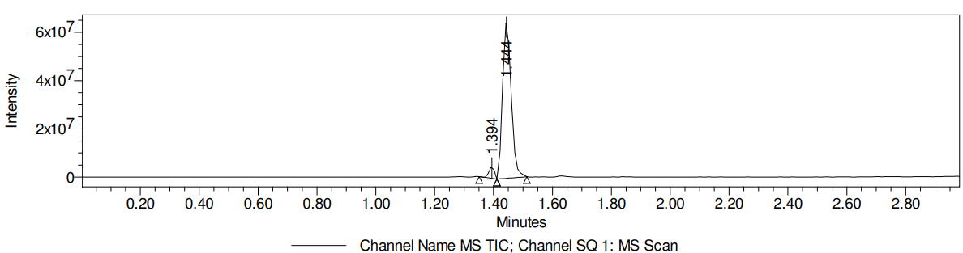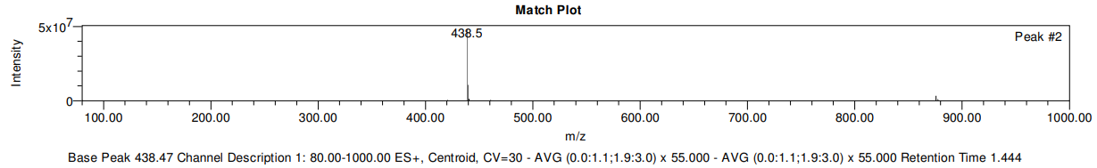

LCMS data for compound 56
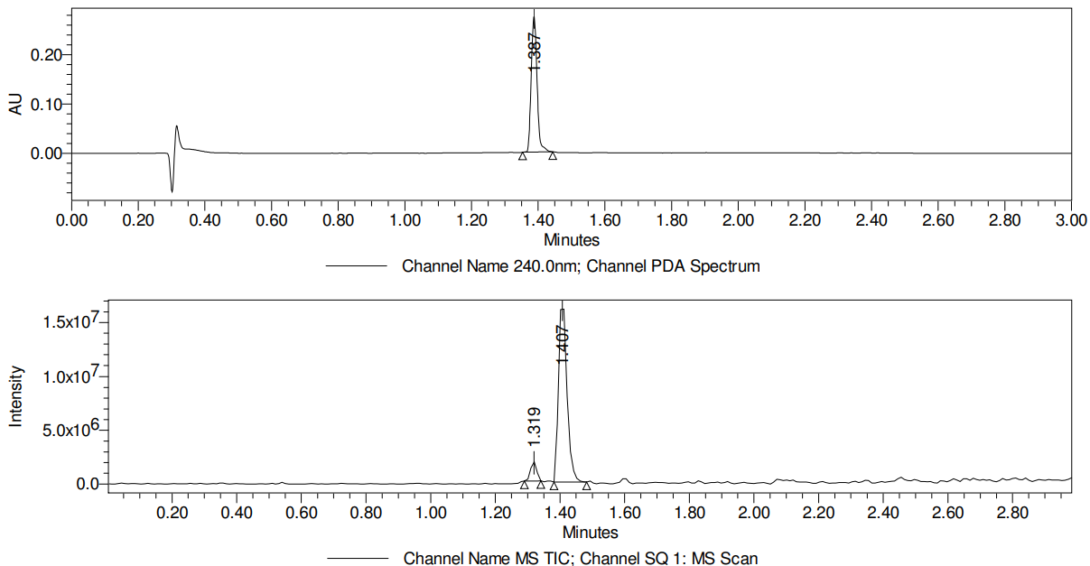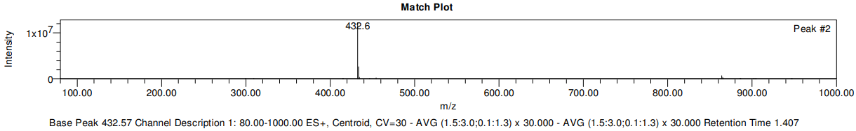

LCMS data for compound 57
