Use of a 3D hand-held scanner to capture trochlear groove shape, a proof of concept study
J Mistry, S Harris, CB Hing

Introduction
Trochleoplasty is a surgical procedure used to treat patellar instability in patients with severe trochlear dysplasia. Trochlear dysplasia is defined as an abnormality of the depth and shape of the trochlear groove which is modified during trochleoplasty. The aim of this study was to establish whether we could use a 3D hand-held scanner to accurately measure trochlear depth, sulcus angle, trochlear facet ratio, trochlear angle and lateral trochlear inclination angle and establish inter- and intra-rater reliability for each knee model. Analysis of the groove with a hand-held scanner would enable accurate real time planning and facilitate tailor made correction.
Methods
The trochlear groove of the knee models were scanned by two investigators and 3D reference models created. The trochlear groove scans and reference models were surface matched and custom software was written to analyse the trochlear groove surface. This trochlear analyser generated Excel CSV files which were utilised to determine the desired trochlear groove parameters. Intraclass correlation coefficient (ICC) was used for test-retest reliability and to determine which trochlear groove parameter results, for each knee model, showed the best reproducibility.
Results
The differences seen between most trochlear groove parameters measured by the two investigators were small demonstrating good inter-observer reliability - trochlear depth (1.0 mm), sulcus angle (2.7°), trochlear angle (4.0°) and lateral trochlear inclination angle (4.0°), apart from trochlear facet ratio (32.0%) of one knee model. With outliers removed ICC was moderate-excellent in (73.34%) of measurements, with trochlear depth showing the best reproducibility.
Conclusion
This feasibility study showed that the hand-held scanner in conjunction with the supporting software can measure trochlear parameters in a carefully controlled environment and justifies extending research into its use in trochleoplasty.

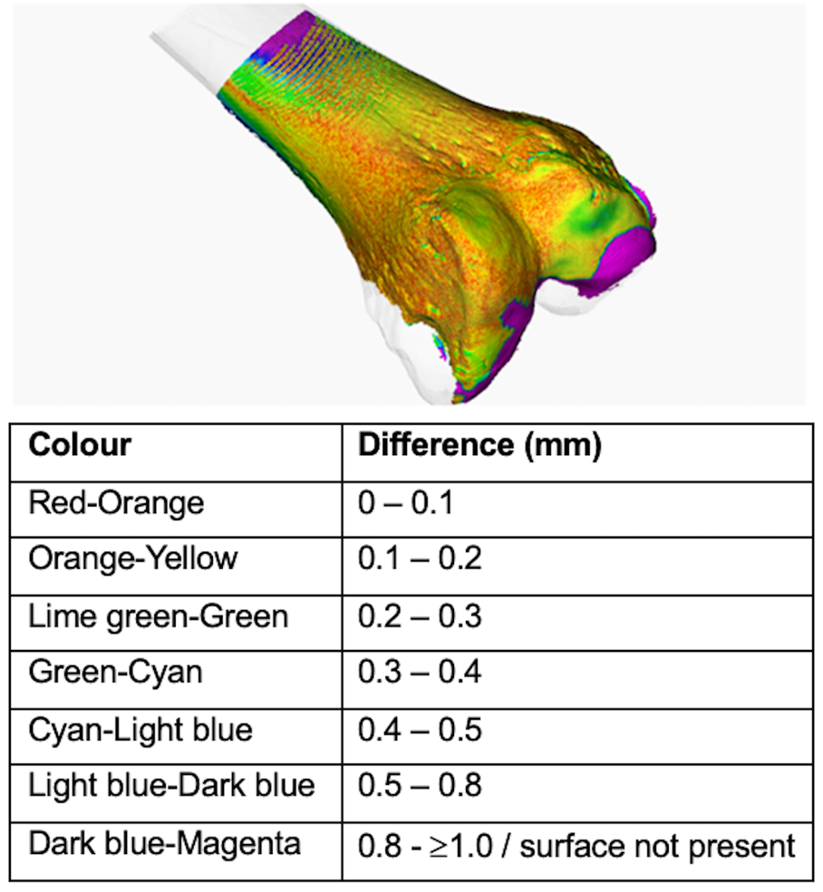

Figure 1: Colour coded difference in the surface of the reference model and trochlear groove scan

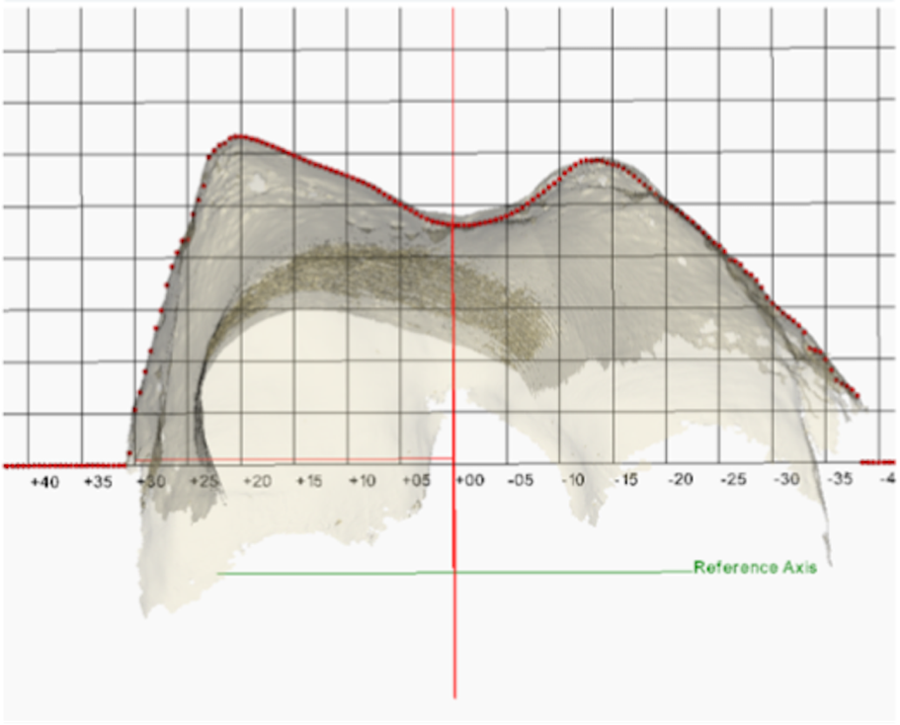

Figure 2: The trochlear contour

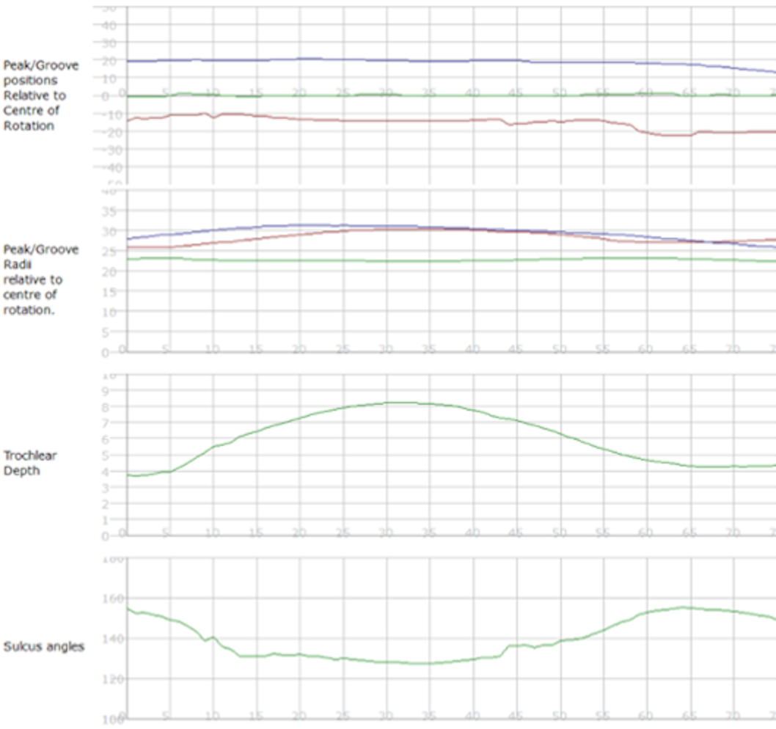

Figure 3: Trochlear analyser graphs showing changes in trochlear depth and sulcus angle through the course of the trochlear groove

Investigator | Trochlear depth (mm) | Angle Slice where trochlear depth is greatest (°) | Sulcus angle (°) | Trochlear facet ratio (%) | Trochlear angle (°) | Lateral trochlear inclination angle (°)
H1 | 7.45 | 70.0 | 138.80 | 105.63 | -2.83 | 18.36
H2 | 8.49 | 86.0 | 138.87 | 137.59 | -6.80 | 17.16
C1 | 7.93 | 33.0 | 128.44 | 82.24 | -1.73 | 21.36
C2 | 7.92 | 30.0 | 128.50 | 82.39 | -1.87 | 21.21
P1 | 7.19 | 16.0 | 132.04 | 82.10 | 1.28 | 22.76
P2 | 7.75 | 21.0 | 129.35 | 78.68 | 4.65 | 26.75

Table 1: Trochlear depth, angle slice, sulcus angle, trochlear facet ratio, trochlear angle and lateral trochlear inclination angle of the three knee models by both investigators calculated using the CSV files

Knee model | Trochlear depth | Sulcus angle | Trochlear facet ratio | Trochlear angle | Lateral trochlear inclination angle
H | 0.94 | 0.86 | 0.69 | 0.67 | 0.08
C | 0.97 | 0.96 | -0.02 | 0.87 | 0.12
P | 0.92 | -0.41 | 0.62 | 0.66 | 0.87

Table 2: Intraclass Correlation Coefficient for the five trochlear groove parameters through the angle slices measured in the three knee models between the two investigators with outliers removed

