Supplementary Figures
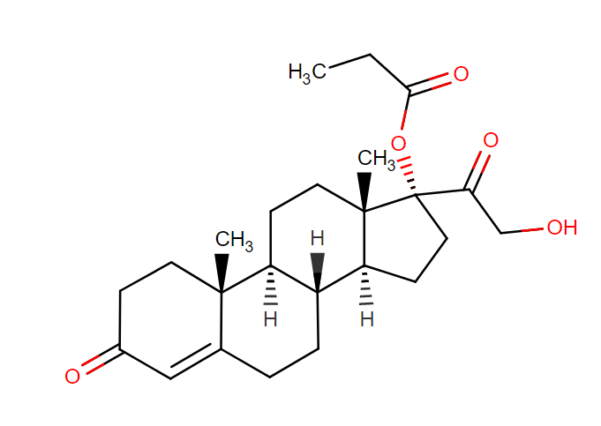
Figure S1. Cortexolone 17α propionate

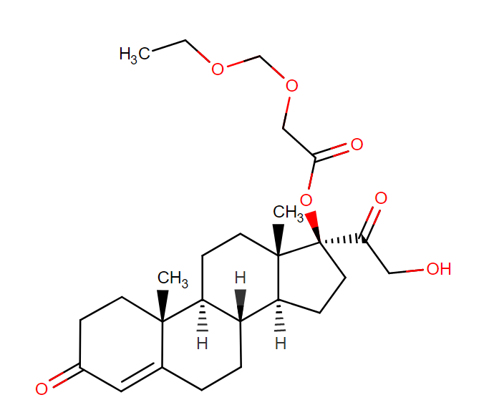
Figure S2. Cortexolone 21 propionate
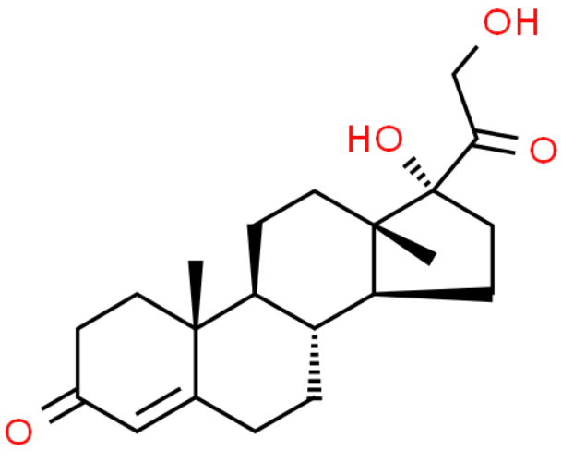
Figure S3. Cortexolone

