Abstract

Background
Despite contributing to significant morbidity in working age adults, there is no consensus on the optimal treatment for prepatellar bursitis. Much of the existing literature combines prepatellar and olecranon bursitis. This systematic review aims to determine the optimal management of prepatellar bursitis.
Study design and methods
A primary search of electronic published and unpublished literature databases from inception to November 2019 was completed. Articles over 25 years old, case reports with less than four patients, paediatric studies, and non-English language papers were excluded. Our primary outcome was recurrence after one year. Comparisons included endoscopic vs open bursectomy, duration of antibiotics. Methodological quality was assessed using the Institute of Health Economics (IHE) and Revised Cochrane Risk of Bias (RoB-2) scoring systems. Meta-analyses were conducted where appropriate.
Results
In total 10 studies were included (N=702). Endoscopic and open bursectomy showed no difference in recurrence after one year (OR=0.41, 95% CI 0.05-3.53, p=0.67), and surgical complications (OR=1.44, 95% CI 0.34-6.08, p=0.44). 80% endoscopically-treated patients were pain free after one year. Patients treated with antibiotics for less than eight days were not significantly more prone to recurrence (2/17 vs 10/114, OR 0.66, 95% CI 0.13-3.29, p = 0.64) compared to eight days plus.
Conclusions
Our study represents the largest cohort of patients evaluating management strategies for prepatellar bursitis, and includes data not previously published. Endoscopic bursectomy is non-inferior to open bursectomy, enabling a shorter hospital stay and lower risk of post-operative pain. Endoscopic bursectomy is a viable option to treat both septic and aseptic prepatellar bursitis. No benefit is brought from antibiotic treatment exceeding seven days for septic prepatellar bursitis.

Introduction
Bursitis is a common cause of morbidity, with a minimum population incidence of 10 per 100,000 [1]. It is defined as inflammation of a bursal sac with swelling and thickening of the bursal walls [2], with the most common forms documented as olecranon and prepatellar bursitis. The prepatellar bursa comprises two anatomically distinct regions, the subcutaneous prepatellar bursa and the superficial infrapatellar bursa [3]. Prepatellar bursitis is most prevalent in working age men [4], causing significant non-productive time [5], with studies documenting a prevalence of 10% in carpet layers and coal miners [6].
Baumbach et al [7] documented 36 different treatment modalities for bursitis in Switzerland alone in 2013. Treatment is commonly divided by aetiology, separating septic and aseptic bursitis, with most cases amenable to non-operative treatment. This is reflected in two treatment algorithms devised for olecranon and prepatellar bursitis [8] [9]. Baumbach advocates aspiration, with antibiotics for septic bursitis followed by re-evaluation every two days. If septic bursitis persists for over 10 days, or aseptic persists for 20 days, they recommend bursectomy. Khodaee [9] also advocates aspiration in most cases, with surgical intervention for non-resolving bursitis.
Open bursectomy has been the mainstay in surgical management [10]. However, as many as 20% open bursectomy cases are associated with skin complications [11]–[13]. Most open bursectomy techniques involve a longitudinal incision over the bursa, where there is a tenuous blood supply, increasing the risk of necrosis and wound dehiscence [12]. Poor perfusion to this area is exacerbated by stretching of the skin following a period of bursal swelling [14], and long-term tenderness of the surgical scar can result from damage to the infrapatellar nerve [15], [16]. Endoscopic bursectomy reduces the risk of damage to the infrapatellar nerve by smaller incisions placed laterally and medially. Various techniques have been suggested to avoid these complications, from minimally invasive percutaneous tube placement [17] to sole excision of the posterior prepatellar wall [15]. Endoscopic bursectomy for traumatic bursitis was first described by Kerr and Carpenter in 1993 [18]. Endoscopic bursectomy has since been evaluated for a number of patient populations including septic and aseptic bursitis, and for a variety of operative techniques [10], [13], [14], [16], [19]–[23].
Septic bursitis represents around one third of all olecranon and prepatellar bursitis cases [24]. Septic bursitis patients are typically younger, and present earlier than aseptic bursitis [11]. Infective bursitis has been associated with skin breakage, trauma, and occupational risk factors [25]. Interestingly, these risk factors have been more pronounced in prepatellar than olecranon bursitis.
Staphylococcus aureus is the most common pathogen in septic bursitis, representing around 80% cases [10], [11], [25]–[28]. Treatment recommendations have evolved from up to four weeks of IV antibiotic therapy [26], to include oral outpatient treatment regimes.
This systematic review aims to determine the optimal treatment for prepatellar bursitis. Much of the existing literature combines prepatellar and olecranon bursitis into one study cohort, and there is no current agreement on the optimal management of prepatellar and olecranon bursitis even when considered together. We will assess both aseptic and septic prepatellar bursitis, operative techniques with a focus on endoscopic vs open bursectomy, and will investigate the use of antibiotics in septic prepatellar bursitis.

Method
Search Strategy
A primary search was performed of the electronic published literature databases AMED, BNI, CINAHL, EMBASE, EMCARE, HMIC, MEDLINE, PsycINFO, and Pubmed using HDAS. The Cochrane Registry of Clinical Trials, PEDro, and TripPRO were also searched. Following this, unpublished literature databases including clinicaltrials.gov, the ISRCTN and the NIHR trial portfolio were searched. The search terms used are shown in Figure 1, with the search results in Figure 2. All databases were reviewed from their inception to the November 2019. Search results were reviewed by three authors (OB, MB, and TP) and any disagreement was adjudicated by a third author (CH) for all potentially eligible studies. Finally, the corresponding authors of all included studies were contacted to ask whether additional results were available.
Eligibility Criteria
Inclusion criteria:
- Patients with prepatellar bursitis
- English language

Exclusion criteria:
- Case reports or case series involving 3 or fewer patients
- Paediatric studies (patient cohort <16 years)
- Articles more than 25 years old
- Conference proceedings or poster presentations
- Book chapters
- Papers that did not separate prepatellar from olecranon bursitis in results, and where the authors were not contactable to obtain the relevant data.

Outcome Measures
The primary outcome was recurrence of bursitis, with primary end-point at over one year post treatment. Secondary outcomes were defined as: recurrence of bursitis, surgical complications, operative time, total duration of antibiotics, hospital stay, subjective rating, duration of IV antibiotics, change in range of motion, time to return to work, and pain at follow up. Outcomes were analysed as either short-term (inpatient stay to 90 days post-discharge), intermediate-term (three months to six months), and longer-term (six months onwards).
Data Extraction
Data were collected by one reviewer (OB) and verified by two others (MB, TP). Where disagreement in data collection occurred, this was resolved through discussion and adjudicated by a third author (CH). Data extracted included: cohort mean age; gender mix; whether septic/aseptic bursitis; severity of bursitis; antibiotics prescribed; presence of immunocompromised patients; timing of follow up; details of the operative procedure; post op management; adjacent treatments administered; and the outcomes of interest. Meric [29] was excluded as we were unable to obtain data on prepatellar bursitis patients separately.
Quality assessment
All included studies were assessed with quality assessment tools. The Institute of Health Economics (IHE) quality appraisal checklist for case series studies [30] [31] was used to assess ten case series, and the Revised Cochrane risk-of-bias tool for randomised trials (RoB-2) tool [32] was used to assess one randomised clinical trial [33]. Cases of disagreement between the two reviewers (OB, TP) were resolved through discussion and adjudicated by a third reviewer (MB). The IHE checklist contains 20 questions, with answers yes, no, and partial or unclear. We gave one point for a ‘yes’ response, 0.5 points for a ‘partial/not applicable’ response, and 0 for a ‘no’ response to generate an overall score for each paper. The RoB-2 checklist assesses risk of bias from randomisation; deviations from intended interventions; missing outcome data; outcome measurement; selection of results; and overall.
Data analysis
Heterogeneity existed between included studies in terms of outcomes assessed, timing of assessment, and statistical analysis presented. Furthermore, cohorts assessed included septic and non-septic patients, and bursectomies done acutely and for recalcitrant bursitis. When studies were homogeneous, data were pooled and analysed as a pooled through meta-analysis. Odds ratios (OR) (defined as the ratio of the probability of an event occurring in an exposed group to the probability of the event occurring in a comparison, non-exposed group) and 95% confidence intervals (CIs) for dichotomous outcomes, and mean differences (MD) (defined as the average of the absolute values of the n (n −1)/2 differences that exist between pairs in a statistical distribution of n elements) and 95% CIs for continuous outcomes, were calculated. For pooled continuous data for outcomes measured in scales, the standardised mean difference (SMD) and 95% CIs were calculated. For incompletely reported data or outcomes, study authors were contacted to request further data. All analyses were performed using IBM SPSS version 25 (IBM Corp, New York, USA).
Results
Studies and outcomes
Following duplicate removal, 424 records were screened, with 10 papers included in the final review. Figure 2 outlines our search results. Mathieu [27] and Meric [29] were excluded from the final review as they did not separate cohorts of prepatellar and olecranon bursitis, and we were unable to obtain data on prepatellar bursitis alone from the authors. One stage versus two stage bursectomy, and antibiotic combination outcomes were deleted as they contained data from one source only each. Demographic data for all included studies can be seen in Table 2.
Quality of evidence
Methodological quality assessments using the IHE checklist are shown in Table 1a. Kaalund [16] had lapses in characterisation of patients included, eligibility criteria, statistical tests, estimates of random variability, and losses to follow up; but clearly defined the intervention and the conclusions were supported by the results. This paper was deemed just adequate as a result. Other papers had higher scores, and were deemed adequate using this scoring system. The RoB-2 tool was used to assess Uckay [33], resulting in an overall low risk of bias assessment (Table 1b). The authors had taken adequate steps to blind the assessors to the randomisation outcome and the results were well structured.
Endoscopic versus open bursectomy
Endoscopic vs open bursectomy: All 5 case studies investigating endoscopic prepatellar bursectomy (Kaalund [16], Ogilvie-Harris [13], Huang [22], Dillon [10], Meade [14]) plus Perez’s [26] two groups treated for less than 15 days with antibiotics that were all operated on, Lieber’s [34] four patients that were operated on, and Uckay’s [33] one and two stage open bursectomy patients were included.
Primary outcome:
Recurrence of bursitis was reported in eight papers, five with endoscopic cohorts, and three with open bursectomy cohorts (Table 3). Long term recurrence, measured over one year after procedure, was demonstrated in 6/87 endoscopically treated patients and 1/34 open bursectomies. These were not significantly different (OR 0.41, 95% CI 0.05 – 3.53, p= 0.67). 1/17 suffered short-term recurrence (less than three months) in the endoscopic group versus 5/51 in the open group (OR 1.74, 95% CI 0.19 – 16.03, p= 0.62).
Secondary outcomes:
There was no significant difference in the complication rate between endoscopic (6/104), and open (3/38) bursectomies (OR 1.44, 95% CI 0.34 – 6.08, p=0.44). This analysis was conducted by raw number of complications across the total number of patients in the endoscopic and open cohorts.
Mean operative time was 18.8 minutes, in two of the endoscopic cohorts. The averages were 18+/- 5.6 minutes in 60 patients for Huang [22], and 25 minutes in eight patients for Dillon [10]. These were not pooled as raw data was not available. Open operative times were not recorded by any paper.
Mean hospital stay was 3.67 days (range 0-9 days) in the endoscopic cohort. In the open group, mean hospital was 6.6 days overall.
Range of motion was normal at follow up in 83/83 patients who underwent an endoscopic bursectomy, vs 33/34 (97%) for open bursectomy.

Pooled results for the endoscopic cohort at a follow up of 7-87 months showed 80% patients were without pain post op.

Operative vs non-operative from septic and non-septic cohorts
This was the largest cohort, with Stell [11] and Martinez-Taboada [35] in the non-operative septic group; Perez [26], Lieber [34], Uckay [33], Kaalund [16], Dillon [10], and Meade [14] in the septic operative group; Stell’s [11] aseptic patients treated non-operatively; Ogilvie-Harris [13] and Huang [22] in the operative aseptic bursitis group. Results are summarised in Table 4a and 4b.

Primary outcomes:
Recurrence in the non-operative septic cohort was 2/27 (7.41%) versus 7/120 (5.83%) for the operative septic cohort (Table 4a). These were not statistically different (OR 0.99, 95% CI 0.20 – 4.95, p=1.00). The operative aseptic cohort had 5/79 recurrences (6.33%), and the non-operative aseptic 2/7 (28.57%). We found no significant difference statistically between these groups (OR 0.17, 95% CI 0.03 – 1.10, p=0.10) (Table 4b).
Secondary outcomes
Mean hospital stay in the non-operative septic cohort was 8.7 days (SD 9.06) versus 6.6 days in the operative septic cohort (Table 4a). There was no result reported in the aseptic non-operative or operative cohorts.

The rate of S. Aureus in the entire reported prepatellar bursitis patient cohort was 48/61 patients (78.7%).
Duration of antibiotic
We compared patients treated for less than eight days, with those treated for eight days or more (Table 5).
Primary outcomes:
Recurrence was demonstrated in two of 17 patients treated with antibiotics for less than eight days, compared to 10/115 patients treated for eight days or more. No significant difference was found between these groups using A 2-sided Fisher’s exact test (OR 0.66, 95% CI 0.13-3.29, p = 0.64).
Secondary outcomes

Mean hospital stay was 7.83 days in the less than eight days cohort versus 8.3 days in the over eight days cohort. No statistical analysis was able to be performed for this comparison as raw data could not be obtained.

Discussion
This study represents the largest cohort of prepatellar bursitis patients to our knowledge. By producing the largest comparison of endoscopic versus open bursectomy for prepatellar bursitis, we can conclude that endoscopic bursectomy is non-inferior to open bursectomy regarding recurrence and complication rates. This safe and effective procedure enables short hospital stay and minimal post-operative pain.
Improved patient morbidity is frequently cited as a reason for endoscopic bursectomy. Our results were in line with this. In the endoscopic group, all patients had normal range of motion at follow up and had returned to work at a maximum of three weeks. Furthermore, three studies with patients treated endoscopically showed that 80% patients surveyed at 7-87 months had no pain post-operatively. In the open group however, one patient suffered reduced ROM at follow up and Uckay’s [33] cohort had not returned to work at three weeks. This indicates that endoscopic bursectomy may be superior to open bursectomy, but further research is required to evaluate this.
The technique used in endoscopic bursectomy has evolved from the first description by Kerr and Carpenter in 1987 [18], and the papers in this review offer anecdotal advice to guide further advances. They advocate inserting the arthroscope at least 1cm away from the bursal skin to prevent bursal collapse, as well as directing the shaver tip away from the joint surface to prevent injury to the subcutaneous tissue [13], [23]. Pressure pumps used in this trial ranged from 35mmHg [13] to 40-50mmHg [14], with tourniquet use and complete bursal resection defined as subcutaneous skin seen superficially and fibres of patellar tendon seen distally [13]. Comparing operative technique between studies would be an interesting topic for further research.
Our largest comparison, comprising 223 patients, showed no significant difference between operative and non-operative management for septic and aseptic bursitis. However, many patients underwent operative management when non-operative management failed resulting in recurrence. The rate of recurrence in operative patients was 5/79, including those non-operative treatment was unsuccessful. This indicates that operative management is beneficial in patients with recalcitrant bursitis.

Previous studies have indicated that 11 to 12 days is the ideal treatment time for septic bursitis [37], [38]. This study indicates that a shorter course of antibiotics is feasible, as recurrence was not significantly different between patients treated with antibiotics for less than eight days compared to eight days or more. In fact, hospital stay was increased in patients treated for over 14 days, though this may be accounted for by greater use of oral antibiotics in those treated for less than 14 days. Data from the multi-centre OVIVA trial demonstrated non-inferiority for orthopaedic infections treated with oral vs IV antibiotics [39]. As such, the pertinent question for further research may not be the total duration of antibiotics but the possibility to treat septic prepatellar bursitis with oral antibiotics.

The rate of staph aureus bursitis in the septic bursitis patients has been well-documented in previous studies, ranging from 80% - 88% [4], [28], [40]. Information is not widely available for prepatellar cohorts alone. Of four studies reporting rates of staph aureus in prepatellar bursitis, it was isolated in an average of 78.69% patients. This is somewhat lower than figures for septic bursitis as a whole, and may represent the contaminated workplace environment that prepatellar bursitis is associated with.
This review presented with strengths and limitations. The principal strength is that the data analysed arises both from published articles, and through communication with authors of select trials to isolate the results for prepatellar bursitis. We were able to obtain previously unpublished data on this selective cohort which has been presented here, and enables comparison between trial cohorts for prepatellar bursitis alone. The principle limitations are the heterogeneity and size of our study sample, and the inability to obtain raw data from all studies. Meric [23] compared open bursectomy with endoscopic bursectomy for prepatellar and olecranon bursitis, but results for prepatellar bursitis patients alone were not available.
Conclusions
This study is the largest investigating prepatellar bursitis, and includes data not previously published. We conclude that endoscopic bursectomy is a safe and effective treatment for prepatellar bursitis. Operative management should be considered for recalcitrant aseptic bursitis, but has not been shown to be superior to non-operative management for septic bursitis. We have found no advantage in antibiotic treatment lasting over one week in septic prepatellar bursitis.

References
[1] S. F. Baumbach, C. M. Lobo, I. Badyine, W. Mutschler, and K. G. Kanz, “Prepatellar and olecranon bursitis: Literature review and development of a treatment algorithm,” Archives of Orthopaedic and Trauma Surgery, vol. 134, no. 3. pp. 359–370, Mar-2014.
[2] T. Myllymäki, T. Tikkakoski, T. Typpö, J. Kivimäki, and I. Suramo, “Carpet-layer’s knee. An ultrasonographic study.,” Acta Radiol., vol. 34, no. 5, pp. 496–9, Sep. 1993.
[3] D. L. Aaron, A. Patel, S. Kayiaros, and R. Calfee, “Four common types of bursitis: Diagnosis and management,” Journal of the American Academy of Orthopaedic Surgeons, vol. 19, no. 6. Lippincott Williams and Wilkins, pp. 359–367, 2011.
[4] J. C. Cea-Pereiro, J. Garcia-Meijide, A. Mera-Varela, and J. J. Gomez-Reino, “A comparison between septic bursitis caused by Staphylococcus aureus and those caused by other organisms.,” Clin. Rheumatol., vol. 20, no. 1, pp. 10–4, 2001.
[5] J. T. WATKINS, T. A. HUNT, R. H. FERNANDEZ, and O. P. EDMONDS, “A clinical study of beat knee.,” Br. J. Ind. Med., vol. 15, no. 2, pp. 105–9, Apr. 1958.
[6] C. R. Reid, P. M. C. Bush, N. H. Cummings, D. L. McMullin, and S. K. Durrani, “A review of occupational knee disorders,” Journal of Occupational Rehabilitation, vol. 20, no. 4. pp. 489–501, Dec-2010.
[7] S. F. Baumbach, H. Wyen, C. Perez, K. G. Kanz, and I. Uçkay, “Evaluation of current treatment regimens for prepatellar and olecranon bursitis in Switzerland,” European Journal of Trauma and Emergency Surgery, vol. 39, no. 1. pp. 65–72, 2013.
[8] S. F. Baumbach, F. Domaszewski, H. Wyen, K. Kalcher, W. Mutschler, and K.-G. Kanz, “Evaluation of the current treatment concepts in Germany, Austria and Switzerland for acute traumatic lesions to the prepatellar and olecranon bursa.,” Injury, vol. 44, no. 11, pp. 1423–7, Nov. 2013.
[9] M. Khodaee, “Common superficial bursitis,” Am. Fam. Physician, vol. 95, no. 4, pp. 224–231, Feb. 2017.
[10] J. P. Dillon, I. Freedman, J. S. M. Tan, D. Mitchell, and S. English, “Endoscopic bursectomy for the treatment of septic pre-patellar bursitis: a case series.,” Arch. Orthop. Trauma Surg., vol. 132, no. 7, pp. 921–5, Jul. 2012.
[11] I. M. Stell, “Management of acute bursitis: Outcome study of a structured approach,” J. R. Soc. Med., vol. 92, no. 10, pp. 516–521, 1999.
[12] J. B. Quayle and M. P. Robinson, “A useful procedure in the treatment of chronic olecranon bursitis,” Injury, vol. 9, no. 4, pp. 299–302, 1977.
[13] D. J. Ogilvie-Harris and M. Gilbart, “Endoscopic bursal resection: The olecranon bursa and prepatellar bursa,” Arthroscopy, vol. 16, no. 3, pp. 249–253, 2000.
[14] T. C. Meade, M. S. Briones, A. W. Fosnaugh, and J. M. Daily, “Surgical Outcomes in Endoscopic Versus Open Bursectomy of the Septic Prepatellar or Olecranon Bursa,” Orthopedics, vol. 42, no. 4, pp. e381–e384, Jul. 2019.
[15] J. B. Quayle and M. P. Robinson, “An operation for chronic prepatellar bursitis,” J. Bone Jt. Surg. - Ser. B, vol. 58, no. 4, pp. 504–506, 1976.
[16] S. Kaalund, M. Breddam, and G. Kristensen, “Endoscopic resection of the septic prepatellar bursa.,” Arthroscopy, vol. 14, no. 7, pp. 757–8, Oct. 1998.
[17] J. M. Knight, J. C. Thomas, and R. C. Maurer, “Treatment of septic olecranon and prepatellar bursitis with percutaneous placement of a suction-irrigation system. A report of 12 cases.,” Clin. Orthop. Relat. Res., no. 206, pp. 90–3, May 1986.
[18] D. R. Kerr, “Prepatellar and olecranon arthroscopic bursectomy,” Clinics in Sports Medicine, vol. 12, no. 1. pp. 137–142, 1993.
[19] P. Nussbaumer, C. Candrian, and A. Hollinger, “Das endoskopische bursashaving bei akuter bursitis,” Swiss Surg., vol. 7, no. 3, pp. 121–125, 2001.
[20] T. Steinacker and A. J. Verdonck, “[Endoscopic therapy of pre-patellar bursitis].,” Sportverletz. Sportschaden, vol. 12, no. 4, pp. 162–4, Dec. 1998.
[21] D. Witoński, “Arthroscopic resection of bursitis changes in the pre-patellar bursae--preliminary report,” Chir. Narzadow Ruchu Ortop. Pol., vol. 62, no. 1, pp. 63–65, 1997.
[22] Y. C. Huang and W. L. Yeh, “Endoscopic treatment of prepatellar bursitis,” Int. Orthop., vol. 35, no. 3, pp. 355–358, Mar. 2011.
[23] G. Meric, S. Sargin, A. Atik, A. Budeyri, and A. E. Ulusal, “Endoscopic versus Open Bursectomy for Prepatellar and Olecranon Bursitis,” Cureus, Mar. 2018.
[24] I. M. Stell, “Septic and non-septic olecranon bursitis in the accident and emergency department--an approach to management.,” J. Accid. Emerg. Med., vol. 13, no. 5, pp. 351–3, Sep. 1996.
[25] D. A. Raddatz, G. S. Hoffman, and W. A. Franck, “Septic bursitis: presentation, treatment and prognosis.,” J. Rheumatol., vol. 14, no. 6, pp. 1160–3, Dec. 1987.
[26] C. Perez et al., “Infectious olecranon and patellar bursitis: Short-course adjuvant antibiotic therapy is not a risk factor for recurrence in adult hospitalized patients,” J. Antimicrob. Chemother., vol. 65, no. 5, pp. 1008–1014, Mar. 2010.
[27] S. Mathieu, C. Prati, M. Bossert, É. Toussirot, M. Valnet, and D. Wendling, “Acute prepatellar and olecranon bursitis. Retrospective observational study in 46 patients,” Joint Bone Spine, vol. 78, no. 4. pp. 423–424, Jul-2011.
[28] N. Gómez-Rodríguez, M. J. Méndez-García, J. L. Ferreiro-Seoane, J. Ibáñez-Ruán, and Y. Penelas-Cortés Bellas, “[Infectious bursitis: study of 40 cases in the pre-patellar and olecranon regions].,” Enferm. Infecc. Microbiol. Clin., vol. 15, no. 5, pp. 237–42, May 1997.
[29] G. Meric, S. Sargin, A. Atik, A. Budeyri, and A. E. Ulusal, “Endoscopic versus Open Bursectomy for Prepatellar and Olecranon Bursitis.,” Cureus, vol. 10, no. 3, p. e2374, Mar. 2018.
[30] B. Guo, C. Moga, C. Harstall, and D. Schopflocher, “A quality appraisal checklist developed specifically for evaluating case series studies.,” J. Clin. Epidemiol., vol. 69, pp. 199-207.e2, Aug. 2015.
[31] “Institute of Health Economics |.” [Online]. Available: https://www.ihe.ca/advanced-search/development-of-a-quality-appraisal-tool-for-case-series-studies-using-a-modified-delphi-technique. [Accessed: 24-Feb-2020].
[32] “Risk of bias tools - RoB 2 tool.” [Online]. Available: https://sites.google.com/site/riskofbiastool/welcome/rob-2-0-tool?authuser=0. [Accessed: 24-Feb-2020].
[33] I. Uçkay et al., “One- vs 2-Stage Bursectomy for Septic Olecranon and Prepatellar Bursitis: A Prospective Randomized Trial,” Mayo Clin. Proc., vol. 92, no. 7, pp. 1061–1069, Jul. 2017.
[34] S. B. Lieber, M. L. Fowler, C. Zhu, A. Moore, R. H. Shmerling, and Z. Paz, “Clinical characteristics and outcomes of septic bursitis,” Infection, vol. 45, no. 6, pp. 781–786, Dec. 2017.
[35] V. M. Martinez-Taboada, R. Cabeza, P. M. Cacho, R. Blanco, and V. Rodriguez-Valverde, “Cloxacillin-based therapy in severe septic bursitis: Retrospective study of 82 cases,” Jt. Bone Spine, vol. 76, no. 6, pp. 665–669, Dec. 2009.
[36] C. Perez et al., “Infectious olecranon and patellar bursitis: short-course adjuvant antibiotic therapy is not a risk factor for recurrence in adult hospitalized patients.,” J. Antimicrob. Chemother., vol. 65, no. 5, pp. 1008–14, May 2010.
[37] B. Söderquist and S. A. Hedström, “Predisposing factors, bacteriology and antibiotic therapy in 35 cases of septic bursitis.,” Scand. J. Infect. Dis., vol. 18, no. 4, pp. 305–11, 1986.
[38] H. K. Macdonald, “BURSITIS.,” Can. Med. Assoc. J., vol. 40, no. 6, pp. 573–7, Jun. 1939.
[39] P. A. Bejon, H. K. Li, I. Rombach, S. Walker, and M. Scarborough, “The OVIVA trial,” The Lancet Infectious Diseases, vol. 19, no. 10. Lancet Publishing Group, p. 1058, 01-Oct-2019.
[40] G. Ho, A. D. Tice, and S. R. Kaplan, “Septic bursitis in the prepatellar and olecranon bursae: an analysis of 25 cases.,” Ann. Intern. Med., vol. 89, no. 1, pp. 21–27, Jul. 1978.

Appendix: Tables and Figures
Figure 1: search terms used for database searching
Bursitis AND (prepatella* OR pre-patella* OR patella* OR (knee AND bursa*)) AND (treat* OR manage* OR aspirat* OR excis* OR therap* OR interven*)

Table 1a: Risk of bias table for IHE Checklist (1 = yes, 0 = no, 0.5 = partial)
 |  |  | Dillon 2012 | Huang 2010 | Kaalund 1998 | Lieber 2017 | Martinez-Taboada 2009 | Ogilivie-Harris 2000 | Perez 2010 | Stell 1999 | Meade 2019
Study objective | 1 | Hypothesis/aim/objective clearly stated? | 1 | 1 | 0 | 1 | 1 | 1 | 1 | 1 | 1
Study design | 2 | Study conducted propectively? | 0 | 1 | 0.5 | 0 | 0 | 1 | 0 | 1 | 0
 | 3 | Collected in more than one centre? | 0 | 0 | 0 | 0 | 0 | 0 | 0 | 0 | 0
 | 4 | Patients recruited consecutively? | 0.5 | 0.5 | 1 | 0.5 | 1 | 1 | 0.5 | 1 | 0.5
Study population | 5 | Characteristics of patients included described? | 1 | 1 | 0 | 1 | 1 | 0.5 | 1 | 1 | 1
 | 6 | Eligibility criteria clearly stated? | 0 | 1 | 0 | 1 | 0.5 | 0 | 1 | 1 | 1
 | 7 | Patients enter at similar point in the disease? | 0.5 | 1 | 0.5 | 1 | 0.5 | 0.5 | 0.5 | 1 | 1
Intervention and co-intervention | 8 | Intervention clearly described? | 1 | 1 | 1 | 1 | 1 | 1 | 0.5 | 1 | 1
 | 9 | Additional interventions clearly described? | 1 | 1 | 0.5 | 0 | 0 | 1 | 0.5 | 1 | 0
Outcome measure | 10 | Relevant outcome measures established (in advance)? | 1 | 1 | 0 | 1 | 0.5 | 0.5 | 1 | 1 | 1
 | 11 | Outcome assessors blinded to intervention? | 0 | 0 | 0 | 0 | 0 | 0 | 0 | 0 | 0
 | 12 | Relevant outcomes measured using appropriate objective/subjective methods? | 1 | 1 | 0.5 | 1 | 1 | 1 | 1 | 1 | 1
 | 13 | Outcome measures made before and after the intervention? | 0 | 0 | 1 | 0 | 0 | 1 | 1 | 1 | 0
Statisical analysis | 14 | Statistical tests used to assess relevant outcomes? | 0 | 0 | 0 | 1 | 1 | 0 | 1 | 0 | 0
Results and conclusions | 15 | Follow-up long enough for important events and outcomes to occur? | 1 | 1 | 1 | 0 | 0.5 | 1 | 0.5 | 1 | 0.5
 | 16 | Losses to follow-up reported? | 0 | 0 | 0 | 1 | 0 | 1 | 0 | 1 | 0
 | 17 | Estimates of random variability in the data analysis of relevant outcomes? | 0 | 0 | 0 | 0 | 0 | 0 | 0 | 0 | 0
 | 18 | Adverse events reported? | 1 | 1 | 1 | 0 | 1 | 1 | 0.5 | 1 | 1
 | 19 | Conclusions of the study supported by results? | 1 | 1 | 1 | 0.5 | 1 | 0.5 | 1 | 1 | 1
Competing interests and sources of support | 20 | Both competing interests and sources of support for study reported? | 0 | 0 | 0 | 0 | 1 | 0 | 1 | 0 | 0
 |  | TOTAL SCORE | 10 | 12.5 | 8 | 10 | 11 | 12 | 12 | 15 | 10

Table 1b: Risk of bias for RoB-2 score
RoB-2 | Uckay 2017
Domain | Judged risk of bias per domain
- risk of bias from randomisation | low
- risk of bias from deviations from intended interventions (assignment) | low
- risk of bias from deviations from intended interventions (adherance) | low
- missing outcome data | low
- risk of bias in measurement of the outcome | low
- risk of bias in selection of reported result | low
Overall | low

Figure 2: Search results from database searching and grey literature
694 Records identified through database searching:
- AMED = 5
- BNI = 0
- CINAHL = 44
- EMBASE = 183
- EMCARE = 68
- HMIC = 1
- Medline = 124
- PsycINFO = 0
- Pubmed = 11
- Cochrane library = 13
- TripPro = 245
424 Records after duplicates removed
8 Records identified through other sources (clinicaltrials.gov, websites, NICE clinical knowledge summaries)
66 Included following screening of titles
358 Records removed from screening title and date relevance
- 64 – wrong anatomical location eg trochanteric bursitis
- 23 – case reports
- 22 – non- English language
- 10 – paediatric
- 208 – wrong pathology eg morel-lavallee lesions
- 31 – age of paper >25 years
22 Included following screening of abstracts
44 Records removed from screening the abstract
- 2– wrong anatomical location
- 7 – case reports
- 1 – paediatric
- 5 – wrong pathology eg morel-lavallee lesions
- 2 – conference proceedings
- 9 – book chapters
- 13 – review articles with no original data
- 1 – duplicate with a different title
10 Records removed from screening the available text of the publication
- 5 – non-English language
- 1 – case report
- 1 – review article with no original data
- 1 – duplicate with different title
- 1 – wrong anatomical location
- 1 – full text unavailable
12 Included following screening of available text of publication
2 Records removed from separation of prepatellar bursitis data from olecranon bursitis data
- 2 – separate prepatellar bursitis data unavailable
10 Included following separation of prepatellar bursitis data from olecranon bursitis data

Table 2: Demographic data for all included studies
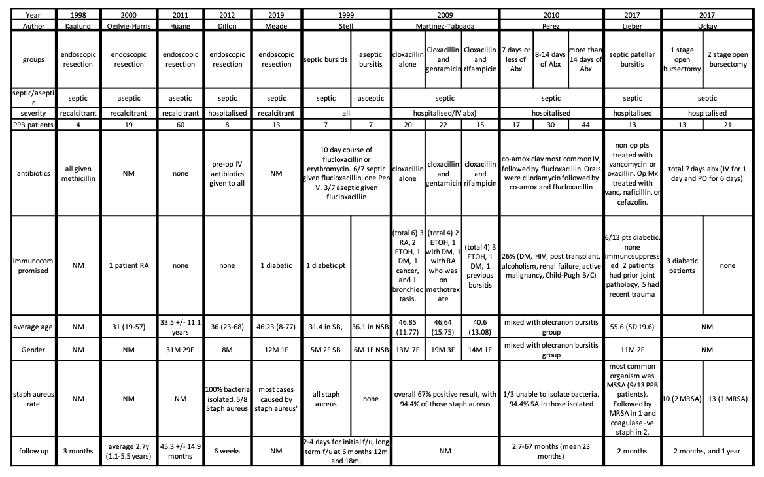
Table 2 – demographic data. Key: NM = not mentioned; Abx = antibiotics; RA = rheumatoid arthritis; ETOH = alcoholism; DM = diabetes mellitus

Table 3: Endoscopic versus open bursectomy, showing no difference in long or short term recurrence, or surgical complication rate
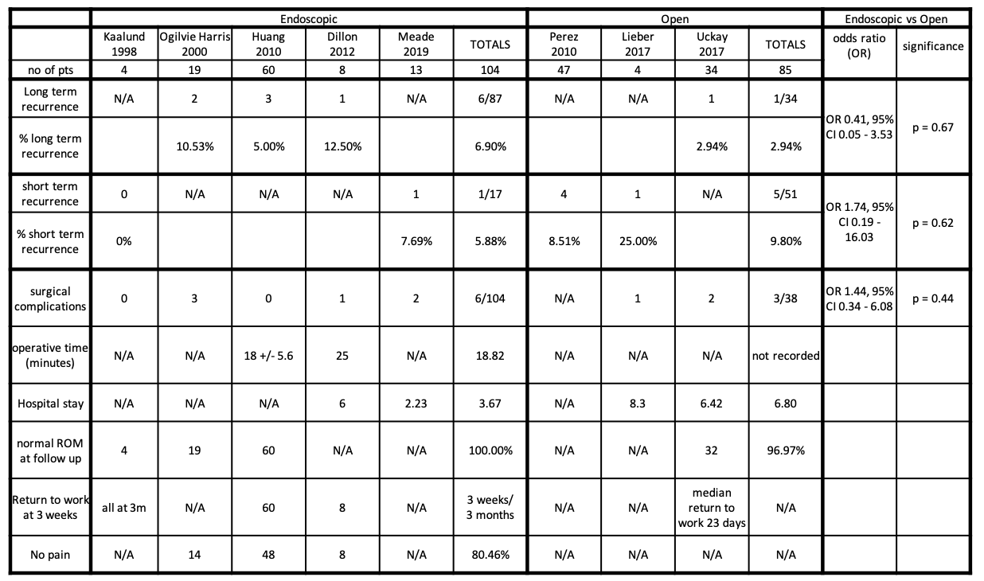
Long term recurrence defined as 1 year or over; short term recurrence defined as three months or less. Key: N/A = data not available or not reported. There were six surgical complications in the endoscopic bursectomy group overall: one case of local irritation, two delayed healing, one needed a second debridement, one recurrent effusion, and two deep vein thromboses. Within the septic bursitis endoscopic arm alone, there were 2/25 (8%) complications. In the open group there were four complications reported overall, only from septic arthritis patient cohorts. One patient requiring multiple operations and two patients with wound dehiscence corresponding to a rate of 17.6%.

Table 4a: Operative versus non-operative septic prepatellar bursitis
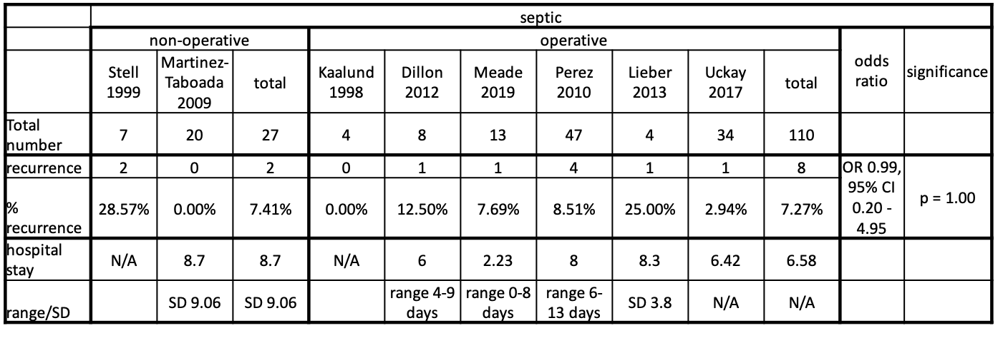
Table 4b: Operative versus non-operative aseptic prepatellar bursitis
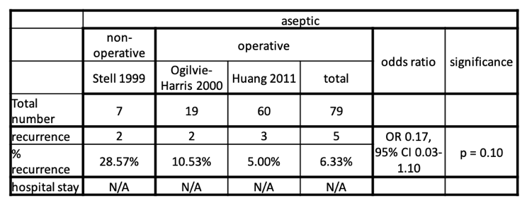
Four cohorts were examined, operative septic prepatellar bursitis, non-operative septic prepatellar bursitis, operative aseptic prepatellar bursitis, and non-operative aspetic prepatellar bursitis. The Non-operative septic cohort comprised Stell’s [11] seven septic patients, and Martinez-Taboada’s 20 patients [35]. The operative septic cohort contained Kaalund’s [16] four patients, Dillon’s [10] eight patients, 13 from Meade [14], 47 from the patients given antibiotics from 0-14 days in Perez [26], 4 operative patients from Lieber [34], and 33 from Uckay [33]. The operative aseptic cohort comprised 19 from Ogilvie-Harris [13], and 60 from Huang [22]. The non-operative aseptic cohort came from Stell [11].

Table 5: Duration of antibiotic treatment, comparing those treated for seven days or less with those treated for eight days or more
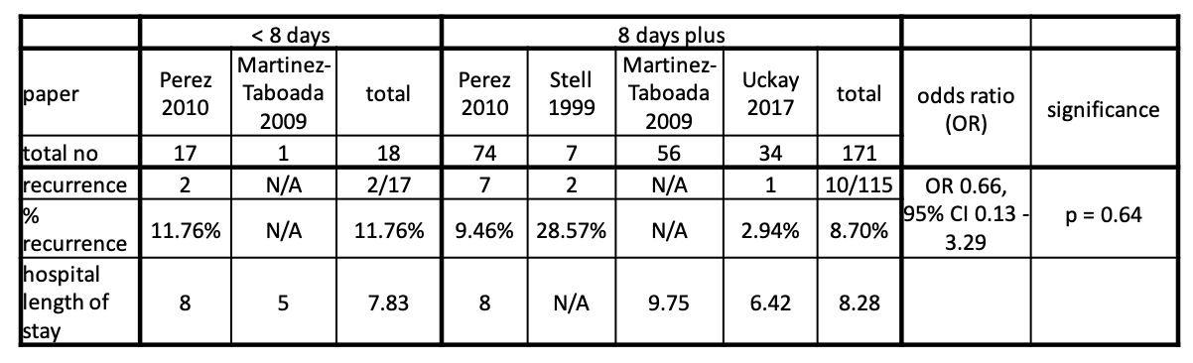
Duration of antibiotics featured Perez’ [26] cohort of patients, split into three groups with less than 8 days antibiotics, 8-14 days antibiotics, and over 14 days antibiotics. We were interested in comparing those treated for seven days with eight days plus, and placed our other groups (Martinez-Taboada [35], Stell [11], Uckay [33]). Martinez-Taboada’s [35] prepatellar patients were used without removal of immunocompromised patients to match the cohort from Perez. Martinez-Taboada’s cohort only reported inpatient characteristics so could not report recurrence.

