The safety and efficacy of SLIT compared to placebo or standard care for children with asthma

Marco Shiu Tsun Leung BMedSc MPH^{‡1, 3}; Parker O’Neill BSc^{1, 3}; Emma Dennett ³; Kayleigh M Kew²; Rebecca Fortescue³
- St George’s, University of London, London, UK
- Cochrane Editorial and Methods Department, Cochrane, London, UK
- Cochrane Airways, Population Health Research Institute, St George’s, University of London, UK

‡ Corresponding Author:
Marco Shiu Tsun Leung
St George’s, University of London, UK
Email: marcostleung@hotmail.com

Background
Over 330 million people have asthma worldwide, and it is the most common chronic disease in children.[1] This creates a large burden on healthcare systems and has a large economic cost of ranging from USD 1,900 to USD 3,100 per patient per year.[2] Many children with asthma experience poor control under standard treatments, leading to exacerbations which further increase the burden of disease. Up to 50% of children with asthma may have an atopic component to their disease, providing a target for treatment.[3] Sublingual immunotherapy (SLIT) aims to build tolerance to an allergen through repeated exposure to the causative agent, and has proven an effective treatment option for people suffering with allergies, particularly allergic rhinitis [4,5] For people with asthma, SLIT may represent an important addition to the more conventional asthma treatments; however, the literature is conflicting regarding the safety and efficacy of SLIT in this population. Many healthcare services either do not recommend SLIT, or reserve it for asthma that has been poorly controlled with more well-established treatments.[6, 7] This Cochrane review assessed the safety and efficacy of SLIT compared to placebo or standard care for both adults and children with asthma. However, this Cochrane Corner summarises data from the paediatric trials only. The primary outcomes measured were all-cause serious adverse events (SAEs), exacerbations requiring hospital visit, and validated assessments of quality of life. Secondary outcomes included all-cause adverse events, exacerbations requiring systemic corticosteroids, doses of inhaled corticosteroid (ICS), and responses to provocation tests.
Method
This Cochrane review consists of the original literature review conducted in March 2015 and the updated literature review conducted in October 2019 using the rigorous Cochrane methodology [6]. We included parallel randomised controlled trials, irrespective of blinding or duration, that evaluated sublingual immunotherapy versus placebo or as an add-on to standard asthma management. We included studies that recruited participants up to the age of 18 years old with asthma, rhinitis, or both, providing at least 80% of trial participants had a diagnosis of asthma.
Results
The updated literature review included 31 studies involving 2,389 children. Few studies reported our pre-specified primary outcome. Trials in children mainly targeted SLIT with house dust mite and pollen allergens.
Occurrence of SAEs was a reported outcome for 13 included studies involving 1137 participants, but only two studies observed any events (Niu 2006; Pajno 2000). There did not appear to be any increased risk of experiencing a SAE with SLIT compared to standard therapy (Risk Difference (RD) −0.00, 95% CI −0.01 to 0.01).
Only one study including 61 participants assessed number of exacerbations requiring hospital visit (Umanets 2017). Five participants in the SLIT group and 10 in the control group either attended the emergency department or were admitted to hospital over 52 weeks of treatment (odds ratio (OR) 0.35, 95% confidence interval (CI) 0.10 to 1.20; participants = 61; studies = 1;) (Umanets 2017). This suggests that SLIT may reduce the number of exacerbations requiring hospital, however, the results were uncertain.
Trieste 2017 reported the paediatric asthma quality of life questionnaire (PAQLQ) and the paediatric asthma caregiver's quality of life questionnaire (PACQL), stating: "QoL shows a higher mean in the study than in the control group. Differences of emotional problem and PACQL scores assessed before and after randomisation are not statistically different in the two groups" (Trieste 2017).
Regarding secondary outcomes, ten studies, including 862 participants, reported all-cause adverse events, and 4 studies contributed 108 events to the meta-analysis. Pooled results suggested an increased risk of experiencing an adverse event in the SLIT group compared with the control group; however, the confidence interval includes the possibility that standard treatment may increase the risk of experiencing an adverse event (OR 1.62, 95% CI 0.70 to 3.76) (Figure 1). Most adverse events were reported to be mild and transient and rarely led to withdrawal from the trial.
Two studies reported on exacerbations requiring oral corticosteroids (Pajno 2003; Umanets 2017), but only one observed any events (Umanets 2017). SLIT reduced the odds of experiencing an exacerbation requiring oral corticosteroids, but the result was very uncertain and includes the possibility of no difference or a difference favouring the control group (OR 0.20, 95% CI 0.02 to 1.92; participants = 91; studies = 2).
One study reported ICS use numerically in budesonide µg/d (equivalent) at the end of treatment (Pham-Thi 2007). Although ICS use significantly decreased from baseline in both treatment and control groups, the results yielded an imprecise estimate with wide confidence intervals including the possibility of both benefit and harm from SLIT (mean difference (MD) 34.00, 95% CI −60.45 to 128.45; participants = 109; studies = 1).
Response to bronchial provocation using the methacholine challenge test was included as an outcome in five studies (Keles 2011; Marogna 2005; Pajno 2003; Stelmach 2009; Umanets 2017). Marogna 2005 reported this outcome using provocative dose (PD)20, whilst the remaining studies used provocative concentration (PC)20. All five studies were at least a year in duration. The pooled results suggest a small benefit of SLIT over control but we are uncertain if this is clinically significant (standardised mean difference (SMD) 0.99, 95% CI 0.17 to 1.82; participants = 200; I2 = 85%).(Figure 2.)
Discussion
Evidence from the full Cochrane review suggests that SLIT may be a safe option for adults or children with well-controlled mild to moderate asthma and rhinitis. Looking at the primary outcomes, SLIT may reduce the number of exacerbations requiring hospital admission and may lead to higher quality of life scores compared to standard treatment. Regarding secondary outcomes, SLIT may increase the risk of experiencing an adverse event, however, most events were mild and transient. SLIT may also decrease the number of asthma exacerbations requiring systemic corticosteroids, as well as reducing the required dose of ICS. However, due to the scarcity of evidence in the paediatric population, as highlighted herein, none of the reported outcomes exclude the possibility of no effect, or the opposing effect of the intervention, which limits our ability to create clinically meaningful conclusions. Most studies excluded children with severe asthma, and as a result, the efficacy and safety of SLIT use in this group remains largely unknown. Our results align with the current international position of not recommending SLIT routinely for asthma treatment and further research using standardised scoring algorithms is required. [7-8]

References
- Asher I, Pearce N. Global burden of asthma among children. Int J Tuberc Lung Dis. 2014;18(11):1269-1278.
- Nunes C, Pereira A, Morais-Almeida M. Asthma costs and social impact. Asthma Res Pract. 2017;3:1.
- Agache I, Akdis C, Jutel M, Virchow JC. Untangling asthma phenotypes and endotypes. Allergy 2012;67(7):835-46.
- Calderon MA, Penagos M, Sheikh A, Canonica GW, Durham S. Sublingual immunotherapy for treating allergic conjunctivitis. Cochrane Database of Syst. Rev. 2011, Issue 7. Art. No.: CD007685. DOI: 10.1002/14651858.CD007685.pub2. Accessed 07 January 2021.
- Radulovic S, Calderon MA, Wilson D, Durham S. Sublingual immunotherapy for allergic rhinitis. Cochrane Database of Syst Rev. 2010, Issue 12. Art. No.: CD002893. DOI: 10.1002/14651858.CD002893.pub2. Accessed 07 January 2021.
- Fortescue R, Kew KM, Leung MST. Sublingual immunotherapy for asthma. Cochrane Database Syst Rev. 2020 Sep 14;9:CD011293.
- Global Initiative for Asthma (GINA). Global Initiative for Asthma. Global Strategy for Asthma Management and Prevention, 2019. ginasthma.org/wp-content/uploads/2019/06/GINA-2019-mainreport-June-2019-wms.pdf Accessed 02 Jan 2021.
- British Thoracic Society and the Scottish Intercollegiate Guidelines Network. British Guideline on the Management of Asthma. www.brit-thoracic.org.uk/quality-improvement/ guidelines/asthma Accessed 02 Jan 2021

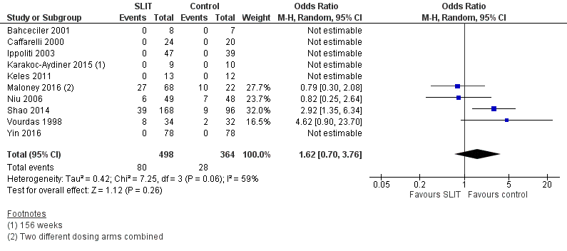
Figure 1. Forest plot of comparison: Sublingual immunotherapy versus control, outcome (all adverse events).

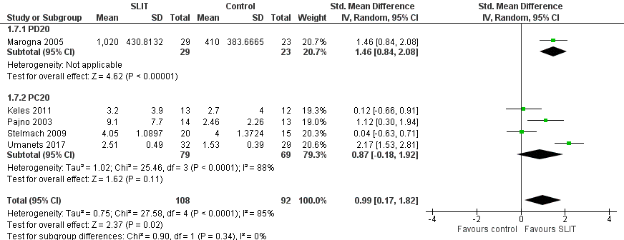
Figure 2. Forest plot of comparison: Sublingual immunotherapy versus control, outcome: Response to provocation tests.

