Contents of Supplementary Appendix:

Supplementary Figure:
S1. Association of blood transfusion with death stratified by study site and adjusted for disease severity. (p 2)

Supplementary Tables:
S1. Clinical and Demographic Characteristics of the Study Population by Site and Transfusion Status. (pp 3-8)
S2. Clinical factors associated with administration of a blood transfusion. (p 9)
S3. Clinical factors associated with administration of a blood transfusion (weight-for-age Z-score omitted). (p 10)
S4. Site-specific associations of clinical variables with administration of blood transfusion. (pp 11-13)
S5. Association between blood transfusion and death in a model that included weight-for-age Z-scores. (p 14)

S6. Severe Malaria in African Children (SMAC) Network enrollment by study site. (p 15)

S7. Power calculations and estimation of minimal detectable difference for the primary outcome. (p 16)

Figure S1. Association of blood transfusion with death stratified by study site (A) and adjusted for disease severity (B). Adjusted analysis included severe anemia, impaired consciousness, lactate, respiratory distress, hypoglycemia, age, temperature and parasite density. P-values were estimated through likelihood ratio test. Diamonds represent odds ratios (OR) and error bars include the 95% confidence interval (CI).

(A)
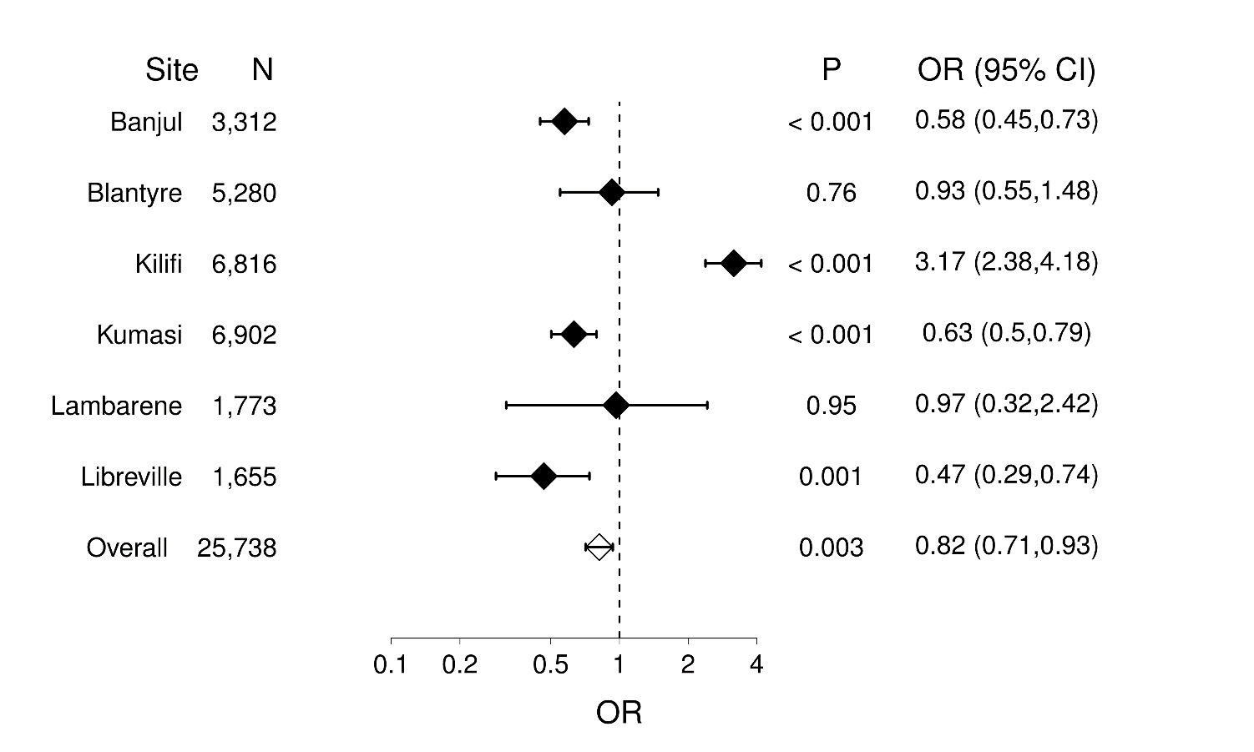
(B)
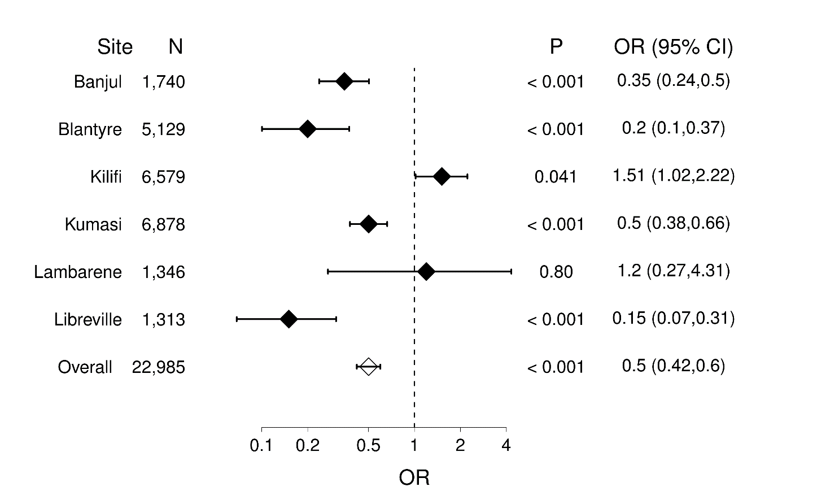

Table S3. Clinical and demographic characteristics of the study population by site and transfusion status.
Banjul, The Gambia | All | Transfused | Not Transfused | P value*
 | N = 3,318 | N = 1,526 | N = 1,792
Age, median (Q1, Q3), months | 32 (18,51) | 25 (15,40) | 36 (22,70) | <0.001
Sex, N (%) male | 1,617 (48) | 743 (49) | 845 (47) | 0.3
Weight, median (Q1, Q3), kg | 11 (9, 15) | 10 (8.3, 13) | 12 (9.6, 16) | <0.001
Weight-for-age, median (Q1, Q3), Z-score | -1.36 (-2.3, -0.5) | -1.43 (-2.28, -0.51) | -1.31 (-2.27, -0.47) | 0.2
Temperature, median (Q1, Q3), °C | 37.7 (38.1, 38.6) | 37.7 (37.1, 38.5) | 37.7 (37.0, 38.6) | 0.75
Respirations, median (Q1, Q3), min⁻¹ | 34 (28,44) | 36 (28,48) | 32 (28,42) | <0.001
Hemoglobin, median (Q1, Q3), g/L | 63 (45,86) | 48 (37,62) | 80 (62,100) | <0.001
Glucose, median (Q1, Q3), mmol/L | 6.4 (4.8, 8) | 6.5 (5.0,8.0) | 6.4 (4.6,8.0) | 0.4
Hypoglycemia ª, N (%) | 126 (6) | 65 (6) | 57 (5) | 0.5
Parasitemia, geo. mean (95% CI), ul⁻¹ | 7,471  (6,755-8,263) | 12,105  (10,566-13,868) | 5,157  (4,455-5,968) | <0.001
Blantyre Coma Score, N (%) |  |  |  | 0.03
5 | 2,587 (76) | 1,185 (78) | 1,339 (75)
4 | 248 (7) | 120 (8) | 121 (7)
3 | 275 (8) | 118 (7) | 157 (9)
2 | 184 (5) | 67 (4) | 112 (6)
1 | 70 (2) | 26 (2) | 43 (2)
0 | 31 (1) | 10 (1) | 20 (1)
Impaired consciousness ^{b},  N (%) | 808 (24) | 341 (22) | 453 (25) | 0.04
Lactate, median (Q1, Q3), mmol/L | 3.9 (2.4, 7) | 4.9 (3.0,8.9) | 3.3 (2.2,5.8) | <0.001
Hyperlactatemia ^{c}, N (%) | 1,106 (39) | 6.19 (49) | 462 (30) | <0.001
Died, N (%) | 316 (6) | 107 (7) | 207 (11) | <0.001

Blantyre, Malawi | All | Transfused | Not Transfused | P value
 | N = 5,358 | N = 813 | N = 4,545
Age, median (Q1, Q3), months | 26 (14, 46) | 21 (11, 35) | 27 (14, 48) | <0.001
Sex, N (%) male | 2,493 (46) | 385 (47) | 2,106 (46) | 0.5
Weight, median (Q1, Q3), kg | 10.2 (8.4, 13.5) | 9.2 (7.5, 11.3) | 10.5 (8.6, 14) | <0.001
Weight-for-age, median (Q1, Q3), Z-score | -1.22 (-2.19, -0.35) | -1.52 (-2.55, -0.66) | -1.14 (-2.1, -0.28) | <0.001
Temperature, median (Q1, Q3), °C | 38.5 (37.8, 39.2) | 38.2 (37.4, 39.0) | 38.5 (37.8, 39.3) | <0.001
Respirations, median (Q1, Q3), min⁻¹ | 38 (36, 44) | 40 (36, 48) | 38 (36, 44) | <0.001
Hemoglobin, median (Q1, Q3), g/L | 88 (68, 103) | 49 (39, 55) | 94 (78, 106) | <0.001
Glucose, median (Q1, Q3), mmol/L | 5.3 (4.4, 6.2) | 5.3 (4.3, 6.2) | 5.3 (4.4, 6.2) | 0.81
Hypoglycemia ª, N (%) | 134 (3) | 38 (5) | 96 (2) | <0.001
Parasitemia, geo. mean (95% CI), ul⁻¹ | 63,815  (61,016-66,742) | 47,973  (42,095-54,672) | 67,109  (64,007-70,362) | <0.001
Blantyre Coma Score, N (%) |  |  |  | <0.001
5 | 4,809 (90) | 674 (83) | 4,131 (91)
4 | 113 (2) | 25 (3) | 88 (2)
3 | 147 (3) | 33 (4) | 113 (3)
2 | 128(2) | 33 (4) | 95 (2)
1 | 85 (2) | 24 (3) | 61 (1)
0 | 81 (2) | 24 (3) | 57 (1)
Impaired consciousness ^{b},  N (%) | 554 (10) | 139 (17) | 414 (9) | <0.001
Lactate, median (Q1, Q3), mmol/L | 3.6 (2.2-6) | 5.4 (3.2-9.9) | 3.3 (2.1-5.4) | <0.001
Hyperlactatemia ^{c}, N (%) | 1,737(33) | 440 (55) | 1,295 (29) | <0.001
Died, N (%) | 133 (3) | 19 (2) | 114 (3) | 0.7

Lambaréné, Gabon | All | Transfused | Not Transfused | P value
 | N = 1,784 | N = 382 | N = 1,402
Age, median (Q1, Q3), months | 28 (16, 56) | 20.5 (12, 32) | 32 (17, 62) | <0.001
Sex, N (%) male | 841 (47) | 172 (45) | 664 (47) | 0.4
Weight, median (Q1, Q3), kg | 11 (9, 15) | 10 (8, 12) | 12 (9.2, 16) | <0.001
Weight-for-age, median (Q1, Q3), Z-score | -1.01 (-1.84, -0.19) | -1.42 (-2.07, -0.47) | -0.91 (-1.69, -0.11) | <0.001
Temperature, median (Q1, Q3), °C | 38.5 (37.7, 39.5) | 38.3 (37.7, 39.2) | 38.5 (37.7, 39.6) | 0.02
Respirations, median (Q1, Q3), min⁻¹ | 40 (32, 48) | 44 (40, 52) | 40 (32, 48) | <0.001
Hemoglobin, median (Q1, Q3), g/L | 77 (58, 95) | 44 (37, 52) | 85 (70, 98) | <0.001
Glucose, median (Q1, Q3), mmol/L | 4.1 (3.1, 5.1) | 4.2 (3.2, 5.2) | 4.1 (3.1, 5.1) | 0.22
Hypoglycemia ª, N (%) | 164 (10) | 30 (8) | 134 (10) | 0.3
Parasitemia, geo. mean (95% CI), ul⁻¹ | 34,592  (31,121-38,450) | 33,046  (26,014-41,980) | 34,931  (31,027-39,326) | 0.76
Blantyre Coma Score, N (%) |  |  |  | <0.001
5 | 1,587 (89) | 298 (78) | 1,280 (92)
4 | 55 (3) | 22 (6) | 33 (2)
3 | 56 (3) | 17 (5) | 39 (3)
2 | 64 (4) | 30 (8) | 33 (2)
1 | 27 (2) | 14 (4) | 13 (1)
0 | 1 (0.1) | 1 (0.3) | 0 (0)
Impaired consciousness ^{b},  N (%) | 203 (11) | 85 (22) | 118 (8) | <0.001
Lactate, median (Q1, Q3), mmol/L | 3.8 (2.4, 5.3) | 4.2 (2.9, 6.8) | 3.6 (2.4, 5.1) | <0.001
Hyperlactatemia ^{c}, N (%) | 408 (29) | 109 (38) | 299 (26) | <0.001
Died, N (%) | 24 (1) | 5 (1)^{d} | 19 (1)^{d} | 0.9^{d}

Libreville, Gabon | All | Transfused | Not Transfused | P value
 | N = 1,662 | N = 829 | N = 833
Age, median (Q1, Q3), months | 25 (15, 42) | 20 (13, 31) | 33 (20, 55) | <0.001
Sex, N (%) male | 793 (47) | 392 (47) | 388 (46) | 0.7
Weight, median (Q1, Q3), kg | 11 (9, 14) | 10 (8, 12) | 12.2 (10, 16) | <0.001
Weight-for-age, median (Q1, Q3), Z-score | -0.08 (-1.70, 0.05) | -0.88 (-1.88, -0.16) | -0.67 (-1.48, 0.29) | <0.001
Temperature, median (Q1, Q3), °C | 38.6 (37.9, 39.5) | 38.5 (37.8, 39.3) | 39 (38, 39.6) | <0.001
Respirations, median (Q1, Q3), min⁻¹ | 42 (36, 52) | 45 (40, 60) | 40 (32, 48) | <0.001
Hemoglobin, median (Q1, Q3), g/L | 62 (46, 84) | 46 (38, 55) | 83 (69, 98) | <0.001
Glucose, median (Q1, Q3), mmol/L | 5.3 (4.3, 6.4) | 5.3 (4.4, 6.3) | 5.3 (4.3, 6.5) | 0.5
Hypoglycemia ª, N (%) | 53 (3) | 27 (3) | 25 (3) | 0.67
Parasitemia, geo. mean (95% CI), ul⁻¹ | 47,226  (42,907-51,978) | 46,095  (39,992-53,129) | 49,134  (43,128-55,975) | 0.9
Blantyre Coma Score, N (%) |  |  |  | 0.006
5 | 1,128 (67) | 545 (66) | 552 (66)
4 | 219 (13) | 128 (15) | 89 (11)
3 | 155 (9) | 69 (8) | 84 (10)
2 | 127 (8) | 56 (7) | 69 (8)
1 | 51 (3) | 26 (3) | 24 (3)
0 | 16 (1) | 3 (0.4) | 13 (2)
Impaired consciousness ^{b},  N (%) | 568 (33) | 282 (34) | 279 (34) | 0.8
Lactate, median (Q1, Q3), mmol/L | 3.8 (2.4, 5.8) | 4.3 (2.8, 6.9) | 3.3 (2.2, 4.8) | <0.001
Hyperlactatemia ^{c}, N (%) | 453 (32) | 295 (43) | 153 (22) | <0.001
Died, N (%) | 83 (5) | 27 (3) | 56 (7) | 0.001

Kilifi, Kenya | All | Transfused | Not Transfused | P value
 | N = 6,846 | N = 1,029 | N = 5,817
Age, median (Q1, Q3), months | 26 (14, 43) | 21 (11, 33) | 27 (15, 45) | <0.001
Sex, N (%) male | 3,188 (46) | 494 (48) | 2,667 (46) | 0.2
Weight, median (Q1, Q3), kg | 9.9 (8, 12.6) | 8.8 (7.3, 10.9) | 10.2 (8.1, 12.9) | <0.001
Weight-for-age, median (Q1, Q3), Z-score | -1.7 (-2.56, -0.86) | -1.99 (-2.84, -1.15) | -1.63 (-2.5, -0.81) | <0.001
Temperature, median (Q1, Q3), °C | 38.3 (37.3, 39.2) | 37.8 (37.0, 38.7) | 38.4 (37.3, 39.3) | <0.001
Respirations, median (Q1, Q3), min⁻¹ | 36 (30, 46) | 44 (34, 56) | 36 (30, 44) | <0.001
Hemoglobin, median (Q1, Q3), g/L | 80 (61, 96) | 42 (35, 54) | 85 (70, 98) | <0.001
Glucose, median (Q1, Q3), mmol/L | 5.2 (4.2, 6.3) | 5 (4.0, 5.9) | 5.3 (4.3, 6.4) | <0.001
Hypoglycemia ª, N (%) | 322 (5) | 88 (9) | 231 (4) | <0.001
Parasitemia, geo. mean (95% CI), ul⁻¹ | 24,355  (22,954-25,842) | 34,288  (29,597-39,723) | 23,063  (21,614-24,609) | <0.001
Blantyre Coma Score, N (%) |  |  |  | <0.001
5 | 5,539 (80) | 680 (66) | 4,812 (83)
4 | 468 (7) | 109 (11) | 353 (6)
3 | 187 (3) | 64 (6) | 121 (2)
2 | 364 (5) | 103 (10) | 257 (4)
1 | 172 (3) | 39 (4) | 131 (2)
0 | 179 (3) | 34 (3) | 143 (3)
Impaired consciousness ^{b},  N (%) | 1,370 (20) | 349 (34) | 1,005 (17) | <0.001
Lactate, median (Q1, Q3), mmol/L | 2.3 (1.6, 3.5) | 3.6 (2.1, 6.4) | 2.2 (1.6, 3.1) | <0.001
Hyperlactatemia ^{c}, N (%) | 866 (13) | 352 (35) | 508 (9) | <0.001
Died, N (%) | 232 (3) | 79 (8) | 150 (3) | <0.001

Kumasi, Ghana | All | Transfused | Not Transfused | P value
 | N = 6,925 | N = 3,934 | N = 2,991
Age, median (Q1, Q3), months | 24 (12, 42) | 18 (10, 35) | 30 (16, 52) | <0.001
Sex, N (%) male | 3,113 (45) | 1,761 (45) | 1,348 (45) | 0.8
Weight, median (Q1, Q3), kg | 10 (8, 13.5) | 9.4 (7.6, 12) | 11.5 (9, 15) | <0.001
Weight-for-age, median (Q1, Q3), Z-score | -1.15 (-2.04, -0.35) | -1.22 (-2.07, -0.37) | -1.1 (-2.01, -0.27) | <0.001
Temperature, median (Q1, Q3), °C | 37.8 (37.0, 38.6) | 37 .7 (37, 38.5) | 38 (37.2, 38.8) | <0.001
Respirations, median (Q1, Q3), min⁻¹ | 42 (36, 54) | 46 (38, 58) | 40 (32, 48) | <0.001
Hemoglobin, median (Q1, Q3), g/L | 62 (47, 85) | 50 (40, 62) | 84 (69, 99) | <0.001
Glucose, median (Q1, Q3), mmol/L | 5.1 (4.2, 6.1) | 5 (4.2, 6) | 5.2 (4.3, 6.4) | <0.001
Hypoglycemia ª, N (%) | 295 (4.25) | 170 (4.32) | 124 (4.15) | 0.7
Parasitemia, geo. mean (95% CI), ul⁻¹ | 44,336  (42,077-46,716) | 40,181  (37,479-43,079) | 50,385  (46,543-54,543) | <0.001
Blantyre Coma Score, N (%) |  |  |  | <0.001
5 | 5,289 (76) | 3,145 (80) | 2,126 (71)
4 | 464 (7) | 234 (6) | 230 (8)
3 | 350 (5) | 173 (4) | 177 (6)
2 | 422 (6) | 199 (5) | 223 (8)
1 | 238(3) | 103 (3) | 135 (5)
0 | 178(3) | 79 (2) | 98 (3)
Impaired consciousness ^{b},  N (%) | 1,652 (24) | 788 (20) | 863 (29)
Lactate, median (Q1, Q3), mmol/L | 3.2 (2.1, 5.2) | 3.8 (2.5, 6.2) | 2.7 (1.9, 4.0) | <0.001
Hyperlactatemia ^{c}, N (%) | 1,886 (27) | 1,392 (36) | 490 (16) | <0.001
Died, N (%) | 313 (5) | 168 (6) | 143 (4) | <0.001

* P-values comparing transfused and not transfused were estimated through Wilcoxon rank-sum tests when reporting medians, and chi-square tests, when reporting proportions.
ª Hypoglycemia: Blood glucose less than 2.2 mmol/L.
^{b} Impaired consciousness: Blantyre Coma Score less than or equal to 4.
^{c} Hyperlactatemia: Lactate 5 mmol/L or greater.
^{d} Given the small number of deaths observed in Lambaréné, our study would only have attained 80% power to detect substantial differences between transfused and not-transfused patients.

Table S2 - Clinical factors associated with administration of a blood transfusion*.
 | Transfused  (N = 8,513) | Not Transfused  (N = 17,380) | Site Adjusted OR† (95%CI)  (N = 25,893) | Adjusted OR‡ (95%CI)  (N = 19,729) | P§
Age||, median (Q1, Q3); | 21 (11, 36) | 29 (16, 50) | 0·89  (0·90, 0·91) | 0·97  (0·97, 0·98) | < 0·0001
Sex, N (%) Male | 4566 (54%) | 9,362 (54%) | 0·98  (0·92, 1·03) | — | —
Weight-for-age Z-score, median (Q1, Q3) | -1·34  (-2·22, -0·48) | -1·28  (-2·21, -0·43) | 0·88  (0·86, 0·90) | 0·92  (0·89, 0·94) | < 0·0001
Temperature, ᵒC, median (Q1, Q3) | 37·9  (37·1, 38·7) | 38·3  (37·4, 39·2) | 0·83  (0·81, 0·85) | 0·86  (0·83, 0·89) | < 0·0001
Parasite density, ln (parasites/µL) | 4·74  (3·97, 5·29) | 4·48  (3·94, 5·28) | 1·03  (1·00, 1·06) | 1·07  (1·03, 1·11) | 0·0010
Lactate, N (%) |  |  |  |  | < 0·0001
< 3 mmol/L | 2,557 (30%) | 9,063 (52%) | — | —
3-4·9 mmol/L | 2,224 (26%) | 4,186 (24%) | 1·79  (1·66, 1·92) | 1·75  (1·60, 1·91)
≥ 5 mmol/L | 3,732 (44%) | 4,131 (24%) | 3·36  (3·13, 3·61) | 2·95  (2·68, 3·25)
Severe anemia, N (%) | 417 (2%) | 2,630 (31%) | 18·8  (16·7, 21·2) | 15·02  (13·04, 17·3) | < 0·0001
Impaired consciousness, N (%) | 1,983 (23%) | 3,132 (18%) | 1·09  (1·01, 1·17) | 0·82  (0·74, 0·90) | < 0·0001
Respiratory distress, N (%) | 2,175 (26%) | 2,454 (14%) | 2·02  (1·89, 2·17) | 1·36  (1·23, 1·50) | < 0·0001
Hypoglycemia, N (%) | 418 (5%) | 667 (4%) | 1·35  (1·17, 1·55) | 0·78  (0·65, 0·94) | 0·0094

IQR, interquartile range; OR, odds ratio; CI, confidence interval.
* The following variables were missing more than 50 observations: glucose (N = 24,390); lactate (N = 24,444); temperature (N = 24,410); and weight-for-age Z-scores (N = 21,992). Removal of glucose and weight-for-age Z-scores from the adjusted model allowed an additional 3,524 children to be included in the model and yielded comparable results (Table S3).
† Estimates obtained in models including only site. C-statistics in models including site and any one covariate varied from 0·72 to 0·81
‡ Confidence intervals and p-values estimated in models including site plus all relevant predictors of transfusion simultaneously.
§ P-values were estimated through likelihood ratio tests comparing the model with and without the corresponding predictor. C-statistic of the fully adjusted model was 0·85.
|| The OR for age is per 6 months change.

Table S3. Clinical factors associated with administration of a blood transfusion. An alternative model, omitting weight for age Z-score and hypoglycemia, allowed an additional 3,524 children to be included in the model and yielded comparable results.

 | Adjusted OR†  (N = 24,312) | (95% CI) ‡
Age, months | 0.99 | (0.98, 0.99)
Temperature (ᵒC) | 0.87 | (0.84, 0.89)
Parasite density, ln parasites/µl blood | 1.06 | (1.02,1.09)
Lactate
< 3.0 mmol/L) | —
3.0 - 4.9 mmol/L) | 1.70 | (1.56, 1.84)
≥ 5.0 mmol/L) | 2.77 | (2.54, 3.02)
Severe anemia  (hemoglobin ≤ 40 g/L) | 14.97 | (13.23, 16.94)
Impaired consciousness  (BCS ≤ 4) | 0.79 | (0.73, 0.86)
Respiratory distress | 1.34 | (1.22, 1.46)
Study site
Banjul, The Gambia | — | --
Blantyre, Malawi | 0.26 | (0.23-0.30)
Kilifi, Kenya | 0.27 | (0.24, 0.30)
Kumasi, Ghana | 2.08 | (1.87, 2.32)
Lambaréné, Gabon | 0.38 | (0.32, 0.46)
Libreville, Gabon | 1.55 | (1.33, 1.81)

BCS, Blantyre Coma Score; OR, Odds ratio.
† C-statistic of the final model was 0.85.
‡ P-values were all < 0.0001, except for parasite density that had a p-value of 0.001.

Table S4 – Site-specific associations of clinical variables with administration of blood transfusion.

 | Adjusted OR  (N = 19,729) | (95% CI)* | P†
Age, months | 0.89 | (0.88, 0.90) | < 0.001
Temperature (ᵒC) | 0.87 | (0.84, 0.90) | < 0.001
Weight-for-Age Z-scores |  |  | 0.02
Banjul | 0.99 | (0.92, 1.08)
Blantyre | 0.88 | (0.83, 0.94)
Kilifi | 0.92 | (0.86, 0.98)
Kumasi | 0.96 | (0.92, 1.00)
Lambaréné | 0.85 | (0.75, 0.97)
Libreville | 0.85 | (0.78, 0.93)
Parasite density (/µl blood) |  |  | < 0.0001
Banjul | 1.15 | (1.05, 1.27)
Blantyre | 0.91 | (0.81, 1.02)
Kilifi | 1.43 | (1.31, 1.57)
Kumasi | 0.96 | (0.90, 1.02)
Lambaréné | 1.05 | (0.87, 1.25)
Libreville | 0.99 | (0.84, 1.15)
Lactate |  |  | 0.004
Banjul
3.0-4.9 mmol/L) | 1.22 | (0.99, 1.80)
≥ 5.0 mmol/L | 2.30 | (1.71, 3.10)
Blantyre
3.0-4.9 mmol/L) | 2.02 | (1.58, 2.57)
≥ 5.0 mmol/L | 3.24 | (2.58, 4.07)
Kilifi
3.0-4.9 mmol/L) | 1.86 | (1.49, 2.31)
≥ 5.0 mmol/L | 3.13 | (2.47, 3.96)
Kumasi
3.0-4.9 mmol/L) | 1.96 | (1.71, 2.24)
≥ 5.0 mmol/L | 3.61 | (3.06, 4.25)
Lambaréné
3.0-4.9 mmol/L) | 1.11 | (0.72, 1.70)
≥ 5.0 mmol/L | 1.58 | (0.99, 2.52)
Libreville
3.0-4.9 mmol/L) | 1.15 | (0.84, 1.57)
≥ 5.0 mmol/L | 2.40 | (1.71, 3.36)
Severe anemia |  |  | < 0.0001
Banjul | 4.19 | (3.12, 5.62)
Blantyre | 19.46 | (13.72, 27.61)
Kilifi | 42.10 | (31.66, 55.99)
Kumasi | 7.29 | (5.64, 9.41)
Lambaréné | 82.36 | (32.66, 207.69)
Libreville | 8.55 | (5.21, 14.02)
Impaired consciousness |  |  | < 0.0001
Banjul | 0.85 | (0.64, 1.13)
Blantyre | 1.01 | (0.74, 1.37)
Kilifi | 1.52 | (1.23, 1.88)
Kumasi | 0.53 | (0.46, 0.61)
Lambaréné | 1.87 | (1.06, 3.27)
Libreville | 0.73 | (0.54, 0.97)
Respiratory distress |  |  | 0.0001
Banjul | 0.98 | (0.73, 1.32)
Blantyre | 1.49 | (1.10, 2.02)
Kilifi | 1.96 | (1.60, 2.40)
Kumasi | 1.13 | (0.98, 1.31)
Lambaréné | 1.33 | (0.62, 2.84)
Libreville | 0.94 | (0.61, 1.46)
Hypoglycemia |  |  | 0.07
Banjul | 1.07 | (0.68, 1.69)
Blantyre | 0.89 | (0.53, 1.51)
Kilifi | 1.07 | (0.75, 1.56)
Kumasi | 0.57 | (0.42, 0.77)
Lambaréné | 0.77 | (0.41, 1.45)
Libreville | 0.52 | (0.23, 1.13)

OR = Odds ratio; CI = confidence Interval; BCS = Blantyre Coma Score.

*Confidence intervals across the study sites and within each predictor were adjusted for multiple testing using Holm procedure.

† P-values were estimated through likelihood ratio tests comparing models with all terms except the interaction between the corresponding predictor and study site. All interaction terms had a P-value < 0.05 and reduced AIC and BIC when included in models with only main effects and the interaction term between the corresponding predictor and study site. The interaction with hypoglycemia became borderline significant when all interaction terms were jointly modeled.

Table S5. Association between blood transfusion and death in analysis including weight-for-age Z-scores

 |  | OR | (95% CI) | LRT P*
Site Adjusted Analysis (n = 19,607) †
Transfused (vs. not) |  | 0.85 | (0.72, 0.99)  p = 0.04 | --
Study site |  |  |  | < 0.0001
 |  | c-statistic of the fitted model = 0.62
Adjusted Analysis (n = 19,607) † ‡
Transfused (vs. not) |  | 0.46 | (0.38, 0.56) | < 0.0001
Age, months |  | 1.00 | (0.996, 1.007) | 0.60
Weight for Age Z-score |  | 0.80 | (0.76, 0.85) | < 0.0001
Temperature (ᵒC) |  | 0.83 | (0.77, 0.89) | < 0.0001
Parasite density, ln (parasites/µl of blood) |  | 0.82 | (0.76, 0.88) | < 0.0001
Lactate |  |  |  | < 0.0001
 | < 3.0 mmol/L | — | —
 | 3.0-4.9 mmol/L) | 1.39 | (1.08, 1.78)
 | ≥ 5.0 mmol/L | 3.14 | (2.52, 3.91)
Severe Anemia (hemoglobin ≤ 40 g/L) |  | 1.18 | (0.95, 1.47) | 0.14
Impaired consciousness (BCS ≤ 4) |  | 4.10 | (3.45, 4.88) | < 0.0001
Respiratory distress |  | 3.46 | (2.90, 4.12) | < 0.0001
Hypoglycemia (glucose ≥ 2.2 mmol/L) |  | 3.47 | (2.80, 4.29) | < 0.0001
Study site |  |  |  | < 0.0001
 |  | c-statistic of the fitted model = 0.86

BCS, Blantyre coma score; LRT, likelihood ratio test
* P-value of the likelihood ratio test comparing the reduced model (with the corresponding predictor deleted from the model) with the full model.
† Both analyses adjusted only by site and adjusted by all other predictors included the same subset of subjects
‡ Gender was not statistically significant in any analysis. In the adjusted model of this table, the OR for male (vs. female) gender and death was 0.96 (95%CI = 0.83, 1.10; P = 0.54). The effect of age in months and weight-for-age Z-scores were correlated and inclusion of one variable in the model excluded the other.

Table S6. Severe Malaria in African Children (SMAC) Network enrollment by study site.

Kumasi, Ghana N = 6,925
PI: Tsiri Agbenyega
Study Team: Daniel Ansong, Osei Yaw Akoto, Emmanuel Asafo- Adjei, Alex Owusu-Ofori, Cynthia Donkor, Sampson Antwi, Justice Sylverkyn, Kingsley Osei-Kwakye, David Sambian, Victor Degenu, Mbort Atan Ayibo, Evelyn Anane-Sarpong, Vida Asante, Emmanuel Owusu-Ansah and Esther Esumming

Kilifi, Kenya N = 6,846
PI: Charles Newton
Study Team: Joshua Ngala, Rachael Odhiambo, Tom Oluoch, Christopher Olola, Sadik Mithwani, Kathryn Maitland, Betty Wamola and Brett Lowe.

Blantyre, Malawi N = 5,358
PI: Terrie Taylor
Study Team: Lloyd Bwanaisa, Alfred Njobvu, James Mwenechanya, Beatrice Mkondiwa, Timothy Mnalemba, Dina Kayaye, Collins Qongwane, Maganizo Chagomerana and Sophie Kazembe

Lambaréné and Libreville, Gabon N = 3,446
PI: Peter Kremsner, Sanjeev Krishna
Study Team: Saadou Issifou, Michel Missinou, Pierre Blaise Matsiegui, Bertrand Lell, Steffen Borrmann, Tim Planche, Maryvonne Kombila, Arnaud Dzeing, Frankie Mbadinga and Nestor Obiang

Banjul, The Gambia N = 3,318
PI: Kalifa Bojang, Dominic Kwiatkowski
Study Team: Muminatou Jallow, Margaret Pinder, Emmanuel Onyekwelu, David Ameh, Ismaela Abubakar, Janet Fullah, Jalli Mori, Abdou Bah, Pamela Esangbedo, Mariatou Jallow, and Augustine Ebonyi

S7. Power calculations and estimation of minimal detectable difference for the primary outcome.

For the primary analysis of the association of blood transfusion and mortality, a study including a sample size like ours, i.e., a total of 25,893 children (8,513 transfused and 17,380 not transfused) and a risk of death in children who did not receive transfusion (baseline) of 3.96% (689/17,380) would attain power of 80% in a 0.05 α-level chi-square test to detect an increase in the overall odds of death with transfusion of 1.2 times. In analysis stratified by study site, a study including our site-specific sample sizes (see table below) would attain power of odds ratio as low as 1.33 to 2.83, depending on the site.

Site |  | Total | Transfused | Not Transfused | Minimal Detectable Effect Size (OR)
Banjul | Total | 3,318 | 1,526 | 1,792 | 1.33
 | Died | 316 | 107 | 207 (11.56%)
Blantyre | Total | 5,358 | 813 | 4,545 | 1.78
 | Died | 133 | 19 | 114 (2.50%)
Lambarene | Total | 1,784 | 382 | 1,402 | 2.83
 | Died | 24 | 5 | 19 (1.36%)
Libreville | Total | 1,662 | 829 | 833 | 1.64
 | Died | 83 | 27 | 56 (6.72%)
Kilifi | Total | 6,846 | 1,029 | 5,817 | 1.67
 | Died | 232 | 79 | 150 (2.58%)
Kumasi | Total | 6,925 | 3,934 | 2,991 | 1.35
 | Died | 313 | 168 | 143 (4.78%)
All sites combined | Total | 25,893 | 8,513 | 17,380 | 1.20
 | Died | 1,101 | 405 | 689 (3.96%)

