**Appendix**

**Forecasting the type 2 diabetes mellitus epidemic and the role of key risk factors in Oman up to 2050: Mathematical modeling analyses**

Susanne F. Awad,1,2,3 Adhra Al- Mawali,4,5 Jawad A. Al-Lawati,6 Magdi Morsi,4 Julia A. Critchley,7 Laith J. Abu-Raddad1,2,3

1Infectious Diseases Epidemiology Group, Weill Cornell Medical College – Qatar, Cornell University, Doha, Qatar

2World Health Organization Collaborating Centre for Disease Epidemiology Analytics on HIV/AIDS, Sexually Transmitted Infections, and Viral Hepatitis, Weill Cornell Medicince – Qatar, Doha, Qatar

3Department of Population Health Sciences, Weill Cornell Medicine, Cornell University, New York, USA

4Centre of Studies & Research, Ministry of Health, Muscat, Sultanate of Oman

5Strategic Research Program for Non-communicable Disease, The Research Council (TRC), Muscat, Sultanate of Oman

6Directorate General of Primary Health Care, Ministry of Health, Muscat, Sultanate of Oman

7*Population Health Research Institute, St George’s, University of London, London, UK*

**Additional Tables**

**Table S1.** Model assumptions in terms of parameter values.

|  |  |  |  |  |
| --- | --- | --- | --- | --- |
| **Assumption** | **Age group** | **Parameter value (95% CI)** | | **Reference** |
| **Men** | **Women** |
| Number of age compartments in the model (each for 5 years; *a*) | - | 20 | 20 | By choice |
| Relative risk of developing T2DM if obese () | All | 6.48 (5.17–8.13) | 8.38 (5.46–12.85) | 1 |
| Relative risk of developing T2DM if current smoker () | All | 1.42 (1.34–1.50) | 1.33 (1.26–1.41) | 2 |
| Relative risk of developing T2DM if physically inactive () | 15–69  70–79  ≥80 | 1.45 (1.37–1.54)  1.32 (1.25–1.40)  1.20 (1.14–1.28) | 1.45 (1.37–1.54)  1.32 (1.25–1.40)  1.20 (1.14–1.28) | 3 |
| Relative risk of developing T2DM if obese and smoker () | All | 9.20 (6.93–12.20) | 11.15 (6.88–18.12) | Calculated based on 1, 2 |
| Relative risk of developing T2DM if obese and physically inactive () | 15–69  70–79  ≥80 | 9.40 (7.08–12.52)  8.55 (6.46–11.38)  7.78 (5.89–10.41) | 12.15 (7.48–19.79)  11.06 (6.83–18.12)  10.06 (6.22–16.45) | Calculated based on 1, 3 |
| Relative risk of developing T2DM if smoker and physically inactive () | 15–69  70–79  ≥80 | 2.06 (1.84–2.37)  1.87 (1.68–2.17)  1.70 (1.53–1.97) | 1.93(1.73–2.17)  1.76 (1.58–1.99)  1.60 (1.44–1.80) | Calculated based on 2, 3 |
| Relative risk of developing T2DM if obese, smoker, and physically inactive () | 15–69  70–79  ≥80 | 13.34 (9.49–19.28)  12.15 (8.66–17.65)  11.04 (7.90–16.03) | 16.16 (9.43–27.90)  14.71 (8.60–25.55)  13.37 (7.84–23.19) | Calculated based on 1-3 |
| RR of mortality in T2DM as compared to the general population () | 20–29  30–39  40–49  50–59  60–69  70–79+ | 3.70  3.30  1.95  1.65  1.62  1.40 | 5.95  5.61  3.41  2.73  2.08  1.78 | 4, 5 |
| The ratio of health expenditure for individuals with T2DM relative to individuals without T2DM () | All | 2  3 | 2  3 | 6 |
| Oman’s health expenditure *per capita* in 2010 (United States dollars) | All | 568 | 568 | 7 |

**Table S2.** Characteristics of the Oman’s population-based surveys used in the analysis for type 2 diabetes mellitus (T2DM) and its risk factors.

|  |  |  |  |  |  |  |  |  |  |  |  |
| --- | --- | --- | --- | --- | --- | --- | --- | --- | --- | --- | --- |
| Survey/Study title | Survey year | Age group | Sex distribution | | | Response rate | | | Method of diagnosis for diabetes | Reported risk factors | Reference |
| **Men** | **Women** | | **Men** | **Women** | |
| National surveys |  |  |  | |  |  | |  |  |  |  |
| *High prevalence of diabetes mellitus and impaired glucose tolerance in the Sultanate of Oman: results of the 1991 national survey* | 1991 | 18+ | 2,133 | | 2,963 | 92% | | 94% | 2 hours oral glucose tolerance test >11 mmol/l  Fasting blood glucose greater than 126 mg/dl | Obesity  Smoking | 8 |
| *Increasing prevalence of diabetes mellitus in Oman* | 2000 | 18+ | 3,506 | | 3,505 | 83.6% | | 84.2% | Fasting blood glucose greater than 126 mg/dl or currently on medication and/or diagnosed with diabetes | Obesity  Smoking | 9 |
| *Oman world health survey: part 1-methodology, sociodemographic profile and epidemiology of NCDs in Oman* | 2008 | 18+ | 2,283 | | 2,371 | 69.2% | | 84.0% | Fasting blood glucose greater than 126 mg/dl or currently on medication and/or diagnosed with diabetes | Obesity  Smoking  Physical inactivity | 10 |
| *National Health Survey of*  *Non-Communicable Diseases Risk Factors* | 2017 | 18+ | 1,780 | | 2,865 | 94.6% | | 93.8% | Fasting blood glucose greater than 126 mg/dl or currently on medication and/or diagnosed with diabetes | Obesity  Smoking  Physical inactivity | 11 |
| Regional surveys |  |  |  | |  |  | |  |  |  |  |
| *Summary Report of the Nizwa Healthy Lifestyle Project Survey 2001. Muscat, Oman: Ministry of Health* | 2001 | 18+ | 701 | | 800 | 80.3% | | 70.8% | Fasting blood glucose greater than 126 mg/dl or currently on medication and/or diagnosed with diabetes | Obesity  Smoking  Physical inactivity | 12 |
| *Nizwa Healthy Lifestyle Project Evaluation Report 2010* | 2010 | 18+ | 876 | | 1,100 | 94% | | 94% | Fasting blood glucose greater than 126 mg/dl or currently on medication and/or diagnosed with diabetes | Obesity  Smoking  Physical inactivity | 13, 14 |

**Additional Figures**

**Figure S1.** Model predictions for the population size of Omanis overall and stratified by sex, as compared to estimates of the National Centre for Statistics and Information of Oman15.

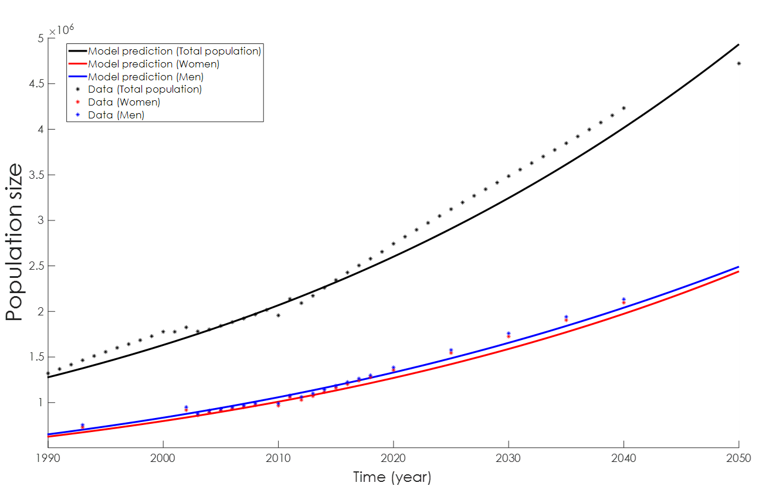

**Figure S2.** Trend in *annual per capita* health expenditure (in United States dollars; USD) in Oman between 1998-2010, as reported in Oman’s Health Vision 2050 report7.

**Figure S3.** Model fit for the sex- and age-specific type 2 diabetes mellitus (T2DM) prevalence in Omanis in 2017 (panels A and B), 2008 (panels C and D), 2000 (panels E and F), and 1991 (panels G and H) national surveys8-11, and also for the 2010 (panel I and J) and 2001 (panel K and L) regional surveys12-14. The regional prevalence measures were ‘anchored’ to fit only the trend in T2DM prevalence, and not the absolute level of T2DM prevalence, as they are not nationally representative. The black crosses in the panels are the data provided by the different population-based surveys in these years8-14.

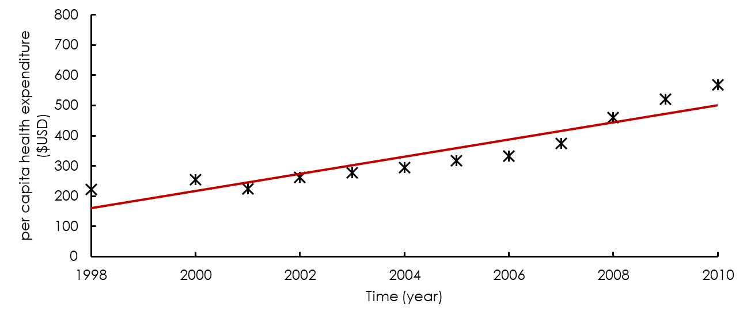

**— Fitted trend**

**Data**



**A.**

**B.**

**C.**

**D.**

**E.**

**F.**

**G.**

**H.**

**I.**

**J.**

**K.**

**L.**



**Figure S4.** Model fit for the sex- and age-specific obesity prevalence in Omanis in 2017 (panels A and B), 2008 (panels C and D), 2000 (panels E and F), and 1991 (panels G and H) national surveys8-11, and also for the 2010 (panel I and J) and 2001 (panel K and L) regional surveys12-14. The regional prevalence measures were ‘anchored’ to fit only the trend in obesity prevalence, and not the absolute level of obesity prevalence, as they are not nationally representative. The black crosses in the panels are the data provided by the different population-based surveys in these years8-14.



**A.**

**B.**

**C.**

**D.**

**E.**

**F.**

**G.**

**H.**

**I.**

**J.**

**K.**

**L.**

**Figure S5.** Model fit for the sex- and age-specific smoking prevalence in Omanis in 2017 (panels A and B), 2008 (panels C and D), 2000 (panels E and F), and 1991 (panels G and H) national surveys8-11, and also for the 2010 (panel I and J) and 2001 (panel K and L) regional surveys12-14. The regional prevalence measures were ‘anchored’ to fit only the trend in smoking prevalence, and not the absolute level of smoking prevalence, as they are not nationally representative. The black crosses in the panels are the data provided by the different population-based surveys in these years8-14.

**A.**

**B.**

**C.**

**D.**

**E.**

**F.**

**G.**

**H.**

**I.**

**J.**

**K.**

**L.**



**Figure S6.** Model fit for the sex- and age-specific physical inactivity prevalence in Omanis in 2017 (panels A and B) and 2008 (panels C and D) national surveys10, 11, and also for the 2010 (panel E and F) and 2001 (panel G and H) regional surveys12-14. The regional prevalence measures were ‘anchored’ to fit only the trend in physical inactivity prevalence, and not the absolute level of physical inactivity prevalence, as they are not nationally representative. The black crosses in the panels are the data provided by the different population-based surveys in these years10-14.

**A.**

**B.**

**C.**

**D.**

**E.**

**F.**

**G.**

**H.**



**Figure S7.** Assumptions used in three sensitivity analyses. **A)** Obesity trend between 1990-2050 assuming that the *age-specific* obesity prevalence remained constant after 2017. **B)** Obesity trend between 1990-2050 assuming a slower growth in obesity prevalence after 2017 than projected in the main analysis. **C)** Physical inactivity trend between 1990-2050.

**C.**

**A.**

**B.**



**Figure S8.** Population pyramid in 2040 in **A)** the baseline analysis and **B)** the sensitivity analysis in which the demographic structure of Omanis was set so that it is similar to that projected by the United Nations for Oman16 (by enforcing a declining trend in the birth rate).



**A.**

**B.**

**Figure S9.** Sensitivity analyses. Projected type 2 diabetes mellitus (T2DM) incidence rate in Omanis aged 20-79 years, between 1990-2050, assuming **A)** the *age-specific* obesity prevalence remained stable after 2017, **B)** lower obesity prevalence than projected in the main analysis between 2017-2050, **C)** higher prevalence of physical inactivity than that self-reported in the Omani surveys8-10, 12-14, and **D)** demographic structure similar to that projected by the Population Division of the United Nations Department of Economic and Social Affairs16.

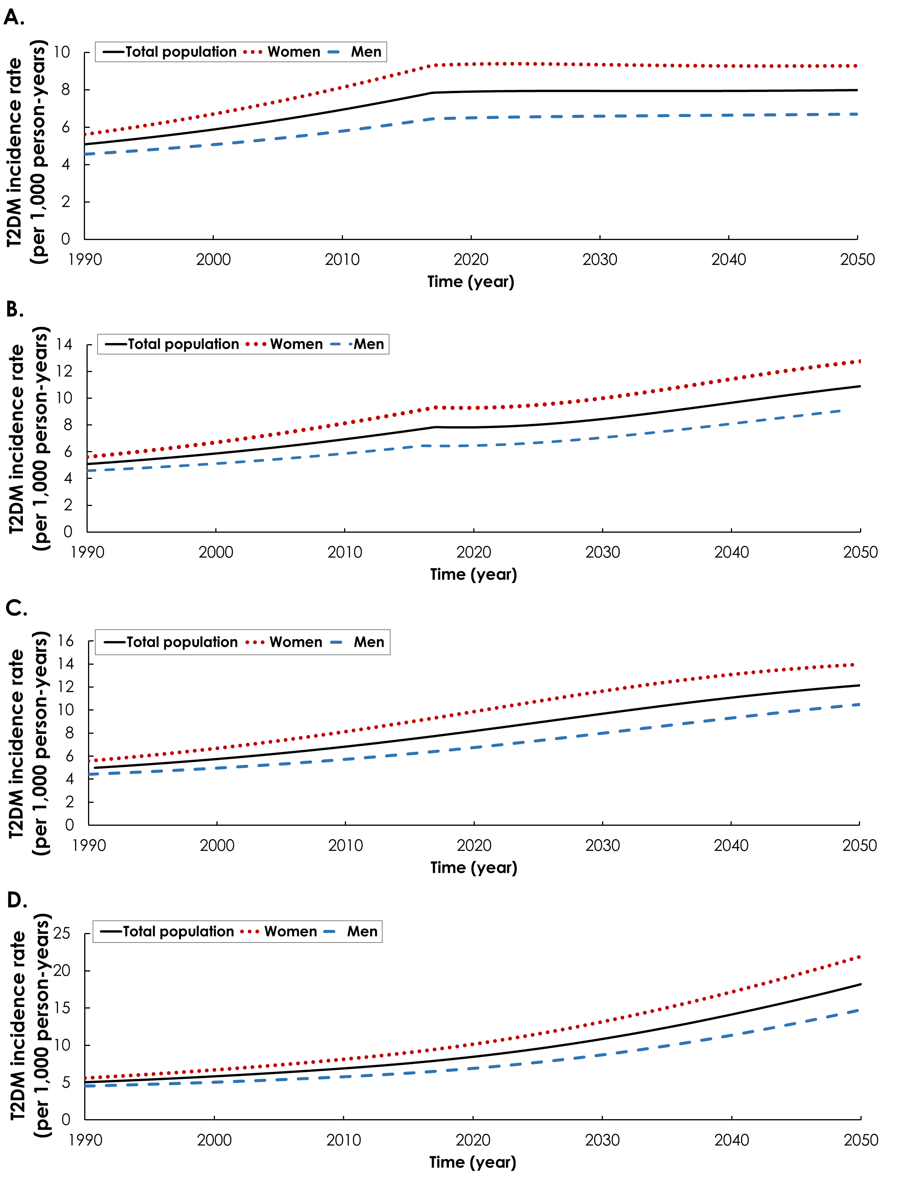

**Figure S10.** Sensitivity analyses to assess the sensitivity of the model predictions for type 2 diabetes mellitus (T2DM) prevalence in 2050 to variations in the relative risks (RRs) of the T2DM-related risk factors and RR of mortality in T2DM compared to the general population. Blue bars are based on the lower bound of parameter values (lower bound of the 95% confidence interval; CI) and red bars are based on the upper bound of parameter values (upper bound of the 95% CI).

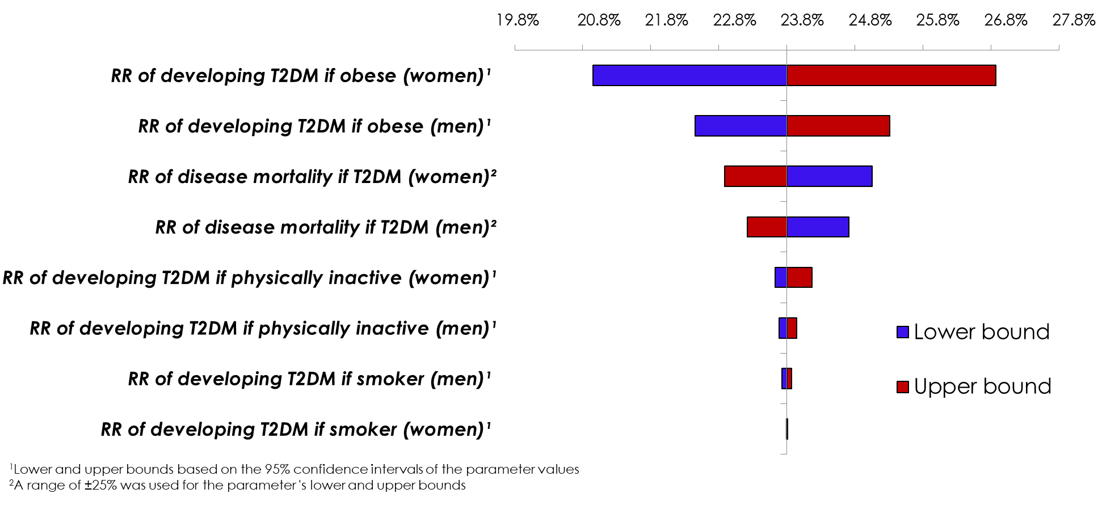

Figure S11. Uncertainty interval for the prevalence of type 2 diabetes mellitus (T2DM) in Oman between 1990-2050. The solid black line represents the mean, while the dashed lines bracket the 95% uncertainty interval.

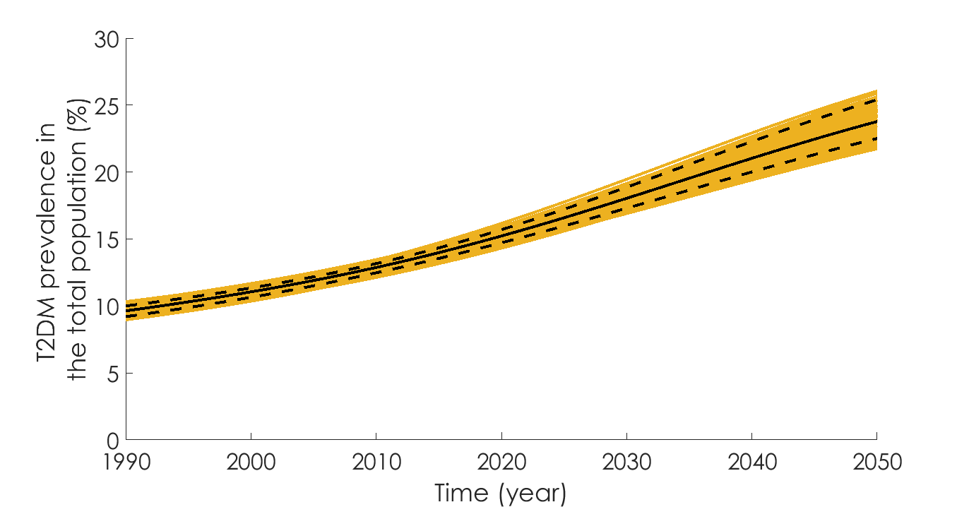

**References**

1. Abdullah A, Peeters A, de Courten M, Stoelwinder J. The magnitude of association between overweight and obesity and the risk of diabetes: a meta-analysis of prospective cohort studies. Diabetes research and clinical practice. 2010;89(3):309-19.

2. Pan A, Wang Y, Talaei M, Hu FB, Wu T. Relation of active, passive, and quitting smoking with incident type 2 diabetes: a systematic review and meta-analysis. The lancet Diabetes & endocrinology. 2015;3(12):958-67.

3. Fiona C. Bull, Timothy P. Armstrong, Tracy Dixon SH, Andrea Neiman, Pratt M. Comparative Quantification of Health Risks. Global and Regional Burden of Disease Attribution to Selected Major Risk Factors. Chapter 10: Physical Inactivity. (available at: <http://www.who.int/publications/cra/chapters/volume1/0729-0882.pdf?ua=1>). World Health Organization; 2004.

4. Nakagami T, Decoda Study Group. Hyperglycaemia and mortality from all causes and from cardiovascular disease in five populations of Asian origin. Diabetologia. 2004;47(3):385-94.

5. International Diabetes Federation. IDF Diabetes Atlas. 3th edition. Brussels, Belgium (available at: <https://www.idf.org/sites/default/files/Diabetes-Atlas-3rd-edition.pdf>. Accessed on 10 Dec. 2015). 2006.

6. Zhang P, Zhang XZ, Brown J, Vistisen D, Sicree R, Shaw J, et al. Global healthcare expenditure on diabetes for 2010 and 2030. Diabetes research and clinical practice. 2010;87(3):293-301.

7. Undersecretariat for Planning Affairs. Health Vision 2050, Quality Care Sustained Health (available at: <https://www.moh.gov.om/documents/16506/119833/Health+Vision+2050/7b6f40f3-8f93-4397-9fde-34e04026b829>; accessed May 31, 2020). Muscat: Ministry of Health, Oman; 2014.

8. Asfour M, Lambourne A, Soliman A, Al‐Behlani S, Al‐Asfoor D, Bold A, et al. High prevalence of diabetes mellitus and impaired glucose tolerance in the Sultanate of Oman: results of the 1991 national survey. Diabetic medicine. 1995;12(12):1122-5.

9. Al-Lawati JA, Al Riyami AM, Mohammed AJ, Jousilahti P. Increasing prevalence of diabetes mellitus in Oman. Diabetic Medicine. 2002;19(11):954-7.

10. Al Riyami A, Elaty MA, Morsi M, Al Kharusi H, Al Shukaily W, Jaju S. Oman world health survey: part 1-methodology, sociodemographic profile and epidemiology of non-communicable diseases in Oman. Oman Med J. 2012;27(5):425-43.

11. Oman Ministry of Health. National Health Survey of Non-Communicable Diseases Risk Factors (Available at: <https://www.who.int/ncds/surveillance/steps/oman/en/>). 2017.

12. Oman Ministry of Health. Summary Report of the Nizwa Healthy Lifestyle Project Survey 2001. Muscat, Oman: Ministry of Health. 2002.

13. Al-Siyabi H A-AZ, Al-Hinai H, Al-Hinai S. . Nizwa Healthy Lifestyle Project Evaluation Report 2010. Ad Dakhiliyah, Oman: Ministry of Health. 2010.

14. Al-Lawati JA, Panduranga P, Al-Shaikh HA, Morsi M, Mohsin N, Khandekar RB, et al. Epidemiology of Diabetes Mellitus in Oman: Results from two decades of research. Sultan Qaboos University medical journal. 2015;15(2):e226-33.

15. National Centre for Statistics & Information of Oman. Population Projections 2020-2040 (Available at: <https://ncsi.gov.om/Elibrary/LibraryContentDoc/ben_projection-Eng_87f44b27-0bf3-4a80-b2d2-1ead231a0165.pdf>). 2017.

16. United Nations, Department of Economic and Social Affairs, Population Division. World Population Prospects: The 2019 Revision, DVD Edition. (Available at: <https://esa.un.org/unpd/wpp/Download/Standard/Population/>) 2019