Supplementary Appendix 1: Cohort construction of individuals presenting with chronic gastrointestinal symptoms

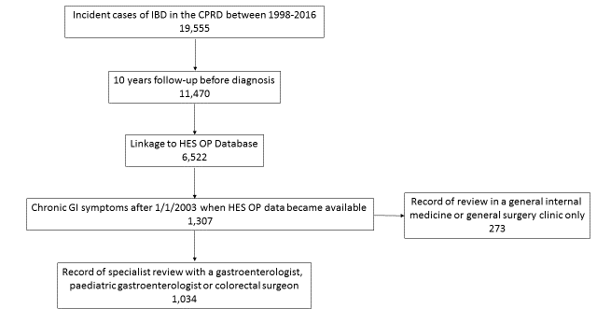

IBD - Inflammatory Bowel Disease
CPRD - Clinical Practice Research Datalink
HES OP- Hospital Episodes Statistics Outpatient data
Chronic GI Symptoms – An individual who presented to their primary care physician with gastrointestinal symptoms twice or more within a 6 month period, where the first and last presentations in that period were at least 6 weeks apart.

Supplementary Appendix 2: List of CPRD medcodes used in the definition of gastrointestinal symptoms.

We identified a cohort of 19,555 incident cases of IBD and then identified any medcodes that were used more than 20 times in the entire cohort. This generated a list of 8,948 medcodes which were reviewed by four clinicians with an interest in IBD (JB, SS, CA and RP). Each clinician separately identified any codes indicative of diarrhoea, abdominal or perianal pain, rectal bleeding or miscellaneous gastrointestinal symptoms. We included medcodes in the code list for gastrointestinal symptoms where the majority considered that medcode to be indicative of a gastrointestinal symptom. In the event of a tie the first author (JB) decided whether the medcode should be included in the list.
Codes were excluded if they described a definite diagnosis (eg. Campylobacter Enteritis).
As rectal bleeding from UC is often initially misdiagnosed as haemorrhoids we included codes for haemorrhoids (eg. Bleeding haemorrhoids NOS) in our list for rectal bleeding. However more specific codes such as Prolapsed Haemorrhoids were not included, as a primary care physician would be unlikely to use this code without definite evidence that haemorrhoids were present.
We defined GI symptoms to include all the codes for diarrhoea, abdominal or perianal pain and rectal bleeding as well as miscellaneous codes for GI symptoms (eg. Gastrointestinal symptoms) which did not fit into a specific category.
Diarrhoea
Description | Medcode
Diarrhoea symptoms | 5134
Diarrhoea | 192
Diarrhoea | 4343
Loose stools | 1695
Chronic diarrhoea | 6685
Diarrhoea of presumed infectious origin | 5090
Diarrhoea symptom NOS | 14695
Noninfective diarrhoea | 6016
Functional diarrhoea | 5036
Increased frequency of defaecation | 18682
[D] Stools loose | 14881
Irritable bowel syndrome with diarrhoea | 29835
Infectious diarrhoea | 4542
Gastroenteritis | 139
Diarrhoea & vomiting, symptom | 2182
Diarrhoea and vomiting | 7644
Viral gastroenteritis | 3107
Diarrhoea & vomiting -? Infect | 14665
[D]Change in bowel habit | 16665
Travellers' diarrhoea | 11155
Viral diarrhoea | 15289
Infectious gastroenteritis | 10294

Abdominal or perianal pain
Description | Medcode
Abdominal pain | 177
[D]Abdominal pain | 1763
Abdominal pain type | 1976
Abdominal discomfort | 2383
Anal pain | 3049
Right iliac fossa pain | 1181
[D]Abdominal colic | 2056
Left iliac fossa pain | 2982
Colicky abdominal pain | 7812
Rectal pain | 2767
[D]Abdominal cramps | 716
O/E - abdomen tender | 5782
[D]Abdominal pain NOS | 3338
Site of abdominal pain | 5960
Lower abdominal pain | 22608
Central abdominal pain | 4617
Flank pain | 7490
[D]Nonspecific abdominal pain | 19283
[D]Functional abdominal pain syndrome | 103540
Iliac fossa pain | 421
[D]Acute abdomen | 948
O/E - abdo. pain on palpation | 15180
Anorectal pain | 2866
Generalised abdominal pain | 24661
O/E -abd.pain on palpation NOS | 14916
O/E - abd. pain - L.iliac | 21583
Non-colicky abdominal pain | 5691
Abdominal pain in pregnancy | 3191
[D]Pain in left iliac fossa | 16868
[D]Pain in right iliac fossa | 16806
O/E - abd. pain - R.iliac | 11647
C/O pelvic pain | 2781
Suprapubic pain | 7300
Perianal irritation | 9837
[D]Colic NOS | 1239
Perianal itch | 5830
[D]Epigastric pain | 542
Perineal irritation | 7090
[D] Perineal pain | 7248
[D]Pelvic and perineal pain | 9920
[D]Recurrent acute abdominal pain | 2234
Upper abdominal pain | 3978
Right upper quadrant pain | 9695
[D]Right upper quadrant pain | 7726
O/E - abd. pain – epigastrium | 19223
[D]Upper abdominal pain | 8436
Left flank pain | 701
Epigastric pain | 290
[D]Flatulence, eructation and gas pain | 14807
Type of GIT pain | 14989
Type of GIT pain – symptom | 6395
[D]Umbilical pain | 4771

Rectal Bleeding
Description | Medcode
Rectal bleeding | 621
Bleeding PR | 3872
Painless rectal bleeding | 11698
Painful rectal bleeding | 11718
Blood in stool | 2873
Blood in faeces | 5462
Blood in faeces symptom | 6151
Gastrointestinal haemorrhage | 3097
GIB - Gastrointestinal bleeding | 1642
Haemorrhoids | 195
Piles – haemorrhoids | 3833
Haemorrhoids NOS | 2096
Bleeding haemorrhoids NOS | 2832
PRB - Rectal bleeding | 6554
Miscellaneous Gastrointestinal Symptoms
Description | Medcode
Gastrointestinal symptoms | 13015
GIT symptoms | 10896

Supplementary Appendix 3: Prevalence of gastrointestinal symptoms before Crohn’s disease diagnosis
 | Prevalence of GI symptoms (%) |  |  |  | Risk Difference (%) | 95% Confidence Interval
 | Crohn’s Disease |  | Controls
n= | 5,874 |  | 23,436
Years before IBD diagnosis
1 | 29.1 |  | 6.5 |  | 22.6 | 21.3-23.9
2 | 16.8 |  | 6.2 |  | 10.7 | 9.5-11.8
3 | 13.6 |  | 5.7 |  | 7.9 | 6.8-8.9
4 | 11.8 |  | 6.0 |  | 5.9 | 4.8-6.9
5 | 10.4 |  | 6.2 |  | 4.2 | 3.2-5.2
6 | 9.1 |  | 6.7 |  | 3.5 | 2.5-4.4
7 | 8.1 |  | 5.3 |  | 2.7 | 1.8-3.7
8 | 7.6 |  | 5.1 |  | 2.5 | 1.5-3.4
9 | 7.4 |  | 4.8 |  | 2.6 | 1.6-3.5
10 | 6.0 |  | 4.7 |  | 1.3 | 0.4-2.2
Prevalence of GI symptoms – The percentage of individuals who presented to a primary care physician for gastrointestinal symptoms in that 12 month period.

Supplementary Appendix 4: Prevalence of gastrointestinal symptoms before ulcerative colitis diagnosis
 | Prevalence of GI symptoms (%) |  |  |  | Risk Difference (%) | 95% Confidence Interval
 | Ulcerative colitis |  | Controls
n= | 13,681 |  | 54,616
Years before IBD diagnosis
1 | 23.9 |  | 6.7 |  | 17.2 | 16.4-18.0
2 | 15.4 |  | 6.4 |  | 9.0 | 8.3-9.7
3 | 12.8 |  | 5.8 |  | 7.0 | 6.3-7.6
4 | 11.3 |  | 5.9 |  | 5.4 | 4.8-6.1
5 | 9.6 |  | 5.6 |  | 4.0 | 3.4-4.6
6 | 9.6 |  | 5.4 |  | 4.2 | 3.6-4.9
7 | 8.4 |  | 5.4 |  | 3.0 | 2.3-3.6
8 | 7.7 |  | 5.2 |  | 2.5 | 1.9-3.1
9 | 8.0 |  | 4.9 |  | 3.1 | 2.5-3.8
10 | 6.8 |  | 4.3 |  | 2.5 | 1.9-3.1

Prevalence of GI symptoms – The percentage of individuals who presented to a primary care physician for gastrointestinal symptoms in that 12 month period.

Supplementary Appendix 5: Sensitivity Analysis - Probability of specialist review, including general internal medicine and surgery appointments, after presentation with chronic GI symptoms according to era of presentation

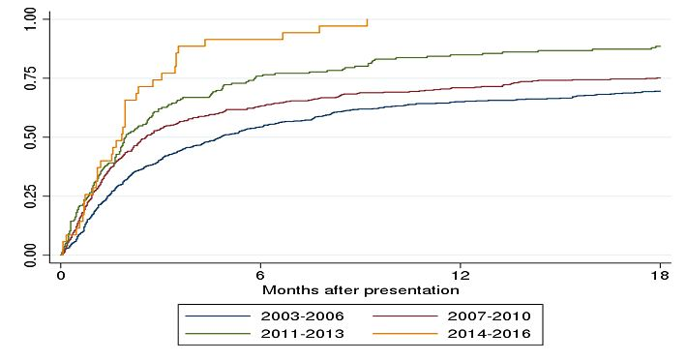
Chronic GI symptoms – Individuals presented to their GP with gastrointestinal symptoms twice within a 6 month period, where the presentations were at least 6 weeks apart.
Specialist review – Outpatient appointment with a gastroenterologist, paediatric gastroenterologist or colorectal surgeon or any appointment coded only as general internal medicine or general surgery

