**Supplementary figure 1**

**Recovery plots for 3 sample pools**

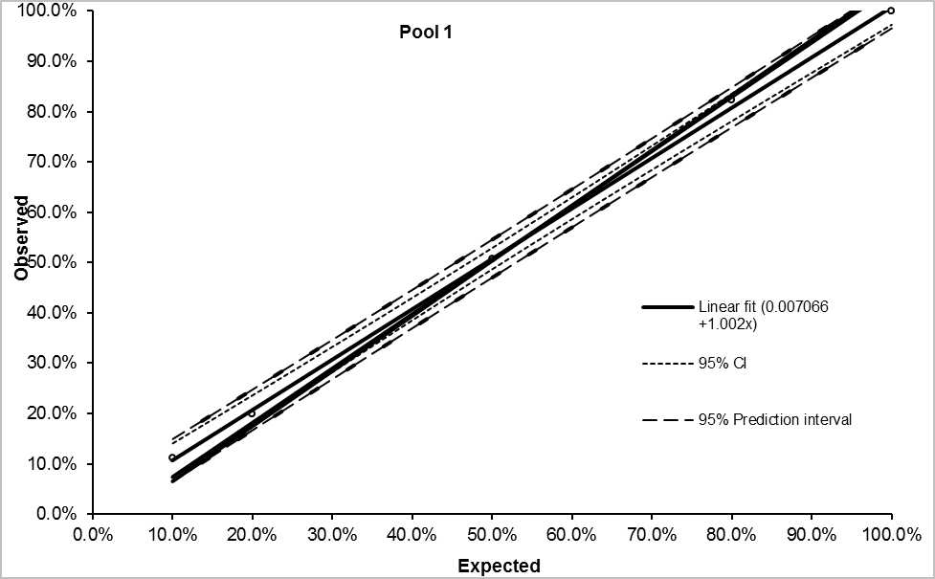

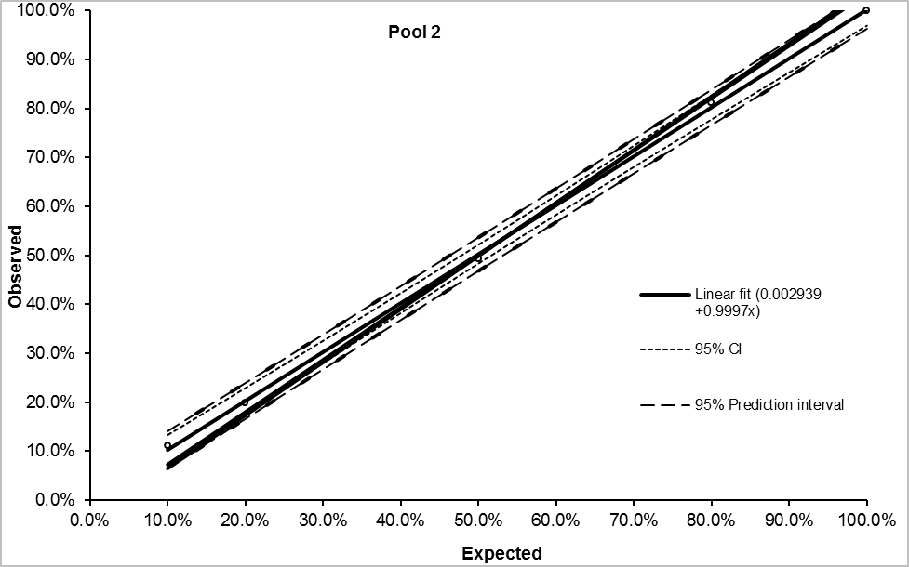

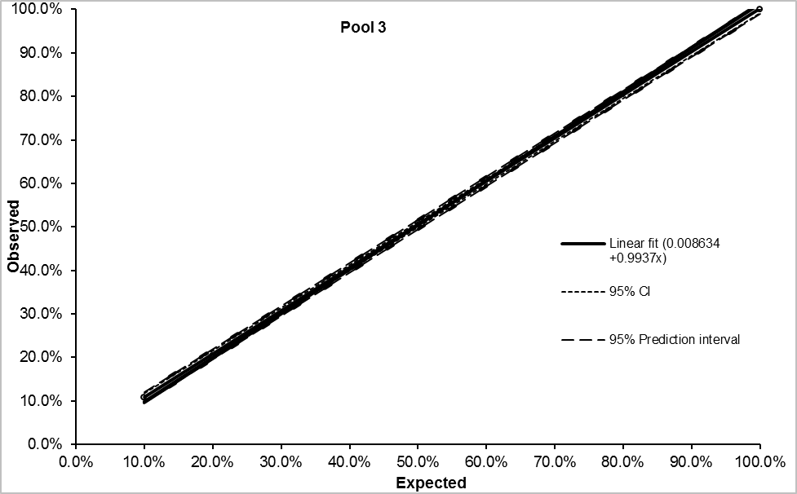

**Supplementary figure 2**

**Linear and polynomial fit plots for 3 sample pools.**

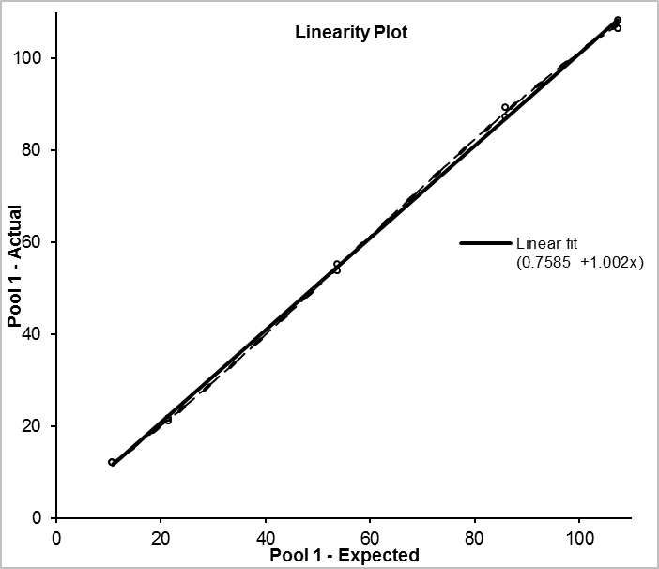

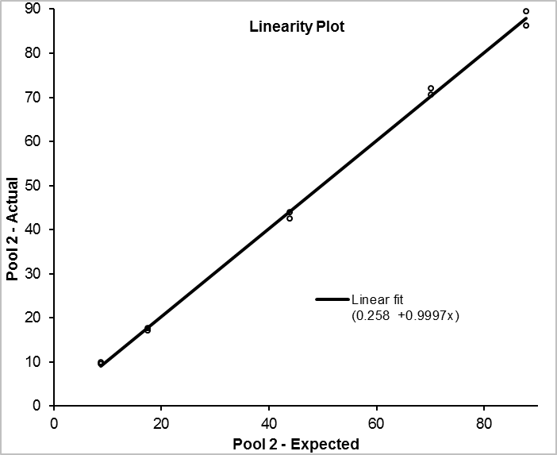

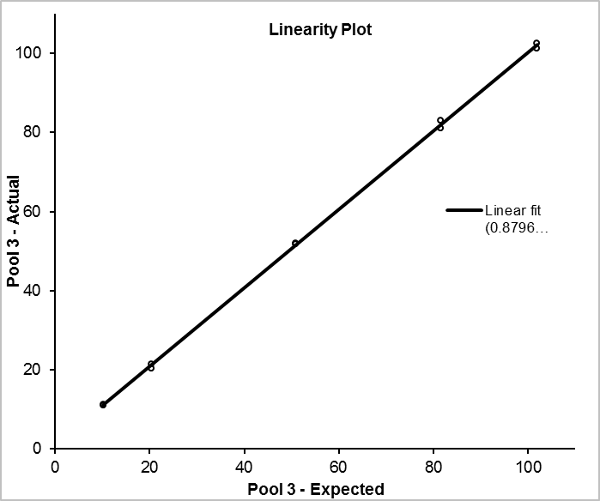

**Supplementary Figure 3 Within run imprecision.**

**Supplementary Figure 4 Receiver operator characteristic curves for the second measurement of cTnI and hFABP.**

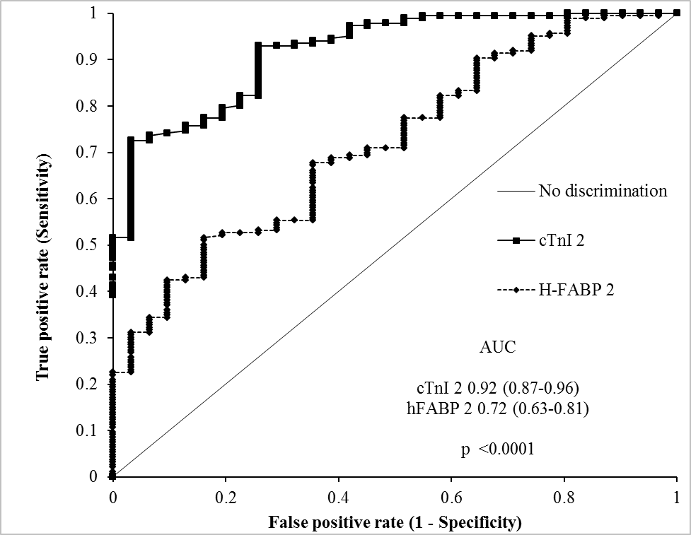

**Supplementary Figure 5 All patients showing pre and post angioplasty samples for hFABP (upper) and cTnI (lower).**

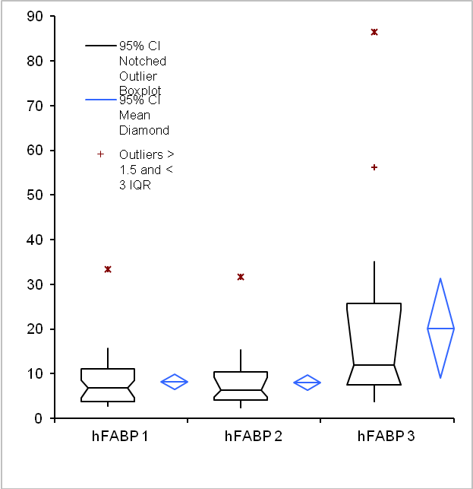

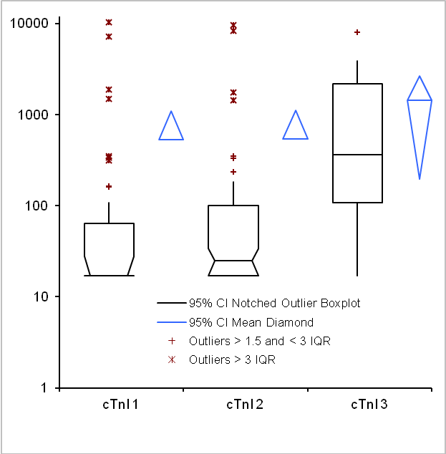

**Supplementary Figure 6 Excluding patients with STEMI showing pre and post angioplasty samples for hFABP (upper) and cTnI (lower).**

