Control/Tracking Number: 20-A-321-OARSI
Activity: Abstract
Current Date/Time: 11/25/2019 9:51:22 AM
DEVELOPMENT OF A NOVEL HISTOLOGICAL SCORING SYSTEM FOR BONE MARROW LESIONS - THE OSTEOARTHRITIS BONE SCORE
Author Block: S. Koushesh¹, D. McWilliams², D. Walsh², M. N. Sheppard³, J. Westaby³, A. Harrison⁴, F. A. Howe³, N. Sofat⁴; ¹Inst. for Infection & Immunity, St George's, Univ. of London, London, United Kingdom, ²Univ. of Nottingham, Nottingham, United Kingdom, ³Molecular and Clinical Sci. Res. Inst., St George's, Univ. of London, London, United Kingdom, ⁴Inst. for Infection and Immunity, St George's, Univ. of London, London, United Kingdom
Abstract:
Purpose: Bone marrow lesions (BMLs) are a known feature of osteoarthritis (OA) and are well described on Magnetic Resonance Imaging (MRI) analysis. However, little is known about the histological changes in BMLs and how histological changes relate to pain in OA BML tissue. We have previously demonstrated that BMLs are highly metabolically active structures, with features of angiogenesis, fibrous connective tissue, cartilage expression and bone resorption. In this work we aimed to develop a novel histological scoring system for BMLs by comparing BML versus non-BML OA tissue and normal bone.
Methods: Tissue was harvested with full informed consent from participants with knee OA defined by ACR criteria who were undergoing total knee joint replacement surgery (TKR). Subjects underwent MRI scan within 6 weeks of TKR. Regions within the tibia demonstrating BML were confirmed independently by two Consultant Radiologists using the MRI Knee Osteoarthritis Score (MOAKS). MRI-identified BML areas were biopsied based on MRI findings. A comparator non-BML region from the same subject was also biopsied for comparison. To compare OA subjects with non-OA controls, tissue sections were obtained from post mortem donated knee joint tissues. The control subjects who had no known history of OA were age and gender matched to the OA group. Tissue was decalcified and sections were stained with haematoxylin and eosin and Safranin O/Fast green protocols. A standardised chondropathy score for each participant was obtained using the Mankin grading system (0-14). Then, a newly developed Osteoarthritis Bone Score (OABS) system was applied to all sections, which included 6 domains comprising the structure of bone (cysts with or without fibrosis), increase in blood vessels (graded as normal, small, moderate or large increase), presence or absence of new cartilage within the bone, thickened trabeculae (graded as mild, moderate or severe), tidemark integrity and inflammation, defined as fibrovascular infiltration of marrow. Based on this system a summed score ranging from 0-11 was reached, with 0 being normal and 11 the highest damage. Immunohistochemistry analysis of BML tissue was also assessed for the presence of nerve staining by using a PGP9.5 primary anti-human antibody, with a donkey anti-mouse conjugated horseradish peroxidase secondary antibody development system.
Results: We analysed a total of 28 samples, of which 9 were BML tissue from TKR, 9 were non-BML regions from the same participants, with 10 separate non-OA control subjects who did not have a clinical diagnosis of OA at post-mortem. Sections were scored for Mankin grade and the new OABS. The mean (±SD) age for the OA group was 66.1, (80 % female) and for the non-OA group the mean age was 64.4 (70 % female), with no significant difference in age in the two groups (p=0.63). The mean WOMAC score for the OA group was 54.84 (± 15.81) with a mean Body Mass Index of 30.58 (± 2.95). We found that the mean (±SD) scores for cartilage damage by Mankin grade was 7.56 (± 4.64) in the non-BML tissue for OA subjects, compared with 9.44 (±3.32) in the BML OA sections. The OABS had a mean of 3.11 (±1.97) in the non-BML regions, versus a mean score in the BML regions of 7.44 (± 2.65). In contrast, normal non-OA bone tissue harvested at post-mortem showed mean Mankin scores of 2.7 (± 1.70) and Osteoarthritis Bone Scores of 1.2 (± 0.63). Significance testing by Mann-Whitney U showed there was a significant difference between Mankin scores in OA subjects and controls (p=0.022), but no difference in Mankin scores between non-BML and BML samples (0.60). There was a significant difference in OABS between OA subjects and controls (p=0.017), and between non-BML and BML OA regions (p=0.008). The domains showing greatest degree of histological change for BML tissue were increased blood vessels, thickened trabeculae and disruption of tidemark integrity, which were found in 100% of the cases analysed. Although cysts were most often accompanied by fibrosis, they were less frequent (80% of cases). Increased blood vessels were most often distributed at the osteochondral junction, but were also increased in number throughout bone (Figure 1). De novo cartilage formation was also seen in 40% of cases. Increased vascular density was also associated with the presence of nerves, confirmed by positive PGP9.5 staining, which was most frequently observed in a perivascular distribution.
Conclusions: We have developed a novel scoring system for BMLs in OA to identify the severity of bone damage in OA tissue based on the six most frequent histological changes. We have also demonstrated the increased vascularity that is the most prominent feature of BMLs. Our work shows, for the first time to our knowledge, that nerve expression visualised by PGP9.5 staining is a feature of BMLs and could be a reason for the high association of BMLs with pain in people with symptomatic OA.
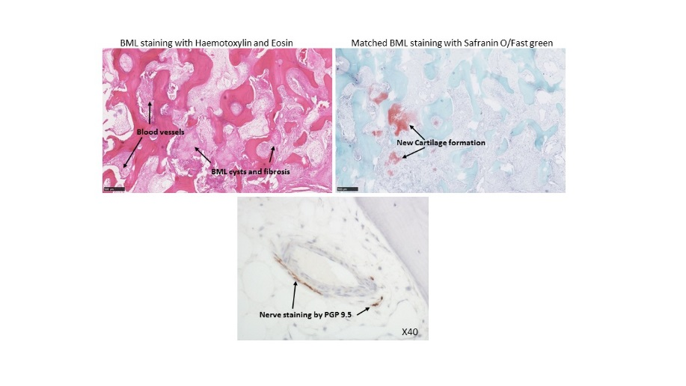
:
Category (Complete): Pain – Molecular Mechanisms
Keyword (Complete): Bone Marrow Edema ; Histology ; Pain ; Joint Replacement
Presentation Preference (Complete): Either Podium or Poster
Additional (Complete):
Type of Abstract (Required): Basic Science
Are you age 40 or under and within 5 years of your research degree? (Required): No
Do you want to be considered for a Need Based Travel Assistance Award? (Required): No

