**SUPPLEMENTARY MATERIAL**

**Epidemiological Impact of Targeted Interventions for People with Diabetes Mellitus on Tuberculosis Transmission in India: Modelling Based Predictions**

Susanne F. Awad,1,2 Julia A. Critchley,2 and Laith J. Abu-Raddad,1,3,4

1Infectious Disease Epidemiology Group, Weill Cornell Medicine-Qatar, Cornell University, Qatar Foundation - Education City, Doha, Qatar

2Population Health Research Institute, St George’s, University of London, London, UK

3Department of Healthcare Policy and Research, Weill Cornell Medicine, Cornell University, New York, New York, USA

4College of Health and Life Sciences, Hamad bin Khalifa University, Doha, Qatar

**Text I—DESCRIPTION OF THE TB-DM INTERVENTION MODEL**

We extended a recently developed mathematical model (Awad et al. 2019b) of the dynamics of tuberculosis-diabetes mellitus (TB-DM) interactions, to investigate the impact of different intervention scenarios on TB transmission in India. The model stratified the population by age (20 5-years age bands representing 0-99 years old), TB infection status, TB infection stage (latent-fast and latent-slow), TB disease form (pulmonary smear-positive, pulmonary smear-negative, and extra-pulmonary), TB treatment status, TB recovery status, DM status, and TB-DM intervention status. The model was described by a set of coupled nonlinear ordinary differential equations codded in MATLAB 2018b (The MathWorks et al. 2018).

**Figure S1. A schematic diagram of the tuberculosis-diabetes mellitus (TB-DM) intervention model.** The different color-coded lines between TB natural history in people with DM but no intervention, and people with DM undergoing intervention(s), indicate the different modelled interventions (i.e. blue for vaccination, green for latent TB treatment, and orange for controlling DM in people with DM).



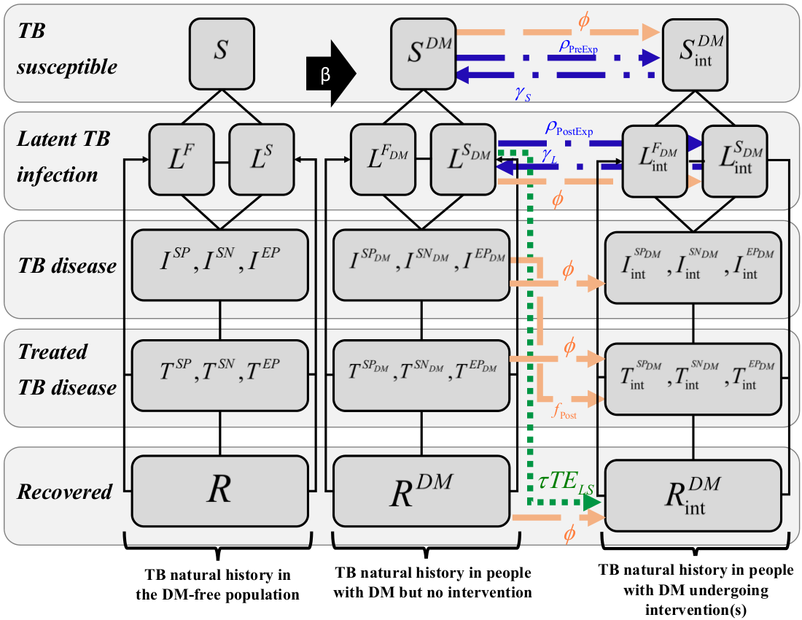

The TB-DM model was a population-based deterministic compartmental model that accounts for the epidemiological dynamics and interactions between TB and DM (Figure S1). The flow from one age group to the next was dictated by the rate . Twenty 5-year age groups (indexed by ) were incorporated in the model, of which the first three were children (ages 0–14). All non-DM individuals were assumed at risk of developing DM at an age-dependent rate  (except those 0-4 years old; ).

Diabetes mellitus was assumed to affect TB natural history and treatment outcomes through 10 different effects that were included based on empirical evidence (Awad et al. 2019a;Awad et al. 2019b): Compared to non-DM individuals, DM increased susceptibility to TB infection (*Effect 1-Susceptibility;* ), proportion of TB infections entering latent fast (LFI) versus latent slow (LSI) states (*Effect 2-Fast progression;* ), susceptibility to develop TB disease among those with LSI (*Effect 3-Reactivation;* ), susceptibility to TB reinfection among those with LSI (*Effect 4-Primary reinfection;* ), proportion of those developing smear-positive pulmonary TB disease (versus smear-negative) for those with pulmonary TB disease (*Effect 5-Smear positivity;* ), and TB infectiousness among those with pulmonary TB disease (*Effect 6-Disease infectiousness;* ).

Furthermore, compared to non-DM individuals, DM increased the risk of TB-related mortality (*Effect 7-TB mortality;* ), reduced the proportion of successful treatment among those undergoing TB treatment (*Effect 8-Treatment failure;* ), delayed the resolution of TB disease (*Effect 9-Recovery;* ), and increased susceptibility to TB reinfection after recovery (*Effect 10-Cured reinfection;* ).

Interventions in the model (indexed ) were incorporated into TB natural history and disease dynamics, by generating a distinct and separate TB natural history for the proportion of individuals undergoing the intervention (Figure S1).

**TB vaccination**

Two different types of vaccination were incorporated in the model: pre-exposure (prophylactic) vaccine and post-exposure vaccine. The pre-exposure vaccine was administered to DM individuals who were uninfected but susceptible to TB, at a rate . Vaccinated individuals could become infected with TB at a rate . If infected, vaccinated individuals proceeded through TB disease stages that were analogous to those for non-vaccinated DM individuals. Vaccine efficacy waned with time, with vaccinated individuals moving back to the susceptible population category at a rate of . Once there, individuals would receive a vaccine boost to return to the vaccinated state at a rate , or they would become infected with TB, at which point they follow the TB natural history of non-vaccinated DM individuals.

The post-exposure vaccine was administered to DM individuals who are latently TB infected, at a rate , moving them into the *vaccinated* latent TB infection category. Once vaccinated, individuals who received a post-exposure vaccine followed a similar TB natural history to those who received a pre-exposure vaccine. Vaccine efficacy waned with time with the vaccinated individuals moving back to the unvaccinated latent TB infection category at a rate .

Only the pre-exposure vaccine reduced the fraction of TB infected persons who were TB fast progressors, by a fraction . Both pre-exposure and post-exposure vaccines reduced the infectiousness of those vaccinated who became infected and developed pulmonary TB disease, by a fraction . Also, both vaccines reduced the rate of progression to TB disease for those latently infected (slow progressors), by a fraction .

**Treatment of latent TB as preventive therapy**

Latent TB infection is a reservoir that serves as the source of new TB disease cases. In the model, preventive latent TB therapy was assumed to be administered to DM individuals with latent TB infection, to prevent development of active TB disease. Individuals with latent TB and DM were assumed to be treated at a rate . Those who are successfully treated (with  being the efficacy of TB latent therapy), move to the recovery state . Once there, they can be reinfected with TB and progress with the usual TB natural history for people with DM.

**Controlling DM for improved TB progression and treatment outcomes**

To alleviate the impact of DM on TB, DM can be managed and controlled as an intervention (i.e. hemoglobin A1c [HbA1c] level of <8.0% (American Diabetes Association 2017)). One intervention is for a proportion  of DM individuals with TB disease to be dually treated for both TB and DM at the same time, to cure TB and to control DM. A second intervention is for all DM individuals whether unexposed to TB, latently infected with TB, with TB disease, treated TB disease, or recovered TB disease, to be treated at a rate .

For those DM individuals with controlled DM, the effects of DM on TB infection, TB disease, and TB treatment outcomes are reduced, relative to those with uncontrolled DM, through a fraction . For instance, the effect size for DM’s effect on the susceptibility to TB infection (*Effect 1-Suceptibility*), for those with controlled DM, is given by:



**Text II—MODEL EQUATIONS**

The TB-DM model was based on extension of the Awad et al. model (Awad et al. 2019b), to include interventions targeting people with DM. The model equations are listed below, with the key intervention-related terms highlighted in color—i.e. vaccination terms are in blue, latent therapy terms are in green, while DM control terms are in orange. Definitions of all symbols in these equations can be found in Table S1.

**No intervention branch of the equations, for the population without DM**

*TB and DM susceptible:*



*TB latent infection:*



*TB disease:*



*Treated TB disease:*



*Recovered:*



**No intervention branch of the equations, for the population with DM (aged**  **years)**

*TB susceptible with DM:*



*TB latent infection with DM:*



*TB disease with DM:*



*Treated TB disease with DM:*



*TB recovered with DM:*



**Intervention branch of the equations, for the population with DM (aged**  **years)**

*TB susceptible with DM:*



*TB latent infection with DM:*



*TB disease with DM:*



*Treated TB disease with DM:*



*TB recovered with DM:*



Here, total number of individuals in the population, , is given by:



The parameter  for the population with DM was determined according to:





while,

,



and

.

Here,  and  are the proportions of smear-positive pulmonary TB cases in the DM and non-DM groups, respectively, as found in Table S3.

**Table S1: Definitions of the symbols in the model**

|  |  |
| --- | --- |
| SYMPOL | DEFINITION |
|  | Susceptible to TB without and with DM, where index *i* marks the intervention status |
|  | TB latent fast infection without and with DM, where index *i* marks the intervention status |
|  | TB latent slow infection without and with DM, where index *i* marks the intervention status |
|  | Smear-positive pulmonary TB disease without and with DM, where index *i* marks the intervention status |
| .. | Smear-negative pulmonary TB disease without and with DM, where index *i* marks the intervention status |
|  | Extra-pulmonary TB disease without and with DM, where index *i* marks the intervention status |
|  | Treated smear-positive pulmonary TB disease without and with DM, where index *i* marks the intervention status |
|  | Treated smear-negative pulmonary TB disease without and with DM, where index *i* marks the intervention status |
|  | Treated extra-pulmonary TB disease without and with DM, where index *i* marks the intervention status |
|  | Recovered without and with DM, where index *i* marks the intervention status |
|  | Total population |
|  | Birth rate |
|  | Natural mortality rate |
|  | Transition rate from one age group to the next age group |
|  | A function that is 1 for age group  and 0 otherwise |
|  | Proportion of TB infections entering latent-fast state |
|  | Proportions of new TB disease cases in each of the three clinical disease categories# |
|  | Fractional reduction in the susceptibility to TB reinfection due to prior exposure to TB |
|  | Progression rate from latency to TB disease for latent-fast progressors |
|  | Progression rate from latency to TB disease for latent-slow progressors |
|  | TB disease mortality rate per TB disease category for untreated and treated cases |
|  | Proportion of TB disease cases that are effectively treated |
|  | TB treatment rate |
|  | Spontaneous recovery rate |
|  | Rate of successful completion of treatment |
|  | TB incidence rate |
|  | DM onset rate |
| , | DM increases susceptibility to TB infection *(Effect 1-Susceptibility).* Here  marks the intervention status |
| , | DM increases the proportion of TB infections entering latent-fast state as opposed to latent-slow state(*Effect 2-Fast progression*). Here  marks the intervention status |
| , | DM increases the rate of developing TB disease among those with latent TB infection (*Effect 3-Reactivation*). Here  marks the intervention status |
| , | DM increases the susceptibility to TB reinfection among those with latent-slow TB infection (*Effect 4-Latent reinfection*). Here  marks the intervention status |
| , | DM increases the proportion of new pulmonary TB disease cases moving to smear-positive as opposed to smear-negative (*Effect 5-Smear positivity*). Here  marks the intervention status |
| , | DM increases the infectiousness of PTB (SP-PTB and SN-PTB) for untreated and treated TB disease cases (*Effect 6-Disease infectiousness*). Here  marks the intervention status |
| , | DM increases the hazard of TB-related mortality for untreated and treated TB disease cases (*Effect 7-TB mortality*). Here  marks the intervention status |
| , | DM reduces the proportion of successful treatment (through increased risk of treatment failure and MDR-TB; *Effect 8-Treatment failure*). Here  marks the intervention status |
| , | DM reduces the rate of TB recovery (i.e. prolongs the recovery time) for those who recover naturally or due to treatment (*Effect 9-Recovery*). Here  marks the intervention status |
| , | DM increases susceptibility to TB reinfection among those treated or recovered from TB disease (*Effect 10-Cured reinfection*). Here  marks the intervention status |
|  | Relative risk (RR) of developing DM in the population with a history of TB disease compared to the general population |
|  | RR of mortality in the DM population compared to the general population |
|  | Pre-exposure vaccination rate |
|  | Post-exposure vaccination rate |
|  | Fractional reduction in the fraction of those who become fast progressors upon TB infection due to prior vaccination |
|  | Fractional reduction in the infectiousness of TB diseases persons due to prior vaccination |
|  | Fractional reduction in the progression rate to TB disease among those who are slow progressors |
|  | Waning rate of vaccine immunity (i.e. duration of vaccine protection) for pre-exposure vaccine |
|  | Waning rate of vaccine immunity (i.e. duration of vaccine protection) for post-exposure vaccine |
|  | Treatment rate of latent TB treatment |
|  | Drug efficacy of latent TB treatment |
|  | Rate at which DM cases are managed to achieve DM control (i.e. HbA1c <8.0%) in all DM individuals whether unexposed to TB, latently infected with TB, with TB disease, or recovered TB disease |
|  | Proportion of DM individuals with TB disease who are dually treated for both TB and DM at the same time, to cure TB and to achieve DM control (i.e. HbA1c <8.0%) |
|  | Fractional reduction (due to intervention) in the effect size of DM-related effects on TB natural history and treatment outcomes |

#The three clinical categories are smear-positive pulmonary (SP), smear-negative pulmonary (SN), and extra-pulmonary (EP) tuberculosis.

**TB force of infection and TB contact rate**

TB force of infection () was determined by the probability of transmission per respiratory contact (), the respiratory contact rate within a population (), the effect of DM on TB infectiousness (, ), the relative infectiousness of individuals with each type of TB disease compared to the infectiousness of individuals with smear-positive pulmonary TB (), and the fractional reduction in the infeciousness of TB disease due to pre- or post-exposure vaccination ():





Given the evidence for declining TB incidence in India, the temporal variation of  was characterized by a Wood-Saxon function (Velicia 1987;Woods et al. 1954):



Here,  is the asymptotic value that describes the contact rate well after the transition, Z is the level of change in  during the transition from  before the transition to  after the transition,  describes the transition duration parameter, and  is the turning point year at which the contact rate crosses half way towards its asymptotic value of .

These parameters were obtained by fitting the model to available country-specific TB-incidence and mortality data (World Health Organization 2017).

**TB treatment and TB case detection rates**

Treatment rate in the model depended on TB disease type and was determined by:



Here, , , and  are the case detection rates (by disease type), , , and  are the TB-related mortality rates, and , , and  are the spontaneous recovery rates.

Given the evidence for increasing TB case detection in India (The World Bank 2015) and the likelihood of underreporting of treatment among TB cases, the temporal variation in TB case detection rate was parametrized through a logistic function:

.

 are the reported case detection ratios (by disease type) obtained from the World Health Organization (Abu-Raddad et al. 2009)), while the parameters , , and  were obtained by fitting the model to available country-specific TB-incidence and mortality data (World Health Organization 2017).

**DM onset rate**

Given that DM incidence and prevalence in India are increasing (International Diabetes Federation 2016), the rate of DM onset in the TB-DM model was assumed to be age and time dependent, and was parameterized through:

.

The parameters of this combined Gaussian-logistic function (, , , , and ) were obtained by fitting the model to the age- and time-specific DM prevalence data for India (Anjana et al. 2017;International Diabetes Federation 2016).

**Demographic parameters**

Population growth rate () and natural mortality rate () were described by the following functions (Ayoub et al. 2018):



and



The parameters , , , , , , , and  were obtained by fitting the model to the age-specific population data for India (United Nations Department of Economic and Social Affairs et al. 2012. available: http://esa.un.org/wpp/Excel-Data/population.htm ).

**Text III—DATA SOURCES**

The TB-DM model was parameterized using empirical epidemiological and natural history data from multiple sources. The model’s parameter values for TB natural history in absence of DM, along with their references, are listed in Table S2.

**Table S2. Model assumptions in terms of parameter values.**

|  |  |  |  |  |  |
| --- | --- | --- | --- | --- | --- |
| **Symbol** | **Definition** | **Parameter value** | | | **Sources** |
|  |  | **0-14 years old** | | **15+ years old** |  |
|  | Proportion of TB infections entering latent-fast state |  | |  | (Abu-Raddad et al. 2009;Dye et al. 1998) |
|  | Proportions of new TB disease cases in each of the three clinical disease categories# |  | |  | (Barnett GD et al. 1977) |
|  | Fractional reduction in the susceptibility to TB reinfection due to prior exposure to TB |  | | | (Abu-Raddad et al. 2009;Dye et al. 2008) |
|  | Progression rate from latency to TB disease for latent-fast progressors (per year) |  | | | (Abu-Raddad et al. 2009) |
|  | Progression rate from latency to TB disease for latent-slow progressors (per year) |  | | | (Abu-Raddad et al. 2009;Dye et al. 2008) |
|  | TB disease mortality rate per TB disease category for untreated and treated cases (per year) |  | | | (Abu-Raddad et al. 2009;Springett 1971) |
|  | Proportion of TB disease cases that are effectively treated |  | | | (World Health Organization 2008) |
|  | Spontaneous recovery rate (per year) | , ,  , , | | | (Abu-Raddad et al. 2009;Dye et al. 1998;Dye et al. 2008) |
|  | Rate of successful completion of treatment (per year) |  | | | (World Health Organization 2010) |
|  | Transmission probability per respiratory contact |  | | | (Abu-Raddad et al. 2009) |
|  | Relative infectiousness for each of the three disease categories and treatment categories with respect to smear-positive pulmonary disease |  | | | (Abu-Raddad et al. 2009;Chang et al. 2011;Small et al. 1994) |
|  | Reported case detection ratio per TB disease category |  | | | (Abu-Raddad et al. 2009) |
|  | Relative risk of mortality in people with DM (per age group) compared to the general population |  |  | | Calculated based on (International Diabetes Federation 2006;Nakagami et al. 2004) |
| **Country specific variables** | | | | | |
|  | Total population | For each year per the database of the Population Division of the United Nations Department of Economic and Social Affairs | | | (United Nations et al. 2017) |
|  | Birth rate | Gaussian function | | | Fitting parameters |
|  | Natural mortality rate | Combination of logistic and Gaussian functions | | | Fitting parameters |
|  | Case detection rate per TB disease category | Logistic function | | | Fitting parameters |
|  | Respiratory contact rate (per year) | Wood Saxon (logistic function) | | | Fitting parameters |
|  | DM incidence rate (per year) | Combination of logistic and Gaussian functions | | | Fitting parameters |

#The three clinical categories are smear-positive pulmonary (SP), smear-negative pulmonary (SN), and extra-pulmonary (EP) tuberculosis.

We incorporated the 10 potential DM effects on TB’s natural history and treatment outcomes to which their effect sizes were based on epidemiological evidence as summarized in Table S3. Derivations, justifications, and summary of the evidence for each parameter can be found in Awad et al. (Awad et al. 2019b).

**Table S3. Effects of diabetes mellitus (DM) on tuberculosis (TB) natural history and treatment outcomes (Awad et al. 2019b).**

|  |  |  |  |
| --- | --- | --- | --- |
| **Symbol** | **Definition** | **Parameter value (range for sensitivity analysis)** | **Sources** |
|  | DM increases susceptibility to TB infection (*Effect 1-Susceptibility*) | 1.50 (1.00-2.20) | (Martinez et al. 2017) |
|  | DM increases the proportion of TB infections entering latent-fast state as opposed to latent-slow state(*Effect 2-Fast progression*) | 1.61 (1.33-1.80) | To fit the pooled TB-DM association of 2.00 (95% CI: 1.78-2.24) (Al-Rifai et al. 2017) |
|  | DM increases the rate of developing TB disease among those with latent TB infection (*Effect 3-Reactivation*) | 1.00 (no effect) | (Awad et al. 2019b) |
|  | DM increases the susceptibility to TB reinfection among those with latent-slow TB infection (*Effect 4-Latent reinfection*) | 1.80 (1.40-2.30) | Estimated based on (Huangfu et al. 2019) |
|  | DM increases the proportion of new PTB* disease cases progressing to SP-PTB as opposed to SN-PTB (*Effect 5-Smear positivity*) |  | Estimated in (Awad et al. 2019b) based on epidemiological evidence provided by (Chiang et al. 2015;Chiang et al. 2014;Dooley et al. 2009;Gil-Santana et al. 2016;Hongguang et al. 2015;Magee et al. 2015;Magee et al. 2013;Mi et al. 2013;Prasad et al. 2014;Reis-Santos et al. 2013;Restrepo et al. 2008;Suwanpimolkul et al. 2014;Viswanathan et al. 2012;Wang et al. 2013;Workneh et al. 2016;Wu et al. 2016) |
|  | DM increases the infectiousness of PTB (SP-PTB and SN-PTB) for untreated and treated TB disease cases (*Effect 6-Disease infectiousness*) | 1.46 (±25%) | Estimated in (Awad et al. 2019b) based on epidemiological evidence provided by (Chang et al. 2011;Chiang et al. 2015;Dooley et al. 2009;Duangrithi et al. 2013;John et al. ;Restrepo et al. 2007;Singla et al. 2006) |
|  | DM increases the hazard of TB-related mortality for untreated and treated TB disease cases (*Effect 7-TB mortality*) | 2.11 (1.76-2.51) | Estimated based on (Huangfu et al. 2019) |
|  | DM reduces the proportion of successful treatment (through increased risk of treatment failure and MDR-TB¥; *Effect 8-Treatment failure*) | 1.00 (no effect) | Estimated in (Awad et al. 2019b) based on epidemiological evidence provided by (Alo et al. 2014;Ambrosetti et al. 1999a;Ambrosetti et al. 1999b;Ambrosetti et al. 1999c;Cavanaugh et al. 2015;Centis et al. 2000;Centis et al. 2002;Jimenez-Corona et al. 2013;K et al. 2013;Mboussa et al. 2003;Reis-Santos et al. 2013;Singla et al. 2006;Sulaiman et al. 2013;Tatar et al. 2009;Viswanathan et al. 2014a;Viswanathan et al. 2014b) |
|  | DM reduces the rate of TB recovery (i.e. prolongs the recovery time) for those who recover naturally or due to treatment (*Effect 9-Recovery*) | 0.82 (±25%) | Estimated in (Awad et al. 2019b) based on epidemiological evidence provided by (Chang et al. 2011;Suwanpimolkul et al. 2014;Viswanathan et al. 2014b) |
|  | DM increases susceptibility to TB reinfection among those treated or recovered from TB disease (*Effect 10-Cured reinfection*) | 1.80 (1.40-2.30) | Estimated based on (Huangfu et al. 2019) |

#The three clinical categories are smear-positive pulmonary (SP), smear-negative pulmonary (SN), and extra-pulmonary (EP) tuberculosis. *X* is latent slow (LS) or latent fast (LF). *PTB: Pulmonary TB; ¥MDR-TB: multi-drug resistant TB.

Two changes in the effects sizes of the DM-on-TB effects were necessary in the present work relative to our previous study (Awad et al. 2019b). The first change was to ensure symmetry in applying the effects. We assumed that both those in the slow-latent TB infection compartment and those in the TB disease recovered compartment, but with DM, have an increased susceptibility of 1.80 to TB reinfection, compared to those without DM (i.e. both *Effect 4-Latent reinfection* and *Effect 10-Cured reinfection* are equal 1.80).

The second change was done, but only in a sensitivity analysis, where we incorporated an effect size for *Effect 3-Reactivation* that was assumed equal in magnitude to *Effect 2-Fast progression*. This was done to assess whether we may have underestimated the impact of latent TB treatment for those with DM, since it is biologically plausible for this effect to exist (Awad et al. 2019a;Awad et al. 2019b).

In implementing these changes, we refitted the effect size for *Effect 2-Fast progression* to ensure that we always generate the pooled TB-DM association of 2.00 as per the meta-analysis of existing studies (Al-Rifai et al. 2017).

**TEXT IV—ADDITIONAL FIGURES**

**Figure S2.** Model projections for **A)** overall and **B)** age-specific diabetes mellitus prevalence in India between 1995 and 2050.

**B**



Prevalence (%)

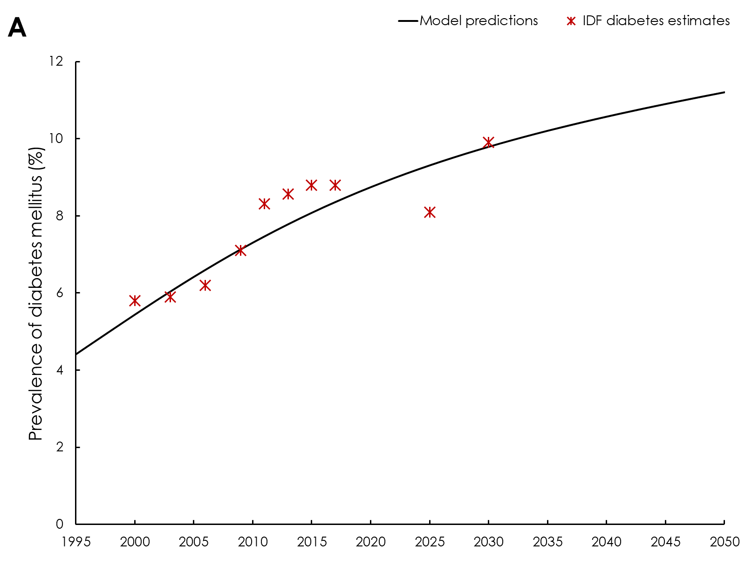

Prevalence (%)

**Figure S3.** Model fitting and projections for **A)** tuberculosis (TB) disease incidence rate, **B)** TB mortality rate, and **C)** total population in India between 1995 and 2050. The red asterisks and confidence intervals (bars) in panels A and B are the data provided by the World Health Organization’s Global Health Observatory data repository (World Health Organization 2017). The red asterisks in panel C are the data provided by the Population Division of the United Nations Department of Economic and Social Affairs (United Nations et al. 2017).

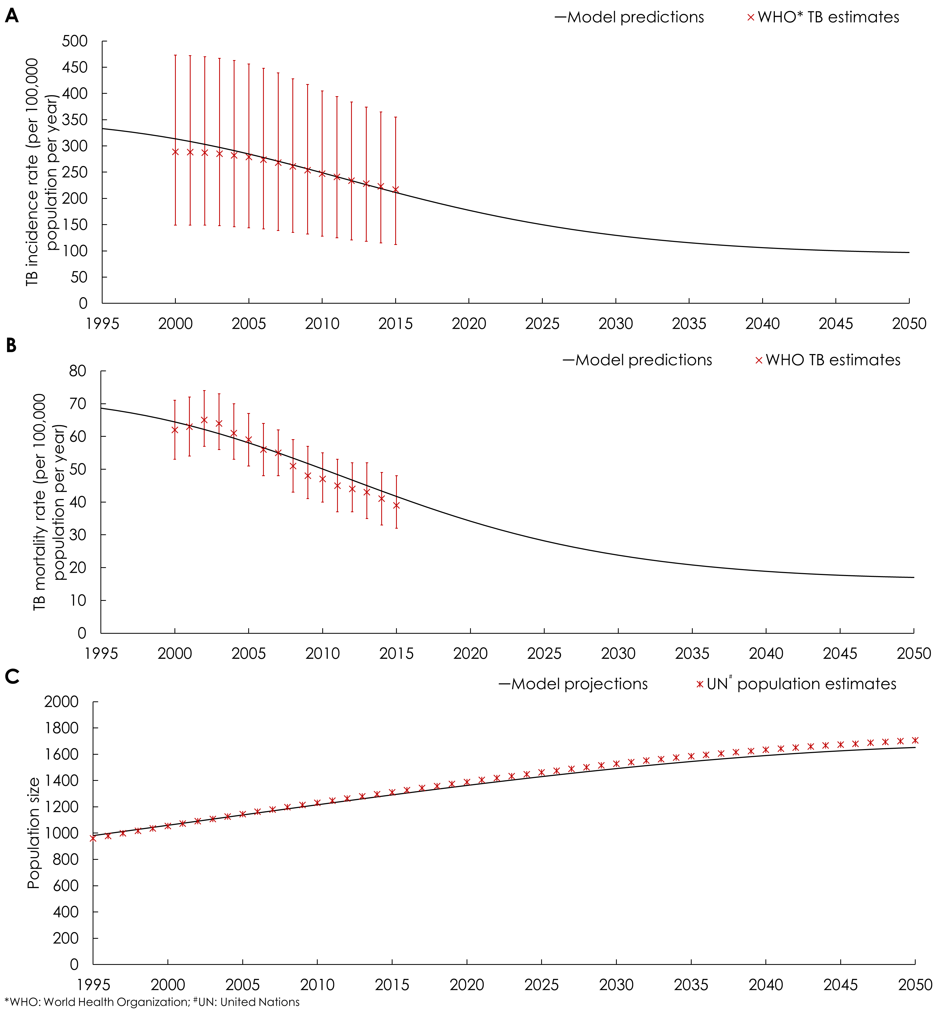

**Figure S4.** Projected tuberculosis (TB) incidence rate for different intervention strategies targeting individuals with diabetes mellitus (DM): **A)** TB vaccination, **B)** latent tuberculosis (TB) treatment as a preventive therapy, **C)** managing and controlling DM for improved TB progression and treatment outcomes. Details of each intervention scenario can be found in Table 1 of main text.

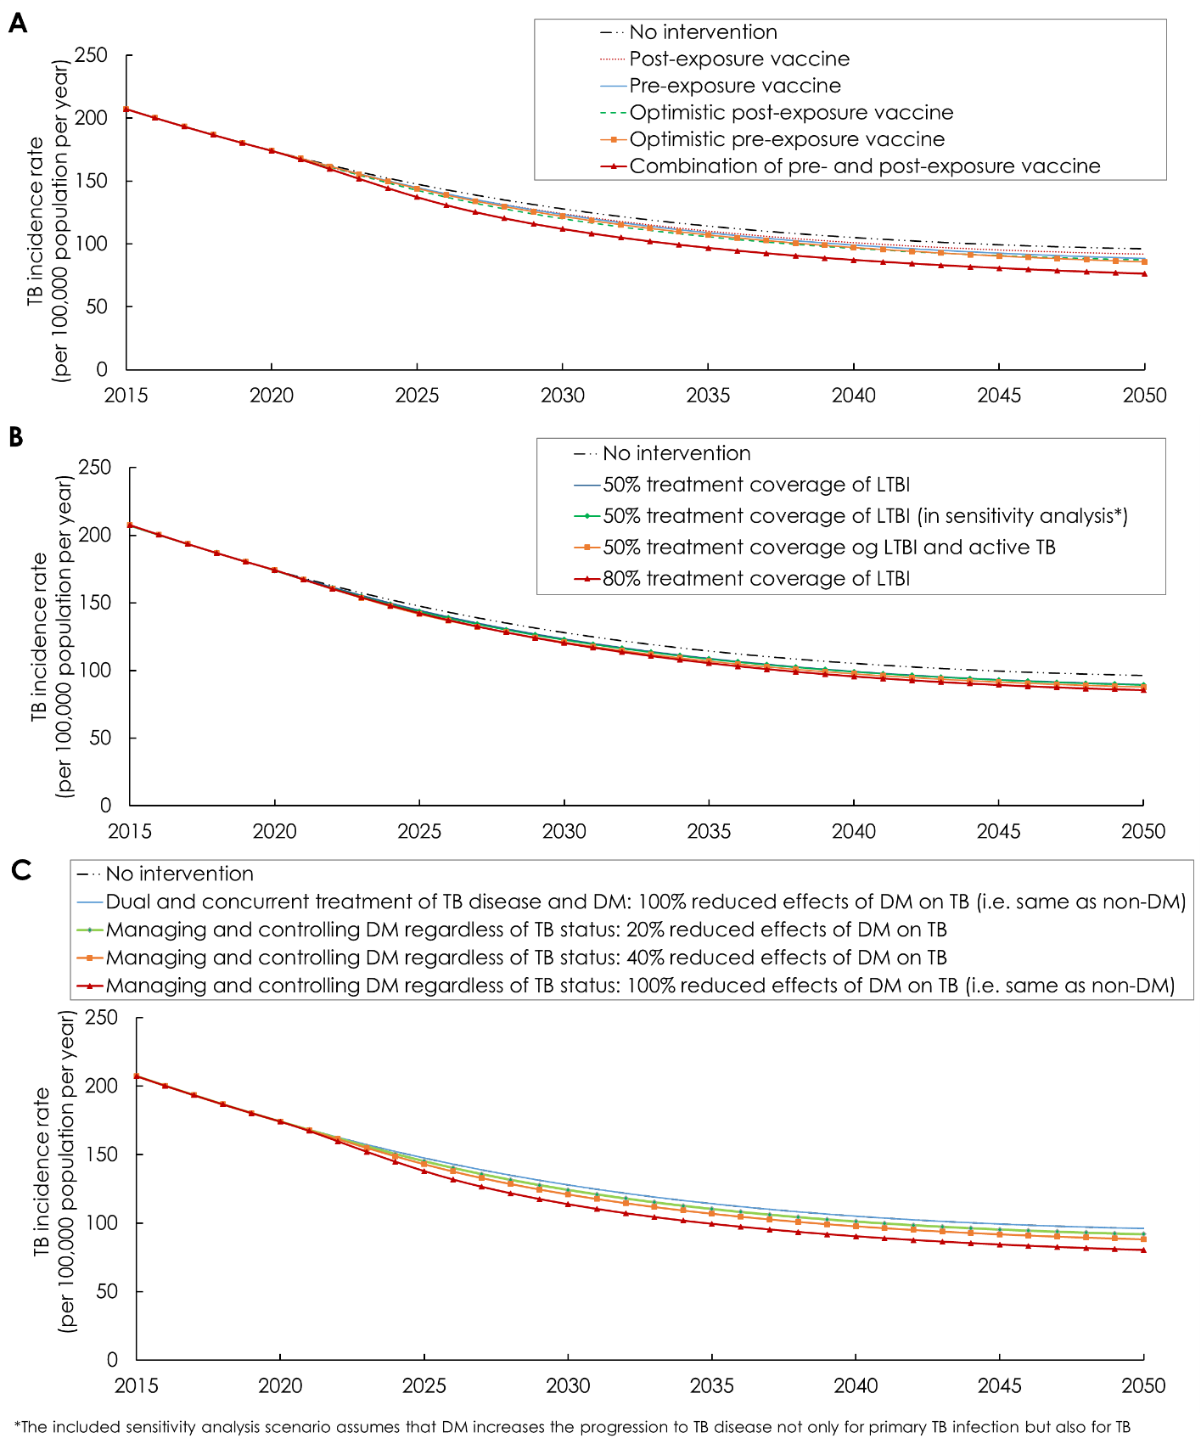

**Figure S5.** Sensitivity analyses to assess the impact of variations in key parameters for the *combination of post- and pre-exposure* vaccination scenario on **A)** TB incidence rate reduction and **B)** number of vaccinations needed to avert one TB disease case (*effectiveness*), both by 2050. Orange bars are based on the lower bound of parameter values and blue bars are based on the upper bound of parameter values. The reference line in this figure represents the impact of the intervention using the intervention’s original parameters as indicated in Table 1.

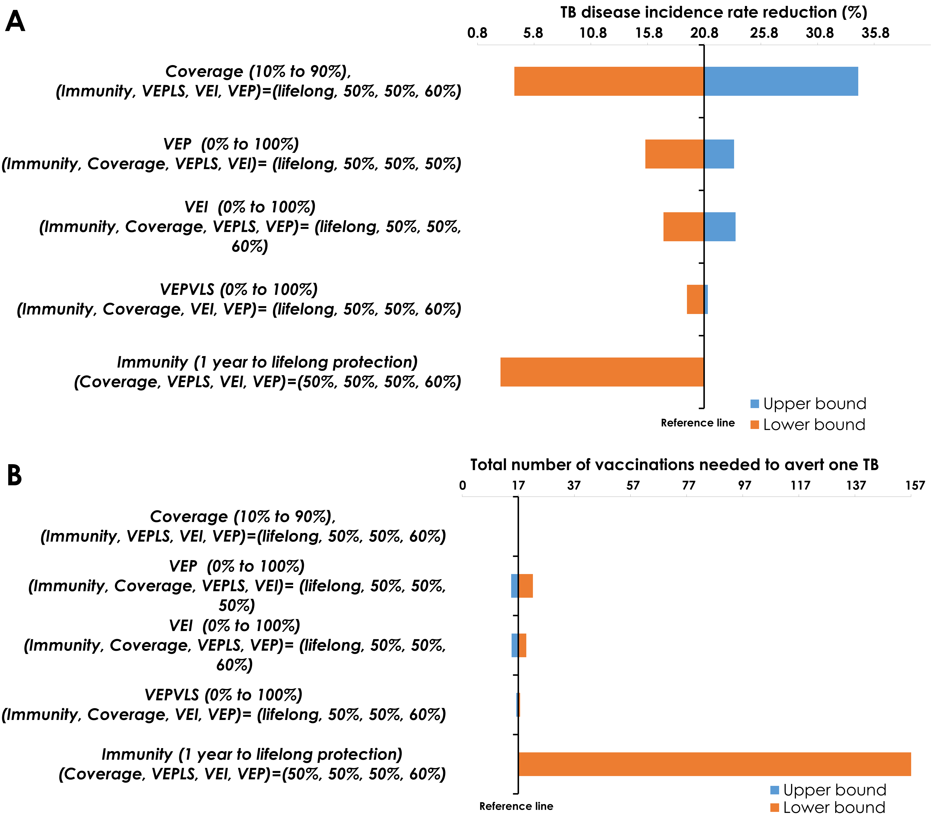

**Figure S6.** Projected outcomes of the impact of tuberculosis (TB) vaccination targeting individuals with diabetes mellitus (DM), assuming different DM prevalence trajectories. **A)** Reduction in TB disease incidence rate. **B)** Reduction in TB mortality rate. **C)** Number of vaccinations needed to avert one TB disease case (*effectiveness*) by 2025, 2030, 2040, and 2050. Vaccine coverage was scaled up to 50% by 2025 and then maintained at this level thereafter.

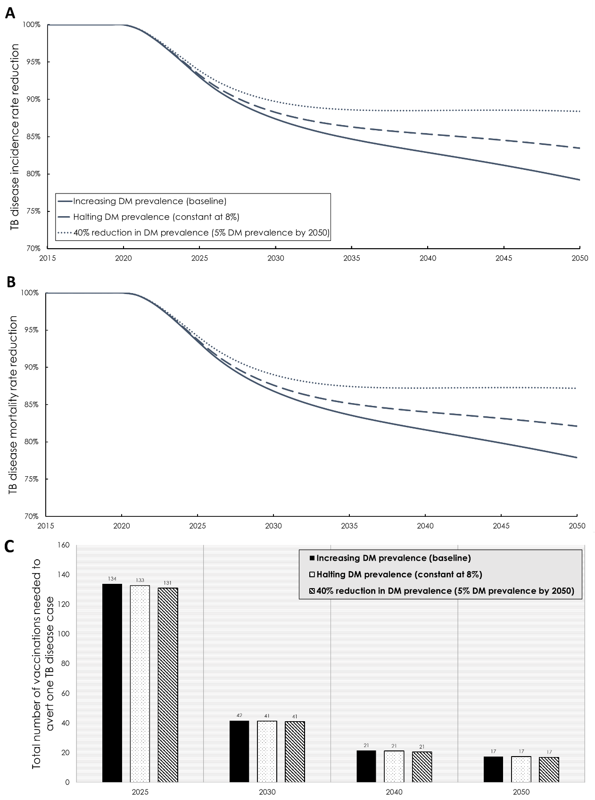

**Figure S7.** Sensitivity analyses to assess the impact of variations in the diabetes mellitus (DM)-on-tuberculosis (TB) effects for the *combination of post- and pre-exposure* vaccination scenario on **A)** TB incidence rate reduction and **B)** number of vaccinations needed to avert one TB disease case (*effectiveness*), both by 2050.Blue bars are based on the lower bound of parameter values (lower bound of the 95% confidence interval; CI) and red bars are based on the upper bound of parameter values (upper bound of the 95% CI; Table S3).

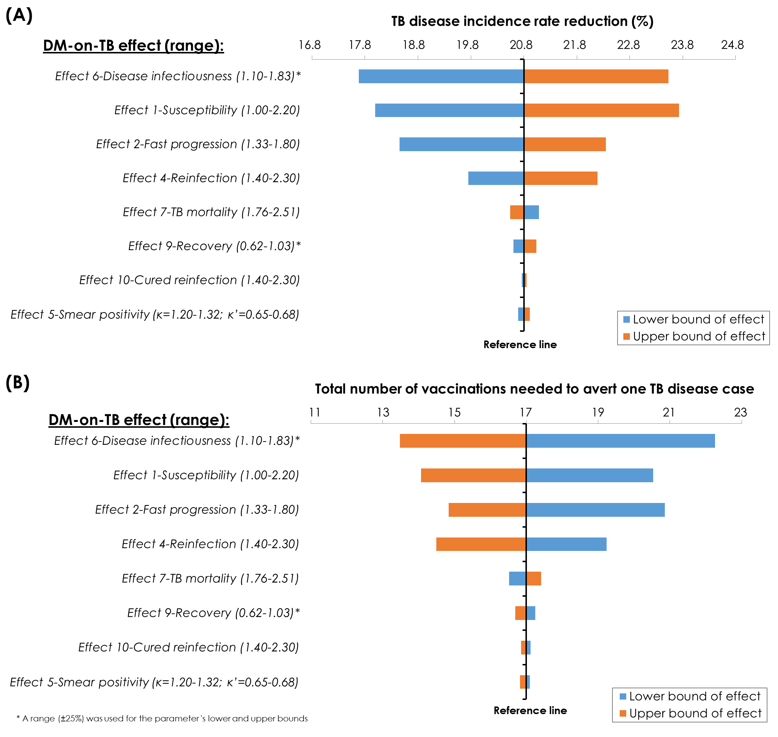

**Figure S8.** Sensitivity analyses to assess the impact of variations in tuberculosis (TB) epidemiological and natural history parameters for the *combination of post- and pre-exposure* vaccination scenario on **A)** TB incidence rate reduction and **B)** number of vaccinations needed to avert one TB disease case (*effectiveness*), both by 2050. Blue bars are based on the lower bound of parameter values (lower bound of the 95% confidence interval; CI) and red bars are based on the upper bound of parameter values (upper bound of the 95% CI; Table S2).

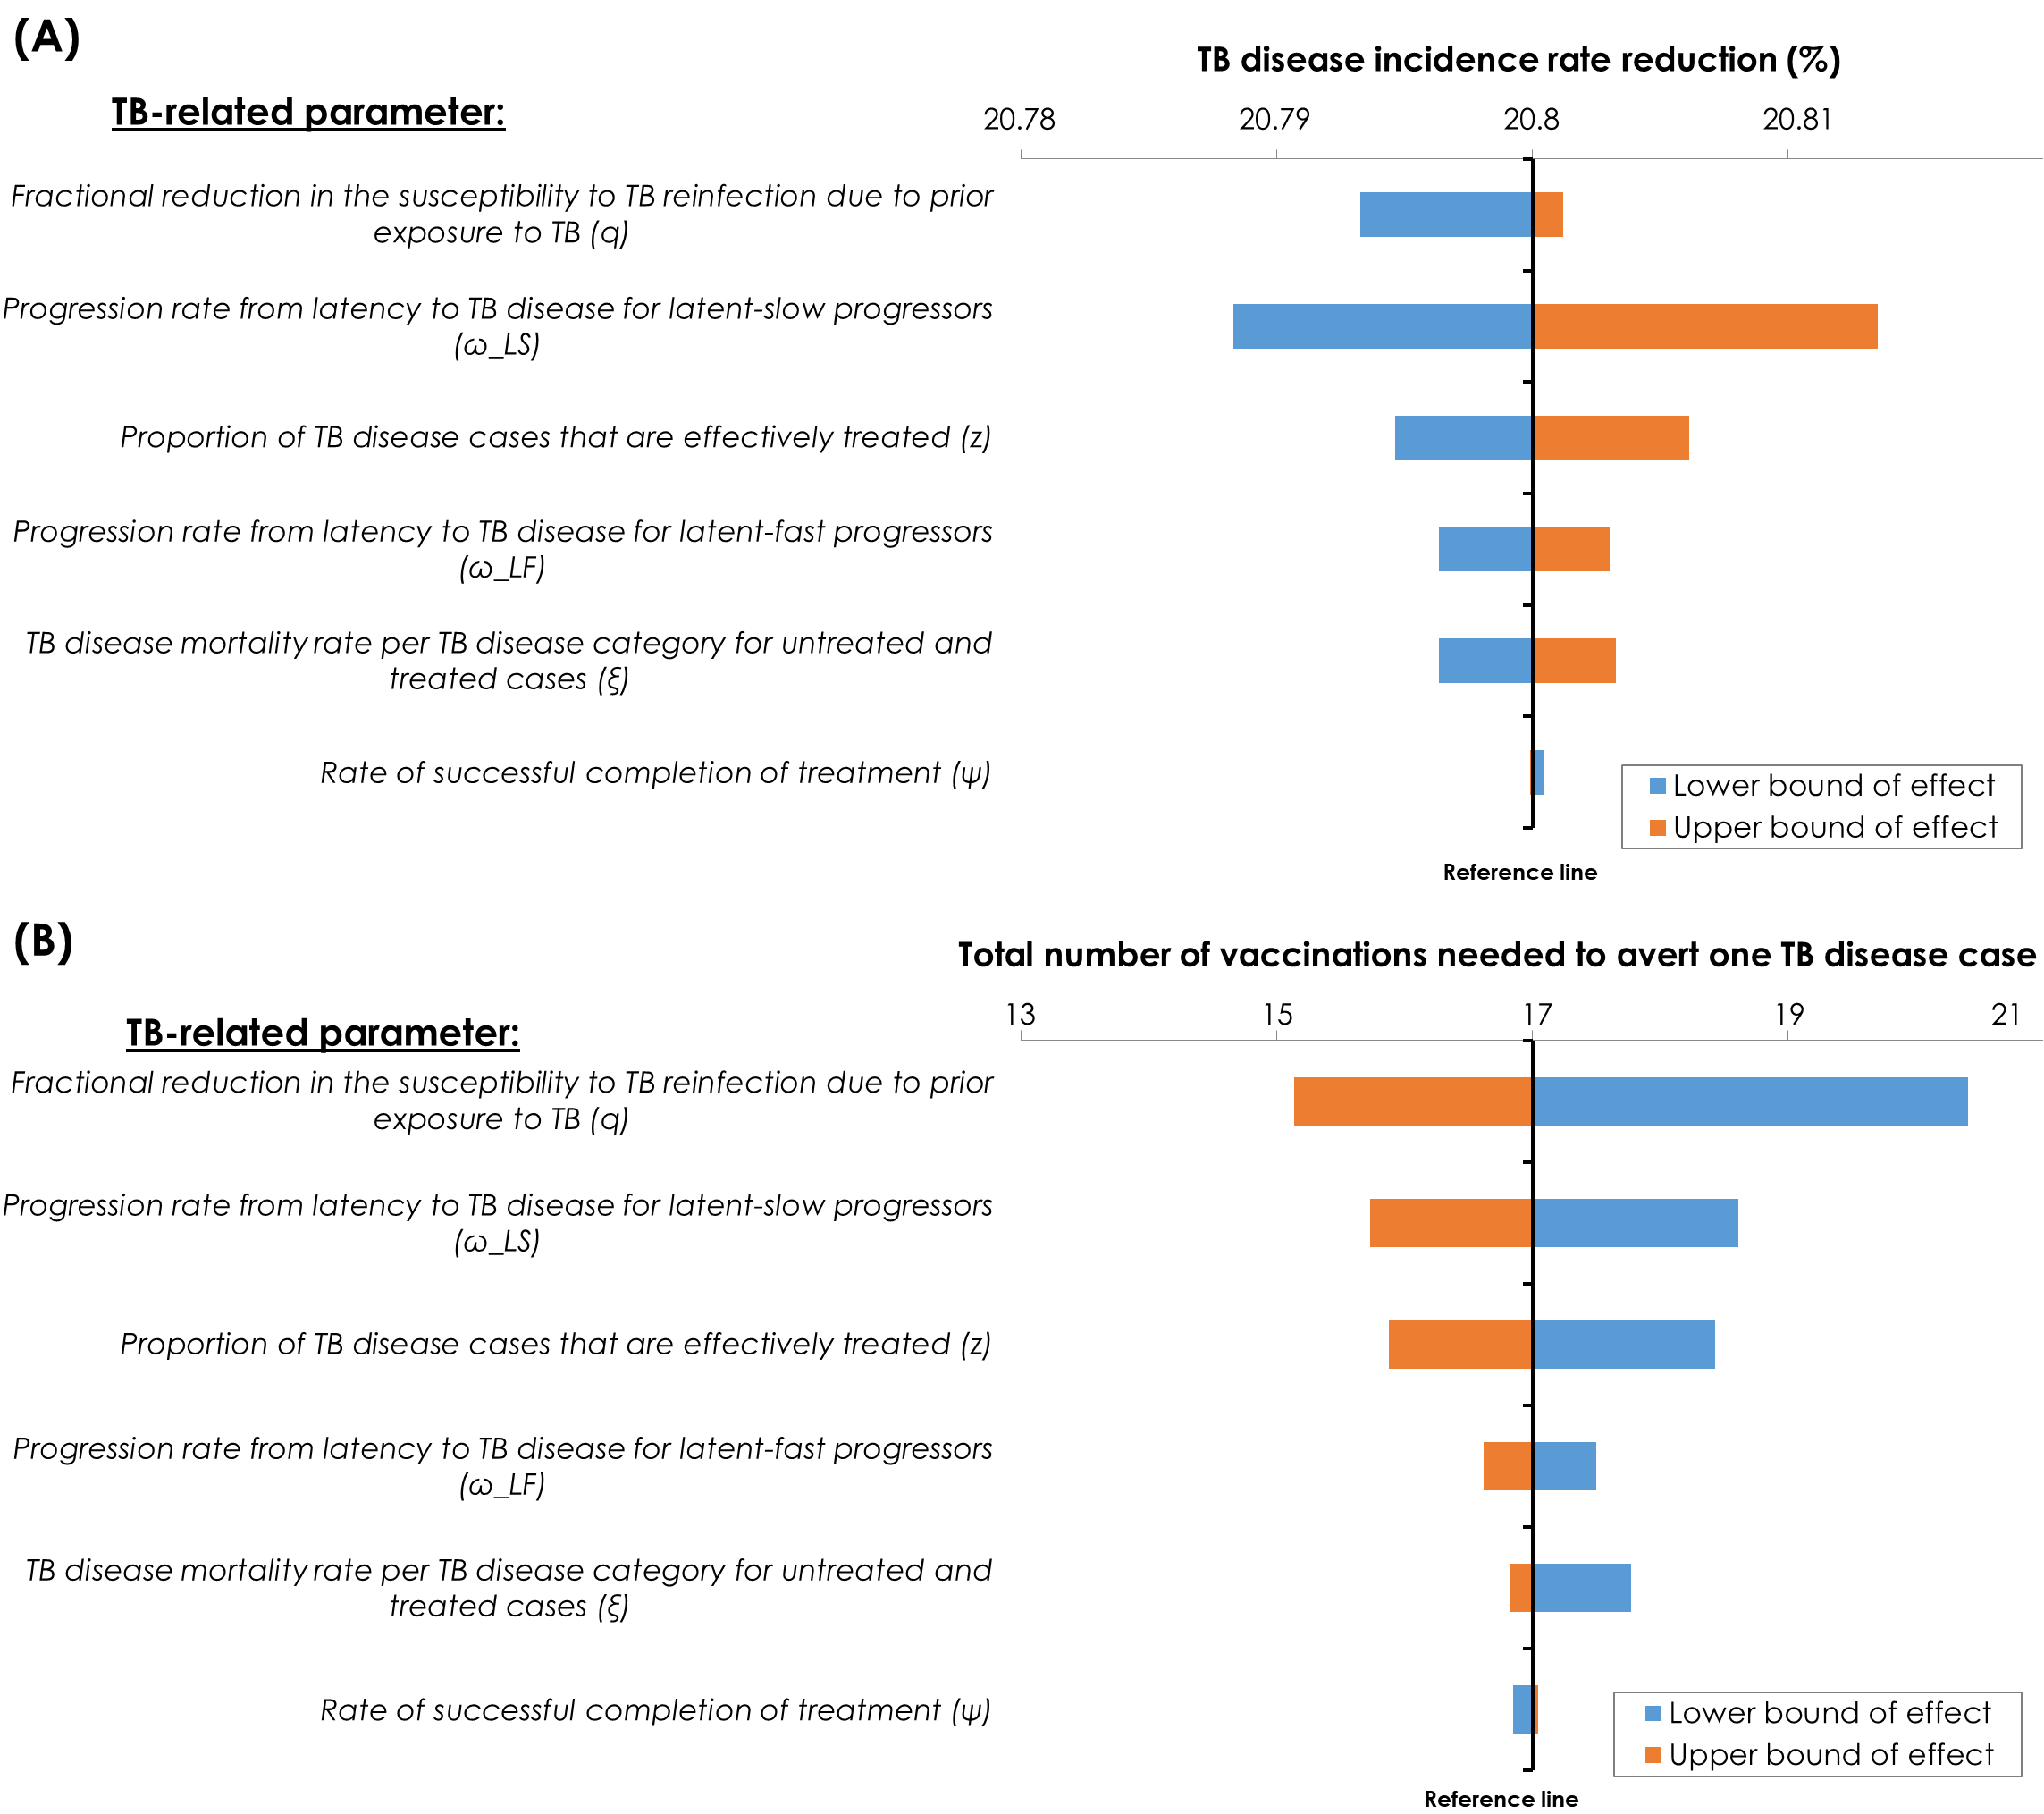

**REFERENCES**

Abu-Raddad, L. J., L. Sabatelli, J. T. Achterberg, J. D. Sugimoto, I. M. Longini, Jr., C. Dye and M. E. Halloran (2009). "Epidemiological benefits of more-effective tuberculosis vaccines, drugs, and diagnostics." Proc Natl Acad Sci U S A **106**(33): 13980-13985.

Al-Rifai, R. H., F. Pearson, J. A. Critchley and L. J. Abu-Raddad (2017). "Association between diabetes mellitus and active tuberculosis: A systematic review and meta-analysis." PLoS One **12**(11): e0187967.

Alo, A., S. Gounder and S. M. Graham (2014). "Clinical characteristics and treatment outcomes of tuberculosis cases hospitalised in the intensive phase in Fiji." Public Health Action **4**(3): 164-168.

Ambrosetti, M., G. Besozzi, L. R. Codecasa, B. Farris, S. Nutini, L. Saini, L. Casali, S. Nardini and G. B. Migliori (1999a). "The Italian AIPO study on tuberculosis treatment results, report 1995. National AIPO "Tuberculosis" Study Group." Monaldi Arch Chest Dis **54**(1): 49-54.

Ambrosetti, M., G. Besozzi, L. R. Codecasa, B. Farris, S. Nutini, L. Saini, L. Casali, S. Nardini and G. B. Migliori (1999b). "The Italian AIPO study on tuberculosis treatment results, report 1997. National AIPO "Tuberculosis" Study Group." Monaldi Arch Chest Dis **54**(5): 407-412.

Ambrosetti, M., G. Besozzi, B. Farris, S. Nutini, L. Saini, L. Casali, P. Pretto, G. Orani, S. Calabro and G. B. Migliori (1999c). "The Italian AIPO study on tuberculosis treatment results, report 1996. National AIPO "Tuberculosis" Study Group. Associazione Italiana Pneumologi Ospedalieri." Monaldi Arch Chest Dis **54**(3): 237-241.

American Diabetes Association (2017). "Standards of medical care in diabetes—2017 care in diabetes (Available at: <https://professional.diabetes.org/sites/professional.diabetes.org/files/media/dc_40_s1_final.pdf>)."

Anjana, R. M., M. Deepa, R. Pradeepa, J. Mahanta, K. Narain, H. K. Das, P. Adhikari, P. V. Rao, B. Saboo, A. Kumar, A. Bhansali, M. John, R. Luaia, T. Reang, S. Ningombam, L. Jampa, R. O. Budnah, N. Elangovan, R. Subashini, U. Venkatesan, R. Unnikrishnan, A. K. Das, S. V. Madhu, M. K. Ali, A. Pandey, R. S. Dhaliwal, T. Kaur, S. Swaminathan, V. Mohan and I.-I. C. S. Group (2017). "Prevalence of diabetes and prediabetes in 15 states of India: results from the ICMR-INDIAB population-based cross-sectional study." Lancet Diabetes Endocrinol **5**(8): 585-596.

Awad, S. F., S. R. Dargham, R. Omori, F. Pearson, J. A. Critchley and L. J. Abu-Raddad (2019a). "Analytical Exploration of Potential Pathways by which Diabetes Mellitus Impacts Tuberculosis Epidemiology." Sci Rep **9**(1): 8494.

Awad, S. F., P. Huangfu, H. H. Ayoub, F. Pearson, S. R. Dargham, J. A. Critchley and L. J. Abu‐Raddad (2019b). "Forecasting the Impact of Diabetes Mellitus on Tuberculosis Disease Incidence and Mortality in India." In press.

Ayoub, H. H., Z. Al Kanaani and L. J. Abu-Raddad (2018). "Characterizing the temporal evolution of the hepatitis C virus epidemic in Pakistan." J Viral Hepat **25**(6): 670-679.

Barnett GD and Styblo K (1977). "Bacteriological and X-ray status of tuberculosis following primary infection acquired during adolescence or later." Bulletin of the International Union Against Tuberculosis 52:5-16.

Cavanaugh, J., K. Viney, T. Kienene, D. Harley, P. Kelly, A. Sleigh, J. O'Connor and S. Mase (2015). "Effect of diabetes on tuberculosis presentation and outcomes in Kiribati." Tropical Medicine & International Health.

Centis, R., A. Ianni and G. B. Migliori (2000). "Evaluation of tuberculosis treatment results in Italy, report 1998. Tuberculosis section of the National AIPO Study Group on Infectious Disease and the SMIRA Group." Monaldi Arch Chest Dis **55**(4): 293-298.

Centis, R., G. B. Migliori, A. I. P. O. Tuberculosis Study Group. National, S. Group and I. S. d. S. National Tuberculosis Project (2002). "Evaluation of tuberculosis treatment results in Italy, report 1999." Monaldi Arch Chest Dis **57**(5-6): 297-305.

Chang, J. T., H. Y. Dou, C. L. Yen, Y. H. Wu, R. M. Huang, H. J. Lin, I. J. Su and C. C. Shieh (2011). "Effect of type 2 diabetes mellitus on the clinical severity and treatment outcome in patients with pulmonary tuberculosis: a potential role in the emergence of multidrug-resistance." J Formos Med Assoc **110**(6): 372-381.

Chiang, C. Y., K. J. Bai, H. H. Lin, S. T. Chien, J. J. Lee, D. A. Enarson, T.-I. Lee and M.-C. Yu (2015). "The Influence of Diabetes, Glycemic Control, and Diabetes-Related Comorbidities on Pulmonary Tuberculosis." PLoS ONE **10**(3): e0121698.

Chiang, C. Y., J. J. Lee, S. T. Chien, D. A. Enarson, Y. C. Chang, Y. T. Chen, T. Y. Hu, C. B. Lin, C. W. Suk, J. M. Tao and K. J. Bai (2014). "Glycemic control and radiographic manifestations of tuberculosis in diabetic patients." PLoS One **9**(4): e93397.

Dooley, K. E., T. Tang, J. E. Golub, S. E. Dorman and W. Cronin (2009). "Impact of Diabetes Mellitus on Treatment Outcomes of Patients with Active Tuberculosis." The American Journal of Tropical Medicine and Hygiene **80**(4): 634-639.

Duangrithi, D., V. Thanachartwet, V. Desakorn, P. Jitruckthai, K. Phojanamongkolkij, S. Rienthong, C. Chuchottaworn and P. Pitisuttithum (2013). "Impact of diabetes mellitus on clinical parameters and treatment outcomes of newly diagnosed pulmonary tuberculosis patients in Thailand." Int J Clin Pract **67**(11): 1199-1209.

Dye, C., G. P. Garnett, K. Sleeman and B. G. Williams (1998). "Prospects for worldwide tuberculosis control under the WHO DOTS strategy. Directly observed short-course therapy." Lancet **352**(9144): 1886-1891.

Dye, C. and B. G. Williams (2008). "Eliminating human tuberculosis in the twenty-first century." J R Soc Interface **5**(23): 653-662.

Gil-Santana, L., J. L. Almeida-Junior, C. A. Oliveira, L. S. Hickson, C. Daltro, S. Castro, H. Kornfeld, E. M. Netto and B. B. Andrade (2016). "Diabetes Is Associated with Worse Clinical Presentation in Tuberculosis Patients from Brazil: A Retrospective Cohort Study." PLoS One **11**(1): e0146876.

Hongguang, C., L. Min, J. Shiwen, G. Fanghui, H. Shaoping, G. Tiejie, L. Na and Z. Zhiguo (2015). "Impact of diabetes on clinical presentation and treatment outcome of pulmonary tuberculosis in Beijing." Epidemiology & Infection **143**(01): 150-156.

Huangfu, P., C. Ugarte-Gil, J. Golub, F. Pearson and J. Critchley (2019). "The effects of diabetes on tuberculosis treatment outcomes: an updated systematic review and meta-analysis." Int J Tuberc Lung Dis **23**(7): 783-796.

International Diabetes Federation (2006). IDF Diabetes Atlas. 3th edition. Brussels, Belgium (available at: <https://www.idf.org/sites/default/files/Diabetes-Atlas-3rd-edition.pdf>. Accessed on 10 Dec. 2015).

International Diabetes Federation (2016). IDF Diabetes Atlas. 7th edition. Brussels, Belgium (Available at:<http://www.diabetesatlas.org>. Accessed on 15 Sept. 2016).

Jimenez-Corona, M. E., L. P. Cruz-Hervert, L. Garcia-Garcia, L. Ferreyra-Reyes, G. Delgado-Sanchez, M. Bobadilla-Del-Valle, S. Canizales-Quintero, E. Ferreira-Guerrero, R. Baez-Saldana, N. Tellez-Vazquez, R. Montero-Campos, N. Mongua-Rodriguez, R. A. Martinez-Gamboa, J. Sifuentes-Osornio and A. Ponce-de-Leon (2013). "Association of diabetes and tuberculosis: impact on treatment and post-treatment outcomes." Thorax **68**(3): 214-220.

John, N. N., J. M. George and M. Narmadha (2017). "Study on the prevalence and incidence rates of diabetes mellitus in tuberculosis." International Journal of Pharmaceutical, Chemical & Biological Sciences **7**(4): 401-406.

K, V. N., K. Duraisamy, S. Balakrishnan, S. M, J. S. S, K. D. Sagili, S. Satyanarayana, V. A. M and D. A. Enarson (2013). "Outcome of tuberculosis treatment in patients with diabetes mellitus treated in the revised national tuberculosis control programme in Malappuram District, Kerala, India." PLoS One **8**(10): e76275.

Magee, M., R. Kempker, M. Kipiani, N. Gandhi, L. Darchia, N. Tukvadze, P. Howards, K. Narayan and H. Blumberg (2015). "Diabetes mellitus is associated with cavities, smear grade, and multidrug-resistant tuberculosis in Georgia." The International Journal of Tuberculosis and Lung Disease **19**(6): 685-692.

Magee, M. J., E. Bloss, S. S. Shin, C. Contreras, H. A. Huaman, J. C. Ticona, J. Bayona, C. Bonilla, M. Yagui, O. Jave and J. P. Cegielski (2013). "Clinical characteristics, drug resistance, and treatment outcomes among tuberculosis patients with diabetes in Peru." Int J Infect Dis **17**(6): e404-412.

Martinez, L., L. Zhu, M. E. Castellanos, Q. Liu, C. Chen, B. D. Hallowell and C. C. Whalen (2017). "Glycemic Control and the Prevalence of Tuberculosis Infection: A Population-based Observational Study." Clin Infect Dis.

Mboussa, J., H. Monabeka, M. Kombo, D. Yokolo, A. Yoka-Mbio and F. Yala (2003). "[Course of pulmonary tuberculosis in diabetics]." Rev Pneumol Clin **59**(1): 39-44.

Mi, F., S. Tan, L. Liang, A. D. Harries, S. G. Hinderaker, Y. Lin, W. Yue, X. Chen, B. Liang, F. Gong and J. Du (2013). "Diabetes mellitus and tuberculosis: pattern of tuberculosis, two-month smear conversion and treatment outcomes in Guangzhou, China." Trop Med Int Health **18**(11): 1379-1385.

Nakagami, T. and D. S. Group (2004). "Hyperglycaemia and mortality from all causes and from cardiovascular disease in five populations of Asian origin." Diabetologia **47**(3): 385-394.

Prasad, P., S. Gounder, S. Varman and K. Viney (2014). "Sputum smear conversion and treatment outcomes for tuberculosis patients with and without diabetes in Fiji." Public Health Action **4**(3): 159-163.

Reis-Santos, B., R. Locatelli, B. L. Horta, E. Faerstein, M. N. Sanchez, L. W. Riley and E. L. Maciel (2013). "Socio-demographic and clinical differences in subjects with tuberculosis with and without diabetes mellitus in Brazil--a multivariate analysis." PLoS One **8**(4): e62604.

Restrepo, B. I., S. P. Fisher-Hoch, J. G. Crespo, E. Whitney, A. Perez, B. Smith, J. B. McCormick and T. Nuevo Santander Tuberculosis (2007). "Type 2 diabetes and tuberculosis in a dynamic bi-national border population." Epidemiol Infect **135**(3): 483-491.

Restrepo, B. I., S. P. Fisher-Hoch, B. Smith, S. Jeon, M. H. Rahbar, J. B. McCormick and T. the Nuevo Santander Tuberculosis (2008). "Mycobacterial clearance from sputum is delayed during the first phase of treatment in patients with diabetes." The American journal of tropical medicine and hygiene **79**(4): 541-544.

Singla, R., N. Khan, N. Al-Sharif, M. O. Ai-Sayegh, M. A. Shaikh and M. M. Osman (2006). "Influence of diabetes on manifestations and treatment outcome of pulmonary TB patients." Int J Tuberc Lung Dis **10**(1): 74-79.

Small, P. M., P. C. Hopewell, S. P. Singh, A. Paz, J. Parsonnet, D. C. Ruston, G. F. Schecter, C. L. Daley and G. K. Schoolnik (1994). "The epidemiology of tuberculosis in San Francisco. A population-based study using conventional and molecular methods." N Engl J Med **330**(24): 1703-1709.

Springett, V. H. (1971). "Ten-year results during the introduction of chemotherapy for tuberculosis." Tubercle **52**(2): 73-87.

Sulaiman, S. A., A. H. Khan, A. R. Muttalif, M. A. Hassali, N. Ahmad and M. S. Iqubal (2013). "Impact of diabetes mellitus on treatment outcomes of tuberculosis patients in tertiary care setup." Am J Med Sci **345**(4): 321-325.

Suwanpimolkul, G., J. A. Grinsdale, L. G. Jarlsberg, J. Higashi, D. H. Osmond, P. C. Hopewell and M. Kato-Maeda (2014). "Association between diabetes mellitus and tuberculosis in United States-born and foreign-born populations in San Francisco." PLoS One **9**(12): e114442.

Tatar, D., G. Senol, D. Cosar, R. Ozacar and H. Halilcolar (2009). "Patterns of drug resistance in pulmonary tuberculosis cases in the Izmir district, Turkey." New Microbiol **32**(1): 31-37.

The MathWorks and Inc. MATLAB (2018). The language of technical computing, The MathWorks, Inc.

The World Bank (2015). Tuberculosis case detection rate in India (%, all forms) (Available at: <https://data.worldbank.org/indicator/SH.TBS.DTEC.ZS?locations=IN&year_high_desc=false>; Accessed November, 2017). The World Bank.

United Nations, Department of Economic and Social Affairs and Population Division. (2017). "World Population Prospects: The 2017 Revision, DVD Edition. (Available at: <https://esa.un.org/unpd/wpp/Download/Standard/Population/>)."

United Nations Department of Economic and Social Affairs, Population Division and Population Estimates and Projections Section (2012. available: <http://esa.un.org/wpp/Excel-Data/population.htm> ). World population prospects, the 2012 revision.

Velicia, F. J. F. (1987). "On the moments of a Wood Saxon beta distribution." Journal of Physics A: Mathematical and General.

Viswanathan, A. A. and N. C. Gawde (2014a). "Effect of type II diabetes mellitus on treatment outcomes of tuberculosis." Lung India **31**(3): 244-248.

Viswanathan, V., S. Kumpatla, V. Aravindalochanan, R. Rajan, C. Chinnasamy, R. Srinivasan, J. M. Selvam and A. Kapur (2012). "Prevalence of diabetes and pre-diabetes and associated risk factors among tuberculosis patients in India." PLoS One **7**(7): e41367.

Viswanathan, V., A. Vigneswari, K. Selvan, K. Satyavani, R. Rajeswari and A. Kapur (2014b). "Effect of diabetes on treatment outcome of smear-positive pulmonary tuberculosis--a report from South India." J Diabetes Complicat **28**(2): 162-165.

Wang, Q., A. Ma, X. Han, S. Zhao, J. Cai, Y. Ma, J. Zhao, Y. Wang, H. Dong, Z. Zhao, L. Wei, T. Yu, P. Chen, E. G. Schouten, F. J. Kok and A. Kapur (2013). "Prevalence of type 2 diabetes among newly detected pulmonary tuberculosis patients in China: a community based cohort study." PLoS One **8**(12): e82660.

Woods, R. D. and D. S. Saxon (1954). "Diffuse Surface Optical Model for Nucleon-Nuclei Scattering." Physical Review **95**(2): 577-578.

Workneh, M. H., G. A. Bjune and S. A. Yimer (2016). "Diabetes mellitus is associated with increased mortality during tuberculosis treatment: a prospective cohort study among tuberculosis patients in South-Eastern Amahra Region, Ethiopia." Infect Dis Poverty **5**: 22.

World Health Organization (2008). Global Tuberculosis Control Surveillance, Planning, Financing (available at: <http://data.unaids.org/pub/report/2008/who2008globaltbreport_en.pdf>). Switzerland, World Health Organization.

World Health Organization (2010). Treatment of tuberculosis: guidelines – 4th ed. (Available at: <http://apps.who.int/iris/bitstream/10665/44165/1/9789241547833_eng.pdf>, accessed Nov. 2018).

World Health Organization (2017). WHO Global Health Observatory Data Repository, (available at: <http://apps.who.int/gho/data/node.main>. Accessed: 21 Dec. 2017).

Wu, Z., J. Guo, Y. Huang, E. Cai, X. Zhang, Q. Pan, Z. Yuan and X. Shen (2016). "Diabetes mellitus in patients with pulmonary tuberculosis in an aging population in Shanghai, China: Prevalence, clinical characteristics and outcomes." J Diabetes Complications **30**(2): 237-241.